Abstract

Content for ATOWM Series II, Rules of Magic for the Astral Plane, Video Commentary, Program Fifty-three, 10.37 continuing Rule X, 3:08 hr.

PENDING: Program 53: A Treatise on White Magic – Rules of Magic for the Astral Plane – Rule X 10.37 619 MB .wmv file
Video by Michael D. Robbins. 13Sep2018 / 3:08 hr.

PENDING: Program 53: A Treatise on White Magic – Rules of Magic for the Astral Plane – Rule X 10.37 90 MB .mp3 file
Audio by Michael D. Robbins. 13Sep2018 / 3:08 hr.

Transcript

Good morning everyone, this is the 13th of September 2018 and we are continuing with A Treatise on White Magic and this is our 53rd program for rules for magic on the astral plane, and it is our 37th program for rule 10, which it's an amazingly large rule filled with all kinds of important information.

We're not too far from the completion of rule 10, and we're working on some preliminaries in Esoteric Astrology this is what He wrote before He wrote His big book on Esoteric Astrology the third volume of the Rays and the Initiations and well He considered it to be His most occult book because it dealt entirely with the realm of energy.

There have been so many deep things said already. He's talked about the simplicity of things of course, and He's given us the basic meanings of the Sun Sign which we call the Sun of probability and the rising sign which we come call the potency of the Sun of possibility and the moon sign representing the past and the lunar Lords and the general condition of the vehicles.

So this is really worth rereading. He's told us that when we die in a certain sign, in a certain astrological month, we are reborn in that month in our next incarnation, and an astrological month is not the same as the normal calendar month, it usually begins anywhere from the 19th to the 23rd of a month, depending upon which ones were talking about. That's interesting, then according to your birthday, you will know the sign in which you died, made your transition in the previous incarnation.

So all of us want to cultivate our rising sign bringing us closer to that which the supervising solar angel intends for this incarnation and then I'm sure as we grow in our consciousness we on the higher planes participate in that choice as well. That's my impression.

Let us then continue and see if we can finish off somehow here, rule number 10. Rule 11 is no small matter either, it's about 60 pages long, and then we'll be finished with the rules for magic on the astral plane.

0:03:40

Astrology now deals primarily with the personality for whom the horoscope may be cast and with the events of the personality life. When, through meditation and service, plus the discipline of the lunar bodies, a man comes consciously and definitely under his soul ray, then he comes as definitely under the influence of one or other of the seven solar systems, as they focus their energy through one or other of the constellations and subsequently one or other of the seven sacred planets. Eventually, there will be twelve sacred planets, corresponding to the twelve constellations, but the time is not yet. Our solar system, as you know, is one of seven. When a man has arrived at this point in evolution, birth months, mundane astrology, and the influences which play upon the form aspect become of less and less importance. This circle of solar systems affects paramountly the soul and it becomes the focal point of spiritual energies. This is the problem of the soul on its own plane,—responsiveness to these types of energy, and, of them, the personality is totally unaware. TWM 437

Astrology now deals primarily with the personality for whom the horoscope may be cast and with the events of the personality life. I remember the contest between psychological astrologers and event- oriented astrologers. Well usually with any debate such as this, everybody has a piece of the truth. I found that event orientation is very useful in helping to rectify the horoscope, but when you want to really deal with the purpose of the incarnation you have to get into the cycle spiritual realm.

So although astrology is the greatest and oldest of all the sciences, it is still very much in its infancy as far as the way we are able to practice it.

When, through meditation and service, plus the discipline of the lunar bodies, a man comes consciously and definitely under his soul ray, then he comes as definitely under the influence of one or other of the seven solar systems, as they focus their energy through one or other of the constellations and subsequently one or other of the seven sacred planets. This is actually quite a deep statement, but we certainly see what the requirements are: meditation, service, and discipline. We see that.

The question is, what are the seven solar systems? From one perspective our Sun is a member of something that's called the seven solar systems of which ours is one. The soul ray is certainly tied in not only with the heart of the Sun of our own system, but probably I would say with the stars in these seven solar systems. If we want to take it further and understand that the term solar systems is quite generic, then we're going to have to deal with seven systems of stars called constellations, which are the chakras of the super cosmic logos that we call, the One About Whom Not May Be Said. I'm calling it a super cosmic levels. DK uses terms like cosmic logos, I think that is applicable to each constellation, for instance the constellation or the grouping of stars in which our sun plays the role of the heart center. There are a number of other such constellations and the entity which installs them, I think can rightfully be called a cosmic logos.

Then on page 293 of A Treatise on Cosmic Fire beyond the category of a cosmic logos, we have something called the Unknown, and I think that is our local One About Whom Not May Be Said in which each one of these constellations is the chakra.

TABULATION II
EVOLUTION IN THE UNIVERSE
Entity | Vehicle | Centre | Space | Time
The Unknown....... | 7 constellations............ | cosmic Logos........... | 5 cosmic planes.
A cosmic Logos.... | 7 solar systems............ | solar Logos.............. | 4 cosmic planes.
A solar Logos....... | 7 planetary schemes....... | Heavenly Man.......... | 3 cosmic planes..... | Period of three  solar systems.
A Heavenly Man..... | 7 planetary chains........... | Chohans and groups.... | 2 cosmic planes..... | Period of one  solar system.
A Man......................... | 7 etheric centres............... | a Principle...................... | 1 cosmic plane....... | Period of one  planetary scheme.

So there seems anyway to be alignment between seven major constellations in the One About Whom Not May Be Said and then our own cosmic logos, in which our solar logos is a heart chakra, and then our solar logos Himself, as we've just learned that, from the heart of the Sun the Seven Rays go forth. The Seven Rays is … I won't call it the last stop, but it's spiritually speaking, it's very important that each one of us is on one of those seven from the soul perspective.

If we wanted to take this even farther, I suppose we could go to the head centers in the One About Whom Not May Be Said, and the Great Bear and it's seven stars would be would be that particular a series of head centers. Basically, all of this is coming from the head centers of the super cosmic levels and also from the zodiac of constellations, which He tells us at some point in The Rays and The Initiations is the heart in the head center of the One About Whom Not May Be Said. That all of this traces its way down to our soul ray. So when He says seven solar systems … or seven major centers in the One About Whom Not May Be Said.

Eventually, there will be twelve sacred planets, corresponding to the twelve constellations, but the time is not yet. As a number of the non-veiled planets are still non-sacred, so we have Mars, we have the earth, we have a planet veiled by the moon, I believe some people have called that planet Rex, meaning King, and there's been a statement made that Rex is a moon, is the king of planets, something like that. So it may be an oblique reference to its veiling of Rex and then there is a non-sacred planet veiled by the Sun. Anyway when these sort of veiled planets emerge veiled and non sacred planets emerge and come into a state of sacredness, then maybe we're going to have those 12 sacred planets. He says the time is not yet, and we have no idea when the time might be because this involves long solar system. Its timing.

Our solar system, as you know, is one of seven. Seven solar systems of which ours is one. Now, some people have, I think, mixed the constellation chakras with the solar logoic chakras; solar logoic chakras is a much smaller thing, a constellational chakra a much larger thing. A constellation of chakra and finds its place in such a being such as a One About Whom Not May Be Said, at which there are, I think and in our particular area of space may be 49, and a solar logos chakra. There's a chakra within one of those within a constellation which is a chakra in a One About Whom Not May Be Said. I mean all these are just words they help us get a picture of a larger cooperation of great entities and at least it helps us get a sense of scale and scope.

When a man has arrived at this point in evolution, birth months, mundane astrology, and the influences which play upon the form aspect become of less and less importance. I guess when He's coming under one of the seven solar systems, ie, when the man is coming under the influence one of the seven solar systems. Or, if that's a later stage, and maybe it means really that, in our case, that the soul ray begins to dominate all the other astrological factors found in the chart, and all the other lower rays.

This circle of solar systems affects paramountly the soul and it becomes the focal point of spiritual energies. This is the problem of the soul on its own plane,—responsiveness to these types of energy, and, of them, the personality is totally unaware. This is responsiveness to stellar solar logoic energies. He does seem to be clarifying the matter. I mean in terms of gradation, if we're going to come into relationship with a solar logos such as our own, at some point in our initiative then it seems that the next greater entity to come in touch with is our own local ruler of the seven solar systems in which our solar logos is a chakra, and then only only then come into relationship with that greater being that contains a number, maybe seven major cosmic logoi.

0:16:00

Again the chart on 293 will help us, and that's A Treatise on Cosmic Fire. And just make note of it, it's important in trying to get a picture:

TABULATION II
EVOLUTION IN THE UNIVERSE
Entity | Vehicle | Centre | Space | Time
The Unknown....... | 7 constellations............ | cosmic Logos........... | 5 cosmic planes.
A cosmic Logos.... | 7 solar systems............ | solar Logos.............. | 4 cosmic planes.
A solar Logos....... | 7 planetary schemes....... | Heavenly Man.......... | 3 cosmic planes..... | Period of three  solar systems.
A Heavenly Man..... | 7 planetary chains........... | Chohans and groups.... | 2 cosmic planes..... | Period of one  solar system.
A Man......................... | 7 etheric centres............... | a Principle...................... | 1 cosmic plane....... | Period of one  planetary scheme.

As we see, solar logos has planetary schemes; heavenly men has its seven chains or chakras. presenting cosmic logoi has solar logoi as its chakras, and the Unknown, as cosmic logos, has its chakras.

So the Unknown here is pretty much One About Whom Not May Be Said and you can see such a being I think on the charts that Master DK gives us, there, that triangle [the top one], I believe it is a One About Whom Not May Be Said [A Cosmic Parabrahman]:

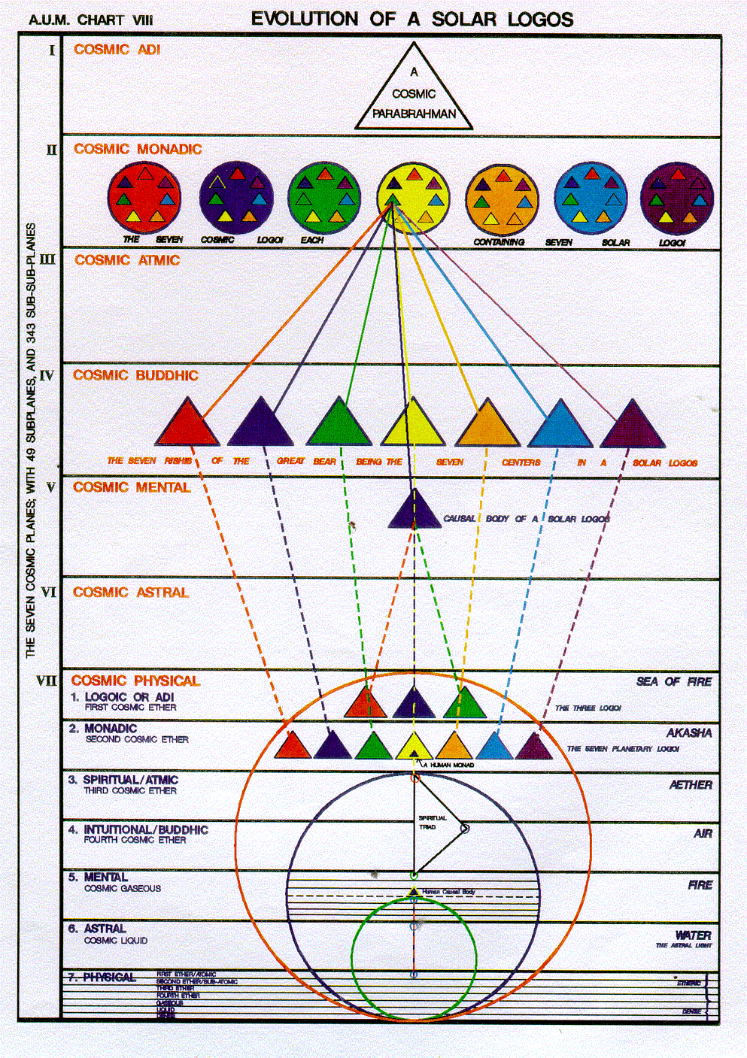

Some may think the big circles are One About Whom Not May Be Said that I think that since this little triangle contains not only the stars of the Great Bear, but also our soul of logos and it's causal body, it shows that it contains more than simply one constellation. That being the case, we can infer that it contains seven major constellations. Well probably the kinds of things we're talking about now are not really even totally soluble by a very high initiates. From our angle it's just speculative, though interesting.

I think this statement, Our solar system, as you know, is one of seven. I think it's a very important statement, and there's no way we're going to confirm all of this in our lifetime. But enough hints have been given out to prompt some thinking along these lines, that much we can do. We haven't come close to dealing with the arms of galaxies, if they are subsidiary ensouled by subsidiary galactic beings, we haven't come close to dealing with that type of logos who is the informing life of a galaxy, yet alone a number of galaxies that being who informs a number of galaxies in which any galaxy is simply a chakra.

So, it's very big. And [laughing] here we are sometimes wondering about why we get angry or lose our emotional poise, so the vision is great but we have to confirm that we have mastered even a few things within our personal energy system.

It makes me want to pause of course, and just dwell on a number of these matters, but I suppose the question turns on the use of the word solar system. In a way even a galaxy as a solar system is made up of many a system of many many stars. The One About Whom Not May Be Said is a solar system in a way, and constellations are also systems of stars. Now when we get down to those structures that just have one or two stars at their center as the dual stars. I'm told actually outnumber the single stars systems. then we have what we normally call a solar system. Let's say, one star and the number of attendant planets. Or two stars and a number of attendant planets. Maybe some systems don't even have planets.

I mean we have so much to learn, but right now we're trying to tread the path of discipleship and of initiation and come on rapport with the higher aspects of our own planet, and come into greater relationship to our own planetary logos, and then we can be more concerned with some of the sacred logoi surrounding the earth like Venus and Mercury (when I say surrounding, I mean cooperating with) and maybe then we can begin to wonder what it's like to be a solar life. In a way each one of the planets of the logos of the planets in our solar system is a solar life. So from planetary lives there's a very big jump I think to the next kingdom, which we call solar lives. In a way Sanat Kumara must be a solar life because He said to be a direct disciple of our soul the logos.

How far can we take this? And how profitable is it for us to think of these things? Not that we should dismiss thinking about them, because they're difficult. It's just as we can only give so much time to them, and then maybe at a certain point the intuition will speak, and more will be revealed.

But the soul on its own plane in a way is a solar angel, and has already been a full human being, and has been trained in the next hierarchy above that of the human monads and it's they who are responsive to the energies of the seven solar systems. So it's the solar angels who are responsive to the seven major solar logoi of the seven solar systems of which ours is one.

0:23:30

The signs which fall therefore into the four categories of earth, water, fire and air, concern primarily the man who lives below the diaphragm, and who utilises the lower four centres:—the centre at the base of the spine, the sacral centre, the solar plexus and the spleen. The inner group of seven major or systemic energies produce their effect upon the man who is living above the diaphragm, and work through the seven representative centres in the head. Four of them focus through the throat centre, the heart centre, the ajna and head centres. Three are held latent in the region of the head centres (the thousand petalled lotus) and only enter into functioning activity after the third initiation. It will be evident therefore how complicated from the standpoint of the horoscope (as well as of the individual problem) is this meeting of the energies of two types of constellations in the case of the man who is neither purely human nor purely spiritual. The ordinary horoscope is negated. The horoscope is not possible as yet of delineation. The only horoscope, which is basically and almost infallibly correct is that of the entirely low grade human being who lives entirely below the diaphragm and is governed by his animal nature alone. TWM 437-438

The signs which fall therefore into the four categories of – He goes back and forth between the words constellations and signs, and I think that with this alternation between the words constellations and signs can be used as a blind and we have to know which He's talking about at the time. It's not that He holds to a rigorous exactitude about these matters, the signs which fall therefore into the four categories of earth, water, fire and air. He's giving us the order of their frequency. These are presented in the order of their frequency and reflect the planes, because earth is of the etheric physical plane, water of the astral plane, fire of the mental plane and air in this case of the Buddha plane although it has its own relation as well to the etheric level. they concern primarily the man who lives below the diaphragm – He’s prompted primarily by the solar plexus the sacral center and certain functions sustaining functions at survival functions in the base of the spine center, plus the spleen and I guess were all dependent for vitality upon the splenic center. So the signs, they're falling into four categories of the four elements, lives below the diaphragm, and who utilises the lower four centres: and He goes in a different order —the centre at the base of the spine, the sacral centre, the solar plexus and the spleen.

The inner group of seven major or systemic energies coming from the heart of the Sun, in a proximate way, a proximate way, have to do with the soul rays, and the source of these rays is not the heart of the Sun. It may be the immediate source for us. I'd have to study, or restudy the four different types of causes. Were they from maybe Aristotle? But it is an immediate and effective cause, these seven rays coming from the heart of the Sun. So the inner group of seven major or systemic energies produce their effect upon the man who is living above the diaphragm, and work through the seven representative centres in the head. Ruled by Vulcan. Justice for the One About Whom Not May Be Said, they are ruled by the Great Bear. there was the definite connection there between Vulcan the Great Bear and Leo.

We can only imagine what the Tibetan has been studying lo these many years, and the access that He has had to sources which clarify these matters, and which is so entirely new to us, given the kind of astrology we had been studying.

Maybe this word signs, it may be correct, instead of constellations. I'll just put it as a question mark …

They concern the man who lives below the diaphragm. So the four lower elements … have particular relation to the one living below the diaphragm.

There are other elements ether, akasha, other elements, and if we were to turn to one of the charts here we would see them: [Page 35 Esoteric Astrology]

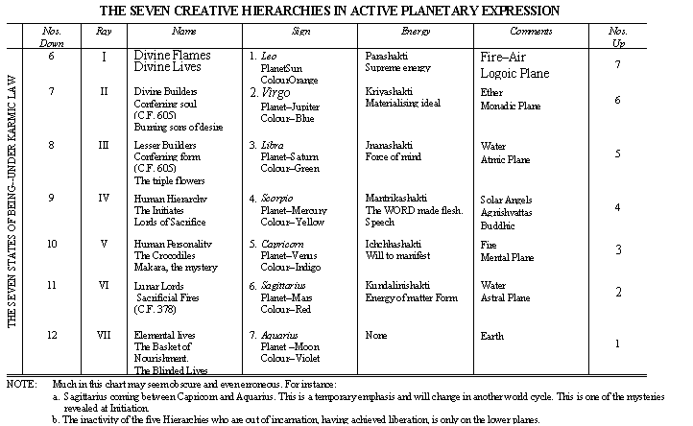

Ether. … here it's called water, but the atmic level is related to the ether, and the monadic to the akasha. I'm not exactly sure what element we would refer to for the logoic plane, but the lower elements are earth, water, fire, and air – air being quite pivotal because it's related to the buddhic level, which is the fourth or central level here on the cosmic physical plane.

The inner group of seven major or systemic energies produced their effect upon the man who is living above the diaphragm. Let's just say the disciple, the initiates, with the aspirant torn between and work through the seven representative centers in the head, now probably, if you count up all the centers related to the head, major centers, you're going to find 21. I suspect. Or maybe 21 will be the entirety of the major chakras in the energy system. If you have seven in the head, and you'll also have some centers maybe seven above the head, that's what we'll have.

When DK was asked by Robert Assagioli to explain some of this, He said, Look, I can't, it's a mystery it's very occults it cannot be at this time revealed. Although other Hindu books do purport to get into the structure of various centers that we've not heard much about at all and seem to be related to the spiritual pride, they get into such things extensively.

If I may just deviate for a moment, let's see where would I find those? … There, a manasic center, a buddhic center, a … nirvanic center and so forth. So chakras, that we've not recovered all the symbols. We've not heard of or seen and with enumerations of petals that are new to us. It's called the ajna system. I wonder how we could put all that together in the meaningful way without getting confused.

But at least, maybe it's enough to know that there are centers within the head. There are centers I think above the head, and the Tibetan head, where it shows kind of a feathered arch above the head, may obliquely indicate that series of centers.

So maybe 21 is a very important number. Seven major in the body, seven in the head, and seven above the head. This is of course at this point just speculation without any kind of detailed confirmation possible.

0:33:30

Four of them focus through the throat centre, the heart centre, the ajna and head centres.

Three are held latent in the region of the head centres (the thousand petalled lotus) and only enter into functioning activity after the third initiation. So there are some things here about the chakra system, which if we are careful to note may carry new revelation to us.

The inner group of seven major or systemic energies produced their effect upon the man who is living above the diaphragm. And work through the seven representative centers in the head.

In one of the rules there are seven above and seven below, I may have called that to our attention, but we can kind of see it in the beginning of the Rays and the Initiations would it be … number eight? Yes. the eye here it is:

[The Rays and The Initiations page 21:]

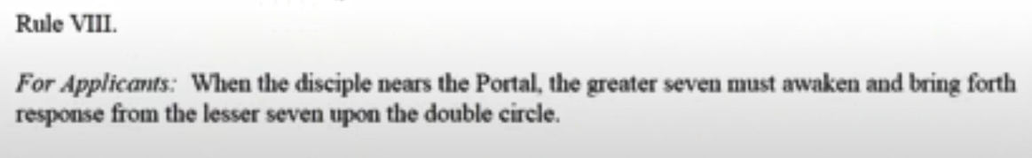

When the disciple nears the Portal, the greater seven must awaken and bring forth response from the lesser seven upon the double circle. We begin to wonder if it's not really given the other latent chakras mysterious chakras a triple circle. So that's number eight of the rules for applicants.

So Four of them focus through the throat centre, the heart centre, the ajna and head centres. These are the focus of the centers in the head; three are held latent in the region of the head centers. The notices are plural there, even though it's just called 1,000 petalled lotus, and the head center probably does have three parts.

The numerology here works out and come only into functioning the activity after the third latent hidden mysterious centers, and the third initiation. Is the head center divided into three parts? The many petals twelve central petals and the jewel at the heart of the twelve.

So we can see what a curriculum would be to really look into this head center, into its numerology, into the functions of each of the parts. Sometimes we see those pictures of the Buddha, and His head is covered by many coils, which each of them represent a particular potency, which He has mastered, and which is occultly found within the head and is the root of all representation in the rest of the body. Representation of those functions in the rest of the body. Light within the seven centers in the head, there is a kind of heart center which is correlated with the normal heart center and so forth for the other centers:

0:38:00

It will be evident therefore how complicated from the standpoint of the horoscope (as well as of the individual problem) is this meeting of the energies of two types of constellations in the case of the man who is neither purely human nor purely spiritual. Now I'm calling that the aspirant … I should add to that the disciple, because the disciple too, up to a certain point is torn between these two factors.

So we have we have zodiacal constellations, and well, here He uses the word constellations, and stars within the seven solar systems which ours is one for constellations which are the prototypes of those of those seven stars of which our star or logos is one. From one perspective, there's a man living below the diaphragm is responding to a certain type of energy from the zodiac of signs and of constellations. Then there is the man who is responding to the seven it's more along the rail line it has to do with the seven solar logoi in the cosmic logos in which our sun is a center, and it has to do with the prototypes of those seven stars, which themselves are constellations or chakras within One About Whom Not May Be Said.

There is a conflict there between the rays and some ordinary astrological meanings of the constellations.

If we go into Esoteric Astrology we will see that the zodiacal constellations are certainly not limited to this low function and maybe we and the signs of course are receiving areas attuned to the constellations they are receiving and distributing areas of devic substance. But sometimes the constellations are related to the soul level, and sometimes even to the monadic level, and this I've covered or discussed. I can only say somewhere on the appropriate page when I was going through Esoteric Astrology page by page.

Anyway, DK is telling us don't place too much faith in the ordinary horoscope, because it is negated under these circumstances the individual. In a way, is living neither in the zodiac of 12, or the zodiac of 10, the zodiac of 10, together they make 22. It has more to do with what's going on, within the One About Whom Not May Be Said. The other zodiac is also in that great being as a heart in the head center but it is it has its own extensive province and is generally lower.

Not what I think is probably, or wise to do, is to look at the particular status of the individual, more or less, and realize that all these 19 or even 22 energies, are going to be very important and will be used according to the type of individual we're dealing with, or group or nation. So will blend in a way the twelve and the seven and the three. We will not be too discriminative about their hierarchicalization as if one were necessarily higher than the other we'll take them all and use them all according to the stage of evolution in which we find ourselves. The horoscope is not possible as yet of delineation.

Let's call it this higher type of horoscope, the only horoscope which is basically and this higher type of horoscope for an individual who is responding to the Seven Solar Systems of Which Ours is One, and even to an additional three constellations the horoscope of ten, horoscope of 12. Ten is a human number. Twelve is a devic number. Just the way we might say that five is a more human number. The man number. Six is a more devic number. We have eleven from the combination of five and six, and 22 two from the combination of ten and twelve. Eventually, man and deva must be put together as is the case for a planetary logos. It has become a divine Hermaphrodite. After the idea, divine hermaphrodite with Hermes representing the man part and Aphrodite the devic part.

Eventually, there has to be a synthesis of these and on the buddhic plane that harmonious approach really begins and by the time we reach the monadic plane there is a kind of a unity which I don't think we can describe but there are human and Ava monads in each one of the major circles or sphere is found upon the monadic plane anyway when we take these wraiths and factors into consideration

The ordinary horoscope is negated. The horoscope is not possible as yet of delineation. How do we work the Rays into the horoscope? How do we work certain constellations which are their source into the horoscope?

The only horoscope, which is basically and almost infallibly correct is that of the entirely low grade human being who lives entirely below the diaphragm and is governed by his animal nature alone.
Probably people of our tired, I'm not going to have so much contact with such people that probably wouldn't be interested in astrology and in the case one has to serve as best one can.

So we were talking about an infallibly correct horoscope for a low-grade human being who lives entirely below the diaphragm. The soul ray factor has not entered in any conscious way. Basically, this is a book given before He wrote the big book on the subject, but it has foundations which the Tibetan tends generally not to repeat himself and if He does it always comes in from a different and more illuminative angle so we're learning things here or we're fixing in our mind certain things here which we have to carry through as we read the larger book.

We see that it's not just a question of considering what the zodiac and its rulers are telling us, it's a question of other constellations which are the bodies of cosmic logoi within the One About Whom Not May Be Said, which are tied in with the cosmic logos of which our Sun is a heart center and that those seven ray energies and maybe three even somehow beyond that because we have 19 energies 12 plus 7. Also we have to reach the number 22.

I think … if we look at great … they each have a array quality which they dispense to the cosmic levels of which our soda locust is apart with great bear a first-ray, Sirius, Little Bear, second ray and the deplete is generally third ray as to what are the Rays of the Pleiades they have a very powerful third ray which may be the fundamental ray of the great ray, but they also have a great cosmic buddhi, or second ray, which they receive from the dragon of all things.

So these big constellations do have more than one ray. When you look at the Pleiades, you wonder how the Draco the dragon can be the source of anything for them, because the … most important center within the one about whom not may be said may be representing all the plate is the higher head center.

What I'm doing is laying out for myself and for us just unanswered questions that will have to be addressed. We know more that's all to address them and pretend that there's any certainty about this is a mental pride I'm afraid and will not work …

It's difficult to delineate a horoscope which applies to all kinds of people, there are other factors that have to be taken into consideration really many factors even the 115 plus planets not to mention the the asteroids as well. So there's a lot going on.

0:51:40

Astrologers must remember also that there are several undiscovered planets which are producing pulls and shifts and focussing streams of energy upon our earth which tend to complicate the problem still further. Pluto is one of them, and having now emerged into manifestation (or rather into recognition) to it will be assigned all the unexplained conditions. Pluto will be made the scapegoat for faulty astrology for a long time to come. This chart failed to work and be true because Pluto must be influential in it and we know little about Pluto. So the story will run. Yet Pluto has always been revolving around our sun and producing its effects. It governs however the death or cessation of old ideas and emotions, and its influence is therefore largely cerebral and in that you have the clue to its late discovery. Mankind is only on the verge of becoming mental. Its effects are felt first in the mental body. The names of the planets are not the result of arbitrary choice but the planets name themselves. TWM 438

Astrologers must remember also that there are several at one point He says there are 115 or more, unless that number in summing to seven carries some other meaning, there are several undiscovered planets which are producing pulls and shifts and focussing streams of energy upon our earth which tend to complicate the problem still further.

This chart failed to work and be true because Pluto must be influential in it and we know little about Pluto. So the story will run.

Yet Pluto has always been revolving around our sun and producing its effects. Now this is telling us something about when this was written because the Masters are not allowed to call attention to certain discoveries which humanity itself must make and Pluto was discovered may be rediscovered in 1930 in 1915 apparently it was photographed but not recognized.

So anyway, among these undiscovered planets we have or maybe just recently discovered at that time, Pluto is one of them, and having now emerged into manifestation (or rather into recognition) to it will be assigned all the unexplained conditions. Pluto will be made the scapegoat for faulty astrology for a long time to come. One of them and having now emerged into manifestation or rather into recognition so we know here that this much was written after 1930 or after Pluto had emerged. I'd have to check the exact date of its of its discovery - it will be assigned all the unexplained conditions and a number of others have now been discovered in the neighborhood of Pluto.

As well and there are a number of hypothesized planets from the work of the German astrologer Vitter He was in the First World War and He was noticing certain effects and on that basis He hypothesized some eight they called the Uranian planets or trans-Neptunian planets.

It governs however the death or cessation of old ideas and emotions, and its influence is therefore largely cerebral and in that you have the clue to its late discovery. Pluto will be made the scapegoat for faulty astrology for a long time to come this chart failed to work ended be true because Pluto must be influential in it and we know little about Pluto. DK is telling us the problem when we don't were not playing with a full deck here, while we're playing with far far from a full deck and so the story will run yet Pluto has always been revolving around our Sun and producing its effects. Let's just say, duly noted in mythology, both Greek and Roman, and probably well before that in the traditions. It governs however the death or cessation of old ideas and emotions, and its influence is therefore largely cerebral – Thus linking it with the mind when the non-sacred planets are considered. and Mars I suppose with the astral body and in that you have the clue to its late discovery. because man only became sufficiently cerebral to notice the perturbations in the orbit of Neptune and then began to look for perhaps a source causing them.

Mankind is only on the verge of becoming mental. It's affects are first felt first in the mental body.

We're told about how the time to drop the vehicle physical vehicle has come and then the mind seizes upon that impulse from the soul and then repeats the word. … The word of death, goes forth. We look here at Esoteric Healing then repeats yeah:

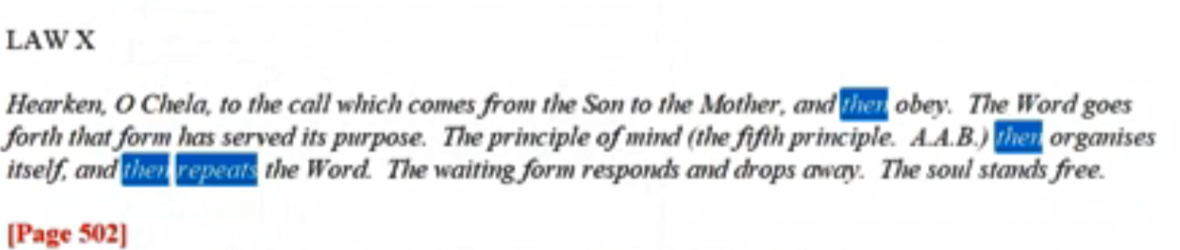

… The word goes forth that form has served its purpose. That's from the soul and that word goes forth. The principle of mind … then organizes itself, and then repeats the Word. The waiting form responds and drops away. … The soul stands free. EH 502

So we see Pluto the planet of death, Pluto, being cerebral. The mind repeating that word of death. All these things fit together.

Its effects are felt first in the mental body. The mind repeats the word of death coming from the Sun or soul.

0:57:45

The names of the planets are not the result of arbitrary choice but the planets name themselves. now that has to be one of those statements that people who are far from occult thought.[ will ridicule after all the planets are just a bunch of dirt in the sky right? A bunch of rocks and other elements various elements how can they He said to name themselves. So the prevailing thought goes about the occult who sees it differently every vehicle being informed by a great intelligence, a planetary logos.

This is interesting … this is all about the mental effect of Pluto. Now, we do see that it comes down and operates in other areas and the disappearing of certain energies into the smoke of Hades, in Esoteric Astrology. … maybe Pluto.

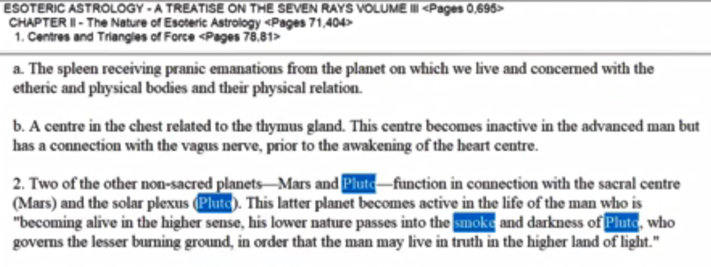

2. Two of the non sacred planets – Mars and Pluto – function in connection with the sacral center (Mars), and the solar plexus (Pluto). Esoteric Astrology page 79

That's a very interesting connection because Mars also has their solar plexus connection. As I've said, more than one planet can be involved with a chakra.

This latter planet becomes active in the life of the man who is “becoming alive in the higher sense, his lower nature passes into the smoke and darkness of Pluto, who governs the lesser burning ground, in order that a man may live in truth in the higher land of light.”

So Pluto, base of the spine, Pluto, solar plexus, those are two that one can see. Pluto related to quite logically this lower nature, passes into the smoke and darkness of Pluto in who governs the lesser burning ground, there is a greater, of course, Uranus is more connected with that greater burning ground, in order that a man may live in truth in the higher land of light. So the obstacles disappear through a process we call a death and much of this is a cerebral process.

1:01:00

Astrologers will eventually find it necessary to cast three horoscopes or three charts:—one purely physical dealing with the body of nature; one primarily emotional, and dealing with the quality of the personality and with its sensitivity, or state of awareness; the third will be the chart of the mental impulses and conditions. It will be found that these three charts will take certain geometrical lines, the lines of energies will form patterns. These three charts, superimposed one upon the other, will give the personality diagram, the individual life pattern. Amazing symbolic charts and lineal forms will be found to emerge when this is done, and the "geometry of the individual" will grow out of this, for it will be found that each line will function in relation to another line, and the trends of the life energies will become apparent. Eventually, even in this department of knowledge, "the star will shine forth." This will constitute a new branch of psychology and its true exponent for our age will duly be found. I but indicate the lines of the future astrology in order to safeguard the present. TWM 438

Astrologers will eventually find it necessary to cast three horoscopes or three charts:—one purely physical dealing with the body of nature; one primarily emotional, and dealing with the quality of the personality and with its sensitivity, or state of awareness; the third will be the chart of the mental impulses and conditions. With His sensitivity or state of awareness and the third will be the charge of the mental impulses. Maybe Charles Jayne had something there with the three ABC charts … animation, birth, and conception, Now really it would be a CAB, if it were in order, but let's just say keeping the order given here. We have Neptune, Saturn and Uranus, and I suppose what would happen if we put each of them on the ascendant of an individual's chart, maybe we would learn then something about these three horoscopes.

There's just so much we don't know, unfortunately, but I have the faith that since astrology was mentioned in one of those statements about the year 2025, and the new writing coming forth at that time that there will certainly be an expansion of the astrological teaching and we will be able to apply it even more successfully in an esoteric manner.

It will be found that these three charts will take certain geometrical lines, the lines of energies will form patterns. I kind of wonder how did He do it? He said black squares, Saturn, and yellow triangles, yellow stars probably Mercury, and blue triangles, maybe Uranus. There's not an exact line up there but He talks about geometrical superimposition of squares, stars and triangles; squares material, stars consciousness, triangles spirit.

These three charts, superimposed one upon the other, will give the personality diagram, the individual life pattern. I think we're working very much in the dark compared to what the great astrologers can really amazing. If he's not given to overstatement, but that's the thing about Master DK He doesn't exaggerate.

Amazing symbolic charts and lineal forms will be found to emerge when this is done, and the "geometry of the individual" will grow out of this, for it will be found that each line will function in relation to another line, and the trends of the life energies will become apparent. All of this is promised for the future and we will be participating in the reception and utilization of these charts.

Eventually, even in this department of knowledge, "the star will shine forth." As if it's been much occluded much occulted in the old sense hidden.

This will constitute a new branch of psychology and its true exponent for our age will duly be found. I but indicate the lines of the future astrology in order to safeguard the present. I would indicate the lines of the future astrology in order to safeguard the present. …

… There's a lot of development in Esoteric Astrology which is slated to take place, and we can't be too proud about our present astrology. It's good but it doesn't amount to much yet, and we will be able to clarify our own path in life through these new developments and help others clarify their path. This is all part of the Divine Plan, the intelligent approach to one's purpose we might say.

So here A Treatise on White Magic, fundamentals are being offered, fundamentals. We see how He developed to those in in the astrology book written later. None of this would be available to us, we'd still be pursuing the old astrology with the old limitations, and the astrology of the soul or at least of the soul working through the personality, would be unknown to us.

We have to be very grateful to the senior light bearers, the givers of, light and their intentions to raise humanity, we had benefited greatly imagine no Blavatsky, imagine no DK, doing His work, or with Master DK behind the scenes, on that woman or Master Morya and KH. They really wanted humanity to have more of the Ageless Wisdom they really promoted that idea and maybe some of the other Masters being a little more conservative were against it, but they were allowed to try their experiment and that experiment is still in process.

1:09:20

One thing astrologers need at this time to do and that is to make due allowance for this transition period out of Pisces into Aquarius. This is seldom done, but it is evident that the tremendous turmoil incident to these transitions affects the individual chart, and frequently offsets individual destiny or karma. People are submerged in planetary and racial destinies, and their own tiny affairs are offset almost entirely and sometimes completely negated. It is not possible to cast the horoscope of the planet, and those who propose to do so are deceiving themselves and others. The horoscope of the fourth kingdom in nature, of humanity, will eventually be cast, but it will be done by initiates, and there are no initiate astrologers working on the physical plane at this time. One hint here I give.

The Sun was in Sagittarius when the first human tendencies struggled to the fore. The stage of animal man was completed and when Sagittarius was dominant (from our planetary standpoint—I am using words with care) the great event of individualisation took place. But the brain of the then human being failed to register what had happened. In the words of the Old Commentary:
"The sons of God shot forth like arrows from the bow. The forms received the impulse and lo! a God was born. The tiny babe knew not the great event." TWM 438

One thing astrologers need at this time to do and that is to make due allowance for this transition period out of Pisces into Aquarius. It's kind of an unsettled time with the counterflows of Aquarius and Pisces causing turbulence, I guess I’d call it.

This is seldom done, but it is evident that the tremendous turmoil incident to these transitions affects the individual chart, and frequently offsets individual destiny or karma. Sometimes we think that our chart is set in stone and will work out no matter what, but there are other larger charts at play and we are parts of the we are constituent in these larger wholes for which though than which those larger charts delineate.

People are submerged in planetary and racial destinies, and their own tiny affairs are offset almost entirely and sometimes completely negated. I was thinking of all those people swept up in World War two, some kind of mass karma involved there, and their normal chart potentials were negated in the larger patterns which were being imposed upon them.

It is not possible to cast the horoscope of the planet and I guess accept members numbers of astrological departments may be able to do so is a Master or beyond, and those who propose to do so are deceiving themselves and others.

The horoscope of the fourth kingdom in nature, of humanity, will eventually be cast, but it will be done by initiates Maybe we can say that the chart of the planets already exists in a way. It can't be done on the outer planes, but it will be done by masters and chohans and those with very, very high planetary knowledge and the charts of humanity, and maybe other kingdoms of nature will be done by initiates, and there are no initiate astrologers working on the physical plane at this time. I wonder how some of those who may have thought of themselves as initiate astrologers felt about that very declarative remark?

Well a lot of time has passed. It's possible that the number of people will use the old formula or that was then and this is now and enough time is passed, so that initiate astrologers can be working again and I'm one of them. Let's see. As they say by their fruits you shall know them.

One hint here I give. The Sun was in Sagittarius when the first human tendencies struggled to the fore.
… the coming of the solar angels was not independent of the aspiration of animal man we find the elevation of emotion even in some of the advanced animals. It may not be aspiration as we recognize it, but it's a higher type of yearning it does seem to be evident. I often refer to this particular chapter and this place …

1:15:45

The stage of animal man was completed and when Sagittarius was dominant (from our planetary standpoint—I am using words with care) so was this a precessional age in Sagittarius? Or an even longer period, of maybe 2,100 years was enough? the great event of individualisation took place. we would say for Earth humanity.

But the brain of the then human being failed to register what had happened. In the words of the Old Commentary: we have been studying the sequence of soul-mind-brain, and how it becomes necessary through meditation and service and purification to enlist the brain in the sequence, so registration of the inner events can occur.

There's so much more in the mind, than in the brain, and so much more in the soul and using the mind that seems to be a couple of statements which are true. But the brain failed to register what happened. Now this is important, how it is Gemini represents the human side, Sagittarius the animal side, the animal side Sagittarius aspires towards the human side. Both are interesting because those are the only two signs in which the earth finds itself as a ruler, esoterically in Sagittarius, and hierarchically in Gemini, although associated with Taurus. We are told and also associated with Sirius a great being but somehow the earth is considered alright so here comes an important quotation and very evocative.

"The sons of God shot forth like arrows from the bow. These, what this could be is the representation of the solar angel we cannot at least I cannot yet find that the entirety of the solar angel logos itself, in the egoic lotus on the higher mental plane. I think a portion of solar angelic energy and presence and consciousness lodges itself there and in the vicinity of the mental the unit and even in the brain and in the brain and maybe in relation to the heart also the sons of God shot forth like arrows from the bow the forms.

The forms of animal man received the impulse and lo! a God was born.

The tiny babe knew not the great event." Individualization. And no brain registration. But many things happen above that are not accounted for or cognized below. Now DK tells us that we're quite active at night, and we fail to remember the great majority of it. But we're active. Let's say we are disciples, were active in in the line of the Hierarchy, we're cooperating, and we are pursuing what is of interest to us and what is of value to the divine plan, and we may not bring all of that experience through in the physical brain, but it will show up in terms of interests which we feel we simply must pursue. I'm sure we all have that inner sense: this I must do. It may be very closely related to Hierarchical activity, pursued in another dimension, namely the majority of it being in the astral plane.

So this shooting forward, like arrows from a bow. It reminds me of a solar angel shooting a fragment of itself which lodges on the higher mental plane. Also, near the mental unit also in the etheric brain also in the etheric brain, even the region of the of the pineal gland.

Isn't the language interesting? There is a scientific approach to interpreting this kind of language, but it's given in more poetic form. Yet it's all there a God is born when soul consciousness and presence is implanted in the usual energy system of man, the lower part of the energy system man is a God already existed as a monad. Saint Paul saying, know ye not that ye are gods? That's very radical. How many Christians today accept that idea and its implications? What really has to be done is that many hard sayings have to be brought together, and it has to be seen how the standard interpretation of Christianity does not resolve them but while the Ageless Wisdom does resolve the contradictions without negating the major theses of the divinity of the Christ.

I've often thought to myself, well, we've got a vast universe which is just infinitesimal. You're going to take one little being, a great being but a little being, who emerged through individualization out of the animal kingdom and developed over many millennia, and even millions of years, into a great, great being of love, and you're going to take that being and make him the one and only Son of God for the entire universe? It seems to me we have myopia going there, and a very great problem with scale. Probably every humanity on every planet has its own savior, or a series of saviors, and there are probably local Cosmic Christs who expressed the second aspect of divinity, and a great Universal Christ, a great Universal Christ related to the one and only universal logos at the time of the expression of any universe of which there have always been an infinitude.
So it's just not proportionate to say that Christ, as great as He is, as amazing as He is, as far beyond the normal human thought and feeling as He is, can be the only son of God for the entire universe. But scale is a big problem and a sense of proportion and as people continue to study and meditate and serve the whole scale problem will come more and more into adjustment.

Anyway, the solar angels were involved here in this Sagittarian shooting forth, having pervaded the entire universe with a fragment of myself I remain. Maybe that fragment was shot forth by the will of the solar angel seeking its anchorage in a lower and upcoming being, and that arrow is the presence of guiding light and love and sacrificial will which hovers over the man for millions of years. Even though at first, maybe there's not so much of a direct solar angelic supervision because other aspects of divinity as DK tells us take care of the earlier part of the evolution.

Anyway in this shooting fourth.

1:27:00

This took place twenty-one million years ago. Cycles passed and when at a later date the sun was in Leo (approximately eighteen million years ago) the first instances of coordination between brain and mind took place and the human being was definitely self-conscious. He registered his individuality. The figures for the first date (though exactness is not possible in a system of mutation such as ours) are 21,688,345 years ago. These figures are useless at this time for they can neither be proved correct nor incorrect. Later investigation will prove their usefulness, when the nature of time is better understood. Sagittarius governs human evolution, for it symbolises progress towards a conscious goal. Leo governs the human consciousness in the human kingdom for the energy pouring through it enables man to say "I am". TWM 440-441

This took place twenty-one million years ago. Cycles passed what kind of cycles? One day we have to know. When we attain all knowledge on the atmic plane at least, all knowledge of the global process, eventually our chain process and scheme process eventually. Cycles passed and when at a later date the sun was in Leo (approximately eighteen million years ago) the first instances of coordination between brain and mind took place and the human being was definitely self-conscious. This self-consciousness didn't occur suddenly with the shooting forth of the arrow of presence, the arrow of the solar angelic consciousness, not immediately. We're talking about a three million year period or at least 2.5 million years.

He registered his individuality. With the help of implanted Venusian I-ness, this quality of self-reflection implanted in the solar angelic substance. Well that's a long time isn't it? You mean we look at a century as if it's a long time.

Sometimes I look back and I say, well I'm 75 now, well where did that time go? How did I arrive at this point? But now it seems like a long time, which is a short time. All times are equal actually in comparison with absolute infinitude or absolute eternal duration, but that's another matter.

Now we're talking about millions of years. We think it was a long time ago that the Christ appeared through Jesus in Palestine a long time ago, and it was and the number of incarnations had passed and in the registration of our experience it seems of great duration, but now we're talking about millions of years whether 3 million or we're rounding off because it doesn't make any sense to be too specific, although a very specific number is coming.

The figures for the first date (though exactness is not possible in a system of mutation such as ours) are 21,688,345 years ago.

So we have to know when this was written, when exactly was this written or typed, and that has not to do with proofreading and later publishing and all that. Sometime in the 1930s, but there's a chance also that there is symbolism in these figures. I know some people have tried to take the figure and work with it and I think we maybe have profited a little from that type of work but there is no assurance the figures for the first date when the sons of God shot forth like arrows for a bow is given in apparently an exact and exacting manner and yet in the very same sentence it says exactness is not possible so we also have to watch for the possible symbolic meaning here when I look at three four or five, I certainly think of the Rays of Mercury. All of them are there included.

I'm not sure quite what to make of 688 and 21, always is a number in occultism of completion with three Sevenfold cycles involved yielding 22, when the entirety is considered a unit. So much work can be done on this and has been done by those who have quite a good knowledge of it, but always be careful as you read because no dogmatism is it all possible. Here everything is moving all the time and He says we live in a system of mutation a solar system of mutation or a larger system of mutation including the interplay that's going on within in constellations and solar, cosmic logoi, and beyond.

These figures are useless at this time for they can neither be proved correct nor incorrect. The path of proportion and humility will confirm that thoughts who can prove this. I think we can anchor the moment when this particular sentence was written. I think there are records of that somewhere, because Alice Bailey would have given the date I think, and somewhere there must have been the intention to save these important seminal writings in the form that they were taken down.

But overall, the figures cannot really be used at this time, so watch everything that is said because at this time tells you that maybe later they it might be usable and can neither be proved correct or incorrect investigation will prove their usefulness when the nature of time is better understood …

Later investigation will prove their usefulness, when the nature of time is better understood. … the word later has been left out, later investigation will prove their usefulness when the nature of time is better understood.

Sagittarius governs human evolution, for it symbolises progress towards a conscious goal. That makes sense doesn't it?

Leo governs the human consciousness in the human kingdom for the energy pouring through it enables man to say "I am". Through Venus, and from the solar angel, the energy which makes the recognition of highness possible comes from all three of these sources.

Leo. Okay, all three sources Leo, Venus and the solar angel. This is a big history and we're only now waking up to a much truer history of humanity and of us individually. Something we hardly would suspect but which gives us hope and courage and incentive to shoot forward so that we can see the goal: I see the goal so that we can reach the goal, and then see another. Until finally the goal for the human being is reached. Then there's entirely new creative hierarchy experiences which lie ahead, because it's not forever that such as we are emanations of a monad, will be members of the human creative hierarchy. They're just the way the president solar angels are members of the fifth creative hierarchy it was not so. In the past where they were human beings in the previous major solar system.

1:39:30

It might be of value if I here attempted a translation necessarily inadequate, of the key word of each sign. These fall into two categories as far as humanity is concerned. There is the key word for the form aspect and the keyword for the soul aspect. In the first case, the word is expressed; in the second it is consciously spoken by the soul. Translated into modern terms much is lost, but the underlying thought which directs the work of the emanating energies is of value. For our world period they are as follows:
For the aspirant who progresses from Aries to Pisces and has therefore re-oriented himself we have:

Aries | I come forth, and from the plane of mind I rule.
Taurus | I see, and when the eye is opened, all is illumined.
Gemini | I recognise my other self and in the waning of that self I grow and glow.
Cancer | I build a lighted house and therein dwell.
Leo | I am That and That am I.
Virgo | I am the Mother and the Child, I God, I matter am.
Libra | I choose the Way that leads between the two great lines of force.
Scorpio | Warrior I am, and from the battle I emerge triumphant.
Sagittarius | I see the goal. I reach the goal and see another.
Capricorn | Lost am I in light supernal and on that light I turn my back.
Aquarius | Water of life am I, poured forth for thirsty men.
Pisces | I leave the Father's home and turning back, I save. TWM 440-441

It might be of value if I here attempted a translation necessarily inadequate, of the that's something we maybe overlooked, that DK says it's inadequate of the key word of each sign. and these are the spiritual and evolutionary approaches the evolutionary are lower and the spiritual indicate a certain point of attainment and the realization that comes with it.

These fall into two categories as far as humanity is concerned. I wonder about of the kingdoms.

There is the key word for the form aspect and the keyword for the soul aspect. Early experience and later experience. We're very familiar with these, and I've gone over them in my analysis or commentary of Esoteric Astrology. Probably no need to be excessively detailed about this now.

In the first case, the word is expressed; in the second it is consciously spoken by the soul. So when we're giving the matram in the second case we should be as if we are the soul.

Translated into modern terms much is lost, but the underlying thought which directs the work of the emanating energies is of value. For our world period they are as follows: I guess our round, because there are other in higher ways of interpreting they are as follows, for there are other and higher ways of interpreting.

For the aspirant who progresses from Aries to Pisces and has therefore re-oriented himself we have: He has reversed the wheel, or he is reversing the wheel. Sometimes of course you're caught in the counter current, just as we were between the greater constellations and then the continuity, zodiacal constellations. Of course you think about it our constellations are the heart and they had Center was the One About Whom Not May Be Said. What could be a higher position than that when that twelve petalled lotus is considered to be major center in the head of man. What could be higher? Yet the ray constellations are other than that. And from the ray constellations the ray is transmitted through the zodiac.

Let's say for instance that the Great Bear is a ray constellation transmitting the first ray. Well the way we would think of this is that the first ray then passes through these zodiacal constellations of Aries Leo and Capricorn. But when you think about the human anatomy, you would think that this heart-within-the-head has certain qualities, and the energies from it would pass through the seven centers in the head and maybe we can think of – well I don't know exactly how we would think of the constellations through which the cosmic logoi work. Are they part of the normal kind of energy system of the One About Whom Not May Be Said, or are they found in the head? We have to look for analogies there because in the human being you have the chakras of the normal energy system you have the superior the greater seven found in the head. Then you have probably a still higher septenate above the head and relating very much to the highest head center. Now what if the One About Whom Not May Be Said has that kind of set up?

In any case, there is a relation the constellations in the heart and the head of the One About Whom Not May Be Said which distribute the first ray. Are Aries, Leo and Capricorn transmitted and they have to get it from somewhere and the major first ray constellation seems to be the Great Bear. So do they get it from the Great Bear? If they do, what is the position of the Great Bear in the anatomy of the One About Whom Not May Be Said? Well, obviously all we can do is sort of pose the issue pose the problem. We're not going to solve this but we can notice where the analogies or the this particular analogy between man structure and the structure of the One About Whom Not May Be Said where there is deviation or not an exact one-to-one correspondence, seemingly.

Anyway DK is looking at something here that is old symbols, much is lost, translation is necessarily inadequate, but at least there is the directing of the work the underlying thought which directs the work of each constellation is somewhat understood and somewhat here of value.

As I said I've have actually spent quite a bit of time working over these things and I wonder it's probably not so profitable to do it but,

1:47:20

Aries | I come forth, and from the plane of mind I rule. Aries. From whence are you coming forth? They come forth and from the plane of mind I rule. I assume it's the higher mind. In a way, Aries is associated with the monad. I don't think I've ever mentioned that. The monad does descend, as you see there it is, straight down,  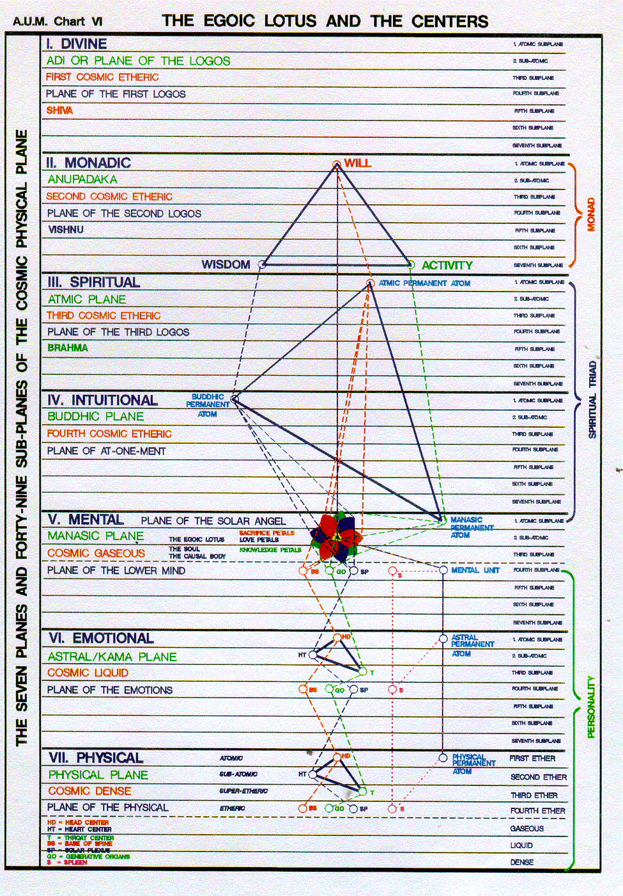  I the monad come forth and from the plane of mind right in the jewel in the Lotus I rule now another way of doing it is that the soul comes forth at a certain point of evolution and rules we effects the lower mind which is held steady in the widen rules the lower three vehicles of astral, etheric, and dense physical. But there is a big archetype here in the sea of fire, a big purpose and rulership is needed to make sure that that purpose is expressed.
Taurus | I see, and when the eye is opened, all is illumined. Taurus is the mother of illumination. There are many eyes and DK goes over them there is the third eye but there's also something different called the eye of the soul, and that's pretty occult, and it's not much referenced and maybe it has a different location than the etheric area around the pineal gland. I know that I did this material quite extensively, I might say something else at this time, but I think it's sufficient to to just say a few things.  We certainly have to open the third eye, but we have to also be able to use the eye of the soul and there are many focal points of energy which can and through which one can see. In a way the whole egoic lotus is an eye, every vehicle was an eye, the three vehicles of the triad, because you can perceive and see through them in a specialized way. Further, the Monad itself is an eye as we are told in one of the analogies and the Points of Revelation.  I guess we'd have to go then to Discipleship in the New Age, and monadic eye, and logos …  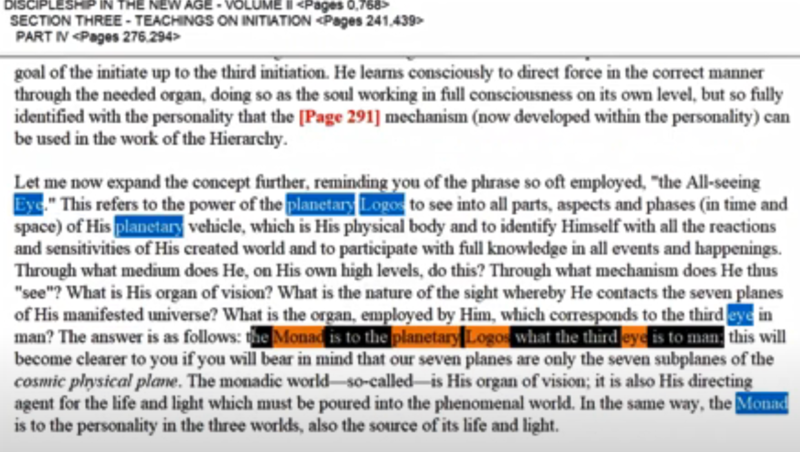  Maybe this is more or less what we're looking for the monad is to the planetary logos what the third eye is to man.  So the monad, the third eye, is etheric in man. It's an area around the pineal gland, the etheric pineal and we have to consider that … is located in the cosmic ethers and so is located maybe in the etheric brain of the planetary logos, the third brain and an etheric pineal representation. So DINA II, page 291, He spells this out in several ways.
Gemini | I recognise my other self and in the waning of that self I grow and glow. So a third-degree initiate can focus within the causal body and see what He used to identify as His personal self, or as His real self and His present position is becoming more and more illumined. It does seem that what He used to believe to be himself is waning in its appeal and its effectiveness even in its light value in contrast to the increasing light of the soul. I guess you can say this even for the monad eye in the monad as the monad recognized the triadally-fused personality does my other self and that too must wane in the growing light of the monad.
Cancer | I build a lighted house and therein dwell. Obviously you could write a whole chapter on each one of these, but I'm having the faith that over the number of years that I worked on the presentation of the Esoteric Astrology book, that I did something which was more complete that I'm doing now.  Who is the Builder? What is the house? there is the Tabernacle in the wilderness the normally unattractive unstable personality. But it can be an income illumined by the light of the soul, and we're working on that all the time. Also I build Solomon's Temple on the higher mental plane, and I learned that the third degree to enter the causal body rather than find my center. But say in the lower mind within the personality around the area of the mental unit now what about the Temple of Ezekiel. I mean every one of these temples will be destroyed once they reach their full quota of radiation.  So am I also, as well as building the glorious causal body which is destroyed at the fourth degree, am I also building the Temple of Ezekiel in some manner not yet discussed? But it is apparently a twelvefold temple and for a while there, and I dwell and the other self is found in all the energy system factors on the lower five planes in the worlds of Brahma and truth be told and there seems to be a hint that appeared in some papers where a kind of temple is existing on the third subplane. Perhaps or maybe the second of the atmic plane and it has to be destroyed before there can be a full entry into the monadic realization and vision.  So we're working potentially on different areas of illumination, possible illumination, and we have to decide maybe in our ordinary discipleship work we are illumining both the personality and building the light content and the causal body.  Now there are other vehicles in which perhaps we can focus and they are tribal vehicles and we have to coordinate them because they're not immediately coordinated, and then around the time of the third initiation we can coordinate something that will become the manasic vehicle, we followed the abstract mind and when the egoic lotus is destroyed there will be some remnant that really belongs to us as a monad and it's not inserted helpfully by the solar angel those are the two. I think we can really build the soul light and the personal light I think we're not yet to the point where we can coordinate - maybe we can coordinate the abstract mind a bit by coordinating the intuition, the ability to reason into a vehicle I think that lies beyond us and certainly doing anything of that kind in relation to the monad so it no longer can hold us is a task to which the Masters can apply themselves.
Leo | I am That and That am I. Leo I am that and that am I or I am that I am and God Moses asked to God. what is your name? I am that I am has kind of a circular enigmatic quality to it, but it is two stages beyond the I am of the personality, and one stage beyond the I am that of the personality, recognizing it is the soul there is something that you just can't specify it is a reality, we just call it that because at first it appears to be other than what we are but eventually we identify as that. So we're dealing with three levels here really, the I am of the personality, I am that of the personality becoming the soul, and the I am that I am of gathering triadal perception becoming monadic perception.
Virgo | I am the Mother and the Child, I God, I matter am. It's a triple sign, the father is there - as God, God the Father. I'm an M, I'm all of those three. Virgo was interesting because it's not only the mother, but as I said or these my hypothesis at the moment, is that father spirit self observes and a mulaprakruti arises out of that observation, so this great being of divinity that works through Virgo finds itself identifying the major three the mother the child and God the Father.  At first let matter reign. We'll see that in a minute, and people are captivated, caught up in matter, but there's more to Virgo than that the mother realizes. That it really is the son the mother gives birth to, the son. But then His crowns ascended sending He is subsumed by the Sun and the one unitary spirit starts it all by seeing itself in articulation. Well this is a mystery, I try to figure it out and the mystery of how sight produces an entire range of divine phenomena I don't see the darkness of matter which is only that lasting forever. I see it regenerated at every Universal opportunity.
Libra | I choose the Way that leads between the two great lines of force. It's kind of a mantram for the noble middle path with, in one way of looking at it, matter on one side and spirit on the other, and the soul rises through the opposition consciousness is aware that somehow it is both spirit and matter.  Another way of looking at it is that the central channel is that of the spirit itself. Being and that we have in the head, ida, sushuma, and pingala. We have soul but that which is the origin and essence of both of them is the central being, the central spirit, which rises and is correlated with the monad, so both are necessary. When we're looking at opposites, at a certain stage both of the opposites are necessary. This in Libra, and is understood in the way you can't have one without the other. We don't say, well, I'm all spirit. Or, I'm all matter or even that I'm also we try to take in harmonized blend and fuse all these different aspects.  So we have respect for that which karma, and dharma force us to confront and we have respect for the higher energies in which we find a truer and more liberated self as our true identity.  2:03:00  With Scorpio, now we really should be looking on page 332 and 333 in Esoteric Astrology where the undeveloped man, the advanced man, and the disciple-initiate, are shown in their reactions to the energies. But now we're pretty well talking about the decide which reaction warrior. … I don't know, it's maybe some training in English literature and in poetry, it seems more euphonious to me and says the same thing, as long as we don't interpret it as a question.
Scorpio | Warrior I am, and from the battle I emerge triumphant. The fighter conflict with duality, but who is the warrior? It is the soul in incarnation. It is the soul on its own plane. There's always going to be a battle, and under Scorpio the opposites will always contend and some projection of the higher of the pairs of opposites will stand between them and have to choose that from which it came rather than be swallowed up by the lower of the pairs of opposites.  Don't we all long to identify as a soul and not to have our identification captured by the material person's fear. Don't we all long to be retracted along the emanated stream into that which sent us forth? I guess we have to always lift for lower into the influence by the higher where it's obstructive qualities are neutralized. There's so much illusion, glamour, maya, but when we lifted into the light of buddhi, in this one instance it's subjected to buddhi, and then all of those illusions are dispelled and remaining glamours are neutralized, and the chaos of the etheric body.  Well, the veil of impulsion, where you have all kinds of energies running this way and that, making a mess of things. They are brought into a beautiful order. So we're always going to be torn when we're taking an incarnation in or under this major for a sign transmitting the fourth ray majorly at this time, and behind the warriors twixt the light and dark glazes the light of hierarchy. We face those whose faces as yet darkened and we try to shed some light on the confidence of those people so they become allies of the Lords of the shining countenance, and do not fall under the spell of the lords of the dark face to use the Atlantean terms which were prominent during the great Atlantean war. Warrior I am and from the battle I emerge triumphant. Now all of these mantrams, are associated with signs which have their ray's at this time and they have their planetary rulers.  So there's a lot of technicalities that go behind the scenes and together make the man. …
Sagittarius | I see the goal. I reach the goal and see another. So interesting about Sagittarius ruling evolution. That is something that I'm taking in, maybe more impressively, for the first time I see the goal I reached that goal and then I see another – it is a very forward-moving method and the arrow which was shot into matter and there's a returning arrow one day it goes along the line of the antahkarana, and it is the rising of the being and it's consciousness out of areas of denser confinement into areas of lesser confinement, until finally the only confinement that remains is the universal ring-pass-not.  This is a very progressive sign, and it begins when we reach that stage in antahkarana building that we call projection. There's a lot of Sagittarius in that and it's one of the intuitive signs. There has to be a link between the astral body and the intuition. That bridge has to be there during the whole projecting process and when we're at the mental unit, and the retained energies around the mental unit, and when the energies of the different aspects of the soul have been gathered and they're retained within a boundary, ready for projection and when the lower parts of the personality have risen. There's going to be another arrow shot forth from the bow, that arrow of light that rapier-like alignment. It's going to have to do with Sagittarius. So that when we are using one of the seven words of power. Let us say I see the greatest light. We think of the the brilliant white light, shot across the seven colored antahkarana, which has been emphasizing to covers anyway that of our soul ray and that of our personality ray. So Sagittarius will arrive at the new state of being.
Capricorn | Lost am I in light supernal and on that light I turn my back. lost a Mayan light supernal from Capricorn and on that light. … But the contrast is better illustrated by the word yet and I should love the light supernal coming in from the great seventh ray … on DINA II, and seven ray supernal. When the light of the seven rays is blended with that of this seventh ray a higher reliable because there are always raised over which we have which have jurisdiction over lesser septenate of rays then light supernal can be known. So light supernal is having to do with the manifestation of a great light which come through seven lesser instantiations of the rays of the seven rays and then Capricorn is connected with the lights. Fertile more of the seventh ray comes through Capricorn at this time anyway then through any other constellation or sign and then we've got Venus as well, that's connected with the beginning of supernal light at the Transfiguration.  We might say here that the transfiguration is the beginning of the expression of supernal light. Well you might think that you want to stay there because it's so wonderful so attractive. But then, and yet I hear their cries below. No matter where my vision leads I hear their plaintive cries below. That's in the Capricorn solar fire ritual, in the song that is tied to this matram. So Capricorn is always be set by this great sense of duty and not just duty to the higher it's it's a diamond there's duty to the lower and Capricorn.  I've even noticed that, it's interesting, you rarely see a Capricorn person unless other things are modifying it with the nose turned upward. maybe with Sagittarius, Gemini you see that Cancer, but the nose is turned downward. It's a Saturnian thing it's the recognition of what's going on in the field of matter and care regarding the duties that must be applied to that lower field. yet on that light I turn my back out of the great sense of duty that I carry.  … I turned my back and I descend into the valley and then we have the symbol of Aquarius, Mountain Valley, Mountain Valley, long valley. So it's the ongoing question of initiation and descent initiation and descent interesting that chapter corn points downward, of course in another way it's the law of elevation, and the law of progress the fifth law of the soul. So Capricorn is as much upward as downward but they do take care of business in the realm of matter then.
Aquarius | Water of life am I, poured forth for thirsty men. Aquarius water of life energy of life, matter of life, not just the water of the astral plane. Water of life am I poured forth for thirsty men. So all the energies really come together in Aquarius; it's a sign of universality and we touch many many energies and synthesize them and collect them and wisely cyclically distribute them. It’s not just the water like dump, that wouldn't be service if I took the whole pitcher and just poured it on somebody. It has to be proportional at the right time according to cycles, right?  We do realize that Aquarius is that sign which particularly has to do with cycles and with the knowledge of cycles. Maybe that's why the story has it that many people with Aquarius in their chart prominent turn out to be interested in astrology, open to it, or astrologers because they're interested in the hidden energies and they know the effect of the hidden energies as causes upon this outer world were effects appear.  So water is matter but its energy too, and this particular type of water stimulates the life aspect in every one that it touches. We have become so familiar with hidden energies everything was so opaque veiled before maybe only initiates knew about this atoms were hard little balls and everything was very concrete, but now it's gotten so subtle and the search in particle physics for different constituents of the atom which are not main frequently taught constituents at all searching for new kinds of particles or aspects venturing into the etheric body.  Aquarius is very fierce ion and it's ruling our normally ferric plane along with Gemini and the higher cosmic ethers are all very Aquarian. Maybe I would have to say along with Gemini. Again, those two air signs are involved with the ethers water of life am I, poured forth for thirsty men then.
Pisces | I leave the Father's home and turning back, I save. It's about the great I, monadic being, the monadic pilgrimage. I the monad. At least an extension of myself through emanation leave the monadic plane while leaving part of myself and all my other brothers. There was a brother that didn't go forth and a brother who did brothers both brothers of the Father. Well, it's important to stay at home, too, and it's important to go forth and then return. So I go on a monadic pilgrimage and I go through the various descents in Volusia nary descents and I round the corner of the mineral kingdom I began to rise again through the plant, animal, human, kingdom of souls, planetary lives.

I guess that's far enough, the planetary lives, and I returned after a monadic pilgrimage of redemption. Have I learned something? I guess I have. I, the disciple, finding redeeming lifting the red cattle of Geryon, those who are affected only by the desire nature read, but they're lifted up into higher possibilities in the chalice which can represent the egoic lotus, sometimes called the chalice, causal body, egoic lotus, chalice. He lifts them up into higher possibilities, so one becomes a savior. A savior, one who brings those who are trapped and lost. See, in Capricorn you're lost in the high, and you venture to the high, in Pisces you're lost in the low and you venture back to the high, and with great compassion and gathering at every stage those who can be lifted to a higher stage.

2:22:00

Well, as I say you can write a book on every one of these.

But we are all residents of the father's home, even now. We all are monads on our own high plane even now that we have multi-dimensional consciousness and we have a type of consciousness which is in which the lower is insulated from the higher. Did it turn and that's part of the task, to bring the higher into the lower and overcome this dimensional ceiling.

I've felt it in my infinity book there's a dimensional ceiling. We're aware of what is below but not of what is higher and those more in a higher position again are aware of that which is below but not necessarily of that which is higher, but eventually it all smooths out and the boundaries are overcome and we have a seamless connection; it's an elevator that can stop at all the floors but it doesn't get stuck any of them.

When it comes to the man.

From the standpoint of the form, the life proceeds in a reverse direction, and the work of nature is seen under the following words:

Pisces | And the Word said: Go forth into matter.
Aquarius | And the Word said: Let desire in form be ruler.
Capricorn | And the Word said: Let ambition rule and the door stand wide.
Sagittarius | And the Word said: Let food be sought.
Scorpio | And the Word said: Let Maya flourish and deception rule.
Libra | And the Word said: Let choice be made.
Virgo | And the Word said: Let matter reign.
Leo | And the Word said: Let other forms exist, I rule.
Cancer | And the Word said: Let isolation be the rule and yet the crowd exists.
Gemini | And the Word said: Let instability do its work.
Taurus | And the Word said: Let struggle be undismayed.
Aries | And the Word said: Let form again be sought.
It will be noted that all these ideas concern the work of energy in some form or another and in the last grouping with the work of the so-called unregenerate selfish individual, full of desire for satisfaction. The group of mantric words used by the aspirant in the power of his own soul, are positive.
It seems needless to deal further with the various types of force and we shall now turn our attention to Rule XI. TWM 442-443

From the standpoint of the form, the life proceeds in a reverse direction, and the work of nature is seen under the following words: in terms of the forms or what I've called dreams, the life proceeds in a reverse direction and the worth of nature is the worth of nature.

Now, that's not an accidental word; probably we better not accuse Master DK of accidental words. He doesn't tend to do that. The realm of nature is very much the realm of the lower subplanes, with the higher three on the mental plane being transitional in the realm of super nature up there in the cosmic ethers. At least that's one way to interpret it.
I call these evolutionary mantrams, and I'm hoping in the big book commentary I did it better and more thorough job. … You can see that rule ten is 170 pages or something … that's astonishing that a rule can have so many pages, but we're getting near the end …

The word is a prompting maybe from the soul and it is received maybe instinctually at this stage nobody's thinking not in that early Piscean incarnation anyway we say the first incarnations taken on the group's ends in Cancer but in an individual sense in

2:27:10

Pisces | And the Word said: Go forth into matter. Pisces, they go forth into matter and gets swallowed by the whale. The whale of all these energies and you can't find your way, but at least take the plunge into the lower worlds, as a human being, and thereby learn the soul in incarnation within you is learning about all that you might encounter and your sensitivity will grow over the years.
Aquarius | And the Word said: Let desire in form be ruler. There's such a selflessness in the developed Aquarius, where you giving all in service, but here you're desiring all. Not just going forth in the matter, you're seeing up look at what I might have, what I might possess. These contacts are for me it's different than the contacts being for others in other words you become the man for others in Aquarius and even more so in Pisces and you give of everything you have to those who give all all is given but in early Aquarius, I take the shower of water poured forth and I turn it upon myself. All of this is for me.
Capricorn | And the Word said: Let ambition rule and the door stand wide. Capricorn. your ego is consolidating in a lower sense and you want to be number one, you want to be above others and rule of it so that you are no longer vulnerable to others and to circumstances. So it's a self-preservation that is occurring Let ambition rule and the door stand wide not narrow. The door of initiation is fairly narrow except when you grasp the hands of your brothers. There's a nice old commentary on that particular act going through the door which was too narrow for you before, but going through it now ,it's a wide door if you are with your brothers and sisters. Let ambition rule you'll see a high goal which puts you in authority and gives you power and reduces your helplessness in your vulnerability and it's the primrose path in one way, and the door to greater possibilities and greater power stands wide open.
Sagittarius | And the Word said: Let food be sought. Sagittarius, you're hunting for nourishment at first it's simply the hunter and you need to be sustained. You may later be a gatherer. Well gathering is less violent than hunting, but hunting is what the centaur does at first and shoots His arrow at other forms of life to absorb their energy rather than shooting the arrow above before the return arrow of intuition. Later maybe the hunter becomes the explorer and learns how to take his own food along with him, maybe he becomes a birdwatcher or nature watcher, and maybe his bow and arrow or his gun is turned into a camera. All of that can happen. But in the beginning you have to hunt for a living.  I've seen those pictures, I mean it's in the fantasy of the artist, but we have the a group of primitive men with whatever they've got as instruments, its weapons, taking down an elephant, taking down a mammoth. What a dangerous task, and maybe how necessary, but it also teaches the group work.  There's a Martian quality to this let food be sought, and a Saturnian quality to let ambition ruling, and well Aquarius has many planets ruling it. The first is Uranus which is a sacred planet, not necessarily easily applied here, but well Neptune is the planet of longing. Neptune has a place in the Aquarian dynamic, but His appearing later as a veiled planet and will Jonah swallow the whale, or where the whales swallow Jonah? In the beginning the whale swallows Jonah and one has just overcome by all those energies which one does not understand.
2:33:30  Scorpio | And the Word said: Let Maya flourish and deception rule. Here we have a lot of Mercury, which is the the planet which lies as well as later reveals the intuitive truth. The many aspects of illusion are before us, and we are deceived by them and we deceive others. Scorpio hides many things and does not bring into the light until later, when in the sequence of meditative stages, it rules illumination.  It's so interesting, this sign associated with darkness and death ruling equally in the meditative stages, with Taurus ruling for the coming of the light but it is intuitive light in Scorpio does rule the intuitive plane but this is all about deceiving and being deceived and promoting the illusion that either the Black Lodge came along with a kind of Capricorn and Scorpio tendency in the negative sense, and they fed desire and promoted desire and curtailed freedom, and made slaves out of people. I mean all of those are potentials of Scorpio and Capricorn.  I mean when you have power over people I was just thinking I mean every once a while something about World War two comes across my screen, having somehow more and more felt some kind of participation in that, and I saw some of these dictators and influences they were by Capricorn. Hitler with the Capricorn moon; I think Goering was a Capricorn, maybe not as bad, says the Tibetan. Who was it again Tojo? Capricorn infamous warlord there was another one, I just had in mind that it just slipped; my friend Phillip Lindsey did an analysis of some of the major Nazi leaders and found how many of them had earth signs, and even Capricorn moon; hardness is there. So you put people down you make slaves of them.  When you look at Stalin, He has that Capricorn look. Somehow He seems to be born in the last degree of Sagittarius, but there's something going on there that relates to Capricorn … I wouldn't be surprised if he was born in the first degree of Capricorn. He has the look. The old saying is, if a person doesn't look like their horoscope, you don't send them to a plastic surgeon, but you certainly certainly changed the horoscope.  Well so there's a lot of cruelty when you get the combination of Capricorn and Scorpio, and I guess one of the cruelest people in modern History is discount Vlad the Impaler. You can't even discuss such a person, but again it appears that Capricorn and Scorpio are found together deceiving, enslaving, murdering. The consciousness. So those two signs which is so prominent in getting a person into hierarchy are also interestingly used by the Black Lodge to destroy their possibilities.  With Libra a a point of balance has been made been achieved and you wake up to the fact that you have a mind and you can go one way or another. Now this is an ascending series of choices and we're not talking about the sixth initiation here.
Libra | And the Word said: Let choice be made. Although I do believe that Libra is involved in that sort of deciding which path upon which you continue your evolution as a monad, but even early on Libra stands in the center and has to decide which way they will go. For a long time and for people like ourselves, it's do we move closer to the soul, or do we fall back into a more material sphere? But we're just learning about Saturn's worth as a choice maker here. Now, some people choose not to choose and they simply stay in that ambiguous state which is neither spiritual nor strictly material.  Some of the early qualities of Libra have to do with fiery passion. I think you go to Esoteric Astrology and page 333, we see unbalanced fiery passion and human love.  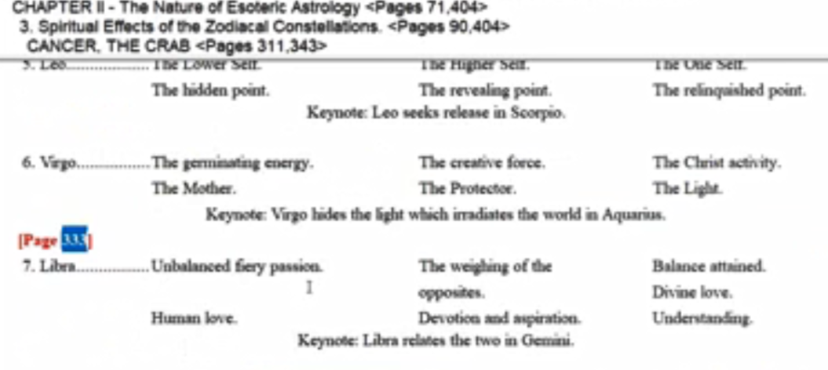  But it's kind of hard to relate that directly to that choice be made unless we're talking about choosing which partners to partner with.  Virgo, at first a very material sign.
Virgo | And the Word said: Let matter reign. Virgo people are very captivated by the garment of God. Virgo doesn't bring in the fifth ray, but it brings in a material attitude in the early days and especially as it did appear in the previous solar system ruling the last part of the previous solar system and more understanding, I think under ray 3 and ray 7 then is now the case transmitting ray two and ray six. So just involved in all kinds of petty little things, and frankly don't see the forest for the trees. So many trees the forest doesn't appear.  There was a man who had a certain glamour, I can't remember what it was but he was a prominent fifth ray type, it's like a glamour of preoccupation or the Lamoureux preoccupation with the material inconsequential or non-essential and you do see that engrossment in material detail among many Virgos. Of course some of these things we carry with us as we move forward into our higher spiritual possibilities. We don't necessarily get rid of them all so fast they can be a vestigial they can remain with us just way the rays of previous times remain with us.  I mean you can't be a first or second ray soul until the first initiation is more or less in sight. So you've saved for the second ray you've been on ray six or a four or maybe who knows, as in the case of the Christ maybe on both of them, sequentially, well you're going to still have those characteristics and first-ray types. Well the seventh ray seems related to the first ray, and when you change or elevate your ray off the seventh it goes to the first maybe under special circumstances to the third, as when Master R was involved in moving His ashram on to the third ray but there's a lot of power people who really carried like for millions of years that tendency towards strict organization.  So, one's previous activities under a different ray, which led to the ray that one is now functioning upon create a conditioning which is evident.  When it comes to Leo Let other forms exist. I rule. They do exist but one does not respect them particularly one has always to be number one and I don’t these other forms. Well, maybe it's a way of increasing your own potentials and developing your own abilities as a ruler but of course it's extremely separative.
Leo | And the Word said: Let other forms exist, I rule. Leo bringing in the fifth ray and the first ray both of those rays have very separative potentials, especially in the early days. Before three minds are uniting and before the sense of synthesis on the first ray is taking over. There's no question about who is in the dominant position here. It is the I, the little ‘I’ and the relationship to other people is exactly that seeking how you can dominate them and maybe some of that as I say carry through even when you're working on I am that and that I am.
Cancer | And the Word said: Let isolation be the rule and yet the crowd exists. Well, you're walled off within that shell and very concerned with your inner process and you haven't had too many shell crushings yet perhaps, that have made you sensitive. But people are not governed by individual streams of thought they're governed more by emotional and instinctual impulses, which are shared in common and thus the crowd thus the mass consciousness which is shared by all because they are not individual thinkers. They don't even think yet. I mean maybe they're much more involved with the irrational aspect of man, the emotional and the dense physical, and yet they can't really contact the other in any deep way, can’t really know the identity of the other, they don't even know the identity of themselves, they all share a certain tribalism under Cancer and everybody has to be somewhat uniform or be thrown out or killed or something. So there is an aggregating of people together but they don't have intimate relations, psychologically they are isolated.
2:46:00  Gemini | And the Word said: Let instability do its work. Yeah Gemini, there's not too much to say about it. And the Word said: Let instability do its work. That's carried over to you do find the flighty Geminis, and there that sign is prominent, but there's no settled position and the work is to acquaint the perceiver with many different situations and qualities. So you become aware of what's going on around you, the environment, you see all the different things that are happening. You don't yet put it all together in your understanding, but at least you've encountered it.  So the encountering of the many. Later it has to be organized either under hire Gemini or under other signs, but don't expect constancy, and don't expect endurance. Is it true that Gemini is the sign also of cowardice? It's colored as yellow is it. But later you can imagine the pillars of the mysteries are ruled by in Gemini, and it takes anything but coward the stream pass through those pillars and endure. Let instability do its work. There's always a factor of movement it is the third sign after all there are different ways look at the rays, but also according to the number of the sign you can tell something about the sign.
Taurus | And the Word said: Let struggle be undismayed. When it comes to Taurus, it does bring in a lot of fourth ray. There is the whole instinctual nature that is struggling to express itself: Let struggle be undismayed. It's a peculiar form of words. It's like the struggle does persist, it's not prevented, it's not countered, it's simply violently instinctually presses for its own gratification, satisfaction. This is a sign of gratification and satisfaction and one struggles to make sure that the instinctual nature can express one owns, one takes, one is proud, one dominates, and does anybody see this struggle? Maybe more so than in Scorpio, where many things can be hidden for a long time. But the conflict eventually approaches the light and in the light unification is seen and understood, and this frictional approach ends and then one becomes a great beacon of the light.  I was thinking about the Buddha, not it is teaching to people, you don't find the struggle, but you do when He was confronting the hosts of Mara, but this is too early for that. Later the great light that He is and was, confronted the Scorpion Mara and all the flourishing of illusion and Maya all of that was seen through because of the great light. But as I say for these types of mattress were not there yet where the instinctual nature is simply struggling for expression.  Lastly, when it comes to:
Aries | And the Word said: Let form again be sought. It's a little different from go forth into matter. Difference between form and matter form as the design and matter is the is that which fills in the design the aggregation the constituents which solidify the form.
It's time to start the wheel again and to look for those forms which will satisfy the personal urges. Are there any really? Eventually satiation comes and there is no truth, satisfaction, and no form within the lower 18 subplanes at least is sought. Maybe the formless forms later will be sought, but not the ones that are evanescent impermanent transient and in the lower world snow those will not be sought any longer but at first you still have hopes that some if you find the right form, you will be gratified and the purpose for your living we'll be manifest, and you will be happy.

So that clockwise wheel is ready to start all over again. We've been on the clockwise wheel a long time. It has to do with the directions that energy flows take within your own energy system, within your own chakra system, and they reverse. At first the higher energies can go straight through … the impact of extra personal transpersonal energies can go right through your higher chakras and anchor in the lower, but later there is stimulation of the higher centers by those extra systemic energies outside your system, outside the solar system sometimes and these lower energies are caused to reverse and rise into and re- stimulate, and add to, the higher chakras which are already being stimulated, and the lower chakras arrive at a stage where they can sustain themselves with whether they are not the center of attention.
So it's the reversal of the wheel. When we look at these two lists of mantrams, there is one in which the wheel is not reversed and one in which the wheel is reversing and is maybe when the mantram can be carried out fully reversed.

That's just a little run through these mantras. I have no idea what I said before and maybe something is added here to what has been said. One just has to find the page on which these mantras are listed in the Esoteric Astrology book. They're also listed at the end of every chapter and if one has the time of interest than to compare them with what may have been mentioned here.

2:54:30

It will be noted that all these ideas concern the work of energy in some form or another and in the last grouping with the work of the so-called unregenerate selfish individual, full of desire for satisfaction. But even he has the energy, even the lower being has the seed of achievement because essentially he is that Being. So even He has the seed of improvement, and I called these evolutionary mantrams. They are man terms of the form doing what the form do or the form being guided in a certain way to do what will lead later to eventual release.

The group of mantric words used by the aspirant in the power of his own soul, are positive. Basically yeah if we go through these sort of negative man terms we get tired of them, and we turn them around we reverse the wheel. I guess that's the point I was trying to make, we reverse the energy currents in our body. Of course it doesn't happen overnight and there are those transition periods just as difficult we're in a transition period, now, between Pisces and Aquarius, and when you're at that stage between the phases when the lower chakras capture the majority of energy, and the later stage when the higher chakras capture the majority of energy and there's going to be turbulence and turmoil Humanity is probably there right now.
So the unregenerate selfish individual will regenerate and will rise and the later mantrams will be his also.

It seems needless to deal further with the various types of force and we shall now turn our attention to Rule XI.

He's talked about the force of the planetary logos or energy the force or energy of the planetary entity. Then He has talked about all of these ambient energies which are so multitudinous and they are impinging upon the disciple and we have to handle all three.

Well, rule 11 is about 60 pages long; I just don't know how long that will take it in, but let's just see, I'm going to end this program here and let's see how we do and where we are … this is the end … to page 444 what would I find in A Treatise on White Magic, 444 is a good place to go … this has been number 53. It takes us from page 437 to 445 and it is rule 10, the 37th program on that. We're no longer on rule 10, we're going to start rule 11. I thought it would never end – 170 pages, and this is the 13th and we begin on 445.

I think that should do it and we start with program number 54 and there's one more rule for rules of magic for the astral plane or rules for magic on the astral plane and were ready to go.

Well friends … we're dealing with as deep a presentation of the wisdom as Master DK and His superiors thought possible at this time. We have no idea how They will judge the elevation of consciousness between the last writing in 1949 and the writing to come in 2025, approximately 75 years; I mean we don't know maybe the contact will be made with whomever will be the amanuensis, if that's the way it's going to work. Then we don't know when the books will be published, will it be an early book published or will again people be drawn into an esoteric school of some kind and offered lesson sets, which later will be collected into a book. But we do have the promise, the assertion, that a new installment, the third installment is on its way, and our duty, or at least I considered an important part of my orientation is to look at what has been given through Blavatsky, but especially now through Alice Bailey, and try to make as much of a synthesis of that gift as may be possible. Now there's no way we're going to absorb all that has been given, because I have given you more than you can ever absorb. Well that's almost like an understatement you begin to read and your estimated percentage of absorption goes down and down and down. I used to think maybe I'd absorbed 5%, maybe I'm down to 2% of 1%. Main ideas, yes, perhaps. But many many details still wanting of absorption and still more wanting of application.

So in this era of the forerunner from 1965 to 2025, we have a few years remaining … only a few years, and we're called upon, just like the hierarchy in a way – they're learning all about Shamballa and moving steadily towards the external plane to appear to humanity, work with humanity openly, so as to prepare for their role in the actual reappearance of the Christ. He's not going to appear before the hierarchy has located itself in the five major centers, has begun to gather its initiates and disciples around the Masters. They're positioned, and has begun to relate to those in those major centers and to be appreciated as offering good counsel and light by those in power in those major centers. Only then will the Christ be in a position really to appear only when there has been that measure of sharing in the measure of peace and the measure of housecleaning, and also when the masters have done their work.

So you can understand that the masters will be involved in helping with the peace and with the sharing and with the housecleaning and they will be respected. Now, right now, it's not even believed that they exist. So how long do we have? Well, we know we have, I think we have, at least 200 years to the year 2117, at least because that's when the true Age of Aquarius will begin, and the vernal equinox will be aligned with the 30th degree. I said something I think incorrect the other day, the vernal equinox is starting at the what can I say. Let's just say that tropically we start at the beginning of the sign but we regress and the very first alignment of the vernal equinox with the new constellation occurs toward at the end of the constellation involved. So, if it's the day of spring and it's the first day of tropical spring, and we're beginning a new age that vernal equinox, that day of spring, is aligned with the last degree of the sign into which we are entering and that would be Aquarius they don't line up to grieve for degree, if I gave that kind of idea I was incorrect, or I had lost my mind for a short period of time.

Well friends, now we I may make this available to you on YouTube, on YouTube we have quite a bit and even somewhere in the mid 40s we have that many programs on A Treatise on White Magic and also to a degree on Makara.

Now we have one more 60 page rule and then we'll be finished with the rule for the astral plane.

How will we assimilate? We will meditate. We will study, and we will apply and we will work it out within our own mind and psyche not just take it as kind of an add-on from a superior source but actually work at understanding and work at applying and then we will us assimilate

Thank you, lots of love, many blessings, and on to rule 11 after 53 programs. See you soon

