Abstract

Content for ATOWM Series II, Rules of Magic for the Astral Plane, Video Commentary, Program Fifty-one, 10.35 continuing Rule X, 1:06 hr.

Program 51: A Treatise on White Magic – Rules of Magic for the Astral Plane – Rule X 10.35 250 MB .wmv file
Video by Michael D. Robbins. 12Sep2018 / 1:06 hr.

Program 51: A Treatise on White Magic – Rules of Magic for the Astral Plane – Rule X 10.35 32 MB .mp3 file
Audio by Michael D. Robbins. 12Sep2018 / 1:06 hr.

Transcript

Hi everybody, I'm back and … I hope everything is clear and … this is commentary 51 for Rules for Magic on the Astral Plane. the 12th of September 2018. Were on page 431.

We've been speaking extensively of the New Group of World Servers and of its symbol, the golden triangle surmounted by a diamond on the upper apex and that triangle enclosing an even armed cross, and the motto of the New Group of World Servers, very beautiful, the glory of the one.

So now we go on, He says:

More I may not tell you now, but this will give you some idea of the reality of the work that is going on. It may serve as an incentive to fresh effort on the part of all working to equip themselves for selfless service.

We are to take up now a very brief consideration of two types of energy of a major kind, which are, in themselves, composed and blended of coordinating energies. The subject matter is therefore of so advanced a nature that it is useless for the aspirant to give much time to its study. Volumes would be necessitated likewise if all that could be said were written, and it will only be possible in this book to outline some broad generalisations, and to indicate certain facts of interest. The main reason that it profits us not to study these energies too closely is because the planetary Spirit or Logos and the planetary Entity are the two forms in active manifestation which respond most forcibly to the impact of these energies. The human being responds, and that only subconsciously, because (in his form nature) he constitutes a part of the planetary expression. TWM 431-432

More I may not tell you now, but this will give you some idea of the reality of the work that is going on. It may serve as an incentive to fresh effort on the part of all working to equip themselves for selfless service. Well, that's what we should be doing. That is the way to help the hierarchy. That is the way to facilitate the externalization the part that we can play, selfless service, that is the part that we can play in facilitating the reappearance of the Christ. and forgetting the things which lie behind. I will strive towards my higher spiritual possibilities and I dedicate myself a new to the service of the coming one and we'll do all I can to prepare men's minds and hearts for that event I have no other life intention. Of course that last sentence, I have no other life intention. That's the big one.

All right moving on then,

We are to take up now a very brief consideration of two types of energy of a major kind, which are, in themselves, composed and blended of coordinating energies. The subject matter is therefore of so advanced a nature that it is useless for the aspirant to give much time to its study. Volumes would be necessitated likewise if all that could be said were written, and it will only be possible in this book to outline some broad generalisations, and to indicate certain facts of interest. The main reason that it profits us not to study these energies too closely is because the planetary Spirit or Logos and the planetary Entity are the two forms in active manifestation which respond most forcibly to the impact of these energies. The human being responds, and that only subconsciously, because (in his form nature) he constitutes a part of the planetary expression.

Notice here that He does distinguish the planetary Spirit and sometimes you will find that the planetary Spirit is actually, well let's say the planetary entity is meant when the term planetary spirit is used. But in this case the differential is there and that entity is an involutionary entity, of great scope but little development as yet. And the planetary spirit in this context is our planetary logos.

As the human being responds and that only subconsciously because He constitutes part of the planetary expression. So we're all being offered a large subject here and told that maybe a few points of interest can be brought to us, but that extensive study in this area is not profitable for us. How would we study it anyway unless Master DK had given the material to us to study, which he's apparently not about to do

0:05:30

The planetary Spirit is a Being Who, ages ago, passed through the state of consciousness which we call the human state and has left it far behind. He (using the personal pronoun simple for the sake of terminological clarity) has an origin which lies outside the solar system altogether; his life is focussed in the planet; his consciousness lies in realms beyond the concept of the highest adept in our planetary Hierarchy. The planetary Entity is the sum total of the forms which constitute the form through which the planetary spirit is manifesting, and therefore is the synthesis of the planetary physical, astral and mental elementals. For the purposes of our consideration, this Entity is the sum total of all physical, mental, astral and mental forms, which, blended and fused, constitute our planet. Each is the embodiment of energy, and these two major streams which produce the form and the consciousness aspects of our planetary existence make their impact on the human being. The life of the planetary spirit makes its impact via the soul; and the life of the planetary Entity is registered through the medium of the personality mechanism. TWM 432
The planetary Spirit is a Being Who, ages ago, many maha-manvantaras ago as they say, He was at the stage of the Master is now a Being Who ages ago passed through the state of consciousness which we call the human state and has left it far behind. We're talking about the a little bit about the history of our planetary logos.

He (using the personal pronoun simple for the sake of terminological clarity), although He is in a masculine incarnation at this time, we've been told just as Venus is in a feminine incarnation, the logos of Venus, He … has an origin which lies outside the solar system altogether; his life is focussed in the planet; his consciousness lies in realms beyond the concept of the highest adept in our planetary Hierarchy.

Well, as they say, many Mahamanvantaras ago, initiates of the fifth degree. He had that type of development as have now initiates of the fifth degree. It all depends on what we call a mahamanvantara; there are different ways of looking at it. One way of looking at a mahamanvantara is the entire duration of a solar system, but maybe that term an be used for shorter cycles too. Anyway, is this the important point, I think, his consciousness lies in realms beyond the concept of the highest adepts in our planetary Hierarchy, and in realms beyond. So it sounds like this is far beyond, far beyond.

The planetary Entity is the sum total of the forms which constitute the form through which the planetary spirit is manifesting, and therefore is the synthesis of the planetary physical, astral and mental elementals. That's so good, such a good description …

Here we are on A Treatise on White Magic page 432 and we'll save it in our AAB extracts, planetary entity.

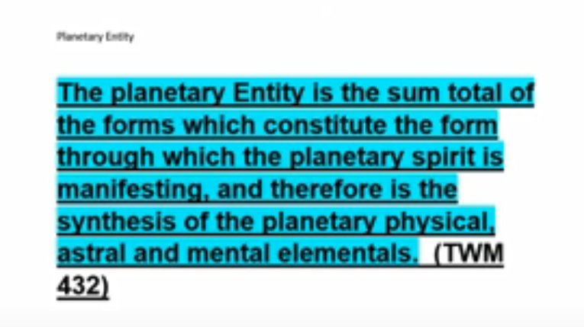

We might say that it is a book … so this the the matter which constitutes this entity comes from the previous solar system.

For the purposes of our consideration, this Entity is the sum total of all physical, mental, astral and mental forms, … why is the word mental repeated? For the purposes of our consideration this entity is the sum total of all physical, mental, astral and mental forms. … for our purposes here we can get rid of the word the first use of the word mental. – sum total of all physical astral and mental forms which, blended and fused, constitute our planet. Of course our planet has entities connected with it which have much higher principles than just those.

Each is the embodiment of energy, and these two major streams which produce the form and the consciousness aspects of our planetary existence make their impact on the human being. The human being is impacted by the planetary spirit and the planetary entity.

The life of the planetary spirit makes its impact via the soul but I think this involves the monad as well and; and the life of the planetary Entity is registered through the medium of the personality mechanism. Well, when it says via the soul, it comes from another place. So when we use a word like spirit in regard to the planetary logos, we may be speaking of the highest nature of that logos than the highest nature of man. So I think it's spirit via the soul.

0:14:00

The duality of these energies is primarily astral-buddhic, and the bias of the life forces and the general trend of the impulses influencing humanity in this great cycle are the attractive energy of the intuitional nature of the planetary Logos, and the potent force of the astral (desire) body. In other words, the astral elemental, which embodies the desire nature of the planetary Logos is exceedingly potent, particularly in this present cycle, but the strength of the spiritual and intuitional nature of the One in Whom we live and move and have our being is steadily increasing. On the one hand, you have the devastating expression of the wild hunt for pleasure, of sex and of the crime incident to the satisfying of desire. This characterises our present civilisation and is now at its height; it may be said that it is even on the decline, little as you may sense it. At the same time, there is found the open door of initiation. Both these opportunities (if I might so term them) are found simultaneously present, but the strength of the one is weakening, and the trend towards the other is growing. Thus the way out can be seen. TWM 432-433

The duality of these energies is primarily astral-buddhic, and the bias of the life forces and the general trend of the impulses influencing humanity in this great cycle are the attractive energy of the intuitional nature of the planetary Logos, and the potent force of the astral (desire) body.

In other words, the astral elemental, which embodies the desire nature of the planetary Logos is exceedingly potent This is on the (presumably) upon cosmic physical plane … The true desire body of the planetary logos is on the cosmic astral plane.

In other words the astral elemental which embodies the desire nature of the planetary logos is exceedingly a potent, particularly in this present cycle He is working on it, towards the second initiation, as there is work going on towards the second initiation of the cosmic kind, but the strength of the spiritual and intuitional nature of the One in Whom we live and move and have our being is steadily increasing. I think we are speaking here of reflections on the cosmic physical plane of the planetary logos is true true vehicles on cosmic on cosmic planes. In other words, the cosmic astral body is, while on the cosmic astral plane, the cosmic mental body on the cosmic mental plane, and so forth, but there are reflections on the cosmic physical plane. This is all I think because the planetary logos is at the stage of evolution at which He finds himself.

Which is as I say, we do not master in any respect our astral body until we take the second initiation. Even though our planetary logos is taking the fourth in a series of seven initiations, as it seems, He has not taken His second cosmic initiation, thus mastering His cosmic astral body. So He is polarized somehow on the fourth level on the cosmic astral plane. This cosmic astral polarization is on the fourth level, which means there's a fight going on until harmony is achieved. Then He can move upward to the fifth level, or third, as Venus is now found –the logos of Venus – moving to the sixth or second level. Well what is the result here? True vehicles on the cosmic planes.

On the one hand, you have the devastating expression of the wild hunt for pleasure, of sex and of the crime incident to the satisfying of desire. This is a quite a sacral focus, He tells us when our logos succeeds in lifting quite a bit of the sacral energy into the solar plexus, that a certain percentage, quite a large percentage, of sex crime, will end. But it's not immediate. On the one hand you have the devastating expression of the wild hunt for pleasure, of sex, and of the crime incident to the satisfying of desire.

This characterises our present civilisation and is now at its height; it may be said that it is even on the decline, little as you may sense it. At the same time, there is found the open door of initiation.

Both these opportunities (if I might so term them) are found simultaneously present, but the strength of the one is weakening, and the trend towards the other is growing. Thus the way out can be seen.
So relief is on its way, and maybe this relief stems from the elevation of planetary logos … so what happens in the system of our planetary logos directly affects the little unit man because that the unit is part of the vehicles of the planetary logos. I guess we're talking about in a way the planetary entity, to a degree, and then the degree of mastery that the actual conscious logos has over His own astral body, and its reflections on the cosmic astral plane.

In any case the way out is seen alright.

0:22:20

In the above paragraph, the dominant planetary urges present in evolution are summed up and man's reaction to them noted.
Solar energies have also a dual effect. First, there is what we might call the pranic effect, which is the result of the impact of solar force, emanating from the physical sun. This produces definite results upon the objective forms, and these are termed physical or vital. These enter the human body—via the spleen and also via a centre found between the shoulder blades; this centre is between the throat centre and the heart centre in the spinal column, but nearer the heart than the throat. Secondly, there are energies which emanate from what is esoterically called "the heart of the sun"; these sweep through one or other of the planets in seven great streams and power into the soul of man and produce that sensitivity which we call awareness. These seven types of energy produce the seven types of souls or rays, and in this thought you find the secret of soul unity. During manifestation, owing to the seven types of energy impacts, playing upon the matter of space, one finds the seven types of soul, the seven fields of expression, and the seven grades of consciousness and of ray characteristics. These differentiations as you well know are like the colouring that the prism takes when subjected to the rays of the sun, or to the tracery of pattern found in reflection upon a limpid pool. TWM 433

In the above paragraph, the dominant planetary urges present in evolution are summed up and man's reaction to them noted. Well, it's a very abstruse subject, and DK is trying to give us a few threads to follow our way through it, and at least extract a little something.

In other words, the astral elemental of the man (and this is influenced by the desire nature of the planetary logos is exceedingly potent) … the astral body of the planetary logos is as yet undisciplined fully and far from master. I sometimes wonder whether the judgement day, said to occur the fifth round, I think in relation to our chain, might not be the time when that second cosmic initiation occurs and with it the analogy to man's mastery of the astral body, occurring on the planetary logoic level.

We have the psychology of a rebel in our planetary logos. Maybe it all stems from his first ray monad, perhaps, and we have a stage of evolution which has been retarded due to a failure on the moon chain, then we have a quite a conflicted astral situation which effects humanity profoundly at this time.

Solar energies have also a dual effect.

First, there is what we might call the pranic effect, which is the result of the impact of solar force, emanating from the physical sun. This is active fire or heat, not latent. It is radiatory.

This produces definite results upon the objective forms, and these are termed physical or vital.

These enter the human body—via the spleen and also via a centre found between the shoulder blades There Is another center there too? It's above the diaphragm, it's a pranic triangle, this centre is between the throat centre and the heart centre so that's important, the shoulder center in the pranic triangle; this centre is between the throat centre and the heart centre in the spinal column, but nearer the heart than the throat. Well, I hadn't remembered that specific piece of information, and it's a good one, and very necessary when trying to work for the sake of others, or when there are pranic difficulties in one's own nature.

So, the first thing is the pranic effect, that's what he's talking to us about, that's the first one.

Secondly, there are energies which emanate from what is esoterically called "the heart of the sun" There is a lot of ambiguity around that term, and different places for its location or for chakras which are associated with it. It can be expressing on the monadic plane, wherein man the heart center is found, it can be expressing on the cosmic astral plane and is sometimes called the subjective sun, it can be expressing as the soul on the mental a cosmic mental plane, and sometimes when we think of our own correspondence in our own make up to the heart of the Sun it is the egoic lotus; these sweep through one or other of the planets in seven great streams and power into the soul of man and produce that sensitivity which we call awareness. This is so important, the relation of the heart of the sun to consciousness, he is giving us the relation of the heart of the sun, to consciousness.

These seven types of energy produce the seven types of souls or rays, and in this thought you find the secret of soul unity. The heart of the sun unifies all soul rays, and the rays coming from the Great Bear must, it seems first, pass through the through the heart of the sun, the soul. I suppose the soul of solar logos, before reaching the instrument of man.

This is really interesting, because this is what I mean by missing pieces, you read something, it's relatively clear but you have the feeling that is not the complete picture then, as DK says, scattered throughout my books you will find your answer. But you have to spend the time and the cautious research to find the missing pieces.

Energy is emanating from what is esoterically we call the heart of the Sun, and these sweep through one or other heard me one or other of the would say at first sacred planets in seven great streams. And power into the soul of man and produced the sensitivity we call awareness second aspect consciousness awareness sensitivity a higher correspondence to the sense of touch and These seven types of energy produce the seven types of souls or rays, and in this thought you find the secret of soul unity.

I think this would be worth noting that the seven soul rays are effectively produced by the heart of the Sun. Let's say, seven soul rays produced by the heart of the Sun, this is A Treatise on White Magic page 433, the seven soul rays produced by the heart of the Sun that is … basically the emanation from the Great Bear which produces these soul rays:

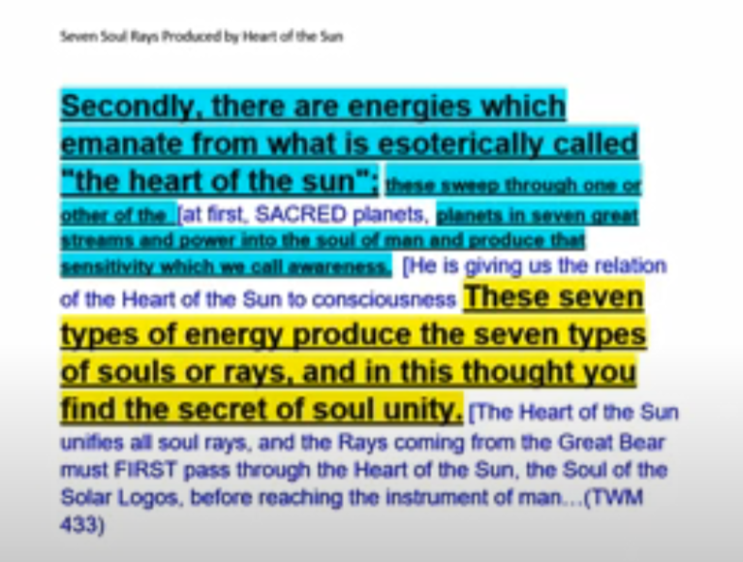

0:32:00

During manifestation, owing to the seven types of energy impacts, playing upon the matter of space, one finds the seven types of soul, the seven fields of expression, and the seven grades of consciousness and of ray characteristics. These differentiations as you well know are like the colouring that the prism takes when subjected to the rays of the sun, or to the tracery of pattern found in reflection upon a limpid pool. TWM 433

During manifestation, owing to the seven types of energy impacts, playing upon the matter of space, one finds the seven types of soul, the seven fields of expression, and the seven grades of consciousness and of ray characteristics. So here we are dealing with ray characteristics, with quality, we are dealing with the dealing here with the quality of a major septenate.

These differentiations as you well know are like the colouring that the prism takes when subjected to the rays of the sun, or to the tracery of pattern found in reflection upon a limpid pool. We've all seen that breaking down of light into the seven colors in various contexts.

So that's all He's going to say about this.

But it's really very interesting that the heart of the Sun is the source of the seven soul rays … [repeated from above: Secondly, there are energies which emanate from what is esoterically called "the heart of the sun”] let's call it the immediate source of the seven solar rays. Now, probably they deal with the seven sacred planets, but they make our way eventually to the non-sacred planets of which ours is one so they sweep through one or other of the planets and seven great streams and power into the soul these types of energy produced the seven types of soul rays and the seven soul rays are unified by this great secondary source the heart of the Sun.

… So these differentiations … during manifestation owing to the seven types of energy impacts playing upon the matter of space and all the different forms composed of that matter one finds the seven types of soul, which, how should we look at that? There's only one soul and that's soul, but seven types of filter soul consciousness each soul type is sensitive to certain types of impacts, and not to others, and that's why as we as ascend towards some acme, the different soul types have to at least to have represented within their particular type of sensitivity some of the sensitivity that is available naturally to the other soul types. Like first ray types have to learn to love, second ray I just learned have to learn how to have necessary power.

A word which is important for the first ray type is inclusiveness, it's a second ray word. A word that's important for the second ray type is centralization. It's a first ray word. We have to borrow and appropriate different qualities from the different, differing rays, otherwise we will remain quite isolated in our own ray structure and really not able to understand. Of course there is a unification here that in a way we're all part of the soul of the solar logos which has its own great solar angel and all of our solar angels at this time supervising our development are emanating from that high source with the inner solar angel and because of that unification that occurs within the source we do have at least a relationship to each other that we can build upon, without feeling isolated. Of course we have personality rays on all the different rays and the different incarnations, to give us that taste or that flavor of what it's like to live in relation to another ray. We build into our causal body different colors that are correlated with different rays.

The unification does occur, and we're not left in the state of ray isolation, which is pretty incommunicado. In the beginning, we're told the rays hate and kill each other, or something like that … the idea is, there's a big conflict between on the lower levels of development, between the rays. …

The seven fields of expression of form the seven rays of consciousness not necessarily talking about elevation but differentiation and of ray characteristics and all of them really have their roots in the white light, which includes them all and which leads eventually to the synthesis of all the ray types, and even for a time as a human being or down on our level, we transcend the need to think in terms of ray, but then it awakens again, when we change hierarchies and or when our hierarchy is elevated to the position of what was the superior hierarchy to our own. Then again, the ray differentiations take over. In fact, in the whole solar system not that mean that in the entire universe is a great septenate, and I don't think they're called rays, but that great Universal septenate, it is the final universal origin of the rays.

0:41:00

He said it was an abstruse subject isn't it? I get a little bit stubborn about it, but He dealt with the planetary spirit and the planetary entity somewhat and they're the kind of interaction and the way the human being reacts to them.

Our initiator eventually is the planetary spirit. In other words, by the time we take our 7th initiation, the planetary logos for planetary Spirit is our initiator, Sanat Kumara up to the 5th, and an unnamed entity which is also an extension of like Sanat Kumara, the planetary logos administers the sixth initiation. There's quite a mystery there He just doesn't go into it.

Since it's a time when a great decision is being made, we can understand the reason for the mystery or at least that it is appropriate that it exists, and then meaning our planetary logos, face to face at the seventh initiation. We're not told immediately about the eighth and ninth, though it would be interesting if the logos continues. Sometimes I think that at the eighth initiation some entry of what the solar logos use comes in in full of measured or maybe I should say what the cosmic logos is and by the ninth initiation. Some hint as to the nature of our super cosmic levels the One About Whom Not May Be Said enters the consciousness in just most minuscule way.

But the path that we take lead to certain constellations, and those constellations are chakras. Within each one of those constellations is the vehicle of a cosmic levels and our chakras within the super cosmic, levels we call the unknown or the One About Whom Not May Be Said.

Quite a destiny we have before us, but it's simply emanated retraction. We've come forth into ever more constrained environments, as some division of indivisible spirit. Talk about a paradox! We return on that emanated stream and regain the fullness of the scope of our consciousness and capability if the tiny miniscule human being, as DK says: microscopic man.

Well what can you say? We understand nothing about these things but just imagine that Master DK had not written about? This we would understand nothing about these states which to the Masters are realities we haven't proven it. But to them they are realities we a huge window upon sovereign reality has been opened for us first revealed and then I suppose opened and it's a clear window. and then you open it and contact is greater.

We have a lot of gratitude to the huge expansion of our vision conferred by the writings of Master DK, and many other messengers, of the spiritual hierarchy of our planet. I mean Master DK is a sanctioned messenger of the hierarchy, and He has the authority, he has been given the sanction the authority by His Master, Koot Hoomi, and by the Christ, and by Sanat Kumara, to bring forward the some portion. Maybe They considered a tiny portion of the Ageless Wisdom and we would really be in the dark just take a look at where philosophy is and the estimation of what man is when the Ageless Wisdom is not considered and it just doesn't have the light, and there are so many errors in that illusion which are being made.

As I say when we're doing this kind of work, and I think I've been doing this kind of recording for maybe about eight years now, that sense of gratitude sweeps over me from time to time, when I'm not shuffling my pages and wondering where my saves went, and other technical issues that I wish I was not bothered by, but the whole idea of the gift that's been given to humanity is extraordinary. Now will we have the good sense to use it? Of course you have to be somewhat along in your mental focus to approach this kind of teaching.

Obviously it's not for everybody and that's not to minimize the importance of those for whom it is. Not because we've all come through a hierarchy of ascension where were we in our consciousness back in Atlantean days, and if we came from the moon chain where were we then – I mean we always have to realize we've occupied a very low position in terms of what a human being is – and we gradually make our way into a higher intensity of living and a greater consciousness graduate.

If I look at my cats, no, I can't blame them for being cats, I can't say, why are you not a human being? Because it's all in cyclic timing and you simply have to pass in that cyclic timing through various stages of limitation, but however lessening limitation. Always some of us human beings after probably long and arduous and painful experience in which we've made terrible mistakes. As He said every human being has erred and humanity has erred grievously.

Some of us stand at the threshold of finding out what the 5th kingdom of nature is all about, and if you're an aspirant or probationer or a disciple or an initiate, your you've kind of included in that indigo circle that was given in Master DK's circles and illustrations charts in A Treatise on Cosmic Fire are pretty much in black and white. Then came along a student who knows a lot about these things, Keith Bailey, and He colored them in so that the qualities that are represented are more evident, but within that circle we stand there, it is that indigo circle that I tend to talk about.

0:50:00

? 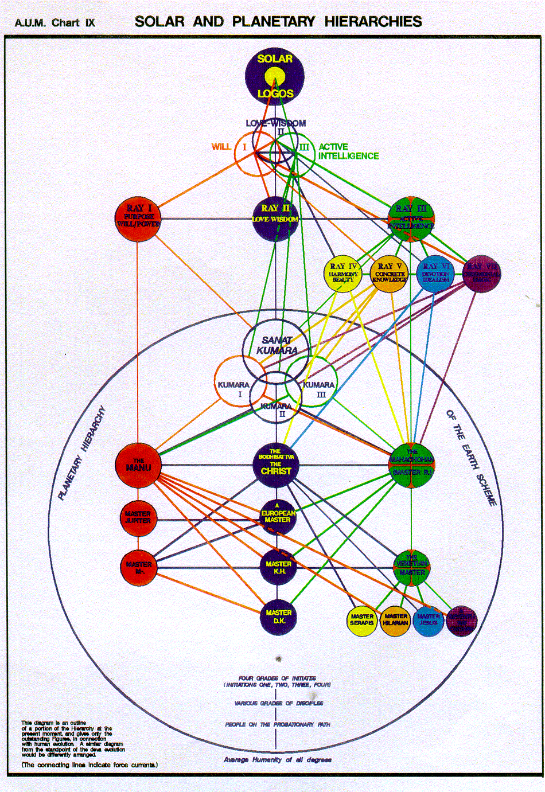

Vicktorya Stone chart, below, vicktorya.com
© 1997 transferred to Bruce Lyon 2004 or so.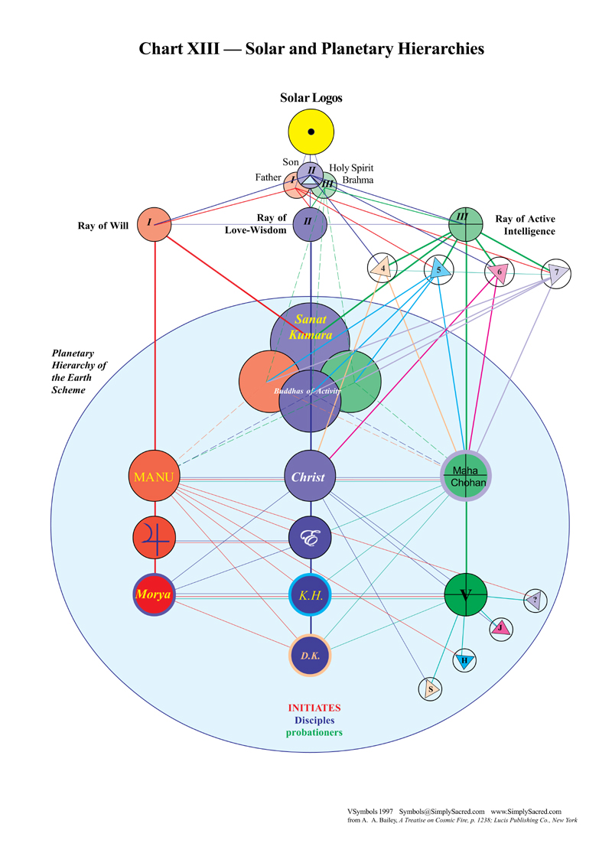

There are of course lower levels of it, just is the atomic triangle in the lower part of the egoic lotus and the jewel in the lotus is more highly placed. Matter of fact, there’s a lot of mystery about the placement of the jewel in the lotus that seems to be centralized, but it may well be placed somehow between the first subplane on the mental plane and the seventh subplane on the buddhic plane, or I won’t even try to solve that one or get into that.

But now we're changing kingdoms. We have the opportunity to learn something about the kingdom of souls and to center our diversified consciousness at will within what we normally call our soul nature on the higher mental plane. Of course soul is universal and every title of consciousness, and that this is important, every type of consciousness is a special case of soul. So we can’t, by any means think that soul as it manifests on the higher mental plane is the full expanse of soul or possible consciousness; it's just one special case which is higher than consciousness encapsulated in a limiting personal form. And it's been even more limited then the personality. It's had mental limitations and those were high compared to the astral limitations, and those were high compared to the simply physical and spatial etheric limitations.

It's always the little circle, expanding and expanding, and creating a wider horizon, so that more and more consciousness becomes possible, and in a certain point that circle may break, will break even as the circle of the universe will break for the sphere of the universe and but when a circle. Let's keep ourselves in the universe for a moment on whatever level when a circle breaks. Do we think we're suddenly free or do we find ourselves then enclosed within a still larger sphere? I think the latter suggestion is the correct one.

Until at long last, all these huge circles which are yet to come in our journey through this particular universe, break and reveal only this universal sphere. However, we are told that God is an intelligible sphere whose center is everywhere and whose circumference is nowhere. So when God is spoken of in that way, we have a super Universal God or Supra Universal God, and one day the sphere of any particular universe will break and we will find ourselves restored to a supra-luminal condition, which is above infinitely above the possibilities of any one finite universe, and we will all find ourselves … restored fully to being the absolute deity. And whose self reflection is absolute infinity.

Every time I'd try to think about what that means, I said, well I missed this. I missed that and I ponder the idea that every being is essentially an only absolute infinity, but it doesn't really stop there. It becomes absoluteness which is the finality and has no articulation in whatsoever it's absolute homogeneity of irreducible substantiality, irreducible substance, and not meaning by that matter at all, just the irreducible. Just nothing else, and its maximized its infinitized, it is brought to a state which is ultimate and always has been ultimate, and without being created and without any possibility of deviating from its nature.

We're struggling here in a certain level of minimalized self projection, but we have to remember what it is we really are. That is forever, and that's the absoluteness or the absolute and when you make a knot now none of these things sounds like it has some kind of limitation or boundedness, but it's called in the Secret Doctrine the boundless immutable principle, and it's infinitely greater than any God infinitely or universal God. Anyway, infinitely greater than any universal deity, which we also are. So that true mysteries of what we essentially are are so profound that the kinds of things we study. They're just minuscule and yet they are necessary given our self-chosen limited state and all of these things are part of the new philosophy which will become eventually cosmology and we'll deal with real energies and their relationships and their diversification and finally their disappearance into absolute infinity. the post universe.

Of course, there's so many enigmas and, what can I call them, paradoxes. I mean the mind just can't handle it; so many paradoxes. In a beginningless, endless sequence, is it even real is anything but absoluteness even real the great breath. Is a beginningless endless sequence of universal universe or no universe universe may do is chicken and egg, which came first? I oftentimes think, well look, it's the egg that came first, because I'll just give a crude example the reptile lays the egg, which becomes the chicken, its mutation.

But let's just say at whatever time we might select there was always either universe or no universe but at whatever time we might select there was ever and always absoluteness without cause we can't even say the cause only of itself because it never was a time when it was not.

See, I guess, I've gone from the relative world in the universe into the supra-universal worlds, but it's good to have these things in the back of one's mind, because the phenomenal worlds have many, many disappointments and much suffering, and the buddha told us, don't identify with them.

Well eventually the day will come when we're told, regaining our universal logoic status, don't identify as a universal logos because it's infinitely less. It's phenomenal, compared to what you are as a supra-noumenon; I guess people wake up at a certain point, and they may become enlightened on these matters, and maybe they become very relieved once again to realize where they are but even now on the universal logoic level we are there we can't be anywhere else. There's an extension of what we are which doesn't know what's going on, but what we are is there and no knowing what's going on.

I just suggest that, as we're studying this great gift which Master DK has given us, with the approval of our superiors, there are only superiors in time and space, and in the universe. There are no ultimate superiors, there is only one being. So you can't have superiors.

But we in this world of have relativity become very grateful to Him for this incredible expenditure of energy. and to Alice Bailey as DK almost He gestured He said well for me giving you all of this has been a labor of love and for Alice Bailey, a labor. Wow, at first I did a double on that one, but then I began to realize the pressure under which she must have had to work. A lot of the students there they were people like you and me, and when they had to be connected with a master and opening with fear and trembling, trepidation, anticipation, eagerness, their letters from Him, they found the pressure considerable because they believed in Alice Bailey and they knew that through her was coming the testimony of a larger consciousness. Much larger. And we're on our way to reclaiming that type of consciousness along our own emanative stream.

So, I guess a certain confidence in the whole process is required and kind of interest in enjoyment the principle of unrepeatability is operative and always as Master Morya would tell us, there's something new and we always go for the new. For us everything is new. He's speaking of the Masters live in the eternal and know the self as one. There is a power that maketh all things new, it lives and moves and those who know the self as one.

Alright, well I've had a little contest with myself, I had 15 minutes to kill, of course my time is totally off and I just wanted to see what I might end up talking about to you before getting into this new section which is all about astrology and the energies. So, somehow I feel that I should I kind of want to do these long programs, but in fact it's better to cut them a bit short at least under the circumstances. I can begin fresh here and say that this is the end of number 51. We're now on page 434 and this is the 35th program in rule 10. It's the end of number … 52 and we begin on page 434. … I hope that's good enough.

All right friends, let's see when I'm able to start this. I hope right away … so I say, study hard, but of course that's advice to myself. What DK has given is beyond our ken, but we can anchor some major thoughts and our lives will be better than if we had not met him and met His work a lot better. We'll see you soon, bye bye.

