**Abstract**

**Content for ATOWM Series II, Rules of Magic for the Astral Plane, Video Commentary, Program Thirty-nine, 10.23 continuing Rule X, 1:05 hr.**

[Program 39: A Treatise on White Magic – Rules of Magic for the Astral Plane – Rule X 10.2](http://makara.us/04mdr/webinars/white-magic-2/2018-09-02-Program-39-A-Treatise-On-White-Magic-Video-Commentaries-Rules-for-Magic-for-the-Astral-Plane-Rule-X-10.23.wmv)3 270 MB .wmv file  
Video by Michael D. Robbins. 02Sep2018 / 1:05 hr.

[Program 39: A Treatise on White Magic – Rules of Magic for the Astral Plane – Rule X 10.23](http://makara.us/04mdr/webinars/white-magic-2/2018-09-02-Program-39-A-Treatise-On-White-Magic-Video-Commentaries-Rules-for-Magic-for-the-Astral-Plane-Rule-X-10.23.mp3) 66 MB .mp3 file  
Audio by Michael D. Robbins. 02Sep2018 / 1:05 hr.

**Transcript**

Hello friends.

We are continuing now with our video commentaries for *A Treatise on White Magic,* rules for the astral plane.

We are beginning on page 363 looks like … this is commentary number 39, and commentary number 23 when it comes to that mammoth rule ten … let’s overlap a little here:

***Remember always that in the vivification of a centre there is always a corresponding vitalisation of the analogous head centre, till eventually the seven centres in the body and the seven centres in the head rotate in unison. Remember also that just as the four minor rays pass into the three major rays, so the four minor centres carry on the correspondence and pass into pralaya, finding their focal point in the throat centre. Thus you will have the three centres—head, heart and throat—carrying the inner fire, with the three major head centres vibrating in unison also. TWM 363***

***Remember always that in the vivification of a centre there is always a corresponding vitalisation of the analogous head centre*** The seven of them, I think ruled by Vulcan, just the way the in the One About Whom Not May Be Said, that the Tibetan tells us that the seven major stars of the Great Bear are the rulers of the seven head centers for that being***, till eventually the seven centres in the body and the seven centres in the head rotate in unison.***

One of the rules I think tells us about that, I think it's one of the rules for of the fourteen rules for disciples. They rotate in unison. I showed you I think page 170 in *A Treatise on Cosmic Fire,* where these seven head centers are mentioned as an important focus for the advancing man, the man of the third initiation and beyond.

***Remember also that just as the four minor rays pass into the three major rays, so the four minor centres carry on the correspondence and pass into pralaya, finding their focal point in the throat centre.*** Are we including the heart center as a minor center? That is an interesting thought. Or are we including the spleen as a minor center along with the solar plexus, sacral center, and base of the spine center.

***Thus you will have the three centres—head, heart and throat—carrying the inner fire, with the three major head centres vibrating in unison also.*** Which have which are the foci of the three major types of monad for a second integrity, carrying the inner fire with the three major head centers vibrating in unison. Also, so the three major head centers are these. one of the seven? Or what? Are we considering the entire center at the top of the head, the crown chakra, the ajna center, and the alta major center?

0:03:30 Anyway … I can find that quickly … here it is,

***Rule VIII.***

***For Applicants***

***When the disciple nears the portal the greater seven must awaken and bring forth response from the lesser seven upon the double circle.***

***Rule VIII. For Applicants: When the disciple nears the portal the greater seven must awaken and bring forth response from the lesser seven upon the double circle.*** Here we have in fact the symbolism for seven lesser centers and seven greater centers in the head, and probably in an ajna series of centers, which are sometimes discussed in Hindu books, we might have the completion of 21, taking the entire group together, and we have the 22nd.

Anyway, these are some of the intricacies of the anatomy and physiology, the subtle, etheric anatomy and physiology. Right. It's interesting that if when we're looking at the head, heart, and throat center here, and we considered three major centers that the head center would not be considered a major center but something above it …

Let’s wait until we can confirm exactly what centers are being discussed. The ajna series of centers is very interesting and include centers related to the buddhic thinking, atmic plane, manasic plane, that we may never have heard of in anything perhaps but hints from Master DK.

0:05:30

***I realise that this is all intricate and technical. It has its place and value however, and much that here is communicated will find its usefulness when you are all passed over to the other side and a fresh band of aspirants will follow in your footsteps. The training of the mental body has a value, and many evade such technicalities, hiding behind an emphasis upon the life side of truth, all due to an inherent mental laziness. This that you now receive is but the A. B. C. of esotericism. Waste not time however in too detailed deduction. All that is now possible is a broad general outline, patient reserve, a willingness to recognise physical brain limitations and the accepting of an hypothesis. Believe these hypotheses possible unless your intuition revolts or they are contradicted by past teaching given by other of the Lodge's Messengers. I do not dogmatise to you. I only in these instructions give you certain information,—the correctness of which I leave the future to demonstrate. I simply ask that you make record and in the coming years much that may now seem peculiar or mayhap even contradictory will be elucidated, slowly unravelled, and more easily comprehended. A little knowledge leads to much confusion unless laid aside for future use when the years of instruction have increased the store. TWM 363-364***

***I realise that this is all intricate and technical.*** Certainly it is for us at this time.

***It has its place and value however, and much that here is communicated will find its usefulness when you are all passed over to the other side and a fresh band of aspirants will follow in your footsteps.*** And maybe some of us are part of that *fresh band,* and now we're getting ready to pass over and a new band of aspirants will appear, and they will benefit from the beginning of the third installment of the Tibetan. There is so much information that has to be correlated, and that's one little thing that I'm making a small attempt to do here, the correlation of quite a number of factors as possible, but it's just a small percentage of what might be correlated.

***The training of the mental body has a value, and many evade such technicalities, hiding behind an emphasis upon the life side of truth, all due to an inherent mental laziness.*** Whoa friends, well it's been said, how much in depth do we want to go? That is an important question.

So here really we have the value of the fifth ray. Sometimes I've noticed that the third ray may be better at memorization per se, but the fifth ray with its law of fixation is very clear about the structure of what has to be memorized. When you put the third in the fifth ray together, you get a strong ability to memorize with accuracy. We need the fifth ray and especially when accompanied by the third ray.

So many are the excuses: ‘I don't need all these details.’ I've heard disciples who fancied that they're particularly disciples of Master DK and they say, ‘Well look, I don't need all that technicality that you find in the presentation of Master DK’. However, let's remember that Master DK is in Master KH’s ashram, and is presenting these matters certainly with the permission and encouragement of KH, and others of still higher rank.

I'll read it *again* ***The training of the mental body has a value, and many evade such technicalities, hiding behind an emphasis upon the life side of truth*** which is the propensity of the of the pure mystic***, all due to an inherent mental laziness.***

What I suppose laziness can't appear in the various vehicles. Sometimes people who are not mentally lazy might be physically lazy, and we might go through what is desired is an activation of all the vehicles in a balanced and proportional manner.

***This that you now receive is but the* A. B. C.s *of esotericism.*** Of course lots of those ABCs were found in *A Treatise on Cosmic Fire* as well.

***Waste not time however in too detailed deduction. All that is now possible*** In other words Master DK is always trying to preserve a balance ***All that is now possible is a broad general outline, patient reserve, a willingness to recognise physical brain limitations*** and I suppose even etheric brain limitations ***and the accepting of an hypothesis.*** I guess we human beings want our instant gratification, and think that anything that can be known should be known now, regardless of the time factor. But the Masters are very aware of the limitations imposed by the time factor.

***Believe these hypotheses possible unless your intuition revolts or they are contradicted by past teaching given by other of the Lodge's Messengers.*** They may contradict certain other teachings given by those, or by sources, that many assumed to be the Masters, but the true Masters of the lodge will not in fact contradict each other.

0:12:10

***I do not dogmatise to you.*** in giving you statements which absolutely must be followed and which contain according to the source the entirety of the truth in the in the church this is happening all the time the limitations imposed are considered to be the great the entirety of what it is possible to know about the subject that the imposition represents.

***I only in these instructions give you certain information*** ***—the correctness of which I leave the future to demonstrate.***

I'm in the midst of a battle with a very good friend, who's extremely brilliant, but he's brilliant along a third ray and fifth ray line, and it's so interesting to see the rejection of this information and the reasons based in the Western, concrete mind, for this rejection; the opposition to it.

***I simply ask that you make record and in the coming years much that may now seem peculiar or mayhap even contradictory will be elucidated, slowly unravelled, and more easily comprehended.***

Also what do we really understand? The true occultist is patient. That's difficult to Master, this patience. It is one of the last things that the Master is able to achieve, preventing him from indulging in irritation which could hurt His students are those who are in contact with him, or that He tries to contact.

***A little knowledge leads to much confusion unless laid aside for future use when the years of instruction have increased the store.*** We might say, and what is all this intricate knowledge but a little knowledge? It is. It's just a little bit. As amazing as it may seem to us, it's just the tiniest portion of what we might call the Ageless Wisdom as applied to this earth manifestation, and the solar system. And I suppose if it's ageless, antedating any possible cyclic universe.

So we have to have the correct attitude towards that which is presented, and the way the mind is cultivated in the world, that correct attitude is not easy to achieve, if one relies solely on Western concrete-minded impartation. But we begin to develop different aspects of mind as we study spiritual occultism with the Tibetan, and we understand from the map …

… the AAB diagrams … and I usually start with parabrahma. A great place to start right? Well it's not really parabrahmam, you can't really be parabrahmam, but it can be in that direction.



I mean I don't think that these maps that were being given our super galactic. I'm not sure, but I don't think so, especially the way they're laid out. They seem to have a limited scope however fast they may seem to us.

Anyway now we return to the theme:

0:17:30

***To return to our theme:—The heart centre in man opens the door into what is called "the heart of the Sun." The throat centre opens the way into full understanding of the path of the physical Sun and all true astrologers must eventually have that centre functioning. The head centre opens the way to the central spiritual Sun, each passing, via the planetary correspondence, to one of the cosmic planes.***

***Thus we have a summation of technicalities, and of facts, which are (under the Law of Analogy) of purely academic interest and no more. Even those of us who are initiate know practically nothing of the cosmic planes beyond the cosmic physical. Our consciousness is only beginning to be solar, and we are labouring in our small measure to overcome those planetary limitations which hold us back from solar knowledge and life. For aspirants who have not even a knowledge of what planetary consciousness signifies, the above information has only one value and that is, that it emphasises the synthetic nature of the great plan and the fact that the smallest unit is an integral part of the whole. It enforces the idea that energy is a life fluid circulating throughout the entire body of the Logos, and vivifying therefore even the tiniest atom in that whole. It is valuable to endeavour to grasp the picture and to vision the wonder of what is transpiring. It is waste of time, nevertheless, to ponder upon the cosmic astral plane, for instance, when even the plane of the ego (the fifth subplane of the cosmic physical plane, counting from above downwards) is as yet inaccessible to the average man and is the goal for all his aspiration and meditation. TWM 364-365***

***To return to our theme:—The heart centre in man opens the door into what is called "the heart of the Sun."*** I think have dealt with that issue: what really is that? there are different estimations on the nature of the heart of the son. The body of the solar logos is one. A demonstration of a subjective son on the cosmic astral plane. And perhaps an etheric demonstration of solar logoic heart energy on the cosmic physical plane on the monadic level. Yeah, maybe that. those are the only ones I can think of at the moment.

***The throat centre opens the way into full understanding of the path of the physical Sun*** and I wonder what He means by *path*? The developmental path of the physical sun? Well, after all the throat center is associated with physicality and the physical sun is that brilliant a theoretic source. I guess we might call it *plasmic gaseous,* etheric source. It's not physical, in the way we think of physical in relation to the dense physical planets.

***The throat centre opens the way into full understanding of the path of the physical Sun*** ***and all true astrologers must eventually have that centre functioning.*** Why? Because astrology develops along the third ray line initially. So all true astrologers are that.

We have the head center, opening the way to the central spiritual sun, each passing via the planetary correspondence to one of the cosmic planes. Now, the planetary correspondence in this case is the monadic nature of the planetary logos, the central spiritual Sun, … is the monadic nature of the solar logos. …

0:21:40

I suppose the physical sun must be related to the personality of the solar logos, but really the 18 lower cosmic subplanes are the domain of the solar logoic agni and are the expression of the solar logoic personality.   
  
Let's look at that again, because it helps us trace the lower centers to the higher. What follows here is the tracing of the lower centers to the higher.

***The heart centre in man opens the door into what is called "the heart of the Sun."*** Now first the what is sometimes called heart center of the monad must be involved, and this is the egoic lotus. But gradually one ascends, even via the the heart center of the planet and the monadic nature of the planet and so forth to a place that represents the heart of our solar logos.

***The throat centre opens the way into full understanding of the path of the physical Sun*** and ascending or that you see a way of becoming familiar that path is a way of the of becoming familiar with the lower aspects of the solar logos, and also ***and all true astrologers must eventually have that centre functioning.*** As I said, because of the particularly third-ray nature of astrology, but of course Master DK is mixing so much of the soul aspect into the present astrology of the soul …

***The head centre opens the way to the central spiritual Sun, each passing, via the planetary correspondence, to one of the cosmic planes.***

What cosmic planes are involved here? All this seems to suggest that these aspects of the solar logos are really on cosmic planes. The path of the of the physical Sun is the path of the personality of the solar logos, the lower eighteen cosmic subprames. The path to the heart of the Sun takes us to the first cosmic subplane on the cosmic mental plane. The path from our head center eventually to the central spiritual sun takes us to the cosmic monadic plane.

What can we say? We can look at the correspondences and say, ‘well yeah that looks right.’ But when we can't even really discuss what's going on, on the monadic plane, on which what we call our monad is found. How can we talk about these cosmic planes but at least we can fill out the structure of relationships.

***Thus we have a summation of technicalities, and of facts, which are (under the Law of Analogy) of purely academic interest and no more.***

It is academically interesting, meaning the mind can a deal with it, embrace it somewhat. But it is not experientially relevant. Now our soul is experientially relevant, or these soul consciousness on high metal plane is experientially relevant, and even the energy of the spiritual triad and eventually monad are all a sooner or later in our developmental cycle as a human being here and now, experientially relevant. But once we start getting beyond the human phase, they are no longer men as are the masters; the masters five-pointed; the chohan is a six-pointed star and is no longer considered a man, although still a member of the fourth creative hierarchy of the ninth, depending on how you number them. What's going on above is not available to us at this time, experience will be relevant though academically interesting.

***Even those of us who are initiate know practically nothing of the cosmic planes beyond the cosmic physical.*** DK, in all humility said, ‘look what's going on the astral plane,’ I paraphrase of course, ‘I don't know because I haven't been there. So I think an initiate of the seventh degree begins to really receive from the cosmic astral plane. Maybe even then at the seventh degree, or maybe more likely at the eighth degree, goes up down, up down, the figure eight maybe can go there, and return, go and return but of the ninth degree one goes and does not in this solar system a cycle. I think at least return or at least not for a very long time, unless those human beings leaving in that way or members of the fourth grade of hierarchy leaving in that way would come back.

Still, in the solar system, to be solar angels to the developing animal kingdom or a future kingdom that is moving through the animal and becoming human and so forth.

So we don't know whether those of us were on the fourth path to Sirius, whether our return is during this solar system. Or … that's a lot of years. If there's still 150 trillion left, but not 150 trillion outer years would remain. I imagined that the whole subjective cycle of a solar system corresponds to that 311 trillion, 40 billion years, but that the shortest phase of that cycle, shortest in duration, is the dense physical cycle. So we certainly don't have I think a hundred and fifty trillion years remaining in the dense physical cycle that remains to the manifestation of our solar system.

0:31:25

[repeating from above:]

***Our consciousness is only beginning to be solar, and we are labouring in our small measure to overcome those planetary limitations which hold us back from solar knowledge and life. For aspirants who have not even a knowledge of what planetary consciousness signifies, the above information has only one value and that is, that it emphasises the synthetic nature of the great plan and the fact that the smallest unit is an integral part of the whole. It enforces the idea that energy is a life fluid circulating throughout the entire body of the Logos, and vivifying therefore even the tiniest atom in that whole. It is valuable to endeavour to grasp the picture and to vision the wonder of what is transpiring. It is waste of time, nevertheless, to ponder upon the cosmic astral plane, for instance, when even the plane of the ego (the fifth subplane of the cosmic physical plane, counting from above downwards) is as yet inaccessible to the average man and is the goal for all his aspiration and meditation. TWM 364-365***

***Our consciousness is only beginning to be solar.*** Now whose is *ours*? Are we speaking here of the masters? -- ***, and we are labouring in our small measure to overcome those planetary limitations which hold us back from solar knowledge and life.*** It looks like it, seems like these are the masters speaking; the initiatives of the type of Master DK. Masters.

***For aspirants who have not even a knowledge of what planetary consciousness signifies*** even globe consciousness or chain consciousness***, the above information has only one value and that is, that it emphasises the synthetic nature of the great plan and the fact that the smallest unit is an integral part of the whole.***

So this is why we're reading it. And what can that sense of synthesis bring to us? … This synthetic point of view can help overcome the great heresy of separateness, which is the one true fallacy of thoughts, the one true heresy. The one true deviation from the truth. The great heresy of separateness.

***It enforces the idea that energy is a life fluid circulating throughout the entire body of the Logos, and vivifying therefore even the tiniest atom in that whole.*** What we have here in these kinds of speculations is a very good definition of energy. … Energy is a life fluid, it is in constant motion, fluid motion, it is not stationary-bound, the way we think of more solid arrangements. -- ***circulating throughout the entire body of the Logos, and vivifying therefore even the tiniest atom in that whole.*** Of course this has to apply to much greater contexts, including cosmic logoi and super cosmic logoi and on and on. Energy is all that and used the great means of vivification.

***It is valuable to endeavour to grasp the picture and to vision the wonder of what is transpiring.*** If we have the awe – you know, having the awe helps us treat all creations with respect. Because after all, they are externalizations, finally, of the One Infinity Being.

***It is waste of time, nevertheless, to ponder*** [laughing,] too much ***upon the cosmic astral plane, for instance, when even the plane of the ego (the fifth subplane of the cosmic physical plane, counting from above downwards) is as yet inaccessible to the average man and is the goal for all his aspiration and meditation.***

Well, put things in proportion here, don't we? This tells us that it is not a waste of time …

0:38:00

This tells us, yes, that to wonder about the nature of what we normally call *the soul,* is not a waste of time. But I would say that, to wonder about the intricacies of the cosmic astral plane, or planes beyond, even though in the charts, He shows us a few things, that is a waste of time … we've got these little 49 little triangles, what are they? They deal with the cosmic atmic plane:

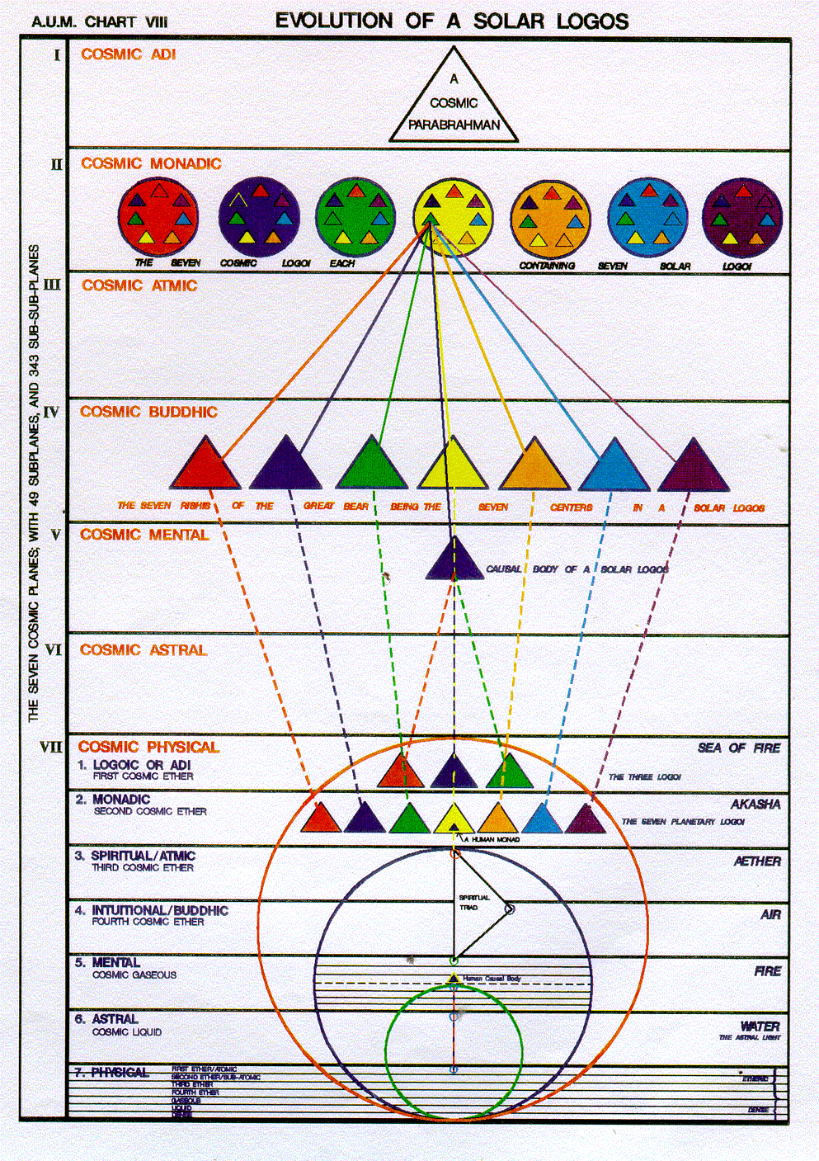

What is the cosmic parabrahman? Who are the seven rishis? They are coming forth from this triangle. I would say they might even be the triangle, except for the fact that the solar logos also comes forth from this triangle. Meaning that it contains far more, and a meaning that it is more than the seven rishis.

You can use these charts and you can generalize from them, and you can learn some important relations. But let's not go too far with them in our pursuit of intricacy, because even if we found ourselves being accurate about them, we wouldn't be able to use the information in any practical way, except it somehow enhanced our sense of the grandeur, the magnificence, and the non-separateness of the whole. That would be the great advantage.

And if we can think and see, that all things are truly unified and interrelated, we have gone a long way toward overcoming one of the major obstacles to spiritual living in our environment. That sense of separateness is an astonishing enemy and prevents us from expressing the very essence of spirituality which is a divine connectedness.

0:40:40

***For man, therefore, the Universal Mind can best be grasped as it expresses itself through what we call the concrete mind, the abstract mind, and the intuition or pure reason. TWM 365***

Now, it's also my opinion that the atmic plane, since it is the third from above, that the symbol is the triangle, which also and in a higher way, expresses the universal mind, but this expression is more for the masters to apprehend, and not us. I mean, it may be the home of spiritual will but it is the master of the wisdom of the fifth initiation that is able to understand. Something of the kind of mentality which is operating on the atmic plane.

You’re going to find there, in the chart that Keith Bailey assembled:

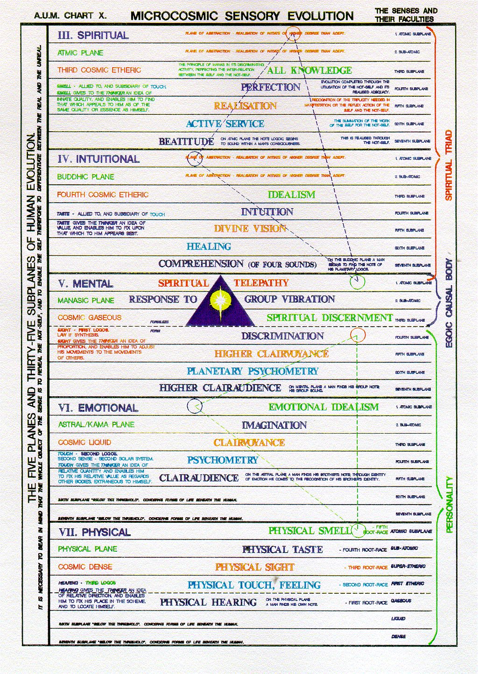

You'll find *beatitude, active service, realization, perfection, all knowledge.* All of these things require a kind of mind which is very high, compared to the mind that we have access, the concrete mind, the abstract mind, and the intuitive transcendental mind.

Okay, we have some access to these but on the atmic plane something much higher mentally. And how can we begin to even understand what that might be? What I would just say, let us seek to build the antahkarana steadily, usefully, let us seek to apply it, that is fine, the right type of meditative approach to begin to receive impressions which have not been normal or customary for us at all. Then maybe as we begin to do the will of God we shall know. Now that certainly applies to the realm of spiritual will, atma. Because the will of God, as it relates to the plan as formulated by the custodians of the plan, is emanating from the atmic plane at least within the worlds of Brahma. Now it emanates above of course, but for practical purposes were still very much living in the Brahmic worlds, and so is the Master.

So if we do the will of God as it comes through to us in terms of the presentation of the Divine Plan, we shall begin to know and on that plane the atmic plane on the third subplane is this power or siddhi, which we call *all knowledge.* Certainly the mentality associated with the atmic plane is evident, or that mentality is associated with the atmic plane is evident and that it is an expression a lower expression of the universal mind is evident, but what the details are we'll have to wait to discover.

0:44:50

***The concrete mind is the form building faculty. Thoughts are things. The abstract mind is the pattern building faculty, or the mind which works with the blue prints upon which the forms are modelled. The intuition or pure reason is the faculty which enables man to enter into contact with the Universal Mind and grasp the plan synthetically, to seize upon divine Ideas or isolate some fundamental and pure truth.***

***The goal of all the work of an aspirant is to understand those aspects of the mind with which he has to learn to work. His work therefore might be summed up as follows:***

***1. He has to learn to think; to discover that he has an apparatus which is called the mind and to uncover its faculties and powers. These have been well analysed for us in the first two books of the*Yoga Sutras of Patanjali.**

***2. He has to learn next to get back of his thought processes and form building propensities and discover the ideas which underlie the divine thought-form, the world process, and so learn to work in collaboration with the plan and subordinate his own thought-form building to these ideas. He has to learn to penetrate into the world of these divine ideas and to study the "pattern of things in the Heavens" as it is called in the Bible. He [366] must begin to work with the blue prints upon which all that is, is modelled and moulded. He becomes then a student-symbolist, and from being an idolater he becomes a divine idealist. I use these words in their true sense and connotation.***

***3. From that developed idealism, he must progress even deeper still, until he enters the realm of pure intuition. He can then tap truth at its source. He enters into the mind of God Himself. He intuits as well as idealises and is sensitive to divine thoughts. They fertilise his mind. He calls these intuitions later, as he works them out, ideas or ideals, and bases all his work and conduct of affairs upon them.***

***4. Then follows the work of conscious thought-form building, based upon these divine ideas, emanating as intuitions from the Universal Mind. This goes forward through meditation. TWM 365-366***

***The concrete mind is the form building faculty. Thoughts are things.*** It's the old philosophical dictum, *if some thoughts are things.* Yeah, and then, what is *a thing*? That is, it kind of assumes we know what the thing is.

***Thoughts are things.*** ***The abstract mind is the pattern building faculty*** we might call it in the old terminology *blueprint making****, or the mind which works*** ); ***The abstract mind is the pattern building faculty with the blue prints upon which the forms are modelled.***

Ah! Goodness, this is the disadvantage from having read too carefully for too long you're always anticipating what you are reading, before my eyes, at least consciously, did not fall on that word *blueprint. …* My uncle was the air conditioning engineer and always carrying blueprints with him for the various jobs that he did, and so I became familiar at least with the existence our blueprints, if not the details that were on them that. Of course that was in pre-computer days, and so forth.

***The intuition or pure reason is the faculty which enables man to enter into contact with the Universal Mind and grasp the plan synthetically, to seize upon divine Ideas or isolate some fundamental and pure truth.***

***The goal of all the work of an aspirant is to understand those aspects of the mind with which he has to learn to work. His work therefore might be summed up as follows:*** This is a wonderful definition of one of the capacities of the intuition.

… We find further descriptions of *the three minds* which must *unite* in the … triadally-oriented student.

So repeating:

***The concrete mind is the form building faculty. Thoughts are things. The abstract mind is the pattern building faculty, or the mind which works with the blue prints upon which the forms are modelled. The intuition or pure reason is the faculty which enables man to enter into contact with the Universal Mind and grasp the plan synthetically, to seize upon divine Ideas or isolate some fundamental and pure truth.***

***The goal of all the work of an aspirant is to understand those aspects of the mind with which he has to learn to work. His work therefore might be summed up as follows:***

***The concrete mind is the form building faculty.*** and the forms built our dense compared to the patterns which the abstract mind presents, blueprints don't have the details but they do have the relationships. We'll just say the blueprints hold in abstract form the relationships and then comes the intuition.

Now when it comes to the three minds that are uniting, we have different points of view here we can say concrete mind, son of mind, abstract right? But we can say as He says here: concrete mind, abstract mind, intuition? Or we might even find a way to include something that leads up to the atmic mind?

In any case, we often find the areas of our mind functionally separated from each other so that we cannot come and go with ease from one to another. I mean, here we are trying to bridge this gap. It's even getting us into the abstract mind, let alone the intuition.

And all this through the antahkarana; it's not a pure seamless relationship between these different levels of mind the way eventually it has to become so, finally. The universal mind of the solar system is a universe, as it sometimes was considered to be We're not by any means talking about the vast entirety we call the universe. If that is the case the universal mind is the concrete mind, and abstract mind, cosmically transcendental mind, and cosmically atmic mind of the solar logos.

Those are just words; they cannot really mean anything to us – when having a real intuition for people of our type is a rarity. And that's right down on the cosmic physical plane, yet alone on these higher cosmic planes.

[not read again, but included for continuity:]

***Thoughts are things. The abstract mind is the pattern building faculty, or the mind which works with the blue prints upon which the forms are modelled. The intuition or pure reason is the faculty which enables man to enter into contact with the Universal Mind and grasp the plan synthetically, to seize upon divine Ideas or isolate some fundamental and pure truth.***

***The goal of all the work of an aspirant is to understand those aspects of the mind with which he has to learn to work. His work therefore might be summed up as follows:***

So let's just say an aspirant, still with much of directed astral fire, must understand the mind. But it all depends on what He thought DK calls an aspirant He says every true aspirant has taken the first initiation.

***The abstract mind is the pattern building faculty, or the mind which works with the blue prints upon which the forms are modelled. The intuition or pure reason is the faculty which enables man to enter into contact with the Universal Mind and grasp the plan synthetically, to seize upon divine Ideas or isolate some fundamental and pure truth.***

… So, what must an aspirant do? Let's consider ourselves all aspirants.

0:51:35

***1. He has to learn to think; to discover that he has an apparatus which is called the mind and to uncover its faculties and powers. These have been well analysed for us in the first two books of the Yoga Sutras of Patanjali.***

***He has to learn to think; discover that he has*** *a mind and learn it's dual use.*

*[a different quote, in the 15 counsels:*  *A Treatise on White Magic.]*

Let's look at it here, page 474 …

***Number four. Discover that thou hast a mind and learn its dual use.***

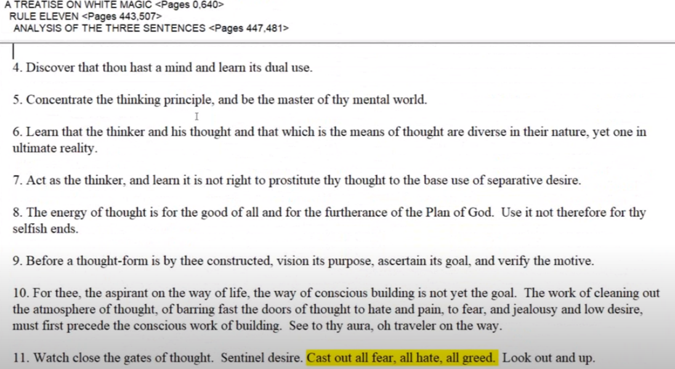

***Number five. Concentrate the thinking principal and the Master of a mental world.***

Sounds like a very little thing to do, learn that the thinker and His thought and that which is the means of thought are diverse in their nature yet one in their ultimate reality. Sounds like one of the fruits of contemplation under Libra.

Anyway, we can assign some of these things to different astrological correlates, but anyway go to page 473 for the 15 councils, which rightly pursued will make of a man an adept.

Anyway, this aspirant, what does he have to do?

***He has to learn to think; discover that he has*** ***discover*** ***that he has an apparatus which is called the mind and to uncover its faculties and powers.*** Latent at first, and unknown at first.

***These have been well analysed for us in the first two books of the Yoga Sutras of Patanjali.***

***1. He has to learn to think; to discover that he has an apparatus which is called the mind and to uncover its faculties and powers. These have been well analysed for us in the first two books of the Yoga Sutras of Patanjali.*** A great sage who lived according to the Tibetan somewhere some reference may be ten thousand years ago.

***2. He has to learn next to get back of his thought processes and form building propensities and discover the ideas which underlie the divine thought-form, the world process, and so learn to work in collaboration with the plan and subordinate his own thought-form building to these ideas. He has to learn to penetrate into the world of these divine ideas and to study the "pattern of things in the Heavens" as it is called in the Bible. He must begin to work with the blue prints upon which all that is, is modelled and moulded. He becomes then a student-symbolist, and from being an idolater he becomes a divine idealist. I use these words in their true sense and connotation. TWM 366-367***

***2. He has to learn next to get back of his thought processes and form building propensities and discover the ideas which underlie the divine thought-form, the world process, and so learn to work in collaboration with the plan and subordinate his own thought-form building to these ideas.***

Well, this requires, I think, not only the abstract mind but also the intuition. But when we're talking about ideas we seem to have entered the intuitive realm, and we're talking about comprehensive lucid abstract renderings of those ideas then we can talk about the abstract mind.   
  
***He has to learn to penetrate into the world of these divine ideas N***ow if they're divine they're coming from the level the monad or beyond ***and to study the "pattern of things in the Heavens" as it is called in the Bible.*** And astrology will help, if esoteric.

***He must begin to work with the blue prints upon which all that is, is modelled and moulded.*** So this is definite work with the abstract mind.

***He becomes then a student-symbolist, and from being an idolater*** The idea, the ideal, and the idol. Descending form and from being an idolaters one who just is worshiping the outer form without knowing its symbolic associations with other things ***he becomes a divine idealist.*** Isn't that a wonderful thought. From being an idolator, trapped in the understanding of the limited understanding without a form, he becomes a divine idea.

There, so ascending it would be the idol, the ideal, and finally the idea.

***I use these words in their true sense and connotation.***

0:57:00

***3. From that developed idealism, he must progress even deeper still, until he enters the realm of pure intuition. He can then tap truth at its source. He enters into the mind of God Himself. He intuits as well as idealises and is sensitive to divine thoughts. They fertilise his mind. He calls these intuitions later, as he works them out, ideas or ideals, and bases all his work and conduct of affairs upon them. TWM 366***

***3. From that developed idealism, he must progress*** obviously, this is an aspirant, but it's a pretty high aspirant already, isn't it? We would call such a person a disciple or even an initiate, once we are reaching this stage from that developed idealism ***even deeper still, until he enters the realm of pure intuition.*** so apparently this last paragraph number two was a lot about the abstract mind. …

But the functioning of the intuition is also suggested.

***2. He has to learn next to get back of his thought processes and form building propensities and discover the ideas which underlie the divine thought-form, the world process, and so learn to work in collaboration with the plan and subordinate his own thought-form building to these ideas. He has to learn to penetrate into the world of these divine ideas and to study the "pattern of things in the Heavens" as it is called in the Bible. He must begin to work with the blue prints upon which all that is, is modelled and moulded. He becomes then a student-symbolist, and from being an idolater he becomes a divine idealist. I use these words in their true sense and connotation. TWM 366-367***

***… get back of his thought processes and form building propensities and discover the ideas.*** Well, we can discover the abstract formulations of ideas in the abstract mind, but the true formless being that an idea is, I think we have to wait until we enter the cosmic vital body of the planetary and solar logos namely the four higher cosmic subplanes, buddhic and higher.

***discover the ideas which underlie the divine thought-form, the world process, and so learn to work in collaboration with the plan and subordinate his own thought-form building to these ideas.*** A lot of mention of ideas. Let's just say the pure idea is at least is at least intuitive, and from that developed idealism he progresses even deeper. ***He can then tap truth at its source.*** This is at least a buddhic tapping.

***He enters into the mind of God Himself.*** This is the transcendental mind, and it's almost as if the mind of God does not begin until the a buddhic plane.   
  
***He intuits as well as idealises and is sensitive to divine thoughts.*** The six ray of idealism is very much related to the third ray which rules the abstract mind. So ideal idealization is occurring on the abstract metal levels … and is sensitive to divine thoughts, which are really ideas.

So here at various points He kind of goes into the distinction between the idol, the ideal, and the true idea and this is one of those very good sections where this is taken up.   
  
***They fertilise his mind. He calls these intuitions later, as he works them out, ideas or ideals, and bases all his work and conduct of affairs upon them.*** So in the triad the man becomes receptive to the idealism of abstract mind and the ideas of the intuition, which are divine thoughts.

I suppose until we have some experience with these things we don't really know what we're talking about. So let's get in there an experience.

***4. Then follows the work of conscious thought-form building, based upon these divine ideas, emanating as intuitions from the Universal Mind. This goes forward through meditation. TWM 366***

***4. Then follows the work of conscious thought-form building, based upon these divine ideas, emanating as intuitions from the Universal Mind. This goes forward through meditation.***

Basically we have reached the point where we're going to stop here for a moment and … then follows the work of conscious thought form building.

We are on page 366 and we began on page 363. … We're finishing up with number 39 … today is the 2nd of September. … This one has been number 23, and we're going to begin with the rule 10 number 24 and it's going to be the 40th of our programs on rules for magic on the astral plane.

Whoa, I'll tell you we really have some amazing things, here and hopefully we will be able to really understand them increasingly …

Now we go on. I have a very adhesive mind and it tends to be attached, it tends not to let go of an unsolved problem … in all the above we have discussed progress from the apprehension of the idol, to the abstract mental ideal, to the true idea from the intuitive realm which, is an aspect of the universal mind. Not the highest aspect but can access divine thoughts, whereas the thoughts formulated on the blueprint-making abstract mind are human human thoughts

I'm a little bit over the limit here and that limit for this program; this is one hour. We'll see you soon for number 40, that's the intention. Study hard.