Abstract

Content for ATOWM Series II, Rules for Magic for the Astral Plane, Video Commentary, Program Five, 7.5 continuing Rule VII, THE TWO PATHS, 1:02 hr: pages 229-231.

[Note: previous solar system is a third ray system, the green system, rather than second ray system – as is mistakenly mentioned in this commentary – it is corrected at the start of the next commentary.]

Master D.K. defines the left-hand path and descent into pure mind, embracing a former type of energy which characterized the first solar system. This confines one to the unprincipled domain and cuts off the path to life on the cosmic ethers. On the path of right activity, the disciple subordinates the personality working with the soul, utilizing consciousness with no ambition for selfish purposes. A vital power developed in silence is felt by the aspirant who turns from the path of form.

The eye of vision becomes the third eye as discrimination and dispassion develop with the energy of Venus and Taurus resulting in a potency and clear vision. This makes right choice on the spiritual path possible. Both are required to move along the razor-edged, the ‘noble middle’ path of the Buddha. These paths meet in a centre of peace based in the area around the third eye and pineal gland, the place “where land and water meet.” There true discrimination and dispassion have been achieved. A point of balance is found prior to the choice being made between the vibrating poles (the highest head centre-Uranus and the base of the spine centre-Pluto). The high point has to do with spiritual inflowing tides. The central channel in the etheric body, the sushumna, is sometimes considered spirit.

Both the probationer with courage and clear vision and the accepted disciple battle illusion. The soul, Arjuna, must win and the form must be utilized for redemption. The accepted disciple is also fighting the ‘black forces’ on behalf of the Elder Brothers and His group. Libra is always involved in choices. There is an ascent to gain perspective. Another type of choice is presented, rapid advancement or steady, slow progress. Some initiates must choose between staying with their group or spiritual advancement. And eventually a final choice is made by the Master who chooses to divine the Path along which He descended. This program concludes on page 231 of A Treatise on White Magic.

Program 05: A Treatise on White Magic – Rules of Magic for the Astral Plane – Rule VII 7.5 166 MB .wmv file
Video by Michael D. Robbins. 11Jul2018 / 1:02 hr.

Program 05: A Treatise on White Magic – Rules of Magic for the Astral Plane – Rule VII 7.5 30 MB .mp3 file
Audio by Michael D. Robbins. 11Jul2018 / 1:02 hr.

Transcript

Hello friends.

We are now continuing with our work on A Treatise on White Magic video commentary it's number five and we are still in rule number seven, so it's a 7.5, and this is 11 of June, 2018.

Now we have talked about a little bit about the black magician. It's a tremendous definition of black magic actually. This is rule VII. So, you have a choice we have a choice of two paths and one path later on is known to him as the left-hand path and the other the path of right activity and then,

On one path, He becomes proficient in black magic, which is only the developed powers of the personality, subordinated to the selfish purposes of a man whose motives are those of self interest and worldly ambition. These confine him to the three worlds and shut the door which opens on to life. On the other path, He subordinates his personality and exercises the magic of the White Brotherhood, working always in the light of the soul with the soul in all forms, and laying no emphasis upon the ambitions of the personal self. Clear discrimination of these two paths reveals what is called in some occult books that "narrow razor-edged Path" which lies between the two. This is the "noble middle Path" of the Buddha and marks the fine line of demarcation between the pairs of opposites, and between the two streams which He has learnt to recognize—one going up unto the gates of heaven, and the other passing down into the nethermost hell. TWM 229

On one path He becomes proficient in black magic and here's the way of defining it, which I think is very good which is only the developed powers of the personality subordinated to the selfish purposes of a man whose motives are those of self-interest in worldly ambition. This seems very straightforward of course, we're told that the concrete mind can be lifted to such a point and that He it is truly amazing in His capacity and is far beyond anything cultivated by those on the path of right activity. It's not the Sirian line of initiation is some kind of devic line of initiation and it's possible to ascend on this path very far on the what's called the path of mahat or pure mind. So it's an embracing of a former type of energy that was characterizing the previous solar system, the first major solar system and the kind of refusal to go with a program of this particular solar system, which is the major love wisdom solar-system, second major and the fifth minor system.

Now that see, when it comes to the path of right activity. Let's see what else it says, but further on black magic:

These confine him to the three worlds which is the dense physical body of the planetary logos. So, in a way not a principle, he is confined to an unprincipled domain considered cosmically, these confine him to three worlds and shut the door which opens on to life. Life being that which is encountered as far as we're concerned on the cosmic ethers.

On the other path, and this is the good path, this is the path of right activity, He subordinates his personality and exercises the magic of the White Brotherhood, working always in the light of the soul the soul or consciousness within the causal body, of the soul or a consciousness within the affair spiritual triad, the soul or consciousness within the monad. We have to not confine our understanding of the word soul only to the consciousness within the egoic lotus, which is not quite on the cosmic etheric level, almost working always in the light of the soul. with the soul in all forms, and with consciousness in all forms, that's how the Master tries to work with us at this time laying no emphasis upon the ambitions of the personal self. Which really is kind of a mistaken identity. We see ourselves as a very small thing and we forget that we our projection an extension of the monad, which itself is an extension of the one life of the universe.

0:04:45 So that's what it takes us here to the next consideration.

Clear discrimination of these two paths reveals what is called in some occult books that "narrow razor-edged Path" which lies between the two. I mean, we do have to respect form and we have to respect spirit, both form and spirit must be respected, and so we cannot make haste with too greater a rapidity, it seems like a contradiction but the old saying make haste slowly applies, and that way which is the way of caution we will not destroy the form by premature application of energies to it which are just too strong for it to withstand.

This is the "noble middle Path" of the Buddha and marks the fine line of demarcation between the pairs of opposites, and between the two streams which He has learnt to recognize—one going up unto the gates of heaven, and the other passing down into the nethermost hell. Which probably is not even found on one of the seven systemic planes, but perhaps even lower as entered at a kind of eighth sphere below even the physical level. I mean it's possible to think in those terms and maybe the wisest way is to proceed with respect for both form and spirit.

Sometimes the mystic wants to reach God so quickly that that mystic will completely disrespect the form at his own peril, and then the form is suffering destruction or impairment and will have to be rebuilt.

There is a wise way, the Buddha is Lord of Wisdom, the Lord of Light, and He is the suggesting a wise path which is not excessively rapid nor so slow, because we get trapped in the dense physical body of the planetary logos especially. As I as I tried to explain. sometimes you just have to choose between the higher way and the lower way, but there is a sort of a central point which rises towards the higher way and brings consideration of the form along with it and when you look at the ida, the pingala, and the sushumna, there is a central a position is usually considered the path of soul or consciousness, not pure spirit not pure form or matter. Matter is different from form of force matter is the basic constituent and form is built by the second aspect the building matter into some sort of a geometrical configuration the second aspect is the Great Geometer.

Sometimes sushumna, the central channel, is actually considered to be spirit and in that case spirit somehow identifies with both form and soul and yet is itself and out of it came performance also that justifies the central position of spirit when is being regarded in that manner.

I think it's so important for many people to realize that Hell is a temporary condition, as are all locales or cars or places within our planetary system this whole idea of an eternity of Heaven or Hell is a sort of a fatuous idea concocted by the unenlightened human, concrete mind, and by the wish life, and it's extremely separative and there are a number of religions, especially Christianity and the Islamic faith that have to disabuse themselves of that particular conception.

By the exercise of the two main weapons of the aspirant, discrimination and dispassion, He gains that quality which is called in this rule "the vital power". Just as the eye is the instrument of choice in choosing the way of travel on the physical plane and has besides a potency all its own whereby it attracts and develops its own sign language, so a vital power is felt in the aspirant. This eventually brings the third eye into activity, and so there is gained a potency and a clear vision which make right choice and quick progress upon the way a steady progression. We are told that power is grown or developed in silence, and only He who can find a centre of peace within his head, where the paths of the bodily forces and the spiritual inflowing tides meet, can rightly practice true discrimination and that dispassion which bring the controlled astral and mental bodies under the guidance of the soul. TWM 229-230

By the exercise of the two main weapons of the aspirant, discrimination and dispassion, the one blind to the mind, discrimination, the other applying to the astral body dispassion, He gains that quality which is called in this rule "the vital power". All right, well, we have to watch our definitions here very carefully because usually the plane of vitality is considered to be the etheric plane, but this is something else, perhaps.

Just as the eye is the instrument of choice in choosing the way of travel on the physical plane and has besides a potency all its own whereby it attracts and develops its own sign language one is led by the eyes of the leader really, so a vital power is felt in the aspirant. This is interesting let’s see that we can fathom this a vital power is felt in the aspirant. This eventually brings the third eye into activity, and so there is gained a potency and a clear vision which make right choice and quick progress upon the way a steady progression.

Alright, let’s take a look here, the vital power feeds the third eye. This vital power gained upon the astral plane feeds the development of the third eye. He gains the quality, a certain type of energy which is called the “vital power”. He involves the concept of the eye and how it is used. So a vital power is felt in the aspirant’s eye, and I want to say felt in the aspirant who chooses correctly and not the path the form. …

0:12:30 So this eventually brings from the eye to the third eye. This is first we have to see in a normal way, perspicaciously, and then the unity of eye, the blue eye, the eye of Shiva can be developed. I feel the energy here of Taurus somehow, it's a very visual sign, it involves Venus which is a visual planet or planet promoting at least one aspect of vision along with Mercury. There is gained a potency and a clear vision which makes right choice on the spiritual path, not just right choice on the physical plane, and quick progress upon the way, a steady progression. This is not just an outward phenomenon.

We are told that power is grown or developed in silence I think one can feel that, sometimes we come together for the glamour meditations, and we're silent or partially at least according to DK's suggestions when smaller groups are working we tried with a larger group to a degree, and one can feel the power growing in the silence – power is grown or developed in silence it's like saying the synthesis which silence promotes.

So synthesis relates to the first cosmic law and in the synthesis there is no frictional waste and enhance the development of power, and only He who can find a centre of peace within his head and this is really a big hint sometimes DK is speaking in terms symbolic, but sometimes he's really talking about anatomical realities, and only He who can find a center of peace within his head, where the paths of the bodily forces and the spiritual inflowing tides and I want to say ‘from above’ meet, can rightly practice true discrimination intuitive passion based on the third eye and pineal gland and the place where land and water meet which is neither dry nor wet. We'll see more about that. So only there in that area around the etheric pineal gland can there be true discrimination and that dispassion which bring the controlled astral and mental bodies under the guidance of the soul.

Look at this again and only He who can find a center of peace within his head where the path of the bodily forces coming up with Kundalini and the latent fires rise into the etheric brain, and the spiritual in flowing tides conducted by the ethers can meet only where these two meets in that etheric area around the pineal gland can rightly practice true discrimination and that dispassion which bring the control of astral and mental bodies under the guidance of the soul. Because otherwise the elementals go in their own direction satisfying their own growth.

Then He can understand the significance of "the vibrating poles", and achieve that point of equilibrium which is the result of their interaction and vibration.

The sensing of the dual forces and the clear discrimination of the two paths leads to the development of the vital power. This vital power demonstrates its first activity in enabling the aspirant to achieve a point of balance and so stand on that pinnacle of achievement whereon "a choice is made".

What is that choice? For the aspirant, it is that between rapid and slow progress. For the disciple, accepted and loyal, it is the choice between methods of service. For the initiate it oft lies betwixt spiritual advancement and the arduous work of staying with the group and working out the plan. For the Master it is the choice between the seven Paths, and it will therefore be apparent how much more strenuous and difficult is his problem. TWM 230

Then he can understand the significance of "the vibrating poles", and achieve that point of equilibrium which is the result of their interaction and vibration. The high and the low, which is bodily as He says, and the high has to do with spiritual inflowing tides; we are the a meeting place of many forces and where those forces meet there may at first be turbulence and a contesting between forces and eventually harmonization and the ability to use the higher properties and virtues of each area, both are necessary.

0:18:40 Arjuna on the field of Kuruksetra, the greater group within his family must win, but that does not mean that the forces of form will be completely abrogated, they have to be used if there's going to be the kind of redemption which the monad has undertaken. The vibrating poles, the high and low, and in a way from the chakric point of view, the vibrating poles are the highest head center and the base of spine center. They are astrologically Uranus and Pluto; Uranus the purpose and Pluto the will, and somehow the descent and ascent and the meeting in a place which is really in neither centre but in a centre within the head, some people call it the cave center, gives the magician his third eye and the ability to practice through discrimination and dispassion and direct the forces of the mind and astral body properly.

Really, the elemental forces have a will of their own or at least a tendency of their own and it's vitally important that we learn how to master them. A master of course has complete mastery over all this, even if His instrument has become a mayavirupa, a will-created body, a body generated through kriyashaktim which finally I think is a monadic power ultimately.

The sensing of the dual forces and the clear discrimination of the two paths leads to the development of the vital power. This is a very straight statement in order to make its impact upon us, the sensing of the dual forces from above, the inflowing spiritual tides and the bodily forces from below, and the two paths, one leading to the right and to the left leads to the development of the vital power which is an extension and extension of sight. Note that we are forming here a cross; we have the higher tides, spiritual tides above, bodily powers below, left hand path and the right hand path. Well, it can be called other things … but let me just do that, right hand path to the right of course and this will this will create the cross.

This vital power demonstrates its first activity in enabling the aspirant to achieve a point of balance and so stand on that pinnacle of achievement whereon "a choice is made". Libra is always involved with choices and the pinnacle of achievement suggests the cross becoming the pyre-mid, the fire within the pyramid, as that central point where the four arms meet creates the possibility of an ascent to a place of perspective. Always with initiation we are trying to gain a higher perspective on energies and forces with which we have been involved previously and which that perhaps trapped us, but as we rise out of them through pratyahara, through abstraction, withdrawal, whatever you want to call it, we can see better, manipulate better, we can become the director and the master of the forces which previously imprisoned us.

If we can sense all this and the first activity of the vital power, as apparently it has other activities achieving a point of balance, and so standing on that pinnacle of achievement where choice is made this sounds like an initiation, type of initiation, and we can see because the third eye is activated and we have a balanced point of view, a completed point of view, which is possible because the because the eye of synthesis is operating. So at the top of the pyramid we can we can develop that synthetic vision. All of these things are occult developments which are most necessary, they lie ahead, they have to be achieved we study academically now, we will become increasingly practical occultists and turn our accurate, hopefully accurate theory, into demonstrable fact. This is what we have to do.

You have to admit it's a very practical book. Of course much of it is not understandable by us entirely at this point we'll see that that is the case, hints are given but words are missing, words of power are missing, methods of controlling certain forces are missing and wisely. So because just like the old joke that so many healers just can't wait to get their hands on you, so many magicians just can't wait to start spouting off the magical words without knowing what they really lead to. It’s just that inflation, that sense of power that they enjoy when they would even summon negative forces, just for the pleasure of showing they could do so, as Aleister Crowley actually did. What's the use of invoking a demon or some negative entity just to show you can do it, or if there's more to it, you want to send that demon on some kind of mission then it's even worse.

So what is the choice when we stand what is the choice when we stand on that pinnacle of achievement what's it all about the aspirant is between rapid and slow progress. Let's just say if the aspirant can steady himself or herself, then it will be more rapid progress instead of kind of coming and going and doing a little bit of this and a little bit of that and going forward spasmodically and subsiding back into one's normal form-directed life, what is this choice.

So let's just see at a certain pinnacle of observation choice becomes possible what if their choice.

0:28:40 What is that choice? When we stand at a pinnacle of observation and possible intervention. Maybe some of us being aspirants have made that choice and have committed ourselves to more rapid steady progress whereby we become a steadily approaching point of light instead of a waxing and waning light; two steps forward one step back, or maybe equal, you know, the shuffle, wearing out the soles of the feet as Master Morya suggests.

So instead of waxing and waning as what should be a steadily-approaching light, we become that steadily intensifying light, For the aspirant, it is that between rapid and slow progress. then here will be more rapid progress.

For the disciple, accepted and loyal and this is this is what the true disciple is, the accepted disciple, it is the choice between methods of service. So let’s really identify these things because we're all faced with determining choices which are so important relative to our success upon the spiritual path, that between rapid and slow progress.

[Let’s get that, I learned how to do this from the fellow that I figured does really good creative compilations His name is Zak [Rymill] and he made wonderful compilations and some of the words are bolded and enlarged for emphasis and others are not. I think it's very useful.]

For the initiate it oft lies betwixt spiritual advancement and the arduous work of staying with the group and working out the plan. So this is another type of choice and the Bodhisattva impulse is there for some and they shoulder a staff but the rules of the road tells us that staff has a crook to hold the wandering sheep, and the others I think are more the pratyeka buddhas and have more the hard line maybe the line of the first ray and they just forge ahead, and they're not so determined to gather the straying sheep, and when you have both of those rays you have a real conflict but also the chance of much spiritual success and much ability to set an example for others both of strength and concern.

For the Master it is the choice between the seven Paths, and it will therefore be apparent how much more strenuous and difficult is his problem.

Now, the Master also has His pinnacle, remember that everyone depending on the Cross has their own pinnacle. It will be different depending on the cross on which one is found, the aspirant is found pretty much on the later part of the mutable cross transferring in Pisces sometimes, the fixed cross the disciple is found, another fixed cross the initiates is found beginning to understand the cardinal cross, but He has to go through a stage with the fourth degree where he is on no cross at all, and then the Master, fifth degree initiate be on the cardinal cross. The pinnacle will be different depending on the cross.

It is the choice between, always choice isn't it? Choice. It's the Saturnian thing; Saturn is most powerful in the sign Libra, whereas not only the hierarchical ruler but the planet which is exalted the choice between the seven paths, now nine paths and it will therefore be apparent how much more strenuous and difficult is his problem as He tries to define the path along which He descended.

Somewhere there is the idea that you must take the path towards freedom along the path upon which you descended. Now, the Buddha apparently didn't do that at first, He chose to remain with the Earth, on the path of Earth Service and as DK said it really wasn't His path at all, but there was such great compassion. Now from one perspective He had the third ray monad, but I've been theorizing about a monadic demonstration on the monadic plane within the monadic vehicle. Temple of Ezekiel and a kind of monadic demonstration within the three circles found upon the logoic plane, which might be some ultimate kind of monadic ray and not so much a subray, that we might be finding on the monadic plane. All of this has yet to be determined, but the fact that there are seven great circles on the monadic plane and three on the logoic plane seems to require. We look at the monads demonstration in terms of a quite full seven possibilities and then three possibilities. …

in this particular diagram there are triangles, but they are called circles at least the monadic presentation is called circles, and Letters of Occult Meditation, I think it's page 39 or so, seven great circles on the monadic plane, and presumably if you can call triangles circles, on the monadic plane you can do that on the logoic plane as well.

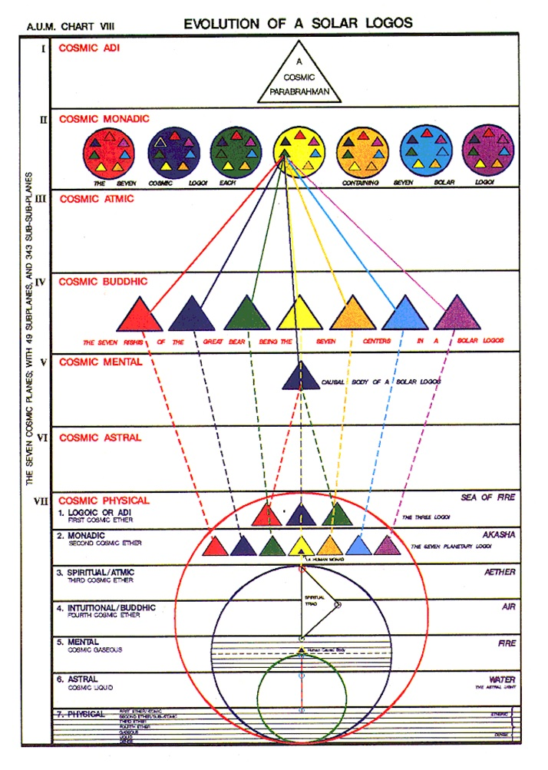
So let's take a quick look, and this Letters on Occult Meditation and we're gonna just go to page 39, hope for the best, there it is monadic plane seven very groups.

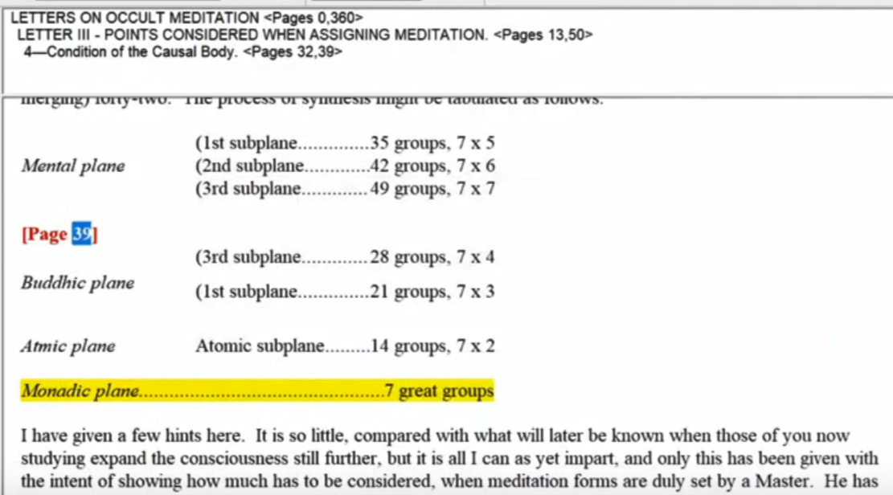

Well, they're not called circles, but to me they are circles, it really makes no difference. And if I were to try to look at this terms of our hierarchy, here they are, circles, here are the three external Buddhas of Activity, and there are three hidden kumaras, and everything is a circle here.

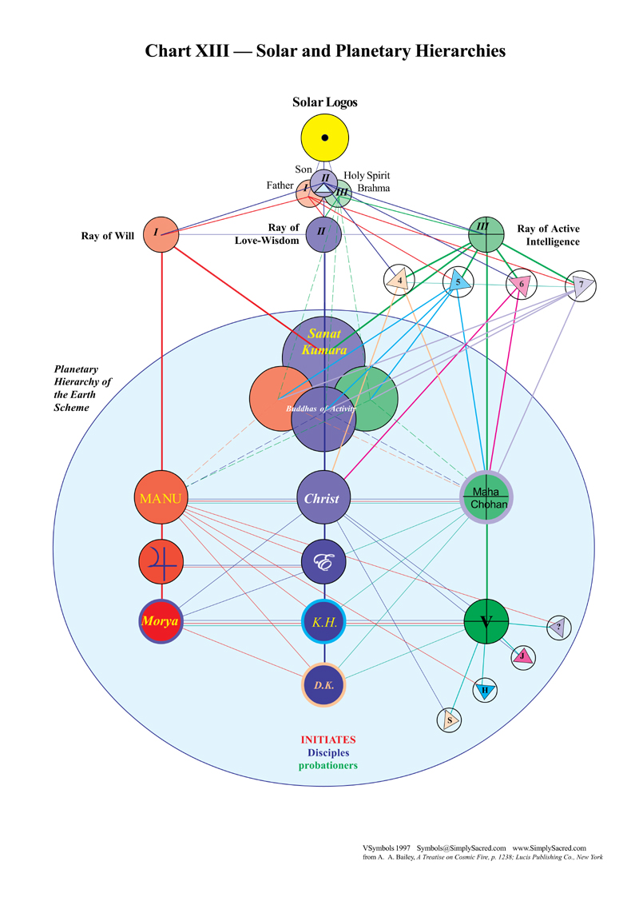

0:37:40 I've often wondered, a little digression here, but there are three beings interlocked the Father, Son, and Holy Ghost and they are in a way responsive to the soul of Louis and I wonder if there are not some kind of analogous grouping to the kumaras around Sanat Kumara. I wonder if there are not kumaras, six of them, around our solar logos. That's just speculation, as to what it is really and when will it be proven if ever? I'll just try to remain alert to the possibility of proof. What will proof be? Will it be logic, will it be a correspondence, will it be an intuition? If it's really going to be proof it has to be direct sight. Has to be intuition or maybe the convincing us of Pure Reason, which is intuitive. Anyway the true intuition doesn't lie and it's not personal.

So, how do we know when we're face-to-face with true intuition? I think it has a very deep salient impact to promise. Yes, it's of a different order, far more superficial than that which reasoning and logic can deliver. But that it, let's get more deeply into the intuition as we become fourth degree initiates and beyond, and let us see what it really feels like, there is a sentiency involved in that kind of touch, and the sentience wiII will make plain the difference between itself and that which logic and reason have delivered earlier in the process.

All right so anyway the Master has a big choice, big choice between the seven, now nine paths. The nine paths, those extra two paths, are not delineated. But, it's interesting that the seven major Pleiades have parents, parent stars, they're called parents, the mother and father of the Pleiades of the Seven Sisters and they're called Atlas and Pleione, and it all works out to a nine, and it's a very, one of my friends says, it's a feminine constellation, and we have to expect that somehow each of the seven paths leading to the Pleiades that as they ultimately do, would go would be focused on one or other of the seven stars, and if we have nine paths that Atlas and Pleione would somehow be included, but then again these are matters that lie before the high initiates, but then they are practical issues involving their destination, and for us they are expected cosmological speculations.

All however prepares the aspirant for right choice through right discrimination leading to right action, and made possible through practiced dispassion. In this sentence is summed up the technique of the warrior upon the battle-field of the desire plane. TWM 230

0:40:00 All however prepares the aspirant for right choice through right discrimination leading to right action and made possible through practice dispassion. There's not a question of just where you feel like going, your impulse to go here or there, rather it is intuitively arrived at with keen deliberation and the emotions don't get in the way.

Now in this case the emotion for the Buddha was this incredible compassion for humanity and the desire to stay with humanity His second ray was really coming out so up on the buddhic plane, does He ultimately have a second ray as the monad called the volatile essence is released from its one of the monadic vehicles. Does it in His case find a place in that second circle or second triangle, and is it really the second ray ultimately? I know I'm going a little far here in the speculation about the monadic ray, but here's the point, the essence of the monad is not any ray, it's pure being and it's sort of the vehicle in which the monad or the volatile essence is contained that determines the ray. So it's not the very essence of the monad that determines the ray, the essence of every monad is absolutely identical, but other types of discrimination have to do with the vehicles and the matter and through which these units of pure being manifest.

So maybe it's possible that the great second ray finally will receive the Buddha even though His monad is said to be on the third ray, in a way that cannot be refuted in A Treatise on Cosmic Fire and the Christ of course, there's no question in being on the right path, it's going to be the second ray at the moment and His demonstration will be through that second circle or triangle.

so All however prepares the aspirant for right choice ah, I notice, my goodness, is the Master also an aspirant in a way? Necessarily so. for a right choicet hrough right discrimination leading to right action, the mind is involved, the ability to tell the difference leading to right action and made possible through practiced dispassion. This practice, this passion, means the vision will not be clouded by extraneous impulse.

In this sentence is summed up the technique of the warrior upon the battle-field of the desire plane. Whoa, it sounds so good. All however prepares the aspirants for right choice, because there is only really one right choice in this return on the way of higher evolution. That's the amazing thing, it's a completely free choice and yet there's only one right choice. So you are free to make the right choice through right discrimination between where these paths lead and what they do, and what's required leading to right action to prepare for the path, and also perhaps serve the arena that you are leaving behind as you prepare for that path remember the sixth degree initiates have been retained by Sanat Kumara, because there's such a crisis here, but they put in there a choice of which path they will take and then help him.

Right action can be directed towards the field you leave behind and right action in terms of the preparation for the path you must tread and made possible through practice, just passion. You don't get swept away by any kind of individual preference. This is something more than that far more in this sentence is summed up the technique of the warrior upon the battlefield of the desire plane. It’s a very Scorpianas statement isn't it? And this is a treatise on the control of the astral body, Scorpionic in this treatise on the astral body, which Lord knows we need to control, it being normally that vehicle which prevents the kind of alignment that we're trying to achieve, especially on this planet which has a planetary logos not yet constantly controlling His own astral body.

It should here be noted that in the steadily developing power of choice, and the loyally fought battle of the astral plane, the consciousness in the man shifts stage by stage. First, it is the battered earth-weary aspirant who has to struggle with desire, with glamour, with ambition and with his sensitive emotional body. He thinks the battle is stupendous but from the wider angle it is relatively small—yet all that He can stand. TWM 230-231

It should here be noted that in the steadily developing power of choice, and the loyally fought battle of the astral plane, the consciousness in the man shifts stage by stage. Everything here is so very important. So loyally fought battle. We we pick up our weapons and we don't relinquish them until the battle is over either ending in our defeat or our victory, and we have this steadily developing power of choice if we choose correctly, it's an act of will. Christ chose correctly in the Garden of Gethsemane, He could've relinquished His adherence to that higher strand of will, that higher impulse of will and everything would have been very different in a negative way for the humanity that followed after. But He chose right in the steadily developing power of choice.

Just look at your own life, your choices become more and more important. At first you have this crisis of opportunity, earlier in life in you're faced with many possibilities, some of which actually will lead to real spiritual development and later you have a crisis of expression. Maybe it's more around the second Saturn return, maybe the first one, crisis of opportunity is more around the first Saturn return. I mean not literally, but in that area, and how shall we then express what we have learned and meditated upon and now understand. How should we do that? Our ways and our memes and are we truly efficient? The third way is involved here with its tendency towards efficiency and it is the ray very much governed by Saturn the planet of choice.

So First, it is indeed, oh boy, it's not humorous, but it is humorous: it is the battered earth-weary aspirant who has to struggle with desire, with glamour, with ambition and with his sensitive emotional body. He thinks the battle is stupendous but from the wider angle it is relatively small—yet all that He can stand. I love this, it's written by someone who's really been through it and that we are passing through it. We're learning the hard way, and I wonder if there's any other way really. It tells us that said if we don't make it part of our experience we haven't really learned, we can't just accept what somebody else says it has to be worked out in our own life.

So the man is shifting this stage to stage, and here the stages are given, the battered, earth-weary, the world is too much with us aspirants who have to struggle with desire leading towards form with glamour distorting and hiding truth with ambition in which he identifies with this little personal self and wants to exalt it, when he's really something much different and much bigger and more essential and with his sensitive emotional body affected by every impact and attracted or driven away and constantly responsive to these impacts.

He thinks the battle is stupendous but from the wider angle that is relatively small yet all that He can't stand and that we can ask ourselves even right now, and we stand we ask ourselves that, and do we think we are engaged in this stupendous battle, are we struggling during the Scorpio phase up to it and through the third initiation, the tests are being applied by Scorpio, even though it's most identified with the second initiation. But physical tests, emotional tests, mental tests, these apply to Scorpio at the different initiations.

Later, it is the experienced probationary disciple who wrestles in the vale of illusion, and deals not alone with his own nature but with the forces of that vale also, recognising its dual nature. Then, the disciple comes forth to battle and faces with courage (and often with clear vision) the forces arrayed against him. They involve not only those in his own nature and in those aspects of the astral plane to which He naturally re-acts, but also involve the forces of illusion arrayed against the group of disciples to which He belongs. Let all disciples take note of this and have it in mind in these difficult and strenuous days. Such disciples are in conscious contact at times with their soul forces and for them there is no defeat nor turning back. They are the tried warriors, scarred and tired, yet knowing that triumphant victory lies ahead, for the soul is omnipotent. Accepted disciples, who battle all the above enumerated factors, plus the black forces arrayed against the Elder Brothers, can call upon the spiritual energies of their group and at rare and indicated moments upon the Master under whom they work. Thus the work and labour expands; thus the responsibility and struggle steadily increases; yet at the same time there is also a steadily growing reception of potencies which can be contacted and utilized and which when correctly contacted insure victory at the end. TWM 231

0:51:00 Later He distinguishes between the aspirant and the probationary disciple later, it is the experienced probationary disciple who wrestles in the vale of illusion, mm-hmm wrong thoughts perhaps, wrong interpretation of impression and deals not alone with his own nature but with the forces of that vale also, recognising its dual nature. So the range of activity is expanded.

Then, the disciple who is more than the probationary disciple comes forth to battle and faces with courage (and often with clear vision) the forces arrayed against him. We might say and they really are arrayed against him.

They involve not only those in his own nature forces and He didn't in His own nature and in those aspects of the astral plane to which He naturally re-acts, but also involve the forces of illusion arrayed against the group of disciples to which He belongs. I'm remembering when Master DK had a kind of necessity of excusing himself in saying, ‘look, I've been involved lately, there's been an attack against my ashram’, I think it was with some kind of thoughtform that was giving good words of mediocre cheer, I think that's how He described it, and it ended up quite severely damaging a couple of disciples. It might have been that, but who knows? Anyway there was an attack on His ashram and He had to deal with it and we as disciples. Hopefully that's what we are increasingly are, have to deal with the forces that are thrown at our group because we are increasingly group-conscious. At least we should be, we're moving beyond individualism and even beyond an excessive concern with individuality. We begin to be able to say I am the group and mean it understand it.

Let all disciples take note of this and have it in mind in these difficult and strenuous days. and this is written back in the thirties, right? Or even maybe He began the book in the late twenties. How far did He get when He wrote this? I don't know, all of that these were given out as lesson sets, and so only later published as complete books, but that was the plan, that they would be completed in books after all the lessons were given. DK wrote with that in mind.

So, what do we have here? Three levels, so far we have the battered aspirants, the more experienced probationary disciple, and the true disciple who may not yet be an accepted disciple.

Such disciples are in conscious contact at times with their soul forces and for them there is no defeat nor turning back. It is the aspirant and the probationer who from time to time turn back, it is said. It is disappointing eventually for them they may not know what they're doing at the time, and it's disappointing for the people around them that would like to see them go ahead. The disciples around them but we outgrow the tendency to turn back these disciples and it's obvious the DK is hoping we number among them.

They are the tried warriors, scarred and tired maybe not scared and tired, it but scarred and tired, yet knowing that triumphant victory Scorpio, right? lies ahead, for the soul the consciousness of the one however attenuated it may be is omnipotent. Hmm, well we have to admit, right, these are encouraging words.

Now, accepted disciples, that's the, let's go back here … I'll just what I'll do is simply:

Accepted disciples and we'll say preceded by aspirants probationers and disciples, who battle all the above enumerated factors, plus the black forces arrayed against the Elder Brothers of course, Master Morya kinda puts it in proportion when He says, ‘you trouble yourself with a few minor demons while the daggers of Satan are aimed at our backs’. I guess that's the Shamballic perspective and we can't handle that, but we can all we can handle and not more, maybe a little more but not much more. We have to stay within the range of our possibilities. So, accepted disciples, that's the fourth group, and He's showing us the stages here, stage by stage. The disciples are having all the above the warfare within and that which is having to do with the environment and with the group plus the black lodge, or those equivalent to the disciple who may be attacking him and are on the black path they, can call upon the spiritual energies of their group and at rare and indicated moments upon the Master under whom they work. Llater in the description of the use of the violet light for defense, this technique will be given in this book.

Thus the work and labour expands; thus the responsibility and struggle steadily increases which is microscopic man, and we think it's a big deal, but it's what we can handle, which is tiny little atoms compared with some beings; yet at the same time there is also a steadily growing reception of potencies which can be contacted and utilized and which when correctly contacted insure victory at the end. So not only the struggle but the energy currents from above which can be used to guarantee victory.

Okay, friends, so this is going to be the end of A Treatise on White Magic video commentary number 5 and it's rules for the astral plane and it's rule 7, and we're calling it 7.5. My next task will be to begin something, it'll be number 6, and it'll be rule 7.6.

Thank you for being here and thinking along with me as we continue our kind of study group experiment here, but as deeply as we can, given the time limitations and the limitations of knowledge and penetration, to help us assimilate what the Tibetan is written as thoroughly as we can before the new dispensation, the third dispensation, is offered from the year 2025 onward.

So, many blessings, lots of love, we'll see you before long when I can, maybe tonight still, I don't know. Let's see what's possible. Bye bye.

