**3 Planetary Centers**

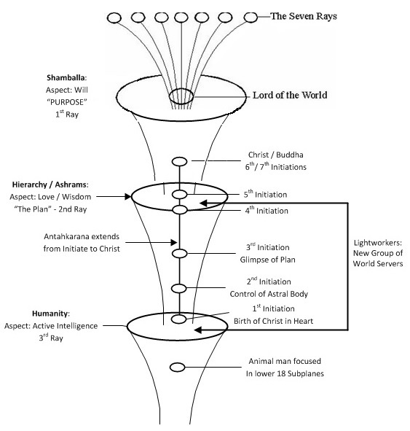

**Rays / Initiations, p. 525**