THE RAYS AND THE INITIATIONS, PART II WEBINAR – 10, Michael Robbins

Abstract

In this tenth program the Tibetan discusses the “Door to the Way of Higher Evolution”. The main emphasis is upon understanding the fact that our seven solar or systemic planes are really subplanes of the cosmic physical plane. The relationship between the cosmic astral plane our systemic astral plane is elucidated. Although the astral plane is not real to the advancing disciple, it is real as a field of service for the Master. The astral plane is the reflection in cosmic physical substance of the cosmic love of the cosmic astral plane. Thus, we learn something about the relativity of the reality of our systemic astral plane. We also learn that glamor arises from focused power wielded under conditions of wrong identification. As long as there is identification with the lower three worlds, there will be glamor. Of interest, as well, is the fact that the buddhic plane is really a fusion of the Divine Love of the monadic plane and the spiritual intelligence of the atmic plane: the fourth arises from the second and third. The three lower systemic planes, from the cosmic point of view of the Solar Logos, are not considered principled.

Contents

Abstract 1
Contents 1
Transcription of Rays and Initiations, II, Program 10, pages 356-359. 1

Transcription of Rays and Initiations, II, Program 10, pages 356-359.

Okay, good morning everyone. I thought at my last program that I had covered this subject of the door to the way of higher evolution, but what I actually had covered is the seven or nine Paths and I did that when I was working in the latter part of the Treatise on Cosmic Fire. Then I gathered what was said in this book and also in Initiation, Human and Solar, and commented on what the Tibetan had to say about all the seven or nine Paths as we are told in this book. There are actually nine Paths: two of which are not really discussed. But I did not do the introduction to this work, so that is what I will now do and when we get to that section when the actual paths are discussed, I have discussed them in great detail, as much as I could of course, and there’s no sense in doing them again, okay. So this is the door to the way of higher evolution. We recall that we had discussed here:

“The other two initiations (vaguely called the Resurrection and the Ascension) are related to the second so-called "door." This door is not in the same sense an obstruction as is the first door; it opens on to the Way of the Higher Evolution. The first door symbolically admits the initiate into the "heart of the Sun," whilst the second door—in a most mysterious sense—indicates the route which must be followed by the liberated initiate who seeks to penetrate to the Central Spiritual Sun—to which all the seven Paths eventually lead.” RI, Page 356

The other two initiations (vaguely called the Resurrection and the Ascension)… the resurrection as it is usually considered following the crucifixion … are related to the second so-called "door." This door is not in the same sense an obstruction… not, well maybe this is in the same sense. Of course you have to make the proper decision and you have to be fit to tread this path it’s … not in the same sense an obstruction as is the first door; it opens on to the Way of the Higher Evolution. According to one's choice. The first door symbolically admits the initiate into the heart of the sun which is as I discussed, this is the soul nature of the solar Logos and how that soul nature reflects on our planet and leads into the Hierarchy … whilst the second door—in a most mysterious sense… a sense that we cannot really fathom at our stage of evolution … indicates the route which must be followed… only followed … by the liberated initiate… and this is at this time an initiate of the 6th degree … who seeks to penetrate to the Central Spiritual Sun… is this the Monadic nature of the solar Logos or is this actually the hub of the wheel, the Pleiades around which our solar system and other related solar systems are said to revolve? And maybe more systems than that … to which all the seven Paths eventually lead. So one suspects that these seven Paths - it cannot be the central spiritual Sun in the sense of the monadic nature of our solar Logos. It has to actually be rather the central constellation, that cluster of stars, a great Being to which all the destinations of the other seven Paths are secondary. Of course these are high matters and maybe more will be said. You know we just need in a way kind of a vague notion of where it all leads at least in terms of our solar system and local cosmosphere. We realize that the figures that scientists give us today about the duration of the solar system or the duration of the universe may one day be compared with the tiny figures that we have been given by let’s say the bible on the duration of man and the creation of the world. Something like, what was it said to be created in 4004 BC, something of that nature? You know maybe the whole universe was 6,000 years old; tiny figure dwarfed by later discoveries.

5:04 So in fact it may be so that the duration of the universe will be revealed as much greater than had been previously anticipated, something like what’s anticipated today, something like 15 billion years. I mean you can’t even talk in those terms according to occultism in the solar systemic sense. Of course the solar systemic duration is considered on the subtler planes as well. And that is not the case with the duration of the universe as modern science conceives it today.

Anyway, I think it takes a long time to reach the central spiritual Sun. There are many mysteries concerning time and space of which we have no notion but we know that in the philosophical sense they are illusory but in the practical and actual sense they are mayavic and we have to deal with them repeatedly, cyclically forever.

So then this section: Rays and Initiations Part II Program #10, I will continue then beginning page 356.

“The Door to the Way of the Higher Evolution <Pages 356,366>

I write not for those initiates who have taken the third initiation, whose personality is soul-dominated and who "walk ever in the light." It will therefore be obvious that there is relatively little that I can say at this point which will be comprehensible, as far as the true meaning goes, to you who have not as yet achieved that state.” RI, Page 357-358

The Door to the Way of the Higher Evolution. I write not for those initiates who have taken the third initiation, whose personality is soul-dominated and who "walk ever in the light." No longer confounded by illusion or misled by glamour or wrongly impulsed by maya. Interesting you know, this is a difficult book you know, no question about it and there are some who claim to have taken the 3rd degree who would be utterly bewildered reading this book or which in a sense is a proof that those who claim a true initiation, by the very claim deny the possibility of the truthfulness of that claim. It will therefore be obvious that there is relatively little that I can say at this point which will be comprehensible,… because he's writing for us who have not taken the 3rd initiation. …as far as the true meaning goes, to you who have not as yet achieved that state. And of course he was talking to those in his ashramic group; he was writing for a particular group of disciples who had remained with him.

“The key to your understanding lies in the realisation that our seven planes are only the seven subplanes of the cosmic physical plane, and that all that now transpires in the life of the initiate simply releases him from physical experience (technically physical, even on the atmic, monadic and logoic planes), into that vortex of force which we know and understand as LOVE, or onto the cosmic astral plane.”

The key to your understanding lies in the realisation that our seven planes… seven systemic planes, they are either called solar or systemic … are only the seven subplanes of the cosmic physical plane… and you know I think we can see that. Here’s an enlarged picture.

But these 7 systemic planes are really only the 7 vibratory levels really 49, really 343 actually of sub-subplanes, 343 vibratory levels of the cosmic physical plane … and that all that now transpires in the life of the initiate simply releases him from physical experience (technically physical, even on the atmic, monadic and logoic planes)… technically physical or at least etheric, but etheric is always considered physical anyway … into that vortex of force which we know and understand as LOVE, or onto the cosmic astral plane. So even though the cosmic astral plane is somehow home to those evil entities who are responsible for cosmic evil, it is also the great center of a kind of love that we can barely conceive, although the Christ is mediating to us that love because he has the touch of the cosmic astral plane.

10:17 And I suppose the question is once you’ve taken the 7th initiation, well certainly you are in touch with the cosmic astral plane, can you “go there”? We know that by the 9th initiation, one certainly can and maybe by the 8th which is called Transition. It’s transition onto the cosmic astral plane without necessarily refusing contact with the cosmic physical plane. So the true love is found on the cosmic astral plane.

“The note, the quality and the influence of the cosmic astral plane is love—the higher correspondence of emotion as experienced upon the astral plane of the planetary or solar manifestation. It is therefore to be realised that the Hierarchy is definitely under the impact of energies emanating from the cosmic astral plane, whilst Shamballa reacts to influences coming from the cosmic mental plane.” RI, Page 356-357

The note, the quality and the influence of the cosmic astral plane is love… okay, this is a high thought … the higher correspondence of emotion as experienced upon the astral plane of the planetary or solar manifestation. According to the great Law of Attraction this love will operate and we've already seen, have we not, that love is different from the magnetism that can be utilized by the brother of the shadow who is using the love petals of the Egoic Lotus. Love, true love and that magnetic power which he can use, along with the considerable knowledge which is not yet wisdom, these are found in the Egoic Lotus but they are not true to their higher correspondences. Real love is something else and real wisdom is something other than knowledge.

It is therefore to be realised that the Hierarchy is definitely under the impact of energies emanating from the cosmic astral plane, whilst Shamballa reacts to influences coming from the cosmic mental plane. This is such an important statement and unless one is careful about this, one can overlook what is necessary. So maybe from the time one reaches the cosmic ethers, the influences of the cosmic astral plane will be felt and the members of Hierarchy are polarized upon the cosmic ethers. We know how average man has an etheric body largely subject to or open to carrying astral energy. And you kind of wonder whether you know, the average initiate of the Hierarchy has a cosmic etheric body open to the energies of the cosmic astral plane. Sort of a correspondence there, kind of a parallel.

“The related stream of energy can therefore be seen to be from:
1. The cosmic astral plane.
2. The solar buddhic plane, reflected in our planetary buddhic plane.
3. The astral plane, the plane of glamour in the three worlds.” RI, Page 357

The related stream of energy can therefore be seen to be from:
1. The cosmic astral plane.
2. The solar buddhic plane, reflected in our planetary buddhic plane. Okay it is the same level, it is the 4th solar plane.
3. The astral plane, the plane of glamour in the three worlds.

So you kind of wonder what kind of cosmic glamour may be all about because if the cosmic Black Lodge has a significant focus on the cosmic astral plane, they must be subject to cosmic glamour - that's the source of cosmic evil. Now I think we may have left out in a sense the monadic plane. All of these I think are along a Neptunian line. Every one of them has some sort of a connection with the planet Neptune and we have an entity that embodies the cosmic astral plane. We’re not given the name of that entity who embodies the solar astral plane but we are told that Varuna embodies the planetary astral plane. Let’s just say that the planetary Logos has a buddhic vehicle which is part of the solar buddhic plane and that somehow, this solar buddhic plane runs throughout the solar system and the various planetary Logoi participate in it according to their own limitations and ring-pass-not. And then the astral plane, okay.

“In relation to the mind, you have:

1. The cosmic mental plane.
2. The solar atmic plane, reflected in our planetary atmic plane.
3. The mental plane, the plane of illusion.” RI, Page 357

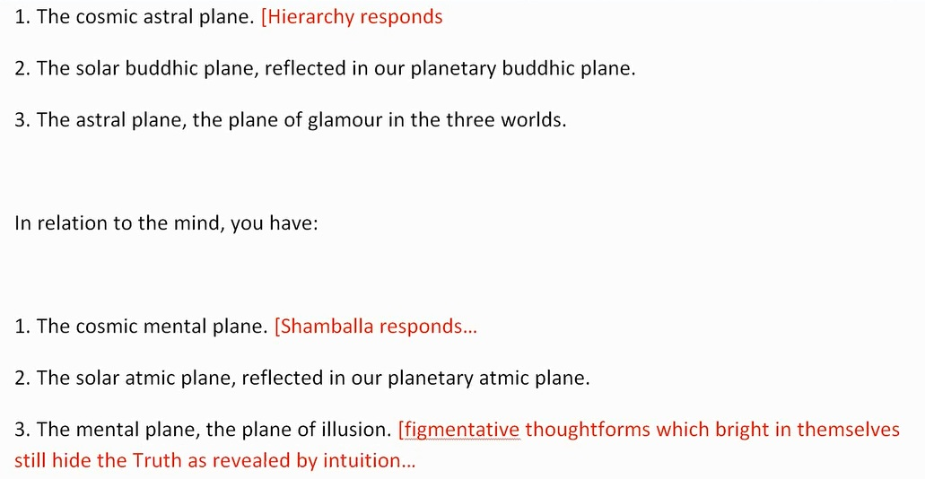
15:18 In relation to the mind, you have:

1. The cosmic mental plane. We remember that, how is it said here, Shamballa is responding to the cosmic mental plane. So let’s just say here (1. The cosmic astral plane) Hierarchy responds, and here for (1. The cosmic mental plane) Shamballa responds. The solar atmic plane reflected in our planetary atmic plane and then our planetary atmic vehicle. When he talks about planes here you kind of wonder whether he's not really talking about vehicles and then 3. The mental plane, the plane of illusion… of figmentative thoughtforms which bright in themselves still hide the truth as revealed by intuition.

Okay so we have Hierarchy responsive to the cosmic astral plane and there the Christ is located, though he is also a member of Shamballa and we have Shamballa where the Buddha does focus at this time, responsible for the cosmic mental plane. And interestingly enough, the atmic plane is very much associated with the Buddha because it’s called the Nirvanic plane and maybe we might say that the first stages of nirvana, as there have to be many stages, the first stages of nirvana occur in relation to the atmic plane.

“In connection with the references to glamour and illusion, (see Glamour: a World Problem) it must be borne in mind that the reason glamour predominates and illusion functions in the three worlds is due to the fact that men identify themselves with the dense physical brain, and interpret life in terms of experience in the three worlds.” RI, Page 357

In connection with the references to glamour and illusion, (see Glamour: a World Problem) … there, of course, the many kinds of glamours are described and their impulsive nature, what they incline a man towards and the seven types of illusion to which we may be prone especially between the 2nd and 3rd initiation before so many of them are cleared up at the 3rd degree. In connection with the references to glamour and illusion,. . . it must be borne in mind that the reason glamour predominates… certainly on our planet at this time and illusion functions in the three worlds, it’s not yet the type of error which affects the greater number; glamour does so … that the reason glamour predominates and illusion functions in the three worlds is due to the fact that men identify themselves with the dense physical brain, and interpret life in terms of experience in the three worlds. Of course, physical brain has to receive the higher energies as well but it does have perceptual limitations and it presents reality in a way which is far different from the actual state of that reality or from the manner in which that reality is perceived by those who are functioning without the limitations of the physical brain. Then comes these difficult matters you know.

“There is no true astral plane, from the angle of personality identifications, but only what might be regarded as the figments of the imagination; yet fundamentally and sub-standing what we know as the astral plane is the reflection of the cosmic principle of love.” RI, Page 357-358

There is no true astral plane, from the angle of personality identifications, but only what might be regarded as the figments of the imagination… I’ve often contended or at least believed that there must be, where the astral plane is, a range of atomic substance of various vibratory frequencies which is the bridge between such atomic vibration on the etheric level and atomic vibration on the mental level. 20:06 But basically, when we’re talking about our astral plane, we’re talking about the kinds of forms which the human imagination has created in that vibratory field. We’re not talking about the vibratory field itself, it’s more that which has been formed by the exercise of the human imagination and which is for the most part, illusory. Well, glamours; well untrue okay. There is no true astral plane, from the angle of personality identifications… maybe higher beings will be able to work within that particular field and we're not dealing, as far as they are concerned, with personality identifications … but only what might be regarded as the figments of the imagination… is it only human imagination or is it the imagination of others as well? It could well be … yet fundamentally and sub-standing what we know as the astral plane is the reflection of the cosmic principle of love. I mean it’s not a cipher. There is something there that has to be a range of vibratory activity which connects the two dimensions of vibratory activity which stands so to speak on either side of the astral plane. So the astral plane is meant to be the reflection of cosmic love and we also learn that at the 2nd initiation, the principle of love as related to Neptune, Jupiter, Venus must be increasingly expressed on that vibratory level we call the astral plane. And many of the are glamours dissipated; those illusory, wrongly impelling forms must be dissipated. But anyway D.K. is connecting the cosmic astral with our astral here, so the cosmic astral plane is connected with our astral plane if the astral plane is serving its true function, okay.

“However, being essentially a reflection, it lacks basic reality from the angle of the true disciple and must be ignored as an expression of fundamental truth; at the same time, the astral plane exists from the angle of the Master, because it is an expression in dense physical cosmic substance of cosmic love.” RI, Page 358

However, being essentially a reflection, it lacks basic reality from the angle of the true disciple… so you know the question will come up, is there actually this dimension, the atoms of which have a certain vibratory frequency? You know, common sense seems to say there must be, but D.K. talks about a basic reality which it seems to lack so we’ll have to try to understand that. However, being essentially a reflection, it lacks basic reality from the angle of the true disciple… apparently not just the probationary disciple … and must be ignored as an expression of fundamental truth… this is so important because although there are phenomenon and the psychic will of course perceive these things, the sensitive person will perceive these things, fundamental truth is not there to be found. I think we have to get into the cosmic ethers before fundamental truth will be found … at the same time, the astral plane exists from the angle of the Master, because it is an expression in dense physical cosmic substance of cosmic love. Well there we have it. It's definitely existent even though the disciple in his search for truth will not look there. So the Master finds that it does exist because it is a type of substance which is correlated with the substance of cosmic love found on the cosmic astral plane. So a type of substance does exist and the Master realizes its correlation with the substance of cosmic love. That is such an interesting phrase because there are some times when we think the idea of substance, we think well this has to be material you know, this has to relate to physicality or dense physicality like we used that phrase.

25:06 Well what kind of substance are you going to use? You use it in the chem lab you know, you use it when we're dealing with matter of various kinds. What kind of substances are in that formula, we say. But that's a very physicalized, a very dense sort of use of the word. That which substands is substance, it may be subtly material. Is it, in fact, essentially material? The great non-substantiality substands all and yet is substance. Well alright, these are philosophical issues to be worked out, sort of a philosophical physics. Those two things have to come together to work out what's actually happening here. So it is an expression in dense physical cosmic substance of cosmic love.

Now what is dense physical cosmic substance? And let’s just say the lower 21 subplanes are dense physical cosmic substance. So the dense physical body of the solar Logos consists of the lower three solar or systemic subplanes. Each one of them sevenfold or forty-nine-fold and that is dense physical cosmic substance. So our usual astral plane is within dense physical cosmic substance.

“Its potency is, however, so great that it produces glamour in those who are not yet liberated. Students should remember that focussed power produces glamour where wrong identification is involved, but only reality and truth where there is freedom from the factor of form life.” RI, Page 358

Its potency is, however, so great that it produces glamour in those who are not yet liberated. We know why you know, in our solar system, our solar Logos is astrally polarized; our planetary Logos is still astrally polarized even more so and has more struggles yet than the solar Logos has, so he has liberated himself to a certain extent. So we who are not yet liberated in terms of the 4th degree are subject to the type of turbulence occurring within the astral plane in the dense physical body of our planetary Logos. As a matter of fact, our planetary Logos has a lot of trouble we’re told even on the cosmic astral plane in this cosmic astral body and this I’m sure is reflected in the condition of that astral body or astral plane which is part of his dense physical cosmic substance.

So we're dealing with the astral plane with a level of subtle nature which is extremely powerful in the solar system and on our planet and it is a great struggle for us to overcome its glamour producing tendencies. Because you know, our planetary Logos himself is still subject to glamours. He’s only a cosmic initiate of the 1st degree. Well of course you know, what does that mean? We say he is only and yet he is a stupendous God you know, unfathomable from our point of view. Yet if you make the analogy, the human being who is an initiate of the 1st degree or probationary initiate of the 1st degree is still mightily subject to glamour. So if the analogy holds good, it will be between the 1st and 2nd initiation that the planetary Logos has to clear his glamorous astral body, cosmically glamorous astral body, just as the human being between the 1st and 2nd probationary initiations has to clear his astral body of the majority of glamours which afflict. So anyway, a very potent astral plane which hides the truth from us or let’s just say, conditions of the systemic astral plane to which we have contributed and to which the black lodge has mightily contributed, stop our perception of the higher reality. So we are drowning in glamour and we are impelled by false emotions which lead in directions other than those the Plan wishes or seeks to manifest.

30:40 Students should remember that focussed power produces glamour where wrong identification is involved, but only reality and truth where there is freedom from the factor of form life. So, D.K. is actually telling us that wrong identification is slavery to the factor of form life, really. And right identification is freedom from the factor of form life. So who are we really? You know, if we think the other form, we are still the slave to that type of wrong identification; we’re the slave of form. If we think we are the form, we are the slave of form through wrong identification. So all of our work in raja yoga whereby we abstract from our ordinary perceptions whether on the dense physical plane or anywhere within the dense physical body of the planetary or solar Logos as we abstract from those, we increasingly identify correctly and we are no longer subject to the factor of form life. So if we have a lot of power and our consciousness is benighted, that is going to produce glamour. Let’s just say power wrongly directed with an ignorant consciousness produces glamour.

“Therefore, temporarily, there is no astral plane for the disciple who is withdrawing identification; there is a field of service for the Master Who has no longer the power to identify His consciousness with anything in the three worlds; He can, however, relate cosmic sources with planetary and solar expressions of energy.” RI, Page 358

Therefore, temporarily, there is no astral plane for the disciple who is withdrawing identification… this is so clarified but again we’re told that for the Master, there is. So sometimes we you know glibly say well, there is no astral plane but we have to remember that for the Master, there is an astral plane as the reflection of the substance of cosmic love within the dense physical vehicle of the solar Logos: an expression in dense physical substance of cosmic love. Well of course, cosmic love is also a substance but the way it’s used here, cosmic love is not spoken of as substantial, though it is; its dense physical cosmic substance that is referred to. I think I earlier referred to the substance of cosmic love which is philosophically correct but that’s not how it's being used here. Therefore, temporarily, there is no astral plane for the disciple who is withdrawing identification… he is just indifferent to it, he is not focused upon it but … there is a field of service for the Master Who has no longer the power to identify His consciousness with anything in the three worlds… so when we say to ourselves well, what do you think you are? If our answer has to do with anything in the three lower worlds we are certainly still subject to wrong identification. So basically, what D.K. is saying here is that wrong identification plus power is producing glamour.

34:29 He can, however, relate cosmic sources with planetary and solar expressions of energy. And the Master is subject to cosmic love, it enters the Hierarchy and there will also be forms of planetary and solar energies to which this cosmic love can be related. So it’s really interesting that no astral plane for the disciple and yet the astral plane exists as a field of service for the Master, well also for some disciples who have managed to correct identification. So no astral plane for the disciple but an astral plane as a field of service for the Master and for the disciple who has achieved correct identification, maybe following the 3rd initiation. D.K. is going into matters very, very deeply here we see and he is maybe clarifying some of our misapprehensions about the so-called facts of occultism.

“As we study the whole subject of initiation and the advanced initiations, it will be found necessary to remember always the relation of our seven planes to the cosmic range of planes. It is necessary also to bear in mind a fact oft forgotten, but which has been known and taught ever since modern occultism began to influence human thinking: the four planes which connote the highest possible spiritual influences, as far as humanity is concerned, are only—in the last analysis—the four etheric subplanes of the cosmic physical plane.” RI, Page 358

As we study the whole subject of initiation and the advanced initiations, it will be found necessary to remember always the relation of our seven planes to the cosmic range of planes. And that’s an interesting statement, it will be found necessary, I’m going to highlight that and I’ll show you what I think he means by the cosmic range of planes.

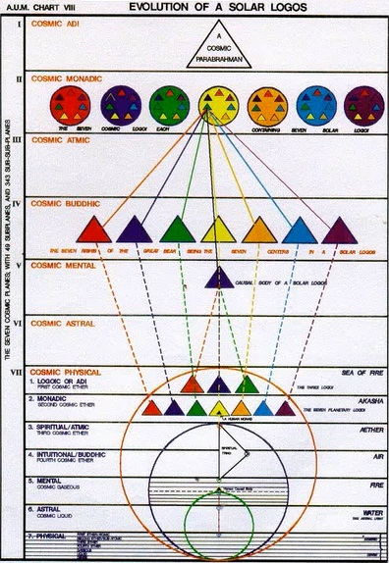

And here on Page 344 of Treatise on Cosmic Fire we see though not depicted in detail, the cosmic range of planes. The seven cosmic planes with only the cosmic physical plane represented in any kind of detail. Obviously, these other planes would have their own type of detail which would be found therein. But it would not serve us to know too much about it though we can infer through analogy.

As we study the whole subject of initiation and the advanced initiations, it will be found necessary to remember always the relation of our seven planes to the cosmic range of planes. He talks about them from time to time, gives us some hints about the cosmic mental plane, cosmic astral plane. He mentions the cosmic buddhic plane and I’m not sure he actually mentions cosmic atmic, cosmic monadic and cosmic logoic planes. Maybe we can see if he does. Yes, here it is: The Jewel in the Lotus, the cosmic atmic plane. That is mentioned (EP II, 344).

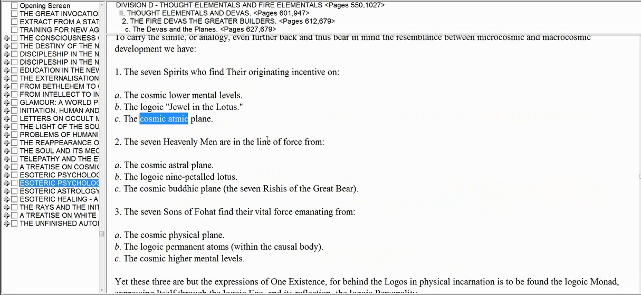

b. The logoic “Jewel in the Lotus”, c. The cosmic atmic plane… that is mentioned, okay. And later in the book all of these has been I pronged through this as carefully as I could in a written matter but that of course was some years ago and probably I would know more now if I would to re-attempt it in one of these video books.

[Back to RI, page 358]

It is necessary also to bear in mind a fact oft forgotten, but which has been known and taught ever since modern occultism began to influence human thinking… Notice it's a modern occultism and it began to influence human thinking, we can say as a result of H.P.B. … the four planes which connote the highest possible spiritual influences, as far as humanity is concerned, are only—in the last analysis—the four etheric subplanes of the cosmic physical plane. And all of our initiations, maybe except for the 9th, well the eighth and the ninth, they are in their own particular category. They have to do with focalizing our consciousness upon the cosmic ethers. I mean, I shouldn’t have said all of our initiations because I really should begin with the 4th: 4, 5, 6, 7. Those initiations have to do with focalization within the four cosmic ethers.

“These highest planes of our planetary life are, therefore, the source of all energy and all originating activity in our entire planetary expression and experience. These four planes are (as you already know):

1. The highest plane...Logoic plane...Will
(Adi) Life 1st aspect
2. The monadic plane...Universal...Love
Human monads 2nd aspect
3. The atmic plane...3rd aspect...Intelligence
4. The buddhic plane...Pure reason...Intuition” RI, Page 358

39:48 These highest planes of our planetary life are, therefore, the source of all energy and all originating activity in our entire planetary expression and experience. So you know usually, when we think of the relationship of an etheric body to a physical body and the expression is within the physical body and upon the physical plane, and basically within the dense physical vehicle of the planetary and solar Logos, but it’s the cosmic ethers which provide the energy and the impulse and the formative power for what transpires in the dense physical body of the planetary and solar Logos.

So the cosmic etheric planes provide the energy and impulse for that which manifests within the dense physical vehicle of the planetary Logos and solar Logos. You know sometimes I have questioned whether you know the dense physical vehicle of the planetary Logos involves only 18 of our normal subplanes and not the higher three planes on the mental plane. That is not yet decided in my mind. But certainly the dense physical body of the solar Logos is comprised of the 21 lower subplanes and does include the three higher subplanes of the mental plane, definitely. Okay, moving on.

These four planes are (as you already know):
1. The highest plane...Logoic plane... where we have … Will… as it is expressed on the cosmic physical plane. It’s called the plane of (Adi) Life… I guess it means number one or … 1st aspect and relates to life. It’s a great source of etheric vitality as it can be experienced cosmically, physically. It’s the … 1st aspect and yes, you kind of wonder whether the etheric head centers, you think they are, I think they are, the etheric head centers of the solar Logos are found on this plane.

2. The monadic plane... it's called Universal... that means it has also to be related to Aquarius. It’s the plane of Love and Human monads are found here and probably deva Monads as well and it relates to the 2nd aspect… and I believe that a kind of solar Logoic heart center is found on this plane, the monadic plane. Now you know it’s still up in the air as far as I'm concerned whether when we're talking about the etheric head centers of our planetary Logos, whether they will be found on the logoic plane or the monadic - I mean whether it’s necessary to shift planetary logoic manifestation on the cosmic physical plane down one cosmic subplane. I’m still uncertain about that. I’ve seen it both ways. You know what I'm basically talking about here and I have mentioned it before, is that just as you see that for the human being is on various planes, we have chakras: Head chakra, the heart chakra and the throat chakra, and also all the others in the ethers.

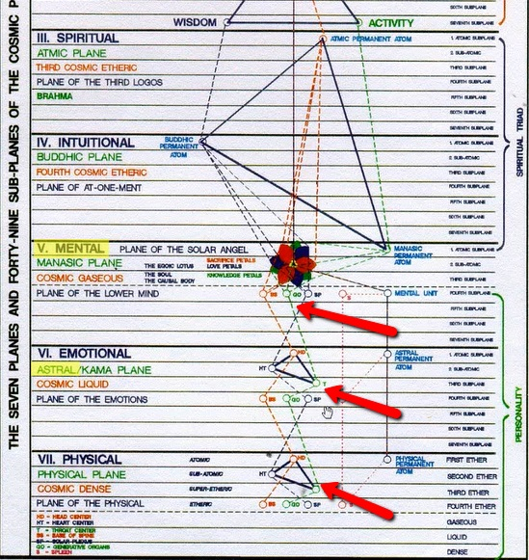

And we have them in the astral ethers and eventually, we will have them in the mental ethers, and probably we have them in the etheric component of all of the planes here just as that is possible. But especially looking at the etheric planes, we have to consider that the logoic plane is going to be the first correspondence of the first ether of the solar Logos and maybe the planetary Logos as well, there is much to be worked out there. But if the head center and probably the ajna center are found on the etheric physical plane, at the atomic level, well this whole thing [see diagram below] is the atomic level of the solar Logoic etheric body and so his etheric head center will be found here and probably etheric ajna center as well.

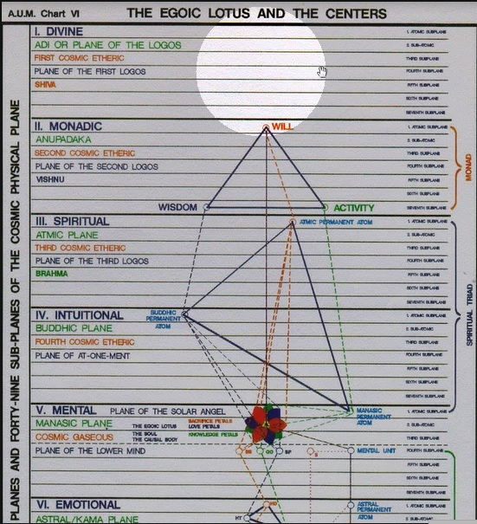

45:06 Maybe the etheric head center is found on one of these subplans [of the Logoic plane]: and the etheric Ajna on a lower one [logoic subplane]. And his esoteric heart center will be found here on the Monadic plane:

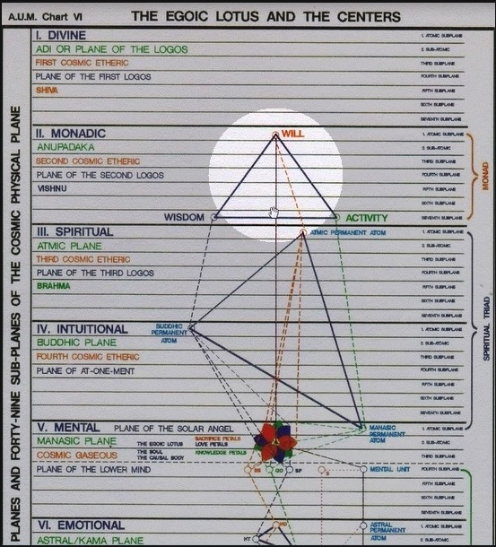

And esoteric throat center will be found on the Atmic or Spiritual plane:

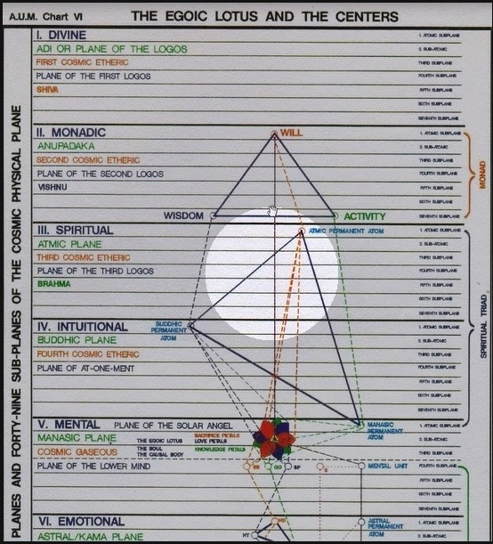

And all of his lesser chakras will be found on various levels of the buddhic plane which is still a cosmic etheric plane:

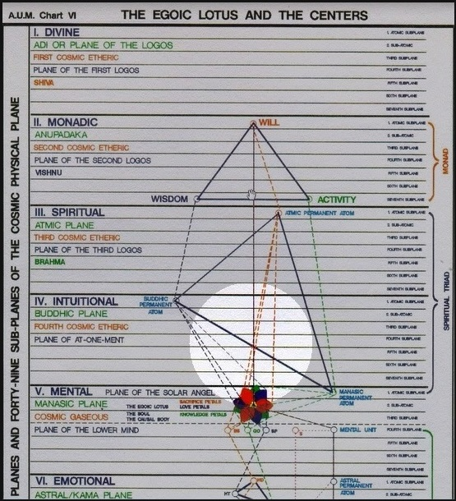

So that’s what I’m getting at when I discuss the etheric heart center of the solar Logos. So the monadic plane which is universal in its appreciation and which allows us to begin perceiving our local universe which is the solar system. Remember the word universe can relate to a solar system. It relates to love and 3. The atmic plane...3rd aspect... relates to … Intelligence… and the throat center of the solar Logos will be found there. Now you know, the alternative to this when considering the planetary Logos is would the head center of the planetary Logos be found on the monadic plane? Would the heart center then be found on the atmic plane? Would the throat center be found on the buddhic plane? Well, all of the other centers be found on the higher mental plane? And you know there’s probably an obvious answer to this. One thing that makes me want to have the head center of the planetary Logos on the logoic plane is the idea that that is where Sanat Kumara holds court and that is the dimension to which the 7th degree initiate rises. So is he see rising then somehow beyond the head center of the planetary Logos as he rises to that point. That doesn't seem quite to make sense, okay.

47:27 4. The buddhic plane...Pure reason...Intuition… now although intuition is deeply related to love, it is considered to be distinct from love or universal love. So they are deeply related. When we study the intuition as we do when we read Glamour: A World Problem and maybe you know around Page 3 or so, how is the intuition described?

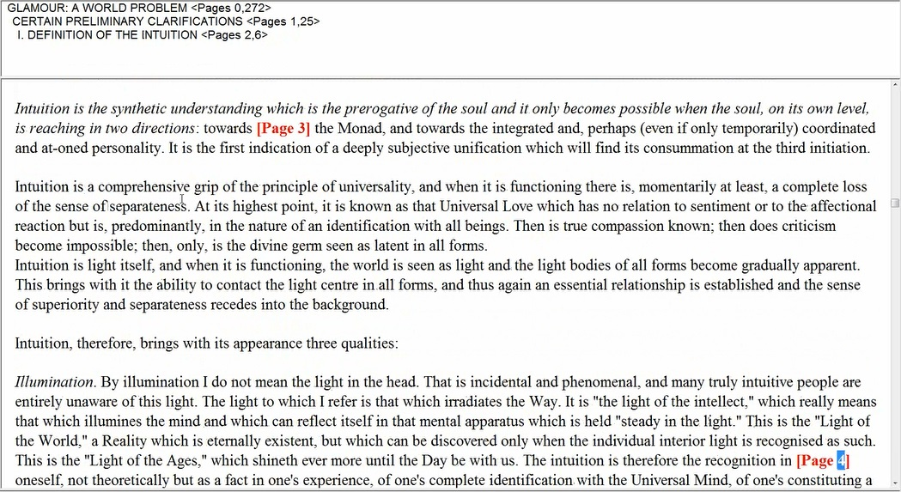

“Intuition is the synthetic understanding which is the prerogative of the soul and it only becomes possible when the soul, on its own level, is reaching in two directions: towards the Monad, and towards the integrated and, perhaps (even if only temporary) coordinated and at-oned personality.” GAWP, Pages 2-3

Here it is, this is what I was talking about.

“Intuition is a comprehensive grip of the principle of universality, and when it is functioning there is, momentarily at least, a complete loss of the sense of separateness. At its highest point, it is known as the Universal Love which has no relation to sentiment or to the affectional reaction but is, predominantly, in the nature of identification with all beings. Then is true compassion known; then does criticism become impossible; then, only, is the divine germ seen as latent in all forms.” GAWP, Pages 3

Intuition is a comprehensive grip of the principle of universality… notice the term ‘universal’ was used in relation to the monadic level so the intuitive monadic level are deeply connected … and when it is functioning there is, momentarily at least… probably it doesn’t always function … a complete loss of the sense of separateness. At its highest point, it is known as the Universal Love which has no relation to sentiment or to the affectional reaction but is, predominantly, in the nature of identification with all beings.

“Then is true compassion known; then does criticism become impossible; then, only, is the divine germ seen as latent in all forms.” GAWP, Page 3

That really strikes me … criticism become impossible… in the area of universal love you know, the 3rd ray can be very critical, that is one of its problems and Monads on the 3rd ray have to somehow resolve upon the 2nd ray Monad. So notice again our chart, intuition and universal love, or universal and love.

“1. The highest plane...Logoic plane...Will
(Adi) Life 1st aspect
2. The monadic plane...Universal...Love
Human monads 2nd aspect
3. The atmic plane...3rd aspect...Intelligence
4. The buddhic plane...Pure reason...Intuition” RI, Page 358

So it’s as if that highest point of intuition is appreciated on the monadic plane, and we could say could it be that the highest point of intuition on the cosmic physical plane is appreciated on the monadic plane? Could it be? It seems a possibility.

49:59 So pure reason is one thing but it’s not the highest form of love. And intuition at its highest point of intuition … it is known as the Universal Love which has no relation to sentiment… we really need to get into the Monadic consciousness in order to appreciate this … has no relation to sentiment or to the affectional reaction but is, predominantly, in the nature of identification with all beings. Then is true compassion known… well it’s known on the buddhic plane too but apparently on the monadic plane even more so … then does criticism become impossible; then, only, is the divine germ seen as latent in all forms. Because after all that divine germ is Monad and maybe one has to be a Monad to see a Monad. So I think hints are interesting. You can read a section over and over again and it is not a hint for you. And then suddenly you read it on another day, another year, whatever, and it becomes a hint for you because you’re ready to see that which it indicates. Suddenly this is a big hint for me. Alright so there is this connection to the monadic plane.

“This 4th or buddhic is a fusion of 2 and 3, of love and intelligence, and produces understanding and intuitive perception.” RI, Pages 358-359

I’m just amazed at how I had never before understood this in the way I seem to be understanding it now. So the qualities of planes 2 and 3 are somehow reflected here. This 4th or buddhic is a fusion of 2 and 3, of love and intelligence, and produces understanding and intuitive perception. Sometimes people say what is the 4th ray because all rays have to be combined of the first three and I think I can justify that it’s a combination of 2 and 1. But when you look at something like this you can see how the combination of 2 and 3 makes a lot of sense. The intelligence of the atmic plane and the understanding of the love of the monadic plane produce understanding and intuitive perception. Well that’s really worth contemplating. And you know we understand that intuition is not just a mental thing, it involves love. It’s not just a loving thing, it involves mind as well. Oh I’m amazed that richness of this book, Mary Bailey called it her bible. You know I was arrested at that moment. My attention was arrested when she said that, “Oh the Rays and Initiations, that’s my bible.” And maybe I was not at a point where I could appreciate that because I was so much into studying the rays in a more technical manner without the expansive and deep wisdom coming in in this book. Well look, we have a little more time I just want to limit this to a 1-hour Program.

“All influences and energies, therefore, which are prevalent in our planetary existence, flow through and create the four above-mentioned planes and thus determine the nature of the evolutionary process at any given time in the three worlds.” RI, Page 359

So these energies are not only coming from the cosmic etheric planes but originate beyond them and create them. So they come into our planetary existence from sources beyond the cosmic physical plane, obviously.

“From the standpoint of a Master, the four planes are composed of forces which are basically responsive to, and finally conditioned by, the energies wielded by the Hierarchy and directed by Shamballa.” RI, Page 359

54:45 This is the Hierarchical and Shamballic lives work in these types of energies and direct them. So from the standpoint of a Master, the four planes are composed of forces. Well we could have said energies but when we’re talking about impact upon a lower plane we oftentimes use the term force … composed of forces which are basically responsive to, and finally conditioned by, the energies wielded by the Hierarchy and directed by Shamballa. I mean words are not used inconsequentially, why is the word ‘wielded’ used in relation to Hierarchy and the word ‘directed’ used? I mean you can use a thing without necessarily directing it. So Shamballa has the higher function of directing and Hierarchy of using, wielding is using in a certain sense.

“In a peculiar manner, and under the Law of Correspondences, the three lower planes—mental, emotional and physical—constitute the three dense physical subplanes of the cosmic physical plane and are not, consequently, regarded as embodying principles.” RI, Page 359

So we can say that the solar Logos certainly has no principles on the lower 21 subplanes. And my ongoing question is does the planetary Logos have any principles on the lower 21 subplanes? Or does that planetary Logos have some sort of etheric principle on the higher mental plane or subplanes?

“H.P.B. says, in connection with our physical plane (the lowest subplane of the cosmic physical plane), that it is not a principle, and this holds good also for the greater whole.” RI, Page 359

H.P.B. says, in connection with our physical plane (the lowest subplane of the cosmic physical plane), that it is not a principle… and you know this is an analogy here … and this holds good also for the greater whole.

“The dense physical plane is matter conditioned by a previous solar system, and is almost automatic in its response to etheric energies; these constitute the etheric bodies of all forms created out of this "unprincipled substance," as it is occultly called.” RI, Page 359

And well you know the dense physical body as a whole of the solar Logos may be involved in this origin from the previous solar system as all dense physical bodies are. We can't just look at the minerality of our dense physical body and say that the liquidity and the gaseous nature of our dense physical body are not densely physical; they all are and they’re all related to the previous solar system. So would it not be so for the solar Logos when considering his own dense physical body? The liquidity you know, our systemic astral plane and the gaseousness, our systemic mental plane would all be related to this previous solar system. At least this is my hypothesis at the moment. Hypothesis that even the solar systemic astral plane and solar systemic mental plane are also related to the previous solar system. I hope the analogy held up, because what is density for us? It is solid, liquid, gas that is all physical for us. It’s not etheric so the etheric physical, the astral and the mental are solid, liquid, gas for the solar Logos certainly and for the planetary Logos as well still leaving the three higher subplanes of the mental plane out of consideration, we have to fathom them more completely.

Alright well, I think we have reached as far as I want to go right now so this is the end of Rays and Initiations Part II Webinar Commentary Program #10 and we started at 356 and we’re at 359. So 356-359 it will be continuing here with Program #11 beginning at 359.
Yes I had not covered this before I think because I just wanted to get into the actual Paths themselves as that was what was being discussed in Cosmic Fire. So alright, it runs deep and our penetration of these things can go only so far but at least we’re plowing the soil. You know we’re turning it over, we’re making it possible for more advanced thoughts to grow in the future when we have the capacity for them. Okay, will see you soon and talk to you soon and then onto Program #11 in this section on, what is it called? It’s called the Door to the Way of Higher Evolution. See you soon. Bye bye.

