THE RAYS AND THE INITIATIONS, PART II WEBINAR – 5, Michael Robbins

Abstract

In this fifth program we tackle one of the most important pages in the entire book—page 340, on which the nine initiations are listed along with the ray or rays conditioning them, the centers involved and the three key ideas which characterize them. This tabulation gives an indispensable overview of the entire initiatory process and provides a vast quantity of food for thought and speculation. We have often referred to this tabulation in other programs and will continue to do so. The full explanation of that which is found on page 340 will be given later in the book when each initiation is discussed individually.

Transcription of Rays and Initiations, II, Program 5, pages 339-340.

Good morning every one. This is the 5th Program of our series on the Part II of Rays and Initiations Webinar Commentary and we've reached a very important chart to which I have often referred and you will recognize when it comes on Page 340 of the book. And it relates to the different rays and different key words that relate to the different initiations. Let’s see.

“The multiplicity of zodiacal influences have eventually a dual effect: one upon Shamballa (the planetary head centre) and the other upon the Hierarchy (the planetary heart centre); the effect is also felt in the head centre and the heart centre of every initiate.” RI, Page 339

And this is the zodiacal effect of the first seven initiations, have to do with the rays themselves. So this would just be a little review for some of you:

“Initiation 1. Birth
Sacral centre 7th ray Physical plane
Beginnings Relationship Sex. Magic.”
RI, Page 340

And we’ll just start with the 1st initiation which is the Birth of the Christ in the heart, and this as we have been studying is taken in the 7th petal process as well under ray and the 5th petal has unfolded fully. It involves the Sacral centre and the control of their dense physical vehicle which is not a principal. This Sacral centre is ruled by the 7th ray of ordered organization and basically of transformation. And what we have involved is the transference of the energy of the Sacral centre, at least the beginning of that up to the throat center where a higher form of creativity can supplant the use of the Sacral centre for pro-creativity which it doesn’t mean that the Sacral centre’s use, is abrogated, that will continue. D.K. basically has said in Humanity, until 2/3’s of humanity are on the Path, we can see that will still be a long time ahead, maybe even into the next round. So the Sacral centre, even more than the base of the spine center relates to the Physical plane and to the production of the physical form. The 7th ray also at some point around the first initiation begins to rule the throat center and so there is a connection there, between Uranus at the throat with the 7th ray and Uranus at the throat center with its 7th ray. Other planets as we have discussed, Mars is found at the Sacral centre, and also the Moon as the mother of the form. But this is really an elevation of this energy into higher form of creativity. It represents in terms of the whole recreation of man Beginnings and it brings the human being into Relationship and we know that the 7th ray is an important sign of Relationship but it must be a hierarchically sanctioned type of Relationship and it’s not about the prostitution of sexual energy merely for gratification. The Dalai Lama has said that the use of sex is primarily for the having of children, this is often the attitude of advanced people who have seen through the many types of glamours which surround the sexual relation. Here you know, I was alerted to this and I was always wondering about this, the 3rd keyword said the Sex Magic but it really is supposed to be Sex, period, Magic, period, and not Sex Magic which is a distortion or the use of the sexual energy for egoistic purposes. So the lower symbol is here, the lower symbol which when understood in a spiritual sense will be the bringing together of soul and personality and even the bringing together later of spirit and the soul-infused personality. The idea of magic is found connected with the 2nd ray and it has to do with the creation of the finding of an outer form for an inner form. Even Plato used the word form when relating to very high collections of energies. 5:29 So this is the bringing together, the bringing out of an inner idea, every human being is an inner idea we could say, and bringing that into form upon the Physical plane. The 7th ray is indispensable for that and the idea being brought forward here is that of the soul, the soul is making its more qualitative impact upon the physical plane and it has brought forth more as it is rather than being veiled by the personality.

So we might say that the 1st initiation is really where the magical work of the soul begins and that the soul in earnest begins the process of infusing the personality and its appearance through the personality is a form of magic. So the Relationship here is not only the Relationship between human beings but Relationship between soul and personality which is the higher correspondence of the sex relation, and this brings forth the magic or the materialization of the inner idea upon the outer plane.

“Initiation 2. Baptism
Solar plexus centre 6th ray Astral plane
Dedication Glamour Devotion”
RI, Page 340

We come to the much later, after a series of lives, to the Baptism in the Jordan, just how many lives are involved here, we don't know. I suppose it depends very much upon the sincerity and intelligent application of the individual and the one-pointedness of the disciple. But this is the purification, Baptism in the river Jordan. Its ray is the 6th and that is the ray always associated with the Solar plexus centre and probably by this time, because we're talking about the disciple and the 1st degree initiate already is a disciple and certainly the 2nd degree initiate is. We're talking about the planet Neptune which is the ruler of the Astral plane and especially of the higher Astral plane. D.K. will go into this in greater detail, it begins with the attitude of Dedication which produces the coming together of fire and water, which produces the mists of Glamour and some degree of distortion of the truth because this is the ray of undue emphasis, the 6th ray and it involves exaggeration, things are seem out of proportion. But when Devotion comes and not Devotion to the outer form or to the outer form of any one but Devotion to the soul, the method of clarifying the distortions is brought about. There’s something about the soul as the balanced and winged heart which brings right proportion into the individual’s mind and consciousness. And this one-pointed Devotion to the soul, it involves the resolution of the Glamour. So from this perspective, Devotion is a more thorough and more spiritual attitude than simply Dedication. Dedication is often performed without a great deal of understanding, Devotion of this type has a greater amount of understanding. So at this particular initiation, there is the elevation, a strong emphasis upon the elevation of the Solar plexus energy to that of the heart.

“Initiation 3. Transfiguration
Ajna centre 5th ray Mental plane
Integration Direction Science”
RI, Page 340

Now we reach the Transfiguration which is the 3rd initiation and the Ajna centre and particularly the 5th ray are involved here. At the Ajna centre there can also be the rulership of other rays, even the 6th and certainly the 4th of Mercury is found there but this is an elevation in a way to a highly mental and directive center. The Ajna centre has its place. I think upon the highest subplane of the Mental plane. It’s not mentioned, maybe I can, I should have gotten this out before, you understand this - actually we’ve been going over quite a bit but if we look at this chart:

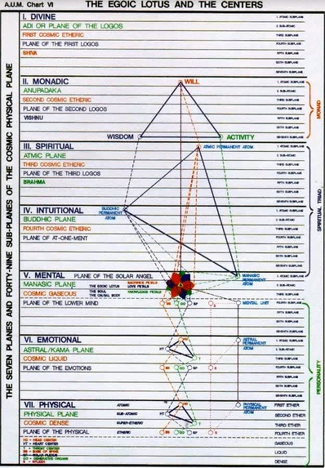

10:45 We will see that the different chakras are located on different subplanes of the various planes and notice the Ajna centre is not listed but I suspect that, like the head center, located on the 1st subplane of the various planes:

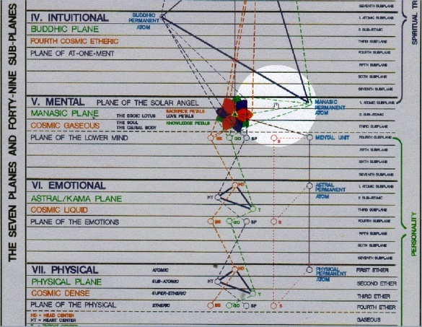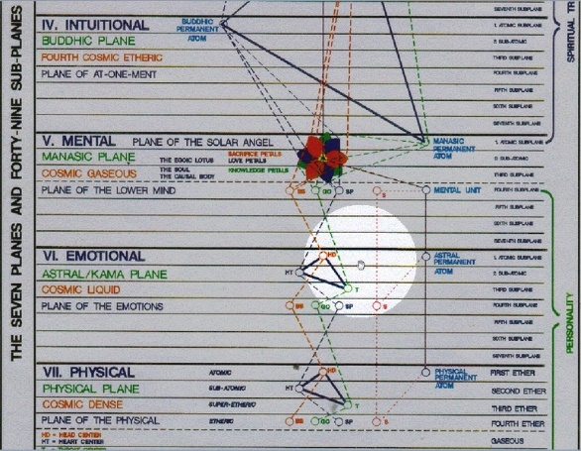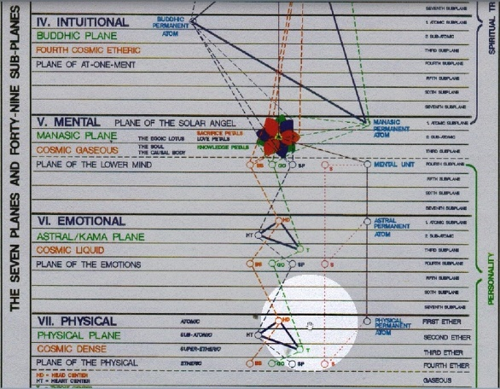

There are no chakras of the higher kind yet on the Mental plane. The Egoic Lotus takes their place but the day will come when the Egoic Lotus is no more and the individual generating his own mayavirupa will have to have the vortices on the various subplanes of the Mental plane as well. And I suspect that the Ajna will be found on the higher subplane along with the head center of the Mental plane:

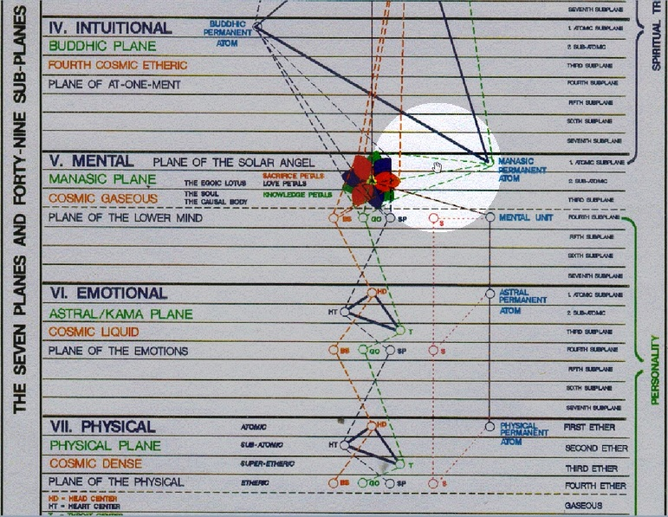

And here on emotional plane:

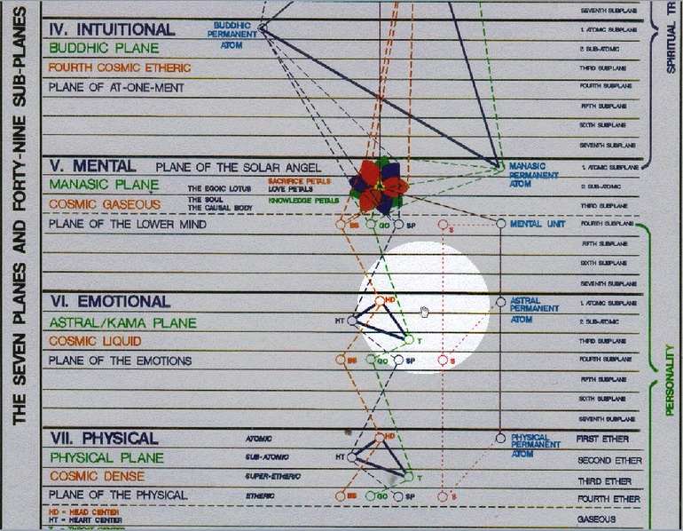

And also on the etheric physical plane:

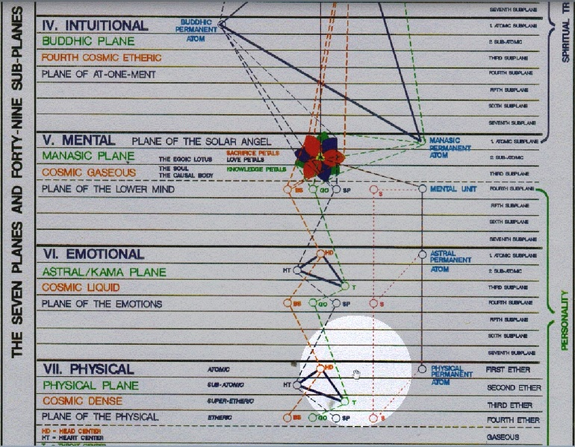

I suspect the Ajna centre is found on one of the sub-subplanes of the highest plane. You know there are actually 7, what we call sub-subplanes on each subplane and this is something the Tibetan brings out. Therefore, there are actually 49 sub-subplanes on each one of the systemic planes and then 343 sub-subplanes on the entire cosmic physical plane.

So there is a strong mental quality to this, to the Ajna centre, and when you combine the Ajna and the throat center, I think you have the two centers which really represent the mental process in man. The Ajna centre is an integrating center, a directing center and involves a spiritual approach through a clear form of knowledge and we might call that Science. So the closer, the real integrated personality appears at the 3rd initiation. Before that time it's in integrating personality. And there's even more of these two energy systems that of the soul and that of the personality, to bring together as we approach the 4th initiation. But suffice it to say that the real integrated personality which is one that is not only integrated within itself but integrated with the energy system of the soul occurs at the 3rd initiation. So it's no small thing when we talk about the integrated personality. The 1st ray starts to come through at the 3rd initiation and it gives that sense of progress onward, straight line action towards a particular goal. The Ajna centre is the center of vision and with a clear vision lying on ahead, we get the sense of Direction. How using the will, the individual can direct himself or herself towards an objective which is in line with the Plan. During earlier phases, we may be quite reactive and have no true sense of Direction towards soul fulfillment. By this time we are very identified as the soul and can also focus at will within the causal body, and we have the knowledge which the soul confers, and we know the direction we must take in order to be the soul-infused personality fulfilling the divine Plan.

The whole idea of straight line action comes in here and the idea of not being deflectable even as we are approaching the 3rd degree, the idea of undeflectability comes in with Sagittarius, which sometimes can be placed at the Ajna centre, probably a number of the different signs of the zodiac, I should go over that some time. They mean different things when related to the different centers. I wonder whether I have done that you know in all this whole mass of commentary here, I wonder whether I have discussed this but certainly, Sagittarius at the Ajna centre gives a strong sense of Direction leading to Capricorn at the Ajna centre which is the mountain top of the first real initiation from the point of view of Hierarchy.

15:40 And then you know rather than approach the soul and the general spiritual path in a mystical, sentient manner, we enter the realm of true knowledge. Knowledge and Science go together and we may be familiar with the idea of the fivefold sequence that involves initiations: know, express, reveal, destroy, resurrect. Well, we can put the word ‘know’ at the first initiation which is a preliminary or probationary initiation but in a deeper sense of knowing the soul, we should put the word ‘know’ at the 3rd initiation which we are here discussing. And this 3rd initiation is approached on the level table, land of true knowledge which is Science. The idea of achieving true knowledge of anything is the scientific pursuit. We are beyond the a lower types of forms and figures, we might say, Transfiguration, we are moved into a higher realm which while still in the dense physical body of the solar Logos is above the lower 18 subplanes and is a realm in which the usual type of form and figure are given up so we are beyond that into a great display of soul light from the 2nd subplane of the higher Mental plane.

Now these first three initiations, maybe we can know something about because Master D.K. is training people for these initiations especially for the first and second but later in his discussion, he also mentioned that he was training people for the 3rd initiation as well. As we get into the higher initiations here, I think the wise thing to do, you know would be not to say too much about them but to wait until we get to a section of the book where Master D.K. really describes what he is doing. And you know it gives me a thought that it would be wise when getting to the sections or initiation to pull out the compilations on initiation which include naturally, material from this book but also from others this would be a way of really looking at the initiations closely. So I have to kind of remember that as I go along. But anyway, true knowledge comes in here at the 3rd.

“Initiation 4. Renunciation
Heart centre 4th ray Buddhic plane
Crucifixion Sacrifice Harmony”
RI, Page 340

And when you reach the 4th, it is the Renunciation of the lower 18 subplanes. It can work out as the Crucifixion, yes, in the West especially, and more called the great Renunciation in the East. It's interesting how we've been ascending through the rays 7, 6, 5 and now the 4th. That sequence however does not fully continue as we will see. The Heart centre is involved, it’s in a way of fourfold center in another way twelvefold center, at least the heart itself is majorly fourfold and the whole idea of the cross is found within the heart and the idea of the synthesis which the heart can bring. The 4th ray is a ray of great division, you know the idea of the very unpleasant prospect in the old days of being drawn and quartered as a punishment, you know just pulled apart in four directions is countered with the idea of bringing everything into a full synthesis where all energy from the four different directions come together at the point. It involves what's called the circle of buddhic life, buddhi is the plane whereon the second divine aspect is a far more strongly expressed than it can be within the lower 21 subplanes. You know I alternate between speaking of 18 lower subplanes and 21 subplanes. In my view, 18 lower subplanes, the dense physical body of the planetary Logos, 21 lower subplanes, the dense physical body of the solar Logos. So the buddhic life from the cosmic ethers is really entering here. The abstract mind enters for the 3rd initiation, but it is not yet in the cosmic ethers, it’s not yet in the area of the vibration where one can truly begin to live outside of the density which has been carried over from the previous solar system.

So there’s a direct connection with the Heart centre and the buddhic life just as there is with the head center and the atmic life and the throat center and the mental life. Well here, we are prevented through Crucifixion from using the hands and the feet to run after that which desire would have, which desire dictates. It’s an extreme form of detachment and of Renunciation. The hands are held out, once the nails are removed, the hands are held out in blessing. But first we, I suspect, have to go through this painful Renunciation involving you know Sagitta, the arrow of death in the first decanate of Capricorn. We go through this process where we are actually prevented from reaching for that which has been desired. We purposefully give it up and the 4th kingdom of nature, the human, ejects us and then we are solely and completely in the 5th kingdom of nature, although within the 4th Creative Hierarchy of Monads.

Notice, Crucifixion leads through Sacrifice of a higher kind. The Law of Sacrifice is related to the 4th ray, we realized that in studying the laws of the soul, but this is a much higher form of Sacrifice because essentially we are rejecting everything we have developed as a human being or at least we’re rejecting the field of development which means eventually, the rejection not only of the personality and its elemental life but the rejection of what I call trans-personality which is the causal body, we Sacrifice that. At first we Sacrifice much of the simply in the personality and now we are sacrificing as well the harvest of the personality. The interesting thing is that the buddhic plane is also called the plane of Harmony and that which is above and that which is below, the three above three below are brought into Harmony and we can say that God's will, God's love, and God's intelligence through the transcendental mind of Mercury are all brought into Harmony. So it produce extreme pain of the detachment from our customary world and through a purposeful relinquishment, willing relinquishment of attachments to that world we enter into Harmony with God's love and Harmony to a degree at this point with God’s will. It is a great privilege D.K. tells us to take this initiation and we have to earn the right to do it. Some people might look at it as sort of you know a horrible finale of human life where one loses all that has been of value, but it is not that. It is something that opens us up into true life, the first level of the cosmic ethers where we actually begin to live and until we can understand what love really is, we don't begin to live. It’s not enough to have the mind functioning in a useful sense or even in an illuminated sense, though that helps, it’s that livingness comes through the heart and even in the human being we know the living comes through the heart. These are just you know preliminary thoughts, let’s just say that the #4 is the ray of Harmony and the higher part of it is the Harmony which follows upon the conflict. Well nothing is more conflicted than Crucifixion. One is really torn by that process but the deliberation with which one makes sacred one's life is Sacrifice and this leads to a Harmony which could never be achieved strictly on the lower planes.

25:17 Interesting the name of initiation 5. Now numerologically rays can be correlated with the number of the initiation, but they are not always the rays that D.K. gives, In this case we might expect the 5th ray for the 5th initiation and indeed I think the 5th sign Leo is involved there and we could find the way in which the luminosity of the 5th ray and the 5th plane from below the atmic plane are all connected with this initiation but he gives instead the 1st ray. And it's interesting here how the rays of aspect come into play, but not necessarily in the order that we would expect but perhaps an order which is correct for this solar system. You know even as in the Masonic lodge, the chair of King Solomon in this solar system is occupied by the representative the 2nd ray, and not by the representative of the 1st ray.

“Initiation 5. Revelation
Base of spine 1st ray Atmic plane
Emergence Will Purpose”
RI, Page 340

So the Base of spine center which is ruled by several planet, but by 1st ray Pluto for the disciple and also deeply connected with the Earth which is a first ray Monadic planet, is the center which goes into a 4th dimension rotation, can I call it rotation? It turns upon itself and becomes a wheel turning upon itself at this initiation. It is the seat of the Will, whereas the head center is the seat of the purpose and it connects with, the highest and the lowest of the Brahmic levels connect. The atmic plane is the highest of the Brahmic levels, it is the first of the Brahmic levels and yet is the 3rd subplane of the cosmic physical plane. So it has about it a 1st ray in terms of Brahma but also a 3rd ray when related to the #7 and to the 2nd ray solar system, whose number is 7 whereas the previous solar system has the #5. So all of these numbers make sense and we have to use the divine Will and understand the Will of the Monad in a way we have not been able to before at this 5th initiation. We are emerging into full command within the Hall of Wisdom and within the 5th kingdom of nature, kingdom of souls. Although we have a touch of the Monad at the 3rd initiation and we begin to realize consciously something of what it's about and it intensifies in a destructive manner at the 4th. The Will as Revelation really comes in at the 5th initiation and we begin to see the paths which lie on ahead.

We do not at that point make our Decision, not anymore. There was a time we are told when the great Decision about which of the ways of higher evolution we would tread was made at the 5th initiation but at least, we see the way ahead and we begin in a sense preparing for our Decision and training for that Decision.

You know the question of Will and purpose is difficult to resolve, I’ve always felt that between world purpose and intention will carry us the 1st ray aspect of it, others think it’s the 2nd ray. Purpose carries the 2nd ray aspect because it relates to the divine pattern. We can't have a purpose I think without a particular relationship to be achieved. And I look at that as the second aspect of the first aspect and then attention being related more to concretion, and there we have the third aspect. But we are certainly, you know, emerging from any captivation by the human kingdom even at the 4th degree we do, but we have to kind of clear the debris of that great destructive act and by the time the 5th initiation is reached, the debris of the explosion or the conflagration of the causal body is cleared away and one can really see clearly unbiased by any type of perspective that being a human being would confine us to.

So we see a much larger purpose in line with Sanat Kumara. If from a certain perspective, this is the 3rd and in a sense the last initiation which Sanat Kumara per se officiates at. Of course Sanat Kumara is an emanation of the planetary Logos so it's always going to be until the 7th degree, the planetary Logos beyond that I'm not sure. Maybe the studies will reveal it but there is a great Being of an unnamed character who officiates an existence who again must be an emanation of the planetary Logos who officiates at the 6th initiation and it is not said to be Sanat Kumara and at 7th initiation, the planetary Logos himself is officiating. So we’re certainly emerging from the human kingdom, we understand the will and purpose of Sanat Kumara at this point. We know that in the Rays and Initiations, seven-ray purposes of Sanat Kumara are given and they are very high purposes and really beyond our present comprehension but certainly for the Master, he has grasped somewhat the purpose of the planetary Logos. Maybe not as fully as some of the Chohans can you know, there is this higher ashram which is being formed, the wisdom ashram and some people call it the ashram of synthesis as some people imagine that they can be members of the ashram of synthesis which is really putting the cart before the horse when even some Masters of the 5th degree cannot yet be members of that ashram because they do not have the qualifications.

So such is the eagerness of the aspiring human personality that they fasten upon things which are too high for their possible attainment and thus cause glamour and distortion. I know that many of my friends don't agree with me on this point, but let's say that when the Buddha, Master R, the Christ are members of this ashram of synthesis, and even some Masters cannot make the grade, so we cannot talk about aspirants being true members of the ashram of synthesis. It’s a very flattering idea in my view but something that is not, at the present level of ignorance, I cannot deem it as true.

So anyway there’s a great light that’s breaking forth and well we understand that at this 5th initiation there is a very a clear channel established between the Base of spine and the highest head center. Maybe the process of establishing that connection is part of what this caused the general destruction at the 4th initiation. The thing about destruction at the 4th initiation is that there are several sources of that destruction. You know it comes from the Monad, it comes from the second aspect of the will, it comes from the Buddhic plane, it comes from the rod of initiation, it comes from the intense rapidity of rotation of the atomic triangle and maybe the rising of kundalini has something to do with it as well. It's a very complete and general destruction of that which has veiled the truth of the spirit and those two veils have been primarily of the personality and the soul body. Well you know, I'm just rounding up a few thoughts here and because the real work will be done when we study these initiations as Master D.K. has discussed them.

“Initiation 6. Decision
Throat centre 3rd ray Monadic plane
Fixation Intelligent cooperation Creativity”
RI, Page 340

Here is the initiation of Decision. I do think the 6th ray is connected with it because it's a great ideal of the origin of the Monad which takes the person on one of those paths of higher evolution. Seven paths are now 9 paths which will lead to great stellar systems, which ones they are, some theorists have posed, Steven Pugh has done a lot of work on this and there are other theorists who maybe come to different conclusions, but the point is that they do lead to constellations the way of higher evolution in its 7 or 9 paths will lead to constellations which are related to our Logos cosmic system. Interesting that the Throat centre, and great intelligence should be involved here in the 3rd ray which is numerically related to the 6th as D.K. tells us is involved because it is the Decision of the Monad actually and it has a lot to do with the origin of the Monad. You know maybe it's planet of origin, its relation to the Sun, its relation to constellations, those are high things and we are not yet again fully the Monad in consciousness so we cannot know the fullness of it. But there are lines living forth, and the opportunity to be connected through many filaments of energy with the local cosmos are here, the 3rd ray gives that kind of connectivity of the Decision as made on the Monadic plane at least at this time and then from that time on, the individual either remains with our solar system or is outward bound so to speak, or inward bound first to the cosmic astral plane and then in the case of some paths to the cosmic mental plane and then even in the case of one path which is the 6th path to the cosmic buddhic plane. And those as I've said before, those who remain with the Earth on the path of Earth service, they eventually fight their way towards the cosmic buddhic plane taking the 6th path.

Well we would have to interpret these words Fixation you know isn’t the same as the Law of Fixation, the 5th law of the solar system, probably not. It’s probably a Fixation of will and intent to remain steadfast to a particular path which one has chosen. And of course the 3rd ray is here and indicates a much higher form of Intelligent cooperation that we can ever imagine as that which the 3rd ray facilitates when we are simply a human being. It’s intelligent cooperation I suspect, with whatever entity is sponsoring the particular path. It could be with the solo Logos and probably initially it is that, and probably its initially Intelligent cooperation with that one of the sacred planets to which the outward bound Monad goes before assuming a more cosmic path before leaving the solar system altogether. Whether or not the outward bound Monad remains in the solar system, whether they all do, we know some of them do, some of them are instructed on Venus, some are instructed on Jupiter, and that is remaining with the solar system. And in a sense, the Monad is that which has its home within the Sun of that which finds its home within the Sun, but we find this from Initiation, Human and Solar, I’ve often quoted the Page but I can’t seem to remember it now; I think it’s Page 190 something. But let’s take a quick look because this is an important quote:

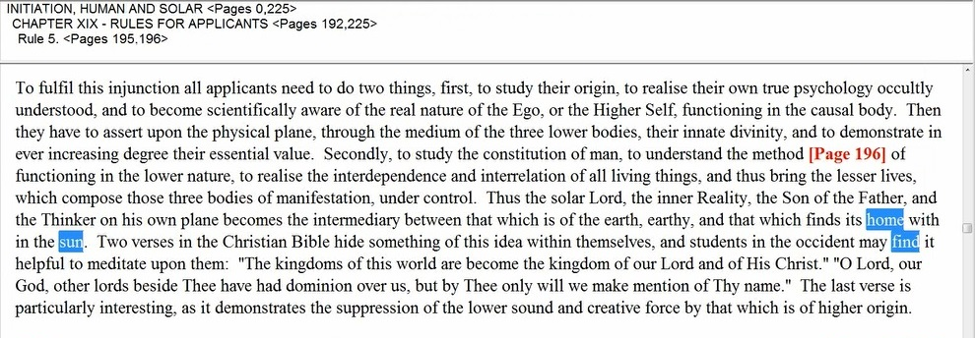

“Thus the solar Lord, the inner Reality, the Son of the Father, and the Thinker on his own plane becomes the intermediary between that which is of the earth, earthy, and that which find its home with in the sun.” HSI, Page 196

Thus the solar Lord, the inner Reality, the Son of the Father, and the Thinker on his own plane becomes the intermediary between that which is of the earth, earthy, … that’s the personality … and that which find its home with in the sun. That is this important idea that the Monad itself really finds its home within the Sun from wherever else it may have emanated. And I think we basically have the idea, not in any ultimate sense, but at least in a sense quite ultimate for us in this solar system that all Monads are emanating from the true central spiritual Sun which is a head center or even Monadic nature of The One About Whom Naught May Be Said, which finds its exteriorization within the Pleiades.

So Fixation along the path, Intelligent cooperation with the various entities that are sponsoring that path and Creativity, again the Throat centre on behalf of the mission to be accomplished by the energies descending on that path and reascending on that path. So it’s Creativity in a wider context. It can be a solar systemic context and later it will be a more cosmic context, but intelligence is the key here and we first develop intelligence on our way. Yes, the one and the three and then finally the two being the most important of the rays for our particular solar system with the 2nd ray personality, and 2nd ray soul, and maybe ultimately 2nd ray Monad.

“Initiation 7. Resurrection
Head centre 2nd ray Logoic plane
The eternal Pilgrim Love-Wisdom Attraction”
RI, Page 340

Resurrection is not the Resurrection that we experience after the 4th initiation when we rise from the tomb of the lower 18 subplanes or even with the lower 21 subplanes and enter into the higher cosmic etheric life. Rather it is a type of Resurrection out of the encapsulation we call Monadic life, at least the Monadic vehicle. I’m of the opinion that it is possible to exist in the sea of fire on the Logoic plane without the usual Monadic vehicle. Whether that has to be destroyed to venture onto the Logoic plane because that does come when the Temple of Ezekiel is destroyed, or whether one can retain that, I'm not sure, but there is a liberation of the volatile essence, the essential Monad onto the Logoic plane, and I think this is what is meant as Resurrection.

So it’s a Resurrection far beyond what we can understand. The Head centre is involved and so we're going to understand, since the Head centre is the center of purpose, much more about the purpose of the solar Logos. This is an initiation officiated over by the planetary Logos but I think it has a direct connection with the solar Logos and its 2nd ray. Usually, the logoic plane is connected with the 1st ray but in this case, the 2nd ray and we do have those divine flames that kind of Leonian Hierarchy on this level of the Logoic plane and we know that Leo of the three fire signs has most to do with the 2nd ray when comparing the three; Aries 1st ray, Leo 2nd ray, Sagittarius 3rd ray. That’s a different way of assigning the rays than looking at the constellations and seeing what rays pass through them, for Leo, the 1st, and the 3rd ray? 1st and the 5th ray. But in this case the 2nd ray and the understanding of the purpose of the solar Logos.

The eternal Pilgrim is the Monad, but it’s the Monad freed into the sea of fire, and it’s a Love-Wisdom initiation. So naturally there would be a connection with this great Deity, our solar Logos who is the Love-Wisdom solar Logos, and interestingly enough, there should be a Gemini connection here with the 7th initiation and love would be one aspect and wisdom another of the twins and we enter now into deep understanding of the solar Logoic Law of Attraction, or we might almost call it the Cosmic Law of Attraction. Shall we say that this is Attraction as experienced on the liberated Monadic level. You know I speculate about things here and D.K. has himself not said too much about some of these advanced initiations which it is somewhat hopeless for us to really understand, but some few indications we might understand. So Resurrection into the sea of fire, the true understanding of solar Logoic purpose or maybe I should call it an initial understanding, entry into the great ray of our solar system, the synthetic ray, the ray of Love-Wisdom. The eternal Pilgrim of Monad is liberated from its temple, at least it can venture out of its temple because its temple is that which is found upon the Monadic plane. And here, the essential Monad can exist upon the Logoic plane, although is there by another temple? You know, the whole universe is a temple and as we move from level to level in our ascent, we always have some form of vehicle, some form of encapsulation given the fact that the universe itself is the temple of the one ray of the absolute, which we all are. So this is really entering solar life, it’s the third of the solar initiations, no I’m sorry it's the 5th Mastership in the solar initiations, and it is a transfiguration in terms of the Sirian initiations which begin at the 5th degree where we become the entered apprentice in relation to Sirius. So we're talking here of cosmic matters. And what I say necessarily has to be quite brief and you know essentially uninformed speculative, correlating ideas that I have read and thought about. So here we have the 1, 3 and the 2. We don’t end with the 1st ray, maybe in the next solar system, the 9th initiation will take the place of the 7th and we will end with the 1st ray. And just as maybe in the previous solar system, Brahma was the height that could be reached and it has the first ray implication being in a the way the head of Brahma.

“Initiation 8. Transition
Hierarchy Four minor rays Planetary
Choice Consciousness Sensitivity”
RI, Page 340

47:30 I will get into initiations here called Transition and I imagine this is a preparation for Transition onto the cosmic astral plane. It's the summation of everything that can happen in relation to our planet and planetary Logos. It's a forward movement of the Hierarchy as a whole, or at least those members or the Hierarchy that are very high in their nature. Notice that the quality of Choice is found here which is amazing because usually the great decision where Choice is involved is considered to be the 6th. We're understanding what Consciousness is altogether and Consciousness is a form of Sensitivity. This is not a, well of course the will is tremendously involved because the #8 is there, there must be a kind of destruction. But I think, if we count the planes, the 8th subplane will take us to lowest subplane of the cosmic astral plane. The Four minor rays are the rays of attribute and from a certain perspective, the rays of form although they could be associated with Consciousness whereas the 3 higher rays would be associated with will and with being. We've jumped from Consciousness to being when we look at the refusal.

So whatever the mystery of Consciousness really is and especially in a Planetary sense, I think there's a deep identification with what the planetary Logos knows unless of course we're taking this initiation away from our planet altogether, and that is the case I think with many, even the majority. We understand Consciousness in a deeper way. What is this Choice? Of that I cannot speak, at least not yet, I would like to study more carefully what he says about the initiation of Transition. But despise it to say, the seven rays are divided into two sectors, of the rays of attribute are featured here and they must relate more to Consciousness and form. Whereas the higher rays will relate to will and being. So it is my estimation that the individual has made his way as a Monad beyond the sea of fire and into the cosmic astral plane. Has the Buddha done that? Well the Buddha, some people think that the Buddha comes from the cosmic astral plane, I think that's premature because he has not yet completed the 7th initiation and it is only I think at the 8th that we can truly venture onto the cosmic astral plane, the lowest level which correlates with 8 subplanes from below. If start counting with the lowest level of the lowest subplane of the cosmic physical plane.

“Initiation 9. Refusal
Shamballa Three major rays Systemic
Seven Paths Being Existence”
RI, Page 340

50:48 When it comes to the 9th initiation, Refusal, well we have been told this Refusal doesn’t have anything to do anymore with the cosmic physical plane and so one is really and truly launched onto the way of higher evolution, the first field of experience of which is the cosmic astral plane and then later for some, the cosmic mental or cosmic buddhic plane. That it involves Shamballa and the will and interestingly, it’s not just planetary, it is Systemic. So it is opposed to planetary initiation. Who is the initiator here? We’re told that the one initiator, well the planetary Logos as the initiator conducts the 7th initiation. But who and what conducts the eighth? And is it in some sense the solar Logos who is involved in the 9th initiation? Is there something about The One About Whom Naught May Be Said that is involved in this 9th initiation? By mentioning Shamballa, and assuming that it is a planetary Shamballa, because we probably have some kind of solar Systemic Shamballa as well, we seem to be retaining some connection with the planet itself. But we are liberated into a major trinity here and the minor rays of aspect do not feature into this initiation, but lest we think that they do not figure into the way of higher evolution, that is not true because we're told that many 5th ray Monads take the 2nd path. So there they are in the cosmic astral plane as 5th ray Monads. So it’s not like we can get rid of the four minor rays when we move off the cosmic physical plane.

And suffice it to say, although in the 8th initiation it seems one can definitely still have contact with the cosmic physical plane, even though one is learning something about the cosmic astral plane that the Refusal one leaves all that behind and definitely has left the solar system. The solar system is usually considered to be that which occurs on the cosmic physical plane. Now one can still be in the cosmic astral body of the solar Logos and not considered to be technically within the solar system. So that's a little technicality there which has to be pondered. The Seven Paths open up and they are paths that do not involve the cosmic physical plane. Some have said, okay there is a path which leads to our own Sun, considered as a constellation. I'm not sure that's accurate; it may be accurate, there certainly is a path that I think leaves to the cosmic Logos of which our Sun is a part. And who knows, on the way to the greater constellations where these paths end, we may have something to do with the 7 solar systems which constitute the cosmic Logos of which our Sun is the heart center.

So there may be some kind of interim travel because just as every chain in our planetary scheme has something to do with one of the planets in our system and every globe as well, so maybe the Suns within our cosmic Logos, each one of them has something to do with one of the constellations which is a chakra in The One About Whom Naught May Be Said and maybe taking the paths of higher evolution, something about our local cosmic Logos is experienced. You know that is sheer speculation; I can't be sure but there would be a certain continuity which would be possible from our solar system to our local cosmic Logos and then to one of the great chakric constellations and The One About Whom Naught May Be Said, and finally into the Pleiades themselves which can be considered the very sense center of our local One About Whom Naught May Be Said.

So anyway, the Seven Paths open up here and they are unencumbered, and they lead a way from the cosmic physical plane. Well if we were taking the path to our Sun per se, it would have to be to a higher aspect of the Sun because the lower aspect of the Sun is on the cosmic physical plane and this 9th initiation leads a way from it. We finally begin to understand what Being is in a sense that we cannot understand when confined by the cosmic physical plane and these are great abstract words, you know. I realize in a sense I’ve never really fathomed them to the extent I should. Being is pure and it is essence itself. Existence is the result of Being and maybe we are talking about the kinds of lives which exist in our local cosmic system. How Being manifests itself in our local cosmic system. Perhaps that's what Existence means. I don't know whether D.K. even describes that, it's something to ponder and I suppose you know those of us who are relatively low levels of initiation here, I don't think we can be too successful in pondering the meaning of these key words as a Master or a Chohan would be. Suffice it to say, we are liberated onto paths that are not involved with our cosmic physical plane. We understand that Beingness of things, you know I wonder if the universal Logos can understand Being as it is and I even wonder whether the universal Logos being, I think, infinitely removed from absolute Existence can understand Being, as Being will not been when we are liberated into the absolute. Well you know probably with the mind here even if using the abstract mind to a degree, can’t touch these things. So anyway, Existence within The One About Whom Naught May Be Said or at least within the cosmic Logos perhaps that is understood in a way that otherwise cannot be understood.

58:33 Okay well that’s been a brief run through friends of, probably things I shouldn’t be talking about but anyway, let’s just say that this is the end of Rays and Initiation Webinar Commentary Program #5 and page 340. You know, I’ve just stayed unto Page 340 and 341 comes later. And I will pick up with this in Program #6. You know it’s going to lead us into a statement here that:

“It will not be possible for you to comprehend the synthesis which governs the four final initiations, and for these experiences we have as yet no adequate language. All that is possible is to indicate certain spiritual trends and tendencies and—as this section is written primarily for those who have taken or who are preparing to take one or other of the initiations—I can only hope that some meaning will be conveyed to those persons who are ready.” RI, Page 340

It will not be possible for you to comprehend the synthesis which governs the four final initiations, … 6, 7, 8, 9 … and for these experiences we have as yet no adequate language. So when we're using words like being, and existence it is just the best we can do. All that is possible is to indicate certain spiritual trends and tendencies and—as this section is written primarily for those who have taken or who are preparing to take one or other of the initiations… which ones? the high ones … I can only hope that some meaning will be conveyed to those persons who are ready. So you know I'll review that slightly as we get back to it but this is where we are for the moment. I love that page, you know I refer to it all the time. I come back to it constantly and now, in looking at it, just in itself for the first time in a very careful way, I see I have overlooked certain keywords which are presented for the later initiations and about which I perhaps have a little idea, but maybe some ideas are being offered, Being is more abstract than existence, I believe, but in a way, Beingness is the one and only absolute, and Existence is the universe itself. The universe is in existence emanated from the Beingness of the pure Being of the absolute. Well it’s philosophy you know but unless philosophy helps us live a better life right here in our stage of confinement it has not so very much used. Okay, will see you then for Program #6. Bye bye.

