EGOIC LOTUS WEBINARS, VIDEO COMMENTARY – 57, Michael Robbins
Abstract
Egoic Lotus Webinar Commentaries 57: Part 1 of Synthesis for petal 9. This webinar is about 3 hours long. Program 57 offers the first of the commentaries for the Synthesis of petal 9—the third petal of Sacrifice: Sacrifice-Love.

In terms of the 80-point outline we have been using, it takes us from Point 1 to the beginning of Point 26. The work in this petal is climactic and when fully unfolded represents the achievement of the third degree, the Transfiguration. Sanat Kumara is the Initiator at this petal. So many energies and forces come together in the work and unfoldment of this petals that all zodiacal signs, all planetary influences and all rays can be understood as playing a prominent part. Through work in this petal and through the application of the Rod of Power, the candidate becomes the true initiate in the eyes of the Spiritual Hierarchy. The demands of sacrifice are very great—”the utter sacrifice of all forever”. The human being can begin to live truly as a soul, consciously influenced by the Spirit aspect Monad.

Egoic Lotus Webinar Commentaries 57 569 MB .wmv file
Video of Egoic Lotus Webinar Commentaries 57 by Michael D. Robbins

Egoic Lotus Webinar Commentaries 57 173 MB .mp3 file
Audio of Egoic Lotus Webinar Commentaries 57 by Michael D. Robbins

Transcript.

Good morning everyone. We are beginning program number 57 and we finally made our way to the ninth petal, which is the final petal of the major unfolding series of petals. The synthesis petals of course have to be dealt with, but so much less has discussed about them by the Tibetan.

I have some references and maybe some speculations when that time comes shortly, but now we'll finish off with at least what I have to say about it at the moment.

c. Petal 3...The utter sacrifice of all forever.
Colours: Yellow, orange, rose, blue and indigo. TCF 824

This ninth petal, with its colors: yellow, orange, rose, blue and indigo. It's the only petal which we have both blue and indigo together, and I'm sure that that is significant. … we do not have here a double rose or a double yellow, we have the uncharacteristic insertion of blue, which is usually found in the middle petals, the second, the fifth, and the eighth, but here we have a climactic sacrifice sub sacrifice petal, and we find that the blue here is included:

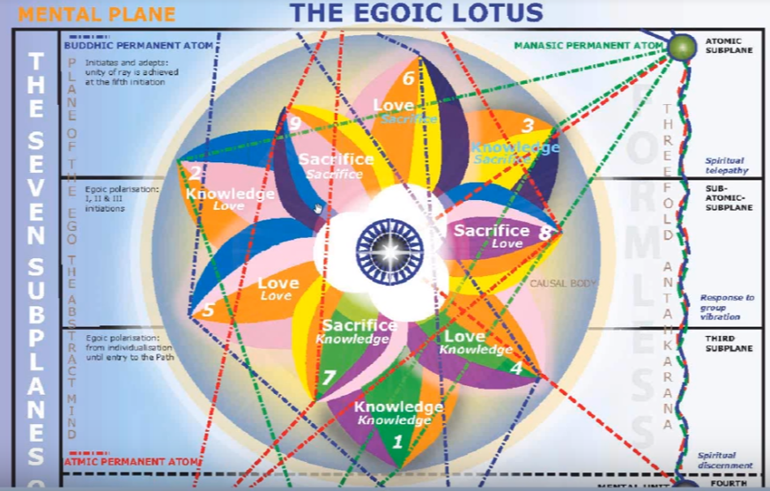

Anyway, here we are on petal number nine.

We have ended program 56 and beginning program 57. This is part one of the synthesis for petal nine. Generally, I cannot do them all in one program.

This is the quote that I've been using for all the sacrifice petals, and by now it should be familiar these things have to become familiar.

So, we know how the developmental process proceeds:

This inner circle of petals is organised and vitalised in the Hall of Wisdom, and simultaneously the middle circle unfolds, so that two rows of petals are duly opened, and only the third remains to be unclosed. This final opening is effected during the period of treading the stages of the Path of Initiation, and in this round it is hastened by the rites of initiation and by the strenuous and abnormal efforts of the man himself, aided by the electrical work of the Initiator, wielding the Rod of Power. TCF 824

This inner circle petals is organised and vitalised in the Hall of Wisdom, and simultaneously the middle circle folds. In the hall of wisdom, I think that these petals are also unfolding. When does the hall of wisdom begin? Does it begin before initiation? Usually the marker point is the first degree, but he sometimes seems to overlap and start the experience of the hall of wisdom somewhat before the first initiation. I don't know that we can pin it down exactly. In the spiritual kingdom, the kingdom of souls, the hall of wisdom, the first degree – these all seem to go together; little chelaship, and so forth. But there is some possibility of irregularity and the cut-and-dried effect is not necessarily to be found: hard boundaries on markers.

Simultaneously the middle circle unfolds so that two rows of petals are duly open. We paused on that word duly before. To wonder whether that means open to the extent that it should be open, or completely open. And I sort of prefer the first, because I definitely think there is unfoldment of the seventh petal, and even the eighth before the second initiation is taken. So not just a question of organization and vitalization, but actual unfoldment. Two rows of petals are duly open only the third remains to be unclosed. That's an interesting term. This final opening and does it mean that the opening to sacrifice petals is the final opening, or that there is a final opening of the sacrifice petals? This final opening is effected to during the period of treading the stages of the Path of Initiation. And, generally in the hall of wisdom, the path of probationary initiation is being trodden. If we're working in the seventh and eighth petal, we are at least preparing for the first and second degree, respectively.

Anyway, this final opening is effective during the period of treading the stages of the Path of Initiation, and in this round—which definitely concerns us except in the historical sense—it is hastened by the rights of initiation and by the strenuous and abnormal efforts of the man himself, aided by the electrical work of the initiator, wielding the rod of power. He seems to be, I would say, talking about both initiators, the Christ and the Lord of the World at the third.

As I said, to truly understand exactly what goes on, we have to have to be clairvoyant powers and see for ourselves and see the various differences and anomalies and contrasts between the different types of unfoldments. But I think we get the idea. What a man can do is to organize, coordinate and vitalize. And then in this series of petals, he can work very strenuously and abnormally, which seems to imply that by his own efforts some unfoldment is occurring, and more unfoldment later through the application of the rod of initiation. He has to reach a certain degree or a certain condition in those petals. And maybe a certain degree of unfoldment even before the rod of initiation can be applied. The reason I say that is because of the statement that the initiate is initiate before he is initiated. …

0:08:00 Now we begin with those very important quotations that are found between 539 and 542 of A Treatise on Cosmic Fire:

3. The Petal of Sacrifice for the mental plane: demonstrates as the predominant bias of the soul as seen in a series of many lives spent by the initiate prior to his final emancipation. He becomes in his sphere the "Great Sacrifice."

This stage can be seen objectively to the eye of the clairvoyant as dual in effect:
a. The mental unit becomes a radiant point of light; its four spirillae transmit force with intense rapidity.
b. The three higher petals unfold, and the nine-petalled lotus is seen perfected. TCF 542

The Petal of Sacrifice for the mental plane: – that 's the sacrifice-sacrifice petal—demonstrates as the predominant bias of the soul –which is sacrificial of course –as seen in a series of many lives spent by the initiate prior to his final emancipation. It is reflecting the tendency of the soul as it has been active in the life of the personality and has contributed, over quite a number of lives now, to the general unfoldment of the egoic lotus. It is the sacrificial demonstration by the soul. He becomes in his sphere the "Great Sacrifice." That fits very well because it is the Great Sacrifice Himself who applies the rod of initiation at the time of the third degree, which signifies the complete unfoldment of the nine petals. He becomes in his sphere The Great Sacrifice.

This stage can be seen objectively to the eye of the clairvoyant as dual in effect: – and until an individual is this, a tiny replica of the Great Sacrifice in his own sphere of influence, how can we say that he has taken the third initiation?

So often this question of initiatory achievement is considered without duly considering the sacrifice involved. And so, we have to ask every one who claims this second or third degree, ‘What is the measure of your sacrifice? How have you demonstrated a sufficient completeness of sacrifice to warrant the degree of which you speak?’

0:10:40 So, this stage can be seen objectively, as the following:

a. The mental unit becomes a radiant point of light; we are dealing with the sacrifice petals for the mental plane and the mental unit is directly concerned there; its four spirillae transmit force with intense rapidity. We saw, probably at the conclusion of the sixth petal opening, that the astral permanent atom was glowing with equal brilliance to the physical permanent atom. And,

b. The three higher petals unfold, and the nine-petalled lotus is seen perfected. This does indicate the third degree. The probationary initiate is spending quite a number of lives before the final emancipation, by that I'm pretty sure that we mean the fourth degree. So, these many lives could have begun at the first degree. Or even, in a way, with the reversal of the wheel, which is occurring in petal number five when we are really as an aspirant oriented towards the higher of the pairs of opposites. The sacrificial mode is ever-increasing in potency. It may be the first law of the soul, but it's so fundamental to all real progress …

So, we have almost the full development of the mental unit, and as the ninth petal unfolds, I have suggested that whatever remains to be unfolded of the seventh and eighth is completely unfolded. I don't think he means the synthesis petals. I've asked myself because that. Because, if the three higher petals unfold, it does make the nine, it is not the three inmost petals.

Well, there were various questions to be asked here, about the degree of atomic matter and all of that in the lower vehicles. But really the unfoldment of the synthesis petals is more a question for the period that follows the third degree. Some degree of unfoldment has occurred, some appreciation of what synthesis is, even follows the second degree as a conscious pursuit. But the real a rapid development involved in the unfolding of the synthesis petals is something to occur between the third and fourth degree, and are there a number of lives between the third and fourth degree? Or, can they both be taken in the same life? We've been told that they can be.

The higher unfoldments are rapid indeed, and we have to do the preparatory work, and then they will be taken care of. That doesn't mean we don't work (when we have the focus after the third degree) on synthesis, we work very hard at becoming planetary in our consciousness, in our knowledge, and our will.

0:14:30 Then the other section of course is important. It's the quotation from the pages 822-824. We're dealing with petal three for the mental plane:

c. Petal 3...The utter sacrifice of all forever. TCF 824

DK just calls it, the utter sacrifice of all forever. It gets very simple now, you kind of wonder if its a kind of third-degree initiate that achieves the utter sacrifice of all forever, because we have been told of the rich young man that he went sadly away when invited by the Christ to follow him. So, there was something there. That rich young man, the third-degree initiate did not want to sacrifice, but in general a high degree of sacrificial attainment is necessitated for the taking of this degree, and very soon the greater buddhic love which rapidly infuses the consciousness will illustrate the needs in the consciousness of the third degree initiate for the utter sacrifice of all forever.

Of course, this theme of sacrifice does continue because even in the Garden of Gethsemane there was a choice before the Christ and the Tibetan seems to imply that the Christ was – well, not appalled but certainly realizing with intensity the contrast of what he himself had planned with regard to the salvation of humanity, and what it is that the Lord of the World saw as a necessity and presented to him a choice which had not been previsioned by the Christ.

The utter sacrifice of all forever and the bringing to a climax of the age-old tendency of the soul toward sacrifice (really beginning from the time that the solar angel) takes increasing control during the process of the fifth petal. I say at least this stage leads to this utter sacrifice, for which a landmark moment occurs at the fourth degree, but the sacrifice of course continues until we find I suppose the Universal Logos forever in the duration of universe giving all he is and has.

0:17:30 Now we're in that 80-point outline that we have used to try to keep our thoughts straight as we have moved through the synthesis of these petals.

Point one, we're in the sacrifice tier for the mental plane, these are the petals of will for the mental plane. It is God's will to give all of course in the right way as it may be appropriately given. Shamballa measures it's giving acutely, and does not ever give inappropriately; it gives what can be assimilated, what can be withstood.

c. Petal 3...The utter sacrifice of all forever.
Colours: Yellow, orange, rose, blue and indigo. TCF 824

We’re in the sacrifice tier, we’re in the division of the tiers, the sacrifice-sacrifice petal. As we see in fact the sacrifice-sacrifice, the emphasis upon sacrifice is very strong, because the yellow, the law of sacrifice, the fourth ray, and of course the second and the first both involved in giving all regardless of what may be the consequences for the form. By this will-to-give the form will be destroyed because it cannot possibly contain the new energies which are contacted in this act of giving, as they're pouring in from the triad.

The elements most associated here? I've named fire as associated with the mental plane with the sacrifice petals, I think it is accurate. Earth, the outer knowledge petals, water the love petals, fire the sacrifice petals, and the air is life, the air is God, air for the synthesis petals.

What is the division of the elemental triplicity most associated with this petal? Well, is that Aries or is it
Sagittarius? I think we can certainly justify either one of them, and when we get into that section we will do so, but either Aries or Sagittarius will be involved. From Aries perspective, the sacrifice is very clear: the sacrificial lamb, or lamb of God, the Lamb slain from the foundations of the world, and the statement in the Bible that except a seed falleth to the earth and brings forth fruit, if it is of no value, of course this is the paraphrase, but you get the idea. A spirit is seeking form.

Interestingly enough, we have the Abraham and Isaac story, where Abraham must sacrifice his son, but the angel stays his hand at the last moment. The father is to kill the son, but there are other methods which can be used where the son will be of great value in the expressing of the father aspect such that people will realize that no man cometh unto the Father except through me, the Son.

I'll get into the idea here presented by Aries and how it fits so well with Uranus and the electric fire and the rod of the one initiator. More so than Sagittarius in certain respects. I've scattered various statements about Sagittarius and Aries all through this series of commentaries on the egoic lotus. In collecting them I think the clear idea will be presented.

There's definitely though a great aspiration for that wider point of view of the soul point of view which is conferred by Sagittarius. The overcoming of illusion, how that can be done by contact with pure being with Aries. But Sagittarius is one of the intuitive signs and it has this touch of the buddhic plane. Jupiter after all its ruler is associated with the buddhic plane. The great insight can come through Sagittarius which dispels illusion which is one of the great tasks of work within the ninth petal.

By the time the ninth petal has unfolded and the third degree has been taken, so much of what we call the sense of fragmentation, the sense of division, the capturing of the of the consciousness by multiplicity of veiling the unity. Those things are taken care of and Sagittarius, invoking the intuition really participate s in this. It's not a sign specifically associated with the taking of the third degree, but it is a sign which leads to the taking of the third degree, and if in the horoscope, Aries or let's say Capricorn are also found significantly present, you have a story of progression from the Sagittarian dispelling of the illusions (not just the glamors, the killing of the Stymphalian birds has a lot to do with dispelling of illusions), then also it can fit well in relation to this petal.

0:24:00 Now one of the reasons that I have chosen Aries is because the petals do seem to reverse, at least in this diagram:

Where the lowest of the sacrifice petal is to touch the third sublevel, the middle sacrifice petal, the second sublevel of the higher mental plane, and the highest of the sacrifice petals touches the highest sublevel. Now is this drawing accurate or just a product of necessity or was that one of the early errors made, this was looked at as petal number eight and this was looked at as petal number seven, and they were all shown as continuing to evolve in a clockwise matter, seven, eight and nine, just like all the others moving in a clockwise matter.

However, in terms of how the petals touch the different levels of higher mental plane, there almost seems to be a suggestion that we rotate now in a counter-clockwise manner, as the zodiac rotates. That still has to be worked out, because after all DK does seem to be saying that all nine petals at one point rotate the same direction and distance as petals in the opposite direction. I hope you understand what I'm saying here.

So, I've been always starting with cardinal signs. Cardinal Aries at petal one, cardinal Cancer at petal number three, and would normally start with Cardinal Aries at petal number seven, except that there seems to be some contrast in the behavior of this sacrifice tier. So, one could then start with mutable Sagittarius and end in the ninth petal as one begins to be aware of what Pure Being is. Aries is one of those signs which introduces the candidate to the presence to the meaning of pure being, and I think it is therefore very suitably associated with this ninth petal.

But we certainly have seen that we can make a case for the presence of just about every zodiacal sign in relation to every petal, and especially in relation to the last, latter petals.

We were told here by one of our mythologists that Aries mythology is filled with contests concerning the father. The contests with the father. Certainly, of the three fire signs, Aries represents the father aspect and we do for the first time in the initiatory regime come in contact with the father wielding the flaming diamond, the rod of power, which is greater than the rod of the bodhisattva. So Aries and a father aspect and the contact with the Sanat Kumara as the initiator. This fits as well.

Which of the three fires is most associated with his petal? I'm calling it solar fire to electric fire. Solar fire very definitely so, and here, the solar fire is very prominent and ascends powerfully over fire by friction, because we are becoming the third-degree initiate. Another synthesis petal the third of the synthesis petals is poised to open further, which happens at the third degree.

Venus as a prime expression of the solar angel and of solar fire is going to be very strong at this petal because solar fire becomes dominant over fire by friction just the way Venus becomes dominant over Mars. Venus, the planet of the solar angels, and of one of the planets of Solar Fire. So, fire by friction is being subdued. Mars is the major planets of fire by friction and in the age-old battle between Venus and Mars, who are lovers in one respect and opponents in another, Venus is coming into its powerful position. So, Venus defeats Mars at the third degree it's the fifth ray and it's the ajna center. These are involved in the third degree and Venus is the ruler of the ajna the center for disciples. Mercury can also be involved of course. So, Venus reduces friction we know that it has a harmonizing quality, and Mars is friction, Mars is subdued.

Venus is always unifying things and that's the very necessary in the overcoming of illusion that we have unified perceptions and not fragmentary perceptions; we're lost in the world of multiplicity and the great underlying unity is veiled from our eyes but the more we become the monad in expression the more the unity prevails. Venus contributes to the gradual harmonization leading to the vision of the unity at the third degree, the realization of the One. Venus contributes to that. Venus in a way is the son, the aspect of the son leading to the aspect of a father. There's also a line from the electric fire of the monad through atma and into the sacrifice petals. This must be considered and it's visible in the maps that the Tibetan has given us. Now at this point spirit is not just a latent factor, but it's really obtruding upon the consciousness.

I've connected some of the eighths here, it's more the end of eighth petal work, but Sirius is connected with the eight, Scorpio the eighth sign, Mercury the guardian at the eighth gates. They all seem to be much involved with the latter part of the petal, which is preparing us to go into the ninth. As we're working on the latter part of the petal maybe with the temptations, we're already working in the ninth the petal … we're organizing and coordinating.

Electric fire is coming in strongly now and we're really having intimations and intuitions of what the father aspect is, it’s not just in the background. The people who are taking the third degree are going to be very interested in what is spirit, what is this ground of all being, what is this factor so close that it is invisible to so many?

0:32:00 What is the plane or a focus associated with this petal? Certainly, the higher mental plane. Here’s the antahkarana has been quite well built, the manasic permanent atom is present, the intuition is growing, it already started growing in relation to the eighth petal and the taking of the second degree tells us we have some buddhic access some intuitional access. The law is coming in, and some of the reason why Aries, a great sign of will, can be connected with the law. You have the atmic plane of course ruled by Libra, its opposite, but wherever the opposites do come together. Interesting, Saturn which falls in the Aries, is the ruler of the atmic plane, but that Saturn also has so much first ray that when Aries has its form-taking tendency, it aligns with the form-taking tendency of Saturn.

The higher mental plane here is the main focus of the one who is moving towards the third degree. It continues to be a main focus. And as I said, especially the manasic permanent atom, the abstract mind comes in here and Aries gives the power to think abstractly, and to set the jungle of illusion on fire, dissolving it in flames, and then a higher path appears.

Increasingly, as we're working in this ninth petal, we're able to focus within the higher mental plane. Now that that means focus within the causal body, surrounded by virtue and expressive of soul quality at all times. Now, that is not necessarily an act of will, perfected, until the third degree is taken, and then we find ourselves not focusing on the personality at all, but just using it as an instrument as we focus consciousness within the causal body. I think we should actually practice doing that, even imaginatively.

So, we have increasingly here in petal nine a mental focus upon the higher mental plane. The individual can become the abstract thinker. Abstract thinking goes with ray three, but it also goes with Sagittarius interestingly enough, when thinking about whether Sagittarius would have a strong role to play in this ninth petal. But ray three and abstract thinking connect with the manasic permanent atom which is the third item in the spiritual triad.

So, we begin to see the world in big patterns and we trust that the specifics will keep their appropriate place within the larger patterns that we begin to detect. From that point of view Sagittarius could be considered connected with the abstract point of view of the manasic permanent atom. When we build a bridge and we sort of declare, affirm, how does it go, tension, visualization, projection. The word projection is so terribly Sagittarian, it's like shooting an arrow towards the manasic permanent atom and anchoring ourselves in the abstract perspective. Buddhi continues to grow because we're becoming ever more intuitive and the presence of Sagittarius here strong contributes to that intuitive ability.

0:36:00 Venus at the third degree, as a planetary logos, is much focused in buddhi on the cosmic astral plane, the buddhic level of the cosmic astral plane. There's more after manasic reception, because we are knowing more what the divine will really is, and maybe not only some sense of the plan, but some faint sense of the purpose. The antahkarana has been quite well built and we're beginning to set our sights upon the transcendental life. My old colleague, wonderful esoteric psychologist, Robert Girard, he used to distinguish between the transpersonal life of the soul, and the transcendental life of the monad.

So, when the manasic permanent atom is conferring upon a stream of energy where it's also aligned with atma, the one of the three are definitely aligned. There's the atmic permanent atom aligned with, quite directly, with a manasic permanent atom, and by this time the antahkarana is built and it is functional.

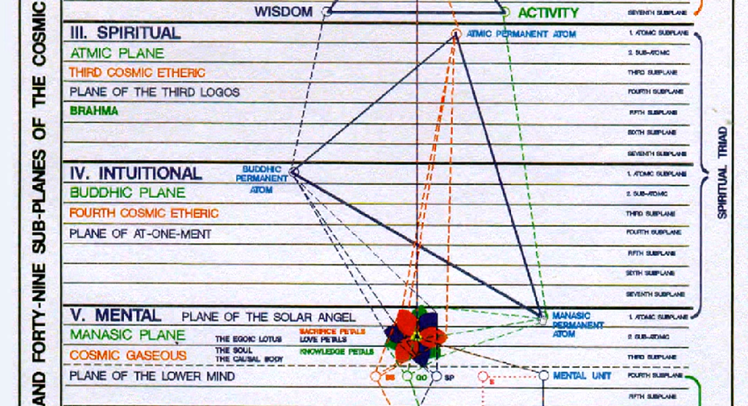

Of course, the antahkarana continues. So, when is the moment when it's really and truly, completely built? It may seem to be absorbed into the monad at the fifth or the sixth degree, but then the whole entire way of high evolution is a kind of antahkarana, our journey is a kind of antahkarana toward stellar sources. So, we're always going to be retracing our steps to the One.

When it comes to permanent atoms, or units, or antahkaranic phase most associated with this ninth petal? Well the mental unit, the antahkarana to the manasic permanent atom. The mental unit is in full expression, especially as we are confirming the third degree. So, it's going to be a time of very strong mental spiritual brilliance. The manasic permanent atom is strongly linked to the mental unit via the functional antahkarana, I think that's something we really have to take into consideration, the mental permanent atom strongly linked to the mental unit via a functional antahkarana. There are three spirillae in the mental permanent atom and four in the mental unit and together they make a kind of sevenfold unit, just the way the astral and physical permanent atoms are sevenfold. They do have to come together. The other permanent atoms in the triad are only threefold, and do not seem to have a connection with any lower four the way the mental permanent atom does.

0:39:30 So, increasingly, the intuitive, buddhi, is coming in, it already did at the eighth petal and as we move towards the third degree obviously, we're becoming increasingly intuitive. The third degree is said to involve intuitive instinct. Spiritual instinct for the first degree, mental imagination and spiritual intelligence for the second degree, and intuitive instinct for the third degree. So, we can see how appropriate in a way the intuitive sign Sagittarius is for this particular phase.

The antahkarana (we know it does continue to the fifth degree) at which point the sun symbolically absorbs Mercury. Mercury is always arranging for the extension of one source until it reaches another, but in a way Mercury and the sun are one, and Mercury is retracted into the sun at the fifth degree. So, the buddhic part is present. If we continue to progress here, the point of focus becomes ever more buddhic, and at the third degree, DK tells us that the power of the knowledge petals is fading out. We tend to use in any deliberate way knowledge less and less, it's just available to us as we need it but our intuitive understanding directs how we will use the items of knowledge that are ours.

Do these petals actually begin to disintegrate at the third degree? The knowledge of the outer world, and perhaps begin to offer up their energies to higher series of petals? If the buddhic part of the antahkarana was touched in the last petal we dealt with, petal number eight, the atmic part will be touched here and that seems pretty obvious, because of the connection between atmic and the manasic permanent atom. The atmic plane is a plane of intelligence, its the third plane. So, from one perspective it yields the first ray being the head of Brahma.

From another perspective, with the logoic plane, operating in the first ray capacity, and the monadic plane in the second, and the atmic plane operates in the third ray capacity. So, it has that third ray connection with the manasic permanent atom. But it's a higher form of intelligence, it’s the intelligence of that which is understanding of that which is intended by divine will.

So, perspective is increasing when we touch the mental permanent atom and higher aspects of the triad, and we are now becoming impersonal – not just suprapersonal, not just transpersonal, but actually impersonal. To be impersonal is to see the person as part of a much larger picture. The person looks much smaller. The big picture puts things in proportion.

I keep on thinking about proportion connected with the atmic plane, which is ruled by Libra, the great sign of proportion. From that perspective, things are really seen far more as they are. Incorrect proportion, even more so than one can see on the two lower planes – that is the higher manasic and the buddhic plane. So, the heights of impersonality in the triad is the atmic level and the master has achieved this.

0:44:00 … in the new schools in the preparatory schools we will first study ourselves and make the necessary adjustments, and only then in the more advanced schools, we study ourselves in relation to the big picture, because the higher types of macrocosmic studies are offered in the advanced schools. It doesn't mean that we forget about the personality entirely, or about the lower self, it is just seen in a much broader context.

All of this development of the antahkarana is very important here. All of the three minds are uniting, if we consider those minds to be the abstract mind the son of mind and the mental unit. With other ways to consider the three minds uniting and they are also the universal mind, the abstract mind, and the concrete mind. The atmic plane is a strong reflector of the universal mind.

So, we have quite full mental expression here, and both Aries and Sagittarius are quite strong mental signs. Of course, we could put the other fire sign, Leo there, because the transfigured glory of the egoic lotus, the causal body, is achieved here. Maybe not the fullest blaze, but the fullest blaze of nine is achieved. A great fulfillment. Leo is connected with the will to fulfillment, and Leo also is related to Jupiter, which may after all if we remove the luminaries of Jupiter may be, in a sense, the ruler of Leo from the orthodox perspective. There is the glory of the nine petals. That's for sure. Jupiter brings to fulfillment, as does Leo. But generally, I work with Aries and Sagittarius in connection with this ninth petal.

Back to the eighth petal, what is the hall in which we are entering? The hall of wisdom. Is the master still involved with the hall of wisdom? Is there such a thing as the hall of life? I think as we move closer to the monad, which of course is a great source of love-wisdom in itself, the whole idea of the hall of life could come into focus. I don't think anything is given about that, but at least the possibility of reading from the Book of Life is given.

We are now in this ninth petal, through our strenuous and abnormal efforts and then in confirmation by the rod of initiation becoming the rich young man. We are a more mature member of the Kingdom of God. We are not just the young man, I think. A young man is the symbol for the mission of the second degree, we are the rich young man. We have accumulated so much experience and knowledge. So, we have many good spiritual qualities in our treasury which is quite full.

Then [in class] a question is asked, ‘but do you go in at night and count your gold?’ We have another, ‘you have the Midas touch’. One is really happy about all the knowledge you've accumulated, and somehow pride yourself upon it and somehow become attached to it, and refuse to relinquish it. Forgetting that it is included in the higher faculties so do you count your gold in stored up. Or do you spend it on behalf of others in the most liberal manner? So many people in the world, they want to be rich, but what does it really mean, once we are rich? How do we handle the riches? We've seen lives destroyed by riches, or let's just say not knowing how to handle the great power which riches confer.

We go on to point number nine. There are different worlds, different dimensions, in which we are focused. We obviously are rapidly moving beyond any deep concern with the personality, so the world of the senses, emotions, and mind, are behind us, but we use them. Then we have the world of meaning, significance, being, and causal causes or purpose.

We're involved here with several things. I guess the world of meaning, mostly because we are developing conscious soul consciousness. The ability to focus within the higher mind. By that, I mean the levels on which the egoic lotus is found. But also, we are entering the world of significance, because that is the world of the spiritual triad, and the finger points towards the plan and purpose of God. We see wither all things are tending. Not complete yet of course. We don't have a plan completely in a first-hand manner. I think it takes the third degree to have that as the true occultist would see it. In my view anyway, the true occultist is the initiate of the third degree, at least it begins there.

If we can focus in the spiritual triad, we are focusing on the world of significance. But we're not really yet focused in the spiritual triad, we are receiving impulses from it. So, something of the significance of things pointing towards destination, and destiny, is coming home to us. There are, what we might call, intimations of the world of being. The Tibetan is an Initiate into the mysteries of being, we are not, but it's at this point that being begins to become a conscious reality. It’s very subtle, because it's always present and always is, but we don't isolate it isolated being. Pretty much the same as isolated unity, and our first steps into isolated unity already taken at this time, even though they are more fulfilled at the time of the fifth degree.

0:52:10 We are looking at the meaning of being, as the triad begins to confer it, from the monad. Atma is the great representative of the monad, from the will angle. And the monadic being resides; the monad essentially is Being. So, we're learning not just what a thing appears to be, what it means, it's relative. It's who has a horrible picture. Its relations where we're not just looking at the relations of one thing to another, we're looking at its essence. Its archetype whole purpose as revealed in the world. Being of course is even more being found in the sea of fire when the monad is liberated from its second subplane vehicle, second subplane of the cosmic physical plane.

In the world of becoming? Well, we sure are active there because we are serving and we have to work out that which has been revealed to us of the divine plan. The plan emanates from the world of significance and especially from the atmic plane of that world, and the numerical alignment is there, all the threes are there, and we are receiving some information about what that divine plan really is. It's not the way a higher initiate sees it, but we're seeing it reasonably so, and we're driven to increasing stand by the spiritual will of the atmic plane to manifest that plan in the world of becoming.

With regard to the world of significance, I said that in that world that which exists from the perspective that world is seen as contributing to the fulfillment of divine purpose. How does anything contribute to the fulfillment of divine purpose? It is not just a question of how this relates to that, but how this contributes to the fulfillment of Divine Purpose? In the world of significance things are moving; they are moving towards the ideation of the Logos which manifests itself as archetype in the world of being. We're all moving towards the fulfillment of the perfect relationship, which is expressed through the archetypes that have been created and are sustained in the mind of God. So, the significance of anything has to do with how it contributes to the archetypalization process.

Of course, we have to be somewhat functional in the world of meaning before the world of significance means anything, before it is understood, and certainly before divine purpose those sustained standing waves in the mind of God, which are purpose, before they are understood. These are high things and we are reaching towards them. We're not really there yet, but we are stretching into them.

0:56:40 Let’s see here about the devic groups, we have quite a bit here. The Agnishvattas and Agnisuryans of a higher kind, they are the ones that are concerning us in the work of this petal and in its unfoldment, the Agnishvattas strongly so, because they are solar angels and the communion the communion with the solar angel is very strong now. We are increasingly soul identified, and the will of the soul will be working out from the atmic plane, but coming down through the synthesis petals and into the sacrifice petals. It’s in our mind all the time. We're trying to represent that will faithfully. It’s another reason why Aries, the foremost sign of will, and really can be considered prominent in this ninth petal.

So, we are realizing ourselves more and more as soul expression. We're talking next about the Agnisuryans of the buddhic plane. Remember, there are higher and lower Agnisuryans, that are not just the devas of the astral plane, which of course are being subdued and are coming more in alignment with the quality of the Agnisuryans of the buddhic plane. So, we are developing buddhi-manas here. Not just the pure intuition but buddhi-manas. The intuition knows the truth and manages and formulates the thoughts to express the truth.

With kama-manas, we have been swayed in our thought by our feelings, but if something comes in as a true intuition, if it's true, it comes from the world of pure reason and it is not involved with the feelings. It may, I suppose, stir up the aspiration at some point.

The intuition (DK labors to tell us), is not concerned with the personal self at all and giving sort of higher advice as how you are to conduct your life, may be from the higher mental plane, that sort of thing can come, a kind of soul guidance, but the intuition is not about that. It's about the larger picture and about creating the perception of unity in the expression of the larger inclusive love. It's all about the plan in the big picture.

We can relate psychism and intuition, just as we can relate the astral body and the etheric body. If we develop the mind very well and learn to think abstractly, it will lead to the intuition, then it will certainly lead to a more intelligent expression of the intuition. So, these higher Agnisuryans are involved with the mediating of the intuition. Intuition, one way to describe it, is the lightening of formless thoughts. It is the realm of ideas, formless beings who contain that which can be worked out in time and space as an expression of their quality.

Are we contacting yet the higher Agnichaitans of the atmic plane? The embodiers of the Divine Will? Well, there is a kind of reflection. I remember discussing with Robert Gerard, and he said, well with first degree you sort of have an apprehension at the first of the second, at the fourth of the third, of the fifth kind of a leap frogging that goes on there, there's some sort of resonance between the one, three, two and four, three and five which makes possible a dim apprehension at the lower stage of what the higher stage may be about.

1:00:44 So, the types of devas involved here, where we're really trying to work with the Agnishvattas and to become more and more the solar angel, to rise to the feet of the solar angel, and we're getting ready as the third degree is taken, to break into the world where the higher Agnisuryans mean something specific to us. Ever a more synthetic approach is followed as we are moving towards the completion of the nine petals of the egoic lotus. We might say of the egoic lotus (the whole thing in a way concerns the second aspect the Holy Ghost), but from a perspective where we leave out of the atomic triangle, the nine petals concern the third aspect, the three innermost petals concern the second aspect, and the synthesis petals and the jewel in the lotus concerns the first aspect.

There are just all these different perspectives and in the question of truth, you have to ask yourself, ‘from what perspective are you viewing the scene?’ There’re different ways to count, different ways to fuse, apparently separate items, to fuse and merge. So, the whole question of enumeration comes in here. How do we enumerate those items that are found in our field of consciousness? According to the way we enumerate will be the meaning of what we see.

St. Paul said, right now we see through a glass darkly, and you can imagine what the glass was like in those days. But now we have more sophisticated means to achieve transparency and always it must be so that the methods of merging with reality are enhanced in quality as we move through the centuries and as hierarchy comes closer.

Let us move on now, point number eleven. The astrological cross most associated with this petal? I think we're dealing with the fixed cross on the path of initiation, and really moving towards the climax of this cross, at the third degree. Of course, we're not experiencing in the eighth petal, the fullness, but we're moving towards it rapidly and the ninth petal, and by the time that ninth petal is completely unfolded, we have what's called the climax of the fixed cross, and the man climbs down from that cross and does not yet mount the cardinal cross, but in fact waits to do that until after the fourth initiation.

So, in this petal the candidate for initiation is still on the fixed cross, and this means that there is a very intense type of experience involving what we have called blinding light. Because, after all, the third initiation is coming. Fiery pain as the purification proceeds and the impurities are eliminated so that there can be a very free flow of soul energy and also spirit energy beginning through the chakric system also. We also have bitter woe, but in a way, we’ve gone somewhere beyond that and a triumph is occurring, and the first aspects of liberation are truly showing because the third degree is a degree of liberation. The third degree is very Uranian in the respect that the rod of initiation is considered to be the flaming diamond, and it's considered to be Uranian and the Initiator is Uranian in the third degree.

The fourth initiation is transitional. Exactly when do we dismount the fixed cross? After the third degree were said to be dismounting from it. In a way we’re still on it during much of the process of synthesis and something of the anticipation of the cardinal cross is coming in, but we're not mounting that cross yet.

If the fourth degree we have to in a way generate our own cross through our karma and dharma, they create a cross together. We're more on our own in that respect and can we stand on our own two feet, evolutionarily? The darkness descends upon us, and we are increasingly abandoned by the solar angel who asks us then to demonstrate what we have learned. We are approaching the fourth degree, following petal number nine, in a clear-eyed manner, and yet a greater dark night than his experience at the second degree also comes into focus.

We’re no longer deluded by time and space following the third degree, and we are working on dispelling the illusion of time and space while working in the ninth petal. The fixed cross still deals with time and space, but the cardinal cross does not.

We’re entering the realm, as the buddhic plane becomes stronger and stronger, we're entering the realm of the eternal now, and it is said: lead me from the unreal to the real. This is occurring and increasingly: from death to immortality. Once we've experienced the third degree, the immortal aspect within our nature. He was a very present, and we identify has that immortal aspect.

In sum, we're still on the fixed cross, as were working in the ninth petal, but once the ninth petal is opened and we're working in the synthesis petals and towards the fourth degree, we are overcoming time and space, overcoming illusion, and in that respect, no longer on the fixed cross. Let's just say consciousness encapsulated within the egoic lotus is no longer the objective, we're reaching towards something higher, and there is a climaxing occurring of all that has been prepared in the millions of years of work. We're actually working to receive the spiritual triad and the synthesis petals are connected with the spiritual triad. They are buddhically inspired and manasically mediated, and because they are connected with the spiritual triad, our work in receiving the energies of the spiritual triad is what helps them unfold.

So, we've moved from the manasic focus into the buddhic focus, and there will be a time after that when the atmic focus, the jewel in the lotus, is the major factor for us – it may be a very brief time, but you have following the destruction of the cause a body of course the spiritual will of the atmic plane is much more powerful, because there is no egoic lotus causal body to intercept it.

Meanwhile I might say that for all of us, really climaxing our experience on the fixed cross is paramount. We do have to learn how to deal with those four factors, and the type of liberation that will come at the third degree. It’s not complete liberation of course, there are increasingly liberated liberations along the way. But learning how to blend together Taurus, Leo, Scorpio, and Aquarius is very much our task at this time.

I don't know anybody, at least anybody that I know in my immediate personal acquaintances, who are dismounting from that fixed cross. Nor have they mastered time and space, nor are they living in the eternal now, and all those things which we can expect when the fixed cross is mastered, and when we are actually entering that very unusual stage leading to the fourth initiation. With the factor of synthesis setting in, the illusions of time and space are rapidly disappearing.

1:12:00 Point number 12. The stage of the path most associated with the opening this petal? Well, we have evolution and ambition, the advanced man, aspiration, probationary discipleship, discipleship, accepted discipleship, pledged discipleship, accepted discipleship, initiation.

Well, we are the probationary initiates. Already because we've taken the first two degrees now, we can be working in the night federal organizing and correlating and vitalizing and still not quite have taken the second degree, because it's not like we work on one petal finish it completely then go to the next. We've talked about this principle of overlap and probably as we examine our life, we will see that we have several levels at which we are working.

There is an advanced level that we have not quite achieved, the tasks remain undone, there's a level at which we are customarily working and we have achieved a great deal, and then there is a level past where we have definitely achieved what has to be achieved. I think every student should discriminate what is his or her cutting edge, and what is the habitual plateau level where one is has customarily been working and feels fairly adept at that kind of work, and what then is the past and second nature, and no longer has to be worked out, but which is fed and somehow stimulated by the work we are doing on ahead? In the egoic lotus, work going on ahead definitely adds power and unfoldment to the work we've already accomplished.

Remember, all this is a plus that is added to work that we have already done and it is augmented by assistive powers like the solar angel and the initiator. So, it's definitely a gift we are receiving from them. Can we say that we've earned every bit of it? No, not really. The gift which supplements the work we have achieved is given more out of grace, it's a great benevolence which is simply bestowed and we're going to become into the position where we too later can bestow that type of assistance on those who have done a certain amount of work and that work will meet our supplementation.

So, we are called the initiate, when the unfoldment of the mind petal really occurs, not only through our strenuous and abnormal labors, but through the application of the flaming diamond, the rod of power of the great lord of the world.

We have passed through the stage of probationary initiation. We can be working in this ninth petal as a probationary initiate, but then there comes that climaxing moment when our status changes to the true initiate, as that initiate is conceived to be in hierarchy. We remember that hierarchy doesn't consider anyone a true initiate unless they have taken the third degree, which is really the first of the great initiations from their perspective.

1:16:10 I mean initiation one and two can be called part of major initiations, because there are still more minor initiations before that. But the true initiation, we know, is initiation three, and so often when DK talks about the initiate, we have to determine who is he talking about. The probationary initiate? Or is he talking about the true initiate, as hierarchy conceives that initiate to be.

What about the stage of discipleship, if any, most associated with this petal? Well, sometimes we have this term called initiate disciple, and even though one might be initiate, he's still a disciple, and so we can be the probationary initiate disciple, or eventually with the unfolding of the ninth petal, be an initiate disciple. Technically speaking, all the way up until the third initiation occurs, we can be called an accepted disciple. But, really that stage of discipleship is at the end of the stage of true initiation, the third degree.

I think of Roberto Assagioli was considered a third-degree initiate and DK called him an initiate-disciple. Well, everyone is a disciple, we're all learning, we're all disciplining, we're all attempting to take that next degree. It's interesting how these terms have kind of a broad utility: we are all aspirants, we are all disciples, and we're not all initiates, but even individualization was an initiation of a kind.

We're not talking about the great manasic initiations. Every time we enter some new field of experience and are released into that field to gather further experience and to express our powers, we are in a general sense, initiated, we’re initiated into something new. The first ray type of will is the will-to-initiate and it has a lot to do with the sign of Aries, which is the great initiator. One day it will be the truly great initiator, not just the sign Capricorn. But then Earth will have to be a sacred planet for that to occur.

1:19:00 At this point we are approaching the third degree, we're probably entering our training which necessitates the antahkarana for the stage of chela on the thread, and we can be directly in contact with the master. Not much of his energy has to be expended to assist us as long as we are really working on behalf of the plan and consciously on behalf of the ashram. Once we have passed that third degree the stage of chela in the aura applies and we have become more central to the master's ashram and we have begun to move from the periphery into a closer relation with the Master.

DK’s students as registered in the DINA books were aspirants on the periphery, they were members of his ashram but had not penetrated very far. So, we under all circumstances want to be realistic about our progress and we want to avoid any type of wishful thinking or inflation. It's usually the realization of the types of sacrifices that are required that encourage the student to be realistic about his stage of development. It is sacrifice really that separates the sheep from the goats. We have to ask ourselves really, what are we willing to give up in terms of attachment to lesser things so that greater things can be expressed through us? Or so that we can clear the path for greater things to be expressed in general?

When we're working between the third and fourth degree, the idea of chela within the aura applies and we no longer need to be on the thread because we can call for an interview. We would never do that except under great need and duress, something we couldn't necessarily solve ourselves. It's a more intimate relation but first we must become the true initiates.

So, what is the initiatory stage if any most associated with this petal? Well, it’s certainly the approach to taking of the third initiation. This transfiguration is the first really solar initiation. We should remember the sun is exalted in Aries, it's a very high expression in Aries and transfiguration is the first really solar initiation, so the power of the sun is very important at this first solar initiation.

It's the third degree and it means that we are entering, with a concerted focus, upon the cosmic etheric plane. Of course, a lot of focus is still on the highest level of the mental plane, which is the lowest level of the spiritual triad, and we can certainly dwell within the growing power and radiance of the egoic lotus. But, in terms of reaching forward, it's into the cosmic ethers and in terms of a habitual place of focus for consciousness, it’s right within the causal body.

Three areas then, there: the higher mind (which will focus us on the second subplane of the higher mental plane, where we will have strong group consciousness), we’ll be able to focus also (because of the antahkarana; two ways really of building that, one from the causal body itself to the manasic permanent atom, and the other from the mental unit to the manasic permanent atom, but the point is we can focus within the manasic permanent atom and begin to think somewhat as God thinks). So that is through the abstract mind, God the planetary logos.

Our real cutting edge is going to be in the higher aspects of the spiritual triad, the atma and buddhi, which in a way represent what the monad is. …

What color are we dealing with in the five color stages most associated with this petal? Well, in a way we're still in the cave but the light is getting brighter the more spacious cave across is not yet over turned. The rosy cross, the cross of utter sacrifice, which represents our fourth initiation. No, not yet completely overturned, but the cross he has well nigh, well we know all about the fixed cross which we have well just about fulfilled or have fulfilled when the third degree is taken. So, we understand something about what it will mean to overturn the rosy cross and go out into full light of day. We are knowing more and more what we have to sacrifice what we have to do, what we have to relinquish, and how we have to collapse the extension of the causal body as it were and reduce that down to the point which can pass through the needle's eye, divested of all things which would hold us not only to the realms of earth but even to the realm of the higher mind.

We begin to know what we have to do. It may be a very daunting type of sacrifice as we begin to think about it. And that's where the rich young man finds himself. It may not have been Christ through Jesus who talks to all of us, but something of the Christ nature will talk to us and say ‘sell everything you have, give the money to the poor, and follow me.’ That is going to be the collapse of time and space and the collapse of all of our attachment to not only to the lower 18 subplanes but even to the lower 21 subplanes. So, shrinking time and space, passing through the needle's eye, and we are preparing to no longer work with the soul per se but our eyes are upon the tribal work and the work with spirit and the soul is grand as it is, the egoic lotus and the consciousness within the egoic lotus is seen as a limiting state.

Here’s an interesting idea that the power of the monad increasing the contacted now after the third degree is compressing us, and burning away all the all the dross, compressing us so we can fit through the needle’s eye. Kind of idea of threading the needles’ eye. They have to crown a still passing through the needle of the high and that being a thread can be brought to bear here time and space and the whole idea of extension in space and time will not fit through the needle's eye, only here and now and the eternal now, here in the here in the eternal now will fit through the eye of the needle so the monadic consciousness and identification as the monad is depriving us of the sense of time and space in which we have been immersed for millions of years. So, our spirit, our monadic aspect, is demonstrating to us the time and space are illusion.

So, the monad, I like the way this is put, sometimes I write things and then forget them and then only remember later am reminded. The monad wipes out sequence and extension. In my series on identification I have some programs on simultaneity and sequence. Sor the monad, which is pure being and immutable, always the same in its essence, wipes out the sense of sequence and the sense of extension in our perceptual mechanism, which gives us the customary sense of space. Kind of wonder about all those universes, innumerable universes, which Blavatsky has told us have already have occurred forever. What do we do with that sequence when sequences are annihilated? Maybe they have occurred but from a higher perspective maybe they have never occurred at all.

1:29:40 So, we get into this interesting idea of the non arising of the universe, and then you kind of wonder what happens to the second aspect of the Secret Doctrine, and second fundamental, because periodicity no longer occurs. It occurs in the relative world but in the realization of Venus, of Venus, it does not. So, on the way to the cardinal cross we are friends the later into the higher triad member the words are transmutation transformation Transfiguration and finally when it has to do with the movement of consciousness into the higher tried, its translation.

We are on the way to liberation, but we are not yet complete and willing servants of the Divine Will. Well, the Christ certainly became that. And we cannot hope at this time to duplicate His experience in the garden of Gethsemane. We can not even duplicate the experience of the becoming fourth degree initiate who says, Not my will father but thine be done on a lower turn of the spiral than the Christ faced in the garden.

We are having now the freedom to be bound. We are allowing ourselves to be crucified for the sake of redemption. We have great internal freedom but we choose to be bound to the redemptive cross. When Christ arises, He goes – it’s kind of an earlier resurrection – He goes forth and he harrows hell, he brings out of hell all of those who are worthy. He ministers to those in prison and that's what we do as well by free choice. There are three days for the harrowing of hell. Kind of wonder whether this also has to do with the sun apparently standing still at the soul’s [inaudible].

1:31:48 But there's an added sense of lightness from the higher realms as we descend into hell and Hell is time and space and the lower plane, also the sense of going deeper into matter but we are sustained by our own realized immortality. This is a peculiar stage with respect to the cross.

We're not really on the cardinal cross here, but once liberated at the fourth degree we are free to harrow hell and become a true savior according to our level. We have detached from humanity and all of the magnetism which necessitates our reappearance in human form is over, and yet we descend in to bring the form of salvation that we can bring, given our new liberated status, and still the limitations of our consciousness.

That's really the big test of the third degree: ‘Do I have the courage, the selflessness, to mount the cross of crucifixion, overcome the rosy cross in the blue oval. Can I take internally the vow of poverty, no matter how much money I may have? An attitude that my resources, whatever they are, my accumulated resources after so many years of many millions of years of development, are strictly for the benefit of the world and not for the benefit of the lower man whatsoever, not for the benefit of the ahamkara. The ahamkara has to be deflated so my identification no longer has any sort of large result that as he goes on the higher mental plane it is utterly deflated, is collapsed. I am identified as something else but if I am detached I may still have what I had before. It's out of my control but I use it in a different way. Of course, one has to be first to the Rich Young Man in that allegorical language, before one can make such a decision. You can't give up what you don't have.

Let's look now at number sixteen. From the point of view of the root races, what is the racial stage most associated with this petal? The third degree, ruled by the fifth ray, is really the fulfillment of the objective of the fifth root race. So, it's climactic area that's the latest Aryan. We could even say that in a way it climaxes with the Master but I'd like to think that the sixth root race can climax with the height of intuition which is the fourth degree, and maybe the seventh root race, with mastership.

Of course, there are so many people that you meet in every race that are nowhere near this point. We've discussed the idea that not even the first tier of petals has unfolded for the great majority, and you kind of wonder whether people are really in the Aryan race until they've done significant work in that third petal. Anyway, because the intuition is coming, we have this sense of the impending sixth root race process here.

Is the master the height of Aryanism initiation? Number five correlates with the fifth root race? Is the chohan the height of that which can be achieved in the sixth root race? Is the chohan of the seventh degree the height of that which can be achieved in the seventh root race? We have the idea of those who are following different rounds, maybe it is in the fifth round that more of these great achievements will occur, and in the fifth round more masters will be produced, and in the sixth round more chohans, and hands in the seventh round if we get that far on this earth (Venus never did). More chohans of the seventh degree, but there are anticipations of this in the sub races that are correlated with these rounds, and maybe in the future rounds a number of different sub races will occur and the one in which is most characteristic of the round will produce the type of emergence we're talking about.

Maybe, here we are in the fifth root race of the fourth round and we are producing an anticipation of what will happen more in the fifth round; we're producing the master who is still after all a human being. So that's one way to look at it. In the sixth root race we will be producing some chohans which a greater number of which will be produced in the sixth round. And in the seventh root race we will be producing more show have more chohans of the seventh degree as might be found in the seventh round.

Most people in this round are fourth rounders, but some are already fifth rounders, like Plato and the masters, and some are sixth rounders, the chohans and some maybe are seventh rounders the higher chohans. In other words, some have achieved even in this fourth root race, what it's going to take future rounds to achieve. In any case, we're meeting kind of the fulfillment of the Aryan stage and even relatively shortly many initiates of the fifth degree will be required. The numerical resonance tells us this and also a direct quote from DK. We can say that the fourth degree is already hinting at the intuitional stage, five and three go together, six and four go together, maybe seven and five go together. What exactly the plans are and how many will be produced, how many initiates of high degree will be produced in various cycles, probably this is hidden in the divine plan and in the divine purpose.

We might say that the sixth initiation is the climax of the sixth root race, but also of the sixth round. The fifth initiation, the climax of the fifth root race, but also more generally of the fifth round. A master is after all a five-pointed star, and interestingly, a master is a human being, but a Chohan is not; they are no longer men, as are the masters, but having passed beyond that lesser state of link themselves to the Great Council in the highest secret place. The chohans link themselves to Shamballa, the masters have not in general done so. So as part of the offering of this fifth root race, which may not last so much longer, a number of initiates of the fifth degree, masters, will be made.

The sixth root race is buddhic, just as the transfigured initiate is one of the higher offerings of the fifth race, so the Arhat will be one of the higher offerings of the sixth race. The Arhat is buddhic, has released buddhic faculty, the buddhic faculty from this perspective is atmic, the master is atmic, and maybe we can anticipate quite a number of masters emerging in the seventh root ray of this particular round.

Who are the ‘rounders’? Well, Plato, Confucius and so forth, fifth rounders. The Christ the chohans, six rounders, but then you can change around quite fast when you achieve these initiations, it just simply means that one achieves. Now what the majority or many will achieve in the round that lies ahead. So, a fifth rounder means a master, and a sixth rounder means the chohan. And we don't talk much of the seventh rounder. At the seventh initiation we are related to the sun and Gemini in love-wisdom, and we become a member I would say of the kingdom of solar lives. So, we find the divine flames on the logoic plane. They are a very high hierarchy and they are related to the sea of fire. Chohans of the sixth degree are six-pointed stars, chohans of the seventh degree are seven-pointed stars, the masters of the fifth degree are five-pointed stars.

We reach the third initiation, that is the first solar initiation, and we become then a disciple on Sirius, not yet a first degree Entered Apprentice on Sirius, you have to be a master for that. Let’s just say a very high degree of Aryanism in terms of consciousness is achieved with the opening of the ninth petal. As we move into the fourth degree and the fifth degree, we are joining what later rounds will produce even greater abundance.

Perhaps it will be the case that in this particular fourth round eventually quite a few fourth-degree initiates will be produced. Maybe it correlates with the round to some extent. But if we're working ahead, already into the fifth, sixth, seventh degrees, we are beyond what this particular round will normally produce.

Yes, the root races ahead will produce a greater number of advanced initiates than our particular fifth root race, but still the majority of the production that will occur of those advanced initiates will occur in subsequent rounds. We really don't know the way the plan has all of this numbered out.

But we do know that certain proportions are planned, certain numbers are planned, an individual may break out of expectation and forge ahead farther than the general plan, but there is a general plan. Just as we are told of the lotuses of passion or desire, that two fifths came from the moon chain and will be on the path before the end of the sixth root race, but three fifths will not be on the path until the next round. That's already planned out. But is one necessarily captivated by that? No. Because progress can be made which is uncharacteristic.

We began lower level Aryan, mentalized consciousness, in the third petal and we are reaching a kind of climax in the ninth petal. While not forgetting the numerical correspondences between the fifth degree and the fifth root ray and the Aryan root race, we're not forgetting that correspondence, realizing that in a way the master is something of a climax of the Aryan process. Beyond that achievement of mastership, we can't really call it Aryan at all, it has to be correlated with the number six. We don't really have a name yet for the sixth root race.

I would say that any disciple or probationary initiate is working in the higher realms of the possibilities of the Aryan race, but it really expand spans over a very broad span of consciousness, all the way from the one who is working with detachment in the concrete mind, not necessarily influenced so much by emotion, but can think in a detached manner and is less and less influenced by kama manas which is which is still a kind of a transitional stage into Aryanism, all the way to the one who is blending with the members of the fifth creative hierarchy of the solar angels, and that is the initiate of the third degree. This one petal represents a high stage of the Aryan process but not necessarily the highest.

What type of egoic lotus are we dealing with here? We've been through the radiant lotus, the lotuses with perfume and now we're focusing on the lotuses of revelation, and the fully blown, nine petalled egoic lotuses. A lotus of revelation. That status continues until the destruction of the egoic lotus.

Here is something to be read, When the third initiation is taken the initiate becomes aware, not only of the significance of the command to know and of the innate ability to express the will nature of the monad – I guess that can even happen in the second degree phase – in carrying out the purpose of Shamballa, but that through his fused personality soul –that's what we have the third degree—he is now in a position to ‘make revelation’ to the Hierarchy that he is on rapport with the monadic source from which he originally came. He can now obey the command to reveal, because the transfiguration is consummated. He is not now revealing the soul only, but all the three aspects now meet in him and he can reveal the life aspect as will. [Ref ?]

So, life and will are different, but they are intimately related and not only the sole aspect is love or the matter aspect has intelligence. It’s a very important statement, earlier I had said, ‘well, I wonder what the second degree initiative is revealing?’ Well, how much of the monad he can reveal? At least he can express the will nature of the monad because Vulcan is so powerful there, increasingly, at the second degree, but the life aspect of the monad begins to be capable of revelation at the third degree.

I've already talked about the way in which, Know, Express, Reveal, can be related to the third, fourth, and fifth initiations, and not just the first, second, and third. So again, we're leap frogging a little bit. We are all was dealing with the relation of one to three, two to four, three to five, four to six, five to seven.

1:50:00 I'm going on here from The Rays and the Initiations, an important area:

It is the subject of revelation and the task of the initiate to reveal with which I am concerned. The disciple, who represents the Ashram, must reveal to humanity the essential unity underlying all creation. This he does, first of all, by acting like a clear sheet of glass through which all may see the reality of Oneness as it demonstrates in practicing operation. When he has, through his own life and words, demonstrated his conscious participation in this basic unity, he passes on to practice ashramic methods of making this fundamental truth still more apparent. You can here see why—as a hierarchical technique—we brought to the attention of the general public the fact of the existence of the New Group of World Servers. They offer a practical expression of an existent unity, based upon oneness of motive, of recognition, of orientation (towards the spiritual world and towards the service of humanity), of methods and of ideas; and all this in spite of the fact that the physical plane relationship is usually non-existent and outer organisation and recognition lack. The unity is subjective, and for that reason is impervious to every taint of separateness. RI 298-299

It is the subject of revelation on the task of the initiate to reveal with which I am concerned. The disciple, who represents the Ashram, must reveal to humanity the essential unity underlying all creation. And we would say is strictly monadic, or is it also of the soul? Because the soul appreciates unity, we certainly must at least reveal the unity, which is understood with the human soul consciousness, can we also reveal the Oneness? That's the question. We’re dealing with the process of revelation. This is lotuses of revelation. Coming in here at the ninth petal and once it is fully unfolded a great revelation coming made and increasingly so beyond the third degree and as the fourth degree is approached.

This he does, first of all, by acting like a clear sheet of glass through which all may see the reality of Oneness as it demonstrates in practicing operation. Such well chosen words profitable. When he has through his own life found words. Notice words to write how important the words are demonstrated his conscious participation in the basic unity, he passes on to practice ashramic methods of making this fundamental truth still more apparent. It is necessary somehow to make this fundamental truth apparent to human beings who can possibly appreciate it.

You can see here why – as a hierarchical technique – we brought to the attention of the general public the fact of the existence of the new group of world servers apparently they are making the underlying unity visible in their practice and in their words they offer a practical expression of an existent unity based upon oneness of motive, of recognition, of orientation (towards the spiritual world and towards the service of humanity) – so oneness of motive, of recognition, of orientation, of methods and of ideas and all this in spite of the fact that the physical plane relationship he is usually nonexistent and outer organization and recognition lack. Which may be of course a great protection because it cannot be attacked in the physical, but by physical methods. The unity is subjective and for that reason he is impervious to every taint of separateness. The physical brain, working in the lower realms, is subject to the perception of separation.

When the third initiation is taken the initiate becomes aware, not only of the significance of the command to Know and of his innate ability to Express the will nature of the monad in carrying out the Purpose of Shamballa, but that (through his fused personality-soul) he is now in a position to "make revelation" to the Hierarchy that he is en rapport with the monadic source from which he originally came. RI 316

When the third initiation is taken the initiate becomes aware, not only of the significance of the command to Know and of his innate reality ability to Express – I've read this before, but it’s so good – innate ability to Express the will nature of the monad in carrying out the Purpose of Shamballa –seems rather high for the second degree, but I guess some reflection of it is coming through for second degree types – but that (through his fused personality-soul) and we're really talking about soul-personality fusion here at the third degree, to a very great extent. Maybe not the full extent but a significant extent we can say we really have the soul-infused personality here, at least in three out of four levels.

But that (through his fused personality-soul) he is now in a position to “make revelation” to the Hierarchy that he is en rapport with the monadic source from which he originally came. So that those who claim to the third degree, or hint at it, or arguments they have taken of it, let them see again the demand. The demand not only of this ability to sacrifice all forever, but the demand to prove to be on rapport with the monadic source, and to reveal it with greater skills, so that people can begin to respond to it and recognize the same within themselves.

He can now obey the command to Reveal, because the Transfiguration is consummated. He is not now revealing the soul only, but all the three aspects now meet in him and he can reveal the life aspect as will and not only the soul aspect as love or the matter aspect as intelligence. He is not now revealing the soul only, but all the three aspects now meet in him and he can reveal the life aspect as will and not only the soul aspect as love or the matter aspect as intelligence. RI 316

He can now obey the command to Reveal, because the Transfiguration is consummated. It was a great and blazing revelation before the three disciples at the transfiguration which I guess we have to say that Christ reenacted. … Jesus at that time was a transfigured initiate, but I believe the type of light displayed was that of one who had passed through the higher transfiguration. In chapter ten of The Rays and the Initiations, normal applications of these words like transfiguration are found, but also higher expressions or higher transfiguration. Even the seventh degree is a kind of Sirian transfiguration. Christ had not yet experienced that but he certainly had experienced the kind of transfiguration which mastership actually is. We can always interpret in ever-higher patterns, and we cannot be limited by thinking that a particular word applies to one level only. Everything depends upon the context in which we choose to work. So,

He can now obey the command to Reveal, because the Transfiguration is consummated. He is not now revealing the soul only –although that is a considerable revelation – but all the three aspects now meet in him including the father aspect and he can reveal the life aspect as will – and not so important because there is life as will. There's life as love, life as intelligence, life is indefinable, it's pure being. Will is not pure being, but it is the closest instrument to pure Being. He can reveal the life as will and not only the soul aspect has love or the matter aspect has intelligence – and really love and matter are life. Of course, according to Madame Blavatsky. We have to get used to a certain fluidity of terms

1:58:00 We are lotuses of revelation at this point, when we simply are working in the ninth petal and organizing, coordinating and vitalizing. We’re not yet the full lotuses of revelation, but by the time we've taken the Transfiguration, we certainly are monadic stage of unfoldment.

I had understood that Alice Bailey was preparing a degree called Sons of the sun. It was for those approaching the second, or the third, degree. I think she did not succeed in making that available but anyway the Sons of the Sun, one of the groupings is called Sons of the sun, but if we're looking at page 101 where the monadic stages are revealed, not necessarily the monadic sources, we have something called rotating units of the seventh order, I think it'll be a little hard to fathom.

… We have to question ourselves if counter-rotation going on. Normally we would think that the synthesis petals, which are going to rotate when they are reasonably unfolded in a different direction than all the other nine, but that is something to be wondered at, is it the way the egoic lotus is drawn, indicating a kind of counter-clockwise direction with petals seven, eight and nine. Not sure that's really true, you see, but it's indicated at least. If we stick to the idea that the lowest of any tier must touch the third level, the middle tier must touch the second. It's not exact. And the middle petal must touch the second level, and the third petal must touch the highest level.

So, it looks like kind of a counter-clockwise rotation here:

2:00:40 Now, we're given the name rotating units of the seventh order. Certainly the rotation has begun and whether the rotation is all in one direction, there is going to be a rotation, and a higher type of rotation will occur with the synthesizing petals and they will (just the way the axis of the earth rotates in a different direction than does the rotation of the earth itself, it’s diurnal rotation, the daily rotation), and rotates in a different direction, or gyrates maybe I should say, in a different direction than does the revolution of the earth around the sun, so we're going to have an analogy here, of a rotation going on and a counter-rotation going on here in the synthesis petals.

The seventh order. Why the seventh order? Is he in touch with atma? The seventh principle? Are we talking here about the rotation only of the third tier? Or are we talking about the rotation of the causal body itself, which also exists in differential rays. I think though we have to stick to the lotus petals. But we can ask are there several orders of rotation within the causal body, and is somehow the rotation of the sacrifice tier of the seventh order. Causal body rotates, mental body rotates, astral body rotates, the etheric body maybe rotates in some manner. All of those aspects of the aura rotate. The outer tier petals rotate, the middle tier rotates, the inner tier of sacrifice petals will rotate, I guess if we count that way, we reach the number seven. With the etheric as one, astral two, mental as three, causal body as a whole, four. Then the aspects of the egoic lotus: five, six, seven.

Now the seventh order? We're told that Seventh Heaven and the third are very related. We're told here in DINA II that St Paul had reached such a point when he referred to the third heaven as a veil of the seventh. Which was the original wording deleted by the recipients of this message at that time, it is utterly meaningless. So, the Seventh Heaven has to be the logoic plane and in some way these achievements in the ninth petal in the third initiation deal with a third heaven. That idea of seventh order may have something to do with the effect of the Seventh Heaven upon the third heaven, and in the third heaven we do find all of the petals of the nine petals of the egoic lotus. Further, even the twelve petals are found in the third heaven.

The relationship between the seventh and third heaven, that I think can come in here relationship between atma and mind can come in here. We're dealing with a harmony of the spheres, that can be considered to be internal as well as external, and harmonization the corridors being produced. Every causal body or egoic lotus will produce some sort of chord, and it will be more and more harmonious. I don't know yet enough about music to anticipate what it would be, but DK does tell us about the [pitch pipe] we start with do, mi, sooo. That's a [toning] ba ba ba baa – that’s a fourfold chord, and the full chord of the monad is involved in that. We're not there yet, we are just on do mi sol, that's as far as we've gotten, because that is going to be the soul-infused personality really of producing a harmonious chord.

But a good musical chord will emerge here somehow, and we as an individual will be in tune with purpose, we're not all of us yet in tune, and the chord we are sounding in our causal, impersonal nature, certainly not yet beautiful at all times. Interesting how the fourth ray souls who have this ability in the arts, music, painting, dance, rhythm – they destroy the causal body through harmony. As more for three souls come into expression we're going to understand more about that process. Even the fourth ray healing method through sound will be some of the first which the fourth kingdom in nature the human kingdom we'll adopt.

2:07:00 Though it's an obscure reference, but when you look at these thirteen names of the monad, they seem to fit pretty well with stages of egoic unfoldment. So, even though some of the names are hard to interpret, I'm inclined to want to read them in terms of petal unfoldment, as some of them really make sense. [TCF 1081]:

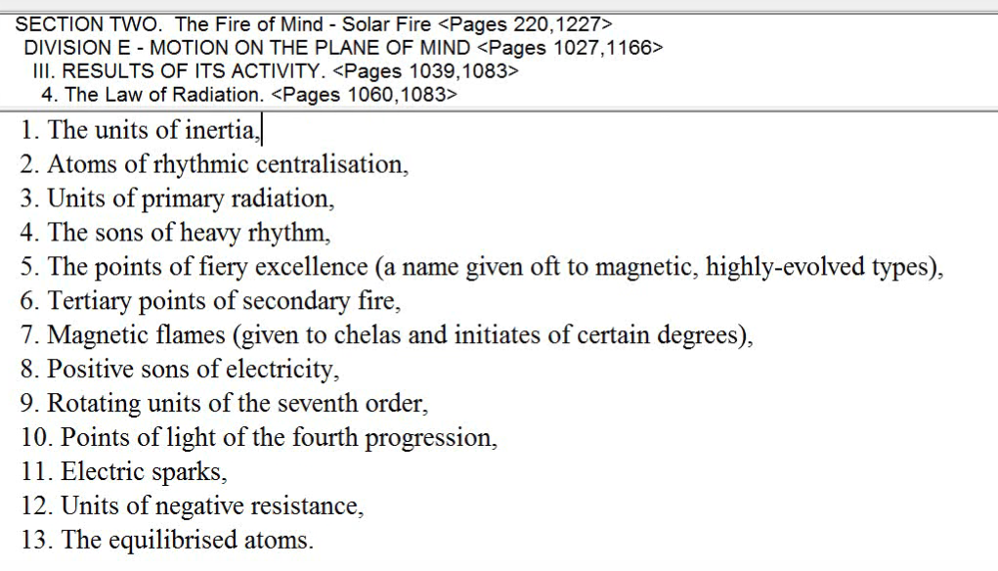

The whole idea of equilibration before destruction makes a lot of sense because the equilibrized atom is ready for destruction.

Number 6. The tertiary points of secondary fire. Makes a lot of sense. Even the fact of three times two is six, pointing to what can be achieved at the sixth petal. Points of fiery excellence seems very related to Leo. When units of primary radiation, we do talk about the primary lotuses that have the third petal quite unfolded in advance with the of the majority of human beings, who are earth chain human beings. Units of inertia fit so well with those who are very massive in the earliest stages of human evolution. Some of them fit extraordinarily well. We haven't gotten into it yet, we will, but the electric sparks fit with Aquarius so well. Units of negative resistance related to Pisces, I think very much so. Probably the twelve petals. There are just certain words which connect us to certain numbers and certain petals. I think we do have here a list of how the unfolding monad demonstrates its unfoldment through the egoic lotus. You can understand how each one of these subjects could open up a great exploration.

What group of souls is most associated with this petal? Human group number nine: they live in the eternal and they know the self as one. They're living in divine cyclic time, they realize there's no my soul. I’m going to turn to this in Esoteric Psychology II, page 207, human group number nine:

9. The souls who are initiated into the mysteries of the Kingdom of God. These are souls who are not only conscious of their vehicles of expression, the integrated personality, and conscious also of themselves as souls, but they know, past all controversy, that there is no such thing as “my soul and your soul,” but simply “the Soul”. They know this not only as a mental proposition, and as sensed of reality, but also as a fact in their own consciousness. EP II 207

The souls who are initiated into the mysteries of the kingdom of God. Well, some of the human group number eight is involved here because they're really treading the path of later discipleship and they are occultists of modern times, but they are reaching towards this human group number nine, and they do achieve it, in relation to petal number nine. The souls who are initiated into the mysteries of the Kingdom of God. These are souls who are not only conscious of their vehicles of expression, the integrated personality, and conscious also of themselves as souls, but they know, past all controversy, that there is no such thing as “my soul and your soul,” but simply “the Soul”. They know this not only as a mental proposition, and as sensed of reality, but also as a fact in their own consciousness. And any true initiate of the third degree knows this, so you ask yourself, ‘Do I know this?’ Really. This is Esoteric Psychology volume II, page 207.

The souls who are initiated into the mysteries of the Kingdom of God. That's the high stage of discipleship, almost initiation, and then initiation, and then they know this. So, this is a one of those prime requirements, the utter sacrifice of all forever, and this type of ability to reveal the monad, let's just say, let’s collect a few of those things: utter sacrifice, reveal the monad, and know that there is only The Soul, and not my soul and thy soul. Those are three strong requirements for the third degree. We live in the eternal, the eternal now is making its way into us, and especially with buddhic understanding and we know the self as one. Sometimes I think of easier to know thyself as one than to annihilate sequence and live in the eternal.

What stage of adaptation is most associated with this petal? Stage seven at last, full knower of the plan, in the world of souls. Even though this already started with the new group of world servers in petal number eight. So, the new group of world servers has a large span, and the third-degree initiates of course can be included and so can, at the heart of it, fourth degree initiates, knowing the plan more as the ashram knows it more directly.

I'll go through Esoteric Psychology volume I, and go to about page 325 and here we are:

7. Here we have complete unselfish adaptation to the group need and purpose. Those who have reached this point in their evolution are decentralized as regards their own personality life. The focus of their mental attention is in the soul and in the world of souls. I make sense with a fair degree initiative right. Their attention is not directed towards the personality at all, except in so far as is needed to force it to adhere to group or soul purpose. These servers are who are expressions of soul radiance and attracting power are knowers of the plan. Real knowers, and in every organization they constitute the new and slowly growing group of world servers. In their hands live the salvation of the world. EPI 327

Here we have complete unselfish adaptation to the group need and purpose. Those who have reached this point in their evolution are decentralized as regards their own personality life. The focus of their mental attention is in the soul and in the world of souls. I make sense with a fair degree initiative right. Their attention is not directed towards the personality at all, except in so far as is needed to force it to adhere to group or soul purpose. Well, that reminds one a bit of petal number seven where that forcing process and controlling process really got going. These servers are who are expressions of soul radiance and attracting power are knowers of the plan. Real knowers, and in every organization they constitute the new and slowly growing group of world servers. In their hands live the salvation of the world.

Well, there's a number seven seems to span the new group of world servers or at least second-degree initiates, but the second degree from another point of view goes on to include the third-degree initiate.

We’re on Esoteric Psychology I, 327, We can see what a high state it is, knowers of the plan living in the world of souls, not attending to the personality, except to make it a fit instrument. it already is quite a fit instrument, but not really being interested in personality life. Where really are our interests? Soul radiance is blazing through in this petal, and remember the sun and its exaltation in Aries, with radiance of the soul shining through in a blaze of glory. We're told about that, when all nine petals are unfolded, there is great attractive power and the attractive power comes in, they have the perfume to be attractive and they are not just expressers of the plan, they're knowers of the plan, the second-degree initiate can express the plan. It takes a real third degree initiate to know the plan.

Within the new group of world servers can be some very high souls. That doesn't mean the rank and file of the servers are high souls in that way, but some in the servers can be third and fourth degree. Alright, well you can see we're becoming knowers, and that's why the word know applies so well to the third degree, if we lift the sequence to the point where true initiation begins from the perspective of the hierarchy.

2:16:48 What about the chakras here? What chakras are most implicated? Well, we're moving in on the third degree, it’s the ajna center. The fifth ray and the ajna center. Can we ask is it strictly Venus that is the ajna center, because Venus has a powerful fifth ray soul? But Mercury has alternately and even more powerful fifth ray seems to me, especially from its monadic level, at least that's how I conceive it to be at the moment. Until I'm enlightened as to my ignorance; we can always hope to be disillusioned along the way.

The ajna center rules the third initiation. The ajna is connecting with the manasic permanent atom, specifically, and with the triad in general. The ajna is a mental chakra. Sometimes it will fulfill a first, second, or third ray function. Actually, when you begin to look at it and you consider the astral ajna as well, you can just about get every ray operating at the ajna center. I've gone through this before, the seventh ray is even involved in the astral chakra and at a certain point the sixth ray and Neptune will come in.

The ajna center is going to allow us to direct our personality life from the soul and allow us also to be very aware of the spiritual triad and because its number is four (has four divisions in it, by numerical resonance) we're going to connect with the buddhic plane as well especially of Mercury, as operative with its fourth ray. As the major ruler of the buddhic center. The ajna represents also, we know earlier, the personality, the integrated personality.

The number four is a number of integration. Integrated personality by itself, and then later because it is integrated with the soul, but it also relates to the triad and we have to remember the number four so important when relating to the personality. We have to remember in a sense that the spiritual triad is the personality of the monad. Now, the normal personality is the personality of the soul, but three become the one. It was a four, and maybe this is true of the triad too, that the abstract mind, it is transcendental mind and the atmic mind are united together into some sort of four, which is the higher correspondence of the fourfold lower personality of threefold personality but united together it makes four.

2:20:00 The ajna center is involved with telepathy, we know. The particular siddhi connected with a manasic permanent atom and with the highest subplane of the mental plane is spiritual telepathy. Of course, Sagittarius helps with this perception of telepathy, which is why it's very connected with this ninth petal. One of the reasons, and Aries ruling the head, and transmission via the head, so spiritual telepathy can come in there as well.

The third eye is emerging as the single eye. The four of the ajna center in a way become the five. Five is the initiatory pyramid; the point above. Let’s also remember the placement of the third eye, not so much at the ajna center, but working through it, because it's really in the center of the head around the area of the pineal gland.

We can see how the fifth ray would be involved in rendering that third eye functional and truly seeing the five gives way to the one. The five is definitely connected with vision, and it is giving way to the number one, in the tetractys, as I have pointed out; the first point is directly above the only, the fifth point.

2:21:50 The higher psychism is beginning to come in and the ajna center is involved in that, the higher psychic powers are unfolding. Well, certainly the power is on the higher mental plane of unfolding. Spiritual discernment, response to group vibration, spiritual telepathy. So, the ajna center is the center for psychism, and DK basically proves that to us when He begins to teach the disciple BSD, a British man, largely on the third and sixth ray, but with a fifth ray mind, how to become more psychic. And his ajna center was poorly unfolded, compared to the degree of unfoldment of the other centers, and so the intention to make him more psychic and his was directed straight through the ajna center. Well, Venus ruling there is important for that, but Mercury even more so, because Mercury has the ability to touch certain higher siddhi areas and transmit them into the normal consciousness. Higher psychism, in a way, is really a type of sensitivity based on the perception of unity. Lower psychism deals only with the condition of the form, and not with the unitive soul.

So, the ajna is very important here; it is the center for the third degree. And is involved of course with this fifth ray, with science, it's involved in the fourth ray with integration.

We would want to turn to The Rays and the Initiations page 340, to see:

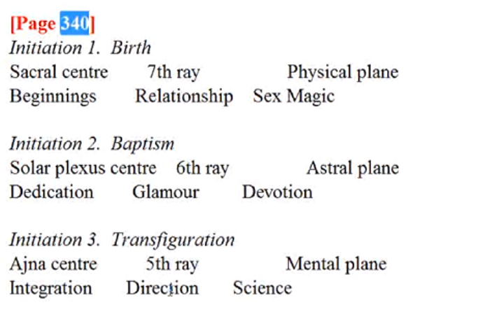

Initiation 3. Transfiguration
Integration, direction – that is so clear, and science. In a way, they're kind of like a two, a one, and a three. The three-five for science. Direction, ray one, and integration, two four, direction kind of one-six, but the three higher rays can be understood through these three words.

Once there is true integration of the energy system of the soul with that of the personality, the way forward is seen and the true science of the soul can be revealed. The fifth ray type of integrative process reveals the relationship between soul and personality which is not that which is normally understood, it's much more technical. Understanding of the dynamics of how the energy system of the soul and that of the personality interact.

In my discussion of the techniques of integration from Esoteric Psychology II, (I've done a webinar commentary series on that), I go through those and talk about the results of the into creative process as it occurs under the different rays.

2:25:45 What chakric triangle is most implicated in relation of his petal? We’re in page 170, A Treatise on Cosmic Fire, we're talking about spiritual man here:

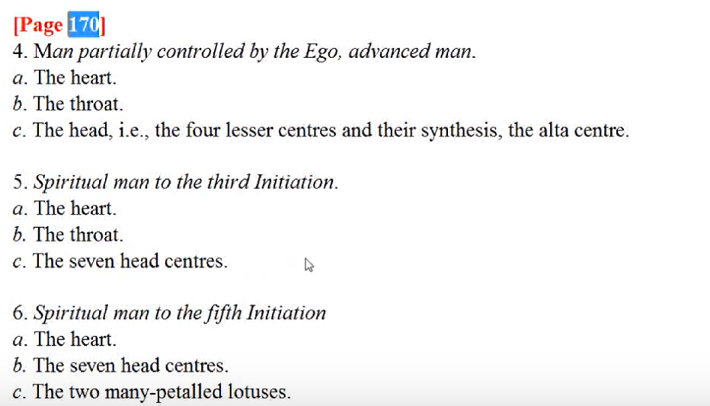

Spiritual man through the third initiation.
The heart the throat and the seven head centers. If we go on beyond that, the seven head centers are there, the heart is as well, the throat is falling below the threshold, as are the knowledge petals, and the two many-petalled lotuses where we have quite a clear statement to differentiate the seven head centers and the two many-petalled lotuses. We would include in those the ajna and the many petalled lotus, head center, the crown center. Now, we want to add the ajna and the heart in the head, we're going to come up with fourteen.

So, we're pretty well working towards the third initiation, at which point the seven head centers. But maybe not the complete fullness of the ajna. The seven head centers are operative, throat and heart still, but then we take off in a new direction, with everything the throat center can do I think being absorbed by the two many-petalled lotus, as though we have a two ring above a seven, and maybe we'll have to also look at the alta. Well that would make ten, wouldn't it? I guess I spoke incorrectly, the heart in the head would make eleven. Well, that is the number of the initiate.

There's so much about the enumeration of the head center which is implied in ancient drawings and paintings about which we don't really know, but it's quite a complex center and it may have even ten levels in it. Ten times 96, which would be the nine 60s plus the 12 of the heart in the head, which would be the total of 972, it's not truly a thousand petalled lotus. … [laughing after some miscalculations] Wait … it's not working, sorry here I'm flunking math.

Ninety six divided by twelve equals eight. So the eight twelves give us the 96 and the nine twelves give us 108. Both are very sacred numbers and remind us of the 108 kumaras. And the 96 times ten giving us the number of petals in the highest head center.

Well, kind of interesting that when Alberto Assagioli asked, after he came or about the head center the Master demurred a bit and said, ‘look, not much is given out or can be given out’. This is one of a few details here, one of the highest occult studies. Fortunately, so much of this will occur automatically without our attempted manipulation of the process. Basically, we just work within the head center and the specifics of its unfoldment are left to the law. Later perhaps, as a Master or under the guidance of the Master, we might be able to involve ourselves in some particular manipulation. I will say that the head center, the ajna and the alta, the triangle existing there, I think can be encouraged by the visual imagination.

Anyway, the heart, the throat and the seven head centers, take us from the third degree, once that my petal is completely unfolded, to the fifth degree, when the causal body is no more. Earlier on, the heart, the throat, and the seven head centers take us to the third degree.

The seven head centers are Vulcanian, just the way the Great Bear, so connected with Vulcan, rules the seven head centers within the One About Whom Not May Be Said. So, Vulcan and the Sun may be one and the head centers may start their activity at petal five, but here we know they are in expression.

The will has grown very strong. The will of the soul is definitely dominating now. The majority has been reached, the three over the two we might say, and we can control with the higher will, so much the transpires within the personality.

2:32:50 The lesser seven and the greater seven are involved. As the disciple nears the portal to greater seven must awaken and bring forth response from the lesser seven upon the double circle. So, certainly the higher seven, all seven are involved, and that of course connects Vulcan with the seventh ray, which is really just another more concrete expression of the ray one will.

Vulcan is also connected with Shamballa and the monad. So, the higher will or monad is definitely now emerging. We have said there are many triangles in the chakric system, many possible triangles, and they are all alike to various degrees. At least in the advanced person. It's just a question of what is most prominent that can be affected by the ray as well. It is so intricate. You begin to realize well there's so many things would be nice to know; Master DK can see and can know these things, someone with such a great understanding of energy, but we have to be satisfied at first with less knowledge of the intricacies. That will be given to us when we can really use it and I suspect that in the next dispensation of the teaching, much will be given.

Are there other chakras that are implicated here? In petal number nine, third degree? Which, and why? The crown, the alta major, the throat, the heart, the base. The crown is growing in power because the monad is becoming a conscious factor. The monad is always connected by the atmic plane with the crown center; the high head center.

When we start to meditate, the monad stream is going to be real, and it's going to be a detectable thing, and this is of course being cultivated also between the second and third degree, but by the time the third degree occurs, Sanat Kumara has wielded the rod and He is the Lord of Shamballa and the monad has its presence within Shamballa. So, the presence of God will be present as a detectable thing.

The presence of electrical fire becomes real to our consciousness and the presence and electric fire are of course, closely correlated.

What about the alta major? It is part of the triangle which evokes the third eye which happens at the third initiation in the pursuit of higher psychism and unity of vision the eye of Shiva. Shiva is the first ray lord and the application of the rod in the ninth petal the will bring forth the Shiva aspect. Again of course, Aries has so much to do with Shiva. Aries, one of the great signs of the dance and the dancer, Shiva, emerges here in realization of the vibratory dancer, Shiva.

So, the alta major is definitely emerging in relation to the ajna and the crown center, the two many-petalled notices as they are called, but in some enumerations the alta major has not just four petals but actually 96, just like the ajna center. So, the last word in counting out all of these divisions is not given to us. We’d have to piece together the many teachings and then see what we can see and also have the confirmation of the master on this would be a good thing.

These three chakras: the alta, the ajna, and the crown, are needed in relation to create the third eye which is really emerging with higher psychism at the time of this third degree. It is the circulation between them that is bringing forth the emerging into functional usefulness of the third eye. So, we can connect to various aspects here, Vulcan of the great light, the first ray, the Eye of Shiva, and the entry of the higher psychism.

2:37:45 The throat center is being transcended, but we will have brilliance of mind here. And with the throat one can speak the word of the soul. But after the third degree, kind of interesting, but the knowledge petals of the egoic lotus begin to melt away, begin to disintegrate, or the person is becoming more and more atmic buddhic, more will and love, will and intuition. So, the throat center and the knowledge petals are very connected and they are not going to be as fully in use. We have gone into the head, and the alta is part of the head, but the throat center is not.

So, we know now as an initiate that not all things can be put into words. And so, silence begins to take the place of speech but one can of course transmit idea, ideas, in the silence. … The initiate Jesus was not dissipating tension in speech so we have the entry into a comprehending silence and we of course,
this implies the buddhic plane and the lower level in the comprehension is the four sounds. But there are silences which are the two sounds.

We do not necessarily have to create in the lower worlds through the throat center as we have been doing. The alta is there, yes, and the throat center of course, the third-degree initiate can still speak marvelously of the vision of the soul and so forth, but the attention is not there, it is just so very automatic.

The heart center is found at the fourth degree very strongly, so certainly is going to be found at the third, growing. The love of humanity and the contact with the buddhic plane, because just as the higher head center has been connected with the atmic plane so the heart have been connected with the buddhic plane and the heart of the head with the atmic plane. The love of humanity in the group soul contributing to a growing sense of universality, because a little taste of isolated unity and for Oneness is coming in at third degree.

Venus is connected with the heart center, Venus is on the mountain. Christ is risen on the mountain. We have the glorified soul, transfigured.

Earth at the heart center. Well, I wonder what that can mean? Sometimes the fourfoldness of the physical heart and the Earth can be connected, just like with a fourfold earth. It's simple at least and the center of the base of the spine, let's just say.

The soul, at this point, is 75% in charge. The soul is the heart, the heart is the soul, these are equivalent terms when we begin to work symbolically here.

The solar plexus center at this degree is increasingly quiet. I mean, it's not that there is not aspiration, as we work with Sagittarius in this petal, but it is quieted. The Stymphalian birds are quieted, we're into now increasingly perception of the impersonal life of the triad.

The rich young man? Well, after the third degree he did go sadly away. But we have experienced the elevation of the solar plexus center into the heart, passion becomes compassion. Perhaps he was still attached in some way to solar plexus functioning to possessing all that, to being rich. The ahamkara was not defeated, that was the problem. He'd liked spiritual possessions and was afraid of losing them that tells us something about the solar plexus, but in general this center is quieted down in a personal sense, and the desires generally at this point are now of the heart and soul.

I quoted here Master Morya’s statement, When have you ever become less through sacrifice? So, when we all become the rich young man we can ask ourselves that? ‘Sell all you have, give the money to the poor and follow me. When have you ever become less through sacrifice?’

We are a Scorpionic kingdom. The group of human monads. We have to get used to paradoxes here, we have to get used to this amazing Scorpionic paradox that we have to die in order to live, and give up in order to get, and if our cup is to run over, we must empty it.

AAB was certainly involved in the full effects in the heart center, it was said. But I think that was before she really took the third degree. In terms of her brilliance and making us extraordinary revelation, I think we can honestly say that she stood as a third-degree initiate. Roberto Assagioli did, I see no reason to suspect that the AAB did not. I mean some people like to minimize her status and minimize the status of HPB, too, since she drank, she swore, she smoked cigars. But, I think if we really look under the statement of the Christ by their fruits we'll know them, I think we cannot doubt what Alice Bailey was.

So, solar plexus quiet. What about Neptune? That part of the solar plexus center. It will be more stimulated than the lower. The higher desires will take the place, we are transcending personal desire and before we take the third degree, Neptune has to be very active, and after we take the third degree, Neptune is active in coordinating the buddhic vehicle. Mars is the red, the lower point, the low desire, that part is quieted, Mars is a pretty noisy planet anyway. We enter into the silence of buddhi, we understand about the silence of Neptune and that which can be wordlessly transmitted via Neptune and buddhic transmission. Maybe the higher part of the solar plexus is taking care of whatever transference remains, but at the third degree and afterwards, Neptune is involved with telepathy and the transmission of the intuition, increasingly, with the buddhic contact. Neptune is all part of this process.

Interestingly, at the third degree, we do defeat Mars and the moon. Mars is defeated and the normal moon is defeated, but that which the moon veils is the method of defeat, the spiritual will. Mars and the moon rule the lunar vehicles, as we're shown in this table of creative hierarchies, you’ve seen that many times I suspect, but just to refresh our memory, going to page 35 of Esoteric Astrology:

We have seen the seven creative hierarchies …

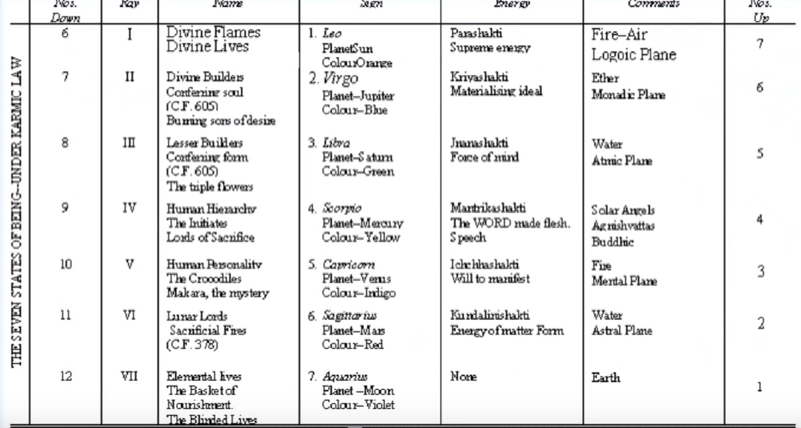

The Lunar Lords, Mars, and since they are Lunar Lord’s … Mars and the moon, lunar, moon, Mars ruler. Interesting what happens to the Lunar Lords in relation to this ninth petal, because Sagittarius is so important here, really, they are entirely reoriented. But the factor which defeats the normal moon and Mars is Vulcan.

2:47:20 Mars and Moon are all about personality control and we are released from that, from the ancient authority, and we deal with authority we deal with will, and Vulcan is the planet of will. This planet of will is applied subjecting us now to the authority of the soul, or we the soul subject our personality to our soul authority. Mars and Moon no longer have the kind of authority they did. So, to defeat Mars and Moon, our desire nature is entirely transmuted and we desire the higher worlds and not the lower ones, and even in petal eight this was operative but here at petal nine, when fully unfolded we really need to conquer the personality as ancient authority is defeated.

When it comes to the sacral center? It can be used for the purposes of having children largely. That's what the Dalai Lama said, that's what the Tibetan seems to imply. But it is an evoked center and not really one of the major centers, it maybe can contribute to manifestation because it's so connected to the physical plane, but he does not the pursuit of sex for its own sake, but always the purposeful use of the sex impulse. Uranus, which is so important at this third degree, is definitely the ruler of the sacral center at this point.

What about the base of the spine center? Well, it is becoming increasingly active, it relates the number four, it represents the will of the personality, it is will and the high head center, purpose. We're learning something about the will-to-be at this third initiation, full unfoldment of the ninth petal.

There's a link here then between Vulcan, which normally rules the head center, but Uranus as well at this point, and Pluto which rules the base of the spine. We're beginning with this will-to-be, which will be I suppose in a way consummated, well I would almost think at the seventh initiation when we achieve operational release from the limitations of the monadic vehicle. How can we talk about limitations of that vehicle? Yet if the volatile essence is to be released into the sea of fire, there will be limitations of the monadic vehicle; all temples must be destroyed.

Vulcan, could it be ruby red? Mars is generally connected with the ruby and the sixth ray. Vulcan seems to have the orange and red quality together. But Morya is so connected with Aires and He loves ruby red, it emerges in His discussions. He has certain preferences and those preferences are brought forth. Mix yellow and red and we get orange, well maybe Vulcan is involved in that way.

I think we've looked at the different planets that can be involved at this point.

We've gone through maybe only a third of this outline, maybe this last synthesis, petal nine, will be the longest, but later some of them are shorter. We've been looking at the chakras involved. And not yet be planets, but I've begun to mention the planets, if they are related to particular chakras.

Head center? Definitely. The will is becoming powerful. The seven head centers, of course, they have a Vulcanian aspect. The third degree is being taken, so the chakra, that controls that degree, the ajna center, is involved.

The throat is sliding, the heart is growing stronger, solar plexus is quieting, sacral center is subdued and the base of the spine center is heating up. And in all of this we can begin to assess our own position. You can get lost when you think of where you are in this great developmental process. So many things happening, but they do tend to accelerate and sort of pile on top of each other as we reach the cyclic end of the human phase of development. As I've told so many people, if you have taken the first degree, maybe you have taken not only 99% of your incarnations but 99.9% of your incarnations. A high number of incarnations have been taken. So, although we may become a little impatient, we are nearing the end of the human stage of development.

With respect to the astral chakras? Well, most of them are found here. They'll all be involved, head, the heart. They must be involved fairly early in the game, but we are already transcending the astral plane. The mental chakras have to be involved with every type of petal because the petals themselves represent chakras. They are energy sources and eventually I think when they are destroyed other kinds of chakras take their place to contribute to the 35 vortices of force which make the master. If we look at Esoteric Healing … page 51, all of these factors are involved:
[Good Aspect; far right column]

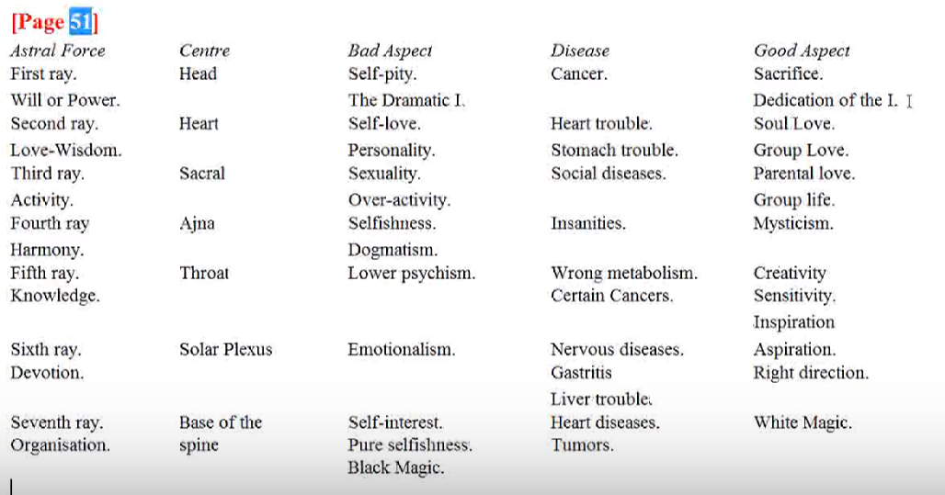

Sacrifice, dedication of the I, which now realizes that self to be something else. So, love, of course Group love, of course. Parental love is not the main thing, but certainly it will be there to a higher degree if such people have children. The group life. The blending of the mystic and the occultist, because Neptune and Uranus will be blended. Creativity, the soul creativity. Sensitivity, inspiration, aspiration may be dying down a little bit, but because we approach the third degree from the level tableland, we are told it's more of a mental approach, but we're certainly going in the right direction. And we can become the white magicians.

So, you can see with this last column, how many of the astral chakras would be involved Some more than others. The mental structures were not told what they will do, we're told there is a mental center, I think maybe somewhere between the heart center and the throat center and it would be involved, but there are some yogic expressions which are not fully given here.

What's the ray most implicated here? For the third degree, it's the fifth ray. Sagittarius interestingly does give the fifth ray; four, five and six. So, there's a great exploration of far spaces and of higher spaces, scientific exploration. Ray five of course for illumination and that's what the Transfiguration gives. There is some mental illumination, but it really comes out as the transfiguring blaze of glory for the ninth petal in the third degree the Enlightenment comes, the satori comes. It is the unfolding of this petal sort of under the Brahmanic regime, which has been so popular by other terms and names in the various traditions. It's the satori of the Japanese the and enlightenment of the Buddhist. This is what we're finding here now obviously for satoris go on forever and enlightenment or ever progressive, but we really understand what we are and what we are not. The illusion of our involvement in the lower three worlds as if we really belong there certainly has ended at this point.

I think this would be a good place to stop, because I'm going to get quite involved here with the other rays that are involved with this ninth petal. I mean as we've understood more and more of the different factors whether planetary, zodiacal, or ray factors, are involved with these more complex petals which are involved in synthesizing our long experience as a human being. …

The end of egoic lotus webinar commentary program 57 and this is part one of synthesis for petal nine and it's going to be about three hours. We'll have the beginning of egoic lotus webinar commentary 58, part two. We still have a long way to go, but we are actually synthesizing. Actually, I’ll have less to say about the synthesis petals, because DK had less to say about them. I have some things and I'll be commenting mostly on what He said, with also some speculation.

It's not that we have not entered the realm of synthesis for those of us who have taken the first initiation, we have entered that. The first synthesis petal has somewhat unfolded as a result of the first initiation, and are we working in those petals the way we work to organize, coordinate, vitalize in the other petals? I'm not sure. Usually unfoldment has to occur because work has been done. So maybe we're working, as we're approaching the second degree, bringing things together because at the first degree the first synthesis petal does somewhat unfold. How much? We don't know, but obviously the further you go on the path of evolution the wider your consciousness becomes and the more capable you are of seeing things together, and in relation, and as a whole.

So, this will be it then, we’ll go on. I'm eager to get into the synthesis petals, not because I know so much, but because it's really interesting to speculate into – they are of a different order. They are the lemon yellow, the beautiful lemon yellow of buddhi. Probably different from the yellow of the mind, the yellow the transcendental mind. It will be interesting to do that.

The time being now friends I will say goodbye, and maybe later come in on program 58, which will be part two of the synthesis for petal nine. I will see you before long, I hope you had the patience to live through some of this. If you have gotten this far in this series of programs you have to have a special reward. What shall that reward be? Well ideally it would be knowledge and wisdom, hopefully.

See you soon, bye.

