EGOIC LOTUS WEBINARS, VIDEO COMMENTARY – 56, Michael Robbins
Abstract
Egoic Lotus Webinar Commentaries 56: Part 4 of Synthesis for petal 8.
This webinar is about 1 hour 32 minutes long.

Program 56 offers the fourth of the commentaries for the Synthesis of petal 8—the second petal of Sacrifice: Sacrifice/Love. In terms of the 80-point outline we have been using, it takes us from Point 60 through the final point in the outline, Point 60.

This petal is closely related to the Human Creative Hierarchy which is ruled by Scorpio and Mercury—the sign most associated with petal 8 and the planet intimately concerned with the tasks related to the unfoldment of petal 8. This is the petal in which the second initiation is taken, though the petal is not completely unfolded until after the application of the Rod of Initiation. It takes a long time relatively, to open petal 8 because of the many lives which usually separate the first and second initiations. In the experiences of this petal, much suffering is endured as the probationary initiate prepares to “enter the Stream”.

Egoic Lotus Webinar Commentaries 56 199 MB .wmv file
Video of Egoic Lotus Webinar Commentaries 56 by Michael D. Robbins.

Egoic Lotus Webinar Commentaries 56 89 MB .mp3 file
Audio of Egoic Lotus Webinar Commentaries 56 by Michael D. Robbins.

Transcript.

Hello friends. We are continuing now with part four of our synthesis for petal number eight, a most important petal involving the second initiation and also the temptations in the desert, the petal which takes long to unfold.

We reached point number 60 here. The main sign is Scorpio if we begin numbering from the first petal with Aries. It's pretty clear that the egoic lotus is a kind of miniature human zodiac, just the way the heart in the head center is, and I wouldn't be surprised if there's something about the monad which is twelvefold as well. Because it has a higher type of heart found on the second subplane which correlates of course with the second aspect the second subplane of the concrete physical plane.

Since Scorpio is the major sign here let maya flourish and deception rule. Well, during the unfolding or the work within this petal a lot of work is done on clearing away the glamour. Maya does not necessarily mean the maya of the dense physical plane, the technical way it is understood – the maya of the etheric-physical plane, it means all glamour and illusion in general. So, during the work on this petal we must learn to see clearly.

Point 61, the keynotes from the angle of the soul? Warrior I am and from the battle I emerge triumphant. Well, there is no question that the second degree is a great dividing line and we are triumphant over Mars, interestingly enough. We would say that Mars contributes to the victory, but the real victory is won through the sources of light which in the case of the second initiation is Venus and we must also mention Mercury as well. It's through the higher light that we emerge triumphant from this battle and indeed once this petal is open, or mostly open, we have passed a major hurdle.

There is another hurdle before us which we confront for the final time of our stage of evolution, the world, the flesh, and the devil, the triple dweller on the threshold, representing the etheric-physical – the world, the flesh of the emotional vehicle, and the devil the mental vehicle with its pride, separativeness and cruelty. We may not have won the complete battle over illusion, but sufficiently at this midway point between the second and third initiation, to say that we are truly on our way in the Sirian stream of initiation.

So, once we have entered the stream at the second degree, and once we have really overcome our temptations in the wilderness, in the desert, we are surely free to make very rapid progress in the unfoldment of the final of the nine petals, the petal connected with Sagittarius and Aries and which gives us the triumph over evolution, at least at our stage. I mean DK has told us really that we're not triumphing over illusion until the ninth initiation, which I suppose means that the entire cosmic physical plane is in a sense a plane of illusion when considered from the higher perspective. Then of course there is still a greater emergence as the synthesis petals begin to really unfold in earnest. They have been somewhat open to the first second and third initiation but the real, full unfolding in their bursting open occurs before the fourth, after the third to before the fourth.

Well now we go into the idea of yoga. The five organs of action? the voice the hands. The voice through which thought has expressed and thought forms are rendered more tangible than they are as thought. Obviously, they're given some kind of embodiment on the physical plane.

The hands, the feet, the excretory organs, and the organs of generation. Excretory organs and organs of generation are very key to this petal, we learn how to control the sex impulse which contributes greatly to illumination. And, it's not just the physical excretory organs we learn what to be rid of and the law of repulse is connected with this ridding of ourselves, of all that here is not only unnecessary, but let's say poisonous to our system.

By human hands and human feet? Well, we serve with the hands and the feet as was given in the Roerich painting which shows us Christ in the desert drawing, with his so-called cane in the desert sand, the solution for the human race, which is basically service. We learn how to blend the usually mentally related throat center with the heart, because there's an increasing amount of Venus here and of the buddhic plane. The filling of the astral body with increased measure of love through Venus and also through a conduit to the heart of the sun provided by Neptune. So, the voice becomes the carrier of love.

The five organs of receptivity, number 63, the skin, the eye, the tongue, and the nostrils. Well, I can only say that all of them become increasingly acute. We become more sensitive to the inner touch. We may begin to hear the four sounds from the buddhic plane, that would explain somewhat, the eye becomes acute, but it is the eye which increasingly sees the unity. Taste is connected with the fourth ray and this is a strongly fourth ray petal contributing to discrimination. Let's call it discriminative taste, learning what is of value and what is not.

Interesting about the nostrils, because they smell the way home to the inner source, not completely yet, but they are also involved in detecting the stench which is interestingly connected with Scorpio. The swamps of Lyrna have a particular connection with the second initiation and the fluid astral realm and all that can accumulate of stench when the waters are not moving, when they are brackish, when they are in some way the hosts to all kinds of nefarious entities. The harmful bacteria, viruses, whether of the ordinary physical kind or internal kind.

So, we learn through smell what is divisive and hostile to harmony and hostile to fragrance. Interestingly enough at this petal we have, when it unfolds, the lotuses of perfume. So, the sense of smell is very important here, whether to discriminate between that which is truly horrible to take into your system by the nostrils, and that which is beautiful, uplifting and the fragrance of the soul and of the inner person, you see, as Master DK discusses it.

0:10:10 The alchemical journey? I'll have to defer to some of my colleagues here, this could be researched, I really don't know enough to say too much, but I'm sure there comes a point at which the ore, which is in process of being melted and changed into a higher form of metal, eliminates impurities. I believe that this petal is very much involved in the drastic confrontation with an elimination of impurities. Of course, this is a whole extensive study in itself, it was included by my colleague in this list of possible associations and I'll just leave this for others, or for a more extensive study at some other time.

We've been including something of the tarot cards and the Scorpio card is particularly the card of death. And here we are, I suppose it's this card, it is the … 13th card: [3rd row, 8th column]

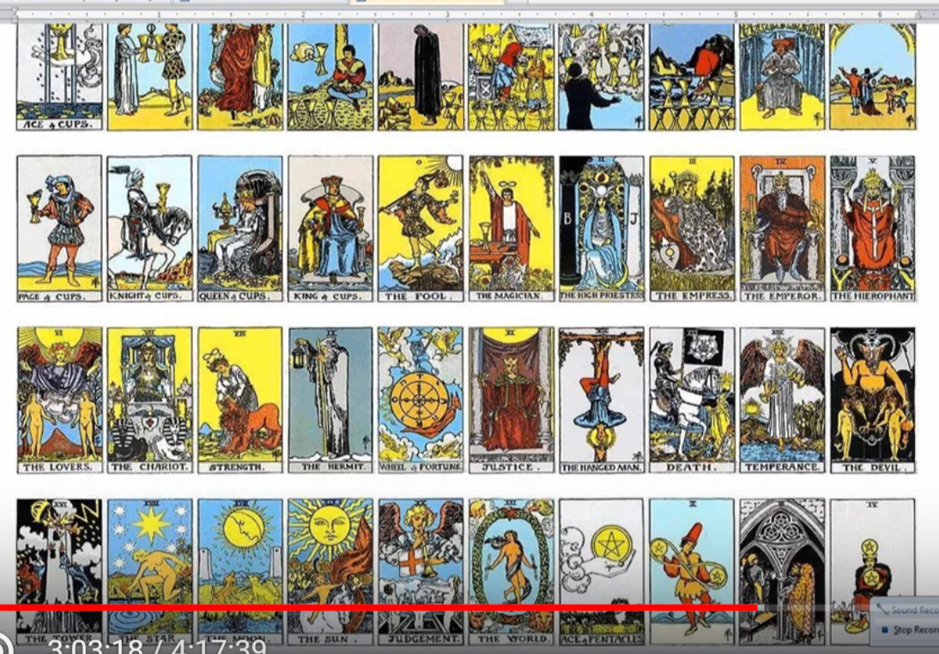

Interestingly enough, the card associated with Scorpio and with death well what is it that dies here? The addiction to personal desire dies. So, in a way, our lower desire nature is dying out, as we say the moon falls in Scorpio. We do run into many death and detachment experiences at this point.

We can possibly connect other cards, this has a Leo component to it, the eighth petal because we can either go starting with Aries, Sagittarius, Leo, or with Aries, Leo, Sagittarius, but it requires great strength and fortitude even at this particular petal and long endurance. We may feel like the hanged man that we are really beginning the sacrificial life in deadly earnest.

The devil card? Well, it's a Capricorn card and it has to do with being chained to materiality, but in this case we are breaking our chains through initiation. You can see through the tarot in a way how one sided the depiction is, because the higher aspects of Capricorn are not really here displayed. But Capricorn is involved with all the first five initiations including obviously the second initiation. So, we can think that some of the devil is being overcome here in petal nine, the devil pride is being overcome as the mental heads of the hydra are seriously confronted. Of course, Scorpio was also involved in that confrontation because it involved in the first three initiations.

The moon card, the moon is falling, falling away. And the sun is rising, the sun of initiation is rising. So, a number of the cards, there are fifty-six in all I think, and they're not here listed, maybe just some of them are listed for some reason, not all, but all the trump cards are listed.

I guess whenever Uranus is involved, the magician comes into practice and the approach into white magic (or black I suppose), is part of the process of petal number eight. There are probably ways that we could connect the many trump cards, tarot trumps, just as we can connect to different signs of the zodiac.

The hermit could come in here because in a reverse manner, reversing the wheel and beginning with Aries and going in a clockwise direction, Virgo shows up here and we are walking in the dark cave and it's become even darker than it was under the influence of Virgo. I think some sort of mini dark night of the soul is possible in this petal, as an anticipation of the real dark night of the soul at initiation number four. There are other areas of darkness which have to be faced as we study the rules for disciples and initiates, the advance rules in The Rays and the Initiations in chapter ten, other areas of darkness have to be penetrated.

But for us, it is enough to think of penetrating the darkness of our psyche and a kind of a barrier before we can enter the causal body, and a kind of a barrier before we can enter the buddhic plane at the destruction of the causal body. There are others and higher ones, areas of darkness which have to be penetrated.

You see the tarot here is kind of in a way an antique system, it's got a lot of profound knowledge but unless we learn some of the higher meanings of these cards, regardless of how they are depicted, we shall not have a fuller story.

0:17:15 The mental chakras? Well, they certainly are unfolding here, under the influence of Mercury. The concrete mind is becoming very powerful in Scorpio in two ways, as I have discussed: one to control the emotional vehicle, and the other to be a vehicle for the illumination of the soul.

Also, really, the petals of the egoic lotus take the place of the higher mental chakra, or is what would normally be the head center or even the ajna center is operative through the sacrifice petals. What would be the heart chakra is operative through the love petals. And what would be the throat chakra through the knowledge petals. Only the lower four chakras are listed on the mental plane. And you can see it here:

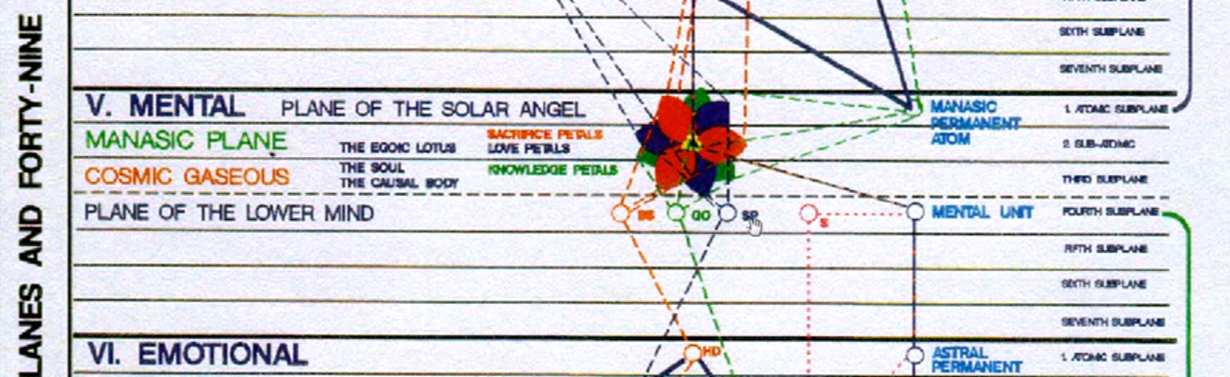

They are base of the spine, generative organs or sacral center, and the solar plexus, and the spleen is listed.

The ajna center is sometimes left out of the equation, but I do think it belongs ultimately on the highest, connected with the highest tier of petals or sacrifice petals. It's there that the personality is really integrated and the first great function of the ajna center is not only to direct to the selfish personality but to see through the integration of the soul energy system with the personality energy system.

We go on to the idea of the eightfold path, now becomes really important, because we are the real disciple and we have entered the stream. When this petal is mostly unfolded and so our perspective and our will is coming in under a right intention is the right use of will. Vulcan as we know is related to Taurus and the conveyor of illumination is very important in this petal energy is the means by which we will confront desire. We have to speak in a magical and appropriate manner as the initiate it should. Right Action, it goes without saying. Right Livelihood, sometimes by the time we reach this petal we are able to make that transition so that the work of the personality truly becomes the work of the soul.

In the lives of so many people there is a divide, and it's just the way things are now. You have to serve Caesar with one mode of making a living and serve Christ in your spare time, but that's not a totally integrated condition. Of course, one can bring the service of the Christ into the service of Caesar, so to speak. One can bring all of the soul impulses into one's normal service in relation to the physical plane and its values and desires. But sometimes the transition can be made so that one is truly carrying out more fulfilling manner the impulses of the soul.

Anyway, in terms of our livelihood, we do not do that which specifically would be against the soul culture. I mean if we were at this point, except under great duress, a bartender, or a drug dealer, making it possible for people to get hold of substances which dimmed their consciousness, that would not be right livelihood. If we were stealing from people, and there's many different ways to do that, it's not right livelihood.

0:22:10 Right effort, of course, it continues. Right mindfulness is very important in this petal because sometimes it's called right memory and interestingly enough, under Scorpio the factor of memory is sometimes activated so that it can go back over a number of lives and through one's dreams or reflections, glimpses of past lives can be brought to the surface and one sees more clearly what one has done and the kind of activities in which one has been involved in former times. That’s memory, but mindfulness is in a way a right observation, right state of alertness. Mercury is so much in a way the planet of alertness and is very powerful here as the hierarchical ruler of Scorpio. So, we do really learn to detach and to see ourselves free of the glamorous impulses.

Right concentration. Well already that has been in effect. Leo rules concentration, this is interestingly a Leo petal from the fire sign perspective and we are deepening all the time, or do we need to centralize our consciousness?

The different kinds of translations of these of the eightfold path here might give a slightly different perspective:

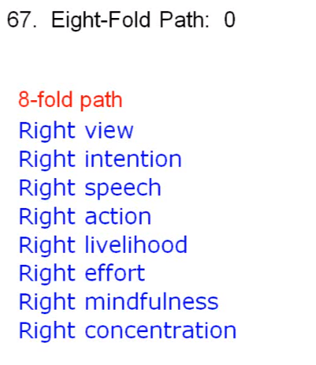

We are certainly reaching the point where the four noble truths are taking hold and we really understand how desire has chained us to the world. There's the devil card in the way, and the lower Capricorn. And how through detachment and the breaking of desire from life in the lower three worlds we can become unbound.

So, certainly for the second-degree initiate, the right means of detachment are practiced and it is possible then to understand the truth that is only revealed when we have overcome the lower desire. Mars does represent the lower desire and Vulcan is already fighting a battle with Mars. Vulcan very close to the sun and actually a great bringer of light. And we're told interestingly that Vulcan burnishes the shield of Mars. Mars is the personality and the light of the personality truly can begin to shine under the Vulcanian influence.

0:25:00 Further here, the means of yoga, the yama (or the commandments) and niyama or the restraints. So, looking at the eight means, well gosh Scorpio can be a sign of extreme harmfulness and we begin to realize the manner in which we have been harmful here and we overcome that. It takes a lot of courage of a scorpion, a kind using the first ray, to tell the truth to all beings and we are practicing that. Scorpio is the sign of vampirism in its lowest expression, where we are stealing the life essence from others, that is a subtle type of theft, we become aware of and will not indulge them as we are overcoming the Hydra heads.

We also learn how to conserve the subtle energies including the sexual energy for the sake of illumination and we begin to realize that we cannot envy and covet what others have, we must generate the fullness of our own treasury from within ourselves and from the energies that are released by high sources within ourselves. In that way and by right effort and right action in the lower worlds we can earn what is in our treasury; we cannot covet or have this avaricious attitude where we are also hoarding and not sharing.

So, this is the way the commandments can be connected with the processes in this petal.

The restraints here are pursued in earnest, internal and external purification. Under Virgo, it’s partially a Virgo petal and under Scorpio, drastic purifications and purgations, elimination are pursued. Maybe it's hard to be content when divine discontent is always to be practiced, but we can contain this apparent contradiction by not fretting with our present circumstances, even while working to improve them and enlarge our environmental surroundings so that greater expression can occur.

Fiery aspiration of course, any applicant for initiation is filled with fiery aspiration, and Mars is still very strong in this petal. Mars, the planet of aspiration, and also Neptune, fiery loving aspiration with the energy of the heart of the sun.

Spiritual reading? We're learning how with Scorpio to look behind things, and within things. Certainly, the inner angel or the inner god is becoming ever more luminous in our devotion, and remember devotion being that quality which releases one at the second initiation, in dedication, glamour, devotion. That is the sequence but the devotion is not to the outer things, it's to the inner, immortal god, and thus we achieve our immortality through right identification with the inner god.

The other aspects continue of course as we deepen our meditation. Uranus is strong here. Rectitude is strong, and that is posture. Pranayama has to do with the right use of the etheric body as the higher ethers are impacting the lower ethers, the rhythmic factor is entering. Abstraction is very strong here, pratyahara, in this particular petal because there is a real pulling back from all that the lower desire had attached us to. Dhyana, intensifying concentration leading to intensifying dharana or meditation leading to illumination. The full Samadhi is not ours yet. It is a realization of synthesis, it is atmic-nirvanic consciousness, and even if monadic consciousness, it cannot be ours yet at this point nor can the higher types of meditation of the higher initiates.

But certainly, we are beginning to live from the concentrated, attentive, soul-reflective mind, at this point Mercury the mind being so strong in relation to Scorpio. So, these are a little bit, a cursory treatment, but it's how we can look at how the ongoing development of the commandments yama and niyamas are proceeding.

DK has thrown in the idea of the eight beatitudes, I suppose the Ten Commandments could be put in here as well, these great negations, DK looked at them as just maybe a little bit primitive and for a people that had to learn restraint, I mean how old these commandments are we don't really know, and they could well, well antedate the Hebrew period in my view.

0:31:40 So many relinquishments are occurring here in petal number eight and although these beatitudes are essentially enunciated from the atmic plane by the Christ, immersed as he was in his understanding of the will of God at that time, his understanding grew of course in the garden of Gethsemane, but it was already extremely powerful. The poor in spirit are not attached to the world because and because they are detached from the world the kingdom of heaven or a higher vibration is theirs. You may mourn to detach yourself from all that you had desired, but the buddhic plane and the triadal energies will await to comfort you. You are really applying of the discipline, so you are meek, i.e., trained. Alice Bailey says the meek are trained, and they will inherit the earth because they will know the law and function according to the law because they have discipline themselves to function according to the law.

Here is something to do with aspiration hungering and thirsting after righteousness. Ask, knock and seek, ASK, seek and you shall find. So, all aspiration will be rewarded, then we've turned our desire away from the things of the earth and instead thirst after the energies of the higher planes and the knowledge and love and power of the higher planes.

Buddhi makes us merciful, blessed are the merciful for they will be shown mercy. Sometimes, not at first, because there is the karmic recoil. That happens and we do end up paying for all those times when we were not merciful, and oftentimes a highly-merciful spirit may meet with a great rebuff, but later it will be it will be so.

Thinking even the story of the inter-kingdom communication, Androcles and the lion, and he at one point found a lion a suffering with a thorn in his paw and removed that thorn. Later went Androcles as a Christian was thrown into the arena with a hungry lions, he came upon the lion for whom he had served and the lion recognized him and refused to attack and showed affection and love instead, and so they were both released. There are many examples of how the one who is not owing, but has been merciful, is shown mercy, the pure in heart. Those are those who are not desiring of the lower things, they have fire in their hearts, and it has so purified their perception that they can see the unity which is God.

The peacemakers, the spirit of peace, buddhi, the second ray, all of these are connected. Blessed are the peacemakers for they will be called sons of God, realizing that God wants the right and just peace of Shamballa to prevail. Of course, blessed are those who are persecuted because of righteousness or persecuted for my sake, as the Christ would say, for theirs is the Kingdom of Heaven. There is always this compensation then it's inevitable that when one pursues righteousness at a certain phase the human kingdom will cast him out and that will be a form of persecution. But they will be cast out into a higher kingdom altogether.

Obviously as we move petal by petal, we are in the position to live ever more fully in the realization of the truth of the beatitudes. The commandments and rules we've already looked at these and here they are given in a more in a fuller way, taken from the book.

Of the three advanced themes for meditation … isolated unity, inclusive reason, and presented attributes … I’ll just mention that the isolated unity comes with the realization of will, will become as powerful here through Vulcan and also through the first ray, which I think is latent in Scorpio, the sign of Hercules. There's lots of buddhic energy here and buddhi contains the ability to see the unity and increasingly identify with it. Also, buddhi contains pure reason, which is another form of inclusive reason, which is the advanced theme for meditation on the second ray line.

When it comes to presented attributes, of course this is very powerful, and now we are at the second degree, members of the new group of world servers and we have to present something to the world in a tangible form which will be useful for the world. The new group of world servers is ruled by Taurus the opposite sign to Scorpio we're in the Scorpio petal, but it's also a Taurus petal from the point of view of illumination and the overcoming of desire. That particular polarity I think is found very strongly in this particular petal. So, we will present the attributes which we have contacted as the soul, in which we are meant to embody.

When it comes to the fifteen councils, well, from the time we were working in petal number six we were taking ourselves in hand, even though a bit selfishly, let us say, and if we look at A Treatise on White Magic, I believe page 473, some of these are preliminary, but we're practicing in a ball and we're certainly house cleaning.

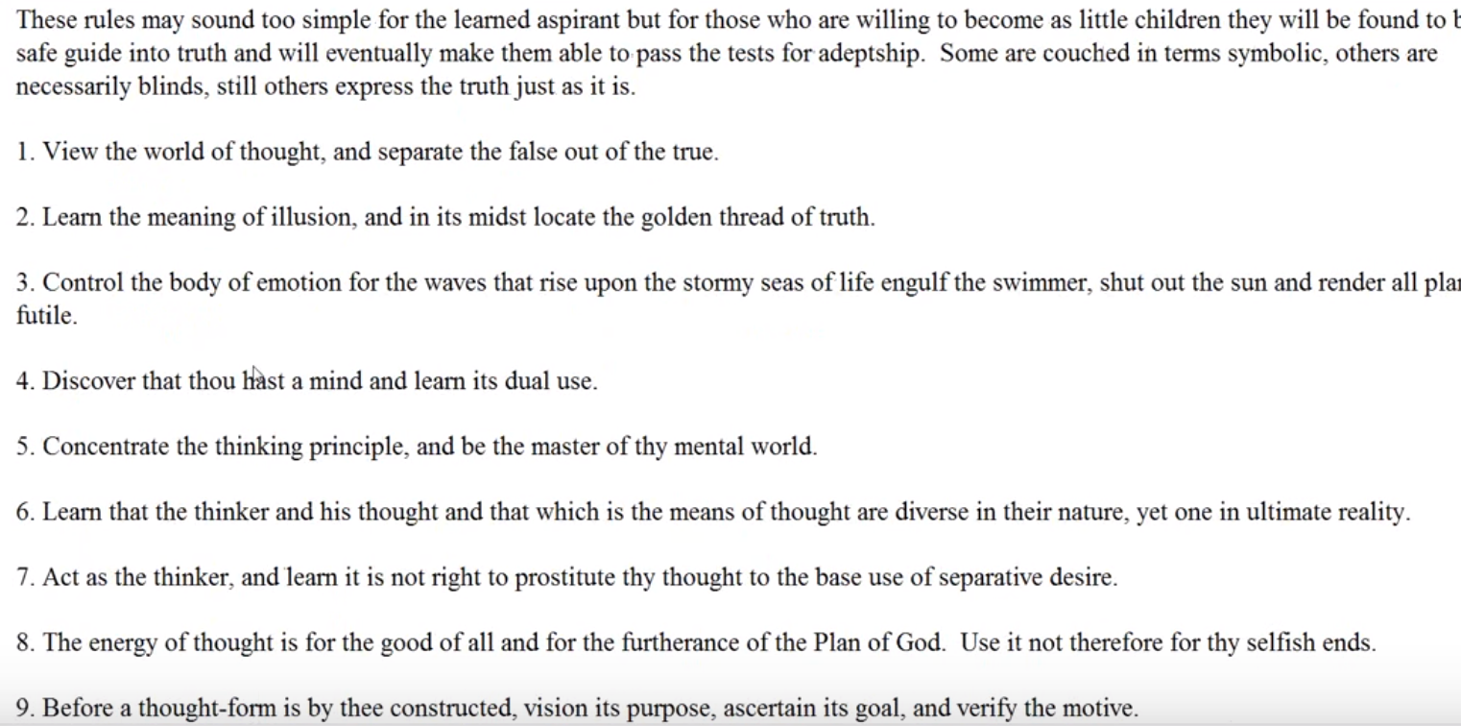

Illusion is fading here under the understanding of Mercury we understand what it means to let maya flourish and deception rule and we are beginning to conquer illusion through the intuition.

The emotions that definitely being controlled, that is point number three.

We have the dual use of the mind as an instrument in the personality as an instrument of illumination is certainly understood here and will be increasingly so.

Increasingly we master our mental world. [Point 5]

Understanding the unity of the thought mechanism I would say is increasing as we move towards the realization of unity.

We are no longer so selfish. If we prostituted thought as the basis of separative desire we would be selfish.

We are building thoughtforms as the members of the new group of world servers indeed do, serving the plan, point 8.

We're getting better at building thoughtforms, maybe will be even better in the work of petal number 9.

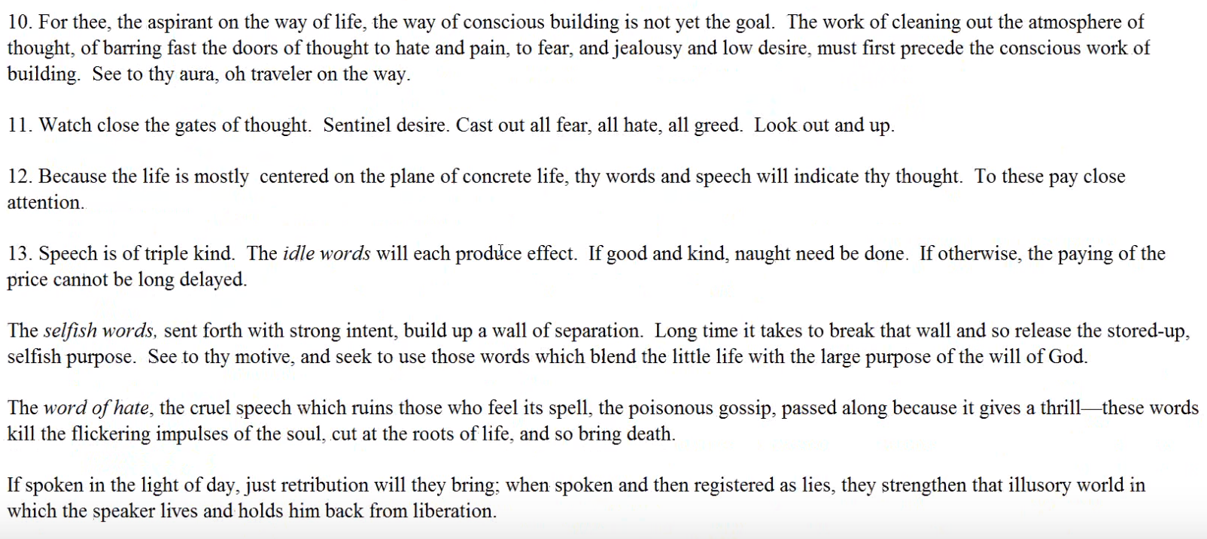

Deep cleansing is involved here. From petal number 10 and 11, it's really all about deep cleaning, casting out, throwing away, using Pluto to cast away what is poisonous and unnecessary.

We're learning that thoughts are things, becoming much more powerful here, we know the word of death exists, Master Morya tells us the thought of death certainly exists, and in Scorpio it can be a very, virulent thing.

Getting rid of selfishness, hate, the intent to hurt and bruise and kill. It can be so easily accomplished in Scorpio, all of these negativities. That's why underscore Scorpio we understand how to rid ourselves of these tendencies. So, we're learning detachment from our lower self, and instead of thinking about our self and pitting ourselves, and doing all the things that bring on glamour, self-pity is one, criticism is another, suspicion is another, I mean you can think of how Scorpio could be involved in all of those. We are learning to rise above them. So, these fifteen councils are intensifying under Scorpio.

0:41:50 Rules for white magic? Well, where Uranus is exalted in Scorpio and Uranus is the planet of the white magician and we are coming closer to the time when the third eye, which has been opening from the time of the first initiation (maybe people don't really realize that) will be functionally open at the third degree. There is a lot of the sense of control, magical control, operative here, under Scorpio. We certainly can discriminate between white and black magic and in this petal if things don't go well we could veer off on the left-hand path of black magic.

So, the discrimination between white and black magic is very important in this petal and the ability to work as a soul creator and not to be overcome by the astral nature that is to control it, and to control, Scorpio is simply a sign of great control and one of the principal qualities belonging to the white magician, or to any magician for that matter, is control. I know some magical controls, some words of power, as the magician says.

This is important in the white magical process though so many people are not into occultism per se, but they are into some sort of positive creativity which will as a member of the new group of world servers, help the world. Now that doesn't mean that when you just start working in petal number eight you're necessarily a member of the new group or world servers. That takes a long time. Remember, we're talking about the stage between the first and second initiation, a very long period. So, it's only later really that we can become a member of the new group of world servers.

Angelology? It's a vast subject. We’re told there are 140 billion, I suppose conscious deva units, self conscious deva units, in our solar system, and only 60 billion human units. They are self conscious. In our solar system. We live in a largely devic solar system. So, it would be an immense study, I'm grateful for my colleagues putting some of these categories in, but I’m not quite ready to take the plunge and go out on a great additional study of these matters.

0:44:44 There is an archangel, however. With all the fixed signs we could say that Uriel is connected with Taurus. Raphael is connected with Leo, and this is a partially Leo petal, as well. Gabriel who is connected with interesting the announcer with Mercury strongly connected with Scorpio, so Gabriel, Scorpio in the eighth petal. The voice of the soul is going to be heard strongly, Christ's coming to birth and really growing up, and we are told to overcome fear. Fear not. There’re different ways to look at this, Raphael can be connected with Aquarius as well. Mikhail is usually connected with Libra and Saturn, but from another perspective he can be connected with Leo, carrying out the will of God in blazing power. We've created obedience, and maybe the healer Rafael can be connected with Aquarius. There are just so many different correspondences.

When it comes to the sephiroth and … well, we're rising in the sephiroth:
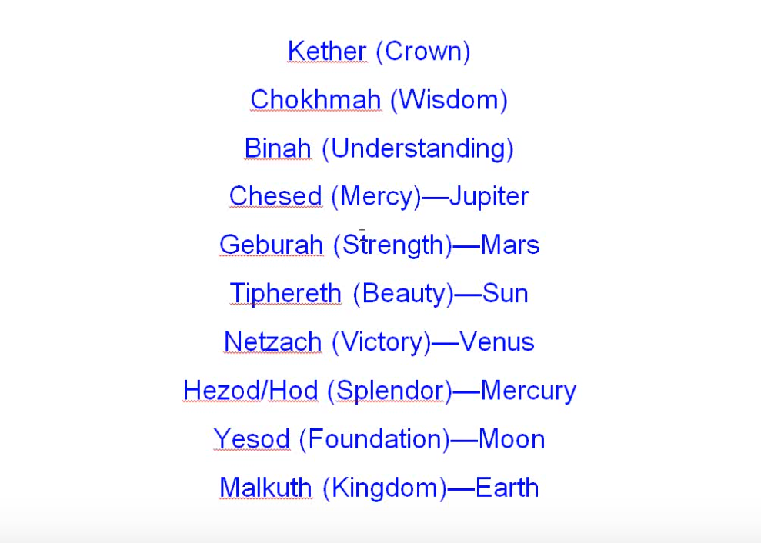

We certainly have strength, Geburah, Mars, in this petal. And the sun, the rising sun of initiation continues to rise. Netzach, victory, is kind of interesting. It would be the victory, at least as says I understand it, maybe not as kaballistically understood Venus over Mars. For some reason, Mars is listed in the higher position, but it is an ancient system more connected with the accumulated wisdom of the previous solar system. So, Mars is listed quite high here, whereas Venus and Mercury, in our system, are more sacred planets. But, we're definitely going to move from Geburah, strength, to Chesed, mercy, Jupiter, where there is the compensation that comes from having given up all the lower desires one is recompensed a thousand-fold by the higher energies.

The higher trinity, Binah, Chokhmah, and Kether. It just depends on how these are laid out. Binah is usually Saturn, and it's kind of interesting to see Saturn connected with understanding, because usually we do that with Jupiter, but of course Saturn is the teacher and leads to understanding.

Chokhmah, is it Uranus, is it Neptune? Sometimes Kether the crown is connected with Neptune but I would tend to connect it rather with Uranus. Because of the second ray connection to the monad of Neptune, it certainly has a connection with transcendental wisdom. But let's just say that Scorpio, which can be so merciless, so terrible, so destructive and dismembering.

When seeing these tendencies, when seeing what the Hydra really is, we’ll also know the ways of mercy and how to cultivate harmlessness. Because it once was so full of harm. So Chesed is important here and naturally the higher trinity is growing, but we certainly are not crowned yet. We might consider the crown coming to a degree in the ninth petal, but not really, if we become the master of the wisdom in the Leonean fifth initiation, with Uranus as the hierarchical ruler, we can certainly understand that the master is crowned and Uranus represents that crown, just as it represents the crown center, the highest head center. With Neptune coming in there as the heart in the head center accompanied by Vulcan which also is related to the heart of the sun, and has a strong head center influence and thus can be related to the heart in the head.

So, there are many correspondences here, but we certainly are moving, if you think about it, from the solar plexus to the heart. Now the heart of course in the kabalistic system is really Tipereth, beauty, the sun, the central one in the Sephiroth, but from our understanding Mars rules of the solar plexus and Jupiter rules the heart, and there is a movement from this militant attitude into the more merciful heart-centered attitude. It's hard to expand the sixth ray type so that they really realize that which is necessary.

Is the moon really the foundation, or is it Vulcan? To tell you the truth, Vulcan is that material planet certainly associated with the mineral kingdom and very much associated with the etheric kingdom and the Agnichaitans thereon. So, ultimately, we would substitute Vulcan for the moon, but this is an old system and Vulcan is not considered.

0:51:10 Well, the celestial orders of angels and the twelve tribes of Israel were probably pretty much repeating the astrological format, so that is something that we can.

Get into that just so many ways we could go off. By off I don't mean into inaccuracy, but off on a fascinating tangent, a fascinating correlational study. So, we see the relations of many systems to each other. I guess what's really important is to be able to look at the world, and through spiritual reading to see all things as symbols and connected with archetypal purpose. There is a grand design and all outer expressions are externalization of the one infinite being are symbolically related to that inner grand design. If we can see that relationship at all times, if everything speaks to us of the union pattern from which it came then we are truly in a position to see pure reason, or see with pure reason, and we can use that technique we use the technique called inclusive reason and it leads to the buddhic faculty of pure reason.

Well now, we have come to this sort of miscellaneous section and with the members of different classes and I, with them, shared comments in relation to this petal some of these will have already been spoken about, others may be new, others may be fascinating, others will be maybe useless and off the mark, and I'll try not to give too much time to those. Basically, in a way, I'm recapitulating many years of study and with the different classes on this subject and the way classes go, there is not necessarily a great deal of continuity because there are so many questions and comments and tangents, if I may so say so.

What I'm doing is giving much greater continuity to the subject. Now, I know you don't have the privilege of stopping me and asking me a question that comes to your mind and getting my feedback on that, but perhaps if you hold the question in mind some sort of satisfactory response will be offered as we go along.

Now we're going to get into these special comments here in relation to petal number eight, the synthesis petal, a petal I think is so important to the current student of esotericism, because if you study DK’s students, and I don't see why they shouldn't be considered pretty much the way we are, you just realize they were working in petal eight. It's the great petal of discipleship. If every true aspirant is an initiative of the first degree, and every true disciple certainly is, and maybe every accepted disciple is more the initiate of even of the second degree – well, I can't really say that. I mean one can become an accepted disciple before the second degree, but certainly every true disciple is at least on the path of probationary initiation, and that's where so many of us find ourselves and this work to be done in petal number eight is for so many of us our work and the reward that comes of succeeding in this most difficult initiation, the second, most difficult for most, is an extensive reward borne along by the energy of the ashram. We find ourselves moving rapidly towards fuller unfoldment and having detached ourselves from lower desire, we're beginning to understand what is the nature of divine will.

0:56:15 So, let us look at this collection of thoughts kind of go along and see if we have a little bit of a synthesis within a synthesis. The emotional body here had laid becomes like a reflection of the buddhic vibration and lower mental states start to become a reflection of the higher mental, and also of course the buddhi is called the transcendental mind and it's related to Mercury and that begins to emerge here after the second initiation.

… Initiation four you are suspended in time and space … I think that if you really should be the world involved in this initiation, I would have to say yes. This is, it does affect very much our work in the world because we have to prove, to demonstrate, in passing our tests. So, the soul has been seeing that the personality is ready for this, actually the solar angel, and the consultation of the master and the initiator determine when there is readiness for initiation. We have to do so much by ourselves and remember that phrase that we have been looking at strenuous and abnormal efforts at the eleventh hour, an augmentation is given to us when we have proven that we are initiate, or have reached a certain stage which needs to be confirmed and augmented by the initiator.

Some people are saying here that the crises we confront have to do with our job. Maybe with our work in the world, and whether we have the strength to do the work that the soul recommends. It may require detachment and leaving something we do quite well for something that must be done. We're left on our own quite a bit here, but consultation with the solar angel is certainly expected.

We use our own resources here; it's a kind of a mini dark night of the soul, we may feel at times abandoned at this point but the solar angel is ever watchful and if we are attentive to the energies coming forth from it all will be well.

We need to go forth fast and find those we are related to. Remember the whole idea of fellowship is coming in here and the fellowcraft initiation, the second initiation which has so many of the affiliated planets, Venus, Neptune and Jupiter. The master is not always looking in and upon us, as some seem to think, not at all. It's a very thorough going crisis however, and we have to be its kind of in anticipation. And in the fourth initiation we have to be demonstrating what we can do on our own. At the end of the fourth degree we really feel quite bereft of assistance.

The fearful conflict is coming at the third initiation, and already some anticipation of that as we leave our desires behind can be felt here at the second and in the eighth petal.

The tenth head of the Hydra, one of our members brought up, is still hissing under the rock, the core of the personality. Humanity has a great dweller, and as we become masters we can participate in the solving of this but we're not really there yet. The mystery of the makara is in some ways the mystery of what the personality is and it's related to our planetary logos who is still suffering from certain maladjustment of personality.

Where is the personality when the something that is initiated goes into the chamber of initiation of the first, second, and third degree, and the personality is in a latent and waiting state? And when the inner man returns from the chamber of initiation, which essentially is the causal body interestingly, here he or she bring the energies which have been conferred and make a big difference in the degree of personality stimulation, which exists.

1:02:12 … So yes indeed, the second initiation is here, the light of buddhi is passing through the soul, through this eighth petal, through whatever we have of the second synthesis petal that has unfolded, through these eight petals, the entire series of love petals. The light of buddhi is coming to the second-degree initiate. We talked about the importance of the sign Scorpio in relation to buddhi. It actually is a buddhic sign, its major ray is the fourth, and the fourth ray, of the human creative hierarchy focused on the buddhic plane.

Decentralization is strongly coming about here. We can say there is discipline for the physical body, dispassion for the astral, discrimination for the mental vehicle, and decentralization for the personality, and overall a detachment from the personality. So, the desires of the personality are on their way to reduction and eventually their ancient authority and the ancient authority of the personality is really overcome at the third degree. It still exists, and there's still 25% of the matter of the personality vehicles which is not yet atomic matter, but the major battle has been won.

There is plenty of the group energy coming in here, as I've talked about buddhi and the fellowcraft and those particular planets which operate under the law of cohesion and draw people together to be responsive to soul. So, the inner group with which we are moving forward to stimulated by the ashram is more revealed. When we enter the stream, we find we're not just being born along ourselves we're being born along with our brothers and sisters related to the same ashram and maybe the outer groups are more revealed as well, where the inner workers with whom we are associated can be found in those outer groups. So, we can see with greater spiritual discernment and we have that response to group vibration those are two of the siddhis that are found upon the higher mental plane.

Were awakening to inner study, inner group studies, with others on the mental plane at night, maybe, since the factor of memory is so stimulated at this point not only out of memory of our past, but maybe the brain will be stimulated in such a way. Saturn ruling the brain that it is possible to bring through the inner astral experiences with greater precision. Those experiences which occur at night with high mental component.

So many people are remembering their experiences in classes as this initiation approaches and as the petal has unfolded we're awakening to the group in which we are helping, or which we are helping.

Interesting, Scorpio is like death, takes you away from your body, it takes you on to the astral plane. I think the tendency in Scorpio or even be to become an astral magician, which is not necessarily a great thing, I mean DK eliminated one of his students from the group for astral magic; he was a strong seventh ray type, first ray, seventh ray type. I don't know whether he had a sign Scorpio we don't have his particular horoscope, but the separation of the consciousness from the body is in a way death, and takes you to the astral plane.

We have an increasing number of these inner experiences. Because Mercury is so strong here in relation to Scorpio in the eighth petal we are beginning, not only to work with glamour but to overcome illusion by accessing the intuition. We know that clear beam of fifth ray light is needed to overcome the glamour from the ajna center and Venus. It is Mercury and the intuition which dispels illusion. Sometimes intuition does not work so well with illusion, DK tells us, and intuition and soul energy may even strengthen the glamour. But with illusion, intuition works. More so at petal nine in the overcoming of the last rays of glamour and also illusion. Well, from a cosmic perspective I suppose, as long as we're involved with a cosmic physical plane we're involved with the illusion.

We are entering the stream, we're touching to a degree of the triple flowers which is that hierarchy involved in sustaining the spiritual triad which we can now access as members of the new group of world servers once we have passed the second degree, and maybe moved a bit beyond. We kind of wonder whether the new group of world servers has to have passed the temptations in the desert? Because we're told, for the new group of world servers to be on the lookout for those who have taken the first degree, and the second degree. So maybe even taking the second degree is not quite enough. This is just a speculation. After the baptism one does go off into the desert and really faces any remaining attraction to the world, the flesh, and the devil.

Ajna center under Venus and Mercury is further developed here and one is able to direct oneself forward with greater power, that is one of the powers of the ajna center.

1:08:28 The law of magnetic impulse, second law of the soul, is awakening the heart center and because of this, we're able to help awaken the heart center of others. We begin to form in these groups of nine, which can be absorbed into the consciousness of the planetary logos. We want to sacrifice and serve and aid others, to enter the stream. So, we are really expressing the soul at this point.

The idea of know, express, reveal, and so forth as DK describes the word express, it has to do with monad, in chapter fourteen of The Rays and the Initiations. We're not really there yet, where we can express the monad, but we certainly can begin expressing the plan as we have the soul understand it.

We've got a lot of magnetic appeal to others and this magnetism touches other hearts and gathers them in, after all we are becoming lotuses with perfume. We're getting glimpses of the plan, we express the plan, where we are part of that energy which is the outworking of the plan. Lots of tests come as a result of Scorpio and we manifest of the result of our tests on the physical plane. We demonstrate that we can be successful on the physical plane, even though there's not a lot of third ray connected with Scorpio. Yet, when you think about it, there is with Pluto and let maya flourish and deception rule. It's a very third ray, lower third ray kind of statement.

Ajna center being strong here helps us direct our efforts towards the plan, our study and meditation are increasing. We are becoming occultists actually. Well, certainly students of occultism, but we're on our way with the occult path, especially those who are somewhat familiar with this teaching. As I say with others they may think in different terms and be equally as advanced.

I wonder did I discuss what we are there. I wonder if I left that out? Maybe not, we're not the little chela, while working in the petal we can be the chela in the light. We certainly can be accepted disciples. I do think I discussed it and we begin to move on to the thread, I think, this is possible as we move towards the third degree, and significant steps can be taken towards the third degree while working in petal number eight, in the latter part of petal number eight.

Five hours a day of occult meditation. Imagine. In the new schools we can be directed towards the first second or third degree five hours of occult meditation. We might think about a luxury at this point but for the people who are moving towards the third degree, I suppose in the advanced school it must be the case, that even in the preparatory school, moving towards the second degree. Five hours. Just contemplate that. Given the usual busy outer life that we lead. When the Dalai Lama was asked about his own desire, it was just for more meditation, he wishes he could.

The Master will supervise all this in the new schools. We will definitely have here spiritual intelligence and mental illumination. The first degree is called spiritual instinct, second degree spiritual intelligence, and mental illumination third degree, intuitive instincts.

The throat center is said to be very stimulated at the second degree with mental illumination of course. Both throat center and ajna are strong here. Obviously, there is a continuation of the lifting of the solar plexus center to the heart, and so if we don't have the heart how can you sacrifice in the way that is required in the eighth petal? But the throat center is very strong here for the kind of illumination and intelligence combined with the ajna center that has to be achieved in this second degree and eighth petal.

I said the spirit of immense sacrifice is here, he says he seeks no reward for the immense sacrifices involved. One of our members thought, well the heart must be open, and certainly that is true and buddhi is helping us open the heart. … We have a confirmation that at the second degree one does touch the buddhic plane, and the antahkarana that is being built can reach as far as the buddhic plane. Certainly, the second ray factors involved in the egoic lotus are activated and can be received, but buddhi as well, that is the great stimulator of all the secondary factors within the egoic lotus.

So, the buddhic plane and antahkarana is not only touching of the manasic permanent atom, but is somehow drawing something down from the buddhic plane. It doesn't mean that the buddhic vehicle is fully organized, fully coordinated, and there are some references that mostly suggest it is coordinated after the third degree. But some them seem to suggest (or at least one) that after the second degree some degree of coordination sets in.

Some have thought, ‘well, what a relief to end the pain of the eighth petal.’ Well that's the human condition, is that the fourth kingdom with its fourth ray ruled by Scorpio and Mercury, the guardian. At the eighth we gave so much, eight in relation to the progress of the human kingdom. He told us about all that suffering that does occur between the second and third degree. If there's going to be a fearful conflict before the third degree it's not going to be easy is it?

There's a lot of pain behind and we do approach the third degree on what DK calls the level tableland, and we have the clear mind, we're moving fast movement of the stream, we are sufficiently detached the community of fellow souls is traveling with us and we feel their support, and the support of the more prominent members of the ashram. We're approaching soul fusion.

The second ray types may do that through study but let's just say these more advanced methods isolated unity, inclusive reason, presented attributes, these are methods by which we encourage soul fusion and probably we have seen some of those in the fusion formulas which I discussed in one of my series, and I think I did that. We understand those particular qualities. I have to check I've done that because there are some amazing alignments which involve the monad the triad the different areas within the egoic lotus and all the way down into the chakras. Sometimes I've done so many of these that I forget which one I've done.

1:16:20 Anyway our relationship to others changes, it's very purposeful, radical, eliminate, and we really find those who belong to us, in terms of soul vibration. We can see the deeply enough to understand the soul vibration and our deep affiliation with certain people who according to the law of magnetic impulse. It's a Libran law but it really does of course continue here.

There is some of the law of group progress which is operated live here, maybe it comes in even more under Capricorn in the next petal, but there is plenty of Capricorn related to this petal as well.

We're traveling together. There's some stability on the path here; we're not just a fluctuating point of light now waxing in approach now waning in retreat. We are a true steadily approaching point of light and we have a constant and steady application of all the powers of the soul. That’s what DK says of the eight-petal process. It's always a power petal.

Now some people working on this petal, they can become the predator elite and they're using soul power for personal means, but the suffering involved in doing that will probably dissuade them of its utility.

We are becoming more and more within ourselves the point of peace and we can attach from the storm around us, our right human relations are refined here, we know so much about what causes pain. Maybe we can know also what causes the glory of the soul and the increased soul impression. We are finally sorting out the astral body in a way that it will no longer be an impediment. It is the major opponent for all types except the third and the fifth ray souls and even for them well it can't be easy, it may be easier, but it can't be easy. It is in our solar system the major opponent.

The soul-mind-brain alignment is becoming very strong because the astral body has clarified and still if you look at the combination of the planets: Venus, Jupiter, and Neptune, the stillness and the quiet of the second ray can enter the ashram in the plan are drawing closer. I mean, a lot of the DK’s students in his group of 24 they were not yet second-degree initiates, but they were accepted disciples and they had been drawn to the periphery of the ashram and they were expected to express together in specific ways the divine plan.

We are becoming what is called here an advanced disciple, and the strictly personal is more and more out of the way. The plan enters in and that of course is the stage of revelation in the ACLRI process. We are subject to the higher light, the plan is revealed, repulse has shown us what we can throw away under the law of love. Integration is approaching, fusion is in process, and we have that kind of thing that comes in Scorpio, a great conviction that we know what we are doing, and even if not fully illumined we are at least moving in the right direction.

1:19:50 Well, here's another class that talks about the fights and battles in this degree, and you can think about petal number five where many lives of struggle are involved. It's a Scorpio, Taurus, Leo petal, so some final fights are operative here we know that Scorpio will always cause a conflict, especially before initiation. The third eye is progressively awakened and some of this may start in the penetrating insight which Scorpio gives. It is not fully awakened, more at the third degree it's really functionally awakened.

But the trumpet of joy is sounding forth on the battlefield on the crisis of the battlefield is coming to an end.

In this petal are very strong Leonian will gets really whacked and we use something higher than our lower self here. There's the lower Leo and higher Leo and Scorpio is putting the lower Leo to death. So, we use our higher self to death here and we do actually when. We're getting ready to tip the scale for once and for all and after succeeding in facing the temptations in the desert the scale really tips and then we are no longer a hazard, we're no longer considered a hazard or a liability. And once we achieve real mental polarization and past the temptations in the desert, then of course real mental polarization means that our mind is a mind held steady in the light of the soul.

We have definitely in the cave but we're sacrificially thinking no thought for our lower self. Our eyes off our lower self except to make it a better instrument. So, selflessness is on its way to be achieved. The monster of selfishness is the early Scorpio type. Look at page 333 in Esoteric Astrology. Now in this concentration upon sacrifice with no thought of return, that selfish monster is really being defeated. The complete selflessness of course I think is coming in at the fourth initiation, but compared to a being like the Christ, what fourth degree initiate would dare call himself truly selfless?

Anyway, the selfishness which is arising from the distinctly lower nature is overcome. The emotional selfishness I think is quite overcome here, but mental pride there still may be, and even at the third degree there may be mental pride. Mental selfishness working in that ninth petal. Pride, separateness and cruelty, these are mental faults. So, we were not entirely free of that of course depending on our ray.

But the heart of group life is beginning to beat and the cohesion between the group brothers is strengthening. We can become increasingly an invocative point for purposes of the group which we're now beginning to lead, because we have the ability to be magnetic, and we're not only radiant but we are emitting a certain type of subtle perfume which gathers others towards us.

We're learning about group life. Scorpio uses group resources for the betterment of all, that's just normal astrology, and we can begin to do that.

All the signs of the fixed cross are brought in here: the blinding light, it's increasing, of Taurus. The fiery pain of Leo, that has to do with experiences within the etheric body as well. The bitter woe of Scorpio and the impending liberation of Aquarius, we're not there yet, but we can anticipate it. We're learning how to give sacrificially through the heart, through the group heart, and we are connecting with the heart of the sun. Seems like I have the need to say wow at the beginning of every new group; it must have been some joke long forgotten.

The possibility of understanding a little bit of group initiation is coming here, because once the antahkarana is being built we can be reading The Rays and the Initiations and even though not third degree in a shift or part of a third-degree initiate group, we can get the sense of what group initiation is. We can study the ashram and approach.

The personality is beginning to feel the effect of initiation. But, of course initiation is really occurring in the causal body above so to speak the personality, and then the energy does come down, it stimulates for better or for worse, the rest of the personality. That's why the masters have to be so careful in allowing that occult accolade because it's so possible to overstimulate the personality and then retard one's progress rather than encourage it.

Anyway, group initiation in the Aquarian age is being understood so that people are advancing together. They have some sort of project which is born of their increasingly realized soul fellowship, the standard is rising here. Everyone will have had to have taken degree number one in such groups, there was one exception in the Tibetan’s group, but generally speaking it is so. They can help many when they are together, or well when you come together sometimes you involved get involved with personality involvements, that's one of those temptations that has to be passed through.

Every month in New York DK had this ashram group of interestingly enough 14 fourteen people, and it is the beginning of the externalization of his ashram in New York. Now these people were not yet by and large second-degree initiates, not quite, maybe a few were, and Alice Bailey certainly at the third degree and as a conscious member of the ashram she lectured them on the ashram a life.

1:26:36 With a lot of cleansing going on here, and so Aquarius is involved in the sense of cleansing the Augean stables, and that have to happen if there's going to be real group power to be able to stand as the master’s group and eventual taking eventual group initiation.

We're told in the New Age many will take the first degree and some will take the second, then the Christ will be the initiator. Our group life is actually growing here, our fellowship is growing, and it's facilitating promoting initiation. There is a lot about group initiation when we think about the second degree. The cohesive factors are really working, we're all coming together under the law of magnetic impulse and we're meeting each other as souls, together as souls. Liking or disliking each other has nothing to do with it, we cast away the glamour of a sentiment. That glamour of sentiment is talked about in the introduction to rule eleven in The Rays and the Initiations for the advanced rules. So, the glamour of liking or disliking – no, we are deeper into it than that.

… something the founding of Findhorn and how two people founded it, but a third had to be brought in so there could be a balance between the Will, Light and Love.

Anyway, the astonishing thing is that the growing in personality results in love. Personality comes first, and then love follows, and the divine indifference method is very strong here. When repulse enters and we learn how not to care about the things we cared about so very much. The personal part of ourselves is so deeply related to the astral body and this is what we are subduing at this time. When we are dying to the wishes of the astral body we can become impersonal and love begins to flow.

Remember this is a love petal, it is the love petal of the sacrifice tier. Without love we're not going to fulfill initiatory requirements. The second degree, although it uses the sixth ray very much, is about love.

I talked about this earlier, about the terrible smells and stenches verses the attractive soul perfumes and were beginning the process of sort of smelling our way home towards the spirit.

One of our members said that as a child they could smell whether one lied or not. Synesthesia, the smelling a lie. How interesting.

Truth emerges with the end of certain of the major glamours. We're going through all that is old and ancient. With the increase of memory, we are really cutting from the past the old stuff that used to belong is now cast away. This is kind of a synthesis within a synthesis, petal number eight. Such an important petal and I hope that this section here is studied strongly because it has so much more relevance to what we're doing.

This is really now the end of egoic lotus webinar commentary program 56 part four, of the synthesis for petal eight and we're going to begin egoic lotus webinar commentary program 57, which will be part one of the synthesis for petal nine. This program has lasted approximately one hour and a half, that's exactly almost exactly what it has lasted. So, it's one hour and let's say two minutes.

I'll close off and say that I know this method of studying probably will leave some ray five types having fits, but I'm trying to gather together the related ideas until we are really steeped in them, and we just have this intuitive understanding of the kinds of experiences we will pass through when organizing coordinating and vitalizing petal number eight. Then also, when contributing directly to the unfoldment a petal or through strenuous and abnormal efforts, and when the rod of initiation is applied by the bodhisattva even more is unfolded.

These are the things we will encounter, and these are the kinds of tasks we can apply ourselves to, and we can facilitate their achievement by understanding them more fully and understanding how they are related to the different energies, which we can certainly begin to wield as we begin to reach this point now developing. With Mercury as a manipulator in a way, and it helps us, being so strong in this petal, it helps us wield these energies to a particular end. So, we've had four parts here and quite a bit of study in petal number eight and now we will go on to petal number nine.

