EGOIC LOTUS WEBINARS, VIDEO COMMENTARY – 54, Michael Robbins
Abstract
Egoic Lotus Webinar Commentaries 54: Part 2 of Synthesis for petal 8. This webinar is about 1 hour long. Program 54 offers the second of the commentaries for the Synthesis of petal 8—the second petal of Sacrifice: Sacrifice/Love. In terms of the 80 point outline we have been using, it takes us from Point 28 to the beginning of Point 43.

This petal is closely related to the Human Creative Hierarchy which is ruled by Scorpio and Mercury—the sign most associated with petal 8 and the planet intimately concerned with the tasks related to the unfoldment of petal 8. This is the petal in which the second initiation is taken, though the petal is not completely unfolded until after the application of the Rod of Initiation. It takes a long time relatively, to open petal 8 because of the many lives which usually separate the first and second initiations. In the experiences of this petal, much suffering is endured as the probationary initiate prepares to “enter the Stream”.

Egoic Lotus Webinar Commentaries 54 140 MB .wmv file
Video of Egoic Lotus Webinar Commentaries 54 by Michael D. Robbins.

Egoic Lotus Webinar Commentaries 54 58 MB .mp3 file
Audio of Egoic Lotus Webinar Commentaries 54 by Michael D. Robbins.

Transcript.

Hello friends.

We are continuing now with our egoic lotus webinar commentary, really sort of a video book on the egoic lotus and associated correlations. We're beginning with program number 54 which is part two of the synthesis for petal, and we've gotten this far as of the 28th item in our 80-point general outline that we have been using.

We talked about the five colors which are found in the eighth petal. They will be the yellow, the orange, violet, which is replacing one of the rose colors we might expect, and then of course rose and blue and I've explained my interpretation of these.

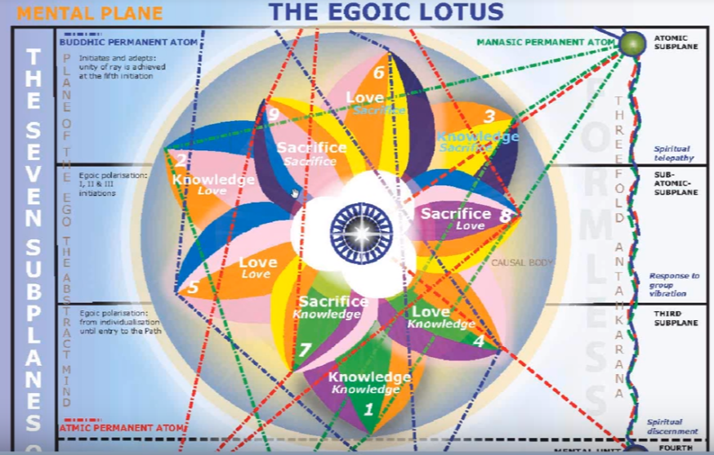

No other additional colors that could be are involved in this petal’s process, so we're really only looking at possibly red and green. Red is actually not found in the petals per se, but it does have its association with Mars and the blood of Scorpio. We're dealing more with the dark red, with the crimson red instead of the scarlet red.

There is no green here. To a degree we are leaving the natural world and natural laws behind as we are involved increasingly with the laws of the soul. But Taurus has a connection with green and Scorpio was the opposite. We're learning how to kill out that which is associated with the lower third aspect, the personality, and instead to make more room for the so called and the super natural. The green is ray three and in relation to Scorpio per se. The green is not prominent. The only thing we could say is that the triple sign Scorpio is most associated with this petal and because it is tripled it has to do with the third aspect and demands the proof of all accomplishments on the physical plane. As I said, the buddhic plane is linked here but those colors relate more to the violet to the blue and also to the yellow all of which interestingly are found in this petal.

Now what rays are implicated on the basis of the color of the petal? I think we may have done this but I can just mention of course that the fourth ray of great conflict is found here, through the yellow of the fifth ray, through the orange, as we dissipate glamour through that beam of focused mental light, the seventh ray as we work at divine alchemy and uplift the quality of matter, transmuting and also transforming and yet at the same time manifesting the roses there because the second ray. Well, the sixth ray is the major ray involved in the second initiation, though the second ray is also prominent as the sixth begins to move towards the two. The blue is a color of both the sixth ray and the second ray showing the possibility of the transference from the solar plexus to the heart. I think in a way we have discussed that.

0:40:40 The major sign in the series, counter-clockwise order beginning with Aries, if we move forward eight signs in the petals we do have Scorpio, and that's what I've been mostly leaning on this just Scorpio petal. Perhaps why this petal takes so long to open and is so intense in the opening. So, it is the sign of transformation. Transformation that has a lot to do with the astral body, as transmutation has to do with the etheric body—Uranus for transmutation and also it plays into the transformational scene as well restructuring the astral body but with the help of certain planets which have a strong second ray Venus, Jupiter and Neptune. So it is a difficult sign and I've spoken a lot about it, and a certain type of major triumph has to occur here because if you think about it the second initiation is so difficult to take under ordinary circumstances except maybe less difficult for the souls on the third and the fifth ray as DK tells us, but since it is so difficult we have the sign of appropriate difficulty which is Scorpio I would say majorly ruling this particular petal.

Of course, if we look at the fire sign, either starting with Sagittarius or Aries, Leo is always going to be the central petal and a certain type of change of identity is going to occur here and a major blow against the selfishness which comes from lower ahamkaric identification. I mean if we think we are the personality we want to be selfish, and if we find ourselves through our meditative process as being something behind the scenes something else, that selfishness is going to be somewhat reduced. We're going to see the second phase of Leo coming in here increasingly, more of the growing sense of ‘I am That, I am the group, I am the I am something beyond the skin-encapsulated ego, that lower sense of the lower self.’

If we begin with Aries and we move in clockwise order, we find Virgo and that's very interesting because there's such a connection between the Scorpio and the Virgo petal. The normal Virgo petal is the sixth and this Scorpio petal the eighth. So, we are learning how to bring about the birth of the Christ in the astral body and the emphasis of which Virgo is very capable is the emphasis on service with no reward. Virgo can contribute to that growing sense of selflessness and certainly it can examine the conscience and can find all the little ways in which the psyche may be deviating from the soul ideal.

0:08:15 Interestingly if we start at the first petal, but with Pisces, and move in a clockwise order, we find Leo again. Leo is anyway the fire sign which belongs here whether we started at petal seven with Sagittarius or with Aries, Leo is the next sign and Leo is very connected with the second degree because of the emphasis through its esoteric rulership of Neptune upon the heart of the sun. And we bring in this increasing divine love energy. It does fit both ways, and in another way, it shows what we have to overcome on the clockwise wheel, we have to overcome the lower ego here in favor of the larger and loving ego. We're told that Scorpio stages the release of Leo. Esoteric Astrology page 333.

So, if the death of the lower ahamkara here, maybe not yet the total death of the kind of ahamkara which still exists after the third degree, the ahamkara for which identification with the causal body is responsible but at least the personal Leo desires are defeated here and the moon will be found falling in Scorpio. I would say that there's a lot of lunar identification with this lowest stage of Leo. It kind of exalts. But the lowest stage of Leo is exalted in the sense of the personal self and it is the personal self here which is going to be defeated.

There are really going to be three stages of release of Leo. One from the lower ego, the lower personal self and this is I think begun at petal number five when one is becomes an aspirant. Later, a release from the causal body itself, and you kind of wonder if a very high level. Of course, the release from the causal bodies also give it relief from all the eighteen lower subplanes, but you wonder when the temple of Ezekiel was destroyed. I mean, that too is a grand Leonean temple and it must make it possible for the monad to be free and to enter the sea of fire where it undertakes to still greater identification, and less inhibited by the monadic vehicle (as great a vehicle as that may be) every temple must be destroyed, eventually, if pure being is to be realized. So, Leo is the self and you can wrongly identify or correctly identify. When the identification is limited we do need Scorpio and it's destroying planet, Pluto, to help destroy wrong or limited identification.

Are there other signs implicated in the meaning of this implication? I guess I have included them all, Taurus, Gemini, Leo, Virgo, Libra, Scorpio, Sagittarius, Capricorn, Aquarius, Prices, Cancer and Aries, too. As stated earlier in these petals which have five colors that are associated with a mental plane with sacrifice, we're going to find a significant role for all of these planets, all of the signs of the zodiac.

0:12:30 … Taurus will be here for the power of illumination. We do have spiritual intelligence and the illumined mind to a degree. The ending of glamour is one of the major focuses of work within this petal and the knowledge of how to do that. Taurus is linked with desire and with buddhi and we're over coming this lower desire. The Buddha showed us how to do this, and he had a lot of Scorpio in his chart as well. The story is that he was born, achieved enlightenment and died at the times of a full moon which would involve the Scorpio moon. So, he overcame the maya and the deception of Mara.

Taurus is also connected with the second initiation. It is the second sign at this initiation, great illumination, light, or greater at least, comes in. The usual glamours or ended here and we have in a way the fall of the moon under Scorpio and the disidentification from desire.

If we go to Gemini we find many taking the second initiation in Gemini. Its interesting that one of the main people who was described as possibly being able to pass through the second degree have the Gemini sun. So, it contributes to what DK calls the dire conflict on the astral plane. I imagine that the heightened conflict between the pairs of opposites and the new unclear or relationship between the pairs of opposites is found here and Gemini also contributes to this mental illumination and spiritual intelligence, Mercury, is strong here in Gemini, but also closely related to Taurus as well and certainly strong in Scorpio where it's hierarchical ruler.

Interesting that in the labor of Hercules for Gemini, he encountered Antaeus, who is a symbol of glamour, a kind of serpent, and he lifted him up off the ground and deprived him of his lower power, of this power to confuse.

0:15:20 So we're here able to overcome the conflict between desire and mentality. Mentality shines through. Mercury in the higher sense must triumph through the intuition and Geminis closely related to the reception of the intuition. Gemini is also related to building the antahkarana with Mercury linking the metal unit and the mental permanent atom and also other links. So, Gemini is closely associated there. It fits with initiation number two which is prominent at this petal and the conflict between the higher and lower selves shows itself in the astral body, but at length this astral body is subdued which is the great achievement of the second initiation. This dire conflict on the astral plane is overcome.

What about Leo? Leo here is the personality of the personality as it is dying and its desire nature is dying, and then we learn something which Dk tells us is all was desirable. We learn to ask nothing for the personal self. We're told the heights of service in Leo can be reached in Leo and it becomes eventually a sign of self-lessness, giving oneself away, pouring it forth through the heart. Already people at this petal can be members of a new group of world servers and therefore the heights of service can begin to show themselves.

We have kind of a sequence here, it begins with the selfish Leo and then comes a greater self-examination, then ‘know thyself’ of the Delphic Oracle, then selflessness begins in the second phase of Leo. So, it's the heart of the sun energy which we do need at the second degree and it fills the astral body with the buddhic energy. Certainly, Jupiter and Neptune are connected with buddhi, and in a certain sense Venus is connected with buddhi too, usually represents the higher mind of man, but it is the planet of the logos of which is making a transition on the cosmic plane to the buddhic except level of a cosmic astral plane sort carries a strong buddhic vibration as well.

What about Virgo in relation to the same petal? Well, the consecration of the form to a higher object if the form is always connected with Virgo and the ‘let matter reign, let form reign, at first’, but then we learn how to make all those purifications which makes the form the true instrument of the soul. There's going to be a lot of astral purification here as we really learn to look at ourselves and see what our mistaken responses are to an astral nature. We go through a deglamorizing process in earnest and we become objective about the astral body. So, service and selflessness take the place, as the lower aspect of the Leonean ego is defeated and we come into real humility, selfless service – we don't ask anything for the personal self, we are willing to be truly humble because we have developed a higher sense of proportion.

What happens is Virgo at first criticizes the lower self, it's been doing that since petal number six and is one of those very mentally clear signs. So clear mentally that the glamour can end and Christ is coming to birth still more fully with a Virgo has a special inner wisdom which is cultivated actually by this time a person is already not just a baby in Christ, but with the taking of the second initiation you can use the symbolism of the young man and then at the third degree the rich young man. I'm recalling when DK talked about some trouble he ran into when he was a young man and I think it was a code for his spiritual status I believe.

0:20:30 What about Libra in connection with emotional body? Well, it brings balance and emotional equilibrium. We do know how important Venus is in relation to the second initiation, and beingness is the ruler of Libra one of the important rulers. So ideally the astral turmoil will subside so that the soul carrying buddhi can be more effectively reflected in that astral body. We need a degree of serenity the fourth ray type really need serenity above all and we have a lot of the fourth ray in the conflicted nature of this particular petal. The process connected with this petal.

So, it's a long time, and a difficult time, so if there can be no serenity which Libra tends to bring at long last, then there's no reflection of the buddhic plane. Libra could be very I'm important here to help balance out the astral body on help make it receptive to the presence of the soul expressed as love within that astral body.

Scorpio we've already said quite a bit about. It's the death of desire. Not that desire never entirely dies, because it's the way which the entire in which the entire universe re-amalgamates, comes back together, Scorpio the death of desire. So, once you kill desire the personality as an independent and often obstructive center is on its way out and that's why that major blow against selfishness is here found. If you blend Mars and the moon together you discover the Lunar lords who are generally opposing the regime of the soul, it's their nature to oppose and try to reemphasize what they actually are but eventually they are subdued and the moon falls and the entire desired nature is elevated to him to be quality of love and aspiration. When people are at a certain stage of evolution and they are having a strong Scorpio in their chart, we can understand something about their task as they face the second degree and move beyond it.

Sagittarius? Well devotion and aspiration and reorientation of astral nature. It’s the continuation of one-pointed discipleship; we reoriented after body towards love and we're on our way to the larger expanse of understanding which will give us a planetary perspective – a large planetary perspective which is necessitated at the third degree.

So, any of the fire signs can be really put here, even Aries where we're sort of coming to the halfway point our evolution, in our initiatory evolution. We are entering that period when we can stand on the periphery of the Ashram and take up a new type of role.

Sagittarius is prominent for initiates of the first degree and second degree and we're talking largely of the second degree and we're supposed to develop when in Scorpio, strength through struggle, and Sagittarius attitudes, certainly Sagittarian attitudes will show themselves here because we are really oriented now towards the mountaintop and we're learning to see things from a higher intuitive perspective. Sagittarius is after all one of the major intuitive signs, and it is the intuition which is beginning to come in here under Mercury and as that buddhi is accessed so it can affect the astral body.

Capricorn? It is sometimes called one who crosses the water. (Page 333 of Esoteric Astrology). We're on the way into the land of the soul crossing the astral plane toward the mental plane. Capricorn is connected of course with all the first five initiations and there is the control of the astral plane here in the manner of its drying. Initiation number three is a drier initiation, I would say the mists that are around the mountain top are dissipated and the fifth ray is the dry ray and it rules initiation three of the fifth ray even at one point associated with Capricorn in one of those obscure and informative referee references. So, he is very good at over the coming of the emotions and signals a kind of definite achievement a kind of confirmation by the rod of initiation of a condition of the astral body which is really conducive to forward movement towards the tests in the desert, even though we accomplished quite a bit of the second degree we are thoroughly tested away from all temptations except the major three. We are in that arid land and we're seeing if we can dry up our normal desires for things which are of the lower nature and so we overcome them the world, the flesh, and the devil, in that rather arid atmosphere.

What about Aquarius here? We are moving in fellowship together this is after all in Masonry the F.C. degree, the fellowcraft degree, it has so much to do with the second initiation and we're moving together in selfless service towards humanity and we're becoming receptive to the second level response to group vibration. The second level found on the higher mental plane we're not asking, we're just giving, we're not asking for any thought of return when this petal is really all open or almost open. We are also cleansing as Aquarius does the astral waters, we are becoming free of the taint of astrality. Free of the taint of lower desire.

Group consciousness and brotherhood can begin to come in here and of course the new group world servers is indicated at this petal and its idea is group consciousness and brotherhood.

What about Pisces? We're really giving up, we’re surrendering, we're giving up any hope of any return. Pisces gives it away. Pisces really helps you die away from the lower self and the esoteric ruler of Pisces is Pluto which is also connected with Scorpio. So, there is a relinquishment for many forms of desire which held us attached to the lower worlds. Also, Pisces is a great sign of forgiveness, we learn how to drop the three Hydra heads associated with the astral plane, the fear, and hatred, and the love of power for the limited ego. These heads are dissolved, they are they are falling away. Scorpio has this conviction of sin so often, it really needs that sense of forgiveness.

Now I didn't Cancer and Aries, but I think we can. Cancer is involved in this labor because a crab comes out to attack Hercules. The building of the increasingly lighted house and the spiritual illumination of that house comes in under Cancer. There is the embodiment of at least two qualities, love and intelligence on the physical plane, and we're helping others as we serve to build their lighted house and we are protecting the light of the teaching. We are helping to nurture others into the solar light. Of course, the lower crab has a lot to do with tenacious holding on to the things of lower desire and that is definitely overcome here, so that we can begin to use our pincers to hold on, to attach ourselves to higher types of energies.

What about Aries. Well, in the labor of Scorpio, Hercules is cutting off the heads of the Hydra. He is acting as a hero here, and it doesn't work entirely to do that, but at least he does face the opposition. He's entering the stream which is a new and rapid phase of evolution, and Aries is always involved with entering into the rapid process. Aries, like Perseus, is pretty much like Hercules, he's cutting off the Medusa’s head. So, there's a lot of psychological work being done here and there is a clearing away of the jungle of illusion that's associated with Aries.

Looking at this process through Scorpio, well it's the mind becomes very important, Mercury is doubly ruling in Scorpio, and Mercury is very important in Aries, allowing one to see one's own psychological nature through the reflection of the mind. Mercury is the esoteric ruler here and if a person is working in petal number eight, he can use Mercury to dispel quite a bit of the illusion: he's heading towards a major dispelling of illusion, the jungle of illusion is set on flames, is set on fire, dissolves in flames, and the path stands clear. I mean that's pretty much the quote, it is pretty close.

0:32:00 That's all of the signs of the zodiac as they are involved in this. Such an important eighth petal process and one is considered a fairly advanced disciple when this eighth petal process is operating. Maybe more advanced than many of the disciples who were in DK’s group; they were on their way and they showed good group potential, but maybe only a few were really moving through the second initiation.

What are the signs that are implicated on the basis of color? Well (I wonder, did I discuss that? Gemini, Virgo, Leo, Cancer, Pisces, Taurus, Sagittarius?) Well yellow is associated with Gemini and Virgo, the orange with Leo, violet, we have Cancer, at least these are colors that DK gave as associated with the signs. They may be from some other, maybe Golden Dawn system of color assignment, but DK thought enough of them to actually assign certain meditations on the basis of these colors. Rose, I think we can associate with Pisces. Blue, well it's the deep blue for Taurus and the rich blue for Sagittarius, but blue will involve both of these.

We've already talked about how they can be used. Yellow, sacrifices a new relationship between soul and personality. The Virgo of discrimination between the soul and the personality, really clarifying what is of what: what is of the personality, what is of the soul. The orange the concrete mind really coming in to dispel glamour. Violet involved with transmutation and precipitation onto the dense physical plane of all the battles that one must go through and the victory must be achieved right there. So the higher and lower must meet via the violet and be embodied in Cancer.

The rose of Pisces, the sacrificial aspiration and desire continues, and the movement towards the blue, the generic blue of the soul, through the illumination of Taurus and the envisioned objective of Sagittarius: the soul is seen as the great goal.

Number 35: Are there any major great constellations most implicated? Well, Canis Major continues, because there is a definite connection between Scorpio, Sirius, and Mars. It's one of the methods by which the Sirian energy reaches humanity and we thereby see that the Sirian energy is certainly going to cause conflict –it’s not an easy energy to deal with. So Canis Major and Sirius are very strongly involved here.

Kama Manas per se beginning to die here and a brilliant madness is beginning to shine forth with mental illumination and spiritual intelligence. We're learning to think more objectively about ourselves and through psychological work to really see our own shadow. We remove our projections, one of the hardest things of all. We see in the others what is pretty strong in ourselves, but not noticed, and we recognize the depths of evil and often within ourselves. So, it's quite a shocking revelation to realize that all the evil we've always thought is out there, is actually within ourselves. But if we see these images are like depths of evil, of with in the mirror of the mind we don't get frozen by it, and petrified, turned to stone, through the shock.

There is the light which shocks of course, it comes in on the first ray in the integration process but that first ray will be involved here through Scorpio and Pluto, but we really are using the mind to give us at least one level of protection against the shocking revelation and we can handle what we see with increasing intelligence. Deeper entrance into the hierarchy here, through Scorpio, Sirius and Mars, fighting our way in. Also, via Pluto. We're going to triumph in Scorpio and we're going to make the mundane sacred, with Sirius. That’s one of the ways this has been described.

Can we say that the Great Bear is involved? Well, certainly was becoming stronger in the will aspect of the Seven rays comes from the Great Bear.

What about the Pleiades? They are in a strange sense the source of cosmic buddhi. Cosmic buddhi is coming in stronger here, Sirius itself is ultimately a great source of buddhi and also of course a brilliant manas. But the buddhi of the solar angels is said to be conferred by the Pleiades.

So interesting the different rays that are found in connection with these great sources – not just one ray and not just one function. So, the will of the Great Bear and the increasing control of the head centers, Great Bear and Vulcan, can come in here and also the higher part of the Pleiades in a way. So that's the Great Bear for will and the higher head centers, and then the Pleiades for the connection with the high cosmic buddhi. Of course, we don't really know what cosmic buddhi is, but we can imagine as we begin to experience some of the Christ love that there is some sense of the wider and greater love which is so universal and so impersonal.

0:39:10 Now we will look at some of the extra-zodiacal constellations that are related to the various signs, and I'm listing quite a few here, and then maybe go through the decanates chart might help, as well.

Serpens. Ophiuchus, Hercules, both of the three associated with a Scorpio. Hydra, associated with Leo, Krater with Leo as well. Canis Major, Eridanus, the River of Souls, the Great Bear, one of these three super-constellations, Perseus, and the Little Bear.

Well certainly we do have the serpent power which has to be controlled here, and it's in the hands of the healer, Ophiuchus, that is sometimes called a thirteenth constellation. I don't think that's likely that there are thirteen or fourteen constellations because the zodiacal constellation is a heart in the head center of the one about whom naught may be said. The heart in the head center has, like all hearts centers, has twelve petals. So, we're going to have to bring Ophiuchus and Scorpius together and not consider Ophiuchus as its own sign, but it may represent an aspect of Scorpius which is more inclined towards healing.

Of course, Hercules represents the triumphant disciple that it is triumph that we seek and we do find he in this sign. There all kinds of triumphs. Triumphs at the first three degrees and even a kind of triumph at the fourth degree as well, when the release of Leo or the egoic lotus ahamkara is achieved.

Hydra is another great serpent and it represents the dweller. It’s a very long one, it probably has a lot to do with the way ahamkara wraps around our consciousness and prevents us from it realizing the larger self.

Krater relates to the astral body and it receives buddhi and results in a cup of karma. It can be as well related to the causal body and the love petals of which begin to flow in greater measure through the astral body here as one takes the second initiation.

Castor and Pollux. Well, we've already discussed Gemini and a new and more communicated relationship exists between them and Pollux is really overcoming Castor.

Sirius, we have discussed.

Eridanus is the River of Souls and here through the reincarnational process it is realized that the realm of death is really the realm of cyclic opportunity.

Great Bear in general for the will. Perseus cuts off the head of the Medusa, the heads of Medusa, and also will be found in the next petal through the clear illumined mind and the slaying of illusion. Medusa is the ancient past and the dweller on the threshold. Perseus using the shield of the mind and the sword of discrimination cuts off the illusion of the past and allows the intuition to take its place.

The Lesser Sheepfold as well as the Greater Sheepfold, I think we're coming into some connection here with the ashram and the group consciousness is increasing. …

If we looked at the decanates per se, it's certainly Cetus, the Sea Monster, is going to be over common any petal where we are really exerting control over the unconscious forces.

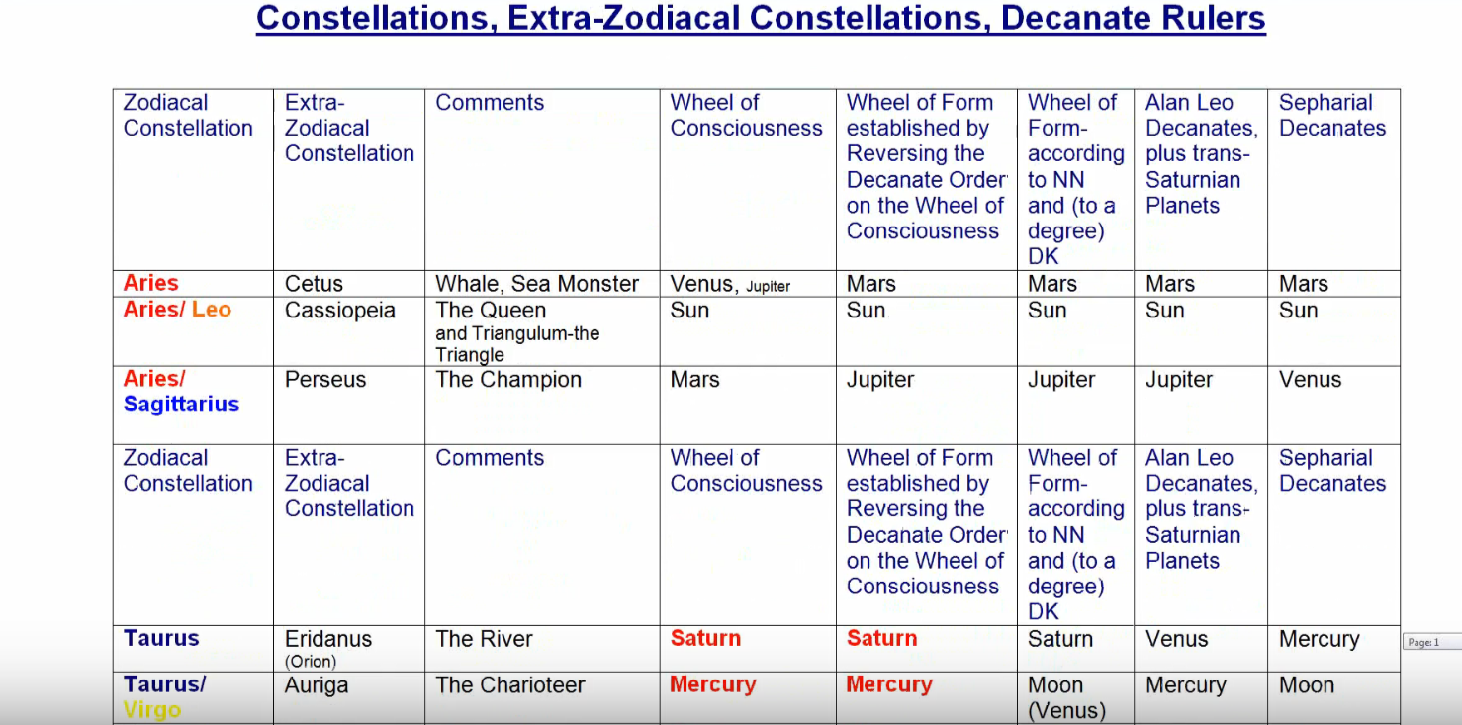

Cassiopeia, the queen, materiality is put in its proper perspective.

Perseus we've already mentioned.

We do realize through Eridanus, how the River of Souls constantly is incarnating and through the death process incarnation is progressing.

Auriga, we're making rapid progress we might say, it's very Mercurial and the Mercurian aspect of the eighth petal is very strong.

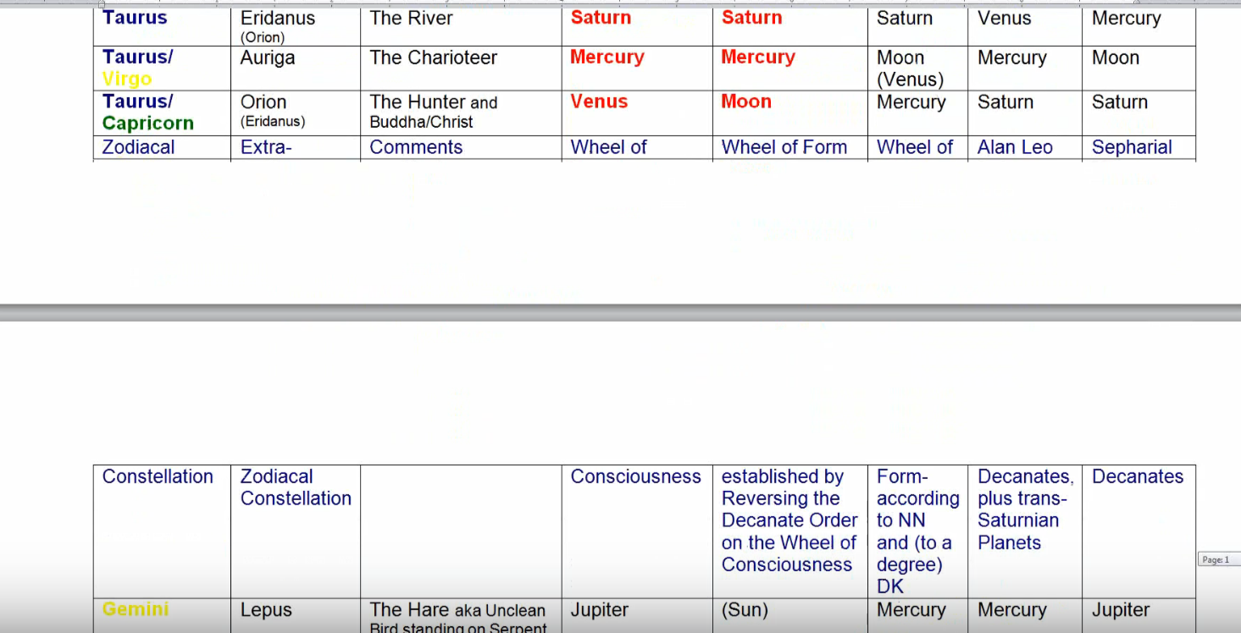

Orion for illumination and this is a petal under Scorpio and Taurus where illumination comes in at the second degree, mental illumination and spiritual intelligence. Well, we're learning how to catch that hare. Lepus may be running away, but we are as the soul-identified disciple, were pretty deadly in catching the hare.

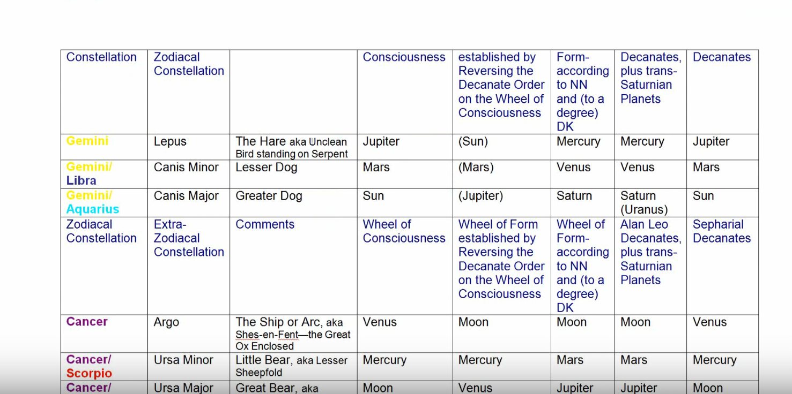

We are certainly, keenly the aspirant towards initiation in Canis Minor.

The Sirian energy in Canis Major is getting stronger and stronger.

We’re travelling with our group of brothers in Argo, the enclosure which takes the heroes who are the members of the group on a great adventure.

We're approaching the lesser ashram, we may be already on the periphery of a certain ashram as the accepted disciple and therefore entering as well be toward the greater ashram.

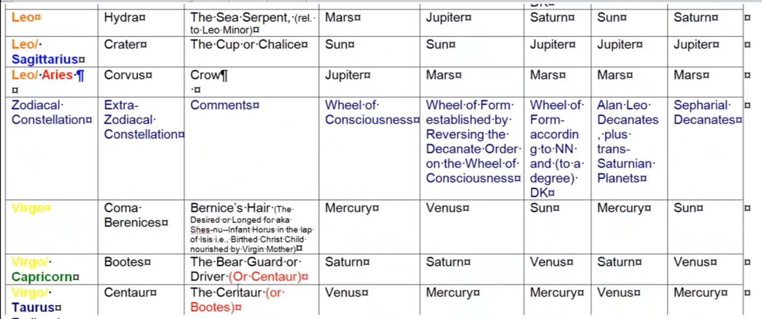

I've discussed Hydra, and Crater.

Certainly, some of the symbolism of the will of god is coming in via the Crow who is in a way the messenger of the gods; these are not always pleasant messages but are telling us how we have to face the difficult things of life.

As well, our sacrifice under Coma Berenices continues.

The Christ consciousness under Boötes is there.

The Centaur? We are really learning how to lay the personality on the altar of sacrifice. Scorpio and yellow and the fourth ray, so connected here with sacrifice. That's what the Centaur does: he spears Lupus, the wolf, from lays him on the altar.

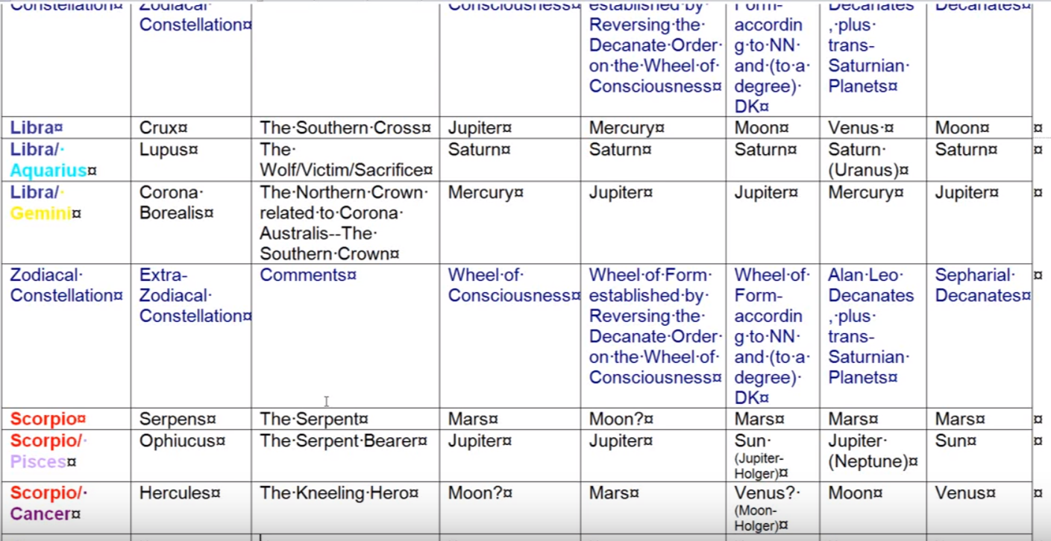

The Christ consciousness under Crux increasing. We are to be our own victim, we set it up so we can spear the personality and sacrifice the personality on the altar.

We're not yet Crowns, I suppose if we were taking the third degree and even higher than that, the Northern Crown would be important, it has a lot to do with Shamballa.

As I've mentioned the serpent power is regulated, subdued, the healing power is coming under Ophiuchus turning poison into the elixir of life, and Hercules is the triumphant disciple.

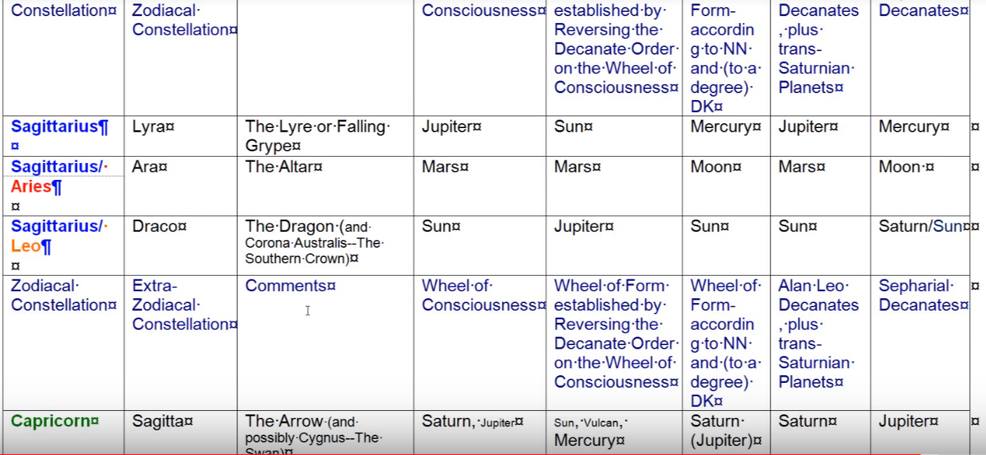

The solar angels, they are the Falling Grype, they are the sevenfold Lyre, the instrument of the sevenfold Lyre. We are coming under the spell of this solar angels in a very kind conscious way.

The altar of sacrifice is definitely blazing away here. There's a lot of sacrifice in this eighth petal. As far as the great Dragon goes it is the source of cosmic buddhi, this is a petal which involves cosmic buddhi.

Sagitta in Capricorn is the arrow of pain through sacrifice and we are definitely experiencing about pain. What we're told about in the fixed cross or Scorpio is bitter woe. We're experiencing that in the eighth petal. It's kind of a mini dark-night of the soul and people go through that.

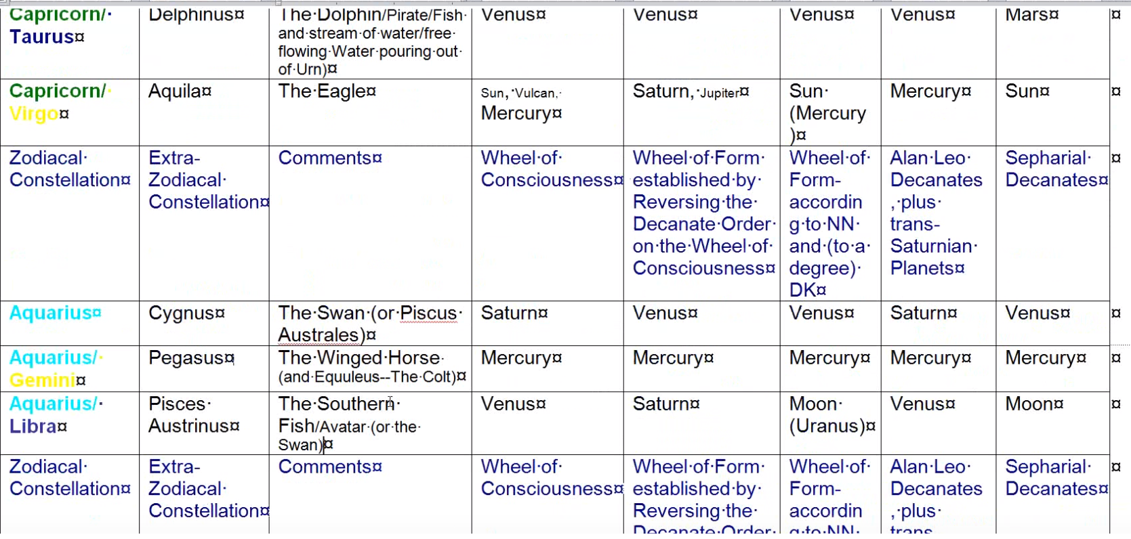

Are we free in our expression of soul energy as the Dolphin is rising out of the water? Well more of that is coming.

Aquila, the eagle? Interesting the ego is often associated with Scorpio and it represents that relentless first ray aggression against all that is unreal and bringing us into the possibility of initiation. But it's still stronger when related to the third degree and to Capricorn.

Cygnus, the swan out of time and space? Maybe not quite yet.

The winged horse? We’re trying to fly high but we're still very much expressing all of these triumphs on the physical plane. So, we're not unrealistic.

We are learning how to be the Fish Avatar, and we're the many, many sacrifices that have to be undergone here. The sacrifices which occur with no hope of reward.

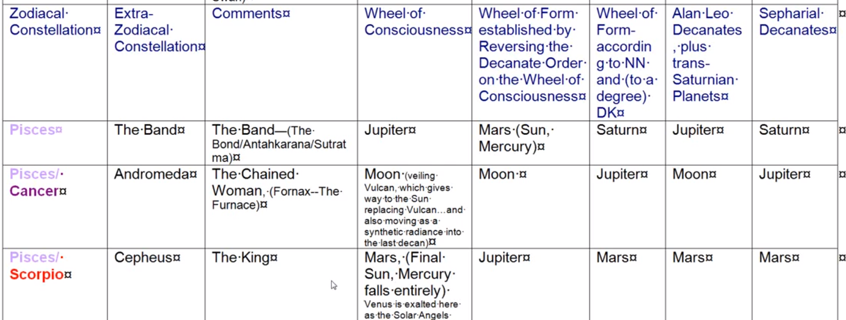

The Band? Well, increasingly, the soul is capturing the personality and they are bound in that way.

With a Chained Woman is becoming unchained slowly, not quite yet, but very much so in process we have not meant see if he is the king but we have met something of the will, and the will comes from Sanat Kumara who is the King [Cepheus].

So, all the different energies relate and flow through and we can access so much if we are really conscious of what we need and what we can call upon.

0:50:00 So much of astrology is what I would call purposeful astrology it's not the astrology of what will happen to me when of course we can sometimes explain why we feel or think in a certain way by looking at the aspects. But we don't want to remain passive about it, we want to remain proactive, we want to say, “Well what's the best I can get out of this configuration? How can I really proactively use what is ambient in the atmosphere in the outer and inner atmosphere? How can I use it?’ And that requires I think some skill in action and a lot of willpower and a whole a different approach to astrology using the available energies.

Is there a synthesizing planet most associated with this tier or petal? Well, with the tier of course, it's Uranus sub Neptune. If we're looking just at the three planets which are synthesizing and which relate to the three aspects: Uranus aspect one, Neptune aspect two, and Saturn aspect three. So really, we can become the occultist here under Scorpio a lot of occultism is achieved and especially when Uranus is strong. Uranus’s exalted planet in Scorpio.

Saturn will certainly be here for the ongoing sacrifices and relinquishments of those things related to the third aspect under the plan which Saturn also rules.

Neptune is here for the giving up of desire and for the bringing in of buddhic energy. Neptune is a major ruler of the intuitive buddhic, love-wisdom energy, the Christ energy as it is found on the buddhic plane.

Number 30: Now the division of the synthesizing planetary triplicity most associated with petal? Uranus sub Neptune, and it's a good place in a way for occultism and mysticism to be rejoined. We may have had a lot of mystical experience before this, we may have begun to concentrate on the mental approach to understanding spirituality. But there's a place in which the mystic and the occultist must be rejoined. I would say that this around the time of the second initiation, and in relation to the eighth petal, it's a good time for that to happen. Hence Uranus, the occultist, and Neptune the mystic. This continues to happen in the synthesizing petals, one of which is ruled by Uranus and the other by Neptune and another by Saturn.

What about the neighboring planets … they are Mercury, Venus and Mars, which neighboring planet would be most associated? It is going to be Mercury sub Venus in a way, but Mercury is the yellow planet associated with sacrifice and with the mental plane.

So, this is a Mercurian tier and a Mercurian petal with a sub Venus to it. It is very good for dispelling illusion and getting rid of glamour three sub Venus. So that is the division of the neighboring planetary triplicity most associated with this petal.

We can get out of it the very limited mind with this combination really bring in spiritual intelligence and mental illumination, so the yellow and the orange are blending. DK in fact tells us about the orange is really more towards yellow so I guess we get some kind of idea here of what buddhi-manas is all about and in terms of our cutting edge the disciples of the modern era, manas is what has to be cultivated.

What about the sun-moon polarity most associated with this petal? Well it's certainly solar, the moon is falling, the moon dies, desire of the lower personality dies, it's one of the deaths. It represents a kind of death of the lower desire nature and Hercules is after all the sun god and Hercules is most identified with the sign Scorpio, and maybe quite a degree with the sign Scorpio which are both prominent here, he is the Son of God. He's the bright glory of Hara. He is the soul so this is definitely a solar petal, and from this time on especially once we passed the temptations in the desert, the way it was really reversed and the sun is really dominating the moon.

Moon falls in Scorpio and each one of us has to learn to make that event real in our lives, the moon falls in Scorpio

0:55:30 I realize, friends, what a lot of detail is coming in here and how much astrology and rayology and mythology is all woven into this presentation of the egoic lotus which is used as kind of this presentation a synthesizing center where the many energies and the many stages through which we pass on the path of human evolution. It may seem like a lot at first to assimilate, but eventually the pure reason will take over and what looks like a lot of detail will all seem to fit together I would say very well. I'm not saying that everything I say is absolutely accurate, it's the best that I can understand when thinking in terms of relationship, but what I what I'm really hoping for is that all of us will begin to be able to access these energies at will, and for a particular past which we consciously understand and which has to do with our next stage of evolution. So, we live a kind of purposeful astrology, purposeful rayology which we apply to our own progress because we see where we stand with reasonable clarity and what has to be done.

I think friends that, under the circumstances, it might be best for me to end this program at one hour so this will be the end of egoic lotus webinar commentary program 54, part 2 of synthesis for petal eight, about one hour. Beginning then next with egoic lotus webinar commentary 55, part 3 of synthesis for petal eight …

So, friends we will move on, continuing in this most important petal, number eight, we kept pass through what it represents a very great achievement will have been made. It really is a kind of a threshold of difficulty for the human being as presently constituted. We begin by trying to understand what we have to do and then applying ourselves over time to the process.

I’ll be seeing you soon. Thank you for studying along and hopefully the process of pure reason is becoming more meaningful.

See you soon.

