EGOIC LOTUS WEBINARS, VIDEO COMMENTARY – 32, Michael Robbins
Abstract
This webinar is about 3 hours, 17 minutes long and covers A Treatise on Cosmic Fire pages 822-824.
Program 32 discusses the meaning of the colors found in the petals of the second and third tiers of the egoic lotus—the love tier and the sacrifice tier. The meaning of each color is referred to the type of experience through which the individual ‘working’ in the love tier and sacrifice tier must pass. As we progress through the petals, we will see that, though the same colors are repeated, their meaning is slightly different in each successive tier of petals.
Egoic Lotus Webinar Commentaries 32 679 MB .wmv file
Video of Egoic Lotus Webinar Commentaries 32 by Michael D. Robbins.
Egoic Lotus Webinar Commentaries 32 189 MB .mp3 file
Audio of Egoic Lotus Webinar Commentaries 32 by Michael D. Robbins.

Transcript

Okay, Friends, Hi. This is going to be program 32, and we're working especially in a section which deals mostly with color in A Treatise on Cosmic Fire. The treatment will not be as exhaustive as in the other petal-by-petal treatment. This is just a look at the possible meanings of the colors in the various contexts. We have noticed that they will differ in intensity in the different tiers, even though they may be the same color. That is something to be aware of; the yellow, for instance, would increase and be the strongest in the third tier, and the rose is certainly equally as strong as it was the second tier, but the other will be still stronger. It depends on the character of the petals themselves.

Let's go with hope towards this section on:

II. the middle “love” triad. TCF 822

The middle “love” triad. Notice it is written here [in the commentary] in the rose color.

We may now make the transition to the triad, or tier, in which the second aspect of divinity is especially expressive, but still in quite a personal manner, rather than, as example, pure and completely altruistic love, because even with regard to the process of the petal there is the attempt to be kind of mystic and serviceable, but always expecting something in return for the service offered. That is not complete altruism and therefore not complete love when we think of the eighth petal expecting nothing in return for the great sacrifices entailed.

During the unfoldment of this tier … it means a general process that includes, in general, organization, vitalization, opening, unfoldment, complete opening, complete unfoldment, the nurturance, and so forth. So, during the unfoldment of this tier, the development of the astral body is especially emphasized as well as the emerging presence in consciousness of the higher of the pairs of opposites: the soul the inner self or higher power; however the man may choose to name it.

00:03:00 We recall that this is assigned as a Venus tier and a Neptune tier. Whereas the first is assigned as a Mars and Saturn tier. Of course, Mars does seem to have something to do, in its concrete nature, with the color orange, at least if you look at the planet we call it the red planet, but if we're really going to be more proper about it, it is orangish-red.
II. The middle "love" triad:
a. Petal 1...Higher Knowledge applied through love on the physical and astral planes.
Colours: Rose, and the original three.
b. Petal 2...Higher intelligent love on the physical and astral planes.
Colours: Rose and the corresponding three.
c. Petal 3...Loving intelligent sacrifice on the physical and astral planes.
Colours: Rose and the same three.

These three petals preserve the fundamental orange but add the colour rose in every petal, so that four colours are now seen. These petals are organised and vitalised in the Hall of Learning, but remain unopened. The outer tier of petals simultaneously unfolds till it is open entirely, revealing the second circle; the third remains shielded. TCF 822

Petal one, Higher Knowledge applied through love on the physical and astral planes. Higher than what? It is not necessarily abstract knowledge, we might just say higher than concrete knowledge. There will be a type of knowledge which enters due to growing rapport with the higher of the pairs of opposites. This is not the abstract mind of the spiritual triad; it cannot be, but of course, given the sign Cancer and its relation to the third ray, the knowledge factor will be important. It is a knowledge petal, of course.

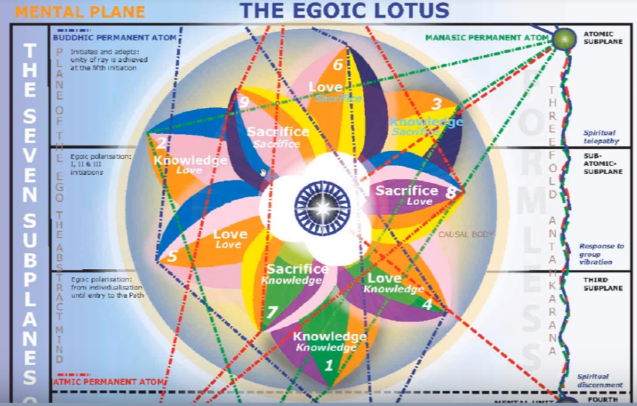

Colours: Rose, and the original three.

It’s colors are the rose, and the original three. In other words, these three in the fourth petal are exactly the same as that as the three of the first petal, but the color rose is added here.
– applied through love on the physical and astral planes. Certainly this is the ideal. This sentence expresses the ideal, which may be found when the petal is completely unfolded. One has to work one's way to it. The knowledge here gained is no longer entirely concrete as was the case in the third petal. The man is dealing with both the physical and astral planes because it's the knowledge petal for the physical plane and the love petals for the astral plane, whereas during his experience for the first tier he was principally focused upon that which the normal senses reveal to him and thus upon the dense physical plane.

There may be some times, very early in the evolution of the race, when there is a higher sensitivity to inner life without really understanding it. H.P.B. said that the newly individualized man was very aware of the presence of the God within him, but that this faded away. Later, man was certainly aware of the astral plane, but then that faded away too; there was a gradual descent into concreteness, which reached its peak I would guess sometime during the Arian phase when the physical brain was considered to be the revealing factor. Even in Atlantis we're told that this diminishment of inner capacity occurred.
Knowledge is gained as a result of the sensed relationship between an inner and outer self. Knowledge, which is based on astral sentiency, begins to accumulate. The man's attitude is no longer entirely extroverted as it was an objective, as in the knowledge petals. He was becoming aware of what will eventually be identified as the “Self” within though his knowledge of that Self may remain for a long time vague. Even as it is rather vague for many people today when we study esotericism, we begin to be aware of the inner God within us, a higher aspect of our own nature that which we more truly are. Still when you think about that, this higher nature within oneself is not necessarily a shared experience of all human beings. In fact, the majority, I think, don’t have it. but maybe increasingly now with the kind of consciousness and education to which we are being exposed in a global sense more will be attuned to the inner and higher aspect of themselves.
00:08:20 The colors … will be rose, and the original three, as I just pointed out. The presence of these colors suggest the following: Rose suggests the intensification of the strength of, let's call it desire-love, it’s not pure love yet. The veil of ignorance is lifting – the veil of ignorance so impenetrable in the hall of ignorance is lifting and the man becomes aware of something within himself – this higher of the pairs of opposites. Rose is related to the law of attraction, which is utilize we are told in consciously balancing the pairs of opposites of which the man is becoming increasingly aware. So, in my higher nature I'm attracted to this; in my lower nature; I'm attracted to that, and one of the just and do demands of each one of these aspects of myself. We might discover that in relation to Libra.

Orange is again found, indicating the growing power of observation. The man begins to view his life and himself from a more interior perspective. This is taken from …

1. The Petal of Knowledge, for the astral plane. TCF 541

1. The Petal of Knowledge, for the astral plane. He works blind to begin to appreciate the effects of the physical plane life by a realization of his essential to I would he begins to understand causes.

This is what we were looking at earlier, and it's important and so we transported it in.
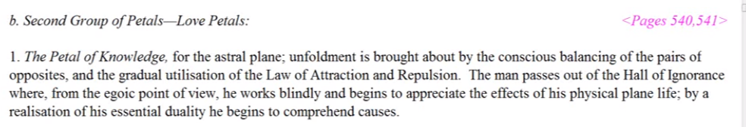

00:10:20 He begins to understand cause and effect, thus the intensification of the orange, I think, although my impression is that the colors will continue to intensify revealing more of their essential nature until perhaps in the sacrifice petals we have the most intense of all, but with one color predominating, that would be the yellow, and the colors within the love tier would intensify over the knowledge tier, but rose would be the predominant color.
He begins to understand cause and effect through the intensification of the fifth ray, not only if they are revealed in the lower worlds, but the manner in which he, as an ‘inner self’ is causative in relation to the environment. In other words, the attitude of I the inner being produces effects in the lower world. …

Green is again present, signifying the act of intelligence by means of which the man begins to integrate his personality Ray three is an ultimately integrative energy, just the way Saturn, ray three, integrates all the lesser rays of attributes; Brahma includes the lower beings within itself, so to speak, includes Indra, lower Agni, Varuna, and kshiti.

This is a Cancerian petal. Cancer brings in the third ray and we're dealing somewhat with the matter aspect of the plane. I thought both thoughtforms here, astral thoughtforms would be a subject we could deal with, here we're dealing with a more material aspect of astral plane.

Violet occurs now on a higher turn of the spiral indicating the personal stability that man gradually achieves as he brings his increasingly integrated personality into order and rhythm. Think of this now, Cancer really fits. Of course we have we have looked at the appearance of Cancer even in the first petal, the three of the seven, and talked about the growing sense of the etheric plane under violet and of the dense physical plane under green.

This is definitely a Cancerian petal. It is the fourth petal starting with Aries, numbering counter-clockwise, and those of the two rays passing through Cancer, the third and the seventh; the green and the violet. It’s all again hard line except for the rose, which is the general coloring of this entire love tier, which is concerning mostly the world of human affairs; the social world. Humanity as we normally understand it, the higher parts of humanity, and not so much entry into the fifth kingdom, at least where the organizational work is concerned. We did read that it is the organizational work for which man is mostly responsible, with the unfolding occurring through added power. Three factors bring about unfolding: the second logos, the solar angel, and of the rod of initiation wielded by the initiator.
Violet is here, and the color of the seventh ray suggests the use of this ray to link the higher and lower pairs of opposites the higher and the lowest meet; the subjective and the objective attitude. I think this is how violet can be used: to link the higher the pairs of opposites with the lower; heaven comes to earth.

Of course we need to think of human groups that are involved here. This is beyond your average individual who is a Lotus of Passion and Desire when this is unfolding. At the same time it is not yet the fully creative individual, but it is the integrating personality certainly aware of some inner sustaining power within itself, not yet as expressive and creative as will be the case as the fifth petal is unfolding.
00:06:15
b. Petal 2...Higher intelligent love on the physical and astral planes.
Colours: Rose and the corresponding three.

2. Higher intelligent love on the physical and astral planes.
Now we have higher intelligent love, it's a higher form of love on the physical and astral planes. A definitely higher form of love. It is such a pivotal petal, we talked about before, so related to Leo and Scorpio and even to Sagittarius, depending on how we count. It is reorienting, and it's got a double rose, and it's the only petal with a double. We had a chance for a double here in petal number nine. It could have been double yellow, but it wasn't, blue was substituted for the possibility of double yellow.

Here in the second tier, it's pretty much rose and the other three. If it's rose and the other three, for petal four it's orange and green and violet and rose and the other three—we go back to petal two, and it's orange, rose and blue, only there is a double emphasis of this Love-wisdom color or sixth ray color, it is a color much associated with Venus.

This is really a Venusian petal, a very Venusian petal. Why? I'm sure you can realize, a Venusian petal because the Venusian solar angel takes its first real interest in the unfolding process. It’s as if … the man does the organizational work, and the factor associated with the second aspect of divinity does the work of further vitalization and opening—we don't literally open the petal, but when we receive sufficient energy from the supervisor (whether it's the second logos, the solar angel, or the initiator) then based upon all the work that we have done on organization, there is the possibility of taking that and really augmenting it into what we call unfoldment.

00:18:00 Higher intelligent love. Now we had before [petal 1] higher knowledge applied through love on the physical and astral plane. We really should remember these –I should remember them certainly. I’m going to copy that to have it side-by-side with petal two, because I think it's so important to look at these two things together.

We had … earlier, petal one higher knowledge applied through love. You are never going to escape the love factor in these love petals, they are magnetic, cohesive. There are various kinds of cohesion I'm various levels which are promoted higher intelligent love on the physical and astral planes. We move from the expression of higher knowledge, albeit expressed through love on two planes, to the expression of a love which is higher than that found in the first tier and which is intelligent as well. … The intelligence gained in the first tier is retained and the quality of love is augmented. Sometimes we hear of so-called emotional intelligence, which is the intelligence applied to an understanding of human relations, and relation, in general. That's a lot of what happens in the second tier, we begin to take people in their own right, people are viewed not as extensions of ourselves, but in their own nature in the second tier. …

The astral body is in process of refinement now. It's no longer so red as it was in the earlier savage days, and is under the influence of the emerging inner Self or soul, and that's how the refinement occurs, even though the true nature of that subjective center may not yet be understood.
00:23:20 Man begins who appreciate, that is, love; Venus and appreciation (interesting how that also means the gathering of finances, one's investment appreciates, that’s Venus, too). Man begin to appreciate, ie love, other beings intelligently, not just in terms of what he can get from them, with some degree of appreciation for who they are in themselves; other selves are no longer considered simply as objects for his gratification or as objects inimical to his objective. There is a growing respect for individuality in this petal. People are not considered important in themselves so much in the earlier, knowledge tier. … the word circle is used also in quite the same way.

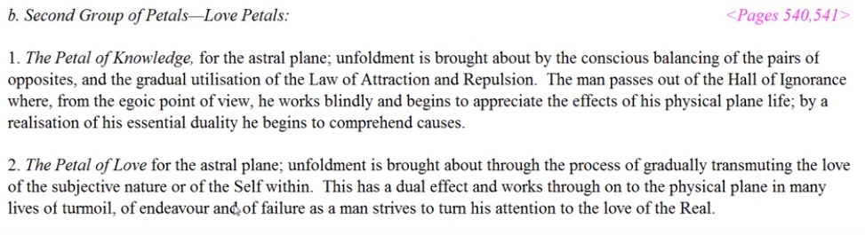

2. The Petal of Love for the astral plane; unfoldment is brought about through the process of gradually transmitting the love of the subjective nature or of the Self within. This has a dual effect and works through on to the physical plane in many lives of turmoil, of endeavour and of failure as a man strives to turn his attention to the love of the Real. TCF 540

So, he is in the process of transforming his love nature. As we're told, from the love of the unreal to the Real. A truer sense of values is emerging and he begins to love with the love of his inner subjective self and desire is being elevated, it’s in the process of transmutation. –Love for the astral plane; unfoldment is brought about through the process of gradually transmitting the love of the subjective nature or of the Self within— to what is it directed?
This has a dual effect and works out on the physical plane in many lives—how many? –of turmoil of endeavor and of failure as a man strives to turn his attention to the love of the Real, and by corollary away from the love of the unreal. The transformation of the love nature no question that what was love in the first tier, what was love in the knowledge tier was for the form because maybe nothing else could be really detected, and even if the individual was detected on the astral plane they would still be he would be the form on the astral plane which would be paramount. So a true sense of value – and now that's always Venus and this is a strongly Venus tier—values relate to Venus and this is a Venus tier.

This is emerging and red desire is turning to rose, it is in the process of transmutation. Soul attitudes have the potential to develop during this organization, vitalization, unfolding of this petal. This is so because the first and second initiation occurs in this love tier by reflex, or at least by the addition of energy from the solar angel.

The love of the inner self is emerging, if all goes well and if the man does not become prideful, right? And if not the destructive egotistical attitudes may here develop and lead to considerable trouble, both in relation to the expression of the fifth petal and later in the developmental process. I think if we begin to develop an egotistical attitude here, it would be such people that would be more likely to veer off and turn towards the left hand path (not many do of course, but veer off on and turn towards the Left Hand Path after the second initiation).

b. Petal 2...Higher intelligent love on the physical and astral planes.
Colours: Rose and the corresponding three.

It’s colors are Rose and the corresponding three, of which rose is one, blue is there, and orange is there. A double rose. The orange and the blue. The presence of the colors above suggest the following, in this petal the color rose appears two times over the double dose, double intensity, giving evidence of the emotional, aspirational intensity, aspiration towards the real. And obviously in the hall of ignorance, desire, or desire-love, has been turned towards the UNREAL—the formal, and not towards energy itself.

Orange is important here for this is a Leo petal that color, given by the Tibetan, is orange. The intellect is becoming bright, it's the fifth petal, fifth ray. The concrete mind is ready to be illumined by the higher of the pairs of opposites, the inner source of light, the soul. This may not happen however until well into the petal process.

00:29:50 I do want to turn to page 869 again, I so much like that quotation, and that I would like to bring it out … I keep on feeling the need to return to it, TCF 869:

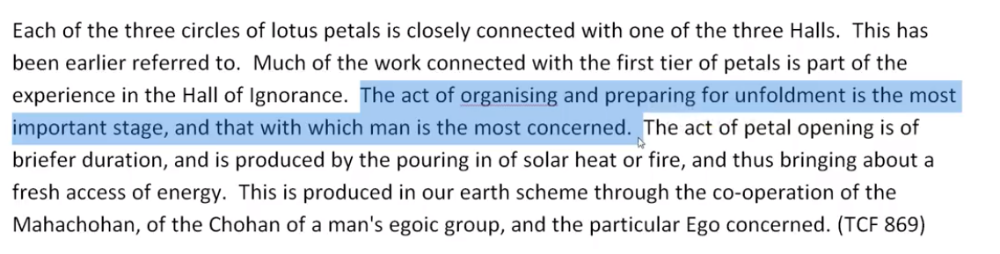

Each of the three circles … The act of organizing and preparing for unfoldment is the most important stage, and that with which man is most concerned. The act of petal opening is of brief duration … TCF 869

The act of organizing and preparing for unfoldment is the most important stage, and that with which the man is most concerned. I guess it means he can be concerned with some other things too, later, but at least most concerned. This is where his labor is. Then he is aided. The act of petal opening is of brief duration. So, organizing, and unfolding, contrasted in terms of the man's labor or work. … [put this into our AAB extracts …]. The act of organizing, preparing for unfoldment, is the most important stage and that with which the man is most concerned. At the time of the first initiation there's a lot of work going on in that seventh petal, and some degree of unfoldment is going to occur there on the basis of man's own labor, but more still with the application of the rod. And when there's a reflex effect, I mean, all that organisational work has been done in the fifth petal, so the unfolding of the petal is simply an intensification of its qualities and more skill and demonstrated quality will show for the man in the world. There will be an increase of his capacity.
Anyway, this is a strongly Leo petal and mind is there, the Leo brings in the fifth ray, and there's an intensifying of the color orange, the brightening of the color orange. The intellect is becoming still more luminous and the concrete mind is ready to be illumined by the inner source of life the soul. … We can begin to have the mind held steady in the light. … We have then the possibility of the mind held steady in the light and meditation can begin. Interestingly, Leo rules the first phase of the meditation process, and that's concentration. At this central petal, concentration upon the higher self or concentration even of the mind and directing attention to a higher self. That is if we get out of directing attention only to ourselves.

The color blue repeats itself as it did in the second petal indicating the growing love and aspiration stimulated by contact with a higher self, or specifically with the downward-gazing soul, the solar angel.

Many struggles are experienced in the development of this petal which is characterized by extremely sensitive sentience, a sense of sensitivity to the presence of the pairs of opposites, right? Leo has this keyword connected with it sensitivity. … remember the key word sensitivity associated with Leo.

00:35:30 The pairs of opposites, the inner and the outer members of the fundamental human duality, (the soul and personality) are eventually clearly evident – or more clearly evident [laughing, (Do they ever get truly get evident until the third initiation?)] – and man if he becomes rightly oriented here he is reaching intensively from the lower to the higher, from the lunar self to the solar self, he's turning the love of the self towards the real turning, the love of the self towards the real.

There's going to be emotional purification, the double rose indicates emotional purification.

All right then the Virgo petal,

c. Petal 3...Loving intelligent sacrifice on the physical and astral planes.
Colours: Rose and the same three. TCF 822

Petal 3. Loving intelligent sacrifice on the physical and astral planes.
Let's do our cumulative work here, taking the preceding information so we can look at all three together: We had Higher knowledge applied through love, we had secondarily higher intelligent love—and notice how the qualifiers are used: It's loving intelligent sacrifice, sacrifice is the last word; higher intelligent love, love is the last word, and then higher knowledge applied through love, higher knowledge, that's the last word.
Loving intelligent sacrifice on the physical and astral planes, we would say though not yet completely unselfish now. We note how the qualities become cumulative and we try to add to that sense of accumulation. Love and intelligence are added to the sacrificial attitude to be found in relation to all third petals. But the sacrificial attitude was acquiescent in the third petal, there was not loving intelligent sacrifice. Love and intelligence are added to the sacrificial attitude to be found in relation to all three petals of each tier, and it is a higher form of sacrifice, higher than that experienced in petal three, of course much more conscious than that here. Experience is purposeful and no longer unconscious, though characterized by mixed motive, as we have been told, that is of course interesting, we can't quite get into the stage of simply giving.
00:39:30 Colors: Rose and the same three. Here we are, petal six, rose and same three: orange, yellow, indigo, orange, yellow, indigo. It's just the addition of rose.

We remember this is a petal of self perfection, a lot of the work done in preparing. It's a probationary discipleship petal, a petal usually called probationary a discipleship, and it takes place before the first initiation, the organizing work there. We have to purify our natures, physically, emotionally and mentally as much as possible, and then we are preparing for the work done in the seventh petal which will unfold completely the fifth petal. I guess when you're trying to describe an interior and natural process it's never easy. … It seems like the little clues are everywhere and if we follow the clues we can get something of the sense of sequence. But there are probably so many different varieties of how this occurs, yet some degree of the sense of sequence will be useful for us.

The rose and the same three. The presence of these colors suggest the following: rose is precisely the color which fits with the sixth ray attitude of this sixth petal, dedicated, devoted to purification, and to taming the elemental self, the moon, towards unselfishness. It will resist of course.

… Under the influence of rose the man is endeavoring to give up selfish desire, but he does not entirely succeed until there is sufficient work going on in the eighth petal, and by reflex the sixth will come to success and unfold. He attempts to give up his own personal desire for the sake of his group. We can see moving toward a group focus, that is there in a latest sense from the time the first initiation is taken. But when we're simply working in the experiences related this petal, the first initiation is not taken. It's only when we're really working with abnormal and strenuous effort … that there will be the first initiation of working in the seventh petal. That way, right now, we're just kind of on a probationary path more than the path of aspiration. He is engaged in more than the path of aspiration, he's actually working as we would expect of Virgo he is actually working.
Orange is as usual, repeated, and this is a mental petal in many respects, because we move in a way as we progress through the tiers, physical, emotional, mental. That is one way of moving. Orange as usual is repeated and assists in the discrimination between that which is truly sacrificial and of the soul and that which is still tainted by personal attitudes and I think you need Mercury there as well. Mercury is a planet of discrimination and it is yellow. The color of Gemini and Mercury is always yellow, so we have the yellow, rose and these original three. So both of these orange and yellow are both discrimination.

Yellow enters here on a higher turn of the spiral and represents conscious response through the law of sacrifice, not necessarily always successful. It's the law emanating from the soul and the energy which is now being strongly sensed. When can we really begin to work for the laws of the soul? It is really only after the first degree that we can begin successfully to work with some of the laws of the soul. But already there are people before the first initiation, who have heard of the ageless wisdom and they are trying to train themselves to have the birth of the Christ in the heart, and not just the imitators what they see other people do or do it because they think it's right, but do it because of the deep motive which is provided by soul contact, sustained soul contact.

Indigo arises again on a higher turn of the spiral. Maybe there's even a spiraling motion in the way the petals are arranged, maybe they somehow symbolically depict the rising spirals. Indigo arises again on the higher the spiral and represents the synthesis of all that has been learned about the nature of emerging subjective love in this love tier. As the conditions particularly the astral body and begins to unite the pairs of opposites soul and personality. Always there is an encapsulation and everything that was synthesized before in petal three is still part of the synthesis in petal six.

Each time indigo appears the man becomes more inclusive. I think the beginning group consciousness that DK discussed when the three petals are opened, such as he said the union worker who develops the group sense, but still in a selfish way, but the time indigo is coming to fruition here in petal six I think a lot of selfishness has been overcome.

It may be most interesting to see the relative timing of the emphasis of the different colors in the petals. Probably not everybody has equal emphasis of all the different colors, probably it depends very much on their more permanent ray structure, their astrology, of their Soul, because probably every Soul has its own abiding astrology. Then of course the astrology of the personality for the immediate incarnation.
00:48:00 These three petals of love preserve the fundamental orange, but add the rosy color in every petals, so that four colors now are seen.

The orange is the color of concrete intelligence and of the sun in a way and of the solar angel and represents the fundamental endowment imparted to animal man by the Agnishvattas and maybe it also begins to appear on its own without the Agnishvattas due to the fanning of the flame. The Agnishvattas give to man what he could have developed for himself in a much longer period of time. So even when individualisation is not through the intervention, those colors will emerge probably through the powers of the monad and triad feeding the egoic lotus.

Orange, or whatever shade it truly is (as the interior colors often are very different from the colors that we think of customary), is also the fundamental color of the Agnishvattas. Also the intensity of orange must continue to grow all through development of the first nine petals as the solar angels begin, little solar angels, major and emanative solar angels, increase their influence over the personality.

But add the color rose in every petal. This corresponds to the refinement of the astral body in the growth of an increasingly real love, a love that penetrates less into the world of form; into the world of form hat love must someday fail to penetrate – the second integration formula. Throughout the development of the second tier the love nature is refined, becoming less and less the slave to form and base desires. The real is not form. …

2. The Petal of Love for the astral plane; unfoldment is brought about through the process of gradually transmitting the love of the subjective nature or of the Self within. This has a dual effect and works through on to the physical plane in many lives of turmoil, of endeavour and of failure as a man strives to turn his attention to the love of the Real. TCF 540

… the gradual transmitting of the love of the subjective nature or of the Self within … man strives to turn his attention to the love of the real and not necessarily the love of the formal. It doesn't mean that form is not essentially real, it is essentially real, but it has no independent reality as form. There is some substratum which makes form possible and without that substratum the form would dissolve.

These three petals preserve the fundamental orange but add the colour rose in every petal, so that four colours are now seen. These petals are organised and vitalised in the Hall of Learning, but remain unopened. The outer tier of petals simultaneously unfolds till it is open entirely, revealing the second circle; the third remains shielded. TCF 822

Four colors are now seen. And when there are three colors, intelligence is emphasized. When there are four, the interplay between the pairs of opposites is accentuated. Four suggests polarity, right? And conflict between the polarities with the purpose of achieving harmony between the higher and lower pairs of opposites and eventually the triumph of the higher the pairs of opposites which absorbs the lower into itself.

00:52:00 The fourth chakra is the heart center, which in this context is not even significant, and so there is the growth of heart, and we would say especially in the social context. Participation intelligently in world affairs, this is the social, civilizational context. People are getting more and more into this as they become integrated personalities. We are coming to a time the Tibetan tells us as when there will be a large number of integrated personalities and this will present its own difficulties he warns us. Probably a pretty strong non-cooperative Leo period, unless the soul can offset it.

These petals are organized and vitalized in the hall of learning, but remain unopened. Until what? Well always there is a general statement, organization and vitalization. I don't expect that it will be equally organized, vitalized, I do not expect that there will be an equal organization and vitalization of all petals him the love tier but rather I expect a progressive organization and vitalization with progressive opening and not sudden, simultaneous opening. I think there's a mathematics behind all of this and one day we will know it.

We must ask whether in fact all the petals of the love tier remain to be opened while there is progress in the hall of learning. … For instance, when there is earnest work in petal six, is it not conceivable that petal four could begin to open just as when there is earnest work in the petal seven, petal five tiers surely opening. We don't see the time-lapse video in front of us, but that's what I expect. I don't expect a simultaneous opening, I expect a progressive opening, one after another. I think in some of the earlier discussions if I could only locate them right now, we found that to be the case.

The first initiation occurs upon graduation from the Hall of learning and the first initiation requires the unfoldment of the fifth petal. What is graduation? Maybe graduation is going to organize and vitalize the seventh petal and the other sacrifice petals.

I've pulled in the couple of things here … some references that I have thought are important.

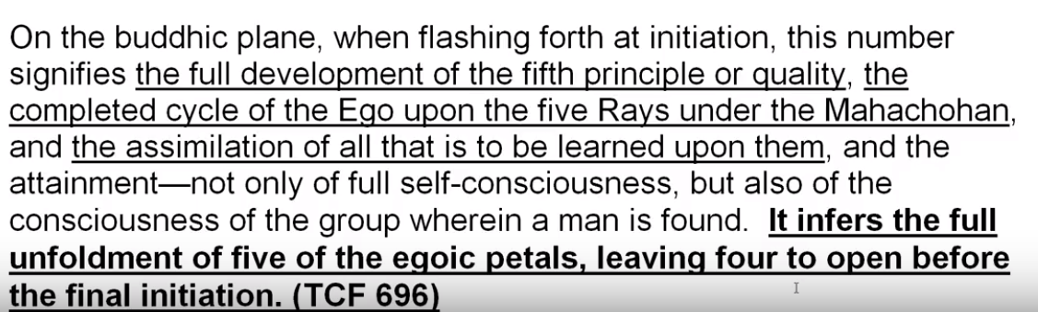

On the buddhic plane, when flashing forth at initiation, this number signifies the full development of the fifth principle or quality, the completed cycle of the Ego upon the five Rays under the Mahachohan and the assimilation of all that is to be learned upon them, and the attainment, not only of full self-consciousness, but also of the consciousness of the group where in the man is found. It infers the full unfoldment of five of the egoic petals, leaving four to open before the final initiation.

On the buddhic plane, when flashing forth at initiation, this number (five) signifies the full development of the fifth principle or quality, the completed cycle of the Ego upon the five Rays under the Mahachohan and the assimilation of all that is to be learned upon them, because at this initiation, at last, emphasis can be placed upon two and one, so one can have then the second or first ray personality, and also one can have the soul transferred to the second or first ray, and the attainment, not only of full self-consciousness, but also of the consciousness of the group wherein the man is found for first initiation consciousness is group consciousness. The egoic lotus shifts position and begins to respond to the siddhi called response to group vibration. It infers the full unfoldment of five of the egoic petals, leaving four to open before the final initiation.

The final initiation, as I’ve said before, that has to do with the final initiation regarding the nine. It certainly does not have to do with the fifth initiation as a final initiation, and it doesn't have to do with the fourth initiation as final, because we have so many references that tell us that the nine petals are completely open at the third. …

00:58:15 There's quite a bit of petal unfoldment as the Kingdom of God is entered, and this is not done in the hall of learning. Work is being done in the hall of wisdom, and there is a reflex opening in the hall of learning, it becomes clear that a process of overlapping. Opening is complex, we've been emphasizing this, and individual, depending upon the two major rays: monad and the subray of the monad, maybe including the seven subrays of the monad which are not soul rays, but are more monadic rays themselves. Without having the actual process clearly before the inner eye a description can only be approximate.
The hall of learning is that period of human development wherein a man participates intelligently in world affairs. There is intelligence here, gained in the hall of ignorance and now that it is applied to the civilization and social context, and learns also about the existence of his inner nature.

These petals are organised and vitalised in the Hall of Learning, but remain unopened. The outer tier of petals simultaneously unfolds till it is open entirely, revealing the second circle; the third remains shielded. TCF 822

The outer tier petal simultaneously unfolds till it is open and tiredly revealing the second circle;

Here is the question, is there some opening of petal four even before this outer tier is completely revealed? We don't know, but it certainly is the next one to unfold. In other words, the idea is when you have a complete unfolding of what is behind, do you have to wait for the complete unfolding before what is immediately ahead begins to unfold? It doesn't seem right in terms of this gradual process.
So must the outer tier unfold if the second circle is to be revealed? This is the implication, but remember we had the same problem with the synthesis petals, because they were disclosed at each initiation, there was some display. It's not as if there was no possibility of recognizing that something was going on there. We didn't necessarily have to wait until all nine petals were unfolded before we knew something was going on, because there was some display. So this can only be I think clarified, the rest is imagination. When we can actually see precisely and study precisely. This has to be a far more demanding science than any kind of study of lower life forms and the gradual development, various kinds of biology. This is a kind of interior, subtle biology, and we need all the difference slides to show us the different stages of unfoldment. But of course it wouldn’t have to be sectioned, all we have to do is focus in and see the process.

01:02:00 The outer tier petal simultaneously unfolds till it is open and tiredly revealing the second circle; the third remains shielded. TCF 822

The outer tier petal simultaneously unfolds till it is open and tiredly revealing the second circle; the third remains shielded. So during the organization of the second tier, sometime during it, the outer tier unfolds entirely. If the unfoldment of the outer circle signals the taking of a kind of initiation (not necessarily one of the great “Manasic Initiations”, no an earlier kind) this initiation is taken when the organizational process in the hall of learning—well I don't want to say has been completed, I want to say he's being completed. This is always a question of timing because … earlier we saw that there were some second secondary types of initiations which were taken when organizational work was done in the petals of the hall of learning.

As a matter of fact, I think it would be advantageous to go here again … here we have it,

c. The first group of solar Angels affected.

At the stage which we are considering (that of the organisation and unfoldment of the first tier of petals), the egoic influence felt at the beginning is but small, but when the three petals become sufficiently active and alive through the energy accumulated and stored up in the ego during the activities of the personal life, a form of initiation then takes place which is a reflection (on a lower plane) of the great manasic initiations. The energy in the outer circle of petals causes it to spring apart from the next circle, and to unfold. This threefold energy becomes interactive and a very definite stage is thus reached. This series of initiations is seldom recognised within the physical brain consciousness owing to the relatively inchoate stage of the bodies, and the unresponsiveness of the brain matter. Yet they are nevertheless initiations of a definite though less important character, and they involve primarily the display (within the personal life of the man) of an intelligent recognition of his group relationships on earth. This recognition is frequently selfish in character, as, for instance, that which the union worker displays, but it is indicative of group interplay.

A similar process takes place when the second circle of petals is organised and ready for unfoldment. This time the World Teacher, the Master and the Ego concerned are co-operating, for these smaller initiations deal with the love nature, with astral or emotional organisation, and with the recognition (by the man in his personal life) of some form of unselfish love, and of a love for some object, person or ideal which leads to altruistic endeavor, and to the negation of the lower self. TCF 869-870

a form of initiation then takes place which is the reflection (on a lower plane) of the great manasic initiations. The energy in the outer circle of petals causes it to spring apart from the next circle, and to unfold. This threefold energy becomes interactive and a very definite stage is thus reached. This series of initiations is seldom recognized within the physical brain consciousness owing to the relatively inchoate stage of the bodies, and the unresponsiveness of the brain matter … They are nevertheless important initiations and they involve primarily a display of some group relationship. Then a similar process takes place when the second tier petal is organized and ready for unfoldment. This is so interesting because it implies that there is not complete organization of the second tier when … the first tier springs open, but that comes a bit later … as some of it unfolds, until it is open entirely, revealing the second circle. …

01:05:40 What I'm saying is that if we have to wait for the second series of initiations, until the second circle petals are organized and ready for unfoldment, this earlier initiation occurs when the outer group of petals simply springs open. That necessarily has to be before the second series of petals is organized and ready for unfoldment. The second types of initiations, these smaller initiations, have to do with some type of unselfish love and we could even say that has something to do with the sixth petal, rather than the seventh. Maybe there is a relation to the work done in the sixth petal.

Anyway … let's look at this. We go back to where four colors are now seen … I'm looking for what DK is saying in this particular section … the outer tier of petals simultaneously unfolds till it is opened entirely revealing the second circle.
But this simultaneous unfoldment does not have to wait until the second tier is completely organized and ready for unfoldment, it happens before. We're sort of piecing together the chronology of opening, of unfoldment. Of course just seeing it would be the way to go, but we have all these clues and we can get a fairly good picture and when the day comes in we're watching it maybe we'll remember these kinds of studies.

When the outer three spring open, one kind of initiation showing some kind of group consciousness, but still selfish occurs when the second tier of petals is organized and ready for unfoldment, then smaller initiations of an astral nature are passed through with a recognition in the man's personality life of some form of unselfish love, and still maybe with mixed motives.
Must the outer tier of the second circle unfold if the second circle is to be revealed? This seems to be the implication. It's as if during organizational work the petals in which there is that work going on are not revealed. I also explained the difficulty that we arrived at with the display occurring within the synthesis petals.

During the organization of the second tier, the outer tier unfolds entirely. … This unfoldment does not have to wait until complete organization and readiness for unfoldment of the love tier. If the unfolding of the outer circle signals the taking of a kind of initiation (the kind where He talked about the union worker), this initiation is taken when organizational process in the hall of learning is being completed. It’s correct, we can't say has been completed because when it has been completed another type of initiation is being taken more in relation to the astral plane. And maybe more of the supervision of the Christ.

In general, the very complete and integrated unfolding of the first tier corresponds to the first initiation and the fullest unfoldment corresponds to the first initiation, but it is not there at the same time. And the fourth unfoldment of the second tier accompanied by its interplay with the first tier corresponds to the second initiation. Because when the second tier is completely unfolded, then the second initiation takes place.

When the first tier is completely unfolded? No. It's interesting, when the fifth petal is completely unfolded the first initiation takes place, the first manasic initiation. When the second tier petal is completely unfolded, then the second initiation takes place, when the first tier of petals is completely unfolded then an earlier type of initiation takes place, and when the second tier petals is organized and on the point of unfoldment then a second series of initiation takes place, which are not among the great manasic initiations, but which relate more to the astral plane.

01:12:12

These petals are organised and vitalised in the Hall of Learning, but remain unopened. The outer tier of petals simultaneously unfolds till it is open entirely, revealing the second circle; the third remain shielded TCF 822

So, revealing the second circle … the third remain shielded as the second circle is revealed, and work goes on within the unrevealed petals before they are revealed. This I suppose has to be seen. But organizational work goes on within the petals before they are disclosed. And it would seem to me, well let’s see, work being done on the first initiation in the seventh petal, on the second initiation and the eighth petal, is that work being done on an undisclosed tier? In other words, do we have to wait until the second initiation before seeing the petals of the sacrifice tier? Because that's when the second group of petals, the love petals, will be completely unfolded. Maybe revealing then, just the way the knowledge petals revealed to the love petals, then the opening of the all the love petals will reveal the sacrifice petals.

01:14:00 Here’s another question, if there is unfoldment in the sacrifice tier, at the time of the first initiation, is this unfoldment not seen? Is it possible to have unfolding petals which are not seen? It does not seem so. There are things to be straightened out. I wish I could really straighten them out of this point, but there's no way to dogmatize about this. Earlier what we discussed was that through the strenuous and abnormal work of the individual, some degree of unfoldment was brought about. Then the rod of initiation brought further unfoldment. Now this abnormal and strenuous work must precede the application of the rod. There's going to be some unfoldment based upon abnormal and strenuous work. Is unfolding is brought about through the strenuous abnormal work and the application of the rod?

I'm assuming that both of these bring about some degree of unfoldment of the seven petals have to be done through strenuous and abnormal work. And that's before the first initiation takes place, before the fifth petal is completely unfolded, before certainly all of the other petals of the second tier are unfolded. We have to wait for the complete unfoldment of the second tier in order to see anything going on in the sacrifice tier, where some unfoldment is occurring. I hope that's clear. Some unfoldment is occurring, and when the rod of power is applied … to the seventh petal more unfoldment takes place in that petal, and yet the entire second tier is not completely unfolded. Petal six remains to be completely unfolded. Do we see the unfoldment which the rod of power has produced in petal seven, or do we have to wait until the complete unfoldment of the love tier before seeing any of the sacrificed tier?

I think that puts it clearly. Different references seem to indicate different things and we're trying to use logic here to determine what sight would reveal instantly. Surely we understand the value of sight. I feel like one of those poor groping creatures in the early days before individualisation before the coming of the eye.

01:18:00 So, we are learning about the unfoldment process in general, but not all the details are being imparted. Nor the apparent exceptions based upon the energy structure of the human being. DK is telling us that as the knowledge tier unfolds, it's revealing the second tier, the inner or sacrifice tier is still not to be seen. Can we ask the same question re the visibility of the love tier?. Must we wait for the entire knowledge tier to unfold before seeing any of the love tier?

When we think of the picture of the full blown egoic lotus usually presented or studied, we can understand that it represents an individual who is very highly developed, in fact one who is virtually an initiate of the fourth degree.

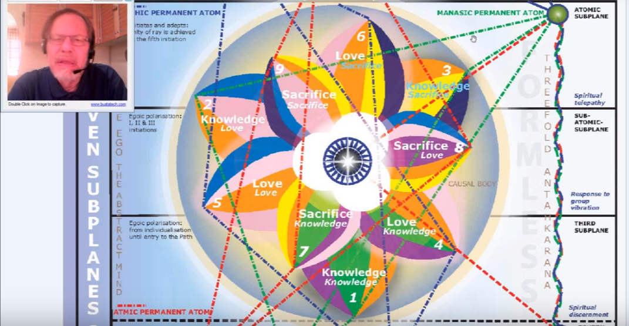

The jewel is shown disclosed and radiant and this is the egoic lotus on the point of destruction, but there are so many in between phases which are entirely individual, and if we were looking out in that field of lotuses we're not going to see everybody looking like this; this will be the rarity, with the all these different possibilities.
We're just about ready then to go into the inner or sacrificial triad, and this more and more comes to light, more and more pieces of the puzzle come forward. It's just all a question of timing. We know something of what happens, but we want to know when it happens, and in the desire to know when something happens we have our difficulties.

The general sequence and what is visible when … what is disclosed, when? That's what we want to know.

We can proceed with the third tier and there will be five of the colors showing from each one of the petals of the third tier and things will become a bit more complex and less regular. So far we've had complete regularity for the first six petals in terms of the colors we might expect, but then some changes begin to occur especially petal eight and petal nine.

III. The inner "sacrificial" triad:
a. Petal 1...The Will to sacrifice through knowledge on the mental plane, and thus intelligently to dominate the entire threefold lower man.
Colours: Yellow and the four colours, orange, green, violet and rose.
b. Petal 2...The will to sacrifice through love on the mental plane, and thus to serve.
Colours: Yellow and the four colours, orange, violet, rose and blue.
c. Petal 3...The utter sacrifice of all forever.
Colours: Yellow, orange, rose, blue and indigo. TCF 822 & 824
We have a few color anomalies in the inner, sacrificial triad. This is the triad which specifically concerns the initiation process only through strenuous and abnormal work.

Will the initiation process be prepared? Will the man come to the point where the rod can be applied, because he can be considered initiate even if the full petal is not yet open?

There is no initiation without the will-to-sacrifice and there is no will-to-sacrifice unless soul love is establishing itself, is influential within the consciousness. Let us assume that somehow, even before the second initiation occurs, we can see something that is happening within the sacrifice petals. Because otherwise we would have to wait until the second initiation. A lot of work would have been done within the sacrifice petals before the whole tier would have opened the love tier, revealing for the first time the sacrifice petals. It seems a long wait. As I've explained before. Let's say it seems we should not have to wait for the complete unfolding of the second tier before seeing the sacrifice petals. …

III. The inner "sacrificial" triad:
a. Petal 1...The Will to sacrifice through knowledge on the mental plane, and thus intelligently to dominate the entire threefold lower man. TCF 822

The inner “sacrificial” triad: Petal one, the Will to sacrifice through knowledge on the mental plane, and thus intelligently to dominate the entire threefold lower man.

It seems an advanced state, does it not? (I'd like to put all these together so that when we come to that we can see them all simultaneously. Hopefully I have them all here like I've done this before, and then put these together and accumulate them and bring them down to the point where the last petal is being dealt with of course it says something so brief and powerful.) [Petal 3] The utter sacrifice of all forever. One wonders how much of all forever; one wonders how much one can really say.

But we will look here: the will to sacrifice through knowledge on the mental plane and thus intelligently to dominate the entire three fold lower man. When the entire threefold lower man dominates. Well, there's the will to do it. Is it really achieved? I guess by the third degree this is achieved by the third degree. This domination has achieved this ending of the ancient authority of the threefold personality.
01:25:30 The descriptions of the meanings of the petal become increasingly complex as we move into the third tier. One would just have to ponder this. The will to sacrifice through knowledge on the mental plane. I believe we have not yet achieved true mental polarization in the technical definition of it between the second and third initiations, and thus intelligently to dominate the entire threefold lower man. We don't have much mention of love here, yet it's a petal connected with Libra and the third ray, and Sagittarius as we've looked at, and or Aries. This complexity is growing in the description.
Throughout the expression of the third tier the factor of sacrifice is to be found the yellow is pervasive. In the first of the sacrifice petals, the kind of sacrifice to be made requires knowledge. It is a knowledge petal. It is not only concrete knowledge, but the kind which arises through soul culture. It’s even a higher kind of knowledge than was spoken of in relation to petal four. In Petal four what did we have? Higher knowledge, simply higher knowledge. That was petal four; petal one of tier two, which was simply higher knowledge.
But this is the will to sacrifice through knowledge on the mental plane. It's going to be a knowledge that is definitely soul cultivated. Maybe not yet triadally cultivated, though the fact that it is a triadal, Libran petal, would seem to link it to the spiritual triad. The fact that petal seven is a Libran petal would seem to link it to the spiritual triad.
The domination of the threefold lower man is not completed with the completion of the major focus upon the first of the sacrifice petals, but it's the will to go in that direction. It cannot be complete, but it represents the Will to go in that direction. Not until the final sacrifice petal is open is this threefold domination of the vehicles of the lower man complete, and it's not even absolutely complete until the fourth initiation. But we must remember that the seven petal may not be fully opened until the very last sacrifice petal is opened. This is the theory we've been putting forward in this three petal process, indeed the domination of the entire lower man. Sacrificial knowledge may proceed in relation to the general program controlling seven petal processes. He keeps going. The power to dominate the lower threefold man continues during the long series of lives between the first and second initiations and the briefer period before the third.
We note that the entire lower man, (etheric- physical, emotional and mental) must be dominated intelligently. There’s that third ray connected with that third petal and Libra. Also that domination will not occur unless the spirit of sacrifice is active, because that which must be dominated must be sacrificed to that which is to dominate. The motive must be correct and the motive relates to the use of all. Here it is … the motive:
c. Third Group of Petals—Sacrifice Petals:
1. The Petal of Knowledge for the mental plane; its enfoldment marks a period when the man consciously utilizes all that he has gained or his gaining under the law for the definite benefit of humanity. TCF 541
1. The Petal of Knowledge for the mental plane; its enfoldment marks a period when the man consciously utilizes all that he has gained or his gaining under the law for the definite benefit of humanity. It's a very generous petal in relation to Sagittarius and Jupiter perhaps, a bestowing petal, bestowing knowledge, all of these petals of sacrifice … are bestowing petals. They pour forth to give. To sacrifice is essentially to give.
01:31:30 Colors: yellow and the four colors, orange, green, violet and rose. TCF 822
Colors: yellow and the four colors, orange, green, violet, and rose. Let's see how they work out. This has to be quite explicit.

The color is yellow, and then orange, green, violet, and rose. And if we look at petal four: orange, green, violet, rose, or rose, green, orange, and violet. Maybe the order here is important. We cannot tell whether the Tibetan is always being exacting in everything He writes down and wants us to look at order, but so often order is important. Here it was … at petal four rose and the other three, but here it is rose at the end. Orange mean by that and rose at the end, but always beginning with the color which characterizes the particular tier, and that color is yellow.
The presence of these colors suggest the following: yellow is particularly the color of sacrifice and is the color which appears in all three of the sacrifice petals, though not doubled as rose is doubled, having appeared twice before once in each of the lower tiers in the third petal of each, and presumably in lesser intensity than in the sacrificed tier.
Of course, sacrificing knowledge, we're in the realm of Mercury here. Yellow is Mercury and the pouring forth of knowledge. There's Jupiter involved, Sagittarius there, Mercury ruling the color yellow. It’s the pouring forth of that which has been accumulated through the power of Mercury and it fits.
Orange represents the increasing influence of the solar angel, the predominating color, orange, and the color of the Agnishvattas, predominant color. Of course they are they are a huge hierarchy with their own subdivisions. They have to have all the seven rays, obviously they cannot have only orange, but maybe it is in some way their predominating color and links them then to the sun. I remember DK said that. The orange we usually conceive of is not the orange of the subtler planes which is more towards yellow.
But until we can see these things with clarity we are groping and we have to grope toward sight, the peculiar groping, sightless creature, had to grope before it could see. So just humbly admit and groping along here, using that great groping tool we call the reason when pure reason comes, that is sight.
Orange represents the influence of the solar angel and the infusion by the concrete mind of the light of the soul the mind tells that in the light and following increasingly by the antahkarana after the first initiation, but maybe more towards the second. I'm just assuming there's more unfolding to be done in this petal even after the rod of initiation is applied and some degree of unfoldment is produced.
Green correlates with the third ray and the abstract mind, which characterizes the function of the first of the sacrifice petals, a Libran petal. Using counter-clockwise counting from Aries it is Libra. First petal Aries, seventh petal, Libra. All the energies of the human energy system must be intelligently coordinated if the inner man is to control and eventually dominate them. The intelligent manipulation of the human energy system for the sake of domination and eventual control.
01:36:45 The third ray is there very definitely. We are really beginning to think abstractly here; the power to think abstractly is growing and the third ray, green, fits with this of course.
… We have to be ready to have all kinds of revelations in the chamber of initiation; things we cannot even conceive of. Here we use what we can and we approach as we can with what we have. And more will be given until we are the heirs to everything that's in the universe. The universe which we are it sounds like a presumptuous claim, an insane claim, but if you really start to think about what Pure Being is, divorced from form, one sees that it is a necessity.
Immediately before and at the time of the first initiation, the third ray (the color of which is green) characteristically rules the personality of the candidate for initiation. You oftentimes have something like this, soul ray: 3 7x7. X is for the astral body, maybe sixth. You can't pontificate about that, but six mostly, 3 767. But a seven-three mind and seven-three brain, whatever this whole ray may be for a third ray personality gathering all things together.
The throat center and knowledge; the sacral center is lifted to the throat center at the first degree. Hence the emphasis upon the throat, and of the second degree, the emphasis upon the heart. Though, there are sub-emphases as well. Heart is emphasized at the first, and the throat also for spiritual intelligence and mental elimination is emphasized at the second.
Violet is here too, in petal number seven. Violet suggests a higher expression of the seventh ray, helping to bring the personality under rule and order. What is said here, domination and control. Seventh ray has a lot to do with that, and I'm going to use a crazy word here, the ‘de-mayafication’. Devitalization of maya. Demayafication through order. And spiritually-responsive coordination of the etheric body is the focus of the first initiation.
Think of it, back in petal one you had violet, but it was those early initiations where man was learning how to control his physical body through the etheric. Now we're having an entirely different emphasis upon the etheric body, not just making the connection with the physical. So that it would begin to function more automatically perhaps? But bringing in the law and order to the physical body’s expression. The seventh ray generically rules the etheric body and the color of the seventh ray is violet. Devas of a violet hue characteristically rule the four systemic ethers.
There's a big emphasis on the first initiation, on the etheric body at the first initiation. Maybe some emphasis regarding the earth as the base of the spine, which is essentially any etheric vital center, maybe some change occurs in the base of the spine when there is a beginning of this initiatory process. Violet is there, and very important for order in the etheric body and for order in the general life, ending the period of license and boundlessness and trespass and so forth.
There is a close connection between the abstract mind (in the triad) and the etheric nature. In this method of examining correspondence, the buddhic plane would be reflected in the astral body and the atmic plane in the lower mind.
So the abstract mind and the etheric body. That is the correspondential way of looking at these two triangles, and not the reflective way. Maybe I shouldn’t have used the word reflected. The buddhic plane would be expressed … in the astral body.
The rose of aspiration and purified emotion continues to express as the spiritual aspiration becomes intelligently directed and the urge to transcend entrapment by form intensifies. On the way to the second initiation we need ray six, the rose. We do continue, at least according to my theory, we do continue to work in petal seven. Knowledge to be poured forth he even as we move into intensive work in petal eight. I can't help it use that that terminology, working in a petal, but what I mean is DK pretty well clarified that we work at organizing our life and developing skills and that's called the organization of the petal. Then when greater energy pours in and what we worked at begins to blossom and express in a natural and easy way, we call that the unfoldment of the petal.
01:43:30 … We just finished the petal on the will to sacrifice, petal one. Petal seven really, will to sacrifice through knowledge on the mental plane, that really requires pondering, and thus intelligently to dominate the entire threefold lower man. Alright, we have the conclusion the petal one for the sacrifice tier. The will to sacrifice through knowledge on the mental plane, which means I suppose to give all the knowledge that one has for the uplift of humanity and thus intelligently to dominate the entire threefold lower man, one lives according to the knowledge one has and one does not let the threefold lower man rule this process. Of course it will take a while and I suppose it's really complete by the time the fourth initiation occurs.
III. The inner "sacrificial" triad:
a. Petal 1...The Will to sacrifice through knowledge on the mental plane, and thus intelligently to dominate the entire threefold lower man.
Colours: Yellow and the four colours, orange, green, violet and rose.
b. Petal 2...The will to sacrifice through love on the mental plane, and thus to serve.
Colours: Yellow and the four colours, orange, violet, rose and blue.
c. Petal 3...The utter sacrifice of all forever.
Colours: Yellow, orange, rose, blue and indigo. TCF 822 & 824
We move on to petal two, which is petal eight,
Petal 2. The will to sacrifice through love on the mental plane, and thus to serve. One thinks immediately of loving thoughts and the thinking within the heart, and constructive thoughts in line with the plan. So for the kind of sacrifice necessitated at the seventh petal, knowledge was required. Now the will to sacrifice is supported by the presence of love. We have here loving sacrifice. Not just knowledgeable sacrifice.
The Buddhic connection with the eighth petal is very strong, and it is a love petal, a very deep kind of love. The love is so strong that it motivates the sacrifice in petal seven. Maybe it was what one knew that motivated sacrifice. I think we all know the difference, we have experienced the difference. There is no real service without love, because love is the fundamental generic quality of the soul, and service is a spontaneous radiation of soul energy. A deeper form of service is here appearing. Knowledge of higher truth and soul destiny served as the motivations at the seventh petal, and love of others and oneself, in the right way, as a projection of the soul, and love of Souls, love of others as souls, motivates the sacrifices undertaken at this eighth and crucially important petal. Into the world to form that love must someday fail to penetrate, and it does. Into the world this type of love has failed to be attracted by forms per se.
One of the important realizations in relation to this petal is that love must express itself on the mental plane; it’s not just an emotional expression. The loving mind we might say, Venus and the loving mind. This requirement brings in the need for Venusian energy which blends love and mind or heart and mind. Jupiter does something of the same. Interesting the relationship of Venus and Scorpio bringing the loving mind even to those dark places. Venus fell into Virgo, fell deeply into matter. Also it's a mental planet in a way, it's falling deeply into the astral plane and there transmuting the normal, desirous love, into a purer type of love. Venus is here at this petal, and we probably have discussed that. The sentimental type of love related the astral body is transcended and increasingly impersonal soul love takes its place. Rose is found in relation to Venus and the love of the soul will be important.
… with no thought of return or any desire for reward for the amends sacrifices involved. TCF 542
How is it said, with no thought of return or any desire for reward for the amends sacrifices involved. The conscious, steady, applied application of all the powers of the soul to the service of humanity with no thought of return nor any desire for reward of the amends sacrifice involved. I think of it as such an important New Group of World Service petal. To be a true member of the New Group of World Service is a high stage, because they are, as I said before, on the lookout for initiates of the second and first degrees. So they would have to be even beyond that, to be able to recognize them.
Colours: Yellow and the four colours, orange, violet, rose and blue. TCF 824
The colors: yellow and the four colors, orange, violet, rose and blue. Again this is not customary, this is not what you would expect: yellow, orange, violet, rose and blue. That violet has come into the picture. We might look at the fifth petal, which is the lower correspondence [rose, orange, rose, blue]. We’re not going to get the double rose. See, it would be yellow, and then rose, orange, rose and blue, but no, it is yellow, and orange, violet, rose and blue. So the violet is substituted for the second rose, we do not have a repeat of the double rose as we had in petal five.

01:52:20 I don't know how much I can make out of the sequence of the colors. Because basically we would expect it to be yellow, plus rose, orange, rose and blue. But He starts with orange, and He reverses or does not bring any order here that has been used before.
What can the presence of these colors suggest?
Yellow is pervasive throughout this final tier and of the first nine petals, and let's just say the sacrifice is getting more intense. Scorpio, a strong sign of losing your life to find it.
Yellow represents the growing will to sacrifice motivated by buddhi, a great loving motivation for sacrifice. A great encompassing, loving motivation for sacrifice … by buddhi, one of the colors which is yellow, maybe the lowest color of buddhi is yellow. It has a planetary logoic connection that has blue, and a solar logoic connection as violet, interestingly. I never thought of that before: all the colors of buddhi are in this petal: yellow, blue, and violet. From the perspective of the man, buddhi is yellow; from the perspective of the planetary logos, buddhi is blue; from the perspective of the solar logos, buddhi is violet. And they all are yellow, violet and blue. Even the color rose has a resonance with buddhi, it's more an astral color, but it has a connection with Venus and with Neptune, which relates to buddhi. It’s very buddhic, a very buddhic petal. Of course the synthesis petal for buddhi would be more so, but with the unfoldment of this petal and the application of the rod of initiation causing in part that involvement, we will be at the second initiation where a very strong power of buddhi is to be expected.
Yellow is a generic color for the linking antahkarana, which is ruled by Mercury, and during the processes associated with this petal (strongly under the influence of Mercury) the antahkarana can be seriously built … Around the time of the second initiation, a bit before perhaps, or a bit afterwards. So many people don't really know about how to build the antahkarana; it's just done instinctually as they reach out for higher thought, higher love, higher will, but the Tibetan has given us a method, and basically it is for those who have passed the first initiation, and I would say even past the midway point between the first and the second initiations. Work in this eighth petal is about that period, on the way through many lives to the second and initiation. Hopefully along the way there have been enough corrections made in that sixth petal so it can spontaneously unfold and become more and more selfless. I've compared them before, the still residual selfishness of the sixth petal compared to giving everything with no hope of reward or any repayment in the eighth petal.
Those who say they are working on the eighth petal, taken the … second initiation, let them test themselves against that requirement. It is also possible to achieve a degree a fusion of buddhi and manas and yellow is a representative of this fusion, because Mercury is a manasic color, and Mercury is a manasic planet, and yellow when it appears in the aura will often mean mentality as well as buddhi. Yellow is both a buddhic and manasic color, just the way Mercury is a buddhic and manasic planet. Yellow has an interesting exoteric association with the fifth ray, and esoteric association with a fourth, and a monadic association with the third, from around page 126 Esoteric Psychology Volume I.
Orange continues to intensify as a concrete mind is used as an instrument of keen discrimination between the soul and personality energies. There’s lots of ridding oneself of glamour here. …
There has to be Scorpio, it is so good with the concrete mind, the mind that supervises, not only the concrete mind the two phases of mind, one that conquers the emotions, and the other that brings in illumination. It’s very good for the dissipation of glamour. The eighth petal being a Scorpio petal and the concrete mind comes under the special cultivation as an organ to be used in the control of the astral body and as an instrument receptive to soul light. Again the ending of glamour through illumination. And remember it's a Scorpio and Taurus petal, if every major sign that rules the petal, it can invoke its opposite.

02:00:00 Violet is mentioned for the second time in the third tier and it does not appear twice in any of the preceding tiers. Just take a look at that, violet appears once in the first tier and once in the second tier, and twice in the third tier. That's an anomaly and of course not without purpose.
So it signifies the will of the probationary initiate to bring his personality life (probationary initiate, notice) under rule and order. Especially the astral body. The path of initiation is ruled by the first and seventh rays, just as the path of discipleship is by the third and the fifth, and the path of probation by the sixth and the fourth. That seventh ray can be very useful here, bringing to order the usual chaotic emotional responses, helping control the astral body. This is really needed in the approach to the second initiation. The path of initiation is ruled by the first and seventh rays and upon the path of a probationary initiation, the seventh ray, which conducts the first (it’s a more formal aspect of the first ray) will be useful.

The seventh ray under violet is also useful in linking the two ends of the antahkarana, because really the highest and the lowest do meet. That's the seventh ray mantram.

Blue appears as it did in petal two through petal five signaling the growing power of the combination of the second and sixth rays. The sixth ray really needs to transpose itself into the second (and sometimes it does into the third). From another perspective, blue can stand in our solar system for the first reality. I showed you that reference from page 206 or so of Letters on Occult Meditation.
We're drawing closer to the soul with this buddhic energy and blue is buddhi, too, as yellow, as is violet. So the most success of all approach to buddhi for the man is through the yellow, I think. Though Jupiter is a great ruler there on the buddhic plane and Jupiter is blue, and Uranus has something to do with the buddhic plane, anyway, maybe more in the revelation of the intuition, and sort of pure reason, Mercury and Uranus.

Within the process of this petal, much work is done upon the astral body and the second initiation becomes a possibility. It’s a second initiation process supported by three planets, Venus, Jupiter, and Neptune, or maybe usually said to be Neptune, Venus and Jupiter. Both blue and rose represent these three planets, in part. You can bring the indigo blue of Venus, but also the rose color. Jupiter has its blue quality, definitely, and Neptune has, if you look at the planet itself, the richest blue of any of the planets in the solar system, and also can be connected in its sixth ray aspect with rose and maybe even indigo. Maybe Neptune contains all of them, the rose, the blue, and the indigo being the second ray monadic planet of our solar system.

Colors have changed, and are not exactly what one might expect if we had continued to simply take the preceding love petal and add the color yellow to it we'd have a double rose, but instead violet has been substituted. Maybe there's that need with Scorpio to really work things out on the physical plane. The M is the triple sign, it means everything has to be proved and tested right on the physical plane. Now that of course applies to the entire process of initiation, but when we're dealing with the second initiation particularly, then we really have to bring it out and demonstrate. It is the hardest of the initiations for a human being on this planet, and especially along the two-four-six line, and maybe in the solar system to demonstrate because the astral body is so very very strong, and our planetary logos has by no means subdued his own astral body. That's one of the problems he has – well how can we talk about problems for a great entity? – but if one could speak from a cosmic point of view there is an issue with the subduing of the emotions and there is a personality issue to the problem of personality which is probably a problem with elementals.
We have reviewed so far in the sacrifice petals.

III. The inner "sacrificial" triad:
a. Petal 1...The Will to sacrifice through knowledge on the mental plane, and thus intelligently to dominate the entire threefold lower man.
Colours: Yellow and the four colours, orange, green, violet and rose.
b. Petal 2...The will to sacrifice through love on the mental plane, and thus to serve.
Colours: Yellow and the four colours, orange, violet, rose and blue.
c. Petal 3...The utter sacrifice of all forever.
Colours: Yellow, orange, rose, blue and indigo. TCF 822 & 824

The will to sacrifice through knowledge on the mental plane, and thus intelligently to dominate the entire threefold lower man. So one has the knowledge and intelligence to do this. Then the will to sacrifice, (we've just dealt with this one). This will to sacrifice through love, love is the great motivator. Maybe knowledge is the motivator here to a degree, increasing the effort here; knowledge was here the motivator and here love is the motivator.

Now Petal 3. The utter sacrifice of all forever. Whoa. Very ultimate, and divine will is the motivator, as much of it as one can appropriate it. The Christ appropriated it at the sixth initiation and this is half that initiation; this is the third
initiation that will come through this is a sacrifice petal, we might call it like a will petal. The lords of active will are involved in this tier, and this is the petal which carries the keynote of the tier most impressively: sacrifice-sacrifice ninth petal, love-love fifth petal, knowledge-knowledge first petal, 159. It's a nicely balanced series. It really shows five at the very center of the process
Let's take a look – what do you when you see the utter sacrifice of all forever? Certainly a world savior. This is a trend which begins irrevocably here, but a world savior only becomes more proficient at sacrifice.

This is an all-inclusive statement, and when indigo comes in here, let's take a look at the colors again, you would think that we would just begin with what the sixth petal showed, like yellow and everything that is within the sixth petal:

Well we would have a double yellow if we did that. We are not advanced enough, nor is the solar system sufficiently conducive to sacrifice to have the double yellow I suppose. So the color blue, a color relating the second and sixth ray is substituted for the other yellow. So instead of having rose, orange, yellow and indigo, we have in a different order orange, rose, blue and indigo, and blue is substituted for the yellow. They are both of them on the soft line for sure.
The utter sacrifice of all forever. So much in so simple of a statement that you can't forget it. One begins to see what it's like to be a third degree initiate and to start on a monadic path which leads to the impulse of giving for the rest of one's journey. Sometimes we talk about these higher gods going through stages parallel to our own, but that's just for the convenience of analogy, we cannot really assess at our present stage of evolution what it's like to have the consciousness of a planetary God. The analogies notwithstanding.

So, an all-inclusive statement and it seems even more fitting at the fourth degree than the third, when only nine of the twelve petals is seen to be fully open, but the monadic trend is there. Perhaps at the third degree there is established that orientation, yes. And there’s Sagittarius for orientation, right? One of the reasons why Sagittarius could rule that that petal; Sagittarius for orientation, the orientation which will instead of effort of being lead to the other sacrifice of all forever. Well, it's not that one has completed this, I mean even Sanat Kumara Who is the Great Sacrifice is not completed the kind of sacrifice of which let us say even to a Solar Logos is capable. We have to can continue our relativistic thinking.

02:12:30
Colours: Yellow, orange, rose, blue and indigo. TCF 824
Yellow, orange, rose, blue and indigo. Interesting that it ends with indigo there, yellow sort of sets the theme. This is sacrifice, this is reconciliation, this is the adjustment of lower energies to higher energy. Orange, the continuing intensification of the mind, remember the third initiation is a fifth ray process. Rose, the aspiration and love are keen. Blue, the aspiration is turning into a purer form of Soul love. And indigo, totally synthetic, and remembering that it's also esoterically the color of the fifth ray, which is the ray ruling the third initiation which occurs when the nine petals are completely open.
What about the presence of these colors, and what do they suggest?

Yellow reaches its strongest intensity (within the nine petals) within this sacrifice-sacrifice petal. Maybe having a double yellow would have been just too much, but it still there is an intensification of certain colors and when they finally find their appropriate sphere of expression, which is the sacrifice petals, they will be of the most intense. Yellow was the color of sacrifice and the bridge from manas to buddhi, and in a way the bridge from the previous solar system to this one, crossing the yellow bridge. Not the yellow brick road, but the yellow bridge between solar systems, the bridge provided by the fourth ray, in a way, and of course there's the Saturnian bridge as well, maybe it's green.

We don't know what the colors of the planets were in terms of the emphasis in the previous solar system, we can only assume from our present position, but it's so interesting that monadically, the third ray considered to be yellow, but in terms of our present system the third ray is considered to be green. There's something going on there with the previous and present solar system in terms of those two colors.
Yellow is the color of sacrifice in the bridge from manas to buddhi which is precisely the task of the initiation of the third degree or the task of the initiates of the third degree to bridge from manas to buddhi, a high development of manas there. Illusion has been ending and intuition, also yellow, ray four, is rapidly increasing. An initiate of the third degree is not entirely intuitive, but buddhi-manasic. …

02:16:00 We have now the ninth repetition of orange, which we can expect will be at its most intense for the following three petals do not carry as a primary color orange at all. They have a lovely lemon yellow hue; maybe of a more refined yellow than that found in the sacrifice petals. One would expect that since they are petals tuned to the buddhic plane, which is a triadal plane, that their quality would be higher and the degree of refinement greater.

The orange of the concrete mind is brilliant and soul infused. Certainly the mind is not only held steady in the light, but one can enter the causal body at this point, and think within the causal body instead of relying only upon a concrete mind held steady in the light. The Solar Angels have completed the majority of their work for the unit man—seventy-five percent, let us say, and the rest is consummated in the very brief period between the first and fourth initiations.

Rose represents pure love as if conditions are now purified astral nature here links easily to buddhi and the astral body of the third degree initiate. This is an ideal of course of the third degree initiate, should be filled with love – then you ask what about H.P.B? She was virtually a fourth degree initiate, and she had some pretty, maybe violent outbursts, not all was milk and honey, not always the soul of kindness, but essentially she was deeply loving. I would recall that story of how she was crossing over … into the United States and she had a good room and she saw that a family had a bad room way down below and she just switched with them, she said ‘you take my room’. They couldn't refuse her, and she took the room below. I mean in the little things you see the power of sacrifice. Always watch for the little things, Master Morya says so, He says ‘the little things reveal the man’.

Interestingly, both blue and indigo are found in this petal. We’ve never seen that before, just the way before we didn't see, what can we say, has there ever been violet and rose? Yes, there has, at the seventh petal. We never saw violet and blue before we got to the eighth petal.

So the last two petals have a couple of anomalies, no doubt for good and sufficient reasons; all having to do with the science of initiation. Both blue and indigo are found here and we might say blue is the bridge between the second and sixth rays, and indigo is definitely the second ray. Indigo is the synthetic color of the second ray.

Just as violet was uncharacteristically repeated in petal seven and petal eight, so blue is uncharacteristically repeated in petal eight and then petal nine. So when such repetitions occur between adjacent petals, a bridge is built. Yes, indeed. Maybe the job is not completely finished and then it can be finished in the next petal.

Indigo represents both the second ray (of which it is the generally accepted color) and the fifth ray of which it is said to be the esoteric color. DK once said look you pay so much attention to the relationship of the second and sixth ray, pay more attention to the relationship between the second and fifth ray.

For emphasis upon the esoteric nature, the fifth ray makes sense in relation to a petal, the opening of which signifies the taking of the third initiation at which time the fifth ray three rules as a center. Ah, this is so important, this one just came to me. At the center, yellow, rose, then blue and violet. … [added some text then removed it from commentary]

02:23:20 Let's just call blue an indigo together are a deepening of the second ray quality and an absorption of the sixth ray into the second. Somewhere we're told (I don't think it's the absolute truth, but) that after the third initiation basically people are going to be found on the three soul rays. It's not entirely the truth because the causal body can be destroyed on any of the seven. That's the fourth initiation and there's all these different colored souls. All seven of the colors, but there certainly is a very strong connection of the second ray with the third initiation, because the Soul really gain this majority, and whereas the activity aspect had triumphed before the ancient authority of that aspect is now ended and the soul, of which is generically the second ray has sway and domination.
Blue opens the door to the influence of the blue logos, but it might well be the indigo logos. Anyway, at this first solar initiation, if blue is to carry some meaning of the first ray, as that ray functions in this love-wisdom solar system (you’ve seen it placed in the first ray position) then its appearance here is significant because at the third degree the initiate experiences the monad consciously for the first time. So much could be said, but I think what's important is to pass through the experience of the transfiguration, and then if one becomes some sort of expert in the study of the egoic lotus and the science of the egoic lotus and tries to help people in that way. Think of what Master DK must go through when He studies a person, a soul, an individual that he takes into his groups and says, ‘okay, I'm taking a kind of responsibility for you now and I am going to advise you on your path.’ Think of the deep study that goes into that. No wonder He said that such study really has to be worth the effort. He sometimes said, ‘I could do this, I could find this out’, but it would not be worth the expenditure of energy; they're still held under the Law of Economy.

One last look and we'll come back to it again in a different way, this last look: yellow, the theme of sacrifice in the manasic-buddha plane; orange, the intensification of the concrete mind which can be filled with light; rose, loving aspiration linking toward the buddhic plane; the blue, the connection of the sixth and second ray; and indigo, the synthesis of it all, the fifth ray esoteric color and the fifth ray being the ray of this initiation, and then the second ray synthesis, the evolution of the specifically second ray aspect of the egoic lotus is completed.

We can look at the central bud and the jewel as relating to the first ray, and the three members of the atomic triangles relating to the third ray, and then the nine petals particularly related to the second ray. If ever we drop the consideration of the atomic triangle and stay within the egoic lotus, then the nine petals relate to the third ray, and the three synthesising planets to the second, and the jewel in the lotus to the first ray. …

In the ajna center of course it is blue and violet, but here it is not. [referring to the strikeout part just earlier in the commentary]. Here it is, there is blue violet here in the eighth, and from a certain point of view of the number eight is an ajna center, it’s like this, an eight, and … well they're all there. Why didn't I see that? It's more related to the ajna center. I guess this is a work in progress right, but, let us say rather, that the eighth petal has a strong relationship to the ajna center, and that all of the four ajna center colors are found in this eighth petal. I didn't see that before, but this is my the redemption of the part that's crossed out [in the written commentary]. The yellow and rose on one side of the ajna, and blue and violet on the other side, there they are. Plus the consistent orange for every petal of the egoic lotus.

02:29:00

In the mystery of these subsidiary colours and of the gradual shining forth within the lotus of five colours in any one petal at one time, is veiled the mystery of the five Kumaras. ^{[cclxi]}62 The student who seeks the significance of the preponderance of orange and of rose is approaching the secret of the two Kumaras Who fell. More it is not possible to say, but the colours hold the esoteric key to this great occurrence. This inner circle of petals is organised and vitalised in the Hall of Wisdom, and simultaneously the middle circle unfolds, so that two rows of petals are duly opened, and only the third remains to be unclosed. This final opening is effected during the period of treading the stages of the Path of Initiation, and in this round it is hastened by the rites of initiation and by the strenuous and abnormal efforts of the man himself, aided by the electrical work of the Initiator, wielding the Rod of Power. TCF 824

In the mystery of the subsidiary colors and in the gradual shining forth within the lotus of five colors in any one petal of one time, is veiled the mystery of the five Kumaras. I think I should stay out of it. [Laughing]

As is the case when dealing with the sacrifice petals, there are five. Mercury (a fourth ray planet from the soul perspective) is a planet of sacrifice and is even more deeply related to the number five, probably more related to the number four. For our purposes, Mercury can be considered most related to number four because we are interested in soul culture and not just monadic culture. Five is a Kumaric number—the five Kumaras, but so is fifteen, the sum of the three fives, each found in a single sacrifice petal, summing to six, showing their Shamballic relationship.

… is veiled the mystery of the five Kumaras. … I can kind of read you what Vicktorya said about this, she's very interested in that. As we deal with the five Kumaras as the three Buddhas of Activity are included. Sanat Kumara also, and one of the two esoteric Kumaras as well, presumably. Of course, are these interplanetary kumaras? I think so and it's a little different, if they were extra-planetary kumaras they would be planetary logoi.

The five liberated creative hierarchies will also be brought to mind, as well as the meaning of the number five in relation to the previous solar system. The five liberated creative hierarchies are sometimes called the five Kumaras. I had a friend here in Finland who made a strong case to discuss the orange and the rose kumaras. But we still don't know whether these are the kumaras who are the interplanetary or extra-planetary. Vicktorya has some interesting speculations on color in relation to the kumaras. … What I'll do is freeze the screen there and read it. [Her writing is in purple], about the Gemini kumara, and then the Taurus kumara … it's a vast subject.

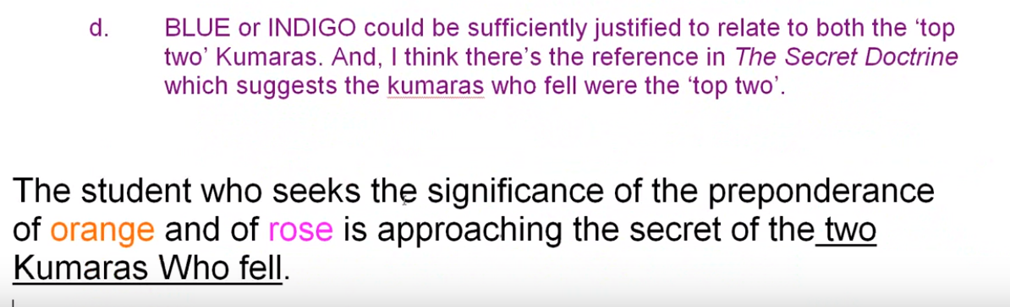

The students who seeks the significance of the preponderance of orange and of rose is approaching the secret of the two Kumaras who fell. TCF 824

The students who seeks the significance of the preponderance of orange and of rose is approaching the secret of the two Kumaras who fell. Well, I suppose fell for service purposes. The rose is connected with Gemini, isn't it? Isn’t that how it works? And here is where we would find it, these are the five kumaras:
[from Esoteric Astrology page 34]:

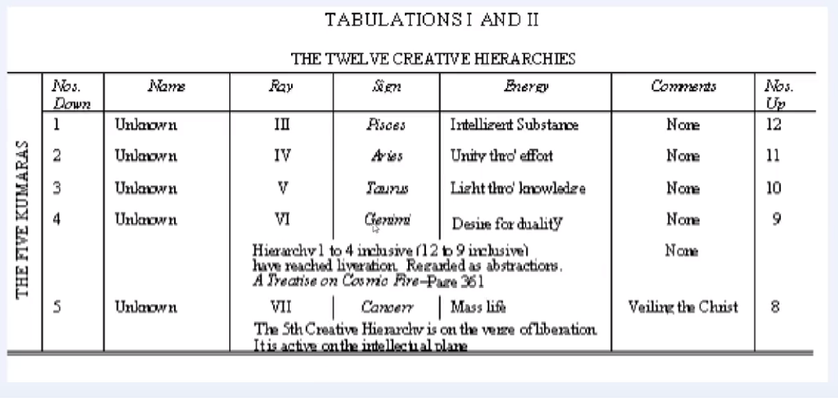
…

02:34:20 Okay, you study that … We'll have to have a class just on this alone.

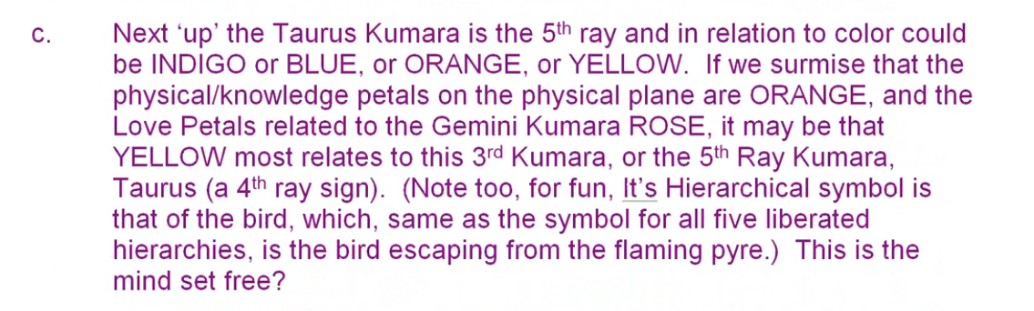

Next, the Taurus kumara is the fifth ray and in relation to color could be indigo or blue, or orange or yellow.
… Well it does give the fifth ray, so indigo could relate to the fifth ray, orange, even yellow could have very well more exoteric manner, I suppose.

If we surmise that the physical knowledge petals of the physical plane are orange, and the love petals related to the Gemini kumara, rose, it may be that yellow most relates to this third kumara or the fifth ray kumara. Taurus is a fourth ray sign. Note too, its hierarchical symbol is that of the bird which same as the symbol for all five liberated hierarchies is escaping from the flaming pyre, this could be a mind set free?

I think there are some good thoughts here.

Blue or Indigo could be sufficiently justified to relate to both the top two Kumaras as. I think there's a reference in The Secret Doctrine which suggests that the Kumara that fell were the top two.

The fall is for service and redemptive purposes; that certain Great Lives are sacrificing themselves through a fall, and that somehow the development of our mind and of our astral nature is connected to this fall. It is still a secret. I think we will all agree about speculation. As I say my friend in Finland spent years speculating about this, and I know Vicktorya has given this a lot of thought, and one day I will too.

02:37:30 Among the nine petals, the color orange appears nine times, and the color rose eight times, if we count it twice in the fifth petal. Let's check that for sure.

Rose appears … [correction] once in petal two, three, four, five, six, seven, eight – eight times if we counted twice in relation to petal five.

Orange is particularly the color of the solar angels, and rose is to be associated with the astral plane and the redemption of the lunar Lords is found. I'm just beginning to realize, with these two colors being so prominent, that which could be solar angels built in the fall of the two kumaras should be related to the sacrificial fall of the solar angels. Maybe that's obvious, but these falls are accomplished – I think the full solar angels are said to have fallen twice, once into the cosmic etheric level, and then further through self-extension into the dense physical vehicle of the solar logos, which consists of the twenty one lower subplanes.

Solar angels are not yet kumaras, right? Kumara are higher beings, but the falling Kumaras are related to the principle colors of the flower of consciousness which the Solar Angels build by self investments. There's definitely a connection here because kumaras can be planetary logoi, they can also be maybe lesser aspects of the planets, maybe chain lords are considered to be Kumaras too. Could be.

Solar Angels are on their way to becoming a planetary logoi and as they do that, will they pass through a lesser structures, will they become globe lords, will become chain lords, as we finally become planetary logoi? I mean groups of them of course there's a whole progression of Jacob's ladder which needs to be clarified not that we can necessarily clarify, but probably quite a few hints have been given.

02:41:00 We must trace this fall. Is it from the cosmic astral plane onto the cosmic physical plane, or is it from the higher levels of the cosmic physical plane to the lower levels? Both change the focus would constitute a fall, or is it a double fall? A question of a double fall also exists, it's really a double sacrifice.
A question arises. Do the esoteric kumaras express themselves only on the cosmic astral plane (as their lowest plane of expression) while Sanat Kumara and the three Buddhas of Activity express upon the cosmic physical plane? This could be a possibility, but then there's a rotation, and those that are Buddhas of Activity now can become esoteric kumaras. It goes into latency, and the ones that were latent go into activity.

Can we however equate any Kumara with a creative hierarchy of the kind represented in Esoteric Astrology page 35. Are not these creative hierarchies too low relatively to equate to the seven interplanetary Kumaras? Maybe. Maybe not. This needs special the investigation.

In the mystery of these subsidiary colours and of the gradual shining forth within the lotus of five colours in any one petal at one time, is veiled the mystery of the five Kumaras. ^{[cclxi]}62 The student who seeks the significance of the preponderance of orange and of rose is approaching the secret of the two Kumaras Who fell. More it is not possible to say, but the colours hold the esoteric key to this great occurrence. This inner circle of petals is organised and vitalised in the Hall of Wisdom, and simultaneously the middle circle unfolds, so that two rows of petals are duly opened, and only the third remains to be unclosed. This final opening is effected during the period of treading the stages of the Path of Initiation, and in this round it is hastened by the rites of initiation and by the strenuous and abnormal efforts of the man himself, aided by the electrical work of the Initiator, wielding the Rod of Power. TCF 824
More it is not possible to say, but the colors hold the esoteric key to this great occurrence.

A redemptive fall. Interestingly Kumaras Who fall do so for redemptive purposes. The Kumaras and the solar angels are directly related to Venus (which is, for the Earth, a planet of redemption). Given the fifth ray/sixth ray nature of Venus, the colors, and then a ultimate secondary one of the colors, orange and rose are particularly fitting in relation to Venus. …

02:46:00 … All right how are we doing? It is at this point that we should recall the Buddhas of Activity. The Buddhas of Love and Compassion, and the Buddhas of Sacrifice mentioned earlier in the text. Now we go on:

This inner circle of petals is organised and vitalised in the Hall of Wisdom, and simultaneously the middle circle unfolds, so that two rows of petals are duly opened, and only the third remains to be unclosed.

As always, it tells us when the inner circle of petals is organized and vitalized in the Hall of Wisdom, and simultaneously the middle circle unfolds. I think this fits quite well with what we have been saying, fits well with our hypothesis, but some degree of unfoldment can be expected before there is complete unfoldment of the fifth and sixth petals. … Can the middle circle unfold without the touch of the Rod of Initiation?

The inner circle of petals is organised and vitalized in the Hall of Wisdom. The Hall of wisdom of course begins with the first initiation, or perhaps a little before, and simultaneously the middle circle unfolds without the touch of the rod of Initiation or the strenuous and abnormal effort of the man enough to begin its unfoldment?

Now we have been told that unfoldment is the result of the application of the rod and also the strenuous and abnormal efforts of the man. We need to get as specific here as possible. Is organization and vitalization part of the strenuous and abnormal effort, or is it so strenuous and abnormal that some degree of unfoldment occurs, which is then further expanded through the application of the rod. It gets pretty intricate, but the most important is that we emerge from this with a few general principles.

The middle circle unfolds as the third tier of petals is being organized and vitalized just as the third tier petals unfold as the second tier was being organized and vitalized. But what I'm trying to say here is, complete unfoldment of the middle tier, of the fifth petal, requires that there be some unfoldment of the seventh; and complete unfoldment of the sixth petal requires that there be some unfoldment of the eighth. At least this is my present hypothesis which I've tried to reason through in various ways.

The hall of wisdom is the area of experience which may be considered as beginning with the probationary path, perhaps and continuing until mastership. In some references it seems that the hall of wisdom begins with the first initiation.

Graduation results when initiation is taken and the initiate passes into the Hall of Wisdom. IHS 65

Graduation results when initiation is taken and the initiate passes into the Hall of Wisdom. From other points of view, when work is being done in these petals we are at least at the ante chamber. Petals number seven, eight, we are in the ante-chamber of the hall of wisdom.

You see how different statements make it seem like unfolding occurs at different times. Maybe He's trying to prevent us from becoming too locked in to our concrete mind.

When thinking of the hall of wisdom and the processes which occurred during that stage, we must include not only the organization vitalisation of the petals, but also of their unfolding for the hall of wisdom continues certainly beyond the third initiation, at which time all three of the second petals are necessarily unfolded.

The halls of initiation are entered during passage through the hall of wisdom.

Again we have overlaps here, and if we're looking for the cut and dried solutions that the concrete mind just loves, we're not going to find them so easily.
Going back a little,

This inner circle of petals is organised and vitalised in the Hall of Wisdom, and simultaneously the middle circle unfolds, so that two rows of petals are duly opened, and only the third remains to be unclosed. This final opening is effected during the period of treading the stages of the Path of Initiation, and in this round it is hastened by the rites of initiation and by the strenuous and abnormal efforts of the man himself, aided by the electrical work of the Initiator, wielding the Rod of Power. TCF 824

This inner circle of petals is organized and vitalised in the Hall of Wisdom and simultaneously the middle circle unfolds, so that two rows of petals – and there's that word, He could have just said ‘open’, but he said ‘duly opened’, are duly opened, and only the third remains to be unclosed.

… There may be a time when the petals of the second tier are duly opened, but not completely opened and I want to remind everybody, in the sacrifice petals there is organization and vitalization going on, but … as the strenuous kind of abnormal effort of the man continues in the sacrifice petals there will be more unfoldment of the love tier and it will be very complete, or quite complete, as the unfoldment, in the sacrifice tier continuous through the strenuous and abnormal effort.

02:54:00 I've been working on that when trying to get that to be as clear as possible, and putting together many different references to get the completed picture. Sometimes one reference won't give it to you, but a combination of references will.
Two rows of petals, that is the petals of the first two tiers, have been opened by the time the candidate treads the passages of the hall of wisdom. Well, yes, and no. The opening of the first two tiers –as ‘interactive entireties’, however, corresponds with a degree of opening of the seventh and eighth petals, and thus, with the first two initiations.

This is one explanation. There is another phase of petal adjustment: complete opening and inter-tier adjustment corresponds to the second initiation. Yes, I still see no reason to think that with the first initiation demanding the complete opening of the fifth petal, that we have a reference on that, why the second initiation should not be that point entering the stream as it were. Having taken the two probationary initiations, threshold initiations, why the opening of the love tier. Should not be the moment when we really have the second initiation more discriminations coming our way?

We must discriminate between the following the opening of three petals, the unifying of three petals in a tier, the synthesizing of the three petals as a complete unity ready for interactivity with the next higher tier of petals. This must be remembered, there are all these different phases and we are somewhat handicapped by not being able to see these dynamically.

I have a friend who is very good with computer and he understands color and dynamics very well and it's long been his intention to somehow animate this. That would be a good, good thing to do. We still could not be assured of certainty.
If we think of the knowledge petals, the opening of three petals of the knowledge tier represents readiness to move out of the hall of ignorance, to take a small initiation under the supervision of the mahachohan. We're not talking about the mahachohan wielding the rod, but there's a connection between this small initiation, which gives some degree of selfish group consciousness and the mahachohan.

The unifying of the three petals and back here represents the taking of a lesser initiation … emphasizing some type of preliminary group awareness. When this happens the fourth and fifth petals have not been fully unfolded. Not at all. … The synthesizing of the three petals of knowledge tier and their readiness as a unit for interactivity with the unfolding petals of the light, may be found at the first initiation at which time the fourth and fifth petals are completely unfolded and the seventh petal is in process of unfolding, having been touched by the rod of initiation and prepared with some unfoldment due to the strenuous and abnormal efforts. I'm trying to synthesize this is best I can.
02:59:00 We have a kind of contradiction here, unless we allow that sometime during the hall of wisdom process, the sacrifice petals can begin to open. I've assumed that they can, which indeed does seem to be the case during the hall of wisdom process. Not just organization, but some degree of opening event, further opening due to the application of the rod.

We might say that during the whole of wisdom experience, process, the petals of the third tier are organized, vitalized, and later, in the hall of wisdom the petals of the third tier are unfolded as well. We might say that during the earlier hall of wisdom experience the petals of the third tier are organized and vitalized, and later in the hall of wisdom, the petals of the third tier are unfolded as well. What we have said before, look at the sacrifice petals: there is organization of them when there is unfolding going on in the fourth, fifth and sixth petals, there is strenuous and abnormal work of the man which can tributes to unfoldment. Then there is at a certain point of unfoldment the application of the rod which continues the unfoldment, but does not take it all the way. There's still more to do and it always looks to me like the final unfoldment of the whole tier happens all at once in differential degrees for each petal.

I've tried to state this many, many times in different places trying to find the exact point at which the hall of wisdom is entered is elusive, because the egoic lotus can move to the second subplane before the first initiation. Even on the path of probation perhaps that movement can begin to occur. It's probably not an overnight thing; even the third eye is opened very slowly between the first and third initiations. It’s probably a question of a heightening of vibration. Maybe not all at once, but progressively.

This final opening is effected during the period of treading the stages of the Path of Initiation, and in this round it is hastened by the rites of initiation and by the strenuous and abnormal efforts of the man himself, aided by the electrical work of the Initiator, wielding the Rod of Power. TCF 824

This final opening – presumably in this context the opening of the final tier of the theory of sacrifice petals—is affected during the period of treading the stages of the path of initiation.

This final opening. And if he means complete, does he mean complete? Because that we have pretty well said occurs at the third degree.

During the stages of treading the path of initiation, the first, the second, and third. Yes it would seem that one treads the path of initiation within the hall of wisdom, it seems necessary in fact.

and in this round is he sent and this is the quote by the rights of initiation about the strenuous and of normal efforts of the man himself, aided by the electrical work of the Initiator, wielding the Rod of Power. It’s an opening, which is hastened by the rite of initiation and by abnormal efforts.

03:03:00 In other words, and this is what I've been wanting to say: Both strenuous and abnormal efforts and the rod of initiation contribute to the opening, and not just the organization and vitalization of the petals. I think we have to have these somehow before us in internal animation to see exactly how they work. But this is precisely the quote that I've been looking for; I always seem to find that eventually. … This is the one on page 824,

This inner circle of petals is organised and vitalised in the Hall of Wisdom, and simultaneously the middle circle unfolds, so that two rows of petals are duly opened, and only the third remains to be unclosed. This final opening is effected during the period of treading the stages of the Path of Initiation, and in this round it is hastened by the rites of initiation and by the strenuous and abnormal efforts of the man himself, aided by the electrical work of the Initiator, wielding the Rod of Power. TCF 824

This inner circle of petals is organized and vitalized in the hall of wisdom, but more goes on of the hall of wisdom and simultaneously the middle circle unfolds so that two rows of petals are duly opened and only the third remains to be unclosed. This final opening is effected during the period of treading the stages of the Path of Initiation, and in this round it is hastened by the rites of initiation and by the strenuous and abnormal efforts of the man himself …

Two things are responsible for the opening, and as I have wondered before, at what point does the opening of the, even one of the petals of the sacrificed tier, become visible? In other words, presumably the rod of initiation touches petal seven as the fifth petal is coming to completion and when the rod touches it, it will cause unfoldment and can this unfoldment remain invisible? Because the sixth petal is not yet completely unfolded, and thus the sacrifice petals should, according to some statements, not be seen? It doesn’t make sense. I must say an unfolding should be seen.
This is the reason for some of the contradiction here. If we examine only one reference we might not get the completed picture, as much of a picture as we can get without seeing it exactly for ourselves.

We’re continuing on page 824:
The final opening is hastened by the abnormal efforts of the man himself and by the wielding of the Rod of Power. TCF 824

The final opening is hastened by the abnormal efforts of the man himself and by the wielding of the Rod of Power, and it would not make sense to me that the Rod of Power could be wielded without unfolding occurring in petal seven, as petal five is completely unfolded. It just seems that unfolding must be occurring in petal seven when the rod of initiation touches, or is applied, and can that unfolding be invisible? I would think not, unless of course unless when the rod of initiation is applied there is no unfolding, just a hastening in getting ready for the unfolding. This does not seem logical, as in petal nine the rod really produces a final unfolding.

I know it seems like a lot of minutia here, but if we can get these points straight and maybe someone will come along some day with a more organizing mind than mine and help with this, then we can prepare to see these things for ourselves.

This is a very important statement, one almost worth memorizing. We can say the final openings is affected during the period of treading the stages of the Path of Initiation, and in this round he is hastened by the rites of initiation and by the strenuous and abnormal efforts of the man himself aided by the electrical work of Initiator, wielding the Rod of Power.
A very important statement, telling us that an opening, which might occur slowly and normally under the influence of the Solar Angels and the second logos, although it seems that the Solar Angels have taken over, is hastened by the rites of initiation and the application of the rod of initiation. The man, too, because he is working strenuously and with abnormal effort, hastens the otherwise slower opening of the petals. Though, we must remember that the man, per se and unaided does not open the petals, and especially the sacrifice petals, but what he does contributes to the opening. The opening occurs either automatically under the influence of the Solar Angels and second logos following the man's effort to organize and vitalize, or under the influence of the applied Rod.

I think there is a direct correlation, and this is my presumption here, I think there is a direct correlation between opening in the sacrifice petals and the strenuous and abnormal efforts of the man that due to these efforts some opening takes place and the initiate is initiate before he is initiated. It's a very tricky thing, and I've been trying to emphasize this as we go along. Maybe what has to be done, I'll find one of my colleagues with a really good organizing mind and they can lay this whole thing out using the fifth and seventh rays, which will make it as clear as possible.

We note that this method of seeing to the opening of the final tier of the nine applies particularly during the fourth round and perhaps it did not or will not apply at other times.

The fourth ray is a bridging ray and the Solar Angels are bridging entities –in this round, hastened by the rite of initiation, because the rites of initiation will not always be given.
03:12:30 And below. Well we've been using it all the time, the new version of the chart of the egoic lotus that has been redesigned. Of course, DK is the designer, whatever may be said to the contrary. He told us what to do, we just fill in the colors. But it has been redesigned by Tuija Robbins, my wife, and careful attention has been paid to the quality of the colors presented and the numerical order of the nine petals especially the sacrifice petals. The white appearance of the synthesis petals will soon be changed to that beautiful lemon-yellow hue which DK emphasizes.

Well, friends we seem to be complete with our study of our preliminary study of the colors. This is, egoic lotus webinar 32, and it is 3 hours and 15 minutes and A Treatise on Cosmic Fire pages 822 to 824.

Next, we begin with our synthesis work, maybe tomorrow. Tomorrow at some point the moon will go into Aries. Right now it's in Pisces, a good sign of course, but you don't want to mess with beginning a really new section on a late Pisces moon. I might have to delay this. [laughing]

But I think you get the picture of this constant overlapping and differential emphasis and the uniqueness of everybody's configuration within an overall generic sequence. What we're trying to describe some inner, rapidly moving, simulating process with these clumsy words. But we are trying to get the idea of page 869, the most important work that a man does is organization and that presumably with what he can vitalization, then comes in the second logos, then comes the Solar Angels, then comes a rod of initiation. In addition to organization there is the strenuous and abnormal efforts of the man which must contribute to vitalization from his part, and not only from the efforts of the second logos the Solar Angels and the One Initiator.

Well, friends, that’s it, the hour is late. It's been quite a day and I think we'll just call it at that, and please forgive me for some of the intricacies that it becomes necessary to go through. There are problems to be solved here, and if I had all the solutions at the beginning I'd be very happy about that, but it's more a work in progress and solutions come to me as I try to explain my present point of view, which then changes as the solution comes.
That will be it for the moment and then we'll tomorrow begin a synthesis work. This will be the beginning of egoic lotus webinar commentaries program 33, and it will be in tables of synthesis, referring to many references, but not yet the clearly laid out tables. That will be dessert, later on.

Okay, we'll see you, 3 hours and 17 minutes that's what we have, and see you later, bye bye and good night.

