EGOIC LOTUS WEBINARS, VIDEO COMMENTARY – 31, Michael Robbins
Abstract
Egoic Lotus Webinar Commentaries 31. This webinar is 1 hour, 1 minute long and covers A Treatise on Cosmic Fire page 822. Program 31 discusses the meaning of the colors found in the petals of the first or knowledge tier of petals. The meaning of each color is referred to the type of experience through which the individual ‘working’ in the three knowledge petals must pass. As we progress through the petals, we will see that, though the same colors are repeated, their meaning is slightly different in each successive tier of petals.
Egoic Lotus Webinar Commentaries 31 199 MB .wmv file
Video of Egoic Lotus Webinar Commentaries 31 by Michael D. Robbins.
Egoic Lotus Webinar Commentaries 31 58 MB .mp3 file
Audio of Egoic Lotus Webinar Commentaries 31 by Michael D. Robbins.

Okay Friends, Hi.

We are continuing with our egoic lotus webinar book. We are on the program number 31. We had we have been working with the introduction to a second look at the petals here in A Treatise On Cosmic Fire and we are on page 822.

Now the colors of the petals are going to be at least mentioned. I don't think they're very much discussed. Another statement made about what is to be achieved in these various petals that can be later compared with what is stated around page 539 of the same book. We will simply forge ahead with this and when we bring it all together try to make sense of the many strands.

We remember that the Agnishvattas of particular kinds were each responsible for a particular tier, and when more subdivided for particular petal, and the great lords called The Buddhas of Activity (we're familiar with that one), Buddhas of Love and Compassion, and Buddhas of Sacrifice were streaming their energy through these Agnishvattas who were substanding the petals, forming them, holding them in configuration and essentially being in a sense the essence of the egoic lotus.

Yes, it strikes me there are different kinds of Solar Angels or Agnishvattas involved with the egoic lotus. They are a hierarchy, it has to be understood. They are differentially involved. Some of them have management over one petal, some maybe over an entire tier, some over the entire egoic lotus. This has to be reconciled with the idea that the solar angel per se projects an aspect of itself into the egoic lotus, substands the egoic lotus. It has a life apart from the egoic lotus and also a life within. Having pervaded the entire universe with the – egoic lotus – with a fragment of myself, I remain.

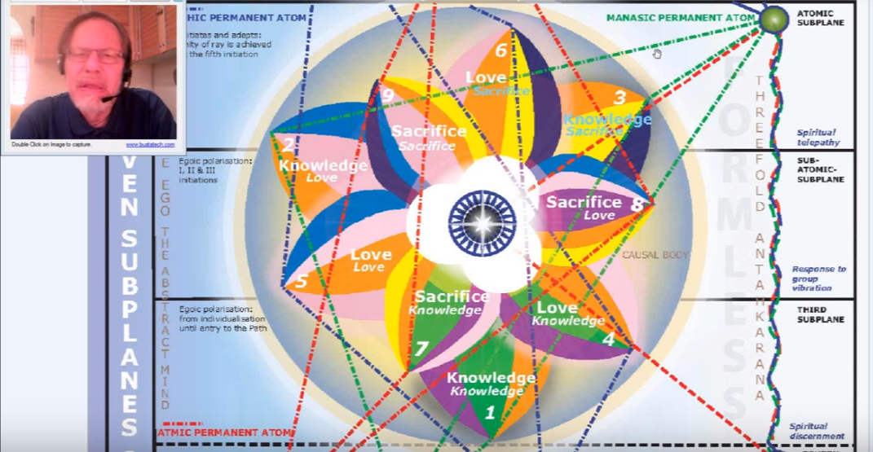

0:02:45 Okay, so now we are ready to I think to continue, let us see where we are. Right, beginning with the egoic lotus program 31 and A Treatise on Cosmic Fire, page 822. We will work with these progressively.

We have what's called here:

1. The outer knowledge triad: TCF 822

The outer knowledge triad: It is in the color orange and orange is the one color which consistently is found in every color of the egoic lotus. Orange is, in a way, representative of the sun. When Blavatsky gives us the notes of the scale D, that is connected with the sun, she gives us the color orange. Also it's connected with the fifth ray of Venus.

We remember that this type of knowledge has been called “active wisdom”. That was active wisdom, active love, and active will. These were the kinds of Agnishvattic lords that were substanding the egoic lotus. Active wisdom, and operates progressively in relation to the three lower worlds. Of course, once the knowledge of the lower worlds is translated into the soul, it does become wisdom, because the wisdom is of the second aspect. So that which is stored in the egoic lotus is at least on its way to wisdom. We might say. It operates progressively in relation to the three lower worlds, but not in relation to the subjective self. Is it possible to have wisdom in the three lower worlds? Well, wisdom in the ways of the world anyway.

There is a reason why we're not hearing the word active knowledge. We're hearing active wisdom. I suppose it has something to do with the nature of the Agnishvattas themselves who certainly by their stage of evolution are Lords of Wisdom. The relationship with the higher of the pairs of opposites and not just the personal pair would begin with processes going on in the love petals.

a. Petal 1 … Knowledge on the physical plane. TCF 822

a. Petal 1 … Knowledge on the physical plane. It is called simply knowledge on the physical plane. The petal expresses itself particularly in relation to the outer five senses and this is also the material which the concrete mind uses to form its thoughts. There is much thinking that goes on in this outer knowledge tier, but the substance, the data that is processed, is largely from the sensory world, especially in this first petal where mind is the most dim. Of course, it lasts for so many millions of years there has to be some mind by the end of its unfoldment, and the man is working ahead. … Experiences to relate to the other petals …

I try to introduce an idea that I call the “three petal process”, meaning that there is work being done across three petals. Man emerges from a state of total I Am Consciousness of himself as a distinct unit. This can last some three million years according to the Tibetan, when he compares the shooting forth of the arrows of the Son of Mind at 21 million years ago, and the awakening of the man to himself at 18 million years ago, and the man begins at great cost to acquire knowledge on the physical plane.

0:07:20 The colors are orange, green and violet, and the presence of these colors in this lowest of all the petals suggests the following: orange signifying the early development of the concrete mind within the egoic lotus. Orange is the constant color, constituent in every one of the nine petals. When we talk about mind, we have to think of Venus because the implantation of the spark of mind was an event which occurred under the Venusian stimulation when we think of those groups which had only the mental unit fanned into a sufficient blaze to cause individualisation, but did not experience the implantation of a spark of mind, we can also think of Venus as well. Venus is a Son of Mind. Venus is intellect. Venus is mind, but mind and love, later.

Green suggests the third ray and the activity of active intelligence within natural surroundings. Early man is active and he's rapidly learning about relationships within his outer environment and this facilitated through his activity. So green always initially suggests closeness to nature and the third aspect of divinity.

Then we have violet, the color of the seventh ray, suggests the rhythms of the dense physical plane to which early man is subject. The repetitive rhythms of early traditional society and I would say first the instinctual rhythms, and then the repetitive rhythms of really traditional society. We have to remember that by the time later Lemuria was reached there was civilization and the solar angeles looked in at that civilization and decided that their intervention had been successful. Of course they didn't really have to look in upon those units in whom they had not implanted themselves, because that was not their experiment. They simply intensified the natural method of individualization.

I would like to say that, whether the method by which we were individualized was the natural method of the upward striving of the animal man and the reciprocal response of spirit, or whether it was through implantation (we have to be careful about that word because it seems to means so much to paranoid people today), but implantation of a spark of mind, is still possible for a solar angel to associate itself with an individual who was individualized in any manner. So because the earlier method of individualization early progress was not necessarily under solar angelic supervision does not mean that the solar angel cannot interpose itself or ally itself, affiliate itself, immerse itself in man and then be a guiding force.

The ray line here is 3, 5, 3, 1, 3, 5, 7, it is entirely the hard line. There is no color for the first ray even though this is the first petal and maybe that's because we are in the second solar system. Maybe in the next solar system, if causal bodies look something like their present appearance, the color red will be prominently featured. But there is red in the life of the early man. DK gives us the history of man in color, and the savage red of rampant desire is definitely there. The earliest phase is red, followed by orange, followed by green, followed by a rose and blue, and so forth.

So red is part of the life and later when there is consummation of the egoic lotus according to the man's ray. By the time the consummation the monadic ray is influential and so is its subray, the ray of the egoic body, so if there is a first ray either one of those apparently, there will be a display of some red in the egoic lotus.

Throughout the color scheme of the egoic lotus we cannot find the red at this time. Can it be that the color blue is meant to take its place. There is a tabulation, I have to find because I've been talking about it so much it’s in Letters on Occult Meditation where blue represents the first ray and red the sixth—an apparent inversion but perhaps not without reason.

0:13:30 … I’m tempted to go to Letters on Occult Meditation and see … … … Yes or some amazing things here. I don't think I'm going to be successful for some reason and I don't know why I don't know why but I can assure you that it is the case and that. I can go page by page through Letters On Occult Meditation … we have so much and see the Letters On Occult Meditation … … just take my word for it, it’s a reference unconfirmed, but it is there, and I have used it so many times. Well, it’s often good not to give up because here it is …

0:17:00

When the logos uttered the great cosmic Word for this Solar System, three major streams of color issued forth, breaking almost simultaneously into another four, so giving us the seven streams of colour by which manifestation became possible are: --
1. Blue
2. Indigo
3. Green
4. Yellow
5. Orange
6. Red
7. Violet

Not unwittingly have I placed them in this order but the exact significance is left for you to discover. LOM 205-206

When the logos uttered the great cosmic Word for this Solar System, three major streams of color issued forth, breaking almost simultaneously into another four, so giving us the seven streams of colour by which manifestation became possible:

So notice that we have blue, green, and indigo. Blue in the position of the first ray, yellow four, orange five, red six, and violet seven. Not unwittingly have I placed them in this order but the exact significance is left for you to discover. Now that's a good teacher, right? Leaving something for us.

Perhaps in this second ray solar system when blue appears it does not have only the meaning of the sixth ray or the second ray. Maybe. The sixth ray related to Mars of course will give us the red, and that is a definite link. But when related to when the first ray it is related to blue, sometimes electric blue is considered to be a first ray color, but we have to figure this out. I'm pretty sure it's because of the kind of solar system that we do have. This is related to the solar system and not to our particular planet.

So, anyway, we found that! [Laughter] Okay, reference confirmed: R.C. You know the old story, when you've lost that reference, it’s RI, reference invented or reference imagined; RL, reference lost. RC, Reference confirmed. There are some others of a humorous nature. But you know how it is when references evade you, and we do not have the capacity the Master has to see these things so we have to trust Him.

Violet, however, is related to the first ray. I'm going back to the first petal. The seventh ray is the concrete expression of the first ray. So that will give us some link, because it's a blend of the red and both can be used for the first ray. Violet is a blend of red and blue, at least in pigment, and both red and blue can be used to indicate the first ray.

Of course especially red. I think this is meant to give us some sort of sense of why the one who designed these egoic lotuses why it is that the colors are apportioned in the way they are. It has to have some basis for the kinds of experiences which will be passed through. When working in the particular phase of evolutionary life that pertains to that petal.

0:21:00 Okay, now we go on.
b. Petal 2. Love on the physical plane.

Petal two. We are using the sort of the sixth ray color rose here, love on the physical plane this petal represents the gradual unfoldment of the astral body. I think one of the places we should be, yes, here it is, let's go to 822 and all right the outer triad petal.

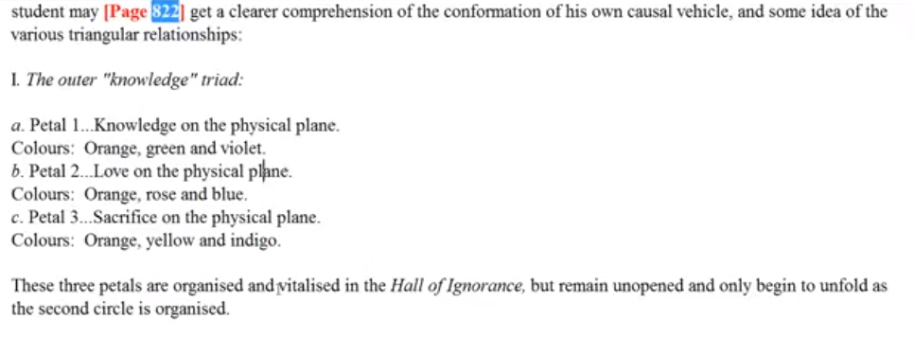

We're not going to talk so much about … there may not be very elaborate statements, but let's just say knowledge on the physical plane and then we're just going to talk about love on the physical plane. It's as simple as that. … Love on the physical plane relates to desire—it is love in form, but as we have been told it is beyond instinct per se, beyond strictly sex instinct.

The petal represents the gradual unfoldment of the astral body. We called it the Atlantean petal, and the previous petal the Lemurian.

The love here found expresses itself as desire and emotion, but not as love … detached from form—because we are in the petals of knowledge for the physical plane and … of what do the contents of consciousness consist? The representation of physical objects then it is a very physicalized consciousness. You can look at your own contents of consciousness and it's certainly not consisting in the majority of strictly physical objects; you have all kinds of astral, mental, and higher impressions within the contents of consciousness, but that would not be so for the early type of individual.

0:22:30 So it is not as soul love, but it does contribute (we have been told) to an elevation of those contribute to a growing degree of interpersonal harmony –not impersonal; we're very far from that. When you look at another human being at this stage what you see is what you get. The human being is a physical form. And even if the astral world is involved, it's the astral world reflecting the physical form. For many the astral world is a very physicalized place. One can think of the heaven that is imagined, the paradise is imagined by people who are longing to be on the astral plane. It's a very physicalized kind of environment, with a real reflection of what we find here on the physical plane. Of course an augmentation and an idealization of what we find on the physical plane, but still the forms are physicalized. We are not dealing with abstract currents of feeling at all.

The colors are orange, that's consistent, rose and blue. So the presence of these colors suggest the following. The continuing growth of the concrete mind of orange, even though the physical nature and emotional nature are still overwhelmingly the more powerful. Mind is still definitely applied to very concrete experiences. Even the Aboriginals Australia, it can be inferred, have something of a second petal in process of development or they could not produce the art as they do. Remember we're told in Education and the New Age, the page where we find the discussion of genius: that when two petals are open that the art, or something creative which expresses the higher self or soul, can begin to come through.

This is such a specialized area of study. Not only the general dynamics and sort of physiology of the egoic lotus but the kind of outer forms, cultures and civilizations, to which lotuses of different kinds attach themselves, or which lotuses of different kinds represent. It would be fascinating to take different groups on the planet, different cultures, different racial groups, cultural groups, ethnic groups, and see if there were different aspects in common in the egoic lotus. This would really be the study of internal man. The day will come of course when it's going to be possible. So many things are possible the question is what is needed?

Some amazing art work is done by the Aboriginals of Australia. Remember of course that high souls can go into groups which are apparently less advanced, to teach and to help and for their own, due to their own karmic relations.

0:27:10 Rose suggests that within the astral body a form of love is expressing itself. The persistent self-love. Very Leonean in a way, primitive Leonian characterizing petal one, gives way to increasing love of others we're told. As a matter of fact maybe the best way to be able to switch back and forth would be to A Treatise on White Magic and start at 539, and the gradual growth of love from love of self to love of others.

We want to continue to relate what was said before to what is being said now. That is how the light grows. If we leave everything that is said in isolation, in its own section, we don't get the arcing of the light, that aha that comes when different points are related, and then we will not have our lighted sphere of knowledge if we don't relate. This of course is the work of Mercury.

Rose indicates a more delicate vibration within the astral body. In the beginning it's really red. Leadbeater has given us some drawings of people in an angry state, or even a fairly primitive state, and the astral body is filled with red of the Mars and sixth ray. The astral body of one who is entirely savage we are told it is shot through with red.

Blue, in this instance, we may imagine that blue is the color of the sixth ray, although the shade of blue is not specified. We’re told that as the blue ray fades out the blue flowers will also fade out and the violet colors of the seventh ray will come in, so no question that blue is related to the sixth ray, although not exclusively. It can represent an elevation of astral sensitivity and a raising of the quality of desire, for perhaps more towards the second red. Blue may be considered a color of aspiration, though this blue is still deeply embedded in the form life blue would be then important emotionally in the Atlantean civilization.

So we find that many of the same colors are found in both higher and lower petals and that their appearance and quality is more refined in the higher than even the lower petals even though the color was the same and also D.K. hinted that the intensity of the color varies from tier to tier. For instance, whatever yellow there would be in the first tier or second tier would be less even less intense than the yellow found in the third tier

There just going to be an amazing study of color dynamics for true students of the processes of the egoic lotus. It is going to be an amazing sort of fifth ray, fourth ray study, and second ray of course because it is the second aspect, and we will have data at our disposal which is just so much more than what we have now. We will really begin to understand what makes the human being as it is.

0:32:00 [referring to video commentary] Here the yellow is brought out for petal three, I guess it’s used deliberately, this is being prepared by my friend who is very color conscious … I'm just trying to keep these colors consistent; I'm a bit of a color-conscious person myself, at least I was when I was a young person how to mix the colors was always my big question, but I stopped because the colors tended to run together and I didn't like that. Maybe I should have used color pencils or some other kind of medium where the running of colors together was not so problematic.

So the next one is:

3. The Petal of Sacrifice for the physical plane.

The Petal of Sacrifice for the physical plane. Let’s just take a look at it:

It's the third, and the orange is there, and also the yellow, but not very intense. It is a sacrificial petal, wherever you find yellow the factor of sacrifice will be involved. Then the synthetic indigo. Since every one of the third petals is a petal of synthesis, the three the six and nine, and they all are the only ones that carry this indigo.

The human being is forced to pass through sacrifices. DK doesn't say much about sacrifice on the physical plane here. He says,

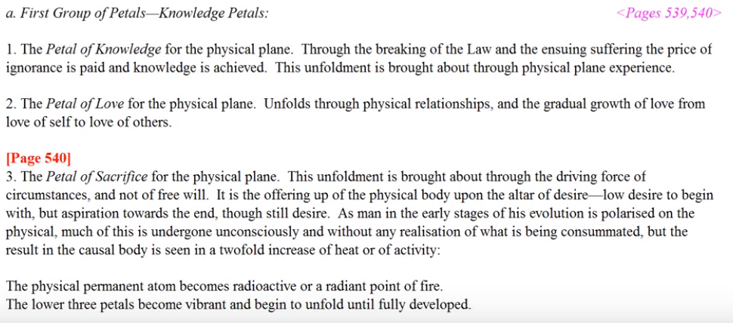

3. The Petal of Sacrifice for the physical plane. This unfoldment is brought about through the driving force of circumstances, and not of free will. it is the offering up of the physical body upon the altar of desire—low desire to begin with, but aspiration towards the end, though still desire. As man in the early stages of his evolution is polarized on the physical, much of this is undergone unconsciously and without any realisation of what is being consummated, but the result in the causal body is seen in a twofold increase of heat or activity. TCF 540

The Petal of Sacrifice for the physical plane. A lot more the unfolding is brought about through the driving force of circumstances, and not of free will. Nobody sacrificing voluntarily here; one just has to or is made to – it is the offering up of the physical body which these petals correlate with upon the altar of desire low desire to begin with; maybe in the earlier part of these petal processes. But because one works ahead one is working in several different areas of experience simultaneously. –low desire to begin with, but aspiration towards the end, though still desires. The physical body suffers, because of the intensity of that desire.

I have experience with that: I used to love to sing and I so much wanted to sing that I would beat my voice up. The desire to sing, the aspiration to sing, was so great that I failed to have respect for the limitations of the physical nature until one day I really got laryngitis and I understood the punishment to which I was subjecting my vocal apparatus. But the desire was so great. Probably the carryover of some kind of operatic past, and in the early days of recapitulation being born with a voice that was strong but it wouldn't take that kind of punishment. There was a sacrifice of the vocal apparatus and one learns that karma works out so much in the physical apparatus.

-- So low desire to begin with, but aspiration towards the end, though still desire. As man in the early stages of his evolution is polarized on the physical, much of this is undergone unconsciously. He doesn't really see with the inner understand any deeper reasons for what is happening. I can't say that entirely, as there are people who understand that the sacrifice simply must be made, because if it isn't the country will go down, the family will go down, there's so many things you just have to do or something that you prize will go down. So, man polarized in the physical has much of this going on. As man in the early stages of his evolution is polarized on the physical, much of this is undergone unconsciously and without any realization of what is being consummated, but the result in the causal body is seen in a twofold increase of heat or activity.

I'm just remembering some of these stories about the Russian war and how the soldiers were just made to fight, they had no choice. If they ran back their own men would kill them, and if they went forward they didn't have enough weapons. One gun shared between two, the idea was when your partner is killed take the gun, or if you're killed the partner just has the gun. We can be put into situations that are really between a rock and a hard place and there's no way out. I guess we call this servitude. So the forced participation in war, or the necessity of making a living under difficult circumstances, are two examples.

0:37:30 The orange the yellow and the Indigo. How can we interpret this? Well the details concerning these petals is dealt with in the commentary for the semester five, section nine. Well when I used to do this in terms of writing out the Cosmic Fire commentaries, and … this is it; this is our comprehensive book on the subject. I guess I've been liberated from the pen. I don't know whether that's good or bad, but it certainly makes for a freer type of association and the ability to bring forward thoughts that otherwise simply would be lost because of their multitude.

So, orange is becoming really more intense here. Just because a color appears in a particular petal does not mean it appears in the same intensity. This is a knowledge petal and the fifth ray is orange, Venus. So more intense as the concrete mind takes on a definite focus in petal three. Just imagine you see the same color but at different degrees of radiance and intensity. That's something that can't really be put down in such a diagram as this, the color looks all the same, but in the living light the intensity of the color would vary.

It must be an amazing sight as D.K. tells us. The human being is becoming definitely intelligent. Intelligent, primary lotuses have the third petal unfolding, though the second is dormant and even shut. Also the first petal is unfolding because perhaps they're not quite as used to earthy physical plane living as are those who are individualized right here on Earth, because they are individualized on earth, they didn't come in until the fifth root race, they didn't come in Atlantean times, and I don't think they were here in Lemurian times.

0:40:00 The yellow emphasizes the growing mentality, but also the sacrifice which the human being is called upon to make, though it is largely an unconscious sacrifice. Yellow linked to red (first aspect) produces the orange (by means of which individualization occurs.

… I'm really working in the realm of light, per se, I'm probably thinking in terms of pigment. If you really want to talk about color then talk to my colleague Vicktorya Stone who helped with the preparation of these things and has her own website on color and it's esoteric meanings. (vicktorya7@gmail.com http://vicktorya.com)

The first ray is forcing the sacrifice. It is in a sense a ray one petal, whereas the knowledge petals, ray three, and love petals ray two. But yellow if the color somehow related to sacrifice. An old friend of mine used to play on the word and say, “Yell oh! Yell out!” Suffering. Yellow.

It can be associated with other less desirable features like cowardice, such as running away. Maybe some Mercurian people, since yellow is such a Mercurian color, do retreat and do not stand their ground.

Indigo is the color of synthesis and is found in the third petal of every series of three, as I pointed out. It may be thought to gather within itself all the qualities generated during the millions of years of evolution required to organize, vitalize, and unfold the first tier of petals. The synthetic color indigo gathers all quality found in the tier. Indigo also suggest the esoteric color of the fifth ray, which is accentuated in this third and concrete-minded petals. Somehow the knowledge on the physical plane in relation to physical plane is synthesized in this indigo, which has the relation to the fifth ray. I was surprised when I saw that, but I really think I do understand. Venus has not only the connection with orange and with rose, but with the indigo and when the Tibetan gave colors for the different signs of the zodiac, He gave Libra which Venus rules Indigo. [VS note: is this DK or MW ref?] It’s a very important color in our solar system and somehow the ability to see and use all that has been developed in the first tier is captured in that indigo.

There is the quite luminous intelligence of the yellow. It is Mercury. In this third petal there is the orange of Venus, but the yellow of Mercury. DK often refers to the Mercury-Venus mind, it is a mental petal and both of those. Planets can be used in relation to the concrete mind, but it is nothing other than concrete minds in this third petal.

But a larger purpose is at work and indigo in indicates the larger purpose. It seems to be appearing with yellow. … so the larger purpose is at work here, represented by indigo. And the purpose and suffering of yellow is purposeful; when you put the two things together, purposeful suffering – even if it is not one is not conscious of it purposeful suffering. Building towards the synthesis that man must become.

0:45:00 We're giving here a fairly light treatment. We had a much heavier treatment in the other work in Cosmic Fire and then we'll bring this all together because here the colors are pretty much on their own. There are a few things said here that are not related to color and they are very important.

Although the various colors in each petal function simultaneously, the sequence in which they are presented may be considered significant. It is we may presume largely a developmental sequence.

We are given here orange, always first, yellow, and then indigo. That's a proper sequence because indigo is the final and synthetic color. When we go higher to the love petals it is rose and then blue. Suggesting a link here in blue between the second and sixth ray; rose being more appropriate for the sixth ray precisely. When DK assigned meditations for the astral body he tended to use the color rose.

Here, green, the third ray of nature. Of course the outer plane and the dense physical body is ruled by the third ray, but what I want to say is violet connects to the seventh ray and the etheric body, which later in the process of this petal becomes an object of attention and a field of initiation. …

Before we get into the second circle and maybe if all goes well I can stop this program before the second circle begins.

It is said then that:

These three petals are organised and vitalised in the hall of ignorance, but remain unopened and only begin to unfold as the second circle is organised. TCF 540

These three petals are organised and vitalised in the hall of ignorance, but remain unopened and only begin to unfold as the second circle is organised.

This is an important statement, but it is problematic. You wonder, is the Lemurian really organizing the second tier petals when that first petal opens? I suppose there's differential organization; organization sequentially of the second tier petals. These kind of statements give the image of the developmental process of the petals. We must remember that the work of man is largely to organize the petals; that's the work of man, largely. Agencies other than the human provide for the unfolding of the petals, at least at a certain point – at least once the rod of initiation is applied later on in the process, but also human labor …

0:49:30 I always think of three petals involved and maybe, can it be that the person who has an organized first petal, he is now working in the fourth petal, which is the first of the second circle, when there is the unfoldment of the first petal. That does seem rather far ahead to be working given what the meaning of the fourth petal is. We have to understand what is really done, the kind of labor required to develop the ability to express the kinds of skills that are associated with the petal is what it means to organize. It is a conscious effort.

Sometimes DK gives a kind of sweeping comment, and later He becomes more specific about it. Such as when He says, after you get off the fixed cross you work on the cardinal cross; you get off the fixed cross at the third initiation. Then you could assume that you begin working on the cardinal cross after that. At some point He seems even to say that. But then He becomes more specific and talks about how the fourth initiation is not taken on any cross and only at the fifth do you really mount the Cardinal Cross.

… remain unopened and only begin to unfold as the second circle is organized. But let us say, certainly not completely organized. Work in the first part of the second circle. … [problems with hardware]

Here is a little bit more, this being said,

The act of organizing and preparing for unfoldment is the most important stage, and that with which the man is the most concerned. The active petal opening is of briefer duration and is produced by the pouring in of solar heat or fire thus bringing a fresh access of energy. TCF 869

The act of organizing and preparing for unfoldment is the most important stage, and that with which the man is the most concerned. The active petal opening is of briefer duration and is produced by the pouring in of solar heat or fire thus bringing a fresh access of energy. And we would say either from the second logos … or from the solar angel. … [problems with hardware] …

From the solar angle,

The Ego takes no active interest in the development until the second petal in the second series is beginning to open. Before that time, the work proceeds under the law of its being and through the inherent life of the second Logos which is the life of the petals of the lotus. TCF 543-544

The Ego takes no active interest in the development until the second petal in the second series is beginning to open.
This we've discussed. Before that time to work proceeds under the law of its being through the inherent life of the Second Logos which is the life of the petals of the Logos, and thus the life of the informing Agnishvattas.

0:53:30

The final opening is affected during the period of treading of the stages of the Path of Initiation, and in this round it is hastened by the rights of initiation and by the strenuous and abnormal efforts of the man himself, aided by the electrical work of the Initiator, wielding the Rod of Power. TCF 824

The final opening is affected during the period of treading of the stages of the Path of Initiation, and in this round it is hastened by the rights of initiation and by the strenuous and abnormal efforts of the man himself, aided by the electrical work of the Initiator, wielding the Rod of Power.

We gather that the petals representing the Hall of Ignorance only unfold when a man is working in the Hall of Learning, but we must be cautious about that. Because that would be in a way a kind of four-petal process, instead of a three. It is possible. But if what the man does, I think this is such an important statement from 869,

… and that with which the man is the most concerned. The active petal opening is of briefer duration and is produced by the pouring in of solar heat or fire thus bringing a fresh access of energy. TCF 869

… and that with which the man is the most concerned, organizing and preparing for unfoldment, is the most important stage and that with which the man is most concerned. In terms of our intensive labor, that's where we are working. Is there any work once the unfoldment continuous or begins? I suppose there is because not all aspects of the petal are unfolded.

We can be working ahead in areas of the petals, so to speak, which require our attention, while some unfoldment is occurring in areas which we have covered: organization proceeds vitalization. Or is it the other way around? Well we have decided that organization precedes vitalization. …

The sequence of words seems ever to be the same: organized proceeding vitalized. Perhaps in this natural building process it does not serve nature to revitalize that which has not been properly organized. I think that's correct. You have to be active organization itself requires at least a requisite degree of vitalization but vitalization is preparation for unfoldment.

The opening of the petals suggests that the qualities represented are quite strongly expressing because they have been well prepared, and when the stages of organization and vitalization are active the qualities and pertinent abilities are being built and are not yet fully formed and expressed. We can say that opening is about expressivity, is about strength. … [problems with hardware]

0:56:40 We have examined the first tier from the color angle and seen the perpetual presence of mind being orange, but that mind will not glow with the same intensity in the earliest petals as in later petals, because the fifth ray will continue to increase. We have seen that the sequence of the colors presented means something and it is moving in this direction at this time.

Rose is an intermediary color leading to blue, which is kind of a link between the second, sixth and second rays. It is that. Always we begin with the orange, and yellow, the suffering, is justified by the purpose, which is related to the indigo.

In terms of direction, in the way Tuija drew this, we have always the beginning point placed so that the direction of the turning of the tier is kept clear. Orange is always first, and the tier is turning clockwise. Rose is always first …five, four five and six, rose is first and it is turning clockwise.

But we have not worked out this interesting thing about the way the petals are drawn and yellow is properly placed on the left hand side because the turn seems to be in the counter-clockwise direction of the natural Zodiac. Yellow, yellow and yellow, there’s always going to be one color which shows itself at least three times, and those colors are orange, rose, and yellow. And in this diagram I think they are properly placed. We still haven't decided but why is the sacrifice here drawn in such a way that it looks like it must have a counter-clockwise complement to it, of course by the time or working we have really reversed the wheel. The first great reversal and the zodiac is proceeding for us in the normal counter-clockwise direction

Okay, friends because of my jumping cursor I'm sorry to say I had to shut the whole thing down, but let's just say that this will be the end of egoic lotus webinar commentary program 31 … and it's A Treatise on Cosmic Fire, page 822, and … then we have the beginning of egoic lotus webinar commentary program 32, at TCF 822.

The duration of this program is one neat hour and no more! So you understand why I've done that. We will see you shortly as I try to heal this computer of jumpitus, it will be too frustrating to work otherwise. We'll talk to you soon, and we’ll go on to the second circle and the third circle.

