EGOIC LOTUS WEBINARS, VIDEO COMMENTARY – 28, Michael Robbins

Abstract.
Analysis of Petals 8 and 9. This webinar is about 3 hours long and covers A Treatise on Cosmic Fire pages 541-542.
Analysis of Petal 8: According to the Tibetan’s Statement: "2. The Petal of Love on the mental plane is unfolded through the conscious steady application of all the powers of the soul to the service of humanity with no thought of return nor any desire for reward for the immense sacrifice involved."
Analysis of Petal 9: According to the Tibetan’s Statement: "3. The Petal of Sacrifice for the mental plane: demonstrates as the predominant bias of the soul as seen in a series of many lives spent by the initiate prior to his final emancipation. He becomes in his sphere the "Great Sacrifice."
This stage can be seen objectively to the eye of the clairvoyant as dual in effect:
a. The mental unit becomes a radiant point of light; its four spirillae transmit force with intense rapidity.
b. The three higher petals unfold, and the nine-petalled lotus is seen perfected.”
Content for EGLWC Program 28: close attention is paid to the astrological, rayological and chakric implications related to the organization and unfoldment of Petals 8 and 9. This is in preparation for wider correlations to be attempted in relation to all petals after what DK has said about them specifically is analyzed.
We focus now on the climactic results of one of the most important phases of human evolution, leading to the third initiation.
Egoic Lotus Webinar Commentaries 28 619 MB .wmv file
Video of Egoic Lotus Webinar Commentaries 28 by Michael D. Robbins.
Egoic Lotus Webinar Commentaries 28 173 MB .mp3 file
Audio of Egoic Lotus Webinar Commentaries 28 by Michael D. Robbins.

Contents
EGOIC LOTUS WEBINARS, VIDEO COMMENTARY – 28, Michael Robbins 1
Transcript. 3
Petal Eight: Petal of Love on the mental plane 4
Taurus, Scorpio, Vulcan and Mars, Pluto 6
Fire Signs 7
Capricorn and Aquarius 9
Neptune 10
Story about Beethoven 11
Jupiter, Venus, Pluto 11
Mercury, Venus, and the Monad 13
Sacrifice, Saturn, Sanat Kumara 14
Rayological Factors 16
Chakric Centers 17
Petal Nine: Petal of Sacrifice on the mental plane 18
Colors 20
Story about Dane Rudhyar and other astrologers 21
Great Sacrifice 22
Mental Unit and Permanent Atoms 22
Complete Unfoldment of Nine Petals 23
The Crosses 27
Vulcan and more astrological factors 28
Scorpio 30
Rayological Factors 31
Chakric Centers 33
Color Discussion deferred, Gratitude, and the Great Invocation 35

Transcript.
Okay, friends, now we continue. We're working on program 28. We had quite a long program number 27, dedicated to petal number seven, and I tried to work out in my mind some ambiguity about when the rod of initiation really was applied. Only was it responsible for all unfoldment on the petal and was it applied when the petal was simply organized and vitalized. Was it applied when the petal had fully unfolded since the initiate is initiate it before he is initiated? Or was it applied at some midway point when some unfoldment had occurred due to the strenuous and abnormal effort of the man in relation to his attempts on the path of initiation?
We seem to be arriving at the idea that it was applied more in a central position. And that its application did not necessarily fully unfold the seventh petal or the eighth petal. But certainly we can see in terms of the seventh petal that only the fifth petal is completely open when the rod is applied to the seventh petal. We have the reference to support that with respect to the eighth petal and the presumed complete unfoldment of the sixth petal at the application of the rod. We also realized that in the eighth petal there is still the experience in the desert to deal with these other temptations. It's hard to think of temptations except in terms of the energy of Scorpio, which we are assuming rules the eighth petal, with all of its relinquishments, with no expectation of return.
We have real reason to believe therefore (and I'm repeating this for myself as much as for you) that the rod of initiation is applied to the seven eight petal when some degree of unfoldment has occurred through the strenuous and abnormal efforts of the individual and then there is a boosting, expanding, accelerating effect due to the rod. And that when it is applied the seventh and eighth petal do indeed unfold still more. But they don't necessarily unfold all the way. They were waiting for the third initiation when the full-blown Lotus is revealed, at least the nine petals, and when the nine are completely open we are waiting for the application of the rod in the ninth petal to complete the opening of the seventh, and certainly have the eighth, petal and at the same time complete the opening of the ninth. So it is a tier process and maybe the application of the rod does something to facilitate that special adjustment between the petals which allows them to rotate together, in a manner which is different from the direction which the synthesis petals will rotate when they are in full flower and able to rotate.
4:20:00 Now of course we have to translate all this in terms of what it means for the individual. Who is the individual who will sacrifice all knowledge for the uplifting of humanity, who will sacrifice his desires at the second, initiation for that same uplift, in eighth petal processus, who will submit his will increasingly to Sanat Kumara in the ninth petal, and who will be seeking to view all things and love all things and will all things in relation to a larger synthesis? Who are these people? It's one thing to have the academic understanding of the stages and it's another thing to discern the action of these people in everyday life. To identify them and out of the normal discontinuous chaos of life, to identify the stage at which they stand, and why they stand at that stage? And that's where the real art of living comes in – the ability to actually see these things in the midst of that interior woven knot of energies, or web of energies, perhaps, in which individual structures do not stand forth in easy identifiability. So to actually discern this – spiritual discernment, the first of the siddhis of the higher mental plane – to actually discern this is quite an art.
About the eighth or ninth petals, there is less written at least by me in this earlier commentary some seven years ago. I've been correcting it as I go along, a kind of humbling task, but okay it has to be corrected or at least room has to be allowed for some alternative interpretations. I actually am surprised to see that I did give quite a bit of room for alternative interpretations, but was a little bit hesitant to come to conclusions. Now I am less hesitant and see some interpretations which make more sense to me.

Petal Eight: Petal of Love on the mental plane
So we are dealing now with the petal of love on the mental plane.
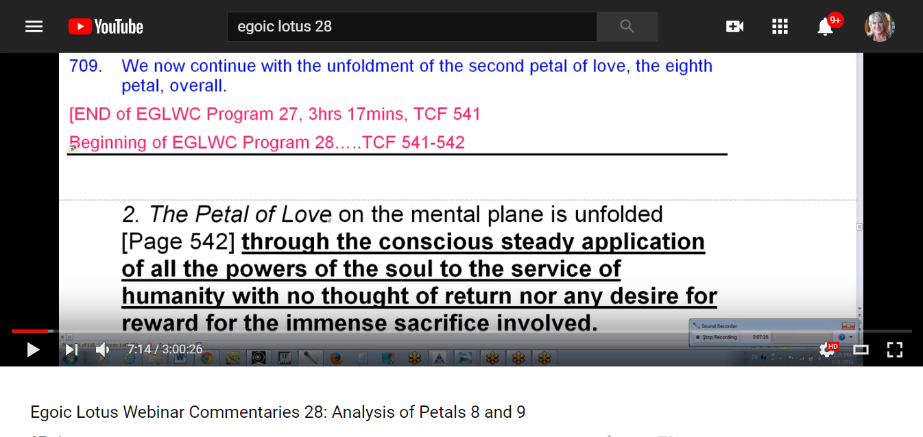
It’s colors should be—well variations in colors do occur—but five colors are always found: the yellow is always there the the orange from the knowledge tier is always there, the rose, when the love tier is always there, but we have a violet that is brought in uncharacteristically. The blue is found in love petals and the blue is sort of a midway color suggesting both the second on the sixth ray.
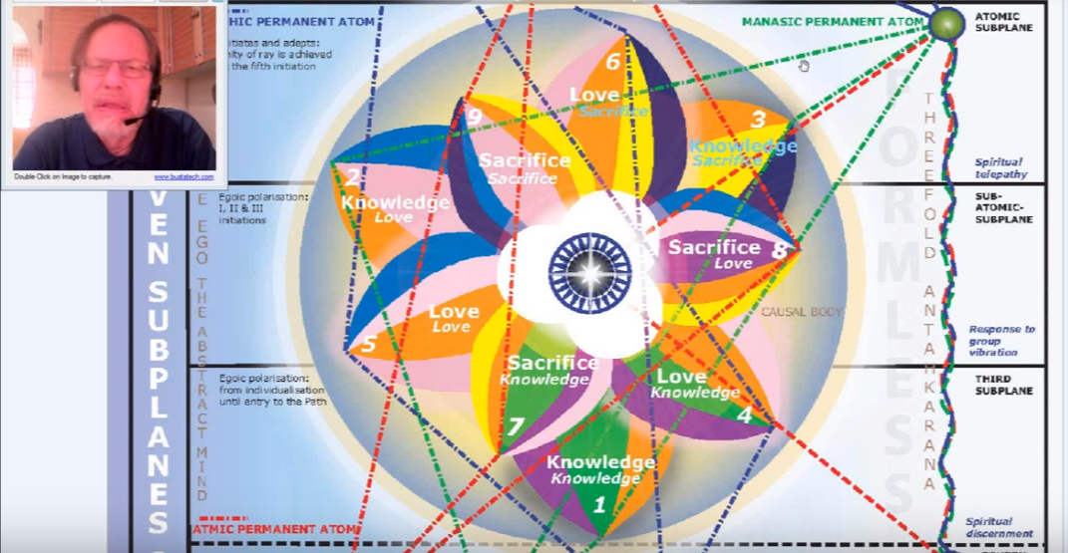
But we have to ask, what is that violet doing there, when it's only found in petal number one, four, and seven, which are the inaugural petals of each tier, and yet it's transposed to petal number eight? As we go along and maybe when we get more into the color section we will see some justification for it.
After all the plan of our planetary logos, He's mentally superior to anything that we can conceive, and there is profound logic in all the assignments, structural assignments of energy which he has pre-arranged through meditation. So there has to be some value here.
It crosses my mind that the exaltation of Uranus in Scorpio, which is the sign assigned to that petal, would bring in the violet and the seventh ray. The defeat of the moon, which is also ruled by violet, would be appropriate in this petal, because the astral body and the desires of the astral body die away. There is the death of the desire nature as it is called, and I think the color violet can participate in that death, in burying it, so to speak. But there will be other ideas and probably the real answers lie in the secrets to initiation and when it comes to this type of study, which is kind of a solar angelic study, maybe a long time before such secrets are given to us. maybe they are secrets even of some of the higher initiations.
00:10:00 All right let's go on, these are somewhat shorter segments coming up but there's no telling with the tendency to elaborate and dialate what might happen.
2. The Petal of Love on the mental plane, it is unfolded through the conscious steady application of all the powers of the soul to the service of humanity with no thought of return nor any desire for reward for the amount sacrifice involved. A Treatise on Cosmic Fire 541-542
It's the petal of love on the mental plane, it is unfolded (quite simply stated) through the conscious steady application of all the powers of the soul to the service of humanity with no thought of return nor any desire for reward for the amount sacrifice involved.
Let's just say it is very different from cornering the market, as is sometimes found in Scorpio, this is Scorpio getting everything for yourself and nothing for anybody else. So that is vampirism and greed and so entirely different than that. And power, Scorpio, associated with this petal, is a power sign and powers are accumulated under Scorpio. We sometimes think of it in conventional astrology as the finances or money of other people. Well that's power. How that comes to us, not just other people. It's the powers that exist out there, not your own necessarily in the human individual sense, but they come to you. This is a power petal. Scorpio is an immensely powerful sign and also the sign opposite it, which is Taurus can be connected with this petal. I've discussed in terms of illumination remember of the second initiation we need spiritual intelligence and mental illumination.
So it is a petal of light, eventually. Spiritual intelligence and mental illumination are both the result of eighth petal processes. I'm assuming. I've been talking for a while here but time is such that one must use it when it is available
This is the eighth petal, and it's the second petal of the sacrifice tier. Thus associated with love. Such a convenient way of organizing many things having to do with the history and process of human development. The level of sacrifice is intensified compared to that which exists in the seventh petal process where knowledge was sacrificed. But here the sacrifice is greater. It is of what one desires. The desire nature is offered on the altar and desires must change and no longer be personal. Easy to talk about and one of the hardest things to do.
00:14:00 We note the steadiness required (is that the word, yes, “steady application”).

Taurus, Scorpio, Vulcan and Mars, Pluto
We think of Taurus in that respect, too. Once some of the obvious liabilities are overcome, then this kind of steady intensity of application.
The zodiacal energies of Scorpio is suggested by the steadiness of the application of the powers of the soul, and this steadiness also suggests the influence of the planetary potency of Vulcan, which has that tendency to continue doing what it's doing unless interrupted, and Saturn as well. Inertia is not only the tendency towards not movement, it's the tendency of that which is in movement to continue the kind of movement that it is displaying.
Vulcan is about the will of the soul and so is Saturn. Both of these are about the will of the soul … They are enforcers and here the higher nature is enforcing, and the man is cooperating. It’s not any blind acquiescence … Acquiesce; there's the quietude in it, a quiet and non-reacting, psychological nature and sense, like a séance. … one day I'll have to figure that out.
So it would seem by the time the second petal is … really unfolding. A considerable degree of selflessness is achieved and the demands of the lower ego have been greatly reduced in significance. That is Mars. The lower ego in a sense is Mars, which is also the ruler of this petal, but Neptune is coming in strongly and giving selflessness, and Uranus he is giving the sense of the archetype. Against the glory of which it's hard to uphold your own personal perogatives. For there is no thought of return. No thought! Nor any desire for reward for the immense sacrifice involved. This is really the sacrifice tier in earnest, with Scorpionic Intensity.
This is an important one, we notice the contrast with the expectation of reward, as exists when one is focusing in the sixth petal. It's not quite selfless and there is still love expected from those one loves and reward expected from those one serves when simply working ahead in the sixth petal. By the time the sixth petal is completely unfolded of course this is gone by the time the sixth petal is completely unfolded this expectation of return will be gone because one has taken the second initiation.
So from the zodiacal perspective on the counter-clockwise wheel, we have the very fitting application of Scorpio to the eighth petal. It is a power sign. In eighth petal processes we have the conscious steady application of all the powers of the soul to the service of humanity. TCF 542
This sounds very much like the attitude of one who is achieving or has achieved the second degree. And it is the second degree with which Scorpio is most identified.
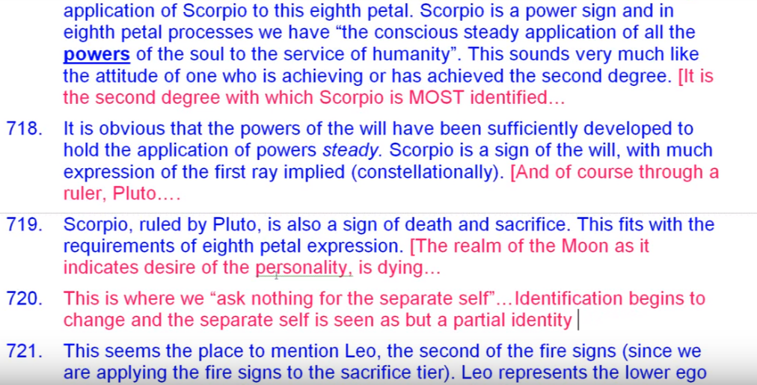
It's obvious that the powers of the will have been sufficiently developed to hold the application steady; Scorpio as a sign of the will, with much expression of the first ray implied constellationally, though of course through a ruler, Pluto. A sign of death and sacrifice, Pluto the Lord of Death, and Scorpio the sign most connected with death. What's dying? This fits well with eighth petal expression let's just say the realm of the moon as it indicates desire of the personality, is dying.
This is important, this is where we “ask nothing for the separate self”. The desire nature, the solar plexus always will ask for the separate self, because such is the level of identification. Identification begins to change and the separate self is seen as but a partial identity.

Fire Signs
00:21:00 This seems like the place to mention Leo, the second of the fire signs (since we are applying the fire signs to the sacrifice tier). We have to find a place for Leo. We've been talking a lot about Aries and Sagittarius and switching them back and forth between the first and third of the sacrifice petals.
Leo represents so often the lower ego which we know is negated by the powers of Scorpio staging the release of Leo. Scorpio stages the release of Leo. Esoteric Astrology page 333, you know the chart … it's one that we use quite a bit because it deals with how the energies work out at different stages of evolution. So this is that chart and here Scorpio stages the release of Leo.
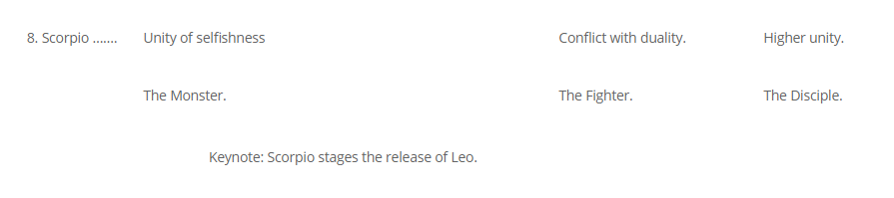
00:22:30 … and a lot of that is happening right there. It happened in a preliminary sense in the fifth petal, but it's happening here in the eighth petal certainly. Interesting the fifth and the eighth of the two petals related to Leo and Scorpio respectively, with lots of Scorpio in the fifth petal and lots of Leo in the eighth petal.
Leo also is representing the heart of the sun, which promotes love and selflessness in the astral body, which under the rulership of Neptune, Venus and Jupiter we expect to find the second degree, more love and selflessness in the astral body. Not completely solved, no.
The “death of desire” is achieved in relation to the eighth petal. Scorpio supervises this death and the Leonean higher self, not the lower egoic self, inspires a more heart-filled astral response. We can just call it love in the astral body, instead of simply desire and reaction. Love starts a long time ago, in a way in the second petal processes. It rises above the strict sensuality, but it's love pretty much in form and of forms and is somewhat instinctual love. Difficult to divorce from the world of form. Later, something different is happening, especially after the solar angel has begun work in the fifth petal processes.
00:24:20 So we're done talking about all these sort of a central petals each tier two five and eight and by the time we reach the petal eight. Love should begin to be released from form, and the love of love that should take the place of love of form.
Using the clockwise wheel and beginning with Aries, the eighth petal will be assigned to Virgo. So interesting, contributing to the relevant of selflessness and the emergence of the energy of love wisdom which rules Virgo so much. We have noticed the relationship between petal eight and petal six, petal six presumed to be fully unfolding by the time the rod of initiation is applied to petal eight. But just as the application of the rod of initiation to petal seven did not mean the full opening petal seven, because you know it's the full opening of petal five, rather, by parallel assumption, we can think that the full opening of petal eight … is not achieved with the application of the rod of initiation at the second degree.
Using the clockwise wheel and beginning with Pisces, which we are justified in doing if you really study Esoteric Astrology you'll see D.K. doing this all the way, all the time as he counts different signs in different houses with a kind of approach in different directions: Aries/Pisces is one sign, really, maybe it was in the beginning, I don't know but certainly they will be at the end – Alpha and Omega will meet and the serpent will swallow its own tail.
Using the clockwise wheel and beginning with Pisces, again we have the Leo emphasis, the sense of Ahamkara working through the astral nature which must be negated. My feeling of who I am … as a separate, sensitive being, must be negated by higher identification and adherence to the Plan. The feeling is the feeling of being the lower self must give way to the feeling of being a higher self this is kind of a felt sense of identity, if you will. I think we all have it, if you just stop and pause, this is a felt sense of identity. It is legitimate to evoke a certain kind of answer by asking, “Well who do you feel you are?” and it will in evoke a different process altogether, but who do you feel, what does it feel like to be you?
We could say, “What does it feel like to be you?” Sometimes we say, “Oh, well I'm an expansive being”, “I feel like exactly what you see.” “I feel like I'm a part of all things.” “I feel like I am all things.” “I feel like I am the personality and nothing more.” It's a kind of sentience estimation identity.

Capricorn and Aquarius
00:29:45 Again, the power of Capricorn ruler of the five first what we call the major initiations. But sometimes major initiations are said not to really begin until the third degree, which is considered the first major. But at other times, the five manasic initiations beginning with the birth of the Christ in the heart are considered five major. Everything depends on the context.
So the power of Capricorn must be applied at the eighth petal generically, just as it was to petal seven, and will be the petal nine, because Capricorn is involved in all these initiations. This Capricorn appliccation gives the ability to cross the water. So he is no longer touched by the usual reactions of the astral nature.
All initiates are distributors of that which they have received. Distribution is the main thing for the initiate, he can never rest content with accumulation, but has to give. The generic application of Aquarius is also required here, pouring forth in selflessness. Aquarius can be one of the most selfless signs. That doesn't mean they're not selfish Aquarians. One just has to look at the present politics of America and all kinds of selfish Aquarians have been put in positions of power, or are in positions of power, seeking positions of power. It's really amazing how limited and idealistic they can be and how controlling from a distance. Aquarius is all about giving, Aquarius is ultimately about giving in the spirit of universal love
The following is important in relation to Leo and Aquarius and the eighth petal, Aquarius-Leo.
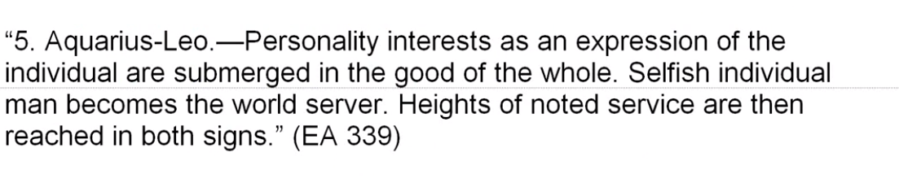
So this is where DK is discussing the interaction of the pairs of opposites.
Personality interests as an expression of the individual, that’s Leo, are submerged in the good of the whole. That's Aquarius. Selfish individual man, that's Leo, becomes the world server. We don't mean to say that everything Leo is lower and everything Aquarius is higher; it can be exactly the opposite depending on the stage of evolution. Heights of noted service are then reached in both signs. Leo setting the example and Aquarius being the universal man. Esoteric Astrology 339
00:33:33 Since Leo is so important at this petal coming in, by the way we assign the fire triplicity in coming in by a moving backwards or let's call it clockwise through the sign starting with Pisces on the first petal, then the opposite sign Aquarius must be very important.
Whenever we get into the area of initiation, Aquarius is important. It certainly is active at the second degree where there's a lot of cleansing of the glamours. Active at the third degree. DK simply says so, it's active at the fourth degree where the heart of the Universal Law begin to take over. And it's one of the signs in which you can take the fifth degree. When it comes to the first initiation, it is opposite Leo which is prominent at the first initiation. I don't know how many people are taking the first initiation in Aquarius. Maybe we'll have to consult the archives. The records are certainly there, all these things that we're speculating about through a glass darkly, trying to earn our way into the light. Those things are written down or impressed in such a way that they can be confirmatory or not.
Pisces is a sign of great sacrifice, related through Pluto to Scorpio, and given the descriptions attached to the eighth and ninth petals, the application of sacrificial Pisces seems very appropriate. Pisces is where you lose everything as a sort of a karmic payback, or where you give everything willingly.
It seems to me there's also the happy ending that Pisces represents. It is maybe an illusion, a happy ending in illusion. There's also the whole devachan idea related to Pisces where your dreams come true. But as happy as the individual may be under such circumstances, it is not a lasting happiness and it has strong elements of illusion.
It can be assumed that a second degree initiate is a confirmed server and can be a real member of the New Group a World Servers. Having passed through a great purification – it's not over yet, the temptations in the desert are there—having passed through a great purification there is little in the way to stop the outflow of serving energy. Usually through glamour, illusion and maya we manage matters to some short circuit the serving energy of the soul.
Aquarius and Leo represent this great outpouring from the heart of the sun and both of these signs can reasonably be associated with the second initiation and its connection with the Heart of the Sun. The astral body has been transformed and now is a vehicle for the outflow of the energy of love for a needy world.

Neptune
00:37:20 We surely see Neptune here as representative of the Heart of the Sun. Probably it's just about what's to be said here, “From the planetary perspective. Neptune associated with self-abnegation the astral plane of the sixth pay will play an important role this is the petal implicated in the process of the second initiation for which Neptune is a planet of considerable influence. Neptune at this stage is the sixth ray planet of the second initiation that is ruled generically by the sixth ray. The sacrificial nature of the eighth petal processes called forth the sacrificial nature of Neptune. And yes, the Heart of the Sun must be mentioned, because the astral body becomes responsive to such energies at the second initiation.
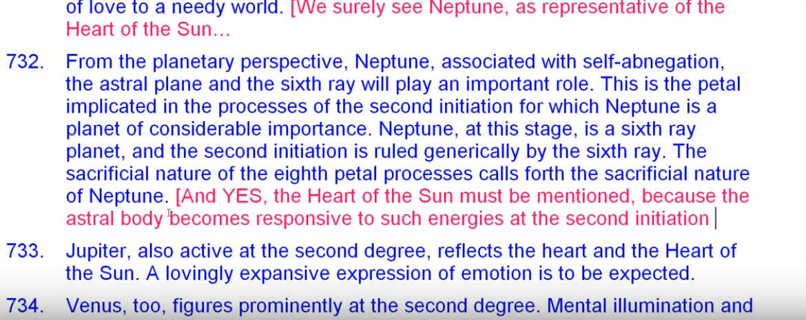

I didn't include everything [in the written commentary, but when you're trying to be inclusive you can't necessarily gather all things together to the point. On a good day you can get most of them but sometimes you have to write regardless of whether it's a good day or a bad day, you just have to write.

Story about Beethoven
I'm remembering one of my music composition teachers told me about Beethoven's Battle Symphony and he said you know we all have our bleak Monday mornings as if to say, “Oh I have to get started again, I'm not inspired, I just have to do it.” And in his opinion at least, Beethoven's Battle Symphony belongs to such a Monday morning. “Must work.” Bach had a lot of must work to do every week he had to crank out a new cantata and get it copied in all the different parts, all of his student copyist involved, and all the rest of it, how did he do it?
I think that the history of coffee is much involved in the creative process in the Western world. I told you that Bach wrote a humorous cantata called A Coffee Cantata and this particular cantata a man with a lot of children had a daughter who was just drinking coffee, and she would sing this lyrical aria about how sweet coffee tastes. And the poor man, he was probably a burger-like fellow and asks, doesn't a man have a thousand problems with his children? is one of the base arias from that cantata. How did I get on that? Anyway. I don't want to retrace my steps …

Jupiter, Venus, Pluto
00:40:30 Jupiter is also active at the second degree and reflects the heart and the heart of the sun a lovingly expansive expression of emotion is to be expected once the usual martian kind of difficulties are overcome. And I suppose especially after … the temptations in the desert are overcome, then the love can really flow. A major victory has been achieved. It's not of the same caliber as The Christ's victory in the desert. We can wonder was that the Master Jesus achieving in that victory in the desert? It was all acted out anyway, because the Master Jesus had already passed those temptations.
I'm of the impression that it was actually the Christ facing the higher octave of temptations in the desert – the world, the flesh, and the devil, has its higher correspondences. So when in the eighth petal, we have overcome the world, the flesh, and the devil, then there's a free Sirian flow, Sirian love energy flowing through this petal.
We can see that Venus, two, figures prominently at the second degree. DK says so, page 71 of Esoteric Astrology. Mental lumination and spiritual intelligence are two requirements for the second degree, and we see their correlation immediately with Venus. Venus is a planet of love and intelligence light and love. Starting in the Arcane School we learned that, you know, the saying, light and love, or love and light, it was as we might have just put the glyph of Venus as we sign off on our letters or whatever.
As well, the astral body must be submitted to the light and love of the soul represented by Venus winos also has its correlation with the Heart of the Sun it's the little sun in which the greater sun of the Sun stores its lights.
Venus is prominent here even though it's in detriment, sacrificial detriment in Scorpio and it's in fall in Virgo. I talked about that earlier. There is sacrifice of the soul in form for the sake of the redemption of form, something of the harrowing of hell going on here, on a minor level. Whatever Christ did in the harrowing of hell it was probably a great feat, but we also in our own way have to harrow the hell within ourselves by exposure to the light and love of Venus, and help with other people as well, reclaiming them for the light.
If glamour is finally to be overcome, and it must be to a considerable extent at the second degree, then the power of Venus will contribute significantly to this overcoming. We know that projecting that beam of light from the ajna center is one of the ways to overcome glamour. And initiation is given on this but the ajna center is ruled by Venus, which is a fifth ray planet. Here the ability to spot and zap that glamour, put it under the magnifying glass, to direct a beam of fifth ray-second ray light into it, is perfected. We can see the glamours, and we can illumine them and dissipate them, and bring them to light.
00:45:40 The power of Pluto is active here as the death of lower desire is required. You can't really get rid of desire in our cosmos. It's a question of Master Morya’s called measuring one's desires. But desire is the process of reconstitution of the scattered aspects so … desire is the urge to holiness ultimately. But the lower desire attracts us to those things which will bring separation instead. Those those are the kinds of desires that the Buddha wanted us to be rid of in the four noble truths, in which desire for the phenomenal world was the cause of pain. We cannot desire phenomenon and hope to be redeemed or restored to our central nature.
The power of Pluto is active here as the death of lower desires acquired and we will find a considerable cutting from attachment to lesser things in preparation for the powerful and sustained outpouring of service. … If we have attachment to lesser things our energies are leaked off into those things and we are not strong. Attachment drained energy which could be used in true service for the divine plan.
I think we all know that to be the case. We have to be in a way attached to the soul of another and even identified as the soul of another, but not attached to the form of another, and that's a keen discrimination which all of us as disciples-in-training have to master to a reasonable extent until we master entirely.
As previously stated willful steadfastness is the act in the application of all the powers of the soul suggests the presence of Vulcan … a planet of repetitive, steady rhythm Mercury acts powerfully in relation to Scorpio to achieve mental polarization and the control of the astral nature and also intuitive response is going to open up through Mercury, in relation to Scorpio rendering the astral vehicle responsive to the powers of buddhi.
00:49:00 We have to say that without buddhi there is no second initiation. Because the second initiation allows the flow of buddhi through the astral vehicle.

Mercury, Venus, and the Monad
Mercury is important here, the mind is doubly powerful in Scorpio. We are told in the Scorpio chapter, that one is to control emotions, but the other is to reach intuition and let through the flow of buddhi into the astral body, and it's done through planets like Neptune and Jupiter, and of course Mercury, and then through the love petals of the egoic lotus via Venus.
Does Venus have a connection with buddhi? The Being Venus is actually achieving buddhi on the cosmic astral plane. We're told. The Earth entity, earth being, the spirit of the earth, the Planetary logos of the earth has not really done that yet. The planetary logos of the earth is struggling on something for attempting to move from subplane four to subplane five. The Planetary logos of Venus is actually moving from subplane five to subplane six, counting from below up.
Venus itself as a planet has relation to Buddhi. Usually it's considered related to the higher mental plane but by its second and sixth rays it has relation to buddhi – its fifth ray relates it to the higher mental plane, it is is kind of a bridge in a way between buddhi and manas. And so is Mercury in another way
This is also a petal, petal eight, in which the soul is by-passed. I was speaking of the antahkarana in The Rays and The Initiations, page 216. Symbolically, the sun (ruler of Leo) in one sentence is by-passed by Mercury which hierarchically is so closely related to Scorpio. Let’s take a look here at Rays and Initiations, page … 217. This is the petal in which the soul is ‘by-passed’. Now there's a higher sun awaiting the entrance of Mercury, but we're talking about the ahamkaric sun and the sun which is the symbolic ruler of the egoic lotus, and it says, It is to this …
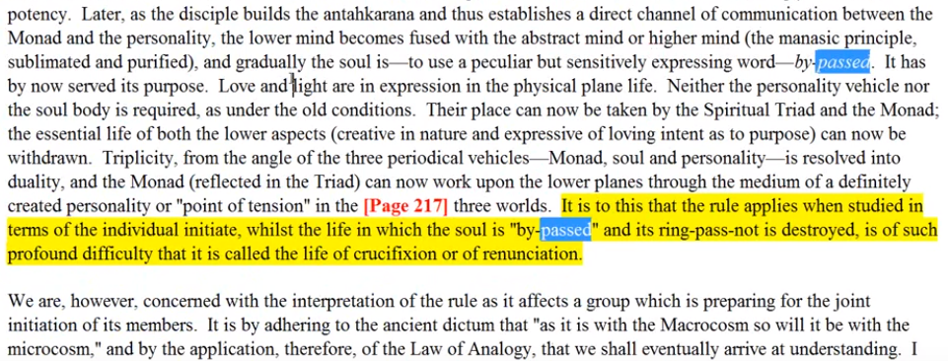
Monad, soul and personality is resolved into duality and Monad (reflected in the Triad) can now work upon the lower planes between the medium of a definitely creative personality or “point of tension” in the three worlds. It is to this that the rule applies when studied in terms of the individual in the shit whilst the life in which the soul is bypassed and its ring passed not is destroyed the use of such profound difficulty that it is called the life of crucifixion or of renunciation. R&I 216
… Monad, soul and personality is resolved into duality and Monad (reflected in the Triad) can now work upon the lower planes between the medium of a definitely creative personality or ‘point of tension’ in the three worlds. It sounds like a mayavirupa. It is to this that the rule applies. It’s rule eleven related to the fourth degree when studied in terms of the individual initiate whilst the life in which the soul is ‘by-passed’ and its ring passed not is destroyed the use of such profound difficulty that it is called The life of crucifixion or renunciation.
I doubt that any of the people thinking they are passing through that – at least among my acquaintances – are passing through. It is more likely the lower reflection that pertains to the period around the second degree. That's what we're talking about here. The soul is by-passed but not in the highest sense I have to say, because that would mean the fourth degree and the cause a body would be on the verge of disappearance.
Nevertheless some some degree of impersonality can be achieved with this lower level by-pass Mercury's getting stronger and stronger in the possibility of building the antahkarana at the period of the second initiation is strong.
00:54:30 I think we have to be approaching the second degree before it's really possible to bridge our way into the spiritual triad. Really before that time our work is simply with the egoic lotus only, and with the solar angel only, and our reach up or towards the monad really is beginning more at the second degree. Remember the numbers two and six and how they are related, second degree ruled by the Sixth Ray, monad sixth plane.
Okay, we are told that the antahkarana can be successfully commenced at commenced at or proceeding the period of the second initiation. So the full building of the bridge takes longer and even now it's being withdrawn into the master, or into into the sun at the time of the fifth degree. And antahkaranas do continue. There are planetary antahkaranas, there are solar systemic antahkaranas and on until the end. Antahkarana ends in the one and only universal logos itself a temporary Being, but the antahkarana is the means of withdrawing all emanations back into the originating source.
The power of Mars has been harnessed here. Yes it's a courageous battle and is subdued at the second initiation at least in its lower aspects. Diversity, selfish aspects. Selfishness is dealt a mortal blow the first real blow against selfishness occurring here at the second initiation which involves this petal. The application of the rod to that petal, when speaking of the immense sacrifice involved, that's what DK calls it with no thought of return nor any desire for reward for the immense sacrifice involved. TCF 542

Sacrifice, Saturn, Sanat Kumara
When dealing with this immense sacrifice at the end of this point, the promise of sacrifice even more immense than can be experienced through eighth petal processes, the power of Saturn must be invoked. Saturn and sacrifice are inseparable. The Great Sacrifice, who is Sanat Kumara, is Saturnian in one of His major aspects, He stands at his post and does not leave that ring-past-not until the last weary pilgrim comes home. It is so Saturnian, to do your duty and stand at your post no matter what.
So interestingly the power of the Lord of the World use invoked following the second initiation. That and the power of identification and the power of the will. All following the second initiation and the Lord of the world you symbolically Uranus, the Heirophant. This is one of the references, Eventually (after the second initiation) the Lord of the world comes in as a factor,--the Lord of the World fully expressing itself in love. … Let's go there, page 871, … yes that is correct … it is fully expressing itself in love.
Eventually (after the second initiation) the Lord of the world comes in as a factor,--the Lord of world power fully expressing itself in love. TCF 871
So that was correct … I also want to mention another quotation here which is very important. After the second degree we see Sanat Kumara comes in as a factor, the Will will come in as a factor, it would have to be cultivated at the second degree, even more so at the midway point between, and it is necessary as the monad comes into focus that the third degree, but listen to this:
The greatest problem facing aspirants and disciples prior to the third initiation is that of comprehending the nature of identification. This concerns (in the first instance) the relation of the self to the Self and of all selves to the all-inclusive SELF. R&I 172
The greatest problem facing aspirants and disciples prior to the third initiation is that of comprehending the nature of identification. So this is following the second degree. This concerns (in the first instance) the relation of the self to the Self (with a capital s) and of all selves to the inclusive SELF. The nature of Identification.
01:01:00 So following the second degree that can be expected along with what is said here the coming into full power of Sanat Kumara – the Lord of world power … fully expressing itself in love. Then, of course the factor of the Will.
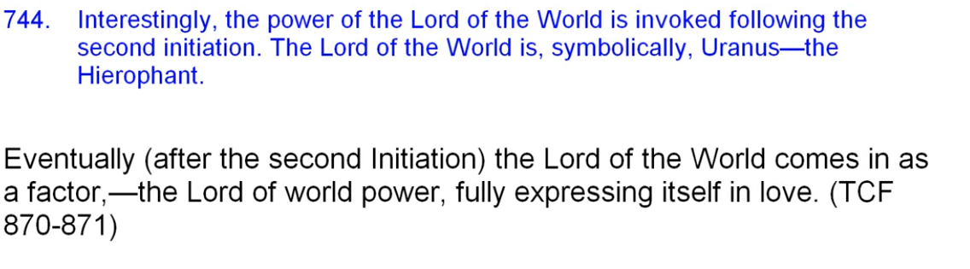
There is another reference that gives what a person has to work on after the second degree. So this is going to involve the period in the eighth petal after the rod of power is applied and the work that goes on in the ninth petal. The Lord of the World, that I think symbolically is Uranus and fits so well with Aries as a major ruler of the ninth petal given that Uranus is the hierarchical ruler of Aries.
01:02:00 Uranus is responsible for collapsing time and space and ending illusion (but more of that when we get to the ninth petal itself).
As earlier stated, we can find a way to involve all the planets in all initiatory processes … let me see … second initiation … there's a section on identification … I can interpolate it here, because I think it's important.
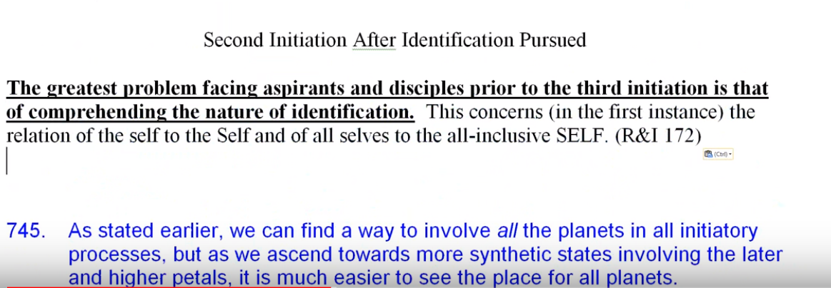
So all the planets can be involved in all initiatory processes, but as we ascend towards more synthetic states involving the later and the higher petals it is much easier to see the place for all the planets, because synthesis is being approached and one or two things are not being emphasized only.
From a ray perspective, the first ray is entering through powerful and steady application of all powers of the soul and service. That is the first three. So connected with Scorpio of course. The first ray also contributes to the necessary self-abnegation, to willingly relinquish so much, yet ask for nothing in return. It is afterall a major ray of sacrifice, the great First Ray Lord, Sanat Kumara, is called the Great Sacrifice. He is a projection, an emanation of … our planetary logos, whose monadic ray is the first, whose soul ray is the second.
In that sense, it's probably not right to think of Sanat Kumara as having rays different from the planetary logos, although he could be considered a kind of emanation along a particular ray line. Anyway his source is rays one, two, and three.
We can see how this eighth petal approach is in contrast to the description of the approach for the sixth petal. … Yes the process of return is still desirable, I sacrifice something, I get something; I sacrifice so that I can get. Some work within the signs Scorpio is that way in the earlier days, but by the time we reach this petal and the second initiation we are really giving for the sake of the plan and not for anything that this tiny emanation of the monad might receive in return.

Rayological Factors
The second ray continues to grow as the Ego (capital e) embodying of the second principle generically becomes ever more powerful in the personality life. Increasing power if the solar angel as we traverse through the petals of sacrifice petals.
The third and the fifth rays are involved in the establishment of mental illumination and spiritual intelligence. There's not so much third ray connected with Scorpio, it seems to be the one ray left out of the rays related to Scorpio, says DK. But it is a mental sign, and as much as Mercury is so powerful that third and fifth rays both have to be present. So we can say because Mercury is so powerful in the eighth petal we will find third and the fifth rays related to it. Third and fifth rays related to the eighth petal. Especially it’s powerful in the dispelling of glamour through the fifth ray, and through the rulership of Pluto there is some third ray involved as well. Pluto has a very cerebral quality as well, and is related to both third and fifth rays. Research. Intrigue. I think you can understand how these relate to Pluto.
The fourth ray represents the disciple’s contest within himself as an increasingly sacrificial attitude is required in the higher of the pair of opposites must prevail. Obviously the fourth ray comes in most powerfully through Scorpio. The sixth ray, its stimulation and its harnessing or overcoming is definitely involved in the second initiation process. The sixth ray is expressed through Mars (orthodox and esoteric ruler of Scorpio) the esoteric ruler here for the big battle is very prominent, and thus would be strongly represented in a petal strongly conditioned by Scorpio.
There are plenty of battles, and as that work is continuing towards the second initiation, plenty of battles with glamour as work is continuing towards the second initiation and even beyond. A lot of courage is required for the “Temptations in the desert”.

Chakric Centers
From the chakric perspective, the integrating, enforced, directing power of the ajna center will continue to grow and Mercury is strong at the ajna center for the initiates. We are having quite a bit of personality integration with the soul by the time we are well through eighth petal processes.
The power of the heart is what will give strength to undertake the necessary sacrifices, and we talked about Leo, so connected with the second ray as well as the first and fifth, it is one of the fire signs most associated with the soul, and of course it's ruler, the sun, and Neptune bringing in a strong second ray, so lots of heart energy for the eighth petal, considering the way the heart is needed at the second initiation to fill the astral body with more real love
01:12:12 Okay, now, the solar plexus is definitely rendered subservient to the heart center at the second degree, right? We raise the solar plexus to the heart. And the solar plexus becomes secondary. Sso the heart is stimulated here and with it the second ray. The stimulation of the heart center comes increasing power of the second ray group. …
More than five of the seven heads are awakening. Remember, in Treatise on Cosmic Fire, page 170. Maybe six by the time we reach the second degree, and perhaps the emphasis is on the sixth head Center. Just as during the ninth petal process, the emphasis would be on the seventh, and at the first initiation when the kingdom of nature is entered, upon the fifth.
So … the fifth center could be the … ajna center as of four head centers and their synthesis the alta major center he is the fifth. And then be the seventh such center, what would it be? There are a number of Vulcanian centers in the head, so we do not necessarily have to think the ajna center is the sixth, but we could be talking about a second ray center, as the sixth. And a first ray center as the seventh.
There's so many subtleties there in the apparatus of the centers of the head. We just have to read the books in the different traditions and we see that certain head centers, not specifically named by the Tibetan, are given, are named, and their nature is specified and it is these chakras which are receiving stimulation as the sacrifice petals are being opened. We know really so little about the complete apparatus of the head, if might be your way even twenty-one fold, 7 and 7 and 7 and then the whole, 22. The head apparatus, head chakra apparatus might be 22-fold. Perhaps.
The Crown Center, receiving occult power, is definitely activated here and also the heart in the head which is related to the heart of the sun, which is related to Neptune at this point. Neptune is taking over from Mars.
See it just it just depends on one's horoscope. We can understand all these things in a generic sense but the horoscope will give us our particular entre into the kind of work that has to be done in connection with this petal. Maybe there's a whole range of work and a horoscope only gives entre into a few of those many possibilities. We have to leverage this and find out where we can gain the most power given the equipment that we have.
As the integration of soul and personality continues, let's just say a lots of ray four for this integration process contiues. And there will be an increasing interplay between crown and ajna, and if the alta major center will be fully involved by the time the next initiation is taken. So that's a really important triangle, isn't it, for the third initiation must involve the triangle in the head. Crown, ajna center and alta major center. Yet another way to look at what must be accomplished, because then the third eye will emerge ,the third eye in relation to visionary Sagittarius, and the horn of the Unicorn in Capricorn. But that's that's going on a little bit ahead, perhaps.

Petal Nine: Petal of Sacrifice on the mental plane
The next petal is the final petal human, sacrificial tier the ninth petal and, we're getting there. It's the final petal in the sacrificial tier the ninth petal is really so much to do with the astral-buddhi nature in the eighth petal, that the ninth petal processes can seem almost easier by comparison. The principle holds that the second initiation use the one of the greatest difficulty, given the understanding of a candidate.
01:20:25 We'll be moving into the ninth petal, its full, or I called it penultimately full unfoldment it will take us to the point of the third initiation, but DK has said that the ninefold lotus is “full-blown”, so perhaps it continues to unfold in the some final or ultimate state in the period between the third or fourth degrees, but I think DK pretty well says it's full.
This thought regarding the continuing unfolding of a chakra after initiation is taken and should be pondered. Let's just say this hypothetical process seems to occur in relation to petal seven and petal eight, but maybe not for petal nine, though there are final rotary adjustments, penultimately. For all practical purposes we can consider that at the third initiation with the ninth petal, all is open, and the next progressive opening is of the synthesis petals, which have already opened somewhat at each initiation disclosing ever more light.
So, does the third initiation happen all at once? Or are there different phases in the process?
I mentioned earlier this may be the case. Saul of Tarsus was blinded during one phase of third degree process, but for years afterwards he seemed to continue with that third process of unfoldment reaching out towards the light. When he was writing the letters for the Hebrews we are told of Paul he was brought to the feet of the initiator through the effect of love. This is so interesting because he was so different from that at first. Was he a six ray soul turning into a second ray soul? With ray five and ray one being monadic? I speculated on his rays. We know his monadic rays are the fifth and it's hinted also the first. You can have two more monadic rays. When he was blind and on the road to Damascus, he was not pushing forward on the basis of love, but more on the basis of fanatical idealism. He was involved in the second initiation; he was an initiate of the second degree apparently. So he's being brought to the feet of initiator must have occurred after the blinding.
So these considerations are of relevance when we consider whether one meets the one initiator before the ninth petal was completely unfolded or only afterwards, and what I had decided and I'm reminding myself of this and I think it's a good hypothesis hypothesis, when the ninth petal is almost unfolded the rod of initiation will complete the unfoldment, give the third degree, and evoke the complete unfoldment of petal seven and petal eight, finishing their process of unfoldment.
01:25:00 It seems maybe a little easier to progress at this point, given the work we did on trying to straighten out when the rod of initiation is applied and whether the strenuous and abnormal efforts of the man have contributed to some unfoldment, which is then more or less completed by the rod of initiation and certainly by the time the ninth petal is reached completed by the rod of initiation. Therefore the full blown lotus can stand forth and all nine petals are blazingly open, fully.
… This type of close study begins to stimulate the intuition and one begins to see inwardly how these things may be. Intuition is a kind of sight, and imagination leads there and intuition can also stimulate the imagination in the reverse direction, imagination stimulates intuition and vice versa.
We begin to see the reality that is taking place in these realms and realizing that every one of us is an example of it. Every one of us has this structure whether it's tiny or larger, its radiation is considerable and these unfoldments are occurring, large and small makes no difference. The universe can detect if you – even if it's the size of an atom. If we can build the microscope we can see now molecules and atoms which are now occurring we have the inner faculty to do the same.
So now we have reached the point of the following the second initiation. The petal of love, which is so difficult and takes so long to open – the petal of love on the mental plane – has opened almost entirely or because after all is the same life is not taking the second and third in the same life is apparent be commonplace so we don't we're not going to have to wait for a thousand years, except under special circumstances for the third initiation to occur.
Rather we're going to move ahead into the foremost sacrifice petal. The petal of sacrifice from the mental plane. It will also have unusual colors.
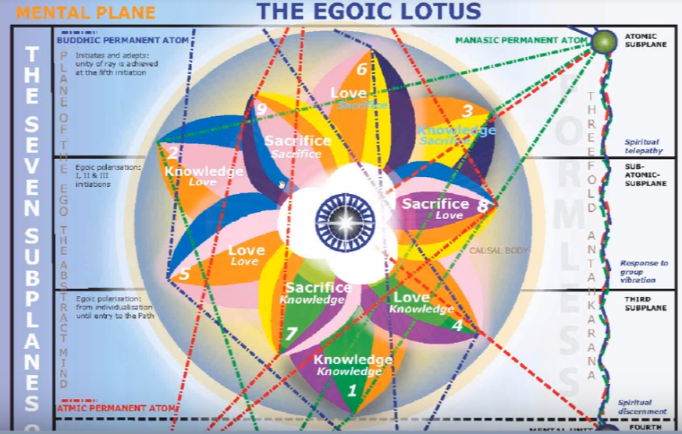

Colors
It will have of course the orange, the rose, and it will have the yellow, and it will have the indigo of final petals which are synthetic – final petals are synthetic and indigo is the synthetic color – but instead of a double yellow, (maybe that will happen in the next solar system), blue is brought forward, just the way the violet was brought forward here, instead of having either a double blue or a double rose.
It seems to me that there are unusual colors found here, in terms of the pattern that has been established. We definitely have devotion, we will have a fifth Ray mentality, we'll have harmonizing effect, we'll have aspiration of the blue, another sixth re-emphasis a sort of transitional between the six and the second ray, and finally the synthetic color of the second ray. The egoic lotus is a great second ray structure and indigo symbolizes its synthesis, so naturally it has to be found in the synthesis petals. It is often called the synthetic color, indigo, synthetic ray, and it's color indigo.
01:30:00 We'll just get right into this [discussion of color] kind of a roll here. Hopefully, it's all falling into place. One day some kind of charts can be made out of this which will be more specific than this particular method. But at least this gives the method of approaching in thought, approaching as much truth as may emerge.
3. The Petal of Sacrifice for the Mental Plane: demonstrates as the predominant bias of the soul as seen in a series of many lives spent by the initiate prior to his final emancipation. He becomes in his sphere the “Great Sacrifice.”
The petal of sacrifice from the Mental Plane demonstrates as the predominant bias of the soul – let's just say the soul always has the bias of the soul; the soul’s bias is giving and service – the predominant bias of the soul is seen in a series of many lives spent by the initiate prior to his final emancipation. This is from the time of the first initiation and even before, because the tendency of the soul is emerging. The higher the pairs of opposites is getting stronger. He becomes in his sphere the “Great Sacrifice.”
The third initiation, with the addition of monadic power, and the bringing in of the energy of the one who is the Great Sacrifice, makes of the man the Great Sacrifice. The touch of the flaming diamond or rod of initiation at the third degree by Sanat Kumara, the Great Sacrifice, makes of the man himself a Great Sacrifice in his own sphere.

Story about Dane Rudhyar and other astrologers
His sphere is not a planet, although this would be the point when there would occur what Dane Rudhyar has called the planetarization of consciousness. Rudhyar was said to be a world disciple. Was he a third degree disciple? DK called him a world disciple and world disciples can be considered third degree. At the same time he said there were no initiate astrologers at work on the planet at this time, meaning in the outer world. But, maybe that was at the time when the book was being distributed, and Dane Rudhyar was one of the ones to whom it was distributed. But I think a strange kind of thing happened he seemed to reject it, and when I talked with him personally, he said, “Well, it's not astrology as I know it.” That’s a well-cultivated response because I'm sure he had been asked that question many times. For me, talking to Dane Rudhyar was like speaking with a great man, I could hardly believe I was having the opportunity to do it. But it was all in the second ray ashram, it was part of that process and I learned a lot.
I've had interviews with Dane Rudhyar and also with Mark Edmond Jones, and these were the two prominent astrologers at the time that I was growing up astrologically, so I feel very privileged. And then getting to work with Charles Jayne later who, in a quite different field not so much psychological astrology but more technical astrology, was one of the luminaries. So I feel very blessed for those encounters.
But it was a while before I really got into the esoteric kind of astrology and I remember buying the book, it was in the Gnostic Bookstore probably back in 1970, or 69, maybe even 68 – 35 years ago. I bought an old copy of the book, it is since all tattered and torn, and I saw that someone had kind of meandered a pencil through it and then gave up at page 70 or something like that. Somehow it's in my mind that it was on the page where the planets in the initiations were given. It was so different from the ordinary kind of astrology that I know a lot of people couldn't tolerate it. At first I kind of kept the book and would look at it and then I really began a systematic reading of it, then worked with it all these years.
Finally, when I did these talking books, or video webinar books on Esoteric Astrology was my deepest penetration into that book and getting through all 700 pages of it, almost 700 pages, it was, it was a major task. But I'm very glad that I have done that, you know it's hundreds of hours of listening and it would transcribe into thousands of pages of talk and all that, but connections were being made and what's important for a person like me is to extract out of the thousands of connections the most important ones and to bring them forward.
We could say that throughout man's development during the unfoldment, especially if the sacrifice part of the bias of the evolving man has been increasingly towards service and sacrifice. So it has been a soul bias, most definitely.
01:35:40 The implication of this section of text is that this predominant bias of the soul is demonstrated in the expression of the ninth petal, in reasonable completion. It's just when the soul is at its peak and the Spirit … has not been there to challenge the soul, but now will be from the third initiation on.

Great Sacrifice
So he becomes in his sphere the Great Sacrifice well, he stands as the reflection of Sanat Kumara, so immediately we know that Saturn must be important here. Saturn and Sanat, you know this is so closely related. From another perspective He is Aries, the sacrificial lamb, I've mentioned this as we went along. Aries we shall see is the sign fittingly associated with the ninth petal. It's the beginning of the end in many respects, he's still a human being and will be, even if he becomes a master of the wisdom, but now he is becoming a real member of the kingdom of souls not just as sort of an applicant member of the initiations of the threshold, but he’s going to be able to live as a soul, going to be able to focus within the causal body. It's a different thing. Instead of aspiring to he's going to be able to focus within.
So the sacrificial lamb. We may wish to ask whether his demonstration as a great sacrifice is really complete at the third initiation. Or only to a degree? It makes sense to me to say, from thence forward … because the sacrifice gets even deeper towards the fourth initiation would seem that in the processies following the third initiation, the sacrificial process would gain momentum and culminate in the great renunciation for the sake of service, but it deepens and deepens. It still continues to deepen, all the way up.
Our planetary Logos made a tremendous sacrifice in ensouling and infusing and pervading all the many lives that needed the energy of an entering God. It's the something about entering God – DK said He doesn't know how else to translate it, but in order to be lifted they needed this entering God, and that was a great sacrifice. Sanat Kumara, as an extension of the planetary logos, descended even deeper and in a more confined and focussed manner.

Mental Unit and Permanent Atoms
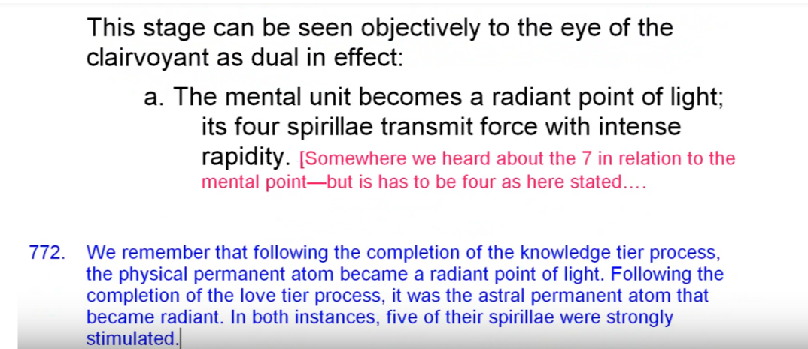
This stage can be seen objectively to the sight of the clairvoyant as dual in effect: the mental unit becomes a radiant point of light; its four spirillae transmit force with intense rapidity.
This stage can be seen objectively to the sight of the clairvoyant as dual in effect: the mental unit becomes a radiant point of light; its four spirillae transmit force with intense rapidity.
Somewhere we heard about the seven in relation to the mental point, but it has to be four as here stated because the mental unit has only four spirit and if we want to complete it we have to go to the manasic printed out of which has three
01:39:50 We remember that following the completion of the knowledge tier process, the physical permanent atom became a radiant point of light. Following the completion of the love tier process, which would be the second degree, it was the astral permanent atom that became radiant. In both instances, five of their spirillae were strongly stimulated. But now we don't have five really; we have a four that the mental unit has and mind is not completed without the manasic permanent atom.
Now following the completion of the sacrifice tier process, it is the mental unit with four spirillae that becomes a radiant point of light. I suppose the antahkarana results in the joining of the two in some way. I wonder how the absorption goes? Does it go so that the mental unit is absorbed into the mental permanent atom? The astral permanent atom will certainly be absorbed into the buddhic permanent atom. But is the physical permanent atom absorbed into the atmic permanent atom, or is that exact correspondence with the physical into the manasic permanent atom, the astral to the buddhic permanent atom, and the mental aspect into the – it seems a long way to rise actually, for the mental unit to have to go into the – atmic permanent atom.
Anyway the long and short of it is that the powers of this atomic triangle are absorbed into the triad, however exactly that is done. It follows the fourth initiation.
So when the spirillae are stimulated (whether the spirillae of the physical permanent atom, astral, or mental unit) these spirillae “transmit force with intense rapidity”. The form destroys the connection, we are told in Esoteric Healing when dealing with the destruction of the causal body. So this rapidly rotating atomic triangle is a very destructive little unit in the disruption of the causal body.

Complete Unfoldment of Nine Petals
b. The three higher petals unfold and the nine petals lotus is seen perfected.
The three higher petals unfold and the nine petals lotus is seen perfected.
Okay, well there's another one of those definitive statements. This is the COMPLETE UNFOLDMENT of the ninth petal of the ninth, and all the petals at the third degree.
Things move fast there at the end; the asymptotic curve approaches the vertical axis rapidly. So we have the perfecting of the nine-petaled lotus but not yet of the twelve. The innermost petals are said to be visible, either unfolding or revealed in bud form surrounding the central jewel, but it is said that they open.
01:43:33 I'll have to look at that again. They open, so if we were to look here and look at the synthesis petals and there are various things that are said here, how they unfold in relation to the crown, ajna and heart center. When those centers unfold the synthesis petals unfold …
It is said here, and I've quoted this before that,
At the first, the second, and the third initiations, one of the three petals opens up, permitting an ever freer display of the central electric point. At the fourth initiation, the jewel (being completely revealed) through its blazing light, and its intense radiatory heat and it's terrific outflow of force. TCF 883, 884
At the first, the second, and the third initiations, one of the three petals opens up, permitting an ever freer display of the central electric point. That's not full opening. At the fourth initiation, the jewel (being completely revealed) through its blazing light, and its intense radiatory heat and it's terrific outflow of force. … This is an important page, 883 to 884.
Let's look at this … the nine-petaled lotus is there, and part of the synthesis petals. Even at the third degree, but not completely because it bursts open at the time of the fourth degree it may be in the same life the life. Must be very difficult and under that tremendous pressure it's possible, or maybe in the next life.
01:46:00 So that is really one to remember. Very very important how the synthesis petals open and it seems fairly straightforward: a little bit of opening at each one of the initiations and probably if petal one correlated with the third ray opens at the first degree, then synthesis petal two correlated with the second ray will open at the Second Degree, then a little more petal one will open, and then when petal three opens, then we have the first re-involved and still a little more of petal two and one that will open. They keep on opening because it's not that we suddenly stop with our synthesis of knowledge or synthesis of love, seeing all things in the one love. We don't stop.
Before continuing with a description of this relative consummation we will consider the energy and chakra relationships which may lie within the ninth petal. Now so many of the students of esotericism, they may be doing some work in the ninth petal, if they've passed the first degree, but it's really after the second degree awareness of Sanat Kumara awareness of the will, the necessity to understand identification, these things occupy them between the second and third degree.
From the zodiacal perspective, considered counter-clockwise, the ninth petal would be ruled by the ninth sign, Sagittarius. Well, the base of the spine is involved as the esoteric ruler. A burning ground is involved through Mars, its Hierarchical ruler. We have the third eye really showing something, visionary is appearing at the time of the third initiation. So, Sagittarius here will indicate the complete completely one point of soul infused personality. Disregarding that little bit more of infusion, that might come about up to the fourth initiation through, certainly three quarters infused. And Sagittarius points it's arrow towards the still higher consummation of the fourth degree.
I've said a lot of things about Sagittarius along the way. It is really a blend of Sagittarius and Capricorn. One uses Sagittarius aid to get to the foot of the mountain, and then one uses Capricorn to climb. However the final synthesis petal, which has to be opening at the time of the third degree, maybe more correlated with Pisces than with Capricorn.
Each of the petals of synthesis is correlated with one of the three rays. … let's see … I have
the influence of the three major rays the other three types of petals being each under the influence of one or other of the major rays. These, in their turn, come under the influence of force from cosmic centers. TCF 767
the influence of the three major rays the other three types of petals being each under the influence of one or other of the major rays. These, in their turn, come under the influence of force from cosmic centers.
I look at it as ray three, two and one, concluding. Capricorn, ray one, Aquarius, ray two, Pisces, ray three. Of course you can start backwards with Pisces and end with Aries, which is a great sign of synthesis, and probably Aries and Pisces together make the Alpha and the Omega.
A Treatise on Cosmic Fire is such a rich book you can understand what it can instill in us when we really study it and how the esoteric universities of the future will make for very, very deep study of these matters and all of the methods of cultivation will be ours, as well. So see you there, right?
01:51:00 Sagittarius indicates the one-pointed disciple in this burning ground, in this fearful conflict where we have Mars and the moon operative. Mars related to Sagittarius of course, the moon, too. The lunar Lords really have no more chance in the ancient authority of the personality is overcome—the Will, Vulcan, steps in, related to Aries. And of course also to other signs.
We must also remember the relation of Sagittarius to the mentally completed antahkarana, the kind that where the mental unit really is anchored in the manasic permanent atom and thus to the abstract mind. So there is a real abstract mind at work here in this ninth petal. I want to say that. A real abstract mind is at work here in the ninth petal process.
The by-passing of the egoic lotus is complete. It will still be used of course, still be used, the solar angel is still active, is still the heart in the monad, but there is a way for the rapidly soul- infusing personality to relate directly to the personality extension of the monad which is the triad. The Sagittarian ‘great adventure’ involving the antahkarana has made this possible. … kind of like a Star Trek into our own spiritual triad, taking off ind inner space going where few men have ever gone – I don't know, I was never a Trekkie, but in culture it just reverberates something like that; reverberates in your ears, so you're going to somehow hear it.
From the clockwise perspective, beginning with Aries, we have Leo, the Sun God, shines forth in resplendent glory at the transfiguration initiation.
May the Holy Ones Whose people we seek to become, show us the light we seek. Give us the strong aid and their compassion and wisdom. There is a peace which passeth understanding; it abides in the hearts of those who live in the Eternal. There is a power which make it all things new, it lives and moves and those who know the Self as one. May that peace brood over us, that power uplift us till we stand where the One Initiator is invoked, till we see His star shine forth. DINA II 360
May the Holy Ones Whose people we seek to become, show us the light we seek. Give us the strong aid and their compassion and wisdom. There is a peace which passeth understanding; it abides in the hearts of those who live in the Eternal. There is a power which make it all things new, it lives and moves and those who know the Self as one ... I think the word, shine forth, it's in that mantra, and I want to find it … yes, peace and shine forth. May that peace brood over us, that power uplift us till we stand where the One Initiator is invoked, till we see His star shine forth.
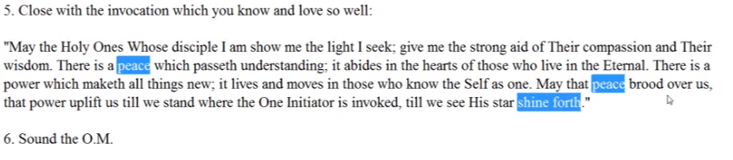
That's what we see of the One Initiator, first his star, then later his eye, and then later at the fifth degree face-to-face. He couldn't stand it before that I suppose, not until the fifth degree do we see the One Initiator face-to-face. Then the Initiator actually in a sense changes, a different emanation, and the Planetary Logos officiates at the Sixth initiation. We are told.
And that's what I mean by the kind of information, please it's right in the first book, Initiation, Human and Solar. So many people are writing the so-called third installment of the Tibetan, and they couldn't come close to even having the information that's in Initiation, Human and Solar. So let's be realistic; let's be realistic about that, we cannot pretend.
01:55:30 Leo is blazing there, all the fire signs can be meeting in this ninth petal. The blazing transfiguration of Leo, the Aries, the coming in of the sense of pure being. Sagittarius, that tremendous orientation towards the heights which is launching a man into the triadal world and into the intuition. He begins to step into the plane of intuition. Through Sagittarius he steps deliberately onto the plane of intuition.
From the clockwise perspective beginning with Pisces, we have Cancer there, and it fits so well. That the whole is seen as one. From that time Rule Five really applies. There are no other selves. That one great unit of evolution or development is complete, infusion has occurred. Let's take a look here at The Rays and The Initiations, page 20 … here it is, let the group perceive that Whole.
Rule V. In unison let the group perceive the triad shining forth, dimming the light of the soul and blotting out the light of form. The macrocosmic Whole is all there is. Let the group perceive the Whole and then no longer use the thought “My soul and thine.” R&I 20
In unison let the group perceive the triad shining forth, dimming the light of the soul and blotting out the light of form. The macrocosmic Whole is all there is. That's what we begin to realize – at the third initiation, “I am the one. I God, the macrocosmic Whole, is all there is. I am before which all forms are merged. I am the soul in which all souls are fused. I am the life and in that life the little lives remain”, but Let the group perceive the Whole and then to longer use the thought “My soul and thine.”
It's the vision of the whole. I talked about that earlier. So a fusion occurs. The vision of the Whole is seen in Sagittarius with the aid of Cancer—the whole is seen as One. Capricorn is the ruler of all initiations and has a particular association with the ninth petal, it is most associated with the third initiation. Scorpio mostly with the second, and Leo with the first, and the fifth. So Capricorn especially rules the third initiation with which this ninth petal is closely associated.
To my surprise, as I was reading Esoteric Astrology, I really saw how closely Aquarius is related to the third initiation. It's frequently associated with the third initiation. The third degree initiate pours forth all he has with a helping of the world he began to do that already in the seventh petal. He's giving in this sacrifice area. Aquarius and Pisces in a way working through all of the sacrifice petals, revealing the unity he has seen in the realization of oneness achieved. Universal consciousness. This universality, this wondrousness, is understood by the highly developed Aquarian.
If we were to look here maybe it's in Esoteric Astrology, we might just say Aquarius. … From self-service he proceeds to World Service and yet it's always the individual Son of God until after the third initiation. EA 136
That's one place. Here it is,
4. In Aquarius -- In this sign the long effort of the soul is consummated and concludes the experience of the disciple upon the fixed cross. The man then takes the third initiation and becomes free from personality control taking the next two initiations upon the Cardinal Cross. EA 144
In Aquarius – In this sign the long effort of the soul is consummated and concludes the experience of the disciple upon the fixed cross. The man then takes the third initiation and becomes free from personality control – … DK clarifies later how the fourth initiation is not taken on any cross.

The Crosses
So cardinal cross, this has the relation of course to Capricorn, and the fixed cross, the cardinal cross, and of the third initiation to those succeeding it.
02:00:30 There's definitely a third initiation connection here. The third initiation has been undergone. That's a little before [in the text, Esoteric Astrology, page 173] suffice it to say if we study all of these we will see that Aquarius, with its universality, is related to the third initiation. There are a couple of references … this is the one,
4. In Aquarius … The man then takes the third initiation and becomes free from personality control taking the next two initiations upon the Cardinal Cross. EA 144
The man takes the third initiation and becomes free from personality control and concludes the experience … upon the fixed cross. In the sign Aquarius, that’s one way of doing it. That's when the third initiation occurs because the Cardinal Cross does not begin until the fifth initiation and the fourth initiation is not taken on the fixed cross. So that's certainly one of those important ones, Aquarius and the third initiation. Yes there it is again. I've looked at it in different ways.
02:02:20 … I think that's maybe the major reference, but there seems to have been others that hint that in Aquarius the third initiation can be taken, if you were to have, here Aquarius—expresses the universal consciousness of the Great Bear. EA 49
Do we begin to get that of the third degree? Yes to a degree because there is an ascent going on through vs signs, Gemini, Libra and Aquarius related to Sirius and the Great Bear. Suffice it to say I think it's pretty close that this in this sign of universality, the universal perspective of the third degree can be appreciated.
The predominant bias toward sacrifice is represented by Pisces, which sign continues growing in power as the fourth initiation is reached. Pisces is a sign of consummation and certainly one type of confirmation is reached at the third degree and another at the fourth. So this predominate bias towards sacrifice is Piscean. Can we take the third initiation in Pisces? Well it usually seems related to earlier and later but it certainly wouldn't hurt because let's say that Pisces will make of us the Great Sacrifice in our our own sphere. It’s preparation to dismount the fixed cross. It’s always an ending, from the time we're working between the third and fourth, we are no longer on either the fixed cross, certainly not mutable cross, and we're not yet on the cardinal cross.
As we move towards the fourth degree we need to carry our own cross … not fixed and not cardinal. It's a big test, huge test because usually we've been able to rely upon some kind of support either the support of the soul or angel which flees and vanishes if time has come, or the support of our own monad with which we are directly connected, and that has not yet been fully established. It is the test of the one who feels bereft at that that point.
If fire signs can be associated with the mental and sacrifice petals, then Aries will be placed in relation to the ninth petal. Indeed, it used to be from Aries to Capricorn, that's ten signs, pretty well climaxed the third degree which was possible. We have reviewed the association of Aries with pure being and with the first ray and hence with the monad, which comes into conscious power at the third degree. Aries and Pisces are like one side, the Alpha and Omega, and thus they are found at this point of relative consummation.
Yes, the third degree is a point of relative consummation, you reach the summit, one summit. … but there are many like on the head the next five initiation three, four, five, six, seven, and even five, six, seven, eight, nine, five more starting from the fifth, about which we can only use words. The third initiation introduces the man to the world of spirit with which Aries has a special affinity. But it is Uranus in relation to Aries, and not Mercury or Mars.
Mars creates a kind of final burning ground. A fearful conflict we are told. Mars with its two satellites, to which we are told occultly it has no right, has a strong fear behind all that courage, which Vulcan at length vanquishes. Martian fear is vanquished. The personality has fear, some sort of realization of its evanescence, its impermanence, it’s own reality, and so it tries twice as hard to assert what it is, but that's overcome by the spiritual will of Vulcan at this point.
Vulcan can have a very strong relationship I think to Aries, you know the that the impress – the ram, the hammer – Vulcan in relation to Taurus of course with the hammer, but Vulcan also in relation to the ram. So very forceful first and second sign.
We cannot forget the relation of Scorpio to the first three initiations even if it is most related to the second, but the mental heads have to be conquered here and conquered. And Sagittarius in the conquering of the illusion conveyed by the Stymphalian birds with metal beaks. So these were the illusory thoughts, they must be killed, banished, for reality of the triad-monad to be perceived. So that went back a little bit to Sagittarius but the Symphalian birds is a very important lesson in the conquest of illusion, and you know they also are birds that have a lot to do with kama and that's a thought, they live in the marshes.
From the planetary perspective, it's hard to conceive how any of the planets could be eliminated from this synthetic point of development.
Vulcan and more astrological factors
02:10:00 Vulcan. What does he say? At this moment all of the the nine petals are shot through with the color of the man's ray predominating. Even if that ray color is red and has no particular place in the petals, or is another color somehow expressing for the first ray. Sometimes even blue is used for the first ray is a peculiar place, in Letters On Occult Meditation, it's a list where where you normally would find red you find blue, and where you would normally find blue you find red. But He's blinding and intermixing all the time and we have to see what he's doing.
Vulcan offers the blinding light of the Transfiguration. Vulcan represents the impact of the monad, which is to be expected at this degree. Well, Paul was knocked off his horse by that blinding light. This impact is such a first ray one, I think he is ultimately a first Ray monad. This impact comes via the jewel in the lotus. The Crown Center with its jewel and also via the seven head centers, which Vulcan is hypothesized to rule, just as the Great Bear rules the seven, hence it centers in the One About Whom Not May Be Said.
So the blinding light of transfiguration is involved here and the vision of ever greater light in Sagittarius and the Light Supernal in Capricorn we cannot forget that, we should have put that in. Okay, The Light Supernal of Capricorn and Venus, both. It is a mixture of Vulcanian and Venusian light, it seems to have much to do with first and second rays, or maybe first and fifth rays, that's another way to look at it. But fifth ray is the most intense of all the ray lords. And Vulcan brings out the light of matter. We've been told because it burnishes the shield of Mars, and Mars is the personality. Mars as matter makes that shield shine, bringing out the light content of matter.
The blinding light of the Transfiguration and the impact of the monad. Yes, at the third degree there is a new capacity to work with the spiritual will and Vulcan is one of the planets representing this will. So is Saturn. So is Uranus. They're all very strong at this initiation – you reach the top of the mountain with Saturn. Uranus is the introduction to pure being and Uranus ruling the head center at a certain point represents purpose.
Mercury offers also an extremely high point of mental illumination which is translated (that’s a deliberate word, it takes us into the triad) translated into two to perception and pure reason so the abstract mind becomes the buddhic transcendental mind. I loved it when I ran into that term: the transcendental mind of Mercury.
So, there was the translation from the abstract mind to the transcendental mind … the intuition of pure reason. Venus here in the ninth petal reaches one of her highest points of expression. As the hierarchical ruler of Capricorn, the sign most associated with officiation, hence with the ninth petal the soul now dominates the personality through the power of love wisdom.
The word dominates is important to musical term related to the dominant, the fifth. Interesting, Venus, fifth ray, and also the second ray. Second Ray found at the dominant, first ray the tonic, second ray subdominant, third ray dominant, second ray tonic, first ray or an octave above, the tonic above.
The earth symbolizing the candidate for initiation is uplifted and transfigured, out the elevation of the earth. Earth is the esoteric ruler of Sagittarius, and hierarchical ruler of Gemini, the two are brought together. So the elevation of all that is earthy.
When it comes to Taurus is the Great Light, the greatest light, beginning to see that (there's Vulcan again and) Earth has a special relation to Taurus – to any of the earth signs but Taurus especially. In other words, we have so much light here that I think we have to bring Taurus into the act because it seems to be the most luminous of the signs.

Scorpio
02:16:00 Have I mentioned Scorpio? Because it's the conquest of the mental Hydra. Mars achieves its exaltation in Capricorn, which is most connected with the third initiation. And Mars is the hierarchical ruler of Sagittarius. So now his energies are thoroughly committed to the expression of the divine plan and of the Oneness achieved. So he's very heroic at this point. The heroism of Mars is found. Mars exalted in Capricorn. Not just the bloody warfare that DK says has characterized India lo these many eons, however long. Fourth ray country with Mars exalted, it's going to be war.
From the mountain top Olympus, Jupiter has conferred expansive revelation. So the vision of Sagittarius has become the realisation of reality in Capricorn.
I've joked about one of my friends, the Saggicorn; we have a transition Sagittarius into Capricorn and this means the practical opening of the visionary third eye, and unicorn horn as the extension, as a weapon of that third eye. So a lot is possible to the third degree initiate. And many many other forces. We remember what DK said before the eye of the astounded disciple when if we look up the word astounded because you don't find many astoundeds anyplace. Is that the word, or is is astonish? There’s one astounded. It's going to tell us something about this transfigured vision we achieve here.
It has been occultly said that, a vision of these powers and their many weaving lines seen as rivers and streams of light is given to the initiate from the mountaintop of Capricorn. Once that summit has been reached he is at the Transfiguration initiation that this vision appears before the eyes of the astounded disciple. The great experiences upon the various mountain tops as related in the Bible have to do with Capricorn. Moses, the law giver on Mount Sinai. Saturn in Capricorn imposing the law of karma on the people. EA 167
It has been occultly said that, a vision of these powers and their many weaving lines seen as rivers and streams of light is given to the initiate from the mountaintop of Capricorn. Once that summit has been reached he is at the Transfiguration initiation that this vision appears before the eyes of the astounded disciple. The great experiences upon the various mountain tops as related in the Bible have to do with Capricorn. Moses, the law giver on Mount Sinai. Saturn in Capricorn imposing the law of karma on the people.
I want to make that one highlighted so beautiful, the many weaving lines seen as rivers and streams of light. This vision appears before the eyes of the astounded disciple all these things coming together. In this one petal we see how important are the many different streams of force; they all seem to have their place.
Saturn represents the fact that the mountain of personal karma is underfoot and that the initiate through the abstract mind and spiritual will is equipped to work with a divine plan to which Saturn is closely related. Saturn has so much ray three, it's connected with the abstract mind of course, and it is the ruler of the atmic plane, which is the third plane, as well as the first plane, emphasizing the first and third rays of Saturn. There is a strong Atma complement to the third initiation and the atmic plane is ruled by Saturn.
02:20:00 I'm remembering one of our good friends, now deceased, Robert Girard, eminent esoteric psychologist. He lived to be ninety-five; amazing man. He said, “Well, we always see two initiations ahead. When you take the first, you're being affected by what will happen at the third. Taking the second, you're affected by what will be taking place in the fourth.” And many people confuse those two, take the third initiation, you’re affected by the fifth, and that is an atmic initiation. So there's a leap frog going on along a ray line. Whatever it is, one, three, five, seven, or two, four, six, so there is a strong atmic spiritual will comeponent to the third initiation and the atmic plane is ruled by Saturn.
Nine is also the number of the third ray, and so the unfoldment of the nine petals indicates a kind of third aspect consummation. That's pretty clear. From another perspective, time and space, both ruled by Saturn … sometimes they say Jupiter rules space, Saturn time, but in general it's the conquest of illusion under the third ray. Saturn being the … Ray Lord of the Third Ray Itself.
From another perspective, time and space both through Saturn have been negated in a consciousness for which the most frequently presented aspects of the great illusion have been overcome. … We cannot overcome the illusion until the ninth initiation, and really the universe is the Great Illusion. Compared to absolute reality. That's a tough one. Can we look all around and say it's just a great illusion? Well, D.K. says, the third ray monad says, All is illusion, O dweller in the shadows. Come forth into the light of day. Convey the hidden glory of the Blessed One. Come forth into the light of day, all is illusion.
Uranus is the Hierophant and the one who meets at the third initiation, exalted in Scorpio, one of the rulers there? Scorpio rules all three, and the hierarchical ruler of Aries with whom we definitely connect this ninth petal. So the Lord of the world is Uranus, and through the rod of power, which is the flaming diamond—(because it really does suggest Capricorn doesn't it?) through the rod of power he conveys this. Electric fire is conveyed through Uranus at the third initiation.
Uranus is also the energy which conquers the illusions over which Saturn and its lower expression presides. And Jupiter too. Uranus collapses time and space. It is the planet by means of which time and space, considered as illusions, are overcome. I like to say collapsing them to a point.
As for Neptune the third initiation signifies the ability to enter the buddhic plane, ruled by Neptune of course, and and also Jupiter and Mercury, to prepare for buddhic polarization to be achieved at … the fourth initiation. But let's remember here that, to me, after the third initiation, the coordination of the buddhic vehicle is achieved. So Neptune is required there. He tells us Neptune will be strong in the chart of the man who coordinates the buddhic vehicle and that will be after the third initiation.
So let's just say that Neptune is good for dissolving the illusions of time and space. To me, Pluto is a non- sacred yet esoteric planet, interestingly signifying the cutting free from illusion. The shears that cut the energy streams of life, but also cutting us free from wrong identification, and leaving behind the world of form and figure. Thus Transfiguration. Beyond figure, beyond form and figure. Well, not really because from the cosmic perspective are still in the world of form even on the cosmic level. But when you look at dense form we're certainly beyond form and figure. Things are dissolve the archetype is imposed by your honest purpose is understood. It’s quite a quite a different way of relating to the world.

Rayological Factors
02:26:00 From the ray perspective, the fifth ray rules the third initiation. It has the power of Venus in relation to Capricorn, it's hierarchical ruler, correlates with the power of the fifth ray at this initiation. Whether it's found all throughout the egoic lotus in the underlying orange, one of the colors of Venus, it’s fifth ray exoteric color is orange. Maybe a deeper color is indigo for the fifth ray and certainly for the ultimate second ray monad of Venus, that I have prophesied, it is indigo too.
The second ray is powerful in relation to the ninth petal as the third initiation represents a significant triumph of the soul or second aspect. It’s like the majority of three over two, 3/2, which is the same as the fifth in music. The interval of the fifth in music. It is the soul tone and when the majority of the five initiations are passed, the soul is sounding. It certainly is sounding above the major third of the minor third. The dominant sounds above the major or minor third of the personality.
There's a whole musical method of interpreting. The universe is music. Sanat Kumara is composing a great symphony we're told, and we're told of the solar sonata – what a wonderful life lies ahead if we can just get rid of the majority of our ridiculous illusions, at least the ones that we can banish by third degree, when maybe we can become use-full, and not a liability [laughter]. If there's some time before the third degree that we are no longer a hazard no longer a liability, up to that point we are a liability. It gives you pause, doesn't it? Those of us who think we may have evolved into something of usefulness. It rings in my ears what DK said (if only I could find the reference) What makes you so sure you are useful? It hit me – just like the greatest of all glamours, my brother, falling in love. That hit me too. That was in one of those sort of extra papers, the ones that I have received I've released to everybody; they're out there in one way or another, they are pretty much the property of all sincere students.
The first ray plays its role … as representative of the monad (no matter what the monad’s ray) if it's the monad it’s the first aspect. At the time of its first conscious apprehension by the soul infused personality. So Ray One is involved here. If ray one is necessarily involved then Vulcan, Pluto, Uranus, Saturn, Mars, Aries, Scorpio, Capricorn, Leo, are all involved. Those are conduits through which the first ray comes, either planetary or Constellational. So what an inter blending, a flowing of forces we have.
The third ray will naturally correlate to the third initiation, just numerical resonance. Usually the third ray is prone to illusion, but it also is a master of reading oneself in illusion. It can. The third ray also can have its type of intuition, maybe a different type, a mathematical type perhaps.
But the intuitive light conferred at this degree makes the third ray not the victim but increasingly the master of the form of the perceived illusions of time and space. There's just something about the third ray that wants to overcome the illusion of time and space and it does so in the philosophical sense. So the third ray confers at this point of configuration the acute energy of divine mental perception.
The third uses philosophy and mathematics to overcome the illusions of time and space. We all have to overcome the illusions of time and space. Off the top of my head it can be overcome by art, by power, by love, by deep thinking, by the realization of light – I mean any one of the rays will give us this, because any one of the rays has to be used at the third initiation, not just the first, second, and third. If all seven rays appear at the fourth initiation, which they do, just look at the beginning of Letters on Occult Meditation, then they are all going to appear at the third initiation as well.
Do I say that the sixth ray is not so potent at this degree? Let’s see about that. The seventh ray can well represent the synthesis of spirit, soul and physical aspects of the human being. The brain is definitely impacted by Spirit-soul the highest and the lowest meet. The “highest and the lowest” have met significantly.
02:32:00 The sixth ray is Mars, and Neptune, too. It's the way they affiliating with the sixth principle of buddhic. So we can do that. The sixth ray, via Neptune is a way of affiliating with the sixth principle of buddhic, as preparation for the fourth initiation. So even the sixth ray has its place; I mean all rays can have their place. One of D.K.’s students was preparing for the third degree he had a sixth ray personality and DK said You remind me of myself when I was preparing for the third degree.

Chakric Centers
But the question is, was it in that life or was it in a life, from the chakric perspective the highest head center is stimulated in a manner more potent ever before and a glimmering of purpose appears. Purpose is found at the Crown, whereas personal will or will in general is found at the base of the spine.
The seven head centers are also highly stimulated and all of them are operative though not necessarily completely unfolded, whatever unfoldment means for those sort of Vulvanian centers. The fourth degree, ruled by Vulcan, which rules the head centers, and they loom ahead so maybe even more – these are will or master centers. Maybe they are more unfolded at the fourth degree, but still they are powerful. The greater seven must awaken and bring forth response from the lesser seven upon the double circle. That's Rule Number Eight for aspirants to initiation. The individual theme is given in those first fourteen rules, and the group theme in the next fourteen rules.
The ajna center (expressing the fifth ray under Venus and the fourth ray under Mercury) is the representative center of this initiation. Let's just say occult vision emerges; it's been emerging since the first degree but now it really becomes reliable.
The throat center, as intelligence reaches a climaxing point and begins to give way to intuition. The knowledge tier of petals ruled by the third ray generically, begins the process of disintegration.
I always thought that was interesting, from the time of the third initiation, it's not just knowledge … take a look at D.K. a superb knowledge and obviously is way beyond this, but there are different ways of acquiring the knowledge maybe no longer entirely by reasoning, but by pure reason. So let's say that, Pure Reason becomes the way of acquiring knowledge.
The heart center is open to the perception of buddhi and perceives or realizes that unity is. There is no My Soul and Thy Soul. Only the soul. I dwell within a world of unity, I know all things are one. All those things are happening now at the third degree the beginning of the stage of isolated unity.
02:36:30 The lower chakras are held in their place in the energies are used to feed the higher chakras, it is no longer the case where the higher chakra’s energy is immediately short circuited to stimulate the lower chakras, although the base of the spine center is important in the later initiations and begins a new relationship to the Crown Center. It's like will and purpose begin a new relationship as the curriculum of the will is now undertaken in earnest.
So by the fifth initiation the base of the spine becomes the major center. Beyond that I suppose the head center becomes all important. Is that at the seventh initiation?
Let's just check this out, this would be in The Rays and The Initations, page 340. Seventh initiation is the head Center, sure enough.
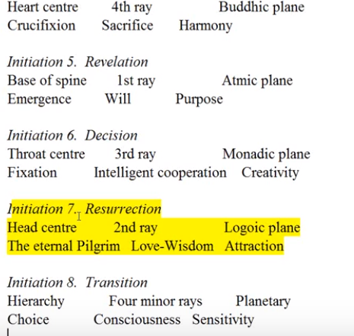

Interesting about the throat center, I mean we're dealing with a mayavirupa here, aren't we? We're not dealing with a generated body in the usual manner, you're dealing with a deliberate construction in the lower worlds, and still the centers are there, are they not? From the fifth, the sixth, the seventh, this is all mayavirupa centers, and yet they are real. So we have to adjust our sense of what is real. And what is not.
Many energy relationships have been discussed. As we have assessed the petals and their interrelationships, and this is just the beginning. There is much more in A Treatise On Cosmic Fire that needs to be correlated with what is here found in order for a more complete picture to emerge. But let's just say eventually intuition will reveal immediately the salient points. And we can search around in a mass of material, that's the problem – searching in the mass of material – and we may not know what is immediately applicable, what is immediately salient, in what the piece we need, but the lightning of the intuition immediately finds and selects what is relevant to the moment. That's really an amazing power ah! this is what is needed – you may have ten million things out – this is what is needed -- the intuition can pull out through the lighting of thought his Master Morya calls it, what he is needed.
The whole question of color has yet to be considered in relation to the nine or twelve petals as to the various kinds of egoic lotuses, although we have done that now. … The various crisis of the soul, we have done that, and the various stages of adaptation to soul life, we have done that, in the stages of human unfoldment in the human groups from Esoteric Psychology volume II, we have done that.
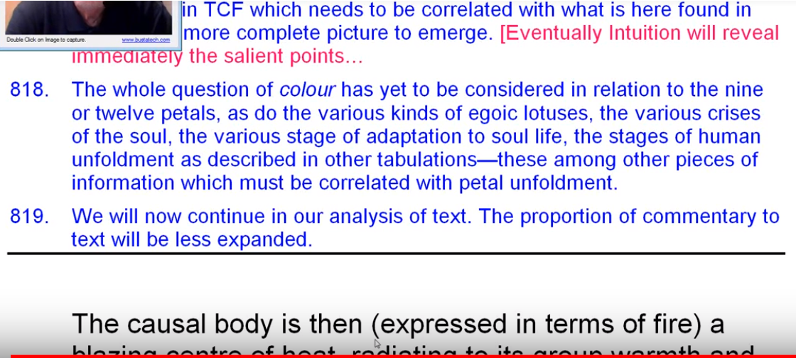

These among other pieces of information must be correlated with the petal unfoldment, and that's what I have done in one of the next things we'll undertake, which is a much more gathering of all things together. Hopefully not having to go over in such detail the kinds of things we have covered here.
We have another ... oh goodness another twenty some pages, and I think they may be worth discussing. We have some beautiful ideas here. It's pretty much about the opening of the petals at times and then it's also about the destruction of the causal body and some of the things I repeated here.

Color Discussion deferred, Gratitude, and the Great Invocation
Maybe before we get into the colors we will in fact deal with the rest of this section. I think it will fill out some things that we may need and we may see something here that is important. It's going to be a fair number of pages but we've been moving fairly fast. We've covered, in discussion of the nine petals, some almost 100 pages, 96 ninety six pages and it's a lot of commentary of course and some interpretations of the quotes from Master DK.
02:41:50 Some of these programs are of irregular length, I cannot help it, but I think we can make this one end at 2:45, which is not too bad, and we could close our commentary program 28 will be … well, we’ll be beginning of egoic lotus webinar program 29, A Treatise on Cosmic Fire on page 542, and I suppose that what remains to be said here will last another few hours of programming. It's really important information.
So we have in fact passed through the nine major petals of the egoic lotus particularly connected with the second aspect overall just as the atomic triangle is with the third, and the inner petals and Jewel are with the first.
We have yet to really explore the colors. We will do that and I think the purpose here is to somehow gather the sense this is living history this is happening as we go all of this inner process, if we have the faith in what the Master D.K. says and I don't see why we shouldn't. All of this is unfolding according to how well we do right here on our planet, with all kinds of tasks, which are related to the powers of these particular vortices that we call petals.
This is not some abstract thing, this is our life. We are living the unfoldment of these inner powers. If we know what we are doing, and what our instruments are, what energies we have at our disposal, we're going to do a lot better at consciously unfolding the petals and of preparing for greater service in cooperation with Spiritual Hierarchy of our planet.
It makes you really want to see these things way Master DK sees them. What did he have to do to reach that point? There is a science in how it is done. He has the texts that he has availabile, but he also sees directly obviously. So what is it for a man who's like that to come and deal with people like us? Talk about service so when we are taking our time to help those who have not reached our degree of unfoldment, we want to be forging ahead, forging ahead, just think of the Masters and how they revolve upon the pedestal of light and turn the other way and their light reaches us and our face we receive the light and lo, the way is not so dark for us.
02:45:35 I love that old mantram, I'm just going to say pedestal … it is it's so wonderful,
He who faces the light and stands within its radiance is blinded to the issues of the world of men. He passes on the lighted way to the great Center of Absorption. But he who feels the urge to pass that way lead yet loves his brother around the darkened path, revolves upon the pedestal of light and turns the other way.
He faces towards the dark and then the seven points of light within himself transmit the outward streaming light, and lo! The face of those upon the darkened way receives that light. For them, the way is not so dark. Behind the warriors—twixt the light and dark—blazes the light of Hierarchy.
He who faces the light and stands within its radiance is blinded to the issues of the world of men. He passes on the lighted way to the great Center of Absorption. But he who feels the urge to pass that way lead yet loves his brother around the darkened path, revolves upon the pedestal of light and turns the other way.
He faces towards the dark and then the seven points of light within himself transmit the outward streaming light, and lo! The face of those upon the darkened way receives that light. For them, the way is not so dark. Behind the warriors—twixt the light and dark—blazes the light of Hierarchy.
So what an example to set there and we have in the Great Ones from Master M, Master KH, Master DK, supposedly those who brought before the Hierarchy the urgent need to bring the ageless wisdom to humanity sooner than otherwise it might have been brought we have in them a great example of what. service is.
… Let's end with the Great Invocation … I like periodically to end with the Invocation I think it's so right for the conclusion of this kind of work, which is really dedicated to the promotion of the ageless wisdom in the world to its emergence in such a way that more minds will be liberated by it and will no longer attach themselves to such lesser formulations of reality. Of course what reality is reality? so the mind will never grasp it but the mind can point towards reality, and there are so many versions of reality conceived by the mind pointing to that which is not real at all.
So here we're given the real thing, but it takes a certain amount of humility and I I have encountered so many people you know well behaved difficult to read oh I have my own way of going at it you know and. All kinds of excuses, Oh I channel this. Oh well I channel this and I know it's true. Okay, what are you going to do?
If one doesn't know it's true, one just experiences the feeling of thinking. It's true the feeling of thinking. Okay, maybe that's pretty close, it’s kama-manas: it came from me, it's got to be true. Well you know that's nonsense isn't it so somehow humility to accept yes there may be someone who knows something more than you do. I have friends who are brilliant in the field of worldly science and philosophy, they just can't make the leap of faith. They cannot humble themselves. It’s inconceivable to them a man is the paragon of the universe – so what the highest thinkers a claimed by society have thought has got to be the peak of what can be thought of the whole universe.
02:50:00 Then of course if you make the leap of faith and you say well here's a master of the wisdom listen to what he has to say, it's just religious nonsense. You're just in the world of illusion, you're just feeding your wishful thinking, just like communism, dialectical materialism. Religion is poison. I remember that being used in relation to the Dalai Lama and Mao, and the generals who came to eradicate what Tibet had been, religion is poison. How do they know, it's just this. Concrete minded willful intellectual proud attitude so we stoop low we humble ourselves we're great wisdom is poured forth for us in a quantity we cannot assimilate even though it's the tiniest thimbleful of the ocean of Theosophy.
Everybody brings their little cup to the ocean and we have to be grateful that some have cared to lift us up sooner than otherwise we might have been lifted, and maybe spared us thousands of years of suffering in ignorance. It doesn't seem to me so much to get oneself into the state of consciousness where one can at least give the ageless wisdom a fair shot. You know, a few years of really finding out what it's all about. Embracing it for a few years at the risk of one maybe an idiot.
Okay, You know one may be a complete fool, but that's just the prideful mind talking in a way that that Hydra must become overcome pride of mind is one of the worst and pride of mind can block many a worthy seeker from the treasures of the ageless wisdom. One can only feel compassion, you know being somewhat along the path one can look back and feel compassion, for those who will not advance into the ageless wisdom. I'm sure as the Masters look at us they see so many things that we will not do, we will not sacrifice this, and sacrifice that, even the Master Morya has said, when have you ever become less through sacrifice?
So you know we're doing our bit here to advance this great gift which is being given by Master DK, Master M and others, Master Hilarion, and they're all working in their own way to give the gift, they write the books, they do things, they bring of the treasures of the ages closer to our apprehension.
I've spent the majority of my life as the seeker from the time I was maybe seventeen years old or eighteen. Now I could see the mystical phase developing and so forth, recapitulation, all that. But you know I was launched on my path when I met my teacher at the age twenty, Masonic rose a crucial man who symbolised the sun with a dot. Okay, we all have had our privileges to be connected with the wisdom.
When Christ said he would reappear in physical form, then and only then was the Great Invocation given to humanity. When have you ever become less through sacrifice? So his sacrifice, immense sacrifice. Think, the Buddha appears, has appeared, eight minutes per year at tremendous sacrifice we're told. And here's the Christ going to take his physical mayavirupa out there into visibility for 2500 years. And that is really pinning oneself down, isn't it? In reflection of what the great sacrifice, Sanat Kumara, has done.
02:55:00 All right so. The Great Invocation
From the point of Light within the Mind of God.
Let light stream forth into the minds of men.
Let Light descend on Earth.
From the point of Love within the Heart of God
Let love stream forth into the hearts of men.
May Christ return to Earth.
From the center where the Will of God is known
let purpose guide the little wills men
the purpose which the Master's know and serve.
From the center which we call the race of men
let the Plan of Love and Light work out.
And may it seal the door where evil dwells.
Let Light and Love and Power restore the Plan on Earth.
The Great Invocation
From the point of Light within the Mind of God.
Let light stream forth into the minds of men.
Let Light descend on Earth.
From the point of Love within the Heart of God
Let love stream forth into the hearts of men.
May Christ return to Earth.
From the center where the Will of God is known
let purpose guide the little wills men
the purpose which the Master's know and serve.
From the center which we call the race of men
let the Plan of Love and Light work out.
And may it seal the door where evil dwells.
Let Light and Love and Power restore the Plan on Earth.

Okay friends, that's going to be it for this, yes you guessed it three hour program. We’ll continue with that last two pages of the Tibetan, and then we'll get into the colors and then we'll get into the synthesis of the whole thing, petal by petal, and then we'll get into the charts, or hopefully you'll be able to see everything all at the same time, or less, and you'll be schooled enough in it all to know what it means. Okay, all the best to you, soon, bye bye.

