EGOIC LOTUS WEBINARS, VIDEO COMMENTARY – 25, Michael Robbins
Abstract.
Analysis of Petal 5.
This webinar is about 2 hours, 15 minutes long and covers A Treatise on Cosmic Fire page 540. Analysis of Petal 5: According to the Tibetan’s Statement: "The Petal of Love for the astral plane; unfoldment is brought about through the process of gradually transmuting the love of the subjective nature or of the Self within. This has a dual effect and works through on to the physical plane in many lives of turmoil, of endeavor and of failure as a man strives to turn his attention to the love of the Real."
Content for EGLWC Program 25: close attention is paid to the astrological, rayological and chakric implications related to the organization and unfoldment of Petal 5. This is in preparation for wider correlations to be attempted in relation to all petals after what DK has said about them specifically is analyzed.
Egoic Lotus Webinar Commentaries 25 446 MB .wmv file
Video of Egoic Lotus Webinar Commentaries 25 by Michael D. Robbins.
Egoic Lotus Webinar Commentaries 25 130 MB .mp3 file
Audio of Egoic Lotus Webinar Commentaries 25 by Michael D. Robbins.

Transcript
Hello friends.
We are continuing with our webinar or book commentaries on the egoic lotus and also our synthetic look at the petals and tiers, and finally some charts, which I hope will be useful to you as you try to bring this subject into your mind considering it as a whole.
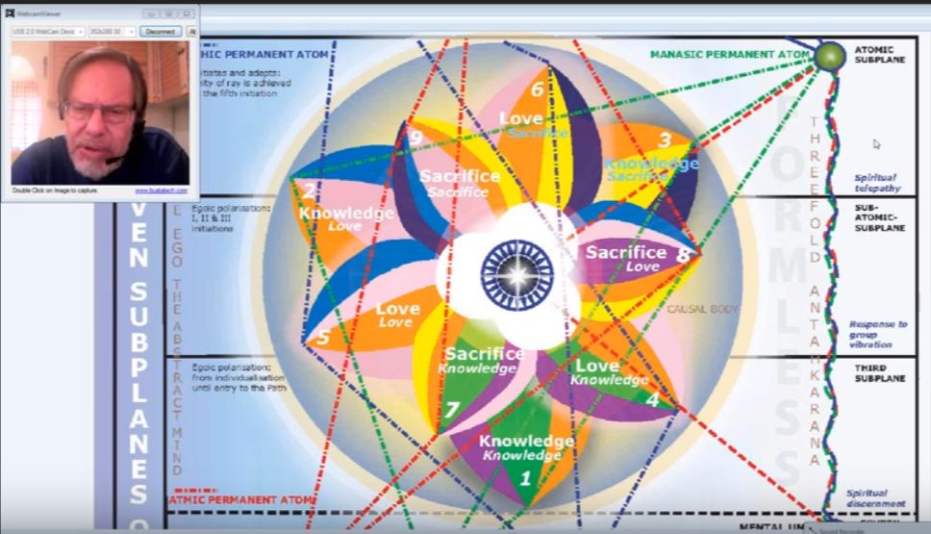
We're going through what DK said about the various petals, we’re dealing with the fifth petal the petal of love for the astral plane, page 540, A Treatise on Cosmic Fire
2. The Petal of Love for the Astral Plane.
The petal of love for the astral plane, we have a double emphasis upon the soft ray lines. This is really one of the most important petals of the nine, and may be considered the first of the solar petals as distinct from the lunar petals, the first four as I assess them to be. So this is a pivotal petal, because it's from this point on that the solar angel really begins to pay close attention to the development of its human being and becomes the downward-gazing soul.
First we will look at what we might call general impressions … I'm going to the actual page and simply read out the whole of it and then we'll take it part by part.
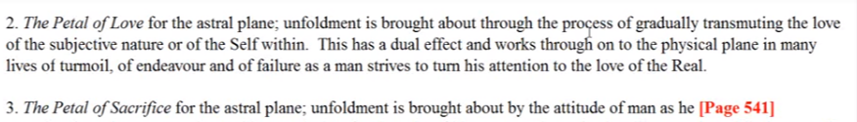
The petal of love for the astral plane; unfoldment is brought about through the process of gradually transmuting the love of the subjective nature or of the Self within. This has a dual effect and works through on to the physical plane in many lives of turmoil, of endeavor, and of failure as a man strives to turn his attention to the love of the real. TCF 540
03:00 In this case the real will be represented by the higher of the two vertical opposites, the soul and his consciousness as compared to the personality and its consciousness.
The first part of this unfoldment is brought about through the process of gradually transmuting the love of the subjective nature or of the self within. I suppose making sure that type of love replaces the commonly expressed love nature in form, or the love of the personality. Perhaps this is a little bit of a strange sentence, I find it a bit strange. In occultism the subjective nature is the soul nature, and it is definitely mentioned. It is too early to be speaking of the spirit, I suppose. It looks like the Self within must indicate the soul. Would soul love need to be transmitted? Or, would the lower type of love be needed, or have to be transmuted into soul love? And soul love eventually be transmuted into a still wider and greater type of love, the love of the Spirit with the fourth petal processes?
The man began to understand that he was an essential duality and he worked in a conscious way to balance this duality. Let’s look at it again, the petal of knowledge for the astral plane, petal four, unfoldment is brought about by the conscious balancing of the pairs of opposites and the gradual utilization of the law of attraction and repulsion. Attracting that which is related to the higher of the pairs of opposites and repelling about which apparently has no relation and which would confine the life to a lower sphere of expression.
The man passes out of the hall of ignorance where from the egoic point of view he works blindly. He doesn't work blindly otherwise, he's fully alive in the world of the senses and even intelligence in the world of the senses. But from the ignorant point of view he works blindly, and begins to appreciate the effects of his physical plane life by a realization of his essential duality he begins to comprehend causes. So he understands that much that proceeds from him. Will proceed from the lower of the pairs of opposites (his personality) and will cause certain effects in his normal life and other streams of energy proceed from the higher of his pairs of opposites and will create in the outer world a different kind of effect, and he has to look at these two effects and make a judgment as to which he will follow. But the real transmutation of the normal love nature which does penetrate into the world of form, but one day must no longer love, in its own right. And that which is of form it can love form but form as it represents the greater consciousness and the greater reality.
07:00 With the fourth petal processes he begins to understand that he was an essential duality. I wonder how many of us think in that way? Even some very intelligent people that I know do not think in that way. They are still under the Leo phase of self-apprehension and think of themselves as a personal unity, with this higher of the pairs of opposites simply being a figment of the imagination of gullible people. Through fifth petal processes he actually begins to know himself as an inner self, a soul. Even more so than as a personality, eventually within the petal.
The sentence of text is worded in an unusual manner. Of what sort of transmutation are we speaking? Usually it is the lower nature that needs transmuting and not to higher, except in the very highest stages of spiritual development. And yet here the man is (presuming these words were taken down correctly) the man is to transmute the love of the subjective nature or of the self within. Or maybe the direction in which that love extends, because all things come from the self within. Perhaps that's it.
09:00 So is he to transmute downwardly? I mean is this task similar to the rule four, for applicants, let the disciple attend the evocation of the fire and thus keep the wheel revolving.
Is this active transmutation really a kind of evocation which brings the fire of the inner self into contact with a gradually integrating personality? That’s what it would mean for the love of the self, love which originates from the inner self to penetrate more deeply into the personality. This is certainly a possibility and at least for me it's hard to imagine what else might be indicated. It’s either one of those enigmatical forms of words on which we have to ponder. Or it could be a mistake. But I'm not one of those who tends to jump at the possibility of a mistake before I've tried to work through the possible meaning that might be hidden in an unusual form of words.
Or, if we look for an upward transmutation, can the love of the subjective nature be the love of the subtle nature? So that is an interesting idea, I think. It's of the subjective nature, but it is of the self within and that's problematic the subjective nature sometimes can be can consider to be the psychological nature. Would we then be speaking of the transmutation of the human psyche and its customary loves into something higher? I assume that in general that's what it means, that the kind of love we have will be transmitted into a higher kind of love and that the inner and higher kind of love will be more easily brought down and expressed through the personality.
At least if I have to round this off in my own mind, temporarily, this is what I think is the meaning. And of course these customary loves must be elevated. If we look at the technique of integration into the world worlds of form that love someday fail to penetrate. So we have to cease loving form. In its own right and love form as an expression of the one infinite being. Anyway, I just have to say that for me it's an unusual form of wording and I'm not certain that the wording warrants this particular type of interpretation which I would find sensible and agreeable. When there is uncertainty one continues to ponder until the degree of illumination comes.
12:40 In general we understand that there is a transmutation love. It moves from the love of form to the love of the real. Now it is possible of course to look at form and still realize that it is the real. Not in and of itself, not in terms of the form per se, but an expression of that which is real. It’s entirely different to look at forms as if they have their own reality, formed by form, or as if they were representatives of one reality and expressions of that, and that the reality would come from back from which they derive rather than their own particular configuration or appearance.
Further if we are simply speaking of the orientation of the inner self whether towards the personality of the soul then the fifth petal process can easily be understood. In other words, the higher of the pairs of opposites which the soul angel is infusing, is beginning to become a greater reality in the consciousness of the growing individual and he has a different idea now about what it is that is real and after certain points of crisis in this petal the man will be oriented towards something within his nature which is truly the higher self and which connects him with the higher worlds and with a different type of reality than he has pursued lo these millions of years.
Shall we say this orientation towards the real, towards the self within, as a dual effect and works out onto the physical plane in many lives of turmoil. When the influence of the higher self is brought into contact with the personality, many lives of turmoil are almost inevitable. Symbolically the sun and the moon are passing through their first intensive clash. The sun symbolically has not yet been that powerful in the life of the individual and his consciousness has been held within the world of form, but now in this Leo petal (from one perspective Leo) the power of the solar factors is growing so strong that there will be a definite clash between energy tendencies which are quite opposite: one seeking to preserve form and involve the consciousness in form and the other seeking to abstract the consciousness from form or at least from its perception that form is a reality.
16:30 From another perspective when the inner subtle self begins to approach the soul the higher self in earnest, turmoil does result. Lives of conflict and many of us, either now, or recently in the past, or perhaps imminently, are engaged, have been engaged, will be engaged, in this type of friction between the way of the sun and the way of the moon.
I've often considered petal four and five to be related in a way to Sirius, and that two energies are involved there are: one represented by the moon and one represented by the sun. But obviously as we move through the processes of this fifth petal, we are trying to become solarized, and our first solarization in practical terms becomes the first initiation, which I do believe is taken when the fifth petal is completely unfolded, and the rod of initiation applied in the seventh petal. So many lives of turmoil of endeavor, and of failure, as a man strives to turn his attention – and we could insert from the love of form to the love of the real. So far the majority of human beings think that form is the real.
18:18 So from the wording of the section of text immediately above it would seem that the orientation of the inner man who strives to turn his attention to the love of the real is a definite consideration in this fifth petal process and we would call this reorientation, or reversal, the first attempted reversal of the wheel is going to occur in the midst of fifth petal processes. And this means that in relation to the fifth petal processes, it is not only a question of how the higher self intervenes in the life of the lower man, but how the lower man orients himself towards the soul.
Here we have an interpenetrative process with that which is above growing into that which is below and vice versa. In a way it seems a kind of Geminian, or Libran process, it operates from two angles: the personality strives and the soul descends. Through fifth petal processes man is attempting to turn his attention to the love, that's the word, he is not only recognizing the real, which he may have begun to do during the latter part of the fourth petal processes, but he is attempting to love the real.
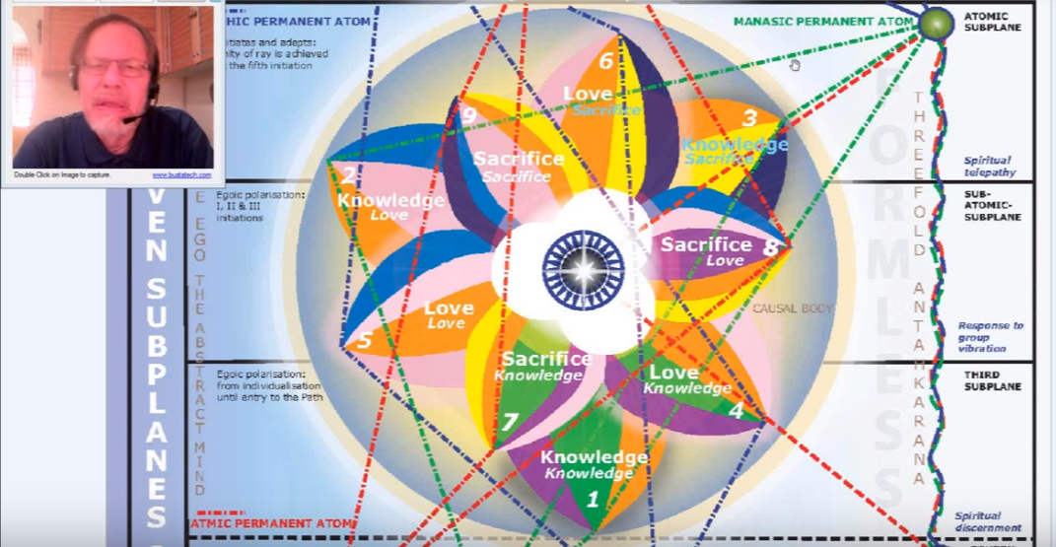
This is a petal of love and … as we look at it we can see the orange of Venus, but the rose color is there as well bringing in the sixth ray, and it's doubly emphasized, as well as the blue again. The sixth ray and blue has the association also with the second ray and he even the orange which probably represents the presence of the presence of the Venusian ray in this process will be connected with this planet Venus which has such a powerful essential second ray.
There's a real blend here of a fifth ray and the two-six line, the love line. This is where the real pivot out of form and into a deeper reality is occurring, and that pivoting is finally crowned by the first initiation under the rod of the Bodhisattva. He turns his attention to the love of the real, and it is more than simply a recognition, it is an aspiration, it is a gravitation: both an aspiration and a gravitation to a higher and deeper kind of inclusive love.
So fifth petal processes the real has become a significant factor in his inner life. Whatever he calls the real. I suppose in the beginning the love of the soul is the real. Later it may be the presence of the spirit which does not mean that the love of the spirit is not included in that. So a major review orientation has taken place or is taking place and a process of redemption has begun. Whenever you see the re- words think of Uranus and suggest Uranus. One does it again but in a better way and one re-versus or flows in a different direction. You say re-verses, reverse used to flow in a different direction. I'm thinking of the of the relation of the word verse to pouring or flowing.
23:30 From one point of view this is a kind of reversal of the wheel even though there is a later kind let us say, a more final kind of reversal of the wheel, which pertains to the processes which occur between the second and third initiation when mental polarization is achieved and the man, successful in his encounters in the desert with the attempt or the tempter, the devil, succeeds, in assuring himself and others that he will move on to the third degree and onto the Syrian line and there will be no deflection toward the left hand path, the path of form. It is a reversal of the wheel, not a complete reversal by any means, because there's another stream which continues to flow along the way of a form, even as the wheel of consciousness is attempting to advance so there's an immediate friction between two wheels found at this petal in the processes of this petal.
The energies and forces symbolized by the sun which is spirit-soul and the moon, which is form, they struggle and in this petal if all goes well the sun begins to prevail. If all does not go well, the lowest aspect of the sun, the ahamkaric aspect, prevails and serves the lunar form, the personality. So then the then you have an encapsulated sense of I-ness.
Okay, so many people find themselves in this stage and on the path of aspiration within the latter part of these fifth petal processes the struggle between the demands of form and the possibilities of the soul, the insistence of the soul for a higher life create quite a turmoil, quite a friction. We can understand how the fourth ray would be involved here pulling in two directions, after all that is a central petal. Fourth ray would be involved with counter poles, above and below.
It is during the opening, that's just generic, I just want to say it is during the work within this fifth petal that the solar angel gives its first really conscious attention to the struggling personality. From this point spiritual evolution can be consciously hastened if the man who is the personality acts correctly and orient himself properly to the downward-gazing soul. This is DINA I, page 714:
You've been told that the soul is in deep meditation for the greater part of the cycle of lives of any one individual and that is only when a fair measure of personality integration is set up that the soul's attention is drawn away from its own interior consideration and egoic affairs to those of its shadow. When this happens the egoic group is definitely affective and the Master (upon the same ray as that of the soul concerned) becomes aware of what is esoterically called a “downward gazing soul.” On the path of discipleship, the ego is all the time consciously aware of the striving personality and there comes a stage when (towards the end of the path of evolution) the soul recapitulates the evolutionary processes of involution and evolution. Soul energy descends and personality force ascends and this takes place through a process of conscious descents and ascents. I refer here to a process which is undertaken by the soul under hierarchical impulse and not to that in which the personality invokes the soul under the desperate need brought about in the lower consciousness by the gradual cessation of desire. DINA I 714
29:50 I think this paragraph has what we are looking for. I find it so interesting that the gradual cessation of desire or of orientation towards the satisfactions of the outer world does produce then a desperate need on the part of the personality, a need for something to replace the orientation of desire which had heretofore existed.
Okay, that reference was correct. And why am I saying this: that we are also told that a man can express as a genius once the two petals of the love here are opened? Well we understand that well at least we know that do we understand it so let's just say that's from the Education in the New Age. It was a phase of conscious descents and assent or a stage to be passed through of conscious ascents and descents.
Actually I brought this little quotation in about the two petals in the love tier, one of which is petal five of course.
Creative work can be carried forward when two of the knowledge petals of the egoic lotus are unfolded. The man can produce, through knowledge and creative energy, something upon the physical plane which will be expressive of the soul's creative power. When two of the love petals are so are also unfolded, then a genius makes his appearance. This is a technical piece of information to those students who are studying the science the science of the ageless wisdom but it is of no value to those who do not recognize symbology or the fact of the higher ego or soul. ENA 18
It is clear that genius involves the expression of the higher ego or soul and already there will be work being performed in the mental tier, if the person is going to be a first degree initiates anyway. And where that expression is missing or insufficient there can be nothing of that which the world recognizes as genius. The higher ego or soul is even present to a degree the soul creative power in relation to the type of creativity possible when simply two petals are unfolding. This would have indicated to us the Atlantean period and probably that which goes beyond it. Was creativity possible during the Atlantean period? Apparently it was, even though the highest aspects of creativity were in the hands of those who had achieved far more greatly than the average human being at that time, and who were able to impress upon the average human being the designs of what is to be carried out.
33:48 We might call the fifth petal then the pivotal petal in human development. The fifth petal signifies at a certain point in the many lives of turmoil, a genuine orientation towards the fifth kingdom of nature. It may not be that way in the beginning of the fifth petal processes. Perhaps not in the beginning or for practical purpose. That is a good general way to cover the kind of attention that's given to organization, vitalization, unfoldment, opening.
See the man himself is not working to do this in the egoic sphere, it is the solar angel, the angel of the presence, that is taking what the man has done in the lower worlds and making possible then this instilling or institution of quality in this structure that we call the egoic lotus. The man consciously does not have the intelligence or the capacity to do this. But based upon what he does in the lower worlds, so will this organization and unfoldment occur. The pivotal petal and the true re-orientation towards the fifth kingdom. It is one thing to be aware of this higher of the pairs of opposites and another thing to be determined to live as if one were the higher of the pairs of opposites, which is more truly the truth.
From an astrological perspective, zodiacally considered in relation to the counter-clockwise wheel which is the wheel of consciousness the wheel on which we should be revolving and towards which our focused attention is given, the fifth petal is a Leo petal and it fits remarkably well.
You have been able to see that I'm sure in some of the things I said, five the Leo petal, fifth silent fifth petal orientation toward the soul and towards the fifth kingdom of nature and towards the fifth creative hierarchy.
So why is there such a fit here? We can say that at this particular point of evolution under discussion it is the fifth kingdom of nature that is coming into view and it is very much so also at our particular historical period. This is the transition that is offered to us, offered to some at least, not all, can't be, but the transition of those prepared souls from the fourth into the fifth kingdom. The light of the soul is the particular kind of light which comes into the human kingdom through the sign Leo and we might say from the higher of the pairs of opposites streams forth the light of the soul.
The fifth is a very luminous petal and that's why when there is a mastery of the processes of this petal and it is fully opened, the man can become (at least in my estimation) a radiant Lotus – he’s beginning to become a radiant lotus. Thus the egoic lotus becomes interested in personality development, in this petal he does, so Leo is closely related to the solar angels and to the individualization process which occurred under the impulsion of the solar angels occurring in Leo, or an astrological period dominated by Leo, and having with it also the Sagittarian and the Geminian influence.
38:55 It's interesting that all those signs, at least in our solar system, constellations let's call them, are quite bright when you look into the sky. Sagittarius is remarkable when you locate it, it has a real luminous presence, Gemini is clearly so, Leo is clearly so, but not so much Cancer and Virgo, which were important in the previous solar system moving at the beginning and end respectively of the previous solar system. One begins to wonder if from the perspective of earth in those far off times those constellations appeared to be brighter. One wonders.
The relativity of the ascension and subsidence of stellar intensity relative to any viewer is an interesting subject and the symbolism at least is working out because Cancer is practically an invisible constellation now, you have to really know where to look. If you look on either side Leo and Gemini are perfectly obvious. If you look between Leo and Scorpio, it's hard to find Virgo. … if you know what to look for you can find it, but Libra is now sort of attached to the Scorpion and represents its claws, and it's fairly luminous and the Scorpion is luminous, more so than Virgo. So symbolically those two constellations which were maybe of even more importance in the earlier solar system appear to us as, in our solar system, the second major, less luminous.
41:10 This association of the fifth petal with Leo, the solar angel, the Leonean being becomes interested in the personality becomes a true guide, a downward-gazing soul, always aware of what's going on, whereas before this solar angel was involved with interior matters, and was not necessarily always aware of what the personality in an earlier stage of development was doing.
Also, that the stage of the dominant personality is reached under the influence of Leo dominant personality not just the integrated personality but the dominant integrated personality. The fact that a powerful dominant personality is forming during the fifth petal processes, especially earlier in them, is the reason for the many lives of turmoil. So there's a struggle between a powerful personality with many presumed prerogatives and an increasingly insistent soul. Where you have two types of energy moving in contrary directions you have a clash of streams and the turbulence is produced. We see where two branches of rivers come together and whirlpools and other cross currents are created.
Leo is said to be the most human sign of all (EA 161), It is during the fifth petal processes that the human personality steps forth in all its glory and yet with the potential for resisting the lighted solar spiritual impulses which are also closely associated with Leo.
43:40 So indeed there is quite a connection between this fifth petal and Leo. Other signs can be noted as well. There is probably a way in which the period represented by any petal can be examined in relation to all signs and their particular type of contribution to that period of development can be understood and noted.
From the clockwise perspective we may consider the fifth petal either a Scorpio petal … When we begin with Pisces we have Pisces Aquarius Capricorn Sagittarius, Scorpio. If we begin with Aries, it should be a Sagittarius petal. Aries, Pisces, Aquarius Capricorn Sagittarius. The fifth petal can be associated with that central sign Libra, but Sagittarius for reorientation is I think is very good, one sets one's sights higher. The point to consider is that Libra as a central sign associated with a central petal, but not because of the clockwise numbering. By beginning with Aries we have a Sagittarius for our assignment for the fifth petal. That should be clear …
Libra can be associated, and Scorpio is associated with the fifth petal for a couple of reasons not just beginning with Pisces at petal number one which were allowed to do, but because of the assignment of water signs to the astral petals. At least one of these signs is related to Uranus. If we consider both Libra and Scorpio Uranus is related to both, but I'm arriving at Libra in a different way, I'm saying central petal central sign, it's the pivot point, Libra is in a way an important pivot between the individual development signaled in the zodiac and the group development signaled in the zodiac.
47:25 Interestingly both of the signs, Scorpio and Libra, are related to Uranus, Libra is ruled esoterically by Uranus, and Uranus is exalted in Scorpio and Uranus DK tells us always is directly implicated in the reversal of the wheel. Which means that energy streams within the body are moving in two contrary directions, and not only with higher energies flowing through the upper chakras, and being directed immediately to the lower. Now there is also a direction from the lower chakras to the higher and perhaps this is a conflict with the energies which are habitually seized upon by the personality and by the lower chakras.
In the same way the fifth petal represents the transition from lunar to more solar living. If the ahamkara grabs the consciousness, it's a bit like lunar living. It is still very personal living, the magnificent personality. The four elementals coming together in Cancer is the integrated personality and here if they come together and display themselves under the most limiting of the Leo types of expression then we have a glorious personality.
I'm reminded of the French king, of course he was actually a Virgo, but he said, “after me, the flood” (in French) He had a great sense of his own importance, he did have the Moon and Venus conjunct in Leo. So he had a certain self-fascination and his ahamkara was considerable.
50:00 So in the same way the fifth petal represents the transition from lunar to more solar living. When you have the aggrandized personality with its solar component it's a bit like exulting the realm of the moon and making the realm of the moon shine with personality light. In other words the light of the sun is appropriated to make the personality shine. But there are higher expressions of the light of the Sun.
It also represents in a way the transition from limited Saturnian living, very confined, and thinged, in a way, made of a compact and formal presentation of self to a greater capacity of Uranian living which has all of these connections, like Mercury does. So we have this choice in the fifth petal. In the fifth petal will we be the glorious and self-glorifying personality, or will we be the through aspirant working towards the second and higher phase of the Leonean self, the I Am That phase? Instead of the I am phase.
Speaking of Libra, even if for the wrong reasons, Libra is the balance between solar and lunar life. The idea is that during fifth petal processes the balance will be tipped in the favor of the soul but not without a struggle. The struggle will be heated and will go on for lives because Scorpio is also there. Scorpio clearly represents the struggle and the will to dominate the hydra. The will to dominate is also strongly associated with Leo and the will to persist as the magnificent personality is also there. The will to persist as the magnificent.
It’s so clear, let's look at some of the stars, and I don't mean those in the sky but those in Hollywood or wherever films are made. It's really hard for some stars to become less important, to be just stars instead of the magnificent sun in the middle of the microcosmic sky. There is a sense in which being a higher type of sun in the microcosmic sky is very good, but the ahamkaric star is much oriented towards the personality. So the ahamkaric star is oriented not towards the higher self but towards the glorification of the integrated personality.
I'm thinking of some people who are just so blazingly present in front of the public; they take up the stage if you know what I mean. Now how do they subside in their own estimation so that they become a star in heaven just like all the other stars in heaven, rather than the sun which blots out the light of the other stars?
This is of course Scorpio that tends to put that ahamkaric tendency to death. So that's why the Scorpio stages is the release of Leo as it says on page 333 of Esoteric Astrology, so Scorpio works against the ahamkaric Leo and brings about a better sense of proportion. The blazing sun occupying the center of consciousness becomes simply another star in the heavens. And there are some people when they they're so used to the adulation and to being the center of things you wonder how they could ever achieve humility? They can surprise you though because that DK tells us that in relation to Leo humility eventually is one of the great possibilities and the heights of service can be found in this sign as well as in Aquarius. So the humbling does occur, and then a change of identity does occur as well, and so much of this process is fought out in this fifth petal.
56:00 The struggles of Hercules are intense during the fifth petal process. Interesting me the two labors for which Hercules was best known where the slaying of the Nemean lion in Leo and the conquest of the Lernean hydra in Scorpio.
Now from different methods of assignment, both of the signs show up in the fifth petal. I reminded myself here that you can get Scorpio into the fifth petal by beginning with Pisces, which DK sometimes does as he's talking esoteric astrology about the meaning of different houses and signs, but the other way to do it is I've discussed in the previous petal is to put Cancer in the first petal, Scorpio in the second, Pisces in the third, and I've given the reasons for that. The reversal of the wheel, let’s just say that Libra is associated with a fifth petal because it's central, and Scorpio for a couple of different reasons.
But both of them have a powerful Uranus and Uranus is the planet of reversal. You move towards the archetype and not towards the patterns which have simply been the conditioning patterns, and are probably not archetypal at all. You rebel against your conditioning and you move more towards your authenticity. Under Uranus you rebel against your conditioning and move towards authenticity genuineness. It's a different thing entirely, the conformist and the non-conformist. The conformist conforms to conditioning – how things are rather than how they should be, which is governed by the archetype which is Uranian. The archetype determines how things should be, and is Uranian.
From another perspective when comparing Leo and Scorpio, it is said that Scorpio stages the release of Leo. I mentioned this. And to some extent and later at the second initiation which involves work within the eighth petal we can see this process working out as the fifth petal unfolds. The idea of unfolding as considering unfolding as generic development. I’d like to have exactly the precise words here but I don't really have them. So by orienting rightly towards the Leonean higher self, the consciousness is being released from the lower expression of Leo which emphasizes the personal ego which is what we think of ourselves, what we think we are. Lower ego is what we think we are as opposed to what we really are.
1:00:22 Such an important petal and one I think in which these processes go on for a long time. Many people are involved here, as they are expressing themselves as dominant integrated personalities, as they're going through the struggles of disillusionment to the glamorization, as they determine that they will aspire towards something higher and marshal all their forces there, and as they become first degree initiates. So they are being aspired and they are being tested on a probationary path maybe five phases all in all connected with this fifth petal, five phases and the fifth petal.
The dominant personality, the struggling personality losing its power and centralization, the reoriented personality which is the aspirant, the probationary disciple, and finally the first degree initiate. All those five phases I think can be associated with its fifth petal and with different stages in the general unfoldment processes, in the general work within this petal, or in the reflexive action within this petal as work is done in higher petals. Scorpio is one of the transmutative signs and so is Virgo. The glyphs of both of these suggest the M of matter and matter responding to the vibration of the previous solar system, which must be transmuted.
Under the influence of the soul the quality of matter in the vehicles of the substance is gradually improved. That's what transmutation is, heightening vibration, purified reaction, but that in vibration purified, and the consciousness begins to be released from preoccupation with form. This is even more the case in relation to the sixth petal, which is a Virgo petal, when one begins counter-clockwise numbering with Aries, and a Scorpio petal if one numbers clockwise beginning also with Aries. If we're going clockwise then from Sagittarius which he is that aspirational ruler of the fifth petal, we also reach Scorpio in the next petal which is the sixth.
Certain of these signs have very definite meaning with the processes undergone within the particular petal. Others are perhaps less important but still are important. So we remember that the water signs in general according to our hypothesis are related to the love tier because it is the petals of love for the astral plane. Petals of love for the astral plane. So we related Cancer to the fourth petal and we will relate Scorpio to the fifth and this gives Scorpio a kind of double emphasis in that fifth petal deriving from a clockwise beginning with Pisces at the first petal.
1:05:30 For the first two tiers, our progression through the triplicities has been: cardinal, fixed, mutable. Whether we begin with Aries and go Aries, Taurus, Gemini – Aries cardinal; Cancer, Leo, Virgo – Cancer cardinal; or whether we assign the petals according to triplicities, cardinal begins it. Capricorn cardinal. Scorpio Pisces. And it remains to be seen whether the sequence beginning with a cardinal sign can be applied with the same confidence to the sacrifice petals and the synthesis petals. I have already discussed this idea that with the sacrifice petals we can begin with Sagittarius, well as with as with Cardinal, Aries. I think I've given a fairly good explanation of that earlier in the work according to what is accomplished in the abstract mind in the seventh petal and in relation to pure being in the ninth petal.
Because the fifth petal marks a point of reorientation we can say that Aries, opposite Libra, is also involved. I'm remembering the crisis of reversal is associated with Aries. Let me find that in Esoteric Astrology … and it would be Aries, the crisis of reversal. (EA 472).
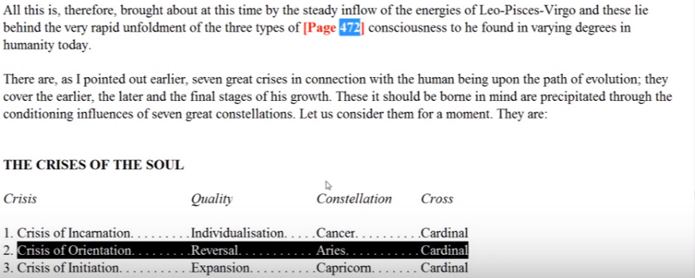
Aries is always beginning something new, and this reversal of the wheel in relation of the fifth petal is something new. Aries fits there. So opposing the middle sign Libra which we can associate with the fifth petal because of the centrality of Libra and the centrality of the fifth petal we would have Aries, both because we have seen that when we use an opposite sign to . a sign which is strongly connected with the petal, we find that the opposite sign is also quite strongly connected. Also simply because of the crisis; a crisis of reversing the wheel.
There's a kind of a fresh start here in the human developmental process as the man turns towards his soul nature and becomes increasingly aware of the solar angel although he may not know it is the solar angel, but simply may call it a higher power. We have to realize that not all people are trained in eastern occultism so they may have different names for the aspects of the energy system which we name in a more technical manner. But anyway a fresh start, a reorientation, and there is Uranus again, Uranus is the hierarchical ruler. It’s when you're going to do something in a new way, start off on a new path, and a new foot so to speak, that Uranus comes in and offers a fresh alternative to the way things have been proceeding.
When we count clockwise, beginning with Aries, Sagittarius is assigned to the fifth petal. The ‘arrow of consciousness’ we might say, the direction in which it is turned must be oriented towards the soul. It is no longer desire, hunting for the objects of desire within the lower worlds, but setting one's sights higher. Expanding one's vision under Jupiter and taking in the higher self is the true objective. But only after having failed in the personality sense or seeing that the personality as glorious as it seems to be, is too small. Too content, the consciousness, which is essentially the sentiency of the spirit.
1:10:45 From a planetary perspective, this is obviously a very solar petal. The Sun rules Leo, initiation is a solar not a lunar process. Even the initiations of the threshold are solar: we are to become sun-like – replicas of the solar sun within our natures. It all begins here with the unfoldment of the fifth petal, final unfoldment really.
The sun stands at first as the dominant personality, the sun stands as the defeated self. The sun falls in Libra. Well to the sense that Libra is involved in this pivoting, from the lunar way to the solar way, the ahamkaric sun becomes defeated in Libra, and then a higher type of sunship emerges. The soul becomes the sun, then the spirit becomes the sun, a still higher part, it’s petal petal petal.
When I think about it, Aries is one of the rulers of the ninth petal. It is the sign in which the sun is exalted, not just rules. This is the transfiguration, the exaltation of the glorious sun, and the entire change of light toward soul light and the first solar initiation. I don't know whether I mentioned those things earlier maybe I did sometimes I mention the same things in different places and because of the context in which they are mentioned they may become easier to remember, to store in the mind.
1:12:40 So the sun is the defeated personality, but the sun also as the higher self, now emerging into greater prominence in this petal, so that it becomes the real object of one's attention. The sun is the a distributor of the second ray energy, which obviously becomes important when the solar angel is exerting its influence. In other words, in the fifth petal, generically speaking, we are moving from the general number three to the general number two, and in the ninth petal we begin moving towards the monad or the one.
Finally, when we're really engaging with the solar angel, and it becomes a downward-gazing soul, when we're influenced by these great uplifting streams that come from the solar angel, it's happening in the fifth petal. We’re becoming solarized at that point. Some forms of solarization are confined to ahamkaric and seemingly anti-evolutionary because there's nothing that gets in the way of evolution like a big fat ego of the lower kind. But later, the meaning of ego becomes capitalized as it were, not lower ego at all, and it the higher self which we share with all others.
The planet Venus should also be associated with the fifth petal. There is the fifth ray of Venus surely, but the fifth petal because Venus represents the solar angel which becomes an increasingly magnetically influential factor during fifth-petalled processes. People who are engaged with the work of other petals do not consider the solar angel as an aspect of themselves; they don't consider the solar angel at all. Maybe vaguely some kind of deities, some kind of God, but not that they are allied with God and that there is within them that which is of God, and which is in essence God itself.
1:15:15 Venus expresses the fifth ray and we are dealing with the unfoldment of the fifth petal. All these numerological affinities and correspondences have to be taken into consideration, where the number is the same or on the odd or even line there's going to be a connection. And there are other methods of connecting a number logically even when the number is not the same or on the same one-three-five-seven or two-four-six line such as three and six, they are connected, but there is one on an odd and the others on an even line, but they are connected mathematically and that is significant occultly, and they both share many aspects together.
Venus will be important here. It’s the first real fruition of the individualization processes is occurring in this fifth petal where we have produced the expression of the first third of the developmental process; the dominant personality. That is an achievement. Later we will produce the transfigured dominating soul, and later still we will produce the dominating monad itself, also a solar factor, but this production of the glorious, colossal, magnificent, radiant personality is a victory of a kind. Who would have thought it when individualization first occurred within the bulk of ancient animal man. So what a huge, transmutative process has been going on and a huge process of transformation.
Mercury, the planet of the fourth ray at least in the soul nature of the planet, represents the conflict and turmoil experienced by the individual passing through fifth petal process. Mercury, the star of conflict what an interesting way of looking at this. Also in a sense of reconciliation of that conflict. So Mercury has as well much to do with the fifth rate in its higher nature and maybe in its mental nature too. We were not given the mental, emotional and physical etheric rays of the planetary logoi, we assume they will have them even though the emphasis is more on the other aspects of their nature. So fifty ray, fifth petal; Venus fifth ray, fifth petal. Venus, the soul, Mercury fifth ray in the monad, maybe in its mental nature and that would be quite enough really.
1:18:40 Mercury interestingly is also the hierarchical ruler of Scorpio, which features strongly in relation to the fifth petal. Can we use hierarchical rulers? Well we are beginning the work of the first initiation. Mercury is definitely connected in this way and engineers the conflicts we find in Scorpio, as does the fourth ray, but also engineers the victory through elevation, which we find in relation to Scorpio, whether Scorpio first initiation Scorpio second or Scorpio third initiation. Finally really in the third initiation Mercury steps into its full right as the representative of the intuition and give that final victory as the lower nature is lifted up and seen in the light of the intuition.
Mercury assists here in overcoming some of the earlier stages of illusion. Since there was an attempt during fifth petal process to love the real, we remember discriminative Mercury is necessarily involved as the man makes the efforts to discriminate between the real and the unreal. The importance of the fourth subplane Mercury, its ruler, and the intuition. The fourth plane Mercury is rather discrimination, and on the less formal side, the intuition. The cosmic ethers are still planes of form from the cosmic perspective but from the perspective of our type of consciousness immersed in the lower worlds they appear more formless.
1:21:20 Two ancient mantrams begin to become meaningful during the fifth petal process: lead us from darkness to light the will to illumine found in Leo, the luminosity of the radiant Sun. And lead us from the unreal to the real. The lower of the pairs of opposites has been the representative of the unreal and the higher comes in as representing the real. And the soul in this context will represent the real.
Moving on, some theorists have suggested the value of Jupiter in relation to this petal. The regime of limited materialistic Saturn, or that side of Saturn to which the form responds is in process of concluding and second ray Jupiter, representing the soul, is growing in strength. Jupiter is the ruler of Sagittarius, which can be associated with this petal if we begin counting clockwise with Pisces. Jupiter has been looked at as the first ruler of Leo; Jupiter instead of the sun as the first ruler of Leo.
This is hinted at in Esoteric Astrology. Indeed from one perspective Saturn does rule the personality which expresses the third aspect which is the same as Saturn’s powerful third ray. And the soul expresses the second aspect the second ray, which is Jupiter's major ray as far as our solar system is concerned, of second ray Sol.
The power of Uranus involved in the reversal of the wheel is definitely implicated. Let us remember that the fifth petal is a petal of transmutation and seventh ray Uranus is the great alchemist. Alchemy as involved in among other things, the transmutative process.
We remember the word transmutation was used here, transmitting the love … Gradually transmitting the love of a subjective nature or of the self within. (EA 541).
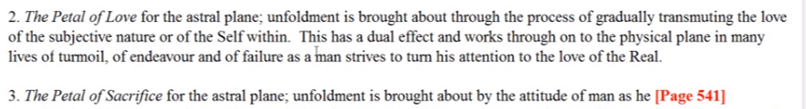
It’s always the self within, under various disguises, as it is operating within the lower worlds. It is the monad in fact, in extension, which is operating in both the world of personality and in the world of the soul. There's only one identity at work here, but we call it by different names according to the stage at which it is expressing.
There is transmutation going on here and the greatest transmutation is the transmutation from the moon to the sun. From lunar tendencies to solar tendencies. That is the transition which every human being has to make. We are moving from the dense physical body of the solar logos into his etheric body, and we are at last becoming attuned with the major theme of this solar system which is love-wisdom. We are no longer to be subjected to the primordial ray which is considered to be the third ray and relates to the previous major solar system.
In that movement from the three through the two, from the moon to the sun, from Saturn to Jupiter, lies much difficulty. That’s really what's being acted out and expressed on our planet at this time in all of the troubles we have within the human family. There is the personality tendency of our third ray planet to remain with the past, there is the progressive tendency of the second ray soul of our planetary logos to advance into the future. And that reflects the movement of our solar logos from the vestiges of his previous solar system under the third ray to the control in this present solar system by the second ray.
We all have this issue and we're all trying to make this reversal, and we all have to deal with the pivot point in which the two tendencies can become extremely conflicted. Both Jupiter and Uranus seem to take over from Saturn when Saturn represents form, limitation or materialism. It often represents far more than that we realize that Saturn does often represent far more than these condensed factors.
We remember that Jupiter with Uranus suggests beneficent organization (EA 71) and even in another book Esoteric Psychology I, beneficent reorganization, the emergence of the new and better order the order of the soul. The geometry of the soul. I would say at the fifth petal, the geometry of the soul begins to make a conscious impression upon the consciousness.
Now on the solar side of the equation, we have the Sun, Venus, Jupiter and Uranus during fifth petal processes and I should not leave out Neptune, as a veiled ruler of Leo, and active through the Christ/Neptune at the first initiation. Anyway, on the solar side we have these planets and they struggle against Mars. The ruler of Scorpio. Saturn in its materialistic expression. Remember how we decided to that both Mars and Saturn could be related quite strongly to the outer petals the tier of knowledge and could be considered, from a certain perspective, each of them the ruler of that tier. Well these other planets are coming in, in a spiritual sense at the fifth petal and struggling against those tendencies to remain encapsulated and egocentric in the lower sense
These planets Mars and Saturn are in a way imprisoning planets, when they are responded to in a negative sense or a lower sense they hold the soul as a prisoner of the form.
1:30:40 Neptune … has some influence at this petal as the man attempts to move into an increasingly subjective world, sensitively, for Leo is the sign of sensitivity, we've been told, that sensitivity is particularly to what is of the self and what is of the not self.
This is a reaching from the dominant personality with its very strong lower Martian solar plexus influence, from the dominant personality under Leo to the higher self also under Leo but representing the heart of the sun and therefore far more of the real. We’re attempting to turn our attention to the real in this case Neptune is not the illusory as it so often is in relation to the lower astral plane, but it relates to the higher worlds of light to the soul of the sun.
Finally Neptune may be, in our second ray solar system, the most prominent planet with a second ray monad, so we can’t just say “ah Neptune, illusion” no, not at all. Everything depends on the form which is reacting to these different planets, so there is definitely a heart emphasis at this petal.
If you think of it, of the three fire signs, Leo is related to the second aspect of divinity and to the heart. Aries the head in the first aspect, and Sagittarius to perhaps the throat but also to the third aspect, definitely. Yes Sagittarius does have a connection to the throat because it is the sign ultimately of silence and the stilling or killing of the Stymphalian birds which create thought forms indiscriminately.
1:33:00 The heart is the middle chakra and the fifth petal is the middle of the nine petals, so it is a heart placement and when the birth of the Christ in the heart occurs with the complete unfoldment of the fifth petal there is a very considerable stimulation of the heart in a higher way. Maybe in its second aspect the heart is definitely active, sustaining some lower focuses. Even the man in the focused in the astral body has the heart chakra as a major chakra, with the solar plexus and the base of the spine, but it's more the third aspect of the heart which is at work. Maybe the vitality aspect.
The love aspect of the heart moves into prominence as we perceive. Neptune, I love this name for Neptune, “the repository of the solar flames” is involved in awakening the heart’s expression of solar fire—the fire of the soul. Really experienced for the first time during fifth petal processes. The love of the solar angels, the love of the soul – somewhat divorced from form.
Check out the second integration formula of how the second ray soul must proceed, no longer loving form per se, but loving form perhaps only as it is an aspect of the higher beingness – the soul and spirit.
As Scorpio is so important at this petal, Pluto will be found playing its part, because it is of course a ruler of Scorpio. So Pluto will contribute to the general catharsis, and eliminative processes, repulsive processes, the law of repulse in a lower turn of the spiral, the general catharsis. He's arising from the conflict between the sun and the moon symbolically considered, and which sometimes manifests as a dramatic Leonean expressivity.
It is Pluto that applies the powers of death to bring the regime of strictly lunar living to an end as the capacity for radiant solar living increases in strength. So the king must die; it’s such an aspect of the psychological process which has been detected by Carl Jung in his depth psychology. King must die. Who is the king? You can well imagine the lower ego, who can no longer reign when the higher of the pairs of opposites becomes so attractive. But first the death process. So putting the lower ego to death, or at least a partial death, trying to corner the lion is another way of looking at this. As one of Hercules’ tasks, to corner the lion of pride, the lion of the lower ego and no longer to let it reign. It’s a subtle type of poison coming through the realization that there is a much greater ruler within. It’s not just a question of suppressing the lower ego without an adequate incentive to rise towards a higher and truer type of ego.
What a petal, to see it in terms of people fighting it out between the higher and lower tendencies. In the hall of ignorance everybody's quite happy to just be as they are, advancing the only thing they think they are, the personality. But then comes the suspicion of duality and the suspicion turns into a recognition of duality and a realization of duality and then the demand to no longer live as a representative of the lower of the poles.
1:38:50 I'm giving some of the major astrological, zodiacal and planetary references. There will be more when I put this together in the synthesis.
From a ray perspective this is a petal of struggle. All the pivot points are struggle because you are torn between opposing directions. So the fourth ray will be prominent. This fourth ray is a ray pressing most powerfully through Scorpio assigned doubly prominent at the fifth petal from this way of reckoning the water signs is ruling the love petals and starting with Pisces at the first petal, and numbering clockwise.
There are many struggles before the first initiation, before the second, before the third and they can all be related to Scorpio, which is powerful in all three initiations. In a different way I suspect at the fourth.
1:40:30 Because the soul aspect (representing the real) is coming into increased prominence, the second ray so distinctly correlated with the higher ego, generically, and with the solar angel will be of importance here. The “love of the real” is a distinctly second ray tendency. We read in Esoteric Psychology, volume one, how the student on the second ray will ever seek greater and greater truth of a pure kind. Love of the real.
When the solar petals begin, the second ray begins. The lunar petals are generically ruled by the third ray and the solar petals by the second ray. Because this petal will see the emergence of many dominant personalities in their three, seven or eleven lives, as DK describes it, we cannot ignore the potent influence of the first ray. The constellation Leo is expressive of the first ray (ray one and five we know), the first ray also expresses powerfully through Scorpio not only through one of its rulers, Pluto, but I believe implicitly through the constellation itself – it is after all the constellation of Hercules.
If Taurus is associated with the Buddha and the Buddha is the third ray monad in this case, Taurus is the third ray cosmic decanate. Pisces with the Christ and His second ray monad, and the second ray decanate, what of Hercules? What of Scorpio’s connection with Hercules? Only the first ray remains. He was a great teacher and did have the second ray, his personality. It’s hard to know his monadic ray, but from the point of view of cosmic decanates, Scorpio will have a very powerful first ray, so much of death and destruction connected with that sign, and the first ray is the ray of death and destruction, but death unto life.
We might say some of the sixth ray may be present in the Neptunian yearning to move from focus upon the personal self to engagement with the higher self, the real. And also through Mars the ruler of prominent Scorpio, and all the struggles to maintain a higher idealism.
The fifth petal is not expressive of the third ray except that the personality in general is expressive of the third ray and this is the petal of the not only integrated, but dominant personality. Integrated in its own nature but not yet integrated with the soul. So when the ahamkara of the lowest aspect of the sun joins forces with the four lower elementals then you have an example of a strong display of a third ray aspect of the energy system. But in general, it's not a third ray. We've had so much of the third way in the previous four petals the major transition is into the second ray.
All the rays and all the signs will be active through every petal. I mean when we have Libra adjudicating the balance between the opposites here, third ray will have to be involved as the ruler of Libra. So there's no way that we can exclude any ray from any human experience mediated through the human being in one way or another. It doesn't have to be in his ray chart– everybody has all the planets, everybody has all the signs, and with them come, in greater or lesser proportion, all the rays. But we can't look at every level. The thing we have to look at the things that are perhaps most prominent.
1:46:20 If anything, the third ray, associated as it is with all things lunar, is at this time in the fifth petal processes, in process of being overcome. At least by those who utilize the spiritual opportunity, the fifth petal presents and do not become fixated as representatives of their own dweller. Because it's always possible to align with form, it's always possible to reidentify with form, some quite high people have realigned with form and then have prostituted in a way the powers which should have gone to liberation. Prostituted those powers to a reassertion of the form in order to control those who are still dominated by the form and then achieve increased personal power. Hitler was one such the Tibetan hints in his discussion of Hitler's ajna center and sacral center.
The fifth ray is of importance in the fifth petal obviously because it introduces the presence of the fifth kingdom of souls. Also I would say of the fifth creative hierarchy of solar angels, the kingdom of souls, the fifth still consists of human beings. The fifth creative hierarchy is made of those who are not human beings but are former human beings, but returning Nirvanis from a previous mahamanvantara.
The fifth ray, of course, the luminous mind is important at the fifth petal stage and even more important is the emerging presence of the Venusian higher self, though I may see it here as well, remember that ray five is transmitted through Leo and the need here to discriminate between the pairs of opposites and to choose. So ray five is involved in this discrimination, whether mediated through Venus or through Mercury, both of them have a very strong fifth ray component. As a matter of fact Mercury even an essentially greater fifth ray component than Venus.
We have listed almost all the rays and probably even the seventh ray could be justified as important certainly in relation to the new way. Uranus and the new way, the new form. We can find a way in which all the rays play their part in every phase of human living but not all with equal emphasis.
Over the many lives required for the unfoldment of the five petals we have thus far discussed of course all the rays may have some particular significance. Probably there's a way of listing the rays or any astrological factor in some relative order of importance for the processes of each petal. It’s a bit like astrodines giving ray weightings, planetary weighting, zodiacal weightings to the types of processes which have to be undergone in relation to any of the petals. This would be a difficult achievement and little bit arbitrary, the one deciding would have to simply make a choice until research could be done but it would at least give some idea of the most important energies in any petal process. I mean like what ray is paramount in relation to this petal process? What sign is paramount? What planet is paramount, most important and then of secondary and tertiary importance and so forth? What's this all for? So that we can invoke and use those energies in a conscious manner as we seek to accomplish achievement, or seek to achieve within the petal process in which we are focused.
I suppose all of us are working in experiences related to a few petals at the same time, but always there is a cutting edge and we want to know what it is we're really using so we can invoke it and consciously apply it and in that way more rapidly will come our equipping the unfoldment of the petal and of the potencies which the unfolded petal represents because they are like chakras and when they are unfolded they have power they have power to influence the lower life and to strengthen the man who seeks to express in service.
The list could be made in two following general categories, those energies particularly involved with the petal, and those energies in addition. So primary and secondary energies and on and on. So we would say primary, secondary, tertiary … there are strata of relevant energies.
1:53:18 … We've gone through petal number one, the ego; petal number two, the heart and the soul petal; number three in the early part of the petal, and when the personality is emphasized but general less emphasis; petal number four, the struggle; petal number five, the discrimination between the higher and lower self; petal number six the aspiration for the higher self; and petal number seven the alchemical reversal. All of them have a place and it would be quite a discipline for any one of us in the present esoteric schools, like let's say the Morya Federation, Arcane School, School of Esoteric Studies. Or in the future esoteric schools, to have a project in which the stratification of influences for each one of the periods of man's development and thus for each petal is created or theorized as speculated upon.
From the chakric perspective the fifth petal is certainly a heart petal, as two roses and one blue. The ego is the heart of the monadic system and this is sort of the central petal of the nine anyway when you're dealing with twelve petals there's no central petal but when you're dealing with thirteen items including the jewel in the lotus then perhaps we would have a seventh petal.
When we deal with sixteen we have no central item, that would include the three members of the atomic triangle. But always there is a pivot point. So it's certainly a heart petal and the soul is the heart the heart is the soul and we are making the transition into real orientation towards the soul, not just recognition but real attraction so contact with the soul considered as the real requires the activation of the heart and contact with the soul will further activate the heart. So we're really beginning, ideally we are beginning super-diaphragmatic living.
The heart is related to the numbers two, four, and one. The numbers of the rays which we have been considering is prominent in this fifth petal process. It gives the second aspect of divinity, the love aspect. It confers life, the first aspect, and it stands as the middle most of the usual seven centers, it has four ventricles, it's in a way the dividing point, and it represents synthesis and always the four directions have to be synthesized. The square has to be synthesized within the pyramid, the cross within the pyramid.
So it's really the crucifixion through the four – the heart center being the center most involved in the crucifixion process, that initiation, and its unification into the one, bringing us to the fifth initiation and under the regime of the monad. The battle at the fifth petal is between the heart representing the sun and the solar energies. On the other hand, the solar plexus center (a sub-diaphragmatic center which is the synthesis of all the sub-diaphragmatic centers) representing the moon and the lunar forces and the third. Solar plexus is lunar related to the third ray, even its color, rose and the admixture of green … let’s confirm, it is rose with an admixture of green. Basically related to the second aspect, but with some admixture from the previous system, the green.
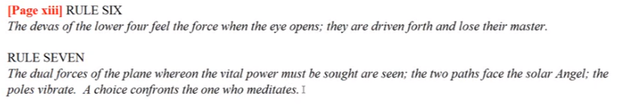
Along this line, the fifth petal represents a kind of dividing line between an emphasis which focuses below that I have from and that which focuses above because it is possible to have a kind of sub-diaphragmatic center focus even though controlled by higher centers if one chooses the selfish ahamkaric path for the reemphasis of the personality.
But as we reach the fifth petal the emphasis is intended to be on largely sub-diaphragmatic center, which does not mean that the senses below the diaphragm have yet been completely regulated and subdued – not quite. It's more at the very powerful second initiation that some of that subduing becomes possible. One other center would be of considerable importance here the ajna center correlated with Venus and Mercury and with the fifth and fourth ray and with the integrated, dominant personality. So the dominant personality found at this petal requires a strong expression of the directing ajna center.
Admittedly, this is not its highest expression, because it relates more to the spiritual triad in its higher expression but the ajna is definitely involved in personality integration and rendering it to be one pointed, directed along a certain beam of intention or desire. So it is involved in personality integration and assertion that's a lower phase than the third initiation where it has to do with revealing the light of the soul and seeing the light of the soul, and there it functions in a second aspect manner. With regard to personality integration more of a third aspect and some of the lower first aspect, and when related to the spiritual triad it expands altogether again in a higher first and third aspect manner. The spiritual triad being the personality of the monad.
2:01:30 The individual who is achieving the unfolding of the fifth petal has the power to integrate the personality and to direct himself. That’s very ajna like. Whether more deeply into the world of form, wrong choice right? Or towards the world of the real? And we can say here, wrong choice if perpetuated. I guess as DK has said, behind all of us who may be sincere students of the wisdom, and it was especially for those who were members of his group and were being integrated peripherally into his ashram, has lain the life of personality expression in a bold and grand manner, and a life spent within some monastery or nunnery where the inner life was entirely the life which was pursued. Two lives lying behind every member of his peripheral ashramic group.
Power starts to come in here, power to the personality and even that power can be put to the service of the soul if certain personality factors are rightly subdued. The man is no longer a representative of mass consciousness.
The number four is associated with the ajna given the four colors which express through it, the yellow and the rose and the blue and the violet. And the integrated personality is fourfold and maybe each of those colors could be associated with one of the factors of the personality to be integrated. How we would do this I'm not sure. The violet with the physical certainly, the rose seems correct for the astral, the blue under some circumstances for the mental at least the throat center, associated with the mental, is said to be silvery blue. And the yellow with the fourth elemental the personality elemental. Of course there are other meanings and higher meanings to those colors and they relate to the eyes and so forth.
There are a number of chakric triangles associated with the expression of human life at various stages of unfoldment and the processes he's involved with each petal implicate a particular triangle or triangles. We will try to get into that later when we talk about the synthesis of all the factors we have been discussing in relation to each petal and tier.
The fifth petal can reasonably be associated with the ajna, heart, solar plexus, or with the ajna, heart, throat. And these are not the same as the ones that were discussed on page TCF 170. So much depends upon the stage, but they are triangles nonetheless action the heart and soul of plexus. It does figure in meditation one two in the DINA (Discipleship in the New Age) books and ajna, heart, and throat seems important for intellectual man.
If we turn to page 170 of A Treatise on Cosmic Fire, ego advanced man, heart, throat, and head, so that's one with the synthesis of the ajna.
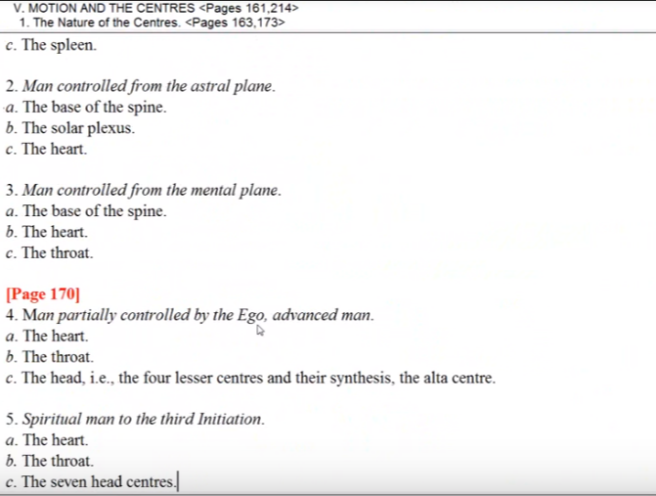
2:06:20 Advanced man partially controlled by the ego, what we call advanced man partially controlled by the ego. Let's just say the heart center is very important. The throat center for creative intelligence remember the sixth of the human groups where we have the true creative thinkers who are on the verge of becoming aspirants. Then enough of the head centers to really give a powerful personality that can either go its own way or fulfill the inner objectives.
In the fifth petal we have the energetic focus during which the white magic of the soul begins to emerge consciously in human living, and I would say again hence the importance of the seventh ray. We were looking for a good way of assigning the seventh ray and just because it doesn't occur to us immediately doesn't mean it isn't there. It is just important to see the great interweaving of energies and how we can ever more consciously utilize those energies to achieve the purposes which we intend to achieve. We don't want to blunder our way through all phases of human living. I'm sure we did enough of that in petal number one, school of hard knocks, Mars and Saturn. Blunder into it, Mars, and pay the price, Saturn.
We want ever more to tread the conscious lighted path, which means being aware in a fifth ray manner of the energies that we have to deal with. We were holding them in our hands we are the weaver of the substance of our lives and we can choose the threads that we will use. Now when we can be selective, I'm speaking now in third ray language, we can select what we need for any particular circumstance. It’s all about being conscious and knowing what it is we're really doing and having to do and what are the tools at our disposal. The energies that are disposal for accomplishing our objective in the most skillful, least wasteful, manner. Speaking here of the Law of Economy under the third ray.
So all of this study of the energies is so that we can use them consciously. It’s not so that we can fill our head endlessly with all kinds of stuff, it's just that at any point in our life we can decide what to apply what is needed and therefore achieve skill in action. So all of this effort is to achieve skill in action. Then obviously we will be much more efficient servers, much more useful to the hierarchy. People sometimes think they don't have to learn all this stuff, they don't have to be specific about the details of the energies with which they are involved, they can simply live intuitively and it will all turn out right. Maybe for some people it is so, maybe the intuition is so hyper selective that it was zero right in on the energy needed without knowing the technicalities. But it doesn't hurt to have the well-stocked mind and be able to draw off the shelves of the minds so to speak exactly what may be needed. Not to say that the intuition is not needed to guide one among the many shelves and what is stored there.
We're moving along approximately at the rate of a two-hour program per petal, not exactly, and we have four more petals of the nine to go and then necessarily a less detailed approach regarding petal number ten, eleven, and twelve. Less is said there because we are not really at that stage. I mean who do we see among our acquaintances that is between the third in the fourth initiation? Many claim of course but let's be realistic the full blown lotus is an amazing thing and that's what you achieve at the third initiation and at that point the ancient domination of the personality, or the ancient authority of the personality, is overcome. So let's be realistic and although we have wishes and hopes in our higher moments let's be just in our assessment of what has been accomplished and what has yet to be accomplished. Inevitably we will but not by presuming falsely that we have already accomplished what we have not, because that will deflect our attention from the process of accomplishment
This will be the end of egoic lotus webinar commentary program 25 … we're not making a lot of progress in the pages and we it will be 2 hours and 15 minutes. We will be beginning egoic lotus webinar commentary program 26, pages TCF 540 and 541 and it will deal with the sixth petal … I find … as I'm going along, and I'm sure would be the case for any one of us, that we would learn more and more by a constant review of these matters and more and more connections would come to mind until all the connections will fill in and instead of the great gaps in our knowledge we will have a thoroughly integrated network of knowledge on these matters, which will be able to be viewed by the intuition as a whole. It will be the manner in which Mercury develops into the Jupitarian perception or normal Mercury develops into the higher Mercury perception and then into the whole Jupitarian perception, not to leave out the important Neptunian perception which is perhaps the most subtle of all.
Okay friends, this will have to be the end of this program and we will go on to program 26 shortly and hopefully you have persistence, tenacity, or the foolishness – whatever necessary to attend closely to what is being said in the hope that something of these relationships of energy can become more impressively your own just as I do I ever seek for the more illumined connections, trusting that they will emerge and it will all give way to the pure reason of the intuition which is in its own way very Mercurian. See you soon.

