EGOIC LOTUS WEBINARS, VIDEO COMMENTARY – 23, Michael Robbins
Abstract: Analysis of Petals 2 and 3.
This webinar is about 3 hours, 24 minutes long and covers A Treatise on Cosmic Fire pages 539-540. Analysis of Petal 2 and 3: According to the Tibetan’s Statement: “The Petal of Love for the physical plane. Unfolds through physical relationships, and the gradual growth of love from love of self to love of others.” And: “The Petal of Sacrifice for the physical plane. This unfoldment is brought about through the driving force of circumstances, and not of free will. It is the offering up of the physical body upon the altar of desire—low desire to begin with, but aspiration towards the end, though still desire. As man in the early stages of his evolution is polarized on the physical, much of this is undergone unconsciously and without any realization of what is being consummated, but the result in the causal body is seen in a twofold increase of heat or of activity:
The physical permanent atom becomes radioactive or a radiant point of fire.
The lower three petals become vibrant and begin to unfold until fully developed.
Content for EGLWC Program 23: close attention is paid to the astrological, rayological and chakric implications related to the organization and unfoldment of Petals 2 and 3. This is in preparation for wider correlations to be attempted in relation to all petals after what DK has said about them specifically is analyzed.
Egoic Lotus Webinar Commentaries 23 668 MB .wmv file
Video of Egoic Lotus Webinar Commentaries 23 by Michael D. Robbins.
Egoic Lotus Webinar Commentaries 23 195 MB .mp3 file
Audio of Egoic Lotus Webinar Commentaries 23 by Michael D. Robbins.

Contents
The Petal of Love for the Physical Plane 4
Astrological Qualities and Chakras 6
Context of Lotuses in relation to Petals 8
Petal Two: Rays and Vehicles 14
Chakras involved in Second Petal 16
The Sacrifice Petal for the Physical Plane 18
Astrology of Knowledge-Sacrifice Petal 20
Chakras and Third Petal (continuing astrology) 36

Transcript
Hello friends, we are continuing our work with the Egoic Lotus webinar book, and we're in the twenty third program and we're working through what Master DK had to say about each petal and we will do this in the section starting on page 539, A Treatise on Cosmic Fire. We've already done petal one, and also we will work in the colors later, and what DK has to say about each petal. They are relatively short sections in terms of what He has to say. Then we'll pull them all together into some sort of synthesis.
00:44 So for right now we are here, just about to go into petal number two and let's take a look. It's the petal of knowledge with the love sub category, knowledge love, and it sustains the orange color as all [knowledge petals] do, and adds the blue and the rose.
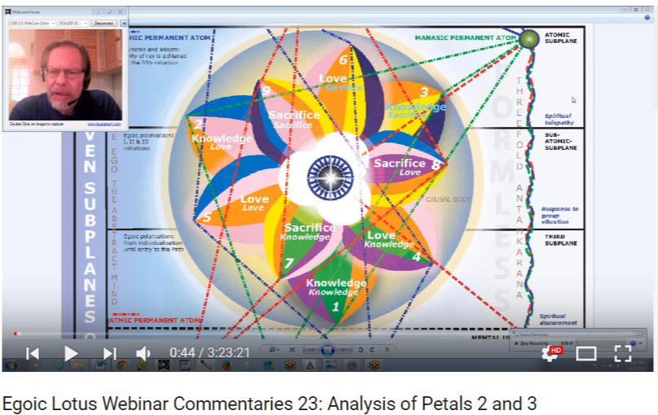
We do remember that Master K.H. works with devas that are blue and rose in color. It is suggesting here the sixth ray and some of the blue can suggest the second ray, especially when we have indigo, but the two major colors connected with the sixth ray are rose, sometimes called silvery rose, but anyway rose, and blue.
2. The Petal of Love for the physical plane. Unfolds through physical relationships, and the gradual growth of love from love of self to love of others. TCF 539
The Petal of Love for the Physical Plane.
When the word “love” is used in this context it of course means “desire”. There is some emergence of love, but it's still very form bound, and love is increasing over sheer instinct such love that it is, it's not that we would call perhaps true love but it is ever minimally soul love the love of one soul for another, but still it's a growth in that direction and it may be expressed grossly. Grossly, as physical man is at this point in human unfoldment.
We have to remember that the lotuses of Brahman are on the point of, the second petal is, showing signs of opening. They have a certain advancement over those who are focused in the Lemurian Petal, so the love involved here we would call it instinctual love and it's probably closely associated with sacral center processes.
Let's not leave out some demonstration of the solar plexus type of love as we are in the petal which will define the Atlantean types, the emotional types, it was the fourth subgroup, particularly the third and fourth human groups. And as well some degree of creativity may also be shown during this, which is also a very lengthy stage. The first two petals are by far those which take the longest to unfold.
04:21 So the opening of the first three petals, takes the longest time – millions of years really – compared to the much more rapid opening of the later petals, and this should be constantly held in mind. I suppose that it varies with the individual, but as a general rule anything that relates to the third aspect of divinity takes longer to unfold than that which relates to the second, and that takes longer than that which relates to the first.
So there should come some realization of the great diversity of experiences which the human unit will experience during the immense time taken to open the first, second, and third petal, during which when they all open of course he will be working in the field. At least organizing in the second tier.
05:25 I just want to say a little bit about some of the minor initiations which relate to the development of the knowledge tier, and to a certain extent:
The organization of the knowledge petals and preparation for unfoldment is going on in the Hall of Ignorance under the guidance of the energy of the Mahachohan with a very small egoic influence but when the three knowledge petals become sufficiently active and alive … TCF 869-870
Whatever that means in terms of efficiency. I just want to emphasize that: a form of initiation then takes place. These initiations are seldom recognized within the brain consciousness, yet they nevertheless are initiations of a definite the less important character and their effect in the personal life of a man is that of an intelligent recognition of his group relation but selfish in character.
07:10 I think we saw a stage of adaptation … let’s just check that, the stages of adaptation number three and number four:
“3. A conscious and purely selfish adapting of oneself to the environment. In these cases, the man is definitely aware of his motives; they are consciously thought out and recognized, and the man makes "the best of his circumstances". He forces himself to live as far as possible harmoniously in his surroundings. In this there is really good motive, but principally the man is governed by a desire for comfort—physical, emotional and mental—to such a degree that he will discipline himself into such a condition that he fits wherever he may be and can get on with anyone.
4. From this stage on the differentiations become so numerous that they are difficult to follow, being mixtures of pure selfishness (developed often to the nth degree), of a growing recognition of the group, of an awakening realization of the right of other people to a similar degree of comfort and harmony, and of a steady effort to adapt conditions of character and personality life, so that the purely selfish interests do no real damage to others, until we arrive at...
5. The average really good man who is struggling to adapt himself to his surroundings, to his group relations and responsibilities in such a way that some measure of love can be seen.” Esoteric Psychology, Volume I, 323-324
So there is some recognition of the group, if only to satisfy his own selfish motives, and perhaps some of these stages of adaptation, number four, where there's a realization of the right of other people to a similar degree of comfort and harmony. Not quite perhaps the average really good man.
08:05 … When it comes to the human groups I think it's stage number five, where we will find the lotuses of passion and desire and He doesn't talk so much about their moral character, I guess He says they are the nice, good people and He likens them to the sheep of the human family, maybe we are talking something about that nature as well.
In the smaller initiations … there is an intelligent recognition of his group relation but selfish in character when the love petals are organized in the Hall of Learning under the guided force of the Bodhisattva – these are not initiations actually but a guided force— another series of smaller initiations takes place so it's more than one which deals with the love nature with astral organization and the effect in the personal life is the recognition of some form of unselfish love.
09:30 I think this would be coming in with some sixth petal work and organization. Now there is another place where the discussion of the petals in relation to these earlier initiations does take place. The egoic influence is beginning to be felt, it's but small, but when the three petals become sufficiently … a little further in the same page:
“The energy of the outer circle of petals causes it to spring apart from the next circle and to unfold the threefold energy becomes interactive and a very definite stage is thus reached. This series of initiation to seldom recognized within the physical brain consciousness owing to the relatively inchoate stage of the bodies and the unresponsiveness of the brain matter. Yet they are nevertheless initiations of a definite though lesser important less important character and they involve primarily display (within the personal life of the man) of an intelligent recognition of his group relationships on earth. This initiation is frequently selfish in character, as for instance, that where the union worker which the union worker displays, but it is indicative of group interplay.” TCF 870
In other words, working with the group because it will serve the self.
11:22 Now let's go a little further, and we see, “A similar process takes place when the second tier of petals is organized and ready for unfoldment.” This is the same page, yes, some form of unselfish love and that is usually attributed, we will see, to what's going on in the sixth petal – not the full unfoldment of the sixth petal by any means – but the second tier of petals is organized and ready for unfoldment, and I'm assuming that the opening is going to occur in a somewhat sequential manner.
So that still remains a little bit ambiguous whether there's a sudden opening of all three petals of knowledge. I don't think so because otherwise we would not have people at the present stage with one petal open, with the second petal on the point of opening, with another group with the second petal opening and work going on in the third petal, and another group with the first and second, first and third petal opening, so this springing open, I think what it means is that that which is not yet fully opened does become fully opened.
This type of initiation occurs when there is work going on, the first type, when there is work going on in the love petals and the outer group, knowledge group, completely opens up, and then another type of initiation when the petals in the Love group are organized and ready for unfoldment. So we have to keep this in mind when we want to judge what the petals will look like at certain initiatory stages.
These are the smaller initiations and now we can come back to the stage of adaptation. I don't think we need to look at that so much, we can come back to the qualities of the petals of the egoic lotus.

Astrological Qualities and Chakras
14:14 We had reached the point where DK was continuing to speak, basically what He said here is that this petal, the love petal, it unfolds through physical relationships. So we are speaking I suppose of family and community relationships to a degree? To a degree. But also of strictly physical relationships involving the sacral center which produce family and tribal relationships.
We can also be speaking of relationships which form in order to ensure survival and when we're considering the customary or counter-clockwise progression of the signs, the sign Taurus would be assigned to this petal. Taurus is a very earthy sign having much to do with the sacral center but it's rulership by Venus brings in the quality of physical love, we have say the quality of physical love through Venus and Libra coming up I suppose. It is a sign in which physical animal magnetism takes on a large significance so there is a strong attraction between people as we can assume there was very much in the Atlantean period.
15:50 Taurus rules the astral body, interestingly, and when we see the three signs together, the three first signs, we see that Aries is assigned the rulership of the mental body. Taurus the astral body, and Gemini the etheric body, but sometimes of course it can be reversed, and Aries has a lot to do with the physical body, and Gemini with the mental body, but you know really, it depends on our perspective.
Taurus is always found there in the middle and it brings in the physical aspects of human love, as does Libra. On the clockwise wheel, we began with Pisces, and that has to somehow be shown because we can begin with Aries as well. If we began with Pisces, the sign Aquarius would be prominent emphasizing its more primitive mantram, “let desire in form be ruler”.
This early Aquarian tendency with the primitive sexual Taurus would contribute to the sexual promiscuity to be expected at this stage of development, because Aquarius is a sign of distribution, and it's a sign that does not know boundaries in its earlier type of expression and there was I think in the earlier society is the tendency to think of sex in a communal way, as at the fertility festivals, and this is communalized sex, it's not simply the primitive instinctual sex involving survival, it is moved up a stage, with the second petal process.
18:10 At this point we must refer to the idea offered by the Tibetan that early man did not respond to the signs Aquarius and Pisces. We should put them in, this thought in at least, that these signs only entered his consciousness when he was more fully developed. But this has to do more with in relation to zodiacs of ten, and eight, which govern early periods, and of course the signs Aquarius and Pisces would be left out in both cases. But it should be said that Pisces in Aquarius will be active unconsciously. There are twelve petals and twelve signs are necessarily involved even though man cannot respond to the higher possibilities of these signs.
When you consider the quite material mantram, an early mantram that simply has to do with the path of evolution, and not with the path of spiritual development, “Go forth into matter”, the more material mantram for Pisces, it does relate precisely to the experiences of the first battle, as does “Let desire In form be ruler”, relates to the second petal unfoldment.
19:50 Plus we have to remember that the first incarnation is ruled individually by Pisces, so that is something that shows then that the incarnation was taken in Pisces, whether or not Pisces is considered a part of the zodiacal wheel or any attention is given to it in that respect.
If we begin the clockwise wheel with Aries, then Pisces becomes the sign in question for the second petal. That's another way to go, with its emphasis upon desire and attachment on the initial cultivation of the emotional nature. And its emphasis upon, well Taurus is a sign of sensuality and so is Pisces at an early stage. The feeling nature of the emotional nature gets involved with the sensuality. Pisces is a water sign and hence its association with astrality, desire and emotion, which is beginning to be developed at various points.
21:27 In the second petal experience from the earth sign perspective, remembering that we assigned the three earth signs to the three petals of the knowledge tier, again it is Taurus. So it's Aries-Taurus and then Capricorn-Taurus-Virgo, so it's a sign with much more animal magnetism in it than Capricorn, the proposed elemental ruler of the first petal.
Here the fourth ray will be coming in, we'll discuss all that, but the attraction between the sexes for reasons that are more than strictly instinctual, but begin to have some kind of emotional component, will be found. The ruler of Taurus orthodoxly, as it's esoteric ruler do not count at this stage obviously, is Venus. This time Venus would emphasize the lower attractive and sexual impulses drawing human beings together on the basis of physical desire and some appreciation of what is seen as beauty and creativity would also be present. These are the Libran factors, and I don't say that, I believe DK brings this idea forward, so let's just say the astral appreciation of beauty begins to emerge and I don't think this is the case under the sort of Mars-Saturn, first petal, Capricorn and Aries.
We cannot forget also here the power of Aries and Libra both of which initiate physical relationships. Regarding the early expression of the Libran energy we are given the phrase “unbalanced fiery passion”, which certainly applies to the first petal but I wonder if we would say “unbalance fiery instinct.” When we get to the idea of passion the astral body is involved. The second petal and the second vehicle and the fiery aspect is a reflection of the polar opposite Aries, and of the ruler of Aries, Mars. So often the polar opposite signs they do go together and they are quite close in their meanings.
24:05 Now we have
1. The Petal of Love for the physical plane. Unfolds through physical relationships and the gradual growth of love. From love of self, to love of others. TCF 540
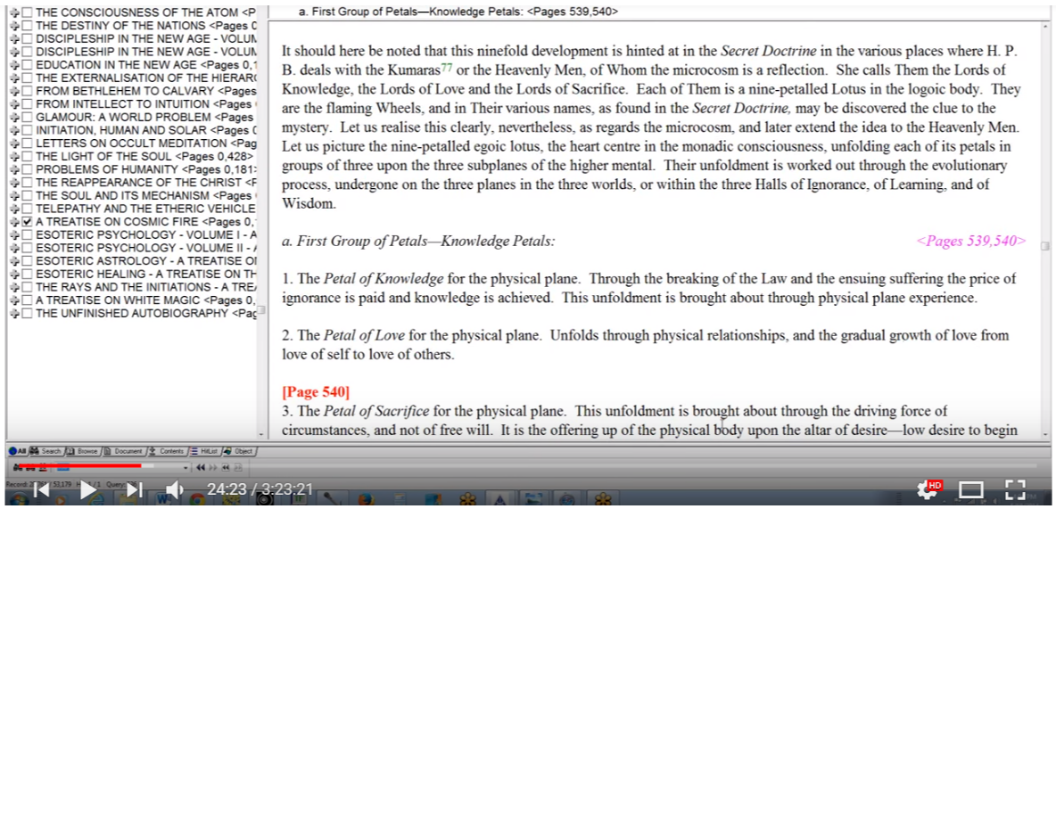
I suppose we would see this in some of the lotuses of Brahman, and not so much in the Brahmic Lotuses, and most certainly we see this in the lotuses of passion and desire, which are a good deal more advanced
Context of Lotuses in relation to Petals, to TCF 842
On the third subplane of the mental plane:
Bud egos. Our planetary scheme, being at the midway point in its evolution, there are therefore no unopened "buds" strictly speaking. All the egoic lotuses have at least one petal open. All the lotuses are organized, but there are vast differences among those of small development showing forth in the brilliancy of the permanent atoms, and in the stage of petal unfoldment.
Brahmic lotuses in which the first or knowledge petal is fully unfolded. They are so called as they represent on the physical plane the fully active intelligent unity, the man of small mental development, the lowest type of workers, agriculturists, and peasants on every continent. They are also called "third class creators," as they express themselves only through the act of physical creation on the physical plane, and their function is largely to provide vehicles for those of their own group.
The lotuses of Brahman, in which the second petal is showing signs of opening and the second aspect in its lowest manifestation is showing signs of demonstration. They stand as representing certain groups of Egos from certain planetary schemes, notably Jupiter and Venus, who are a grade higher than the class above, but which have as yet a long way to go. They are called "second class creators," for though they demonstrate on the physical plane in the act of physical creation, yet they are more swayed by love than by animal instinct as in the first case. They are to be found incarnating at this time in the Orient, particularly in India and in the Latin countries, and just lately in America.
Primary lotuses. These are a group of special interest brought in under the influence of the Lord of the fifth ray… TCF 842
… so in the gradual growth of love, it is still love in form very much within the Hall of Ignorance, from love of self to love of others. This signifies that love of self characterized first petal processes, completely, and probably quite a bit of the second petal process and let's remember Leo in relation to love of self. But the animal magnetism of Taurus and the power of attraction characteristic of this sign can begin to reorient desire, so that it is not so entirely bound to the instinctual nature and that is at some point discussed in the types of people that emerge. I think maybe even in the third and fourth groups.
See here Human Groups Plus Commentary, EPII 203-20, and in the third group perhaps, the third human group … yes, the mind nature is not strong in the physical body slipping steadily below, okay, that is something that is said here … and the third group of souls is emotionally alive and the desire nature is becoming rampant.
26:38 The desire nature is almost entirely oriented towards the physical life. But it is desire nonetheless. I think we could say that, especially in group four, with a physical body steadily slipping into the realm of the unconscious, that there is not so much application of the desire nature to the strictly physical aspects of life, and that does begin to happen. Anyway it's not so entirely instinctual, as was the case let's say in human group number Two.
Alright, so now, the gradual growth from love of self to love of others. So not so tied to the instinctual nature because the instinctual nature simply wants to satisfy its own promptings, but when the term love enters, there's the beginning of recognition of the other and that's of course where Libra will come into the picture: the other can be experienced as having value in itself instead of simply a means to satisfaction.
28:28 We remember the relation of Taurus and Venus to the experience of value. So as an interpolation, we can speak of love of self. When we speak of that we cannot omit the early influence of Leo (the sign of self-love) and yes, I mentioned that a little earlier, which in early ahamkaric days tends to contribute to the glorification of the lower self, the body basically.
We recall that in the Atlantean period, the most materialistic of all signs, Leo, must have been intensely prominent, for the self-love of some powerful, intelligent and wicked individuals rose to unparalleled heights. Or should we say sunk to unparalleled depths and brought on a great war between the forces of light and darkness.
29:35 So we remember too as we've mentioned when some of the periods of the black lodge flourishing were with us, we had a strong Leo in Imperial Rome, and a strong Leo among the French kings and I mentioned earlier that Hitler too had Leo very prominent in his soul chart, DK tells us, and also with Saturn culminating in Leo at the top of the chart in his personality chart so it is said in those days that such individuals erected stupendous statues of themselves as part of the cult of self-adoration, self-adulation. I like to put in self adulation, as it also gives the idea certainly self-emphasis and of course the individual is capable of doing such things were more highly advanced than the individual working through simply through two petals. They were I think initiates from the previous solar system who had chosen the way of the third aspect rather than the progressive way of relationship.
So it is possible to have been working in the fifth petal and to have been going through a stage where DK describes as the nth degree of selfishness, but they were an aberration. But those great, colossal statues erected to their own grandeur have something to do with the early periods, and with the Leonean self-love.
31:22 The movement of love of self to the love of others is, in a way, a movement from Leo to Libra and from the Sun (considered in an exoteric way) to Venus. And we recall interestingly about Leo and Libra in that they do show up later in terms of the reversing of the wheel, and maybe at an early stage. I'm not saying that this gives you necessarily the first initiation, but I think there's organizing work done in the fifth petal, where the wheel is being reversed and Leo and Libra are involved. The individual decides to move in pursuit of the higher of the pairs of opposites which he begins to sense.
Let us remember that all these zodiacal and planetary factors have energies, which can be utilized at many strata of development so one energy can express a great variety of ways. There are some very low expressions and some on the very highest end of the spectrum. So when we simply name the energy of Leo and Libra we have to think about its various possible applications at different stages of human unfoldment.
32:50 This is one of the really important advantages of the way that esoteric astrology is taught, as it takes the reincarnational factor deeply into consideration, and realizes that science can be used in many ways. Modern astrology has a much narrower range of how the energy of a sign or a planet will be used, and the stage of development of the person, over a period of lives, is not so emphasized. There is some emphasis in that transitional astrology from the usual orthodox astrology to the type of esoteric astrology, and in transitional astrology maybe reincarnation is emphasized.
So desire is becoming an issue in the second petal. Since that is the case, water signs must have something significant to do with it, because the water rules our feeling and desire nature at least it is one of the major contributors. We can't say that fire is missing in terms of fiery desire, but maybe watery desire is coming first. We have already mentioned Pisces, but what about Cancer and Scorpio? Cancer could give the instinctual tendency to cling to that which is desired and to that which is seen to be of value, as we would expect in the Atlantean consciousness. And Scorpio would feed the connection between desire and sexuality, which is moving it appears into a higher phase here.
We remember that man did not respond to all the signs of the zodiac in those early days, at least his response could not have been a high or conscious response. I've mentioned what I interpolated earlier, that the zodiacs of eight signs, ten signs, even eleven signs are perhaps something of an enigma to us today, because after all a zodiac is a heart center and a heart center is twelvefold, but they're based I think not on the appearance and disappearance of the energies of certain constellations and their vehicles or expression the signs, but on man's power to respond to various influences and especially in a conscious manner.

Taurus
Returning then to Taurus we know Taurus is one of the paramount signs of desire and so there's this petal is surely a desire petal, physical desire, or maybe we can call it here, a desire in form Petal, which is going to link it to Aquarius.
Venus as the ruler of Taurus emphasizes in terms of second petal processes not so much the fifth ray but the sixth and the second both expressed by Venus on one level or another. Actually the lower second ray we might say perhaps the personality of Venus is the second ray. And the sixth ray is said to be its monadic ray. It’s the home of the planetary logos of the sixth ray. Venus is that.
One of the stages of its monadic expression is on the sixth right now. To what extent this would work through into life and form can be questioned, but there is some soft line Venus expression in this particular petal.
Mars of course is the planet of sexuality and a non-sacred planet much associated with deeply material processes and it is extensively involved in the second petal process I think we can say, for the love of others in the beginning at least is largely does the desire for others. Sexually especially. Though it is expected that the influence of Mars would gradually give way to some Venusian process as unfoldment continue. I mean, Mars is sex and desire, and Venus is love from the conventional point of view how we view these, so Mars is sex and desire, and Venus is more related to love and eventually to love-wisdom.
We might say that magnetic Venus would make it possible for some of the first human groupings, along the community lines, community in tribal lines, and this would come to be valued as fulfilling primitive community needs. Maybe some of this would even show up to a degree in the first petal. Because that's quite a number of years and there was a Lemurian civilization at least towards the end of Lemuria but we're having there at overlapping of the Atlantean period and the Lemurian period and the overlapping of the civilizations has to be understood in the relation to a kind of overlapping a petal emphasis.
38:40 People do need other people even if only to fulfill instinctual needs, and magnetic Venus would induce this gathering together in relative harmony. Of course if we want to talk about harmony we might be talking about Libra, and so Venus is also related to Libra as an exoteric ruler. Venus in relation to Libra is related to the formation of primitive community, with emphasis upon the possibility of harmony and cooperation in community and not merely selfish Martian aggressiveness and competition. So this is likely to occur a bit more in the second petal, when work is being done in the second petal, but even, we have people gathered together today who have one petal open, we have to remember that.
I don't know if we can ever duplicate how when looking at present day humanity what happened in the very early days after individualization because obviously we were dealing with lotuses in bud and the type of selfishness that demonstrated would be much different than what is demonstrated now in the Aboriginal groups, which He says have one petal open, whether it's fully open or not, but it has shown signs of opening, and they certainly have developed community life. But of course they would be working all through in the second petal and through the smallest extent in the third.
40:40 Let’s look at Earth. It's a planet associated with Taurus. DK says very much associated with Taurus, and it continues to be emphasized in a way all the way through the Hall of Ignorance, all the way through the petals of knowledge. It does have the third ray, which is related to intelligent activity and intelligence, active intelligence and intelligent activity. So it is closely related to Taurus and it continues to be emphasized for the desires of second petal individuals especially during the early part of the (well I don't know if I should call it) unfoldment. Maybe I should call it the work in. I need to discriminate more carefully because unfoldment is a later stage and quite a bit of the influence of any petal is exerted upon those who organize it and work within it.
So desires of second petal individuals, especially in the early part of their work in this petal, used to have that which is earthy and obvious, tangible, and it reveals to the senses close at hand. It's not about abstraction at all though there will be after the experience and that is a type of abstraction we could say that. That astral experience is a type of abstraction from the senses, the physical senses.
So during the later stages of unfoldment, I see what I've done. We're told that the lotuses of Brahman, the second petals on the point of unfolding. Let’s just say during the later stages of organization and work within can be hypothesized that as travelers he becomes of importance and that there's a higher shift away to a degree from that which is revealed by only the outer senses. I’ve talked about the dreamtime of the Australian Aboriginals and remember that highly advanced souls can be born within these early groups for purposes of service.
43:20 It seems important to note that there are still many people on our planet who have not yet unfolded the second petal, the unfoldment of which covers what we loosely call the Atlantean period of human development. It’s a long period, millions of years. Maybe ten million years, eleven million years, so we must not conceive the second petal prophecies as being entirely primitive at all. We must not conceive of the processes related to any petal as being completely homogeneous and I'm beginning to realize that more and more, there are cycles within the unfoldment of any. Well I would say within the organization and unfoldment of any petal, and these cycles may be ruled by laws, with timing involved of course.
Even the good nice people, the Lotuses of Passion and Desire, are primarily emotional even though they are doing organizational work in the third petal and maybe even slightly beyond. So there's no substitute for actually seeing this process at work with all of its different varieties and being able to examine.
45:04 You can understand what this might be like within the inner libraries, to see the examples of the horoscopes, the ray charts, such as they were, the condition of the petals in a large number of individuals, so if the sample is wide enough to gain a certain accuracy, it would be a great research project. As I speak about it now I know the day will come when one can simply do that, but of course we have certain issues to work through as human beings and they have to be worked through Here and Now before we can refine our mechanism to the point where this type of revelation can really be given to us, even through our own powers or through will, most likely that, or through studying that which is made available in our sources, all the inner manuals, the inner books, and so forth.
46:24 Desire does become more refined and less attached to the physical processes as the second petal continues to -- I'm always going to have to say here to be organized and to open and Venus is showing her true colors. So from this perspective, the sign of our Sagittarius enters, re-orienting desire from a strictly physical preoccupation to higher and wider possibilities. We can think of many signs in relation to the processes as they are described, as we've looked at Taurus, we've looked at Libra, we've looked at Aquarius. Maybe to a certain degree we've looked at Pisces, Cancer, Scorpio. To speak of Sagittarius, well it can be very physical of course, and it's interesting that Sagittarius is ruled esoterically by the earth but Sagittarius is also associated with Mars and with the lunar Lords. So we know it has very strong elemental, material meaning as well.
48:15 So of course Sagittarius and the Centaur can be very much a sign of animal man, but by the time the true Atlantean period is reached then the fourth type of human group is there – the Atlanteans – the human being is lifting his sights so to speak, “what is your aim? What do you aim for?” Visioning that which is more than the physical body can provide the physical body has very limited instincts which can be satisfied and have to be satisfied and their satisfaction becomes the main preoccupation for so many types of people in the very early days, but once there is satisfaction, even the modern psychologist will tell you.
A psychologist like Maslow has that hierarchy of needs: he draws it in kind of a triangle or a pyramid and once the lower needs are what it senses needs are satisfied then one sets one sights to higher things. Of course the evil people of that day completely detached their desires from what was really necessary and conceived of all kinds of enormous and even monstrous desires. So the astral body took on a completely unnatural type of expression. But as I say they were already more advanced and they were considered initiates from a previous solar system, so they certainly had a lot more unfoldment than the people we're talking about who are working in an unfolding the second petal.
49:44 I'm not sure I have, in this particular commentary, dealt with all of the signs that could be active here. Probably I have not, but when I begin to pull everything together petal by petal, and many more factors than are here demonstrated, then I will probably mention, in one way or another, all of the signs, or most of them.

Petal Two: Rays and Vehicles
50:18 Let's look at the rays which would have been prominent at the time that physical relationships were so important and when love of self, that is the desire for the fulfillment of one's own desires, was beginning to transform into love of others, the instinctual seventh ray would still have been there of course. That would carry over. But the sixth ray would begin to come into prominence then in the second petal as we have seen the colors of the sixth ray are there – the rose and the blue. So the sixth ray would come into prominence. It is the ray that rules the astral body in general and during a huge expanse over which this petal is organized and open the astral body becomes an important center of focus.
As a matter of fact we're living on the kind of planet in which the planetary logos has not tamed his own astral body, cosmically speaking, and is still struggling with that on the cosmic astral plane and we live in a solar system which is astral-buddhically polarized so the astral body is going to carry over and be of immense power.
I'm even thinking about highly developed people whose astral body runs them; they have the intellect but their astral body runs them. And that of course was the problem with those evil initiates of the early days who had come over from the previous solar system. The astral body had not been controlled and as a matter of fact there was no reason for them to control and the intellect they had developed was used to fulfill what the astral body wanted, and not only normal promptings, but enormous, monstrous, colossal promptings, for all kinds of unnecessary things and unnecessary states.
52:35 So in relation to this petal we can reasonably say that kama, kama-manas, comes into a very full expression, but I want to say kama, of course, kama first … We always have to distinguish it from karma, right, because kama is desire. And then to the extent that, and later kama-manas comes into very full expression. The manasic aspect of the man is relatively quiescent. Ok, I meant to say it’s kama, I didn’t mean kama-manas. Kama comes into full expression because the manasic aspect and later with the Lotuses of Passion and Desire, kama-manas would come there, and there we do have the unfoldment of the second petal.
54:00 If we were to look here in A Treatise on Cosmic Fire, I'm not sure exactly what page … we insert the name, lotuses passion, or maybe, lotuses, or passion, why not? Should be there, only one, lotuses passion and desire let's see what we find here …
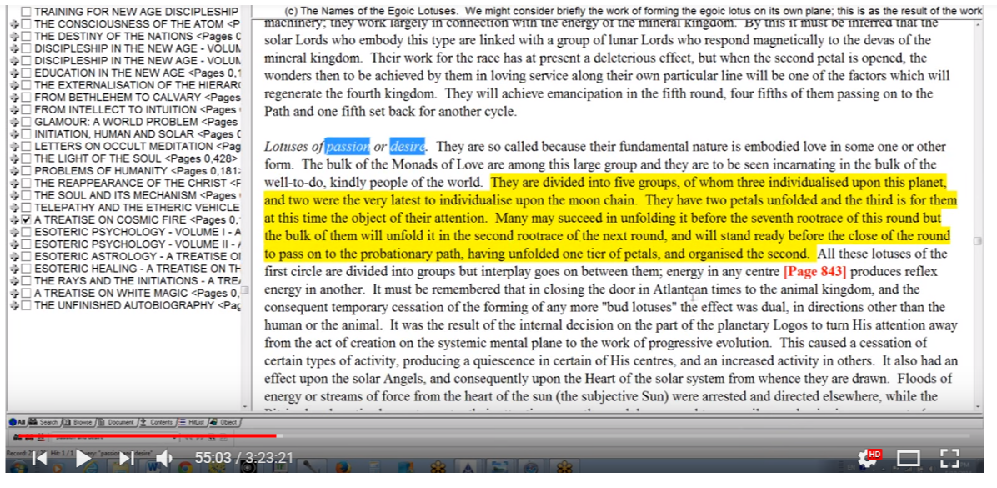
Their fundamental nature as we have discussed is embodied love in some one or other form. And it's embodied love. The bulk of the Monads of Love are upon this in this group and … the well-to-do kindly people of the world. TCF 842
55:22 Lotuses of the first circle. Let’s see if we can find this petal now …
Lotuses of passion or desire. They are so called because their fundamental nature is embodied love in some one or other form. The bulk of the Monads of Love are among this large group and they are to be seen incarnating in the bulk of the well-to-do, kindly people of the world. They are divided into five groups, of whom three individualized upon this planet, and two were the very latest to individualize upon the moon chain. They have two petals unfolded and the third is for them at this time the object of their attention. Many may succeed in unfolding it before the seventh root race of this round but the bulk of them will unfold it in the second root race of the next round, and will stand ready before the close of the round to pass on to the probationary path, having unfolded one tier of petals, and organized the second. All these lotuses of the first circle are divided into groups but interplay goes on between them; energy in any center produces reflex energy in another. It must be remembered that in closing the door in Atlantean times to the animal kingdom, and the consequent temporary cessation of the forming of any more "bud lotuses" the effect was dual, in directions other than the human or the animal. It was the result of the internal decision on the part of the planetary Logos to turn His attention away from the act of creation on the systemic mental plane to the work of progressive evolution.
This caused a cessation of certain types of activity, producing a quiescence in certain of His centers, and an increased activity in others. It also had an effect upon the solar Angels, and consequently upon the Heart of the solar system from whence they are drawn. Floods of energy or streams of force from the heart of the sun (the subjective Sun) were arrested and directed elsewhere, while the Pitris already active began to center their attention upon the work begun, and temporarily new beginnings were out of order. It must not be forgotten here that the work of the solar Pitris from their point of view, is not primarily the evolution of man, but is the process of their own development within the plan of the solar Logos. The evolution of the human race is, for them, but a method. TCF 842-843
55:45 Okay that caused a cessation of certain kinds of activities … coming in floods of Pitris … must not be forgotten here ... so, here in the Brahmic Lotuses the lotuses of Brahman, really the second petal is showing signs of opening. The lotuses of passion or desire, he must be definitely opening and that's the five groups. “They have two petals unfolded.” Is the word unfolded the same as open? Or does it give us a sense of the process?” Maybe open is like completely unfolded, and unfolded is unfolded to a degree, “and the third is for them at this time the object of their attention.” Which means that organizational work is going on there.
56:23 Okay, so lotuses of passion or desire. Two petals unfolded. Completely open? Maybe not. But unfolded. So how we could put it, can we say, shut, organizing, organized stimulated unfolding, opening, unfolded completely, unfolded completely unfolded open. These are different ways of looking at the sequence. It shows a process of working on something, and then also having completed, I think the word is vitalize. So that which is organized is then vitalized, then an unfolding begins, an opening begins, it becomes the petal becomes unfolded, and then completely unfolded, and I suppose completely open. He doesn't always use those words but this is the idea of the sequence of the petals.
So our kama is very important and kama-manas later, comes into very full expression with the lotuses of passion or desire. But generally the manasic aspect in any pure sense is quite, quiet, quiescent, and is only used in order to promote the fulfilment of desire. We would however find the man beginning to desire something other than his own physical satisfaction and that's of course the nature of this petal. And beginning to love something other than himself and this DK basically says.
58:47 Taurus we know brings in the fourth ray, so we would find the beginning of the struggle between opposing desires of which the fourth ray is the representative. But these are not these opposing desires, are not between the pairs of opposites, soul and personality. We're not into the factor of soul. There may be something about God, or some higher powers that one has to propitiate, but we do not think of ourselves as soul, and that's what begins to happen when work is being done in the second tier.
We are speaking of the second petal and so to some small extent because of numerical affinity, the second ray must be involved at least in a general sense. As I said in relation to this possible second ray personality of Venus, we have already noted that it is not possible for an individual before the stage of spiritual aspirant to have a personality on the second ray nor on the first ray, but then at this period there would be no personality as an integrated unit in expression, though we have to explore this. But whether in a latent and interior sense the personality ray would at least exist.
So, does the personality ray only emerge later, from a state of preexistence? Or does it come into existence period at a later stage? This is something we note that the personality ray emerges, emerges at a stage of development, a stage of development which is relatively high, but does it pre-exist its emergence? I'm not sure I've ever straightened that out entirely in my mind. There are places and ways in which it seems that it does preexist but for practical purposes it's invisible. So no human being before being an aspirant or stepping on the path, or early part of the path is going to have a second or first ray personality. Yet the law of attraction comes in under the second ray.
1:01:45 It is at this point that the Law of Attraction begins to work through a more intense manner through the astral body and we can also link, linking to Venus-ruled signs through the Law of Attraction and that those would be of course, Taurus and Libra, both of which are important in the human relationships and in the early days in physical relationships.
I'm trying in this commentary to touch on some rays. It is nowhere near as complete as the synthetic work that I've done later, but it does highlight some of the things DK talks about, and it gives us a basis for understanding a greater synthesis.

Chakras involved in Second Petal
Well the emphasis upon the base of the spine certainly must continue, maybe it's not as primal as it was in the first petal where it's fight or flight and survival is the complete issue. There are probably ways that the growing relationship between people assists with survival, the community-built fences, build walls, the animals couldn't come in, they couldn't attack, people could go out together and look out for each other on hunting expeditions and so forth.
1:03:37 But there is now an extra emphasis on the sacral center and the physical desire that is said between human beings, and also on the solar plexus, center the seat of desire life, this is through the organization and gradual unfolding of this petal, there is emphasis upon both the sacral, of course the sacral was very strong, but let's say, in the first petal, but this is a different way of emphasizing the sacral center, because it begins to serve the growing sense of love of others … so it's a mixture of the sex instinct and love … Of course we even see that mixture going on today. … We know to what extent Taurus in its more primitive expressions is associated with sexual expression and with a desire nature, both before this desire nature has developed into aspirational nature, and afterwards as well. So those egoic lotuses with two petals open are said to be lotuses of passion and desire.
I’ve spoken then a little bit now about this second petal. I call it the Atlantean petal, and when does work within it begin? I can only say this Atlantean period goes from about twelve million years ago to about one million years ago. So you can see what a huge span this, and of course the Aryan race would have begun it's overlapping.
As Philip Lindsay describes it, from the time we reach four point five (4.5) of the Atlantean period of the fifth sub race, already there is the seed of the Aryan root race even though we do not normally attribute the Aryan to beginning before one million years ago, but these overlapping periods occur and maybe even from well can it be as early as three point four (3.4) that the Atlantean period begins as a kind of seed to be germinated? Then you have to go through three point five, three point six, three point seven, (3.5, 3.6, 3.7) before the Atlantean period really emerged, but let's just say twelve million years ago, He talks about early Atlantean times and one million years ago about the beginning of the area and race.
We see that we have a very long time for these instincts to be transformed into love. Still love in form pretty much a very long time for the selfish instinct to be transformed into love in form, and some consideration of the other. We have to realize that many people today are still living in this Atlantean period, in a way they are modern. They are modern Atlanteans. …
1:08:25 So we are gathering our understanding. It is by no means a complete understanding. We were there in a certain sense because even if we are moon chain egos, we came in in the Atlantean period and if we were egos from a previous solar system we came in even before individualization on earth occurred. We have a long history one way or another, and even if we were individualized in Lemuria, we were there and if we were individualized in Atlantis we may have been living so to speak the Lemurian way during the Atlantean period, because these would have been the least developed of the human beings. But even though we were in a sense there we don't have the overview of how this would have occurred.
Really in the works of DK, He is content with giving us the ABC's of things and the large outline form. In case we feel we are really grasping all the details, one has only to understand what the kinds of records that are kept in the departments of karma, incredibly detailed and far more than we could comprehend. We need to give the broad type of view and what's important is to look at people today and have a general sense of the kind of period of development they are passing through in relation to the petals maybe in our modern messed up Western civilization we don't come in contact so much with Lemurians and early and later Atlanteans. We do come in contact with lotuses of passion or desire all the time I think, but maybe in our circles, since so many of us are students of the wisdom and really working mentally on the ageless wisdom, maybe our circles do not include so many, but I'm sure that when one looks into one's family contacts and when one looks on the media the lotuses of passion or desire are everywhere to be seen, and also even the modern Atlanteans.
1:11:33 It is important to somehow be realistic enough about humanity to identify what's actually happening in their psyche and in their process of living, and in that way we can more wisely understand how humanity as a whole can be elevated. It’s not by handing the books of Alice Bailey to the modern Atlantean. That’s not going to do any good. And still less to those who are still going out and still living out some of the myriad ways of being, but if we have an idea of the objectives of the different type groups with so many overlapping examples, but in general the objectives then we're in a much greater position to understand wisely what has to be done with humanity and how to meet the various kinds of needs well.
1:12:40 You know my passion for completeness. It’s always going to be frustrated. I keep on hoping that in what is added later that there will be more completeness. I realize it's not organized in the way that those with a prominent seventh and fifth ray would like it to be organized, but it least it has the subject headings upon which it is possible to expand so our next a discussion it will still keep it within this program, will be the discussion of the petal of sacrifice for the physical plane.

The Sacrifice Petal for the Physical Plane
1:13:20 Okay friends, then let us in fact move on to the discussion of the third petal. We see the colors there of course the ever-present orange and this time the yellow of the fourth ray, the yellow of sacrifice in a way, and also the synthetic indigo color. Every one of the sacrifice petals in every tier, this is knowledge sacrifice we're talking about, is offering a kind of synthesis of the entire tier. So let us look and see what we have, the petal of sacrifice for the physical plane, the knowledge-sacrifice petal.
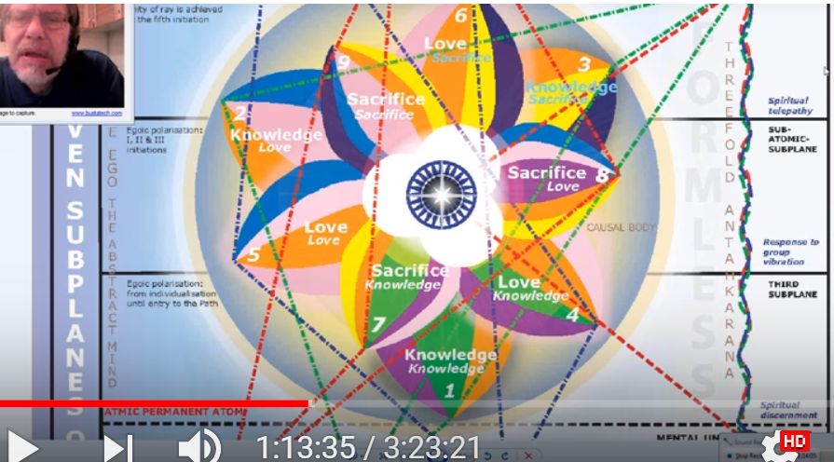
So this is the third petal of the knowledge tier … it relates to the first ray, just as the first petal relates to the third ray. Not exclusively, but we build three-two-one in every case. And just as the first petal relates in the third ray and the second to the second, so all of these rays are to be considered as sub rays of the third ray, which is the ray of aspect, which rules of knowledge per se, and which rules the third tier petals as a whole.
1:15:02 It is like analyzing the entirety of human evolution, and it would be so somehow fascinating to see the many lives as the Buddha did see. Of course, He only saw five hundred and some, and I'm sure that many of us have had many more than that. We have to remember that He entered in the moon chain. But maybe I wonder if it took him back to the other chain; his view of all his many lives? Because if you think about it, in Atlantis He took the third initiation so He had to enter, since He was ready to take the third initiation – and the initiate is always initiate before He is initiated, so He would have had to had the entire nine petals unfolded when He entered in probably the third sub race, of the fourth root race. That was when the moon chain egos came in. Plus there's every possibility that He had development in the previous solar system, where from all I can gather He was probably individualized.
The duration here of the process is seeming to be shortening now, and DK tells us on pages 84 and 85 of Initiation Human and Solar that the second, third, and fourth initiations can be taken in the same life and probably will be taken in that life or in the next. You know that's a long time when you think about it. I mean in other words, a very short time, but it's a long time if you think of the Buddha having been ready for the third initiation at the end of the moon chain but was not being offered. So his petals were very unfolded and there, with that type of unfoldment apparently, He remained until it was possible in a fourth ray ashram, for The Christ and Him to take that initiation together. A much greater stretching of time seemed to occur in the earlier days. And then we have to wait a long time before he is a full master. We cannot say at what point He became a full master (well the Tibetan certainly knows), but He became head of the hierarchy and was head of the hierarchy around the year three thousand. B.C., at the death of Krishna. So this only makes sense if we separate the being who was the Buddha, from the prince Gautama Siddhartha. So the Tibetan is cautious about what He says and does not say, and I think if we look into the Buddha's history it's really going to be quite amazing.

Astrology of Knowledge-Sacrifice Petal
1:18:34 Anyway we should recall at this point that Mars, generically, from the assignment at least that I give it, rules all three knowledge petals, as Venus rules all three petals love of love petals, and Mercury all three sacrifice petals.
It's kind of a generic ruling so, because orange can be associated with Mars very definitely; just look at the planet. Venus, the rose color can be indeed. And Mercury the yellow color. These end up being prominent colors in the three tiers assigned. From the perspective of the synthesizing planets we can say that Saturn generically rules the tier of knowledge petals; Neptune the tier of love petals; and Uranus the tier of sacrifice petals.
1:19:30 The colors don't exactly correlate, but Neptune does correlate with the rose very definitely, and probably the deep, deep blue, when we speak of its monadic ray which is not really being expressed. Or is not, that which the experiencers in the love petals are drawing upon. They are drawing upon more of its sixth ray in relation to the astral body.
So when we speak of this kind of rulership we're not speaking of the expression of the very highest characteristics of the synthesizing planets. I suppose the first ray of Uranus fits quite well with the will sacrifice petals, and in a sense, because love is being cultivated, even the second ray does fit. The third ray of Saturn fits very well. There is no hard and fast rule here, and always there are overlaps. We can only gain the clearer idea by first-hand vision, not just of the egoic lotus but of the whole process and a sample of many types of unfolding lotuses from many different kinds of monads.
1:20:50 What an amazing subject! It is such a vast subject. I'm sure there are those of solar angel capacity and status who have to oversee this kind of unfoldment, and we're a long way from that maybe a whole solar system to be able to do that one. All of the signs of planets are contributing their energy to every process in the development of man over his very long history, but of course the emphasis is going to change depending upon the particular stage of the developmental process which will require different types of developments, different types of achievements.
1:21:48 I think I want to read the whole sentence. It’s going to be short one …
3. The Petal of Sacrifice for the physical plane. This unfoldment is brought about through the driving force of circumstances, and not of free will. It is the offering up of the physical body upon the altar of desire—low desire to begin with, but aspiration towards the end, though still desire. As man in the early stages of his evolution is polarized on the physical, much of this is undergone unconsciously and without any realization of what is being consummated, but the result in the causal body is seen in a twofold increase of heat or of activity: TCF 540
1:22:50 So we have the physical point of becoming radioactive or a radiant point of fire, and the lower three petals become vibrant and begin to unfold until fully developed.
You know it kind of makes you wonder about the unfoldment of that very first petal, especially for the lotuses of Brahman. Have they in a sense already done some work in the third petal?
There's some kind of apparent inconsistency here, because it does seem that there is some petal unfoldment which is sequential, but then at a certain point there is an increase of vibrancy and the complete unfoldment of the petals. All three, as the man is working at organizing the higher petals in the petals of love. It doesn't seem to me that the man is working in all three petals simultaneously and while working actively in the third petal nothing has yet unfolded in the first. It doesn't seem right especially since the lotuses of passion or desire have two petals open and the third petal is there gaining their attention, which means that they are working at organizing activity within that third petal. Let's not get on the point of unfoldment.
1:24:38 At my present level of ignorance I'm opting away from the idea that these petals simply unfold all at once. I think there is a gradual unfoldment, but it's of differential degrees of unfoldment and then maybe one final stage of unfoldment where whatever is incompletely unfolded in any of the first two petals is completely done as the third petal is completely unfolded, pretty much like what's happening up there in the seventh, eighth, or ninth petal, the sacrifice petals. Because we don't think that at the first initiation the seventh petal is completely unfolded. Nor, at the eighth, at the second initiation, of the eighth petal is completely unfolded. But that there is a final unfolding when the third initiation is really taken and that whatever remains for unfolding in the seventh and eighth petal will be accomplished along with the very rapid unfolding, final opening, completed opening, of the ninth petal.
1:25:52 Now we can divide up with what The Tibetan said, in parts, this unfoldment is brought about through the driving force of circumstances. What energies come to mind when one thinks of the “driving force of circumstance”? Saturn is certain, as Saturn with its strong third ray represents circumstance (that which ‘stands around’, i.e., is peripheral as the third ray suggests) and the “driving force” of the first ray (correlated with the sacrifice petals in general, since the sacrifice petals and the driving forward through space is the key to first ray motion, right? Forward through space is first ray motion.
First ray is always associated with the sacrificial aspect of divinity, will, sacrifice, and giving are all the same thing: will, sacrifice, and giving are all the same. We're going to have other planets involved here too … what about Mars, for driving? Mars has so much of the first ray in it, not only the sixth, because it the school on Mars that trains the destroyers and that's the first ray and the entire tier is ruled by Mars, in a way by Saturn they're both very closely related and are part of the same great third rate entity. Saturn representing the mental body, and Mars the astral body of that great entities, with certainly Mars involved here.
You know how we can often say this circumstances forced me to do it I had no choice. Well, when you're drafted in the army and they send you into battle there's no choice when you have to provide for your family or, a living hell three made under difficult circumstances you have no choice there's the, we call life and death drive, and also economic drive, and all other manner of intensified desire and aspiration, and later aspiration because if we think about it there is some work being done on ahead in organizing the love petals while the third petal is getting ready to unfold.
1:29:33 So there can be a higher form of desire also operating at the later end. We saw that there is an element of group awareness that comes in with one of the lesser initiations when all three petals of the outer tier sort of spring apart and then fully open up.
3. The Petal of Sacrifice for the physical plane. This unfoldment is brought about through the driving force of circumstances, and not of free will. It is the offering up of the physical body upon the altar of desire—low desire to begin with, but aspiration towards the end, though still desire. As man in the early stages of his evolution is polarized on the physical, much of this is undergone unconsciously and without any realization of what is being consummated, but the result in the causal body is seen in a twofold increase of heat or of activity: TCF 540
We're looking for the forces of compulsion, since the free will is not involved. Well Saturn is there with the law, absolutely and I thought centers on Saturn and also Pluto, planets through which the first ray in its forcing or compelling aspect is expressed. And I should not leave out Vulcan—for force and pressure and its connection with Virgo—as the Earth sign ruler proposed earth sign ruler of this petal, its connection with Virgo and the Sacrificial aspect of Virgo.
Virgo and Pisces so often are involved in sacrifice they sacrifice their identity they become faceless, nameless they self-effacing servers so that which forces us to do something people are born in poor circumstances they have to struggle for a living they have to do things they normally might not do if circumstances were more conducive to a gentler approach. But this is also a hard petal and one must learn to relinquish a great deal. Let's just say of the process of relinquishment has begun here unconsciously.
1:31:50 I mean there's not so much awareness of the deeper implications, because the man is still working in the Hall of Ignorance when he says, “oh yes I couldn't help it.” All of us were forced to do as we have done we were forced. Little realizing that this kind of forcing aspect of servitude is leading to the ability to serve later. In the moment we will be more systematic about the energies involved in the third petal process but for the moment we will simply list what comes to mind as related. Maybe I've already begun listing them.
It is the offering up of the physical body upon the altar of desire—low desire to begin with but aspiration towards the end, though still desire. We can we can say that the physical nature is sacrificed because the desire nature is intense—the Astral Plane is thus becoming more powerful than the physical plane.
So the development of the second petal takes place over millions of years … maybe I should have said third petal here. I think so I think there's a mistake here. Nothing like proofreading something or seven years later. So, the development of third petal takes place over a million years of years. So the words to begin with and towards the end, can be separated by a vast period of time. But aspiration towards the end. It is not a completely homogeneous process occurring in every petal, there are many stages and cycles and different energy rulerships over the cycles.
1:34:42 The physical body can be represented principally by Mars and the moon. I would say Saturn has some connection with it in terms of a dense precipitation. Saturn has a connection also with the physical body. But definitely Mars is said to rule the physical body and every other vehicle of the personality including the personality itself, and the moon is definitely that outer rind of the man, made of substance which is more attuned to the previous solar system than to this solar system. So under the processes of Saturn both tendencies (Martian and Lunar) and the physical body they represent are sacrificed to a larger process.
Let's put it like this, if a strong desire did not exist this sacrifice would also not exist, such as the desire to feed one's family with say the desire to defend one's country, or to carry on some sort of crusade that one feels one has to be a part of. Circumstances compel and desire accelerates the compulsion. The higher part of Mars is involved here as Mars can generate aspiration. That's the key. Upon the altar of desire, low desire to begin with but aspiration towards the end. So where as Mars can rule the factor of lower desire, aspiration also comes from Mars and a high form of idealism. So the higher part of Mars is involved here as Mars can generate aspiration especially after its objectives have been adjusted through exposure to the refining aspect of Venus experience in the second petal process, so the sacrifice is often made for high or relatively high motives.
1:37:30 I'm thinking about the sacrifice of Russia in the second world war. Twenty million people. I wonder if I have the number correct, it was it at least that. And people were faced with the Nazi onslaught. Three million people line soldiers lined up on June 22, 1941, and attacked Russia along a huge front all simultaneously trying again that sort of blitzkrieg effect, and there was just no choice you could run I suppose, but even then it is interesting how the Russians didn't allow running if you if you were running back you were shot and actually it's not only them. It's not only they who have done such a thing, even in the English army there was someone left back in the trenches so any soldier found retreating running back was shot. So there's the rock and a hard place and no way to go but forward and the force of circumstances compelled it.
We are here reminded that in the third petal process desire has not yet transcended. Well within the hall of ignorance it hardly is.
3. The Petal of Sacrifice for the physical plane. This unfoldment is brought about through the driving force of circumstances, and not of free will. It is the offering up of the physical body upon the altar of desire—low desire to begin with, but aspiration towards the end, though still desire. As man in the early stages of his evolution is polarized on the physical, much of this is undergone unconsciously and without any realization of what is being consummated, but the result in the causal body is seen in a twofold increase of heat or of activity: TCF 540
1:39:05 We really have a division in the whole petal growth between desire and love. It has not yet here become the real love in any significant sense, but there is a great division in the petal process between desire, and desire and love. And thus between Mars and Venus. The pivotal point I think is at the fifth petal the non-sacred verse the sacred, the inverted pentagram versus the upright pentagram.
The whole story is, can one grow into the love? And also we can say the Moon versus the sun, the lunar petals of which I count four, and the solar petals of which I count five. This is interestingly called five over four, 5/4, and in musical terms it equals the note Mi or E or the Mercury, buddhic note, the yellow note … So that takes us right into the yellow beauty. Well it's a bit of an extension of thought. But we are meant to make the transition from desire into love, and depending on how the petals are unfolded we see whether we have done that successfully.
There is a constellation it's called the altar and it's found in Sagittarius and is reasonably associated with its second decanate of Sagittarius, so in the picture book of heavens, so of speak, and offerings being placed upon the altar it is the speared form of lupus the wolf, and I think lupus is found in Libra and this offering suggests the offering up of the physical body upon the altar of the desire. So this suggests the physical body and its offering up on the altar of desire, whether high or low.
Of course it's still very possible to have low desire in this petals. I mean I'm thinking about all of the average nice very good people who have two petals open and are working in the third, but it doesn't necessarily work out that way, it depends on the ray. Love is very hard for some of the first ray types to achieve and maybe the petal of love the Atlantean petal will not be sufficiently developed, and yet they can move on and develop the mental petal.
1:42:40 I'm sure they're all kinds of differences we cannot take one particular pattern and say that it's going to suit all. It's not going to do that. I'm trying to think of where these fanatics and really difficult, aggressive people come in. Seems to me they have to achieve something in the organizing of the fifth petal under the first ray to have the Leonian power of domination, and maybe selfishness in the nth degree, but they are still very much ruled by desire and all of their higher faculties are – until the transition in the fifth petal is achieved – the higher faculties are used to achieve what they as an ahamkaric person wants. And they use desire and follow desire, not following what they would follow the higher of the pairs of opposites it's possible for them to sort of consolidate around the concrete minds and forget the higher of the pairs of opposites. Somewhere in esoteric astrology it talks about how the worst disaster that can befall a man is that the concrete mind become a vehicle in and of itself a sphere; of itself unresponsive through the higher of the pairs of opposites. I'm synthesizing there and I'm not quoting exactly.
1:44:23 DK is suggesting that although selfish love may have characterized life as very much focused on the systemic physical plane, by the time the third petal is really developing, some degree of aspiration may be in process.
He has talked about low desire or high desire, but desire in the end, low desire aspiration, but after all desire. The quality of desires has been elevated and there is aspiration towards mental development and acquisition and this may be partly due to the work being accomplished in the organizing of the love tier. As I said, whether all petals of the love tier are equally organized I would expect not, I would expect there to be a progression there. It is not that we would wait for all of those love petals to be equally organized before finally the bursting open of the first tier could occur. But a certain measure of organization and vitalization must be reached: organization, vitalization, unfolding, opening, unfoldment, open. Completely open.
We must not suppose simply because the first petal accords with the physical-etheric body, the second with the astral body, and the third with the mental body, that physical development stops when astral development begins, or that astral development stops when mental development begins, because we move on from petal to petal, and there is still work left behind.
1:46:28 It's a bit like the seventh, eighth or ninth petal as I conceive them at the moment anyway, but even though the rod of initiation has been applied the objectives of the seventh petal continue because it's not completely open at that application. Even though the rod of initiation is applied to the eighth petal, continued development occurs, even though the concentration may now be in the ninth, and for the seventh, though the concentration may be in the eighth, the seventh continues to unfold.
So there is a perfecting of all the three aspects in a continuous form which is finally seen when the whole tier is open. I sometimes wonder whether there isn't some work within the synthesis petals when at the time that the entire sacrifice tier opens. I would think there would be, because of each initiation there is some unfoldment and maybe people are thinking in terms of synthesis when that third initiation is finally confirmed. The lower vehicle continues to be developed even after the process for developing the next higher vehicle is set in motion; it's this principle of overlap, overlap which makes things so difficult to apprehend in some sort of neat concrete-minded sequential manner. I think only by actually seeing the developing petals in motion we get the idea of exactly how it is. Meanwhile our concrete mind and thoughts are fairly crude when compared with what the process actually is.
1:48:28 So the principle of overlap is operative in all the evolutionary processes. It’s operative within the zodiac itself. It is operative within the precessional ages, the smaller precessional age and the larger precessional age. The larger precessional age has a five thousand year overlap, a smaller precessional age five hundred, the tiny little a monthly zodiac looks like it has about five days, two and a half degrees on either side.
As man in the early stages of his evolution is polarized on the physical much of this is undergone on consciously and without any realization of what use is being consummated. You know people always ask, “Why must I suffer so? Or, why must my country suffer in this way?” And probably a great development is underway which cannot yet be fathomed.
I recall talking to an astute man who said that. He was a Finnish man and he said, “Well we had a very hard in the second world war because they were caught between the Nazis and the Russians.” It was a very nasty situation: Russia was attempting to overrun it completely and there was an astrological connection with Germany and some support of Germany and German support of Finland at a certain point and then a reversal of that. That was such a difficult situation and difficult to understand. DK did talk about sympathy for the plight of the Finnish people. Since I live in that country quite a bit now I take on some of that understanding, but this man said to me, “Well I think Finland may have passed through a kind of first initiation at that time, in that war in which so many were compelled – no choice – forced through to battle and to stand between two opposing forces. So many of the soldiers I'm sure and there's so many stories of sacrifice they didn't have any idea of what this man could have been talking about that the country may have been taking a first initiation or really stepped upon the path of discipleship another alternative there they would have understood that but still their grouped sacrifice made it possible.
There’s such a strengthening in this particular country that comes from remembering how it functioned during that war. Most of the battles were with the Soviets, but later the Soviets I think insisted that the Finns battle the Germans, and they did, so such a situation of, ‘Who is my enemy who is my friend?’ In the last analysis they paid their entire war debt which is maybe the only country ever to do it, but the heavy hand of Russia was over them that they paid it in real material and not just in money.
1:52:30 So many people are going through things even on a mass scale and they don't know why. Maybe we can look at this happening now in the Middle East. Such a karmic situation in many ways between the Muslims and the Christians, and you wonder what might be the karma of the Crusades, you wonder who's who, you wonder if out of all of this extreme pain caused by unrelenting ignorant fanaticism whether some good can at last emerge for the many sixth ray souls that are involved.
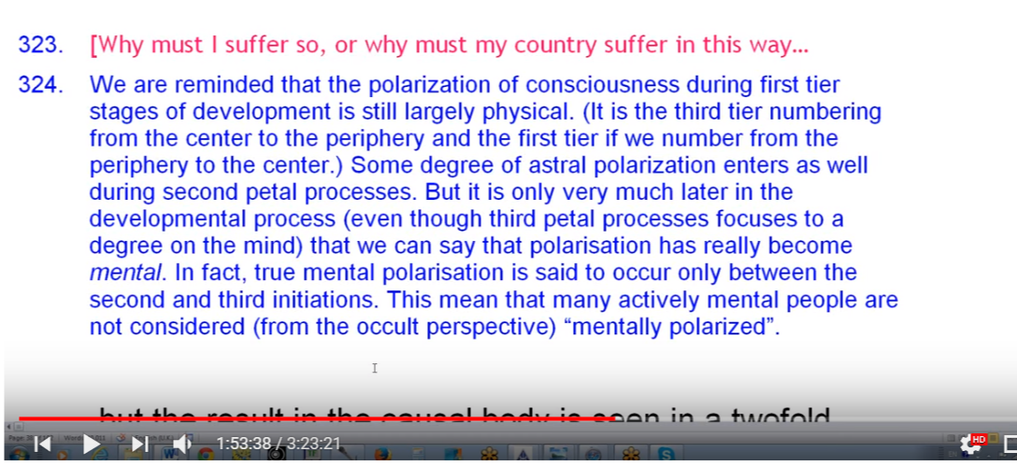

In any case, we are reminded that the polarization of consciousness during first tier stages of development is still largely physical; the senses rule. (It is the third tier numbering from the center to the periphery on the first here if we number from the periphery to the center.) Some degree of Astral, well shall I call it polarization? Yes maybe it enters as well during the second petal process, it is after all the Atlantean petal.
Astral polarization is not the same kind of thing that we find when working in the petals of love for the astral plane. It’s just a kind of emotional focus one cannot escape at that stage. But it is only very much later in the developmental process, even though the third petal process is focused to a degree on the mind, that we can say that the polarization has really become mental. In fact, you're up there between the eighth and ninth petal before you can really say you have mental polarization that occurs between the second and third initiation maybe midway between those initiation so this means that many actively mental people, or people who are mentally active, are not considered (from the occult perspective) “mentally polarized” at all.
Probably on our planet there are very few now who are strictly speaking physically polarized maybe the first couple of human groups perhaps in whom the spark had not been yet planted can be considered physically polarized but they are on our planet now all people have one petal open, even if not completely open, but all people have one petal in a stage which we can call open. Open obviously we don't have percentages here, which means that they have to have done some work in the astral petal in the second petal for this to occur so if we go among the less developed the least developed on our planet the Aboriginals not only of Australia but all manner of Aboriginals, we’re going to also find a fairly developed emotional life. It’s not as it used to be back in the Lemurian and early Atlantean times even though there was a correspondence, but the result seen in the causal body is seen in a twofold increase of heat or activity.
1:56:08 While the personality is unfolding, so is the causal body—through its petals and through the members, or constituents, of the atomic triangle which are contained within the periphery of the cause the body at the base of the lotus.
What is a twofold increase? Well we just know it's an increase, and it I the physical permanent atom which is going to be the recipient of this increase. DK must be speaking here of a time of consummation when the twofold increase in heat can actually be noticed. The physical permanent atom becomes radioactive, or a radiant point of fire.
I suppose this would happen when the entire lower or entire knowledge tier is fully opened. I suspect. So we have here some further discussion on this.
1:57:40 It is clear that the petals in the first tier are tied to or associated principally with the physical permanent atom. Then of course the Astral permanent atom for the second tier, right, and the mental unit for the third. There may be further development of the physical permanent atom as the remainder of the petals unfold. I mean how many spirillae are we talking about here? Probably the height of the blazing forth of all of these members of the atomic triangle is occurring just as they're about to go into a triangular rotary form and become very destructive in relation to the causal body. The form then shatters the connection, we are told in healing, Law Number Ten. We're talking about the form and the seven principles of any form which DK associates with the permanent atoms.
1:58:38 So by the time the third petal of knowledge has unfolded, the physical permanent atom is highly stimulated. Is it the final simulation? Probably not because the form can always increase in his radiance, if the theory gradients is if the final stimulation? And I say probably not.
We are talking about the kinds of vibrant bodies we will have in the Aquarian Age under the seventh ray. And if we have such vehicles it is probably going to correspond with still further development of the spirillae in the permanent atoms. So some of those cruder forms which are going to exist in those earlier days are not going to be of the same vibrancy, ethereality, energy transmitting potential as in later days of development. But still significantly so, the lower three petals become vibrant and begin to unfold until fully open.
2:00:06 Now this almost sounds like one process. I've questioned whether it is. Almost sounds like one process, but is it or is there unfoldment of the petal one, before the unfoldment of petal two, which unfolds before petal three? So there can be quite a difference in the stages of development of those who are unfolding the first petal and those who are working in the third petal. It seems strange to me anyway, maybe something I don't understand here, that they would all unfold simultaneously. But I concede that they might continue from their present state of unfoldment, they might continue the rest of it at a rapid rate. So I'm going to say, how it seems to me is that from their present state of unfoldment they might continue the rest of their unfoldment at a rapid rate.
Okay, and then lead to the fully developed tier. But when we're moving towards that stage of full development it seems that the first petal has less unfoldment to go through before completing itself, the second petal is less than the third; and it is the third that has the most. Seems to be two different kinds of indications. The lower three petals become vibrant and begin to unfold until fully developed. This seems to suggest that all unfoldment occurs simultaneously, but if that is so, then why do we have the differential? Of a group, lotuses of Brahman which … all have one petal unfolded … definitely one petal unfolded with the second on the point of unfolding, and no unfolding of the third, and the lotuses of passion or desire two petals unfolding. You see there seems to be something of a contradiction, so I would suggest the theory of differential unfoldment. But perhaps all together in moving towards the final state of complete unfoldment of a tier of petals.
I hope you understand what I'm what I'm saying because otherwise we have, well it just doesn't make sense with what it has been said. We have, but that tier completion, tier completion, can involve all petals continuing their unfoldment together. That’s how I presently see it. Unfoldment precedes full development. We may look at the process … I've tried to do this but really organization actually comes first. I'm going to have to change things around a little bit here organization comes first, stimulation is the same as vitalization, then comes unfoldment/opening and then comes openness or full development, or the full unfoldment of the petal and or tier.
Following the counter-clockwise mode of assigning zodiacal signs to the petals, the sign to be studied is Gemini. From one perspective, Gemini always signifies duality and so often mentality and I should also say, and struggle, fourth ray. So There’s no mental process (in fact) unless there is a dualism in consciousness – in fact a triplicity: the thinker, the thought, and that which is the means of thought.
2:05:38 Of course it is the third sign, as dualistic as it may be. The second ray is also a sacrificial ray, the giving of oneself for the sake of others making a sacrifice of oneself. It’s done differently than in the first ray method. If the petal is Gemini connected with Gemini they'll be a lot of the second ray, I probably go on to say that, and it's connected with Virgo in the sequence of Capricorn, Taurus, Virgo the second ray will also be there, as well as the sixth.
So through contrasts the mentality, observing contrast mentality, is developed and one tries to see the antecedents of different conditions: what led to these conditions. Some of the fifth ray is involved here. This is mentation but not really the solar angelic part of Gemini, which is Venus, not really yet.
The third petal signifies the power to begin developing the concrete mind. When this petal opens we have the man who can think. And maybe even think in a manner divorced from his desires. He would have moved out of the category of lotuses of passion and desire those in which the second petal is in full flower and whose attention has turned to the third. Probably that means organizing attention but how are you going to put that in there. Organizing attention.
2:07:42 When we talk about organization just really exactly what do we mean? See, the petal is being organized but the attention of the man is really in the three worlds. The organization factor is left to the solar angel and to other interior intelligences. The … man's attention here is in the lower three worlds. The organizing of the petals occurs under the auspices of the solar angel and maybe of forces, building forces, connected with the second aspect of divinity. For the second ray person.
So we human beings we're not in there organizing our petals, we are concentrating in the world in a certain manner, developing the skills and expressing certain energies and forces and as a result of doing that, the petals are organized by those intelligence as which can see through the organization, which is certainly not man at this time. The Solar Angels are experts in the knowledge of the building and organizing and folding of the egoic lotus, but even if the Solar Angel were not there other forces would have to manage this because the Solar Angels did not intervene in the moon chain and yet the certain higher examples of humanity like the Buddha entered with many petals unfolded. So they certainly had to be organized in different ways; a higher type of power has to see to it. I can just say it simply that way. A higher type of power must see to the organization and unfoldment of the petals. Man, with his present intelligence is not capable.
I hope that's been clear. I can't say that the man has been organizing, that's why I use the word working within, so when I say working within a petal it means working at those experiences associated with the petal and achieving some kind of victory or mastery in those circumstances and then the reflex action of the petal will be thus, and so according to the inner building forces. I hope that's clear, it’s certainly becoming clearer to me.
2:11:30 During the unfoldment of the third petal or the working within it, working within those experiences associated with the third petal the individual may still be largely under the sway of kama-manas. Just the way the lotus of passion and desire are, but its power will be lessening as that petal becomes more fully open or begins to unfold. Much ever will depend upon the personality ray (and especially the soul ray) of the individual and maybe even the monadic ray. So these rays guide the processes unconsciously to the man possessing them.
Let us not forget the importance of the monadic ray which basically is determining the geometrical rising of kundalini and the opening of chakras that are in triangles and the opening of petals that are in triangles. The monadic ray gives the emphasis just the way at the first initiation, the monad chooses one of the three major centers, throat, heart or head and will concentrate its force through that center predominantly.
Since mentality and astrality are so minimal in the first petal process – there I can get away with it if I say first petal process I don't have to specify: organization, vitalization, unfolding, opening, open, unfolded,— anyway the first petal process with individuals focused in the first petal unfoldment cannot be considered kama-manasic. They are like so many of the least developed on our planet they are more concerned with physical factors and their environment and that which the senses reveal. So I say there will be the astral life now if there is an astral life is it necessarily emotional. That is a question, I think up, with that down, that if there is an astral life, is it necessarily emotional in terms of the expression of great emotion, or something of that nature? I think maybe not. It can be still treated as yet another sensory environment and not feeding the great responses of the astral body.
Those passing through the experience of the first part of the second petal are largely kamic, but those passing through the experience of the latter part of the second petal can be considered to express kama-manasically. And let us remember also why, because they are working ahead in the experiences related to petal three. So mind began to enter in the Atlantean period indeed and so did initiation. Well maybe it was part of the general forcing process and the second petal correlates with the Atlantean phase of consciousness. Mind was not so highly developed. Most of those who built the colossal structures were impressed by the task and had little mind to conceive on their own what they were doing.
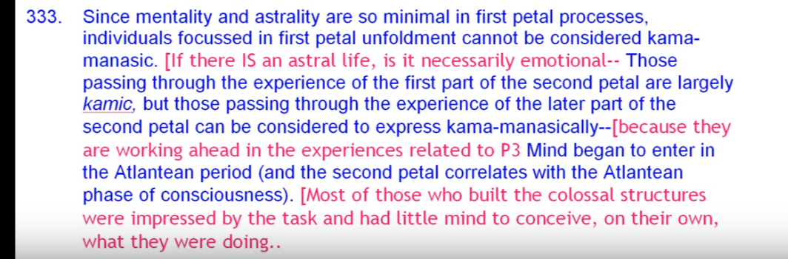
2:15:34 But there will be from the very beginning the mind is there, either fanned by the solar angels or implanted as a spark of mind. Which is a far greater stimulation than fanning the mental unit or stimulating that mental unit. So mentation is a capability, but it's only used increasingly by the time we get into a Mercury petal. Like the third petal, its mind is really much more active in a Mercury petal such as a petal three. Related to Gemini and Virgo. The mind is far more acute and active than in the first or second petal processes.
I think the general idea is there, some greater degree of understanding. But remember we are still in the Hall of Ignorance, and the higher of the pairs of opposites is towards the end of this Hall only dimly seen. Even though one is working ahead let us say in petal four.
I can't help but think that there must be sequential working because the different capabilities that have to unfold, cannot unfold simultaneously, one depends upon the next. So there has to be a sequence and as there is organization going on one is working in the outer world in such a way that organization would occur first on the fourth petal then the fifth and then only then the sixth and not all three simultaneously. Simultaneity is a synthetic stage and it calls together different kind of work which was sequenced really accomplished and then relates all of that work in a synthesis but unless we do our sequential work we cannot do our work or simultaneity. In other words … that Saturn of sequence must precede Uranus of simultaneity.
So if the people today who say, “Well we take all the five initiations at the same time”, forgetting that the work they have to do in the world is sequential work with each further expansion of that work dependent upon the successful accomplishment of that which preceded it. Then, that there may be a sudden simultaneous interblending of energies so that all the work can be simultaneously accessed, and it's all considered to be part of everything else, everything is part of everything else, I don't deny that that can happen, but I think there has to be a sequence as well. The Saturn sequence must precede Uranus.
If we consider the zodiacally clockwise manner of understanding the petals that is not the natural order of the signs. the sign Capricorn would be assigned to the third petal of the knowledge here. You know so this is the zodiacally clockwise manner of understanding the petals and I have to say here as said at the beginning with Pisces, then the sign Capricorn is going to be assigned to the third petal of the knowledge here or should we begin with areas then Aquarius.
Capricorn with its ruler of Saturn is much associated with a concrete mind yes and with a process of sacrifice especially compulsory sacrifice – no escape from death and taxes. You cannot escape the compulsion of Capricorn, Saturn. So we all know the forcing regiment in qualities found in Capricorn seventh ray in the Capricorn individual. And let's say here conditioned by the seventh ray. And we might say that a measure of Capricorn in reality which depends upon the power to think at least to a degree is entering the consciousness.
2:21:21 I'm remembering my old teacher used to quote this following statement must do. He is a stern commander. This can come this can come from circumstance or from an inner voice and in this case it's more the compulsion of the circumstance, the must do comes from circumstance.
Should Aquarius characterize this petal (as would be the case if we began with Aries) Aquarius is an air sign and easily associated with mentality even a concrete mind at times although much later the elevated, abstract mind which looks at all things from a great distance. Let’s just say how can I say here that, I think this is an interesting analogy that Capricorn must stand on an earthy mountain to see its great perspective. Aquarius takes off into the air, flying, one way or another and can see from an even higher perspective. Perhaps Pegasus the winged horse, helps with this flying because it is the second zodiacal constellation associated with Aquarius. And then there's the swan. Whoa. Cygnus the swan; the swan from the greatest heights. At the same time and after that you have to descend into the valley, and carrying the burden, indeed, but Aquarius is aviation and so no wonder the heights in the depths occur in Aquarius.
2:24:02 We're not looking for the great factor of obstruction when we get to the third petal and it's use. We're looking simply looking for the concrete mind and sometimes the scientific mind which we find in Aquarius in relation to Uranus. Later will come the abstraction. Think about Emanuel Kant’s third ray, but Taurus pursuing wisdom and knowledge, but with Aquarius rising. And his degree of abstraction was something phenomenal. I think one of his friends gave the book Kant gave him to read returned to Kant half read and said “It's driving me crazy – I’ll go mad if I continue.” I wonder how many students of philosophy have felt that way in reading Kant. I think lately most of what has happened is that the basic digest of what contests offered has come into the philosophical mind and he's known for a particular type of contribution and you wonder how many people read him with exactitude and endure it. I suppose in a course specifically given to his work it would happen.
The kind of sacrifice experience is not self-originated but “at the mercy of circumstance” and very much the result of group pressure. All of us have to do this, all of us countrymen have to do this, all of us in this level of economic hardship have to do this. We have no choice in this way.
2:25:55 Aquarius could be seen as somewhat involved in the process. I'm trying to find all the wheels turning upon themselves simultaneously and everything is related to everything else. We learn that about chakras in relation to petals we will be learning it, and the whole egoic lotus is like a heart chakra in a way within the monadic demonstration. So at a certain point everything will turn upon itself and I suppose this will happen just before the destruction occurs, the greatest amount of spherical brilliance. Color, sound will occur before the destruction. So group pressure is typically Aquarian.
We recall that the Earth signs can be reasonably associated with the knowledge tier, and certainly Taurus has a lot to do with the pursuit of knowledge at its higher levels, and it is sensory knowledge. It seems it's earth experience in the field of the senses and fits well with the Earth signs, since this tier concerns consciousness upon the physical plane, even if that consciousness is at times emotionally driven, or has mentation involved with it, and it also concerns the physical permanent atom. Even in relation to the process for the mental petal of the knowledge tier there is an offering up of the physical body because in this tier mind and emotions are directed towards or focused upon the body. We do not have, this comes later, upon the body. Later, emotions are focused upon emotions. And that would be perhaps in the second tier at some point. Still later the mind is focused upon mind it all depends on the ray, maybe with a third ray this is easier to happen but then the number nine you know we can expect that to happen in the philosophical ninth petal, that mind being the number of the third ray. But the major focus is the physicality, and so whatever emotion there is, whatever mind there is, it’s about the physical world. The next tier is more about the astral plane. And mind can be focused then more upon the sentient level, even if it's a relatively high sentience, and physicality can be focused in support of that growing sentiency. Then come the petals of mind, the will, sacrifice petals, and there what's going on in the mind disabusing it from illusion is the main focus, and emotions and the body supports the major mental emphasis and mind can be focused upon mind. But at this point what thinking power there is, is focused upon physicality.
Capricorn was associated with the first petal (the most physical), Taurus with the second petal (in which desire and emotion become significant developmental factors), and now Virgo will be assigned to the third petal. We can say Virgo is first a highly mental sign and concrete.
A friend of mine did an analysis of philosophers and found that Virgo and Taurus were very prominent among them. The pursuit of knowledge and maybe in Virgo the deeper pursuit of wisdom, but also meticulous analysis of language. I'm trying to remember whether Wittgenstein was a Virgo that's I know it's a bit of a tangent isn't it, but … Wittgenstein’s birthday, and it looks like Virgo … but, no he's a Taurus. Well that's okay, too.
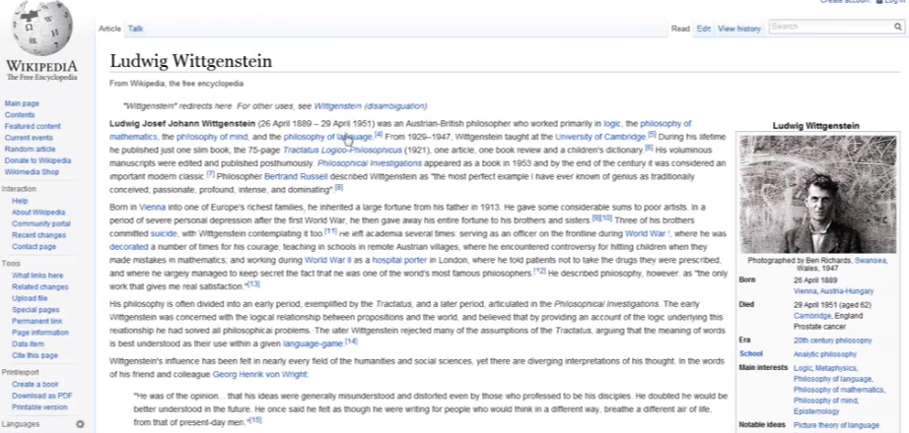

Somewhere from the 26th to the 29th of April, if the 29th he's still in the Taurus decanate, I forget what his Ascendant is, I have it somewhere. But maybe it just goes to prove the point Virgo and Taurus, Bertrand Russell, Taurus, Socrates, Taurus, Emmanuel Kant, Taurus, all great philosophers. And will have to study astrology in a manner that is statistical; that is recommended by the Tibetan.
2:32:09 Virgo (in the earliest stages of human development) is experienced as a very materialistic sign but also holds much promise for the development of mentality. The rays of Virgo in relation to the previous solar system are hypothesized as the third and seventh. And Virgo rules the latter part of the previous solar system, we are told. In the beginning, it's all about developing mentation, almost with a kind of momentum from the past, encouraging that, and it's a lower example of Mercury. But Mercury is also exalted in the sign Virgo, so very high mental processes can be found there.
The beginning of mental discrimination is therefore to be expected in the process of third petal development. Mercury, indeed lower Mercury, but also exalted Mercury, because Virgo also tells the Tibetan about the cultivation of wisdom. With Virgo enters the possibility of the manipulation of the environment and the possibility of distancing oneself somewhat from the imperative urges of driving desire. Well we have the whole idea of monasticism in relation to Virgo; we have those withdrawn. We have the hermit and we could say, withdrawing in the mind from all the desire which usually compel engagement. But really that hermit phase is more related to the sixth petal and its processes, I think. Virgo is cultivating the concrete mind in relation to the third petal. From the planetary perspective Mars and Saturn are constants throughout the unfoldment of the first. Here they both relate to the concrete mind. Both relate to the concrete mind.
When we speak of the “driving force of circumstances”, Mars and Saturn as suggested features strongly. Mars drives and circumstance (and the fate arising from its pressure) pertain to Saturn. These sacrifice petals are karmic petals also. So there's a clearing that occurs in the process of each sacrifice petal to prepare for the next phase of higher experience. So if there is the sacrifice of the physical body, then of course the planet of death, Pluto, will reasonably be involved. I guess it's possible to experience death from any one of the planets.
2:35:45 Is it possible to die of beauty? Well maybe, under Venus. The Tibetan has discussed of dying of one's aspiration. In the mystics, they so externalize their desire nature that it just leaves the body, and doesn't come back. And Saturn, the crushing pressure can kill, and also lack. Jupiter is a type of release and a magnetic – being magnetically drawn into higher spheres. The death through air is not easily understood, He says, it's not pertinent at this time, but involving Mercury you might wonder. Would it be a death through scattering and dissipation?
Mars of course is the typical sword. Uranus, death by electric shock. Neptune, death by drowning, one way. Pluto, death by poison. I probably left something out. Earth? Suffocation. Buried alive and so forth. Vulcan? The hammer hits you. That's it. Crushed. Mercury is little harder. Going to be death through division, being torn apart in four directions and scattered to the winds. There are these air burials in Tibet that I've heard about, and the birds come and that … but you have to already be dead, I hope so. And that is more related to the winged planet Mercury.
2:37:40 Probably in relation to all the sacrifice petals and the sacrificed tier altogether, Pisces, the sign of sacrifice should be considered present. It certainly is in petal six, and I think we can find a way in the stepping off the mutable cross onto the fixed cross, I think with petal six it could happen that way. And stepping into the realm of synthesis, stepping out of the dense physical vehicle of the solar logos at the ninth petal, and getting into the synthesis petals, which Pisces represents. Pisces takes from all the signs; the most synthetic of all the signs. And here as well, at the third petal we have to give up our life, or give up the form anyway.
Pluto, all of the planets ruling involved in the death process. Some good astrologer I know has always said, “look for Jupiter”, because it's going to indicate the possibility of being abstracted – magnetically abstracted – into the next dimension. You know the drowning of Neptune is obvious, being engulfed with Jupiter and Neptune. And of course Pluto, the planet of death, per se. Pluto of course is the esoteric and hierarchical ruler of Pisces and connecting it with the end. Of course when the end is pralaya, Neptune is considered because things go into inchoate state and are absorbed. Things just dissolve.
We cannot forget here that Mercury, as the exoteric ruler of both Gemini and Virgo, is involved. The Gemini petal from the Aries, Taurus, Gemini, and Virgo petal from the Capricorn, Taurus, Virgo side. Mercury is involved here, and interesting, the fourth ray and Mercury are associated with sacrifice, with the color yellow. Fourth ray and Mercury associated with the color yellow and with sacrifice. Being in a higher place and yet having to extend yourself into a lower place. This is so Mercurian; having pervaded the entire universe (or whatever) with a fragment of myself I remain. Having to invest yourself partially in the lower worlds like the Solar Angels, with their wings. They have their own cosmic etheric place and yet at the same time they have to extend an aspect of themselves into the lower worlds. This is what Mercury does.
2:41:00 In this instance, Mercury is the Planet of the concrete mind at this point it gives new understanding and control over the environment: its mental control over that which the senses relate (the quite material environment material environment, which the senses reveal, and in which the individual of growing intelligence finds himself surrounded with which he finds himself surrounded).
Is there any role for Venus here? We cannot dismiss it from the developmental process of any of the petals of the first year, (even though its association with the second tier is definite.) I mean we do have that color orange there, and the fifth ray was present, so Venus was instrumental in individualization and developments followed immediately upon individualization: Venus contributes to the heightening sense of values, what's worth desiring (promoted by the second petal when physical self-centeredness becomes desire for other things, and maybe for other people. The magnetic attraction to people places and things of greater or lesser values contributes to that growing sense of discrimination which will eventually become the mental discrimination of the third petal.
2:42:18 Venus rules taste and that is related to discrimination. When it has the fifth ray of discrimination connected with it. Of course Mercury is very much involved in the discriminative process as well: Mercury has the fifth ray on some of its levels and so does Venus of course, the fifth ray soul. In relation to the third petal, Venus is very much the bestower of the fifth ray with its relation to the concrete mind. The development of concrete mentality is Venusian, as well as Mercurian, (and Saturnian and Martian) through Venus the mind begins to be magnetized by and select objectives of a more refined nature.
2:43:12 But if we really look at how the concrete mind got going, the mental unit had worked its way up as instinct, approximated mentality, but that mental unit was greatly stimulated by the presence of the Venusian ray coming from the solar Angel. So from that perspective, Venus is a planet of tasteful discrimination, and applying mentality to that which is really of value. It kind of falls in Virgo, interestingly enough, and that represents the story of the Solar Angels falling into dense physical matter. We cannot forget how materialistic really Virgo is. We have a very materialistic mind, in the third petal.
DK tells us of the primary lotuses that the first and third petal are both opening maybe that we would expect the third petal to open we might expect the first petal open but maybe it's because they are coming in and are more related in a way to the mind.
Of course coming from Vulcan you would think there would be a physical polarization there as well. But it says the first petal is opening as well for them. It’s not going to be a very affective relationship with the environment. It's going to be more mental manipulative. It’s going to deal with physical action, and the mind to support that action, and not “oh I love it, I hate it”, which is more of the second petal.
Looking at all this from the ray perspective we will always have the first ray where a sacrifice petal is found, but since it is the third petal it has to do with the development of mentality. The third ray must be included, as must the fifth ray of concrete mind, and mentality. In Virgo there is plenty of first ray, through Vulcan coming in as the veiled planet on the esoteric level.
2:45:41 Now this is not really an esoteric level, but to me when I think of working in matter and Virgo, I can't erase from my mind the application of Vulcan, in its material aspect. I don't think of it only as the planet of spiritual will and of the light of matter, I think of it as fashioning matter through mind, which is what happens in this third petal. Mercury in its lower aspect is closely associated with the third ray, just the way Venus is with the second ray.
Interesting, you look at the Buddha, you think Mercury, you look at the Christ, you think Venus. The Buddha is supreme intelligence, accompanied by compassion. And the Christ's unparalleled love, at least regarding any human beings of which we are aware, his unparalleled love in relation to the planet of love-wisdom. One of those planets is Venus, and Jupiter is another, perhaps. Mercury in a slower aspect is closely associated with the third way. And in its higher aspect with the fifth, (as well as the third, in a very high sense.)
2:46:59 What I'm hinting at there is, the monadic, secondary monadic ray of Mercury being the fifth, and its final monadic ray since it has to be one of the three, being the third. This is what I presume to be the case and stand to be corrected as necessary.
We recall the following that we discussed, which hints at a ray, important for the third petal. It is the offering up of the physical body upon the altar of sacrifice – low desired to begin with, and I would have to say in the early phases of the experience related to petal three, and aspiration towards the end and of course we would tend to say, in the later phases of the experiences, related to petal three. But though still desire.
2:48:10 When you look at the rays, the sixth ray is going to be very prominent here. It’s associated directly with desire and is the ray of Mars, at least exoterically. What's really interesting here when you look at Ara the Altar in in the second decanate of Sagittarius (as we noted before), it is a decanate that is ruled by Mars. Here is the altar, ruled by Mars, and Sagittarius also ruled by Mars, Mars and its sixth ray. So there is a sacrificial aspect of Mars related to high courage. Not just a bloody battle. At this stage of development the sacrifice may be relatively unconscious but it represents a preparation for the type of sacrifice which will be both conscious and willing.
Think about the eighth petal: with no expectation for any reward for the great sacrifices involved, and then finally the ninth petal, for which Mars is the hierarchical ruler of Sagittarius, the utter sacrifice of all forever. That sounds so final and so drastic.

Chakras and Third Petal (continuing astrology)
2:49:27 We have the sacral center, as the seat of the mental elemental. We're liable to forget that altogether. Certainly the concrete aspect of the mind. The sacral center is in one sense, since it provides for the birth, i.e., manifestation of the physical body, a peculiarly earthy chakra. Of course this is related to water, because of the fluids involved in the production of the form, but it finally produces an earthly form, and so it will naturally be associated with all the tiers of the knowledge tier.
Knowledge is in a way the precipitation of wisdom, and it is the etherealization of knowledge that will lead us to wisdom – or transfiguration of knowledge which will lead to wisdom? A de-concretization of knowledge which will lead to wisdom? Or, perhaps an accumulation of knowledge and seeing the interrelationships of those items of knowledge which will lead to wisdom. Along with the heart.
So the sacral center in terms of the mental elemental? Yes. And the sacral center in terms of reproduction in the second and the first petal. Reproduction does not cease of course unless of course we get into one of the Scorpionic petals or Virgo petals. And we have a deliberate disciplining of the sacral center and a movement away from the sex activity, so as to use the energy for illumination. Which both Taurus and. Scorpio rule, in different ways. The illuminated process in the meditative sequence is ruled by Scorpio. And in general, illumination by Taurus, and when we get to the eighth petal we can always have the opposites, Taurus and Scorpio.
Interestingly enough, in the Labors of Hercules, Taurus is associated with celibacy and the deliberate disciplining of the sacral center in order to produce the eye of wisdom.
2:52:08 The sacral center is related to developing mentality; mentality increases in its development as sacral energies are elevated to the throat center. And this is a familiar idea. It's like Mars going to Uranus, or Uranus going to Uranus, or the moon going into Uranus. Depends on how we look at the sacral center.
We must naturally include the solar plexus center in relation to the third petal, since desire, and even aspiration, is prominent in the third petal of the knowledge petal as we are told. Laying the physical body on the altar of desire, low desire at first, but aspiration at the end aspiration, but desire nonetheless. The physical body is offered up, and this means that man begins to care more for what he desires or for that which he aspires than for the fate of the physical body, per se.
2:53:16 Kind of interesting that it comes in here at a mental petal, since the highest form of aspirational idealism is found in Taurus, we would have to include Taurus as well. Taurus as the highest form of aspirational idealism should be included as well. When does aspiration really strike? I think it's going to be very strong. Aspiration will be very strong during the work involving the love petals. And I think in a way it will only increase, with the one-pointed discipleship of the initiate of the first and second degree ruled by Sagittarius which has the hierarchical Mars. That's to say, it will only increase and become more targeted and become more targeted … in the petals of … Sacrifice. So we can see that some of the sacrifices entailed in the process of war do relate to this third petal.
The sacrifices of economic hardship. The sacrifices a family too, you know, it's sacrifices of economic hardship and of family, where Virgo-like, one must give up one's own preferences for the sake of others. I keep on thinking of motherhood and Virgo, and how with a Gemini petal, not necessarily, but with Virgo ruling those sacrifices it's another one of those must do's. Now some people try to avoid this but it's karmically very expensive and very divisive to be avoiding those sacrificial responsibilities.
2:56:09 One more center has some initial development here and that is the throat center and I say initial development, which can be closely related to both Mercury and Saturn and to the earth as well. So the throat center certainly: the concrete mind and not only abstract mind. We've talked about the sacral center being the home of the mental elemental, but the sacral center has to send its energy to the throat, and the first kind of throat activation will be of the concrete kind. So after all earth is quite concrete, Saturn is among the synthesizing planets, the most concrete, related to Brahma and not to the utterly esoteric. Concretion occurs at the form-building throat center, whose number 16 sums to 7, which give us certainly tangibility.
2:57:24 Regarding the primary lotuses they are from another planet who have come to Earth for the development of the second petal. They already have the third petal … well I want to say, I think this is better to say developing because I think when we read it, it said that the first and third petals are unfolding and they are intelligent.
A number of the intelligent but emotionally unresponsive scientists – and maybe emotionally immature are found in the ranks, and this substantiates that considerable development can accompany the unfoldment of the third petal. The gradual and general unfoldment of the third petal … How is it said of the primary lotuses, let's go to that page just for fun. Page 841, Treatise on Cosmic Fire:
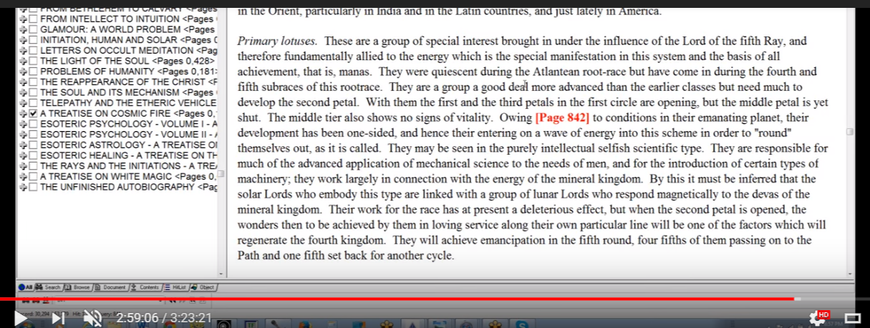
… going a little farther down, primary lotuses brought in by the Lord of the fifth ray: They were quiescent in the fifth race, associated with that petal. Quiescent during the Atlantean race. Were they even here? But have come in into incarnation during the fourth and fifth sub races of this root race. Maybe they were in some sort of pro-life state who knows when they came from their planet of origin.
They are a group a good deal more advanced than the earlier classes but have much to develop the second part of with them the first and third petals are opening. TCF 842
So that sounds like a fairly ultimate development and are coming near a state of being fully open. So these are intelligent people but need the influence of the earth and its second ray soul and its type of magnetism to develop an understanding of emotional relations, sentient relations.
3:00:15 So considerable unfoldment of the third petal does show that there's quite a bit of which we call it intelligence involved there. Now we cannot really say the lotuses of passion and desire, some of whom come from the moon chain, but three fifths of which come from the earth chain, the lotuses of passion and desire do not have the third petal as unfolded as do the primary lotuses. The primary lotuses seem to be working in the second petal; it's almost like having to do a little remedial work. But inasmuch as they will be with us for a while, it would seem that they would have to because their first and third petals are unfolding that they'd have to be working also at least organizing in those types of experiences which relate to the central tier of petals.
If there is growing and even considerable intelligence, then the throat center must also be unfolded. Must also relate to that third petal. Mercury (prominent through Gemini and Virgo) and Saturn (prominent through Capricorn—with its initial emphasis upon concrete mentality) are both planets related to the throat center. And even later, but not now, Uranus comes in with it seventh ray, but we don't want to get ahead of ourselves here, we're not anywhere near the first initiation. Consequently, Aquarius will have to mean something other, it can mean concrete science.
Earth is, for the average man, the throat center ruler (that's from Esoteric Astrology, page 517), and earth is somehow connected with all the earth signs, Capricorn, Taurus, Virgo, for all of them emphasize materiality and the earth at this stage, under its third ray personality emphasize materiality. The expression of earth under its third ray Personality … emphasizes a material, but under its second ray soul, it abstracts from the material. And that's one of the battles we're having right now on this planet with the fourth initiation a kind of fourth initiation being undergone.
3:03:24 So we can see that the mind provides a degree of detachment and vision. It is possible to abstract to a degree from the kama-manasic mind as the third petal processes unfold, because as the third petal continues to unfold and, on the basis of this abstraction, from kama minus sacrifice becomes possible. Let's just say, one sees more clearly. We have to remember though that much of it is unconsciously undertaken. Even if the larger spiritual reasons for the sacrifice are not known by the human unit who is at this point more sacrificed than sacrificing.
Let's just say that when we are ruled by the kama-manasic mind, the true reason for things (even an intermediate reason) is not so easily seen, but with the growing mentality of this petal there can be the beginning of the understanding of why sacrifice is necessary. I suppose even more so at the sixth petal we really really come to understand, because by that time we're on the path.
Many human units are caught up in this type of sacrifice. The circumstances are forcing the sacrifice. I wonder if you can think of instances in your own life where circumstances force the sacrifice I can think of some cases where a student is perfectly able to attend a school of very high-status, like a college but cannot because the family lacks sufficient funds and yet does not lack them so much that a scholarship would be offered. People want an education, maybe, but they have to go to war to find it and be part of a G.I. Bill which will give them education after they put themselves on the line in the military, also ruled by Virgo. Interestingly, we call it the service “I entered the service”, that is so Virgo.
3:06:17 And then you have to obey orders, and Virgos are forever obeying orders from those that are higher in command. One of the old, let’s see, “Ours is not to reason why ours is but to do or die.” Let me look at that, I want to get the entire quote. I'm pretty sure Wittgenstein did have some Virgo in his nature as well…the Charge of the Light Brigade this is by Tennyson, and has this statement … ours is not to reason why … I want to see whether it's do and die or do or die and … I should be able to find this … maybe we can find that quotation, the partial quote ours is not to reason why; theirs is not to reason why, theirs is but to do and die is in the second stanza of the poem. Okay, so the partial quote is attributed to Alfred Lord Tennyson but the quotes are various, is not to reason why, theirs is but to do and die. And that's exactly what happened in that particular charge, so we should put that down, “theirs’.
Well anyway, compulsion … what we sometimes see when we look at the draft occurring in various countries used to be in relation to war. Sometimes if there was a huge and general war everyone was drafted, but often going to the service are the people who come from a lower social socio-economic levels of opportunity. It may be, and I cannot say for sure, that this particular petal for them is the focus, and it may be that many people who seem to have escaped the draft, because they are raising families or perhaps going to the university, have at some point earlier fulfilled the requirements of that petal. It’s hard sometimes when we look at the apparent inequalities that occur into society we forget the karmic factor that may be involved in the degree of experience.
3:10:26 In any case, when one superior principle or aspect of the human constitution (for instance kama or desire) is expressed with sufficient intensity it always results in the sacrifice of a lesser principle or aspect of the human constitution for instance the etheric-physical body. In this case, or you can you can also imagine mind when intensely exercise will lead to the sacrifice of emotionality, and still later the intuition when exercised will see the usual approach of mentality sacrificed. So when we emphasize a superior principle a lesser principle is sacrificed.
When pondering these thoughts we should remember the sacrifice means to make sacred so the sacrifice of the lower principle is not necessarily its elimination, not necessarily, but rather its elevation through sacralization. These lower principles are often retained but they are used in a manner subservient to a higher principle, which means they are used more correctly. Of course some have visual patterns associated with the principle to be sacrificed will also be eliminated. So there will be loss of a habitual way of doing something but it's not necessarily a loss at all.
As Master Morya said in relation to sacrifice: Master Morya, “When have you ever become less through sacrifice?” A question, and it causes you to think.
Always there is some gain through true sacrifice. The gain may not be in the immediate life and you may look at sacrifice and say “I've lost everything.” But in the larger scheme and when the eye is allowed to behold, one will see.
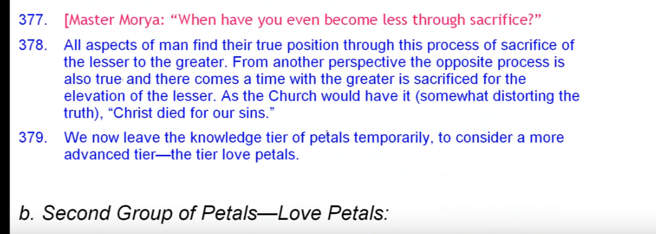
So all aspects of man find their true position through this process of sacrifice of the lesser to the greater. And from another perspective, the opposite process is also true and there comes a time when the greater is sacrificed for the elevation of the lesser, as the Christ with, the church would have it anyway, somewhat distorting the truth Christ died for our sins but, another way, I, if I be lifted up, will draw all men to me; I, if I be lifted up, will draw all men unto me.
3:13:10 Well we spent a fair bit of time on this particular petal, the third. There are apparent contradictions in it; it's a mental petal and yet it's the sacrificial petal. Mentality is growing and yet the need to sacrifice much of what was pursued out of simple desire also comes upon the individual. Now you look at the nice good people, the lotuses of passion and desire, a sacrifice lies ahead one can already begin to feel what it must be you know there is a such a thing as the comfortable life, and the pursuit of happiness as meant for many under Jupiter in Cancer in the United States, pursuing the comfortable life. Maybe it is so in much of western civilization the pursuit of the comfortable life, and it seems that there will be a demand that that type of life be relinquished for higher possibilities.
We can almost see this in our Western civilization now, a simplification during the Aquarian Age is needed, otherwise we will continue to pursue materialistic satisfaction as if our desire nature was attached to the processes involved in the petals of ignorance. And we want our desire nature for these people to be attached to what occurs in the petals of love, where the man is a creative individual and aspirant can truly emerge. But when you're tied to the desires that the masses hold, and you know consciousness is pretty much not individual consciousness within the knowledge. Here it's pretty much mass consciousness and maybe more emotional mass consciousness when dealing with the second petal of the Atlantean tendencies, but still one in the middle of ignorance, one does not know oneself to be an individual soul who is responsible for one's own salvation. One does not know that one is the higher of the pairs of opposites.
3:16:11 So for a lot of people, there in the Hall of Ignorance is perfectly adequate for them to say “Christ died for our sins”. It's taken care of: all we have to be is be obedient and do the right thing and we will be safe forever. That way of safety, of going to haven or going to heaven, is not the way of the individual who has to begin kind of a heroic journey who has to fight for his individuality and then to later sacrifice that individuality for the welfare of all.
So wherever we are on the path and wherever we are in the organization, vitalization, opening, unfolding of the egoic lotus, we at this point have been through stages before, we have paid our dues, within certain petal processes, and we have other challenging possibilities ahead of us and we simply have to have you know the courage to go through them and to realize this is a divine process. No one is spared the transit through these different stages. The Christ didn't become as the years because He's the only Son of God and therefore in a privileged position. He became what he is through merit, and thus for the Buddha, and thus for any great soul and thus for us on our way to becoming greater souls than we are, and eventually great souls. It is inevitable.
Now we have actually completed our discussion. Well, nothing's ever complete. Any completion is only a partial completion the only completion there is the absolute, the infinity of all infinities, the greatest possible infinity.
Anyway, we have completed our discussion of the outer circle. And the lotuses of that outer circle, which He has named. He hasn't really named the lotuses of the middle circle so much. But more of the lotuses of the third sacrificial circle very He seems to have named them.
3:18:35 This is a long program I know but once I get going and once I break and divide, and all that I lose my train of thought. I lose a lot of time and time is of the essence. So more along this line will be synthesized when we come to a different approach of gathering many things in, and to the final charts. By that time, I hope you are so familiar, and by that time I too will be so familiar, there's nothing like re-learning and reaffirming certain things you thought you knew, and making adjustments as you see you might have been mistaken before. So by that time I hope we are all in such a position that when we synthesize this information it will really set up a great network of interrelated knowledge. A synthesis of knowledge. Kind of a seventh petal activity and I suppose the first of the synthesis petals.
We do this of course so that we can offer to humanity some type of vision which would be so uplifting that they will leave behind their older pursuits of lesser value, and reorient their desire nature so that they can really begin to achieve in line with the plan, and that will of course elevate humanity and eventually the whole planet.
So this this is number 23, so it's the end of Egoic Lotus Webinar Commentary program 23. And believe it or not … we on page 540… We haven't been going very far in TCF, but let's give it the benefit of the doubt, 3 hours and let’s say 22 minutes. I know it's an ungainly time but I've decided on this and I hope there are those who will be willing to follow me in this type of learning.
So it will go with the beginning of Egoic Lotus Webinar Commentary program 24, and we will certainly be in T.C.F. page 540, but how long we will go that remains to be seen.
This is really the method of meticulous entirety. It is an aspect of the second ray, third aspect of the second ray, the ray of detailed unity. It is a particular way of proceeding upon the second ray, so that we can gather all relevant and interrelated items of knowledge and see them both in articulated particularity and also in terms of a wholeness of relation. When the intuitive faculty of the master function just ceases. We will bring ourselves through Mercury to that kind of intuitive perception which is under Mercury yes, but also under Jupiter, and then we will simply see all at once and then we can take the time to break out in an articulated manner all that has been suddenly seen. I would say the sudden sight also will involve Uranus. We're trying to make our way into the spiritual triad and the type of perception there to be found. I think increasingly we understand that.
And now we will say this is 3 hours and 24 minutes, because it's closer. Okay friends, we will continue our work to either on my tonight or more likely perhaps in the morning. Take care and let’s keep learning together.

