EGOIC LOTUS WEBINAR COMMENTARY #21 – Michael Robbins

Abstract

Egoic Lotus Webinar Commentaries 21: Introduction to the Egoic Lotus from A Treatise on Cosmic Fire. This webinar is about 3 hours, 21 minutes long and covers A Treatise on Cosmic Fire pages 536-539. In this program we begin our study of the egoic lotus as Master D.K. presents it in detail. This first program is, however, rather abstract, and deals with the causal body and its relation to similar structures in certain higher Beings and the manner in which those higher Beings, such as the Planetary Logos, feed the egoic lotus with energy. The idea is presented that the egoic lotus is the heart center of the monadic system of energies. The numbering of the parts of the egoic lotus is explored from several different perspectives, as well as the fires and their divisions which are involved in the functioning of the lotus. In this section the egoic lotus is presented as an expression of fire and not as substance, per se.

Contents

Abstract 1
Contents 1
Transcription of Egoic Lotus Commentary #21 1

Transcription of Egoic Lotus Commentary #21

Hello friends. We are beginning our work on the 21st program. I guess so far we have over 30 hours of programming into it. Twenty programs so far of preparatory material to study the Egoic Lotus carefully in a synthetic manner. This is kind of a work in progress. Whereas I thought I was going to begin immediately petal-by-petal what I decided to do instead was to work on the large sections, which are called Qualities of Petals of the Egoic Lotus, in detail. It's really only 13 pages in A Treatise on Cosmic Fire but it's such an important 13 pages and I thought I would simply incorporate this material into the study of the petals per se. But I think it's much better to go with what the Tibetan has said in a very coherent and precise manner. And then to do the same thing for the study of the colors and only then begin this more synthetic work. The synthetic work will be in two phases.
2:00 First we will have the study of petal-by-petal, bringing many things together in relation to each petal and of course to the tiers that are involved and then we will begin to look at some charts, as a final piece of work for us, where we can see these many factors listed side-by-side. I think that will be our final useful event. This will maybe take a little bit longer, things will be a little bit more expanded than I thought, but I thought when I looked over this material from 536 to 549 and although I have written on it, I have the feeling that people are much more likely to assimilate in this manner which is more taught, more spoken, than simply to be directed to these pages of commentary and hope that by themselves they will gather what is necessary. Of course they can do that. But I will add to what I have already put into this commentary on these 13 pages as new ideas come to me, because this was written 7 years ago, maybe some new ideas have come and I will do this with this second important section on the colors as well, and then I think we will be ready to proceed petal-by-petal and then work on the final charts which are laid out in tabular form with the subjects simplified and many subjects adjacent to each other so they can be seen under the eye.
So here again is our picture which we are referring to with the higher three planes of the mental plane and this particular Egoic Lotus is on the point of its final destruction.
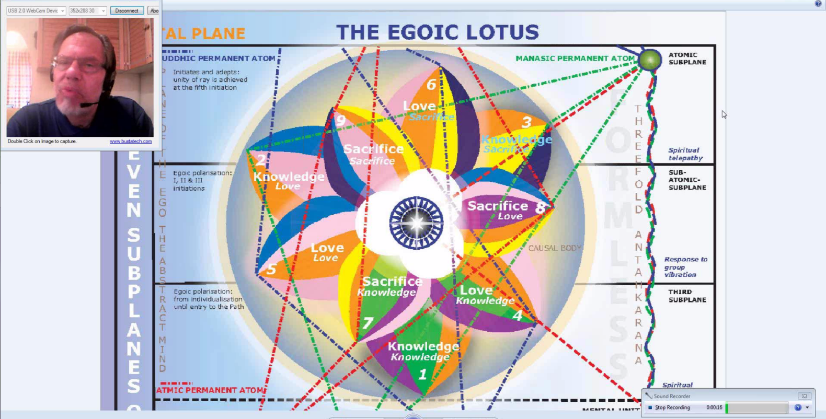
It's a fully opened Lotus of course. It's static. And we cannot see the blaze of glory that D.K. says is there to be found in all of the rotation and scintillating movement and this amazing synthesis in color and sound of the light of the life process. But even with this static form, we can at least, in a fairly 5th ray manner, identify the different features and the different associations to be made. We are working more in the field now of knowledge than of synthesis per se, but at least it's a place to start.
5:25 We are on page 536 and this section is actually called The Egoic Lotus. It goes on for about 13 pages in Cosmic Fire and this is really a subject of the utmost psychospiritual importance, and we can learn so much about our development as human beings and disciples by studying the Egoic Lotus perhaps in a way more than in any other way. We actually begin with a footnote. In Cosmic Fire D.K. has many footnotes embedded and sometimes when people read the book they do not really pay enough attention to the footnotes. Of course there is a bit of a complication because so much that is footnoted relates to a 3rd edition of The Secret Doctrine that has been out of print for a long time and is difficult to acquire. I managed to acquire it, but well, it's in storage, what can I say. haha.
"The Egoic Lotus ". . . the laws of karma are adjusted, the clue being found in the mastery of the sixteen rays of the Ego, for which sixteen rays sixteen mantras or words are given, the real pronunciation being however reserved for initiates only."" Kali Upanishad, footnote TCF 536
﻿﻿The exact pronunciation of the evocative word is so powerful. This says The Tibetan is from the Kali Upanishad. So we don't know at the moment the method by which the sixteen rays have been, shall we say, derived in the Upanishads but in our own teaching we can find ways to support this numbering and so let's look at a way to look at the 16 rays of the Ego:
Notice the 1 and the 6 are the 7 and we are talking about that which in its entirety manifests the human being in form. The 7 being the number of particularized manifestation and 3 the number of generalized manifestation, at least I see it that way.
If we number the 16 parts of the Egoic Lotus, we can arrive at the number 16 in this way. There is one Jewel in the Lotus. 3 Synthesizing petals. 3 Sacrifice petals. 3 Love petals. 3 Knowledge petals and the 3 constituents of the atomic triangle which will be the mental unit, astral permanent atom and the physical permanent atom. So we can see a 16 there. Three five's and the Jewel and the Lotus. There are so many different ways to count and each one of these ways is significant.
9:23 From the number 16, you look for numerical similarities, and when you find numerical similarities you realize there is going to be a connection, so from the number 16 it is clear that the Egoic Lotus is associated with the throat center - think of the 16 petals of the throat center and the number 16 of the Egoic Lotus. Of course we can also do this by thinking of not just the number 16 of the Egoic Lotus but of its 12 petals in which case we would relate the 12 petals to the heart center and it’s clear the Egoic Lotus is a heart center. We call it the heart of the Monad. So using the 12 petals of the Egoic Lotus, we can relate it to the heart center and the heart in the head center, both of which have 12 and also to what's called the higher twelve which are the monadic 12.
So there are yogic mantras - we have seen that in the way the Hindus display the different chakras with different Sanskrit letters in each one of the petals of the chakras. There are yogic mantras for the 16 petals of the throat center and we can wonder whether there would be a relation to the 16 rays of the Ego and their respective, well maybe we'll just say mantrams, maybe mantra is the plural but it's possible that mantram is the singular and mantrams is a kind of plural, mantra can be plural but since it's not much used that way, we'll just us it this way.
So maybe there is a relation. The number 16 is a 7 and we know even there is a point at which the throat center is ruled by the 7th ray. This happens when the initiation process starts. Maybe even at the 1st initiation when we have the sacral center ruled by Uranus rising to the throat which then begins to be ruled in part by Uranus, the dispenser of the 7th ray and the use of speech becomes more magical.
12:22 We know how important the Egoic Lotus is and the whole question of manifestation. It is important in the act of manifestation, because it sums to 7 and 7 is really the number of embodiment. Words are produced through the throat center and the Word, we are told, issues from the soul, the soul is the Word and so the Egoic Lotus is associated with the Word, the Word issues from the soul aspect of which the 16-fold Egoic Lotus is for man the representative, whether we have that kind of numbering for higher Beings, one doesn't know but there seems to be a certain consistency about it.
So in the Egoic Lotus all the 3 aspects are represented. We say the Jewel in the Lotus, 1st aspect; the petals of the Egoic Lotus, the 2nd aspect; and the atomic triangle the 3rd aspect. That's one way to do it. Sometimes the Synthesis petals are included with the Jewel in the Lotus as the central unit and altogether they represent the 1st aspect and then the 9 petals represent the 2nd, and the atomic triangle the 3rd. And there are ways to divide the 9 petals, we know so that they represent the 3 aspects: Sacrifice, Love and Knowledge: 1, 2, 3. But in general we have the 2nd aspect represented in the Egoic Lotus because the Lotus is the vehicle for the middle principle, the soul principle, the consciousness aspect.
14:23 The third aspect within the Egoic Lotus is represented by its connection to the throat center and by its connection to the mental plane and the 5th ray. Maybe we could say the 1st is represented because it's in charge. You know it's the vehicle for the Solar Angel. Our personality life is controlled by the Lotus through which the Solar Angel/”Angel of the Presence” works. So the Knowledge petals represent the 3rd subaspect of the 2nd aspect and the Sacrifice petals the 1st subaspect of the 2nd aspect. These are thoughts gathered in relation to the aspects and the Egoic Lotus. The Solar Angel is the superior and even though the Egoic Lotus represents a blend of what we are as the Monad with a blend of the Presence of the Solar Angel as the Angel of the Presence, it represents a superior force, a dominating force. The word dominate is important in music. It relates to the dominant which is the 5th in the scale and the soul, the Egoic Lotus is associated with this 5th. The Monad is the tonic and maybe the tonic an octave higher.
So 5 is a potent number of manas and we shall find this number also represented in the Egoic Lotus revealing its manasic function. It's a function of love and mind. It's so much like Venus in that respect, a combination of love and mind, of ray 2 and ray 5. So this 5 appears if we count in the following way: we have already enumerated a kind of 16, have we not? But if we want to look at the 5-ness of the Egoic Lotus we will see that the 3 constituents of the atomic triangle can be considered as one: 3 as 1, a familiar thought in occultism. The 3 Knowledge petals as one. The 3 Love petals as one. The 3 Sacrifice petals as one. And the central bud of 3 Synthesizing petals and the Jewel in the Lotus, as I said, they are often considered as a unit; the 3 and the 1 as a unit and you just add these together and you get your 5. The 5th ray with its esoteric color indigo is so important in relation to the Egoic Lotus and there is a definite connection between the indigo, Venus and the Egoic Lotus and you notice how that indigo connects both the great 2nd ray, the synthetic ray with ray 5, whose esoteric color is indigo, we are told.
18:26 So if we wish to consider the Egoic Lotus with the number 6, as the form producer, we can simply consider the 3 Synthesizing petals as one and the Jewel in the Lotus as yet another one. So the atomic triangle is one. Each of the 3 tiers is one, that's 4. The Synthesis tier is another one and the Jewel in the Lotus is 6. And there because it would represent the 6 it would be a representation of the Monad whose number is in a way 6 just the way of Shamballa is 6 when you reduce the number 24.
We can also find - I guess I'm counting out here the ways we can enumerate the Egoic Lotus - the number 22 can also emerge. How do we find this? Twenty-two of course is a Master number, along with 33, 44, maybe 55, I'm not sure. The 3 members of the atomic triangle and their radiation, now those will each be counted separately, and the 3 Knowledge, Love and Sacrifice petals, so we are probably up there to 12, and the 3 Synthesizing petals, and the 7 facets of the Jewel in the Lotus and sometimes the radiations are considered to be 7, but sometimes 8. The 8 coming forth from the 7. So we clearly have 22.
And I wonder if there are other ways to consider and other enumerations. We had interestingly the idea of the 24, the representation of Shamballa in the midst of the central fire. Well, all the number in occultism reveal the manner in which the creative process has occurred. So they have to be tended to carefully. But to consider the Egoic Lotus as a 16, as a kind of a throat center in a way because it does create form - from it comes the human being on the lower 18 subplanes.
21:43 And as a five, as demonstrated, related to the great 5th ray and the 5th plane, and to the 5th aspect, the manasic aspect and as a 6 as a representation of the Monad, the number of the Monad. And as a 12, a heart center, leaving out at this point the central life and considering that more in relation to the Monad. And then as the 22 which is the combination of the 3 seven's plus the entirety. And D.K. has spoken of the 21 powers, and then we sum them all the final one is a synthesis. Here is something from Cosmic Fire:
"It should be remembered in this connection that there is a jewel at the heart of every atom. Every jewel has seven facets which are the seven doorways to the seven Paths." TCF 1245
It should be remembered in this connection that there is a jewel at the heart of every atom. ﻿And remember an atom is not just an atom of substance. An atom is a man. An atom is a planetary Logos, a solar Logos, and on and on, the different Logoi. Every jewel has seven facets which are the seven doorways to the seven Paths. ﻿And this would be especially so of the Monad. Because when one is, what can we call it, a Monad that has returned to itself, a completed Monad after the pilgrimage, one is taking the 6th initiation and is ready to embark upon the way of higher evolution.
23:52 Now interestingly enough, there are now 9 paths, two additional paths have been offered on the way of higher evolution. And can we correlate that 9 in any way with the central fire? The 7 facets are there, how is it the Monad can take now one of 9 paths because the Monad is after all the one who journeys on the way of higher evolution. The Monad unit of being consciousness, sometimes called atma-buddhi, but it is the essential unit of being accompanied by such consciousness as is possible for that unit at its particular degree of immersion in matter which I sometimes simply call prakritic immersion. Here are some different quotations that I have brought together that pertain to this:
"The causal sheath is to the clairvoyant therefore a sphere of vibrant living substance; within it can be seen three fiery points. At the heart of the sphere is a central blaze of light, emitting Page 514 rays; these rays are given as seven in number, and play upon these points or circles (analogous to the electrons in the atoms of science) and at this stage produce most effect upon the astral permanent atom." TCF 513-514
﻿﻿﻿﻿So emitting rays. These rays are given as 7 in number and sometimes, strange as it may seem, 8 but at least this 7-ness relates to the 7-ness within the Jewel and it will relate to the 7 head centers which are connected with Vulcan and Vulcan we know is that worker in metal, maybe in stone and also taking the diamond in the rough or any precious stone in the rough and exercising his art upon it until it becomes a true gemstone.
27:28 So there is a Vulcanian relationship here in the central Jewel in the Lotus and there is a way in which 7 does relate to Vulcan as it rules the central Jewel over which Vulcan has power. And also there are 7 centers of will in the head. Here is another one which I think is important.
"The Jewel itself remains occultly static, and does not circulate. It is a point of peace; it pulsates rhythmically as does the heart of man, and from it ray forth eight streams of living fire which extend to the tips of the four love petals and the four sacrifice petals. This eight-fold energy is atma-buddhi." TCF 1118-1119
The Jewel itself remains occultly static, and does not circulate. ﻿Around it are these rotating vortices of force. It is a point of peace;. . . ﻿a kind of Shamballa center in the middle of it all, because Shamballa is said to be the perfect point of peace . . . it pulsates rhythmically. . . ﻿that's a 1st ray action, pulsation . . . as does the heart of man,. . . ﻿which is the center of life and thus is 1st ray and 2nd . . . and from it ray forth eight streams of living fire which extend to the tips of the four love petals and the four sacrifice petals. ﻿It looks like we are not considering the Knowledge petals at all. So there would be 3 normal Love petals and a Sacrifice love petal. There would be 3 normal Sacrifice petals and a Love sacrifice petal. This eight-fold energy is atma-buddhi. ﻿Our question is: Are these 8 radiations in the same category as the 7 light rays emitted from the 7 facets? Maybe not. There is definitely a numerical discrepancy, but we do know structurally the Jewel is 7-fold and one begins to wonder about these 8 streams of living fire. Why eight? And are they of the same order as the light rays which emanate from the same facets? Well we can't answer that yet.
The first aspect, motion is associated with pulsation and the heart, even though the heart is qualitatively associated with the 2nd aspect. In every heart are both the 2nd and 1st aspects - the life and the love. And we have to remember that. So the Jewel is the home of the 1st aspect. The Jewel in the Lotus representing the 1st aspect - it pulsates and it doesn't rotate which is interesting. Around it rotate other tiers of petals and apparently in contrary motion, 9 and 3 going in different directions, just the way we have the planet Earth with the direction of the gyration of its axis being opposite to that of the direction of its rotation on its axis. So the gyration of the axis is different from the rotation. And from what I have been able to see, the gyration is clockwise and the rotation is counter-clockwise.
31:43 So that pulsation, you know, think of The Power that Touches and then withdraws. That is of the 1st Ray Lord - one of the names of the 1st Ray Lord. Well, you know, if it's 1st ray, and it's Shamballa, let's say, the power that touches, continues to touch, continues to touch, until that which it touches is totally destroyed. So that is the reason for pulsation. To give an assimilable touch of energy and not overmuch which would destroy the form. In that sense pulsation is related to revolution and rotation because it's the circling in rotation and the circling around a center in revolution that gives a way of assimilating the central point, the energy of the central point, not all at once, but incrementally according to the part of the rotating body that is facing the source.
I have come up with another thing here - doing our numbers work. If we wish the Jewel in the Lotus to represent Shamballa, the number which is 24 or 6, we can do it this way. So the 3 members of the triangle, and their radiation because it’s the energies that are important; the 3 Knowledge petals and the radiations, the 3 Love petals and their radiation; the 3 Sacrifice petals and their radiation; the 3 Synthesizing petals and their radiation and at this point the 8 radiations of the Jewel in the Lotus and then the radiation of the entirety of the Egoic Lotus, you know you always can take the whole and count it as one and all its parts, taking it as a unit, making the 24th unit. But we still do not know the sources of the 8. There is a geometrical figure which has 8 sides, a platonic solid and if we talk about a 7-faceted Jewel we don't know exactly what it would look like but we can imagine the octahedron. But apparently the Jewel is not an octahedron. And even though it has 8 radiations of a certain kind.
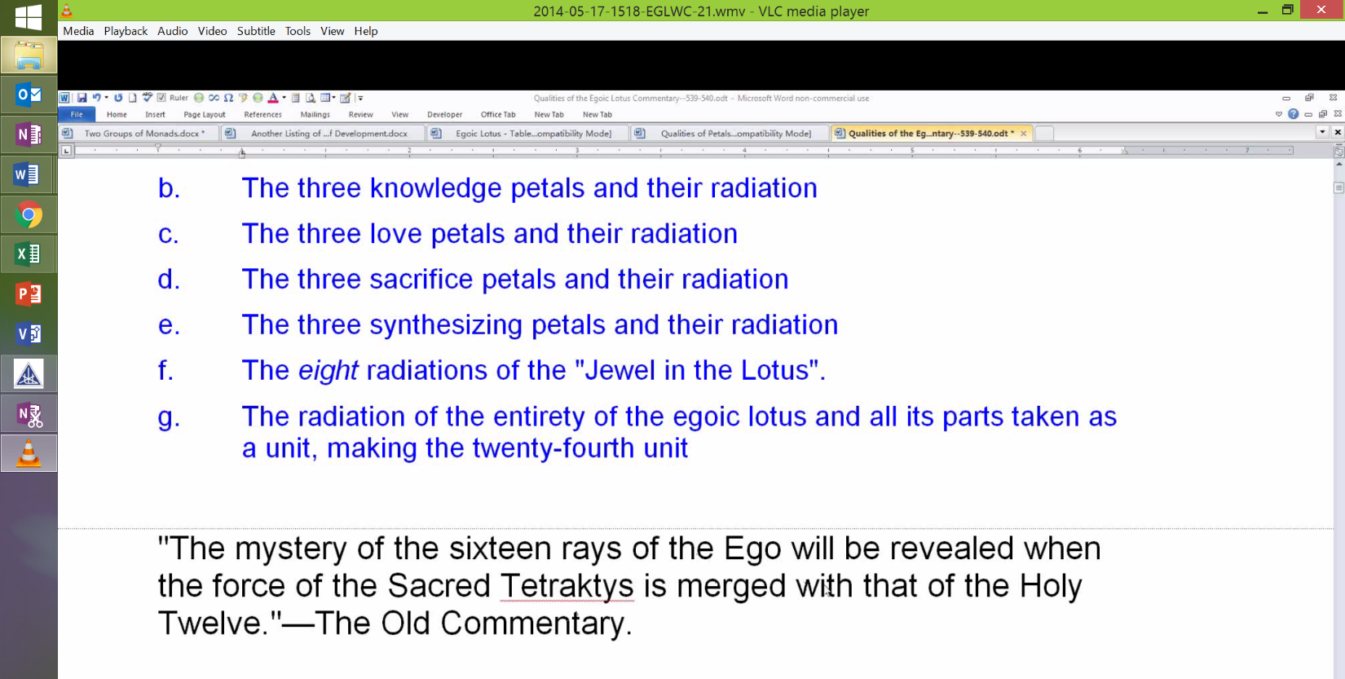
34:24 So the mystery of the 16 rays of the Ego will be revealed when the force of the Sacred Tetraktys is merged with that of the Holy Twelve. This is interesting. I may say this later but this is a 22, because the tetraktys has 10 points and the Holy Twelve has 12 points. It's the deva evolution which is connected particularly with the 12 and the human with the 10. So this is a difficult statement here and what do we make of it? Well the 16 rays of Ego summing to 7 and we have no trouble justifying the 7 emanations of the 7-fold Jewel in the Lotus and they have their origin as specified in the 16 parts of the Lotus.
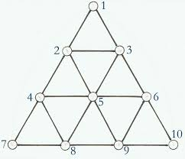
(Image not in video webinar – added by transcriber)
So there are 10 parts to the Sacred Tetraktys but when we examine the number of rows we find only four. And thus the tetraktys as the word suggests, tetra, is a four, as well as a ten. So the Holy Twelve can be any of the many 12 fold structures, the zodiac is one such proposal and the holy 12 can represent also the heart center which is the chakra, representative the heart center, I think I want to add there of the Monad. Anyway the central Egoic Lotus is a 12 which represents the heart of the Monad. So obviously the four and the 12 but which four and which 12? Can we make a tetraktys out of the Ego? Is there a way to make a 10? There is a way to make a 10. One way to make a 10 is by leaving the lower atomic triangle out altogether as pertaining to the lower form and use the nine petals plus the unit of the three petals of Synthesis and the Jewel as one.
Well we did find, of course, earlier the way to make two and it had to do with adding seven fold Jewel to the other three’s. The tetraktys of course can mean many things and in its structure the 10 fold constitution of man is indicated wherever there is a seven there are three more, there is a 10.
So the principles usually associated with man. The first dot the Monad. The two dots in the second row of the tetraktys are atmic-buddhi, yes. The three dots in the 3rd row of the wheel, 3 aspects: abstract manas, son of Mind within the causal body and the lower mind. So these are mental aspects. Then the 4 dots considering principles kama-manas, kama, prana and the etheric body by some way of reckoning principles. This is looking at the constitution of man in terms of the tetraktys.
38:56 So we can look at the Egoic structure as follows. The 1st dot of the 1st row of the tetraktys represents the Jewel in the Lotus and the 1st ray. The 2 dots of the 2nd row of the tetraktys represent the 3 Synthesis petals produced by buddhic energy, hence the number 2 because buddhi is the 6th principle, but gives us the 2nd ray of Love/Wisdom. The 3 dots in the 3rd row of the tetraktys represent the 9-fold structure on the higher mental plane. Often the Egoic Lotus is referred to as a wheel with 9 spokes, a 9-petaled lotus, so there is a funny kind of way that if we don't include the atomic triangle, the 9 petals represent the 3rd aspect of divinity and 9 is the number of the 3rd aspect of divinity. Then the 3 Synthesizing petals represent the 2nd aspect and the Jewel in the Lotus, of course, the 1st aspect. Then the 4 dots in the 4th row of the tetraktys represent the 3 members of the atomic triangle which precipitate the 4-fold personality: lower mind, astral body, etheric body and dense physical body. So we have a way then of understanding the Egoic Lotus itself in terms of a tetraktys.
40:33 So we are changing different perspectives here. From another perspective we may be talking about merging the 12 of the heart center with the 16 of the throat center something just occurred to me. There is another way of saying the merging of soul (12 and the heart) with the 16 and that is a 22 but what if the Monadic structure is 12 fold in the Egoic structure (including the atomic triangle) is 16-fold, then we have another way of reaching the 22 with the call the Monad Ego. Maybe I’m going on to talk about that here. Maybe there is a 12-ness to be seen in relation to the Monad. I gather this from these second ray old Commentary formula speaking of the Higher Twelve. How the lower 12 responds the greater twelve. That
So the 12 sign Pisces I leave the father's home and turning back I say that that's a 12. You can certainly connect to it the Monad because Pisces sends the Monad forth on its mission of redemption. So there must necessarily be a connection between the Monad and the major 12 petals of the head center indeed. So another perspective shows that the Holy Twelve, when added to the tetraktys, not considering it as a 10 but as a 4, yields 16, the number we have been looking for.
42:45 So the Holy Twelve and the 4 together - 16 which is the number of the Egoic Lotus. There is more to be said here and our pondering will be required to determine which 12 and which 4 must be summed to yield the 16 rays of the Egoic Lotus. Certainly we find it easily when we just sum the parts of the Egoic Lotus considering the Jewel in the Lotus as a unity and that we began to do right at the outset of this little discussion. But I am actually kind of impressed by this idea that we can count the Egoic Lotus itself as a tetraktys, as a 10. See we count the Egoic Lotus as a 10 if we leave off that which represents the lowest aspects in the unreal world of personality and we can get the magical number 22 if we count a 12-foldness in the Monad and a 16-foldness in the Ego. Now I also wonder whether there is a 16-foldness in the Monad as well. Because always with the Higher Twelve, you have to have that point which we call the 13th which is the Christ in the center of his disciples and the Sun in the center of the zodiac. And there may be a central triangle in the Monad with sort of 12 radiations, a triangle and a point which will bring a 16. Hum, other numbers are coming to my mind. We add that 16 to the 12-ness of the Egoic Lotus as the heart center, we get the AUM whose number is 28. 16 plus 12 and that equals 1. Well, we can play with numbers quite a bit, the point is can we make them practical in some sense? And when we learn the mantrams and the particular rates of vibration associated with the different layers of matter, then the numbers and the words will become practical and we can do something. Right now we have to content ourselves with simply learning.
45:47 So what I have been trying to show here from this simple footnote, is that we can count the Egoic Lotus and the Monad even in various ways by extreme differentiation and also by combining various structures. As I said every tier is really a one. And yet it is a 3. So sometimes we may want to combine the structures as when we derive the 5 from the Egoic Lotus: the Jewel and each of 4 tiers of petals, and sometimes we may want to articulate them: the Jewel and the 12, that would be a 13, plus 3 more in the atomic triangle is sixteen. And sometimes we may wish to articulate minutely in which case we would add the 15 that come from the 4 tiers of petals and then also the atomic triangle, and that is 15 and add a 7 to it which would bring us to 22. The 7 being the 7 facets of the Jewel in the Lotus. But you know we also said what if there are 8 additional radiations? I mean before long we could come up with 33. I can see how we could begin to do that.
So it all depends on the perspective and how one wants to consider the nature of a structure. But for practical purposes, the Egoic Lotus is a great heart center. It's the heart center of the Monad, of the entire constitution of man, and when we can live in that Lotus we have learned to live in the Love/Wisdom aspect and when it is destroyed we live in the spiritual triad and the love/wisdom aspect is not destroyed because the triad itself is an expression of both the 1st and 2nd ray and when we return to the Monad, the 12-ness of the Monad is there. It is a unit within the Sun which is a great heart center, so the love/wisdom gathered from the expanded Lotus is not destroyed by any means when the Egoic Lotus is destroyed, but it is preserved and manifests even more fully and in a less bounded manner progressively. And all these things we will discover when we are liberated from this cave of materiality, cave of elemental materiality in which we as personalities habitually live.
49:14 This is another kind of footnote.
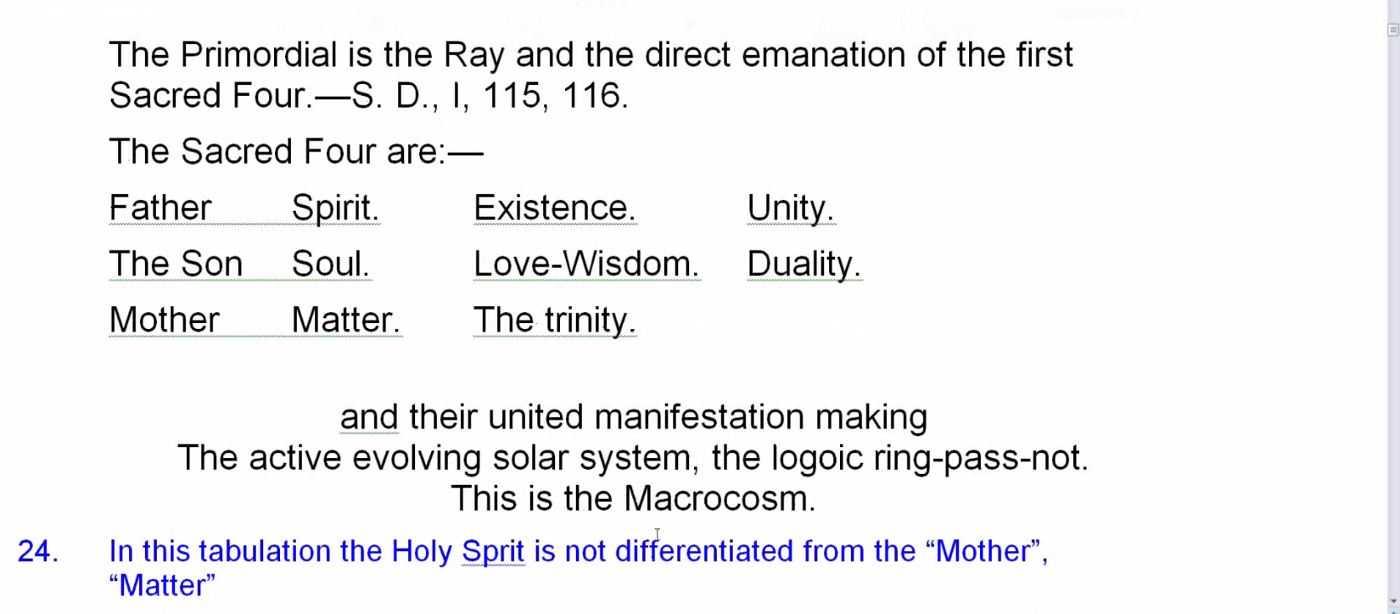

Robbins reads quote from Secret Doctrine 1. And this is at least for our purposes the macrocosm. Now in this presentation here we are not given the Holy Spirit as differentiated from the Mother. Mother is so often used as the 4th term associated with the number 4 and the Holy Spirit as Brahma, with the 3rd.
So in this case the 4th is treated by summing the 1st three and considering their unity as another unit and this is often allowed in occult numerology. And the term unity, we have seen, is oftentimes associated with the 2nd ray when synthesis is applied to the 1st, but sometimes unity seems to be applied also to the 1st ray aspect, so unity has this aspect of oneness and hence its association with the 1st aspect, but also the many things that are harmoniously united are also considered a unity and hence its relation to relation itself and hence its relation with the 2nd aspect.
50:57 Unification we are told is that towards which the 2nd ray and the 2nd aspect strive through the Will to Unify, that is the 2nd aspect of the Will and yes, the Solar Logos is our macrocosm. There are many greater macrocosms. The statement in the text is interesting [Robbins notes]. The Primordial Ray is, when considering our Solar Logos, is actually the 3rd ray, expression of Brahma. That is the primordial ray. At the beginning of Cosmic Fire we are told in relation to our solar system at least, the primordial ray is not the 1st, it is the 3rd and the Divine ray is considered to be the 2nd. So the 3rd ray, expression of Brahma and one of the principal numbers of Brahma being 5, so if we sum the primordial ray and the direct emanation of the first Sacred Four, we shall have the requisite 5 of Brahma.
What we have been trying to do is connect the Egoic Lotus, not only with the 2nd aspect, but with the 3rd. It has sort of 3 principals within it and an embodiment. When you look at the buddhic plane also there are shall we say 3 higher planes within the buddhic plane and the buddhic is the embodiment of the cosmic ether.
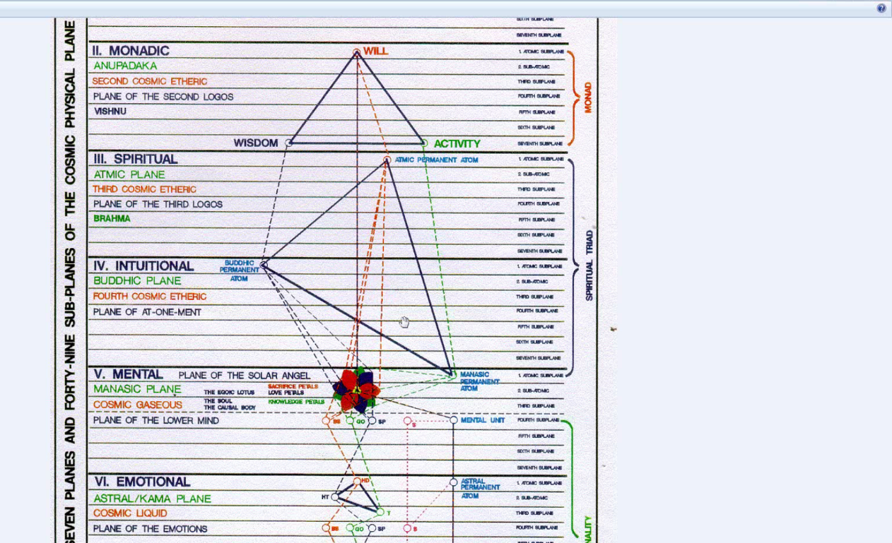
It seems to be the embodying ether. So there is the 3 and the 1. So the buddhic plane embodies and the Egoic Lotus embodies and stands as sort of a 4th factor.
Well all of that simply from a couple of footnotes. So you can see what a profound study the Ageless Wisdom really is and how Blavatsky brought forth for us some of the really profound aspects of the Ageless Wisdom so demanding in a way, maybe a few students apply themselves to it. There has been a movement towards greater practicality in that which the Tibetan presented and applicability in terms of many human activities, such as psychology and healing and politics and science and economics, all kinds of things, religion, where the knowledge of the Ageless Wisdom, per se, could be actually applied in what the human being does.
53:53 So we go on to say that we must now.
"We must now deal with the subject of the causal body on its own plane from the point of view of FIRE.” TCF 536
Fire relates very much, in general, to the 1st aspect, although there are 3 fires of the 3 aspects, Fire by Friction, the 3rd; Solar Fire, the 2nd; and Electric Fire, the 1st. This is sort of the ABCs and we know that. This is, after all, A Treatise on Cosmic Fire, and fire is sort of the first expression of being and where there is fire, there is always motion of some kind, whether it is pulsation, spiral cyclic motion or rotary motion, where there is fire there is motion. Where there is absolute Be-ness, there are no parts and so there is no motion. It's as if perpetual motion is ingrained in reality, because there is the constant breath. The breath has had no beginning; it has no end and it is the ultimate symbol of duality. We can in a sense relate this greatest of all breaths to the breath of fire. The breath of fire has particular applications to the energy system of man, that is how that term can be used when dealing with kundalini, but I am talking in a very high philosophical sense. When speaking of the Great Breath, we could say fire, no fire. Fire, no fire, and on and on. When there is Universe, there is Fire. And when we are dealing with the absolute reality we cannot call it fire. Fire, motion and specificity go together. So we are going to be studying the causal body apparently here from the principal of the 1st aspect - its various fiery sounds, fiery colors. We will have to see what that will really mean for us.
“We have studied it briefly from the more ordinary angle, and in materialistic terms, considering it as a vehicle of rarefied substance, containing within itself the seventh principle of each of the two lower sheaths of the microcosm, and the mental unit. This latter is that which embodies the first aspect in manifestation, and which is analogous to the first logoic aspect—one that in this solar system does not come to full demonstration." TCF 536
We have studied it briefly from the more ordinary angle, and in materialistic terms,. . . ﻿not really looking at causes, right? . . . considering it as a vehicle of rarefied substance,. . . ﻿but substance is fire, of course, isn't it? . . . containing within itself the seventh principle of each of the two lower sheaths of the microcosm, and the mental unit. ﻿How interesting to consider the physical permanent atom and the astral permanent atom as 7th principles, respectively of the astral body and the physical body. Is it the 7th principle itself or is it the embodiment of the 7th principle? Are these permanent atoms the actual principles of the physical body and the astral body or are they embodiments of those principles? It depends on whether shall we consider principles material? And in a way I do not consider principles to be material, but kind of modes of motion, modes of apprehension, modes of consciousness. When you consider buddhi, do you consider it material? I mean is a buddhic permanent atom a principle or an embodiment of the principle of buddhi. I prefer the latter. But it may be that I don't sufficiently understand what he is saying.
59:49 So it is clear that the mental unit cannot easily be considered the 7th principle of the mental body. It only has 4 spirillae and this distinction, at least in the context that we are discussing it here, would be reserved for the manasic permanent atom, which has interestingly, like all the other triadal permanent atoms, only 3 spirillae, so somehow we still get a 7 on the mental plane with the 4-fold mental unit and the 3-fold manasic permanent atom. To study in terms of substance, he says, is considered to study in materialistic terms, but if we study in terms of fire, it is not. And maybe to study in terms of fire is to study motion. It seems difficult to find that there is any type of motion or any type of fire where there is no motion. The only motionlessness that we have and that is of course theoretical, is in absoluteness and yet it is the source of infinite variety of motion. Well we are getting a bit philosophical but all of this is part of the Egoic Lotus chapter, just these 13 pages in Cosmic Fire, which we can consider in a way to be a definitive source: the core source of so much that he developed later in other books.
This latter. . . ﻿﻿ ﻿﻿﻿I guess he means the mental unit here . . .is that which embodies the first aspect in manifestation, and which is analogous to the first logoic aspect—one that in this solar system does not come to full demonstration. ﻿That is so important. The mental unit is not the complete permanent atom and so signifies in the realm of personality manifestation the first aspect. It’s the highest of the 3 which in this 2nd ray solar system will not come into manifestation. And the general here is that the mind is the conduit for the will. When we look at the spiritual triad, it is obviously atma, the atmic permanent atom, which is the conduit of the 1st aspect; buddhic permanent atom, 2nd aspect; manasic permanent atom, 3rd aspect. But when we separate the personality from the higher Triad and from the Egoic Lotus we have another type of structure in which mind takes the place of the 1st aspect and so the mental unit is the creator of the lower mental body, creator of what we call mind in the personality and hence it represents the 1st aspect, the astral permanent atom, 2nd aspect, and the physical permanent atom, which is really etheric, of course, the 3rd aspect.
1:03:19 It's kind of interesting in how he begins this because he's talking about the solar system and larger macrocosmic factors before really getting into the Egoic Lotus. Well the solar system is a great lotus and it has its own type of Egoic Lotus on the cosmic higher mental plane which is either 21-fold or 12-fold depending on how the references are read.
"I would like to point out here that in studying the solar system as the physical manifestation of a solar Logos, we are investigating:
a. The physical permanent atom of a solar Logos as contained within the logoic causal body on its own plane.
b. The seven types of force, or the seven logoic spirillae within that permanent atom. This, if realised, gives a new outlook upon the subject of plane vibration.
c. The close correspondence between the planes and the seven spirillae in the permanent atom of a solar Logos." TCF 536-537
I would like to point out here that in studying the solar system as the physical manifestation of a solar Logos, we are investigating: a. The physical permanent atom of a solar Logos as contained within the logoic causal body on its own plane. Which is the higher cosmic mental plane. And we know that these permanent atoms, members of the atomic triangle are considered to be contained within the Egoic Lotus. They are found, it is said, at the base of the Lotus which presumably means under, whatever under and over means on those higher planes, but under the petals. So there is some kind of physical permanent atom on the higher or at least contained by the matter is it of the higher mental plane or the energy of the higher mental plane and it's associated with Saturn. Saturn is a correspondence to the physical permanent atom of the Solar Logos. So although the physical permanent atom of the Solar Logos is said to be contained within the Logoic causal body on the higher cosmic mental plane, it is composed of substances of our systemic logoic plane, the 1st cosmic ether. So we have to look at that word contained. So this is analogous to the idea that although the human physical permanent atom is contained within the human causal body on the systemic mental plane, that permanent atom is composed of etheric substance of the systemic atomic etheric plane.
1:05:54 The way this look if we can see the physical permanent atom is here in our microcosmic setup and yet it is enclosed or contained within the substance of the higher mental plane, enclosed, surrounded, it doesn't mean that the physical permanent atom actually moves to the higher mental plane, nor does it mean in the Solar Logoic sense that the physical permanent atom of the Solar Logos which is found on the systemic logoic plane moves to the cosmic mental plane and yet it is contained.
Contained: a word which must be closely examined meaning more surrounded by and held within a periphery.
It is the expanse of the 2 types of causal bodies which makes it correct to say that the members of the atomic triangle, if the Solar Logos has a mental unit and I think it does. I think it sometimes considered to be the Earth, interestingly enough, and Venus the manasic permanent atom, sometimes. So it's the expansiveness of the 2 types of causal bodies which make it correct to say that the members of the atomic triangle, if the Solar Logos has a mental unit and we are actually told in places that it does, are contained within the periphery of the causal body. So substantially, the material composition of the physical permanent atoms in either case is not of causal substance. I think we understand that and yet the enshrouding, the ensphereing, the containing, so it's not causal substance, that is substance of the higher mental plane, either the systemic or the cosmic higher mental plane and yet, there is a notion of containment because it's within the aura of the two types of causal bodies and I don't know how we would register space on the cosmic mental plane. We have some idea that we can still speak in terms of space when we are dealing with our own lower 21 subplanes of our systemic plane but these physical, astral permanent atoms and the mental unit are said to be at the base of the lotus. Of course they are atoms, so being atoms they are tiny and it has often made me wonder whether the causal structure itself is not, at least for the human being, somehow on the atomic scale, very small within an immense radiation. Nothing is said about the actual scope of the causal body, in other words in spatial measures, or the scope of the Egoic Lotus. The causal body, yes, apparently it is a factor produced by radiation and it has a great extension beyond the number of rather oval-like auric fields. But in terms of the generator of that causal body, which is the Egoic Lotus, there is nothing said about its size. It could be the tiniest of things, somewhat on the atomic scale.
01:10:28 These are sort of some preliminary cosmic considerations.
b. The seven types of force, or the seven logoic spirillae within that permanent atom. ﻿So what was the first one here. . . .in studying the solar system as the physical manifestation of a solar Logos, we are investigating: a. The physical permanent atom of a solar Logos. . .﻿now that is connected with Saturn which is said to be a correspondence to it at least and it must be a question of perspective, but it has always troubled me how the various planetary schemes can either somehow represent permanent atoms of the Solar Logos and be home to certain principles, then we are told, if a planetary scheme lasts throughout the mahamanvantara, and also be embodiments of the chakras of a Solar Logos. How can they be both? This still has to be worked out, at least in my mind. There is an interesting relation I think between Venus representing the manasic permanent atom of the Solar Logos from one perspective and the Earth representing the mental unit, but from another perspective it is Saturn as the physical permanent atom, Neptune as the astral permanent atom and Uranus as the mental permanent atom, so we are given some partial configurations which have not been entirely worked out by us. In Master D.K.'s mind I'm sure it's clear. So when we are considering studying the solar system as the physical manifestation of the Solar Logos, we are also considering the 7 types of force or the 7 Logoic spirillae within the permanent atom, what are they? ﻿
1:12:44 This, if realised, gives a new outlook upon the subject of plane vibration. ﻿Because these spirillae are the systemic planes, at least from the Solar Logoic perspective the 7 types of force related to the physical permanent atom are the 7 solar or systemic planes. The 7 systemic planes are the vibrations of the 7 spirillae within the physical permanent atom of the Solar Logos. It's on page 406. I think I want to turn to this in Cosmic Fire where he basically tells us about these 3 synthesizing planets.

"Neptune, Uranus, and Saturn will, therefore, have absorbed the essence of manifestation and (in connection with the solar Logos) they correspond to the three permanent atoms in the causal body of a man. We say "correspond" for the analogy is not in detail. Uranus and Neptune are reflections of the logoic astral and mental permanent atoms. Saturn is in fact the correspondence to the logoic physical permanent atom. This is an occult mystery and must not be separated from its allied truth in the cosmic scheme." TCF 406
Neptune, Uranus, and Saturn will, therefore, have absorbed the essence of manifestation and (in connection with the solar Logos) they correspond to the three permanent atoms in the causal body of a man. ﻿The mental unit, of course, it is sometimes called the permanent atom. We say “correspond" for the analogy is not in detail. Uranus and Neptune are reflections of the logoic astral and mental permanent atoms. ﻿Which then would seem to be something other. Saturn is in fact the correspondence to the logoic physical permanent atom. ﻿Because we are talking about a physical planet in relation to the cosmic physical plane, but when we talk about Uranus and Neptune we are also talking about physical planets, but they are in relation to the cosmic astral and cosmic mental planes, so how they appear on the cosmic physical plane﻿ are considered reflections. This is an occult mystery and must not be separated from its allied truth in the cosmic scheme.
1:14:52 You know I have gotten into this in my written commentary, but I think I would go way off the track if I tried to bring in all of these factors right now, but you can just look this up in the Cosmic Fire commentaries on Makara.us and see if I said anything worthwhile at that time.
What is a cosmic scheme? Well, we have a systemic scheme, but a cosmic scheme is something in which our Solar Logos is simply a heart center. We are dealing with a Cosmic Logos. Even the word scheme is tantalizing because it will make our solar system something of a chain in a cosmic scheme, a certain chain within that 7-fold or 10-fold cosmic scheme. But as I say I am not going to veer off because there is such complexity here that it would defeat us a little bit.
So since Saturn is, in fact, a correspondence of the physical permanent atom of the Solar Logos, there must be a strong connection between Saturn and the 7 Logoic spirillae. We must not remove Venus from the picture, nor the Earth when considering it in relation to the mental unit of the Solar Logos. Now we are studying the solar system from the physical point of view and so point c is:
c. The close correspondence between the planes and the seven spirillae in the permanent atom of a solar Logos. ﻿We have been talking mostly in terms of physical systemic planes, but there are probably cosmic astral subplanes in the great cosmic astral plane and cosmic mental subplanes and so forth, so maybe we can imagine this somewhat and we will have to establish whether the 7 systemic planes are only correspondences to the 7 spirillae in the physical permanent atom of the Solar Logos or whether the 7 planes are the 7 spirillae of the Logoic physical permanent atom. This seems to be taking us far away from the Egoic Lotus but it is in that section.
1:18:22 So we have through the medium of the planes which are the correspondence of the seven spirillae of the physical permanent atom of a human being. (TCF 1180) And the planes are correspondences to them, they must be in fact the 7 spirillae of the physical permanent atom of the Solar Logos. . . . through the medium of the planes which are the correspondences to the seven spirillae of the physical permanent atom of a human being. [TCF 180] So if we have spirillae of a human being in the planes are correspondences to them there must be in fact the seven spirillae of the physical permanent atom of a solar Logos.
"We have touched upon these spirillae and their function very briefly, and can now approach the question of the egoic Ray and the fire of mind from the subjective point of view, or in terms of fire." TCF 537
We have touched upon these spirillae and their function very briefly,. . . ﻿thanks goodness, haha . . . and can now approach the question of the egoic Ray and the fire of mind from the subjective point of view, or in terms of fire. ﻿That is so interesting because basically he is not talking about appearances. He is talking about what these things are like from the inner vision. So if we work in the realm of fire, we are dealing with subjective work. Fire is God and God is subjectivity.
So now we have made it to structures that are more akin to the Egoic Lotus itself. The other was background consideration and basically it seems to be telling us that we are taking up a cosmic consideration though in a microcosmic way. And that there are important correspondences between the two levels.
1:20:53 We are taking up centers or wheels of Energy. This is putting the whole subject in a larger context.
"1. Centres or Wheels of Energy.
a. Centres of force. We shall again reach the clarity of vision desirable if we study the subject of monadic development from the angle of vision of the human unit. It has been taught in many occult text books that man has seven centres of force (or ten, according to some calculations); that three of these centres are paramount, and eventually synthesise the other four, or absorb their force or energy. This produces their eventual obscuration, or their passing out of manifestation; they occultly 'die.' This is paralleled in the logoic centres, the planetary schemes, which also in due course of time pass into obscuration, and transmit their energy to the major three schemes." TCF 537
a. Centres of force. We shall again reach the clarity of vision desirable if we study the subject of monadic development from the angle of vision of the human unit. ﻿And I just want to say that when studying the Egoic Lotus one must always study the Monad as well, because the Egoic Lotus is an extension of the Monad with the supplemental structuring power of the Solar Angel. We study the microcosm here as a practical measure and from there we may be able to generalize meaningfully to the other and larger context. As I have said study the high and understand more about the lows. Study the low and understand more about the high.
It has been taught in many occult text books that man has seven centres of force (or ten, according to some calculations);. . . ﻿remember always suspect the 10 when you see a 7 because there seem to be always 3 subjective factors in relation to any objective septenate. So the 10-fold calculation must be considered carefully as it applies to the number of planetary schemes in the solar system, the number of chains in a planetary schemes and perhaps even the number of planetary globes in a planetary chain. There are some subjective chains and I think subjective globes and maybe that has something to do with the inner round. And we have also been taught how in the permanent atom, which has 10 parts - 3 superior and 7 inferior, the 10 may be transformed into a 7 by considering the lower 3 simply as reflections of a higher 3 otherwise you would have kind of a 13, which is meaningful in its own way as well. But we are allowed to combine groups of numbers in various ways to reinforce a particular perspective.
It has been taught in many occult text books that man has seven centres of force (or ten, according to some calculations); that three of these centres are paramount, and eventually synthesise the other four, or absorb their force or energy. ﻿Well we have the 3 synthesizing planets, don't we? We have those on the macrocosmic level. The synthesizing centers have usually been considered the heart, head and throat, usually the 3 major centers. But the 3 major centers in the head can also from another perspective be considered the synthesizers and finally, let's also consider the 3 within the head: the Jewel, the Greater Twelve within the head and the other 960 petals. Three aspects and ultimately the head is the synthesizer.

This produces their eventual obscuration, or their passing out of manifestation; they occultly 'die.' So what we have here is the idea that synthesis produces obscuration - the passing out of manifestation and there is an occult dying away of all the centers as they are absorbed into one center.

1:25:24 So the process of synthesis of gathering all the many into some, the some into a few, the few into 3, the 3 into 1, this precedes obscuration per se. It precedes pralaya. And the stages of absorption has to also be factored into this sequence - shall absorption be considered a part of synthesis? Or shall absorption with its sense of finality follow obscuration? Well maybe both. The sequence we have been using is synthesis, obscuration, absorption but we may not be justified in making these terms utterly distinct, suffice it to say that the many wheels of force that we have been studying are absorbed into a final and then that itself disappears in pralaya.
This is paralleled in the logoic centres, the planetary schemes, which also in due course of time. . . ﻿see death after all is the raising of all the centers of the vehicles into the head center. And eventually the abstraction of that energy from the dense physical body, that is if death comes as a natural and orderly process. There are other Logoic centers too which are the planetary schemes, notice how he calls them centers and not homes for principles which are permanent atoms. In a way the permanent atoms have a kind of higher status than a chakra, because within any vehicle generated by a permanent atom many chakras appear, over and over again. And if we are looking for the source of both permanent atoms and chakras, we have to look into the Monad itself, whether it's the Monad of a Solar Logos or the Monad of a man.
1:27:36 . . . logoic centres, the planetary schemes, which also in due course of time pass into obscuration, and transmit their energy to the major three schemes. ﻿So it would seem in this transmission following obscuration we have what we might call absorption of the lesser into the greater. The major 3 schemes, as we should well know by now are Saturn, Neptune and Uranus with the double emphasis given to the Saturn scheme which can from one perspective simply be considered a normal planetary scheme or in a larger sense can be considered the entirety of all schemes to be absorbed into the 3rd aspect. If we turn to Chart VI, I'll show you what I mean here and you've seen it I think a number of times, this is one that Tuija made:

Lesser Saturn
Greater Saturn

and this is in a sense greater Saturn. [See what's inside the circle.] Saturn as simply a planetary scheme is here but this is greater Saturn which seems to include all that can be related to the 3rd aspect or Brahma within a solar system. So lesser Saturn, greater Saturn from a certain perspective. Maybe it's sometimes called esoteric Saturn.
So here is a little tabulation which is familiar to us I think.
"The three main centres in the Microcosm are the Head, the Heart and the Throat.
1. The Head centre The Monad Will Spirit.
2. The Heart centre The Ego Love Consciousness.
3. The Throat centre The Personality Activity Matter." TCF 537
The three main centres in the Microcosm are the Head, the Heart and the Throat. ﻿And these are the usual descriptions: Monad, Will, Spirit; Ego, Love, Consciousness; Personality, Activity, Matter; corresponding to the 3 centers and this is familiar to us. In the disciplic microcosm, which we actually have reviewed in preparation for this study, the throat is ruled by Saturn, the heart by Jupiter and the head by Vulcan, so not all the 3 synthesizing planets are there, but they are higher rulers I think of those center at later stages of development beyond discipleship.
1:30:15 Between the 1st and 3rd initiation, which should include the stage of discipleship beginning really at the 1st, the head center is ruled by Uranus, and we can say that Neptune, the repository of the solar flames gains increasing influence over the heart center and Uranus becomes also prominent at the throat with the growth of the 7th ray at the throat. So even though, on page 517, we have planets that are not synthesizing planets ruling the head and the heart, in a higher way the synthesizing planets, which are the Monadic 1, 2, and 3 do find their way back in to rule man's microcosmic 1, 2 and 3 - his head, heart and throat center.
Well you know we are laying out the map here. This whole study is in a way a map and we will have practical experience of these things, but it's always best I think if a country has been mapped, it's always best to study the map before going there. If you are going into entirely uncharted area or as they say uncharted waters as they say, well okay, you are the pioneer and you have no map. But we do have a map and I think it's part of wisdom to study it. Here is something I brought in from esoteric astrology. “The throat center is ruled by Saturn just as the two head centers are ruled respectively by Uranus (ruling the head center) and Mercury (ruling the ajna). This is only where the disciple is concerned; the rulership changes after the 3rd initiation or before the first.” [EA 151] Well, if this is the disciple, we are really talking about the period from the 1st initiation to the 3rd. That's where the disciple really reigns. After that we have the initiate, but it wouldn't surprise me to see Uranus as continuing in its rulership of the head center with sort of Vulcan/Neptune at the heart and the head and I don't know what else we would substitute if we simply go into the head we may find that Neptune has a place at the ajna center and Saturn at the alta major center. Well we won't get lost in the correspondences here. Suffice it to say we keep moving upward towards synthesis and there are ways of dividing the head center. The head center contains everything so we can find all the 3 aspects and all the synthesizing planets there at a certain time when the man is being ruled entirely from the head center.

You know Vulcan can be considered as ruling the 7 centers within the head and Vulcan also associated with the Heart of the Sun which is like the heart in the head of the highest head center, but Neptune belongs there as well and Neptune belongs at the ajna center and Uranus belongs to all of the many, many petals of the highest head center, but as it is, in a way the master planet, maybe not yet, maybe in the next solar system, with its first ray Monad, more the next solar system, Neptune is more the master of things. Will Uranus with Vulcan be at the central Jewel? Uranus has that 7th ray precipitating power also and that 7-ness and the Jewel is 7-fold and so what we can take out of this is that the head center has everything and the 3 synthesizing planets really have all the rest of them within and so when we look at that synthesizing head center, we are going to want to find all of the synthesizing planets playing predominant roles which is not to say they don't play roles in the other parts of the body.
1:34:29 "It will, therefore, be apparent that just as in man these centres are related to the threefold spiritual man in his total development, so the three types of centres—microcosmic or macrocosmic—come gradually more and more under the vitalising power of one of the three aspects of the Logos. These centres are recognised also as focal points of active force, manifesting to the vision of the clairvoyant as fiery wheels or the flaming petals of a lotus." TCF 537-538
It will, therefore, be apparent that just as in man these centres are related to the threefold spiritual man in his total development, so the three types of centres—microcosmic or macrocosmic—come gradually more and more under the vitalising power of one of the three aspects of the Logos. ﻿When the Monad anchors itself, at least microcosmically, it tends to choose the head, the heart or the throat, depending on whether it is ray 1, 2 or 3 of the Monad and this will also operate in terms of the greater type of being. We have been told that by the time of the 1st initiation is taken, one of the 3 major centers comes into greater prominence depending upon the Monadic ray of the microcosm, as the Monadic ray has much to do with chakra dynamics indeed and how the various triangles of the chakras, different points within the triangle are activated according to the Monadic ray if they have resonance with the particular Monadic ray, they will be activated sooner than normally is the case when the Monadic ray is other. Maybe it's always the 3rd aspect that is first activated, but when you have a 2nd ray Monadic type or 1st ray Monadic type, the other point of triangle is activated much sooner than otherwise it would be if the ray were different.

So we are looking here at the 3 major centers as they at least connect to the head and the torso. If we go entirely into the head, the centers will change and the ajna center may take on a second ray meaning, and if we go entirely into the head center per se, the ajna and head center will be considered as one and then we will have to find other ways, the 2nd aspect will represent the heart in the head and the central jewel will represent the 1st aspect.
1:37:02 Here are some other statements. “This is effected definitely at the first Initiation when the polarization becomes fixed in one or other of the three higher centres,—which centre being dependent upon a man's ray." [TCF 124] And that's just what I was saying and of course look at how D.K. blinds this. A man's ray in this case is the Monadic ray but he doesn't say so and working so much as we do with the soul ray, we might think that's a man's ray. But by not being too specific in places, a form of necessary blinding can occur and one has to simply work it out according to one's ability to understand. If he Monadic ray is the 3rd, the throat center will receive extra vitalization by the 1st initiation. If the 2nd ray, then the heart center. If the 1st ray, then the head center. So what is the Monadic ray? It's always going to be, ultimately, one of the 3, but as we also have been studying and realize there are 7 monadic rays and again that is the structure that whenever there is 7 always expect 3 more. So the very highest 3, which I think relate to the logoic plane, are the 1st, 2nd and 3rd and the other 7 rays relate more to the Monadic plane. This is my present theory. With all theories, you hold them, you test them, and you finally accept or reject them as further confirmation or disconfirmation comes.
These centres are recognised also as focal points of active force, manifesting to the vision of the clairvoyant as fiery wheels or the flaming petals of a lotus. ﻿Either the 16, the 12 or the 960 + 12 = 972 altogether. I am tempted to start counting in the head center just as I did within the Egoic Lotus, but I'll leave that for another time.
1:39:36 So the wheel and the Lotus are two ways in which the Solar Angel appears to be represented to the candidate passing through the first 4 initiation ceremonies. An angelic presence is also conferred, we are told. So, in the actual initiation ceremony - can it be so, certainly so for the first 2, maybe things begin to look a little different for 3 and 4, there is a representation of the Solar Angel as wheel, lotus and angelic appearance. So it’s important to realize that the petals are as flaming petals and we have been talking about fire here, the chakras are manifesting in different fires. So, if we are examining the lotuses from the perspective of fire, then we have to realize that petals are fire as flaming petals. So we tend to think substantially as if we were dealing with a concrete form here in the lower worlds, but no, we are actually dealing with inner radiant movement which we can call fire.
So substance is fire, really. There is really nothing that is material at all. It is just our rather veiled perception that makes us perceive apparent materiality instead of fire. The whole outer world is fire also and maybe one day, well almost certainly one day we will be so perceived. So materialism is just a limitation of perception. I think we can say that. And with the inner perception acute, everything appears as fire.
1:42:12 Well we finally made it to the place where we are dealing with the causal body as the Monadic heart center. Point a above was what? Centers of force. And point b, the causal body, the monadic heart center.
"b. The causal body . . . monadic heart centre. In studying the egoic body it should be remembered that the causal body is the correspondence in the monadic manifestation to the heart centre. It is a flaming wheel of fire within the monadic auric egg, which embraces the five planes of monadic manifestation; it is also seen as the twelve-petalled Lotus. Of these twelve petals, the innermost three are unrevealed, or are embryonic, and hence the causal body is frequently considered as a nine-petalled Lotus, or as a wheel of fire with only nine spokes or whorls." TCF 538
b. The causal body . . . monadic heart centre. ﻿So here we are, the causal body, the Monadic heart center and of course because it is a heart center, the number 12 is always associated with heart centers. The heart in the head of the One About Whom Naught May Be Said we are told is the zodiac itself - zodiac of constellations. Hearts centers all the way up, at least as far as we can see, seem to be associated with the number 12. So viewing the causal body as 12-fold can be accomplished if the Jewel in the Lotus, which represents the 1st aspect, and the 3 units in the atomic triangle, representing the 3rd aspect are eliminated. We just keep it within the 2nd aspect particularly, or at least we keep every aspect pertaining to its own sphere. The Jewel in the Lotus is really a projection of the Monad and the 3 members of the atomic triangle pertain really to the personality. Of course it all ends up having the source within the Monad. But suffice it to say the number 12 is what is accentuated and when it comes into the powers of the Jewel in the Lotus, that is another study and I wonder whether D.K. will bring that out in his next work. It seemed that so much of the historical 3rd ray aspect was brought forward with Blavatsky. With Alice Bailey the emphasis has been upon the 2nd ray. Of course D.K. is a 2nd ray Master and he is teaching along that line. But maybe in the 3rd installment which we can expect after 2025, who knows whether in 2025, but not before apparently, the 1st aspect will be represented.
1:45:36 Well let us hang on and see. Well I'm sure it's well in hand, this 3rd installment of the teaching and will be of great importance and value in helping occultism win the day by the end of the 21st century, as HPB predicts that it must. So let us stay involved with it and aid that winning as much as we can.
In studying the egoic body it should be remembered that the causal body is the correspondence in the monadic manifestation to the heart centre. It's a 3-fold manifestation. We can call it the 3 periodical vehicles - Monad, Soul/Egoic Lotus, Personality. It is a flaming wheel of fire within the monadic auric egg,. . . hence the appropriateness of the word “Ego” when related to the Monad. So the causal body is then within the periphery of the Monadic auric egg, just as the permanent atoms are within the periphery of the causal body. But it is not co-substantial of the same substance. It's of a lesser substance, of a lesser vibratory rate. So we can have the idea of enclosure occurring when different vibratory rates are involved. The highest vibratory rate will be in this particular set-up will be the vibration of the Monadic auric egg. The triadal vehicles will also be included at some point. And they will be of lesser vibratory frequency. The causal body is included as a heart center at this time within the Monadic auric egg even though it has a lesser frequency - the energy of which it is composed is of lesser vibratory frequency and on it goes. So that we get the sense of enclosure, vibration, space. Tt begins to look like a spatial kind of configuration. And maybe on the cosmic physical plane some kind of space is possible. After all we are told that the buddhic permanent atoms are shaped somewhat like the figure 8. Well if there were no space to be considered, there could be no shape of the 8 and that's on the cosmic ethers. So perhaps within the cosmic physical plane space somewhat as we conceive it is still allowed and the whole idea of enclosure of sphere within spheres, within spheres is operative on the cosmic physical plane.
1:49:23 So in gaining some clear idea about the anatomy of a man's inner vehicles - location of a factor within another factor may not depend upon co-substantiality of the 1st factor with the 2nd. You know everything here is cosubstantial. If I have a sphere and there is a lesser sphere within it, they are made of the same material and the same frequencies for the most part. But not when we consider enclosure involving dimensions of different vibratory frequencies. So the members of the atomic triangle are “located” within the causal body but are not cosubstantial with any part of it. I think that's an important point and maybe I hit upon this cosubstantiality a little later than when I was trying to describe it before. The causal body is located spatially within the Monadic auric egg, from a certain type of perception but is not cosubstantial with it and yet the within-ness is still significant, still said to exist.
It is a flaming wheel of fire within the monadic auric egg, which embraces the five planes of monadic manifestation;﻿﻿. . . ﻿the Monad being on the 6th plane. Five planes are external to it because they have a lower rate of frequency. So you know the atmic, buddhic, manasic, astral and etheric/physical are those five planes. The Monadic auric egg includes within its periphery the sheaths to be found on all the 5 Brahmic planes; so as I said, it would include the buddhic and atmic sheaths, as they become organized and coordinated, which is not immediately. You know if the coordination of the buddhic vehicle seems for most references to occur after the 3rd degree, then when does the coordination of the atmic vehicle occur? The permanent atom is there but I imagine that the field to be build around that permanent atom is still a little bit inchoate before a certain point of initiation is reached. Well on the surface this text statements seem straightforward but there could be problems associated. So much depends on how we read the previous two sections of text. We can easily fathom that the Monadic auric egg would embrace the 5 planes of Monadic manifestation, okay. It would be much more difficult to justify that the causal body could embrace these 5 planes, which could be one interpretation. I don't think so. The causal body cannot really embrace 5 planes. It would be more contained within it.
1:52:34 It is a flaming wheel of fire within the monadic auric egg, which embraces the five planes of monadic manifestation;﻿﻿. . . ﻿It's not the causal body that embraces. It is the Monadic auric egg. So atmic substance, buddhic substance are no cosubstantial with the higher manasic matter out of which the causal body is composed, so in what manner could the causal body embrace 5 planes? I think I just misread it. It is the monadic vehicle that embraces. We can say that the force of atma and buddhi make their way into the causal body via the petals of that causal body. You can see that in Chart VIII, atma influences the Sacrifice petals. Buddhi, the 3 Love petals and probably each of them will influence one of the Synthesizing petals, I guess. But we have sometimes seen within the causal periphery, a triangle representing atma, buddhi and manas. So certainly the energies of the spiritual triad is playing through or translated into the Egoic Lotus, but it's easy to resolve this. From this perspective then it would be possible to say that the causal body embraces or encompasses, well if not the 5 planes of Monadic manifestation, at least 3 of the Brahmic planes: etheric/physical, astral, mental and two additional energies which somehow are centralized within the sphere of the causal body, but they are not cosubstantial. I think the preferred reading is, I don't even know why I went through this, but it's that the Monadic auric egg embraces the 5 planes of Monadic manifestation including the causal body.
. . . it is also seen as the twelve-petalled Lotus. ﻿And this is the way that it is usually depicted and most of the information that has been given to us about the causal body has not been in terms of the 9 spokes of the wheel, nor in terms of an angel. So it has this heart center association and we are really studying solar fire, higher manasic fire, when we are studying A Treatise on Cosmic Fire and the parts of the book D.K. predicts will be most frequently read by the majority is all about the 2nd aspect. The discussion in the book about the 3rd aspect, it is in the beginning of the book and it's quite technical and would be of interest to the scientist working in the field of matter/energy. The last part of the book is relatively short and it relates to the 1st aspect and one would have to have a certain capacity to really study it. It is not where most people are. You will be studying the soul aspect mostly.
1:56:15 Of these twelve petals, the innermost three are unrevealed,. . . ﻿they are closed in still, but opening with initiation . . . or are embryonic, and hence the causal body is frequently considered as a nine-petalled Lotus,. . . ﻿well there we have it and that's the reason why so often it is considered to be a 9-petalled Lotus when in fact we who study this know there are really 12 . . . or as a wheel of fire with only nine spokes or whorls. ﻿Or vortices, you know. The use of the word petal is revelatory in terms of the unfolding of consciousness but when looking at the actual energy demonstration, whorls and vortices are probably more descriptive. I think so. So this a very good explanation and it shows how the Lotus can be considered both 12-fold and 9-fold and we need to keep this in mind. We can say, however, that these 3 innermost petals are no longer embryonic for one who has begun to tread the path of planetary initiation, even at the 1st initiation we are told that one of the Synthesis petals, I suppose associated with knowledge, begins to unfold and at the 2nd initiation, the 2nd and presumably at the 3rd, the 3rd. So there is activity there - for most people no, but for those who are actually treading the Path of Initiation, yes. So all of this is essentially true as regards the evolutionary process. But when man has succeeded in awakening and unfolding the 9 petals or in arousing the fire of the 9 spokes or whorls, all the different language used here to describe this 9-fold structure, which is practically consummated at the 3 major initiations. Not entirely. I would say that the 2nd tier is not fully unfolded until the 2nd initiation. Then . . . the inner 3 are revealed. Well work has been done upon them. In other words, at every initiation, there is a degree of activity within the corresponding Synthesis petal. Now at the 2nd initiation, how much one really begins to see the Synthesis petals in unfoldment, that remains to be seen.
2:00:00 During the 1st and 2nd initiation, it remains to be seen how much of the activating Synthesis petals are actually revealed. We know they burst open at the 4th degree, but the question remains about whether they are seen or detected or felt in some manner before that final bursting and I would say so. It would seem so. We will have to correlate some references here. So the majority of the evolutionary process involves the 9 petals. It might only be one life that really involves the development of the innermost 3. So when he tells us that the unfoldment of the 9 is practically consummated in the 3, does it mean that the unfoldment of all the 9 is completed consummated by the time the 3rd initiation is taken or almost so? I think so. There are other places where he does say that the unfoldment of the 3 Sacrifice petals is accomplished by the time the 3rd initiation is taken. Of the last tier of the 9 remains to be accomplished between the 3rd and 4th initiations, but maybe not. Other references contradict and tell us that the 3 inner petals: Sacrifice, are unfolded by the 3rd degree and then the work is focally on the innermost petals. So let's take a quite look at something if I can find it. Here is what I wanted to find. It is a reference.
"Each of these three petals is related to one of the three circles, and is organised as each of the three circles is unfolded. They form, therefore, a synthesis of knowledge, love or sacrifice, and are closely connected through the type of force flowing through them with one of the three higher centres of the planetary Logos of a man's particular ray. This central unit of threefold force is dealt with in a specific manner at initiation." TCF 883
Each of these three petals is related to one of the three circles, and is organised as each of the three circles is unfolded. ﻿They form, therefore, a synthesis of knowledge, love or sacrifice, and are closely connected through the type of force flowing through them with one of the three higher centres of the planetary Logos of a man's particular ray. ﻿Which may not, of course, be our planetary Logos at all but if we have the 1st ray, it could be Vulcan or the 2nd ray, it could be Jupiter, and so forth. This central unit of threefold force is dealt with in a specific manner at initiation. ﻿And this is the point.
"At the first, the second, and the third Initiations, one of the three petals opens up, permitting an ever freer display of the central electric point. At the fourth Initiation, the jewel (being completely revealed) through its blazing light, its intense radiatory heat, and its terrific outflow of force, produces the disintegration of the surrounding form, the shattering of the causal body, the destruction of the Temple of Solomon, and the dissolution of the lotus flower. The work of the Initiator in this connection is very interesting. Through the medium of the Rod of Initiation and of certain Words of Power, He brings about results of a co-ordinating, transmuting and liberating nature." TCF 883
At the first, the second, and the third Initiations, one of the three petals opens up, permitting an ever freer display of the central electric point. ﻿So even at the 1st degree, when the 5th petal is completely opened and work is being done, the Rod of Initiation is being applied and directed to the 7th, something is happening in this inner tier which can be called opening up and revealing an interior light. At the fourth Initiation, the jewel (being completely revealed) through its blazing light, its intense radiatory heat, and its terrific outflow of force, produces the disintegration of the surrounding form, the shattering of the causal body, the destruction of the Temple of Solomon, and the dissolution of the lotus flower. ﻿ The work of the Initiator in this connection is very interesting. Through the medium of the Rod of Initiation and of certain Words of Power, He brings about results of a co-ordinating, transmuting and liberating nature. ﻿So Sanat Kumara is involved in this process and the Jewel in the Lotus is active, the Monad is active, the buddhic plane is active, the lower atomic triangle is active, we have learned in other places.
2:04:53 "Through the action of the Rod as wielded at the first two Initiations, the two outer circles unfold, the energy of the two is set free and the two sets of force as embodied in the six petals are co-ordinated and become interactive. This stage of petal adjustment succeeds upon that called earlier "unfoldment" and has to do with the simultaneous action of the two tiers of petals." TCF 883
Through the action of the Rod as wielded at the first two Initiations, the two outer circles unfold,. . . ﻿now this is the question, is there for the very 1st circle, not a complete unfoldment until the 1st initiation. We know at the 2nd initiation, there seems to be an unfoldment of the 2nd circle, but it has to be examined carefully whether there is an unfoldment of the 1st circle only at the 1st initiation. Elsewhere it seems to say that as the 1st circle completely unfolds a type of earlier initiation, a lesser initiation can be undergone. Not directly related to the 1st initiation. But anyway, this is what it seems to say here. . . . the energy of the two is set free and the two sets of force as embodied in the six petals are co-ordinated and become interactive. ﻿ This stage of petal adjustment succeeds upon that called earlier "unfoldment" and has to do with the simultaneous action of the two tiers of petals. ﻿So maybe, you know, I have always been under the impression that the unfoldment of the first 3 petals occurs before the 1st initiation really is consummated, otherwise, we would have the first 3 petals and the 5th petal completely unfolded, which would mean the 4th petal would have to be completely unfolded. It has always seemed to me that when we look up the minor initiations - we will have to do that - the unfoldment of the 1st tier gives us entree into a type of initiation in which a certain type of group consciousness begins to show itself but not the complete 1st initiation type of consciousness. These apparent contradictions have to be reconciled.
2:07:17 So there is a stage of petal adjustment, at least after the 2 initiations, and there is some simultaneous action of the 2 tiers, probably the type of rotation.
"The interplay between the two circles is completed, and the circulation of the force currents perfected. According to a man's ray and subray, so is the Rod applied to what might be termed the "key" petal." TCF 883-884
The interplay between the two circles is completed, and the circulation of the force currents perfected. According to a man's ray and subray, so is the Rod applied to what might be termed the "key" petal. ﻿And here we learn that the rod is actually applied to a petal and it's not just a question of the direction of force. Some references I have gathered that to be the case, but okay, he says application.
"This of course differs according to the unit of force involved. It is of interest to note here that, as the petal substance is deva substance and as the energy of the petals is the energy of certain manasadevas (one of the three higher orders of Agnishvattas) the initiate is overshadowed (the word is not entirely satisfactory in explaining the type of deva service here necessitated, but it must suffice) by a great deva who represents the equilibrium of substantial vibration which is brought about by the efforts of the initiate, aided by the adepts who present him, and who each represent one of the two polarities of force." TCF 884
This of course differs according to the unit of force involved. ﻿And the Monadic ray. It is of interest to note here that, as the petal substance is deva substance. . . ﻿of those planes . . . and as the energy of the petals is the energy of certain manasadevas (one of the three higher orders of Agnishvattas). . . .﻿substanding the substance . . . the initiate is overshadowed (the word is not entirely satisfactory in explaining the type of deva service here necessitated, but it must suffice) by a great deva who represents the equilibrium of substantial vibration which is brought about by the efforts of the initiate, aided by the adepts who present him, and who each represent one of the two polarities of force. ﻿Amazing thoughts and it looks like we are going to have to go over these parts of Cosmic Fire, but I thought that writing it out might be enough but there might be more explanation that is needed and some elaboration. At the 1st, 2nd and 3rd initiation one of the 3 petals opens up, permitting an ever freer display of the central electric point. We have to keep that in mind when it seems to tell us that the 3 are still hidden at the 1st and 2nd initiation.
There are other references here. The main references are here and if I need them, I'll call upon them.
"This is essentially true as regards the evolutionary process, but when a man has succeeded in awakening or unfolding the nine petals, or in arousing the fire of the nine spokes or whorls (which is practically consummated at the three major Initiations) the inner three are revealed." TCF 538
The inner 3 are revealed. The 9 spokes or whorls which is practically consummated at the major 3 initiations. The inner 3 are revealed. See TCF page 883 approximately and 884. So the majority of the evolutionary process involves the 9 petals and the 3 inner petals appear to be opening, displaying some of the central fire at each of the 3 initiations, according to one reference. So according to one reference, at each of the 1st three initiations more of the central fire is revealed because the Synthesis petals are opening. I think that is the word that was used. Well, ever freer display opens up. One of the 3 opens up - it's there.
2:11:43 You know, until we can see these things directly for ourselves there may be mistakes and so many think they see these things and they don't and there are mistakes, because it is simply the astral reflection of what is going on. So the inner 3 petals are called the Synthesis petals and when they are in the process of unfoldment, the consciousness of the initiate is in process of achieving a relatively complete synthesis at least in terms of the human kingdom, in knowledge, love and power. And we can meditate upon and dwell upon what does it mean the synthesis of knowledge, that's fairly easy to grasp. What does the synthesis of love mean? Finding the love of the Planetary Logos everywhere perhaps? The synthesis of power or will - finding the will and power of the Planetary Logos in all acts of will perhaps. The many items of knowledge he has experienced through his long evolutionary journey are being synthesized in what might be called knowledge of wisdom. The many loves are being synthesized into the love of the divine, the many skills, faculties and powers are being synthesized into a great adequacy when facing the normal conditions of human living. And his ability to wield spiritual will is becoming consummate - heading for consummation, at least with respect to his development within the 4th kingdom, which he is rapidly leaving behind.
So that is a little attempted explanation of the meaning of synthesis. We also have to go back. The inner 3 are revealed. This is essentially true as regards the evolutionary process, but when a man has succeeded in awakening or unfolding the nine petals, or in arousing the fire of the nine spokes or whorls (which is practically consummated at the three major Initiations) the inner three are revealed. ﻿
"They respond to the monadic vibration, to the aspect of pure Spirit; it is the stimulation or revelation of these inner petals, by the One Initiator at the third and fourth Initiations which brings about the final conflagration and the blazing up of the causal body with the subsequent liberation of the central positive Life or Fire." TCF 538
They respond to the monadic vibration,. . . ﻿just as the spiritual triad does, being an externalization of it. It's like the 3 Synthesis petals are closely related to the Jewel, just as the triad is closely related to the Monad. . . . to the aspect of pure Spirit; it is the stimulation or revelation of these inner petals, by the One Initiator at the third and fourth Initiations. . . ﻿so there must be an increasing revelation, even at the 3rd degree . . . which brings about the final conflagration and the blazing up of the causal body with the subsequent liberation of the central positive Life or Fire. ﻿And we would say here, into the spiritual triad and eventually to the Monad returning. Now I will look at some of the other thoughts that have been offered here.
2:14:46 Well it seems that the greatest stimulation of these Synthesizing petals does occur between the 3rd and 4th. So it is reasonable to think of them as stimulated by and responsive to Monadic vibration which becomes conscious and focal at the 3rd initiation. In other words, in a way, the Monad comes into view at the 3rd initiation and the initiator is Sanat Kumar. So much greater stimulation of that which is associated with the 1st aspect - from a certain point of view, the central 3 and the Jewel are. If we differentiate them, the central 3 are more buddhic, and the Jewel more atmic.
So Chart VIII we have been looking at shows the line of Monadic power descending straight to stimulate the Jewel in the Lotus and probably as well while doing so, the 3 Synthesizing petals, which are drawn around the central Jewel - well the line goes straight down.
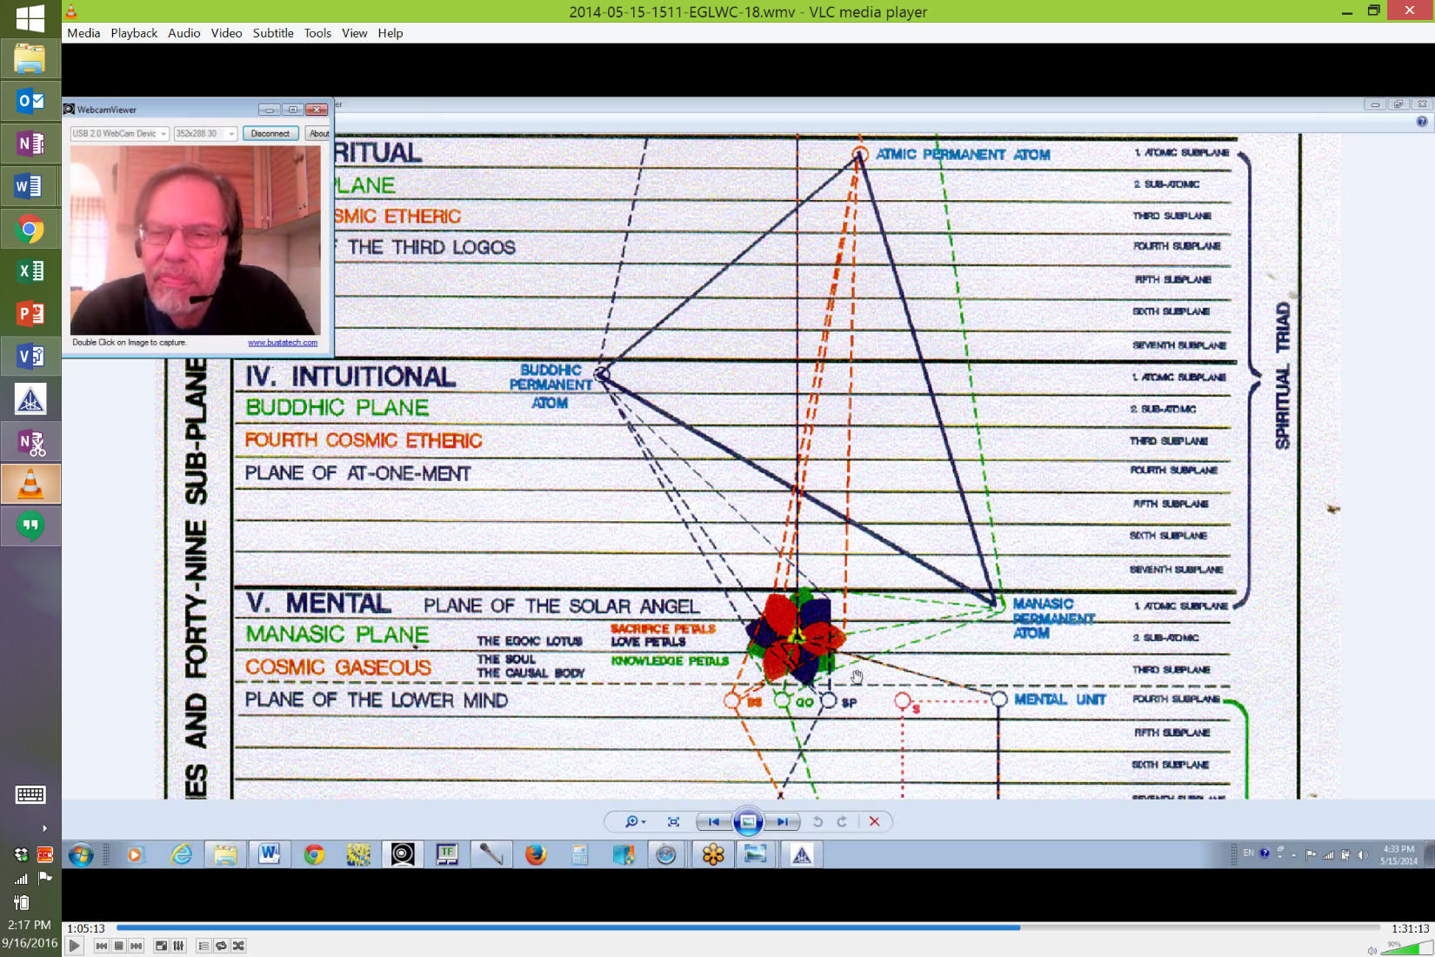
We really don't see any lines coming into the lemon yellow petals there, not really, but certainly the major line of force of the Monad does stimulate them and we do have to remember they were developed by a down flow of buddhic force so there must be some connection with the buddhic plane.
So each of the Synthesizing petals can be conceived of as correlated with one aspect of the spiritual triad, right? Either the knowledge part, love or buddhic part or the atmic part. The 3 inner petals, as a whole, arose as a result of buddhic stimulation. Let's just take a look at page 709 where we should be able to find that. This is how it all works out.
"Third. At a certain stage of vibratory activity, the work of the Lords of the Flame having produced a body or form and a vibration calling for response, there occurs a practically simultaneous happening.
A down flow of buddhi takes place along the line of the manasic triangle until it reaches a point at the very centre of the lotus. There, by the power of its own vibration, it causes a change in the appearance of the lotus. At the very heart of the lotus, three more petals appear which close in on the central flame, covering it closely, and remaining closed until the time comes for the revelation of the "jewel in the Lotus." The egoic lotus is now composed of twelve petals, nine of these appear at this stage in bud form and three are completely hidden and mysterious." TCF 709
﻿And notice that the down flow of buddhi occurs along the line of the manasic triangle which I suppose occurs here, (between the manasic permanent atom and the Jewel) because there is a manasic connection here with the lotus. Not all lines are drawn, but it's not straight from the buddhic plane, it goes from buddhi through manas, apparently.
2:18:53 Then the Jewel in the Lotus would seem to be directly responsive to the Monad and to atma and as the principle of man closest in nature to the Monadic nature. So buddhi is directly related to the 3 Synthesizing petals, but they are also stimulated by the down flow from the Monad directly. So it is, as we had read before, it is the stimulation, revelation of these 3 inner petals by the One Initiator at the 3rd and 4th initiations which bring about the final conflagration of the blazing of the causal body. Okay. So we are getting the picture, you know. We are not necessarily looking at the Egoic Lotus from beginning to end in a sequential manner, but we can fill in these different steps. We will go sequentially when we have the knowledge base to really understand how to relate the many energies and processes to the petals and tiers one at a time.
So we are speaking of the alchemical liberation of the central positive life or fire into the triad first and then in its return. I don't know what it means to be liberated into the triad before returning to the Monad but I know the references support that idea. Between the 3rd and 4th initiations, the Jewel is revealed and it looks like the light of the Jewel is revealed at each initiation increasingly. And it is the opening of the Synthesizing petals that reveals the Jewel. But at first, maybe not so much, maybe we are first dealing with 1st translucence and then transparence and then the actuality of the Jewel. So as the Jewel is progressively revealed, its power is unleashed in the act of destroying the causal body, even at the 3rd degree there is disintegration of the outer 3 petals, gradual, because intuition is taking over. After the 3rd degree, the study is of the intuition and one is increasingly buddhically responsive and so the Knowledge petals per se are not needed, but the disintegration is not a loss of all that has been stored in the Knowledge petals because there is an elevation of that content into the manasic permanent atom. You see that's the kind of thing that should be edited out but whether there will ever be any editing of these things one does not know.
2:22:31 Anyway, the attempt is simply to bring forward the interpretation and then it can be discussed and affirmed or repudiated as the case may be. I'm certainly not claiming all knowledge with respect to this matter. I'm simply trying to correlate what has been said. So, the causal body has been destroyed in a number of ways or is destroyed from different agencies from the touch of the rod of the initiator from triadal and Monadic impulses from below as a result of the intensely heated activity of the atomic triangle which is gathering in its heat and finally these 3 representatives of form are very effective in contributing to the destruction of the vehicle. The stage of synthesis achieved from the time of the 3rd to the 4th is signaling the impending destruction of the Lotus so we realize that the Christ as initiator is not so much involved with the stimulation of the central petals, but they are opening up, definitely at the first two initiations, 1st and 2nd. One of the 3 petals opens up so what the Christ does, and it does look like there is going to be a directing of force to the petal. There will be an ongoing, gradual revelation of that which is contained within the hitherto hidden area of the Egoic Lotus.
So we should be on page 537 by now. We might be really inching along here. Let's see where we are. We are on the end of 538, we are moving along.
"2. The Twelve-Petalled Egoic Lotus
Solar Fire is dual. It is the fire of matter or substance and the fire of mind blended." TCF 538
1:24:57 Solar Fire is dual. It is the fire of matter or substance and the fire of mind blended. ﻿This is a very interesting statement. It's simply often called the Fire of Mind or the Fire of Love. When we speak of the matter of substance, we have to decide whether the lower substances are involved, the substance fires of the personality or only the matter substance fires of the higher mental plane and that seems better, it seems to me. It does not seem accurate to consider the matter substance of the planes of the personality when considering solar fire, so we don't even consider solar fire for the lower 18 subplanes except to the manner in which solar fire affects the fire by friction of the lower 18 subplanes. So we discuss the fires of matter/substance primarily here I think in relation to the higher mental plane. Solar fire, however, is also as we have earlier established active on the triadal levels and so the substance there will also be involved. We are talking about the solar fire aspect of Agni and it seems to involve the monadic, atmic and buddhic planes. So it is the fire of substance and the fire of mind blended and that I think is a phrase which requires a lot of pondering. This blending only begins with the substance of the higher mental plane. It's not strictly the fire of mind per se. Why this should be so? Well we can understand it's the fire of love so it should be dual, the 2nd ray is dual ray, the ray of love and wisdom and which aspect correlates with which? The fire of matter or substance and the fire of mind. Which with which? I can't really answer that at the moment.
So this is another bringing in of ancillary, useful references.
". . . man demonstrates as electric fire on the second plane, or the second cosmic ether; as solar fire on the third, fourth and the three higher subplanes of the fifth plane, and as fire by friction on the lower subplanes of the fifth, on the sixth, and seventh planes." TCF 521-522
. . . man demonstrates as electric fire on the second plane, or the second cosmic ether; as solar fire on the third, fourth and the three higher subplanes of the fifth plane,. . . ﻿So that type of substance belonging to these planes and subplanes will be involved. . . .and as fire by friction on the lower subplanes of the fifth, on the sixth, and seventh planes. ﻿But this is really important, isn't it? Demonstrating as solar fire on the 3rd, 4th and 3 higher subplanes of the 5th, so solar fire is definitely found in the triad and not only upon the higher mental plane and there is a place, if I can find it, you know I am always hunting for these things.

2:29:09

He Lord Agni shows forth as solar fire. . . now remember what was just said before about the 3rd, 4th and part of the 5th, now Lord Agni shows forth as solar fire on the 2nd, 3rd and 4th and as fire by friction, at least from the solar Logoic point of view, from the 5th, 6th and 7th. So I think this is a Solar Logoic point of view.
Additionally this will be important because Agni really is of the Solar Logos and what we are talking about here, man demonstrating electric on the 2nd, has to do with the Planetary Logos. Here the Solar Logos is implicated. In the previous reference, it was the Planetary Logos and things move up and down a plane, depending upon the type of being we are talking about. haha. And here I have chosen the way out and said, look we don't have to address this complication in this context but I guess I have already somewhat addressed it.
"This makes man the six-pointed Star of Light, for each of these fires is triple. The fire of mind is also in essence dual, bringing in another triplicity, thus making the nine. When a man has awakened the nine fires, and has unfolded the nine petals, and when he has received the stimulus which is imparted at initiation, through being brought into conscious contact with the electric spark of his own particular Heavenly Man, they all blend and merge.” TCF 538
This makes man the six-pointed Star of Light, for each of these fires is triple. ﻿So the triple fire of mind and that the fire of matter/substance is also triple. So the two together will make the dual solar fire and related by 6-ness to the Monad. The 6 pointed star. From one perspective it is the 3 fires of matter/substance, fire by friction, considered as a triple fire. And the 3 fires are called the fire of mind which makes the Star of Light. So there are a number of ways to render the fires of matter/substance into a triplicity and we will try to keep things simple, yes, let's do that by focusing on the higher mental plane and stating that the 3 fires of matter/substance here discussed are related to the 3 higher subplanes of the mental plane and we will also affirm that the fires of matter/substance, even matter/substance of the higher mental plane are not the same as the fires of mind, otherwise, he wouldn't differentiate them. ﻿The fires of matter/substance and of mind can also be seen as both dual and triple.
In fact, we must say that both these kinds of fires - matter/substance and mind - they are unitary, they express their duality; they express their triplicity. So generally, probably one of the best ways to view the fires of matter/substance as triple is as follows. So the internal fires of the system and the planet and of man are 3-fold: interior fire - we studied this at the beginning of the book, in the center of the sphere, those inner furnaces that produce warmth, this is latent fire. Remember latent and active radiatory fire. Radiatory fire - this type of fire might be expressed in terms of physical plane electricity of light rays and etheric energy. This is active fire. And then essential fire or the fire elementals who are themselves the essence of fire and these are divided into two groups: the fire devas or evolutionary entities and the fire elementals, the involutionary entities. You know this is a little bit of an extract bringing this in from earlier.
2:33:00 So the 3-fold division of fire is usually used in relation to the 18 lower subplanes, the planes of personality, and if we try to apply the triple division to the 3 levels of the higher mental plane, then the interior fire would be analogically associated with the 3rd subplane, radiatory fire with the 2nd and essential fire with the 1st. So it sounds as if solar fire, described above as dual fire, is formed by the triple fires of mind, each blending with one of the 3 fires of the higher mental substance. This six pointed star is a very generic figure in occultism and can be formed in many ways, blending substance and mental fire is one of the ways, but also the 6-pointed star is that of the Monad. Interestingly, that Master Morya in one of his earlier incarnations as Akbar, his symbol was the 6-pointed star and he had it on many of his buildings. When I was there I saw it and in Agra it was and also it's called the Seal of Solomon. It's a profoundly occult astronomical cosmological symbol but Solomon used it as a 6-pointed star and it was related with him and he was an earlier incarnation of Master Morya as well. So somehow this Monadic 6-pointed star I think is very connected with Master Morya. It certainly not simply the star of Israel, the star of the recent nation Israel, it's much more. So when we read all of this we can only agree with the Tibetan when he states it is therefore obvious that this matter of fire is as complex as that of the rays. haha. Right. And I think we will have to leave this to some of the scientists who will have the mind to get into cosmic fire.
The fire of mind is also in essence dual, bringing in another triplicity, thus making the nine. ﻿So solar fire is the fire of mind and the fire of matter/substance and then the fire of mind being dual as well. If the fire of mind is essentially dual, then each of the members of this duality can be divided into a triplicity. So examining the fire demonstration on the higher mental plane, we would have the 3-fold fire of substance/matter relating to the 3 subplanes of the higher mental, the 3-fold fire of one division of the fire of mind, and the 3-fold division of the other division of the fire of mind. So how shall we understand the duality of the fire of mind? Well one easy way is to think of the fire of concrete mind and the fire of higher mind. That is one possible method. But when dealing with solar fire we are thinking of fire upon the higher mental plane and not of the elemental fires of the concrete mind itself, so our division of the fire of mind into a duality must occur in relation to the higher mental plane. Well perhaps that is so. If we concentrate upon developments upon the higher mental plane and seek to divide the fire of mind there found into a duality, we can have the fire which animates the normal 9 petals of the Egoic Lotus and the fire which animates the Jewel in the Lotus and the 3 innermost petals. That may be one way of dividing. I'm not sure that it's necessary that we solve this completely, but some prospects are offered.
2:36:54 It would appear that each member of the triplicity of fires which animates the 3 tiers of petals of the Egoic Lotus is further divisible into a triplicity because each tier of the Egoic Lotus has 3 petals. So he said the question of fire is just as complex as that of the rays, all the rays and subrays and here we have the fire and subfires. We have to remember that even though the inner petals are buddhically derived along a manasic line, and the Jewel in the Lotus is monadically and probably atmically derived, these energy structures are nevertheless found upon the higher mental plane and thus are necessarily related to the energy of the higher mental plane.
So in this case, it is probably the manasic permanent atom which is that particular energy of the higher mental plane which is related to the inner structure of the Egoic Lotus. The manasic permanent atom is 3-fold, isn't it? Because of the 3 spirillae which compose it. So we can begin to wonder about the substantial positioning of the Jewel in the Lotus, and the inner or Synthesis petals. Are they ever located on the 3rd and 2nd subplane of the higher mental plane or are they always to be found upon the 1st subplane? And even between the 1st subplane of the mental plane and the lowest subplane of the buddhic plane – that is said that of the Jewel in the Lotus. So are they ever located on the 1st and 2nd subplanes of the higher mental plane or are they always to be found upon the 1st subplane even when the other aspects of the Egoic Lotus may be focused on the 3rd and the 2nd, or between the 1st subplane of the mental plane and the lowest subplane of the buddhic plane? So we can we can see how much intricacy there is here, and how little of the truly technical nature we actually know.
So let's confine ourselves to the higher mental plane in this discussion of the fires of the Egoic Lotus and we can suppose whether it's going to be correct or incorrect remains to be seen, that the essential dualism of the fire of mind mentioned in the section of text above - it refers to a fire focused in relation to the 3rd and the 2nd subplanes of the higher mental plane and another fire focused in relation to the 1st subplane. So there is a triplicity there.
The mental fire focused in relation to the 3rd and 2nd subplanes is first triple, because it has to animate the 3 tiers of petals of the Egoic Lotus and then 9-fold because each of the tiers is triple, so there is a 9-fold fire and a 3-fold fire. The higher of the divisions of that portion of the fire of mind confined to the higher mental plane is the division we will associate with the manasic permanent atom and all that point of force animates. So this fire is in a way the representative of the 3-fold fire of the triad. It is triple anyway, because of its 3 spirillae. Since the spiritual triad is expressing the world of Brahma, its 3 fires are in a way mental or manasic.
2:40:38 So this whole question of divisions and subdivisions into dualities and triplicities is not easy to understand and it would be easy to gloss over the inherent difficulties in the first few sentences on the 12-petalled Egoic Lotus, but we must not allow ourselves to do so and we have not. Not that I suggest that you concentrate all that excessively on what has been proposed here.
Triplicities evolve out of dualities and one member of an original duality divides again and thus a triplicity is formed and it works that way, I was going to say on the rays from the psychological point of view, this method of division can be seen in relation to how the 2nd subtype of the 2nd ray soul that from that a 3rd subtype is created through subdivision yielding 3 major subtypes of the 2nd ray soul and a number of others as he says as well.
So that is a little bit of a complex explanation.
The fire of mind is also in essence dual, bringing in another triplicity, thus making the nine. ﻿One would begin to wonder whether the fire of the manasic permanent atom per se which is on the 1st subplane is not most related to the Sacrifice petals. Let's see if that is the case in the diagram. Not in this diagram, no.
But one might be able to infer it, that the higher type of mind, let's just say, that which comes from the manasic permanent atom has a lot to do with the Sacrifice petals per se. Okay, don't give up. I won't, if you don't. Alright.
When a man has awakened the nine fires, and has unfolded the nine petals, and when he has received the stimulus which is imparted at initiation, through being brought into conscious contact with the electric spark of his own particular Heavenly Man, they all blend and merge. ﻿There are really interesting things being said here. If we tabulate the 9 fires at least according to the present hypothesis, we would have: 3 fires of matter/substance, relating to the matter/substance of the 3 highest subplanes of the mental plane. There is after all, what do we call it, elemental essence and even the highest subplane is called monadic essence, but it is substance energy and it belongs to the plane. A type of mental fire, then point b, a type of mental fire in 3 and 9 divisions which animates the 3 tiers and the 9 petals of the Egoic Lotus. And also a higher type of mental fire, which is associated with the 3 Synthesis petals and in some manner difficult to determine, with the Jewel in the Lotus. So these are possible types of mental fires that we can find on the higher 3 subplanes of the mental plane.
2:44:23 If we remember that solar fire expresses through the spiritual triad as well as through the higher mental plane and we have just reviewed those references, we can relate the 3 higher mental fires connected with the manasic permanent atom to the spiritual triad. After all it is still solar fire, isn't it? Atma, buddhi and manas are all manasic in that respect. The spiritual triad is ruled by the 3rd ray and by Saturn, we see in the study of the spiritual hierarchies. So they express the world of brahma and brahma is manas from the perspective of the greater Logoi, so atma expresses on the 3rd systemic plane and is thus a blend of mind and will. Buddhi is called the transcendental mind and c) the fire associated with the manasic permanent atom is obviously manasic. So the triad, just as the personality, is in a sense, related to the 3rd ray and to manas, and so is the spiritual triad as the personality of the Monad related to the 3rd ray and to manas.
So we should be cautious in realizing that the 9 fires, which have been discussed, do not have a one-to-one correspondence with each of the 9 petals but the interplay of these 9 fires, 3 fires each divided into 3, ensures that the 9 petals will be open. I think that's an important point. So it all fuses and blends together. ﻿And this is most interesting about the electric spark of his own particular Heavenly Man. Well we seem to be talking about the people of Earth and Sanat Kumara is the initiator and the representative of the planetary Logos, but is there a way in which somehow the electric spark of the Logos that a man's ray is correlated with is somehow conveyed. The Monadic nature of his own particular Heavenly Man might be conveyed to each individual through the process of initiation depending on the ray of his Monad.
2:46:26 So the human Monad is an electric spark of a particular Heavenly Man and not necessarily the Heavenly Man of Earth. After all it all really comes from the Sun. So at first it seems we are speaking of the Heavenly Man of the Earth scheme but in another way, each Monad might be particularly related to one of the other Heavenly Men, a Heavenly Man who expresses through a different planetary scheme. So because the manasic permanent atom is the highest structure to be found upon the mental plane, it will be analogically related to the Monad, considering the Monad as the highest of the 3 aspects of man's constitution. We remember we talked about the mental unit in relation to the personality as carrying the 1st aspect, astral; 2nd aspect; and physical permanent atom the 3rd.
So one analogy here would be as follows. Monad, soul and personality correspond respectively to manasic permanent atom, then the fires which animates the 9 petals of the Egoic Lotus, and then the mental unit. That's one way of doing it. We are being told that at the 3rd initiation, the initiate is brought into conscious contact with the electric spark of his own particular Heavenly Man. The 3rd initiation is therefore, one in which electric fire is definitely involved and some references tell us that the 3rd initiation is taken on the ray of the Monad even.
2:48:00 So at the moment of climax in the case of the 3rd degree, there is a blending and merging of 9 fires with the energy of the electric spark via the Jewel in the Lotus, though not the entirety of that energy, for still more is released at the 4th initiation. So in this respect the 3rd initiation is characterized by the number 10 which of course makes sense. It’s on the fifth ray, interestingly, and the first ray comes in. To the degree that the energy of the three Synthesizing petals are involved in the fusion of the nine fires of the Egoic Lotus at the third initiation, such energy is considered one with the energy of the Jewel in the Lotus through which the energy of the electric spark of his own particular Heavenly Man reaches the initiate. So the number 10 than is appropriate in the context of the third initiation, considering that the 10th sign, Capricorn, is the sign archetypally associated with a third initiation and sign.
I may have gotten just a little bit too intricate here, but okay I’m trying to go through this section of Cosmic Fire which is specifically related to the Egoic Lotus does has ramifications. So another enumeration of 10 can be conceived in relation to the fourth initiation. The destruction of the three members of the atomic triangle, the destruction of the three tiers petals, each of them threefold, destruction of three inner Synthesis petals, and the destruction or translation of the Jewel in the Lotus. You know, it really goes to here if I may say, we just go here to, page 23 in Rays and Initiations.
“Let the group together move the fire within the Jewel in the Lotus into the Triad and let them find the Word which will carry out that task.” RI, 22-23
2:50:18 So, obviously the Jewel in the Lotus is first going into the triad before it returns to the Monad. It’s all a question of time, but not many lives are remaining and this whole thing can be done, the fourth and fifth initiations being taken even in the same life. So that’s a 10, another enumeration of 10. It would seem that the manasic aspect of the electric spark, that is of the Monad, reaches the third-degree initiate via the Jewel in the Lotus and the aspect related to Love/Wisdom at the at the 4th degree. It is the second aspect of the will which is really very strongly involved in the destruction of the Jewel in the Lotus and the causal body. Well do we call it the destruction of the Jewel in the Lotus or its translation of the central fire? Maybe that’s more like it.
So just reading over a little bit of what D. K. has said, When a man has awakened the nine fires, and has unfolded the nine petals, and when he has received the stimulus which is imparted at initiation, through being brought into conscious contact with the electric spark of his own particular Heavenly Man,. . . ﻿ remember his Monad is that the Jewel in the Lotus is the extension of his MONAD, so the electric spark of his own particular Heavenly Man will relate via his Monad and via the Jewel in the Lotus. . . . they all blend and merge. At the 3rd degree, certainly, and the inner three petals which complete the 12 and which are concerned with the final and essentially spiritually stages, essentially spiritual, notice how we’ve moved out of the Brahmic aspect, are really related more intimately to the evolution of the Heavenly Man. Well he is already receiving the essential spark of his own particular Heavenly Man so that’s at the 3rd degree and it continues I suppose in intensity through the fourth. So that which is spiritual pertains to the spiritual Triad and in the initiation process initiations would specifically pertain to the focal influence of the spiritual Triad begin at the third. So once the third initiation is reached one has entered more consciously, more intimately into the evolution of the Heavenly Man and certainly this is so when working within the cosmic ethers.
2:55:37 The three petals which complete the 12 are related more intimately to the evolution of the Heavenly Man and are connected with the stimulus which he receives himself in contacting the Logoic electric spark or the pure spirit aspect of the Logos. We will look at that in just a moment.
The inner three which complete the twelve, and which are concerned with the final, and essentially spiritual stages, of his evolution, are really related more intimately to the evolution of the Heavenly Man, and are connected with the stimulus which He receives Himself in contacting the logoic electric spark, or the pure Spirit aspect of the Logos. This is a very deep statement. Maybe a few indicative things can be said, perhaps a few. The term Logos suggests Solar Logos indeed and so we have a parallel process. The human being when reaching the third initiation contacts the electric spark of his own particular Heavenly Man and when the Synthesis petals of the man are stimulated, it reflects the stimulation which the Heavenly Man receives from contacting the spirit aspect or electric spark of the Solar Logos. So we could question to what degree different Heavenly Men contact the spirit aspect of the Logos, and some of them are not even cosmic initiates of the 2nd degree, but apparently it is happening. So we are into some pretty abstruse matters here.
“It should here be noted that this ninefold development is hinted at in the Secret Doctrine in the various places where H. P. B. deals with the Kumaras77 or the Heavenly Men, of Whom the microcosm is a reflection. She calls Them the Lords of Knowledge, the Lords of Love and the Lords of Sacrifice. Each of Them is a nine-petalled Lotus in the logoic body. They are the flaming Wheels, and in Their various names, as found in the Secret Doctrine, may be discovered the clue to the mystery.” TCF 539
So the term Heavenly Man can mean many things and here the Kumaras are called Heavenly Men and there are different kinds of Kumaras, some of them planetary, some of them intra-planetary. If they are the systemic Kumaras, the inter-planetary Kumaras let us say, the ones who exist in the solar system, one can understand this for the systemic Kumaras are Planetary Logoi. Yes indeed.
2:56:28 There are also interplanetary Kumaras and perhaps they are to be called Heavenly Men as well in a different sense. In any case we can the microcosm man is a reflection of a Heavenly Man. Perhaps it is even more true to say that the microcosm is a reflection of the Solar Logos. So HPB calls them the . . . Lords of Knowledge, Lords of Love and the Lords of Sacrifice. So it appears that the Heavenly Men, considered as Kumaras according to HPB, come in three categories as stated. The categorization may well depend not only upon their rays, but on the degree of unfoldment of the tiers of their Egoic Lotus and I think that’s very important whether they are Lords of Knowledge, Lords of Love or Sacrifice because they have similar petals to what we in the microcosm have. Some of these Lords are more sacred than others in their degree of spiritual maturity and of unfoldment is unequalled.
Each of Them is a nine-petalled Lotus in the logoic body. And more than nine really just the way man is more than nine. So as is the case with man perhaps they are nine petal from one perspective and 12 petal from a more advanced perspective and we have another issue which surfaces here, in the human being each chakra has a different number of petals. The Planetary Logoi as Kumaras are chakras within the energy system of the solar Logos, so here it would seem that they each can be represented as a nine petalled Lotus, perhaps a 12 petalled Lotus and why to each of them not have a distinctive number of petals or do they when viewed from a different perspective which is not the causal perspective you see I think that’s the thing.
2:58:17 We appear to be viewing this from the causal perspective. Perhaps we can solve this question by thinking of their causal nature as numerically uniform, right, consisting of 9, 3 and one, just like the man, even though the numbers of petals in their chakras found upon the cosmic ethers as well as upon the cosmic astral and all of that will vary.
In other words, what they appear to be on the lower planes in terms of the number of petals they have may vary from what they are causally. In any case we seem to be given a hint here concerning the structure of the Egoic Lotuses of the Planetary Logoi, ninefold it appears from HPB’s perspective. They are the flaming Wheels, and in Their various names, as found in the Secret Doctrine, may be discovered the clue to the mystery. So they are flaming wheels. The wheel is another way of viewing the chakras so these great Kumaras are lotuses, wheels and may be said angels also because it is set of man that they are angels. In fact, archangels. The Planetary Logoi our planetary Angels. The Saint Michael is Saturn from a certain perspective and so it goes correlation archangels. So it is important to realize that not only are Planetary Logoi called Heavenly Man, but according to HPB they are angels, archangels perhaps as well. The causal body of man upon the higher mental plane can also be seen as a Lotus, a wheel and an angel. In this case the Solar Angel take a look at Initiation, Human and Solar there in 115 and 116.
It is as if this solar Angel associated with a human being is a reflection of a Heavenly Man who is an archangel, perhaps. But perhaps it is there soul nature that the Planetary Logoi are considered to be archangels because thus it is with that which is associated with man in his soul nature. He is the Angel. The Angel of the Presence is very much in a sense a part of his Egoic nature.
3:00:46 So we can infer that just there are great Solar Angels associated with the causal bodies of the solar Logoi, so it must be the case in relation to the causal bodies of Planetary Logoi. Along this line of thought we do know that Solar Angels in groups endeavor to become Heavenly Man indeed. So what can we say? They are flaming wheels. You know we are going pretty cosmic here but it is giving us the cosmic view of the Solar Angels and the condition of the Planetary Logoi as demonstrating as angels and so forth, in their various names is found in the Secret Doctrine, maybe discovered the mysteries. What are the names of speaking of? There are a number of them and they should reveal some clue to the mysteries. So what are these? Prajapatis, these Planetary Logoi, these flaming wheels, the Logoi with nine petals upon their own causal plane. They are called the seven rays, the seven spirits before the throne, seven Planetary Logoi, seven great Lords, the seven aeons linking this Gnosticism. The seven emanations, the seven Pajapatis (Light of the Soul 268). Other names from Cosmic Fire (233): the seven Planetary Logoi or Spirits before the Throne of the Solar Logos, right? Seven Ray Lords, Dhyan Chohans, seven archangels, so there is a definite statement and seven Logoi, the seven Builders. Alright we are looking at the relation of man the microcosm with his planetary macrocosm. Also here: Divine Manasaputras, Pajapatis, Kumaras, Primordial Seven, Rudras, Heavenly Men, Rishis, (TCF 270), so many names but essentially we are looking at this question of the Egoic Lotus starting from a large perspective. Sometimes they are said to be seven but sometimes 10 and they are also called Rishis, as it says above.
With so many names given to the Heavenly Man a number of valuable hints regarding their nature can be gathered. So D.K. goes on to say:
“Let us realise this clearly, nevertheless, as regards the microcosm, and later extend the idea to the Heavenly Men. Let us picture the nine-petalled egoic lotus, the heart centre in the monadic consciousness, unfolding each of its petals in groups of three upon the three subplanes of the higher mental. ” TCF 539
Let us realise this clearly, nevertheless, as regards the microcosm, and later extend the idea to the Heavenly Men. Well, he is giving us a lot about the Heavenly Men first and we can generalize from our understanding, hopefully increasingly clarifying of the microcosm. So that which is now stated pertains to man, the microcosm. Let us picture the nine-petalled egoic lotus,. . . usually nine petals because for most people the inner three petals are not revealed nor is the Jewel, . . . the heart center in the Monadic consciousness. So he speaks again of the heart centre in the monadic consciousness,. . . but behind the thought as previously stated is the fact that more essentially it is the 12 petalled Lotus and when the time comes for the revelation of the inner three, it’s 12-ness will be fully realized.
3:04:22 The real esoteric development of the man which relates to his own Heavenly Man and to the Solar Logos, concerns that which is generated from the cosmic ethers, namely the inner three petals and the Jewel in the Lotus. That’s the really esoteric part of the man and is not concerning so much his development in the lower three worlds, but his development as a soul. . . . the heart centre in the monadic consciousness, unfolding each of its petals in groups of three upon the three subplanes of the higher mental. And that is kind of interesting because usually you don’t see that kind of reference. The unfolding is generally thought to occur on two subplanes of the higher mental plane and this is curious. I have heard people say well, really at the 3rd degree or something the Egoic Lotus moves up to the first subplane of the higher mental plane and there goes through the final initiation namely the fourth. But it doesn’t seem to be the case from the other references, the destruction seems to occur upon the second subplane of the higher mental plane, and only the manasic permanent atom itself is found on the first subplane and in a strange kind of way, the location of the Jewel in the Lotus is said to be between the highest mental subplane and the buddhic plane, whatever that means, well we will have to make that clearer if we can as we go along. Here particularly is the reference I was speaking about.
“The Jewel in the Lotus is situated between manas and buddhi whilst the third eye is found between the right and left eyes.” TCF 1130
That is a very interesting statement and I wonder if there is anything about subplanes particularly there. It seems to suggest that between those two planes whatever that interim ground might be. Is it on either one of the planes or is it on a special level of vibration which we don’t understand as belonging to either one of the planes? Anyway there are all these references and I think we have been given enough with this to understand something I think. Okay.
3:07:32 So, let’s go on. This statement: . . . unfolding each of its petals in groups of three upon the three subplanes of the higher mental. . . is one we have to carefully attend to. Usually is conceived that the causal body is located only on subplanes three into of the higher mental plane but here the unfoldment of the petal seems to occur on all three subplanes. This is problematic. It would only have to do with the Sacrifice petals if any. It is hard to imagine when this would occur as there is reason to believe that so-called advanced initiations, the fourth is actually taken with the causal body still upon the second subplane and maybe the following will make this clear. Yes it looks like the reference that is needed here.
“The causal body of the average man is on the third subplane, and as a man becomes fit for the merging into the Triad, that causal body has to be discarded and done away with. Under the Law of Sacrifice and Death, the disintegration is begun on the third level and is consummated on the second, when the man merges with the Triad, preparatory to the final merging with the Monad.” TCF 581-582
Man merges with the Triad, now that is the destruction of the causal body, right, preparatory to the final merging with the Monad. That is so important. The second level, second subplane, then a merging with the triad and final merging with the Monad. It is all sequential in that sense. So we may recall a question posed a little earlier in the commentary might be Synthesis petals of the Egoic Lotus and the Jewel in the Lotus be ‘located’ on the highest mental subplane regardless of where the rest of the causal body was focused well, maybe. This might not seem as strange as it seems when we think of the fact that the chakras in the human etheric system are located on different etheric subplanes. You know we learn that when - take a look here.

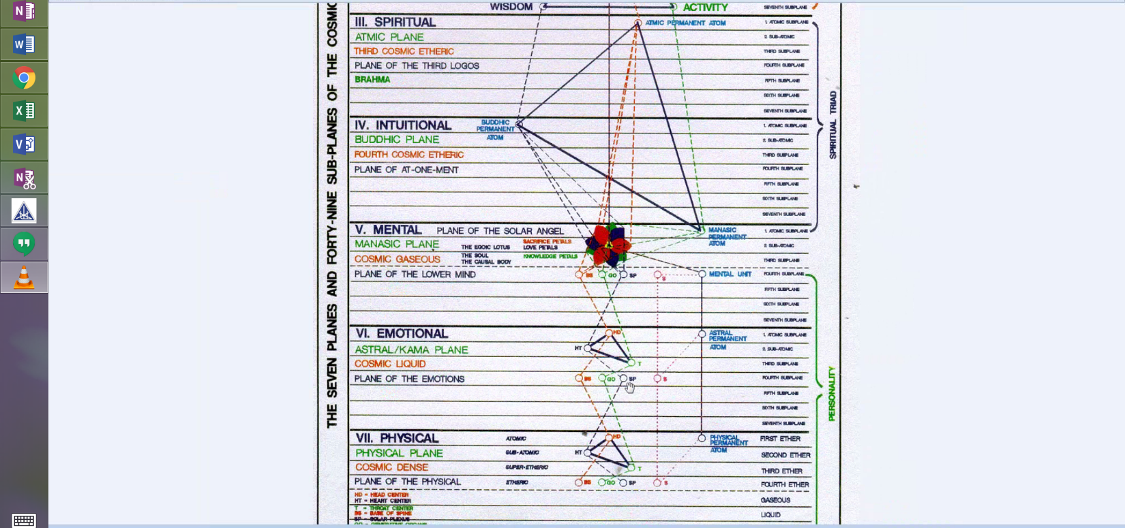The chakras are located on different etheric subplanes, four of them in fact with the lower chakras on the fourth subplane and the higher respectively throat heart and head on the third, second and first. So okay, so it may not seem so far-fetched. Four chakras on the lowest ether, the throat on the super etheric, heart chakra on the subatomic, head chakra on the atomic level. Yet they are all a part of the same chakra system and they all work simultaneously even though expressing through different etheric levels, so it could be that there is a great centralization occurring on the first level with the Jewel in the Lotus there. I know we can’t really draw that in our types of drawings but we can imagine that that would be the case with the Jewel in the Lotus and the other petals located in a frequency higher and yet the other petals still surrounding them at a frequency lower. It would make sense.

3:10:36 Let’s say the centrality of the Jewel in the Lotus need not be disrupted by the assertion that it is located on the higher mental plane or between manas and buddhi at whatever vibratory level that signifies. Analogously various parts of the Egoic Lotus could be focused on different subplanes of the higher mental plane and nevertheless still be part of the same coherent Egoic Lotus system. So we are asking then are all parts of the Egoic Lotus always focused together on the same subplane of the higher mental plane or are there parts of the causal body, let’s say the Synthesis petals and the Jewel in the Lotus for instance which may be focused on the highest of the subplanes of the mental plane while the other parts, the Knowledge petals for instance may perhaps be focused simultaneously on the lowest of the three subplanes. Then what does it mean to change polarization? Or that the Lotus moves to the second subplane? What is it that moves to the second subplane? So far we have had the idea of a pretty coherent non-divisible Lotus but the focus of the inner being moves up a plane and so does that mean that the petals of Knowledge also move up a plane and can they in some way well you know this is a very important sentence what we’ve had here that in fact unfolding its petals in groups of three upon three subplanes of the higher mental plane. Yes and when you look at the picture of the Egoic Lotus it does seem that one of the Knowledge petals touches the higher subplane. Of course that is just a representation, we don’t know.

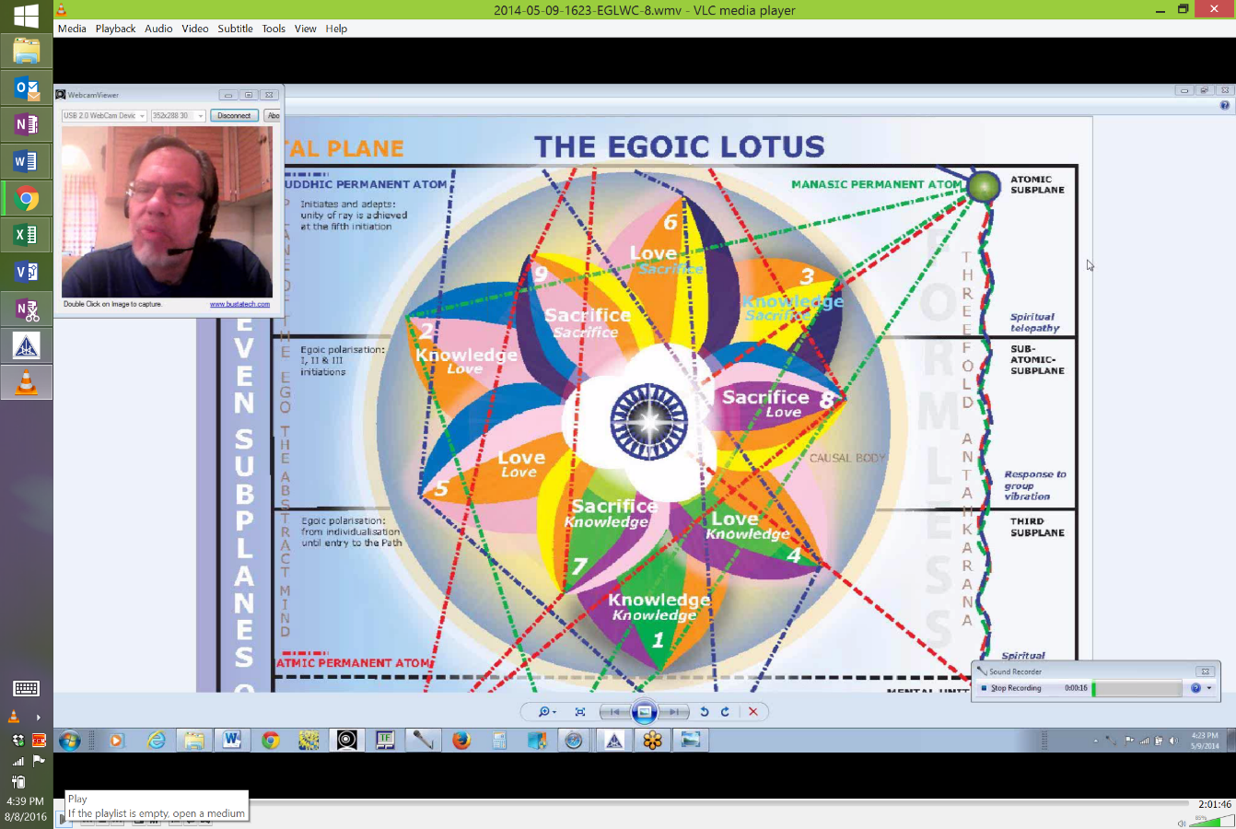

And one of the Love petals touches the higher subplanes so perhaps this is simply a question of frequencies, but we do know from what has been said that the Lotus as a whole, whatever that means, seems to be focused on the third level. So the causal body of the average man is on the third subplane and it sounds like the causal body of the one for whom the absorption of the triad is occurring is focused on the second. We are dealing with frequencies and how frequencies affect this position in space, so it’s not an easy question.
“Their unfoldment is worked out through the evolutionary process, undergone on the three planes in the three worlds, or within the three Halls of Ignorance, of Learning, and of Wisdom.” TCF 539
3:13:43 So their unfoldment, that is the of unfoldment of the petals is worked out through the evolutionary process undergone on the three planes, lower planes, in the three worlds or within the three Halls of Ignorance, Learning and of Wisdom. And so on the three planes, i.e. the lower planes, right, and thus in three Halls of Wisdom. So this is a very gradual unfoldment. When you consider that the causal body, at least in some methods of individualization can be taking shape long before the moment of individualization. So we might say that the Hall of ignorance is associated with the tier of knowledge petals of course. The Hall of learning with the love petals and the Hall of wisdom with the Sacrifice petals. And there would be some degree of overlap. Nor is experience within the Hall of Wisdom consummated in the nine petals are unfolded because there is a lot more wisdom to be gathered after the 3rd initiation. We might say the Master is still very much in the Hall of Wisdom and the Master has dropped or transferred the energy of the causal body, elevated it somehow into its petals, the energy of the causal body and its petals into the triadal level.

So the following material will be linked with that found from Cosmic Fire 820-823. That’s the second the reference section and if we take them together we will have a lot of information on the meaning of the petals in the Egoic Lotus and their process of unfoldment. We will now go into the meat of the matter, really and I wonder perhaps I have been so inattentive to the time that these are taking that I think it might be a good place to break, because we are now taking the petals of bit by bit, one at a time, tier at a time and we had done about one-fourth of this particular document. So it’s probably going to be about a 12 to 14 hour document, presentation.

I realize we’ve been into some very abstract material that requires a lot of pondering because somehow the different levels, systemic maybe even cosmic have been connected to the question of the human Egoic Lotus, but now we’re going to take up a more concrete version of this same thing. We are going to look at each petal, petal by petal, and this will be material that can be drawn together when we examine the synthesis of these really petal by petal. Now I am taking what D.K. has to say but there are other things to be brought together when we do this, so I’m thinking that in spite of the fact that it’s a bit of an ungainly moment, I’m thinking that we should say that this is the end of the Egoic Lotus Webinar Commentary Program 21.

We have dealt with TCF 536 to 539, I believe. Was it really necessary to go through these first three pages which have been so complicated in a certain way? Well let’s just say there is much to ponder here and every one of those sections that we kind of went through kind of briefly could take hours of thinking to get through, so let’s call it at this moment and we will continue shortly. Okay friends here we go.

