EGOIC LOTUS WEBINAR COMMENTARY #18 – Michael Robbins

Abstract

Egoic Lotus Webinar Commentaries 18: The First Four Initiations in Relation to Rays, Chakras and Petals. This webinar is about 1 hour, 30 minutes long and covers The Rays and the Initiations pages 339-340, 684-686. In this program we study two important sections from The Rays and the Initiations. In each one we examine closely the first four initiations (those which relate to the egoic lotus—leaving the others for later video programs). The themes of the initiations, the key words, rays, chakras and planets are all discussed in relation to the egoic lotus and its petals.

Contents

Abstract 1
Contents 1
Transcription of Egoic Lotus Commentary #18 1
1st Initiation 5
2nd Initiation 6
3rd Initiation 7
4th Initiation 8
1st Initiation 14
2nd Initiation 15
3rd Initiation 16
4th Initiation 17

Transcription of Egoic Lotus Commentary #18

Hello everybody. Today is the 15th of May, 2014. We have just had our Wesak Festival all over the world and I have not done anything the day before except prepare for that. So now I am back again and we are in program #18. We are preparing the understanding of various references so that we can gather them all together as we move petal by petal for a more synthetic understanding of the tiers and petals of the Egoic Lotus.

So, now we are dealing with initiations and the rays governing initiations and the results of the various initiations. We have, of course, mentioned this as we go along but I am now going to look at the two references which are very valuable in that respect, beginning with a little background around page 339 of the Rays and Initiations. And then going later into the book.

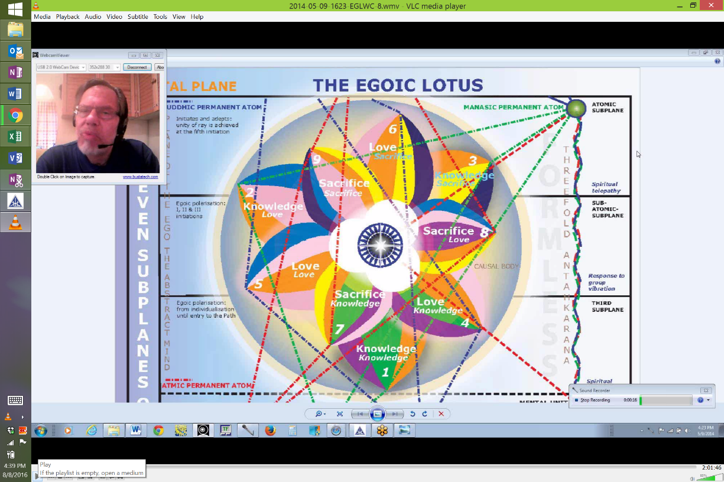
1:32 "As esoteric astrologers know well, there comes a life cycle wherein the disciple reverses himself upon the Wheel of Life (the zodiacal wheel) and from going clockwise around the zodiac, he now begins to go anti-clockwise; he learns that the substance aspect of his nature may still be conditioned by the forces flowing through them sequentially and serially, and according to his horoscope and according to the exoteric mode of the zodiacal revolution; at the same time, the disciple is receiving energy currents from the reversed wheel whereon he, as a soul, finds himself. He is consequently the recipient of two currents of energy, going in reverse directions; hence the increased conflict in his life and circumstances; these constitute the reason for the tests of initiation." RI 339

As esoteric astrologers know well, there comes a life cycle wherein the disciple reverses himself upon the Wheel of Life (the zodiacal wheel) and from going clockwise around the zodiac, he now begins to go anti-clockwise. . . Now we have to look at that word disciple because that may give us a hint about when the reversal is occurring, and we see that petals 1, 2 and 3 are traveling in a way clockwise, petals 4, 5 and 6 clockwise, but if we look to start the Sacrifice/knowledge petal in relation to the 3rd subplane of the higher mental plane, and to keep each petal touching that subplane to which it is particularly related, the aspect to which it is particularly related, then we are going to have the beginning of a counter-clockwise motion whether this is literally the case, we have further to investigate. We do know there comes a time when all 9 of the ordinary petals turn in a manner different from those that the petals of Synthesis turn. We are not told what the direction is, however, we might think perhaps that the first 9 petals would turn in the clockwise manner and the petals of Synthesis counter-clockwise, but certainly the wheel is already being reversed by the time we are working in petals #7, 8 and 9.

So I guess it also depends upon what we mean by the reversal of the wheel. Is it that first tendency to move in the direction of the higher of the pairs of opposites that we find in petal #5 or is it something that occurs still later after we have won the battle in the desert with the devil, so to speak - the world of flesh and the devil and then find ourselves moving definitely onto the Sirian regime of initiation without any possibility of going backwards? That has also to be established. There are different points of view on that matter. But certainly some sort of reversal, some sort of moving in a new direction does occur in relation to petal 5 when the Solar Angel begins to look in and become a downward gazing soul and begins to deliberately superintend the evolution of the man, where it had been left to other processes mostly before, including simply the development work of the 2nd Logos.

So, further, . . . he learns that the substance aspect of his nature may still be conditioned by the forces flowing through them sequentially and serially, and according to his horoscope and according to the exoteric mode of the zodiacal revolution;. . . ﻿﻿05:06 so in a way one part of our nature, or one energy flow within our energy system is moving in the direction of matter/form, hence the clockwise direction. It's kind of interesting when you think about the swastika, you know, if the swastika were to turn in a clockwise direction we might consider this a symbol not of evil. Were it turn from the left to the right, in the counter-clockwise motion, we would remember what the Germans, the Nazis had done with it and we would consider it a symbol of evil, and yet it is the counter-clockwise direction of the zodiac which symbolizes moving forward on the true path of spirituality and not as it were backwards into matter form. So there are some perspectives that have to be worked out there.

6:12 . . . at the same time, the disciple is receiving energy currents from the reversed wheel whereon he, as a soul, finds himself. And these currents are moving in his energy system in a different manner and are emphasizing the centers above the diaphragm and their activity rather than feeding the centers below the diaphragm. He is consequently the recipient of two currents of energy, going in reverse directions; hence the increased conflict in his life and circumstances; these constitute the reason for the tests of initiation. ﻿﻿Well St. Paul well knew that and he knew that there was an aspect of his nature, maybe some Christians call it original sin, that was moving against his higher intentions. In other words, simply moving as it has always moved. It is the disciple. It is the Monad in incarnation awakening to himself who has reversed the direction of his striving and is therefore moving against all that had been natural, all that had been clockwise in his nature in terms of his zodiac, all that had been instinctual for millions of years, he starts to go against that. And that is the result of the rending process. So when we think of a person working in the 5th petal and so called fighting it out in that petal, because it's a Scorpionic petal as well as a Leonian petal, then we understand the reason for the conflict because from that time on the higher of the pairs of opposites is really coming more clearly into view and one wants to as it were to swim in that direction rather than just go with the flow which in this case is clockwise and is problematic because it stimulates the vitality of matter/form and of the lower of the pairs of opposites which is the personality, the 18 lower subplanes, rather than developing the higher soul powers within the individual.

"This, on a tiny scale, is true of the centres in the etheric body of the disciple; they too evidence the same dual activity, once the Path of Discipleship is trodden and the Path of Initiation is entered. The zodiacal wheel is itself essentially a cosmic centre; it is a twelve-petalled lotus, but it is a twelve-petalled lotus within the thousand-petalled lotus of an unknown cosmic Entity, the One referred to in my earlier books as the ONE ABOUT WHOM NAUGHT MAY BE SAID." RI 339

This, on a tiny scale, is true of the centres in the etheric body of the disciple; they too evidence the same dual activity, once the Path of Discipleship is trodden and the Path of Initiation is entered. I included this because I thought it was so interesting. I don't know how immediately relevant it is to our task. This on a tiny scale is true of the centers in the etheric body of the disciple. What is true? The contest between currents. They too emphasize the same dual activity once the path of discipleship is trodden and the path of initiation is entered. Because there has not been complete conquest of matter/form.

9:31 The zodiacal wheel is itself essentially a cosmic centre;. . . ﻿﻿now we want to come to something which I think you will think is most interesting. I often quote it but every once in awhile I do run into the reference and therefore should not be suffering from the loss of the page number. . . . it is a twelve-petalled lotus, but it is a twelve-petalled lotus within the thousand-petalled lotus. . . ﻿﻿i.e., the highest head center . . . of an unknown cosmic Entity, the One referred to in my earlier books as the ONE ABOUT WHOM NAUGHT MAY BE SAID. ﻿﻿That is such an important reference and basically we are understanding that this lotus structure is operative cosmically as well, and who knows, it could go on and actually be universal. Now I want to bring in these as well.

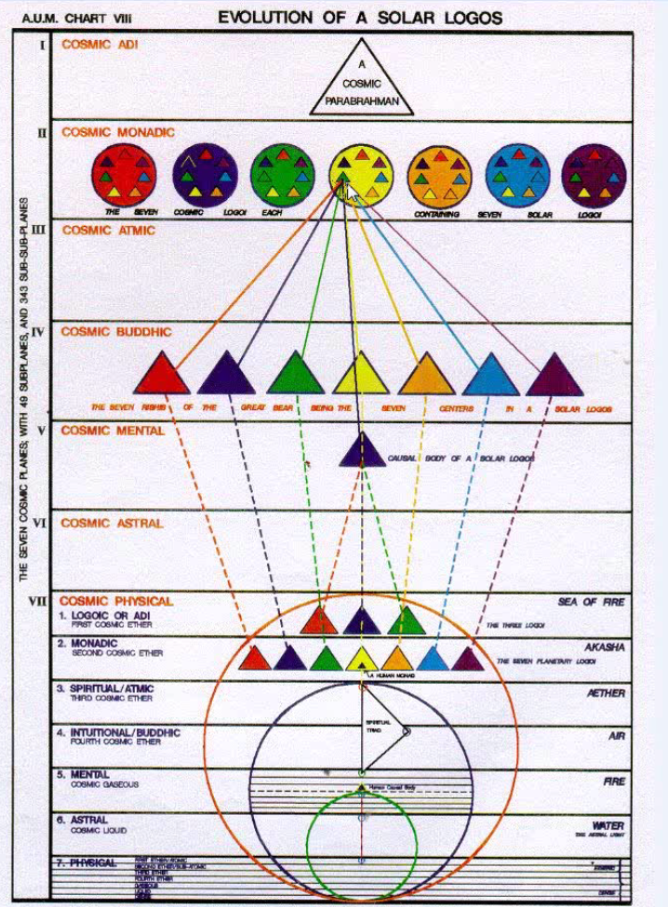

What I want to say about the One About Whom Naught May be Said, it will be found as this triangle here that is colored green, in the fourth parabrahmic lotuses. And I believe that in this little green triangle will be found that great unknown cosmic Deity with such constellations as the Great Bear and our constellation and oh also the Little Bear, and Orion, and maybe the Pleiades, aspects of them, and maybe the Southern Cross and let's see, maybe the Centaur, maybe our own cosmic Logos - all of those as chakras within its nature. Now I don't know if my interpretation of this chart is correct. I know there are very many interpretations, but so far I have located our local One About Whom Naught May Be Said and you can that there are 49 others, more of less on the same level, in that 3rd triangle. This chart was colored by Keith Bailey for AUM. I think he has done this correctly here. This looks like the 3rd of triangles and there is so much association of the Pleiades with the color green and the 3rd ray. It has other associations as well, as with cosmic buddhi and then with the 2nd ray.

12:54 "The multiplicity of zodiacal influences have eventually a dual effect: one upon Shamballa (the planetary head centre) and the other upon the Hierarchy (the planetary heart centre); the effect is also felt in the head centre and the heart centre of every initiate. This final dual activity is registered by the initiate of the highest degrees when he undergoes the eighth and ninth initiations; the other seven initiations are governed by the seven rays." RI

The multiplicity of zodiacal influences have eventually a dual effect: one upon Shamballa (the planetary head centre). . . ﻿﻿﻿and gathered there I would say under what we call the Law of Assembly where all the forces that are needed for the planet are gathered into that great center . . . and the other upon the Hierarchy (the planetary heart centre);. . . ﻿﻿﻿now, it just struck me that if Shamballa is the planetary head center, there has to be a heart in the head within Shamballa, but of course, there are many Shamballas in a sense. Shamballa is Shamballa for our globe. Are there other Shamballas for other globes? What is the Shamballa for each chain? What is the Shamballa for each planetary scheme? We don't want to get lost in multiplicity here but we do want to point out that Shamballa is usually considered to be related to our globe and yet the concept demands that we elevate it and if Sanat Kumara is really the Lord of the World in extension, then his home in Shamballa has to have a meaning on the level of the planetary scheme, not just a planetary globe, such as ours. So . . . the effect is also felt in the head centre and the heart centre of every initiate. This final dual activity is registered by the initiate of the highest degrees when he undergoes the eighth and ninth initiations;. . . ﻿﻿﻿not too much is said about those initiations. But let's just say the zodiac is working upon Shamballa as a planetary head center and upon Hierarchy as the planetary heart center, and something about that dual relation, something that we don't know is vouched safe to the initiate of the 8th and 9th degrees. . . . the other seven initiations are governed by the seven rays.

15:00 So we move on. Some of this will be review for you but I think it's beautifully put here.

1st Initiation

One of my friends alerted me to this, sex magic is not right, it's sex AND magic. This is something we have to consider because obviously all the qualities given here for the initiations are positive and while there may be a tendency towards sex magic it's more in relation to sex and magic. Well this is initiation 1. It is the birth of the Christ in the heart. Many things are stimulated. The sacral center is one. And D.K. applies the idea of the 7th ray to the sacral ray. The 3rd ray is also there as it is the home of the mental elemental, and it's much related to Mars as well which rules sex and the 6th ray is involved and generally the way that 6th ray people get themselves in difficulty is through the abuse of the sex instinct so there are other rays there as well but the sacral center is prominent and a higher form of creativity has to be involved. It rules beginnings, that's Aries, isn't it, in a way? It rules relationships and that's Libra and it rules both sex and magic and so we have the coming together of the 2 poles and there is the sense of the highest and the lowest meet. Well, at least the bringing together of 2 poles, heaven and earth, in a sense, and in general the beginning of the magical approach to divinity.

When we look at the petals that would be involved at the 1st initiation, well the 7th petal which is a Libran petal, is definitely involved. And there is work in that petal, organization work, while the 5th petal is unfolding and by the time the 5th petal completely unfolds, we do have the 1st initiation. That can be found in various obscure references which I managed to gather, which will show up at a certain point.

The whole idea of relationship is between soul and personality and we know that that really occurs in the work of the 5th petal when the pairs of opposites are coming together. At least the vertical pairs of opposites are understood in the 5th petal, and especially in the stage when aspiration begins and one begins to long for that. The probable coming together, the union of the two, is accomplished I think more under the impulse of the rod of initiation in the 7th petal. There is where the Divine marriage is really at work, and the soul and personality begin the infusion process which is not consummated, some say, until the 3rd initiation, but also we could even say the 4th initiation is really the moment of consummation because there is still more of the soul that the personality has not absorbed or been able to express until the 4th initiation is ready to occur.

19:04 A higher form of creativity at the throat is required and interestingly that at the 1st initiation, D.K. tells us elsewhere that the throat center begins to be ruled, at least in part, by the 7th ray. It is normally ruled for the disciple, even the probationer, by Saturn and the 3rd ray. And for average, nonaspiring people, by Earth and the 3rd ray. But in comes Uranus at the sacral and it also takes its place at the throat center at this time. So a kind of creativity which is more in line with the streams of energy sent forth by the Solar Angel is what is desired. A kind of creativity which will be creativity in line with the good, the true and the beautiful, creativity in line with the Plan.

2nd Initiation

Then comes the initiation we call the Baptism in the river Jordan. This is the cleansing and control of the astral body and it's connected with the solar plexus center. Obviously again we are in the Love petals here when this is occurring and there is work on the 6th of the petals, which correlates with the sign Virgo, which also the 6 correlates with the solar plexus center as the solar plexus is ruled by the number 6 even though in another sense it is the 5th petal counting from above to below. Counting from below to above it's the 3rd petal which is half of six and D.K. has told us how the 3rd and the 6th rays are intimately related. So there will be work in this 6th petal. It will be on the verge of unfolding as the initiation is taken and definite in the 8th petal, which again interestingly is ruled by Mars from the Scorpionic point of view. It is a petal of great relinquishment and sacrifice of giving up with no thought of gaining for that which has been offered in sacrifice. So it fits with the Scorpio ideal of losing one's life to find it.

It gives us, and D.K. elaborates on this later and when I go through this book, I hope to go through it as a video book, I have already done the 1st half or part of the book in a detailed kind of written commentary. Now I am choosing to work in this way, so the 2nd half of the book will be done, hopefully, in the verbal manner, audio and this gives us dedication which tells us inevitably arouses glamour which is actually dissipated by a higher form of devotion. I think it's really important for us to realize that devotion is not a form of glamour. That glamour so often occurs in the same field in which devotion is exercised and there can be false devotions and so forth. But the soul, Solar Angel, has a tremendous devotion to its projection, the personality and the Monad came into incarnation for the very purpose of devotion. He is called a Lord of ceaseless and persevering devotion. And that is not the same as the glamour of devotion.

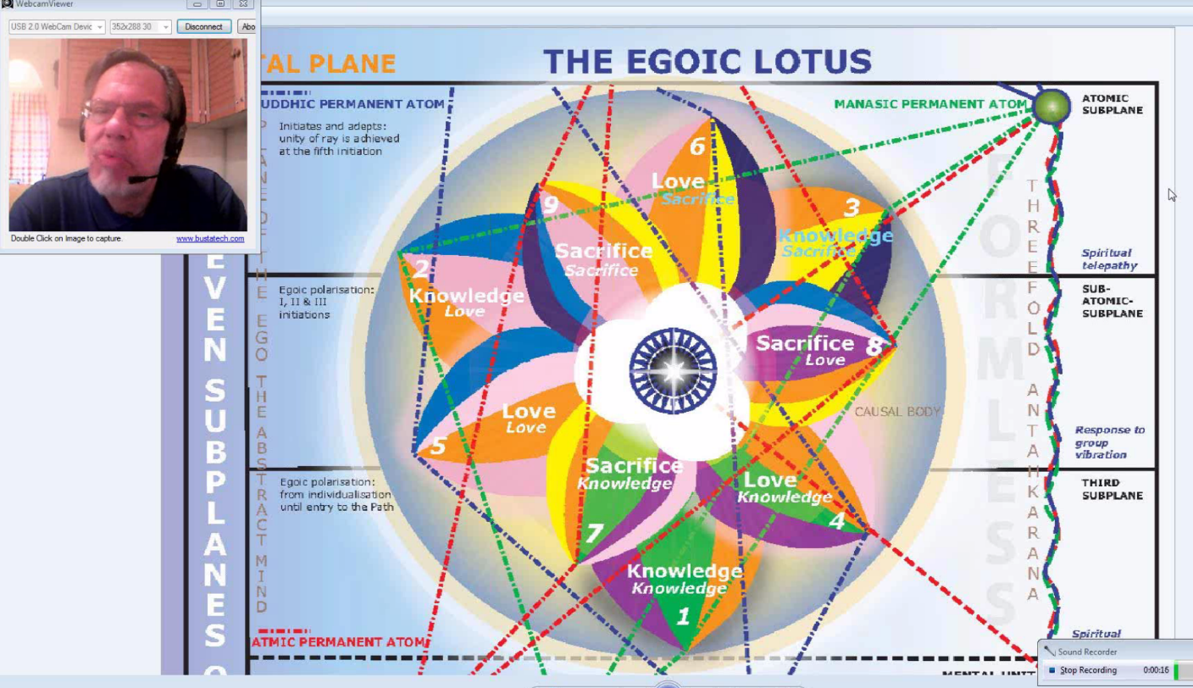

So here we are then working on the unfoldment of the 6th petal, which has, like all the petals of Love, it has the rose color of devotion, and working also in the 8th petal, it carries with it as well, the rose color because it is just carried along as one of the ongoing qualities. When the rod of initiation directs its energy to the 8th petal, the work of the 6th petal can be considered complete and the man will be in the position to do many things. One of them might be to consciously return to incarnation without having to dissolve the mental and emotional vehicles, which certainly would save time. Some kind of continuity of consciousness would be found there when the person is occultly trained. There will also be, interestingly, the ability to give up one's body to a higher initiate if that higher initiate needs to use it. So this requires great control of the astral vehicle.

24:29 I'm going over these lightly. There is definitely a purification operating here. As we know, the planets are Neptune, ray 6, Venus ray 5, but with much ray 6 in it, and Jupiter, ray 2 with some suspected ray 6 in it on some level with its bounding enthusiasm. So the solar plexus is stimulated and now we are ready to exit and work within the unfolding process of the Sacrifice petals. The work is then done at the 2nd degree within the Love petals. There are many correlations here but I think you get the main correlations.

In this list of initiations, obviously, the causal body does disappear long before the list has been exhausted, so we'll just take in mind and then only deal briefly with the remaining initiations. There is a lot to say but our subject is the Egoic Lotus so we will try to stick to that.

3rd Initiation

This is the initiation of Transfiguration and it's very obvious that when he tells us that all nine petals are unfolded, that the ajna center has to have a great deal to do with the work of the 9th petal, which is in a certain sense, a Sagittarian petal and from another sense, I call it an Aries petal, an Ariesan petal. The ajna center is a center in the head and the possibility of divine vision or of seership is entering here at the ajna center and Sagittarius is also a sign of seership and by the time we are reaching transfiguration the higher type of psychism can begin to occur. The 5th ray will always be needed here because we are entering the luminous domain of the soul on its own plane and we are able now to see through higher psychism, increasingly through soul sight. The great problem of course is that people think that lower psychism is higher psychism and when their mind has learned about higher psychism but their mechanism still tends to engage in lower psychism, there can be a lot of confusion attributing what should be understood by higher psychism to what is actually seen through lower psychism. Well it's a transition phase.

27:31 The keynotes are integration. Integration of the personality with the soul. This has been going on ever since the 1st initiation and maybe even earlier but the phases of integration are several and they are fairly well consummated by the time we reach the 3rd initiation. The integration of the energy system of the soul with that of the personality but not as I say entirely. Interestingly enough, the work integration corresponds so much with the number 4. There is something about this fusing and blending and harmonizing power of the number 4 which is equivalent to integration. And the wholeness of the 4th sign, Cancer, its ability to see wholes is very much related to the integration process. Well let us say that pretty much 75% of the integration has occurred by this time and interestingly, Sagittarius, at this 9th petal, is a sign of direction, and the direction is towards the Plan and towards the expression of that Plan as it serves the purpose. And we are leaving the mystical stage behind and attempting to know something of the science of the Kingdom of the Soul. We are not just talking about science in the usual materialistic sense, which can even be undertaken when there is engagement with the 3rd petal. We are talking about the science of spirituality and that is a Uranian factor, rather than a strictly Neptunian factor. So this transfiguration as we have probably discussed before occurs when the 9th petal is completely unfolded and there is quite a bit of unfoldment of the Synthesis petals as well.

All the petals are unfolded. These petals of Sacrifice are Mercury petals. And Mercury, strange as it seems, with its color yellow is deeply connected with the process of sacrifice. If I were to think about what that means, a part of Mercury remains above while a part of Mercury descends below. It's a bit like the Monad in that respect. Part stays at home while part goes forth as the Monad in extension. So the Law of Sacrifice is ruled by the 4th ray, Mercury is the distributor of the 4th ray at this time. It might not need to send a part of itself into the lower worlds, but it does. Having pervaded the entire Universe with a fragment of myself, I remain. The Solar Angels have a particular place or focus on the buddhic plane. The buddhic plane is ruled in one respect by Mercury and there they do the same thing. They stay at home and yet they send an aspect of themselves forth into the lower worlds - the mental plane especially and they have connections with the permanent atoms and so forth. But all the permanent atoms, anyway, are inside the Egoic Lotus which is basically the structure which the Solar Angel underlies.

31:07 So, let's just say that Mercury is also closely related with the Solar Angel's work, the Law of Magnetic Control, the 4th systemic law, the staying at home while sending oneself off into the lower worlds sacrificially - that's a very Mercurial thing to do and that is what the Solar Angel does. And all those Sacrifice petals, well you know yellow is their predominating color. Yellow is found in each of the Sacrifice petals. You might expect that there would be a double yellow in the 9, and not the blue, the blue is somehow substituted for the yellow. There is a double rose in the 5, showing what an important petal it is for the transition into the love aspect rather than continued preoccupation with the intelligent aspect. But we don't seem maybe to have earned the double yellow yet, I'm not sure. The blue, which is not really the complimentary color of yellow, violet is really, is found in place of the double yellow in petal #9, so we will work out the meaning of that as we go along.

4th Initiation

Then comes initiation four. It is called renunciation. Sometimes called the crucifixion and so forth. By the time that is taking place the Egoic Lotus is under threat from within and without. The Monad contributes to its dissolution. The triad contributes. The three members of the atomic triangle contribute. There may be other contributions to the dissolution of this treasure house of development which may have been with the incarnating Monad for maybe 25 million years. I mean that's just a very rounded off figure that I have come up with because it is related to the 4th ray, at least there is good reason to think so and the rayologists, esoteric astrologers, even Puse (??) seems to think that it is related to the 4th ray and he comes up with good reasons why it should be so. So I've kind of looked at where most people are today after 21 million years and kind of estimated how long it might take them to complete their unfoldment of the Egoic Lotus and another 4 million years or so seems about right to me. So I have offered this idea of 25 million years as a period of unfoldment but then it's hard to calculate because if you go back to the Moon Chain, where individualization took place in a different manner and even to the previous solar system, how long ago was that? If solar systems last according to the Hindu/Brahmanical chronology, some 311 trillion, 40 billion years, that had to have been a long time ago. And for some of us, individualization did occur then. And individualization means there will be an Egoic Lotus or at least if there are means of individualization without that particular petal structure, flower structure, we haven't been told about it. But we have been told that there are different methods of achieving that petal structure.

35:14 So anyway, the heart center is the focus and it just keeps on ascending, you know.
  - 7th ray for the 1st initiation
  - 6th ray for the 2nd initiation
  - 5th ray for the 3rd initiation
  - 4th ray for the 4th initiation

There is an exact correspondence and it doesn't really continue that way interestingly enough. But we will get to that. Well crucifixion of the form, really the form can no longer seek for itself. The elemental nature can no longer fulfill its desires. The hands cannot grab for the elemental nature. The feet cannot go on errands to acquire what the elemental nature wants and all of the faculties of the mind, well they can no longer - it's really more like a tau but even the head is kept in place and can go nowhere so one cannot even think in terms of satisfying the elemental nature. And there is a great sacrifice involved here - the 4th ray, the color yellow is involved because it does fit one to move to the buddhic plane, whose color is yellow, at least in terms of man. So the color yellow is fitting and eventually there is harmony achieved after much pain and sacrifice and that harmony will be with the will that one has within one's Monadic triadal nature. Harmony at last with the intention. It's not really harmony in the lower worlds; the lower worlds are no more a concern. One serves in those lower worlds and one seeks to create harmony but because there is harmony between oneself and the Divine purpose and plan, then that is the type of harmony is meant.

Well, here in a way we can go no further, because this is where the Egoic Lotus disappear by one of 7 methods. I have talk about those methods. You know basically it's a fiery disappearance but in a more specific sense it is:
  - Shattering, ray 1
  - Inclusion, ray 2
  - Accumulation, ray 3
  - Harmonization, ray 4
  - Perforation, ray 5 (that's my own word for it)
  - Immolation, ray 6
  - Magic Incantation, ray 7
So just go to the beginning of Letters on Occult Meditation, right there about pages 15-18 you and you will find the methods by which the causal body is destroyed. So once it is destroyed, you know obviously there is no more Egoic Lotus, the faculties stored in the atomic triangle are raised to the 3 higher permanent atoms and so are all of the abilities that are found in the treasury. They are raised up into the triad so that in a way nothing is lost, it's only translated into a higher vehicle from which it can be recalled at will. I'm remembering the Tibetan, he said, I am remembering my brother being in love. He was talking to a Libran disciple. And then he called it the greatest of all glamours, but you know he was remembering the time when it had occurred to him. But he was a Master, so therefore he is remembering from the triad, is he not? He is not remembering from the lower permanent atoms because he doesn't have those anymore. He just is remembering from the content of those atoms which has been transposed, translated, lifted to the higher permanent atoms and still available on demand if one wishes. It's not that one necessarily has to forget all that one has done as one goes on. Of course it can fall below the threshold of consciousness, just the way so much of what we have done in life, in many cycles, is well below the threshold of consciousness. It's not something we deal with, fortunately, but it can be retrieved and incidentally and is under our own particular Bodhi tree, whatever that experience will mean to us, is retrieved. So the day will come of bringing everything into the light and seeing what has led us to this position of liberation - the path we have taken. And I'm sure it's going to be one of those experiences where you kind of hold your head, if you have a head, and say oh, did I do that?

When I was a child, I just 3 or 4 years old, I always had this dream of seeing movies of my life or something like that. It's as if I could see other things and I was going to watch it all in a movie. And I saw things, even at that age, when I said, ohhhh, you know. But one day we will have the detachment, the scientific interest to observe all that as if it was really happening, in a way, to someone else, to a personality and will be sufficiently detached to learn from it instead of reacting to it.

41:00 Well, okay. You know I dearly love all the stuff that is coming up but I think it's not on our subject. You know I would love to speak about it and talk about the planetary correlations and the zodiacal correlations and all of that, but rather but just to keep myself from spinning out of control here and doing my usual tangential thing, I will draw a red line, haha, and rather than speak of these things at this point, I will speak of them, because it is my intention to do the 2nd half of this marvelous book Rays and Initiations in the video book form, and then it will be inevitable that these have to be spoken of in some clear manner. But you know with all of this, 6 and 7 and even 5 where we are way beyond the Egoic Lotus and really it's sort of the discussion of initiation and the triad initiation and the Monad. You know from the time we have taken the 6th initiation, we are pretty well a Monad. You know there are other vehicles. There seems to be a vehicle on the higher atmic plane, maybe on the 3rd level of it. Is it flower like? I don't know but it has to be destroyed before further progress is possible.

And then there is the Monadic vehicle itself, the temple of Ezekiel. Now that also has to be destroyed. Is it 12-fold? There is a lot of hints that talk about the 12-fold Monad, the higher 12 as it's called. Are there petals there as well and does it have its own kind of higher counterpart to the thing we are talking about here? Well if it does, it's way beyond our ken at the moment. It would be most interesting of course. And something has to bring about that destruction so that the Monad can go free at the - when would that occur? Is it the homecoming of the jiva that has gone forth, is that when the destruction occurs or is it more likely preceding the 7th initiation when the volatile essence which is in a way pure being is released into the sea of fire? Maybe that's when it occurs. But, you know, we will live and learn and we will see as we go on.

So I won't get into initiation #8, oh it's so fascinating but we will deal with those things when we actually are working in the later part of the book. And initiation #9, refusal. I think one of the interesting things with all of these initiations, later ones, is when is one liberated onto the cosmic astral plane? I mean certainly the Christ is responding to the cosmic astral plane and has had some sort of cosmic touch from that plane and the question is can the Christ focus on the cosmic astral plane? It also seems the Buddha can focus on the cosmic astral plane. There is something about that sign Taurus in that connection with desire and even cosmic desire, but although they can focus there perhaps, I mean certainly respond to those energies, and although they can perhaps journey there, I mean it seems certainly possible given that a 6th degree normal initiate can begin a cosmic path which the lowest of which occurs on the cosmic astral plane, so why not the great teachers? But then it's not until this 9th initiation that they in a way are focused entirely on that plane or increasingly beyond and refuse contact with the cosmic physical plane. It would almost be like, well you know when we give up our need for incarnation and maybe take some of these astral incarnations or mental incarnations but never again on the etheric physical plane.

So we will not deal with those, but instead we will go on similarly, to what is called the accomplishments of initiation, at least I call it that. And this is found on page 684 and following of the Rays and the Initiations, and there is another one of these long wonderful lists which probably we can only take up to the 4th level even though it's so important to discuss what goes beyond. It takes it all the way to the refusal, but we can't really do that. Well not only are we not equipped to do that, but it's not on the subject. So with the attempt to stay on the subject, we will limit ourselves.

"I have pointed out continuously that initiation is not really the curious mixture of self-satisfied attainment, ceremonial, and hierarchical recognition as portrayed by the major occult groups. It is far more a process of excessively hard work, during which process the initiate becomes what he is. This may entail hierarchical recognition, but not in the form usually pictured. The initiate finds himself in the company of those who have preceded him, and he is not rejected but is seen and noted and then put to work." RI 684-685

46:36 Accomplishments of initiation. "I have pointed out continuously that initiation. . . I love how he describes it here, . . . is not really the curious mixture of self-satisfied attainment, ceremonial, and hierarchical recognition as portrayed by the major occult groups. Well you know, as a matter of fact, ceremonial, I believe is not even used beyond the 2nd initiation, other factors are used. But then ceremonial probably has its own higher turn of the spiral and the daily ritual of Sanat Kumara is a kind of ceremonial in itself and it's occurring on levels much higher than can be appreciated by the normal 2nd degree initiate. And the smugness of it you know and the whole idea being better than someone else because you have taken an initiation that they haven't taken. It almost denies the attainment to say such things, because there is such an emphasis of ahamkara and such a violation of the Law of Love. It's almost as if climbing higher, one is more and more obliged to serve in love below and D.K. says we should substitute for criticism and putting others down, the loving recognition of limitation. That would be quite a difference rather than the usual stratifying of oneself along some kind of ladder and taking pleasure in one's position: I am an initiate. Self-satisfied attainment. Ceremonial, and of course that great need for recognition that is so much a part of many people's psyche. If hierarchy recognizes me, then I must be someone, right? Well that's a long way from what one really is. The true boundary breaking, boundary pervading, extending identifications are what one truly is and not this limited unit that seems to ascend by degrees and lord it over others who have not. Anyway, the occult groups are the most glamoured of all the groups says Master D.K. So let's think about that when we think about our worth to the world. And this is what people don't want to hear, you know?

It is far more a process of excessively hard work, during which process the initiate becomes what he is. ﻿Meaning that in form he is able to bring through that which on the higher planes he already is. The initiate is the Monad. And eventually and gradually over much work with resistant material from an earlier solar system, what one is can be manifested through what one has seemed to be. And in that sense Sanat Kumara walks the earth or Shamballa comes to the lowest levels and pervades it. This may entail hierarchical recognition, but not in the form usually pictured. haha. Well you know the flattery - Master Morya warns about flattery. He says just use flattery and just see how quickly the fruit drops into your hand with no further effort. So the Masters who are the ones who could recognize are working even harder than the one who seeks or the one who might be recognized. So the recognition comes in terms of responsibilities heightened and spheres of service offered. And not in terms of saying, oh what a good disciple you are. Now you have achieved this initiation or that initiation. Such a distortion isn't it? The initiate finds himself in the company of those who have preceded him, and he is not rejected but is seen and noted and then put to work. ﻿Well there is the beauty of it all. We are working on the cosmic physical plane which is a plane ruled essentially by Saturn. The physical permanent atom of the Planetary Logos, I guess and maybe it's the Solar Logos as well is ruled by Saturn. Saturn the planet of work and we have to make the archetype appear through work down here in these conditioned worlds of becoming, ruled essentially by the 3rd ray which is Saturn's ray, so no time is wasted in having a victory banquet or something.

52:11 "It is also a graded series of liberations, resulting in the attainment of increased freedom from that which lies behind in his experience; this carries with it the permission (soul enjoined or given) to proceed further on the WAY. These freedoms are the result of Detachment, Dispassion, and Discrimination. At the same time Discipline enforces and makes possible the hard work required to pass the grade. All these four techniques (for that is what they are) are preceded by a series of disillusionments which, when realised and comprehended, leave the aspirant no choice but to move forward into greater light." RI 685

It is also a graded series of liberations, resulting in the attainment of increased freedom from that which lies behind in his experience;. . . ﻿the door is closed upon the past experience and that is found in our frequent references in our rules for disciples and initiates. So . . . this carries with it the permission (soul enjoined or given) to proceed further on the WAY. ﻿The soul after all is a great Master. The Solar Angel is anyway and the Master or in collaboration with other Masters or in collaboration with the Master of the particular individual may decide that further permission can be given. There is a tremendous inner obedience in all of these decisions. Somehow one is always looking to one's superior and realizing in what one does there may be implications upon a system. Those implications being seen fully or sufficiently only by one who is superior to the one making the decision. Superior in scope of vision and understanding. So there is always a looking above to see whether permission is granted to go ahead in a particular way. It's not any kind of rampant individualism, I'll do what I please, nothing at all of that nature. So initiation is a graded series of liberations, a graded expansion of rings-pass-not. These liberations allow for the coming in of faculty which before could not be exercised, so one's scope of expression is much greater than heretofore and then one may proceed upon the Way if permission is given. I'm remembering even on a lesser scale that the Masters decide upon the ashramic placement of an individual, shall he remain in a particular ashram or shall he move onto another ashram which is more in line with his ultimate destiny which may be a premature movement at the moment? All of this has to be decided with great wisdom, understanding, compassion and practicality by the Masters.

These freedoms are the result of Detachment, Dispassion, and Discrimination. ﻿So in a way detachment from that which is - well, well. There are different ways to look at this. It is oftentimes discipline of the physical dispassion from the emotional. Discrimination in relation to the mental. Detachment is the general term. But then decentralization is the word used in relation to the personality as a whole and then the whole thing is a process of detachment which characterizes it all the way back to the Monad. But detachment can apply to any of the levels. It is the sort of the common denominator. It is found in every level. At the same time Discipline enforces and makes possible the hard work required to pass the grade. ﻿You know Saturn is such a loving Deity in a certain way because that's why he's the God of opportunity. In a way he forces you to do the very thing which will after all liberate you. You know you can have a lot of rope and enjoy your Neptunian/Venusian/Jupiterian holidays, but in the last analysis will it have given you what you need to actually pass the grade? Well you know Saturn just forces the shoulder to the wheel, nose to the grindstone, all of that and makes you do those things which actually work for progress, and so you stand back and you look at how hard it's been and you say thank goodness it's been so hard and that is a gratitude that is really going to Saturn.

56:59 All these four techniques (for that is what they are) are preceded by a series of disillusionments which, when realised and comprehended, leave the aspirant no choice but to move forward into greater light. ﻿You know it's not that we choose dispassion readily until we are disappointed with what has happened on the plane of passion or that we choose discrimination until we understand that our mental formulations have led nowhere and thus it is with the physical disciplines, the elemental nature running wild, well it leads nowhere and just to exhaustion and so then we say, okay, discipline and thus with the general detaching process. All of this obviously becoming more evident to the person as they move into the petals of Love and still more evident as they move into the petals of Sacrifice where abnormal, strenuous effort is required in addition to the application of the rod of initiation to make further progress. So it's not that we choose the hard way just because we are inclined to, we look at what the broad and easy way has given us, not so much. And, that within us wants more.

So, I like this: preceded by a series of disillusionments, and you know sometimes people say, uh I'm so disillusioned and they don't realize what a gift it is. Of course to remain in a state of disillusionment followed by self-pity and sort of a circular consideration of all the things you've lost, well that's not what disillusionment is meant to give. The gifts of disillusionment - lightening up on the illusions - are to apply some technique which will lead you out of those illusions, lead you out of those thoughtforms and ways of desiring and acting that have really led nowhere.

"I would like to have you study initiation from the angle of liberation, looking upon it as a process of strenuously attained freedoms. This basic aspect of initiation—when realised by the initiate—ties his experience into a firm relation with that of the whole of humanity, whose fundamental struggle is the attainment of that freedom "whereby the soul and its powers can unfold and all men be free because of an individually attained freedom."" RI 685

I would like to have you study initiation from the angle of liberation,. . . ﻿it's not a pat on the back; it is Uranian liberation which releases into the hands of the soul-infused personality more of the powers, virtues, capacities of the soul, triad and Monad. . . .looking upon it as a process of strenuously attained freedoms. ﻿Now when I look at that I say, well there is a real combination of Saturn and Uranus. The freedoms are Uranian and the strenuous application is Saturnian and I think that anybody who has really emerged into a state of greater freedom, even if it's the physical freedom of an athlete, I have seen some figure skaters do some things which don't look like a human being could do them, but one can only realize how much hard work is demanded in preparing to do such things and then one flies you know. So, strenuously attained freedoms. We have to really be willing to work for each step forward and in that work we actually do serve the lesser lives which we have incarnated to serve anyway. So the working out of our freedom is a service to the lives which have bound us hitherto. That may be an interesting consideration.

This basic aspect of initiation—when realised by the initiate—ties his experience into a firm relation with that of the whole of humanity, whose fundamental struggle is the attainment of that freedom. . .﻿I guess we are all working on that . . . "whereby the soul and its powers can unfold and all men be free because of an individually attained freedom." ﻿Not just because they have been artificially let out of prison, they wouldn't have the capacity. They have to work up the capacity when they are attaining their freedom. They are building their abilities. They are building receptacles for their higher abilities so those higher abilities can flow in and be expressed. So unless we have struggled for freedom and really earned it, the benefits of freedom can rarely be expressed. It's like giving an uneducated, undisciplined person a hundred million dollars and do with it as you will. Well what's going to happen under such circumstances when the power which should be earned is simply bestowed without any responsibility on the part of the recipient, or even capacity. We all know where it leads and power given to the unready results so often in disaster and their retardation and is of no value to the whole. So even though we struggle inch by inch and it seems that we are held down, there is a great wisdom in this apparent Saturnian oppression which makes us earn our capacities and then we are more likely to use them with wisdom.

1:03:04 Let's see what we have here. Now we are going to study the 9 initiations. We won't study the 9 now. I'm tempted of course you know. They are so fantastic and so interesting, but it's another subject really.

"If you will study the nine initiations and look upon them from this angle, you will see how each does most definitely mark a point of attainment, and therefore the entire subject of initiation takes on a new beauty and appears more worthy of the pain and struggle of attainment. Let me give you an indication (no more than that) of what I mean." RI 685

If you will study the nine initiations and look upon them from this angle,. . . ﻿how do you call it? Strenuously attained freedom . . . you will see how each does most definitely mark a point of attainment,. . . ﻿it's a step up the ladder and it's a step through the gradually unfolding petals, the unfolding of each higher petal indicating a point of attainment and a point reached by which higher capacities can be exercised. Remember that the petals are not just passive accumulators of faculty worked up from below. Bestowed upon them are streams of energy from the spiritual triad, especially from the spiritual triad and I think you can kind of see that if we go to this drawing.

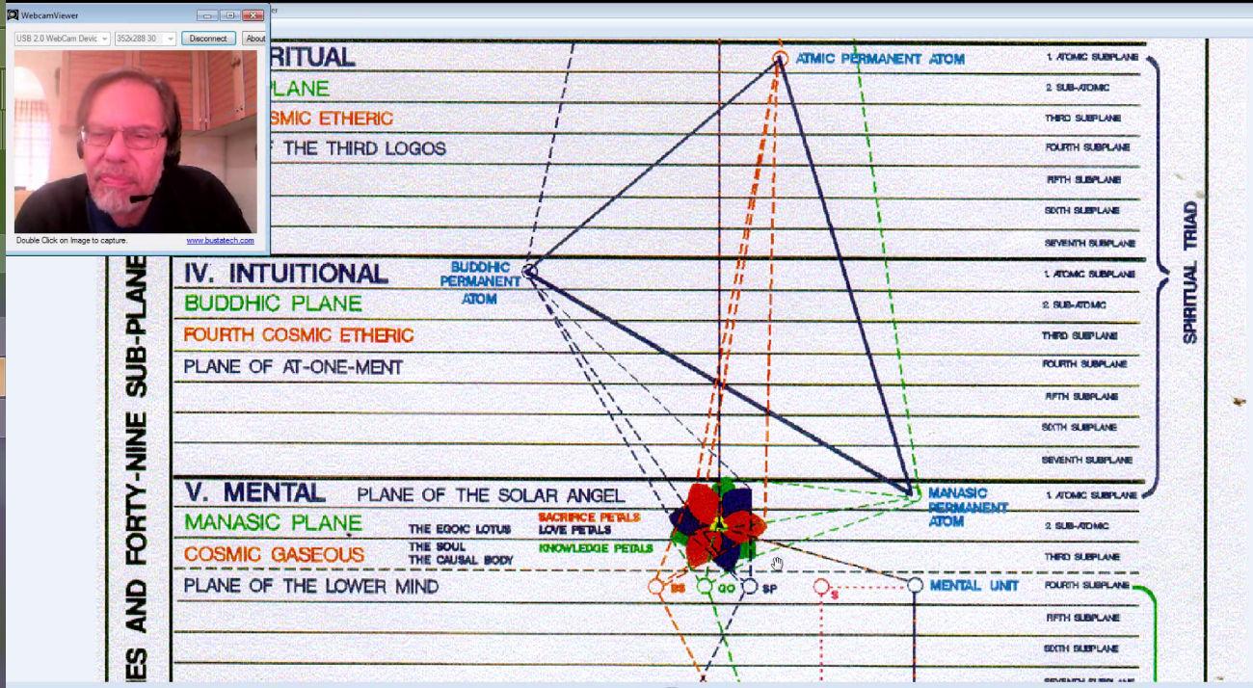

﻿﻿You see into the petals come these triadal energies which are ultimately, of course, Monadic energies. So it's not what we work up from below and which comes in as our own experience into the members of the atomic triangle and is harvested as quality in the Egoic Lotus. This contributes in quite a specific way to the capacity of the Egoic Lotus, but it's not the only thing, it is? There is nourishment from above, from the Solar Angel. There is a Divine content also that is coming in and is making it even more possible for us to use what we have gathered from below. Well finally we seem to be getting there. . . . you will see how each does most definitely mark a point of attainment, and therefore the entire subject of initiation takes on a new beauty and appears more worthy of the pain and struggle of attainment. ﻿It's not just a question of birthdays and rewards, you know. We have to earn our liberation. It's so Saturn leading to Uranus. Uranus is the father planet, the mystery planet and although Saturn is old and venerable, Uranus is older still. Let me give you an indication (no more than that) of what I mean. ﻿

1st Initiation

"Initiation I. Birth. Freedom from the control of the physical body and its appetites." RI 685

Initiation 1 is birth, birth of Christ within the heart. And it's so practical in how he discusses this. Freedom from the control of the physical body and its appetites. ﻿Well we expect much of this to be manifesting as the appetites of the physical body to the 1st petal, and the 2nd petal and even in a kind of mentalized way to the 3rd petal. But particularly that which Lemuria conferred upon man, the sexual instinct, which D.K. tells us became rampant in later Lemuria and led to all kinds of abuses, the results of which we are struggling with today, this is the petal that is going to be mastered completely and its influences mastered by the time we are working in the 7th petal, which interestingly enough, if it's seven, it's connected with Uranus, the Uranian ray and thus with the sacral center. And probably there is some kind of connection here related to the sacral center, which is the home of the mental elemental, because we have a definite knowledge influence here on this 1st petal of Sacrifice, and the use of knowledge in a sacrificial manner. But knowledge has to be earned, doesn't it? So if the sacral center is still doing its thing and is in anyway rampant, the energy which should be rising into the higher centers and nourishing them and expanding them, the energy which should go to the pineal gland in a sense ruled by Taurus, the giver of light, and Taurus, a major sign of sexuality, well that center will not open. That pineal gland will not be stimulated. The etheric area around it will not be stimulated.

So appetite is pretty much ruled by Mars. The whole outer tier of petals is Martian in a certain sense just as the middle tier is Venusian, and the inner tier is Mercurian and if I were to expand that idea, I would say that the outer tier is Martian/Saturnian, the tier of Love is Venusian/Neptunian and the Sacrificial tier is Mercurian/Urananian. And of course Mercury and Uranus are so close and so are Venus and Neptune and so are Mars and Saturn, so very closely related for various different reasons. Mercury is eventually synthesized into Uranus. Venus synthesized into Neptune and Mars is synthesized into Saturn, eventually, at the end of the ballgame.

1:09:30 Well, you know, it is a ballgame. It's a sphere. And it's the game of the relationship of all of these spheres on all these different levels. We all like to play ball in a way, you know, it's the symbol of movement and achievement, but the whole universe is kind of a ballgame as well, a wheel game.

Physical appetite is controlled by Mars and the emphasis is particularly on the complete subduing of the petals and of the centers where the emphasis is upon physical appetite. So we will definitely have the sacral center, and also the solar plexus as it induces the hunger of the physical body or is related to that. It is the center which rules the stomach and other related areas in the digestive system.

2nd Initiation

"Initiation II. Baptism. Freedom from the control of the emotional nature and the selfish sensitivity of the lower self." RI 685-686

﻿﻿Initiation II called the Baptism and it's all about purification. Baptism in the River Jordan. You kind of wonder what it is in the human energy system which represents the River Jordan. We have all these rivers, you know, Eridanus and we have the Alpheus and Pineios. We have two rivers that are found when Hercules is cleansing the Algean stables. You begin to wonder about the flow of the kundalini energy, whether, this sort of serpentine movement can be considered riverlike. Obviously there are flows in the etheric body which are indicated. Freedom from the control of the emotional nature and the selfish sensitivity of the lower self. ﻿The emotional nature, particularly is growing is power in the 2nd petal, the Atlantean petal, so of course that all that comes from there has to be subdued but the selfish sensitivity part can be very much related to petal #4, the Cancerian petal, always considered an emotional sign, and interestingly Leo is the sign of, we are told, sensitivity. And there are definitely selfish phases of the Cancerian and Leonian experience before one begins to say, oh there is something more than me, you know the world doesn't revolve around me and there is a Higher Self and all that is discovered in the 2nd tier of petals, but there is a lot of experience in petal #4 where we are integrating the personality and petal #5 where we are expressing our precious personality where there is a problem with selfish sensitivity. So the 2nd initiation, obviously requires overcoming all of that and even, interestingly enough, it means that even the 6th petal will be completely unfolded. So it's a conquest.

We might say in a certain sense that the 1st initiation is a conquest of the entire Hall of Ignorance and the petals of knowledge and that the 2nd initiation is an entire conquest of the petals of Love for the astral plane and the Hall of Learning. You know we have by the end of that spiritual intelligence and the illumined mind, we are told. There are specific petals where physical instinct or emotional tendency comes in most strongly, but in general the 1st tier of petals is the physical, instinctual appetite group of petals ruled by the earth signs and the 2nd tier of petals are ruled, at least by my way of thinking, by the emotional water signs.

Freedom from the control of the emotional nature. . . ﻿doesn't mean one doesn't have an emotional nature. It doesn't mean one doesn't have sensitivity. One preserves the sensitivity without the selfishness. One preserves the emotional nature without it drowning the individual. The waves that rise upon the stormy seas of life, engulfing the swimmer and shutting out the sun and rendering all plans futile as we have discussed for us in page 485, the 15 councils of Treatise on White Magic.

3rd Initiation

"Initiation III. Transfiguration. Freedom from the ancient authority of the threefold personality, marking a climaxing moment in the history of all initiates." RI 686

1:14:35 Then comes the initiations from another angle. Transfiguration. Freedom from the ancient authority of the threefold personality, marking a climaxing moment in the history of all initiates. ﻿So climaxing because you are on the top of the mountain in a sense. You have reached an important summit and probationary initiates are found before this point but the true initiate is of the 3rd degree. The Masters don't consider one an initiate until one has achieved the 3rd degree and then one has freedom from the ancient authority of that personality and what's so interesting is you see people claim initiate status, 3rd degree status, and it's so obvious that the personality has quite a bit of authority remaining so it has become a wish fulfillment, one visualizes what might be possible, what looms on ahead, and one imagines one has achieved it without taking away the authority of the elemental life with those things put into their proper place. Maybe not completely overcome until the 4th degree, but sufficiently overcome, as D.K. tells us so that the individual is never hindered in his service by things arising from the personality. They may be there, they are acknowledged, they are let be and one gets on with the service.

So this means the opening of the 9th petal, the Sagittarian, Aeritian ?? petal, and one has a great vision. One understands what being is. One is able to set one's sites. I have a friend who calls himself a Sagicorn. ha. He is an ideal Sagicorn. I think he has about the last degree of Sag rising and Jupiter in Capricorn. He's a wonderful fellow, and he exemplifies those traits so beautifully and when I look at petal #9 I just feel it’s a petal where the transition is from Sagittarius into Capricorn, because after all, by the time it is completely unfolded, you're into a pretty full unfoldment of the 1st Synthesis petal, which I think can be attributed to Capricorn in terms of the synthesis of knowledge. It's almost as if Sagittarius is striving forward towards the unfoldment of this petal and when it is achieved, we are into the Capricorn qualities. We have reached the top of the mountain and Sagittarius is always about, so to speak, getting there.

1:17:30 And the light shines forth. A great vision of light under Sagittarius and a great exemplification of mountaintop light under Capricorn. So the ending of the ancient authority of the 3-fold personality, you know, you conquer the 3-headed dog in hell, Cerebus and that is in the Capricorn labour and you conquer the 3 tiers of heads of the hydra who are liable to return in a very threatening manner, all of them, you know you have laid the physical appetites to a rest, reasonably so. You have laid the emotional tendencies to rest, reasonably so and then they all come back, all 9 heads of the hydras and all 3 tiers challenging you at the last minute at the gate of the 3rd initiation, so it is as Master D.K. says a fearful conflict because one has to relinquish all that is familiar, detach oneself from all that one has thought to have been and embark, Sagittarius in a way, on an entirely new phase of unfoldment and in a way enter what is unfamiliar or has for a long time been unfamiliar.

. . . marking a climaxing moment in the history of all initiates. ﻿So the great light shines forth, the supernal light or at least a modification or an attenuation of supernal light shines forth from the mountain top and one goes beyond figure and form. One is transfigured. One goes into the world of real form, rather than of the dense form which is simply an effect of the cosmic etheric archetypes around which the matter of the previous solar system is gathered.

And so you know when you are looking in the Egoic Lotus, all the 9 petals are unfolded here, and the 1st Synthesis really is majorly unfolded. The 3rd Synthesis petal has opened. It's the petal connected with spirit and there is going to be so much work done in that Capricorn/Aquarius/Pisces area of the Synthesis petals following the 3rd initiation, but maybe they won't burst open until just before the 4th initiation. To which we come.

4th Initiation

"Initiation IV. Renunciation. Freedom from all self-interest, and the renouncing of the personal life in the interest of a larger whole. Even soul-consciousness ceases to be of importance and a more universal awareness, and one closer to the divine Mind, takes its place." RI 686

Initiation IV. Renunciation. ﻿Crucifixion, renunciation. Depends on the perspective. More crucifixion in the West, renunciation in the East. It's just marvelous. Freedom from all self-interest,. . . ﻿that is we don't look at life as a personality anymore and how to enhance the well-being of the personality and its satisfactions. It is simply an instrument that's it . . . and the renouncing of the personal life in the interest of a larger whole. ﻿And we do begin to see that the 3rd degree initiate, while 75% hasn't really fully done that yet. Let's just say the renunciation of the ancient authority of the 3-fold self is achieved. In other words, he cannot be swayed from his service by the antics of the 3-fold personality, but the all personal interest, and so forth is only achieved at initiation #4. Even soul-consciousness ceases to be of importance and a more universal awareness, and one closer to the divine Mind, takes its place. ﻿Well, you kind of wonder if the divine Mind is not found on the 3rd/atmic level. I mean it's certainly found on the cosmic planes as well, but #3 is so connected with mind and it's connection on the cosmic physical plane is the atmic plane, which is not only a plane of will but a plane of mind. Just like the monadic plane is a plane of love and the logoic plane is a plane of will.

So when he says,. . . ceases to be of importance and a more universal awareness, and one closer to the divine Mind,. . . you begin to think of the buddhic plane - takes its place and that's the area into which the renunciation liberates the person, onto the buddhic plane and he is now free from containment in the dense physical vehicle of the Solar Logos. So that's quite a test, isn't it? Because self-interest can be so very, very subtle and can masquerade and you can have all these motives, just the way the rich young man had, he had so many wonderful motives, so many gifts he wanted to - but you know in his intention to give what he had, there was still a subtle form of self-love. He wanted to keep his treasury, not trusting that the treasury would be augmented many-fold if he would only relinquish it, mainly sell all you have, which means basically to use it for no self-interest whatsoever, and to allow it to begin to dematerialize into some more cosmic etheric form and sell all you have and give the money to the poor. Basically, to empty the bowl completely and without any reservation. To take every possible gift you have and without the slightest eye upon the personal self, to offer it in the interest of the divine Plan.

1:23:34 I had another explanation of that a few programs ago and I think it was a little better. I don't know where it is but maybe you'll find it along your way. Sell all you have and give the money to the poor and then follow me right into the spiritual triad. Now of course in selling all that he has, he will still retain it, but it won't be recognizable in the form that he had those qualities before. He will have the essence of the qualities, always be able to use those things, but he will not be connected with the specifics of those qualities and how he attained and the experiences that led to them and his whole personal/transpersonal history, all that will be gone.

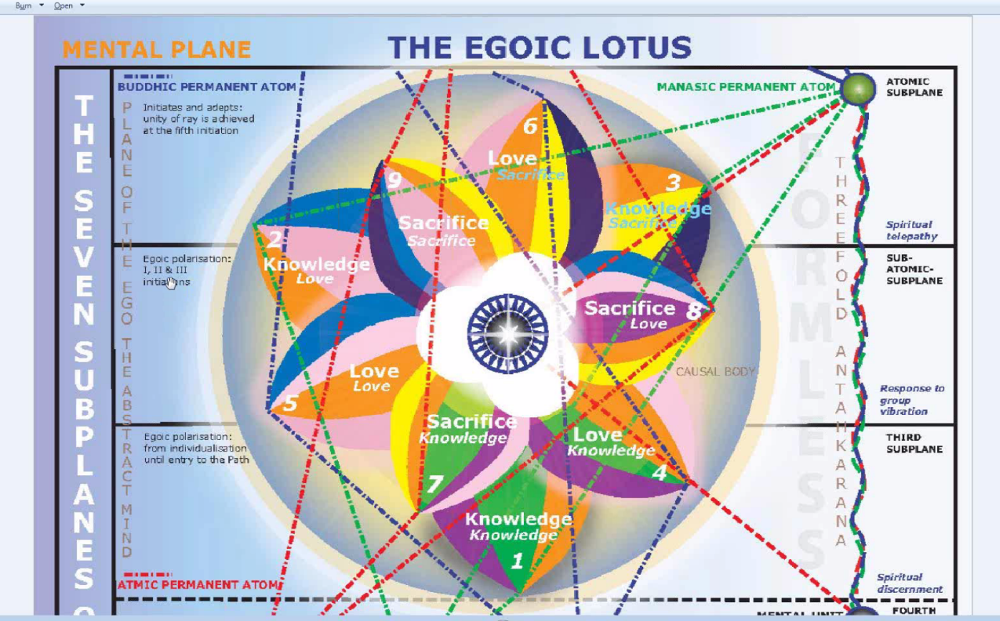

So you know that renunciation; it’s the kind of lotus we are looking at right here. It's a full blow lotus. It is the ideal for all of us to reach this full unfoldment. The center is white but D.K. says these petals are of a beautiful lemon hue, and probably they have color too of some kind, striations and all of that, since they are so synthetic. Just the way the personality elemental synthesizes the lower three elementals and is the number four and maybe Cancer synthesizes the first three signs, we can say that in these petals of Synthesis this color yellow synthesizes all the foregoing colors and somehow contains them. It is the harmonious harvest of all of them. And it shows the relationship of the Synthesis petals to the buddhic plane, particularly D.K. tells us it was a down flow of energy from the buddhic plane which originally produced them.

As far as what is here in the middle on this Egoic Lotus you know the idea of 24 and 8, well are these absolutely accurate? I cannot say, but they certainly are very evocative of thought. Twenty-four, the number of Shamballa, eight the number of Sirius, and there we have the two crosses: the cardinal cross and the St. Andrew cross, superimposed which has a lot to do with how the higher energy of the will is operating within the head.

1:26:12 Okay, let's see where we are friends. We are just about there, it's good. I would love to go to Initiation #5 and all that and we can say the consuming of the debris of the causal body to a certain extent, and the clarification of anything that is not yet clarified so there can be a great divine revelation here. But you know lead me not into temptation. I am going to try and avoid that temptation. It's really hard to avoid but okay. No, the more I contemplate it, the more I don't want to avoid it. I will come back to this. And in doing so and fortunately it's fairly early in the split of the book Rays and the Initiations at page 340, and if we go to page 300 and we find that we are still at the 14th rule so if we were to go on here, here we go, esoteric catechism, yes it could begin there, right around page 300, so page 340 would be fairly early in the book so in my plans I probably will get there and I would like to fulfill my plans, you know. There is an old German saying, Man plans and God laughs. But let's see how it goes. Alright there is so much to discuss there.

We will say that this now the end of Egoic Lotus Webinar Commentary Program 18 and basically we have look at RI page 340 and 685-686, and that should be sufficient. We are preparing the way for going petal by petal for the true synthesis of the understanding of the Egoic Lotus. You know when I look at Master D.K.'s work I find his knowledge is scattered throughout the books, making us work. We have to earn our synthesis. He basically says earn the synthesis of knowledge. Earn your 10th petal or even your 7th, your first Sacrifice petal. You have to earn it. You have to make your way laboriously through. You have to fix your sight in a Saturnian manner on every piece of knowledge. Then you have to focus the magnifying glass of 5th ray Venus upon it, so as to be utterly clear about what it is. Then you have to use Mercury to connect all of those clarified nuggets of knowledge. And then you have to Jupiterize the whole intersecting network of related knowledge until it stands forth as an articulated whole. Then sacrifice it all under Neptune, you know and dematerialize it all, etherialize it all so it is essential wisdom and can be drawn up at any time and translated into any concrete form of knowledge upon demand.

Alright that will be it for the moment. And we will see you for Program 19.

