EGOIC LOTUS WEBINAR COMMENTARY #17 – Michael Robbins

Abstract

Egoic Lotus Webinar Commentaries 17: Three Phases of Man’s Development in Relation to the Tiers and Petals of the Egoic Lotus. This webinar is about 2 hours long and covers Esoteric Astrology page 333. In this program we study an important tabulation which shows the manner in which the signs of the zodiac are expressed by man in three stages of development – the Undeveloped Man; Advanced Man; Disciple/Initiate. In this program we link the modes of expression with the development of tiers of petals and of individual petals. Program 17 focuses upon Libra through Pisces.

Contents

Abstract 1
Contents 1
Transcription of Egoic Lotus Commentary #17 1
Libra 3
Scorpio 6
Sagittarius 9
Capricorn 12
Aquarius 15
Pisces 20
Review 23

Transcription of Egoic Lotus Commentary #17

Hello everybody. We are continuing with our webinar book on the Egoic Lotus. We have worked with a very important tabulation on page 332-333 of Esoteric Astrology in which we have been looking at the way the difference signs express themselves for the undeveloped man, the advanced man, whatever that actually means, and for the disciple/initiate. And we have looked at the way that these different modes of expression would correlate with the work in, i.e., the organization of and the opening and unfolding of the various petals of the Egoic Lotus. So we have gone through Virgo now in our work and we are beginning now with program #17 and we are working on page 333. It divides conveniently right there at Virgo, I do believe.

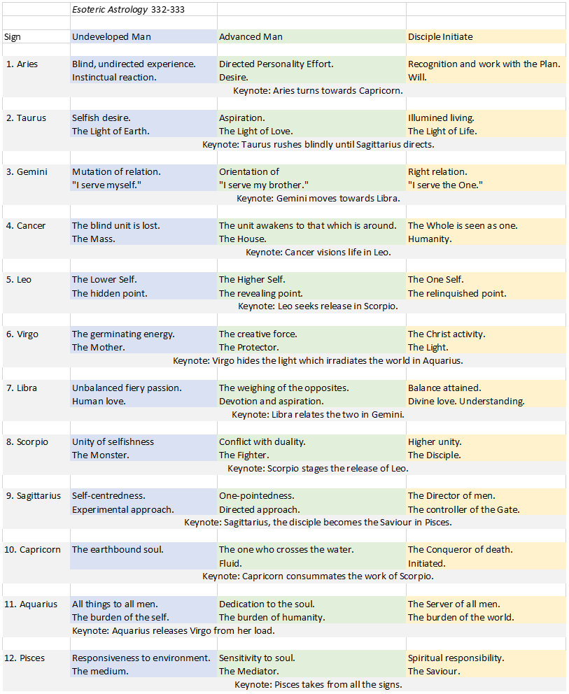

Libra

With Libra, notice the color is indigo, so we do have indigo coming up in the Egoic Lotus, usually in the 3rd, 6th and 9th petals. Let's see how it looks.

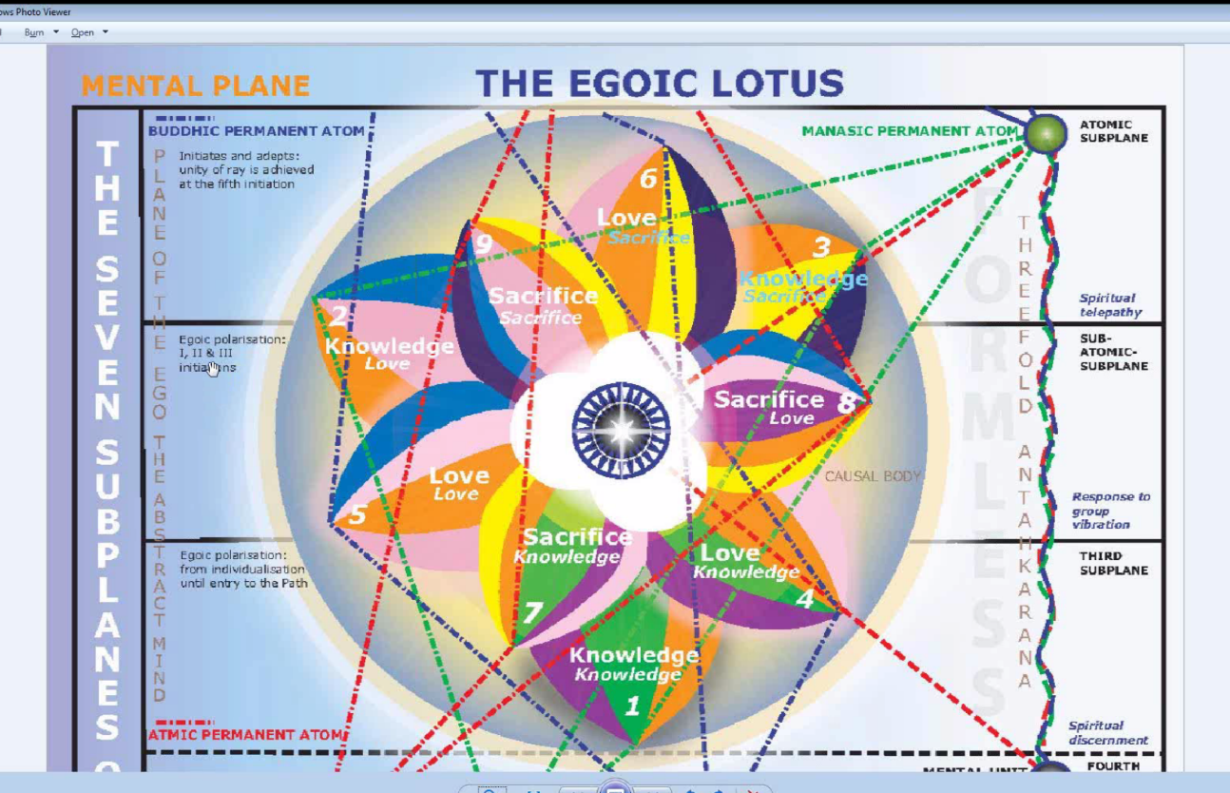

Yes, indigo comes up in - 3, 6, 9, so Libra is probably involved with some kind of fusion. The Tibetan had a meditation for some of his members of the glamour group and he assigned them some different colors based upon their birthdays, and upon the decanate of their birthdays and these are the colors that he used. It has been mentioned that these are some of the same colors that the Golden Dawn might have used. However that may be, they are the colors the Tibetan did assign. So, he thought them usable and I find the color indigo for Libra emphasizing its 2nd ray nature, which is hinted at in some of the discussion on the cosmic paths and also right in this very document before us where it talks about divine love and understanding. Those are clearly 2nd ray characteristics and not characteristics of the 3rd ray, which we do know works through Libra.

03:25 7. Libra. (Undeveloped Man) So interestingly enough here, we have unbalanced fiery passion for the undeveloped man. And that is certainly going to fit with the 1st and 2nd petal. If it is instinctual passion, then certainly with the 1st petal even more so. So it's the sex instinct that looks like out of control and D.K. did talk about the difficulties that had occurred with the rampant sex instinct towards the end of Lemuria and how that had led to a reaction in Atlantean times, that reaction being a suppressive one and because suppressive, became one of the causes of cancer. But in any case, it is human love. If he mentions the word love, we are going to think of the 2nd petal particularly because the love instinct, well the love response in form rises above instinctuality, D.K. tells us. Things are out of control. Things are not balanced here. Obviously there is a lot of Mars, Mars and Libra issue, and the human love.
Now how far can we say that this goes? Well petal #1, petal #2. By the time we reach petal #3, Libra is involved but the balancing power of the mind will be found I think. It is a cardinal sign and it's found as the inaugurating sign of the Sacrifice petals. If we begin with Aries, by the time we reach the 7th petal we have Libra. So that is one of the ways of assigning signs to petals simply by beginning at the very first one. Of course we can also move backwards through the signs as men would tend to do in those early periods. We can begin with Aries and move to Pisces, go to Aquarius and so forth. We will have some interesting results in doing that which we will discuss when we look at the petals.

We can also begin with Pisces as the 1st petal and D.K. seems to do that as well. There are different ways of counting. So at least in this human love, unbalanced fiery passion, certainly human love is going to continue really throughout the petals, maybe weakening some, so the soul love becomes stronger than the strictly human love when in the Sacrifice petals, but all the way through the petals of Love I think human love is with us. But in terms of unbalanced fiery passion, we are in the Hall of Ignorance and I think the continuation of Libra in the other petals is more balanced because there is some balancing effect of the mind in the 3rd petal. By the time we get to the higher petals, where Libra rules, we are dealing with something else altogether.

7. Libra (Advanced Man). When we look at the advanced man we are weighing of the opposites. Devotion and aspiration. For so long I used to think that the pairs of opposites had to be on the horizontal level but then a number of references including the kind of light which Libra is associated with, it's a vertical movement in that light. And so the vertical pairs of opposites are what I think are meant here, and one is weighing the direction of the personality with the direction of the soul and I do believe this is happening in the petals of Love. In a Treatise on Cosmic Fire, we will have the petal of Knowledge for the astral plane unfoldment is brought about by the conscious balancing of the pairs of opposites and the gradual utilization of the Law of Attraction and Repulsion.

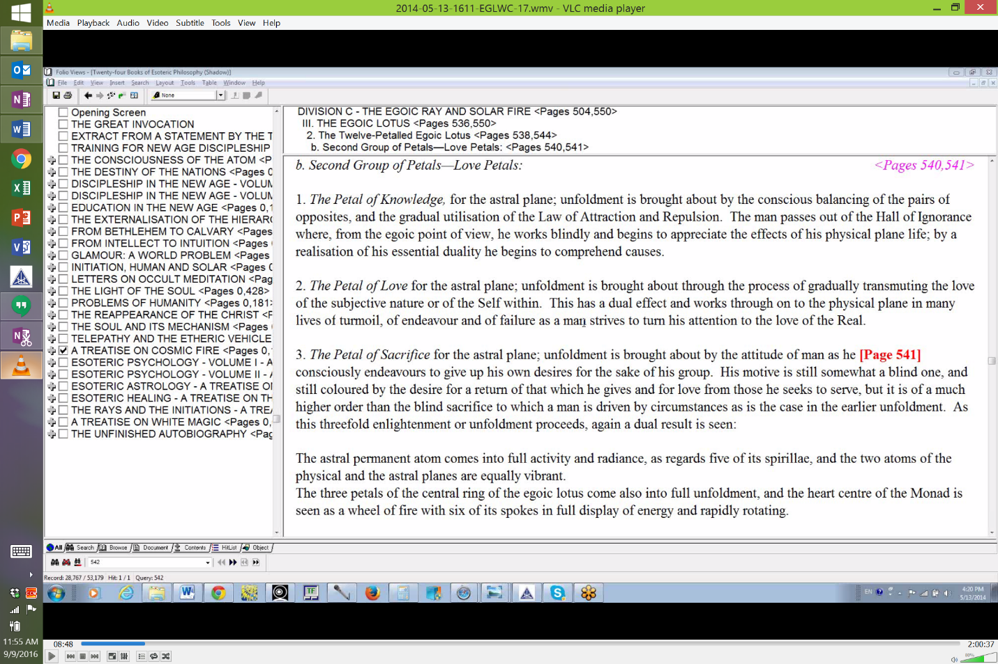

So we are preparing for the Law of Repulse here, maybe not really experiencing it until we get into the 5th petal, which is also a Scorpionic petal. The man passes out of the Hall of Ignorance into the 4th petal, yes where from the Egoic point of view he works blindly. You see the ignorance is the ego. He does not know that the higher Ego exists, and begins to appreciate the effects of his physical plane life. In other words, what are the causes, really, of what is happening, so he is able more to evaluate. So we see this weighing of the pairs of opposites, that is the reference I was looking for. And we find that happening in the 4th petal, very much. As well this will be going on in the 5th petal where the scales are finally tipped in the direction of aspiration and devotion towards the Higher Self. So the middlemost petal, although when you start with Aries, the middlemost petal does not come out as Libra, still Libra is associated as the central or pivot point.

09:52 Those two petals particularly I think are involved in this question of advanced man. Now you know there are ways to associate the signs and planets with every petal and it's a good mental exercise to do that and also just to see how people who are doing the work of particular petals and yet born in a particular sign, particular planets, can apply those signs and planets precisely to the work that they are supposed to be doing in terms of their unfoldment.

7. Libra (Disciple, Initiate). Now we move further and we see that balance is attained. Well when precisely does this really occur? It's from one point of view it is the balance between the pairs of opposites. But that balance between the pairs of opposites is a temporary stage and it's not the ultimately desirable stage because the balance has to be tipped in favor of the soul, of the higher of the pairs of opposites. So this balance attained can well be, at a certain point in the 5th petal before the lower ego gets sick of itself. That might be the one we are talking about - the balance between the soul and personality. Of course maybe we can talk about a kind of fusion between the soul and personality occurring at the time of significant soul infusion at the 9th petal. Usually that's the point where we consider the individual to be the soul-infused personality although there is still a bit more to go as we move towards the 4th initiation.

When it comes to Divine love and understanding, they do not fit with the 1st balance attained. The 1st balance attained is the balance between the demands of the Higher Self and the demands of the lower self. One is not completely filled with Divine love and understanding, otherwise one would have definitely chosen the Higher Self rather than to try to maintain a kind of compromise between the Higher Self and the personality.

So this Divine love is growing with initiations. The Libra petal signifies the taking of the 1st initiation, at least work within it, organization within it, (petal #7) signifies the taking of the 1st initiation, when the 5th petal completely unfolds and no doubt the 6th petal is affected by that as well. So we have to do that organizational stimulating work within the petal and then the rod of initiation is applied and I'm sure that that contributes to some degree of opening of that 7th petal.

So this then will be very important, this 7th petal, in terms of Divine love and understanding - it's the movement towards that, but that movement really continues and it continues all the way into the Synthesis petals, because when you think about the Synthesis petals, they are derived from buddhi and buddhi is the source of Divine love on the cosmic physical plane. It is one of the sources anyway, along with the monadic plane and Libra, being an air sign, will be powerful in this - it will probably be the sign connected with – well you know that is the question, which should be which? Whether the 1st petal should be Libra and 2nd Gemini or 1st Gemini and the 2nd Libra? I tend to prefer Libra as the 2nd petal associated with Divine love in a higher sense.

14:15 So Libra will achieve a kind of loving balance or marriage between the Higher Ego and the personality at the 9th petal, which correlates with the 3rd initiation and then it will continue bringing about increasing balance with triadal energy and soul energy. Libra after all rules the spiritual triad and has a lot to do with the incoming of Divine will. So Libra will be active obviously beyond the point when the Egoic Lotus is incinerated - the 1st ray smashes it, the 2nd ray over-includes, the 3rd ray accumulates, the 4th ray harmonizes it out of existence, the 5th ray perforates it out of existence, the 6th ray immolates it, that the fiery death, and the 7th ray uses the magical words to dissipate it. But in a sense it's going to be a fiery consummation one way or another and finally.

So that looks like Libra will be important in instituting the Divine love which is coming in at the 1st degree in which a lot of work is done in Libra, that's the 7th petal, and of course Libra is very much connected with the 1st degree from other points of view. Buddhi may be entering the Egoic Lotus in a strong measure and buddhi may be applied in love through the personality, but also Libra is ruled by Uranus and therefore we have the transfer of the energy of the sacral center towards the throat, where Libra has much to do because it is ruled by the 3rd ray also and the 3rd ray finds one of its places of expression at the throat center.

So let's just say that as the Egoic Lotus really unfolds, the power of Libra to blend and merge the soul with the personality increases and Libra has this high function of drawing the Geminian twins, soul and personality, together into a fusion. Libra relates the two in Gemini. So we can see its place at the 3rd degree when there is a real marriage in the heavens.

Scorpio

Now, Scorpio. I've tried to make its color that kind of crimson color, a darker red. Sometimes blood is scarlet red. Sometimes it takes on the darker appearance maybe it depends on whether it is arterial or venous blood. Anyway, Scorpio with Mars is associated with blood.

8. Scorpio (Undeveloped Man). Well there is some pretty dramatic things said here regarding the undeveloped man. Unity of selfishness, the Monster. Well the man has pretty well, we can see, become his dweller. But in a way he doesn't become his dweller until much farther in the developmental process, even in the 8th petal associated with Scorpio. But let's just say that the man knows no difference in the period of ignorance, working in the Hall of Ignorance. So, instinctually he is selfish from the very beginning and he is grasping for himself alone. He knows no better. So this unity of selfishness at least can be related to how the man works within petal #1. Some degree of love of others begins to come into petal #2 and some mentality, petal #3, so maybe there is not such a complete unity of physical instinctual selfishness as would be found in petal #1. But when you call someone the Monster, well that is an aberration of nature; that is a distortion of what nature intended. We are not talking about the natural man. So by the time we become the Monster, I would say we have to be in petal #5 where the man is deciding upon a life of dedicated egoism and we might almost say that petal #7 is involved because it's a Libran petal where decision is made, and the kinds of decisions made in the 7th petal promote the opening of the 5th petal in the right way. But if a man refuses to, so to speak, kill the lower ego, and if he remains unified in his selfish intent, it signifies that the wrong kind of decision is being made up there in the Sacrifice petals, that there is a refusal to sacrifice and the man is in the process of becoming his own dweller.
So the Monsters among human beings are often very intelligent and they are egotistical. I am thinking of - well there are all kinds of people we could talk about - think about the Marquis de Sade and he had this great intelligence but he was extremely cruel in its application and extremely sociopathic. He enjoyed the pain of others and that is one of the things that can be attributed to Scorpio when the lower ego hardens and a person feels no commonality or sympathy with others. And I suppose that if you think about it, people are working in the 8th petal, they take the 2nd initiation and yet they veer off towards the left-hand path and I suppose there too, that Scorpionic petal can be the scene of some activities that would give the man the title: The Monster.
20:42 If we are talking about some kind of brainless Godzilla, I don't think we're talking about that here. A Monster is a definite perversion of nature and generally in the earlier petals you don't find that. When a man is becoming an individual, and twisted and distorted, that is when you find those kinds of perversions. So we can see then that even what is said about the undeveloped man will extend somewhat into activity in the 2nd tier of petals because the man has intelligence but he is simply focused in the lower chakras. D.K. talked about the tremendous power that such an individual could have if he was working through the ajna center and yet focused as well through the sacral center, basically using his higher powers not in a selfless way but enlisting also the lower powers and directing those lower powers in others - manipulating those lower powers in others.
8. Scorpio (Advanced Man). Well then we come to something higher in nature. We come to the Fighter. Again, you know there is none of this crimson red in the Egoic Lotus, but we can find places here where it will express. Conflict with duality. Well the real conflict with duality requires the recognition of duality and that is recognized within the 2nd tier of petals. It's particularly the 5th petal here where I think there is a real conflict with duality, where the man begins to sense the Higher Self in quite a brilliant way and yet he is very strong as a personality. So here he has to become the Fighter on behalf of the soul. This is interesting because it will involve the 6th petal as well.
It's the 2nd initiation where Scorpio is particularly applied. It is applied at all the initiations: 1st, 2nd and 3rd, but it has the reputation of being most associated with the 2nd initiation, particularly in the fight with the emotional nature. So we read about the many lives of conflict which are associated with the 5th petal and we realize also that Cancer, Scorpio and Pisces as 3 water signs can be quite conveniently assigned to the astral body and to the Love petals which are associated with that astral body. So once in the 5th petal, I'm not sure how much fighting goes on in the Cancerian petal, it's more kind of coming to terms with the pairs of opposites and realizing that indeed they do exist and maybe trying to do some building in the light of those pairs of opposites. But by the time we are at the 5th petal, we are either fighting against the soul or fighting for the soul depending upon the period of development we are talking about.

24:25 So duality is vividly realized and we have to fight there interestingly enough, Leo being a materialistic sign, we have to fight with duality concerning the physical body: sex, money and comfort. Those are the battles that are fought out in this Leo/Scorpio petal and hopefully one is fighting on the side of the soul. When we get into the 6th petal, and we have taken the 1st initiation, then the fight is with the emotional nature. So there is a lot of this conflict going on within the 8th petal and 6th petal simultaneously. If the choices are done correctly and the masterfulness is demonstrated in the 8th petal, then the 6th petal will unfold properly and one will have the 2nd degree initiate. The duality is vivid and one finds one must fight. One is still in the Martian phase here. One can understand how strong Mars will be with this Monster. I am remembering they didn't look so good in War of the Worlds, you know. They were kind of green which related them to the 3rd aspect and definitely from Mars and definitely deadly with respect to the human family.
When it comes to Mars as the fighter, it is being used in a more noble cause on behalf of the soul. So the soul is the warrior and one is identifying more with the soul in this conflict. Now also there has to be a battle on the mental plane as well. And this battle on the mental plane refers more to petal #8 and it's all part of the process, I assume, of achieving the 2nd initiation because when there is sufficient mentality, one can understand what the emotions are doing. One can understand the traps in which fear, hatred and ambition lead into. So this is the overcoming of fear, hated and ambition at the 2nd degree with the application of the mind, and the mind is active in two ways we are told, in Scorpio. In one way it overcomes emotions. Just look in the Scorpio chapter of Esoteric Astrology and you will find the dual uses of the mind, but also the mind is the illuminator and the illuminator is helping to overcome illusion. That is battle on the mental plane.
So a lot of work is going on this 8th petal. Eighth petal work refers to the 2nd initiation but continued work in the 8th petal after the rod of initiation has been directed or applied will contribute to the overcoming of illusion and thus it is in the 9th petal as well. Well the disciple is still in the 8th petal and of course Scorpio is paramount as a sign of the disciple, but the initiate is consummating the opening of the 9th petal and it is a Sagittarian petal and interestingly enough, illusion is overcoming there. When you combine Gemini, which in its lower aspect with Mercury, is the producer of all kinds of lying and illusion. Sagittarius is the intuitive sign of truth and it is this intuition which is going to help dispel illusion in the 9th petal. But there is still work going on in the 8th petal to overcome pride, separativeness and cruelty. These things have to be overcome when the mind is being mastered at the 4th degree.
28:37 So we can see that even after the application of the rod of initiation the 8th petal will not be completely open. It will require further work whilst there is work going on in the 9th petal to get that larger intuitive point of view which overcomes illusion. You have to remember that Sagittarius rules the higher mind, but it also rules the intuition which begins to infuse the higher mind. There is quite a difference between the formulations of the higher mind which might be correct or incorrect and the intuition which is always correct. So when intuition infuses the formulations of higher mind, then we are going to be really going to be overcoming illusion.
Now that's only one phase of illusion. D.K. says it's only at the 9th initiation, the number of completion, that we actually do overcome illusion and in that respect we divorce ourselves from the cosmic physical plane which from a certain perspective must be considered a plane of illusion from a cosmic perspective. And with the brothers of the shadow, you know, the black lodge in the cosmic sense hanging out on the cosmic astral plane, there must also be some delusion to conquer on the cosmic astral plane but those things are way beyond our consideration and we will leave them to such great beings as the Christ and the Buddha who probably have quite a bit of interplay with the cosmic astral plane and maybe can even go there so to speak. Maybe the initiate of the 7th degree can go to the cosmic astral plane. D.K. says that he doesn't know what's there, because he hasn't been there. But then, when he was writing he was an initiate of the 5th degree and the Christ is an initiate of the 7th degree or pretty much complete in that and so is the Buddha.

It correlates with the logoic plane but there is the inference that the connection with the cosmic astral plane is also possible, especially because the 8th Creative Hierarchy which says veiling the Christ and which has a lot of Neptunian energy and Christ is Neptune has not yet made its way onto the cosmic astral plane.

8. Scorpio (Disciple, Initiate). 31:12 Higher unity. The Disciple. Unity is appreciated. Isolated unity is understood in a preliminary sense and that is with the taking of the 3rd initiation with the unfoldment of the 9th petal. There is a lot of work still being done in the 7th, 8th and 9th petal as the 3rd initiation is being taken. Sacrifice in terms of knowledge, in terms of love and finally in terms of will. So that when the 9th petal unfolds, all of the final tier unfold together. I say final of the 9, not counting the Synthesis tier.
And what is said then of it? Scorpio stages the release of Leo. Well we have talked about that. The king is sick. The king is dead. You know the lower ego in the 5th petal is perishing and one realizes that who he thought he had been is insufficient to contain his real identity which is the Higher Self. But if we go further, towards the 4th initiation, we can judge that Scorpio is helping to destroy the causal body which in itself is the Leonian sunflower. When the causal body is destroyed, the major blow against ahamkara is achieved. Ahamkara is that limiting sense of I-ness.
Well you know all the way through, from the time of individualization, we begin to have the sense of I-ness. We may not really grasp it in any sort of tangible sense until 3 million years later, but as we can continue the sense of I-ness grows and grows and by the time the causal body is destroyed, the limiting sense of I-ness, of being some sort of encapsulated eggo or ego has to go. But then you kind of wonder about all the greater beings and they do have ring-pass-nots and a certain sense of what they are and do they have any kind of ahamkara on a cosmic level that also has to go?
So lots of fighting going on at the 5th petal. Lots of fighting even going on at the 6th petal, in relation to the 8th petal which is ruled by Scorpio but by the time we really are moving toward the 3rd initiation, well, do I want to say the fighting should be eliminated? A certain kind of fighting between what is the soul and what is the personality in the lower sense, yes. Those things can be eliminated, but there is a kind of final battle that occurs in the 3rd petal and it involves Mars and Vulcan. So the higher unity is eventually achieved but not without that fight between the soul, Solar Angel, Higher Ego, and the dweller on the threshold as a completed unit. If we are completing something at 9, then the dweller too is completed at the 9th petal and there is going to be a battle in order to achieve the higher unity. This is a battle that the high disciple has to engage in before he really becomes the initiate.
What I have discovered, you know, having a lot of 3rd ray, I like to turn things every which way and look at things from every possible angle, not every possible angle but as many angles as I can think of and when I do, more comes to light. I used to wonder about Sagittarius and the 9th petal and of course that sign does belong there, and more has come to light as I have been doing it this way about why that is appropriate. Of course, also Aries is appropriate at the 9th petal as well, as I have explained earlier in terms of the 3rd initiation being entree into the world of Being with which Aries is identified. In terms of overcoming illusion, both Aries and Sagittarius are involved. The jungles of illusions dissolve in flames and the path stands free. The path to what? Well you know, Aries is the beginning of everything. It can even be the path outward bound towards other planets and constellations when the initiation of decision is made. You almost have to look at two things. If Libra rules the initiation of decision, then maybe it's opposite, Aries, has something to do with it as well. And so does Sagittarius, being the sign of great journeys. Well, that was a little fugue off to the side.

Sagittarius

8. Sagittarius (Undeveloped Man). 36:18 With Sagittarius, self-centeredness. The eyes are fixed upon oneself as the center. One’s self is the target of one's perceptions. And one tries all different kinds of things. The experimental approach or some would even call it the reckless Sagittarian approach. What I think we have here in the Hall of Ignorance, is man the hunter, trying all different ways to find the satisfaction of his desire. This would be particularly active in the 1st petal and in the 2nd petal, some kind of vision may appear and one is hunting after the 1st expressions of beauty perhaps. And the mind is being focused in the 3rd petal. But the old saying about Sagittarius you know willing to be try anything, at least once, you know. So there is a lot of errors, mistaken paths, connected with Sagittarius as you try one approach and then another, but finally one hits upon the approach that works and that of course involves the 6th ray. We try different ways and we kind of become devoted to those ways only to find out that they are disappointing. We try other ways and eventually we find something we can really be dedicated and devoted and it actually works.
The self-centeredness quality is interesting. Sagittarius brings in the 4th ray with its reputation for self-centeredness and also the 5th ray, helping to stabilize the mind in the 3rd petal, and the 6th ray which is involved at the 2nd petal and I think it's very strongly orienting towards something higher even though it be a fairly formal type of otherness: spirits, God, whatever - believe in something even though that something is hardly abstract in these early stages.
The color for Sagittarius is blue. It's rich blue, it's called. I don't know about the color here but we do have a kind of a rich blue or blue at least in the 2nd petal where the process of probably belief in something other is rising. Although we could even say that in the 1st petal since it's fairly, quite Lemurian and the man still has maybe a better connection with his inner God than he did when he lost it later in Atlantean times, there can be belief in the Solar Angel, belief in that feeling of the inner God, and animism comes in here as well. So the religious sense, even in the most material ways has been with man almost from the beginning. As a matter of fact, maybe before he finds himself, which is going to be sometime here in the 1st petal because it only takes 3 million years, only 3 million, before the individualized man comes to himself. Before he finds himself, he may be oriented towards immaterial otherness, he still has a certain sense of immateriality.

39:57 We have to remember how much Sagittarius is connected with the very 1st petal because it was the arrows that shot forth from the bow that individualized man. It was the Solar Angels going into extension and pervading man, arrow-like, with a certain fragment of themselves and yet they still remain greater and higher on their own plane. Is that plane the buddhic plane? Some say it is. Others might take these beings even higher than the buddhic level. D.K. says we will never, at our present stage of knowledge, solve the mystery of the Solar Angel. It's just too complicated and too veiled. But I think we can see the hunter at work here. Primitive man. I was looking at some of the pictures of the Veddas of Ceylon in the early days, maybe these pictures were taken 100 years ago, I don't know, and they were with their bows and arrows and in very primitive conditions and they were passing through the hunting phase where lots of experimentation is needed, otherwise, one doesn't live, one will not capture one's prey. One will not achieve the object of one's desire. So it's in the attempt to achieve the object of one's desire that all of this experiment has to be employed.

8. Sagittarius (Advanced Man). The errancy of Sagittarius, the recklessness, the shooting arrows in all directions, many of them simply an error and useless, that errancy ceases with advanced man who becomes one-pointed. Now he knows where he is going and he directs himself forward as an integrated personality. Here is that kind of connection again, I think, between Cancer and Sagittarius which I talked about earlier. They both have the Jupiter connection. There is different ways of looking at them. When Jupiter is exalted in the sign, as it is in Cancer, and when it rules the sign, as it does in Sagittarius, you can use those exaltations to link the signs. They are linked in the 4th petal with let us say Sagittarius as well, bringing in the 4th ray as it does and Cancer of course bringing in the 4th ray by the Moon, and it being the 4th sign, so having a residence with 4, they are linked there. And we begin to pull ourselves together there as an integrated personality.
42:50 The integrated personality elemental or at least, yeah, integration, the integrated personality elemental has everything to do with the sign Cancer. It's all under one roof. Pull it together, the many conflicting forces, pull them all together under one roof and make them one, even on a lesser stage, the whole is seen as one and Sagittarius that alignment, straight through mind, emotions and body, with the 4th elemental which integrates them all. So when D.K. talks about Sagittarius in Esoteric Astrology, he says a lot about the integrated personality. So I think we are going to find this one point in this beginning in petal #4 and a more directed approach and as the man gets ever more intelligent, and creative and expressive, it will be very powerful.
Sagittarius is linked with Leo as a fire sign and will be operative that way. And then let's not forget what can happen in petal #6. In petal #5, the Sagittarian color is there and the colors of the 6th ray are there: blue from the 6th ray angle and also rose from the 6th ray angle. But by the time you get to the 6th petal, we are potentially becoming the probationary disciple: learning how to be the one-pointed disciple. We may not be that entirely yet until we manage to take the 1st initiation, but we certainly are straightening out our objectives and a lot of fanaticism, I judge, can be found in relation to the 6th petal where you are seeking to purify the physical vehicle, the emotional vehicle, purify the mind and direct it all forward. So the directed approach applies here and it is the approach of the personality aiming to reach the soul, aiming to become in closer contact with the soul, even to become the soul eventually.
8. Sagittarius (Disciple, Initiate). Then finally we have a high kind of development here. A man with great vision having tried so many ways he knows what works. The director of men. We could almost say directing them towards initiation and the controller of the gate of initiation. It's as if you have to fulfill certain requirements, fulfill a certain vision, integrate yourself in a certain way and then you can be allowed to pass through the portal of initiation and in this case the portal of initiation I think is very much the third.
Now, there is a place in the books where Sagittarius is connected specifically with the 1st initiation and the 2nd initiation, and all of the kind of one-pointed aspiration that is needed for those two initiations. So, that definitely works in connection Sacrifice petal #7 and then #8, both of those petals can be the home to that kind of Sagittarian, one-pointed activity. The man is definitely at that point the one-pointed disciple. He has taken the 1st degree. And once he has taken the 1st degree, he is definitely the one-pointed disciple. But to become really the director of men, you know, you have to have great wisdom. You have to have that which the whole life experiences has given you. A degree of completeness you have to have. And you have to have the intuition working as well, so the 9th petal, to me, which is the Sagittarian petal allows the individual to become the director of men and perhaps he is assigned some task in saying when men may pass, pass the 2nd degree and pass the 2nd degree to the 3rd degree. The rites of passage are found here with Sagittarius when you can move on and so even in terms of the rites of passage it works at an early and primitive degree, then socially later in the 2nd tier, and then in the 3rd tier in terms of the rules of initiation. Rites of passage, the man passes through them, but the laws concerning them come from the Hierarchy.

47:27 Does Sagittarius shoot its arrow into the petals of Synthesis? Yes because there the intuition is required and also the antahkarana meanwhile is being built which is the way into the spiritual triad and when we reach that stage of projection, you know it's kind of like spiritual artillery here, we are shooting the arrow of consciousness into the realm of the spiritual triad. So within those Synthesis petals the intuitive understanding of Sagittarius can be applied and of course even beyond the destruction of the causal body when thinking of the paths that the man will take at the 6th initiation when he takes one of the 7 or 9 cosmic paths. Sagittarius is ever going on and beyond widening its horizons.

The disciple becomes the savior. Sagittarius, the disciple, and he is the one-pointed disciple, will one day, and it will have to be really after the destruction, well a man like the initiate Jesus can be very much the savior at a certain level. The real Christ beyond the level of the causal body is a savior in Pisces in a much wider sense. It's Jupiter operating again which unites these two signs - they are both ruled in an orthodox sense by Jupiter and the arrow of Sagittarius is found in the Plutonic arrow of Pisces which you know, the sign Pluto being the upward pointing arrow. And it’s also Saggita the arrow which is found in the 1st decanate or in relation to the 1st decanate of Capricorn. This question of relating the extra-zodiacal constellations to the decanates, I think Nicholas Nillen (??) has done a lot of good work on that and whether there is an absolute one-to-one correspondence or whether the entire sign is the beneficiary of the energies of all the 3 constellations associated with it, well I think both are true.

49:48 There tends to be kind of a one-to-one correspondence but not exclusive, and any one of the decanates in any sign can be the beneficiary of any of the 3 constellations associated with the sign. But that is another subject and we went into it with fair, fair depth in the commentary on the Esoteric Astrology book.

So what do we have here? Have I left anything out? Of course I have left something out, but what is it? Anyway, there is an indigo color that can be associated with Jupiter and also with Sagittarius, especially with Jupiter I think. The blueness and also the rose of that 9th petal seems to be very appropriate for Sagittarius where we are really preparing to shoot our way into the spiritual triad. That is what can happen and we can begin to polarize our consciousness increasingly within the spiritual triad and the evidences of what transpires within the triad are ours during the later phases of the antahkarana process, we are reaching with the antahkarana the realm of intuition. So the full opening of the Egoic Lotus at the 3rd initiation of the 9 petals gives the Sagittarian entree into the petals of Synthesis and with its really broad perspective of the higher Sagittarian, there are a lot of ways to connect Sagittarius with synthesis.

I suppose we really out to find all the signs in the Synthesis petals. We know we are going to find the air signs, the air is God, as it is said. But we will also find Capricorn, Aquarius and Pisces, but we can also find a way in which synthesis is achieved with the help of all the signs and that would be quite a task. It's something that initiates between the 3rd and the 4th degree would have to know something about as they begin synthesizing knowledge, synthesizing love and synthesizing all the different types of will.

Let us continue. You know there is always more to be said but everybody can come up with his or her own approaches here. All light cannot be delivered in one approach. The Secret Doctrine is a magnificent book but it's just the ABCs of the Ageless Wisdom and even Cosmic Fire and all of these written either by a Master or by an Arahat or in conjunction with the Master is just giving us certain amount, hopefully something that can be useful. How can all of this be really useful? Well, okay, we are all struggling forward towards emancipation if we can call emancipation a kind of 4th degree experience, no longer bound to the wheel of rebirth, no longer needing to incarnate and there is just certain things which dharmically and karmically we must do in order to facilitate release from the wheel and to facilitate our service work helping others to release themselves or take their next step forward and wouldn't it be great if there was an astrological/astroraylogical science which helped us understand precisely what it is that needs to be done to take that next step in the planned fulfillment of the causal body.

To do this scientifically, to do this with real understanding instead of just sort of blundering our way into whatever the next thing might be, a real clear vision of the precise types of activities to be undertaken and the manner in which they should be undertaken and the duration of their undertaking and so forth, I believe that work with the qualities and nature of the Egoic Lotus and its tiers and its petals will help us do that. Especially when we combine the study of the Egoic Lotus which is basically our history in terms of a flower, in terms of a great display of energy, when we combine that with a detailed knowledge of astrology and the rays and the initiations and the centers and so forth, in a way it's all esoteric psychology, not only the therapy of it but the understandings of the beings in whom we live and move and have our being, so sort of the wider theosophical perspective that is found in those who are members of the 8th or psychological seed group.

Capricorn

55:42 Well, here in green is the color of Capricorn and it's connected with the 3rd ray but also with the 7th, the 7th is violet, and also the 1st which is red, but it's connection with Saturn here is what is being emphasized and the 7th ray is an aspect of the 3rd though related to the 1st, so in a way the violet and the red come together, but violet is also an aspect of the overall green color.

10. Capricorn (Undeveloped Man). Well the earthbound soul. What should we say? The earthbound soul - could there be any soul more earthbound than the one who is taking incarnation? He is taking incarnation in Cancer and as I said, the opposite sign, Capricorn should be utilized. In other words whenever you have a sign which seems to be the predominant ruler of the petal, if there is such a thing, then we also look at the sign opposite it for interesting information about how that process is meant to go. And certainly this individual in the 1st petal is subject to the school of hard knocks. He learns by breaking the law - that is Mars, but he learns what the law is, that's Saturn. And with Capricorn, Saturn is the ruler and Mars is exalted. When something is the ruler it doesn't mean that its energies will be used only for good purposes and even when the planet is the exalted planet, it only means that it's powerful. It doesn't mean that it will be used necessarily for morally good purposes. D.K. talks about India ruled by Capricorn as being a battleground down the ages. We can imagine, I believe I was consulting with Phillip Lindsay and he was telling me that he felt that there was a great plane, maybe it was called Kurukshetra, it was south of Delhi, where Delhi is now and that's where the great war in Atlantis involving Krishna or June (???) and all of that, that's where that took place. So a battleground down the ages. The 4th ray personality of India, I don't know how often it is changed. The 4th ray is not associated with Capricorn, but Mars in Capricorn for battle is very prominent.
58:10 So the earthbound soul. How long does the person stay the earthbound soul?
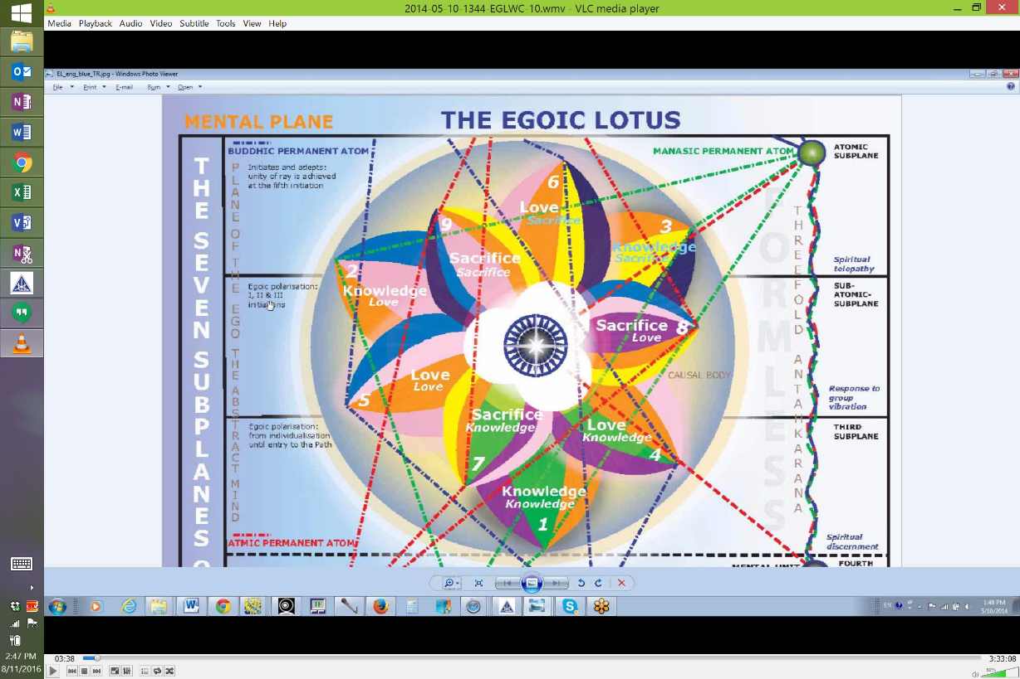
The petals of the 1st tier are easily associated with Earth. Here we have Capricorn, the very first one (petal). It's the inverted mountain - right down into incarnation. Not the mountain of initiation, which is up above all of the usual elemental experience. No this is descent into the depths of the mineral kingdom - Capricorn and then Taurus is very fitting, and we will discuss why that should be so. And then comes Virgo, the 3 earth signs fit very well this first progression from cardinal to fixed to mutable. From the instinctual physical to the emotional to the mental, it fits well.
So he simply says the earthbound soul. How long does the soul stay earthbound? Well, throughout the tier of Knowledge, which is the Hall of Ignorance, there is an earth-boundedness because what reveals the Earth, Earth is revealed by the senses, the lower senses, the lower five and man is very subject to those lower 5 senses during that period. So even though he becomes more emotionally responsive and more loving of form, and more intellectually capable in the world of form, he still is earthbound throughout that entire process but in terms of the primitivity of earth-boundedness that of course is occurring in the 1st petal to which at least I connect particularly with Capricorn.
10. Capricorn (Advanced Man). 1:00:45 Then we get to advanced man. One who crosses the water. Fluid. Well what water are we talking about? There is a lot of water to be crossed in the 2nd petal, even to get a mental grip on things. Water, as far as I can understand the astral plane, and you have to cross the water, of course there are higher types of water - any type of matter is water, so we might want to cross the water into the higher worlds of the soul, and with all the 18 subplanes being considered water and matter at the same time, but here we have to learn to become mental in our nature, and so even though it's the advanced man we can also talk about the water of the 2nd petal where the man begins to develop the emotional response but especially let us say, the petals of the astral plane. In other words the Love petals, these I have assigned to water and they are the Love petals of the astral plane. So there is probably a good reason to assign them to water, wouldn't you think? And the one who crosses all of those waters and finds himself in the Hall of Wisdom.
So to think of Capricorn, the most rigid of all the signs as fluid, is a little strange perhaps but there is a lot of adaptability in the 3rd ray and in Saturn which the 3rd ray characterizes Capricorn and its color green, the color of the 3rd ray. The adaptability seems to be there, so a type of fluidity which allows always coming out on top you might say. Some sort of success, some sort of conquest over circumstances as one continues to rise by being fluid and adaptable.

So I am looking at this in a way as the one who crosses the waters of the 4th, 5th and 6th petals and moves beyond duality altogether - moves beyond the sense of an identity that is torn by duality. Moves towards oneness. The top of the mountain to me is oneness. There is only one point at the top of the mountain, at least if we consider this in an imaginative way. Really a point has no dimension at all so here we are looking at this virtual mountain and we imagine that there is just one peak point on top of it, and yet it's really a dimensional cipher but in terms of the way we conceptualize things we can say, yes there is but one point on top of the mountain.
So I am looking at this in a way as the one who crosses the waters of the 4th, 5th and 6th petals and moves beyond duality altogether - moves beyond the sense of an identity that is torn by duality. Moves towards oneness. The top of the mountain to me is oneness. There is only one point at the top of the mountain, at least if we consider this in an imaginative way. Really a point has no dimension at all so here we are looking at this virtual mountain and we imagine that there is just one peak point on top of it, and yet it's really a dimensional cipher but in terms of the way we conceptualize things we can say, yes there is but one point on top of the mountain.
So the color green is operating here but also the color violet is operative with the 7th ray of Capricorn and no real 1st ray. These 1st ray signs are not represented with any true 1st ray color. Orange, because the 5th ray is connected with the 1st and because orange is said to be an exoteric color of the 1st ray, the closest we come here really is the orange. So, the one who crosses through this sphere of duality where oneself is realized as two things in the process of becoming one. When we are working in the Love petals we have not yet reached the realization, the identificatory realization that we are One, we are absorbed into the One and there is but One into which anything is absorbed. That's more realizations that are cultivated in the Sacrifice petals and even better yet beyond the existence of the Egoic Lotus at all, we will have isolated unity of the Master.

1:05:08 So, the one who crosses the water. Not just the astral plane, but also the central petals on the way to the petals where unification can be realized.
10. Capricorn (Disciple, Initiate). The conqueror of death. Death is always for the disciple, initiate due to separation. And death is a matter of consciousness, a consciousness which cannot be expansive enough to contain different vibratory locations, so there seems to be separation from one thing from another. But when the consciousness expands sufficiently, then all that was divided by apparent barriers of consciousness is comprehended in one unifying consciousness. Thus man conquers death.
Of course there is also a lot of physical things that can be done and rising above materiality at will. Well when is one really the conqueror of death? You could say that one is certainly learning how at the 3rd initiation, one is initiated. And this says initiated. But since there is so much death in the 4th initiation and so much necessity to leave behind the elemental worlds completely, the dweller being overcome, I would say that death is really conquered at the 4th degree. And of course, interestingly, Capricorn is said to be associated with all the first five initiations. Can we take it beyond that point? Well it says all the five initiations, Capricorn is associated with and you know maybe beyond in higher ways that at least I do not realize, but certainly the first five initiations and particularly associated with the 3rd initiation where it says here, initiated and also I would say with the 4th initiation, where death, through the means of death, death is conquered. And through an elevation above any necessity to be reincarnated, death is conquered. As long as we do not have to enter that sphere of limited consciousness, and can be alive, awake and alert in a very holistic and inclusive way, as long as our consciousness is not confined, we are conquering death.
Now, there are all kinds of deaths and on and on it goes. And even the greater Beings experience some kind of death because their consciousness is certainly not ultimately universal. The consciousness of our Solar Logos does not contain the entire cosmos. It's much more limited than that. The Universal Logos has conquered death completely as its consciousness is every possible where in the universe and that consciousness cannot be excluded form anything. But then is it excluded from the absolute? And is the ultimate conquest of death its reabsorption at the universal praylaya into the absolute? That's the question.

1:08:31 Okay, Capricorn consummates the work of Scorpio. Well, Scorpio is really active at the 2nd initiation. There is a great battle going on for control of the astral body, but there is one more step to be taken and that is the 3rd initiation. So these great battles in this dualistic sign, Scorpio, end in the realized unity of Capricorn when illusion is overcome at the 3rd initiation. And you kind of wonder whether we couldn’t transpose that up another octave or so, and say, well the causal body is being destroyed in Scorpio but the realization that comes to Capricorn shows that there is still a higher mountain of perception than was perceived before within the contents of the causal body.

So after the great battle where the 2 face each other, comes the consummatory peak of Capricorn which is unified vision. You sometimes see people take those panoramic shots, you know the camera goes around like this. Suppose they were standing on the top of the mountain and they would take shots all around the mountain and then it would be all laid out as one united whole. Well that would be some little analogy to the unified vision that can be seen from the mountain top. It's as if you have eyes in back of your head or you are just one spherical, all-seeing eye, an eye of Shiva seeing in all directions simultaneously. And that overcomes segmentation, fragmentation which is equivalent to death.

Death and division go together. When you divide consciousness, you have death. If there is any barrier to consciousness, you are dead to the area you cannot penetrate into. And when those barriers are broken down as they are by the 3 synthesizing planets, I'm thinking about how Neptune dissolves barriers, and how the lightning flash of Uranus destroys barriers. Saturn crushes out the barriers, crushes the walls between things and yet is the wall between things. Then you have conquered death through the panoramic consciousness which the initiate in Capricorn can achieve. Capricorn definitely takes us into the Synthesis petals. From the method of starting in Aries and going through the 12, it rules one of the Synthesis petals and we could call it the synthesis of knowledge with Aquarius ruling the synthesis of universal love. Synthesis of knowledge on the atmic plane which we can relate to Capricorn through its Saturnian rulership, and through the 3rd ray where that city called All Knowledge is found.
01:11:34 It is a very knowing sign and is intimately related to knowledge through its connections with the 3rd ray. Of course so is Aquarius through the 5th ray. Capricorn belongs among the Synthesizing petals most definitely. It also belongs in all jewel-like structures through its connection to Vulcan and its relation to hardness and crystallization and so there is going to be a sense in which it is part of the 1st ray demonstration of the Jewel in the Lotus. In many ways the three 1st ray signs can be connected with the Jewel in the Lotus but Capricorn has the advantage of being intimately connected with Vulcan which rules the formation of all jewels.
Well, these higher energies of which we have just the tiniest inkling, all are operating in ways unknown to us on levels which we cannot yet penetrate. We can speculate about what those operations are but we have to be practical and use the astrological signs and planets and rays in the immediate dimension in which we find ourselves focused, so as to master that dimension and move on. Speculation is good. It gives us a certain method of procedure and a certain way to prepare, to anticipate what might be required on above, but if want to ask, well what is happening in the Jewel in the Lotus now and in what way is it the reflection of the Monad and how am I experiencing that? That might just be a little beyond us.

Aquarius

1:13:22 Now we move into Aquarius. I feel, of course, that I am passing things all too rapidly but there is enough here to keep us digesting for awhile and we can't know everything, we just can't. And even the Tibetan who is one of the most learned of the Masters, at least the most learned in terms of the astrology and rayology and the Creative Hierarchies would if he were measuring his knowledge against that of the Planetary Logos, see the huge lack of co-measurement. You know, obviously as vast as the Tibetan's knowledge is, and any one of us who is studying his books understands what kind of vastness we are dealing with, what is it compared to the knowledge of Sanat Kumara? What is it compared to the knowledge of the full Planetary Logos on his own plane? or focused on the cosmic mental plane? You see it's all relative, this question of great and small. So we have to opt for a utilitarian approach. What can we use? And what, even though we can't use it, helps us use other things. We have to ask ourself those questions.
Aquarius. Well the diversification of Aquarius. But notice it's in the turquoise which is the combination of the green and the blue and it has not only the 5th ray which seems to be indicated, but Aquarius has that 3rd ray, it's hinted and it's universal love suggests the 2nd ray and I think that it is the constellation which is veiling a hidden etheric constellation of the 1st ray. You know the Bear is associated in one way with the 1st ray. Aquarius and the Great Bear and this other constellation to which no name is given, all connected with the 1st ray.
11. Aquarius (Undeveloped Man). 1:15:36 All things to all men. Well, you know we usually think of Aquarius as such a sign of altruism and sharing and giving and serving and it is all those things, but in the early days it also exists and the person can be still very self-centered and seek to be utterly multiple, seeking to fulfill all roles. The man for all season, Sir Thomas Moore, had great skills in many, many different areas, there are lesser people who simply try to fulfill a multiplicity of roles in a way that is not very accomplished and they don't have the centralization to say well that I am this, this is my nature. I am this, I am that, and I am the other. So it's the beginning of the distribution of self which eventually will allow it to find the self in all different types of people and circumstances but at first, it's a bit of a burden because you can't pin the person down as to what he really is and he himself doesn't know what he really is so this doing of many things, it's a bit Geminian in that respect without bringing of them to any degree of real development is characteristic of the early Aquarian. Diffuse, diversified and spread, scattered about in its energy.

It doesn't seem to have so much connection with the 1st petal. We could find a way in which it does, of course, but in the community building of the 2nd petal it has its place because that is where the magnetism begins to come in and people gather together into community if only to save themselves, to survive. So the division of labor in its earlier sense is found there. You won't find the color of Aquarius, not really, in the Egoic Lotus. You won't find the turquoise that the Tibetan gave but then Aquarius is interesting because it's like the coat of many colors. I think the story in the Bible about Benjamin and the coat of many colors - Aquarius is all the colors and the synthesis of all the colors. When you think about the head center and its great display through the 1,000 petals, you can think about somehow all the colors being present, just the way they are virtually in the causal body except for the red. So there is the rainbow, that's what Aquarius is all about. The rainbow has entered politics of course, but it's the idea that all the different qualities are needed together. And that we cannot leave anything out in the inclusiveness of the Aquarian, that where universal love is displaying but that's a bit later in the day.

1:18:48 The burden of the self. Well, you know, Aquarius is used to carrying burdens, but at first selfhood and concentration upon desire and form, bringing all the many things to the person for their own fulfillment so that the shower of all good things rains down upon the single egotistical person, this is the burden of the self. They use all things for themselves instead of using all things that they have accumulated for others. So in a way, in this 3rd ray accumulative mode, everything comes to them and they shower themselves with the gifts of all the Earth to which they think they have the right. This we can see, of course, in some of the selfish Aquarians. They do exist. I am looking in politics, and I am just astonished at the number of quite reactionary people who are conditioned by the sign Aquarius. They are part of the elite and they are not accountable to others. It's also a sign of aviation which allows it to rise into the air, to unreachable heights and to control from above. It has a controlling factor in it as well, to control the many. It can also be very selfishly idealistic. So my particular group is the best of all. And it has the 6th ray associated with it in that context.

When we look at Russia, it is ruled by Aquarius, so communism had that attitude that it alone was the way to save the world and when we look at the Third Reich, when it came into existence on January 30, 1933, it was ruled by Aquarius and the Nazi party, with the Third Reich thought of itself as the one method of salvation, the true ideal for humanity which all had to conform. So this wonderfully distributive sign Aquarius is not always distributive; it can be very selfish and it can use all things for itself. I am reminded, Hitler was a Taurus, of course, and you look at Taurus and Aquarius, there are the acquisitive sides of these signs. He looked at all countries surrounded him and in the world in terms of their material resources which he was determined to bring back to Germany or to use on behalf of Germany - so all things would flow not out of him but into him, and we can see how all of the Aquarian energies eventually would do that as well, including the energy of atomic energy which he planned to utilize for Germany's sake and distribute in a way that would have destroyed all opposition.

So in the beginning, before breaking through the ahamkara we have the burden consciousness thinking of itself and all the things that it needs. So desire in form is ruler and all the things that are desired are brought back to the individual and all of that creates an inability really to relate in the larger sense. It's a reverse flow. The divine circulatory flow is out and among all for the benefit of each and all. The reverse flow is from all for the benefit, the grandeur, the exaltation of the limited ego, and that can be considered the burden of the self. Even though that self may not have such a strong sense of individualistic center, it does manage to gather from many places what it thinks it needs; so that all the good is showered upon it and the others are neglected. And rather than being a sign of sharing, it's a sign in which etherically and physically things are taken away from others so what they need is not theirs anymore. It's a sign of greed in that sense, in the early days. So how will that operate? Does it operate much in the Hall of Ignorance? I think it operates more in the 2nd petal where from the positive perspective, communities are formed and people recognize their proper associates. Maybe it has something to do with the tribe as well. Maybe it has to do with exchanges between tribes and so forth. Those are all on the positive side.

1:23:49 With the 3rd petal, I think we definitely have to look at it as present. If we begin with Aries at the 1st, Pisces at the 2nd, and then Aquarius is at the 3rd. Then going in the clockwise direction is a very legitimate way of proceeding. But here the Aquarian mind begins to focus and we know that the scientific mind can still be the mind that is ignorant of the Higher Self and sometimes he talks about Aquarius and Uranus in terms of concrete science which is coming in here at the 3rd petal and is at least helping people understand the relations between things in the world of form. D.K. talks about when the 3rd petal is used correctly, motivated by the love of the 2nd petal, that we are going to have all kinds of technological advantages which will lift the burden, think of that, Aquarius lifting the burden through technology for many people. So it can be used there, in that way, in a positive sense. You know at first we still have the ignorance of the Higher Self. So we might really call it the burden of the not-self. It says, the burden of the self, which is really the not self and simply believing in all rationality that that is all that exists. So a lot of skepticism still found there. Interestingly, 5th ray, the skeptical ray is very powerful in Aquarius, and Uranus can be connected with concrete science.

11. Aquarius (Advanced Man). However, we do move into something else. It's dedication to the soul which begins to be sensed in the 2nd tier of petals and dedication, it's kind of a 6th ray thing in a way, but it does show itself in the Aquarian idealism. The soul is sensed and the wideness of the soul is sensed. That is the wonderful thing about Aquarius, how very broad it can be because it doesn't know the ring-pass-not of Leo necessarily. Its self is the many selves. Well in the early primitive days one doesn't know who one is. All things to all men. I'm this to you; I'm that to you and I keep on changing the self that I am. But later, being the many selves is a step on the way towards universalization, isn't it? So, the humanitarian tendency is entering here in these socially oriented Love petals. And as I said, try to find the opposite of the sign that rules a particular petal and look at the 5th petal there, the opposite is Leo so Leo/Aquarius can be thought of as being found there, and under the stimulus of the Solar Angel we begin to realize that there is more to me than I thought in my lower self nature. I have a Higher Self and that Higher Self is actually connected in an Aquarian manner with all other Higher Selves, so instead of having the distinct personalities which are separate from each other, we begin to understand the unity of the many personalities, because the soul, which is the source of those personalities is one, unified thing. So we are taking a step towards universality. And again, you know, when I think of Aquarius, I just have to think of all the colors. I don't find the turquoise particularly. Though you know in some ways Aquarius and the 7th ray Age, I think of the way this group sense has to be manifested eventually in the Age of Aquarius. And the violet color would be important. Sometimes white and violet are connected in the teaching.

1:28:06 So, here we develop the humanitarian impulse and we understand from our lofty perspective, up in the air, with our aviator, the difficulties that humanity passes through and we realize that we really have to be down here in the valley of service upholding humanity and that can be realized even before the 3rd initiation is taken. So we realize the soul demands this and we are pretty well working in the petals of Love when we do that.

11. Aquarius (Disciple, Initiate). Then we move onto the true disciple and initiate and the sense of universality is really stepping in here. In Sacrifice, sacrifice is giving. One way to understand sacrifice is giving, even though it may hurt the lower individual, it is going to feed and nourish the expansion of that which we really are. We give. And the petals of Sacrifice are all about giving and so Aquarius increasingly is going to be operative.
Can Aquarius be associated with the 1st initiation? Well in the sense that the man becomes aware of the group, yes. With the 2nd initiation, there is the cleansing of all of the 3 stables, you know, the 3 different levels, but especially the cleansing of the astral plane, and the waters are what provide the cleansing. So Aquarius is not a water sign, but it is associated with the waters and it is associated with all the good that the cleansed, purified waters can bring of nourishment to all the different areas, so it is the emotional nourishment of humanity. Then of course in the mind universality enters and the Aquarian becomes the genius and really knows all things.
So here there is the great environmentalist, thinking of the Earth as the environment. He is not only the server of all men in the petal of Sacrifice when he takes the 2nd initiation, he is learning how to do that, how to really express the Plan, and serve humanity, but when he takes the 3rd degree, then he really is the server of all men and Aquarius is the sign which should be much associated with the 3rd degree, the 3rd initiation can be taken in Aquarius but so can the 4th, so can the 5th, and also the 2nd. The purification of the astral plane in the 2nd and a less rigid focusing of the emotions, a broader sense of human friendship. And in the 3rd degree, the coming together of all the many energies and the realization in the mind of the wholeness of things and in the 4th degree, a pouring out of everything that one has in sacrificial service to the point of death, and in the 5th degree great universality, the revelation of the interconnectedness of many things even beyond the planet.

So then, remember Gemini - Hercules was walking around and then he heard Atlas groaning, struggling, carrying the burden of the world. Aquarius is in there too, helping Atlas, the Hierarchy, carry the burden of the world. We could say, is he helping the Planetary Logos? Well, is Atlas the Planetary Logos or is Atlas the spiritual Hierarchy? I think for our purposes, Atlas is the spiritual Hierarchy ruled by Aquarius, carrying the burden of the world, interested in the ecology of the whole world, not just the welfare of man, but the welfare of all the kingdoms and we know that Aquarius in its diversification is the great environmentalist. You know thinking about how all things relate to all things, and making sure that the divine circulatory flow works through all things. So again, it's certainly found in the Synthesis petals and is it found here in the 9th petal, indicating the 3rd initiation? Yes, because it conventionally does associate very much, along with Capricorn, to the 3rd initiation. And then the distribution of all these energies from the Synthesis petals. It sees things in synthesis, in universality and therefore is much related to the Synthesis petals and maybe, well, you know, I can see how it can be related to all of them actually but maybe the synthesis of love is very important for Aquarius. We learn about the universal love of the developed Aquarian, but it certainly has vast knowledge - it all depends upon the ray and so Aquarius can be certainly used in a genius like way in the field of knowledge.
I don't know if I have emphasized enough the development of genius at the 5th petal. That's what D.K. discusses in Education in the New Age and when that 5th petal is open, the genius can appear. Now that's not necessarily the most highly developed individual, but it does show you how high mentality can go in relation to the 5th petal.

1:33:43 Aquarius releases Virgo from her load. Well Aquarius has been doing a lot of burden carrying anyway, but you know Virgo has the load of the Christ and somehow the Christ is born and Aquarius is lifting the Christ up into a position where that Christ can be radiatory for all humanity and for all the planet. Both of them are related to matter, quite interestingly. You know, let matter reign in Virgo and Aquarius is the lowest of the Creative Hierarchies, is it not?
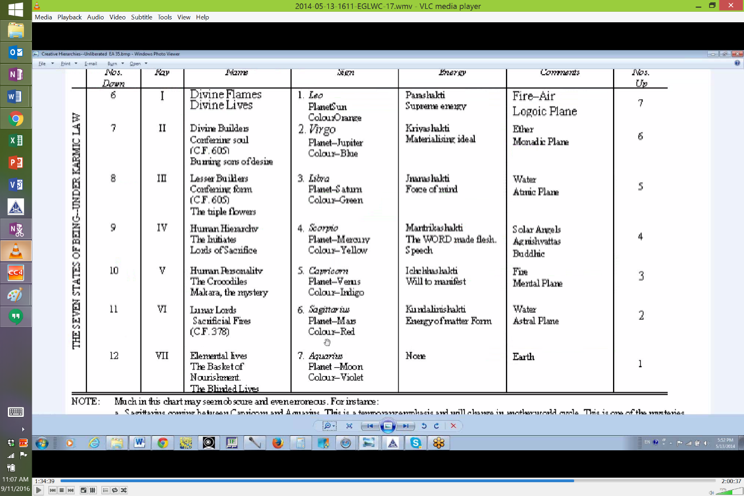

Look right down here, Aquarius is ruling the elemental lives, the baskets of nourishment. So they are both connected with materiality, but also with redemption with that which is material and the heavy material concerns of Virgo are at last lifted up into the air where Aquarius flourishes - the air is God and from there, all the values of wisdom, and whatever other values, of love, of intelligence that Virgo has been nurturing are now upheld by Aquarius and distributed to all of humanity. So that pretty well goes along with this auxiliary phrase that we have under #6, that Virgo hides the light which irradiates the world in Aquarius. That is the Christ light. And that hiding is quite a job, yet one has to in a way make sure that it is of a proper quality. But then it is born out into the world and rises into the air and Aquarius gives it to everyone.
So I certainly think that in terms of the Egoic Lotus, we can just see Aquarius just pervading the whole thing. This is the coat of many colors and there are some places were its higher functions are less obvious. The fact that it's related to the elemental lives will give it a lot of influence in the 1st petal, but of a different kind. It's the vitality that's needed in this 1st petal. It's related to the etheric body, right? Aquarius is. So the vitalization of primitive man is found with Aquarius. And later you know the waters are flowing in petal #2 and the community is coming together and people are attracted into groups. It's operative there. And in the scientific mind, the mind that is investigating all manner of things, all manner of distributed things. It's operative in petal #3. Well we could go on with it. The family is forming but who is the family? Eventually it's going to be the family of man. There is that famous book of photographs, from 50 years ago or more, called The Family of Man, a very Aquarian gesture. But one can also see the Cancerian nature of it and the radiatory qualities of genius at the 5th petal and well we could go and we will. We will relate the signs to all the petals, but you get the idea that it is pervasive. It is developing the impulse of giving through the Sacrifice petals. It's developing altruism in the 6th petal where a person tries to be selfless. Aquarius, although it can be very selfish in the beginning, is one of those signs of selflessness because after all you are giving it away. It's a sign of altruism where you are looking out not just at your own Leonian, self-centered self but you are looking at all the others as if they were other selves as well. And that is being cultivated in the Virgo petal where we can say that Virgo and Aquarius can be related. And on it goes.

Pisces

12. Pisces (Undeveloped Man). 1:38:02 Well then I think then we come to Pisces, and Pisces is such an interesting sign, you know. We have been told that there is only in the beginning 8 signs, then 10, maybe 11, but not 12 and yet Pisces is the 12th sign so is it even active in early man and yet it must be possible to be born in all the signs even though the zodiac of the time may have only emphasized certain signs. The very first thing that is said on the evolutionary wheel so to speak, or the wheel turning clockwise is, "go forth into matter." Well everybody has to do that and if the very 1st incarnation is taken in Pisces, well indeed it has to be found in even the very first petal and water is matter and man is the earthbound soul, subject to matter. So the confusion of being in this new world of matter and of what the senses reveal of the lower worlds is belonging to Pisces and in the early days it gives a responsiveness and indiscriminate responsiveness to everything. Maybe there is more sensitivity in the 2nd petal than in the 1st, but certainly the Piscean confusion - what does he say, bewildered by circumstances and not by events, that's what we find in the 2nd soul group, but it's either in one of those early stages of the soul groups or an early stage of adaptation - bewildered by circumstances and that is so Piscean because we know that with Neptune accompanying it for all humanity it has that sense of being lost at sea and not really being about to orient itself, having no fixed place from which to reckon and which to begin to judge of location. And maybe in the early environment, for early man, it was something like that and there was a lot of confusion with regard to circumstances.

Let's just say that it is a sign of impressionability and so the medium is brought into our focus, maybe is the medium intelligent? Well if the medium is not intelligent, maybe that mediumism is coming even through the 2nd petal. I think there are a lot of people involved in the very primitive religions who are mediumistic. So we can find a connection with Neptune, Pisces and the 2nd petal, especially if we start counting backwards from Aries to Pisces with the 2nd petal. We are allowed to do that. We are also allowed to count from Pisces at the 1st petal and then count backwards or clockwise to Aquarius 2nd, and Capricorn 3rd, and so forth. And we will try to discuss that when we are dealing with each petal and focusing precisely on one petal at a time.

1:41:34 So yes, very much Pisces can be ignorant, swallowed by the whale so it was. Jonah the soul is swallowed by the whale, and doesn't really know he exists. In other words, the higher of the pairs of opposites, the Higher Self isn't really understood to exist by people who are operating in the Hall of Ignorance. So it can be operative in the 1st petal, the 2nd petal, overcome by matter in the 1st matter, sensitive to subtler things but not knowing what they are in the 2nd petal, and in the 3rd petal, sacrifice - it's a petal of sacrifice and you do lose your life, you are compelled, your will is not your own. You are forced to make a living for your family under very dire circumstances. You are forced into the army or you are forced into battle. You are at the mercy of the elements, you know, it can overcome you, but that would be pretty 1st petal. But sacrifices occur in Pisces and Pisces is the sign of sacrifice. Interestingly enough Virgo is definitely there. It's a Virgo petal. It's a Gemini petal and we can talk about the sacrifice of Pisces so we have 3 of the mutable signs operative there. And maybe we can probably find the mutable cross there with Sagittarius hunting in the concrete mind for new types of understanding.

So looking at the diagram,

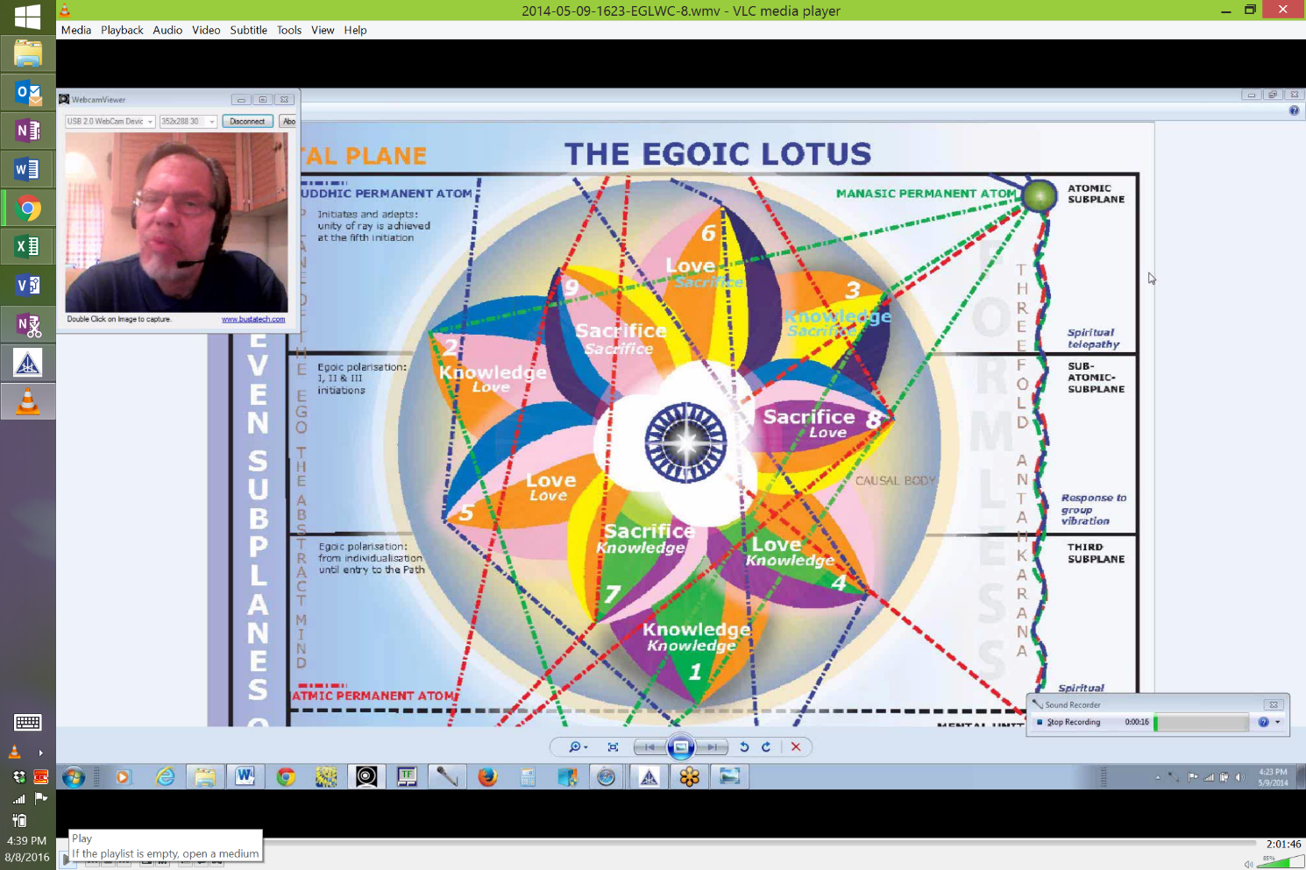

you know Pisces has particular connection with the rose color and with blue. I think it will be important in that 2nd petal but certainly it is vulnerable man. We hear about how vulnerable early man was not only to the elements necessarily, although who knows what the elements were like in those days, but to predation by the animal kingdom and you kind of wonder, preliminary man must have been very large. Is D.K. talking about that time when man was of colossal height and the animals somehow even greater in their stature or is he talking about the time when humanity in later days began to have a diminished stature and was the victim of larger animals? Anyway, vulnerability is the key here. Vulnerability and impressionability go together but disorientation as well. And not really having the mind to find out the kind of environment in which one is living. Only in the 3rd petal is the mind developing I think to a sufficient degree to really understand the environment. I mean the modern Atlanteans had a mind, but not much and you know in the 2nd petal we learn about the modern Atlanteans. We also learn that those wonderful, colossal things that were built in Atlantean days were built by impression and directed by the Higher Directors and that man himself did not have the intellect to conceive of those things. He was simply impressed by what he had to do and the impression came from much more advanced beings and so there we have the mediumistic quality of Pisces, again.

1:45:08 It is a sign of sensitivity. Notice it's in the color lavender. Again it's not found in the Egoic Lotus but violet is and lavender is very related to violet. It's interesting that things from the subtler planes make their way through, via the mediumship of Pisces and become tangible. If you look at spiritualism as a kind of a religion or a way of interested investigation of the subtler realms, we have both the 7th and Pisces together. Pisces and Cancer are mediumistic, and the 7th ray rules precipitation, and the medium is bringing through the subtler thing so that it appears in form via the 7th ray, so we see that in the early appearance of violet some of the subtler worlds can have come through. I have read stories in some of the theosophical literature how precipitation from the astral plane was really an ongoing thing and it wasn't always very savory, it could be horrible, monster like things being precipitated from the astral plane and there they did their damage on the physical plane and then they disappeared. If you read The Lives of Alcyone you'll see that in one of his incarnations, at least according to Leadbeater and Besant he and his sister, whoever it was, met a very unhappy ending in the jaws of one of those precipitated astral monsters. You know the whale is a monster in a way, monster of the whale and great things could be precipitated from the subtle planes without much knowledge of what was really happening or what it meant or what its value was - a combination of Pisces violet and the 7th ray with lavender thrown in.

12. Pisces (Advanced Man). Then the advanced man. Well advanced man is always going to move into the 2nd tier of petals, right? That is where we have the possibility of not just being smart as in the 3rd petal, but advanced, in other words advanced out of the Hall of Ignorance, into the Hall of Learning. Certainly by the time we reach the end of the Hall of Learning, man is really advanced and the pairs of opposites appears to consciousness in the 2nd tier of petals. So whatever soul is by whatever name we call it, it is registered and because it is registered it can be sought after because its advantages are realized. So, what we have here is sensitivity to soul and we can find that in the Cancer petal #4, increasingly as the Solar Angels begin their supervision, their sensed supervision, we can find that in petal #5 and certainly as the opposite of the Virgo petal where we are becoming ever more careful about enacting what soul tells us to do in this very practical 6th Virgo petal.
1:48:40 So here Pisces is not just the unintelligent medium receiving whatever from wherever and not really knowing what it is at all. It is dealing with the human pairs of opposites and is the means by which the higher of the pairs of opposites can come through to the individual and also I would say on behalf of others. Pisces can mediate the presence of the soul or that higher type of energy which is non-elemental - it can mediate that to others and present that to others. Again kind of interesting because there is a precipitation there. Something that was invisible is now coming through the mediator and is appearing in a tangible manner so that you can sense its presence.
That would be all the way through the 2nd tier of petals and advanced man, well, we are told that the intelligent medium is found in Virgo, so just think what can be done in that 6th petal which is ruled by Virgo in one sense and by its opposite, Pisces. So the intelligent medium could really appear and be able to explain what is this invisible something that is now tangibly sensed of which we can be aware and so forth.
12. Pisces (Disciple, Initiate). Then finally I am reminded of Saturn in Pisces which the Dalai Lama has whenever I see these words, spiritual responsibility. That's obviously a really strong one for him and he's a Cancerian on top of it, so the whole is seen as one. We are definitely now into sacrifice because the only ones who take spiritual responsibility are the ones that know how to sacrifice. So we are moving towards saviorship. We don't even achieve the full thing in the sacrifice petals. We are just learning the ABCs. We are told in the 9th petal that there is sacrifice regardless of the pain - well you know, I quite forget it but I think it's found on page 824 (TCF) - the will to sacrifice through love on the mental plane and thus to serve and yes, there it is and also it is found on page 543, let's try that - probably 542, it said the petal of Love on the mental plane is unfolded and through the conscious, steady application of all the powers of the soul to the service of humanity with no thought of return, nor any desire for reward for the immense sacrifice involved. So, wherever we have sacrifice we have Pisces. Their self-effacement there. There is giving up of one's central point of ego in a sense dissolving that central point and hence related to Leo where the relinquish point comes in.
So no matter what the sacrifice may be in the 8th petal, there is no thought of wanting return for it and then the utter sacrifice of all forever with the complete unfoldment of the 9th petal and you would have to go even beyond that because the savior is the deliberate giving of the causal body at the 4th initiation for the welfare of others and the heart center which is also connected with Pisces via the 2nd ray is the object of attention.
1:52:36 So he has this spiritual responsibility - he holds himself to the sacrificial task, the great sacrifice - imagine Sanat Kumara in his sacrificial mode, holding himself through Saturn to that spot and not leaving until the last weary pilgrim has found his way home, whatever scope that pilgrim may have. It's probably a certain group of the human pilgrims that has to be involved but I don't know, maybe it's all the life forms until they become human and find their way home. I don't know but Sanat Kumara stands steady at his Pisces sacrificial post holding himself there through the power of Saturn. After all he is Sanat and it's a word very closely related to Saturn.
So the spiritual responsibility comes in on the mental plane, increasingly and as the 1st and 2nd initiations unfold, the 5th and 6th petals and the rod of initiation is applied to the 7th and 8th petals, at least the stream of energy is applied, spiritual responsibility is growing. The 3rd degree initiate realizes this is the life for others and the entire content of his treasury is to be poured forth upon them and he even has to sell everything he owns, that's all the content of the causal body and give it to the poor. Okay? See the language which is pictorial, parable language. Sell everything you own - the contents of the causal body, give it to the poor and the poor are everybody below you. So pour it all forth and do not cherish it; do not hug it; do not hold it to yourself and think this is what I am and I am going to increase my virtues. No it all has to be poured forth. It's very Aquarian in that sense but it's salvational, and Piscean in another.
1:54:38 And finally the entire content of the causal body is completely destroyed and given to everyone by rising in translation into the spiritual triad. So the motive there is to become the savior and you don't even really become the savior until you're at the 5th degree and are ending your history as a human being in relation to Shamballa and not in relation to Hierarchy. So the path of the savior is Piscean and it relates the man to that statement, not my will Father, but thine be done. The giving of everything once the will is understood and one can understand that Pisces will lead on in acquiescence to the 6th degree. All of this is far beyond the causal body, of course.
Pisces takes from all the signs. It is the complete synthesis and the most synthetic of the signs but Pisces and Aries are really one thing in that respect so the end becomes the beginning and the beginning becomes the end, but it's found in the Synthesis petals of course and we can say Pisces gives to all the signs as well because it has this complete synthesis of wisdom, this pervasive wisdom and of course love and it pours it all out, it gives it all out, even after the causal body is completely destroyed and all of its contents have risen into the spiritual triad towards the Monad. After all, Pisces rules the Monad. What did the Monad do? It came forth to help all the other lives - I leave the Father's home, monadic plane, and turning back I save. So, you know, with Pisces we go beyond what we can see here in the causal body. We certainly see that there is a lot of this kind of - if we blended the rose and the violet together we would probably get some kind of lavender out of it and it's operative we see at the Sacrificial petal level. It's operative in the petals of Synthesis being the foremost sign of synthesis. It's related directly to the Monad and its sacrificial journey and it relinquishes all it has, giving it to all in saviorship, much I suppose would depend upon the ray but when Pisces is present there is many ways to save along many ray lines. So eventually we find our way back to the Monad which was the original givingness of the whole monadic journey.

Review

One more look at our subject. What we have done here is take all of the 12 signs of the zodiac, looked at them in 3 different phases: undeveloped man, advanced man and disciple/initiate; seen how these signs are operative in those different phases and seen what parts of the Egoic Lotus are activated, functioning when these different types of activities connected to the signs are functioning and operative. So I think we have some idea there. The zodiac is spread throughout the Egoic Lotus. When you really look at it, it is a zodiac. It is a 12-fold energy system, but the wheel is coming and going and turning in all directions, two directions simultaneously and eventually in all directions simultaneously and eventually we are going to have a complete synthesis of all the signs of the zodiac. Maybe that kind of happens when the Egoic Lotus is destroyed at the 4th initiation. Okay that’s going to it for now.
I am going to call this the end of Egoic Lotus Webinar Commentary Program #17. It is 2 hours in length and it is from Esoteric Astrology page 333. Okay friends that is going to be it for now.

