EGOIC LOTUS WEBINAR COMMENTARY #14 – Michael Robbins

Abstract

Egoic Lotus Webinar Commentaries 14: Crises of the Soul Completed. This webinar is about 1 hour, 2 minutes long and covers Esoteric Astrology pages 278-279 and 472. In this program we continue to focus on the Crises of the Soul in relation to the egoic lotus. Our particular focus at first is upon nine signs of the zodiac which are not included in the three preliminary Signs of Crisis—Leo, Libra and Capricorn. We see how these nine prepare the man to face the crises indicated by at least two of the first three. We cannot say how the signs of the zodiac prepare animal man to face the Crisis if Individualization. Then we study Seven Crises of the Soul, in which five the signs among the previous nine are also considered signs of crisis. The seven Crises of the Soul are explained and their relations to developments within various petals are considered.

Contents

Abstract 1
Contents 1
Transcription of Egoic Lotus Commentary #14 1
1. Crisis of Incarnation Individualisation Cancer Cardinal 4
2. Crisis of Orientation Reversal Aries Cardinal 5
3. Crisis of Initiation Expansion Capricorn Cardinal 6
4. Crisis of Renunciation Crucifixion Gemini Mutable 7
5. Crisis of the Battlefield Conflict Scorpio Fixed 7
6. Crisis of the Birthplace Initiation Virgo Mutable 8
7. Crisis of Burning ground Liberation Leo Fixed 9

Transcription of Egoic Lotus Commentary #14

Hello friends. We are continuing with our Egoic Lotus commentaries and we are working with the crises of the soul. This program #14 and we are in Esoteric Astrology actually. We are on page 278 and 279 and then we go onto 472. We have reviewed 3 signs of crisis and they have been Leo, the crisis of individualization, Libra the crisis of balance, and Capricorn the crisis of initiation. And we have looked at how these crises can work out in the Egoic Lotus itself, in the petals of the Egoic Lotus. Now much of this, well really all of this material has been covered in my webinar presentation of Esoteric Astrology but here I am paying more attention to the crises and to the behavior of the signs in relation to the Lotus itself. So we are beginning with a section here called nine signs and their attendant crises.

"The relation existing between Virgo and Pisces (between the Virgin Mother and the Fish Goddesses) is well known, for they are polar opposites and their functions are interchangeable in a peculiar manner. In the revolution of the ordinary wheel, Aries and Scorpio mark the beginning and the end, and consummate in the rounded out and equipped personality." EA 278

02:21 The relation existing between Virgo and Pisces (between the Virgin Mother and the Fish Goddesses) is well known, for they are polar opposites and their functions are interchangeable in a peculiar manner. ﻿﻿We see this actually in petal #6 which is ruled by both Virgo by one way of counting, by Pisces in another. They are both ruled or express the same rays, the 2nd and 6th ray, and they both have much to do with the matter aspect. It is said go forth into matter in relation to Pisces, and in relation to Virgo let matter reign. So they are connected previously with the 3rd aspect of Divinity and probably in the previous solar system very much so. Virgo certainly was in the latter part of the previous solar system, D.K. tells us, and there is a sense in which Pisces represents humanity's engagement in a very early aspect or in a very early aspect of evolution, in its engagement with the waters, the matter of Pisces.

03:47 In the revolution of the ordinary wheel, Aries and Scorpio mark the beginning and the end, and consummate in the rounded out and equipped personality. ﻿﻿It's interesting about Scorpio. It is a triple sign and it does call for the man to demonstrate on the physical plane all that he is. So but this is the first time that I have really noted here that the rounding out and equipping occurs in Scorpio, but then that is not the initiate equipping, so to speak.

"They are, exoterically, Alpha and Omega. In the life of the disciple, Virgo and Pisces stand in the same relation. Pisces consummates the work carried forward in this major world cycle. Some idea of the creative story above indicated can be gained if the tabulation of the nine constellations with their signs is studied." EA 278

They are, exoterically, Alpha and Omega. ﻿﻿ In the life of the disciple,. . . Indeed, Scorpio is particularly the sign of the disciple and it puts him through the testing process and three different types of tests have to be undergone with the three different heads of the hydra and the first three initiations. At that point he truly is rounded out in a certain sense. He is the initiate, this is a higher sense than the exoteric sense. So they are exoterically the alpha and omega. In the life of the disciple, Virgo and Pisces stand in the same relation. Pisces consummates the work carried forward in this major world cycle.﻿﻿ It is the sign of consummation and it brings us to what is called the true achievement and liberation of the man at the 4th degree. I think Pisces ruled as it is by Pluto, and being a sign of death and yet a sign of salvation has much to do with the 4th degree. Some idea of the creative story above indicated can be gained if the tabulation of the nine constellations with their signs is studied. ﻿﻿And there we have another hint - nine constellations with their signs. The signs are the means of distribution of the energy of the constellation.

"1. Aries Beginning Cardinal Cross.
2. Gemini Relation Mutable Cross.
3. Taurus Desire Fixed Cross.
4. Cancer Movement Cardinal Cross.
5. Scorpio Test—Trial Fixed Cross.
6. Sagittarius Direction Mutable Cross.
7. Aquarius Service Fixed Cross.
8. Pisces Salvation Mutable Cross.
9. VIRGO THE MOTHER MUTABLE CROSS." EA 278

Aries represents the beginning, all undertaking are begun in Aries, with the cardinal cross. You see what I think is being left out here is Libra, Leo and Capricorn which were the signs of crisis reviewed in the previous program. Gemini brings us into relation. It represents duality and the interplay between them.

06:42 It's interesting that he is not taking these in order, unless there is some mistake and we can check it with the book itself, but Gemini seems to come before Taurus and yet all the others are in order. But we will leave that go for the moment. Taurus represents desire on the fixed cross and the transformation of desire into aspiration. Cancer, it's of the cardinal cross and represents movement forward, I would say, in the process of evolution. It has much to do with the will to evolve.

Scorpio, test - trial and eventually triumph in the fixed cross. Sagittarius the direction of the tested and purified personality following those tests. Struggle, strength and Sagittarian attitudes - those are further tests in Scorpio and we see how one sign leads to the other. Aquarius, the dispensation of the waters of life in service. Pisces salvation and Virgo the mother of it all. The sign that provides the form for all of these different processes to be worked through. D.K. did mention - it's an internal sign in many way - just a little earlier he did mention Cancer, Virgo and Pisces: “Constitute the triangle of the Mother or matter aspect, conditioned by intelligent activity. They indicate points of opportunity of an inner kind where consciousness is concerned, and therefore you have the recognition of the mass,. . . I would say Cancer. . . . individual consciousness. . . that is Virgo. That is the individual Christ associated with Leo . . . and group consciousness.” (EA 266) which would be Pisces which is more, we might say, the cosmic Christ or the greater Christ associated with Aquarius. Pisces is associated with Aquarius in the same way as Virgo is associated with Leo. We have nine signs which lead to the crises.

"There are, therefore, nine signs through which potencies pour which are creative in their effect and which produce changes which are needed in the progress of the soul towards divine expression. You have also three signs of crisis whereby the point in evolution is determined. In this connection it should be noted that:" EA 266

09:28 There are, therefore, nine signs through which potencies pour which are creative in their effect. . . ﻿﻿so the nine we have just read are creative in their effect . . .and which produce changes which are needed in the progress of the soul towards divine expression. ﻿﻿And then these are worked out I suppose in a more dramatic way in the signs of crisis. Interestingly enough though Libra has been also considered, with Aries, as a sign of noncrisis, a sign of equilibrium. So there are different perspectives here.

"One point of interest emerges: All the four arms of the Mutable Cross are represented in this interrelation, indicating the completed activity of the Mutable Cross or of the preparatory stage of evolution which has successfully prepared the man for mounting the Fixed Cross. The personality is prepared to be the mother of the Christ." EA 278-279

One point of interest emerges: All the four arms of the Mutable Cross are represented in this interrelation, indicating the completed activity of the Mutable Cross or of the preparatory stage of evolution which has successfully prepared the man for mounting the Fixed Cross. ﻿﻿Pisces interestingly is the last sign on the mutable cross and frequently is found in the transition of the man from the ordinary wheel to the reversing wheel - from the cross of the personality to the cross of the soul. Pisces also is a sign of transition from the cross of the soul to the cross of the spirit and when the series of incarnations ends in Pisces one is transferred into the world of the Monad, into the world of the spirit and in a sense into Shamballa.

The personality is prepared to be the mother of the Christ. ﻿﻿Under the four mutable signs. All of them are here represented. I suppose it's because in these other signs of crisis we had Leo, Libra and Capricorn and none of them were mutable signs, so the four mutable were not touched, and the preparation goes on.

11:45 Now it's interesting that some of the signs which are here considered to be creative are also listed as signs of crisis in the next section we are going to study.

"THE CRISES OF THE SOUL

Crisis Quality Constellation Cross
1. Crisis of Incarnation Individualisation Cancer Cardinal
2. Crisis of Orientation Reversal Aries Cardinal
3. Crisis of Initiation Expansion Capricorn Cardinal
4. Crisis of Renunciation Crucifixion Gemini Mutable
5. Crisis of the Battlefield Conflict Scorpio Fixed
6. Crisis of the Birthplace Initiation Virgo Mutable
7. Crisis of Burning ground Liberation Leo Fixed" EA 472

And these signs are Cancer, Aries, Gemini, Scorpio and Virgo. Five of them are listed as signs of crisis and in these crisis of the soul the signs which were involved in Leo, Libra and Capricorn are also listed again, at least some of them - Libra is not but Capricorn is and Leo is, though both of them in a different sense, than the earlier types of crises. Let us see.

1. Crisis of Incarnation Individualisation Cancer Cardinal

Because as we begin the crisis of incarnation, whose quality is individualization, is associated with the constellation Cancer and we do know from the Tibetan that the 1st mass incarnations were taken in Cancer and that it is a sign with Gemini and with Leo much associated with the individualization process. It's the transference of the animal man into the human although at the beginning there isn't really much difference, because it takes a long time for the freshly individualized man to realize the benefits of individualization in self-consciousness.

13:34 But in any case, individualization here is associated with Cancer and not with Leo. Leo in terms of a crisis is given a much higher status. So these signs can repeat themselves in their involvement with various kinds of crisis on ever higher turns of the spiral. I mean we cannot imagine that once a human being has graduated from the human family that crises are over. All forms of life have their crises - forms of life or beings much higher than the human. Our Planetary Logos, right now is passing through a crisis and certainly there will be Lords of constellations that are associated with those crises or our Planetary Logos' crisis or the crisis of our solar system.

We have to remember that a Lord of a constellation is a very great being. He is working through a number of Solar Logoi and so it is not out of co-measurement to think that if Solar Angels had a crisis, if globe Lords, chain Lords, Planetary Lords had a crisis that these great constellational lords could be involved, participating or at least their energies would be used in dealing with such crises. Even so with our Solar Logos, who is after all is but one single Solar Logos. And compared to which the Lord of a constellation is much greater, so the Lord of the constellation let us say of Leo, is very intimately connected with our Solar Logos and the crises through which he might pass. Also the Lord of the constellation Taurus and thus the Pleiades is intimately connected with the development of our Solar Logos because in a way our Solar Logos is following the 6th path which leads to the cosmic buddhic plane to which the Pleiades have a great connection. Cosmic buddhi is one of the major energies of the Pleiades.

16:09 So we move from smaller to ever larger and ever larger context and the various lords of constellations are involved in these varying contexts. So the crisis of incarnation, which was engineered by the upward striving man, by the downward intent Monad, by the beneficent intervention of the solar flames, the Solar Angels, this occurred in relation to the sign Cancer, but also using the energies of Gemini and Leo as well, that's the period. Because the 2 aspects were brought together in Gemini, and in Leo a potentially self-conscious being was produced. In Cancer the elemental lives were raised up and brought into connection with solar lives so we can see the reason for all of them.

If we look at the Egoic Lotus, as I say, individualization occurs in such a way that we are at the very beginning of the process, but none of the petals are unfolded. We have simply the lotuses in bud. We have colorless lotuses growing out of that and lotuses of closed and sealed condition; it's all very Cancerian in a way. Closed in upon itself and not unfolded as is the case with Leo.

So there is not too much to be seen in the Egoic Lotus on that account. From a certain point of view, we could understand the sign Cancer associated with the very earliest phases of petal unfoldment, although I have associated Cancer with the 4th petal, beginning in zodiacal order with Aries at the 1st, there is good reason to think of these early lunar stages and of the petals of Ignorance, well let us say particularly the Lemurian petal, as associated in some respects with Cancer. I have not thought of that before, but after all the very earliest stages of elemental man are connected with the dense physical plane, and so is Cancer and Cancer is the 4th sign and the dense physical plane is the 4th in a series of dense physical, etheric, astral, lower mental. So it does represent beginnings, nascent beginnings in incarnation and for that reason I think it can be associated with the 1st petal. There are other ways to consider it, but it is a somewhat new thought for me and I think it has some merit at least.

2. Crisis of Orientation Reversal Aries Cardinal

19:35 With Aries we have the quality of reversal in the crisis of orientation. Now I am assuming in a sense this is reorientation. We have learned that Uranus is always connected with the reversing of the wheel. And here the man has been treading for a long time the Cancerian path which is one of slow development in the dense physical world, and he is very much the blind unit who is lost. That reminds me, of course, that this particular - there is another chart - I'll show it to you which we really have to consider in light of the Egoic Lotus and its unfoldment and I do believe I have done that. Here it is. (EA 332)

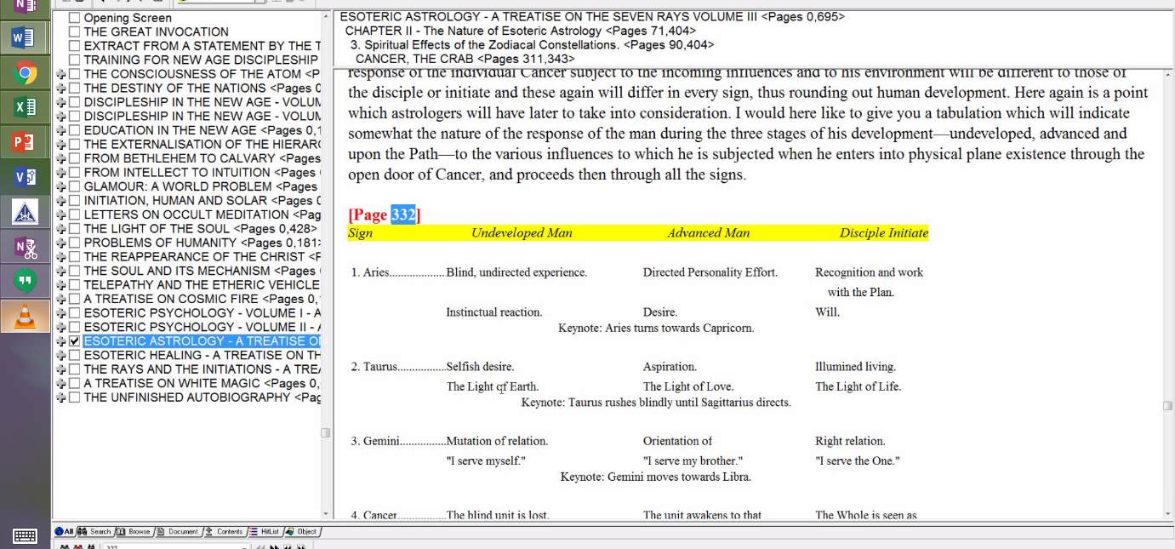

There are different phases at which the signs do work. And we can look at all of the signs of the zodiac in terms of the undeveloped man, the advanced and the disciple initiate which in a way means we can consider them in terms of the three tiers of petals. I have gone over this extensively in the discussion in Esoteric Astrology, but this has to be done with respect to the Egoic Lotus and the petals. You can see how blind, undirected experience of undeveloped man would be very much associated with the 1st petal. But directed personality effort of advanced man with the 5th petal and recognition and work with the Plan we can associate with the 9th petal and all of them under Aries you see. Yeah, I'm seeing different connections here that I have not seen before and maybe we will have to examine this particular table in that light.

22:04 So this crisis of orientation occurs I think very much at the 5th petal where the apotheosis of that elemental we call the triple personality or four-fold, depending on how you want to look at it, that occurs in the 5th petal and the man begins to seek the path to the Higher Self. Now we also know that Libra and Leo are involved with that reversal of the wheel. Leo of course is associated with the 5th petal, but I also think as I try to explain that Libra should be as well because the 5th is the very central petal of the 9, and Libra is so often considered the pivot and the place of centrality, the place of neutrality where one is pulled equally towards the elemental and towards the spiritual life.

Uranus is involved in this reorientation and Uranus is the hierarchical ruler of – It’s really interesting; I just realized something - Uranus is involved in the crisis of reversal. Now several signs are involved as well and these are Aries, Leo, Libra, Scorpio. Those are the ones that I can remember that are involved in the reversal of the wheel. And isn't it interesting that Uranus is hierarchical ruler of Aries, the veiled hierarchical ruler of Leo, the esoteric ruler of Libra and the exalted planet of Scorpio. There is of course one more and that is Aquarius and I'm not sure how we would associate Aquarius with the reversal of the wheel, but certainly with the kind fullness we might say and with the sense of the wider life which begins to lure the satisfied personality away from its satisfaction. That is a kind of contributor to reversal as well.

Anyway, that of the signs which Uranus rules or has special significance within four of them definitely are involved in the reversing process. For Aries it's always a new beginning and this crisis of reorientation is occurring before the 1st initiation, of course, and it is a new type of life that is being led in pursuit of the higher of the pairs of opposites by whatever name that one of the pairs of opposites may be called. Whether the soul or higher power or maybe the inner god or maybe even God and it's always something higher than what one is doing and Aries gives that reorientation. Now interesting that it's opposite sign, Libra, does the same. So maybe we can find a way to associate Aries even with this 5th petal. Scorpio already is, isn't that interesting because of the three water signs: Cancer we connect with the 4th, Scorpio with the 5th petal of reversal and then Pisces with the 6th petal which is the transition point into the world of wisdom.

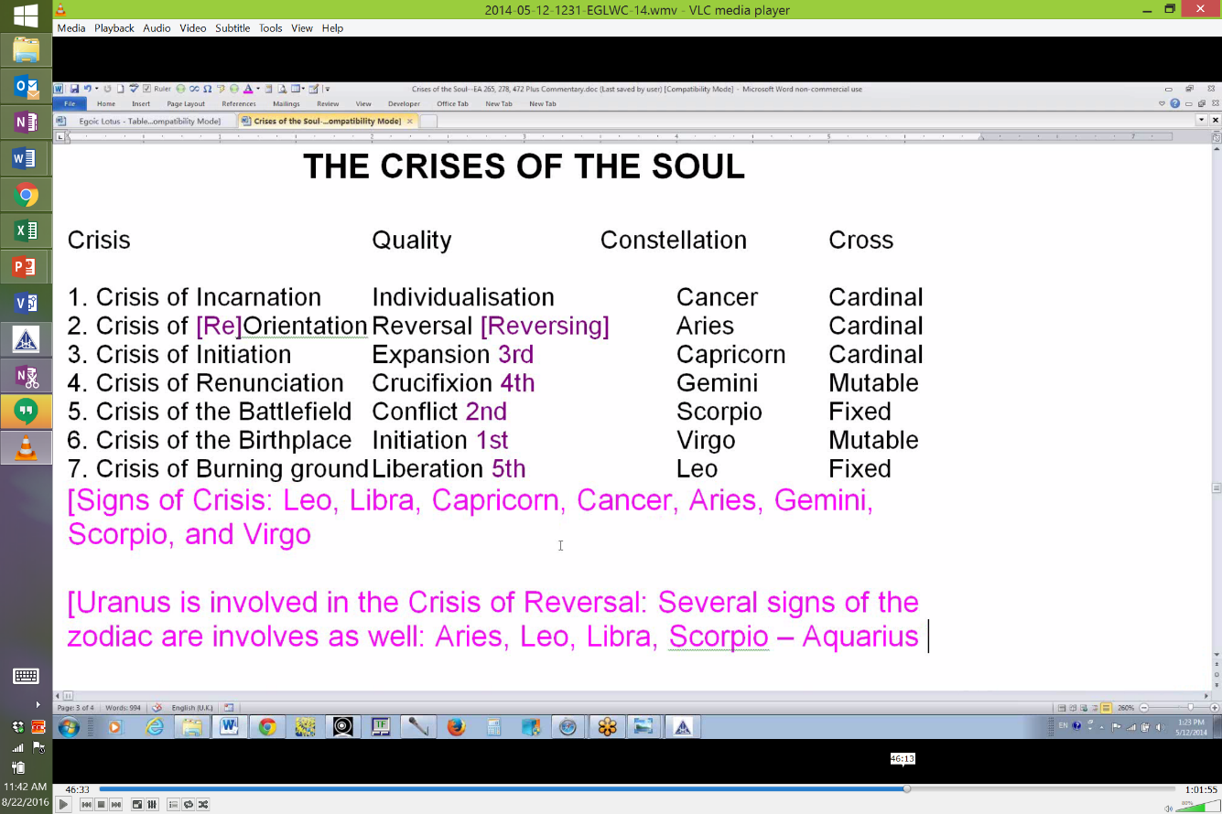

3. Crisis of Initiation Expansion Capricorn Cardinal

26:16 The crisis of initiation, that's a repeat in a way of what we studied above when we studied Leo, Libra and Capricorn and it is ruled by Capricorn and its quality is expansion. This is interesting, because when you think of Capricorn usually from the exoteric perspective it is ruled by Saturn in two modes and Saturn is not particularly a planet of expansion; it's a planet of testing what you have already achieved, and possibly it's a planet of reduction until a correct and solid state is reached which can be depended upon. But overall Capricorn has more to it than Saturn. It is a constellation or sign through which the 1st, 3rd and 7th rays are expressed and the 1st and 3rd can give much of the quality of expansion. Anyway, it has to do with enhanced vision from the top of the mountain and not only enhanced vision but enhanced capacity.

I am labeling the initiations because a number of these crises now are having to do with the initiations and so this transfiguration initiation where the light value within the man emerges dramatically is one that gives expansion of the causal body, expansion of understanding, expansion of the scope of power. Altogether it raises man out of his ancient subservience to the personality elemental. It's not complete there, but there is at least the wider world in he lives. The man then technically lives within the causal body and when we wish to speak of what it has to do with the Egoic Lotus, this crisis of expansion has everything to do with the 9th petal - the completely unfolding of which signals the 3rd initiation.

4. Crisis of Renunciation Crucifixion Gemini Mutable

Now we move further on and note an interesting thing, that the crisis of renunciation or crucifixion is connected with Gemini and of course it is the 4th initiation. Now Gemini is ruled by Mercury which is one of the two planets giving us the 4th initiation. Saturn also has a special function in Gemini allowing the individual to face the dweller and at the 4th initiation it's not just the individual dweller anymore, it's the dweller provided by humanity. So both Mercury and Saturn have an interesting relationship connected Gemini. Mercury will take the man onto the buddhic level which is the 4th level and which is the right of all crucified individuals, those who have gone through the great initiation - it's their right to enter that buddhic plane as their point of polarization. We could say that through Gemini the greater brother definitely assumes complete ascendency, but in this particular case it's going to be in a way the spiritual triad following the 4th initiation, the 2nd aspect will be taken by the spiritual triad.

30:39 Another way we can say is that duality is resolved at the 4th initiation and the earlier splits that a man had achieved are seen within a fluid synthesis and a great 2nd ray will enter because it is the heart center which will be particularly stimulated in a higher way than the 1st initiation at the 4th initiation. So Gemini and the heart center and the 2nd ray are all involved here. It is however an initiation ruled by the 4th ray and there again the 4th ray is coming in from one of the rulers of Gemini and that is Mercury.

I would also like to mention that Gemini is the head of the cosmic Christ and we can say that when one enters the crucifixion one is really entering through the heart into the 2nd aspect of divinity. So the Christ connection there is very important. It is actually in a sense the initiation with which the image of the Christ is most associated. Of course the resurrected Christ, the Master, and even the higher Chohan is known to esotericists. The resurrected Christ to humanity but if one wants to go to the Christ experience, this crucifixion is needed and it is the utmost sacrifice in the spirit of love and there comes the 2nd ray of Gemini and the idea of Gemini's connection the head of the cosmic Christ.

5. Crisis of the Battlefield Conflict Scorpio Fixed

"The crisis of the battlefield." Well you know right away we recognize Scorpio of course, the great warring sign most associated with the 2nd initiation and it really is conflict between the soul and the personality in three different levels. Maybe the most arduous level is the emotional level and that is why Scorpio is most associated with the 2nd initiation. This is fairly straightforward. Where will we find that? Well when we go into the petals of the Egoic Lotus we are going to look at petal #8, which is the Scorpio petal. We are also going to look at some of the battles that occur in petal #5 between the Higher Self and the lower self - the higher of the pairs of opposites and the lower. It's also a Scorpio petal and D.K. talks about lives of turmoil there.

33:46 This will lead finally to the 1st initiation in which Scorpio is also involved and then a deeper psychological crisis, many forms of mastery - Scorpio is a sign of mastery in a way; it's a sign of control certainly. It's not only a 4th ray, it has a lot of the 1st ray in it. It is after all the sign of Hercules. So the mastery has to occur between the 1st and the 2nd initiation and that mastery is going to be worked on in the 8th petal which is the Scorpionic petal and when sufficient abnormal strenuous effort has been exercised by the man and when the emotional body, interestingly enough the purification of the emotional body can be connected with petal #6, after all the emotional body is petal #6, petal #6 is a Virgo petal with a lot of the 6th ray in it. So we have a process of mastery going on, under Scorpio, the astral body is being mastered. And then when sufficient work has been done in the Sacrifice petal of love which is the Scorpio then the rod of initiation will then again be applied by the Christ and the 2nd degree initiate will stand forth and the unfolding of the 6th petal will indicate that a great change has occurred within the astral body and there is plenty of the 2nd ray there now. It can reflect love.

We have to remember also that Scorpio is the sign associated with the buddhic plane. If we look at this chart:

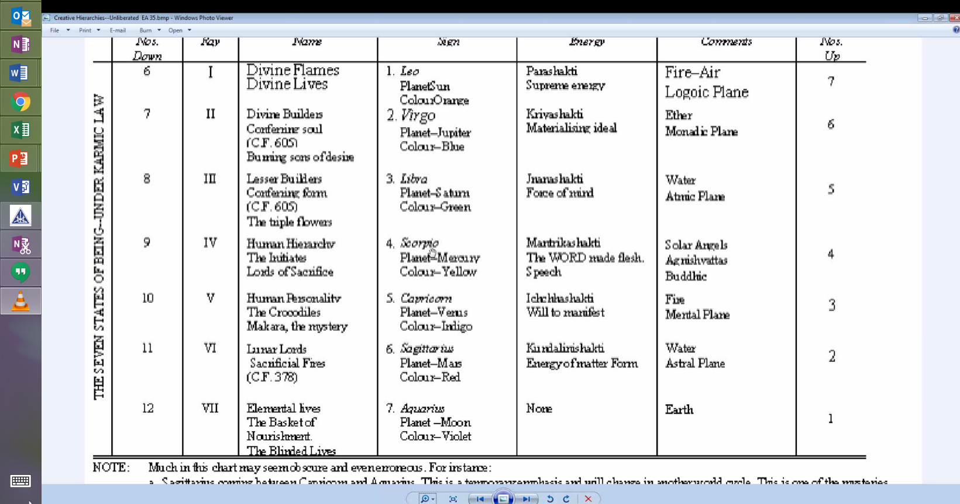

(EA 35) We see that Scorpio rules the human hierarchy and the buddhic plane and it is precisely the buddhic plane that we need its energy in order to transform the astral body at the 2nd initiation into an instrument of love rather than an instrument of desire. So in a way Venus is triumphing here and even though it's in detriment in Scorpio, it is controlling more the astral body and Mars is falling away even though it rules Scorpio. So the battles within the astral body per se are reduced at this point.

37:00 So when we are passing through this crisis of the 2nd initiation, much work can be done in the 8th petal and consummatory achievements occurring in the 6th petal which we can associate in a way with the purified astral vehicle. After all these three petals, 4, 5, and 6 are the petals of love for the astral plane and by the time we reach #6 ruled by Virgo, at least in one sense, we are going to have the necessary purification of that vehicle due to the many struggles under Scorpio which have been lived through. And when there is work being done in petal #8 and petal #6, we can't leave petal #7 out of it - the growing knowledge of how things really are, the knowledge of the Ageless Wisdom and of occultism and so forth are going to be active in helping the individual achieve his goal.

6. Crisis of the Birthplace Initiation Virgo Mutable

Then we look at the crisis of the birthplace and that is of course initiation #1 - there are a number of different signs that one can associate with that. We can associate Capricorn of course, the whole Christmas story and this is the birth of the Christ in the heart and the deity coming down into the densest form we might say and Virgo prepares for that. There is this whole gestation period which brings to birth in Capricorn and there is all different kinds of signs one can associate with the 1st initiation for different reasons and we will discuss that as we are going through the petals, but you know Leo is involved, a new identity, the birth of the Christ. Aries, it's a new beginning. Gemini, D.K. definitely connect Gemini with the 1st degree because a relationship is now set up between the Christ self and the personal self and others as well of course. We will discuss that as we go.

39:40 When is this 1st initiation occurring in terms of the Egoic Lotus petals? It's occurring when work is being done in the 7th petal, the mind is expanding. All knowledge that one has is being used, continuing work on purification in the 6th petal is occurring and what happens is the 5th petal which is in a way a petal of identity, either personal identity or a new kind of identity which is more identified with the higher of the pairs of opposites, that 5th petal is a time when identity emerges. So when it is completely unfolded we can judge that the man is the aspirant and has visioned a Higher Self, is increasingly identified with that Higher Self. I do kind of wonder what the Egoic Lotus would look like for one who chose to continue along the path of selfishness and continued to emphasis the lower Leo which has been associated with the black lodge and with materialism. And it's so interesting that certain places were the black lodge really emerged have had a powerful Leo component to their energy structure. You just look at ancient imperial Rome, that is one of them where Leo is so powerful - you know the whole idea of the emperor emerged, the sole authority.

Also, when we are looking here for Leo we find France with its Leo personality and at the time of the French kings, it is said that the black lodge was active. Then you look at Germany. It's not a Leo country, but its leader was powerfully Leo, Leo was so strong in his personal horoscope having Saturn elevated in Leo and also D.K. says that even more significantly it was powerful in his horoscope and related to his soul. When we talk about soul, even those who are tending towards the black lodge have soul - it is consciousness. And human beings even on the left-hand path have developed the causal body to a certain extent. They can even reach the 2nd initiation and that would mean that 2 tiers of petals would be unfolded for them and one wonders if the 2nd degree initiate who is correctly tending and the initiate who is tending off towards the black lodge, both having taken the 2nd degree, would their, in some technical way that we don't know, would their Egoic Lotuses look different from each other? I mean this is a very technical question. You know you have to have a certain amount of the love energy developed. Of course D.K. says love is not the word, really, and he begins to talk about magnetism and how magnetism can be used either for good or for ill. So we can understand the magnetic power of the 2nd tier of petals in those who are tending toward the left-hand path.

43:17 But it always seems to me that they would draw more upon the Knowledge tier than upon the Love tier, and yet because some of them can even be 2nd degree initiates, they have to have completely developed the Love tier and the amazing thing to me, at least, since Christ is the initiator and let's look at the modern members of those who are on the left-hand path, they have to have stood before the Christ and they have to have been blessed by the Christ and loved by the Christ, two times unless I am missing something here, because they can even be initiates of the 2nd degree. And yet because free will is as it is, they still have the power to embrace the Dweller as themselves rather than turn away from it. They just don't pass the tests in the desert - of the world, the flesh and the devil, albeit on a lower turn of the spiral than the Christ in the body of Jesus was encountering this, but still for the human being significant. They don't pass those tests and in a way D.K. says they become the Dweller, the manipulator of souls on the 3rd ray, the deluder of souls on the 2nd ray and the destroyer of souls on the 1st ray and you know you kind of look at Hitler and it seems, well maybe Goebbels was the manipulator of souls. I don't know how advanced he was. He was a Scorpio with Leo rising of all things and Hitler more along the line of the destroyer of souls, it seems to me with his definitely I would say 1st ray soul.

45:11 Well maybe a little bit of a deviation there, but you are looking at the causal body here and you are looking at these initiatory crises that people are going to pass through and you want to know what area of the Egoic Lotus is involved when these crises are the focus of the life of the man passing through them. So many of us as disciples and probationary initiates are passing through the 1st and 2nd degree on the way to the 3rd degree and we will experience these crises and within our Egoic Lotus the development will occur. When the days of clairvoyance are with us we should be able to look at what is going on in the Egoic Lotus and well I suppose you could even see it in the chakra system of the etheric body but you could look in the Egoic Lotus and you could see what crisis of initiation or preinitiation is occurring. Now we go onto to yet another.

7. Crisis of Burning ground Liberation Leo Fixed

﻿﻿And this is the crisis of the burning ground. Liberation well that is not the crisis. It's almost like Leo was the beginning and the end. Leo signifies the entrance into the human kingdom and Leo is said to be the most human of all the signs, so in the other series of three crisis we have the crisis of individualization, really I think that Cancer and Leo together are very much involved in this individualization process. So that was one place that Leo was occurring.

We also know that when you are taking the 1st initiation, Leo is the sign to watch for because people tend to take the 1st initiation in that sign or under that sign. I think we could find a way in which Leo and the Sun are involved in all the initiations. The kind of illumination that occurs at the 3rd degree is a definitely solar and Leo factor - the great enlightenment with both of them being the symbol of enlightenment and Leo having the will to illumine and emerging as a loving being whose astral body can reflect the qualities of the heart rather than just the solar plexus. This is Leo at the 2nd initiation with the Sun and there is great destruction of a lower part of Leo in the Sun at the 4th degree, and so I wouldn't be surprised to see it showing up in the horoscopes of people who are taking the 4th and certainly and here we are now, the crisis of the burning ground.

48:16 This, to me, is the 5th degree. The constellation is Leo, okay. It's not that you cannot experience the energies of the fixed cross once you have destroyed the causal body, no. The energy of all of these crosses can appear in much higher mode. And so what is this burning ground? And what is being burned away? Well it's not just the causal body. I mean from a certain point of view, the causal body is being burned away and there are various modes of destroying the causal body. Not all of which seem to be akin to burning. For the 6th ray causal body, self-emolation or immolation is the way to go, but there are other methods of destruction. To me it looks like the burning ground, purging oneself of all human limitations as one prepares for the great revelation of that which lies beyond including a revelation of the cosmic path which one will have to prepare to travel. In the earlier days, everything keeps rising in demand and requirement, but in the earlier days it was at the 5th initiation that one made that choice about which of the cosmic paths one would be taking. Now that is at the 6th, the choice is made, but the revelation of what they are and what it takes to tread them and how to prepare and all of that, that is occurring at the 5th initiation.

50:06 Liberation is very interesting here. There is a kind of liberation that occurs at the 4th degree. But he's not calling the 4th degree liberation here. It's crucifixion. And there is a lot of fallout. There is a lot of debris from the destruction of the causal body. It has to be cleared and everything has to become less and less distorted by even the previous human perspective and all that which remained of the previous structures have to be cleared away or maybe we can say burned away. A final burning. You know the path that leads from the base of the spine to the top of the head is here involved, because it's at the 5th degree that we would expect a great flourishing of the top of the head. The 5th initiation is still administered by Sanat Kumara in his mode as Uranus and Uranus is the veiled hierarchical ruler of Leo and, of course, it is the planet of liberation par excellence. And at the 5th degree Pluto is the main chakra to deal with which is the center of will.

Well we have a burning ground in a way, created from the chakra of will, ruled by Pluto all the way up to the chakra of purpose which is ruled by Uranus at this time. So Uranus will be at least a ruler of the highest center and there must be a burning - it's not the little burning grounds that we experience before the lower initiations which burn away from us the dross which keep us from resonating with that which is on the further side of the door. This is a final burning and I believe - if I check this out -

"Uranus leads the soul to the burning ground during the final stages of the Path, when the fire of Aries and the fires engendered through the potency of Uranus produce the flaming heat of the final burning ground. Through this burning ground, the initiate has finally to pass. Uranus rules the occult Way and is, in an esoteric sense, connected with the Hierophant of the Mysteries of Initiation." EA 100

. . . the potency of Uranus produce the flaming heat of the final burning ground. Well in this series of initiations at least it is so. The flaming heat of the final burning ground. Uranus leads the soul to the burning ground during the final stages of the Path,. . . ﻿﻿we can consider that leading to Mastership. There are other stages of the Path and Uranus will also be involved with the burning ground which can bring about resurrection at the 7th initiation along with Aries, the sign of resurrection. . . .when the fire of Aries and the fires engendered through the potency of Uranus produce the flaming heat of the final burning ground. ﻿﻿Through this burning ground, the initiate has finally to pass. Uranus rules the occult Way and is, in an esoteric sense, connected with the Hierophant of the Mysteries of Initiation. ﻿﻿And especially with Sanat Kumara even though Saturn and Venus are so much connected with him.

53:52 Leo, it seems to me, rules the burning ground that precedes the 5th initiation. Aries rules the burning ground which precedes the 7th initiation, and maybe D.K. does mean here, by final burning ground, the burning ground before the 7th degree, but we are only considering five initiations thus far, and it seems to me that Uranus veiled in Leo by the Sun is also involved in this very intense burning ground which basically signifies the culmination of kundalini rising from Pluto to Uranus, giving us, well, it's going to be liberation from the 4th kingdom of nature. We don't have to incarnate anymore when we are initiates of the 4th degree unless we do so by an act of will, but it seems to me that the Master stands as the apotheosis of what the human being is. And he is liberated into his full humanity and at the same time liberated from any of the limitations of humanity as he sets off on the path to become a Chohan and of the Chohans, D.K. says, they are no longer men as are the Masters, by having passed beyond that lesser stage have linked themselves to the Great Council in the highest, secret place.

So we see a very different Leo here than the Leo of individualization, than the Leo of the 1st initiation where we are entering for the first time the realm of the soul, entering into the Hall of Wisdom, however tentatively, and then the Leo of the 5th initiation. There is also another Leo, maybe four stages: the Leo of individualization, Leo of magnificent personality expression, at the 5th petal where the man becomes colossal in the words of D.K., the Leo of the 1st initiation where you begin to change your identity and enter into the aspect of the Son. The three fire signs - Aries the Father, Leo is the Sun Son and Sagittarius is the Holy Spirit, the personality and so forth. So we have Leo fittingly connected with the aspect where the Son comes into play as the growing and major source of inspiration and source of attraction. And then, we have Leo at the 5th degree, the 5th sign, 5th degree. The symbol can be the Son, the symbol for the Master. Leo indicates the blazing Mastership of the man who has achieved the 5th degree and the revelation in the light which has come to him.

57:17 In some of these later ones we don't imagine that the causal body will have much to do with the process because the causal body will have been destroyed, but in the final burning ground all of the vestiges of what it meant to be confined to the human race have to be burned up. This final burning ground is in a way the path of the fire between the base of the spine and the highest head center and then all of the energies are focused in that highest head center, which is interestingly connected with the atmic plane, which is the plane which signifies the achievement of Mastership just as the monadic plane signals the achievement of Chohanship.

There is a lot here and basically you see what we are trying to do. We are trying to look at crises. Let's just review them very quickly. The crisis of incarnation, individualization, constellation Caner. Crisis of orientation, or reorientation - quality reversal - Aries. Crisis of initiation, expansion, it's the 3rd initiation, constellation is Capricorn. Crisis of renunciation, crucifixion is the quality, 4th initiation, and the constellation is Gemini. Crisis of the battlefield, conflict. It's the 2nd initiation and Scorpio is the sign. Crisis of the birthplace - the very first initiation, and Virgo leads up to that and several signs, including interestingly enough, Leo and Capricorn and even Libra, again all of them we can find at that 1st initiation because Libra is going to rule the sacral center which has to be lifted to the throat and Leo entering the new Kingdom and Capricorn the 1st of five initiations - it being the major sign of initiation. So you see how combinations of signs can be discussed in different contexts and in relation to different phases of human unfoldment and then the crisis of the burning ground. Maybe we cannot call it the final burning ground because maybe that is before resurrection, but it is leading to liberation from the human kingdom as a Master.

Okay friends. We will go onto something else very shortly. We have this Egoic Lotus table and I'll have to choose one of these for further discussion. I think the Centers and Discipleship would be a good one. What we have done right now is Crises of the Soul and for the moment we are complete with that even though there is always so much more one could say if one studied the subject exclusively. We are trying to study this subject in relation. That is our work. I will just say that this is the end of Egoic Lotus Webinar Commentaries program 14.

