EGOIC LOTUS WEBINAR – 2, Michael Robbins

Abstract

Egoic Lotus Webinar Commentaries 2. This webinar is about 1 hour long. Review of the Structure of the Egoic Lotus; continued discussion of the types of egoic lotuses; various divisions of these types kept in the records of the Department of Karma; reading of the ten categories of soul development.

Contents

Abstract 1
Beginning of Egoic Lotus Webinar Commentaries Program No. 2 – EP II 203 1
Illustrations of the Egoic Lotus 1
The Names of the Lotuses (cont. from Program 1) 10
10 Premises of Basic Occult Teaching 18
The TEN GROUPINGS That Arise Out of Awareness Expressed 20
Closing with the Great Invocation 24

Beginning of Egoic Lotus Webinar Commentaries Program No. 2 – EP II 203

Now, we are beginning with our Egoic Lotus Webinar Commentaries Program No. 2. We had reached around page 203 of Esoteric Psychology 2. It is not so easy to give you the page numbers because I am doing this in a different way. And we are beginning with Program No. 2 at approximately EP II page 203.

Illustrations of the Egoic Lotus

I wanted to go once more into this illustration of the Egoic Lotus –

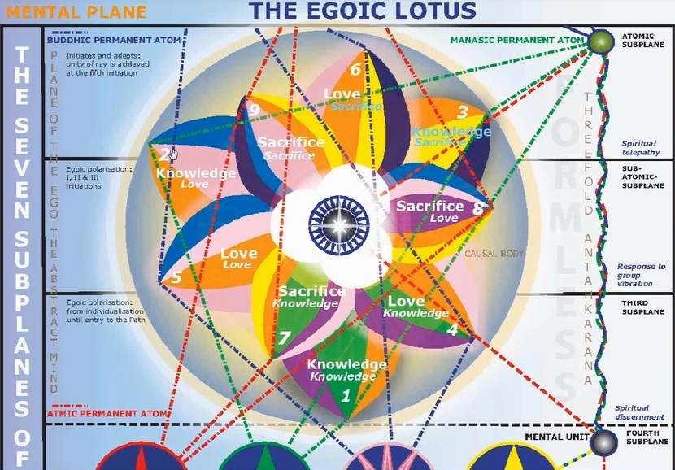

You may have noticed that I tried to call it to our attention that – in the original book, A Treatise on Cosmic Fire – this kind of detail is not given. What is given is Chart IX. What is given is actually incorrect, and not in detail –

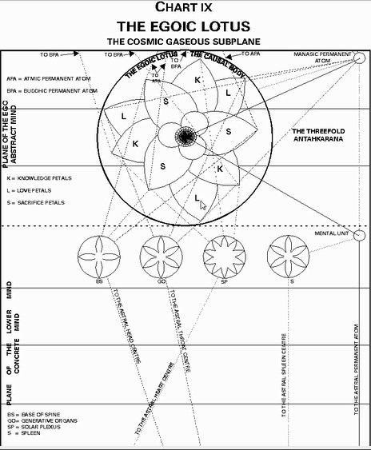

You will notice that the Love petals appear to be the largest petals that are on the outside. Then comes the Knowledge petals. This is a mistake.

These that say “L”, should say “K”. And these that say “K” should say “L”.

The one thing that is important about this Chart is that it shows us that:

.

One Love petal touches the 3rd subplane of the Mental Plane
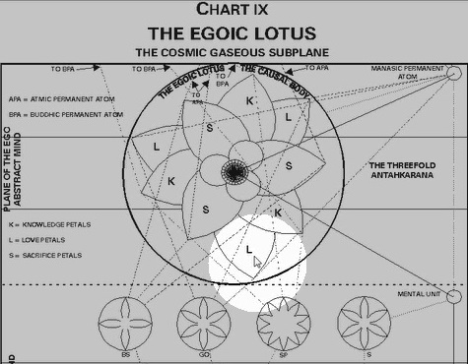

Another, the 2nd – it is on the border of the 2nd.
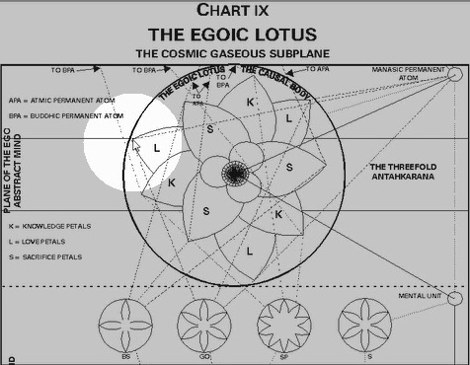

And another, the 3rd.
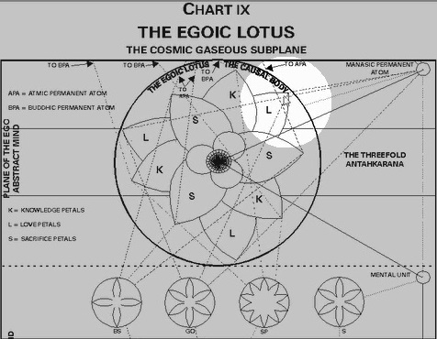

And thus, it is with the Knowledge petals –
The 3rd,
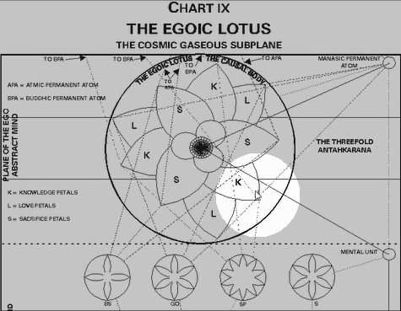

The 2nd,
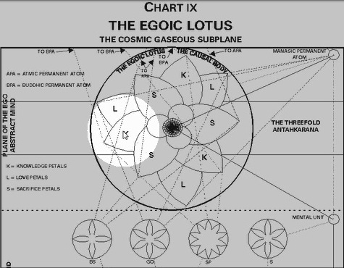

The 1st.
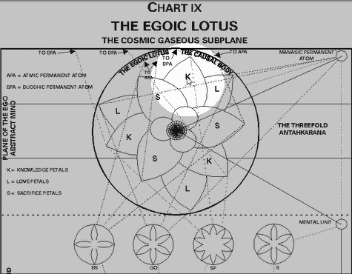

And the Sacrifice petals –
The 3rd,
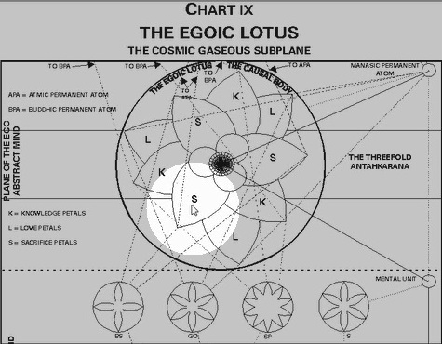

The 2nd,
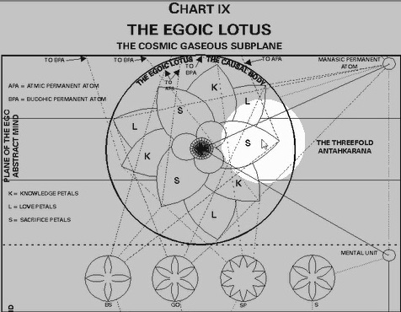

The 1st.
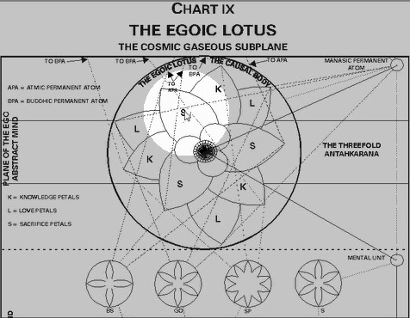

02:02 Now, when these diagrams were first rendered a long time ago, I think a mistake was made. Because it does seem that a type of rotation is suggested from the first – well, this ‘L’ should be a ‘K’ – Okay. Let us imagine it is a ‘K’ –

‘K1’ to ‘K2’ to ‘K3’.

And that tells us that the rotation is clockwise.

‘K’ should be ‘L’

And then this case should be an ‘L’. But notice again, it would be like from – L1 to L2 to L3.

Again, clockwise or the reverse direction of the normal zodiac. In other words, as if going from Aries to Pisces to Aquarius and so forth. However, the Sacrifice petals, and these are correctly drawn in their place, because they are the smallest of the nine. . .

Goes from S1 to S2 to S3.

From the 3rd sublevel to the 2nd sublevel to the 1st sublevel. And these appear to be going in a counter-clockwise order in the direction that the normal zodiac proceeds.

Eventually the Synthesis petals will also be turning, and they will be turning in the direction different from the turning of all these other nine. So from one perspective, it seems that all nine turn in the same direction which would be clockwise. But from the way this diagram is set up, it does appear that the Sacrifice petals which are more closely allied with the inner group of Synthesis petals is turning in a counter-clockwise direction because we would always move from the–

- Sacrifice Knowledge to
- Sacrifice Love to
- Sacrifice Sacrifice.

So, there is something to be sorted out there. But I just want us to be clear about how the diagram actually reads. Now, this is the corrected diagram from the way it was first rendered more than twenty years ago. –

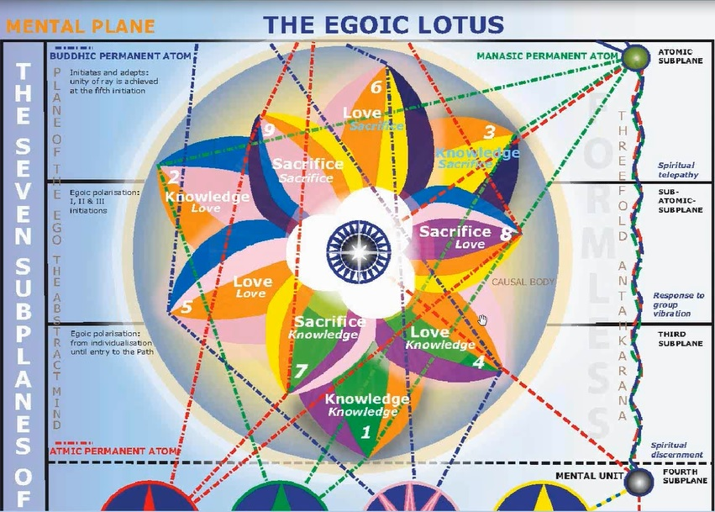

And here, we find that the Knowledge petals are in the correct place. They are the outer and the largest group. And they have only three colors. They are 4, 5 and 6, they are also turning in a clockwise direction. So it appears. And they have four colors. But notice that whereas in the first program, we used the original by mistake and not the corrected version.

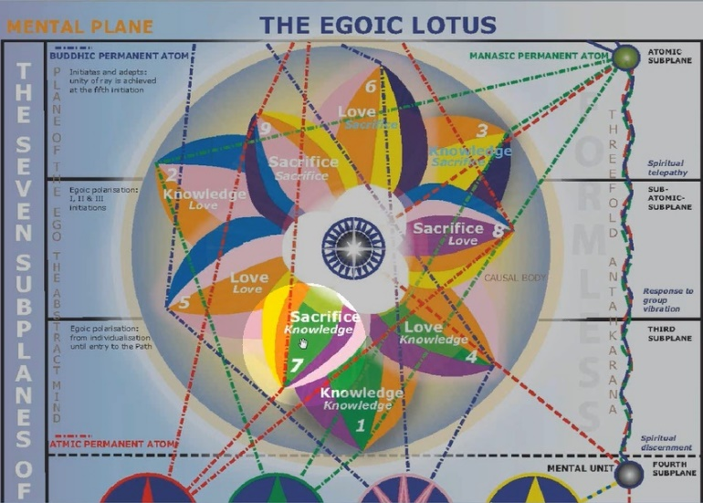
What I am pointing to here was called petal 8.

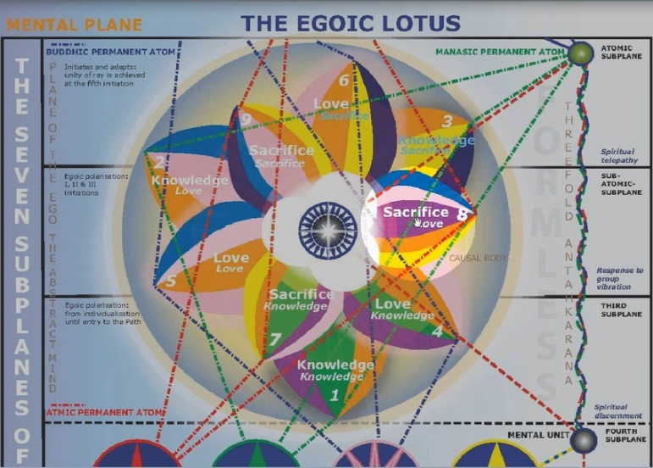
And this was petal 7.

These two were reversed.

We cannot begin with Sacrifice Love.

We have to begin with Sacrifice Knowledge.

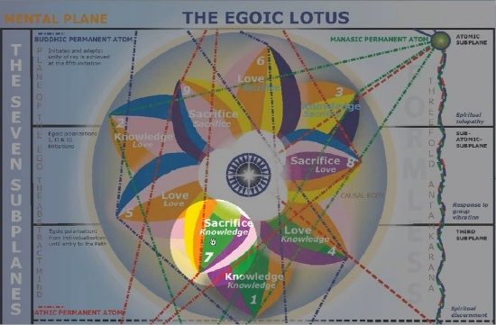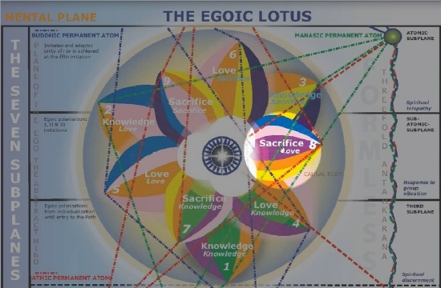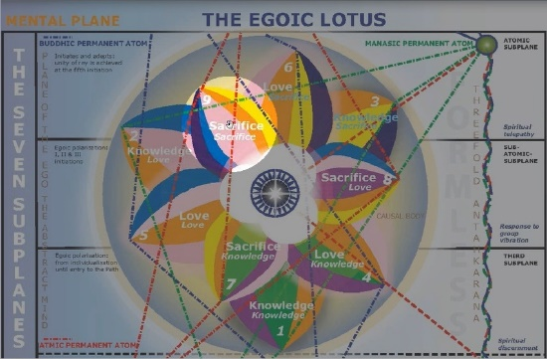

And so, this must necessarily be petal 7. Then Sacrifice Love, petal 8. And then Sacrifice Sacrifice, petal 9. So, the direction implied here is a turning in the counter-clockwise or ‘Proper Zodiacal Direction’. The direction of what is called the ‘reverse wheel’.

No indication is given of the innermost petals, which are called Synthesis petals. And they are said to be of a lovely lemon-yellow hue.

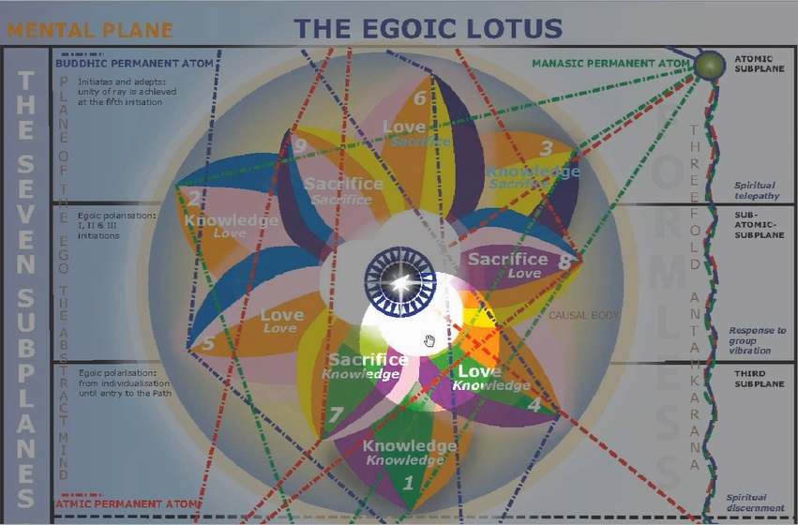

And so we have the Synthesis of Knowledge, the Synthesis of Love, and the Synthesis of Sacrifice. They are all seem to be centered in the central subplane. But perhaps, that is not so. Perhaps in a way, they do touch the lower subplane for Synthesis Knowledge, the middle subplane for Synthesis Love, in the upper subplane for Synthesis Sacrifice.

Anyway, there are many details of this which remain to be filled in. But this is the diagram we will be using in case there was any uncertainty. I had mistakenly pulled up the old diagram. But it did made the point that –
We cannot begin when all the other petals seem to begin with the Knowledge subpetal.
We cannot begin Sacrifice with the Love subpetal.
It would not be consistent.

The Names of the Lotuses (cont. from Program 1)
(A Summary of Previous Program EGLWC-1 Types of Souls or Lotuses, EPII 202-203 / TCF 855-857)

06:51 Well anyway, we are here at a point – we are continuing – talking about the names of the lotuses:

- We have discussed the highest name – at least given to us. The Lotuses of revelation around the period of the 3rd degree and beyond.

- The Lotuses with perfume around the period of the 2nd degree and beyond.

- The Radiant lotuses around the period of the 1st initiation and beyond.

- And then some of these interim states where lotus are on the point of opening. How does that say here? Lotuses wherein the flower is on the point of opening and we have related that mostly to the outer tier where one of the minor initiations – not one of the great manasic initiation is being taken.

- And then Lotuses of closed and sealed condition which are not unfolded but are being at least organized. So, let us just say that the outer group of petals, the Knowledge petals are at least being stimulated and organized but not unfolded, in general.

- And then The colourless lotuses which suggest that the lotus form is there but no quality is built in.

- And the Lotus in bud which is the condition of complete folding in upon itself at the time of individualization when the lotus is first created by the combined efforts of the Solar Angel and the Monad, the human Monad.

So now, we are going to go on and a little bit more is being said about the lotuses.

“They are grouped also according to primary colour, to subsidiary colouring, according to key or tone, and one tabulation is entirely numerical. It might be of interest [Page 856] to the student if we here pointed out that in the Hall of Records in connection with the human Egos certain of the records under symbological terminology keep a minute account of the following facts concerning each unit:” — TCF, 855-856

They are grouped also according to primary colour, . . .Now, this is interesting when the word ‘primary’ is used. It could be a hint because the primary colors are three in terms of light. They are the red, the blue, and the green. With some variation there. But together, they all make white light. And sometimes, they say – you know, the color cyan for blue, and the sort of magenta is for red, and green for green. But basically the red, blue, and green. And sometimes, the primary ray. So the primary ray is the monadic ray, and the primary colors are red, blue and green.

So are we talking about the color of the Monad, or are we talking about the soul ray color? How they are grouped? Because they are, if possibly, classified in both ways.

They are grouped also according to primary color, to subsidiary coloring, . . . and you know, this could be monadic, the word ‘primary’ is so much related to monadic functioning. And subsidiary, this could indicate the color of the soul ray.

They are grouped… according to key or tone, . . .because every one of the seven colors has its appropriate tone. You know, we have discussed this before. But one way of looking at this, that HPB does, is that:
- Note C is related to Mars, and that is the ray 6. (red)
- Note D for the Sun or Vulcan and that is the ray 1. And the color orange.
- Red note then orange note then…
- The Note E is related to the color yellow and to the 4th ray, Mercury.
- And Note F is related to green and to the 3rd ray, and thus Saturn.
- And Note G is related to the 2nd ray, and to Jupiter – the major secondary planet.
- And the Note A that follows G is related to indigo. But in this case, to the 5th ray and to Venus – as the planet of 5th ray.
- And finally, the Note B is violet in color and related to the Moon – but really veiling Uranus.

12:11 We have gone over this before in the various discussions. So the primary color may be the color of the Monad and the Jewel in the Lotus will reflect or express that color of the subsidiary coloring – may well be the color of the soul ray. Because, you know, there are so many different personalities. I don’t think it is not that the Egoic Lotus will change color with every differing, varying personality ray. There are so many thousands of them.

. . .according to key or tone, and one tabulation is entirely numerical. Okay, well we will just have to take that at face-value. What could that numerical tabulation be? It could relate simply to the ray-number of the monad. The ray-number of the soul – maybe the ray-number of the personality ray of that particular time, and so forth. But if it was really going to pertain to the Egoic Lotus. I would think the important numbers would relate:

- To the Monad.
- Well, maybe to the major monadic ray, as I have discussed.
- To the minor monadic ray.
- To the numbers associated with the spiritual triad, which are largely 1, 2 and 3. And then, a subsidiary 1, 2, and 3.
- And then also, to the ray of the soul which is the same as the ‘Triadal Focus’ and especially with all the Triadal permanent atoms are of the same ray, but the secondary focus in the triad gives us pretty much the ray of the soul.

What the specifics are, we do not need to know at this time. It could only be a speculation, but at least, we understand that there is an organization here of these Egoic Lotuses, and a correct kind of classification according to the major energy constituents that lead to the creation of the lotus.

“It might be of interest to the student if we here pointed out that in the Hall of Records in connection with the human Egos certain of the records under symbological terminology keep a minute account of the following facts concerning each unit:” — TCF, 855-856

14:42 So, what we really come to understand here is that the Lords of Karma need detailed specifics regarding each unit so that karma may be properly apportioned. So, it is very specific, kind of, in a way, a 3rd ray department with all the details laid out.

“The lunar record. This deals with all the lower vehicles and forms, employed by the human Monads and concerns itself with:
a. Their rate of vibration,
b. Their type,
c. Their key number,
d. The particular group of lunar Lords who are concerned with those bodies,
e. The detailed history of the elemental lives who construct the bodies.” — TCF, 856

a. Their rate of vibration,. . . the rate of vibration of every one of the vehicles and its particular, I suppose, subplane focus. As each one of the subplane is differentiated by a different rate of vibration, a different color, a different musical pitch.

b. Their type,. . . I don’t know what is meant by the word “type” but usually, things are typed along seven different lines according to the ray.

c. Their key number,. . . the musical idea here. Because every one of these vehicles vibrates to different musical factors and there are twelve different keys, really – but there are seven major ones.

d. The particular group of lunar Lords who are concerned with those bodies,. . . And I suppose they can be classified according to their development, higher or lower.

e. The detailed history of the elemental lives who construct the bodies. They have been associated with a particular incarnating soul for many lives. So these have been associated with a particular incarnating soul for many lives. And they are gathered and re-gathered continually. These elemental lives, not necessarily the tiniest elemental life which are atomic. But let us just say that the elemental lives which constitutes the entirety of any particular lunar vehicle is gathered and re-gathered, associated with the incarnating soul at each point of that soul’s reimmersion into matter.

17:37 So I guess the important point here is to realize that records are accurately kept and all that which we are demonstrating through these vehicles are carefully understood. And their constituents – the constituents of each one of these vehicles – understood in a detailed manner.

“This information is employed by the karmic official responsible for the production of a new set of vehicles at each incarnation, in order to assist the working out of karma. The history of the lunar bodies is stored up in the permanent atoms.” — TCF, 856

This information is employed by the karmic official. . .It does sound like great bureaucracy, doesn’t it? But of course, it has to be operating in a way that is functional on the inner planes, probably different from our own outer bureaucracies.

This information is employed by the karmic official responsible for the production of a new set of vehicles, at each incarnation, in order to assist the working out of karma. So what you have here: Solar Angel’s directive, soul intention, if the Ego concern is efficiently conscious on the higher mental plane and karmic necessity. All of these are working out for the production of the particular vehicles that any incarnating soul will use.

The history of the lunar bodies is stored up in the permanent atoms. And this history can be read from there.

“The solar record. This deals with the more permanent egoic vehicle, and concerns itself with:
- The rate of vibration.
- The history of the petal unfoldment.
- The history of any particular group of solar Angels concerned with the formation of the lotus.
- The activity of the deva substance out of which the lotus is constructed.
- Group relationships.” — TCF, 856

The solar record. This deals with the more permanent egoic vehicle. . . There is also the solar record. And this concerns… deals with the more permanent egoic vehicle. And notice that it is just simply more permanent because this vehicle of the Monad is also temporary but of much greater and longer duration. Okay, so it deals with:

a. The rate of vibration. Probably of the different petals. What they have thus far achieved.

b. The history of the petal unfoldment. When certain changes and elevations and unfoldments did occur, in which particular incarnations.

c. The history of any particular group of Solar Angels concerned with the formation of the lotus. And this is such an important statement that shows that the Solar Angel is a group being, and let us just say there are more than one in each Egoic Lotus. And that is something that perhaps we have not been sufficiently aware of. There is an emanative situation going on there where one greater Solar Angel emanates – a number of them – and they are, each of them lesser Beings than the original. But they supervise a particular province of the Egoic Lotus.

d. The activity of the deva substance out of which the lotus is constructed. And this deva substance is going to be found differentiated on each one of the subplanes. So let us just say that we sometimes read that the Solar Angel produces the Egoic Lotus out of its own substance, but the substance of at least of the two higher mental subplanes is involved in this construction and not only the substance of the Solar Angel. So there is devic substance which pertains to itself. It is not Solar Angelic energy builds that deva substance into the form of a lotus, and the Solar Angel, or at least a portion of it, substands this deva substance and holds it in the form of an Egoic Lotus. And later of course, that form is dissipated with the final conflagration of the Egoic Lotus, and there is a separation of the substances. The Solar Angel as a substanding entity returns to the heart of the Sun. And maybe some of them to the central Spiritual Sun. And the substance of the higher mental planes which has been conditioned in a certain way, returns to its own reservoir.

And also, the elementals which consist of this minute deva substance, they are ready to move on into another category of impression and will be on their way toward maybe entering the Animal Kingdom.

e. Group relationships. What are the different Egoic groups that this particular Egoic Lotus has been associated with? There are different types of associations on the different planes, then if you look on Page 39 of Letters on Occult Meditation, you will see the different possible group relations especially on the higher mental plane when the Ego still exists and has not been destroyed. There are some associations on the buddhic plane but by, well, yes maybe we could say that – even when the Egoic Lotus has not been destroyed, its essence is a member of those higher groups. I think, to make the long story short I will just go to that particular place in Letters on Occult Meditation:

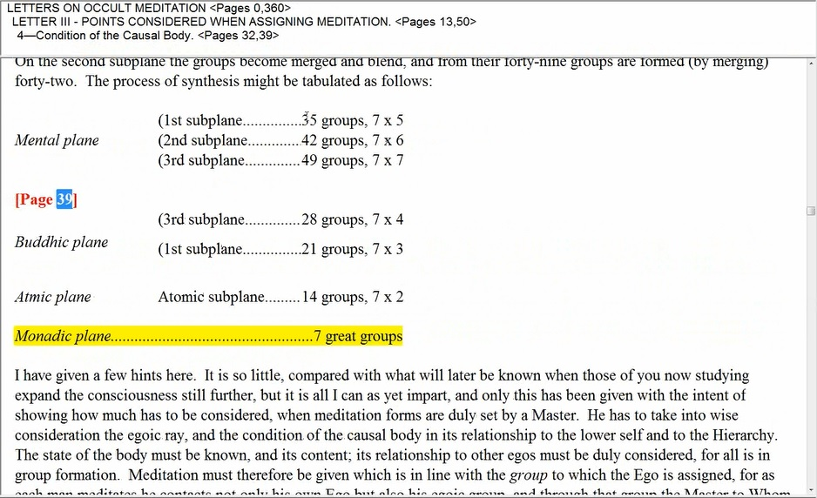

LETTERS ON OCCULT MEDITATION
LETTER THREE – POINTS CONSIDERED WHEN ASSIGNING MEDITATION
4 – Condition of the Causal Body
Alice A. Bailey

One of my favorite pages because it seems to describe group relations on these higher planes. We can see that pretty well for the 49 and the 42 groups for subplane three 3 and subplane two 2 the Egoic Lotus as we understand it will still exist. But, if you come to get to subplane one 1, there has been destruction, and there are groups, but the Egoic Lotus is not necessarily involved. I don’t think it is involved. This is a type of mental group in which the projected Monad finds its place after the destruction of the causal body though even while there is an Egoic Lotus, there may be a destiny, and a destination to be part of these 35 groups as well as of the 28 groups of the buddhic plane, and there are also the 21 groups on the highest level of the buddhic plane, and finally on the atmic plane, 14 groups, and finally the Monadic group.

All of these have our destiny as a projected Monad and we are part of these groups even though we have not risen to focus within them necessarily. The day of our focus within them will come with the rising of the consciousness which was focused in the Egoic Lotus. When the Egoic Lotus is destroyed, that consciousness will rise into these other groups, and probably sequentially, until at last, the day comes when that projected Monadic consciousness is focused in one of the seven great groups, and maybe even later into 1 of 3, still greater groups.

25: 54 So, it is the life essence which is confined in different kinds of vehicles. And the numbers of these vehicles are given – 49, 42, 35, 28, 21, 14, 7 and 3 as well, and then finally 1 – or maybe 2 and then 1. Those are not given here.

I hope that is, you know, somewhat clear: it has to do with our destiny. And where we as jivas or we as Monads in extension will be focused at various times of our development even after the destruction of the causal body.

“This information is used by the Master Who has made Himself responsible for the stimulation and the growth of any particular series of Egos, and also by advanced Egos who are consciously working with their group.” — TCF, 856

This information is used by the Master Who has made Himself responsible for the stimulation and the growth of any particular series of Egos,. . . Notice that the Masters are not necessarily concerned with just one individual, but perhaps with an Egoic group for which he is undertaken with responsibility.

. . . and also by advanced Egos who are consciously working with their group. So, if we are sufficiently conscious as an Ego to know what group we belong to, we can render clearer and more effective our various types of relations and our various types of activities that we are intending to carry out on the higher planes.

Interesting though that a Master is responsible for a series of Egos. One things of Master D.K. and the Ashram he has been gathering around himself since apparently 1875. I think that was when he began to gather his Ashram, well at least, he became a Master in 1875. Maybe the Ashramic gathering occurred more around 1925 and following. But a group of Egos was involved with him and is involved with him, and on the outer plane, there is probably a smaller group than on the inner planes. And so, a Master has wide responsibilities for a group of I won’t say personalities; I will say: Egos, Monads in extension on the higher mental plane, Monads in descent, Monads in immersion.

“The consciousness record. This concerns the response of the indwelling Entity to its surroundings. It deals with the utilisation of knowledge by the knower, and is in many ways the most intricate and the most lengthy of the records.” — TCF, 856-857

28:25
The consciousness record. Okay, that is still another one – and that is not a formal record, although it is related to form.

This concerns the response of the indwelling Entity to its surroundings. The response, in other words how are we doing in terms of our sentiency, our registration, that which we know, that which we feel, that of which we are conscious.

It deals with the utilization of knowledge by the knower, and is in many ways the most intricate and the most lengthy of the records. Oh my goodness. Well, these are just hints to show the kind of mind that is required to create and utilize these karmic records. He does not really say much here, does he? But there are, I think we have you might call formal records; they have to do with vibration, degree, formal unfoldment, the particular types of Solar Angels that are involved in petal construction, and maybe supervising petal unfoldment, devic substance, and so forth.

And then the consciousness record – this is more about the qualities that a person is building in and what the Monad in projection is capable of doing when confined in various types of substance. How masterful, how effective is this consciousness? What does it register out of all the possibilities of what it could register? Alright, well there is a lot to learn, is there not? Master D.K. has given us the ABCs, but for us, they sometimes seem like the XYZs. We will gather the information as we need it.

“These records are mostly used by the Lord of the World and His pupils to ascertain information in connection with the planetary centres. They are arranged in such a way that the entire record of any group, however vast and extensive, is embodied in seven sheets of symbols, each containing forty-nine symbols. These sheets are changed and corrected once every seven years, and are precipitated on astral matter by an effort of will by the Chohan responsible for the particular group involved.” — TCF, 857

30:33
These records are mostly used by the Lord of the World and His pupils. . . Now, who are the pupils? We could say they are high initiates and maybe Shamballic beings… But to a certain extent, if the hierarchy is the Ashram of the Lord of the World then all the members of the hierarchy are pupils in a sense of Sanat Kumara. Although those lives that are in Shamballa and are lower than the Lord of the World I mean, that is almost all of them, but there are certain representatives from other places which might be quite high in their development. But anyway, some of the Shamballic lives are his pupils, as well. So they are used by the “Lord of the World” and his pupils…. . .to ascertain information in connection with the planetary centres. So, we might say larger areas of unfoldment are the focus of attention. And the development of the human beings tell these higher lives something about these larger areas of focus within the planet. Well for instance, humanity is such a center within the planet. And all of these details can tell us something about the unfoldment of humanity.

They are arranged in such a way that the entire record of any group, . . .This is amazing stuff, you know. I remember, well, I went through Cosmic Fire a number of times listening. And then, also writing and that took years. And then at the end, speaking a bit. I could go through again and again.

They are arranged in such a way that the entire record of any group, however vast and extensive, is embodied in seven sheets of symbols, each containing forty-nine symbols. So, what do we have here? 343 = 7 x 49. 343 symbols. Apparently, that number is going to be important. It comes out to 10, as we see. So 7 x 49 is 343. 7 x 50 would be 350. Okay.

These sheets are changed and corrected once every seven years, and are precipitated on astral matter by an effort of will by the Chohan responsible for the particular group involved. So these appear to be ray groups. Well, this is fascinating information, and it tells us about what lies beyond or behind the development of any Egoic Lotus. It is a tremendous science being exercised here. And a type of knowledge far beyond our ken – and it is detailed knowledge. Let us just say that our development is known. Nothing is left to chance. We are well in hand. And every detail of every vehicle that we have is understood from a number of different perspectives.

33:59 We simply use these vehicles; we are in them. We don’t know how they are constructed. Solar Angels, you know, are initiates of a very high degree, already from a previous solar system, already trained on Sirius. Their method of construction using the various devas transmitting, and building, and manipulating, and so forth, is far beyond our knowledge. But these are not chance vehicles, they do represent the entity which we are. They represent opportunity which is to be provided for us. And karmic liability, and they represent the different groups in which we find ourselves, inwardly divided along qualitative lines.

So, nothing is left to chance in this system of vehicles. And the great inner science of the high initiates is operative here.

Actually what I have here is I have really dealt with what is at the end of page 202 and 203. Then I branched out to another document in which I had made some comments, and I pulled in some references from A Treatise on Cosmic Fire as well. If I go on with the original document, which began at Page 200 and it goes to Page 214, here is where we find ourselves at this point. So, we could say here returning from the related document discussed, with amplifications from TCF – A Treatise on Cosmic Fire.

Okay, so we will then go on with this document. We do remember, there are quite a few foundational documents that we need to look at before we can really put together all these information on the Egoic Lotus. We could simply if we wish to study the Egoic Lotus in or of itself. But it has so many interesting relations to the different aspects of the human being’s development, that we should look at these aspects as clearly as we can before we really start to put all the information together on the lotus, because I am interested in demonstrating how many different types of energies come together to create this unfoldment and how the different stages in the human being’s life are indicated by the unfoldment. So, it ends up to be quite a large and ramifying subject. It’s of the nature of a synthetic subject. You know, maybe indicates a little bit of unfoldment of the Synthesis petals putting this information together, so that a network of relations making a whole is demonstrated.

Now what we are really looking at here, let’s remind ourselves, we are interested in the occult teaching on the soul, basically.

10 Premises of Basic Occult Teaching

“The occult teaching accepts all these hypotheses as correct, but as relative in time and space, and as having reference to different forms of divine life and to differing aspects of those forms. It is with the occult teaching, right or wrong, that we are at present engaged, and our premises and conclusions can be stated in the following propositions:

“1. Every human being, in or out of incarnation, is a "fragment of divinity," and an outpost of the divine consciousness, functioning in time and space for purposes of expression.

2. All these souls, selves, or human beings are found, as we have seen, on one or other of the seven emanations of spiritual energy, issuing forth from God at the beginning of an era of creative activity. They return to their emanating Source when that particular cycle is brought to a close.

3. In the interim between emanation and reabsorption, these souls pass through various experiences until such time as they can ‘shine forth in all their exactitude of truth.’” — EPII, 202

1. Every human being, in or out of incarnation, is a "fragment of divinity," and an outpost of the divine consciousness, functioning in time and space for purposes of expression. So, we looked at the first. The human being is a fragment of divinity.

2. All these souls, selves, or human beings are found, as we have seen, on one or other of the seven emanations of spiritual energy, issuing forth from God at the beginning of an era of creative activity. They return to their emanating Source when that particular cycle is brought to a close. Every emanation here, every human being, every essential Monad in extension, is coming in on one or other of the 7 emanations, which means that the vehicles surrounding it are basically conditioned by one or other of the 7 emanations.

3. In the interim between emanation and reabsorption, these souls pass through various experiences until such time as they can ‘shine forth in all their exactitude of truth. And it is necessary that each one of these Monads in extension eventually ‘shine forth in all exactitude of truth,’ which means, to demonstrate its true inner name.

And then, we have discussed the names of these seven types or probably many more names but D.K. divides it, more or less, into seven categories. Three of them, dealing with the later phases of evolution, from the time of the 1st initiation, and 3 of them with very early phases of evolution. And only one of them, number 4, all the interim periods of unfoldment, for which, there are probably many names.

“4. They are called, as has been stated, in A Treatise on Cosmic Fire (page 855.)
1. Lotuses of revelation.
2. Lotuses with perfume.
3. Radiant lotuses.
4. Lotuses wherein the flower is on the point of opening.
5. Lotuses of closed and sealed condition.
6. The colourless lotuses.
7. Lotuses in bud.” — EPII, 202-203

39:24.3 And now, we continue with point five on the original list.

“5. These souls, cycling through various forms of life in the long evolutionary process arrive eventually at full, self-conscious existence. By this we mean that they are self-determined, self-conditioned, and self-aware. They are also conscious of and responsive to their environment.” — EPII, 203

5. These souls, cycling through various forms of life in the long evolutionary process arrive eventually at full, self-conscious existence. They are souls in incarnation. They are deeply immersed in matter. And they are not really self-aware, not understanding where they came from, but eventually, they realize that their essence, well, their more real life is found on the higher mental plane and still more real life on the monadic level.

So, they come to know who and what they are despite distracting pre-occupation with the outer forms. But eventually, the nature of the outer forms, when properly studied, reveals to every human being what he is, essentially, because the outer form is, basically constructed, built upon, what one is – in essence. So, they become fully self-conscious. . . . at full, self-conscious existence. And by this, we mean that they are self-determined, self-conditioned, and self-aware. Self-determining: they have the will. This is all related to the sign Leo. Notice the connection. Self-determination, self-conditioning, self-aware. So all these abilities or capacities related to the sign Leo

They are also conscious of and responsive to their environment. So, they have this outgoing sentiency as well as an inner self-awareness. This is what occultism says of the soul. We just looked at what the conventional psychology or different types of psychology says of the soul all the way from believing it doesn’t exist to a statement which is much nearer the truth.

“6. Once this conscious awareness is achieved, then progress becomes more rapid. It should be borne in mind that many human beings are not thus aware. The groupings which arise out of this awareness (limiting our ideas entirely to those within the radius of the human family) can be expressed as follows:” — EPII, 203

Once this conscious awareness is achieved, then progress becomes more rapid. Presumably, people of our nature have entered this stage of a more rapid development. We have completed, you know, the majority of our lives as a human being. We are at least approaching the first initiation, if we haven’t taken it. And so, basically, 99% of the process is already experienced. And because of our increasing knowledge, we can cooperate with the intended evolutional development.

It should be borne in mind that many human beings are not thus aware. I would say the great majority of human beings at this time are not thus aware. They have not really worked very much in the 2nd Tier of petals in which, awareness of the pairs of opposites comes home to them. They may be quite intelligent human beings but they may still be working in the Hall of Ignorance, i.e., ignorance of the pairs of opposites and especially of the higher of the pairs of opposites.

The TEN GROUPINGS That Arise Out of Awareness Expressed

43:12
The groupings which arise out of this awareness (limiting our ideas entirely to those within the radius of the human family) can be expressed as follows: . . .” You will realize – D.K.’s knowledge is so vast, he has to circumscribe the extent of his knowledge so often in order to make it comprehensible to us. So, we are consciously aware of our environment, consciously aware of ourselves. We can progress more rapidly. And there are groupings that arise out of this awareness.

I think I am just going to read this at first. And then, I am going to develop the ideas. Reading them at first will give us a sense of these ten categories which are very important categories. Because every one of us is going to find himself or herself in one of these categories. I mean, we are already in so many groups. We are in Human Groups. We are in Soul Groups. We are in Personality Groups. We are in ‘Monadic Groups’. So many of these groupings in which we are participants, we are not aware. Of so many, we are not aware. Let me first read this. We get the sense of it. And then, in the next Program, I will develop these ideas. Because I think I have something here. Yes, I have the development of these ideas and I want to expand upon them.

“1. The souls who live but whose consciousness sleeps. These are the dormant human beings whose intelligence is of such a low order, and their awareness of themselves and of life is so dim and nebulous, that only the lowest forms of human existence come into this category. Racially, nationally, and tribally they do not exist as pure types, but occasionally such a person emerges in the slums of our great cities. They are like a "throw back" and never appear among what are called the natural savages, or the peasantry.” — EPII, 203

“2. The souls who are simply aware of physical plane life and of sensation. These people are slow, inert, inarticulate, bewildered by their environment, but they are not bewildered, as are the more advanced and emotional types, by events. They have no sense of time or of purpose; they can seldom be trained along any mental line, and they very rarely exhibit skill in any direction. They can dig and carry, under direction; they eat, sleep and procreate, following the natural instincts of the animal body. Emotionally, however, they are asleep, and mentally they are totally unawakened. These too are relatively rare, though several thousands of them can be found upon our planet. They can be recognised through their complete incapacity to respond to emotional and mental training and culture.” — EPII, 203-204

2. The souls who are simply aware of physical plane life and of sensation. See, we were going to want to take these categories, and when we study the unfoldment of the lotuses and of the petals, we are going to want to assign the different stages of unfoldment to these different categories. If they can thus be assigned, then oftentimes they can.

The souls who are simply aware of physical plane life and of sensation. These people are slow, inert, inarticulate, bewildered by their environment, but they are not bewildered, as are the more advanced and emotional types, by events. He is discriminating environment from events.

They have no sense of time or of purpose; they can seldom be trained along any mental line, and they very rarely exhibit skill in any direction. They can dig and carry, under direction; they eat, sleep and procreate, following the natural instincts of the animal body. Emotionally, however, they are asleep, and mentally they are totally unawakened. These too are relatively rare, though several thousands of them can be found upon our planet. They can be recognised through their complete incapacity to respond to emotional and mental training and culture. So, it is almost like early Lemurian development. But we will discuss it further.

“3. The souls who are beginning to integrate and who are emotionally and psychically alive. In them, of course, the animal nature is awake and the desire nature is becoming rampant. These people are to be found in all races to a small extent, and a number of them can be found among the negroes, which race contains a large number of those who are today relatively children. These are child souls, and though the mental equipment is there and some of them can be trained to use it, the preponderance of the life emphasis is entirely upon physical activity as it is motivated by the desire for satisfaction of some kind, and by a shallow "wish-life" or desire nature, almost entirely oriented towards the physical [Page 205] life. These souls are the modern correspondences to the old Lemurian cultures.” — EPII, 204-205

3. The souls who are beginning to integrate and who are emotionally and psychically alive. In them, of course, the animal nature is awake and the desire nature is becoming rampant. These people are to be found in all races to a small extent, and a number of them can be found among the negroes, . . . You know, we can see that this is written in the older days. It was an older language. Maybe, some of these language is not acceptable to the modern reader. But one will have to realize that, you know, written 80 years ago in the prevailing understanding at that time.

. . . can be found among the negroes, which race contains a large number of those who are today relatively children. Of course also, a great advanced souls who are working through that race.

These are child souls, and though the mental equipment is there and some of them can be trained to use it, the preponderance of the life emphasis is entirely upon physical activity as it is motivated by the desire for satisfaction of some kind, and by a shallow "wish-life" or desire nature, almost entirely oriented towards the physical life. These souls are the modern correspondences to the old Lemurian cultures. So, you know. The first two – they did not even make it as far as let us say, the more developed Lemurian cultures. Remember that discipleship was achieved in later Lemurian days by some.

“4. The souls who are primarily emotional. The mind nature is not functioning strongly, and only rarely does it swing into activity, and the physical body is slipping steadily into the realm of the unconscious. In every race and nation there are millions of such souls in existence. They may be regarded as the modern Atlanteans.” — EPII, 205

“5. Those souls who can now be classed as intelligent human beings, capable of mental application, if trained, and showing that they can think when need arises. They are still, nevertheless, predominantly emotional. They constitute the bulk of modern humanity at this time. They are the average citizens of our modern world,—good, well-intentioned, capable of intense emotional activity, with the feeling nature almost over-developed, and oscillating between the life of the senses and that of the mind. They swing between the poles of experience. Their lives are spent in an astral turmoil, but they have steadily increasing interludes wherein the mind can momentarily make itself felt, and thus at need effect important decisions. These are the nice good people, who are, nevertheless, largely controlled by the mass consciousness, because they are relatively unthinking. They can be regimented and standardised with facility by orthodox religion and government and are the ‘sheep’ of the human family.” — EPII, 205-206

Those souls who can now be classed as intelligent human beings, capable of mental application, if trained, and showing that they can think when need arises. I guess they are not the prevailing thinkers.

They are still, nevertheless, predominantly emotional. They constitute the bulk of modern humanity at this time. They are the average citizens of our modern world,—good, well-intentioned, capable of intense emotional activity, with the feeling nature almost over-developed, and oscillating between the life of the senses and that of the mind. Well, the feeling nature is in the center.

They swing between the poles of experience. Their lives are spent in an astral turmoil, but they have steadily increasing interludes wherein the mind can momentarily make itself felt, and thus at need effect important decisions. These are the nice good people, who are, nevertheless, largely controlled by the mass consciousness, because they are relatively unthinking. You see, this is still the Hall of Ignorance. They have to understand that. We have not gotten out of the first three petals.

They can be regimented and standardised with facility by orthodox religion and government and are the ‘sheep’ of the human family. Not the goats.

50:55 Alright. Okay, reading this is important – to get this overall picture. And then I will take it apart, analyze it. And we will see what some of the implications may be.

“6. The souls who think, and who are minds. These are steadily increasing in number and gaining in power as our educational processes and our scientific discoveries bring results, and expand human awareness. They constitute the cream of the human family, and are the people who are achieving success in some department of human life. They are writers, artists, thinkers in various fields of human knowledge and aspiration, politicians, religious leaders, scientists, skilled workers and artisans, and all those who, though in the front rank, yet take ideas and propositions and work with them for the ultimate benefit of the human family. They are the world aspirants, and those who are beginning to get the ideal of service into their consciousness.” — EPII, 206

We this covers quite a span, you know. In this category, there are those who are less developed and more so.

“7. Those souls whose sense of awareness on the physical plane is now of such an order that they can pass on to the Probationary Path. They are the mystics, conscious of duality, torn between the pairs of opposites, but who are yet unable to rest until they are polarised in the soul. These are the sensitive, struggling people, who long for release from failure and from existence in the world today. Their mind natures are alive and active but they cannot yet control them as they should and the higher illumination remains as yet a joyous hope and final possibility.” — EPII, 206

Those souls whose sense of awareness on the physical plane is now of such an order that they can pass on to the Probationary Path. This seems to be discriminating the Path of Aspiration. Here, the aspirant from the Probationary, it is a fine distinction.

They are the mystics, conscious of duality, torn between the pairs of opposites, but who are yet unable to rest until they are polarised in the soul. These are the sensitive, struggling people, who long for release from failure and from existence in the world today. Their mind natures are alive and active but they cannot yet control them as they should and the higher illumination remains as yet a joyous hope and final possibility. Though certain types of illumination are possible on an irregular basis.

“8. Souls whose intelligence and love nature is becoming so awakened and integrated that they can begin to tread the Path of Discipleship. They are the practical mystics, or the occultists, of modern times.” — EPII, 207

So, I think you know, many find themselves here. Those who are, you know, students of the blue books in an earnest way, may find themselves here.

“9. The souls who are initiate into the mysteries of the kingdom of God. These are souls who are not only conscious of their vehicles of expression, the integrated personality, and conscious also of themselves as souls, but they know, past all controversy, that there is no such thing as "my soul and your soul," but simply "the Soul". They know this not only as a mental proposition, and as a sensed reality, but also as a fact in their own consciousness.” — EPII, 207

So this is really a step-upward, isn’t it? And I think when you look at that great old Atlantean chant where the initiate basically sings; swept to my about universal life, and as I sweep upon my onward way, the way of God, I see all lesser energies die out of Menesis. I am the one-I, God. I am the form, which all forms are merged. I am the Soul in which all souls are fused. I am the life and in that life. All little lives remain.

Finally, we come to number 10.

“10. The souls who have achieved release from all the limitations of the form nature and who dwell eternally in the consciousness of the One Soul, withdrawn from identification with any aspiration of the form life, no matter how highly developed. They can and do use the form at will for the purposes of the general good. These are the Masters of Life, the perfected adepts.” — EPII, 207

And it is these categories that we are going to discuss, in their own right. And then later, since we will have discussed them, when I refer to them in relation to the petals, we will understand them more clearly. Obviously, we are dealing with unfoldment of the petals:
- From the very 1st petal
- All the way to the 9th petal
- And to all of the 12 petals including the Synthesis petals
- And to the destruction of the Egoic Lotus itself

Because the category number 10 requires, if you are going to be a Master of Life, all of the 12 petals have to be destroyed and the Jewel in the Lotus, the central fire, elevated into the triad and beyond toward the Monad.

So, that will be our next task. But we are going to say that this is the end of Egoic Lotus Webinar Commentary No. 2 and EP2 Page 207.

Closing with the Great Invocation

57:19 So, why not we close with the Great Invocation. It is a good way often to end some of these Programs. Okay. Let us view that. And yes. Here we are.

From the point of light within the mind of God, let light stream forth into the minds of men. Let light descend on Earth.
From the point of love within the heart of God, let love stream forth into the hearts of men. May Christ return to Earth.
From the center where the will of God is known, let purpose guide the little wills of men. The purpose which the Masters know and serve.
From the center which we call the race of men, let the plan of love and light work out and may it seal the door where evil dwells.
Let light and love and power restore the plan on Earth.

Hey friends, we will go on with Program No. 3 shortly. What I have here is an opportunity to collect what I have been teaching for, maybe 20 years or so. Maybe more, actually. Almost 24 years really, two Jupiter cycles. And hopefully, to present it in such a way that it creates something re-synthesis in our minds and a growing awareness of our unfoldment in our consciousness.

