Abstract

Content for A Treatise on White Magic, Video Commentary, Program 25, Rule 3.4, Continuing Rule Three, SOUL LIGHT AND BODY LIGHT. 1 hr, 3 min: pages 109-111.

The steps of the magical work outlined. Alignment is produced, the work of discipleship and of initiation becomes possible and proceeds according to the Law of Being. Beginning the section: PRINCIPLES AND PERSONALITIES. “Provided one repairs to his appointed station and there serves in his acceptance of Brotherhood in the Presence of Fatherhood, what difference does it make that the fundamental postulate is with him a thing of the head rather than of the heart?” Both head and heart must function with equal power. A Treatise on White Magic Video Commentary 25 87 MB .wmv file
Video of A Treatise on White Magic Video Commentary 25 by Michael D. Robbins.

A Treatise on White Magic Video Commentary 25 60 MB .mp3 file
Audio of A Treatise on White Magic Video Commentary 25 by Michael D. Robbins.
Transcript

Hi, hello everybody. We're continuing with out work on A Treatise on White Magic and we're on video commentary number 25.

I just want to point out that the Tibetan has been speaking about the power of the light in the head which comes through the refinement of the personality vehicles, especially the etheric and physical brain, and which has an evocative power over the centers in the etheric body, and also can evoke the dark light of the dense physical body. I just want to point out that at some points He speaks of the four, the lower three are thrown upward and the work of the four proceedeth, He speaks of the four as if they were the solar angel the head, the heart, in the base of the spine. Notice that head heart and base of the spine are the same centers which are active in group number five, that of the political workers. Look at that around page 40 or 41 of Discipleship in the New Age, Volume I.

I'm just going to read that and then I'm going to point out an earlier section in which he includes the solar plexus as necessary to form the floor of the triangle.

Then the work of the four proceeds. The four are at-one. The Solar Angel is identified with his instrument; the life of the sheaths is subordinated to the life of the inner divinity; the light of the sheaths is fused with the light of the soul. The head, the heart, and the base of the spine are geometrically aligned and certain developments then become possible. TWM 108

Then the work of the four proceeds. The four are at-one. The Solar Angel is identified with his instrument; and presumably is the fourth. The life of the sheaths is subordinated to the life of the inner divinity. Now, the base of the spine would have to do with the dense physical nature and also it is associated with the etheric nature. The astral body will be left out in this particular enumeration the heart center actually is associated with the etheric nature, as well, and in this context he is related in that way and the head presumably to the mind at the lower mental plane anyway. It has of course other and higher associations for instance. The life of the sheaths is subordinated to the life of the inner divinity; the light of the sheaths is fused with the light of the soul. But we are in this case leaving out the astral body

The head, the heart, and the base of the spine are geometrically aligned We don't know much about this what is the nature of this geometry and certain developments then become possible. So, this is one way of looking at the four.

I went up earlier into the text [page 106] and pulled this forward to contrast with what we have just read:

When the radiant light of the soul is blended with the magnetic light of the vital body, it stimulates the atoms of the physical body to such an extent that each atom becomes in turn a tiny radiant centre. This only becomes possible when the head, heart, the solar plexus and the centre at the base of the spine are connected in a peculiar fashion, which is one of the secrets of the first initiation. When these four are in close cooperation the "floor of the triangle" as it is symbolically called, is prepared for the magical work. TWM 106

When the radiant light of the soul is blended with the magnetic light of the vital body, it stimulates the atoms of the physical body to such an extent that each atom becomes in turn a tiny radiant centre. So this is I'd say this is the drawing forth in radiance of the latest dark light of the dense physical body associated with the sign Cancer.

This only becomes possible – this linking of the soul with the vital body and consequently with the dense physical body when the head, heart, the solar plexus and the centre at the base of the spine are connected in a peculiar fashion, were not told how that works but this is geometry which is one of the secrets of the first initiation. Now, whether we actually know what that geometry will be at the first initiation or whether it is somehow enacted upon us or confirmed at that time we do not yet know

When these four are in close cooperation the "floor of the triangle" in the trial can be called soul as it is symbolically called, in a floor some kind of square representing the etheric while representing the personality let us say the square is prepared for the magical work.

So, we have here the heart head heart solar plexus and the base of the spine center. The head can continue to be related to the mind, the heart to the vital body, interestingly enough, solar plexus to the emotional body, and the base of the spine center to the physical body. Although as I say sometimes we do have the base of the spine center related to the etheric body and the sacral center related to the dense physical body.

In other words—these can be enumerated as follows:

a. The physical material form with its centre at the base of the spine.

b. The vital body working through the heart centre where the life principle has its seat. The activities of the body which are due to this stimulation are carried through the circulation of the blood.

c. The emotional body, working through the solar plexus centre.

d. The head centre, the direct agent of the soul and its interpreter, the mind. These four are in complete accord and alignment. TWM 106

0:06:00 In other words, these can be enumerated as follows. (I'm still continuing an earlier quotation).

The physical material form with its centre at the base of the spine. The vital body working through the heart centre where the life principle has its seat. So, life is vitality and the vital body is the distributor receiver and distributor of vitality. So naturally, the life principle having a seat in the heart center is definitely related to the vital body the vitality of the etheric body the activities of the body which are due to this stimulation are carried through the circulation of the blood. It is said the blood is the life the emotional body work through the solar plexus center, and the head center the direct agent of the soul and it's interpreter of the mind the agent of the mind as well.

So the soul was found on the higher mental plane, the soul as we understand it normally and the mind as here given is the lower mental plane. These four are in complete accord and alignment, so that means according to a certain arrangement.

In these two Rules, the foundation of the magical work of the soul has been laid down. Let us list, for the sake of clarity, the steps outlined:

1. The Solar Angel begins the work of initiating the Personality.

2. He withdraws his forces from soul enterprises in the spiritual Kingdom, and centres his attention on the work to be done.

3. He enters into deep meditation.

4. Magnetic rapport with the instrument in the three worlds is instituted.

5. The instrument, man, responds, and also enters into meditation.

6. The work proceeds in ordered stages and with cyclic activity.

7. The light of the soul is thrown downwards.

8. The light of the vital body and the physical form is synchronised with that of the head.

9. The centres swing into activity.

10. The light of the soul and the two other aspects of light are so intense that now all life in the three worlds is illumined.

11. Alignment is produced, the work of discipleship and of initiation becomes possible and proceeds according to the Law of Being. TWM 108-109

In these two Rules, the foundation of the magical work of the soul has been laid down. We're going to get into that going to get into that now. Yeah, and that would be page 109, so I think the important thing to realize is that all the energies of the sheaths have to be controlled by the soul on the higher mental plane.

In a sense it's an extension of the monad that soul is and it's undergirded or supported by the solar angel, angel of the presence, which has its sustaining presence within the egoic lotus, causal body. You found a wandering here, at least I am. Why is it that the solar plexus is left out of the threefold arrangement? And why later in this section? Why is it that earlier in the solar plexus is included when in fact all of the energies of the sheaths have to be controlled by the soul? Well, you wouldn't, if you're including the soul as the fourth if you included the solar plexus you would have five. It is interesting that the solar plexus is left out of some alignments. We have the idea of soul mind brain as a necessary alignment and so often the solar plexus and astral body that body being the one that is most usually out of alignment are left out of the soul mind brain alignment and you kind of wonder is that what's happening here.

I just want to draw that to our attention maybe we can resolve this later, but let's just say that we're now dealing not so much with the effect of the magician upon the star form as a corresponding and the higher analogous relationship which involves the soul perhaps as the fourth element and the head heart and base of the spine centers as the lower three, but of course if we're dealing with the lower three we do want to and somehow include the astral body because the etheric physical in the way should not be divided the astral body should be included, and the mind should be included, that's three, that the light of the three can be thrown upward at the light of the three vehicles as represented by well four centers really because in this case although the base of the spine center sometimes represents the etheric body, in this particular configuration it represents the dense physical body on the heart represents the etheric body solar plexus the astral body, and the head center the mind and the soul.

0:11:00 So there's a bit of variability here and we're wondering what are the three. We’re looking at this microcosmically, in terms of the structure of the human being what are the three and finally what are the four because we have a fourness and we have a fiveness as well. I guess just generalizing we might say that there is a way to focus light within the head and this could be the light of a number of centers and then to abstract the consciousness with that focus light from the body revealing the nature of the subtle planes and finally revealing or seeing the silver angel he also spoke about that.

I'm just saying that what has been presented here is fairly intricate and a few may be decisive statements to clarify our mind on this scene either to be missing or I'm just overlooking them, but at least I've sounded the warning here to read this very carefully, because there's a certain fluidity to what is presented which does not allow us to become excessively certain about the process. We cannot really ascertain whether the solar plexus and the emotional body should be included, or should not, when the triple light is raised upward into the head and then under pratyahara the substracted to illuminate to the subtle vehicle's end to come in touch with the solar angel at least by sight. We're not sure whether the light of the solar plexus is among the light carried upward.

Let me stop, not sure, so I'm going to delay my judgment on this until I find some kind of certainty. DK says we are to read very carefully, I hope I've been reading somewhat carefully here, and have come up with an apparent discrepancy which may be as easily resolved and maybe other readers can resolve it more easily than I can at the moment you know then as much as you may be reading this thing or listening to this 20 years after I'm gone, if there's maybe about this time. I know.

Okay now we go further so this is the continuation via the A Treatise on White Magic video commentary number 25 as stated above and here thank goodness he's going to give us a simplification. Well I never should use that word, at least an enumeration of the steps because He wants there to be more clarity.

0:14:30 In these two Rules, the foundation of the magical work of the soul has been laid down. And if we ever want to go for the foundation and wonder where it may be this is the place to go.

So for the sake of clarity and let's hope it brings clarity, I'm realizing that somehow I went through this section some years ago, but now I'm giving it even more attention and I'm sharing with you and kind of a little study group atmosphere, what thoughts occur to me as I try to read carefully through what the Tibetan has offered.

I gained great satisfaction and a feeling of accomplishment when I'm able to read carefully what He says, and come up with some kind of interpretation where needed or some kind of linking process which it feels to be fairly accurate and not too far from the truth, at least but who knows, another 100 years, 200 years more light will shine we venture forth in speculation and we are corrected along the way

Let us list, for the sake of clarity, the steps outlined: And maybe this will take us back to some of the questions that I've been proposing here and maybe give something of a greater certainty to our considerations.

- The Solar Angel begins the work of initiating the Personality. He communicates with his shadow, whether it's in the very beginning the solar angel collects himself how he scatters his forces we do not know he is a relatively great beam. Are there male and female solar angels? Well there are planets which tend towards the positive or the receptive and maybe there are the solar angel collects himself/herself scatters not his forest but in meditation deep communicates with his reflection. So, basically DK is going to go over these three rules and some interim material that he has inserted to clarify the process rule.

When the shadow hath responded in meditation deep the work proceeded. Basically we're lucky to have a solar angel because our aspiration is an evocation from the invocation of the solar angel who starts the process going the lower light is thrown upward the greater light illuminates the three and the work of the four proceedeth and almost certainly you know in this work of the four.

Well, that's interesting, it includes the soul because it's exchange and reciprocity there but if there were four centers the head heart solar plexus and based on the spine, then there would be a fourness proceeding in this word below in the personality and under the stimulation of the greater light but, it almost certainly lead the soul is a numbered among the four.

Rule three the energy circulates the point of light the product of the labors of the four waxeth and aromas the myriads the lesser devas, I suppose, the myriads gather round it's glowing warmth until it's light recedes. It’s fire grows dim. Then shall the second sound go forth. He’ll tell us all about that, and has not yet completed since there's still plenty of pages left in this rule 3. He is not completed the process for us yet. So the solar angel begins the work of initiating the personality. How interesting way to say it, DK has said it in various way is that the solar angel gives the first initiation.

Okay, so the second initiator will be the head of the hierarchy will be the Christ or later a sanat-kumara but the solar angel gets this process going quite interesting.

0:20:30 We do have this solar angel as the initiator of the initiating process this communion of course is going to lead to the illumination vitalization transformation of the soul in incarnations vehicle the personality vehicle.

- He withdraws his forces from soul enterprises now that were and they do exist and DK is not speaking about what they are in the spiritual Kingdom, it may be that He is indeed working within the spiritual triad because we do have the solar angel seen in this chart:

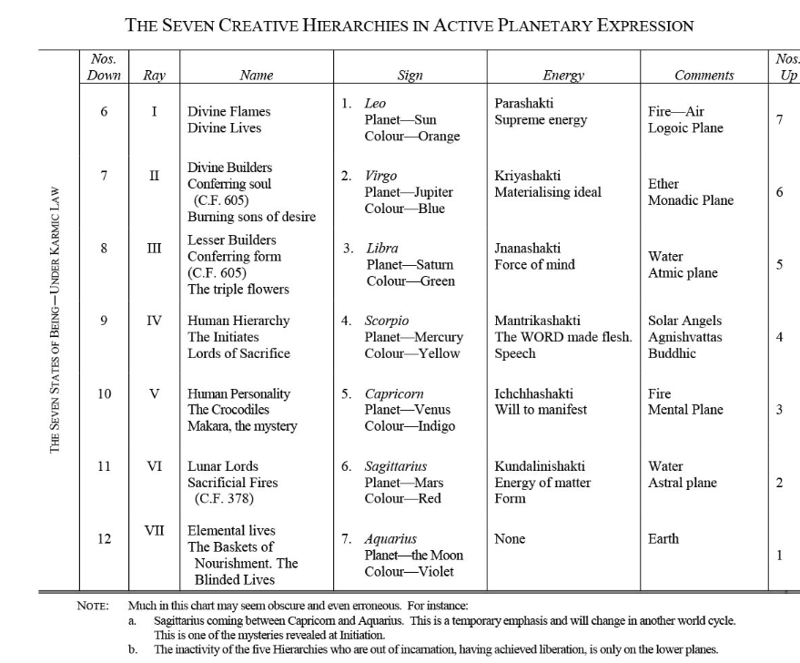

as working within the Buddha's vehicle or least polarized there in the buddhic vehicle so solo enterprises and maybe I did some where He talked about spiritual telepathy and centres his attention on the work to be done. Is this a constant centering? Because the Tibetan has said don't be always importuning your soul solar angel as it has its own affairs to conduct.

So the question is how intense and how constant is the attention of the solar angel to its shadow, how frequently are those impulses coming which we recognize as our higher inspirations? I imagine that as the process continues and the possibilities of the higher initiations like the third the fourth enter that the communications from the solar angel are more rapid and occurring at more frequent intervals.

So anyway he withdraws his forces from soul enterprises and maybe later He'll tell us what a little bit about what those enterprises are this remember also this remember that the solar angel knows far more of the divine plan then a human being and though at this stage.

So the soul of enterprises no doubt have a lot to do with advancing the divine plan

3. He enters into deep meditation.

4. Magnetic rapport with the instrument in the three worlds is instituted.

5. The instrument, man, responds, and also enters into meditation.

6. The work proceeds in ordered stages and with cyclic activity.

7. The light of the soul is thrown downwards.

The light of the vital body and the physical form is synchronised with that of the head.

The centres swing into activity.

The light of the soul and the two other aspects of light are so intense that now all life in the three worlds is illumined.

Alignment is produced, the work of discipleship and of initiation becomes possible and proceeds according to the Law of Being.

0:24:00 3. He enters into deep meditation. Presumably not before the fifth petal is being energized because before that time. It's the general second aspect of divinity which is attending the development of the causal body and not so much the attentive solar angel, somewhere DK mentions that, this is not a reference imagined it exists but temporarily lost and I'm not going to take the time to be looking for it.

So he enters into meditation deep and communicates with his shadow and then is known as a downward gazing soul, and this is the service that He has volunteered to render upon returning to this solar system after having been an evolving unit in the previous solar system. Seems solar systems last a long time according to the chronology, I don't got a wild goose chase here but this is A Treatise on Cosmic Fire … maybe page 39, yes here's notice this is the footnote that it is worth copying or having available to oneself be that these figures are not fanciful but are founded upon astronomical facts has been demonstrated says HPB

0:26:18

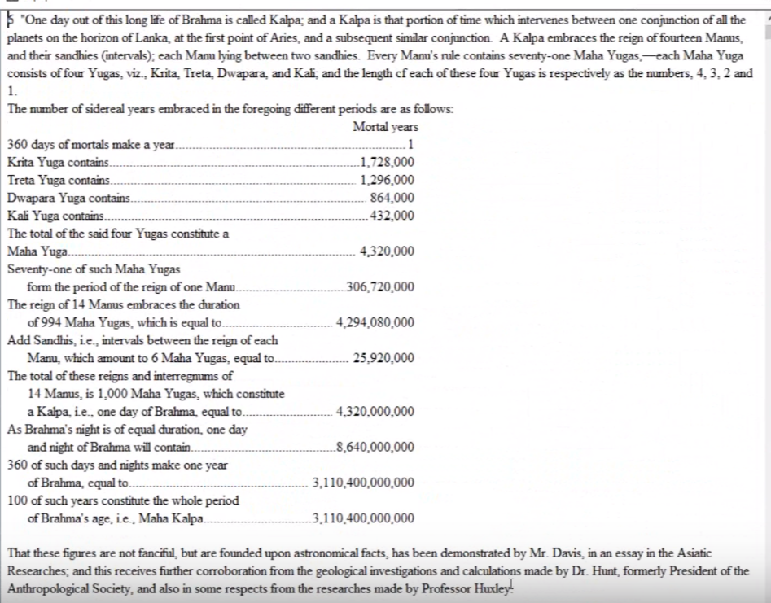

By Mr. Davis in an essay in the Asiatic Researchers; and this receives further corroboration from the geological investigation and calculations made by Dr. Hunt formerly president of the anthropological society also in some respects and the researches of Professor Huxley. Yes, so copying this we can put this into the picture, to say the solar angel was a evolving form of life as a man in the previous solar system and its development takes place over a very long period of time and thus for us in the future I suspect … this is a being that's been around a long time and has many things to do in the higher realms of course … this is the chart that demonstrates the yuga and their combinations and the Mahayugas and the day and night of Brahma. It shows, that such a solar system no doubt, with its extensive subjective aspect last trillions of years now … seems to think that these figures are vastly exaggerated and he brings the figures down to much more amount of manageable proportions, thousands of years rather than trillions of years, but as usual we had when we have contending points of view we have to wait until we know more and can confirm or deny with certainty

… Notice that this is from the perspective of the solar angel and not so much from the soul in incarnation which is in a way a projection and extension of the monad and yet an extension of the soul consciousness upon the higher mental plane, the soul in incarnation is an emanated radiation of consciousness into the lower vibratory spheres How consciousness can extend itself and be in more than one place at the same time and even all places at the same time is something we learn about as we study the transcendence of individuality into the group and the transcendence of the group into the one.

4. Magnetic rapport with the instrument in the three worlds is instituted. Then what we say we know we have a solar angel and there is communication which can be felt and deliberately invoked

5. The instrument, of the soul man, responds, and also enters into meditation. As I said here earlier we meditate perhaps because we have first been meditated upon and our invocation is really an evocation that comes from the invocation of a superior agency.

6. The work proceeds in ordered stages never lose sight of the seventh ray and the gradualism of all this and with cyclic activity. And ever shortening intervals.

7. The light of the soul is thrown downwards. It does penetrate into the dense visible body of a planetary logos and into the relative density of man and focuses in the mental body in the vicinity of the mental unit and also within the physical brain in the vicinity of the pineal gland.

8. The light of the vital body and the physical form is synchronised with that of the head. In many instances the light in the head has been produced and is the light within the head and also within the etheric head and especially physical and very bright all right the light of the vital body and the physical form synchronize with that of the head. So maybe three centers especially, the heart, solar plexus, and the base of spine center, constitute in this case the targeted light of the vital body and these three are synchronized with the light in the head which represents the mind and the soul.

Now of course this is the area that I've been pointing out just how many of these centers are involved? Is the entire floor of the triangle involved and interestingly enough the soul is called the triangle, so whatever is created down there is trapped like a square with the triangle above it.

9. The centres swing into activity. All of them, all of these centers swing into activity being evoked and aligned while invoked first, and aligned by the light in the head to the various chakras of the etheric body.

10. The light of the soul and the two other aspects of light are so intense that now all life in the three worlds is illumined. So here He's focusing on three lights here is the focus on three lights. It's not so much the light of the soul with a strong enough word but these other lights can be thrown upward so what are the other two aspects of light lighted three lights the light of soul the light of the etheric body and the evoked, now more radiant light of the denseness of the etheric body

0:37:10 11. Alignment is produced, the work of discipleship and of initiation becomes possible and proceeds according to the Law of Being. Alignment is produced the work of discipleship and of initiation becomes possible and proceeds according to the law of being. Well the DK told us He was an initiate into the mysteries of being and this should tell us something so for someone to really be such an initiative tells me that they are master, but whatever beingness is by the time of the third initiation it becomes part of the curriculum.

Now in this we have three lights the light of the soul and the two other in other words, it's enough the light of the soul on its own plane plus two other forms of light and by these I think vital body and thence physical body are enough to illumine the three lower worlds, however in all that has been said I think that there is light coming as well from the astral body and from the lower mind. Certainly leaving aside the light potential of the astral body which has his problems due to glamour and failing and all, the light of the mind is real and illumination of the mind is occurring. So let's just say that when Master DK gives these summaries and then focuses a particular section on the process he does not necessarily include in every section all aspects of the process and end it's up to you to piece it together. When we have missing pieces in this section, in that section of the other we have to find a way to bring them into relationship.

So that the whole picture he is demonstrated and that is one of the tasks that we have alignment is produced and the light in the head working upon the center's aligning them, and evoking from the dense physical body that radiant miniaturized life of each atom.

So two lights are below, big ones, and one light above, but as I say we cannot leave out of this picture of a light of mind because the head center is connected with the light of the mind and we have seen the necessity of including the etheric assuming the vital body as part of the flow of the triangle.

0:41:00 Maybe that's the best I can do on that at the moment and there are little pieces and parts that are missing in any one section but if you put it all together and make your own summary we can possibly see every aspect of the process. We have to combine what he said about pratyahara about the seeing of the solar angel, about the abstraction we have to combine what he said about the astral body. There are supposed to be three lights for the thrown upward, but here he talks basically about two, plus soul light. So almost there's a little fragment possibly missing in each one of these paragraph presentations, and somehow we have to find them and make a summary or a synthesis which is satisfactory to us.

Okay, well naturally I'm a little frustrated not being able to get everything to fit together perfectly, but I do have speculations about this. Basically there is a higher light, it does work upon the brain and the head center and it does work upon other centers and centers come into alignment and the light of the physical body is evoked and then whatever lights we have below are thrown upward and combined in their work with the presence and light of the soul and then the work of the four proceedeth.

We will assume that the work of the four which proceedeth includes the soul as the fourth, this naturally involves the solar angel / angel of the presence, and I hope that's enough. I'm rather tenacious in my approach and if I sense that one or two things are missing I keep going but that can be a self-defeating method. Sometimes we need the overview and we do know that if we have true soul alignment our whole body will be filled with light our chakra system will be energized and even our physical body will undergo an evocation of light.

I think very much under the planet Vulcan and remember that Taurus which Vulcan rules in two aspects is the mother of illumination and we're dealing here from another perspective with the eye of the bolt which is stimulated by the soul stimulation of the pineal gland and the ethers and cells brain cells around the pineal gland so Taurus in Vulcan are involved in this process as well.

Every source of energy in our solar system and in our local cosmos system involving the zodiac can we see in our local one about One About Whom Not May Be Said does contribute its energy to the advancement of the evolving units on any planet and on the Earth, particularly that is what we are discussing and were most interested for the moment in our own humanity and its evolution which is receiving very strong stimulation from many, many sources, which we have to understand something about the way Master DK understands. He is the expert you know when it comes to matters of astrology rayology and the creative hierarchies.

0:46:00 Ok, I'll let my tenacity go and get on to this question of principles and personalities.

PRINCIPLES AND PERSONALITIES

There is, however, a point which merits consideration and which could be approached in the form of a question. The student might well enquire into the matter as follows:

"Some people approach the problem of Being through mental appreciation; others through heart understanding; some are motivated through the head and others through the heart; some do things or avoid doing them because they know, rather than feel; some react to their surroundings mentally rather than emotionally.

"The point on which to seek illumination is whether the path for some is not to serve because they know rather than love God, Who, after all, is but their innermost selves. Is [110] this not the path of the occultist and of the sage rather than of the mystic and the saint? When all is said and done, is it not a question, primarily, of the ray one is on and the Master under whom one serves one's apprenticeship? Is not true knowledge a species of intellectual love? If a poet can pen an ode to intellectual beauty why may not we express appreciation of a unity that is conceived of the head rather than of the heart? Hearts are well enough in their way but they are not suited to the world's rough usage.

"Can one do aught but accept his present limitation while seeking such transcendence as is his by the Divine Law of evolution? Is there not such a thing (by comparison) as a spiritual inferiority complex on the part of such as are sensible (and perhaps over-sensitive) of the fact that while their lives intellectually are replete with interest, the desert of their hearts has not yet been made to blossom like the rose?

"In other words, provided one repairs to his appointed station and there serves in his acceptance of Brotherhood in the Presence of Fatherhood, what difference does it make that the fundamental postulate is with him a thing of the head rather than of the heart?" TWM 109-110

PRINCIPLES AND PERSONALITIES

There is, however, a point which merits consideration and which could be approached in the form of a question. The student might well enquire into the matter as follows: I am beginning to realize what a very, very necessary book this is. Sometimes you can get lost in what A Treatise on Cosmic Fire may offer or the Rays and initiations – the presumably most advanced texts, but this is foundational.

"Some people approach the problem of Being through mental appreciation; others through heart understanding; some are motivated through the head and others through the heart; some do things or avoid doing them because they know, rather than feel; some react to their surroundings mentally rather than emotionally. So, mm-hmm, this pretty well describes our approach doesn't it? Different ones of us approaching different ways … I'm very interested in the problem of being, and I do approach through mental appreciation, but I also know that unless I feel registered that which the mind reveals that only part of the process has been completed.

"The point on which to seek illumination is whether the path for some is not to serve because they know rather than love God, Who, after all, is but their innermost selves. Every once in a while a little statement is made, you wouldn't almost know where to find such statements they're scattered and they really carry father God is our innermost self but when the Buddha tells us to be self-reliant, He's telling us to be reliant upon the inner God whom we are and not just upon the personal self a lower self He didn't mean that at all rely upon yourselves, He said in His last sermon.

I set that last sermon to music, and so it made a deep impression upon me and I wondered what is the self upon which we have to rely. It’s obvious that it's the one and only self which is God the point on which to seek illumination is whether the path for some is not to serve because they know rather than love God, who after all is but their inner self. If I were looking at this, I would say knowing and loving together is very important and that the Venus which she brings heart and mind together and Jupiter does something the same our planets from which we have to receive that ability to blend and fuse the knowing and the loving, it seems to me.

Is this not the path of the occultist and of the sage rather than of the mystic and the saint? Obviously it's a somewhat divisive question. We are at a certain point entered apprentices, as they say, in masonic terminology and the fifth degree makes us in entered apprentice on Sirius, maybe the third degree makes us an entered apprentice in the slar scheme of evolutions and of initiations and the first degree of the birth in the heart makes us an entrance princess with respect to planetary initiations. That's one way of looking at this.

When all is said and done, is it not a question, primarily, of the ray one is on and the Master under whom one serves one's apprenticeship? When all is said and done. It is not a question primarily of the ray one is on, and the master under whom one serves one's apprenticeship.

Is not true knowledge a species of intellectual love? This is getting back to the way of the neo-platonist were defining intellect it's not just your mind or mind alone its intellect involves the intuition okay so for the neo-platonists involves a deep intuitive knowing

If a poet can pen an ode to intellectual beauty we're going back there to the metaphysical poets of the 17th century why may not we express appreciation of a unity that is conceived of the head rather than of the heart? of course remember that in the head are all the other chocolates including the heart center within the head may be one great heart center within the head and then one of seven centers under Vulcan which is a type of heart center within the head. Hearts are well enough in their way but they are not suited to the world's rough usage. So how is this DK leading us into a trap? [laughing] which will be revelatory power attitude. You get the feeling you're being led along and that He is going to present some kind of inclusive point of view.

"Can one do aught but accept his present limitation while seeking such transcendence as is his by the Divine Law of evolution? Well we do have to, to a degree, accept the present limitations without complaint, but we want to alter those limitations change them. So, then with motive limitations.

Is there not such a thing (by comparison) as a spiritual inferiority complex on the part of such as are sensible (and perhaps over-sensitive) of the fact that while their lives intellectually are replete with interest, the desert of their hearts has not yet been made to blossom like the rose? These are profound questions and indeed for second-ray types there is a spiritual inferiority. He points this out all the time and maybe for anyone who's really coming into the influence of the soul and the site will begin to contrast with the assister soul with what he appears to be otherwise and the lower part feels vastly inferior.

"In other words, provided one repairs to his appointed station and there serves in his acceptance of Brotherhood in the Presence of Fatherhood, what difference does it make that the fundamental postulate is with him a thing of the head rather than of the heart?" But of course the heart is related to sensitive experience this. One would not want to miss following and exclusively approach.

0:55:15 Okay, what is He going to say here? I know in the old days I wrote can I approach with the mind as legitimately as approach through the heart. How about both? Is that okay?

I would answer such a questioning as follows:

It is not a question of ray or even of the basic distinction between the occultist and the mystic. In the rounded-out individual both head and heart must function with equal power. In time and space, however, and during the process of evolution, individuals are distinguished by a predominating tendency in any one life; it is only because we do not see all the picture that we draw these temporary distinctions. In one life a man may be predominantly mental and for him the path of the Love of God would be unsuited. The Love of God is shed abroad in his heart and to a considerable degree his occult approach is based on the mystic perception of past lives. For him the problem is to know God, with the view of interpreting that knowledge in love to all. Responsible love, demonstrated in duty to group and family, is therefore for him the line of least resistance. Universal love, raying out to all nature and all forms of life, will follow on a more developed knowledge of God, but this will be part of his development in another life. TWM 110-111

Now Master DK is going to answer this question.

It is not a question of ray or even of the basic distinction between the occultist and the mystic. In the rounded-out individual both head and heart must function with equal power. We can presume that the Christ with his perfectly balanced endocrine system is an example of this rounding out.

In time and space, however, and during the process of evolution, individuals are distinguished by a predominating tendency in any one life; or in any one phase of development it is only because we do not see all the picture that we draw these temporary distinctions. In one life a man may be predominantly mental and for him the path of the Love of God would be unsuited. The Love of God is shed abroad in his heart and to a considerable degree his occult approach is based on the mystic perception of past lives. So right the two are so intertwined.

For him the problem is to know God, with the view of interpreting that knowledge in love to all. Worlds is so magnificent and true and some one of the books made the externalization maybe the repents of the Christ he mentions to no Meister a heart as an intellectual knower.

Oh, and there are others. I'm thinking about Ramakrishna who is from all reports of his knowledge and behavior a great lover of God and yet his foremost pupil Swami Vivekananda said, ‘oh no, I am the lover and the true guru, and knower is Ramakrishna.’ Okay, well from his perspective.

Responsible love, demonstrated in duty to group and family, is therefore for him the line of least resistance. We can emphasize in any one life or series of lives the love of God the knowledge of God.

Universal love, raying out to all nature and all forms of life, will follow on a more developed knowledge of God, but this will be part of his development in another life. So we do not settle on either one or the other exclusively but over a period of lives we build in both approaches and rather equally no one thinks about the planet Venus and all the Mayan that's in its and presumably the wisdom but one thing's then about the second ray monad or six rainbow and at both really.

As my earlier statements here were don't expect too much too fast all will be added to us in the time if we look unbalanced to ourselves with others in any one life you may not be really looking at the series of lives which would tell another story.

So this gives us tolerance for others. Why? Because we do not know where they are in their developmental sequence. So the rounding out of the mental sequence both is very interesting, the rounding out will not necessarily occur at the same life and we are not in a position really to touch.

Alright, this would be then the end of A Treatise on White Magic video commentary and number 25 rule 3.4 and as usual slipping from my mind is where we really are. We're on page 111, but where did we begin … at 103 [to] 111 … We will begin beginning A Treatise on White Magic video commentary number 26 rule 3.5 and that will … will be 3.4.

Okay friends, well very interesting material, very practical material, having us preserve judgment realizing that we cannot really see into this development of another soul with such expertise as a master can, and not just judging by the present incarnation. Who knows. So, not a position to judge especially by as if present incarnation folk whole story. Who knows where we have come from and what we have reacted against and so forth, but we're trying to compensate for a person with much love maybe compensating for overly focused mental development and vice versa.

Thank you, and we'll be back soon. Not so long, bye bye.

