A Treatise on White Magic — Mental Rules 21
Transcript of Video Commentaries by Michael D. Robbins

Abstract

Content for A Treatise on White Magic, Video Commentary, Program 21, Rule 2.5, Continuing Rule Two, THE OVERCOMING OF THE HINDRANCES. 29 min: pages 89-90.
Continuing the discussion of the re-orienting of the Solar Angel. Bring mind and brain into such a functioning condition that a man can slip out of his own meditation. The soul in humanity is seeking contact with another divine aspect. The Sons of God will triumph on earth in full incarnated expression. The passing things of the senses are but trivial.
A Treatise on White Magic Video Commentary 21 41 MB .wmv file
Video of A Treatise on White Magic Video Commentary 21 by Michael D. Robbins.
A Treatise on White Magic Video Commentary 21 28 MB .mp3 file
Audio of A Treatise on White Magic Video Commentary 21 by Michael D. Robbins.

Transcript

Well, hello everybody. I decided to go straight on, and try to finish this rule 2.5, meaning that this is the fifth program. It'll be shorter I think, or you never know, shorter than the other ones because we're nearing the conclusion.

So, we're talking about the meditation of the soul and its second crisis. The second crisis of the soul, or solar angel, or angel of the presence, and how it, in company of other downward-gazing souls works more individually in meditation deep, works with its shadow, man. We realized that in the early days there was an implantation of the spark of mind or his stimulation of the brain. As well, and along with that, came two other potencies which would develop later a spiritual love and spiritual will has the soul would express them. Not fully as the triad would express them and when we've achieved samadhi. We have blended our own meditation synchronized our meditation at least with the meditation of our soul and this would be later in our development. Samadhi is not going to be occurring until the solar meditations are working and in process, and they begin with the third initiation, up to that point we can aspire towards them.

For this the solar Angel, the soul, is organising itself and re-orienting itself so that its power can be redirected into the world of men. Contact must be made by the soul between the lower aspect of its triple nature and the aspect which has already found lodgment in the brain of man.

Intelligent activity and love wisdom must be united, and the union must take place on the physical plane. In order to do this the soul is entering into "meditation deep", in union with all other souls who may have brought their instrument into a responsive state. This is the basic group meditation, and when a man achieves what the oriental books call "samadhi", he has succeeded in participating, as a soul, in this group meditation, and enters upon that cycle of service which expresses itself through the planetary Hierarchy. The rational mind and the abstract mind function as a unit, and the motivating principle is love. The soul, expressing love and abstract intelligence, is at one with its expression on the physical plane through the brain, and, when this is the case, the lower man has synchronised his meditation with that of the soul. TWM 88

So in order to do this, Intelligent activity and love wisdom must be united, and the union must take place on the physical plane.

In order to do this the soul, through the brain and etheric brain. In order to do this the soul considered as the solar angel, angel of the presence, is entering into “meditation deep” in union with all other souls who may have brought their instrument to a responsive state. So it is a group process, this downward gazing, and this stimulation of the soul in incarnation, that extension of consciousness which is immersed in the personality field. We, the disciple, the awakening disciple, are that. It really comes from the monad ultimately, everything is the monad, as I've said, the monad is the monad, the triad is monad, the soul as the monad, the personality is the monad, but there are apparently different monads, there are different centers within the one monad, and the solar angel has its own center. It's not the same center as that of the less developed man that it is supervising, but ultimately all is one and all of these points, monadic points within the greater monad that learned that they are one identity.

0:03:50 So The soul, expressing love and abstract intelligence, is at one with its expression on the physical plane through the brain, so, we have to realize that the solar angel was reaching right down into the brain and, when this is the case, the lower man has synchronised his meditation with that of the soul. Sometimes at the top of the head one feels the vibration and pressure, and this is the result of soul contact, not always high blood pressure, it’s not always a physical thing.

So here we are, if I could just remember, page 89, when we reached the end, right, hmmm?

This is the objective of our work. Let this not be forgotten, and let every effort be made to bring mind and brain into such a functioning condition that a man can slip out of his own meditation and (losing sight of his own thoughts) become the soul, the thinker in the kingdom of the soul. TWM 89

This is the objective of our work. This union of soul and personality this reaching down of the higher aspects and principles right into the physical mechanism for the purpose of its redemption, and …

Let every effort be made to bring mind and brain into such a functioning condition that a man can slip out of his own meditation and (losing sight of his own thoughts) become the soul, the thinker in the kingdom of the soul. … So this would be contemplation, this slipping out of the personality environment into the higher and environment of the soul on its own plane. The causal body egoic lotus. This plane is not the same as the solar angel on its own plane … which is minimally the buddhic plane. Sometimes when you think that that which is now the solar angel has already been to the cosmic astral plane for training on Sirius, you begin to wonder what is its own plane in the chart we have to show to you this chart:

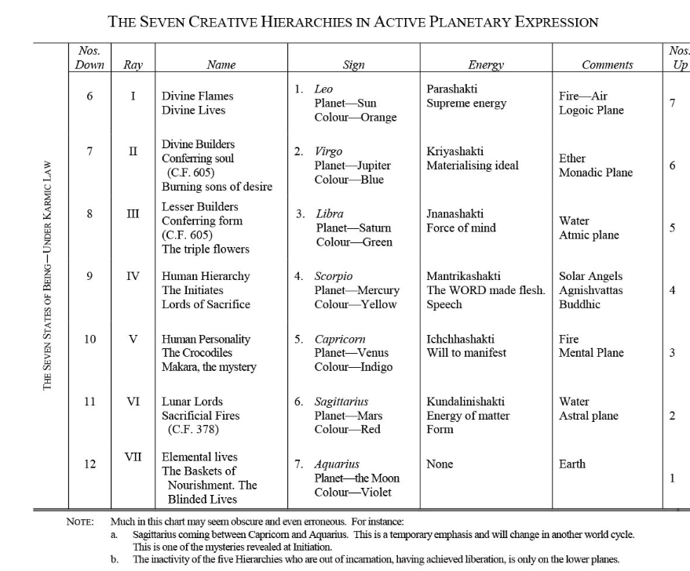

Here, we seem to have the solar angel placed upon the plane of buddhi. Agnishvattas on the buddhic plane, and not just on the concrete mental plane, but this was as much of the Tibetan wrote this. … I think it was gathered maybe by others but solar angels are found here on the buddhic plane. That is the extent apparently of their fall into the cosmic ethers, but they fell further for purposes of service onto the higher mental plane and even extended themselves onto the lower mental plane and into the brain thus their sacrifice is really extensive.

Okay, now where are we? There we are.

It is perhaps a new thought to some that the soul is organising itself for effort, re-orienting its forces, and preparing for a fresh and powerful impulse, but so it is. All forms of life under the force of evolution pass from initiation to initiation and the soul is not exempt from the process. Just as the soul of animal-man became united with another divine principle, and so brought into being the fourth kingdom in nature, so the soul in humanity is seeking contact with another divine aspect. When that contact is made the Kingdom of God will come on earth; the physical plane will thereby be transformed and that peculiar period, presented symbolically under the term millennium, will come. TWM 88

It is perhaps a new thought to some that the soul is organizing itself for effort, re-orienting its forces, during its second crisis. the first of which was individualization and preparing for a fresh and powerful impulse but so it is. And we might say cooperating mightily with the Christ and his reappearance.

All forms of life under the force of evolution pass from initiation to initiation. Now the soul is not exempt from this process and again as I say before thus it is not an avatar in the strict sense. Because if it has something to gain it is not an avatar. Now I guess avatar of descent is purely altruistic, at least in his definition of avatar as He seems to suggest this.

Just as the soul of animal man became united with another Divine Principle that of mind right and so brought into being the fourth kingdom of nature (let's say that of manas) so the soul and humanity is seeking contact with another divine aspect. This being love, especially.

When that contact was made the kingdom of God, will come. On Earth, if sufficient human beings make the contact the physical plane will thereby be transformed and that peculiar period presented by these symbolically under the term millennium will come. The Satan, personality, will be bound for the symbolic 1,000 years, the era of brotherly love under the third decan of Aquarius ruled by Venus will supervene, and how long will that thousand years really last? It’s a symbolic 1,000 years and in the old days one would call a relatively small number to indicate vast numbers which the mind at that time did not conceive so the term the millennium will come and the year of the Christ will come and the Christ will see of his labor and he satisfied.

The Knowers of God in that era will preponderate over those who are simply aspiring to that knowledge, and their contact and the results of the force they transmit will be felt in all the kingdoms of nature. Dominion over all forms, and the power to act as transmitters of that spiritual energy we call love is the promised reward of the triumphant solar Angels, and the prized goal of their meditation work. The Sons of God will triumph on earth in full incarnated expression, and will bring light (therefore life) to all the manifested forms. This is the "life more abundant" of which the Christ speaks. This is the achievement of the true Nirvanee who, living in unbroken meditation in the spiritual realm yet can work on earth. The work of initiation is to enable a man to live ever at the centre, but to act as a distributor of divine energy in any direction and—after the later initiations—in all directions. TWM 88-89

0:12:10 The Knowers of God in that era will preponderate over those who are simply aspiring to that knowledge, and their contact and the results of the force they transmit will be felt in all the kingdoms of nature. Okay, this is almost a description of the Judgment Day when only those who are on the path will be the humanity of Earth. That's a long time to come, some millions of years. We have to finish this round before that becomes possible. So millennium well one way of looking at it is the 1,000 years Satan will be bound. But, if we're talking about.

The knowers of God preponderating. Oh there are many moon chain humanity who won't even be on the path until the next round, so what about Earth humanity? The numbers of which probably are extensive. Earth humanity in many numbers will not yet maybe be on the path, and so we have to be talking about the word millennium in relation perhaps additionally to another time perhaps far ahead.

Dominion over all forms, of the power to act as transmitters of that spiritual energy we call love is the promised reward of the transference over angels and the prize goal of their meditation work they have this to a certain extent now, but this could indicate the type of development they capital they are now undergoing – Dominion over all forms, it seems the master has some of that, but where these forms found? Are they only on the lower 18 sub planes or lower 21. – and the power to act as transmitters of that spiritual energy we call love – they can already do this to a certain extent, having both the second ray and the fifth ray highly developed generically – is the promised reward of the triumphant solar angels and the prized goal of their meditation work. We might say that the men they supervise will be able to do this to a lesser extent. When we have dominion over all forms, when will we be able to truly transmit the energy we call love.

The Christ is learning to do this now, He's eventually on his way to becoming a ray of love on the fifth or ray path, we are told. The solar angels are still older and from a previous solar system which existed – it’s gotta be billions and billions of years before the present solar system and even trillions of years possibly, if the interlude between solar systems is anywhere near the duration of a solar system is given in the Brahmanic chronology,

somewhere in The Secret Doctrine, somewhere in A Treatise on Cosmic Fire on page 62, there's a footnote which gives all of this, 62, 63, 64, in there, it transplants The Secret Doctrine listing of the ages. Okay.
The sons of God will triumph on Earth in full incarnated expression now that's us again and we'll bring light therefore life to all manifested form. So, we have to note the equivalence of light and life … sons of God will triumph on Earth, and we are we also are the sons of God who will triumph in our own way because of the triumph of these solar angels.

0:17:00 [Repeating:]

This is the "life more abundant" of which the Christ speaks. This is the achievement of the true Nirvanee who, living in unbroken meditation in the spiritual realm yet can work on earth. The work of initiation is to enable a man to live ever at the centre, but to act as a distributor of divine energy in any direction and—after the later initiations—in all directions. TWM 88-89

This is the “life more abundant” of which Christ speaks. And it can only become more and more abundant, some people in the Age of Aquarius will be submitted to it. So, during the Age of Aquarius, we will know and experience more of the … life more abundant, and certainly during the very great Platonic Aquarian Age of approximately 25,000 years this life more abundant will come into greater expression. Okay.

This is the achievement of the true Nirvanee who, living in unbroken meditation in the spiritual realm yet can work on earth. The solar angel … a true Nirvanee, this is the returning solar angel. We are not yet that Nirvanee, although, well let's just say from a certain extent there is the Nirvanee who becomes the monad in full consciousness, and the Nirvanee, higher, who leaves the cosmic physical plane behind. Each of them is a Nirvanee … who, living in unbroken meditation, as the solar angel does, and others in the spiritual realm can yet work on earth from the not only from the higher mental plane, but somehow extend it on to the lower mental plane and into the brain.

The work through initiation is to enable a man to live ever at the center, but to act as distributor of divine energy that is monadic energy. If it's really divine energy, it is monadic energy. in any direction and after the later initiations in all directions. He becomes a distributive sphere of radiation.

0:20:00 We … are being told basically we are being told in the same paragraph about the triumph of the solar angels and the consequent triumph of the man under their supervision. Because, if you really look at it, the fourth initiation is a great triumph for the human being, and that's the moment when the solar angels are released back into the heart of the Sun or – somewhere I read I think the central spiritual Sun as well – there are grades of solar angels just as there are grades of human beings.

We will now in our consideration of the next rule, take up the work of the lesser light of man upon the physical plane yeah.

I'm really beginning to understand that this is a microcosmically written book, and that a lot of what I thought may have been in this book was really in A Treatise on Cosmic Fire dealing with the magical process per se, but I don't want to interfere and throw that in here too much, when it's not really written about what I want to be able to do, which is to suggest we go back to my written commentary on the book A Treatise on Cosmic Fire the section about magic, somewhere in the 900s there, and if we want to get more technical about it, can consult that. Although later I think there are some technicalities that are dealt with in this book as well.

I who have entered somewhat into an understanding of the life of the solar angel. hmm and here He is a master. Well remember, this solar angel is higher than a master, and thus Master DK can say that he has entered somewhat into an understanding of the solar angel.

So, I who have entered somewhat into an understanding of the life of the solar angel. No wonder He says it's such a difficult mystery and insoluble in a total sense, for man at his present stage of evolution, I seek to assure my fellow pilgrims notice the brotherhood that the passing things of the sense the trivial and of no value compared to the rewards here and in this life I suppose on the lower 18 or 21 subplanes to the man who seeks to merge his everyday consciousness with that of his soul I seek to assure my fellow pilgrims that the passing things of the senses are but trivial here. Our sense of values is being adjusted and of no value not even no value not even slight value compared to the rewards here and in this life as a human being apparently to the man who seeks to merge his everyday consciousness into that of his own soul what an objective.

So this is our objective and highly worthy. Thank goodness we're given the kind of proper instruction that leads us along this, well, path of worthiness.

He enters then into the community of souls and stands not alone the limitations of the personality make the man think during a period of ignorance that he is alone. But it's an illusion. The only lonely periods are the result of wrong orientation and the holding on to that which hides the vision, thus the old adage goes, let go hard to do. Unless you’re on the second ray and certain signs are, what we say a bit adhesive and fills the hand so full and the mind so full from that point of view they have so full that they cannot grasp what has been called the jewel in the Lotus leaving truly to the monad the high value of the jewel in the for all jewels are of great price are they not especially a really fine jewel so this is the finest of all the jewels and we have to learn through an adjusted sense of values na to hold on to all the things.

0:26:00 I'm looking around at my little study here temporary study. I'm always moved out when Tuija has someone else coming in, but I'm on the third ray a bit, so I'm fairly mobile, [laughter] and I'm looking around at all these things and realizing where it really is the pearl of great price?

Where is the jewel? The Jewel in fact is right within our the heart of the Lotus, are the very center of the lo the Sun that it is which we must attain as we significant self to the spiritual will ruled by Vulcan, which also has crafted or plays its part in crafting the jewel. Probably we will know regarding our form and energy system which planets whether representatives have contributed to the formation of the of the different aspects of our energy system.

Okay friends, well, this is like I say, I'm finished here now. I want to go to rule three, but I want to start with a new series of programs, three point whatever, and I'll just simply say that:

This is the end of A Treatise on White Magic video commentary number 21 rule 3, rule 2.5, and page I think I remembered 89, right page 89 - but what? But what? Ninety, 90 not much but enough and this will be the beginning of A Treatise on White Magic video commentary number 22, rule 3.1, page pair of opposites page 92, whatever alright I end of italics I'm simply copying the italics from the cd-rom as they don't tend to appear in the kind of document that I am using.

So, bye for now and we will go further a wonderful book and so fundamental to success in practicing our discipleship, see you then.

