Setting Up a Spiritual Practice - SERVICE
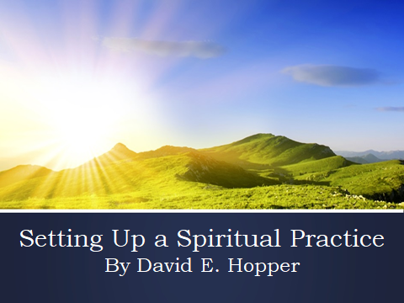 | We are continuing to build on the theme of the Soul evolving in consciousness.  Today, we’re going to be working with information about he concepts of Service and Spiritual Study. These are actually 2 pillars of a spiritual practice, the other pillar Meditation, was discussed earlier in November.  Also, with these themes in mind and with the events taking place in Wash. DC, lets look at how the individual and group Soul are functioning in our lives.
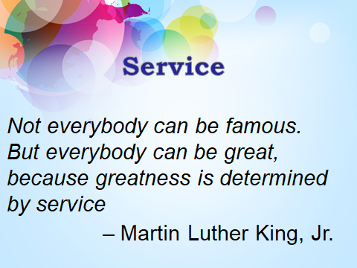 | MLK quote:  Not everybody can be famous  But everybody can be great,  Because greatness is determined by service.  ~ Martin Luther King Jr.
Service: The Impulse of Light  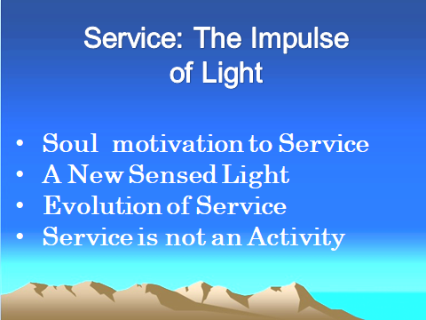 | Service: The Impulse of Light  The need to serve is a concept and impulse that has evolved in people and groups over time. This concept of helping people in crisis or need, or expressing service through intelligent loving or giving was a very foreign concept to most people up until recent times.  Over the last 800 years or so, western civilization in part, evolved out of a new influx of light sensed by creative, courageous, and ambitious people throughout Europe, and Asia. This new sensed light stimulated man’s creativity, and opened up his mind through inquiry to initiating revolutions in culture, science, the arts, and politics, and brought Humanity the Age of Exploration, the Renaissance and the Age of Enlightenment. Although it was a time of great openings and new inventions and ways of being, this was nevertheless an era of the individual.  As we look back over the centuries, we see that man’s consciousness has evolved from the perspective in which only the needs of individual matter ….to the perspective in which we need to be concerned also for the larger community or group. In recent times, we have seen the emergence of a new way of approaching how the individual and the group function that is based upon the concept of service.  Through a new sensed light, and through awareness of the Ageless Wisdom teachings in its myriad forms, many enlightened servers are acting on the impulse of selfless service. The concept of selfless service involves helping the larger group and not just the individual.  Less than a century ago, the urge to serve was largely felt at the spiritual seeker’s emotional level. In many instances feelings arose from a reaction to the problems of the day, and enabled him to have a tendency for laying blame for the deplorable conditions seen around the world caused by certain individuals, families, corporations, and nations.
Service is Goodwill in Action  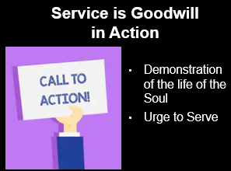 | Service is Goodwill in Action  The Tibetan Djwhal Khul says Service is the spontaneous effect of Soul contact. It is an energy that demonstrates as the life of the Soul working within the Personality’s nature. It is the activity of intelligent loving and giving motivated through the expression of goodwill. The motivation to serve will not come from the spiritual seeker alone, as he must have Soul stimulation or inspiration. The term service denotes spiritual qualities and values, such as cooperation and goodwill emanating from the Soul, which are focused outwardly, but known by the spiritual seeker as an inner reality.  How effective you will be in your service work will be determined by the amount of integration and alignment of your lower three vehicles with your Soul. If you are Soul integrated, then the Soul’s light and love will pour more easily into your vehicles. In this teaching and philosophy, it is understood that service is not an activity, nor something which people must do. Service is considered to be a demonstration of the life of the Soul as you are allowing your personality to become A living channel and expression for the Soul on the physical plane.  In your meditations, when you make Soul contact, you are aware and that you are a living principle of this harmony. After a rhythm has been established, you begin to experience “standing in spiritual being”. The effect of this living energy will demonstrate as power (i.e., a force) and love (i.e. an energy) and radiance as you touch others.
Concept of Livingness  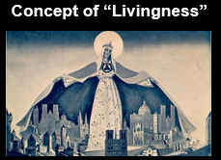 | Concept of Livingness  When the spiritual seeker is consciously holding Soul consciousness while engaged in a service related activity, that connection has a "living" quality to it.  What is the nature of livingness?  In essence, "livingness" is that Soul energy, of light and love moving through your consciousness freely in whatever activity you’re involved with.  Livingness is also a prompting energy to practice harmlessness, integrity and compassion with individuals and groups. But it is more than just an awareness, it is a vitalizing energy and consciousness of the Soul that you hold as you go about your work. It can be thought of also as a presence always in the background. As much as you make the effort and identify with that Soul energy, then you are guided and can set you intentionality from that place. This energy gives you purpose, intention and direction when it is present.
Urge to Serve   | Urge to Serve  As the Soul is naturally group conscious, it impresses the spiritual seeker with the URGE TO SERVE and the spiritual seeker responds with the inner urge to cooperate, and as a result, implements the higher purposes of the group. In the outer world, we see that service is a powerful Soul expression for enabling right group relations.  - As harmony becomes part of the natural expression of the Personality, the server will naturally be practicing harmlessness. This energy breaks down blockages. For example, if the server is a facilitator of a group that has members with opposing viewpoints, his poise and expression of harmlessness will allow him not to take sides and be able to see a higher way for fostering mutual cooperation.  - The outward expression of service is also a means par excellence for awakening people to their own spiritual consciousness, giving them a sense of responsibility for themselves and the greater group they are increasingly identifying with.  - The server will offer help for others to know and understand what it means to stand in spiritual being as he himself has learned.  - The server will aid individuals in expressing service in their chosen field as he or she desires to express it, and not dictating how and where service should be done.  - As a member of the inner Ashram, an effective server will facilitate the working out of the Plan.
Holding the Vision of One Humanity  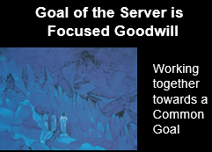 | Holding the Vision of One Humanity  Around the world in all cultures and nations are men and women of goodwill working with a sense of responsibility towards improving the common good. They foster a quality in consciousness that helps to remove tensions between people, and brings new awareness of man’s mutual interdependence. They never take sides, nor dwell on separation, but work with the attitude of what brings people together. They have been called by some the New Group of World Servers. Other people, such as psychologist Sherry Ruth Anderson and sociologist Paul H. Ray, wrote about the Cultural Creatives. They all share in the following common values:  - They bring people’s attention to all that is positive in society, and they are spokespersons for the principles of goodwill and cooperation. There is no problem that cannot be solved through goodwill and cooperation. They understand that these are part of the secret of how to create right relations between peoples.  - They seek to expose old outdated patterns and forms, and build new ones based on goodwill and working together towards a common goal.  - They hold the vision of One Humanity and espouse the concept of a world without hatred or violence. They envision a place where divisions across religions, or class lines have disappeared, or have been neutralized. Some are actually building and providing the Thoughtform for a Solution to World Problems  - They hold the concept that all kingdoms and the environment can mutually co-exist for a sustainable future, and that mankind has the responsibility of caring for them now and into the future. They hold the vision that we are One Humanity and invoke the principle of sharing the world’s resources, and that no one individual, corporation, or nation can control the resources vital to the health of Humanity.  - While they may or may not be part of any spiritual group or organization, they never interfere with the free will of any individual or group. They help stimulate the spiritual concepts of tolerance and community in human affairs. They understand that higher human values help foster better human relations among all peoples and nations. This mindset helps with spiritual integration and promotes a foundation for civil discourse between all members of Humanity.  - Through all of this, we underscore the notion of the individual “radiates the Soul’s light” and the will to good.
Serve from a Balanced Nature  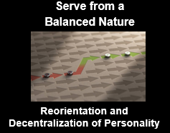 | Serve from a Balanced Nature  From a certain perspective, performing service is like putting on new clothes and requires a reorientation of the Personality. Many of you who have or are engaged in service related activities are already doing many of these things. My purpose here is to provide whole picture of what service can ideally look like as part of a spiritual practice.  With reference to a reorientation of the Personality, keep in mind that service itself is a result of an inner effect between the Personality and the Soul. When this rapport is established, certain things occur in the Personality.  A change in the Personality awareness will occur when he will have a tendency to turn away from the things of his personal self and re-focus on the larger issues of the needs of the group. This results in a reorientation or decentralization of the Personality. In a worldly context, this can also be letting go of addictions – minor or small….such as, shopping, gambling, or food cravings….as a distraction.  The true and conscious server will have achieved what could be called a ‘spiritual balance.’ He will be aware of:  - Where his consciousness is at any moment  - Have confidence in What he is doing  - Know the environment in which he’s working….this is relating to the inner landscape of his mind  - He always maintains a connection with his Soul, knowing that this connection is a spiritual tension.  - Spiritual tension originating from the Soul has a quality of radiance, and can be used for outward expression of service and goodwill.  To be the most effective in his work, he will study the energies and forces present in his consciousness and bring balance within himself. From his inner balanced place, he will radiate confidence from the Soul level, and help create an amicable outcome in whatever he does.
Effects of Service  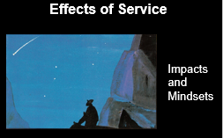 | Effects of Service  When the Soul is beginning to transform the consciousness of the individual server, it is beginning to affect the larger group – Humanity itself. How?  Since most people are not conscious of this inner connection with each other, it is my belief we can nevertheless experience others through telepathic and other psychic means. For these types of subjective connections, look at the concept of “a national conversation” on a political or social issue. For example, the “MeToo” Movement started when certain individuals were abusing other people, namely women . Or the “Black Lives Matter” Movement where police brutality towards black men or women has occurred over and over. The conversation continues with officials, the media and protests in the streets about what transpired. The very ideas discussed effected our minds. We may have agreed or disagreed with outcomes, but the concepts were of a subjective nature and the effect is felt on the inner planes of the mind.  Another idea is running after service, for example, through will-nilly giving to philanthropic causes. Activities can interpreted by the Personality, who seeks to impose his ideas of service upon others. Although the server is sensitive to impression, he, in the initial phases of Soul contact can misinterpret the truth. He must learn to identify with the unfolding Soul life and not just dwell on changing the outcomes only on the physical plane.  This concept is about the server being connected with his Soul, and learning to hold a ‘spiritual mindset’ in his life. In this way, he is responding spontaneously to service, as opposed to the mentality of: “I think I’ll engage in this activity because I think it is needed.” The type of service may indeed be needed, but the point here is to realize and know how much the Personality is driving the decision process. Knowing this can help to facilitate greater effectiveness in service work.  Only by honestly looking at yourself, will you really be able to answer this.
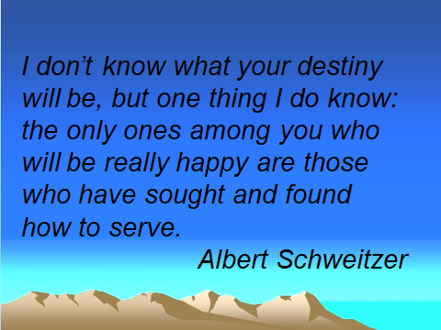 | Quote from Albert Schweitzer:  “I don’t know what your destiny will be, but one thing I do know, the only ones among you who will be really happy are those who have sought and found how to serve.
Upgrading Your Vehicles for Service   | Upgrading Your Vehicles for Service  On the face of it, “Upgrading Your Vehicles for Service” is a odd expression. When engaged in service you do not think about the conditioning of your mental, emotional and physical bodies. But there is a form of preparation and mindset of maintaining these vehicles for service.  I alluded to this in November’s and December’s talks. With regards to the physical, you can keep your body fit by eating right; going to the gym, take walks, ride a bike, or do whatever to maintain your physical body…..as it is your vehicle for physically performing service.  Emotional Preparation  In November, when I talked about meditation, I mentioned the Soul’s natural state is calm, clear, and of pure awareness. For you the spiritual seeker, your intention should be to create a stable, quiet emotional vehicle for the Soul to flow through in all the activities you engage in, or with the people you meet.  Mental Preparation  For mental preparation, the mind must become stable, clear and in a listening and observing mode. This entails:  - Being alert for impressions and subjective contact. This allows the server to express higher values, such as cooperation and goodwill.  - Learn to make all of your life’s experiences and activity that of the Soul's purpose by creating a new intentionality.  - Recognize “Soul Awareness” as a connection and as a point of tension. Then, attempt to hold that tension or awareness in your conscious waking life. This is akin to developing a "continuity of consciousness”.  - This TENSION is developed through the practice of meditation, which allows for the livingness aspect of the Soul to freely move within the your consciousness.
Inconvenience and the Path  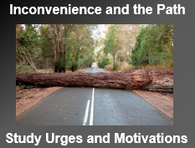 | Inconvenience and the Path  This is a topic which I’m sure many of you have encountered…and is rarely discussed. I call it “Inconvenience and the Path”.  There are times in the person’s life when he must fulfill obligations and perform service. This means he must stop what he is doing and help somebody in need.  From a worldly point of view, a person will encounter situations where he must perform some activity, and say: “I don’t have the time, “this is not what I planned to be doing right now,....but I must.” So what are some of the potential energies happening in the person’s consciousness?  Answer: Anger, Resentment, Selfishness, and Impatience….These are the feelings of a person NOT Soul focused.  A person who is Soul focused will encounter similar situations of inconvenience, but have a different response. The reaction will not be anger or resentment, but love, gratitude, and perhaps even a sense of flowing with, or adapting to the situation. It is also knowing that service sometimes works by bringing the server to a particular place and allowing his Soul’s radiance to be present. Ideally, you do not question the circumstance, but as a consciously aware and Soul-focused person, you understand that you are bound to bring forth the highest energies of love and the mindset “I am a pure instrument of service.”  Another way of approaching the energy of “Me Only” mindset is to study your urges or motivations by noting them in a spiritual journal. Ask yourself:  - Do I tend towards thinking of myself in all circumstances, or do I embody compassion and kindness?  - What are my motivations?  - What are my first impulses when an opportunity to serve arises?  To the server on the Path who understands these dynamics, he is ever vigilant and aware of the possibility for serving at a moment’s notice. He asks: “When so-and-so happens in my life, then what are the choices I am making?” and “what am I bringing with me at any moment?”
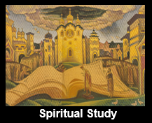 | For our next section, we will talk about the 3rd Pillar of a Spiritual practice, Spiritual Study.
Spiritual Study  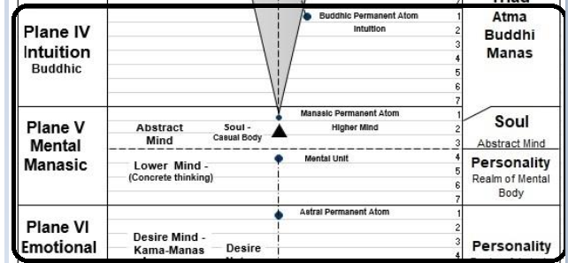 | Spiritual Study  Perhaps, everyday person may consider his or her life uninspired because they’ve made little or no attempt to gain knowledge or information that will inspire the mind.  Here, we understand that the esotericist is Self-taught. This is the ancient saying and it is profoundly true. By identifying with the wholeness of life, all knowledge and wisdom is within your own nature. This approach to spiritual study simply attempts to help you draw it forth objectivity through the mind. Ultimately, we wish to develop a synthetic understanding of given subject and allow for “pure reason” and understanding to come forth from the buddhic plane. [CHART]  When we have blended buddhi (intuition) with manas, we will be able to see the whole and the relationship of every part to that whole. This will enable us to think and act with wisdom—another word related directly to the quality of buddhi.
Develop World of Meaning  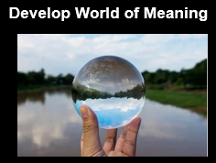 | Through study and analysis of spiritual teachings, the esotericist can bring inspiration to his life. When combined with meditation and spiritual living, spiritual study can help develop the world of meaning.  Daily stimulation of the mind is necessary so it can become responsive to impressions and higher energies from the Soul.  Remember, an impression is an idea, feeling about something or someone, especially one formed without conscious thought…this can be your “first impression” of a person or place and what you sense on the inner planes.  - It is, by its very form is of a subjective nature, and is closely aligned with the intuition. Impressions often come in the form of symbols, or an image, and register in the concrete mind as an idea, or thoughtform.  - As an esotericist, you will observe that people covey thoughts through voice, body language, or even in print, such as magazines and books. These are examples as forms of telepathy, as they are conveying subtle thoughtform energy. Here is where you act as a sensitive receiver of impulses from outside sources. These other “voices” are thoughtform energies and you need to become sensitive as to how you respond. This could also be called spiritual reading, where you are looking at outer events and life’s circumstances, and deriving meaning.  - The highest response is the intuition, as this infers that you are making a connection with the higher mind, such as connecting with the Buddhic Plane. There pure reason, “knowingness”, and truth are registered.  - By studying, reading, contemplating of spiritually related material, you will increase your capacity to rationalize and reason wisely. You will open yourself to other ways of thinking, varying points of view, and you will learn to develop the capacity to filter, choose, and make your own conclusions, using discrimination and discernment.  In short, a higher objective for spiritual study can build a foundation of mental knowledge, thus allowing you the spiritual seeker to render service in intelligent and effective ways.
Question Yourself  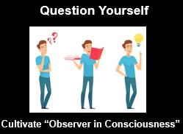 | Question Yourself.  Besides increasing your own spiritual knowledge on a particular subject, the study of spiritual teachings will help train you in the ability to function freely in the world of meaning, It is instructive that you frequently ask the questions:  - For What am I aspiring?...OR “What am I tending towards?”  - ‘Who am I and why am I doing this, i.e. spiritual study?  - ‘Why is “X” thoughtform or feeling happening in my consciousness?’  By asking these questions, you may seek to understand why certain events and crises are happening in your life. Your spiritual studies can help you learn and acquire a deeper meaning behind these events.  Also, you the spiritual seeker over time can develop is what is called a “continuity of consciousness”. This is a more advanced stage and refers to you the meditator having a near continual contact with the Soul in both your meditative and waking state. This most likely won’t happen until the 3rd Initiation.  So overall, learn to develop your ability for becoming the Observer in consciousness. This is akin to tuning into or observing what’s happening around you in any situation, whether you are hearing or reading the information. How does it resonate with you?
Conduct Evening Review  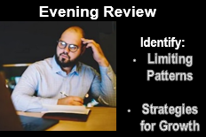 | Conduct Evening Review  Another aspect of spiritual study is conduct an Evening Review or create a Spiritual Journal. The journal becomes a record of previous experiences, which can be referenced, such as observations, impressions, dreams, etc.  The spiritual journal can become a tool for seeing patterns that may emerge in consciousness. It is up to you the seeker to interpret what was written before, and use the intuition to come up with a strategy for growth and transformation of a thoughtform or feeling.  For example, I used to have a fear of public speaking. I noted in my journal before, that the fear came from an earlier time in my life. This fear held me back from growing in my service work. Now what’s new is that I got an idea or impression telling me to use public speaking as a means for getting past the fear. That is, I the seeker know that I must challenge myself to transform the energy of fear. So, with a measure of courage and will, I have been giving public talks, and over time the fear has dissipated considerably. By getting past the fear, his Soul’s radiance can now flow better through me, and my service work is enhanced.  One of goals a seeker should learn is to use thoughtform energy and expression of will and force efficiently and wisely. In the example above, I the individual review my own journal, and develop personal skills about how the effects of energy and force play out in my life. I can study and ask:  - With what I know of the situation, how can I make this work in a better way? Or  - What worked, or did not work well, and why?  If I have a good understanding of the problem, I can learn to use my intuition to develop further insight. If there are additional hindrances and even potential crises, then I can learn to move through them and develop a strategy for preventing it from happening that way again.
Methods of Transformation  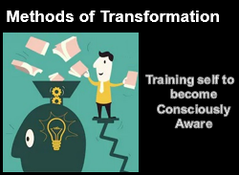 | Methods of Transformation  I’ve talked a lot about the importance of purification and dealing with energies such as fear, anger and self-centered thoughts. While many of us are dealing with these energies through various situations and encounters with other people in our lives, we understand that spiritual study can provide tools and a means for learning how to observe, interact and integrate with our thoughts, and emotions. This can provide a way for studying and discovering methods of transformation for unfolding the Soul aspect.  Deeper levels of spiritual study can be for those who want to sincerely discover origins and get to the bottom of how “X” feeling or thoughtform and how it can be transformed. Spiritual study will help you to understand what these energies are and how to purify, transform and transcend them into love, cooperation, goodwill and acceptance towards yourself and others.  - If your are dealing with a crisis, you will want the mind will need to be firmly aligned with the Soul’s will before tackling any strong emotions or thoughts. This is the Role of the Observer.  - Determine which tools to use. For example, Technique of Light, As If, affirmations, etc. ….reference handout  - Through your studies you develop a deep level of knowingness of WHO and WHAT you are – WHAT you ARE NOT.  In essence, you are becoming a consciously aware 'spiritual seeker.’
Studying a spiritual text or reading?  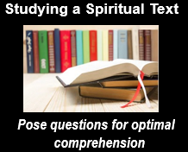 | Studying Spiritual Texts  You may ask “Which spiritual texts or readings should I study”? ….OR  How should I study a spiritual text?  We want to approach this with the idea that you are wanting to stimulate the brain and mind so it can become open to impressions. Prior to study, it is recommended to align with your higher Self and pose questions for providing the conditions for optimal comprehension.  In this course so far, I have touched upon the following topics:  - Evolution of Consciousness and the Path of Liberation.  - Human Constitution. This is made up of the Mental, Emotional and Physical - Etheric vehicles.  - Learning how to function as the Observer.  - The Science of Meditation.  - Purification of thought…dark side of thought….concept of harmfulness vs. harmlessness  From any one of these topics you can choose to delve deeper into understanding how these effect for example, the vehicles of the Personality (i.e. the Mental, Emotional and Physical) and function and within your consciousness. Authors of spiritual texts can include: Helena P. Blavatsky – The Secret Doctrine, the Blue Books of Alice A. Bailey, books of Sarydarian, and many Buddhist, and Hindu texts, such as a study of the Yoga Sutras. Any of these can provide considerable information on these subjects.
Concluding thoughts on Spiritual Study   | Besides meditation, as a critical part in developing and integrating the Soul’s life and energies with your Personality, spiritual study will help to expand your consciousness.  I have mentioned before that meditation is based on the premise our natural state of mind is calm and clear. Meditation provides a way to train your mind to settle into this state. It certainly could be recommended, prior to spiritual study, that you bring the mental, emotional and physical vehicles into an alignment with your Soul.  - So, studying spiritual texts stimulates the intuition, which you are developing in meditation.  - True esoteric studies will focus on developing, and unfolding the Soul aspect and showing new opportunities for service.  - In your quiet reflective time, you learn to use your thoughts and feelings wisely by asking questions about your purpose and discovering deeper subjective parts of yourself – as a Soul.  - Think of it as providing you with a well-rounded spiritual education.
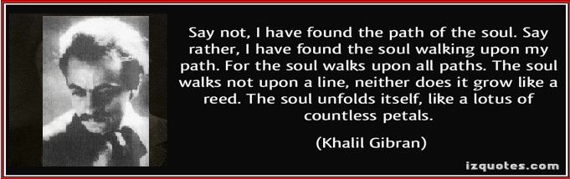 | Quote from Gibran  “Say not, I have found the path of the Soul. Say rather, I have found the soul walking upon my path. For the Soul walks upon all paths. The soul walks not upon a line, neither does it grow like a reed. The soul unfolds itself, like a lotus of countless petals.”
 | Path of Discipleship  I’ve talked about how the Soul expresses itself through Service and Spiritual Study. The last topic I want to impart is about the path of discipleship. Its actually a background process during the aspirants life in developing a connection and direct experience of the Ashram. It is the Soul, as the agent of the Monad, who is our Master, and it guides us through all the stages of transformation.  When we speak of the path of discipleship, the term “discipleship” refers to the disciple or esotericist who takes on a more serious tone and is committed towards deepening his spiritual work. Disciple is a term related to a person who follows a particular teacher, for example the Soul, or a philosophy. The various stages an individual goes through in inner transformation are called stages of discipleship.  The stages of discipleship will take place over a number of lifetimes and parallel the aspirants efforts towards purification of the lower mental, emotional and physical / Etheric vehicles. It also parallels the path of Initiation, which I’ll discuss in next month’s talk.  The stages of discipleship refer to technical changes and spiritual achievements in your consciousness. D.K. lists 6 distinct stages in detail in DINA I.  - Your consciousness is evolving and is entering into new and wider field of awareness, relationships, responsibilities, and power.  - Your life is characterized by a shift from an emotionally focused polarity in the mind of the Personality to a mental-mindful focus. At this stage, much of the emotional and reactionary tendencies are largely under control and do not dominate the lower consciousness.  - Overall, during these stages:  - You learn the meaning and difference of loving and the Will to love….this is akin to connecting the heart and mind together for service  - The higher Buddhi is replacing the lower emotional errant feelings/ thoughtforms  - Experience of deepening levels of pure Awareness and Beingness in meditation
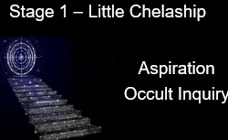  Refer to [Handout] “Stages of Discipleship” | Stage 1 – Little Chelaship (dedicated student of a teacher)  - Aspirant develops an aspirational life towards the Soul, as the Soul also has a downward gaze on the aspirant.  - Enters onto the Probationary Path and is the longest of the 6 stages. Aspirant is beginning to “consciously” practice Soul values, e.g. harmlessness, while integrating and developing character.  - Esoteric or occult inquiry and spiritual study drives the disciple to want to know and understand the changes he is beginning to sense within.
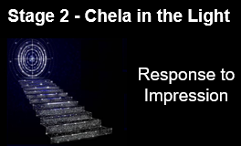 | Stage 2 - Chela in the Light  - Purification is ongoing; Emotional nature being transformed and aspirant begins his polarization shift to the mental plane; He is replacing lower sub-plane substance with the higher corresponding finer substance, such as astral is replaced with buddhic substance. This is an early recognition of the intuition.  - Building of Antahkarana continues for connecting to the higher Spiritual Triad. The higher planes and Intuition are felt; Begins to practice Soul “Livingness”.  - Guide(s) aid the students’ learning by helping him discover the subtleties of his shifts in consciousness; Master or Soul may contact the aspirant through dreams or impression.  - He is learning to study and observe in his own mind how the emotional body works and realizes that in order to control the emotional body, it must be done from the mental plane.  - Nearing the end of this stage, he takes the First Initiation, which is characterized with establishing the Christ Principle in the heart.
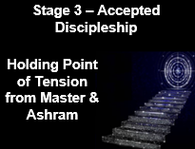 | Stage 3 – Accepted Discipleship  - He has moved consciously onto the esoteric path. The mental plane is quite active through analysis and observation.  - Disciple can easily invoke the light and wisdom of the Soul and the light /intelligence of the Spiritual Triad. He is learning to hold a point of tension with the Soul and its relation to his inner work.  - May have direct contact with Master and Ashram in meditation; When sensed, disciple has stronger sense of obligation and responsibility for carrying out Soul’s wishes and seriousness to the Path.  - Disciple understands the difference between loving, and the Will to love. This is akin to connecting the heart and mind together. Disciple is consciously and mentally linking-blending the heart and mind together.  - Within his mind, he is aware of the difference between the lower selfish will and the higher Divine will….and feels the pulls of both.  - He learns to hold the point of tension with the Soul’s and is learning the meaning of “holding the mind steady in the light”. This is done through an act of will.  - Second Initiation is possible at this stage as the disciple willfully controls emotional tendencies by transmuting them into higher aspiration. By anchoring the Soul’s awareness in consciousness, this helps to create a stability that making the 2nd Initiation possible.
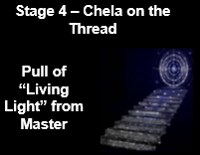 | Stage 4 – Chela on the Thread  - At the beginning of the this stage, the disciple will have already taken the 2nd initiation. He has achieved a great stability in the emotional-astral body through the power of the will. The 3rd Initiation will possibly follow within a short period of time.  - “Chela on the Thread” refers to the pull of the sutratma or the "livingness" thread of "living light" emanating from the Master. It is like a current drawing the disciple towards the Master and Ashram. He becomes trusted in the eyes of the Master and Ashram.  - Although the draw of the Ashram is powerful, the disciple can still chose the path of selfishness.  - Disciple realizes that he IS the active agent and identifies with the point of spiritual tension coming from his Soul and the Ashram.  - With the connection from Master-Ashram, a “continuity of consciousness” is developing.  - He identifies with beingness and can easily relate to energies of the Buddhic Plane.  - At end of this stage, the disciple takes the 3rd Initiation, and becomes “Monad-infused. He now has full identification with the Monad and his Ashram. He sees the Plan for the first time.  - The Soul is no longer the prime motivator for change.
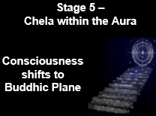 | Stage 5 - Chela within the Aura  - There is an "almost" complete at-one-ment with the Master, His aura, and his Ashram.  - To dwell in Master’s aura, he must substitute peace with serenity.  - Disciple recognizes the difference in consciousness between “becoming” and “being. He’s moving into the Triad and (out of the casual body of Soul) the Buddhic plane where the Ashram is really located. The Buddhic plane is the plane of “being” and synthesis whereas below that is the world of “becoming” or moving towards.  - Disciple simultaneously perceives the world of being and the world of synthesis and yet he has a part of himself that can perceive clear distinctions; is approaching 4th Initiation and becoming an Arhat.  - Disciple realizes difference between being and becoming. He is now approaching Arhat level as his consciousness now exists in the Spiritual Triad.
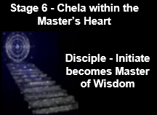 | Stage 6 - Chela within the Master’s Heart  - Disciple is approaching 5th Initiation to become Master of the Wisdom.  - At this level, he is relating to the heart of the Earth’s larger planetary system that whom the Christ Himself oversees; Disciple works in cooperation with Christ and enabling the Plan.  - The disciple moves from being the initiate to becoming Master. His Soul and causal body disappear, and his cycle of rebirth on the Earth plane is over. This stage happens at the completion of the Fourth Initiation.  - He is recognized by fellow Masters and can freely work in the planetary heart center.  - The Master can now build a Mayavirupa, or body of manifestation, and interact with the lower dense planes at will.
Meditation  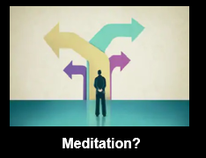 | Meditation? …Possible Themes?  - Experience of pure Beingness and Awareness  - Be aware of impressions and Soul contact  - Alignment of 3-Fold Personality incorporating Meditation, Spiritual Study and Service as a daily ritual?

