Fellowship of Cosmic Fire
Commentary Semester VII Section VII
TCF 822-825 : S7S7
Part II
19 June – 3 Jul 2008
(Most of the Tibetan’s text is put in font 16, to provide better legibility when projected during classes. Footnotes and references from other AAB Books and from other pages of TCF are put in font 14. Commentary appears in font 12. Underlining, Bolding and Highlighting by MDR)
It is suggested that this Commentary be read with the TCF book handy, for the sake of continuity. As analysis of the text is pursued, many paragraphs are divided, and the compact presentation in the book, itself, will convey the overall meaning of the paragraph. So please read an entire paragraph and then study the analysis.

III. The inner "sacrificial" triad:

- This is the triad which specifically concerns the initiation process.
- There is no initiation without the Will-to-Sacrifice and there is no Will-to-Sacrifice unless soul love is establishing itself as influential within the consciousness.
- Petal 1...The Will to sacrifice through knowledge on the mental plane, and thus intelligently to dominate the entire threefold lower man.

- The descriptions of the meaning of the petals become increasingly complex as we move into the third tier.
- Throughout the expression of the third tier the factor of sacrifice is to be found.
- In the first of the sacrifice petals the kind of sacrifice to be made requires knowledge, and it is not only concrete knowledge but the kind which arises through soul culture.
- The domination of the threefold lower man is not completed with the completion of the major focus upon the first of the sacrifice petals. Not until the final sacrifice petal is opened is this threefold domination of the vehicles of the lower man complete, but, we must remember that the seventh petal may not be fully opened until the very last sacrifice petal is opened, so, indeed, the domination of the entire lower man through sacrificial knowledge may proceed in relation to the general ‘program’ controlling seventh petal processes.
- We note that the entire lower man (etheric-physical, emotional and mental) must be dominated intelligently. Also, that domination will not occur unless the spirit of sacrifice is active, because that which must be dominated must be sacrificed to that which is to dominate.

Colours: Yellow and the four colours, orange, green, violet and rose.

- The presence of these colors above suggests the following:
- Yellow is particularly the color of sacrifice and is the color which appears in all three of the sacrifice petals, having appeared twice before—once in each of the lower tiers, in the third petal of each.
- Orange represents the increasing influence of the Solar Angel and the infusion of the concrete mind by the light of the soul and, following, increasingly by the antahkarana.
- Green correlates with the third ray and abstract mind which characterizes the function of this first the sacrifice petals. All the energies of the human energy system must be intelligently coordinated if the inner man is to control and eventually dominate them.
- Immediately before and at the time of the first initiation, the third ray (the color of which is green) characteristically rules the personality of the candidate for initiation.
- Violet suggests a higher expression of the seventh ray, helping to bring the personality under rule and order. The ‘de-mayafication’ and spiritually-responsive coordination of the etheric body is the focus of the first initiation. The seventh ray generically rules the etheric body and the color of the seventh ray is violet. Devas of violet hue characteristically rule the four systemic ethers.
- There is a close connection between the abstract mind (in the triad) and the etheric nature. In this method of examining correspondence, the buddhic plane would be reflected in the astral body and the atmic plane in the lower mind.
- The rose of aspiration and purified emotion continues to express as spiritual aspiration becomes intelligently directed and the urge to transcend entrapment by the form intensifies.

- Petal 2...The will to sacrifice through love on the mental plane, and thus to serve.

- For the kind of sacrifice necessitated at the seventh petal, knowledge was required.
- Now the Will-to-Sacrifice is supported by the presence of love.
- There is no real service without love, because love is the generic quality of the soul and service is the spontaneous radiation of soul energy.
- Knowledge of higher truth and soul destiny served as motivations at the seventh petal. Love of others (and oneself) as souls motivates the sacrifices undertaken at this eighth and crucially important petal.
- One of the important realizations in relation to this petal is that love must express itself on the mental plane. This requirement brings in the need for the Venusian energy which blends love and mind or heart and mind.
- The sentimental type of love (related to the astral body) is transcended, and increasingly impersonal soul love takes its place. Rose in relation to Venus and the love of the soul will be important.

Colours: Yellow and the four colours, orange, violet, rose and blue.

- The presence of these colors above suggests the following:
- Yellow is pervasive throughout this final tier of the first nine petals.
- Yellow represents the growing Will-to-Sacrifice motivated by buddhi (one of the colors of which is yellow even as one of the major planets of buddhi, Mercury, expresses the color yellow).
- Yellow is a generic color for the linking antahkarana, and during the processes associated with this petal (strongly under the influence of Mercury) the antahkarana can be built seriously.
- It is also possible to achieve a degree of fusion of buddhi and manas, and yellow is representative of this fusion, for yellow is both a buddhic and manasic color (exoterically associated with the fifth ray).
- Orange continues to intensify as the concrete mind is used as an instrument of instrument of keen discrimination between soul and personality energies.
- The eighth petal is a Scorpio petal and the concrete mind comes under special cultivation as an organ to be used in the control of the astral body and as an instrument receptive to the soul light.
- Violet is mentioned for the second time in the third tier (it does not appear twice in any of the preceding tiers) and signifies the will of the probationary initiate to bring his personality life under rule and order. The Path of Initiation is ruled by though first and seventh ray and so upon the Path of Probationary Initiation, the seventh ray (conducting the first) will be useful.
- The seventh ray under violet is also useful in linking the two ‘ends’ of the antahkarana.
- Blue appears as it did in P2 and P5 signaling the growing power of the combination of second and sixth rays. From another perspective, blue can stand (in our solar system) for the first ray.
- Within the process of this petal, much work is done upon the astral body and the second initiation becomes a possibility (a process supported by three planets—Venus, Jupiter and Neptune). Both blue and rose represent these three planets in part.

- Petal 3...The utter sacrifice of all forever.

- This is an all-inclusive statement, and would seem even more fitting at the fourth degree than the third (when only nine of the twelve petals are seen to be fully open).
- Perhaps at the third degree there is established that orientation which leads inevitably to “the utter sacrifice of all forever”.

Colours: Yellow, orange, rose, blue and indigo.

- The presence of these colors above suggests the following:
- Yellow reaches its strongest intensity (within the nine petals) within this sacrifice/sacrifice petal. Yellow is the color of sacrifice and the bridge from manas to buddhi, which is precisely the task of the initiation of the third degree.
- We have the ninth repetition of orange which, we can expect, will be at its most intense (for the following three petals do not carry the color orange—only a “lovely lemon-yellow hue”).
- The orange of concrete mind is brilliant and soul infused. The Solar Angels have completed the majority of their work for the unit, man.
- Rose represents pure love as it conditions the now purified astral nature. Here rose links easily to buddhi.
- Interestingly, both blue and indigo are found in this petal.
- Just as violet was un-characteristically repeated in P7 and P8 so blue is un-characteristically repeated in P8 and P9. When such repetitions occur between adjacent petals, a bridge is created.
- Indigo represents both the second ray (of which it is the generally accepted color) and the fifth ray (of which it is the esoteric color). Emphasis upon the esoteric nature of the fifth ray makes sense in relation to a petal, the opening of which signifies the taking of the third initiation at which time the fifth ray rules.
- Blue opens the door to the influence of the “Blue Logos” at this first solar initiation. If blue is to carry some meaning of the first ray (as that ray functions in this Love-Wisdom solar system), then its appearance here is significant because at the third degree the initiate experiences the Monad consciously for the first time.

In the mystery of these subsidiary colours and of the gradual shining forth within the lotus of five colours in any one petal at one time,

- As is the case when dealing with the sacrifice petals…
- Mercury (a fourth ray planet from the soul perspective) is a planet of sacrifice and is even more deeply related to the number five than to the number four.
- Five is a Kumaric number but so is fifteen, the sum of the three fives, each found in a single sacrifice petal.

is veiled the mystery of the five Kumaras ⁶² [S. D., I, 483.]

- When we deal with the Five Kumaras, the three Buddha of Activity are included, Sanat Kumara also, and one of the Esoteric Kumaras as well.
- The five liberated Creative Hierarchies will also be brought to mind as well as the meaning of the number five in relation to the previous solar system.
- Below, VSK shares some interesting speculations on color in relation to the Kumaras.
- The colours of the five kumaras therefore may be corresponded to colours. If so, we look at the five liberated lives (E.A. 34).
- One suggestion: the 5th Kumara, Cancer, that of the 7th ray, is violet – but notice VIOLET is NOT in the last petal, the 9th. We have INDIGO INSTEAD. (Perhaps at the stage of the 9th petal activation, violet is transcended as the orb of purple dark, or earthly realm, may be said to be). Alternately, the yet-unliberated 5th kumara is not involved? Or, as it says He is “active on the intellectual plane” (EA. 34); this is more logically, perhaps, knowledge on the physical plane, and the Cancer Kumara is ORANGE. The 7th ray being the densest of the Kumaric lives, still immersed in matter of the cosmic physical plane, and wearing, therefore, the robes of orange, of the lords of flame and a colour of mind.
- The Gemini Kumara, the 6th ray, that of ROSE. (And, perhaps, that ‘also’ of BLUE?) Somehow, the ‘two who fell’ seems to relate to Gemini and Cancer. If we translate the influence of the Kumaras to the Creative Hierarchies down to the cosmic physical plane, these two would relate to Aquarius, the lunar 7th ray Hierarchy, and Sagittarius, the martian 6th ray Hierarchy. If ‘unprincipled matter’ can be referred to as ‘fallen’, then ROSE and ORANGE Kumaras may have ‘fallen’ (sacrificed themselves, as fuel for the flame?, or were inadvertently drawn into indulging in?)
- Next ‘up’ the Taurus Kumara is the 5th ray and in relation to color could be INDIGO or BLUE, or ORANGE, or YELLOW. If we surmise that the physical/knowledge petals on the physical plane are ORANGE, and the Love Petals related to the Gemini Kumara ROSE, it may be that YELLOW most relates to this 3rd Kumara, or the 5th Ray Kumara, Taurus (a 4th ray sign). (Note too, for fun, It’s Hierarchical symbol is that of the bird, which, same as the symbol for all five liberated hierarchies, is the bird escaping from the flaming pyre.) This is the mind set free?
- BLUE or INDIGO could be sufficiently justified to relate to both the ‘top two’ Kumaras. And, I think there’s the reference in The Secret Doctrine which suggests the kumaras who fell were the ‘top two’.

The student who seeks the significance of the preponderance of orange and of rose is approaching the secret of the two Kumaras Who fell.

- Among the nine petals, the color orange appears nine times and the color rose eight times, if we count it twice in the fifth petal.
- Orange is particularly the color of the Solar Angels and rose is to be associated with the astral plane and the redemption of the lunar lords there found.
- We must trace this “Fall”. Is it from the cosmic astral plane onto the cosmic physical plane? Or is it from the higher levels of the cosmic physical plane to the lower levels. Both changes of focus would constitute a “Fall”.
- A question arises. Do the Esoteric Kumaras express themselves only on the cosmic astral plane (as Their lowest plane of expression) while Sanat Kumara and the three Buddha of Activity express upon the cosmic physical plane? This is a possibility.
- Can we, however, equate any Kumara with a Creative Hierarchy of the kind represented in EA, 35. Are not these Creative Hierarchies too ‘low’, relatively, to equate with the seven intra-planetary Kumaras? This needs careful investigation.

More it is not possible to say, but the colours hold the esoteric key to this great occurrence.

- Interestingly, Kumaras Who fall do so for redemptive purposes. The Kumaras and the Solar Angels are directly related to Venus (which is, for the Earth, a planet of redemption). Given the fifth ray/sixth ray nature of Venus, the colors orange and rose are peculiarly fitting.
- VSK comments again:
- This tabulation most clearly shows that the knowledge petals are effective only on the physical plane; the love petals on the physical and astral planes, and the sacrifice petals are mentioned as dominating from the mental plane (not, as could be surmised, ‘active on the mental, astral, and physical’).
- This may be another hint regarding the orange and rose Kumaras as the ‘two who fell’, as They are the ones no longer connected to the spiritual triad, whereas the mental-yellow-sacrifice petals ARE. Thus, perhaps, indicating the sacrifice (or gift or realm of responsibility) by each of these Buddhas.
- It may be necessary to study our TCF Charts closely to see in what manner the permanent atoms of the spiritual triad are related to the three tiers of petals.
- It is at this point that we should recall the Buddhas of Activity, the Buddhas of Love and the Buddhas of Sacrifice mentioned earlier in the text.

This inner circle of petals is organised and vitalised in the Hall of Wisdom, and simultaneously the middle circle unfolds,

- The middle circle unfolds as the third tier of petals is being organized and vitalized, just as the first tier of petals unfolded as the second tier was being organized and vitalized.
- The Hall of Wisdom is an area of experience which may be considered as beginning with the Probationary Path and continuing until Mastership. In some references it seems that the Hall of Wisdom begins with the first initiation.
Graduation results when initiation is taken and the initiate passes into the Hall of Wisdom. (IHS 65)
- When thinking of the Hall of Wisdom and the processes which occur during that stage, we must include not only the organization and vitalization of the petals but also their unfoldment, for the Hall of Wisdom continues certainly beyond the third initiation, at which time all three of the sacrifice petals are necessarily unfolded.
- The Halls of Initiation are entered during passage through Hall of Wisdom.

so that two rows of petals are duly opened, and only the third remains to be unclosed.

- Two rows of petals (i.e., the petals of the first two tiers) have been opened by the time the candidate treads the passages of the Hall of Wisdom. The opening of the first two tiers—as ‘interactive entireties’, however, corresponds with a degree of opening of the seventh and eighth petals, and thus, with the first two initiations.
- We must discriminate between the following:
- The opening of three petals
- The unifying of the three petals in a tier
- The synthesizing of the three petals as a complete unity ready for interactivity with the next higher tier of petals.
- If we think of the knowledge petals:
- The opening of three petals of the knowledge tier represents a readiness to move out of the Hall of Ignorance
- The unifying of the three petals in that tier represents the taking of a lesser initiation emphasizing some type of preliminary group awareness. When this happens the fourth and fifth petals have not been fully unfolded.
- The synthesizing of the three petals of the knowledge tier and their readiness, as a unit, for interactivity with the unfolding petals of the light may be found at the first initiation, at which time the fourth and fifth petals are completely unfolded, and the seventh petal is in process of unfolding having been ‘touched’ by the Rod of Initiation.
- So we have a contradiction unless we allow that at some time during the Hall of Wisdom process, the sacrifice petals can being to open, which, indeed does seem to be the case.
- We might say that during the Hall of Wisdom experience, the petals of the third tier are organized and vitalized, and later in the Hall of Wisdom the petals of the third tier are unfolded as well.
- Trying to find the exact point at which the Hall of Wisdom is entered is elusive.

This final opening

- Presumably, in this context, the opening of the final tier or the tier of sacrifice petals…

is effected during the period of treading the stages of the Path of Initiation,

- Yet, it would seem that one treads the Path of Initiation within the Hall of Wisdom.
and in this round it is hastened by the rites of initiation and by the strenuous and abnormal efforts of the man himself, aided by the electrical work of the Initiator, wielding the Rod of Power.

- This is one of the very important statements, telling us that an opening which might occur slowly and normally under the influence of the Solar Angels and the Second Logos is hastened by the rites of initiation and the application of the Rod of Initiation. The man, too, because he is working strenuously and with abnormal effort, hastens the otherwise slower opening of the petals. Though, we must remember that the man, per se and unaided, does not open the petals and especially the sacrifice petals. The opening occurs either automatically (under the influence of the Solar Angels and the Second Logos) following the man’s efforts to organize and vitalize, or under the influence of the applied Rod.
- We note that this method of seeing to the opening of the final tier of the nine applies particularly during this fourth round. Perhaps it did not or will not apply at other times.
- The fourth ray is a bridging ray and the Solar Angels are bridging Entities.
- Below is a new version of the Chart of the Egoic Lotus. It has been Earth-designed by Tuija Robbins and careful attention has been paid to the quality of the colors presented and the numerical order of the nine petals.
- The white appearance of the synthesis petals will be changed to the lemon-yellow hue DK indicates.
[Page 823] CHART IX—THE EGOIC LOTUS
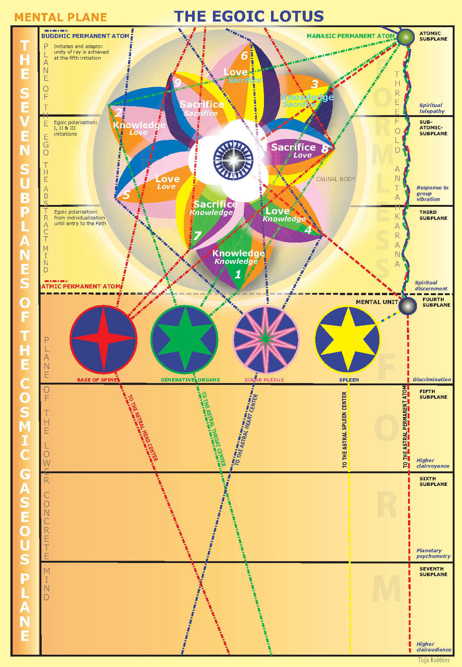

[Page 824] Though we have thus divided off the different stages of development, we have but dealt with the general average,

- To divide the different stages of development, one from the other, is something of a distortion as it does not emphasize the very obvious factor of simultaneous, multi-leveled unfoldment.
- As well, the mode, manner, order and speed of unfoldment will be a very individual matter for each disciple/initiate. It would be impossible to cover all the possible variations, but as time elapses, and we gain intuitive and sentient insight, the details of the process (as regards both others and ourselves) will be revealed.

gathering our facts from the records to which we have access and which are grouped in relation to this subject into the three groups, related to:

- DK is telling us how the records to which He has access are grouped.
- We can see how much there is to know and how little anent these matters we can know until we have access (and, therefore, deserve) access to the same records.
- We will note that DK is studying the subject according to monadic groupings. This is fitting as the petals unfold in order (and perhaps in intensity of radiation) according to the monadic ray.

a. The Monads of power.
b. The Monads of love.
c. The Monads of activity.

The student must remember that according to these groupings, so will be the tendency of the petals to unfold. For instance, in the case of the majority of men, being [Page 825] Monads of Love, the love petals are more easily awakened, for love is the nature of the present manifestation and the line of love in some direction (low, high, or spiritual) is the line of least resistance for the many.

- We have discussed this type of sequence on many occasions. The unfoldment of chakric triangles is also related to the monadic ray.
- Eventually, it becomes necessary to know one’s monadic ray as the specific dynamics of one’s energy-unfoldment process is determined thereby.
- We can hypothesize that the Monads of Intelligence have the most difficult time unfolding the sacrifice petals; the Monads of Love, the knowledge petals; the Monads of Will, the love petals (even though, relatively, the knowledge petals are the easiest for all to unfold and the sacrifice petals the most difficult—generally.
- In our solar system, the great majority of Monads are Monads of Love and the expression of love is, therefore, for them, the line of least resistance.

Yet the Monads of activity are numerous and influential

- Especially is this so upon our planet as well as Mars and Saturn.
- Because the Monads of Activity are the “oldest” in terms of incarnational experience they are “influential”. They can more easily arrange circumstances to conform to desired outcome.

and the first petal in each ring is for them the easiest to unfold.

- It seems that the Monads of Activity have much resistance to both love and will, but (even though will is found on their own line of energy) it seems that will is most difficult for them to unfold, perhaps because it is most easy for them to evade through the misuse of intelligence.

For both groups the "knowledge" petal is the first opened, owing to the inherent nature of the Manasadevas themselves, and their basic vibration.

- The basic vibration of the Manasadevas is divine knowledge represented by orange.
- Manasadevas respond most, therefore, and most immediately, to the knowledge vibration, though their capacity to embody love is exceedingly strong.

For all, sacrifice is the hardest, for it involves ever the two factors of intelligence and love,—intelligent knowledge and a love that goes out to that which must be saved through sacrifice.

- Thus we have a situation in which knowledge is generally easiest and will/sacrifice is hardest. We may presume that will/sacrifice is easiest of for the Monads of Power, even though, for them as well, it is difficult—apparently more difficult, in general, than opening the knowledge petals.
- It is interesting that there is no true sacrifice unless supported by both intelligence and love. So there is much assimilation to be accomplished before sacrifice can really be achieved and expressed, thus accounting for the relative difficulty in opening the sacrifice petals.
- We are leaning why it is so difficult to read the Path of Initiation—for all types, even though the Path of Initiation is ruled generically by the first and seventh rays (so presumably these types should find it easier to tread), and the second ray types are adept at teaching the science of initiation.
- For third ray types it may be fairly easy to be responsive to will and power, as that will and power express in personal/individual ways, but not so easy to be responsive to the loving expression of will and power.

