3 The Lesser Centers
The stage has been set for a consideration of the lesser centers. As the description of them proceeds, the reader will take note of how important a thorough understanding of the meridian system is with regard to the lesser centers. Without a systematic knowledge of the meridians, understanding of the lesser centers becomes fragmented at best and hopelessly confused at the worst. One begins to realize that those centers represent spheres of influence directly impacting and impacted by the meridians.

The lesser centers can be compared to railroad round houses. A roundhouse is a circular house in which several railway lines intersect. The centre of the house is a single piece of track which can be rotated. Thus, if an engine is on the central track, the track can be positioned such that the engine can be switched to any one of the railway lines coming into the building. Of course, a lesser centre is more complicated than that, but hopefully this example will illustrate the point.

"A lesser centre is formed at the point of intersection of two or more meridians or where two meridians pass close together." (Sara) The energies of the meridians making contact there become intermingled or antagonistic dependent upon the state of the meridians involved. In other words, the energy can become a blend of meridian energies and exhibit a completely new quality based on that mixture, which in turn adds to the total and quality of energy within the two or more meridians. The centre thus becomes a sort of storage battery or generator and there is an exchange of energies between the meridians involved. It is in this manner that meridians tend to support one another and replenish depleted meridians. Conversely, if the energies of the intersecting meridians clash and do not mix, there is no free exchange of energy between them and the centre and the meridians involved are devitalised or thrown off balance. Shock to the system or repeated misuse of energies can cause such a situation to develop.

If one could see the various centers, it would be possible to discern at a glance which meridians were not functioning properly and why by viewing the condition of the centers. It would also be possible to determine somewhat of the psychological disharmonies underlying various conditions. The lesser centers tend to be more associated with the major centers they are closest to, so it is also possible to diagnose at a glance the condition of the various major centers. It should be kept in mind, however, that the major centers are the reflections of consciousness and thus of a person's psychology. The following format will be used when considering the lesser centers:

1) Name of Centre
Location on body "landmarks" for identification

2) Meridians involved
Colours
Magnitude: 1-10

3) Clairvoyant observations
Qualities already observed

4) Commentary on information from information on meridians

For the convenience of the reader, the following tabulation offers the primary psychological functions expressed as key words of the major meridians:

Conception Vessel: Intensification; consumption in goals; goal setting, electrical charge and current through the system.
Positive expression - balanced pursuit of objectives, realistic goals, high spirits.
Negative expression - obsessiveness; workaholism; unrealistic expectations; depression or mania.
Governing Vessel: the weather vane; gauge of environment; will power; bodily energy levels; endorphin reactions to various substances; hearing of intuitive essence.
Positive expression - strong will power; regulated energy; positive inner guidance.
Negative expression - lack of will; stubbornness; overbearing; fluctuating energy; deafness inner and outer.

Bladder Meridian: Circadian rhythm; feeling and release of childlike emotions; release of emotion; regulation of kundalini.
Positive expression - ability to release harmful emotions; good sense of timing; timing of outward expression to greater cycles (progress in right timing); control of emotions.
Negative expression - hardened; "toxic" emotions; accentuated "macho" attitudes; poor judgment as to time and place for action; blocked flow of kundalini with devitalization as the result; explosive emotional outbursts.

Kidney Meridian: registers hatred, anxiety and depression and was set up to get rid of such feelings; sensor or warning system; karmic relationships; sentient response; strongest psychic meridian; very refining; the feeder; feeder of chi.
Positive qualities - positive; happy outlook; clairsentience; good reserves of chi; alert; responsive; refined emotions.
Negative qualities -depression, neurosis; unbalanced emotions; unreliable energy levels; insensitive; unfeeling; unresponsive emotionally; stress.

Pericardium Meridian: backup; protection; energy storage; emotional defences; being able to fend off discord.
Positive expressions - secure in emotions; emotional reserves; firm foundation of energy; being able to pull through in times of stressor attack.
Negative expression - insecurity; emotions sap all reserve and person must retreat to rejuvenate those reserves; takes illness easily; feelings of defencelessness; defensive.

Triple Burner Meridian: creation of vitality; centred, focused expression; grounding; posture - one's "standing in community"; "sound reasoning;" regulated metabolism.
Positive expression - "grounded"; focused; sound, balanced reasoning faculties; upstanding.
Negative expression - poor or misplaced reason; no common sense; flighty; unable to stay focused; short attention span; laziness; fatigue; diseases of metabolic origin.

Gall Bladder Meridian: decision-making; logical thought; breaks down and stores information; calculating and balanced thought; registration of information.
Positive expression - rational, balanced thinking; decisive; good with facts and figures; able to put things in proper place and order; keen observation.
Negative expression - cunning; manipulative; unreasonable; illogical; indecisive; poor powers of observation.

Liver Meridian: rules movement; filter for emotions; love-hate, "black and white" relationships; nurturing; inner child; ability to give; polarity of divine Mother; "fighter"; how well a person handles stress.
Positive expression - resilience; giving, loving demeanour; secure internally (feelings); able to formulate and give life to ideas; calm under pressure.
Negative expression - miserly; irritable, hateful; insecure; inability to carry through ideas - nothing ever comes to fruit; cannot bear any kind of stress; retreatist.
Lung Meridian: timing of divine will; how a person reacts to authority; speech; registers fluids necessary for body; philosophical beliefs; integrity; how conscious a person is.
Positive expression - present in body and attentive; recognition of place in scheme of things; positive philosophy of living; strong leadership abilities; fine integrity; balanced, thoughtful speech; impeccable sense of when and how to act; sense of integration with the "Grand Order."
Negative expression - the person who can never do anything correctly; daydreams; poor listener; fidgety; fast talkers and incessant trivial speech; procrastination or impulsive/compulsive behaviour; atheistic or negative philosophies; the people who think the world owes them something; rebellious.

Large Intestine Meridian: emotional holding patterns; guilt; ability to release when necessary; conscience.
Positive expression - a sort of "divine indifference"; well developed conscience; non-attachment to non-essentials; able to work through and past heavy emotion.
Negative expression - clingy and cliquish; guilt-ridden; psychopathic and sociopathic behaviour, poor self image; "anal-retentive ", neurotic personality.

Stomach Meridian: how well the "game is played"; coordination; mental prowess and ability to concentrate; how one “calls the shots” energy regulation; drive; organization; follow through.
Positive expression - socially graceful; well-organized; coordinated; able to see projects through; fair, honest interactions; good leader; focused but positive determination; "stick-to-itiveness," balanced, regulated living pat- terns.
Negative expression - the klutz; disorganized; slovenly nothing ever gets completed; wide swings of energy from lassitude to overwork; dishonest, selfish dealings; must be constantly looked after; energy dissipator due to poor judgment.

Spleen Meridian: "the click in the heels"; humour, incarnation; responsibility; acceptance or denial; self-protection; people who wear the masks.
Positive expression - acceptance of responsibility; high, good humour; able to be "present"; high vitality; lively expression; "infectious high spirits."
Negative expression - daydreams and fantasizes constantly; depression; no sense of humour; irresponsible; escapist tendencies; self-denial and denial of responsibilities; the person who masks their feelings.

Heart Meridian: thought clarity; group living; belonging; membership; feelings about prosperity; vision and foresight; memory; Oneness.
Positive expression - community spirit; thoughtful of others; prosperous or at least feels that way; visionary, but clear; reasonable; feels oneness with all; good memory; clear eyesight.
Negative expression - separative; inconsiderate; hateful; clouded thinking; lacks vision; cannot "see the next step"; poverty; tries to forget; loneliness; depression; down-and-out.

Small Intestine Meridian: non-physical agitation; fight or flight; fears; filters emotions; prosperity (feelings about) registers shadows and things that appear to be attacking; use and carrying of sound waves.
Positive expression - calm; courageous; attentive but confident; good listener; grants inner guidance.
Negative expression - skittish; nervous; cowardly; paranoid; distorted thinking due to fearful emotions; poverty; unable to face fears; irritable; constantly agitated.
!!! WARNING !!!

Before any attempt is made at working with the lesser centers, it must be clearly emphasized that the reader does so at his or her own risk. Many of these little centers contain psychological issues that can be very painful to a person when confronted by them. It is not advisable to attempt any work with any centre unless there is a reasonable assurance that whatever painful memories are accessed in that centre can be competently handled by the therapist, the person whose centre is being worked on, or unless appropriate support counselling is in place. Follow-up consultations are commonly needed after such work. This book is introductory in nature and is not intended for use as a therapeutic manual. Therapeutic uses for the lesser centers will be treated in another volume of this series.

With all this initially imposing information from the previous chapter in hand, consideration of the lesser centers can now be attempted. Again, keep in mind that a lesser centre is formed where two or more meridians pass close together or at a connection of the same. It is thus a blending or unbalancing of energies, depending upon a person's consciousness as expressed through that centre. The centers are indicated on the following figures with letter demarcations.

(S) 1 Emotional Presence Centre
Location: Just above the pubic bone
Meridians: Liver, Conception, Spleen, Kidney
Magnitude: 7

Note. As a general rule, this centre should always be the last of the lesser centers to be approached on a person.

Clairvoyant observations.. 'This is the point of pleasure or pain. It opens to the tonality of the heart centre. It is immediately affected by sound quality contained in verbal communications. When positively expressed, it opens the heart centre to experiencing the pleasure in sexual relationship. When closed, it is as a result of emotional trauma in childhood resulting from misguided parental objectives, i.e., parents controlling of childhood behaviour rather than loving guidance of the same. Therefore, this centre reflects whether or not a person can be present in their emotions. It has been called a point of woe or sorrow because people are frequently verbally traumatized as children by their elders. Karma is also somewhat accessed there because trauma in the present life so often has its roots in a past life, especially if that trauma has greatly modified a person's expression. Going into that centre in healing work or meditation can yield keys to emotional shocks in the past which are reflected in the consciousness in the present situation.'

Commentary. The Liver and Kidney meridians both work as filters for emotions. The Conception Vessel works more to form an image of self and with goals and intensity of consciousness relative to that centre. The Spleen meridian works there to enable the person to be present as an individual, to be accepted as the same and with the vitality existent in the sacral centre. It therefore energizes personal expression. There are essentially two pairs of energies at work at that point: the Liver and Kidney meridians possibly as one pair with the Conception Vessel and Spleen as the other.

The consciousness expressed through this centre would then be related to how a person reacts to and processes emotions (liver and kidney) and the person's ability to be present, settled and clear-thinking in the process (conception and spleen). Remember that the consciousness expressed through this centre is conditioned primarily by the sacral centre and is therefore childlike in one way and energetic in another. The sacral centre is particularly related to or active in certain key phases of life - the toddler or infant stage and puberty. At both stages of life, there are certain decided events which take place in the development of the individual astral body. The toddler or infant stage is where the person's feelings about individualized selfhood are formed. The stage at puberty is related to how a person feels about relations to others, which naturally has its foundation in the infant stage of development. The stage of puberty begins the true dualistic life and hopefully the urge toward unity or various "marriages" of which the secondary sex characteristics are one indication.

This centre at the pubic bone is primarily yin. Therefore, the centre works primarily with a person's internalised feelings. But the feelings expressed by the sacral centre are unrefined. Nonetheless, they form somewhat of inner child conflict. The kidney filters out anger, rage, fear, etc. The liver works on a love-hate, black or white, i.e., absolutist basis and is particularly related to the inner child. The kidney is a very strong psychic meridian. The union of the two meridians at this centre is a potent receptor or indicator of a person's ability to psychically or sentiently register love, hate, fear, anxiety, etc., etc. If a child is not loved, that is known subconsciously or consciously to the child (it does not matter which) and imprints this little centre. All emotional trauma would therefore upset the functioning of the pubic bone centre. Peter has noted the quality of a parent's or person's voice has the greatest effect on this centre. In the author's work with people, it has been found that physical abuse can also be accessed there, aside from vocalization. Discordant energies would thus cause the two pairs of meridians to be antagonistic at that point. How would such a condition surface, one might naturally ask?

Consider the following scenario: Johnny and his father are at the grocery store one day picking up some things for Johnny's mom. Johnny is two years old, full of energy, into everything and beginning to assert his own identity - a typical two year old. He sees some candy on the shelf he really wants. "No," says dad. "it will ruin your supper." Johnny is angry that his dad will not get the candy for him, so he expresses his anger in the typical fashion of most two-year olds -- by having a tantrum. His dad is not amused and, in fact, is quite embarrassed because there are quite a few people in the store and they are all looking at Johnny and his dad. His dad tells him to be quiet and that he will get him something after supper. Johnny wants the candy now and continues his tirade.

His dad finally loses his patience and his temper, picks up Johnny by one arm and soundly spanks him, telling him to be quiet or he will really give Johnny something to cry about. Johnny gets the message and stops crying, but he is very hurt and angry. The message to him from his father has been very clear - to keep his feelings to himself and be an obedient little boy - or else. Johnny's behaviour has possibly been changed for life, especially if similar situations occur later. Clearly, unless Johnny and his father receive some guidance, Johnny may become one of the countless numbers of men who are impotent or negative when it comes to expressing emotions. The scene just described is all too common.

What happens is that the person, like Johnny in the preceding example, can no longer be present in the feeling state faced with the given situation. A facade is created, feelings are hidden, the person may overcompensate for feelings of lack, unreasonable, illogical, childish reactions come to the fore and the person feels out of control. The person can no longer function normally. All will power and ability to express feelings are gone or directed elsewhere. Such patterns as the sex offender who was molested as a child, the alcoholic child of an alcoholic parent, etc., are all imprinted on the pubic bone centre.

Clearly, if parents would give loving guidance to children instead of seeking to control the child's behaviour, then the wonderful inner child would continue to express throughout life. Parents little realize the effect that their voices have on their children. Children learn by example. If a parent's own inner child is stifled, then the real child has little hope of realizing a full expression of potential. Love is the key to all successful interactions with people. People cannot express their hearts unless they are present emotionally.
The following diagram will serve to clarify the interactions of the meridians:

Liver | Kidney | Spleen | Conception
Love/hate relations | Filters hatred, anger, fear, etc | High vitality and good spirits | Goal setting
Ability to give | Refinement of feelings | Humour | High vitality
Inner child | Karmic relations | Incarnation | Objectives
‘fighter’ ability | Psychic warning | Self protection | Intensification
Nurturing/neglect | Feeder of chi | Acceptance/denial | High spirits/depression

The positions of the key words in each column can be arranged in any fashion. From a very cursory examination of the permutations possible with the above table, it is easily seen how complex one of the lesser centers can be. One can see clearly that the subjective evidence bears out the commentaries just attempted. As was stated in the introduction to this work, the findings or synthesis represented here are not to be taken as infallible or complete, but merely as indications.

In examining the lesser centers only a brief outline or Commentary will be given in each case with the exception of some of the more pertinent centers. Such an approach is taken both to avoid dogmatising of data and to encourage the reader to try the same synthetic process for him or herself. Clarity will undoubtedly result. Hopefully, in the near future, a fuller exposition of the various syntheses represented by the lesser centers will be written. It is simply beyond the scope and intent of this present work.
Figure 16

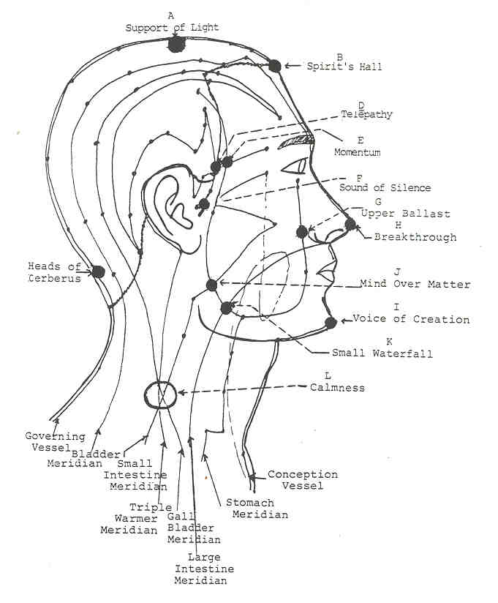
(A) 2 Support of Light Centers
Location: On either side of the crown chakra parallel to the Governing meridian
Meridians: Bladder, Liver
Magnitude: 10

Clairvoyant observations: "These centers help to establish what is called the 'ring of silence' above the head, which resembles a halo. These work with involutionary energies and the creation of a space for something to move into. The silence before creation: these points put one in touch with the creative Sound. These are how one contacts Celestial Sound and the music of the spheres.

Commentary. The keys to these centers lie in the relation of the Bladder meridian to timing and circadian rhythms and the relation of the liver to emotional responsiveness and nurturing. These centers are most closely attached to the crown centre which is the centre of God - contact and control. It is the centre that unites the fires in the body and draws the fully awakened kundalini fires up the spine. While considering the Bladder meridian, it was mentioned that meridian was associated with kundalini.

These lesser centers are apparently concerned with 1) seasonal control over metabolic and digestive processes 2) release of emotional residue and toxicity in relation to astrological or circadian cycles, 3) control over the fires in the body according to season (as with animals that hibernate) and 4) with rhythmic control over the astral body. These function as a sort of safety valve for the astral body, but only according to proper timing. They are also related to the quality of emotion necessary for proper kundalini flow, which is a vital consideration. Poisoned emotions will not allow raising of kundalini.

(B) 1 Spirit's Hall Centers
Location: At what would normally be the widow's peak
Meridians: Bladder, Governing and Stomach
Magnitude: 7

Clairvoyant observations.. 'This centre is involved in the synchronization of the crown and ajna centers. It engages the belief system aspect of the crown chakra. From there, it draws down the light from the crown which is then interpreted by the perceptual nature of the mind and is then projected outward onto the world by the agency of the ajna centre. It has a close connection with the astral portion of the limbic system. indifference closes this centre because indifference removes a person from interaction with life. Involvement in life thus has a strong effect on the Spirit's Hall centre. This centre also works with issues around authority, but more in the realm of guidance. It helps to integrate direct contact with higher spiritual realms, which should be the guiding force of authority in anyone's life.'

Commentary: This centre lies between the crown and ajna centers and would appear to relate the two. If it is involved at all with the integration of these two centers, then it plays a definite role in the workings of the forehead centre, better known as the third eye. It is known that the coordinated functioning of the three centers - crown, ajna and alta major - form what is known as the third eye. This lesser centre is thus a sensitive point for the third eye functioning.

It will be remembered that the Bladder meridian has a termination at the pituitary body, and, also, that the Governing vessel has a termination at the medulla oblongata or alta major centre. A further point of great interest here is that two subsidiary meridians, the yang chiao mai and yin chiao mai (see glossary) both have terminations at the pineal gland and both connect to the Bladder meridian directly and the Governing vessel indirectly at the back of the head. At a strictly physical level, this little centre has a role in hormone regulation, especially in response to circadian rhythms. This is a point of very clear perception and fine regulation of systemic functioning, which is due largely to the Stomach meridian's connection there. The reader is warned not to stimulate this centre except under strict supervision due to hormonal imbalances that could possibly occur by improper stimulation. It is a yang centre and affects the inner workings of the system in response to outside influences, especially light. Time in terms of cycles is also a prime factor in its functioning.

(C) 3 The Heads of Cerberus Centers
Location: Horizontally at prominence of base of skull
Meridians: Bladder and Governing
Magnitude: 7-9

Clairvoyant observations: 'There are two aspects to these centers, one involutionary and the other evolutionary. (Most people have a tendency to work the involutionary side of these centers which is why the name was chosen. MNA) In their evolutionary aspect these centers work with the evolutionary levels of soul growth. It is one of the last places where kundalini connects with the ajna centre to be established as a permanent residence. They establish a strong vertical shaft of light from the head to the spine. They also work with the splitting of the light shaft in the head. There are actually two shafts of light in the body, one corresponding to the sushumna and the other passing directly through the centre of the body.

The lower aspect of these centers governs the flow of energy going down the spine. The evolutionary aspect marks a return to the origin or soul The involutionary aspect marks a return to the body or matter.'

Commentary. In mythology, Cerberus was the three-headed dog who guarded the gate to the underworld permitting neither the living to enter nor the dead to leave. These three centers lie at the point of entry for the Governing vessel and Bladder meridian into the brain. The base of the brain is most closely associated with the alta major centre. These centers thus form points of integration between the alta major centre and ajna centre. Remember that the Bladder meridian terminates at the ajna centre and the Governing vessel has a termination in the medulla oblongata. The alta major centre stands sentinel over the energies coming up the spine into the head and going from the head into the spine. It is also a centre that works with the subconscious mind and, in an analogous manner, with a person's "underworld" - hence, the Heads of Cerberus Centers is an appropriate name for these three lesser centers.

When a person starts to tread the Path or return to their "Origin," the evolutionary aspect of these centers is activated. The alta major centre begins to expand and all body functions are heightened and invigorated. Light begins to pour down the spine, invigorating all the major centers in the torso. A reflex action occurs with the base chakra, and kundalini begins to be allowed into the skull cavity thus awakening higher perception. These lesser centers apparently play a role in dissolving the etheric web separating the head and spine and also with integrating the more subconscious workings of the forehead centre giving past-life recall, control over racial and individual karma and thus releasing a person from the Mayas, glamours and illusions of personality life. To express it otherwise, the soul is enabled to have increasing control over the lower person and the personality unites with its originating source.

These centers in their higher aspect could be called the "Flight of the Arrow" centers as Peter sees them. He goes on to state that "they are somehow related to the constellation Sagittarius (the Archer) in the zodiac." Sagittarius is the sign of discipleship and of the person treading the Path. The centre of the Milky Way galaxy, which is the origin of all life in this galaxy, lies in the direction of Sagittarius. Sagittarius thus marks a path of return, an alignment with the soul and a one-pointed adherence to that soul. Once the alta major centre is opened along with the Heads of Cerberus centers and are aligned and integrated with the ajna centre and the central shaft of light in the head, then there is no deviation from the control of the soul and the spiritual life takes off like the flight of an arrow.

In its lower aspect, the Heads of Cerberus centers form a barrier between the spine and head and only allow that portion of energy to travel back and forth into the head and spine which is allowed by karma. The lower person is then under the influence of the quelle psychic monitor (see glossary) as expressed through the alta major centre. The Heads of Cerberus centers then act as impediments and sentinels over the person's use and misuse of energies and the person lives a dualistic existence, sometimes faintly sensing some higher purpose, but more often living a materialistic life.

Karma is therefore somewhat accessed in these centers. Kundalini cannot rise into the head and the third eye (forehead centre) will not function until the demands of karma have been fulfilled. Anyone who would foolishly seek to stimulate these centers with a mind toward raising kundalini without first meeting the demands of the queue is only inviting trouble. In the myths, Cerberus was a foe to be defeated and a fearsome one at that. One's karma, though, should never be seen as inimical but rather as a welcome lesson, showing strengths to be acquired. Karma is thus a teacher and not a feared, dreaded foe. Until love can placate Cerberus (karma) and people can gain egress from their own underworld into the clear light of day, only then will there be enough light for the archer (soul) to aim carefully and let the arrow fly back toward its source (Spirit) so the archer can follow it home.

(D) 2 Telepathy Centers
Location: In temples, but more toward ears
Meridians: Triple Warmer and Gall Bladder
Colours: pink and green
Magnitude: 4

Clairvoyant observations: "The centers in front of the ears in the temples work with mental telepathy. They help in the interaction of the forehead centers by helping to create spatial relationships. They help the mind to formulate space as a dimension and allow time to take on spatial characteristics.

Commentary.. Since the triple warmer allows a person to be present in time and space and the gall bladder rules a person's thought processes, the Telepathy centers indeed indicate how a person decides where and how to be "present" or conscious at a personal level. They are yang points and since they are connected with some area of the reasoning faculties, they are involved in cognitive reasoning and logical thought processes. They would seem to form a polarity to the centers just in front of them in the temples, somewhat like a left brain/right brain relation with these two being more closely associated with left brain functions. The Triple Warmer governs that portion of energy which allows one to exist physically and thus in time and space.

These two centers also indicate how well a person acts on decisions, how deeply they are registered, and the force available to carry them out. These centers indicate the amount of energy available for thought processes. Conversely, they could also possibly play a role in conscious utilization of chi (triple warmer) at a physical level.

(E) 2 Momentum Centers
Location: In temples but more toward the eyes
Meridians: Stomach, Triple Warmer
Colours: Orange, sometimes brown
Magnitude: 4

Clairvoyant observations: 'These centers are concerned with the imaginative faculty and a person's feelings of being integrated. This feeling of integration has much to do with how one imagines oneself These centers are therefore indicative of the integration of emotion and image, what one sees and feels and how the two are correlated.

Commentary: These centers are also yang in polarity and thus deal with more cognitive thinking, but the emphasis is not on logical thought and figures as it was with the preceding centers. The stomach works more with organization and apparently gives these centers more of a role in organizing mental processes. The stomach does have a very refined emotional essence to it and one of the more refined activities of the solar plexus with which the stomach is associated is imagination. People normally coordinate their activities around their desires. Thoughts take on momentum when clothed by desires. So, the emphasis here is not on hard reason, but organized thought is still indicated. These centers are somehow more active in the constructs or grid structure of the mental processes than with thoughts themselves - i.e., how a person thinks rather than what a person thinks. There is also possibly a role played by these centers in the growth and culture of the solar plexus centre and thus the astral body. Both "organs" are abdominal.

(F) 2 Sound of Silence Centers
Location: Just in front of each ear
Meridians: Small Intestine, Gall bladder
Magnitude: 7

Clairvoyant observations: 'These centers have an effect on how the inner ear opens to clairaudience. They are involved with guidance and listening - the sound of still water [Note. Higher clairaudience or any higher psychic faculty will not open if the astral body is in conflict with higher spiritual values.(re.. Higher Self. If the lower self is dominated by lower astral forces, these centers close. They tie in with the Emotional Presence centre.'

Commentary: These centers are obviously associated with hearing and there- fore are more closely associated with the throat centre. They represent a curious blend of energies. Both are yang and hence would figure in with the senses since yang polarities work from outside toward the inner. But what is further represented by the two meridians is often antagonistic - emotions (small intestine) and analytical mind (gall bladder).

One of the first associations the occultist would draw is that these centers work on the control of some emotional essence by the lower mind, or possibly the total confusion of mental processes by an unruly astral body. The most obvious conclusion to be drawn from these centers is that they work with the processing of sound - registration of sound by the mind. It will be remembered that these centers lie on the points at which the small intestine meridian penetrates the skin and enters the ears. Analysis of sound would thus be indicated by these centers. The clairvoyant observation will be most revealing to the attentive occultist.

(G) 2 Upper Ballast Centers
Location: On each side of the nose just into the cheeks
Meridians: Stomach, Large Intestine
Magnitude: 4

Clairvoyant observations: "The Upper Ballast centers represent emotional holding patterns and how a person feels in the present or at any given moment Persons who are emotionally unstable and cannot live in the "here and now' have these centers unbalanced. The clearer they are the more energy is available. Parents and their influence on child development greatly affect how these centers appear. These centers represent socialization skills. All learning is interactive to a child.'

Commentary: These little centers are reflective of how negative emotional patterns can stymie reason. There are several points with similar characteristics to this all over the body These are particularly yang centers and would show how emotions impact mental development, particularly unresolved emotional conflicts.

These centers are more closely associated with the ajna centre and thus with imaging faculties. Is it not interesting how the cheeks flush when one is embarrassed, i.e., when one feels painfully self-conscious?

As mentioned previously, the Large Intestine meridian tends to release un- wanted emotions but it should also be noted that the large intestine retains emotions that are useful to development. Retention and timely release are the key words to associate with the large intestine's psychic function. Outgrown emotions need to be released. When such emotions have not been processed and re- leased, then potentially embarrassing situations can occur and the self image suffers. It would appear the stomach would play a pivotal role in how and when such emotional constructs are used and discarded.

(H) 1 Breakthrough Centre
Location: Under the nose, but opens to the tip of the nose
Meridians: Liver, Stomach, Large Intestine, Governing
Magnitude: 8-10

Clairvoyant observations. "The Breakthrough centre is used to clear dukkha or patterns of negative habitual repetition. It deals with unwanted emotional reactions and a feeling of being trapped through recurrent patterns. Work with, the breath through the nose when working with this centre.

Commentary: The Breakthrough centre is very closely related to the two centers discussed under the previous heading, especially since it contains the two meridians that form those centers. This one is also similar to the point of the pubic bone which was discussed under the example. This is primarily a yang centre, but it has some yin qualities by the presence of the Liver meridian. The Liver meridian connects this centre with the centre at the pubic bone.

What is involved with the Breakthrough centre is the same as with the Emotional Presence centre, and more. Again there are two pairs of meridians indicated. The Liver and Large Intestine meridians form one pair and the Stomach and Governing vessel form the other pair. This centre is thus an indicator of internalised emotional stasis and is especially so with regard to inner child work as the foundation of emotional structure. All fixed emotional patterns are therefore indicated here as well as the timing and means for their processing.

What is especially noteworthy with such a combination is that since the Governing Vessel is present in it, there is a connotation of autonomic or automatic functioning with this centre. But there is also the implication that patterns held or indicated in it can have effects on a person's automatic responses to situations. Weather conditions can also adversely have an effect here. Seasonal Affective Disorder (SAD) and associated disorders may impact this centre. Breathing through the nose and assimilation of prana have a bearing on how this centre operates and how it releases its contents. Prana from the air is only assimilated properly if one breathes through the nose. This centre is more closely associated with the throat centre.

lnterweavings (Peter): "Persons who wish to clear unwanted emotional patterns should connect this centre to the centre at the pubic bone via the fingers, one hand at each location and form a triangle with those two and the heart centre. Breathe through the nose while using this as a meditation."

(I) 1 Voice of Creation Centre
Location: At the chin where the dimple would be
Meridians: Stomach, Liver, Conception Vessel
Magnitude: 6

Clairvoyant observations: "The Voice of Creation centre affects how sound comes out of the mouth. Negative speech or expression of negative thoughts puts this centre in stress. It plays no role in eating. Stimulating it liberates the inner child in the heart centre which is the child of wonder, joy and creativity. There is pressure put on the pericardium when it is blocked, which throws the Triple Warmer meridian into stress. it is a centre which can balance the Pericardium and Triple Warmer meridians.'

Commentary: The Voice of Creation centre is more closely associated with the throat centre and aligns more closely with the throat centre when the mouth is open. It is balanced more or less with respect to polarities and appears to play a role in personal expression, i.e., expression of feelings through speech. The Stomach meridian and Conception vessel apparently form a pair with the Liver meridian having a singular emphasis.

Speech is closely connected with the will. Mantrikashakti, or the power inherent in sound and speech, plays a special role in this centre. The Conception vessel-Stomach meridian pair relate to the workings of the will, which, in this case, is the will to express Self which works through the throat centre. The liver is more connected with expression of inner feelings. Persons with strong stomach meridians make agile speakers, able to weave in and out of conversations and expressing with facility whatever is on their minds. A strong Conception vessel gives force and authority to the speech. Timid speakers likely have the pair of Stomach-Conception weak. A strong Liver meridian gives the ability to "speak one's heart."

There is a further facet to the centre to be considered. No doubt everyone is somewhat familiar with the phrase "to take it on the chin" which refers to being able to face difficulties without being daunted. This centre is an indicator of a person's ability to do that. If the Liver meridian is conflicted, then the person has inner turmoil and has difficulty facing certain aspects of life depending upon the individual situation. The Liver meridian also gives the ability to think under stress. A weak Conception vessel indicates a person who cannot measure up to goals and meet challenges head on. A weak Stomach meridian indicates a person who cannot see a way out of tense situations.

All centers having the Liver meridian associated with them work with the release of the wondrous, but often wounded, inner child. A wounded inner child feels as though his or her heart had no protection (pericardium) and is thus under great stress when confronted by painful circumstances. Stress depletes all reserves of energy, first draining the pericardium (storage battery) and then pulling on the triple warmer chi. Depression of energy and then of spirits is the result. A protected heart and liberated heart expression releases the inner child and adds to one's energy of expression. Joyful, exuberant play characterizes such release which can turn one into a little rascal, but in a joyous manner. This centre could perhaps be called the "Little Rascal centre."

(J) 2 Mind Over Matter Centers
Location: Just in front of the bend of the jaw
Meridians: Small Intestine, Stomach
Colours: Violet, white
Magnitude: 6

Clairvoyant observations: "The Mind over Matter centers are involved in integrating eyesight, and in particular with parallel vs. crossed vision. They have primary emphasis on control of parallel movement of walking and vision. Their particular psychological role is in enabling one to know where he or she is going. They are also involved in the processes of mind-over- matter as an integrating process.'

Commentary: The Mind over Matter centers are yang centers in polarity. They are more closely associated with the ajna centre and are thus involved in the imaging and visualizing capacities along with the way a person integrates with the environment. As the reader will have noted at various places throughout this manual, emotion has a key role in personal integration. Self-esteem is a very emotional quality and self image is tied in with it. The ajna centre is very connected with emotions. It has also been noted that the Small Intestine meridian terminates in the inner ear. Therefore, hearing as a means of personal integration is involved with these centers. The ears enable one to sense direction and to gauge distance. Orientation in the environment may be a key phrase to use with these centers.

The Stomach meridian resonates closely with the ajna centre especially when one considers that the keywords of both the stomach meridian and ajna centre sound remarkably similar. One's personal integration has a pivotal role in how one plays the game and vice-versa. Again, there is the connotation with these centers as with others, of the control over emotion (small intestine) by the mind (stomach). There is a very interesting parallel between the jaw, chewing, digestion, integration and these two meridians.

Food taken into the mouth must be integrated into the body structure. Each food has its own psychic qualities to it, which must be psychically subdued by the body before that food can be assimilated. Food that is difficult to subdue causes discord in the digestive tract and, hence, indigestion. Food that cannot be subdued is usually summarily ejected. This psychic subduction is performed by the solar plexus centre which is also an integrating centre.

(K) 2 Small Waterfall Centers
Location: In jaw in front of previous two toward chin
Meridians: Stomach, Large Intestine
Colours: Yellow to Green
Magnitude: 2

Clairvoyant observations: "The Small Waterfall centers have some role to play in the sinus cavities concerning mucus formation and with salivation They are apparently involved in protection of the digestive and respiratory tracts by the formation of mucus. They work with the lower humours, as with fire (stomach) and water (large intestine). The psychic sensation received from them is of draining, like thick fluid moving downward. In ayurvedic terminology, such fluid movement would be termed 'heavy damp ' "

Commentary: The Small Waterfall centers would appear to be "flushing" centers, somewhat like the large toe and the cheek centers. They are small centers and therefore do not work so much in tandem with the conscious mind since consciousness causes centers to take on light and brightness. They are yang centers, but it is more difficult to understand how unconscious centers can work with the outside world.

The implications are again of emotional holding patterns and defensiveness due to the presence of the Large Intestine meridian. The stomach would indicate when such protective modes should go into action. By now, the reader should have noted that much of the work of the large intestine goes on unnoticed by the conscious mind. But we are often made painfully aware of its presence when we ignore its contents. The same is true at a psychic level.

The position of these centers in the jaw connects them somewhat with the digestive process. The primary role of the jaw is to give support to the lower teeth and to permit mastication. In speech, it only serves to give shape to the lower part of the mouth.

(L) 2 Calmness Centers
Location: Sides of the neck
Meridians: Small Intestine, Gall Bladder, Triple Warmer
Magnitude: Variable

Clairvoyant observations: "These are not etheric centers, but are astral They are ill-defined and fuzzy, appearing that way due to anxiety. Anxiety is the primary indication of these centers.'

Commentary: It is very unusual that no etheric centers appear on the sides of the neck, especially considering the fact that there are many meridians passing along it. These are yang centers, working from without inward. The Small Intestine meridian registers astral agitation and holding or processing. The Calmness centers are thus potent indicators of the state of the astral body. The Triple Warmer meridian at these centers works both with vitality and presence in the astral body. The Gall Bladder meridian here indicates how one decides to act under pressure and absence of logical thought during periods of worry or anxiety.

Anxiety and worry are crippling disorders to the astral body. Perhaps the closest physical corollary would be something akin to intestinal flu. Most people know how disabling such a physical disorder is even if only temporarily. Worry implies several things. One is over-attachment to something or someone which results in the next implication - a nagging fear of loss - either with or without due cause for such. The small intestine indicates both feelings of fear and feelings of loss or poverty. Another implication is an unhealthy imagination which destroys a person's sense of presence. That is indicated by the Triple Warmer meridian. Imagination turned to wrong ends becomes destructive, takes a person out of their bodies or makes one overly aware of them and distorts a person's sense of mental balance and reality. An anxious person is not generally a good decision maker.

Worry blows all concepts grossly out of proportion. It is a very astral phenomenon. It causes disintegration of the bodies which the throat centre seeks to keep integrated. It adversely affects the digestive tract, causing indigestion, ulcers, diarrhoea, etc. It puts undue stress on a person, thus draining the adrenal glands and disrupting base chakra functions. The base chakra seeks to keep the etheric body integrated. It totally distorts the solar plexus centre which seeks to keep a person organized and cogent. It closes the heart centre because the person who worries thinks only of self. In short, worry is based in fear, is totally disruptive and makes a person ineffective. They are of no use to themselves or anyone else.

Why would the Calmness centers be situated on the throat? Basically, because the two major areas these centers seek to address in a person are those of a person's integration (both bodily and environmentally) and a person's self esteem, (which worry destroys). A worrier has a distorted sense of allegiance, a poor self- expression and a decided disinterest in guidance. The throat centre, which works with the sense of hearing, is the centre through which one receives clairaudient or inner guidance.

The astral body must be calm in order for the throat centre to work properly. A mind distracted by an agitated astral body cannot focus and is thus a poor receiver of instruction and formulator of plans. Therefore, what these lesser centers seek to express is calmness, hence their name. But, given the state most people find themselves in, the Calmness centers are more often than not the worry centers. Almost everyone has something or someone they agonize over. Money, children, jobs, husbands, wives, the future -- the list seems endless. All take their toll on a person's serenity. Virtually no one is immune from anxiety.

The throat centre is receiving tremendous stimulation at this time of human evolution. The world is full of man's creations. Each new creation seems to bring with it some new concern. People typically cannot divorce themselves from their creations. Not surprisingly, an entire new crop of worries grows out of each new creation as people seek to extend themselves through the creative act. Creation for self, though a necessary part of evolution, brings karma on the creator. Creation for others should remove the attachment of the individual from the creation. One of the prime rules of white magic is that the magician (creator) must sever the link between himself and the creation. Such is not the case the vast majority of times.

"The throat chakra creates space." (Peter) It needs space to function properly and fully. Attachment is anathema to the throat centre. Attachments are constricting to one's spiritual expression as well. We all must rediscover the plenitude and opulence (small intestine) of Nature and our higher Selves, seek to express to our fullest potential (triple warmer) and decide how best to use our resources (gall bladder). None of that can happen without serenity (small intestine), focus (triple warmer) or clarity of thought (gall bladder). Let us retreat to a calm space periodically and perceive, receive, and create in truth.

(M) 2 Breath of Life Centers
Location: In the centre of the clavicle
Meridians: Kidney, Stomach, Triple Warmer
Magnitude: 3

Clairvoyant observations.. 'The Breath of Life centers are vitally important for breathing and feeling present in space. If the hara (seat of the triple warmer) is not clear, people cannot move forward emotionally. They should be balanced with the Pulsation Points (yet to be discussed).'

Commentary. The Breath of Life centers are connected with the throat centre. They appear to be more yang in influence even though the Kidney meridian is a very powerful meridian. The Stomach and Triple Warmer meridians tend to work as a pair here especially in the utilization of prana. These centers would be closely related to breathing and the intake of prana since they are situated just above the lungs.

Remembering that the Kidney meridian is a strongly psychic meridian and works entirely with water and emotions, these centers are indications of physical vitality relative to emotional stability and security. Asthma would be a good example of a disorder of these centers. Anyone who has asthma can testify as to how essential breath is to vitality and the fear and panic an asthma attack can produce.
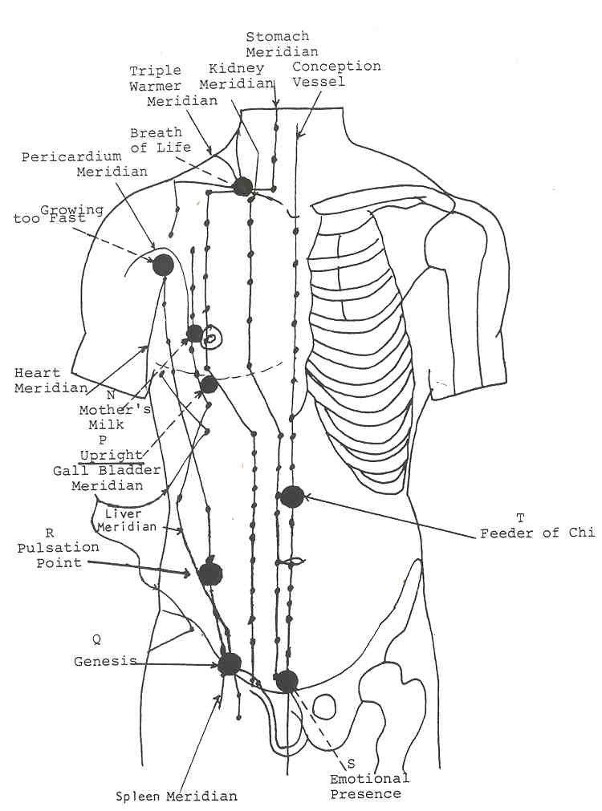

Figure 17

(N) 2 Mother's Milk Centers
Location: Just to the outside of the nipples
Meridians: Pericardium, Spleen, Stomach
Magnitude: 3

Clairvoyant observations.. 'These centers work with nurturing.' (Peter) 'The aureoles are indicators of the functioning of these centers. It has been noted that women with large dark aureoles around the nipples have trouble with heart centre issues. (Sara)

Commentary: The Mother's Milk centers are primarily yin in polarity. They are more closely associated with the heart centre. The Pericardium and Spleen meridians seem to form a pair in this case. The Pericardium and Spleen meridians both have a veiling effect; the spleen with emotional masking and the pericardium with emotional shielding as a protective agent. What is indicated with these centers, however, is not so much emotional isolationism, but the forming of a wall or framework in which something can grow. The heart centre is the font of life, as we know.

Every expectant mother forms a shield of fluid around the foetus so that it can be protected and nurtured. The mother's desires shield the foetus as it grows. These little centers perform the same function for ideas. After the mother gives birth, these centers also aid in the production of milk, which is also a fluid, to nurture the now-separate life. The role of the Stomach meridian in this case is to give form and definition to the developing ideas, to insure that they work properly and to ensure that they get what they need from the rest of the system. These centers receive part of what the stomach "sends upward."
1
(O) 2 Growing Too Fast Centers
Location: At the front of the armpits
Meridians: Heart, Pericardium
Colours: White, pulsating
Magnitude: 8

Clairvoyant observations. 'The Growing Too Fast centers work with pranic energy moving into the blood through oxygen. Oxygen is a carrier of prana. They elevate blood levels of oxygen in response to consciousness. They are affected adversely by pollution. They also open into an entire range of feeling around pranic light and the heart chakra. People drop into a survivalist mode of thought when these lesser centers get weakened from pollution or lack of prana. These centers also affect sexual attitudes because they can be used to stabilize the Emotional Presence centre. They create sexual vitality and transmute attitudes of sex as a means of sensual release into the more tantric levels of sexuality in which sex is a divine expression. This transmutation is brought about both through increased pranic fire in the blood and by action of the heart centre as a unifying agent. "

Commentary. The Growing Too Fast centers are yin in polarity and most definitely associated with the heart centre. They represent a union of the heart and pericardium energies which are inseparable in reality. In these centers, one sees the union of the prime mover of chi (heart) with the storage battery (pericardium) with a great intensity of force being indicated by that. Both the Pericardium and Heart meridians descend into the hara to receive chi from the triple warmer. There is thus a tremendous amount of energy which can be moved through the heart and pericardium meridians. The heart receives oxygen directly from the lungs (the upper burner) which is the agent for reception and moving of prana from the air.

In the Chinese system, there is a close relation between the heart and pericardium and the hara, the central point of which is in the centre of the sacral centre, which has been rightfully called the physical sun. The Taoists had essentially two systems for achieving longevity. One was through celibacy and the control and culture of prana through the hara. The other was through what is now known as sexual Tantra. To the Taoists, to have emission during the sex act was to lose precious vitality. The object in the sexual act was for the man to retain his semen. There is also a system known today as karezza which utilizes this knowledge.

It has long been known that overindulgence in the sex act causes a loss of vitality, whereas if Tantra or karezza is properly applied, vitality is gained. Testimony from persons who practice karezza would seem to lend support to these statements. It is also known that regular aerobic exercise has a very balancing effect on the sex drive. People who have gone through basic training in the military know that exercise can take its toll on the sex drive as well.

From the preceding statements, it is possible to understand how sex and vitality can be related. It has been stated that the primary function of the sacral centre is as a generator and reservoir of prana. If this function is misplaced by a focus on sex, especially sex as a release of tension, then the function the sacral centre has on vitality is diminished and the body is devitalised. Further, the reserves are drained from the pericardium and the heart has to work harder. These facts will only be truly known as etheric vision is developed. Modern science dismisses them for the most part.

(P) 2 Upright Centers
Location: At lower edge of pectoral muscle
Meridians: Spleen, Gall Bladder
Colours: Rose, Yellow, Amber.
Magnitude: 6-7

Clairvoyant observations: "The Upright centers are expressive of assertiveness, directness and capacity to employ the will to move through time and space. They are therefore indicators of one's ability to hold one's own, to stand for or against something or even to stand upright.

Commentary: These centers have a yang polarity and thus put the person en rapport with the outside world. The Spleen meridian, it will be remembered, registers a person's ability to be incarnate and thus to express. People who mask their true essence do not express in truth. The Gall Bladder meridian registers a person's decision making ability. The blend of these two meridians thus would indicate how and when a person decides to be present in time and space. Though this last sentence would seem somewhat enigmatic, it must be realized that to be incarnate is to be fully conscious in every vehicle of expression (body). To be conscious takes an act of will and thus the indwelling entity or thinker becomes present in his or her vehicles.

True expression takes courage and a decided act of will. If a person cannot overcome emotional and mental blocks to expression, then some aspect of the will is either not adequate or not present to begin with. The mind is the representation and agent of the will in the lower person. To have the Upright centers clear is to register deeply for decision making. It takes a clear, cogent mind (gall bladder) and a strong will and vitality (spleen) to be assertive, expressive and to be able to carry plans through to fruition - to move forward through time and space. These centers would appear to be more closely associated with the solar plexus centre. They lie on the line of the diaphragm.

(Q) Genesis Centers
Location: Just above the hip sockets
Meridians: Spleen, Liver
Magnitude: 8-9

Clairvoyant observations: 'These centers are initiatory centers. They work with what has been called the lesser stages of the genesis phases of evolution. Their primary mode of action is to move a person past the lower levels of the astral plane and to move one past racial and family karma. They are very involved with genetic predispositions to emotional complexes and vice-versa.

Sara has some additional information which relates to the Genesis centers.. 'There are two centers in addition to the Genesis centers on each person which have a bearing on sleep. Those additional centers are the Emotional Presence Centre and the centre at the head of the penis on a man and at the clitoris for a woman. These four centers resonate particularly to the lower subplanes of the astral plane. People who have nightmares need healing in these four centers. Magnetic healing put into them just before sleep helps a person to rise above the lower dream states. "

Commentary. The Genesis centers are very similar to the Pulsation Points in their activity. Note that they are separated from the Pulsation Points by only a few inches and the same meridians pass through all four centers. They are most likely connected with the sacral centre complex although they may form a set of bridging centers between the sacral and base centers. Note also that the Liver meridian passes through the centers mentioned on the genitals as well as the Emotional Presence centre. It becomes very clear, then, that the Genesis centers also have a significant role to play in the developmental psychology of a person.

Racial imprinting is a function of the Gonad minor centers (to be discussed) as well as both the sacral and base centers. Psychologically considered, the racial unconscious of any race represents a formidable set of constructs for a persons to grow past, if such a goal is desirable for the person. The Genesis centers would appear to play a role in the balancing of such constructs. if a person does not feel comfortable with his or her race, the Genesis centers are almost certainly affected. Balance is a key word for these centers as well as for the Pulsation Points. Such constructs keep a person bound to family and racial thought and emotion, which is separative in the final analysis. The Souls of all are One. Race can form a barrier to that realization. That type of thinking is what is known as family and tribal genesis. A person in such an evolutionary state cannot grow past family and racial pressures.

As soon as a person seeks to live life as a Soul, then a series of initiatory testings confront the would-be aspirant. Family and racial karma is brought to bear on the individual in order that he or she might be freed of limiting thoughts such as bigotry, reliance on blood lines, racial pride, family karma, etc. Every family has its karma to contend with. People are reincarnated in groups, frequently in the same family or as future spouses or in-law relations. That is the means whereby family karma is perpetuated and worked out. The Genesis centers have a specific function in terms of family karma in that they serve to imprint such karma on the child.

From the discussion of Spleen-Liver meridian interactions under the Pulsation Points, one can see that the Genesis centers also imprint inner child conflicts. It is in this manner that "the Sins of the father are delivered four-fold unto the succeeding generations." Since all of that imprinting is very subconscious once one reaches adulthood and since most people do not try to analyse their reactions to things, it is not difficult to understand how a parent's own psychological problems can be passed on to his or her children. If the parent is not analytical or does not seek to understand their own problems, the child very likely will not either, unless that child is fortunate enough to be helped with those problems.

The action of the Genesis centers is closely tied to the functioning of the quelle psychic monitor in the base of the brain. Resolution of inner child, racial unconscious and family karma issues fails under the domain of the quelle, since it represents the past and the subconscious. All such trials are fiery, unpleasant, fraught with emotion and usually many tears. All persons seeking to live a spiritual life must pass through such trials, usually after the age of 28 and every seven years thereafter. The years of life between 42-49 are usually full of such trials also because the person is then preparing for the succeeding life. No person who has failed to successfully demonstrate an ability or especially a willingness to pass such trials will ever be permitted access to more than modicum of spiritual light. After all, spiritual living is group living. If one cannot redeem himself and his family in the process of living, how can he be entrusted with greater group life, spiritual power and spiritual knowledge?

The sacral centre has proven a centre of ruin for many aspiring spiritual seekers and precisely for such reasons as these just outlined. Once one passes the lower initiatory trials of family and tribal (racial) genesis, then a true genesis has occurred. The individual is freed of a great many unconscious compulsions and stands as a redeemer for his small group. Every family has at least one family member who can or does act as its redeemer. There is thus hope for us all.

if one would seek to uncover subconscious compulsions and patterning in his or her nature, then the Genesis centers should be stimulated and accessed along with the Emotional Presence centre. The same is true if one seeks to work with impunity on the astral plane, or if one seeks to reach past the abyss into the realms of Light. God said "Let there be light ...... But in the beginning, darkness was upon the face of the waters. The "face of the waters" is reflected in the groin. For light to appear, the individual soul must move on those waters. Self-genesis can then occur.

Stubbornness tends to show in these centers as it is more often associated with a person's feeling that their security and comfort are being threatened. Stubbornness often belies deeply held insecurities and is certainly an indication that the person has become set in his/her attitudes. As such, it becomes a mask (spleen) of a wounded inner child (liver).

(R) 2 The Pulsation Points (peter)
Location: On either side just below the plane of the sacral centre and above the Genesis centers
Meridians: Liver, Spleen
Magnitude: 10

Clairvoyant observations: 'The Pulsation Points are two of the most important of the lesser centers from both a developmental and psychological standpoint They have very much to do with a person's early childhood development and consequently with the development of sexual attitudes. Early emotional development is indicated at these points along with sexual attitudes. How one utilizes sexual force and prana are indicated there.

They form an integral part of the sacral centre complex. The sacral centre complex is composed of the main sacral centre, the Pulsation Points, and the point above the pubic bone. The pulsation points are highly developed both from a consciousness standpoint and from a structural standpoint. These centers have stems whereas hosts of the lesser centers simply float on the surface of the etheric body and are unconnected with major centers. These points, however, connect with the sacral centre in the spine. The pubic bone centre does not. The entire sacral centre complex therefore resembles a diamond in the pelvic area.

The pulsation points represent the male-female relationship in each person. The female point is on the left side and vice-versa. Imbalanced attitudes about sexuality, about the opposite sex and about one's parents are reflected in these centers. If either one of them is out of balance, then the functioning of the entire pelvic area is upset.

These points work with distribution of prana, especially through movement. Swivelling the hips, walking, aerobic exercise, taiji, dancing, etc. all serve to stimulate them and aid in the distribution of prana. If the pelvic area is 'frozen' then chi does not move very well. The pulsation points ensure the movement of chi. There is a natural pulsation, like the ticking of a clock back and forth between these points, hence their name. Walking stimulates this pulsation. Sedentary work inhibits their functioning. One of the greatest scourges of modern civilization is sedentary existence. "

Commentary: The Pulsation Points have the same polarity as the Genesis centers, but the fact that the Pulsation Points are fully unfolded and integrated with a major centre makes their action much more potent. They further take on the essential qualities of the sacral centre and distribute its essence. Readers should compare and contrast the qualities exhibited by the Genesis centers and the Pulsation Points. Both sets of centers work with image to varying degrees. Both work with emotional constructs. Both are very sensitive regarding emotion, space and security. The Pulsation Points are yin centers as well and are important to unfolding human potential. After reading the experimental data on them, there remains little to be said about a synthesis of the meridians, but a small volume could be written about their interactions, uses and possibilities. Hopefully one will be forthcoming.
(S) 2 Emotional Presence Centre
See the example at the beginning of this chapter.

(T) 2 Feeder of Chi Centers
Location: On either side of the Conception vessel between the sacral and solar plexus centers
Meridians: Stomach, Conception
Magnitude: 7

Note: There are many such centers parallel to these lying between the diaphragm and the pubic bone. The one about to be discussed is larger than the others but all of them have a similar meaning and act as feeders and integrating points between the various major abdominal chakras.

Clairvoyant observations: 'The Feeder of Chi centers are involved with emotional integration. They try to feed the solar plexus centre from the Pulsation Points. These centers and the Pulsation Points form a triangle of force. Balanced Pulsation Points give a healthy flow of physical-astral force to the solar plexus. Healers should examine the Feeders of Chi centers if a person's astral body is disintegrated in any way.'

Commentary: How one "plays the game" (Stomach meridian) is simply another way of stating how a person integrates various parts of his or her nature. It is interesting to examine goals (Conception vessel) people set for themselves. If a person's ego structure is unbalanced, over inflated or devitalised, one's goals are very likely to be out of proportion with one's abilities. One of the most common indicators of the presence of a wounded inner child syndrome is an overachieving, perfectionist attitude. Attitudes such as this are extremely stressful for the individual as that person tries to overcompensate for a sense of personal lack. It is difficult for such people to recognize that there is no perfection in the human kingdom. Such attitudes are most likely born out of the person as a child trying desperately to please his or her parents in order to attract their love and security. Perhaps things were probably often lacking in the child's early development, or, at least, the child thought so.

Remembering that the solar plexus centre brings things into organized form and that the stomach itself is an externalisation of that centre, it can be seen how the Feeder of Chi centers would play such a role as feeding the solar plexus. A wounded inner child's desires are out of proportion with what it can realistically handle. The astral body in such a case is simply not properly formed or integrated. Emotional stability and reasonable desires are indicators that the four aforementioned lesser centers are balanced in their functioning.

It seems rather curious that below the diaphragm there would be a row of lesser centers, like pearls on a string, connecting the three major spinal centers below the diaphragm. There is no such arrangement in the upper body. Perhaps these little centers indicate a means whereby the lower or animal person becomes an integrated, functional entity. It is said that the solar plexus is the integrating and synthetic centre for animals and lesser evolved humans. Could these lesser centers be a means whereby the synthetic purpose is achieved? That question could generate a fruitful area of research.
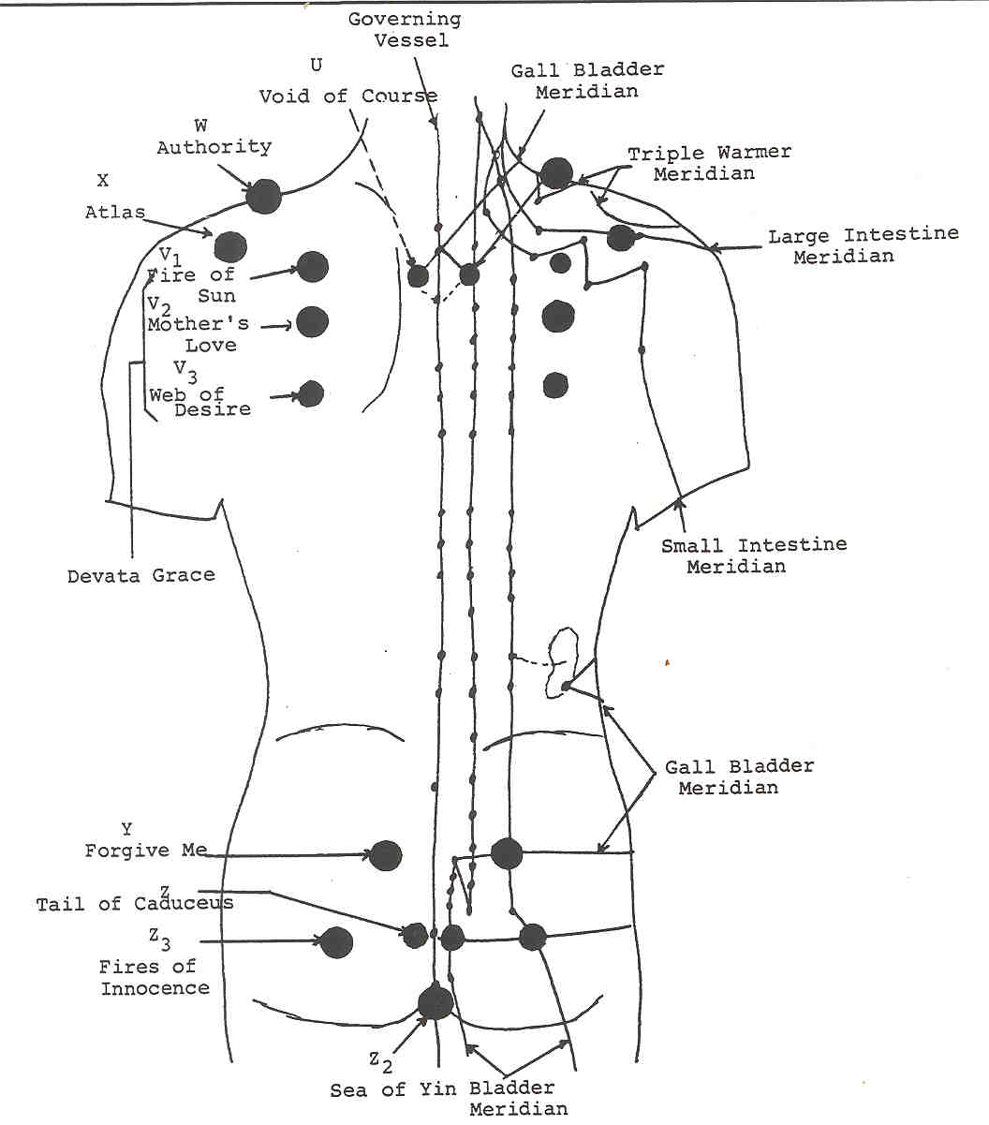
Figure 18

(U) 2 Void-of-Course Centers
Location: On either side of the third thoracic vertebra
Meridians: Governing, Gall Bladder, Bladder
Magnitude: 4

Clairvoyant observations: 'These centers provide a means to integrate the emotional outlook on life. They are definitely connected with lunar activity and connect lunar forces with the limbic brain. They are connected with the back of the heart centre. When they are opened, the forehead centre becomes subject to various kinds of telepathic influence, especially when the moon goes void-of-course.

Commentary: In astrological literature, a planet is considered to be void-of- course when it fails to make a major aspect with another planet before transiting into the next sign of the zodiac. People born with such a planet in their natal horoscope, especially the moon, are said to have a very difficult task when trying to externalise the psychological constructs represented by that planet. The moon in astrological terms represents the past, the imagination and a large part of the emotional nature. When the moon is void-of-course in the natal figure, the person typically cannot externalise plans in such a case because it is difficult to make real what one imagines.

The limbic brain is very much associated with lunar faculties, of which imagination is one. The ajna centre rules the limbic brain via the pituitary gland and its associated nuclei. Most emotional reactions arise in that area of the brain. Inner guidance cannot be received very well when the emotions are high (bladder). Stillness of the personality is a prerequisite for all higher psychic work. Perhaps that is why the forehead centre becomes subject to telepathic influence when the moon goes void-of-course. Emotions are typically at a low ebb during such times and the mind is not so disturbed by the otherwise unruly astral body. A void-of-course moon is not a good period in which to externalise plans, astrologically speaking, but it may be an excellent time to receive guidance on them.

The heart centre is necessary for control of the astral body. It is the centre which is the "higher octave" to the solar plexus centre and receives the transmuted emotional essence from the solar plexus centre. When the heart controls the solar plexus, then the situation arises where the astral body is said to reflect the light of Buddha, which resides in the heart centre. Buddhi, or pure reason, can find no adequate means of expression when the personality is in the thralls of astralism. The thoughtful occultist will recognize that the heart-solar plexus centre pairing in the torso has an analogy and correspondence in the limbic brain. The Void-of-Course centers are yang in polarity. Since they lie on the surface of the back, their sphere of operation lies mainly in the realms of the unconscious mind, but they work with exterior forces. The moon gives off no light of its own but reflects the light of the sun. The astral body is also a reflective body. It is ruled by and associated with the moon. Accurate reflection can only occur on a still surface. The astral body should become as a still, reflective pool and not a turbulent sea. When it becomes still and it is ruled by the heart, then the limbic brain follows suit and the ajna centre becomes what has been called a bliss-pool, reflecting the light of Buddhi and thus opening one to a state of bliss. The Void-of-Course centers apparently monitor lunar activity and form a link between that activity and the heart and head centers.

The gall bladder can not perform its psychic function effectively if the person is mired in astralism. Emotional outbreaks are inimical to clear logical thought. It seems strange that two apparently mental meridians would form the basis for centers so connected with the lunar forces. But what these centers work with is emotional integration and telepathy which are decidedly mental functions. The mind is the integrating factor for the personality and telepathy must be mentally interpreted.

The forehead centre is a synthetic centre formed by the synthesis of vitality, emotions and mind and guided by the soul. That centre never works with accuracy or at all in a disintegrated-integrated personality. When it is remembered that the Governing vessel links the three head centers and acts as an environmental gauge, then the connection of the Void-of-Course centers with the limbic brain and forehead centre (third eye) becomes clear.

Astrologers deem a void-of-course planet as a negative influence. That may be so for some planets, but for the moon, that is not necessarily true. A busy imagination and astral body (ruled by the moon) are good for externalising projects but not for receiving inner guidance. Perhaps that is why psychism is not as prevalent in Western cultures, but also why the Western mind-set is so much more productive of material results. In any case, astrologers would do well by advising their clients to try engaging in telepathic interplay during a void-of-course moon. Stimulation of the Void-of-Course centers during that period may yield some surprising results. If the client feels blocked in expression of plans, then he or she may perhaps find they are pursuing a new course after the moon makes its next major aspect. The higher psychism should not be underestimated.

(V) 6 Devata Grace Centers
Location: 6 Centers Underneath the scapulae (3 on each side)
Meridians: It should be duly noted that none of the diagrams showing acupuncture meridians show meridians routed underneath the scapulae or shoulder blades. There is therefore nothing to base a synthesis on, but these centers can be seen clairvoyantly nonetheless. Their qualities have been examined, but it is questionable how much work could be done with them since there is a rather thick bone overlaying them. Perhaps in the near future a means will be found to work with them.

Clairvoyant observations 'All 3 sets of centers beneath the scapulae are involved in the development of the devata (angelic) nature and the development of large etheric wings. All three sets of centers, united in their functioning, are necessary for large wings.

(V1) 2 Fire of the Sun Centers
Location: One inch down from the top of the shoulder blade
Magnitude: 4

Clairvoyant observations.. Pete r sees the Fire of the Sun censers as "pranic centers. " They are impersonal and work with the flow of etheric force. They connect to the liver in some fashion and are related to the large intestine. There is a hot amber ether which forms the structure of these centers. They work with the burning away of astral debris. The heat of the liver releases the function of the large intestine.'

(V2) 2 Mother's Love Centers
Location: Underneath the centre of each scapula
Colours: Cool white and blue
Magnitude: 8-1 0

Clairvoyant observations: 'The Mother's Love centre works with the emotional nurturing of the heart chakra. People who do not feel loved have these centers closed down or diminished. These work more on the fourth auric level of the heart centre. The heart is nourished by these centers at that level '

Note: There are minor centers above the nipples on the front of the body which also work with emotional nurturing. The Mother's Love centers lie on the same axis and plane of those minor centers and are possibly associated with them.

(V3) 2 Web of Desire Centers
Location: At the bottom of each scapula
Magnitude: 7

Clairvoyant observations: "The Web of Desire centers are associated with the astral portion of the throat chakra. Emotional tension closes them.

(W) 2 Authority Centers
Location: Tops of shoulders
Meridians: Triple Warmer, Gall Bladder
Magnitude: 7-9

Clairvoyant observations.. 'These centers work with issues concerning authority, hence their name. This is true both concerning people in authority over us and with our attitudes toward authority over others. These centers also work very closely with the principle of allegiance, good or evil They are especially geared toward personal interactions within the workplace. Sensitivity to celestial Sound is also activated by them.'

Commentary: "Allegiance is especially associated with the throat chakra." (Peter) The shoulders are generally associated with the throat centre. The throat is a very authoritarian centre which wields the higher creative forces within a person and delegates how these forces are to be used. Both of the meridians passing through these centers are very mental in their activities, tending toward sound reason and logical thought, which are essential qualities for a good leader. In fact, the emotional qualities of these centers are greatly lessened because neither the Triple Warmer nor Gall Bladder meridians act very much in the emotional sphere.

The Triple Warmer meridian works with a person's presence and vitality. In leaders, it contributes a fiery vitality which adds to their presence. All the great world leaders have been characterized by an ability to persist and to be a tremendous presence to their followers. The Gall Bladder meridian works more with the thought processes and with the ability to delegate work. Persons who have either one of these meridians weak or in discord have difficulty appearing authoritative and with being able to put their plans into action.

The gall bladder reflects the lower mind and intellect. The lower mind is what usually locks people into power games and struggles. The mind reflects the will. People overly focused in the lower mind have difficulty feeling either for themselves or for others. A supervisor or leader who does not feel for those under him can be a tyrant and exceedingly unpleasant to work for. On the other hand, individuals, for example, who may be brilliant intellectually but lack the stamina it takes to be a leader (strong gall bladder, weak triple warmer) often have a bitter pill to take. Though they often have great ideas about how things can be done, they lack what it takes in terms of presence, to which the triple warmer contributes, to be noticed. Of the two meridians, the Triple Warmer will always come to the fore. Such individuals see with great clarity the glaring stupidity and blundering of their superiors but find themselves powerless to change things. Powerlessness is a feeling often associated with weak Authority centers. Accountants and secretaries often suffer from such a situation. Bitterness (bile) is usually the result of such frustrations.

When the meridians' strength is reversed and the logical mind (gall bladder) is weak, one often finds a leader who can be quite a motivation and exhibit great liveliness, but who cannot see past the end of his or her nose. These form the rank and file of executives and bosses who live off the ideas of those under them but who, if on their own, would probably be discharged after a short time due to their misjudgements. This is the mark of a leader who makes classic and often tragic blunders. Business and military history is full of such accounts. It would be interesting to note the condition of say, General Custer's Gall Bladder meridian. Such people made or make charismatic leaders, true, but their decision-making capacity leaves something to be desired. Charisma is something to which the Triple Warmer contributes a great deal. Charisma without intelligence is a very dangerous situation.

Almost everyone has worked under a "dinosaur brain," a "Neanderthal," an "old-boy" or an "Attila the Hun" boss at some point in their career and knows the frustration and the bitterness such people can bring out in a person. Or, perhaps the reverse has been the case. Almost everyone has felt frustration at not being able to present things in an authoritative manner, only to have their ideas used by someone else in a better position to make them work. It is commonplace in the American workplace to "bash the boss," to feel resentment and bitterness toward the "old boys," to feel impotent when it comes to changing that workspace and to feel the frustration over the continual misuse and waste of funds and time by supervisors, managers and directors. The lower mind tends to be very separative and to see things in black and white. The "us/them" mentality is nowhere more emphasized than when it comes to money, power and the workplace. Workers and managers alike must ask themselves where their allegiance lies - to the company, the country, the worker, the boss, the individual, God, etc.?

Actually, to one who is spiritually inclined, one's allegiance must be to all of those people or concepts listed above in order for things to approach any sense of wholeness, interdependence and brotherhood. Allegiance to the company while ignoring the individual worker cuts a company off at its foundations. Allegiance to one's self at the expense of others cuts one off from security, companionship and society in general. Allegiance to country, do or die, creates a dangerous protectionism which has spawned many wars and only serves to line the pockets of the rich at the expense of the common person. All of these attitudes would seem to be reflected in the Authority centers.

The Celestial Sound of Creation made a space for everyone and everything in the great economy of Nature. To realize all of existence as a great Hierarchy of lives is to begin opening to that Sound. Realizing the relative insignificance of even a powerful CEO or world leader compared to the awesome construct of Nature gives one a more just sense of proportion and removes a lot of bitterness. We are all as ants on the back of the great Mother. When She moves, none is spared. Does it not make more sense to recognize one's unique contribution to the economy of Nature than to become enraged over the feeble misgivings of a short-sighted boss? Life is not judged by the Guides by who has more "toys" and power when all is said and done, but by our caring, our love for our fellows and our stewardship. Authority is actually about stewardship.

(X) 2 Atlas Centers
Location: Just over the shoulders into the back
Meridians: Triple Warmer, Large Intestine
Magnitude: 8

Clairvoyant observations.. "Holding back of emotional expression stresses the Up- per Atlas centers. The idea of bearing all in silence is implicit with them. Unwanted sacrifices without the possibility of expressing emotions about those sacrifices closes these centers, somewhat like carrying the weight of the world on one's shoulders. These centers need exposure to sunlight They appear usually as dark, depressed centers and are particularly vulnerable. They are uninsulated and connect to the spinal portion of the throat centre. They can sense demonic presence. "

Commentary: Just as Atlas was condemned to carry the world on his shoulders for eternity, so everyone has burdens they feel they must bear. Both the Large Intestine and Triple Warmer meridians seek to express in some manner. The large intestine seeks a timely release of its contents just as the triple warmer seeks to spread its vitality throughout the system. The Triple Warmer is one of the more expressive of the meridians and expresses fully when allowed to. It has been discussed how easy it is for the large intestine to become retentive and unable to release. Blockage of emotional release is one of the more common psychological complaints these days. The lower mind sees to it that emotions are effectively inhibited and since the intellect is so god-like in Western culture at this point in history, it is not difficult to understand why emotional release should be so difficult.

Orthodox religions often preach sacrifice of the self and suffering in silence -- (most definitely in silence), as a means of redemption. [Suffering is a favourite word among Christians.] The West comes from a heritage steeped in suffering. Of course it is not the white races who have suffered so much, but the idea of suffering is near and dear to them. The fact is that suffering is good, as long as someone else bears it! Does that sound familiar? The occultist knows that our little planet is the globe of suffering. Humanity learns best by suffering, learns more by it and achieves liberation by it. We, as a species, seemed doomed to misery. We must love it. We do so much to perpetuate it. But silence is not one of our greater virtues.

The throat centre rules the metabolic functions of the body through the agency of the thyroid gland. Command over matter and the forces of nature come through the throat centre by the power of mantrikashakti, or the power of sound and speech. Death occurs if throat centre malfunctioning is severe enough. Celestial Sound directs the functioning of the universe. By means of the throat centre, one hears Celestial Sound as well as the sounds of nature and the sounds of one's own voice. The throat centre integrates the various ethers in the various vehicles. The mind is the sphere of karma. Psychological issues about power over others and being subservient to others have their root in the mind. Remember that the mind is the representative of the will in the lower man. There is an interesting connection between the Atlas centers and the sacral centre. The lesser centers in the sacral area, the sacral centre itself, and the Atlas centers should be checked by the healer for imbalances in functioning, especially with respect to each other. Issues around authority ultimately have a root cause in the sacral centre. The mind is reflected in the sacral centre.

Self image is the mould into which self-esteem anchors or enlivens the sense of self. A poor or over inflated self image as mapped in the sacral centre ultimately effects the throat centre and the Atlas centers by causing problems with self-esteem. Persons with such imbalances as those typically have issues around authority. The Atlas centers show the qualitative aspects of such issues whereas the pelvic centers show the structure of them. Allegiance is simply the working with and under a greater authority.

(Y) 2 The Forgive-Me Centers
Location: In the sciatic area at the top of the buttocks.
Meridians: Bladder, Gall Bladder
Magnitude: 7

Clairvoyant observations: 'These centers work with self-forgiveness. They indicate confusion around identity and guilt or shame from improper parenting and internalisation of the same. They lie almost directly behind the Pulsation Points and are connected to them.'

Commentary. The Forgive-Me centers have very much the same meaning as the Tail of the Caduceus centers and the Fires of Innocence centers in the manner in which they work. These little centers would appear to play a role in how the muscles in the lower back are used and have a great deal to do with proper alignment of the spine. A straight spine is absolutely essential to proper flow of kundalini. Sedentary work, improper lifting, lack of exercise, etc. all take their toll on the lower back and on one's vitality. Lower back trouble is epidemic in industrialized societies. It is also indicative of a misuse of pelvic energies and a devitalization of the same. Again, persons with a locked pelvis slowly have their energy drained.

The Forgive-Me centers are also apparently associated with or form a link to the sacral centre. Persons who cannot hold themselves upright cannot support themselves, either literally or monetarily in most cases. Self-image suffers, energy stops flowing, strength is slowly sapped and a vicious cycle of events gets set in motion. Proper lifting of objects is essential to pelvic health. Proper lifting of emotions is essential to a good self-image and self-esteem. Proper lifting of kundalini is essential for life.

In summary, then, the Forgive-Me centers are reflective of how energy is lifted up the legs from the Earth, how kundalini is lifted up the spine and of how well a person is supported from an energy standpoint. They also apparently monitor how energies from the higher centers are directed down to the earth for release or for cleansing. Shame causes one to bow the head, disturbing proper spinal alignment. Self-image suffers (sacral centre) and the identity becomes distorted. It is quite possible these centers played a role in enabling the humanoid to stand erect. All Bladder-Gall Bladder meridian connections are indicative of conscious use (choice) around energy usage. Only man consciously directs energy in the lower four kingdoms of nature.

(Z) 2 Tail of the Caduceus Centers
Location: On either side of the tip of the coccyx
Meridians: Governing, Bladder, Gall Bladder
Magnitude: 7

Clairvoyant observations: "The Tail of the Caduceus centers are physical in nature and are related to the ida and pingala energies of the etheric spine and thus influence the flow of kundalini.'

Commentary: Part of the censorship function the alta major centre performs is the regulation of kundalini's flow into the head. There should be a natural polarity between the Heads of Cerberus centers and the Tail of the Caduceus centers. Kundalini cannot raise consciously until a very late stage of human evolution. There is a very definite relationship between the lower mind as the representative of the will, the causal body, the abstract mind respectively with the alta major centre, the ajna centre, the crown centre and their united functioning. To state it from a different point of view, the alta major centre will not allow the full force of kundalini to be let into the skull cavity until the three head centers are unified in their functioning, the three types of mind are united and the personality is of such an order of refinement that such a high intensity of energy as the kundalini represents can be safely worked. The esotericist will recognize the condition outlined in this paragraph as a description of the Transfiguration or Third initiation. When this situation takes place, the Heads of Cerberus centers open wide and allow the full "voltage" of Kundalini into the head.

Until that time, the Tail of the Caduceus centers are the gateway for that flow. The Gall Bladder meridian works with decisions. The raising of kundalini is both a well pondered logical decision as well as a normal occurrence when such a high degree of purity is reached as that represented by the Third Initiation.

In the lesser evolved person, the Gall Bladder meridian responds to the mental elemental essence in the sacral centre. The Tail of the Caduceus centers allow only as much kundalini up the ida and pingala channels as the alta major centre dictates. The lower man or woman is still very much impacted by the action of the quelle psychic monitor functioning of the base of the brain Emotions (bladder) are unstable. Karma rules. The sacral centre governs kundalini flow at this stage.
In the highly evolved person, karma no longer rules in the person sense. Only group karma influences the individual. Therefore, decisions are registered deeply and do not upset the rhythm of group living. All highly evolved persons work in group formation and with group consciousness. The spiritual life is the rule, emotions are stable, and the person has conscious control over all the bodies of the personality. The crown centre governs kundalini flow at this stage.

Although these little centers are predominantly physical, the connection of the Gall Bladder meridian with them means that there is a decided mental control over their functioning. Such control works below the level of consciousness at first and is very much affected by misuse of sexual energies along with all other sacral centre functions. it is important to note that all centers with bilateral symmetry work with dualistic energies and reflect the separation of the lower person from the higher Self until the divine marriage occurs at the higher initiations. The ida, pingala and sushumna are all united after those initiations, as are all the head centers.

The Tail of Caduceus centers thus have a significant role in the amount of vital heat available to the body. The kundalini fire, being the latent heat of matter, is what generates heat in the physical frame. Increased warmth and activity result from open, free interactions with these centers. Uncontrolled living lessens that heat. One could say that poor decisions and unruly emotions rob a person of heat and vitality whereas a balanced, sane and thoughtful existence increase that vitality and heat. Such is the meaning of the Tail of the Caduceus centers.

(Z2) 1 Sea of Yin Centre
Location: Perineum
Meridians: Conception and Governing Vessels, Kidney
Magnitude: 9

Experimental data: The Sea of Yin centre is the most yin point on the body. It is the external etheric point of reception into the base chakra and works with expansion into earth etheric energies.

Commentary: One can certainly recognize that this Sea of Yin centre represents a point of great sensitivity on the body. Lying between the anus and genitals, it is a spot that people and animals try to protect as much as possible and, for humans, represents one of the most closely concealed and guarded places on the body. Clearly, keeping the legs together closes access to it and thus closes the base chakra to reception of earth energies.

It is a strongly psychic centre and at the same time, acts as a register for many of a person's closely guarded feelings. It is mostly yin in polarity (Conception and Kidney), but there is also a strong yang component from the Governing Vessel. Above all else it is primarily a receptor. All three meridians passing through or close to it are marvellous receivers of information and energy. Since it points straight toward the earth when a person is standing, it makes good sense that it would receive earth's energies. It most likely has a synergistic relationship to the large and small toes with respect to receiving information from the earth. It probably is extremely sensitive to changes in the Earth's magnetic field, to ground water, vegetation and various chemical elements under foot, not to mention all types of etheric elemental forces.

It is therefore most important to keep the Sea of Yin centre open and receptive. The base chakra cannot read the earth if that centre is closed. All exercises that spread the legs are beneficial to it. People who really wish to put that centre in touch with the earth should squat. In fact, there are some squatting meditations that could be used to obtain all sorts of information about one's immediate environment and bodily needs.

(Z3) 2 Fires of Innocence Centers
Location: In the centre of the buttocks
Meridians: Bladder, Gall Bladder
Magnitude: 8

Clairvoyant observations: "The Fires of innocence centers have little white wings extending out from them. These centers are involved in how a person experiences sexual pleasure and the freeing of kundalini during sexual activity. They open to the Mother Goddess energy and work to assure purity in the base chakra. They are opened during love-making when one makes love with a being instead of to a body.

Commentary: The raising of kundalini has been compared to a sexual orgasm in many respects, except much more fulfilling and intense. The sexual orgasm is accompanied by a release of kundalini as well. The Gall Bladder and Bladder meridians link the Fires of Innocence centers to the Tail of the Caduceus centers. It comes as no surprise that those four lesser centers are closely connected. Sex is a conscious use of energy. Like any energy, it can be properly used or misused. The discussion under the Tail of the Caduceus centers yields many keys to the Fires of Innocence centers. Many of the connotations are the same except that in this case, the element of desire is clearly present. Some of the most insidious influences of sexuality are the attentions paid to the sensuality of sex, the release that sex can bring, the raw, animalistic pleasure that sex may bring and the prostitution of the sexual act to grant one's desires. None of these influences has any rightful place in the sexual act. From a larger perspective, sex should only be engaged in for two things and those two things should be inseparably related: as an expression of love (true love) on the physical plane and procreation.

With these centers, there is again the concept of right or wrong decision-making, right or wrong desiring and 'proper use of energy. Sex should be a physical, emotional, mental and spiritual union of two people with the aim of producing something or someone new in the process - a strong, beautiful relationship or a strong, beautiful body for another soul to inhabit. Thus an archetypal group is formed which is known as a family. Families give rise to communities, nations and races.

There is a concept that the future parents intent and feelings during lovemaking and especially at the moment of ejaculation determines the type of body the new- born will have. There is also astrological evidence that supports that statement. Therefore, the amount of fire or vitality available for the developing infant depends very much on the stewardship the parents practice concerning their energies. If the preceding statements are true, then sexual perversions, lust, misgivings about sex, lack of love between partners, etc. all take their toll on the developing child. In short, and in a very real sense, the strength of a nation would depend upon sexual purity, but not in a puritanical, foolishly emotional expression.

There are several sets of centers which work along these very lines, such as the Pulsation Points, the Genesis and Genital centers, the Tail of the Caduceus centers, etc. All of them have certain things in common such as the loss of self- image, inner child conflicts, being able to be present or to be able to release emotionally and so on. As a final note, parents may wish to consider what effect spanking has on a child, especially as it relates to the Fire of Innocence centers. True, the child releases emotionally and makes a decision based on that experience, but is it a healthy choice and/or attitude?
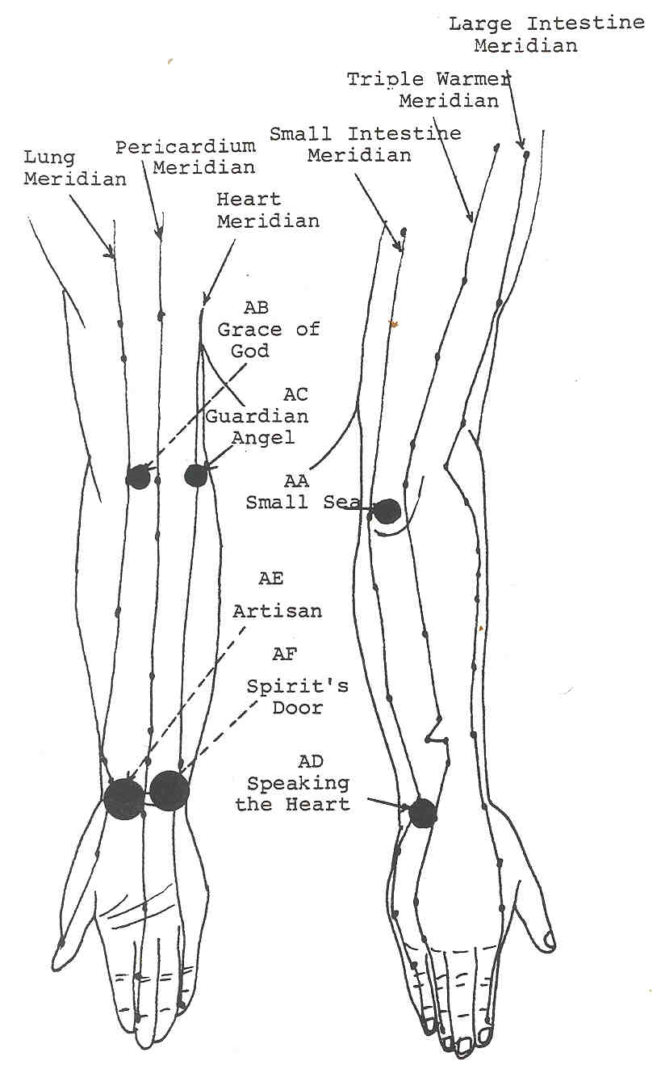

Figure 19

(AA) 2 Small Sea Centers
Location: At the back of each elbow
Meridians: Triple Warmer, Small Intestine
Magnitude: 3

Clairvoyant observations: 'The Small Sea Centers are small censers which work with a person's origins and forgetfulness of the same. They are connected with the back of the brain, especially with the cerebellum. "

Commentary: All lesser centers in the arms have an association with the heart centre. The arms extend outward to express the heart's desire, to give love, to embrace, to touch, to feel. The arms also have an association with the solar plexus centre. They extend to bring things inward, to grasp, to cling and to express lower desire. The lesser desires in the solar plexus centre are eventually transmuted into the higher desires as expressed through the heart and through union. The heartfelt embrace is one of the highest physical expressions of the arms. The Small Sea centers are named after acupuncture point S18 which is said to be where chi and blood flow into the arm, like water flowing into the sea.

The origin of every personality is the soul. The matrix and programming for each personality is found in the heart centre as that centre relays that information from the Egoic lotus which overlays it. The origin of each vehicle of body is to be found in the permanent atoms which are at the base of the Egoic Lotus. Life springs always from the heart. The Egoic lotus holds the key to every incarnation. The heart centre has the Egoic lotus as its prototype. Imprinting from life to life is also found in the quelle monitor, the medulla oblongata and the cerebellum.

These centers work with the plenitude exhibited by the heart centre. The triple warmer gives its plenitude of energy or life to the body while the small intestine gives its plenitude of substance. Life and substance merge at the Small Sea centers. They indicate a person's ability to express or give abundantly. The tendons that pass over the back of the elbow extend the arms. The tendons passing through the hollow of the elbows pull the arms inward. The Small Sea centers are yang in polarity and work with outer expression or with movement outside the body.

These centers are indicators of a person's stewardship of all types of energy (money, love, work, etc.), i.e., any energy which involves interaction with another person, which essentially means all energy. Stewardship is indicated more by the triple warmer because not only is the triple warmer the steward of chi for the system, but it also takes sound reasoning and strength of purpose to be a good steward. The person's attitude, or more appropriately, feelings about the energies being given or received are mapped by the small intestine. Just exactly how much a person feels he or she can give out or take in is a function of the small intestine.

Misers and wasteful people wreak havoc on the Small Sea centers because those people have forgotten how to give appropriately, or at all. One who hoards all for selfish purposes or gives away indiscriminately gets cut off from the natural givingness of the heart. The fact that the Small Sea centers are small and situated in a place where they cannot be seen by their owners is an indication of the sorry state of stewardship in the human kingdom. Right giving and receiving is a natural state in the lower and higher kingdoms in nature. The marvellous economy of nature is only interfered with by man. A person's adherence to the ethic of the soul is watched over by the quelle. The soul is always giving and group conscious. To extend the arms in greeting, giving, and judicious receiving, is a divine birthright, but one which must be cultivated by sound reasoning and above all, by love.

(AB) 2 Grace of God Centers
Location: Hollow of elbows toward outside
Meridians: Pericardium, Lung
Magnitude: 3

Clairvoyant observations. 'The Grace of God Centers are involved with showing one's grace and attachment. "

Commentary: These centers are yin in polarity. In fact, the hollow of the elbow in its entirety is a yin location and reflects a person's inner feelings toward the Spirit and group life. The rhythms of breathing and of heartbeat are to be found reflected in the lesser centers of the hollows of each elbow. The breath and the mind are one. The Grace of God centers are indicators of the will and its reserves of energy. The lungs are also a reflection of will. One who has no reserves has been removed from grace.

Those centers are indicators of whether or not a person is proceeding according to right timing (lungs) and the will of the Creator (lungs again). The Pericardium meridian lends support to the expression of divine Will and gives the extra impetus when needed for plans to be put in motion. It would seem that it is not so much that these centers are outlets for that kind of expression but they can help feed it. A person is considered graceful if their timing is perfect, if they skilfully carry out a specific Plan of action, if effort in doing so seems to elude them, and if their elocution is a thing of beauty to behold. It is the same with a spiritual act done in right timing, which the lungs indicate. Such acts seem effortless, to fall into place with few problems and to create works of beauty in the process. Such acts are said to be performed by the Grace of God.

Persons who have breathing disorders have abused the will in past lives and in the present one and have found themselves somewhat cut off from their grace. Harsh words also detach one from grace. Colds and flu are meant as warnings to be mindful of one's self-will and the timing in the use of that will. It would be an interesting study to see if breathing disorders were indicated in the Grace of God centers. To be mindful of the timing of the Greater Order of God and to apply one's will accordingly is to grow in strength, vitality, magnetism and to draw close to the grace of God.

(AC) 2 Guardian Angel Centers
Location: Inside of the elbows in hollow
Meridians: Heart, Pericardium
Colour: White fire
Magnitude: 3

Clairvoyant observations: 'The Guardian Angel centers have a function similar to the spleen in that they form a sort of protection for the heart. They help in that quality of the heart centre known as occult isolation (MNA). They also represent the values one lives by.'

Commentary: The meridians at the elbows and at the hollows of the elbows do not cross which is one reason why the centers located at those points are not as energized as those where the meridians actually cross. The primary function of the pericardium as an organ is seen most clearly with the Guardian Angel centers. These centers act as sensors of energy movement up and down the arms. They sense whether or not the pericardium needs to lend protection to the heart. They may be thought of as sentinels.

The heart centre contains the ethic one uses in any given life. It is monitored in the brain by the alta major centre by means of the quelle. The causal body and egoic lotus are both tied directly to the heart centre, especially when one considers that the egoic lotus overlays the heart centre in the causal body. The causal body contains the blueprint by which a particular incarnation is lived. The spiritual side of this blueprint can be spoken of as the individual ethic. The Jewel in the Lotus is in the centre of the egoic lotus and forms the core star through which the Monad impresses Its Life on the individual man. The heart is thus a reservoir of the most intense spiritual power.

Except for the brain, the heart has more protection than any other organ in the body. Not only is the heart covered by ribs and surrounded by the lungs, it is enclosed by the pericardium. Every heart centre seeks to express the soul's ethic and purpose. The arms extend outward to work in the physical world, to build according to the soul's design. The arms also receive either what is just and required for life, or they receive what has been obtained by unscrupulous means and wrong action or building. The Guardian Angel centers indicate a person's adherence to ethic and they also monitor the same.

It has been stated that the elbows bend to bring or gather in energy. But they also bend to protect the body. Extension of the arms in a protection mode is for fighting or self-defence. When the arms are brought in to cover the chest, the Guardian Angel centers align themselves with the major spleen and liver minor centers. Arms bent in prayer give the same alignment. The Guardian Angel centers can then both partake of the essence of the centre they cover and also serve to cover the major centers. The spleen and liver both feed energy into the heart and can thus aid in its replenishing and protection.

The Guardian Angel centers emit the white fire of spirit which is somewhat similar to that fire found in the Jewel of the Lotus. One's adherence to the ethic of one's own soul increases that light and enables one to increase in energy, magnetism and grace. Denial of that ethic and deliberate offence of it removes one's protection, drains vitality and leaves one open to "pernicious influences" - physical, astral and mental. Indulgence in lower astral concerns poisons the fluids in one's body, drains the reserves of energy in the pericardium and leaves the heart open to attack. People should bee that they adhere to the soul's ethic.

(AD) 2 Speaking the Heart Centers
Location: Backs of the wrists
Meridians: Triple Warmer, Small Intestine
Magnitude: 6-7

Clairvoyant observations. 'These centers allow one to express heart-felt emotions. Emotional clinging to people and things shuts down that expression. "

Commentary: There is a natural flow of energy and fluids through the body. The small intestine is not meant to hold food, but to process it. The holding of food in the small intestine causes septic conditions to manifest eventually. At a higher level, emotions were meant to be expressed, not held within. The psychic function of the small intestine in the processing of agitation is to use what is useful and to move the remainder downward and out of the system. Any clinging to emotions, especially the lesser emotions, causes "toxicity" in the astral body and an un- healthy stasis of expression.

The heart, which is the distributor for the triple warmer chi as well as the fire of Spirit, is usually associated with expression of higher emotions which is true in a lower sense. The reader would be mindful in that regard, to realize that true love is not an emotion but is rather an expression of one of the highest forces which humanity is capable of embodying. It has been stated previously that true love can be described as pure reason or Buddhi. Sound reasoning as expressed by the triple warmer becomes pure reason when one dwells in the heart.

The triple warmer gives one the strength of presence to speak one's mind and to express emotionally. A devitalised system cannot express. If the Small Intestine meridian is clear and the triple warmer is producing adequately, then proper expression of emotion is assured. Since the arms express so much of the energy of heart, the highest expression for these little centers is to speak the emotions of one's heart. There is an astral portion of the heart centre which vibrates closely with the soul when one is expressing in truth. The astral body, which expresses so much through the small intestine, has its highest expression when one begins speaking the heart or higher emotions. Interestingly enough, such expression usually has a positive reflex action on the vitality as evolved through the Triple Warmer. The hands usually become quite animated when one speaks heartfelt emotions.

(AE) 2 Artisan Centers
Location: Bend of the wrists
Meridians: Lung, Pericardium
Magnitude: 7-9

Clairvoyant observations. 'The Artisan Centers work with creative expression and balanced expression. They indicate how we give out creative force.'

Commentary. It is curious that even though the Artisan and Grace of God centers share the same meridians, their expression is different. It may be stated that the Grace of God centers are precursors or preconditions for the working of the Artisan centers. True creative expression demands that one be at least somewhat in touch with the currents of divine creative force that flow out of the heart. Creation implies both design and will, which should be of the Spirit. Of course there are creations that are negative and involutionary but they are not of a quality which allows for their persistence. Such creations are inevitably swept away when the light of Knowledge shines upon them.

The hands are instruments of creative force and outlets for the same. The wrists direct the hands. The hierarchy of force in the arms runs straight from the shoulders, which represent authority, to the tips of the fingers which are the final outposts and arbiters of that authority. The Artisan centre is the farthest lesser centre in the arms although there is a minor centre in the palm of each hand. The Artisan centers feed creative force into these minor centers.

The Artisan centers are yin in polarity. Creativity is always a deeply personal process and must come from the depths of one's heart to be accurate. It is said that beauty is only skin deep, but the greatest beauty comes from the very core of one's being. It springs from the inexhaustible supply of 'Light and Love which we call the soul of each person. The lungs represent the breath of life that each person pours into their creative acts whether the act is the creation of a child, a work of art or a great social structure. The will (lungs) of the creator must vitalize and hold the creation in a coherent order until life is complete and then must give that creation an extra push or reserve (pericardium) of energy so that the creation might perform its desired task. Magic is implied in the creative process. It is said also that the creator or magician must isolate himself from his creation at some definitive point in the creative process or his creation will consume or vampirise his energy. The pericardium represents and aids in that isolation.

(AF) 2 Spirit's Door Centers
Location: Bend of wrist above thumb
Meridians: Heart, Pericardium
Magnitude: 7-8

Clairvoyant observations: 'These centers work with discipline, especially regarding meditation, and with rhythm. The rhythms referred to are those of the sacral centre, which has a great influence on the pulsation of vitality through the body and the integration of cycles into the etheric body".

Commentary: Through the ages, it has been said by all religions that the doorway to the Spirit is in the heart. The heart pulses and life courses through the bodies. The Master is contacted in the heart centre. The heart centre is overlaid by the gorgeous Egoic Lotus in the causal body at the centre of the aura. The Soul pours its life through that centre and sets up a resonant pulsation with the physical-etheric heart. All of the etheric and dense bodies are governed by pulsation - by rhythm. Rhythm is the means whereby the seventh Ray or Life-Wave does its work.

Every organ in the body has a pulsation. All organs depend upon the pulsing of the heart for survival. The heart sets the tone of and for life. There is a discipline in the body -- the discipline of cyclic and rhythmic response. The body responds to the cycles of Nature, the rhythms of other's bodies and the soul's cyclic ebb and flow. The Spirit's Door centers work with integrating all of these cycles. They are located close to the hands because the hands are tremendous receptors of energies.

The Soul is contacted through meditation, through an ordered life and through service. Meditation, to be most Effective, should be done as a ritual at the same time every day, if possible. Therefore, a rhythm is set up which facilitates soul control. The use of mudras can help open the Spirit's Door Centers by making the hands active agents in meditation. All Western disciples, since they employ so much self-will, should begin their meditation in the heart, thereby cooling the lesser will and opening the life to service for others. Will always must be balanced by the heart or love. In the West, the self is glorified, hence the base and sacral centers become overheated and stressed which draws heavily upon the vitality and causes many base-sacral centre psychological complexes to surface. The way to cool the lower centers is through rhythmic movement, exercise, meditation, and above all else, through the heart. Thus the lower centers are brought under the rhythm of the heart and all cycles within the etheric body become integrated. The Orientals know much about rhythmic movement and the culture of the lower centers.

Above all, the Spirit's Door centers indicate the condition of one's heart centre and the degree to which the lesser self has been integrated with the Soul's pulsation coming through the heart. Discipline of the lower self is paramount to spiritual living. The Soul cannot express through an unruly personality. The sacral centre seeks to keep timing with greater cycles and becomes non-separative and calm once it has come under the control of the heart centre. Then all vitality generated within the hara goes to its rightful place and not to a heated pursuit of personal gain or cupidity.

The Heart and Pericardium meridians are united at the Spirit's Door centers. Thus the heart centre in toto is both indicated and expressed there. When the heart centre is clear, then the hands' receptivity is increased and the creative spark can be expressed with greater ease through the hands. It is of interest to note that, the area of the hand that the Heart and Pericardium meridians pass through, is labelled by palmists as the unconscious portion of the hand. People who can ac- cess the unconscious come to know the compulsions of their souls. The Heart centre is a great generator (Heart meridian) and storage battery (Pericardium meridian). When the two functions of generation and storage are united and harmonious, their life takes on a great abundance and joy. To know the unconscious compulsions of soul is to enter into that great abundance of living. When one opens the heart, then the door to Spirit opens wide.

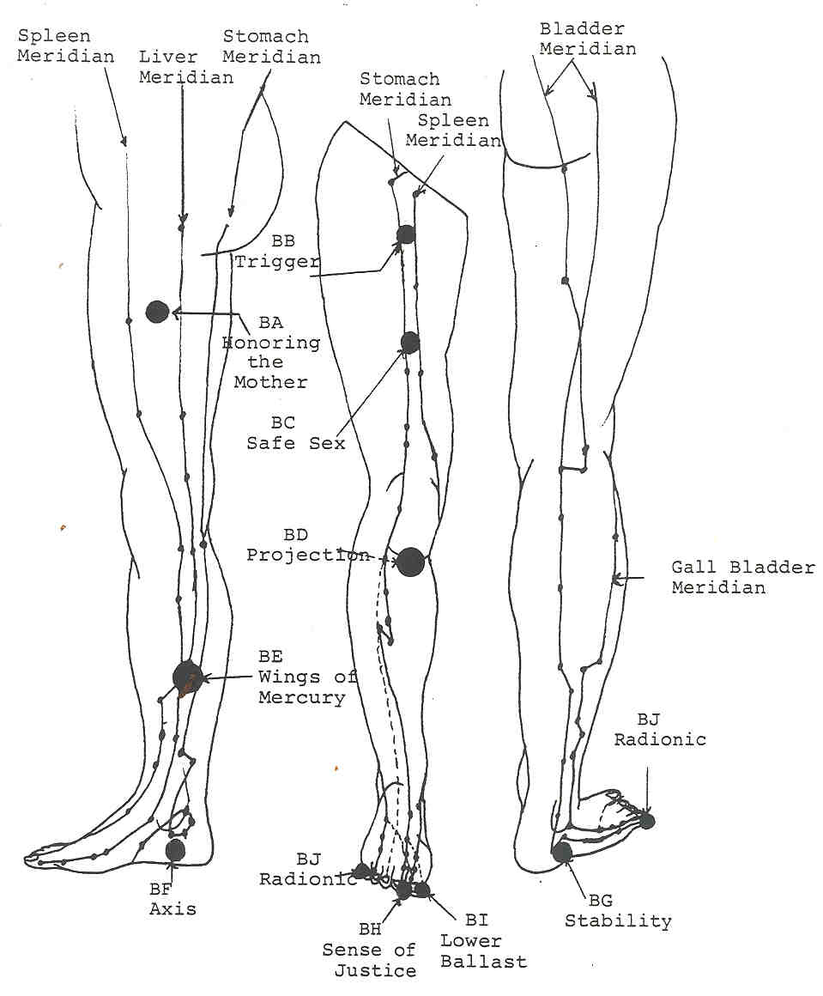
Figure 20

(BA) 2 Honouring the Mother Centers
Location: Below the perineum inside each thigh approximately two hands-width down
Meridians: Liver, Spleen
Magnitude: 3-6

Clairvoyant observations: 'These centers work to maintain purity of desire in the base chakra. They reflect the astral portion of the base chakra and form the demarcation of the ends of the petals of that chakra at that level of the aura. They also provide a great deal of etheric vitality to the base centre. Essentially, the Honouring the Mother centers rid the base centre of lust in order that one may honour the Great Mother.

Commentary: The remaining lesser centers are all in the legs and feet. All of them are extensions of the base chakra and are very much involved in the expression of self will as well as feeding earth-chi into the system.

The Honouring the Mother centers are yin in polarity and therefore reflect a person's inner feelings about base chakra issues. The Spleen meridian feeds a portion of negativity from the base chakra down to the Lower Ballast centre to be released. In this case, the amount of chi available to the base centre is subject to the psychological implications of the liver meridian. It is of interest to note that persons with a wounded inner child syndrome typically have some type of trouble with sexuality. The self image is distorted, which detracts from the functioning of the sacral centre. The sacral centre feeds off the chi coming from the base centre. If the chi from the base to sacral centre is blocked, then there is not sufficient chi to bolster a sound vitality in the hara or tan-tien and self-image again suffers. A vicious cycle is then set up which continually serves to drain the vitality. As a general rule of thumb, if a person is over-concentrated on sexuality or ego problems, the normal function of the hara as an energy centre is interfered with and the entire system suffers. That is typically why spinsters, old bachelors and sexual addicts tend to appear so sickly and ill-at-ease as the years slip by.

Sex is often said to be a love-hate relationship between two people. The worst domestic arguments usually occur in the bedroom. All of a person's weaknesses tend to be bared in the bedroom. Any couple that has been intimate for some time knows that sex is the first relation to suffer if love begins to wane or anger upsets relations. Invariably, at the same time, the question of sex becomes a gnawing question in the couple's minds. Another vicious cycle is set in motion. Psychologists' offices are filled with people whose problems can be traced directly to some dysfunction of the base-sacral complex.

Both the Liver and Spleen meridians register strongly in the workings of emotional response. The Spleen meridian contributes the vital force necessary for one to be present in the astral body and indicates if one is to put on a facade or show himself/herself in truth. Since the liver rules movement and growth, the Liver meridian's presence in these centers would govern or sense whether or not the person seeks nurturing and to nurture another person through sexual intercourse and if that union is to lead to new growth -- either a child or a deeper relationship. The Spleen meridian works to protect what the Liver meridian seeks to grow, so there is a very mother-like synergy set up between them at these centers. If, however, only release through the sexual act is desired, then the nurturing faculty of the meridians and these centers is thrown into disarray. Lust is highly detrimental to both the Spleen and Liver meridians. Desire is not love. Desire seeks only for self. Love seeks always for the good of others and causes growth.

Naturally, these centers increase in magnitude as healthy desires are fostered by a person. Right desiring and loving emotions bring increase to a person. Conversely, lust, hatred, anger, etc., close the Honouring the Mother centers and renders one unable to discern what is proper sexually and who is the correct partner. Promiscuity and lust shut the base chakra off from the earth. For proper nourishment by chi from the earth, one should endeavour to be reverent and to live according to the rhythm of the Great Mother.

(BB) 2 Trigger Centers
Location: 4 inches below the crease of the groin on top of the thigh
Meridians: Spleen, Stomach
Magnitude: 4

Clairvoyant observations: 'These centers act as triggers for the adrenal glands, hence their name. This is their etheric function. In addition, they give a sense of lift. They work with the thigh muscle that lifts the legs. "

Commentary: The Trigger centers are primarily yang in their functioning although the Spleen meridian contributes a strong yin component to them. It should be remembered that these centers are extensions of the base centre and thus would automatically have an effect on the adrenal glands. All the centers in the legs and feet effect these glands regardless of the meridians passing through them.

The Stomach meridian, indicating primarily "how the game is played," forms the mental component to the Trigger centers. By its means, these centers sort out what is appropriate for the base chakra in the mental realm. Both the Stomach and Spleen meridians are primarily mental in their actions. Note that the Trigger centers are the more mental component of the pairing while the Honouring the Mother centers are much more internal in their action and are astrally polarized. Both sets of centers seek out what is appropriate for proper base chakra functioning in their respective spheres of influence.

The stomach works with a person's drive, coordination, mental process and organization. The spleen allows presence in the mental body while the stomach performs its functions. It also adds its quota of responsible actions, acceptance or denial of thoughts and ideas and, above all, vitality. There is a direct relationship between vitality and the adrenal glands. A lack of adrenalin in the system causes a corresponding lack of desire for living. The Trigger centers are on the front of the body which would indicate that they are involved with direct experiencing of events.

The Trigger centers are, in the final analysis, most necessary for proper base chakra functioning and in enabling a person to both feel present in the physical bodies and vitally active in life. There is also a curious connection between these centers and the latent fires of matter or kundalini in the base of the spine. Kundalini has been called a condensed packet of mind-stuff. The mind as the agent of spiritual Will raises the kundalini toward the conclusion of the evolutionary proc- ess. The Trigger centers have their role in that process.

(BC) 2 Safe Sex Centers
location: In top centre of each thigh
Meridians: Stomach, Spleen
Magnitude: 4

Clairvoyant observations: Sara gives the following: 'The Safe Sex centers are used for clarity in sexual thinking. That which is appropriate, safe, clean, the correct species (animals also have these centers), etc., are indicated by these centers. People who are out of control sexually will have these centers distorted. " Peter adds that "these centers are more astrally polarized.

Commentary: The Safe Sex centers apparently form a "lower octave" to the Trigger centers. They both have the same meridians passing through them. How one adheres to proper sexual conduct is sensed by the Stomach meridian while the Spleen meridian gives one the presence of mind and emotions to carry on the act. All types of sexual perversions and misconduct would therefore show in these centers. Misuse of sexual energy would also affect the vitality of the system as distributed by the Stomach and Spleen meridians via these little centers. They are balanced in polarity, but seldom in their expression.

These are two of many of the lesser centers where control over astralism is sought after by the soul. The Spleen and Stomach meridians are both primarily mental in their influence and those centers are yet another instance where the mind seeks to stabilize and control the otherwise unruly astral body. The fact that these centers appear to be more astral is more a symptom of misdirected thought or absence of thought. Given the meridians that pass through them, they should not be astrally polarized at all. Humanity's insistence on the sensualisation and misuse of sex is what gives the Safe Sex centers their appearance.

(BD) 2 Projection Centers
Location: Just under each patella
Meridians: Stomach, Spleen
Magnitude: 7

Clairvoyant observations: 'The Projection centers are closely associated with the minor centers at the gonads. The knees have a close connection with fertility. A person who has a poor self image cannot project outward effectively, and this is reflected physically as infertility. The gonads conversely have much to do with the ebb and flow of etheric energy (prana). Impotence can be treated by working on these centers.

In addition to Peter's data, Sara has the following information about the Projection centers.. "There are two aspects here.. 1) Feelings of astral support whether financially or ideologically, are indicated by these centers. They are related to feeling secure, which is usually associated with money. Stealing blocks or unbalances these centers. 2) They are also associated with feelings about one's value to society and toward the quality of living. How productive one feels oneself to be is also an issue here. They are further related to how well one takes a stand on issues. They are therefore concerned with feelings of self worth. They form a polarity to the solar plexus centre. "

Commentary: Psychically considered, the Projection centers are connected with self-will and how that will is carried forward or projected outward. Sex is also an act of projection outward, initially for the male and later for the female. In a curious way, these centers form a sort of vehicle for that psychic function of the sacral centre known as self-image. The knees are part of the mechanism of propelling the self-image forward and enabling that image to stand and persist. When one walks, the knees project forward in the direction one is moving. The patella protects the knee joint.

The Projection centers have the same meridians passing through them as the Trigger centers do. There is a similar situation in the arms with the Grace of God and Artisan centers. The Trigger centers form the "advance guard" for the Projection centers. The physical analogy is that the thigh muscles raise the leg and project the knee outward. The Trigger centers work with the muscles on top of the thigh. As can be seen in the clairvoyant observations, though, the Projection centers appear to have an astral polarization. What should be noted in this regard is that self- image, self-will and projection of will are mental functions, even though the effects are to be noted more in the astral realms.

Poor self image usually has very emotional components associated with it. The mental elementals construct the self-image from the design contained in the causal body. It is a matter of karma most of the time and usually has its roots in past life misuse of energies. Of course, it should be realized also that these same patterns are set by the soul to spur growth of the personality toward a spiritual life. The lower centers are all power centers of varying degrees. Misuse of power will distort the self-image as contained in the sacral centre, the self-will as contained in the base centre and the self- desiring and organizing faculty as contained in the solar plexus centre. One cannot project a thought or feeling outward with accuracy when the equipment with which to project it is faulty or when the thought or feeling is not clearly defined.

The Stomach meridian, working with how the shots are called, governs the way in which thought and feelings to be projected are carded outward. The spleen, working with the presence of the person, gives the person the focused consciousness to will such constructs outward. Without both the stomach and the spleen working properly, the projections are either faulty or never make it outward to begin with.

Feelings of security require a positive self-image. Persons who are insecure are not present in the astral or mental bodies during certain types of experience, depending upon what psychological issues they have concerning self image. The spleen Works through the Projection centers to allow a person to stand. To "bring a person to their knees" is to destroy their self-image and to defeat them. Self-esteem (throat centre) suffers because there is no image or structure to contain it. To bend the knees in prayer is to subjugate ones' self-will to a higher Will. Being on one's knees almost always has the connotation of submission and the consequent inability to project oneself forward.

Stealing hinders or injures the other person's self-image and self-worth. To be stolen from gives one a feeling of betrayal, of nakedness and of vulnerability. All such feelings hurt one's self-image and disable one from moving forward for action. To steal from someone else causes a reflex of karma to settle in one's Projection centers. Stealing is unnecessary and an abomination to the law of supply and demand in nature. Nature supplies all one could possibly need. Since the stomach is part of the solar plexus complex, it works with the Law of Supply and Demand in nature. Adherence to that law is indicated in the Projection centers. Most criminals would benefit greatly from a healing of those centers. Right stewardship of energies ensures one's ability to project, to stand on one's own, and to feel valued as a part of the great economy of Nature.

(BE) 2 Wings of Mercury Centers
Location: Just above the ankles on the inside of the calves
Meridians: Liver, Kidney
Colours: Blue/violet
Magnitude: 7-8

Clairvoyant observations: "The Wings of Mercury centers are almost entirely concerned with physical survival They work with fight or flight reflexes and feed directly into the hara. These centers help one to move in and out of challenging situations and to be fleet-of-foot. They are connected with running. They are almost Mercurial in terms of the speed of their response.

Commentary: The Wings of Mercury centers are yin in polarity and form one of the first lines of defence for the organism. The Liver meridian in this case registers whether a situation is friendly or not (love/hate) while the kidney registers the amount of discord present in it. These are highly refined and sensitive centers and work with our more primitive responses to situations. They are marvellously clairsentient and can sense the slightest danger in a situation.

The two organs (liver and kidney) are two of the most intelligent organs in the body, so the sensitivity of these centers comes as no surprise. Remembering that the liver is a "fighter" and can handle heavy stress and the Kidney meridian feeds chi, it is small wonder that these centers make one fleet-of-foot or a formidable opponent. These, too, are adrenalin trigger centers due to the presence of the Kidney meridian there. The god Mercury may have had wings on his heels, but he should have had them at these centers.

(BF) 2 Axis Centers
Location: Below inside of the ankle next to ground
Meridian: Kidney
Magnitude: 5-6

Clairvoyant observations: "The Axis centers work with one's etheric alignment to the Earth's axis and with the flow of etheric energy from the ground in conjunction with the centers in the soles of the feet. The Axis centers should first be worked on by spreading the feet A person who feels closed in emotionally will often have these points closed.

Commentary. The Axis centers are primarily physical in their functioning. They are yin centers. The Kidney meridian works both as a feeder of chi and with a person's feelings of alignment. These centers are an exception to the rule that the lesser centers have at least two meridians feeding them. All points in the feet and calves tend to work at a subconscious level. People hardly ever think about whether or not their alignment with the axis of the Earth is true. In the same vein, people never think about keeping their balance, either -- until they lose it. If a person stands with sound posture then proper alignment is assured and chi flows smoothly throughout the system. Just as a garden hose with kinks in it will not pass as much water as it could, so a person with poor posture cannot process energy correctly.

It should be remembered that the Kidney meridian begins close to the minor centre in the sole of each foot. Feet that do not contact earth do not move or receive chi. The ankles have everything to do with stability both in standing and walking. Weak ankles or constricted ankle muscles will not allow a person to walk. The Axis centers along with the Projection centers and the muscles of the sacral region especially allow a person to stand and move.

Negative forces often seek to cause injury in the area of the ankles. Injuries to the ankles are registered subconsciously as impediments to one's direction in life. Any person who finds him or herself in a situation where emotions cannot be expressed or processed will have the Kidney meridian adversely affected. The base chakra complex forms a rather formidable vent for emotions. It allows us to "ground" our emotions, i.e. to give what we do not want emotionally back to the earth. People in conflict about survival therefore cannot release emotions. Peter has noted that "in the same situation, the sacral centre can find no release and sex along with vitality can become wholly obsessive concerns." Every time a foot is picked up and set down in another location, one moves and a new alignment is formed. To have the ankles bound even symbolically means a person is stuck both physically and emotionally.

The Axis centers allow one to stay on the Path. Standing erect, one is aligned both with the Great Mother (Earth) and with the Father (Sun). Agitation, which the kidneys process psychologically, if it persists, will eventually throw one off course for a time. Injuries to the ankles should be signals to people that some form of non-physical "pernicious influence" is seeking to keep them sidetracked from some purpose or goal. Just as the kidney keeps fluid balance in the body, so the Axis centers work with emotional balances. The astral body powerfully affects the etheric body and is difficult to keep stable. One should always seek the axis which connects Mother with Father and thus know solidity and strength of standing.
(BG) 2 Stability Centers
Location: Outer heels next to the ground
Meridians: Bladder, Gall Bladder
Magnitude: 6

Clairvoyant observations: "The Stability centers work with a person's emotional and physical stability. Physically it is concerned with the stability of the foot. These centers also govern the movement of magnetic lunar force from the earth into the lower chakras. People who are always getting knocked off balance emotionally need these centers worked on.'

Commentary: The reader should always bear in mind that "the higher always controls the lower." This is an old occult axiom and it applies to the synergy of the Bladder and Gall Bladder meridians in these centers as well as to the various synergies of the other centers. The gall bladder works primarily with mental essence; the bladder with emotional essence. Again, the mind controls and stabilizes. The Bladder and Gall Bladder meridians work together in the Stability centers to insure a coherent, ordered emotional response (if there is such a thing). The gall bladder brings mental focus to bear on the child-like emotions released by the bladder. The Gall BIadder meridian thus works to balance an otherwise unruly astral body.

Magnetic lunar force refers to astral currents that are earth bound and more connected with the elemental kingdoms of nature. The lower chakras, which are all primarily lunar in consciousness, feed on lunar forces and build responsive essence into the various vehicles. Lunar force is the energy animals work with to find food, water, mates, etc. The Bladder meridian is the primary feeder in this case although the Kidney meridian is the main feeder both of chi and lunar force. The gall bladder controls the amount that is taken in and its meridian acts as a sort of safety or control valve in order to balance solar and lunar forces within the body.

It may be noted that people who suffer sudden shocks to the astral body often urinate uncontrollably until they get their wits about them again. It would be most revealing to study whether the stability centers play any role in urination. The primary sphere of influence with these centers is etheric in that they work with the stabilizing of the ankle, but they can and do influence the astral body.

People unbalanced or unstable emotionally leave themselves open to the darker influences from this lunar force. The dark forces seek to destabilize one emotionally to keep the life in turmoil. Such turmoil shuts out the light of the soul and keeps one in a constant chimera of astral currents. Even mild influence along such lines causes physical symptoms such as poor bladder control, bladder and urinary tract infections and blocked urinary passages. Ankle problems also surface and, as with the Axis centers, one suffers from an inability to stand and face life. The clear light of higher mind is the only real cure for such conditions because such light dispels all glamours and illusions. It is not wrong to release emotion, but one should exercise self-control and seek to do so in right timing.

(BH) 2 The Sense of Justice Centers
Location: Under the nail of the large toe next to the second toe
Meridians: Liver, Gall Bladder
Magnitude: 3

Clairvoyant observations: 'These centers work with one's feelings of justice and fair play - the feeling that one should get what is coming to him or her. They work to balance the Solar Plexus centre via the liver. "

Commentary: Nowhere is justice more an absolutist concern than in the minds of children. Children see things in terms of black or white, yes and no. As the child becomes internalised with the passage of time, so do people's absolutist attitudes. The Liver meridian's termination in the large toe is a release point for such feelings since the liver expresses the inner child. The gall bladder is also a very absolutist organ since it works with logical thought. Therefore, its meridian's termination at the large toe further adds to feelings of fair play or injustice. It would be interesting to examine these centers on people involved in litigation. It would probably be most helpful to such people to stimulate or " to clear those centers.

It is rare to find anyone who thinks that justice is always done or that society as a whole is fair. Our inner children always yearn for justice and to see people get what is coming to them. But there is also somewhat of the criminal mind in almost everyone. How can there be fairness with greed, maliciousness, indifference or any of the host of misguided thoughts to which people are subject? Yet, there is justice for all. The person of sufficient vision knows that karma always brings its absolution. "Justice is ours," sayeth the Lords of Karma. The person who feels injustice should examine his/her own inner feelings (liver) and thought constructs (gall bladder) to ascertain the karmic connections to the perceived injustice. By opening the large toe to the earth, one can rid oneself of many such feelings and open the heart centre to the greater Good, thus giving a greater alignment of the solar plexus with the heart centre and rendering negativity to the earth, where it becomes fertilizer for something greater.

(BI) 2 Lower Ballast Centers
Location: Under the nail of each large toe
Meridians: Spleen, Stomach
Colour: opalescent
Magnitude: 3

Clairvoyant observations: Sara gives the following information about these centers.. "The Lower Ballast centers work with the gravity pull of the earth to pull negativity downward and out. The large toe is a flusher point. There is a high magnetic-electrical potential for healing at these centers.

Commentary: These centers have already been discussed somewhat. The Stomach meridian acts as a valve to regulate the outflow of psychic waste at these points. The spleen would appear to send its negativity to these points as well. Physically, the spleen is a blood cleanser and works with the immune response. Release of negativity from these centers insures that no toxicity builds in the Spleen meridian and immunity from astral infectious agents is thus assured. The cleansing action of these centers insures a clean supply of vitality as well as helping to assure presence. A person walking in a cloud of negativity is hardly able to be a presence.

(BJ) 2 Radionics Centers
Location: Ends of the small toes
Meridians: Bladder, Kidney
Magnitude: 1-2

Clairvoyant observations: Sara gives the following information: 'These centers act as antennae to sense what is needed from the earth in terms of nourishment for the body. People should keep the feet bare and in contact with the earth as much as possible. " Peter has the following observations. "There is a direct connection between these centers and the Tail of the Caduceus censers. When blocked, the person does not want to move forward psychologically. There is felt to be a lack of support from the Great Mother.'

Commentary: The Radionics centers are known as such primarily because of the Kidney meridian's termination there. These centers are highly clairsentient points and are highly astral in polarization. The yin-yang polarities are balanced. There is a constant comparison which goes on between the body and the lunar currents which the small toe encounters.

Additional Lesser Centers

By looking at the accompanying Figures, one will notice that not all meridian interactions or lesser centers have been discussed. The reader should be able to at least approximate the effects and actions those other centers have on the system by following the procedure used on the lettered centers in the figures. It should be noted also that there are many lesser centers formed by the crossing of meridians inside the body. These all play their part in the psychology and physiology of a person but remain beyond the reach of workers at this time. In all, there are at least 150 centers formed at the junctions of meridians.

Eventually the remainder of the external centers will be catalogued and investigated. The ones examined in this work are among the more important centers. The others tend to be more physical in their effects. The exception to the preceding statement is the genitalia. The genitalia have lesser centers on them as well and these figure among some of the more important lesser centers, but not on a day- to-day basis. Peter has made a cursory examination of these centers, but they will be examined in another work.
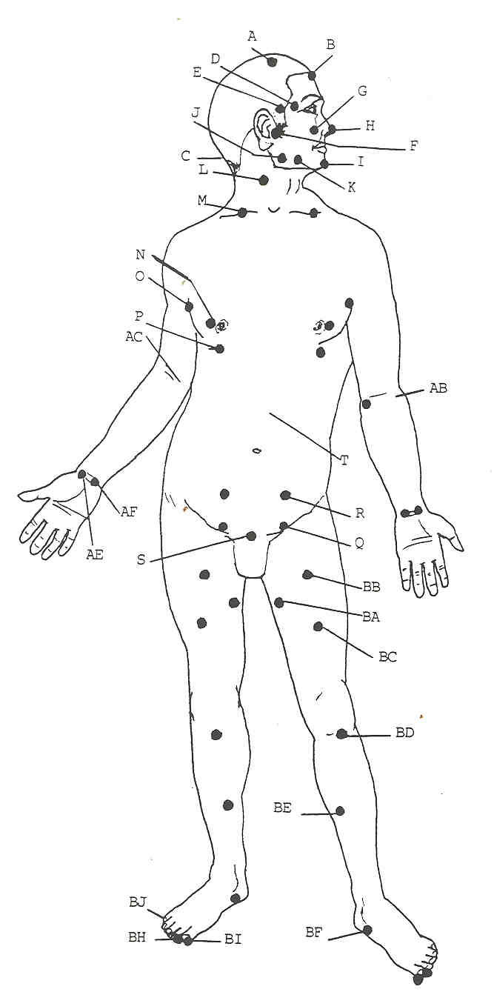

Figure 21

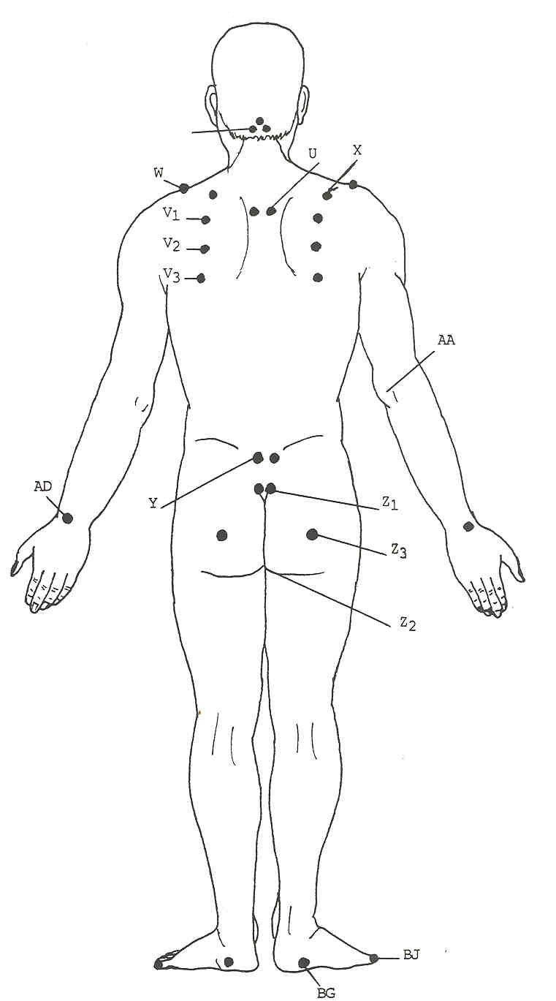

Figure 22

Tabulation of the Lesser Centers
Supposedly there are only 49 lesser centers and many hundreds of even smaller ones. If the reader has been counting he or she will note there are approximately 80 lesser centers listed. Sara lists only 49 lesser centers, but Peter recognizes all of them. It is actually a moot point because each centre has its gift to the system and can release certain blocks to expression. For quick reference, they are listed again below:

The Lesser Centers

Letter | Qty | Name of Centers | Meridians | Location
(A) | 2 | Support of Light | Liver, Bladder | beside crown centre (head)
(B) | 1 | Spirit’s Hall | Bladder, Governing, Stomach | widow’s Peak
(C) | 3 | Heads of Cerberus | Bladder, Governing | base of skull
(D) | 2 | Telepathy | Gall Bladder, Triple Warmer | temples – towards ear
(E) | 2 | Momentum | Stomach, Triple Warmer | temples – towards eye
(F) | 2 | Sound of Silence | Small Intestine, Gall Bladder | front of ear
(G) | 2 | Upper Ballast | Stomach, Large Intestine | beside nose
(H) | 1 | Breakthrough | Lge Intestine, Liver, Stomach, Governing | tip of the nose
(I) | 2 | Voice of Creation | Liver, Stomach, Governing | chin
(J) | 2 | Mind over Matter | Small Intestine, Stomach | bend of jaw
(K) | 2 | Small Waterfall | Large Intestine, Stomach | jaw towards the chin
(L) | 2 | Calmness | Sm and Lge Intestine, Triple Warmer | side of neck
(M) | 2 | Breath of Life | Kidney, Stomach, Triple Warmer | clavicle (upper torso)
(N) | 2 | Mothers Milk | Pericardium, Spleen, Stomach | beside nipples
(O) | 2 | Growing Too Fast | Pericardium, Heart | front of armpit
(P) | 2 | Upright | Liver, Stomach | edge of pectoral muscle
(Q) | 2 | Genesis | Liver, Spleen | just over the hip sockets
(R) | 2 | Pulsation Points | Liver, Spleen | Aprox. 3” above Genesis centre
(S) | 1 | Emotional Presence | Conception, Liver, Spleen, Kidney | above pubic bone
(T) | 1 | Feeder of Chi | Conception, Kidney | between hara and solar plexus
(U) | 2 | Void-of-Course | Governing, Bladder | between Shoulder blades (back)
(V₁) | 2 | Fire of the Sun | ----------- | top of scapula
(V₂) | -- | Mother’s Love | Devata Grace Centres | middle of scapula
(V₃) | 2 | Web of Desire | ----------- | bottom of scapula
(W) | 2 | Authority | Triple Warmer, Gall Bladder | top of shoulder
(X) | 2 | Atlas | Triple Warmer, Small Intestine | top of shoulder towards back
(Y) | 2 | Forgive Me | Gall Bladder, Bladder | sciatic area
(Z₁) | 2 | Tail of Caduceus | Governing, Bladder, Kidney | tip of spine
(Z₂) | 1 | Sea of Yin | Governing, Conception, Kidney | perineum
(Z₃) | 2 | Fire of Innocence | Gall Bladder, Bladder | centre of buttocks
(AA) | 2 | Small Sea | Triple Warmer, Small Intestine | back of elbow (arm)
(AB) | 2 | Grace of God | Lung, Pericardium | hollow of elbow
(AC) | 2 | Guardian Angel | Pericardium | hollow of elbow
(AD) | 2 | Speaking the Heart | Triple Warmer, Small Intestine | Top of wrist
(AE) | 2 | Artisan | Lung, Pericardium | bend of wrist
(AF) | 2 | Spirit’s Door | Heart, Pericardium | bend of wrist
(BA) | 2 | Honouring the Mother | Liver, Kidney | inner thigh (legs and feet)
(BB) | 2 | Trigger | Spleen, Stomach | top of thigh (3” below groin)
(BC) | 2 | Safe Sex | Spleen, Stomach | centre of thigh
(BD) | 2 | Projection | Spleen, Stomach | below patella
(BE) | 2 | Wings of Mercury | Liver, Kidney | inside of calf
(BF) | 2 | Axis | Spleen, Kidney | inner ankle – next to ground
(BG) | 2 | Stability | Bladder | outer ankle – next to ground
(BH) | 2 | Sense of Justice | Liver, Gall Bladder | inside of big toe
(BI) | 2 | Lower Ballast | Stomach, Spleen | outside of big toe
(BJ) | 2 | Radionics | Bladder, Kidney | end of small toe
Table 3
Notes for Chapter 3

KW 206
EH 178
Homecoming Intro - 25
ibid
ibid
ibid
All the centers in the spine and head have etheric webs separating them. The one in particular between the throat and alta major centers is said to be dissolved as the Antahkarana (bridge of light between the Spirit and personality) is constructed. TCF 961-2
TCF footnote 965-966 item #11
TCF 173, 97
Pranayama is the control of prana via control of the breath. It is an exacting discipline and most dangerous if misapplied. See Note #43 under chapter 2 notes. It works under the premise that the mind is connected with the lungs and breath. By the use of pranayama in meditation, the entire system is vitalized and mental clarity and stillness is greatly enhanced.
11 There are six shaktis or powers. They are a) Parashakti - supreme force; b) Jnana-shakti - the power of intellect; c) lchchhashakti - the power of will in the manifestation process; d) Kriyashakti - the force which materializes ideals; e) Kundalinishakti -- that force which adjusts internal to external circumstances; f) Mantrikashakti - the power in sound, speech and music
12 TCF 997-1026
13 Karezza: The Ethics of Marriage by Alice B. Stockham, M.D. available through Health Research, P.O. Box 20, Mokelumne Hills, CA 95245
see glossary under "Genesis"
Bible Numbers 14:18
DOR 51-59 42-48
DOR 61-62 EESP 147-148
TM 301-302
Bible Genesis 1:3
Homecoming lntro-25
KW 85,87,91,93,176 EH 217,435
KW 44
TCF 242,1178
R&I 589-602
PE 207-210 EESP 166
TCF 761-762, 876,1101,1118-1119
KW 12
Homecoming lntro-25

