Content for ATOWM Series II, Rules of Magic for the Astral Plane, Video Commentary, Program Twenty-Four, 10.8 continuing Rule X, 1:02 hr; pages 293-295.

Program 24: A Treatise on White Magic – Rules of Magic for the Astral Plane – Rule X 10.8 276 MB .wmv file
Video by Michael D. Robbins. 17Aug2018 / 1:02 hr.

Program 24: A Treatise on White Magic – Rules of Magic for the Astral Plane – Rule X 10.8 58 MB .mp3 file
Audio by Michael D. Robbins. 17Aug2018 / 1:02 hr.
Hello friends,

We are beginning with video commentary number 24 in this series, where we're working on the rules of magic for the astral plane. These are being posted on YouTube and will be on Makara as well.

We're on page 293 and we're beginning a very important section, a very practical section called:

ASTRAL ENERGY AND FEAR

The subject now to be considered is of most practical application for it concerns the astral body—the body in which a man is pre-eminently polarised and of which he is more potently conscious than of any other body. The etheric body is really below the threshold of consciousness. Human beings remain unaware of the passage of forces through this vehicle and the nearest they get to the recognition of it is when they speak in terms of vitality or lack of vitality. The physical body makes its presence felt when something goes wrong or through the gratification of one or other of the appetites. The situation is however different in connection with the astral body for there is the vehicle of experience for the majority, and few there are who do not pass the greater part of their conscious life, recording the reactions of that body and vibrating between the two poles of happiness and misery, of satisfaction or non-satisfaction, of assurance or doubt, of courage or of fear. This really means that the inherent force and life of the emotional sentient vehicle govern the life-expression and mould the experience of the incarnated soul. Therefore, it is of value to us to understand something of what those forces are, where they come from, and how they act and react on the man. There lies his battleground and there also lies his field of victory. TWM 293

ASTRAL ENERGY AND FEAR

Remember that this particular book certainly is useful in mastering the astral body, and so I suppose it's useful in preparing for the second initiation, though it's subject matter does actually go far beyond that as we have noticed. The Tibetan is writing some very abstruse things about the eight points. For instance that we've been reviewing the eight aspects of man and their correspondences within the physical body

Let's go ahead with it.

The subject now to be considered is of most practical application for it concerns the astral body—the body in which a man is pre-eminently polarised and of which he is more potently conscious than of any other body. Does this mean all men? Or does this mean those who are not yet disciples? Perhaps. But maybe more than we realize. We are attentive to our feeling and desire states and to the reactions of this sentient vehicle.

The etheric body is really below the threshold of consciousness. You might say so many automatic systems operate through the etheric body: we have the autonomic nervous system, and the sympathetic part, and the parasympathetic part. We have all those things and we're no longer aware of them functioning; they take care of things on their own and we do not have to give conscious attention to them as perhaps we had to do in some earlier initiations in the Lemurian times.

Human beings remain unaware of the passage of forces through this vehicle and the nearest they get to the recognition of it is when they speak in terms of vitality or lack of vitality. Well, that is going on quite frequently, right? The sense of being filled with vitality or being tired, at least that is a common experience for all.

The physical body makes its presence felt when something goes wrong or through the gratification of one or other of the appetites. But otherwise again, below the threshold of consciousness. Maybe if a person is very athletic … and the body is well trained, it probably supports itself without calling much attention to itself in the consciousness. If one is sick or debilitated or disabled, then again we have the physical consciousness.

0:04:40 I remember, back before Mary Bailey retired, somewhere in 1983 or ’82, she had to go into the hospital for some kind of a heart issue, and she said her consciousness was drawn right down into the physical body. The way she talked about it, it sounded to be a very unusual thing. Actually what we hope is that all the aspects of the personality will operate in an automatic way, and that we will be somehow focused in the higher consciousness, maybe on the higher mental plane or eventually as the Masters are even higher than that.

The situation is however different in connection with the astral body for there is the vehicle of experience for the majority, and few there are who do not pass the greater part of their conscious life, recording the reactions of that body and vibrating between the two poles all goodness of happiness and misery, of satisfaction or non-satisfaction, of assurance or doubt, of courage or of fear. Well, let's just say this … type of astral awareness is very common and eventually when we achieve true … mental polarization, perhaps the awareness of the astral body slips below the threshold of consciousness.

This really means that the inherent force and life of the emotional sentient vehicle govern the life-expression and mould the experience of the incarnated soul. In the majority of cases, and the aspirant cannot assume that this is not the case for him or her, in fact if we're truthful, what depends on our astrology and rays, some rays are less inclined towards emotionalism. We're told the second initiation is easier to take for fifth and third ray souls, because they tend not to be focused in the astral body, or to be focused emotionally in or to react emotionally, but still it looks like a general condition.

Therefore, it is of value to us to understand something of what those forces are, where they come from, and how they act and react on the man. We did study some of the forces released upon the astral plane.

There were three of them … I remember that sex emotion was one, and probably a general turbulence caused by the Black Lodge, and the reaction to the new incoming forces of a superior kind, which does not mean that that reaction will be tranquil, this does not mean a tranquil easy reaction.

There lies his battleground and there also lies his field of victory. Here we are speaking in the Scorpionic language.

Think of it, the warrior, the one who struggles. Well the sign most associated with the human monads years Scorpio and it is conveying the majority of the warlike forth ray at this time.

So, all human beings in one way or another, in order to become true adjudicators between the pairs of opposites have to go through the great struggle and achieve victory through humility and a willingness to kneel and to accept the impress of the higher energies rather than asserts their personality, which is so often the case. Remember the entire personality is ruled by Mars. If you look at it, every elemental vehicle except maybe the etheric vehicle is ruled by Mars.

To begin with, it is advisable to bear in mind that all astral energy is part of the astral energy of the solar system and that therefore:

1. The sentient body of a human being is an atom of substance in the sentient body of the planetary Logos.

2. The sentient body (a term I much prefer to the term astral, and which I shall continue to use) of the planetary Logos is an aspect—not an atom—of the sentient body of the solar Logos.
3. This in its turn is influenced by, and is a channel for sentient forces, emanating from vast centres of energy outside our solar system altogether. TWM 293-294

0:11:00 To begin with, it is advisable to bear in mind that all astral energy is part of the astral energy of the solar system and that – now, let's see, Varuna is the ruler … of the astral plane of Earth, and a greater being of the astral plane of the solar system.

So all astral energy is part of the astral energy of the solar system. Obviously, we're going to respond much more to the astral energy of the human kingdom, and probably the animal kingdom, and we are to some other kingdoms on other planets at this time, and many of them have mastered their astral vehicle, our planetary logos has not yet mastered His astral vehicle, He's not yet a cosmic initiate of the second degree, not yet then. Maybe the Judgment Day has something to do with that. Anyway, that's a long way off still.

So a part of the astral energy of the solar system and that therefore:

1. The sentient body of a human being is an atom of substance in the sentient body of the planetary Logos. … we note that the term atom is used, and maybe well do we understand something about scale when we use such a term. That is a question. …

2. The sentient body (a term I much prefer to the term astral, and which I shall continue to use) of the planetary Logos is an aspect—not an atom—of the sentient body of the solar Logos. A larger structure really.

So an aspect is generally one of seven principles or seven factors. Let's just say there is an astral body, a sentient body of the solar logos. Maybe there are seven major astral centers, having to do with the esoteric or the higher planets synthesizing the sacred planets, but our planet counts and has its place. The numbers are much smaller as we understand there are so many human astral bodies right? But when we consider the planetary logos’ astral body, it's one of what may be well one of ten, or one of even 115, but if the number is much smaller so then the term aspect is justified. …

3. This in its turn is influenced by, and is a channel for sentient forces, emanating from vast centres of energy outside our solar system altogether. So, here we have the influences upon the astral body of the solar logos, from great sources, and of course Sirius would be one. And other stellar sources and probably our local cosmic logos, whose logos of the Seven Solar Systems of Which Ours is One, probably from the One About Whom Not May Be Said, which I often call a super cosmic logos.

So, we're trying to get a sense of scale but really all astral bodies are part of one great astral body ultimately, but we're most concerned with our the astral body of humanity. the astral body of our planetary logos in three kinds of divisions scheme chain, and here we have our globe, and eventually maybe the astral body of the solar logos from whence which we would call from one perspective the heart of the Sun and from whence great love tides come forth. Maybe when we are higher initiates we will be responding more to those.

If this is borne in mind it becomes apparent that man, being but a tiny fragment of a vaster whole which in its turn is incorporated into a still vaster vehicle, is the meeting ground of forces greater and more diversified than his brain is capable of recognizing. Hence the complexity of his problem and hence all the possibilities growing out of those expansions of consciousness which we call initiation. Every stream of energy pouring through his body of desire and of sentient reaction, is but a pathway leading him to wider and every widening contacts and realisations. Here also lies the safeguard for the majority of human beings, in the fact that they possess as yet an apparatus inadequate for the registering and recording of those infinite possibilities which these avenues of realisation offer. Until the mental apparatus is sufficiently awakened and controlled it would not be possible for man to interpret rightly and utilise correctly the information which his body of sensitive response could, but fortunately does not yet, convey to him. TWM 293-294

0:17:00 If this is borne in mind it becomes apparent that man, being but a tiny fragment of a vaster whole which in its turn is incorporated into a still vaster vehicle, is the meeting ground of forces greater and more diversified than his brain is capable of recognizing. Well that's clear. Of course we may react, but in a way we don't respond. The main response is something greater than reaction. it involves perhaps a knowledge of where the energy comes from and what its purpose and nature may be.

Hence the complexity of his problem and hence all the possibilities growing out of those expansions of consciousness which we call initiation. Let's just say we become aware of force. Well it's the energy and force currents and their sources. So we can begin to recognize and utilize.

Every stream of energy pouring through his body of desire and of sentient reaction, is but a pathway leading him to wider and every widening contacts and realisations. So we feel our way towards ever higher sources.

Here also lies the safeguard for the majority of human beings, in the fact that they possess as yet an apparatus inadequate for the registering and recording of those infinite possibilities Well, certainly amazingly multiple, those infinite possibilities, which these avenues of realisation offer. Until the mental apparatus is sufficiently awakened and controlled it would not be possible for man to interpret rightly and utilise correctly the information which his body of sensitive response could, but fortunately does not yet, convey to him.

I think DK calls this the unveiled Neptune, and fortunately the moon does veil, as does the Sun, blocking out fullest sensitivity which we could not have: those veils seem to be something we want to overcome, the veils upon the moon are the veils which relate or signifies, the veils which relate to the personality vehicles which certainly do repel or at least remain opaque to the higher energies, and then the Sun as a veil is the ahamkara principle that principle of - is such a repelling factor that egotism or if it's not egotism it's a repelling factor when it comes to the registration of certain more universal energies.

Apart from the constant circulation through his astral body of planetary and solar and cosmic energies, every human being has appropriated, out of the greater Whole, enough of the astral energy wherewith to construct his own individual and separate astral body, responsive to his peculiar note, coloured by his peculiar quality, and limiting him or not according to his point on the ladder of evolution.
This constitutes his astral ring-pass-not, defining the limits of his emotional response to life experience, embodying in its quality the range of his desire life, but being at the same time capable of tremendous expansion, development, adjustment and control under the impulse of the mental body and of the soul. It is subject also to vibratory activity as the result of the interplay between it and the physical plane life experience, and thus the great wheel of experience is set in motion and will persist until the four Noble Truths of the Buddha are understood and realised. TWM 294-295

Apart from the constant circulation through his astral body of planetary and solar and cosmic energies, Goodness, so this is going on all the time, and sometimes ignorance is bliss, or ignorance is a protection.

I'm remembering DK telling, ‘well that healthy skepticism which is part of the modern root race and subrace is a protection against too much knowledge of an occult or esoteric kind, which humanity really couldn't understand wisely or handle correctly. So sometimes ignorance or a certain attitude of mind protects the unready the unwary, and when we begin to wake up to occultism, we realize there are many hidden dangers involved in treading this path. So as Alice Bailey is always saying and as the Tibetan is always saying, one has to count the cost.

Apart from the constant circulation, just think what's going on all the time here, through His astral body at planetary and solar and cosmic energies. Oftentimes, let's just say too high for him the to register.

every human being has appropriated, out of the greater Whole, enough of the astral energy wherewith to construct his own individual and separate astral body, this is done in the stages of appropriation in which the soul is building becoming personality mechanism. So every human being has appropriated out of the greater whole enough of the astral energy wherewith to construct his own individual and separate astral body responsive to his peculiar note, coloured by his peculiar quality, and limiting him or not according to his point on the ladder of evolution.

Let's remember that the astral body is attuned to the soul and even to the monad, if we look at the numerology, the monadic ray has the effect upon the mental ray, the soul ray has the effect upon the astral ray, and the astral body, the mental, the personality ray has the effect upon the dense physical body. That can be a ray effect.

In some of the students from Master DK that ray effect was showing up. This man, L.U.T. thought he had a ray one physical body, it was really an impress and overlay from his ray one personality. Well that's one way of looking at it, and the other way is that the monadic plane is two from the top, and the astral plane is two from the bottom, the astral body or plane is six from the top, and the monadic plane is six from the bottom.

0:25:00 So on the monadic plane there is found heart centers really, and the monad in a way is as much a heart as it is a factor of will, so there is an affiliation there as we know that heart and astral body are closely connected, just the way the two and the six are closely connected.

This constitutes his astral ring-pass-not that which He has appropriated and the condition in which the astral condition in which He finds himself. or descending condition. This constitutes his astral ring-pass-not, defining the limits of his emotional response to life experience, embodying in its quality the range of his desire life, but being at the same time capable of tremendous expansion, development, adjustment and control under the impulse of the mental body and of the soul.

I guess what's being said here, there are many sentient potentials for higher contact. Master Morya is always using the word field, as if it's an important word and not to be discounted because it's associated with the astral body. It has something to do with heart, and the heart has something to do with the astral body. So we feel into things that are far beyond us, and this astro vehicle can grow capable of tremendous expansion, development, adjustment and control, under the impulse of the mental body in the soul.

I think DK is talking about sometimes the astral body or sentient body of the artist and how it has to be enlarged and very rich in order to make the true artist and of course the past lives will come into that and the memories stored in the soul will come into that and add to the richness of the expression of the astral body.

It is subject also to vibratory activity as the result of the interplay between it and the physical plane life experience, and thus So, let's just say astral body also subject to physical currents and thus the great wheel of experience is set in motion and will persist until the four Noble Truths of the Buddha are understood and realised. The assimilation of the Four Noble Truths with the Eightfold Path gives liberation at last.

So the Buddha prepared the way. As we are on the way to initiatory possibilities, we use this as a great foundation and realized somehow that the lower 18 subplanes really are the dense physical body of the planetary logos. They are an effect, they are the world of phenomena, which is related to the past and nothing within this world of transiency and phenomena is to be so keenly desired that one becomes attached to it.

Now that detaching process is hard, and there's a lot of understanding that has to go into it a lot of bitter experience and the whole idea that what we relinquish we never really lose but regain on a high return of the spiral. DK talks about the law of sacrifice in Esoteric Psychology II, how when we release something we regain it in a better form on a higher turn of the spiral.

Every one of us has a sort of astral body which we have made, and which we somehow have cultivated over many many years, no better nor worse than what we have created over many lifetimes. But of course there are ray and astrological impulsions which may be assigned to us and will condition the way the astral body reacts, whatever it's present vibratory condition.

For instance, if you're born with a lot of water signs, there's going to be real emphasis on the sensitivity of this sentient body, maybe more so, and if you're on one of the rays that is resonant with the astral body, two, four, six, then there's going to be a lot of focus there, whereas if a different ray is your soul ray, then there may be less emphasis. Certain signs perhaps give a greater detachment from the astral body. So everything has to be taken on an individual basis.

This astral body has in it the counterparts of the etheric or laya centres, and through them stream the forces and energies, earlier dealt with, into the etheric body. These centres carry energies from the seven planets and from the sun to every part of the astral organism, thus putting man en rapport with all parts of the solar system. This results in the fixation of a man's life destiny, until such a time as the man awakens to his immortal heritage and so becomes sensitive to forces that are as yet—for the many—unrecognised. These emanate from the form. This is the reason why a horoscope is frequently quite accurate in its delineation for the unevolved and for the unawakened, but is quite in error and at fault in the case of the highly evolved man. Man is, en masse, what his desire body makes him. Later, "as a man thinketh so is he". The astral body, with its longings, appetites, moods, feelings, and cravings moulds the physical body through the attractive forces which flow through it, and so guides the man on unerringly to the fulfilment of his desires. If the cravings of the sentient nature are dominantly animal in their objective we shall have the man with strong appetites, living a life given over to the effort to satisfy them. If the craving is for comfort and for happiness, we shall have the man with a sensuous, beauty-loving and pleasure-loving disposition, governed practically entirely by selfish effort. So it is through all the many grades of desire, good, bad, and ordinary, until that re-orientation takes place which so refocusses the astral energies that they are turned in a different direction. Desire becomes aspiration. Thus liberation from the wheel of birth is brought about and a man is freed from the necessity to reincarnate. Then the horoscope as now understood proves futile, untrue and useless and the term sometimes used, but wrongly, 'the horoscope of the ego or the soul' means nothing. The soul has no individual destiny, but is submerged into the One. Its destiny is the destiny of the group, and of the Whole; its desire is the working out of the great Plan, and its will is the glorification of the incarnated Logos. TWM 295-296

0:31:20 This astral body has in it the counterparts of the etheric or laya centres, and through them stream the forces and energies, earlier dealt with, into the etheric body.

This really has to be remembered, and the chart helps us … let’s take a look.

Here are the astral chakras and there is a kind of etheric section to the astral plane, just the way the first four subplanes with the egoic lotus can be considered an etheric or directive portion of the metal plane and on and on it goes. We don't really know what's lying on the highest levels of the buddhic plane, subplane one and two, atmic plane one and two. We do know that the etheric factors are involved in the first four subplanes and I suppose on it goes through the monadic plane and maybe even into the sea of fire. Interesting.

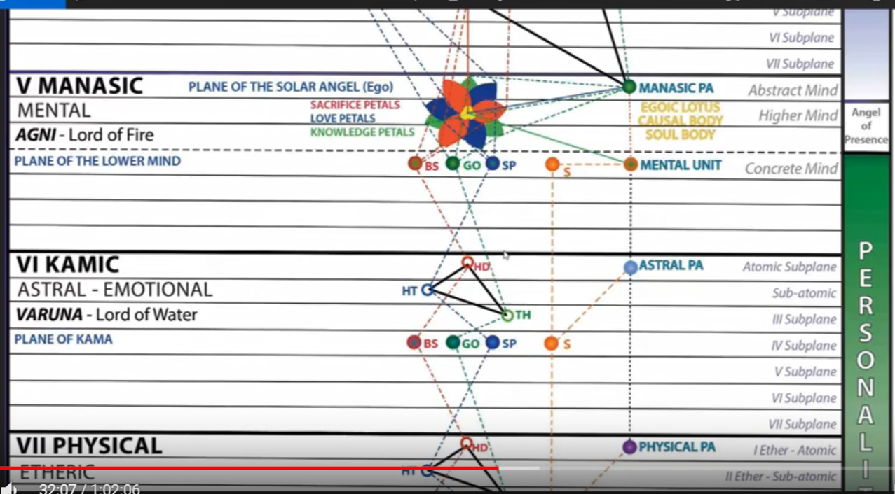

So the astral body has in it the counterparts of the etheric or laya centres, and through them stream the forces and energies, I think that 35 vortices of force make the master. So that takes us to the atmic plane, with seven on each one of the five planes; the 42 vortices of force make the chohan of the sixth degree, and then 49 vortices of force make the chohan of the seventh degree. Every one of those higher centers I think descends through its correspondence on a lower plane. So you're really getting energies all the way from the sea of fire, ultimately, even down onto the etheric level, even though we don't recognize that to be the case.

There are seven centers, 49 vortices of force makes the chohan of the seventh degree, and I suppose we're dealing with a head center there, well then there's going to be a head center on the monadic plane, atmic plane, buddhic plane, something on the mental plane eventually, maybe the synthesis maybe the synthesis petals or one of the synthesis petals or the sacrifice petals or eventually our own vehicle, once we get rid of the causal vehicle, and on the astral plane, and finally on the physical etheric plane.

So things just descend from the highest all down through the correspondences on lower planes, that would be my guess. Because we'd have to know is something about vehicular relationships and how one vortex may induce another or relate to another.

The work of Duane Carpenter is very good in all of this, I think he has more understanding of these type of occult motions than anyone I've met, so go to his website http://www.light-weaver.com/ study what he's put there, and if you have a chance to listen to his webinars or lectures, then do that.
[This link is specifically on the vortex: http://www.light-weaver.com/LW-old/vortex/1vortex.html]

So we have the counterparts of the chakras, of the etheric chakras on the astral plane:

These centres carry energies from the seven planets and from the sun to every part of the astral organism, thus putting man en rapport with all parts of the solar system.

Now things are a little different, we know on page 517 of Esoteric Astrology that shows us that maybe the rays and the planets that are involved with the etheric chakras for the undeveloped man, and the average man, and the disciple initiate:

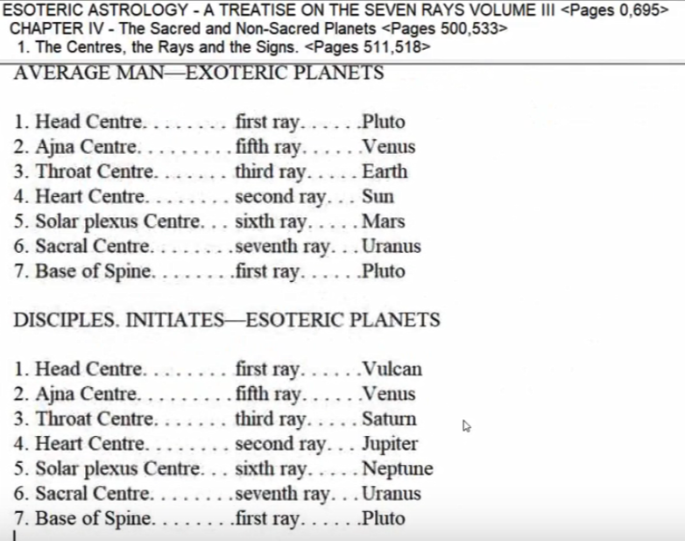

But when we get to the astral chakras, maybe something different appears. First ray, head center and see, we have different rays than the ones that are assigned etherically, and probably, accordingly, different planets:

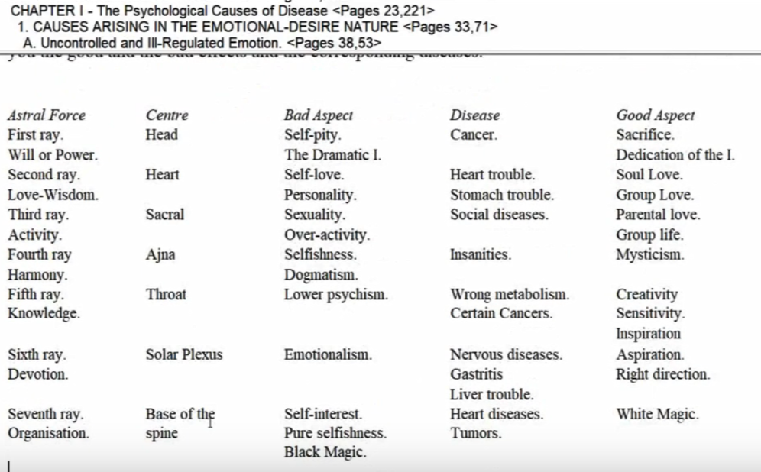

The fifth ray is assigned to the throat instead of the third ray, the fourth ray is assigned to the ajna instead of the fifth ray, the third ray of the sacral center instead of the seventh ray. Solar plexus remains sixth ray, and the seventh ray to the base of the spine.

Well there's a number of rays to assign there, so there is a difference.

I wonder if we went to page 151 or so … in Esoteric Healing that's the important chart to show the differences between ray and thus planet assignments for chakras found on the astral plane, compared to chakras found on the etheric plane, but still they carry some of the same meaning at least.

So these centers carry energies from the seven planets and from the sun note that the Sun energy, etheric energy, pranic energy, or maybe there are other energies involved, other essences involved to every part of the astral organism.

Just the way it will be done etherically, , thus putting man en rapport with all parts of the solar system.
and we would say through the astral body and its chakras, rapport with the entire solar system via its planets and the Sun is established.

There are always going to be representations on our planet of of the different factors in our solar system, in Shambala every planet is represented, every planetary chain is representing. One of the greater ray Lords we call planetary logoi and so forth.

So we have the reflection at least within our own planetary system of what's going on in the solar system and I suppose the reflection as well of the Sun.

[repeating from above in part]

This results in the fixation of a man's life destiny, until such a time as the man awakens to his immortal heritage and so becomes sensitive to forces that are as yet—for the many—unrecognised. These emanate from the form. This is the reason why a horoscope is frequently quite accurate in its delineation for the unevolved and for the unawakened, but is quite in error and at fault in the case of the highly evolved man. Man is, en masse, what his desire body makes him. Later, "as a man thinketh so is he". The astral body, with its longings, appetites, moods, feelings, and cravings moulds the physical body through the attractive forces which flow through it, and so guides the man on unerringly to the fulfilment of his desires. If the cravings of the sentient nature are dominantly animal in their objective we shall have the man with strong appetites, living a life given over to the effort to satisfy them. If the craving is for comfort and for happiness, we shall have the man with a sensuous, beauty-loving and pleasure-loving disposition, governed practically entirely by selfish effort. So it is through all the many grades of desire, good, bad, and ordinary, until that re-orientation takes place which so refocusses the astral energies that they are turned in a different direction. Desire becomes aspiration. Thus liberation from the wheel of birth is brought about and a man is freed from the necessity to reincarnate. Then the horoscope as now understood proves futile, untrue and useless and the term sometimes used, but wrongly, 'the horoscope of the ego or the soul' means nothing. The soul has no individual destiny, but is submerged into the One. Its destiny is the destiny of the group, and of the Whole; its desire is the working out of the great Plan, and its will is the glorification of the incarnated Logos. TWM 295-296

0:39:10 This results in the fixation of a man's life destiny, the design which brings on his fate until He can really control His stars as it is said. So this results in the fixation of a man's destiny in any one incarnation – until such a time as the man awakens to his immortal heritage and so becomes sensitive to forces that are as yet—for the many—unrecognised. These emanate from the form.

Then he can begin to direct his destiny, AAB tells us. Well, DK says, we are no longer a prisoner of the tendencies of our horoscope. But up to that time as the horoscope is, it made pretty well determine what happens to man, but we can correct that, we can use that, use things on higher turns of the spiral then seemed to be indicated if we find the immortality of our soul. If we are becoming aware of ourselves as soul and spirit and then we can begin to guide and utilize our stars according to the purpose which we discover within ourselves.

So, These emanate from the form. This is the reason why a horoscope is frequently quite accurate in its delineation for the unevolved and for the unawakened, but is quite in error and at fault in the case of the highly evolved man. I must have remembered that from long ago, because that's basically what I'm saying, we have to be able to control and direct our stars, or at least determine the level of response to these energies. People respond in all different ways in the orthodox, esoteric, and hierarchical rulers indicate, different modes of response to certain zodiacal energies. It all depends on the quality of the form: the higher the quality of the form, the higher its frequency, the more it has been transmuted, transformed, and even transfigured the higher will be the response to the energies which are making their impact.

Man is, en masse, what his desire body makes him. Later, "as a man thinketh so is he". Maybe that's more for the disciple, because right now it's a bit like as a man desirous, as a man feeleth, so is He. So this comes later when there is more mental focus. One day we'll get to review all of our lives; it'll be an astonishing movie, I guess.

I'm reminded of that Kirk Douglas movie, and it was called Illusion, or something, anyway he's a dying film director and he dies, basically he gets to sit in the big movie house as the only attendee, and watched the movie of his life. There's the projection booth and the big film canisters and all that and the whole film is about wanting to redo certain things, because he has the objectivity to realize where he's made terrible mistakes. The entertainment of the film is he really gets to redo it and alter his fate, because he comes back to life and he knows what he has to do and things work out much much better.

The creative arts in film, if we have good ones, that Neptunian kind of conveyance really does open our imagination to possibilities we might not experience in our normal encounters and therefore it can be extremely valuable and help us share the experiences of other human beings which gives us the sense of commonality and identification and harmony and sameness and unity. All those things. Great works of art sometimes really leave you with that wonderful unitive feeling.

I remember when I was in school in the University of Michigan, the Stratford Ontario wasn't too far away, and there they had wonderful Shakespeare Festivals, and something magical was going on; it was Stratford-on-Avon, but the Canadian version of it, not the English version. And when the play was over, even though it might have been one of those blood-curdling Shakespearean tragedies, you'd come out with that sense of timelessness and a great sense of the panorama of the human experience and you were just beyond your ordinary personality, you had the appreciation of the pageant of human evolution.

0:46:00 The astral body, with its longings, appetites, moods, feelings, and cravings and there's a lot of words right moulds the physical body through the attractive forces which flow through it, and so guides the man on unerringly to the fulfilment of his desires. We really have to co-measure our desires, you can't really get rid of them, Morya seems to think so. We have to co-measure our desires in line with the divine plan.

So those are quite some words, aren't they? Let's just say we say here important words in relation to the dynamics of the astral body: longings, were not there yet, appetites, reaching, seek to fulfill moods, harmony, disharmony, feelings, sensitivity, cravings, focused intense desire molds the physical body. I guess if we are a person of low appetite, low desire, our physical body will reflect it, and there will be something more beautiful about the physical body of one who has the higher desire.

When trying to understand where upon the path the person may stand, really do consult regarding their desire nature. What do they really, really in their heart of hearts, desire? That's gonna tell you a lot about the level of emotional focus. Remember the soul will use – when considering the emotional, mental, emotional, and physical body, the soul will particularly express through one of those bodies which is vibrating the highest with the greatest frequency, and the personality will express through a body which is vibrating to a lesser frequency.

So when you study your Discipleship in the New Age book, you will see that happening, and He does take a little paragraph or two and say, ‘well your soul expresses itself primarily through this vehicle, your personality primarily through this vehicle’, and you begin to understand why it is it seems easier to do certain soul related activities through a particular body to another. Maybe a person has a good mind but their astral body is kind of a mess. So in this particular case the soul is expressing through that higher frequency of the mind, and the astral body will be the recipient of the energies of the personality leaving always one body unattended, and that has a lot to do with the history of the soul and what can be in any one incarnation left unattended.

If the cravings of the sentient nature are dominantly animal in their objective we shall have the man with strong appetites, living a life given over to the effort to satisfy them. So many people are exactly there, and even people with a good mind, and they use that mind to fulfill the unredeemed appetites which are still running rampant, so they're not really initiates of the first degree when you're having physical appetites running rampant, you just aren’t there yet, right?

If the craving is for comfort and for happiness, we shall have the man with a sensuous, beauty-loving and pleasure-loving disposition, governed practically entirely by selfish effort. This is low physicality, low astrality, reminds me of lower Taurus, you know when Venus is not really functioning according to its higher nature, it's looking for all things pleasant.

So it is through all the many grades of desire, good, bad, and ordinary, until that re-orientation takes place We call it the reversal of the wheel in the fifth petal, that is the place I think where a lot of reversing takes place which so refocusses the astral energies that they are turned in a different direction. This is all preparatory of taking the first initiation, and if you look at low astrality, at what's going on in that fifth petal in the middle of the love tier, the sign Leo and Scorpio is very prominent, we're going away from egotism and through struggle we're trying to birth a new type of Leonian identity. The struggle of Scorpio, obviously those two signs don't get along so well, but they are very necessary for each other.

Desire becomes aspiration. A scientific method of elevation, He tells us. Aspiration isn't just desire. Elevated desire is the scientific method of transmutation. With transmutation we are always elevating the frequency of a particular matter that constitute a vehicle.

Thus liberation from the wheel of birth is brought about at the fourth degree pretty much, unless you decide otherwise and a man is freed from the necessity to reincarnate. Saturn in one of its aspects is overcome, and much lower karma is fulfilled. We're not there yet and we'll just be pretense if the students, even the advanced students of Master DK at this point on the outer plane, claim to be there, not there really if one is honest. Maybe occasionally here or there someone can be found but that would be the rare, rare exception.

Thus liberation from the wheel of birth wheel of rebirth is brought about and a man is freed from the necessity to reincarnate. Though a choice may indicate otherwise.

Now the one who is now Master Jesus, the Chohan Jesus, He was born as the third degree initiate, but He was born in the ordinary manner, at least DK seems to cast some kind of doubt on this idea of the Immaculate Conception, which I think was thought up to give the priests more power, and there may be some deep kind of symbolic meaning there, but He says, ‘well, Jesus is pictured as having been born in an unnatural way’, I think you see what DK is saying there, obviously there was something natural about it.

0:53:50 Then the horoscope as now understood and not forever, it's now understood that proves futile, untrue and useless and the term sometimes used, but wrongly, 'the horoscope of the ego or the soul' means nothing. There are horoscopes which are very useful and there are inner charts, which some of us have been looking at sort of the ABC charts, Charles Jayne was much on that. ABC, B is the birth chart, the outer chart, the C part is the conception chart, and the A part is the animation chart, when the heart starts beating. So they are under the three synthesizing planets, and you have the conception chart which is very important and discussed a little bit about the reorganized potentials in Esoteric Astrology.

… Then the horoscope as now understood proves futile, untrue and useless and the term sometimes used, but wrongly, 'the horoscope of the ego or the soul' means nothing. But there are other ways to look at the horoscope, and it's a little complex but there I said to be like 49 inner charts or something like that, it's too complex for me to get into right now, in the old days one person was lucky if they could do all their 49 charts and just concentrate upon that alone, which I think is excessive.

The soul has no individual destiny, but is submerged into the One. Well, that's interesting, in other words, let's just say always … there will have to be consideration of the Divine Plan when considering the destiny of the of the soul, and even more so the monadic destiny.

Its destiny is the destiny of the group, and of the Whole; its desire is the working out of the great Plan, and its will is the glorification of the incarnated Logos. This means even the consciousness of the monad, which is also generically soul. In other words, monad has soul, monad has consciousness, and in all this no individualistic destiny, but only that which is related to divine plan and divine purpose.

We're getting near the end, really.

I would like to suggest to students that they procure if possible The Science of the Emotions by Bhagavan Das. It is an able treatise on the astral and sentient body, and deals with the factors that most nearly concern the aspirant as he faces the problem of understanding and of controlling his emotional nature, of mastering the technique of development, and of reorienting it to wider experience and of preparing it for the tests and expansions of the second major initiation—the baptism and the final entering of the stream. TWM 296

I would like to suggest to students that they procure if possible The Science of the Emotions by Bhagavan Das. It is an able treatise he's got a lot of fifth ray, this Bhagavan Das, He describes the different types of emotions. He's got a lot of fifth ray, this Bhagavan Das, He describes the different types of emotions. It is an able treatise on the astral and sentient body, from a very mentally polarized person I think and deals with the factors that most nearly concern the aspirant as he faces the problem of understanding and of controlling his emotional nature, of mastering the technique of development, and of reorienting it to wider experience and of preparing it for the tests and expansions of the second major initiation—the baptism and the final entering of the stream.

And note that the second association is called major, but then there are some pre-manasic initiations which are the minor ones, and they bring on some increasing group consciousness. …

This is ending number 24, page 293 to 296 …It's going to be number 25, rules for magic on the astral plane, 10.9. So we'll get back together on this as soon as we can.

Lots of really interesting material. I've been involved with some other books for quite a while, but in the beginning I used to read a lot in this book, as we all did in the Arcane School, it's very necessary, that second lesson set for white magic; first Light on the Path, and then the white magical work. But it's all scratching the surface, but still we have to make a beginning the journey of 10,000 miles begins with a single step. So we make our beginning and we forge ahead, assimilating during these next seven years, especially towards the the coming forth of the new dispensation. Let us be ready for it, and let us not only assimilate here but let us apply.

This is page 296 and off we go.

Thank you friends, lots of love, many blessings, and we'll see you soon. Bye

