Abstract

Content for ATOWM Series II, Rules for Magic for the Astral Plane, Video Commentary, Program Twenty-One, 10.5 continuing Rule X, THE CENTRES, ENERGIES AND RAYS, 1:05 hr; pages 288-289.

Program 21: A Treatise on White Magic – Rules of Magic for the Astral Plane – Rule X 10.5 392 MB .wmv file
Video by Michael D. Robbins. 13Aug2018 / 1:05 hr.

Program 21: A Treatise on White Magic – Rules of Magic for the Astral Plane – Rule X 10.5 61 MB .mp3 file
Audio by Michael D. Robbins. 13Aug2018 / 1:05 hr.

Transcript

Hello friends, we are dealing with A Treatise on White Magic and we are on page 288, approximately [laughing], we're only doing a few pages per program, the material is so deep. We are in rule 10, a mammoth rule. I think I looked at it and it was about a 170 pages in the book. So that's just about a fourth of the book spent on rule 10.

I keep on puzzling over this eight-fold chart that we've been looking at, and I just noticed another interesting kind of anomaly.

The base of the spine is controlled by the adrenals, and the head center by the pineal. So we seem to skip one of the glands and one of the centers. Then when we look at the thyroid, we have self-assertion. Then the self-conscious life.

[repeating the two tabulations, for context:]

Therefore we have the following to consider:

1. Cell life | Blood stream | Heart centre | Thymus gland.
2. Sensory life | Sympathetic nervous system | Solar plexus centre | Pancreas.
3. Mental life | Cerebro-spinal system | Ajna centre | Pituitary body.
4. Vital life | Seven centres |  | Spleen.
…
5. Self-conscious | upper brain | Head centre | Pineal gland.
6. Self-expression | lower brain | Throat centre | Thyroid.
7. Self-perpetuation | sex organs | Sacral centre | Reproductive organs.
8. Self-assertion | entire man | Centre at base of spine | Adrenals.

…

1. Self-assertion (full development)..the coordinated quaternary..Centre at base of spine...Adrenals.
2. Self-expression (creative work)..Lower brain....Throat centre...Thyroid.
3. Self-conscious life (personality)..Upper Brain..Head centre.....Pineal gland.
4. Self-perpetuation..Sex organs..Sacral centre..Sex glands.
5. Mental life...Cerebro-spinal system..Ajna centre....Pituitary.
6. Sensory life...Sympathetic nervous system...Solar plexus..Pancreas.
7. Cell life........Blood stream...Heart centre..Heart.
…

Well pineal is more than that. Pineal is also related to the highest head center, well it is discussed as the upper brain, I suppose, so it relates to the highest head center. So the very bottom is the pineal, and the very bottom is the adrenals, followed by the pineal gland in elevation. In the center of the head, and controlling that area where magic is performed. It is a meeting of land and water and air.

Then, if we look at the next gland of self-expression we notice that we skip one, we relate the thyroid gland, the gonads and ovaries of the sacral center. So, again we have this relationship, if we skip one of the glands. Now, we also find this very same skipping, listing, if we look at the pineal gland and the pituitary, which are also a pair, the final relating to the soul and to the higher faculties and the pituitary to the personality. And we notice again there is a linking here, not a skipping, but a linking, between the pancreas and the heart. It's not really a gland but maybe we should call it … thymus gland …

0:04:30 Anyway, there are links between the different glands and centers and they do not seem to be continuous. Remember that this is the chart of the man as he is supposed to be with the full development of the will at the perhaps fifth initiation, and then it's followed by creative work. But one would think of the creative work of the soul a bit more.

Here's another threesome: the monad, the triad, and the egoic lotus. In this case the egoic lotus or causal body represents the third aspect and is thus connected with the throat center. We have a very powerful first ray under Pluto, here we have a creative aspect under the self-expression of the soul, under the throat center, involving the thyroid gland as well, and then the pineal gland. It seems to me to relate specifically to the soul energy, but I wouldn't be surprised if it involves other and higher energies as well.

Then we get more into the realm of personality, it's a bit unusual to see self perpetuation above the mental life. But remember we're talking about the self.

I think He said somewhere here … that the self referred to here is the self realization of the spiritual man. Now who is the spiritual man? It's partially the soul consciousness, yes, but it's also as well the triadal component of the man and also still more, well maybe we'll call it the divine self, it's the monad.

So it seems to me that when we look at the self here, we're looking at the soul-triad, but finally if we really think about it, the real area of self-assertion in our energy system is the monad itself, and none of this would exist -- no our triad, not our soul, not our personality, unless the monad had asserted itself.

Now, the base of the spine is ruled by Pluto, but there is an interesting triangle: Aries-Pluto-Shambala. It's a very first ray sort of of triangle. So it connects the base of the spine in a way with Shamballa, and from another perspective, the head center should be connected with Shamballa, it is certainly connected with atma, and there are aspects of it which should be connected with Shamballa. It's a very complex center.

When Roberto Assagioli asked Master DK to elaborate upon the head center, He really couldn't do that because it was one of the very esoteric and when regarded secret, so He could not elaborate at least in a book meant for the general public upon the head center, at least not yet, in some of the Hindu books there is some elaboration and factors are mentioned which are not yet mentioned in the blue books, but I have a feeling that the next dispensation, for which we are trying to prepare, through assimilation, will have a lot of the first ray in it, and maybe more detail on the head center will be released.

We certainly have to go through this purging time, when everything is coming to the surface prior to the reappearance of the Christ, and it's a very Plutonic time and Vulcanian time, and we'll just have to see how much can be revealed, as Pluto brings to the surface all kinds of things, which human beings did not expect of themselves, or of humanity as a whole, but we have to live through that in order to have the way cleared for the presentation of the next teaching.

0:09:00 You notice how the first world war came along, and eventually an armistice was enacted and a temporary way was cleared for the presentation of the intermediate teaching through Alice Bailey, the second installment. Of course. the war really went underground and emerged again and the teaching continued, even during the war, but at least it got its start after the major conflict, after the major war to end all wars.

So I keep on coming back to this.

I realise that the teaching given here is both deep and abstruse, but it is needed for the few, and their numbers will increase as time elapses.

The complexity of the subject is also increased by the fact that each ray holds within its teaching a different approach and a different method for those souls who are found responsive to its peculiar impulse.

I give here the seven keys for each of the ray methods. These can be studied in relation to the above tabulations and in connection with the four words we have been considering. We must remember that 'To Will' is the prerogative of Spirit, 'To Know' is the function of the Soul, 'To Dare' is the duty of the personality, and 'To Be Silent' is the ultimate dharma or destiny of the matter aspect, of the animal nature in its interplay with the soul. TWM 299

Well, He says it's very intricate, and He says it's complex and abstruse, and it is. I keep on meditating upon it, and as I think we all should, and then we will gain more light in the process, because these various factors are arranged in ways, in a sequence, that we might not suspect. And each one of the centers has functions, different from the ones that are here given.

But we're looking very much at the physical organism of the man and how these higher centers are connected with structures within the physical organism, such as the cerebrospinal nervous system or the sympathetic and maybe parasympathetic nervous system.

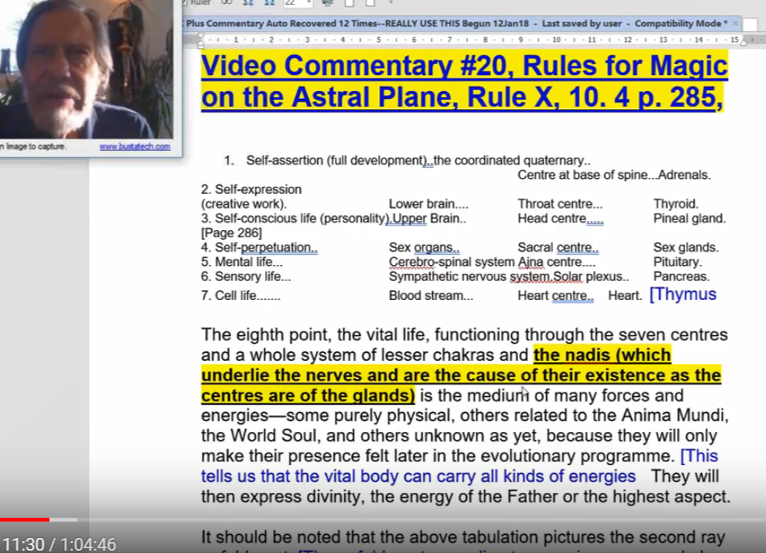

But I think the parasympathetic has more to do with the pineal gland than with the ability for soul consciousness to affect the system, and certainly the heart center is a lot more than the bloodstream and the nourishing of the cell life, but He's giving us a particular point of view.

A lot of understanding of Master DK is to figure out the point of view which He is presenting. He varies His point of view, and different points of interest, different sources, different centers, have a different function, depending upon the point of view.

I'm thinking, from one perspective, let's say the Earth is the base of the spine of the solar logos, from another perspective we might say it's connected with the mental unit. Certainly its symbolism is the same, interestingly enough. And there's a kind of a splenic connection with the earth and therefore in the structure and functioning and physiology of the solar logos, the earth has its place there, and of course in terms of form creating, it has its place in relation to the sacral center.

So every … principal expressing itself through the solar logos may involve as much as three chakras, for each principal. When you take a look at the base of the spine, you find out interestingly that not only is Earth involved, but Pluto is involved, and Mercury is involved. There are other ways in which we could look at Saturn and even Uranus, but I certainly think Mars is involved. So, what do we have there? We have Earth-Pluto-Mars though three and Mercury as the Kundalini active whereas Mars is considered kundalini latent.

So, we're presented with a picture of great relativity and we have to keep our mind flexible, not to lock in a particular center, chakra, source, area of the anatomy, etc. not to lock it in to one function only. This is shown even in the disciple.

Let's say that the Sun, or a non-sacred planet veiled by the Sun, rules the heart center for the average individual. But Jupiter carries on that function for the disciple, and in probably for the initiate.

See page 517 of Esoteric Astrology, we have the same factor with the throat center, where earth is the usual ruler. Then along comes Saturn and then at a certain stage the seventh ray takes over, and we begin to speak in magical terms, and probably Uranus is somewhat involved, and certainly Mercury has a lot to do with speech and will be brought into relation to the throat center somehow.

So we have to remain flexible in our assignment of the positions of the various planets, chakra, centers, points of concentration. Because they vary according to, I think what the Tibetans call something like the law of mutability, or the law of mutation. Then you can imagine how He is able to flexibly look at all these different relationships and see how a particular point of force, point of energy, has a different function depending upon the combination that He is witnessing.

0:16:00 Well, I'm just as hopefully we would do pondering this most difficult chart, abstruse chart, and gaining more from it, as as go … it all depends on the context.

Now you see something similar happening, when you go to a A Treatise on Cosmic Fire around page 259 or 260, somewhere in there, you say, ‘well, we know what are the principles of man’, but do we? From what perspective? Do we know what are the principles? There are all these different perspectives and sometimes what we thought was an invariable principle, always found in the manifestation of the man, is eliminated and something higher or lower is inserted.

So there are the principles of man from a higher perspective, I dealt with this in the written commentaries (found on https://makara.us) or maybe a lower perspective, a more average perspective, where the principles are viewed in a different way and certain of the higher principles are not considered to be included. So read through that section, and maybe if you wish, see what I said about it in the commentaries on that particular chapter or section around page 260.

[Transcriber wondering where this is on makara http://makara.us/02tcf/commentary/s3/fcfcomment_s3s5.doc (email vsk@makara.us to confirm.)
Back to Michael:]

… Will I ever get started on today's work? That's a good question. A Treatise on Cosmic Fire that say 259 and what is the mind aspect? What's the manasic principle and so forth? Here it is made basically starting I think on page, yeah around 261, I guess the monad. The threefold triad, the egoic body and then the threefold nature, and so forth, but here's one look at the principles of man, the monad, pure spirit, the one and only.

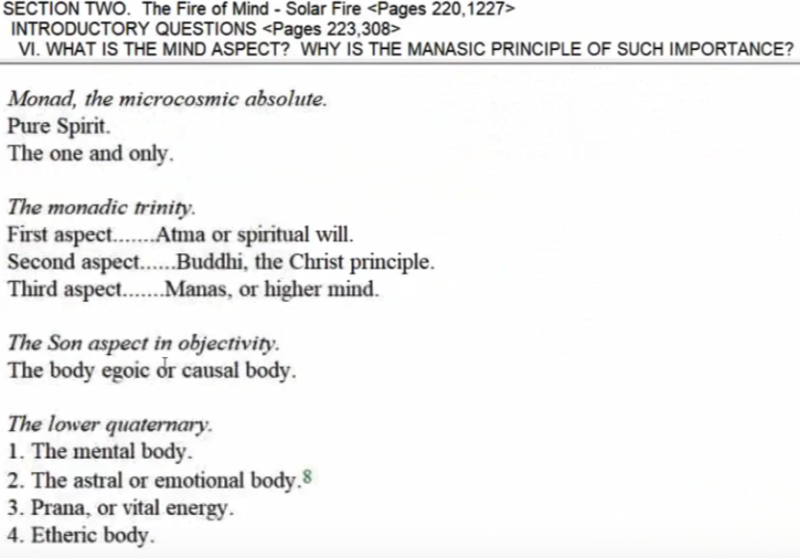

Then the monadic trinity, then the Sun aspect, and then the lower quaternary. That's one way to look at the principles, but there are other ways to look at the principles than they're given here, and there are five of them, page 262, 263.

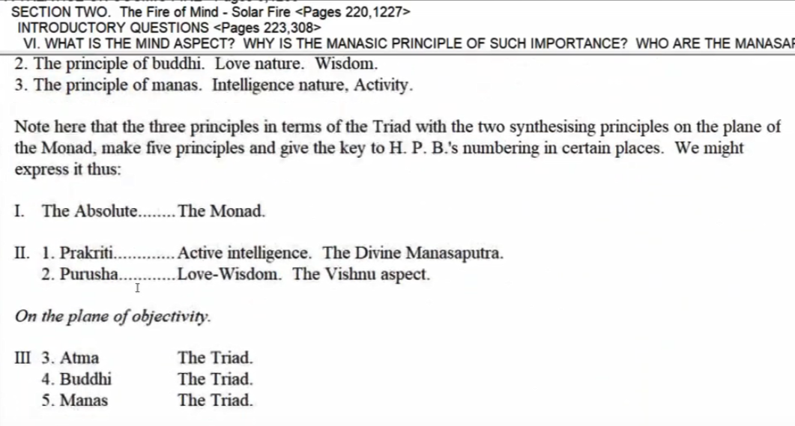

Here's something even more abstruse perhaps, and then we descend to now navigate at buddhi, they're all changing constantly.

Here's another one, which really begins with the spiritual will, or ascending from the etheric body and doesn't go any higher than atma. That's another one. Here's another more objective type of development, another presentation, which ends with the astral vehicle. It is not considering the etheric or physical at all, and all of these are the principles of man seen from different contexts. So somewhere around ten pages, this abstruse subject is dealt with and more than I could do right now off the top of my head. I have written about it, some years ago hopefully with some degree of clarity, as much clarity as I could muster at the time.

Anyway, this is all about the law of mutation and the relativity of meaning and function of any energy center or force center.

Now, maybe after twenty minutes of this, it could be time to go into the subject of the day. We did have fun with to will, to know, to dare, and to be silent. We can look at that in different ways as well, and the different centers involved for the disciple given here as the ajna center, the base of the spine, sacral center. I suppose solar plexus center somewhere, yes indeed.

So we see that not all of the higher centers are even the main concern of the disciple, but rather the mastery and control of some of these lower centers … This is our consolation, if I can put it this way, and remember we're looking at an introductory book here. This is not a book that is considered one of the later, advanced books.

0:22:00 Look at the subject matter:

I realise that the teaching given here is both deep and abstruse, but it is needed for the few, and their numbers will increase as time elapses. Remember, DK says that many, many initiates of the fifth degree will be shortly needed. So there's an intensified training at this time for people who can begin to approach such possibilities. It seems like a steep climb doesn't it?

The complexity of the subject is also increased by the fact that each ray holds within its teaching a different approach and a different method for those souls who are found responsive to its peculiar impulse. … We are speaking of the responsiveness of souls and not the action and the intelligence of personalities.

Now we get to the subject matter. I always feel it's often necessary to consider this material in what ultimately is a cursory manner, not a truly in-depth, studential manner where we would just take the time to really get into even a sentence or two and spend the whole hour doing that. So then my conscience afflicts me. Then I think well maybe there's something more that can be said that will be illuminating. Maybe that is possible, and it's only possible up to a point given the depth of the teaching.

Here we are then at commentary 21. He talks here about ray teaching is that the subject here each ray holds with His teaching a different approach … It comes to our attention as important, and a different method for those souls who are found responsive.

So this is advising how the soul is to respond to life circumstances and I've memorized these, of course, use it or lose it. I've just considered, it's so important and I've used these mantras which verge upon unity in seven different ways to induce the sense of unity in my own consciousness soon as we all know I mean we both of the day and there are moments when the unity of all things may present itself but other moments that are of a lower vibration and value where we stand within the illusion and the unity evades us.

So He says:

I give here the seven keys for each of the ray methods. These can be studied in relation to the above tabulations and in connection with the four words we have been considering. We must remember that 'To Will' is the prerogative of Spirit, 'To Know' is the function of the Soul, 'To Dare' is the duty of the personality, and 'To Be Silent' is the ultimate dharma or destiny of the matter aspect, of the animal nature in its interplay with the soul.

First Ray:—"Let the Forces come together. Let them mount to the High Place, and from that lofty eminence, let the soul look out upon a world destroyed. Then let the word go forth: 'I still persist!'"

Second Ray:—"Let all the life be drawn to the Centre, and enter thus into the Heart of Love Divine. Then from that point of sentient Life, let the soul realise the consciousness of God. Let the word go forth, reverberating through the silence: 'Naught is but Me!'"

Third Ray:—"Let the Army of the Lord, responsive to the word, cease their activities. Let knowledge end in wisdom. Let the point vibrating become the point quiescent, and all lines gather into One. Let the soul realise the One in Many and let the word go forth in perfect understanding: 'I am the Worker and the Work, the One that Is.'" TWM 288-289

I give here the seven keys for each of the ray methods. We might say methods for what? One way to look at the methods to achieve the realization of unity, or even oneness, which is beyond unity. Now if I was really being accurate I'd just say that unity and oneness, I reserve my total capital letters for that which lies beyond the universal demonstration.

So anyway these methods.

These can be studied in relation to the above tabulations and in connection with the four words we have been considering. Well, He gives us a real project, you can almost feel that student X in the new esoteric schools, this is your assignment: study the following seven stanzas in relation to the eightfold sevenfold eightfold tabulations here, given and in relation to the will to know to dare and to be silent. that would be quite a research paper wouldn't it? So these can be studied in relation to the above tabulations and in connection with the four words we have been considering

We must remember that 'To Will' is the prerogative of Spirit, yes and indeed this is to be emphasized the prerogative of spirits monad 'To Know' is the function of the Soul, 'To Dare' is the duty of the personality, and 'To Be Silent' is the ultimate dharma or destiny of the matter aspect, of the animal nature in its interplay with the soul. Well that's just perfect, and I knew how it is, what do we call it something like cryptonesia or where use and sort of memorize something, you don't know where you got it from, but there it is in your consciousness and I can see that this particular paragraph, or section, made quite an impact upon me, as I tried to associate before activities: to will to know to dare to be silent with different aspects of the man: the will of the monad or spirit to know, the soul or consciousness, to dare the personality but the personality the kind of daring we're talking about personality wouldn't undertake that daring unless guided by higher principles, and then to be silent the fate of Dharma or duty of the matter aspect the lunar vehicles of the animal nature of the man and we all have them and their interplay with the soul.

The idea here is let the soul control, and the matter aspects, the personality, remain the essence and obedient to obey, silent obedience.

Now it's my impression, I've done some work on these seven, and that maybe since they appear in various places, I wish I could locate them right now, there may have already been some commentary work done here, but let's go on in the context [repeating:]

First Ray:—"Let the Forces come together. Let them mount to the High Place, and from that lofty eminence, let the soul look out upon a world destroyed. Then let the word go forth: 'I still persist!'"

First Ray:—"Let the Forces come together.

0:30:45 There's a great factor of centralization here for the first ray.

Let them mount to the High Place, which I suppose is actually in a way anatomical. Where would it be? Head center perhaps or soul consciousness? But anyway we're not looking out through some lesser force center of the mechanism we're looking out from a center which is lofty and gives us a very high perspective on what's happening. Let them mount to the High Place which may well be the center of the head center, or even eventually the jewel in the lotus. Let's just limit this at first to the soul consciousness, but we might find in fact that we could carry it even further but

Let them mount to the High Place and from that lofty eminence, let the soul look out upon a world destroyed. So is this about soul consciousness, about soul … Let the soul look out upon a world destroyed, and all attachments are gone. Attachments to the personality, and maybe even to the causal body.

Then let the word go forth: This is the word of the true consciousness, I, the true I consciousness, the true being` 'I still persist!'" The true being consciousness still persists, even though the attachments to the personality and its worlds, the attachment to the personality, and to the content of the causal body, has vanished.

I guess we can interpret some of these mantras, great statements at various levels. So there's the centralization factor. I'm going to just write that word because it's important, that's such a first ray word. So the forces are coming together and are elevated, they're being carried up into a relative heaven. Heavens are relative, there are a number of them. St. Paul talked about a seventh heaven, right? As it was reflected in the third, and the third heaven really has a lot to do I think with a higher mental plane, not with devachan so much..

Let the forces come together. Let them mount to the High Place, and from that lofty eminence, let the soul look out upon a world destroyed. So what persists? A supra-personal consciousness and being, that persists. So it's not that the personality persists at all, it's that the real man, the person. I still persist.

Well you first ray souls, you read this to yourself, and you can memorize it, and you can practice drawing all the energies of your etheric system to a high place, and even all the energies of the personality to a high place. Your consciousness is drawn to a high place and it looks out upon the personality. Maybe from a certain perspective, even looks out upon what we normally call that limitation of soul consciousness, the consciousness within the causal body and egoic lotus. That is a limitation upon soul consciousness, because the true ego is the spiritual triad, and if we look at maybe totally capitalized EGO, we're gonna find the monad there, because it is being within an egg, the world egg in the microcosmic sense.

I'll read it again: Let the forces come together. Let them mount to the High Place, and from that lofty eminence, let the soul look out upon a world destroyed. Then let the word go forth, ‘I still persist’.

What is speaking? Let's just say the true higher man or higher being is enunciated. The word. So we have to learn the difference between thinking and speaking as a personality, thinking and speaking as the soul in incarnation, and thinking and speaking as a consciousness, which has been abstracted from its personal prison.

0:37:20 Anyway, how would we link this to – to will, to know, to dare, and to be silent. Well I won't undertake that now, we could do it. Maybe I'll reserve it for the future when, as I intend, to be a student at one of these one of these esoteric schools, I'll have to undertake that linking. But meanwhile just to say, that it can be interpreted in this way, we can lay out before us.

Let's go up here, and I'll show you what I mean, we can lay out these eight, cell life, sensory life, mental life, vital life, and then everything related to the self consciousness, self expression, self perpetuation, self-assertion.

1. Cell life | Blood stream | Heart centre | Thymus gland.
2. Sensory life | Sympathetic nervous system | Solar plexus centre | Pancreas.
3. Mental life | Cerebro-spinal system | Ajna centre | Pituitary body.
4. Vital life | Seven centres |  | Spleen.
…
5. Self-conscious | upper brain | Head centre | Pineal gland.
6. Self-expression | lower brain | Throat centre | Thyroid.
7. Self-perpetuation | sex organs | Sacral centre | Reproductive organs.
8. Self-assertion | entire man | Centre at base of spine | Adrenals.

We can lay out those eight, and we can lay out these seven: self-assertion, self expression, self conscious, life self perpetuation, mental life, sensory life, and cell life.

1. Self-assertion (full development)..the coordinated quaternary..Centre at base of spine...Adrenals.
2. Self-expression (creative work)..Lower brain....Throat centre...Thyroid.
3. Self-conscious life (personality)..Upper Brain..Head centre.....Pineal gland.
4. Self-perpetuation..Sex organs..Sacral centre..Sex glands.
5. Mental life...Cerebro-spinal system..Ajna centre....Pituitary.
6. Sensory life...Sympathetic nervous system...Solar plexus..Pancreas.
7. Cell life........Blood stream...Heart centre..Heart. TWM 284

And we can lay out to will to dare to know and to be silent.

Then we can start comparing these wonderful evocative stanzas which induce in us, I would say, those higher states of realization if we can but understand what we're saying, and we can make the correlations to do that.

I would have to diverge and digress, well it’s not really a digression, I'm tempted of course, if a random thought comes to me about how to relate things,I will. But remember, we're controlling everything from the point of the self assertion of the Spirit, and the mantram is the final mantram in each one of the statements is like a word of power, and it is spoken from the perspective a very high perspective which is abstracted from imprisonment within the personality.

Well, for myself, being a second ray soul, I like this next one very much, and I practice with it very much, especially the second ray mantram in it, the final sattement.

Second Ray:—"Let all the life be drawn to the Centre, and enter thus into the Heart of Love Divine. Then from that point of sentient Life, let the soul realise the consciousness of God. Let the word go forth, reverberating through the silence: 'Naught is but Me!'"

"Let all the life be drawn to the Centre see, somehow there is this ingathering for all of these, so that let’s say you almost always find an ingathering of many diverse and even scattered forces to a center of power along a particular ray line so that all the life be drawn to the Center. It's a heart center, really but then the soul is a heart and strangely the monad on the second plane has a kind of a heart center function as well. …

0:42:20 Here's the egoic lotus:

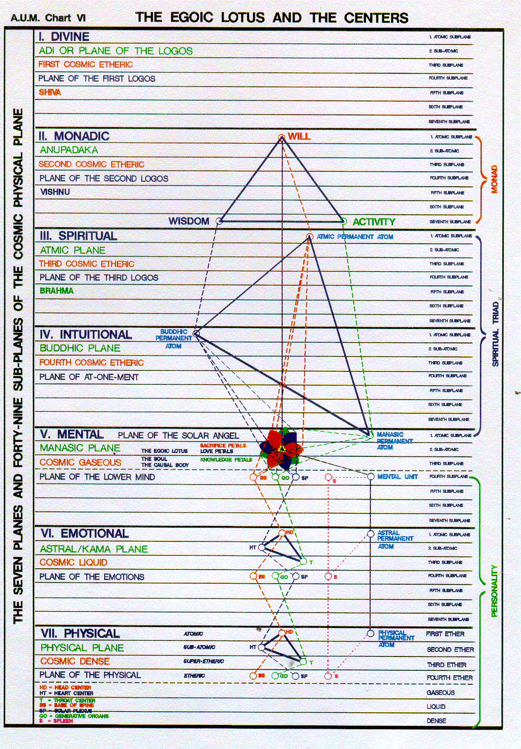

What you notice is that the heart centre, the etheric is found on the second subplane, so you would expect to find a head heart throat triangle on the first three sub planes. Well these are systemic sub planes.

But now let's look at the cosmic subplanes, number one, number two, number three.

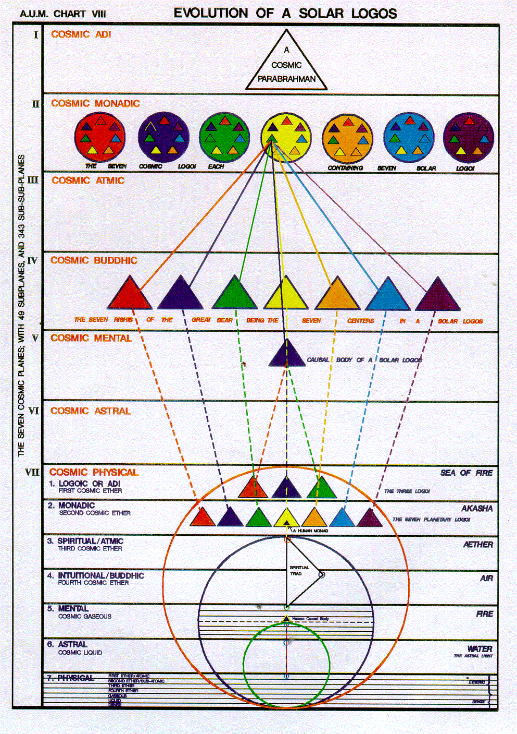

So this whole monadic plane is associated with the heart. The monad carries a kind of second ray function as well as a first ray function. I guess when the true monad is released into the logoic plane.

The true and released monad is the volatile essence, the flying essence, released without a vehicle or with at least without its usual temple ,into the sea of fire. Then what happens? I don't know, but it's likely that one of three circles takes over, or three triangles and that becomes in a way the new vehicle for the monad, ultimately a first, second, or third ray monad. But there is a definitely liberation and it's on this logoic plane that the first ray function of the monad would manifest most powerfully, and there's a heart function like a second subray for the monad, all seven types of vehicles or seven types of Temples of Ezekiel, right?

—"Let all the life be drawn to the Centre is that the soul? Is it the monad and enter thus into the Heart of Love Divine. And the soul in the egoic lotus is considered the heart center of the monad. Then from that point of sentient Life,

So, now we're relating to feeling. We remember how the solar plexus was ruling the sympathetic nervous system, and the solar plexus is the second center out of the lower three: base of the spine, solar plexus, and then sacral, you kind of skip one from the base, first ray, and the solar plexus second ray and then down to the sacral center, third ray. At least they're associated with the three major principles in that way although they have other rays we can consider in relation to those centres.

0:45:50 So, we're dealing with sentience, sensitivity, responsiveness, consciousness, feeling, let the soul realise the consciousness of God. That's the key: it's not just the power of God, not just the livingness of God, the persistence of the immortal factor, but the consciousness of the immortal factor and let the word go forth, reverberating through the silence and that's a hint, because the silence will reveal if you've ever tried it in the silence the forces gather.

Let the word go forth, reverberating through the silence: 'Naught is but Me!' This is the Me which includes all things, and Naught remains, which is not included.

So, whether you're looking at a high form of life, or a low form of life, or something that you hardly consider to be life at all, Naught is but Me. This can be practiced, use that mantram, and look around you, focus on anything; if it's there, if you're perceiving it, it's in a state of isness. It is because you can not perceive a negation, you cannot perceive that which is not, and because it is included in everything. In other words it is not ejected, it is not cast out, it is part of the Everything, and there is it, this naught includes that everything. So if it can be registered in your perception, it is you. What a statement, right? If it can be registered in your perception, and so many things that are not registered in our perception are ‘we’, I, as well. It is you,

Let me read it again, because in the reading without stopping for elaboration more may come.

Second Ray:—"Let all the life be drawn to the Centre, and enter thus into the Heart of Love Divine. Then from that point of sentient Life, let the soul realise the consciousness of God. Let the word go forth, reverberating through the silence: 'Naught is but Me!'" You can really ponder that, word for word, phrase by phrase, line by line, and it will give more and more as we bring it in to our selves.

Now, this is especially for second ray souls, but I would think that if you're a second ray monad, this type of contemplation could also be effective. So work on this one, particularly because Master DK, as a second ray master will gather His serious students from among those who have the soul ray on the second ray, or the monadic ray on the second ray, and if the soul ray is on the second ray then there's a part of the spiritual triad which is very strongly on the second ray.

As well, because the spiritual triad is the truer soul, let us say, I can't say it's the only soul because soul is consciousness whatever the vehicle may be, and extends all the way – monad has soul and also even the great One Life has its universal consciousness which can be considered the soul.

But I still persist for the first ray. It is such a powerful mantram to keep the life aspect life and consciousness aspect going, and Naught is but Me for the second ray, which is all about identification with every single perception that you can possibly have.

… it's so important these seven techniques for the different types of souls.

0:52:40 So this is the third ray, relating to the third ray soul or the third ray above.

Third Ray:—"Let the Army of the Lord, responsive to the word, cease their activities. Let knowledge end in wisdom. Let the point vibrating become the point quiescent, and all lines gather into One. Let the soul realise the One in Many and let the word go forth in perfect understanding: 'I am the Worker and the Work, the One that Is.'"

Third Ray:—"Let the Army of the Lord, responsive to the word, cease their activities. So there again, the silence. Because so much is accomplished in the silence.

Let knowledge end in wisdom. There is a difference of course. Venus is that planet was which is particularly good at transforming knowledge into wisdom, and here again we have the quiescence, the lack of activity which the third ray types so much needs because the third ray abuses activity and lets activity veil reality.

Let the point vibrating become the point quiescent, So remember, that one of those words for the third ray, the integrative word for the third ray is stillness, and all lines gather into one and and all lines gather into One. In other words, we're dealing with the many, and the one the one and the many, and people who are on the third ray. They're so aware of the many, but they have to learn how to solve this of the many and convert the many into one, that the point vibrating become the point free essent and all lines gather into one, it's a bit like what was going on for the second ray.

Let's see if I can look at that there that all the life will be drawn to the center. There's this constant in gathering and I just want to say for all of these, note the factor of ingathering in all of these powerful statements.

We are in ray three.

Let the soul realise the One in Many and let the word go forth Again this is a higher word, this is not any kind of personal word … or say a higher word … in perfect understanding: So we have a sequence here, we have knowledge, leading to wisdom and perfect understanding.

In the beginning of a Glamour a World Problem. He does deal with the contrast between wisdom and understanding, somehow understanding is a linking factor between wisdom and knowledge, and here is this final mantram, which we look for in each case, and which souls on these rays should particularly meditate upon.

'I am the Worker and the Work, the One that Is.'" I am both. So I am the one and the many, the one that is. All of these … are what are called words of power, lead to oneness, to the realization of the one.

Maybe it's particularly difficult for the third ray type to realize the one, because they are so overcome with diversity, the outer form. We're supposed to, on the third ray, not rush from point to point or be deluded by the outer forms, and that's difficult for the materialistic third ray type. Basically materialism is a state of consciousness. But always we return to the one, and in this case the solution of the one and the many is the key striving for this type of soul, and maybe even this can be applied to the monad.

So, let me read this again and then I think that's all I have time for in this particular program.

Third Ray:—"Let the Army of the Lord, responsive to the word, cease their activities. Let knowledge end in wisdom. Let the point vibrating become the point quiescent, and all lines gather into One. Let the soul realise the One in Many and let the word go forth in perfect understanding: 'I am the Worker and the Work, the One that Is.'" TWM 288-289

—"Let the Army of the Voice, responsive to the word – now, it's going to be always a higher directing word that the Army of the Voice, responsive to the word cease their activities, because they are the builders. These are the devic builders on many different levels, with many different functions.

But actually, I've been saying the Army of the voice, but actually, interestingly, it really says the Army of the Lord. I'm so used to thinking in terms of the Army of the Voice, that I looked at that word Lord and just said Voice. Anyway, it's the same thing, that the Army of the Lord, responsive to the word, cease their activities.

So silence will reign, Let knowledge end in wisdom. Let the point vibrating become the point quiescent, and all lines gather into One. You find that as the common theme, the gathering of the forces, the gathering of the forces and streams of energy into one. This is a common theme.

I just can't resist commenting. I guess I better, I just have to read it through.

Let the soul realise the One in Many and let the word go forth in perfect understanding: The word that explains and reveals the higher consciousness, 'I am the Worker and the Work, the One that Is.'"

Now this word reveals a higher realization.

So now, I promise I'm not going to say anything, I'm just going to read it the way the Tibetan has it.

Third Ray:—"Let the Army of the Lord, responsive to the word, cease their activities. Let knowledge end in wisdom. Let the point vibrating become the point quiescent, and all lines gather into One. Let the soul realise the One in Many and let the word go forth in perfect understanding: 'I am the Worker and the Work, the One that Is.'"

All was behind the outer, we have to find the reality, and we're always so often misled by the outer, and every ray has a way of misleading those who are found upon it, but eventually we learn how really to find the reality behind the outer phenomenon.

… I guess we've only really done one page, but that's because we have this sequence of words of power, let me call them that.

This is the end of A Treatise on White Magic number 21 and it's program 10.5, page 288 to 289 … we're not any further than that, frankly, yeah that's as far as we've gotten because of this tabulation, let me call them words of power. So 288 and 289.

Then we're going to go on when we can to number 22m and it will be 10.6, and it will be from 289 to whatever, probably to only to 290, because basically we have other parts of this tabulation with which to deal.

So contemplate these paragraphs, these techniques, these ray techniques. Don't worry yet about correlating them with the eightfold and sevenfold tabulations, or necessarily with the fourfold sequence of to will, to know, to dare, and to be silent. That type of correlation can come along and just to know that there is a correlation of that nature is enough, maybe, at this point, and then if we want to get together as a group sometime, and really discuss the possible correlation. We can do that.

All right, looks like we're at the end, and we'll see you when we can. All the best, study hard and it's a great book a lot deeper than people might imagine.

We might say, ‘this is a beginning book,’ but no, it is hardly a beginning book and much of it has been broken out into still other more elaborate of books. So many books are contained within this A Treatise on White Magic book just the same way as it is so in A Treatise on Cosmic Fire.

We'll see you, all the best, bye bye.

