Abstract

Content for ATOWM Series II, Rules of Magic for the Astral Plane, Video Commentary, Program Seven, 8.1 beginning Rule VIII, TYPES OF ASTRAL FORCE, 1:02 hr.: pages 235-238.

The Rules for White Magic are given in A Treatise on Cosmic Fire and are terse and difficult to comprehend as the explanation in A Treatise on Cosmic Fire is given for initiates and should be studied and augmented with this more detailed study offered by Master DK in this volume.

Focus on alignment with the higher part of oneself and receive instruction from one’s own soul, perfecting our technique of meditation to function in the causal body on the mental plane. The magical work begins in the magician’s own life and when He makes of himself a new creation he regenerates, transmutes, transforms and transfigures His personality.

Our first work is to work on the astral plane. We should consider ourselves as average students otherwise we fall into pride and separativeness. The rule is divided into three parts: astral elements and the resulting ebb and flow; dangers of the midway spot and its opportunities; and the place where magic is wrought.

DK summarizes the previous rules. The heart, throat and eye are allied for triple service. When the astral plane is conquered, ending the ancient authority of the personality, the Agnisuryans or elementals of the astral plane are controlled and the astral plane becomes a field of service as is the case for Seed Groups: Trained Observers, Workers in the Field of Religion, and Psychologists. This marks the passage of the second initiation and the soul is released from the prison of the astral body.

The three different stages in which this works out are given: for the probationer, the accepted disciple and the initiate. The battle takes place over many lives learning to be guided by the soul in the egoic lotus and maybe by the soul in the cosmic ethers. Yet there is a culminating life in which Arjuna obeying Krishna, the soul, chooses the way of light and all the vehicles become vehicles of light aligned with divine purpose as radiatory Vulcan burnishes the shield of Mars. This program concludes on page 238 of A Treatise on White Magic.

Program 07: A Treatise on White Magic – Rules of Magic for the Astral Plane – Rule VIII 8.1 154 MB .wmv file
Video by Michael D. Robbins. 12Jul2018 / 1:02 hr.

Program 07: A Treatise on White Magic – Rules of Magic for the Astral Plane – Rule VIII 8.1 30 MB .mp3 file
Audio by Michael D. Robbins. 12Jul2018 / 1:02 hr.

Transcript

Hello friends, I'm continuing with this method, not wearing my usual gear and hopefully everything is loud and clear.

We had reached the beginning of rule 8 in A Treatise on White Magic, these video commentaries, and so this is really commentary number eight actually in this series.

Now there are on http://makara.us about 50 other programs on white magic preceding these that I'm doing, and they are on the introduction and on the rules for magic on the mental plane. The six rules.

Now we're working on, the five rules of magic for the emotional plane, and we're on with the second of those rules which is rule eight …

So, we've read rule seven, just catching up with that.

The dual forces of the plane upon which the vital power must be sought are seen the two paths face the solar angel the poles vibrates a choice confronts the one who meditates

Now, we'll get into, and I think I've done to the best of my present ability, explained my perspective on that, all I can offer is my own perspective without claiming that it is necessarily correct in all particulars, probably somewhat correct, but in all particulars I would be very hesitant to say that I had achieved that, one day, one fine day for all of us.

Now rule eight:

RULE EIGHT

The Agnisuryans respond to the sound. The waters ebb and flow. Let the magician guard himself from drowning, at the point where land and water meet. The midway spot, which is neither dry nor wet, must provide the standing place whereon his feet are set. When water, land and air meet there is the place for magic to be wrought. TWM 232

The Agnisuryans respond to the sound. The waters ebb and flow. Let the magician guard himself from drowning, at the point where land and water meet. The midway spot, which is neither dry nor wet, must provide the standing place whereon his feet are set. When water, land and air meet there is the place for magic to be wrought.

Well, deeply symbolic phrases, pictorial language, but all of it conveying inner happenings and attitudes and points of focus and timing. We'll get into that, why should it be when water, land and air meet, instead of where? but water land and air meet, and what is the difference between the point where land and water meet and this other midway spots where there is land and water, but air as well symbol of etheric energy in this case.

Types of Astral Force.
Cyclic Ebb and Flow.

So we will proceed ,and look at these types of astral force and the cyclic ebb and flow.

We realize what a work Master DK has undertaken here, and how well organized all this is for our assimilation. I must say, DK said, ‘well it will serve you for the coming generation’, that for students, but what is a generation? When I look at this material I see it like the Secret Doctrine, serving for probably hundreds of years to what does He mean by a generation?

Anyway, all of that is to be solved by us as we as we go along.

TYPES OF ASTRAL FORCE

It would be advisable for the student to read with care the commentary on this rule as given in the Treatise on Cosmic Fire. It will be noted how extremely abstruse it is and how full of almost blind occult information. This should however be studied. The word "astral plane" should also be looked up and a general idea gained as to its nature and its function as the battle-ground of the senses, and as the place from which magic is wrought. The intelligent and constructive desire of the white magician, acting under the instruction of his own soul and therefore occupied with group work, is the motivating power back of all magical phenomena. This magical work is begun in the magician's own life, extends to the world of the astral plane and from thence (when potent there) can begin to demonstrate on the physical plane and on the higher planes eventually.

We shall, therefore, take a good deal of time over this rule for it covers the immediate work and activity of the intelligent aspirant. It is the most important in the book from the standpoint of the average student. It cannot be understood where there is no soul contact, nor can the magical force of the soul work out in manifestation upon the physical plane until the meaning of its esoteric phrases has been somewhat wrought out in the inner experience of the magician.

Most true aspirants are now at the midway spot, and can either drown (and so make no further progress this life), stand and so hold the ground gained, or become true practicing magicians, efficient in white magic, which is based on love, animated by wisdom and intelligently applied to forms.

We will, therefore, divide this rule into several parts, the more easily to study it and take them up step by step, so as to grasp their application to the average life of the probationary disciple, and to gain a wise understanding of their wide implications. TWM 233-236

Types of astral force

It would be advisable for the student to read with care as always the case, He says you don't read carefully enough, to read with care, the commentary on this rule as given in the Treatise on Cosmic Fire. Now I actually have worked on that, and when I went through A Treatise on Cosmic Fire, most of it with written commentary, I included some of the A Treatise on White Magic commentary, so the two are occurring side-by-side and in fact they do emphasize different things. He's really not repeating himself.

It will be noted how extremely abstruse it is and how full of almost blind occult information. He seems to do a different thing here in A Treatise on White Magic. We remember that A Treatise on Cosmic Fire is written for initiates, and by that I'm sure He means initiative at least the third degree, but A Treatise on White Magic is not, and He elaborates more fully and in language which is not so terse and impenetrable and occult, the fuller interpretation of some of the things found in A Treatise on Cosmic Fire.

So, it's extremely abstruse. I found it that way when i was trying to say something about it, all you can do would be try to say something about these things and pull out your reasoning power in your memory and your intuition when that is possible and offer what dawns upon you. Other things will dawn upon other people and in the collection of all those dawning Zoar revelations will come increased illumination

0:07:20 Anyway,

This should however be studied. This relatively short section on A Treatise on Cosmic Fire and sectional magic it should however be studied. The word "astral plane" should also be looked up and a general idea gained as to its nature and its function as the battle-ground of the senses – I suppose our astral senses as well as the normal five, more material senses, the higher correspondences of these senses, but how will the senses in the dense physical planes be used according to our desire? So how will the dense physical senses be used according to, let's say, the nature of power? He says, the battleground of the senses, and as the place from which magic is wrought. As the place where magic is wrought. Well that's to say, in this way magic seems to be wrought in relation to a number of planes and subplanes, but there is much on the astral plane which needs to be cleared up, probably through the magical process.

The intelligent and constructive desire of the white magician, acting under the instruction of his own soul and therefore occupied with group work, is the motivating power back of all magical phenomena. Especially the phenomenon associated with the white magical process; it’s constructive, it's in line with the plan, it seeks to mobilize the energies and forces of the lower world so they adhere to the design of the plan.

Then instruction from our own soul. When we're in alignment what is that current of energy which reveals to us the right way to go in various situations and when we are confronted by choice and do we consult with that stream of energy. Do we feel it? Do we feel the presence of the solar angel projecting itself into our causal body, egoic lotus, and substand that structure, and functioning as the angel of the presence, which eventually introduces us to the presence which we are. Are these just words or do we have the experience. So everyone has to figure that out and go for the experience rather than be happy with the manipulation of words having spent a lot of time you have a lot of third ray dealing with the manipulation of words, I certainly realize the insufficiency of that particular approach.

So align, align with the higher part of oneself, and was shown that that does indeed happen. …

0:12:30 So where are we here?

The battleground. Instruction from one's own soul. Notice the line here from the mental unit seemingly to the very center of soul life which is the attenuated consciousness extended or projected down onto the higher mental plane by the monad … here is that line …

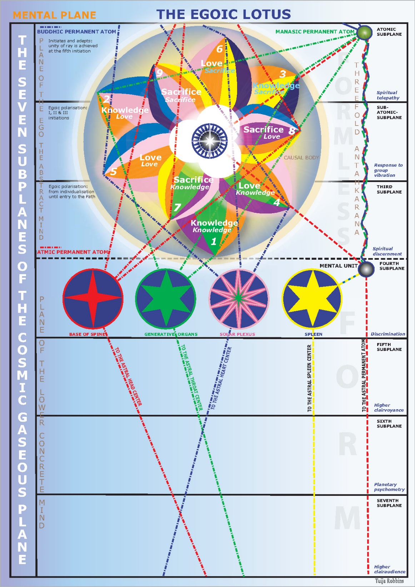

… which goes to the center of the egoic lotus, and which is generated through ordinary occult meditation. Now whether that is a dotted line or a solid line will depend on how much we have actually achieved, in not only receiving energy from that level but somehow changing our point of tension to such a degree that we are actually focused within that level, which Master DK strongly advises in regard to perfecting our meditative technique.

It impressed me so much when I long ago read Letters on Occult Meditation and saw that He was saying that we failed in our meditation because we cannot really focus with Ian the causal body upon the higher mental plane. I saw well, this is a problem, and it's a problem which has to be rectified in our studies, meditation and our attempts thus to meditate.

[repeating:]

This magical work is begun in the magician's own life, extends to the world of the astral plane and from thence (when potent there) can begin to demonstrate on the physical plane and on the higher planes eventually. We shall, therefore, take a good deal of time over this rule for it covers the immediate work and activity of the intelligent aspirant. It is the most important in the book from the standpoint of the average student. It cannot be understood where there is no soul contact, nor can the magical force of the soul work out in manifestation upon the physical plane until the meaning of its esoteric phrases has been somewhat wrought out in the inner experience of the magician.

Most true aspirants are now at the midway spot, and can either drown (and so make no further progress this life), stand and so hold the ground gained, or become true practicing magicians, efficient in white magic, which is based on love, animated by wisdom and intelligently applied to forms.

We will, therefore, divide this rule into several parts, the more easily to study it and take them up step by step, so as to grasp their application to the average life of the probationary disciple, and to gain a wise understanding of their wide implications. TWM 235-236

This magical work is begun in the magician's own life, so He makes of himself a new creation. He regenerates, transmutes, transforms and transfigures the substance and the vehicles of His personality nature. So it be it's begun in His own life, extends to the world of the astral plane and those who are working with thee glamour meditations. We know that our work is with the triple beam of light projected onto the astral plane. We have a lot of work to do there and from thence (when potent there) can begin to demonstrate on the physical plane and on the higher planes eventually.

But it looks like our first work is in relation to the astral plane, then changes later can occur on the physical plane, and still later He becomes a worker in magic upon the higher planes.

Well, we're beginners here. In another few hundred years, I think Master DK will reveal some of the practical formulas which are involved in working the practical white magic. On the other hand He says if we really study in all of this carefully academically we will be in a much better position to absorb that kind of instruction when it is given. We may feel we are delayed by having to deal with the academic material and we actually want to get in there and do something. I mean one can hold off too long and just stay in academia, or one can plunge in too quickly, and not have the academic foundation again the noble middle path will be required of us.

We shall, therefore, take a good deal of time over this rule for it covers the immediate work and activity of the intelligent aspirant. Of that is for whom He is writing.

017:30 So much of this kind of work is written for initiates of the first degree. He does tell us that's the case, certainly with Esoteric Psychology I think, but He doesn't really say that when it comes to the Rays and the Initiations, which carry forward a kind of group work for the Aquarian age which produces the initiate group.

It is the most important in the book from the standpoint of the average student. Let's consider ourselves, all of us, as average, because if we don't we will be guilty of pride and separatism and so forth, so let's consider ourselves to be the average student and this rule eight is the most important in the book. Now He knows the fifteen rules of magic and He could look ahead and have in His mind what He would say and probably with that prognostication, He's still saying that from our point of view the point of view of the average student of this book this is the most important rule.

It cannot be understood where there is no soul contact, nor can the magical force of the soul work out in manifestation upon the physical plane until the meaning of its esoteric phrases has been somewhat wrought out in the inner experience of the magician. So, requirements are, our soul contact and inner experience of that which the esoteric phrases of this rule suggest. It is quite an adventure, some of us are older students and we've been with this a long time, and maybe we seized upon this book early in our work with the Bailey material. I know I did, and I'm always just getting more and more out of it as I carefully read and that's what I'm trying to do with you in this kind of a study group experiment, carefully read and offer thoughts which may be useful when added to your own thoughts arising from your own reading and interpretation of the material most true aspirants

Now there we go , initiates of the first three, every true aspirant is an initiate of the first degree.

Most true aspirants are now at the midway spot -- well what does He call it here actually the midway at the point He hosts at the point where land and water meet.

Now the midway spot seems to involve air as well. Does this mean the point where land and water meet or the dirac area surrounding the any of that because there's a lot of drowning to be done at that point where land and water meet, – and can either drown (and so make no further progress this life) --, in a way drowning has a technical meaning and it can be fatal life or it can mean just being overcome and engulfed by emotion, they control the body of emotion for the waves that rise upon the stormy seas of life engulf the swimmer shut out the Sun and render all plans futile.

0:22:30 Go to page 473 of this book and you'll find 15 counsels which will make of you the counsels and if you've properly followed there, it is control the body of emotion for the waves that rise upon the stormy seas of life engulf the swimmer shut off the Sun and render all plans futile. So memorize those counsels and apply them right.

So he can drown and make no further progress in His life because overcome by emotion with all of its distortions and being cut off from the illumination of the mind, he'll steady in the light or He can stand and so hold the ground gained at least that, or become true practicing magicians, efficient in white magic third-ray seven-three efficiency, which is based on love because it's the white magic of the soul and the soul was the love principle animated by wisdom, love wisdom is the factor connected with this second principle, animated by wisdom and intelligently applied to forms.

So we have three choices: go backwards (and this is a type of drowning maybe not the technical type of drowning that kills you for that incarnation), hold the ground gained, or go forward and become the true white magician.

We will, therefore, divide this rule into several parts, the more easily to study it and take them up step by step, Master DK knows our assimilation process. Sometimes when I'm correlating all these things I know it's not ideal for the assimilation process, but at least I set out a picture of connections which may be more sequentially studied piece by piece, and bit by bit. the more easily to study it and take them up step by step so as to grasp their application to the average life of the probationary disciple

Now, who is the probationary disciple? Maybe, well, it's even the true aspirant, the probationary disciple exists before the first initiation but for those who are purists in assessment. He is still a probationary disciple until you accept the disciple.

But on the other hand, were always on probation, were always being tested and who is the disciple who was not being tested. So in a way although the technical term applies to an early stage upon the path and no matter where we stand we're all probationary disciples or probationary initiates who are necessarily disciples

, and to gain a wise understanding of their wide implications.

so we want to grasp the various parts of this rule, and their application to the average life of the probationary disciple.

It’s always wiser to underestimate one's accomplishments because as He says, the beginner is always more conceited, the beginner is always more conceited overestimating himself, we joke and say subtract 1, subtract 2, and you estimate where you stand.

So we want to gain the wires understanding of their wide implications and implications it's an interesting word, it said this word implications is a bridging, connective, Mercurian word … making bridges between things, energies, sources, that we did not know were connected and when the connecting occurs we see a much more unified picture so.

These three divisions are:

1. The response of the astral elementals and the consequent ebb and flow of the waters.
2. The dangers of the midway spot, its nature and the opportunity it affords.
3. The place where magic is wrought.

We will study now the first point which is summed up for us in the words:

"The Agnisuryans respond to the sound. The waters ebb and flow."

The situation might be stated in the following terse statements. The rules already studied convey the truth anent the magician.

1. The soul has communicated with his instrument in the three worlds.
2. The man on the physical plane recognises the contact, and the light in the head shines forth, sometimes recognised and sometimes unrecognised by the aspirant.
3. The soul sounds forth its note. A thought-form is created in consonance with the unitedmeditation of the soul and the man, his instrument.
4. This thought-form, embodying the will of the ego or soul, cooperating with the personality, takes to itself a triple form, constituted of the matter of all three planes, and vitalized through the activity and by the emanations from the heart, throat and [237] ajna centres of the white magician—the soul in conjunction with its instrument.
5. The personality sheaths, each with its own individual life, feel they are losing their power and the battle between the forces of matter and the force of the soul is violently renewed.
6. This battle must be fought out on the astral plane and will decide three things:
- Whether the soul will, in any one life (for some life holds the critical stage), be the dominant factor and the personality from henceforth be the servant of the soul.
- Whether the astral plane is no longer the plane of illusion, but can become the field of service.
- Whether the man can become an active co-operator with the Hierarchy, able to create and to wield mental matter, and so work out the purposes of the Universal Mind, which are prompted by boundless and infinite love, and are the expression of the One Life. TWM 236-237

0:27:35 These three divisions are:

- The response of the astral elementals and the consequent ebb and flow of the waters. And we say, to what are they responding? To a sound uttered forth by the magician - the word of the soul which is reinforcing the word of the magician?
- The dangers of the midway spot, or point where land and water meet because it we have to watch out for spots and points right its nature and the opportunity it affords.
- The place where magic is wrought. This is the place where land and water meet, midair, and the midway spot which is neither dry nor wet must provide the standing place whereon His feet are set. That midway spot is involving the etheric brain and what some people called the cave. Perhaps overdoing the implications of that word, but definitely it is related to the cave of initiation. So many of the external symbols have to do with some sort of anatomically correct inner structure.
So this midway spot, this is the true midway spot where magic is wrought, there is the place for magic is wrought where water land and air meet when water land and air meet there is the place for magic to be wrought.

So watch His words carefully, sometimes He's extremely precise sometimes He is fluid.

We will study now the first point which is summed up for us in the words:

"The Agnisuryans respond to the sound. The waters ebb and flow." Well, agnisuryans, a type of I think unconscious deva, maybe having even more to do with the elemental life than with a conscious deva life.

The situation might be stated in the following terse statements. I love the way He summarizes things so really get a handle on things and can be clear in our studies. The agnisuryans respond to the sound the waters ebb and flow and here are some terse statements and maybe they will offer a degree of clarity to us; it's better to proceed with no rush, there is no rush, no hurry, and yet there is no time to lose.

The rules already studied convey the truth anent the magician.

1. The soul has communicated with his instrument in the three worlds. There is a high consciousness up there, and it's aware of its extension, and is supervisee, which is what we are as a personality.
2. The man on the physical plane recognises the contact How we'll recognize it? Different ways perhaps, maybe a sensation, maybe a some sort of feeling, maybe certain kinds of thoughts. the man on the physical plane recognizes the contact, and the light in the head shines forth, sometimes recognised and sometimes unrecognised by the aspirant. One can be intuitive we are gold and still not recognized re see it recognized as the phenomenon probably in the light in the head. So it depends on the quality of the brain cells He tells us, so these are ters, they are direct, they go in a way looks like rule after rule.
3. The soul sounds forth its note. A thought-form is created in consonance with the united meditation of the soul and the man, his instrument. It's a dual meditation which creates something creates something, creates a thoughtform to be materialized eventually.
4. This thought-form, embodying the will of the ego or sou,l cooperating with the personality, takes to itself a triple form, constituted of the matter of all three planes, and vitalized through the activity and by the emanations from the heart, throat and ajna centres of the white magician—the soul in conjunction with its instrument. We remember this is called heart, throat, and eye … allied for triple service.) We remember this is called heart throat … I allied for triple service.

0:35:00 So the ajna, heart throat and either white magician are engaged and the soul also in conjunction with its instrument. It is as if the soul is using the heart, throat, and eye. Remember, the motives the condition of the waters the mantras which protect the eye under steady gaze which controls. It's kind of a two-three and a one, with the eye as the first ray, throat as the third ray, heart as the second.
5. The personality sheaths, each with its own individual life, feel they are losing their power and the battle between the forces of matter let us say of the personality and the force of the soul is violently renewed. What will we call it, last ditch stand of the personality, because this time it's really going to have to relinquish its control, it is driven forth and looes its master. How was it put?
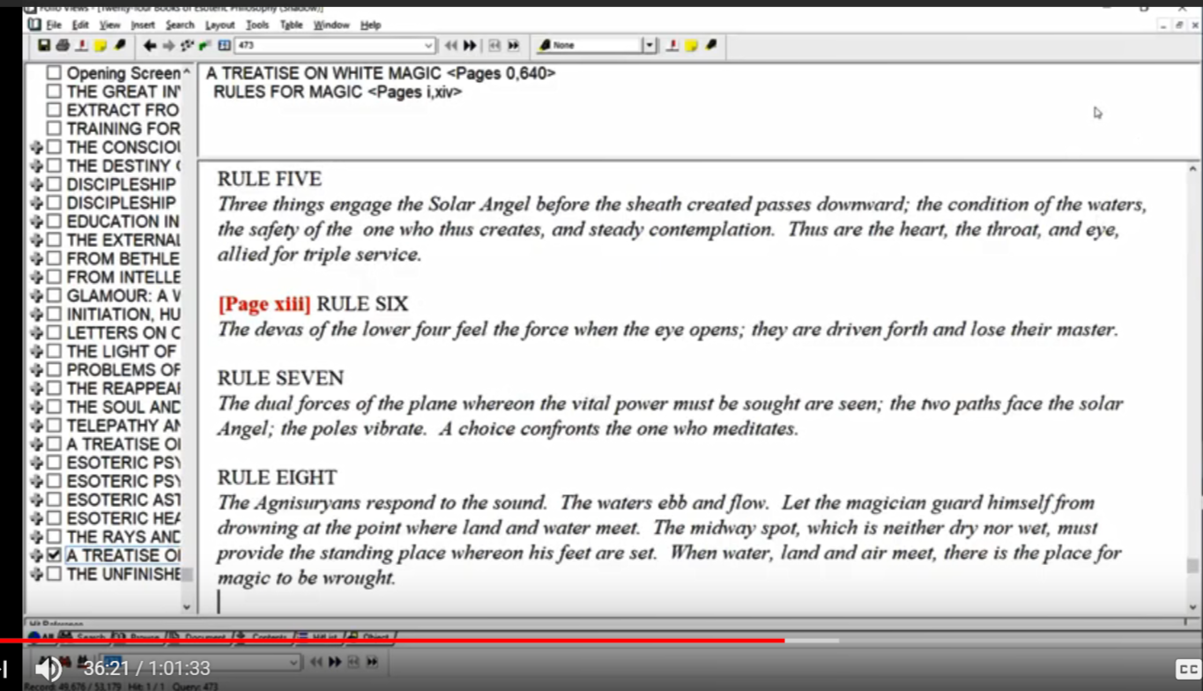

[RULE SIX]
The devas of the lower four feel the force when the eye opens; they are driven forth and lose their master.

The previous master was the personality, now a higher center is involved as the directing force it, will be the man as the soul of an incarnation and the soul through the man through the consciousness projected into the personality areas.
6. This battle must be fought out on the astral plane and will decide three things: Note those disciples who are battling. Maybe every disciple is battling, I think the battle goes on and on given the fourth ray monadic nature, or at least the focus of the human monad upon the fourth or Buddha plane when it comes to what is the monadic ray of man, one has to wonder about the first way and eventually the secondary soul and fourth ray personality. but now the fourth race whole probably and the fifth fray personality.
Anyway, man is a destroyer in many ways He is associated with Vulcan. Vulcan is an interesting planet in that it represents the constructive aspect of the first fray as well as the power hammer-like to destroy. So, This battle must be fought out on the astral plane and we'll decide three things.
a. Whether the soul will, in any one life (for some life holds the critical stage), if we could only recognize that, be the dominant factor and the personality would henceforth be the servant of the soul. we are ending the ancient authority of the personality had pointed that out in the Rays and the Initiations where you have freedom from this, freedom from that, and the third point freedom from the ancient authority of the personality. so whether the soul will be the dominant factor and the personality from henceforth be the servant of the soul. If we conserve the soul we can serve the Christ if we can serve the Christ we can serve the soul.
b. Whether the astral plane is no longer the plane of illusion, but can become the field of service. As is the case for seed groups number two, the trained observers who involve the solar plexus center and number eight, anyway, which is the psychologists, the new-age psychologist. Oh, I forgot one and that is number six the workers in the field of religion. So instead of being baffled and confused and misled and pursuing desires that lead nowhere, we can use that vehicle to express the energy of love and high desire and aspiration and we can help other people eliminate the tendency to become ensnared in the illusions of the astral plane the glamorous and illusions of the astral plane. Onward.
c. Whether the man can become an active co-operator with the Hierarchy, able to create and to wield mental matter, That's where they work, with regard to us, the Masters work upon the plane of mind and so work out the purposes of the Universal Mind Would say the mind of the solar logos, high cosmic mind of our planetary levels, which are prompted by boundless and infinite love, and are the expression of the One Life. Beautiful phrase.

So even the universal mind, we have reflections of it down here on the cosmic physical plane, but the real universal mind has to find its place on the cosmic planes, and on ever higher areas of the cosmic planes. We cannot imagine that the mind of a being that expresses through a galaxy he's on the same sort of cosmic plane, as the mind of a planetary logos or the mind of a soul of logos. Just imagine there's a trillion something solar logos through which one of these galactic beings is expressing.

There are higher and higher cosmic planes, super super super super super super, until we reach what is called by the Tibetan the ten dimensions of cosmos. Cosmos being after all, at least in my view, a finitude, and not an infinitude the only infinitude is the absolute deity which is the sort of self observation of absoluteness but again that gets into unfair avaiable factors. So these are the terse statements are there others …

0:43:30 so we've been presented in certain terse statements, from another point of view the meaning of the first six or seven rules I think, and He says,

This is the crux of the entire situation, and when the man has mastered the forces opposed to him, He is ready for the second initiation which marks the release of the soul from the prison of the astral body. Henceforth the soul will use the astral body, and mould desire into line with divine purpose.

It is of value for the student to know where He stands and what his particular problem is. The average man is learning the control of the physical body and the organizing of his physical plane life. The student on the probationary path is learning a similar lesson in relation to his astral body, its focus, its desires and its work. The student on the path of accepted discipleship has to demonstrate this control and begin to discipline the mind nature and so function consciously in the mental body. The work of the initiate and the adept grows out of these achievements and they need not be dealt with here.

The battle is spread over quite a series of lives, but in some one life it becomes critical; the final stand is made and Arjuna triumphs in the fight, but only by letting Krishna assume the reins of control, by learning mind control and by the revelation of the form of God. By distinguishing between the soul and the form, and by a vision of the perfection of the glory which can radiate from the forms "indwelt by God", He learns to choose the Way of light and to see his form and all forms as custodians of the light. So He buckles down to the work of making the astral body simply a reflector of that light and by the quelling of desire, through the subjugation of the "Agnisuryans" who constitute his astral body and are the living substance of the astral plane, He learns to function as an adept on that plane, to pierce through its illusion and to see life true. TWM 237-238

This is the crux of the entire situation, and when the man has mastered the forces opposed to him, we might say, opposed to His assent in points of tension, He is ready for the second initiation which marks the release of the soul from the prison of the astral body. And so many of Master DK's students stood at this point whether in this life the next or the next. How long does it take between the first and second life, we've discussed that, sometimes it seems like many lives sometimes it seems that even one life will do, initiation see page 120.

So He is in a way kind of training us to deal with the astral body here and with the possibility of preparing for the second initiation.

Henceforth the soul will use the astral body, and mould desire into line with divine purpose. And before that, divine plan. It is different than having a battle raging all the time. Now when you have a Scorpio incarnation (being born either in Scorpio or under Scorpio Rising Sun) and when the Mars is prominent when Pluto is prominent and many square in the chart and oppositions and so forth, and then the battle will rage and the resolution of every battle into harmony is followed by another battle at least for those who are members of this 4th creative hierarchy, which we are.

0:46:00 Just pause and think you don't have to look at Star Wars and a bar experience and Star Wars to realize that there are other types of beings in our solar system and in our cosmos. They were pretty strange they're quite amusing. But here we are all together embodying or embodied consciousness embodied in this type of form and we might be in an entirely different type of form. but somehow in our descent into increasing individuality and particularity this planet this creative hierarchy and so forth have been our choice, and we look as we do and we present as we do because of the choices we have made either as a kingdom a family or maybe as individuals on our descent from identification as the one.

It is of value for the student to know where He stands and what his particular problem is. Why be blind, we can't really solve anything if we are in a state of blindness. So, clear and brave, and face what we are at least relatively, what we are in essence, of course this pure being. Which cannot really be described as anything in relative terms.

The average man is learning the control of the physical body which is you know, achieved at the first degree more or less. The control of the physical body and the organizing of his physical plane life. So goodness don't we see we see in this how important is the seventh ray.

The student on the probationary path is learning a similar lesson in relation to his astral body, its focus, its desires and its work. So we are on the path of probation, we are mastering our emotional body our etheric body.

The student on the path of accepted discipleship. He does not put the term discipleship between the path of probation and accepted discipleship. Pretty well He's saying you're on probation to be accepted until you are accepted the student on the path have accepted discipleship has to demonstrate His control and begin to has to demonstrate this control and begin to discipline the mind nature and so function consciously in the mental body. Right that's what it takes and on the path of discipleship through discipleship perhaps Mercury and Saturn - very strongly metal planets having a lot of third ray and to a degree fifth ray, concreteness, they are planets of accepted discipleship or of discipleship.

The work of the initiate and the adept grows out of these achievements and they need not be dealt with here. and involves a work within the cosmic etheric realm of the abstract mind, and the intuition, and probably the spiritual will.

I mean when we look at a mind, and there are a number of them, Einstein doesn't stand alone but when we look at a mind like that, even though He seemed to have this belief in God, and when Spinoza who was a God inspired man was a great inspiration to Einstein, I have a little book where He writes the introduction this is the Spinoza dictionary, but we've got to say that such a mind was initiated what is the level of initiation it's along the third ray and fifth ray line.

What is that level of initiation? We don't know but it has to be quite high because the intuition revealing the workings of the mind of God in the most significant manner was activated. Without that intuition or help coming from His Piscean nature and His Cancerian nature, with Neptune bringing him in attunement with the buddhic plane, he wouldn't been able to capture the visions and the thoughts which made His presentation so unique. At least at the time and many great scientists still puzzle how did He come up with that, how did He come up with? All that, well it was imagination to a degree imagination being stronger than intellect so really buddhi-manas was something that a mind like Einstein used.

Now the battle. Were involved in it.

The battle is spread over quite a series of lives, but in some one life it becomes critical and you can ask yourself, is this a Scorpionic life, as that's when you really suffer and that's when you really have to decide? You must decide anyway; the final stand is made and Arjuna triumphs in the fight in other words, we we learn to be guided by the soul within the egoic lotus.

Maybe, for some by the soul within the cosmic ethers. I still have to kind of work that out, the true position of the solar angel is difficult to determine and since it has already been to the cosmic astral plane pursuing the path to Sirius, the fourth path, it would have worked its way through the higher cosmic ethers and could ostensibly position itself through the point of tension on any one of them, but the chart that we have shows it in His fuller nature dwelling on the buddhic plane and thus a heart of fiery love.

He lets Krishna assume the reins of control, and have we done that? Have we allowed Krishna our soul another name for the Christ principle, to assume control and do we immediately obey the inner impulses of the soul one of those commands require the way obey the inner impulses of the soul, pay no attention to worldly wisdom and set an example.

Those are roughly those four demands at the end of the book.

So but only by letting Krishna assume the reins of control, by learning mind control and by the revelation of the form of God. I mean what a system we might say, seeing all things as within God.

By distinguishing between the soul and the form it's done on the fourth plane of discrimination, the fourth subplane of the mental plane, and by a vision of the perfection of the glory which can radiate from the forms "indwelt by God" so radiatory Vulcan is involved, because it burnishes the shield of Mars as we're told, that bringing the light value out of the normal Martian personality, He learns to choose the Way of light and to see his form and all forms as custodians of the light. Seeing all things within a greater life, right? Do we? Do we?

So He buckles down to the work of making the astral body simply a reflector of that light when we send that beam forth, to save a beam of discovery, is a beam of revelation, a beam of destruction. When we send it forth, we are interested increasing the light reflecting value of the astral body. that's in the glamour of meditation.

So he buckles down to the work of making the astral body simply a reflector of that light and by the quelling of desire especially that kind of desire that is aimed towards the phenomenal worlds, through the subjugation of the "Agnisuryans" who constitute his astral body and are the living substance of the astral plane and here that I think that's a a very good definition of an experience.

Remember, there are agnisuryans in relation to the Buddhic plane, and there's probably whole hierarchies of Agnisuryans, so some of them are maybe very substantial in a way, and others may become higher in their hierarchy as beings.

the subjugation of the agnisuryans who constitute His astral body and are the living substance of the astral plane. I like that because we need the definitions here of the kinds of beings that we encounter, He learns to function as an adept on that plane, to pierce through its illusion and to see life true. Instead of through a glass darkly, or distorted.

All right, well we'll go on. Not this moment, speaking symbolically the substance of the astral plane is animated by three types of divine force which when brought together produce the great illusion. Even the universe itself is compared to absoluteness the great illusion.

This is the end of A Treatise on White Magic video commentary number eight, rules for the astral plane rule eight, and we have what's called 8.1, and we are on page 238, and then we will begin here next time, and whatever that is, beginning A Treatise on White Magic commentary number nine, which will be 8.2, and the second part of it.

Well, I'm trying to work in a somewhat contemplative manner here going along fairly slowly to let the ideas sink in sometimes I speak too fast I know, and I've been thinking about that and how to slow things down so assimilation is a greater possibility. So we'll go on.

Remember that all of this is up on YouTube on Morya Federation Esoteric Education channel.
https://www.youtube.com/watch?v=JBQOinUxeeo&list=PLVFB-s6rGtNwbbHH28VCnrPk6YpQ8zXzR&index=8
There'll be a place where you can see all these rules as program one, program two, etc. in the work of the rules for the astral plane. So this is rules for the astral plane rule seven …

Friends, so we continue our studies to continue our assimilation of these matters, and we make the teaching parts of our deep understanding, so we can apply it in a true way and not just be speaking words. All right, many blessings and we'll talk to you when I can and before long. Take care.

