Abstract

Content for ATOWM Series II, Rules for Magic for the Astral Plane, Video Commentary, Program Six, 7.6 completing Rule VII, THE TWO PATHS, 0:32 hr.: pages 231-232.

The one who meditates being the soul, Arjuna, is guided by Krishna, the consciousness projected onto the personal field and as the aspirant relinquishes His point of view to the point of view of the soul on its own plane. Wherever there is duality there is a battle. The two paths and the forces upon those paths do battle with each other: the Divine Plan versus materialization. When the battle is won, the disciple becomes a white magician, an adjudicator between the polar opposites, a graduate of the school of magnetic response. The result is the bringing of order out of chaos.

The point in the square produced by the cross rises to form a pyramid and the possibility of observation and control from an elevated point. Saturn, the Lord of Karma, when one fulfills one’s karma, in the sign of balance enables the disciple to find freedom as an elder brother who is a Master. To will is the monad, to know is the soul, to dare is the personality and to be silent is the elemental nature which may not protest against the plan. Desires are rightly oriented and the motive of all activity is love which correlates with the direction of the Divine Plan in this solar system of Love and on this planet which has the Second Ray of Love Wisdom as its soul ray. With the idea of beginning Rule Eight: Types of Astral Force with the reading of the Rule, a moment of reflection is called for to consider what we are truly involved with in this esoteric study.

We are all fulfilling karma but not likely that we are fulfilling karma as in Lemuria and Atlantis at the time of the creation of the imbalance. Millions of people will be making the transition into the Kingdom of Souls and the Hall of Wisdom. The lives of relinquishment have been passed through, leading to the contemplative life and we can now go forth as true helpers and servers, practical and yet spiritually aligned. This program concludes on page 232 of A Treatise on White Magic.

Program 06: A Treatise on White Magic – Rules of Magic for the Astral Plane – Rule VII 7.6 82 MB .wmv file
Video by Michael D. Robbins. 12Jul2018 / 0:32 hr.

Program 06: A Treatise on White Magic – Rules of Magic for the Astral Plane – Rule VII 7.6 15 MB .mp3 file
Audio by Michael D. Robbins. 12Jul2018 / 0:32 hr.

Transcript

Hello friends. … I just realized we were at the end of the fifth commentary on the second part of A Treatise on White Magic 7.5 I call it, beginning 7.6, but maybe I should have just gone on, because there's so little left in the discussion of the rule. I think what I'll do is just discuss it a little bit and end, then begin with rule eight. Usually I try to have these be completely separate, but I think there's so little that it doesn't pay to do it that way.

Now, remember the rule itself:

RULE SEVEN
The dual forces on the plane (whereon the vital power must be sought) are seen; the two paths face the solar Angel; the poles vibrate. A choice confronts the one who meditates. TWM 217

RULE SEVEN. The dual forces on the plane (whereon the vital power must be sought) are seen; the two paths face the solar Angel; the poles vibrate. A choice confronts the one who meditates. We're about to look at who is this one who meditates:

The phrase "the one who meditates" relates to the soul. Arjuna, the aspiring disciple, resigns the struggle and hands the weapons and the reins of government to Krishna, the soul, and is rewarded at last by understanding and by a vision of the divine form which veils the Son of God Who is Himself.
When this battle has been fought and won the disciple steps into the ranks of the white magicians of our planet and can wield forces, cooperate with the plan, command the elementals, and bring order out of chaos. He is no longer immersed in the world illusion but has risen above it. He can no longer be held down by the chains of his own past habits and his karma. He has gained the vital power and stands forth an Elder Brother.

Such is the path ahead of each and all who dare to tread it. Such is the opportunity offered to all students who have made their choice with dispassion and are prompted by love and the desire to serve. TWM 231-232

The phrase "the one who meditates" relates to the soul. The soul of course is what we are, and we have a soul in incarnation, the solar angel on its own plane is meditating, but we as the soul in incarnation confronted with the limited environments of the vehicles of the personality are also meditating.

Arjuna, the aspiring disciple that's what we are as well, resigns the struggle and hands the weapons and the reins of government to Krishna, the soul which means that Arjuna … follows the advice, the energy streams, the direction provided by His soul contact. See always there are two meditating here, there is the soul (let’s call it) on its own plane, meditating within the causal body. There is to a certain extent the soul meditating on still higher planes, and there is the consciousness (just substitute the word consciousness for soul), there is the consciousness which is projected into the personal field all of these are aligned and all of these are meditating.

So … Arjuna decides he can no longer decide the issue and perhaps know what is right or wrong and then relinquishes His own personal point of view to the point of view of the soul on a higher plane. …

[by the way I realized that in the previous discussion I was talking about the previous universe as the green universe and I think I mistakenly used the word second ray; it was the third ray solar system. Of course sometimes solar systems are called universes, when I use that, universe, I try to have it mean a much greater system the grand entirety galaxies are called universes and so forth, but now we're talking about a previous solar system the green solar system sometimes I just I forget what I say and then only later in review do.

I realize that there's been a mistake so the green is one of the colors of the third ray, and the previous solar system could be called the system based upon the note fa, a note F which is considered here in the occult assignment of colors two notes, it's considered a third-ray note and our presence of a system on the second ray is correlated with the note sold or in the first soul it's a blue note, and we are the system of the blue logos just to straighten that out and if you notice that I made that mistake.]

… the aspiring disciple that we all are resigns the struggle and hands the weapons and reins of government the control of His personality faculties, the soul , and is rewarded at last by understanding and by a vision of the divine form which veils the Son of God Who is Himself. And that is, as I recall, a very beautiful moment in the Bhagavad Gita, the vision of the form of God as a grand totality.

Well, think about it, we go along through our lives and when do we finally develop that kind of perspective which is soul perspective and abstract ourselves from the usual personality concerns and the perspective which is based upon the limitations of the lunar lures, the elemental vehicles of the personality. When do we adopt the attitude that we are not only the soul in the incarnation, which is a step, but we are the soul on the mental plane type of consciousness, blended I think with monadic projected consciousness, and that, well, we are less the solar angel per se, considering that being as a separate monad.

Now really, there are no separate monads; the monad is one, there is but one monad, but there are different projections of that universal monad, which seem to be distinct in time and space and eventually they all become one being. They have to become one being. One does not sustain any individual, if you can call it that, individual monadic being from universe to universe. Eventually we all blend into the multi-faceted being which each and every one of us is that grand universal unity. But meanwhile we do seem to have different rays and to be different and to be located in different locations in the universe and certainly here in our solar system some of us are Tellurians, we belong to the earth, and others are Mercurians and Venusians and Jupiterians, and so forth, probably our origin before coming to a non-sacred planet in formation one that does not last throughout the entire mahamanvantara may have been other sacred planets and then the Sun but as monads we have origins which take us beyond the solar system and probably we began our descent from sources that were not within our particular solar logos.

Those are obscure matters and we have to straighten them out at some point, but I think we will discover that our being is at last universal being and what is that universal being but the identity of the absolute one the true origins of our identity are ultimately being obscure, but finally there is nothing but absoluteness which is homogeneous and indivisible and absolutely of one substance which is itself can we call it business certainly there's no substance of which we are aware, it is the ultimate subjectivity.

0:10:00 Finally, we are the one who meditates, and a choice confronts us, we are the soul on the mental plane and a choice confronts us, in that way we have the soul in incarnation and a choice confronts us in that way.

Now the soul on its own plane, which is a projection of the solar angel, will war furiously with an aspect of itself which is choosing incorrectly from within the personality. There are choices that we make from a limited and ignorant position, and as personalities or as projections of the soul, or really projections of the Monad ultimately, our own monad, if we can call it that. I mean those wrong decisions will send us off in the wrong direction and may even lead to our destruction in terms of our vehicles with respect to the solar system in which we are participating and we may have to start again the entire monadic quest – a very rare fate I think and one that is in terms of solar systemic development, the ultimate disaster.

Anyway, let's look at the battle because there is always point wherever there is duality, there is going to be a battle at least at first until there is a harmonized duality but the two the tendencies of the two halves and the forces upon those paths do battle with each other, and one of them represents the Divine Plan and another one represents entrapment in the material element and identification with a stage of energy-force from which one should have moved on. This recalls the old idea that evil is the good that should have been outlived.

When this battle has been fought and won the disciple steps into the ranks of the white magicians of our planet and can wield forces as the Masters can, cooperate with the plan, command the elementals not necessarily all devas, of course, some are very high, and bring order out of chaos.

This is the result of triumph in the great battle between the pairs of opposites … especially on this planet we are called adjudicators between the pairs of opposites, that is, when we graduate from the curriculum offered on this planet, as every planet is in a way a school, a planet, every school we are called adjudicators between the pairs of opposites. You'll see this if you go to … Esoteric Astrology, and you'll see the planetary schools …

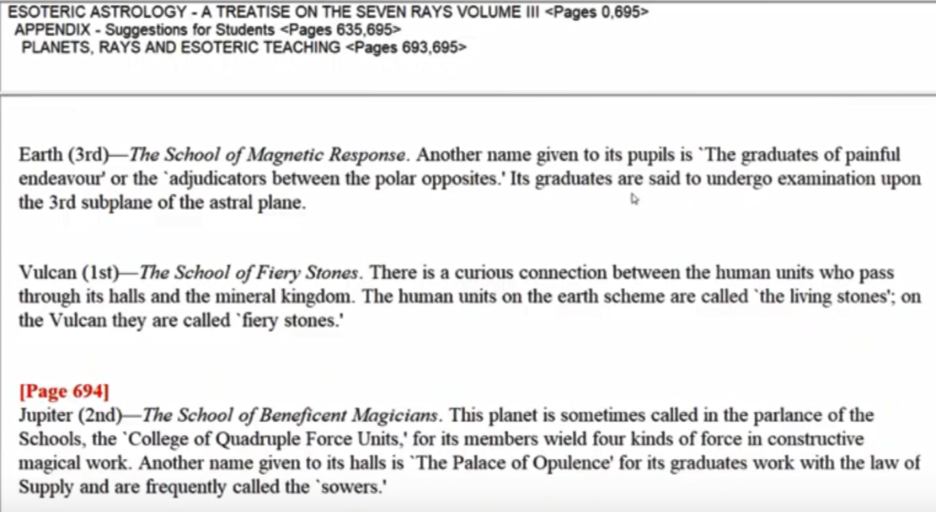

… and Earth we have The School of Magnetic Response. Another name given to its pupils is ‘The graduates of painful endeavor’ or ‘the adjudicators between the polar opposites.’ Its graduates are said to undergo examination upon the third subplane of the astral plane. It is a position which our planetary logos has not yet reached cosmically but His in process of doing so, because it's really the fifth subplane which Venus has mastered, moving on to the sixth, and our Earth is fighting it out on the fourth subplane moving towards the third, to see whether that point of relative stability can be cosmically achieved and then we as microcosmic human beings are trying to do something similar down on the systemic level.

He is no longer immersed in the world illusion but has risen above it. Notice the rising through abstraction, and the point in the square produced by the cross rises to form a pyramid and the possibility of observation and control from an elevated point.

He can no longer be held down by the chains of his own past habits and his karma. Notice Saturn, the Lord of karma, planetary Lord of karma, also is the lord of imprisonment but when one fulfills one's karma and balances it, because Saturn as well is the exalted's planet in Libra, the sign of balance, then there is freedom.

He has gained the vital power and stands forth an Elder Brother. Not just a brother, this is a brother who is a master.

Such is the path ahead of each and all who dare to tread it. So the sequence, the descending sequence that we must observe will monad or soul, let us say, to dare no to will is the monad, to dare is the personality, and to be silent is the condition of the obedient elemental nature, which is not allowed to protest against the superior plan. To protest, that is, with its usual elemental tendencies, which have been transmitted, such as the path of each and all who dare to tread it.

Such is the opportunity Saturn again offered to all students who have made their choice with dispassion and are prompted by love and the desire to serve. In other words, in terms of a larger perspective, and are prompted by love and the desire to serve.

So, desires are rightly oriented and the motive of all activity is love which correlates with the direction of the divine plan in this solar system of love, and on this planet the soul ray of which is the second ray of love-wisdom. Sounds very promising, sounds like we know what we have to do, we have to exercise our faculties of discrimination so that we choose aright, we have to be connected with that within us which knows more. Because the soul does indeed know far more of the Divine Plan than its projection within these spheres of the personality can know, and then according to what we know when subject to the soul light, and thinking in our mind held steady in that light we act with love and intelligence in the lower worlds.

These are things easy to say, but then we are challenged to do them under all sorts of circumstances and we have to recognize in every circumstance what is the right choice, because we're constantly making choices and some of these choices can seem very mundane and of little consequence but they are either a plan-aligned or they are not.

So that's rule 7 and we've had six programs on that. …

0:21:00 … So the key here again as we read it rule 7, the first of the rules for magic upon the astral plane. The dual forces of the plane upon which the vital power must be sought are seen remember how that vital power encourages the development of the third eye which has really been under process ever since the first initiation the just the way the mental unit is long being built up before it becomes truly the functional mental unit the two paths face the solar angel the poles vibrates a choice confronts the one who meditates.

There's no question about what the solar angel on its own level will do, there may be a question about the skill of the solar angel’s projection into the causal body, and there is a great question about what the projection of the angel of the presence into the material spheres. There's a greater question about what that projection will do, that's what we identify as ourselves, our individual nature, and the old statement comes up, which way do you go?

Now, Master DK speaks about the tremendously successful work of the White Lodge because so few wind up on the left hand path and even fewer making their way all the way in to bondage, becoming black magicians whose power is great but illusory and will necessarily be eradicated.

So the system of Sirius that has nurtured through initiation the sons of men, the fourth creative hierarchy, that system has been very successful on our planet, and the chances are that we're not going to veer off in that way, and those who do veer off return certainly returned sadder but wiser, and are protected in the future from such selfish choices. I've been in the atmosphere of those who were heading for such selfish choices, they followed the path of selfish occultism. You could see that the whole idea of love and true consciousness were absolutely foreign to them and they didn't know it.

So, we're very fortunate to be in the tutelage of such a great teacher as Master DK, who learned so much from His Master KH, and His ashram being directly under the Christ and being that ashram which does the most to prepare for the return of the Great Lord, the Christ. You can ask, why do we study these things? But the opportunity has been offered to receive a kind of teaching which on our own we could never originate or fathom at least at our present stages of development.

Let me kind of end this, A Treatise on White Magic video commentary (astral) number six, and rule seven, rules for the astral plane rule seven and we're calling it 7.6, and we're going to begin now as I reach the half hour points in this program. …

0:27:00 I just want us, in a moment of reflection, to realize what we're really involved with. We do live busy and demanding lives and many of us are fulfilling Karma, the origins of which we have lost or maybe are lost in the night of time. Sometimes I wonder about the fulfilment of karma, that certain types of karma are not allowed to be withheld for too long before they have to be balanced, and then new commissions occur and those imbalances cannot wait forever either to be fulfilled. I don't know what the law is there, but it would surprise me if people such as ourselves were fulfilling the karma that was generated in Lemuria or in early Atlantis; it would seem to me that in order to fulfill that kind of karma correctly you'd have to have vehicles and conditions that were closer to the mismanagement of circumstances which occurred at the time of creating the imbalance.

But here we are right at this transition time into the fifth kingdom of nature when so many, even millions of people, will be making the transition into the first stages of the fifth kingdom, the kingdom of souls and into the Hall of wisdom. It is a remarkably pivotal time, and the only thing that will really get in our way is the failure to realize the consequences of the choices that we are now making, and the failure to compare the spiritual possibilities which lie ahead with the kinds of living that ordinary non-aspiring human beings are passing through at the present moment. I don't think any of us can become again the non-aspiring human being seeking for nothing, but some sort of imagines personality fulfillment there would simply be no real sense of fulfillment at all even if the personality were elevated to a very high level of expression. He tells us that that particular type of incarnation where the personality becomes quite a magnificent thing lies behind many people such as we are and that the lives of aspiration and relinquishment have been, to a degree passed through, maybe we've spent some times in monasteries, convents, whatever, the leading of the contemplative life either in the West or in the East, and now we go forward into something even more a real effective approach to the spiritual hierarchy of the planet so that we can be a true helper and server of the race, practical and yet a deeply spiritually blind.

Okay, friends, well I think a program that's about 30 minutes in durations is okay. We'll go on to the next one when I can, I hope it's even this evening, maybe, could be, and then we'll have a true beginning a concerted beginning for rule eight.

So, all the best to everyone, and I wish you all a deep appreciation of what we have been given through the teaching of hierarchy by that messengering Master DK, the messenger of the hierarchy, or one of the major ones with His identification with Mercury and His identification with a sign Gemini bringing the higher energies into the sphere of the lower energies and allowing and exchange to occur. Right. many blessings and let's move on together, we'll see you soon. Bye, bye.

