THE RAYS AND THE INITIATIONS, PART II WEBINAR – 13, Michael Robbins

Abstract

In this thirteenth program we conclude this first section on the Way of Higher Evolution. Upon this Way, the high initiation acquires the "Key to the Sun". This idea is related to the thought that the Monad is "that which finds its home within the Sun". There are parallels between the processes of treading this Higher Way and the process of treading the normal Path of Initiation.

We then move forward into a new section on "The Entering of the Ashram". Sanat Kumara is seen as the Head of this great Planetary Ashram, and His relationship to the "Unknown God" is speculatively discussed. A great analogy is offered involving the idea that Sanat Kumara has a special relationship with the "One about Whom naught may be said", however discussion is offered on just what may be meant by the "One about Whom naught may be said". There may be many "Ones about Whom naught may be said" and this is explained with special reference to the tabulation on TCF p. 293. The selection upon which commentary is made closes with the listing of three possible unfoldments which lie before humanity when it accepts three great areas of truth involving Hierarchy, Shamballa, and the obedience of the Highest Planetary Lives to the Will of Sanat Kumara. One additional thought is suggested; it involves the explanation of 'Dimensional Distance' when considering any analogy involving the relationship of Great Lives to lesser lives.

Contents

Abstract 1
Contents 1
Transcription of Rays and Initiations, II, Program 13, pages 366-368. 1
The Entering of the Ashram 4

Transcription of Rays and Initiations, II, Program 13, pages 366-368.

Hello friends and let us continue with the Rays and Initiations Webinar Commentary on Part II of the book and we have finished Program #12 and are into Program #13 on Page 366 and we’re discussing the Way of Higher Evolution. So let us see further what is said here.

“The door into the Way of the Higher Evolution simply permits the entrance of the sensitive initiate into "spheres of intimacy" (as they are sometimes called) which are this time cosmic in their implications, planetary in their effects, and which give to the initiate what has been called the "key to the Sun"—as it conditions the solar system—just as the door to initiation gives to the aspirant the "key to the kingdom of God." RI, Page 366

The door into the Way of the Higher Evolution simply permits the entrance of the sensitive initiate… now there’s a word relating to Leo and to Sirius, the brilliant star of sensitivity, the whole Sirian regime of initiation that leads to the Way of Higher Evolution, it … simply permits the entrance of the sensitive initiate into "spheres of intimacy" (as they are sometimes called) which are this time cosmic in their implications… we always enter at initiation into a new sphere of intimacy, what was remote for us now becomes immediate and can be immediately felt and interacted with. So which gives an initiate what has been called, okay … "spheres of intimacy" (as they are sometimes called) which are this time cosmic in their implications, planetary in their effects… and this is so important … and which give to the initiate what has been called the "key to the Sun"—as it conditions the solar system—just as the door to initiation gives to the aspirant the "key to the kingdom of God. And I cannot help but remember at this point that it is said of the Monad which is the subject of these higher initiations especially as they lead onto the Way of Higher Evolution, the Monad is that which finds its home within the Sun. Now there have been some theories that one of the Ways of Higher Evolution actually leads to the Sun, into our solar Logos, but it should be considered that all of the other Paths seen to lead to distant constellations which are centers, chakras in the “One about Whom not may be said”. These chakras are composed of many Suns, they are constellational chakras. So it must be realized that our Sun is part of a cosmic Logos in which our Sun is the heart center; thus the 7 solar systems of which ours is one.

So if for any reason, one of the Paths does leads to the Sun, it is really leading to that particular cosmic Logos which manifests through what is called the 7 solar systems of which ours is one. Now there is honest difference of opinion on these matters and none of us is really qualified to assert with certainty the accuracy of such speculations. But the speculations are put there and one day a confirmation will follow. Now the kingdom of God is entered at the 1st degree and one continues in that kingdom of God, but we are talking now not about the kingdom of God, but about the kingdom of solar lives: not just the planetary lives which is the 6th Kingdom - beyond the kingdom of souls, but eventually into that great kingdom, the 7th. Every Monad has its home within the Sun no matter where else it may venture.

04:56 Now the question is speculative: must a Monad that goes forth upon a particular Path and towards a particular cosmic plane and towards a particular constellation must it in some way find its way back to our Sun? Or must it depart from our Sun? In other words, this venturing forth upon the Way of Higher Evolution, does it occur immediately or must one wait until the solar system itself is dissolved? And then, one as a Monad, would return to the Sun before the Way of Higher Evolution is trodden. There are probably many objections to that particular theory and I probably can find objections myself to that, but we have to reconcile the idea of treading the Path of the Way of Higher Evolution and going to distant constellations with the idea that the Monad is that which finds its home within the Sun. And the question is, must it return to the Sun before the solar system dissolves? Or can it break free of our solar system and go to one or other of those distant constellations? Well we don't even know how long those constellations last in manifestation with respect to our solar system, nor do we know that those different solar systems and constellations have to be in manifestation in order for the Monad to venture to them. So what I’m saying here would probably be classed in the category of useless speculation.

But there are questions which do occur. We don’t know how long these great entities are in manifestation relative to each other and some of the destinations, maybe even the Pleiades themselves, are said to manifest in far shorter duration than our own solar system. But, of course, the entity is different from its manifestation and when we're talking about Monads traveling on a Path we aren’t necessarily talking about traveling to some manifested star or constellation. The entity which is their destination is within and they are already journeying on the cosmic astral plane or even on the cosmic mental plane. So, it's not a question of whether there are externalizations in constellational or stellar form of these great entities which serve as the destination of the venturing Monad, venturing on the Way of Higher Evolution.

8:27 Anyway, key to the kingdom of God is one destination for the average initiate and then for the higher initiate, the key to the Sun. And this says something about the relationship with the solar Logos and the level of solar initiation achieved. So when actually do we receive the key to the Sun? There’s something about the 7th initiation which has much to do with the solar Logos and with the constellation Gemini. Can it be at that point that one is receiving the key to the Sun? I’m reminded also that a great Hierarchy is existing on the logoic plane and the 7th initiation is taken in relation to the logoic plane and that Hierarchy is called the Divine flames and it relates to Leo, and the Sun rules Leo.

Well these are, you know, I’m aggregating some related thoughts here, but at the same time I’m well aware that we don’t know or at least, I don’t know the actual meaning of this. It has to have to do with coming into intimacy with some aspect of the solar Logos, some level of that Logos, I suspect.

10:10 And you know there are solar Initiations which begin with the 3rd and climax with a kind of solar mastership. A kind of solar mastership is achieved at the 7th initiation. So certainly as we begin as Monads of the 6th initiation as Chohans, we have to take the 7th initiation somewhere on this higher Path. In other words, the Christ is on the ray path at the moment and I suppose taking this 7th initiation has something to do with that Path that he will eventually follow. Of course right now he’s on the Path of Earth Service. So is it possible to take the higher initiations on the Path of Earth Service? Probably it is, but at least one is treading one of the Ways or Paths when one does take the 7th initiation. Alright that’s speculative material and when the Cosmic Fire aficionados and others with a deep love of the arcana of the Ageless Wisdom can get together, they can hash this out as to the possibilities.

“We have dealt in the foregoing pages with deep matters and have touched upon topics too high for the understanding of the average student or probationary disciple; dim recognitions, based on past acceptances are, however, possible to some of you.” RI, Page 366

We have dealt in the foregoing pages with deep matters and have touched upon topics too high for the understanding of the average student or probationary disciple… Even the average student who let’s just say might be a disciple in fact, or unless the average student is the probationary disciple. Anyway I'm sure we have all felt that the matters are extremely high and beyond anything we might call confirmed comprehension … dim recognitions, based on past acceptances are, however, possible to some of you. So we accept certain statements as true and we build upon them.

“We have seen, among other things, that the so-called "door of initiation" presents obstacles whose purpose is to block entrance and to draw out the latent will of the applicant; an initiate is one who succeeds in penetrating to the further side of the door, where recognition awaits him.” RI, Page 366

13:07 We have seen, among other things, that the so-called "door of initiation" presents obstacles whose purpose is to block entrance and to draw out the latent will of the applicant… that's very interesting the … "door of initiation" presents obstacles whose purpose is to block entrance and to draw out the latent will… now what can this mean? I’ll just say following along with Master Morya, he says that “obstacles are possibilities”. So the door of initiation must indeed offer possibilities for growth by evoking the latent will of the candidate to overcome the obstacle, alright … whose purpose is to block entrance and to draw out the latent will of the applicant; an initiate is one who succeeds in penetrating to the further side of the door, where recognition awaits him. He will recognize this next dimension. Recognition may come from those on the further side of the door of initiation but also, he, the candidate, will recognize and realize the truth of that which before he only dimly sensed. It’s like changing from sight through a glass darkly to seeing face-to-face. The new types of energies which one had some sense of but could not confirm.

“We will now concern ourselves with the basic theme of the Ashram itself.” RI, Page 366

I should have actually maybe completed this in the last program but of course I’ve been trying to keep them to about an hour when I'm doing hour-long programs and this is taking 15 minutes so probably maybe it was a good idea to reserve this for Program #13.

16:04 We have been discussing the way of Higher Evolution so it has stimulated our speculative mind, our abstract mind, perhaps it has seeded that mind with some intuitions. It has raised certain questions. We have to realize certainly that we as a personality are not traveling upon that Path nor are we as a unit of consciousness which is confined to the higher mental plane, we as a life, a unit of life, a Monad, and maybe I would suspect a unit of life divested of the monadic vehicle, are traveling that Path. So until the 6th initiation is a reality in our lives and well you know, that could be thousands of years, we cannot speak authoritatively of the Way of Higher Evolution, but D.K. is giving this vision to us to promote the higher correspondence to aspiration. Well aspiration is still there of course but the higher correspondence is this kind of reflective higher thought which involves buddhi-manas and which expands the abstract mind and accesses the intuition and generally proves the antahkarana fruitful.

So he's giving all of this to us so that we have a destiny. Monadic destiny is a term often used in the teaching and the true destiny of what we are is the destiny of what we are as a Monad, as a unit of life, an emanated unit of life at various degrees of procritic immersion or immersion in matter and ever lessening degrees of procritic immersion. We are retracing our steps along the Path by which we emanated along which we descended when being descends to manifest as it says in the six trumpeted words of DINA II Page 285.

18:40 So we are retracing our steps as a Monad and we are divesting ourselves of one vehicle after another so we can travel freely on the Way of Higher Evolution; of course bound by certain constraints which are part of the Path we have chosen. So you know, we’re still along a certain line until we eventually reach the universal Logos and rebecome one, with and as the universal Logos, we will always be traveling along a certain line of attribute or aspect, along a certain division of a greater reality.

Well anyway, let’s hope that we are inspired to think far ahead about what Path we as a Monad might travel. We may have some kind of intuition about that. Of course we have so many immediate things to handle on a much more humble level. Many of us have to learn how to control our astral body, have to learn to rid ourselves of the fragmentation which is illusion, simply of a wrong thought. We have to learn how to contact that greater and wider Love which will eventuate in the destruction of the causal body. We have to learn how to focus ourselves within the Spiritual Triad and become an aspect of the planetary Logos in expression. And all of this before we can possibly think of treading the Way of Higher Evolution, but such is the incredible reach of the Tibetan’s thinking and his presentation that he just offers visions to us which we could not possibly conceive under ordinary circumstances by ourselves. I mean you know, you just have to look at the types of speculation that are involved in philosophy per se. Philosophy demonstrates the need for philosophical occultism and for factual occultism but is not that occultism. It simply leads towards an understanding that knowledge of these inner worlds and in detail is necessary for true advancement and growth of the unit of life out of particular levels of procritic immersion. We’re going to learn how to widen our rings-pass-not, the plural of ring-pass-not.

22:00 Okay well let’s get into this important subject that we’re going to call ‘The Entering of the Ashram’ and it looks like a long section going almost 70 pages, maybe 65 pages.

The Entering of the Ashram

“THE ENTERING OF THE ASHRAM
This theme necessarily has great interest for all aspirants and would-be disciples, but I am not at first going to deal with the subject from the angle of humanity and its effort to establish contact with the Ashram.” RI, Page 366

This theme necessarily has great interest for all aspirants and would-be disciples… okay especially when we are rather self-centered and view the world anthropomorphically, according to the nature of man. But you know, D.K. is going to in a way disappoint us, at least disappoint those who are looking for the particular microcosmic approach to the subject. He says…but I am not at first going to deal with the subject from the angle of humanity… maybe he will again later. He’s already dealt with it quite a bit … and its effort to establish contact with the Ashram. He is going to deal with this differently. So maybe if you've already done some work in his books and in Discipleship in the New Age, Volume I, the beginning of the book, the end of the book and some of Volume II, you are prepared then to study the type of presentation Master D.K. is going to give.

I desire first of all to speak of the Ashram as a whole, constituted of many Ashrams and creating an "invoking area" of relationship for the supreme Head of the Ashram, Sanat Kumara, the Lord of the World.” RI, Page 366

I desire first of all to speak of the Ashram as a whole, constituted of many Ashrams and creating an "invoking area" of relationship for the supreme Head of the Ashram, Sanat Kumara, the Lord of the World. … an "invoking area" of relationship … obviously, Sanat Kumara is being called upon, yes he is being called upon and he is invoking as well the response of those who are gathered in the greater Ashram. We are speaking of the greater Ashram. So, this is the Greater Ashram consisting of all ray ashrams and their sevenfold divisions; 49-fold Ashram of Sanat Kumara and he can call forth response from those who are members of these Ashrams and they can invoke him. So it’s the relationship between the Great Lord, Sanat Kumara, and those who are aspiring towards further and more intimate relationship with him.

“I seek to enter into no discussion of this leading Life of our entire planet.” RI, Page 366

25:25 He who is an aspect or emanation of our planetary Logos and sometimes called the planetary Logos himself.

“HE is to a still greater Being, the One referred to elsewhere as "the One about Whom naught may be said," what the vehicle of a Master in physical incarnation is to Him, and on a less accurate basis, what your personality is to you…” RI, Page 366

Now we might say here, okay which one of ‘The Ones about Whom naught may be said’ are we discussing? Are we talking about the super constellational Logos that has its center, I would say within the Pleiades? Or are we talking about the Lord of the 7 solar systems of which ours is one? We could call that cosmic Logos a kind of ‘One about Whom naught may be said’.

I were to go to page… I hope I remember the page number if I go to A Treatise on Cosmic Fire and go to Page 293:

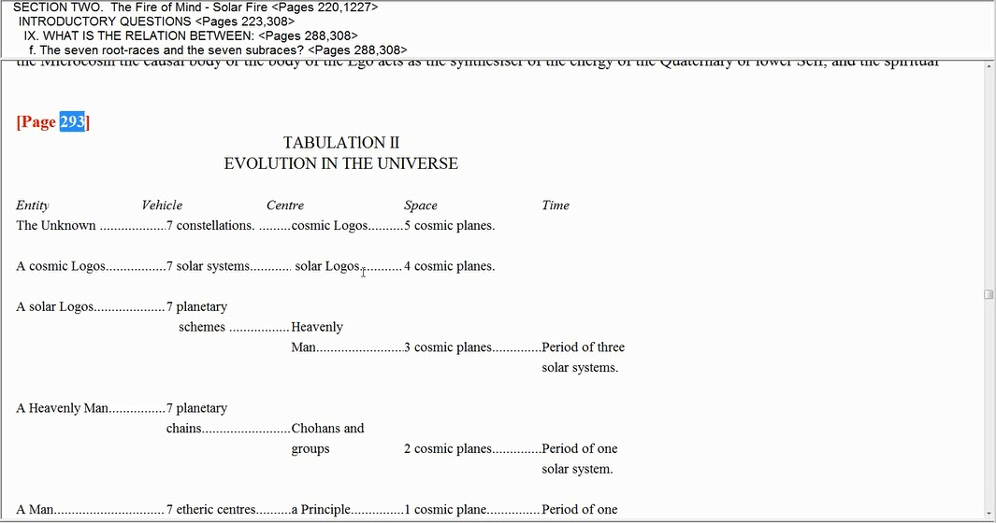

But here are various great Logoi and we see that above the solar Logos is a cosmic Logos which manifests through 7 solar systems and uses the solar Logos as its center. And this is what I call, at least for us, the 7 solar systems of which ours is one and its great ruler. Now beyond that we have the unknown who is our local, the ‘One about Whom naught may be said’. There do seem to be a number of them at least my interpretation of Chart 5 on Page 344. They are seem to be indicated there even Beings even greater than the ‘One about Whom naught may be said’. So this is the Unknown and that term fits well with the ‘One about Whom naught may be said’ and it manifests through 7 constellations in the cosmic Logos, is its type of chakra and it operates on 5 cosmic planes from the atmic plane on down.

29:21 Now you know I may go to that particular chart. I have located our ‘One about Whom naught may be said’ is this green triangle:

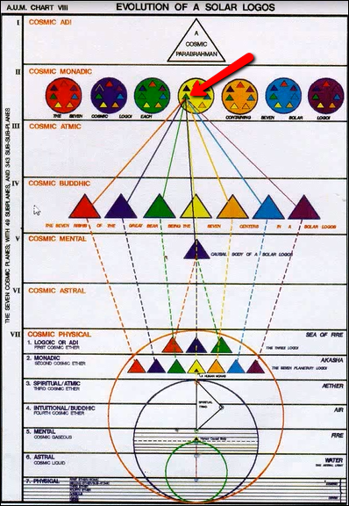

The colors are provided by Keith Bailey you know who is drawing these up for the A.U.M. group but the colors probably have a lot to do something with the progression of the rays and it makes it more vivid for us. But what is this Great Being containing that particular green triangle? I call it the sub-parabrahmic Logos and it is much greater than the ‘One about Whom naught may be said’. And for my perspective, there are then 49 “Ones about Whom naught may be said” in this particular diagram.

And above them all is a cosmic parabrahman which is really probably 1 of 7 and on and on. You know how that particular chart goes which shows us, there:

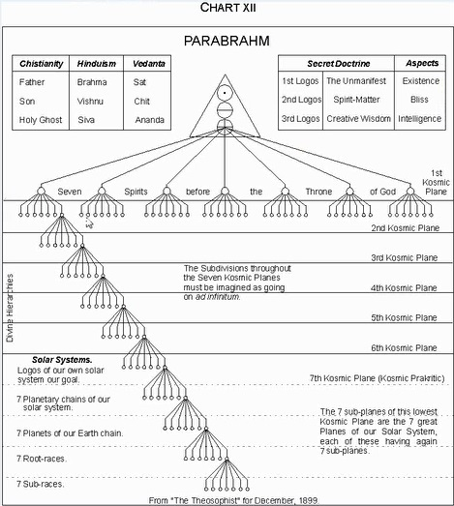

All these rising, seems like forever rising septinates. So even at the top of this chart we have a 1, but that 1 is probably a 7.

30:40 Well in any case, do we think that our tiny little planet somewhere down here may be not even drawn on this map, maybe these of the 7 sacred planetary Logoi, has no intermediary Beings between it and a ‘One about Whom naught may be said’. I would say that it is more likely that a cosmic Logos is going to be working through our planetary God and certainly our solar Logos is, and only then a ‘One about Whom naught may be said’ in whom this cosmic Logos, which contains our solar Logos, which contains our planetary Logos. Well I don't think I can get to the end of that sentence but they are all working through our particular Heavenly Man.

“HE is to a still greater Being, the One referred to elsewhere as "the One about Whom naught may be said," what the vehicle of a Master in physical incarnation is to Him, and on a less accurate basis, what your personality is to you; it is an expression of the soul or of the Monad when a disciple has attained initiate-consciousness.” RI, Page 366

HE is to a still greater Being, the One referred to elsewhere as "the One about Whom naught may be said"… so I’m asking which one? As probably a number of these great Beings of whom naught can be said … what the vehicle of a Master in physical incarnation… and that’s the mayavirupa composed of substance from the dense physical body of the solar Logos … what the vehicle of a Master in physical incarnation is to Him … now what do we mean by the vehicle of a Master? Do we mean only the physical vehicle or the personality vehicle? What do we mean? So to what level shall we assign Sanat Kumara? To a strictly physical level? And I’m going to ask that question, shall we assign Sanat Kumara and his planetary demonstration to a strictly physical level? Or should we consider the entire personality manufactured or envisioned personality vehicle of the Master, not just the physical part of it? Yeah and here I think we get the hint, it's not just about the physical body; it's about the whole personality. And so can we honestly say that our planetary demonstration is as a personality to this hugest of the Ones about Whom naught may be said? Alright that’s a difficult question, but seems that the scope or the span or the distance between what we have called here, the ‘One about Whom naught may be said’ is too great when coming down to our solar Logos. To what is our planetary Logos and Sanat Kumara like a vehicle? And we might say well, the entire planetary manifestation is a personality to what? Kind of like a personality to the soul nature of our planetary Logos.

So all I'm pointing out is that there seems to be a very great ontological distance between this super entity, super constellation Logos and our tiny little planetary demonstration which Sanat Kumara is supervising. Even when Sanat Kumara is compared to the Logos of Sirius, we are given to understand that there's a tremendous distance between them. But somehow, the Logos of Sirius is nonetheless cognizant of our planetary deity. Well the Logos of Sirius is probably part of this cosmic Logos that we've been talking about over here, this cosmic Logos:

35:28 And our cosmic Logos is part of the unknown, of the ‘One about Whom naught may be said’. So the distance increases tremendously and if it was unusual to think that the Logos of Sirius could be cognizant of our planetary Logos, i.e. Sanat Kumara, and the planetary scheme, then what about the Logos of the cosmic 7 Suns and more? And then what about the super Logos of 7 constellations and more? It seems like a greater distance than is easily understood. Well I just bring that out to try to show somewhat the nature of the analogy being used.

“HE is to a still greater Being, the One referred to elsewhere as "the One about Whom naught may be said," what the vehicle of a Master in physical incarnation is to Him, and on a less accurate basis, what your personality is to you; it is an expression of the soul or of the Monad when a disciple has attained initiate-consciousness.” RI, Page 366

HE is to a still greater Being, the One referred to elsewhere as "the One about Whom naught may be said," what the vehicle of a Master in physical incarnation… thus the mayavirupa … is to Him, and on a less accurate basis, what your personality is to you… and ‘to you’ maybe in this case, as not only a soul, but a Monad. Maybe that’s what it is. Huh, well I realize you know, that I have not completely explained that. I'm not capable of it but at least I'm capable of offering some thoughts about the analogy that is being offered and some of the intervening entities of an ever greater nature which must be considered. Look, a Heavenly Man, a solar Logos, a cosmic Logos, the Unknown. Here is the heavenly man, here is the unknown - we've got two major entities between the Unknown and the Heavenly Man, so that's why I'm wondering if this term the ‘One about Whom naught may be said’ can be variously applied to different types of Beings.

And perhaps there are more than one level of Ones about Whom naught may be said. And even when you are referencing a Being that we think we know something about, if we’re referencing a part of that Being that we know nothing about such as the Monad of the solar Logos for instance, then maybe we can use a term like One about Whom naught may be said. It’s certainly a One and we can't talk about it, so well… and the galaxy too is ‘One about Whom naught may be said’ and on and on. So it may be a generic term. I don't want to relativize things too much but I seem to be invited by my own thought to do that. And not just simply accept verbatim what is stated without the attempt to interpret … it is an expression of the soul or of the Monad when a disciple has attained initiate-consciousness.

So let's see. Let’s read this over again.

“I seek to enter into no discussion of this leading Life of our entire planet. HE is to a still greater Being, the One referred to elsewhere as "the One about Whom naught may be said," what the vehicle of a Master in physical incarnation is to Him, and on a less accurate basis, what your personality is to you; it is an expression of the soul or of the Monad when a disciple has attained initiate-consciousness.” RI, Page 366

He, the … leading Life of our entire planet. HE is to a still greater Being… and we know this that the Monad is included in what we just read. HE is to a still greater Being… what … the One referred to elsewhere as "the One about Whom naught may be said," what the vehicle of a Master in physical incarnation is to Him… it's kind of like a Monad-vehicle relationship … and on a less accurate basis, what your personality is to you; it is an expression of the soul or of the Monad when a disciple has attained initiate-consciousness.

“All the qualities, the love and the purpose of a supreme Entity, referred to in The New Testament as the "Unknown God," are focussed in Sanat Kumara.” RI, Page 367

Well who is, you know, again the Unknown God? Do we have to stretch that far?

“Some gauge of the unfoldments which can lie ahead of humanity will enter the human consciousness when:
1. The fact of the Hierarchy,
2. The nature of its relationship to Shamballa,
3. The spiritual nature of Those Who respond in reverent obedience to the slightest wish of the Lord of the World, are among the accepted truths whereby men live. This will happen after the externalisation of the Hierarchy.” RI, Page 367

40:23 Some gauge of the unfoldments which can lie ahead of humanity will enter the human consciousness… okay so we're into a new subject and this particular subject, if we're really talking about the ‘One about Whom naught may be said’ in the sense in which he is portrayed here, as having 7 sacred solar systems and probably many more representing him and each one of those cosmic Logoi having 7 sacred solar Logoi and probably many more representing it, a cosmic Logos, then one wonders how. All the qualities, the love and the purpose of a supreme Entity, referred to in The New Testament as the "Unknown God," are focussed in Sanat Kumara. You know, one is even tempted to think of the solar Logos or one of the seven Rishis of the Great Bear who are just part of a cosmic Logos which itself is part of the ‘One about Whom naught may be said’ as we usually think of it.
So sorry no resolution here but a plowing of the field of thought. So the different associations can arise and we can ponder these matters. You know always there has to be a sense of occult proportion. If you find that relationships meant to indicate soul and personality, or Monad and personality are too wide, too distant, then you have to question whether there may not be perhaps an occult blind here.

So you know the question of how the super cosmic Logos,… when the question arises, how can the Logos of Sirius even be mindful of our little planetary Logos and his planet, then you wonder what can be said about the Logos of a Being which includes simply as a chakra, the Being of Sirius, which includes as a chakra the Being which includes Sirius as a chakra. And I'm assuming that Sirius is somehow included in the 7 solar systems of which ours is one.

Well you know D.K. has said that the material in Cosmic Fire, there'll be a lot of interest in it in the 5th round. It’s millions of years ahead, right? And will be reduced to textbook form later on in that round. So while I don't think what we are engaging in here is the wildest speculation, I consider it to be reasoned speculation, it is nonetheless speculation. And with reluctance I leave it behind at this moment. Maybe you are not experiencing that kind of reluctance as I try to move on here because you know, it could be a confusing subject. But all I can say is always go back to Page 293 and see these 5 levels and how each greater level includes the lesser one. It shows some amazing chakra relationships and it's not even complete. I'm saying that what is portrayed on Chart V of Page 344 of Cosmic Fire is a sevenfold relationship and the Unknown becomes simply a chakra in a greater sub-parabrahmic Logos which itself becomes a chakra in the topmost entity possible, in such a tabulation a cosmic parabrahman. Of course that word ‘parabrahman’ does not really mean what it does to Hindu philosophy. I mean that's the One and only Being we're talking about when we're talking about parabrahman. We're talking about that which is the Absolute. 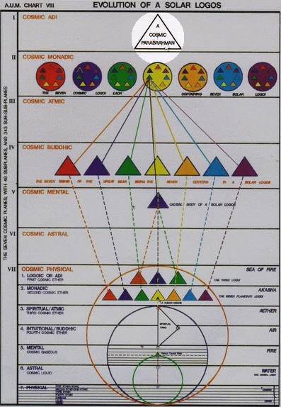

45:00 But just the use of the article ‘a’, a Cosmic Parabrahman’ shows us that the term parabrahman cannot possibly be used in that way, in this case.

Alright, you know, hoping for illumination to come on these matters although there are probably many more important things of an immediate nature which must be faced and somehow mastered before any of this material really makes any practical difference. Maybe this is telling us something about where the energy which animates Sanat Kumara, our planetary Logos, where it comes from, and the distant sources from which it may arrive. I mean probably the ‘One about Whom naught may be said’ is a factor in the consciousness of Sanat Kumara just the way the solar Logos is, just the way our local cosmic Logos is. But let me put it this way, I think that they’re having trouble leaving this subject: our local cosmic Logos is really an unknown entity. Sometimes we hear of the 7 solar systems of which ours is one but we do not hear of the Logos of that 7 solar systems of which ours is one.

So I sometimes call this cosmic Logos the ‘One about Whom naught may be said’ Level 1. And some people fight me about that you know, that I don't have the right to do that. And the super constellational Logos which is our usual ‘One about Whom naught may be said’, I call this ‘One about Whom naught may be said’ Level 2. And what this implies of course is that you could keep going. The subparabrahmic Logos would be called a ‘One about Whom naught may be said’ Level 3 and the cosmic parabrahman Level 4. And who knows what level we would get to before we got to the galactic Logos about whom we could say nothing or the Logos that informed families of galaxies. Those galaxies being simply as chakras and on and on, families of galaxies forming chakras, and on and on. About these entities we can say nothing so they are all ‘Ones about Whom naught may be said’. Alright well we can go on a little bit now if I can pry myself lose from this tantalizing subject which has vexed my consciousness for, aaahhhhhh, (long sigh) years.

“Some gauge of the unfoldments which can lie ahead of humanity will enter the human consciousness when:
1. The fact of the Hierarchy,
2. The nature of its relationship to Shamballa,
3. The spiritual nature of Those Who respond in reverent obedience to the slightest wish of the Lord of the World…” RI, Page 367

Oh you know, just think of the reverence which Masters of the Wisdom express. You know we're worried a little bit about being devotional. D.K. told one of his students that it’s through devotion that got you to us, not your mind. And look at what is said here:

“3. The spiritual nature of Those Who respond in reverent obedience to the slightest wish of the Lord of the World, are among the accepted truths whereby men live. This will happen after the externalisation of the Hierarchy.” RI, Page 367

49:38 3. The spiritual nature of Those Who respond in reverent obedience to the slightest wish of the Lord of the World… I find that awe inspiring. So when these things: the fact of the Hierarchy, the nature of its relationship to Shamballa - hardly suspected at all by the great majority of men and the spiritual nature of those who respond in reverent obedience. And you know these are the Masters, Chohans, and even the Members of the Council at Shamballa. He is their Hierarch and they certainly have learned occult obedience along the way.

So these factors have to be … among the accepted truths… not just accepted as truths but truths … whereby men live. This will happen… a whole new paradigm will appear… after the externalisation of the Hierarchy. So it’s a really amazing paradigm which Hierarchy intends to bring to humanity. We think of these as very remote matters. And you know, how can people consider these kinds of things when they don't even know the fundamentals about reincarnation and cyclic opportunity and eternal evolution? You know, how can they accept these things? But the way is being prepared internally and very quickly that which is obstructive can fall away.

“This Lord of the World is the sole repository of the will and purpose of the One of Whom He is an expression; this again can be understood by you as evoking the same relation to the "Unknown God" as your personality—when expressing adequately the soul and later the Monad—conditions your perception, knowledge, plans and purpose, and controls the quality of your life and directs the energy which you express.” RI, Page 367

This Lord of the World is the sole repository of the will and purpose of the One of Whom He is an expression… well then of whom it is the Lord of the World an expression? Well let’s call the Lord of the world an expression of the planetary Logos, but also of the solar Logos, and even more remotely of the local cosmic Logos. And also to a very slight degree of the ‘One about Whom naught may be said’, Level 2 … this again can be understood by you as evoking the same relation to the "Unknown God" as your personality—when expressing adequately the soul and later the Monad… well you know, I must say here that one of the Rishis of the Great Bear stands to our planetary Logos as the Monad stands to the - well is it the personality or the soul-infused personality? Maybe this will condition our perception, okay. … this again can be understood by you as evoking the same relation to the "Unknown God"… see who is the Unknown God? I tried to go through that and let’s just say there are a number of Unknown Gods, so a cosmic Logos is also an Unknown God. Well okay let’s realize also that what we usually call the unknown here, or the ‘One about Whom naught may be said’ is also an Unknown God. So of … the One of Whom He is an expression this again can be understood by you as evoking the same relation to the "Unknown God" as your personality—when expressing adequately the soul and later the Monad… so what stands to our planetary Logos as the soul stands to us? Is it not in a sense the soul of the planetary Logos, is it not? 55:15 And who stands to the planetary Logos as the Monad stands to us, is it not the Monad of the planetary Logos? But somewhere it is said that the Rishis of the Great Bear stand as the Monad. And I wonder if I can find anything like that. (search: typing) ‘Rishis Monad’, maybe:

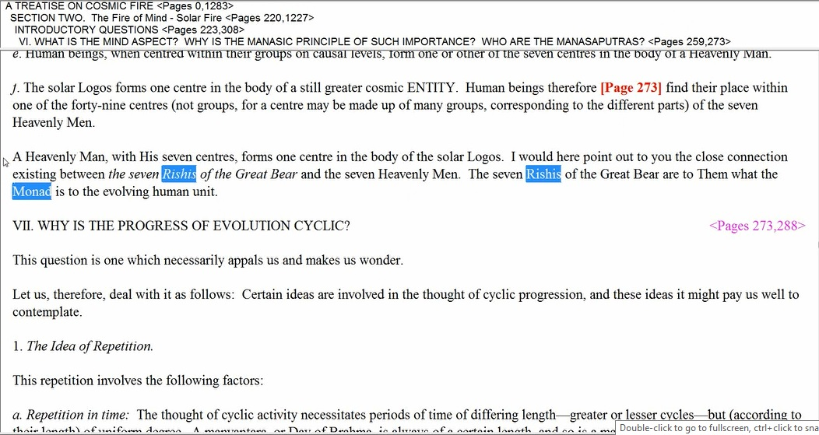

“A Heavenly Man, with His seven centres, forms one centre in the body of the solar Logos. I would here point out to you the close connection existing between the seven Rishis of the Great Bear and the seven Heavenly Men. The seven Rishis of the Great Bear are to Them what the Monad is to the evolving human unit.” TCF, Page 273

Remember each one of these Rishis is just part of the cosmic Logos, and the cosmic Logos is just part of a super-cosmic Logos which is the ‘One about Whom naught may be said’.

We must come to understand, I’ll call it ‘analogical distance’, and where the distance between two factors is disproportionately great when compared with the ‘distance’ between the other two factors which are related to the original two as an analogy, one has to suspect an occult blind or information which is not yet revealed. I hope that makes sense. In other words, let's put it like this. Is the Monad, let us say, to the soul-infused personality, what the ‘One about Whom naught may be said’, the Great One, is to the planetary Logos or is the relation between the Monad and the soul-infused man more like the relationship of a star in the Great Bear to our planetary Logos. I hope you understand. I hope I understand!

It seems inevitable to bring Cosmic Fire into the picture. Why am I doing that? Why do I bring Cosmic Fire into the picture? Because we are working synthetically at this point and the whole writing of the Tibetan is fair game in a way – you know relating this to that. And we're not only studying one book we're studying a synthesis of the books. Every book that is studied is related to all the other books. It’s like one of Great Book, what the Tibetan has given us. So we are free then to call in associations from other books. At least I’m making those rules and I hope it helps at least some of us, okay so … this again can be understood by you as evoking the same relation to the "Unknown God"… and you know what is that Unknown God? I’ve given some different ideas about what that God can be … to the "Unknown God" as your personality—when expressing adequately the soul and later the Monad conditions your perception, knowledge, plans and purpose, and controls the quality of your life and directs the energy which you express. Yes. So the soul will affect our perception and the Monad will affect our perception. What we're trying to do here is understand ‘dimensional distance’ separating various entities focused within various “spheres of intimacy” whether microcosmic, planetary, solar, cosmic, supercosmic, etc.

1:00:50 Alright friends, well I realized that gosh we haven't gotten very far at all here, have we? We’re on Page 368 and we probably began this thing on 366. We haven't really moved very far but it's such deep matter so let us say this is the end of Rays and Initiations Webinar Commentary Program 13, Pages 366 to 368 and will begin in this subject Rays and Initiations Webinar Commentary Program 14, Pages 368 to whatever.

“His vehicle of manifestation is the planet with its seven centres, of which only three are yet recognised by the occult student:” RI, Page 367

So now when we take this up again, we’ll be getting down onto the planetary level and will not have to reach quite so far. Okay well I think that's enough. I'm sure you would agree that's quite enough. But we'll take up the subject again descending a bit into a more normal sphere of consideration with Program 14. See you soon, bye bye.

