THE RAYS AND THE INITIATIONS, PART II WEBINAR – 7, Michael Robbins

Abstract

In this seventh program we take up the subject of the Esoteric Catechism concerning initiation. In the marvelous Old Commentary a dialogue is established between the Hierophant/Master and the Candidate/Chela. The Master guides the candidate through the initiatory process and explains the errors in the candidate’s perception, his misunderstanding of the process. It turns out that initiation is always group initiation, and this the candidate comes to know by grasping the hand of his brother before he can enter through the door. The Tibetan then goes on to explain the individual and group nature of initiation—individual in Lemurian times; in groups up to seven in Atlantean times; and the hint is given that larger and larger groups are admitted together before the initiator in Aryan times—our times.

Contents

Abstract 1
Contents 1
Transcription of Rays and Initiations, II, Program 7, pages 344-347. 1

Transcription of Rays and Initiations, II, Program 7, pages 344-347.

Okay hi. We’re on Program #7 on the Rays and Initiations Part II Webinar Commentary and we’re facing this wonderful old catechism which I am going to read through straight and then make some comment upon. So the Master is speaking or the Hierophant and the chela is responding:

"And dost thou see the Door, O Chela in the light?

I see the door and hear a calling voice. What should I do, O Master of my life?

Go through that Door and waste not time in backward glances at the road just trodden. Go forward into light.

The door is far too narrow, O Master of my life. I fear I cannot pass.

Go closer to the Door and take the hand in thine of another pilgrim on the way of life. Go closer to the Door; seek not to enter it alone.

I cannot see the door, now that I grasp the hand of the brother on the right and the brother on the left. I seem surrounded by the pilgrims on the way. Alike they seem, their note is one; they seem like unto me, and press around on every side. I cannot see the door.

Move forward on the Path, O pilgrim in the light, and stand together, hand in hand, before the Door of Light. What seest thou?

The door again appears, and wide it seems, not narrow as before. What was that I saw before? It was not like the door which now confronts this band of brothers as we stand together on the Path.

The door you saw before was a figment of your mind; a thoughtform of your separative creation, something that cuts you off from truth—too narrow for your passing yet full of wrong allure. Only the man who holds his brother's hand can see the Door in truth; only the man, surrounded by the many who are one, can enter the Door which shuts itself upon the man who seeks to enter it alone.” RI, Page 344-345

Marvelous, marvelous, marvelous. So we're going to take a look at this and see perhaps some of the indicated meanings but of course, I think you can understand these meanings and I’ll just maybe say a few things. So this is a catechism concerning initiation and the guide or the Hierophant or the one who knows the process is asking the questions and giving the advice.

"And dost thou see the Door, O Chela in the light?
I see the door and hear a calling voice. What should I do, O Master of my life?” RI, Page 344

And dost thou see the Door, O Chela in the light? And we wonder whether this is a specific category of Chelaship. There is that, you know, little Chela, is the 1st, and the 2nd is Chela in the light. Of course this might apply to those taking a number of initiations, but by the time one has taken the 2nd initiation, one knows what the Master says here, to be the truth. So maybe this is the Chela in the light, in a technical sense, that is following the 1st initiation, but one who was not yet taken the 2nd and one who is not yet an accepted disciple. I see the door and hear a calling voice. The calling voice, the voice of the hierophant, the voice of one's own soul. What should I do, O Master of my life? Because and of course this elicits the proper response and the proper advice because catechisms are not just for the Catholic church, right? They are meant to teach something.

“Go through that Door and waste not time in backward glances at the road just trodden. Go forward into light.
The door is far too narrow, O Master of my life. I fear I cannot pass.” RI, Page 344

04:28 Go through that Door and waste not time in backward glances at the road just trodden. There is the tendency to always look back over what we have done and not face in the fullest possible way the future. Master Morya tells us we should be racing forward like a man on horseback crossing a burning bridge, burning behind him and if he does not hasten to the other side it will collapse upon him. That’s the forward looking view of the 1st ray with its idea, main theme of progress onward or driving forward into space as it is called. Go forward into light. And behind the door of initiation always a greater light will be found and in that light we shall see light. So there will be an increase of light over that which we now experience when we stand before the door, but it turns out that this door may be after all an imagined door. The idea is that there is a forward progression and too much viewing of one’s previous path, of course some of it may be necessary because it shows us where we have made mistakes and where we have succeeded and it may teach us something, but if we ponder upon that excessively it not only increases the ahamkara, it gives us a sense of being the isolated individual which we are not. It leads backward into the personality, but we do not use the time properly because there is not a moment to lose. There is no time to waste and yet there is no time to lose. So both Master D.K. and Master M. tell us to hasten forward. But what happens? The door is far too narrow … You know the straight and narrow path. The man conceives of himself as not fit to pass through the doors, it’s the straight and narrow path. I fear I cannot pass. The requirements look too high and there's no way for me to pass. This is the anticipation of the passing through the eye of the needle. It's only after we have collapsed time and space in our consciousness that we can actually pass the needle’s eye and this is some anticipation of that later process which will occur as we approach the 4th degree. Anyway, this is not a passable door.

Well, then the Master advises. Go closer to the Door and … here’s the key … take the hand in thine of another pilgrim on the way of life. Go closer to the Door; seek not to enter it alone. This is all about group initiation and what it does is it makes the door passable. You would think if the door was what it seemed to be at first, that taking the hand of another, either on the right or the left would make the door totally impassable. But it is the power of love which widens the door immensely and initiation has always been a group process, D.K. tells us, and when we take the hand of another, take the hand in thine of another pilgrim on the way of life. A pilgrim is a Monad in extension going through this entire process and we are on the way of life, the way of the antahkarana, the way that leads back to the monadic plane and to the source of life which is the interior of the Monad. And when we do that we express our unity with the One soul and our unity, our identicality with the One Being, and it’s in a way equivalent to collapsing time and space. So do not seek some individual, ahamkaric, isolated, lonely passage through the door as if it was an egoistic event. It’s not an egoistic event. It has to do with the stimulation of the heart and the realization of a group consciousness and group being. So although it's somewhat paradoxical when we think of it simply in imagined terms, because you know we become a very broad thing when we take the hand of another, it somehow dissolves the barrier; it widens the door and dissolves the barrier. And suddenly, okay.

09:32 I cannot see the door because I’m not even concerned now about the path of initiation, I'm concerned about the welfare of my brother. So you know the 2nd rule, let me see if I can turn to that 2nd rule in The Rays and Initiation because those rules are included. And here we go:

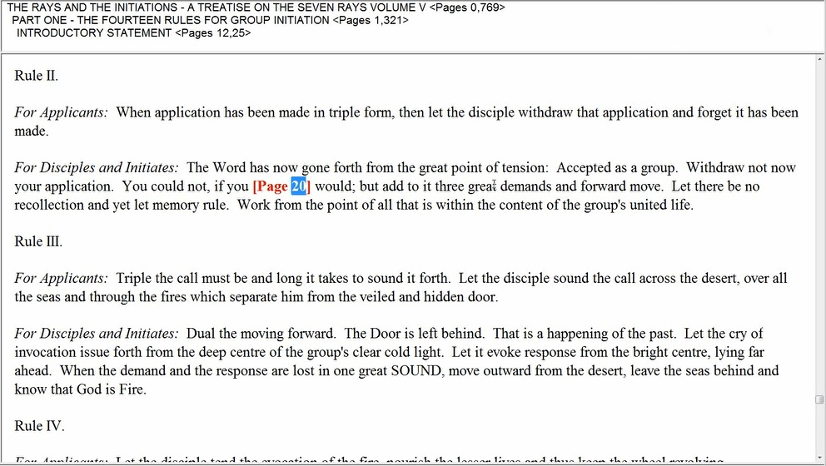

“Rule II.

For Applicants: When application has been made in triple form, then let the disciple withdraw that application and forget it has been made.” RI, Page 19

Well basically what's happening here even in the first of the rules we find that the fire is burning bright in our heart to warm our brother. It's not heating us as Mars in the solar plexus would do, it’s warming as the heart would do and then we can make application to stand before the door. Basically, this is another way of saying we have grasped the hand of our brother. So let’s see if there is anything more here for the third one. No, it’s basically the first two that deal with this stage. We've made our application to the door, but since we care about our brother, you know we have grasped his hand and have empathy for him and have united with him and therefore can understand him and therefore care about our friend we’ll do what we possibly can to improve his or her lot, then we are ready to go through the door and as a matter of fact, we just are not concerned about the door anymore. It’s so often a selfish concern, the usual selfish concern of the applicant to the earlier initiations is gone.

“I cannot see the door, now that I grasp the hand of the brother on the right and the brother on the left. I seem surrounded by the pilgrims on the way.” RI, Page 345

Now we just see our brother. … now that I grasp the hand of the brother on the right and the brother on the left. And so it implies the creation of the circle of group life. There are a certain number in a group going through the door and if we all are meant to grasp each other’s hand, then it will complete a circle and we can go through the door in a circle. But now that we care more about our brother than about our selfish initiatory satisfaction so to speak, we don’t see the door. I seem surrounded by the pilgrims on the way. Again this takes us to: again I stand a point within the circle and yet myself, it takes us to the second technique of integration. And again I will point to that because it is related:

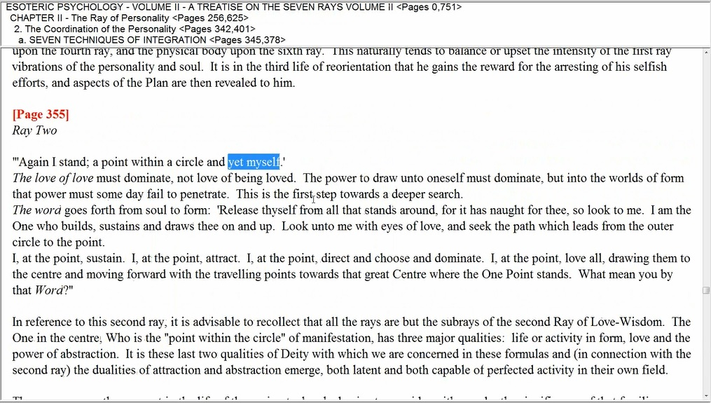

"Ray Two
'Again I stand; a point within a circle and yet myself.'
The love of love must dominate, not love of being loved. The power to draw unto oneself must
dominate, but into the worlds of form that power must some day fail to penetrate. This is the first step
towards a deeper search.” EP II, Page 355

'Again I stand; a point within a circle and yet myself.' The love of love must dominate, not love of being loved. The power to draw unto oneself must dominate … you see that's what happens when we grasp the hand of our brother … but into the worlds of form that power must some day fail to penetrate. We love our brother but not in a formal sense but in the soul sense. It doesn't mean that we dislike our brother in the formal sense. This is not the important thing. This is the first step towards a deeper search.

“The word goes forth from soul to form: 'Release thyself from all that stands around, for it has naught
for thee, so look to me. I am the One who builds, sustains and draws thee on and up. Look unto me
with eyes of love, and seek the path which leads from the outer circle to the point.
I, at the point, sustain. I, at the point, attract. I, at the point, direct and choose and dominate. I, at the
point, love all, drawing them to the centre and moving forward with the travelling points towards that
great Centre where the One Point stands. What mean you by that Word?” EP II, Page 355

And then you know we release ourselves, all it stands around ('Release thyself from all that stands around,) and basically we have a togetherness achieved. I, at the point, love all, drawing them to the centre and moving forward with the travelling points towards that great Centre where the One Point stands.

13:41 And we are moving forward together through the door. This is what I wanted to point out. We are is surrounded by our fellow human beings, our fellow applicants, we move forward together through the door.

“I cannot see the door, now that I grasp the hand of the brother on the right and the brother on the left. I seem surrounded by the pilgrims on the way. Alike they seem, their note is one; they seem like unto me, and press around on every side. I cannot see the door.

Move forward on the Path, O pilgrim in the light, and stand together, hand in hand, before the Door of Light. What seest thou?” RI, Page 345

I seem surrounded by the pilgrims on the way. And this takes us to the rules of the road which says the same thing, doesn't it? So let’s see if I can find this. These things are said in so many different ways, and here it is:

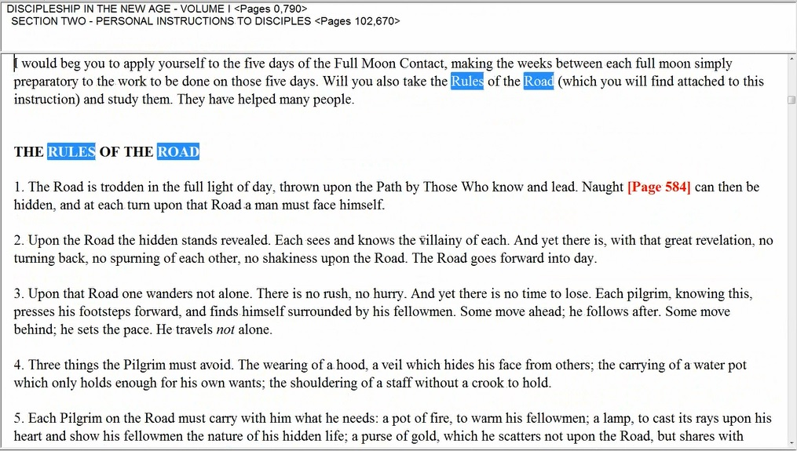

“1. The Road is trodden in the full light of day, thrown upon the Path by Those Who know and lead. Naught can then be hidden, and at each turn upon that Road a man must face himself.” DINA I, Page 583-584

The Road is trodden in the full light of day, thrown upon the Path by Those Who know and lead. It's the Masters, the Hierophant asking these questions. Naught can then be hidden, and at each turn upon that Road a man must face himself. And here it is:

“2. Upon the Road the hidden stands revealed. Each sees and knows the villainy of each. And yet there is, with that great revelation, no turning back, no spurning of each other, no shakiness upon the Road. The Road goes forward into day.” DINA I, Page 584

And this is the one I was after, okay.

“3. Upon that Road one wanders not alone. There is no rush, no hurry. And yet there is no time to lose. Each pilgrim, knowing this, presses his footsteps forward, and finds himself surrounded by his fellowmen. Some move ahead; he follows after. Some move behind; he sets the pace. He travels not alone.” DINA I, Page 584

Upon that Road one wanders not alone. There is no rush, no hurry. And yet there is no time to lose. Each pilgrim, knowing this, presses his footsteps forward… he thinks he is going alone at first … and finds himself surrounded by his fellowmen. Some move ahead; he follows after. Some move behind; he sets the pace. He travels not alone. And even at the end of this marvelous rules of the road, which everybody can say, Oh yes I know this and then I do it. He knows … He travels not alone.

15:10 So you see how all of these work together, the catechism and you know all other things that I’ve mentioned from Esoteric Psychology and from the The Rays and Initiations Rule 2 for applicants and Esoteric Psychology integration formula #2 and then the Rules of the Road. They all emphasize the same thing, we travel not alone.

“I seem surrounded by the pilgrims on the way. Alike they seem, their note is one …” RI, Page 345

And that takes us to Rule IX where it says:

“Rule IX.

For Applicants: Let the disciple merge himself within the circle of the other selves. Let but one colour blend them and their unity appear. Only when the group is known and sensed can energy be wisely emanated.’ RI, Page 22

Let the disciple merge himself within the circle of the other selves. Let but one colour blend them… you see. Alike they seem in note, right? Let but one colour blend them and their unity appear. Only when the group is known and sensed can energy be wisely emanated.

“Alike they seem, their note is one; they seem like unto me, and press around on every side. I cannot see the door.” RI, Page 345

Alike they seem … they are on the same note right? Alike they seem, their note is one … it’s the note of aspiration, of dedication, of soul response, of unity, all those things … they seem like unto me, and press around on every side. I cannot see the door.

In other words this is so important, I drop my selfishness, right? I drop it away and you know how it is with so many of us we are, oh when will I be initiated when it is a group response. The ahamkara looms far too large and we think of ourselves in a limited isolated way instead of having an identity as a group or as the One. Until we can shift our identity into that which is the group and that which is the One, then we're still under the illusion of separative selfhood which seeks to go alone through a door, and that is not the truth.

“Move forward on the Path, O pilgrim in the light, and stand together, hand in hand, before the Door of Light. What seest thou?” RI, Page 345

So in other words, at first, we have our concern for our brother and maybe we forget about the door of initiation but later it seems that as a group we must train ourselves to pass through the door and receive the accolade of fire and be empowered in a way that will help us serve better. So among the true aspirants who are working together hand-in-hand, in mutual cooperation, they press forward and the door again appears.

“The door again appears, and wide it seems, not narrow as before. What was that I saw before? It was not like the door which now confronts this band of brothers as we stand together on the Path." RI, Page 345

The door again appears, and wide it seems, not narrow as before. The whole group can pass together and we are getting involved in the process of group initiation which will be so important from now on and into the coming Age when groups will be presented to the Initiate. I told you know when I went to the Masonic lodge the first time, I went with two other guys and you know we had to share our responses. It was very good training and it was such that they didn’t have a schedule to take only one alone. So that bringing several in together taught us a very good lesson about the impending nature of group initiation. The door again appears, and wide it seems, not narrow as before. The whole group can pass through but … What was that I saw before? It was not like the door which now confronts this band of brothers... that’s so beautiful … as we stand together on the Path. And you know we can be on the path, the path is not necessarily wide, it’s narrow, and yet there are many of us, we are in a way reduced to a point and we are one being in unity on that path together, one group.

The door you saw before was a figment of your mind; a thoughtform of your separative creation, something that cuts you off from truth—too narrow for your passing yet full of wrong allure. Only the man who holds his brother's hand can see the Door in truth; only the man, surrounded by the many who are one, can enter the Door which shuts itself upon the man who seeks to enter it alone." RI, Page 345

19:29 Well and what does the Hierophant answer? The door you saw before was… not the real door, it was … a figment of your mind… it was how you imagined the door of initiation. It was the door of selfishly intended initiation. It was not real. … a thoughtform of your separative creation… when you thought of you yourself as an isolated personality passing through that door. Only the man who holds his brother's hand can see the Door in truth… alright, this is such a lesson. Sometimes we try to protect ourselves. We’re afraid we'll get some kind of weird vibration from our brother and we don’t want to hold our brother’s hand and so forth and that’s just against the Laws of Occultism. It’s just based on separative ignorance. So … Only the man who holds his brother's hand can see the Door in truth… the real door, the wide door, the door that is not wide open to the separative man but is wide open to the loving, cooperative, mutually progressing group.

Only the man, surrounded by the many who are one… This is marvelous because you know we must solve the problem of the one and the many of the many and the one is the many. This is something we do maybe at all the rays but particularly, we have to do this on the 3rd ray which is a ray that tends towards the impression of the reality of multiplicity and of course, it’s not real. So we have to resolve that and then ray 2 and ray 1 are very good in their own ways of resolving into unity and resolving into oneness. Ray 1 finally resolves into complete oneness; ray 2 into unity which suggests the One. Only the man, surrounded by the many who are one can enter the Door which shuts itself upon the man who seeks to enter it alone. What a lesson and it’s self-explanatory: their initiation, real initiation is group initiation and it is the hierarchy of love and unless we love we don't go through and the loving itself is the going through. According to the intensity of love that we have, so will the various doors open unto us. And you can imagine the Christ standing in the process of the 7th degree, what his degree of love must be as all these Doors have opened unto Him. And as so many of the great Masters they bow on bended knee to him.

22:08 So that’s the catechism. There are others and we will look at these others. Just when I finished it said 22 22, I like that two mystical numbers that sum to 44, another one of those magical numbers. There is a numerological key to the secret doctrine, there are many keys and we have to learn how to turn those keys. We may not turn them all, but once we are through, we will know more about how to turn the other keys which were not necessarily our path. They have to take the one or two keys which really belong to us and learn how to pass through and then we can really be of some use, some value.

“In Lemurian days, initiates entered alone and one by one, and then only a few managed to attain the goal and one at a time were admitted to the Mysteries. In Atlantean times, when the Door of Initiation stood wide open, the aspirants to the Mysteries were admitted in groups of seven, but had not contacted their fellow group members in physical consciousness; the emphasis was still (during the training period) upon individual attainment and achievement.” RI, Page 345

In Lemurian days, initiates entered alone and one by one… there was initiation in Lemurian days. It may be that the 1st initiation was more what could be taken, but I think even the 3rd was possible. In Atlantean days, the 4th was possible. And now in the Aryan days, the 5th is possible; although you know there were Masters in those days of Atlantis so somehow they achieved. In Lemurian days, initiates entered alone and one by one… the door had to be pretty tall I guess because they were pretty large beings you know I’m sort of joking there, but my friend Philip (Lindsay) told me that the Bamiyan Buddhas, those great statues in Afghanistan which were destroyed the Taliban, were actually the representations of the true physical stature of early man which H.P.B. incept. ??? You know we talk about these Atlanteans which were about 9 meters tall, or maybe in English terms 27 feet, 28 feet. That’s small compared to some of the size of the Lemurians.

24:20 Why aren’t these skeletons available? Well we understand that probably there are many reasons including the Earth’s shifts but there is something more that cremation was universally practiced and so the totality has been destroyed, but we are told somewhere, I think by Master Morya that in the caves which the Master supervised, there are these relics which can be brought forth for proof at the right time and it’s going to be an amazing time, you know. When we read in the bible there were giants in those days, we take it as a piece of fabulous writing, fable, myth but if it’s going to turn out to be true. Then we’re going to have to revise our view of man's history and then we will go to the Secret Doctrine where this is all laid out in an understandable form and we’ll say aha, here it is, this is an amazing story and then for those who give credit to it, it will lead right into the Ageless Wisdom, right to the Hierarchy, right to the wisdom stored in Shamballa. It will lead us into the secret doctrine, understood in the large and general sense, not in terms of the book which was you know is a small presentation of the vast secret doctrine.

In Atlantean times, when the Door of Initiation stood wide open… I guess maybe in the period of 4.5 as my friend Philip would say. The 5th sub-race of the Atlantean rootrace. …the aspirants to the Mysteries were admitted in groups of seven… amazing … but had not contacted their fellow group members in physical consciousness… and yet they together, on the causal plane, they stood before the initiator … the emphasis was still (during the training period) upon individual attainment and achievement. So here they thought they were achieving in an individual sense, that their attainment was their own, and parallel to them and other places that they did not contact, were others whom they did not contact and they were achieving similarly and they all came together on the inner planes.

“Today, so rapidly is man making spiritual progress, the Hierarchy is admitting groups all the time, particularly in connection with those rays which are at present in incarnation. This means that the three major rays (which are always [Page 346] predominantly active though they may have varying cycles of increased or decreased activity) have large groups undergoing their preparatory training for some one initiation. This group admission will develop rapidly as the world settles back into a cycle of peaceful growth and unfoldment after the drastic experience of the world war (1914-1945); it is for this that information such as I am here attempting to give must be made available.” RI, Page 345-346

Today, so rapidly is man making spiritual progress, the Hierarchy is admitting groups all the time, particularly in connection with those rays which are at present in incarnation. Well you know, the 2nd ray is certainly among them, the 1st ray Ashram is coming in, the 5th ray, but as he says this means that the 3 major rays (which are always predominantly active though they may have varying cycles of increased or decreased activity) have large groups undergoing their preparatory training for some one initiation. This group admission will develop rapidly as the world settles back into a cycle of peaceful growth… a cycle may be a cycle only … and unfoldment after the drastic experience of the world war (1914-1945); it is for this that information such as I am here attempting to give must be made available. So people will understand the advantages of this peaceful cycle of growth and will not simply settle back into a comfortable sort of materialism. They will in fact realize that it's a great opportunity to speed forward but not alone, holding the hand of our brother.

Today, so rapidly is man making spiritual progress, the Hierarchy is admitting groups all the time… And I don’t know if these are limited by number. In Atlantean days apparently limited to 7, one-by-one, 7 and now what are the groups that are to be admitted, do they have a number? Here it’s not given. So rays 1, 2, well ray 2 and 5 are strongly in incarnation at the moment, ray 6 is passing out, ray 3 is in incarnation, ray 1, yes but only in a limited sense, not too many of the 1st ray types can be allowed in in greater concentration. Well at least not the pure 1st ray types, whatever pure means - maybe it’s the soul and Monad being both on 1st ray. Humanity couldn't handle that. Ray 4 will be coming in, but not really until 2025 and following, and ray 7 will be coming in strongly. But anyway the 3 major rays are preparing their groups and I'm not sure whether you know that the ray 6 fading out at this point, maybe if they make transition under the 2nd ray they can be part of this process.

29:39 Anyway, so many of us are undergoing preparatory training. We probably don't realize that we are, but all of this work that Master D.K. and the work to serve and the work to spread the Ageless Wisdom and the work in psychology and healing and education and whatever of the of the seed group areas we may be attracted to is all part of our preparatory training. So D.K. is thinking far ahead and when people want to know, well look what’s it all for, because we're passing through a time which I think will lead to nihilism and relativism, humanism in a sense, that the personality is seen as the God and the welfare and the comfort of the personality is seen to be the greatest good. And that is just not true. I mean disciples can tell you it’s not true. We don't have to treat the personality badly, it is our good instrument and for many people who just don't get it yet, you know, we have to serve the personality first and make sure that the personality is in reasonable condition so that the mind can be cultivated and emotions sensitized and the physical vehicle made more vital. But we cannot fall into an age of comfort and I'm sure that Saturn as the ruler of the first decanate of Aquarius and since humanity is the world disciple, humanity will be under that Saturn even though they usually enter in the opposite way, Saturn will prevent excessive falling into comfort. It can be neither this nor that as the Buddha said, you know not the extremes. If there’s extreme discomfort, all you do is think about that and you can't get on with things. If there is extreme comfort then you are overcome by it and your aspiration is stifled and your will remains latent.

“One other point I would seek to make clear. As you know, an Ashram has in it disciples and initiates at all points of evolutionary development and of all grades and degrees; these all work together in perfect unison and yet—within their differentiated ranks, for each degree stands alone yet united with all the others—with their own established rapport, their coded telepathic interplay, and a shared occult secrecy and silence which guard the secrets and knowledges of one grade from another and from the unready.” RI, Page 346

One other point I would seek to make clear. As you know, an Ashram has in it disciples and initiates at all points of evolutionary development and of all grades and degrees… well somewhere it tells us that those who have taken the 1st degree are not really members of the Ashram. Well maybe the probationary initiations are not really members of the Ashram, but they certainly stand on the periphery, and as I have pointed out before and will now point out again:

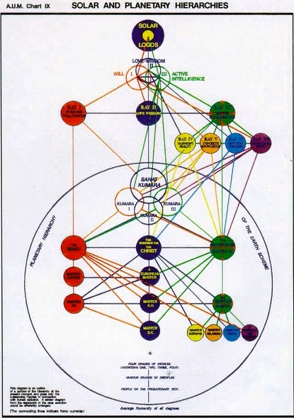

Notice, this is the circle of Hierarchy. And as I showed you before, that even though you may not be an initiate, if you’re on the probationary path and have not yet taken initiation, even some probationary disciples here, various grades of disciples before they have taken initiation are still technically within this circle of the Planetary Hierarchy.

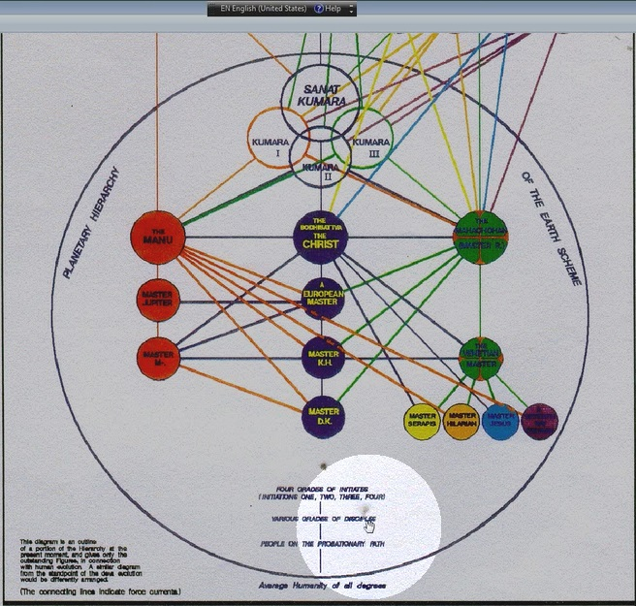

The great circle of Shamballa, which I suppose would be drawn in red, is not drawn. Okay. So we are within that blue circle, we’re part of the Hierarchy, but technically to be in an Ashram, I mean the Tibetan’s group was in a sense being invited into his Ashram and sit on the periphery of his Ashram, but was not in any sense intimate to his Ashram. It’s all a degree of our consciousness that allows that or prevents that. So all grades and degrees you know especially 3, 4, 5 and maybe peripherally initiation 2, initiation 1 probably at first, the individuals are not drawn into a group around the Ashram. … these all work together in perfect unison and yet—within their differentiated ranks, for each degree stands alone yet united with all the others… and that’s kind of one of those paradoxes of the occult path, that we are alone with the members of our degree and we are preparing for similar realizations and stages of unfoldment and yet we are in very fine, very good cooperation with all the others who are preparing for other things. We really have to learn about that, since there is no separation allowed or at least no separativeness. There is a kind of a separation between the degrees. There is at least distinction between that for which the members of various degrees strive and that which they must attain.

34:45 … for each degree stands alone yet united with all the others with their own established rapport, their coded telepathic interplay… meaning that we're liable to receive thoughts in common with the members of our degree, but those kinds of thoughts may not enter the mind of those of different, or let’s say of lower degrees. And those of higher degree will have types of thought which will not enter our receiving mechanism. So we are in rapport with all the others but the coded telepathic interplay tells something about the difference of the kind of thought and energy which is received by the different distinct groups. … and a shared occult secrecy and silence which guard the secrets and knowledges of one grade from another and from the unready. Of course if we are of lower degree we can speak of these with those of higher degree who have passed through them but we are not to disrupt the work of those of lower degree by dealing with thoughts and theories and types of realizations which do not concern them, which they cannot really approach yet and which would take their mind away from that upon which they should be concentrating.

This really requires a great refinement of understanding to understand the stage of consciousness of one’s interlocutor, so to speak, to understand the stage of consciousness without any separative attitude. You know, I mean, you’re not going to say hey look I can’t talk about this thing because you’re of lower degree. I mean you know, that’s nonsense. One can’t do that. But one has to have that sort of intuitive sense of what is appropriate to speak of with those who have maybe not had as much experience as one has had and then similarly that's being done by those above, the Tibetan is doing it all the time really. Sometimes he’s just saying, well I’m not permitted to speak of these things, I can’t speak of these things you as an aspirant will not understand these things but you can try, you know. He is careful about what he says to us and he doesn't bring to us those who are in trainings for the first 3 degrees basically that’s who is training, doesn't bring into us those kinds of thoughts which are not appropriate to our level of consciousness. Of course you know in his books, he has written for all degrees and so if we are alert, we will see what may be written for the 4th degree or even in some cases for the 5th degree. Not that we will understand them as those who are at the 4th or 5th degree, or candidates for those.

“Similarly, when an aspirant, seeking upon the physical plane to find those who will share with him the mystery of his next immediate step or demonstrated expansion, discovers his own group, he will find that it has in it those who have not reached his particular point of wisdom and those also who have already left him far behind.” RI, Page 346

And this, you know, this is a hard saying because we live in these Aquarian days, days of leveling. You know as I discussed the tall poppy syndrome of Australia, if one poppy sticks its head up too far, whack, it’s decapitated. So everybody should be the same, you know, and that is one of the early misinterpretations of Aquarian vision. Aquarius has to include unity within diversity and hierarchy within the field of commonality. In other words, we’re all one being but there is also a vertical arm, so that does exist and all through nature we discover the truth of hierarchy. And when we discover it, we have to be careful not to become mentally proud or condescending and at the same time not jealous or envious. So those are things that have to be rooted out and we realize we had been there and we will be where others are now. Okay so, reading it again:

39:10 Similarly, when an aspirant, seeking upon the physical plane to find those who will share with him the mystery of his next immediate step or demonstrated expansion, discovers his own group… you know in rule nine and what was that?

“Rule IX. For Applicants: Let the disciple merge himself within the circle of the other selves. Let but one colour blend them and their unity appear. Only when the group is known and sensed can energy be wisely emanated.” RI, Page 22

So I'm sure we've all gone looking for our group and we have sometimes been excited about a group that we may have found only to discover that we did not really resonate with it and it with us. Or that it seemed to be preparing people for steps too far for us or steps not far enough for where we stood. So when we find this group with its differentiated strata of achievement.

“He will be drawn into a vortex of force and a field of service simultaneously. Ponder on this statement. He will learn, therefore, the lessons required by one who is to work in an Ashram and will know how to handle himself with those who may not yet share with him the secrets which he already knows, and with those who have penetrated deeper into the Mysteries than he has.” RI, Page 346

He will be drawn into a vortex of force and a field of service simultaneously. Think about that field of service within the group, those who have not yet attained what the particular disciple has attained, can be served and those who are ahead will serve those who are behind. But those who are at a certain stage will also cooperate with and serve in a lesser way those who are ahead. So the vortex is a field of service and of course the vortex can also look out towards humanity and the whole group can serve humanity in different ways according to those who can modify, qualify and adapt the Plan. Different levels of service given to humanity according to the strata within the group. So …He will be drawn into a vortex of force… and it can be very challenging, very testing although there are a lot of glamours about your life that are going to fall apart when you enter this group, but you know, that might not happen at all, and it might and then the group thinks of itself as just a little bit exclusive because it can induce a falling apartness in the entering disciple, some distress. Ponder on this statement. And we have just a little, done that.

He will learn, therefore, the lessons required by one who is to work in an Ashram. Even though it’s a group preliminary to the Ashram …and will know how to handle himself with those who may not yet share with him the secrets which he already knows, and with those who have penetrated deeper into the Mysteries than he has. You know, I look above I help below. And my hand, in one of the catechisms is grasping the hand of the brother above me, and his hand grasps mine and at the same time I grasp the hand of the brother below me and his hand grasps mine. So this is chain of hierarchy and you know how it would go: maybe left hand should be held above and the right hand down. I’m not sure about that whether that’s the way the Magician does do it. Maybe it’s the other way, actually. But it would make also sense if the left hand, or receptive hand we held above, and the hand of will, which can confer a greater power were held below. But you know, it can be on the other way as well, I have to recheck the Magician card because in a way we will to reach upward and what we have already established as second nature is in our left hand and we can extend it downwards. So both can be considered as working. Okay, I think we will go on even though we have ended a certain phase here. Now, let’s go on.

“SECTION ONE - THE ASPIRANT AND THE MYSTERIES OF INITIATION

Let us now take up our first point in this section and see what is really meant by the hackneyed words "door of initiation," and what constitutes the difference between the door which faces the disciple and that which confronts the Master.” RI, Page 347

43:46 Let us now … well you know, I don’t know maybe all of these should be hour long programs. I have the notion that this should end and the next work should begin. So end of RAIWC Program 7 and it is page 344 to 347. We’ll begin RAIWC Program 8, and it will be from 347 onward. But you know, in case people want to study the esoteric catechism all by itself and a little bit of commentary on it, it will stand alone in that sense. How many of us will read it by ourselves, reading it carefully or maybe with a class or a study group? But maybe this kind of approach that I am offering will be an incentive to study this together to study it on your own, you know it’s between us. Okay, see you soon. Bye bye.

