EGOIC LOTUS WEBINARS, VIDEO COMMENTARY – 58, Michael Robbins
Abstract
Egoic Lotus Webinar Commentaries 58: Part 2 of Synthesis for petal 9. This webinar is about 2 hours, 1 minute long. Program 58 offers the second of the commentaries for the Synthesis of petal 9—the third petal of Sacrifice: Sacrifice-Love.

In terms of the 80-point outline we have been using, it takes us from Point 26 to the beginning of Point 37. The work in this petal is climactic and when fully unfolded represents the achievement of the third degree, the Transfiguration. Sanat Kumara is the Initiator at this petal. So many energies and forces come together in the work and unfoldment of this petals that all zodiacal signs, all planetary influences and all rays can be understood as playing a prominent part.

Through work in this petal and through the application of the Rod of Power, the candidate becomes the true initiate in the eyes of the Spiritual Hierarchy. The demands of sacrifice are very great—”the utter sacrifice of all forever”. The human being can begin to live truly as a soul, consciously influenced by the Spirit aspect Monad.

Egoic Lotus Webinar Commentaries 58 325 MB .wmv file
Video of Egoic Lotus Webinar Commentaries 58 by Michael D. Robbins.

Egoic Lotus Webinar Commentaries 58 116 MB .mp3 file
Audio of Egoic Lotus Webinar Commentaries 58 by Michael D. Robbins.

Transcript.

Good morning friends, hello. We're continuing now with our egoic lotus webinar commentary program number 58. We're working in the last of the nine usual petals in the sacrifice tier.

The colors are yellow, orange, rose, blue, and indigo. We have reached point number 26. This is part two then of the synthesis for petal number nine and we are working on the various rays that are implicated in this petal and the manner in which they are implicated.

We've discussed ray five. Of course, in relation to satori, the enlightenment to the transfiguration, the third initiation, it is after all the petal that leads to the third degree, and Sagittarius has a great deal to do with the fifth ray, which is the most prominent. The ajna center and a number of its different capacities are involved here in the work of this petal.

I notice that we have left out ray six. We'll talk about the degree to which the sixth ray may be involved in the aspiration involved this petal through Sagittarius and perhaps the sense of direction. So, this initiation, the third, is not approached through high aspiration, yet it is a quality which never dies and when Master Morya says to strive, fierily, I don't suppose He conceives about at any time in this initiatory process it will be discontinued.

Anyway, looking at these different rays as they may be involved here, the second ray stands for the union of heart and mind and this comes in through Jupiter and also through Venus. This petal is about the enlightenment and satori, the bursting in of reality in a manner that illusion cannot veil. DK has told us that the most luminous souls are second ray souls. The word of power there is: I see the greatest light.

We're beginning to deal with light supernal, Capricorn motto or mantra: lost am I in light supernal, yet on that light I turn my back. This is something that is achieved at the third degree, the soul gains the majority. The light supernal brings in I think the second ray and the fifth ray. The fifth ray lord is the most luminous of the ray lords. There's something about the light of life itself which is joining in, coming in on the first ray.

0:04:00 Anyway, the soul here is the second aspect of divinity and at this point with the full unfolding of that petal, the soul wins the day and stands as it were upon the mountain top of consciousness, able to perceive reality in a new way for the first time and with consistency.

Ray two stands in a Jupitarian manner for the expansion of consciousness and interestingly, we are undergoing here what is called the crisis of initiation, this is the real initiation as the hierarchy conceived it and the word associated with that crisis is expansion, it's connected with Capricorn. It's also been a crisis of inclusion which transcends the usual duality of soul and personality. There is a sense in which all is seen as soul in this unity of consciousness, which is characteristic of the second ray. We're really beginning our work in earnest with inclusive reason and we have which is a buddhic faculty, and we can begin to understand that.

So, Jupiter, a planet of completeness, a ray two, a synthesis at least in our solar system, and we are at the point where we are completing the work of the nine petals and that is a synthetic moment. All is gathered into the realized light. Certainly, the second ray is powerful here, because the soul gains dominion, and the soul represents the second aspect. A great light breaks forth, it may not be the greatest light yet, but it certainly is a great light and. The word of power I see the greatest light leads along this path of the great light to a still greater light.

0:06:30 Well what about the third ray? Certainly, it is the third initiation, so by numerical resonance, the number three comes into prominence. We stand upon the mountain which represents the matter of the third aspect, of the third ray, and we are bringing the what represents in ourselves the earlier solar system, to a stage of elevation. Always Capricorn which is connected with the third ray too, brings about elevation. At least when it is properly pursued along the right-hand path.

So, you have a facility here with the manasic permanent atom, which is the third of the atoms in the spiritual triad, and in a way it's the third from below, as we can blend the mental unit and the manasic permanent atom. We have a physical permanent atom, astral, and then manasic permanent atom, it's the central permanent atom.

We are standing here on solid ground, spiritually considered, and so much of karma is under our feet. Not just in theory, but in reality, and in the spiritual sense. We see the unity and we have the confidence to reveal the unity. We have moved beyond the customary dualities, with which we are so familiar, and through the abstract mind, as enriched by the intuition, we can comprehend the unity we are now increasingly seeing.

This is bringing the third aspect to a high point and finding the possibility for it to be infused by the second aspect; it's a blend of the two and the three.

Whenever there's an initiation we have to look at its number, and by numerical resonance the first initiation will involve ray one in some way, and the second, ray two, the third ray three, and the fourth ray four, and the fifth ray five – even though the rays assigned to those initiations (on page 340 of The Rays and the Initiations) is quite different with the first initiation having ray seven assigned to it, the second ray six, the third ray five, and the fourth ray four, I guess that's the same, and the fifth ray one. But all of those assignments are true, it's just a question of understanding how the rays work in relation to the process being undergone.

Now what about the fourth ray? We're having a transfer here, from the human kingdom into the kingdom of souls, human kingdom, the fourth kingdom. We are definitely members now of the kingdom of souls and that in a new way from the time when we were probationary initiates for the first and second initiation. It's a fuller entry and a fourth ray is instrumental in bringing about a fusion between soul and personality, which is a harmonizing of soul and personality.

The ajna center, so important in this particular initiation, is ruled by Mercury at a certain point in the initiatory process. We're sort of midway between the monad and the persona. It's a point of mediation, ruled by the fourth ray. Fourth ray brings in buddhi, the mediating energy of the seven cosmic subplanes.

We’re becoming at this point, having overcome the animal nature to a very significant extent, a true human being. We're becoming the true expressive member of the fourth creative hierarchy.

There is a big conflict here, as well a fearful conflict DK called it, before the third degree. And whenever there is conflict, we have to suspect the presence of the fourth ray.

Well, we are the true human being now and the master of the wisdom is the climax of human development. Is the human kingdom almost left behind? When did we start to leave the human kingdom behind? Well, even at initiation one, we're still very much human beings, but we're entering the fifth kingdom. We're really straddling two kingdoms, the spiritual kingdom and the human kingdom. Even at initiation one, and now we are at initiation three. For the first time we're really a human being instead of – well, an animal as well. The animal nature is gravely subdued, Mars is greatly subdued, we have defeated that aspect of Mars and Mars is the ruler of the animal kingdom. So, to be truly human is to take the third degree. Up until that time Mars presents quite a problem.

Interesting though that Sagittarius should be connected with this petal, because it has a lot to do with the animal kingdom, ruled as it is by ray six. Very much by ray six, or at least expressing ray six. And, with Sagittarius we have that zodiacal component which combined with Gemini to bring about individualization of animal man in the early days. So, Sagittarius, the Centaur, had a lot to do with animal man, and yet at this point we are overcoming the animal nature.

Of ray five I have spoken, we're into full luminosity here, this is the light supernal. I mean at least it's so full compared with anything we've been able to achieve us far. Sagittarius is the yearning after the light and Capricorn is the conferral of the light. It's so interesting how at least a couple of the earth signs have a lot to do with the light, and yet you would think of them as being the densest. But ray five is giving us the light of a kingdom of souls which we begin to appreciate in a new and immediate way of the third degree. It gives us the light of the solar angels and of the fifth ray hierarchy, and again we appreciate it far more immediately than before this point of Transfiguration.

About ray six? Well, I've said a few things about it. Maybe it is not so prominent here except Sagittarius is prominent and before the third degree we are still of course yearning for the light, striving towards the light, and it is the third degree and six is related to the three, DK tells us the two threes makes six. He talks about the special relation between some rays based upon a numerical mathematical relationship: two ones make the two, two twos make the four, two threes make the six, that is the first and second, and the second and fourth, and the third and sixth rays have an important relationship based upon that mathematical relationship.

You see that with rays one and two, at least in one way they represent the great pairs of opposites. They represent two distinct approaches and it's so interesting that in the occult groups of the modern times. The majority of the Souls are either ray two or ray one. When it comes to ray two and four, there is a point of transference involving them and there are a number of fourth ray types of souls that transfer easily onto the second ray. They both have so much in common in terms of mediation. Ray two between the three rays of aspect, and the middle point, and ray four between all the seven rays, it's the middle point. So, harmony and beauty they both share about.

For ray three and six, the idealism is strongly there and the tendency towards abstraction. Just the way we have abstract thought connected with ray three, we have abstract devotion connected with ray six. It is a strong ray of abstraction, of course it can be very concrete in the objects of its devotion, but its higher aspects have similarity with ray three, and ideation and idealism, these two go together: abstract ideation, abstract idealism.

0:17:30 So, again, although the sixth ray will not confer upon us the third degree if unaided by other rays which are still more related to it, especially the fifth and the second, it can assist in the general process of approach to this degree.

Ray seven? The soul and the persona are meeting, ray seven can indeed rule the ajna in terms of the astral chakras, interestingly enough. Organization is coming in, and that’s related to one of the theme words of the third degree, integration. We are organizing the energy systems of the soul and personality systems in relation to each other and they are becoming productively interactive.

The sense of direction, of course, that is interesting, that does connect with Sagittarius, as it connects with the sixth ray and also the first.

The origin of the seventh ray? Well the atmic principle is the seventh principle. There is something to do with the organizing power of the will, atma, for which the seventh ray is the concrete expression. The highest and lowest are meeting here, in the sense that the integrated personality is meeting with the monad, via mediation of the soul. So, we’re learning how to successfully embody the soul and when we talk about embodiment that is the seventh way. We’re concerned now with the building and using of the lighted house of our causal body in which our consciousness can be focused. Our foot is, so to speak, upon matter, in the mineral kingdom, the seventh ray. High energies within us are meeting the lower energy is directly. That is always the linking power of the seventh ray, through which the highest and lowest meet. We’re meeting the one initiator here, in due time, and that initiator plays the role of Uranus and Uranus is the major seventh ray planet. There's a new etheric condition created when transmutation is completed.

The monad is entering in fuller measure. The etheric body, through the mediation of Uranus, which is brought into expression through the work of the Hierophant who plays the role of Uranus in this particular initiation. We're meeting Sanat Kumara, He is Uranus. We're not meeting him face to face, but we're meeting him as the supervisory star. He is the Hierophant.

We’re completing the structure of the first aspect of the lotus, interestingly related to the third ray, as I've said, whereas the three synthesis petals of the second ray, and the jewels of the first. So, the highest in the lowest are meeting. Maybe the permeation of the lowest by the highest is not complete. That tends to occur more at the fifth degree and probably through a mayavirupa, but the monad is involved here and this is, in a sense, a spirit and matter initiation.

What about ray one? It does represent the monad in general, the monad met consciously. Spirit is coming into the equation and the candidate; the initiate recognizes the presence of spirit and identifies as spirit. The generic ray one meaning of spirit is brought forward here. Doesn't make any difference what your monadic ray may be.

Some of the work between the lowest, base of the spine center, and the crown center, the highest head center, is beginning in earnest. Some of the kundalini experiences are working, starting from the third degree. At least in a more controlled manner.

A few other things: ray seven relates specifically to Capricorn. Capricorn brings in more of a seven at this time than any other constellation and this is the exemplary Capricornian initiation, the third.

I talked about the etheric reorganization, that involves the seventh ray, so that the etheric body can carry more of the soul influence. But, perhaps ray two and ray five are the most influential at this initiation. Venus and Sirius are two major influences here, and their rays are two and five – well, actually they have very similar rays, I think, I suspect the personality ray of Venus and Sirius both are two. That the soul ray of both are five, that the sub monadic ray of both are six, and that the highest of the monadic rays for both will be the second ray. It's almost like Venus is a replica of Sirius on the planetary level. And just as Venus has had a tremendously rapid evolution, one wonders if in a stellar sense Sirius has had that kind of rapid evolution. Just as the Christ within humanity representing both of these has had the most rapid evolution.

So, that's all of the rays, I think. And how they can relate to this petal in which we are approaching the third initiation through our labors, and taking the third initiation through our abnormal labors and through the application of the rod of initiation. We have to realize that it will not always be the case. It is the case in this round that the hastening method of initiation – this kind of divine intervention is applied – but it has not been so in the past and it may not be so in the future. Therefore, the unfoldment of the last three petals will depend very much on the man, and maybe if there is a solar angel what that solar angel can do, but not at all then upon the application of the rod of initiation with its hastening potencies.

0:25:25 Now, we're going to the point number twenty-seven. It’s the question of the colors of the petals and their meaning: yellow, orange, rose, blue and indigo.

The yellow is certainly mental, and this is a strong petal for the abstract mind, but it's also buddhic. It relates to ray four and ray five, and in an interesting sense ray three in terms of expressing the third ray monad. It's an esoteric color for ray four and ray five. So, yellow represents manas when it is ready to fuse with buddhi, and buddhi-manas is the key here for both. Buddhi-manas is coming in strongly at the development of this petal. I also have to say that since this is the sacrifice-sacrifice petal. Yellow is the color associated with sacrifice and with the fourth ray which is the ray ruling the law of sacrifice. The yellow has a very important meaning in all the sacrifice petals, but especially in this one which is the most characteristically sacrificial and involves what Master DK calls the utter sacrifice of all for ever.

Now we can look at the color orange. It's the luminous mind of a solar nature so the solar angels are arriving at a point of climax, now all is assured. This is the ninth orange petal. Orange is found in every single petal and orange is a color that has directly to do with solar angels and with the fifth ray, its compliment is blue which is the second ray, interesting. So, there is completion here of the orange and after this ninth petal we don't know what other colors may be involved in the synthesis petals, but we're told they are of a beautiful lemon hue. There is no more orange, there's only yellow as the color of buddhi. Yellow is a mental color of course but also relates to the transcendental mind that we find on the buddhic plane. Mercury also has to do with this transcendental mind, the mind which appreciates or which works through pure reason.

Then there comes the rose color:

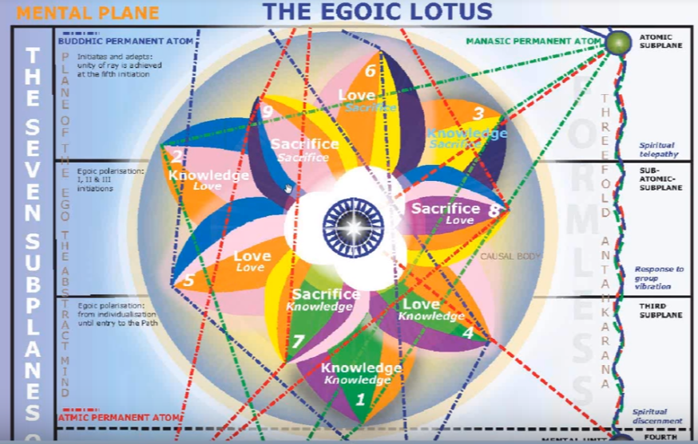

The rose color seems to be in the central position here for petal number nine. Desire is on its way to true love, this is Neptune. There is a rising up towards the intuition, the higher point of the solar plexus is still involved. Neptune is one of the great planets of intuition and its color s blue and also rose. Rose is related to Venus and Neptune and it also relates to the buddhi necessarily, or to a way of invoking buddhi. I would say that rose is related to the relationship between the astral body and the buddhic vehicle, especially when love and is characterizing the astral as it does increasingly after the second initiation, if all goes well of course.

There comes a time when rose does not only signify that which is astral, but also, I think that which is buddhic. Certainly, the connection between them is mediated by rose and also by blue. DK does so often use the color rose when assigning meditations for the astral vehicle, but there's something about it, which really invokes the buddhic energy. It's so interesting that the cross which must be overturned is the rosy cross. That's linking to the fourth degree necessarily and the fourth degree links to buddhi.

What about the blue which shows here uncharacteristically? It's because there is no duplication of the yellow. The only duplications that occurs is in the fifth petal where the rose is duplicated. There's a double expression of the rose. You might expect that maybe somewhere in the petals of sacrifice there would be a double expression of the yellow but there is not. And, that double expression of the yellow would naturally come … maybe in the next solar system, which is going to be of the first ray, there will be a double expression of the sacrificial color. But then we don't even know what the egoic lotus will be like and even on what level they will be found. DK seems to hint that much of what now takes place within the egoic lotus will be taking place within the monadic vehicle.

In any case, those are just imaginings and speculations. But the true blue is coming here because the soul is emerging into prominence and the second ray is becoming stronger and the astral nature is becoming love. But what if blue is the version of ray one, in a ray two system? It's interesting that tabulation in Letters on Occult Meditation where blue is given to the first ray, and red to the sixth. Well, one can understand the usual ray one color red as a related to the sixth, through Mars, but blue is given to the first ray.

Sometimes you see the men in blue, the security forces or police forces are dressed in blue, and they wield the first ray, albeit for second ray purposes.

There is a connection though of the blue with ray one and ray two. This connection is seen through the monad which is a ray one center on a ray two plane, and the question arises here what if the blue is sapphire blue? We're told Sanat Kumara sits upon the sapphire throne. He is a great combination of rays one and two. Also, Sanat Kumara is sometimes called the Yellow Dragon. He is the fourth Kumara as well as the first. From another perspective and being the fourth Kumara will relate to the color yellow.

Blue as a directing color, blue as a color which again links the astral and the buddhic. When we think of the buddhic plane, it is yellow for the man, blue for the planetary logos, and violet for the solar logos. Blue does have a direct connection with the astral plane, but also with a higher secondary vehicle, so it is a bridging color. I mean, we notice that DK assigns it both to the six ray and the second ray. As a sixth ray color, its connected with the astral plane and he tells us as an example of the fading out of the six ray, the blue flowers will begin to disappear and the violet flowers will take their place. But it is also definitely connected with Jupiter, with the second ray, with the soul, with the higher mind, as the compliment of orange. So, it has a second ray complement as well as a sixth ray component.

I think again blue is put here as a bridging color. We are completing the transference of the solar plexus to the heart interestingly enough. At one point the heart center is related to recreate to the buddhic plane, so we're going from astrality to buddhi via the blue. We can do that to an extent via the rose color also. Those are bridging colors.

Red, in that sense, is not a bridging color. If you have read in the astral vehicle it indicates a condition of primitivity or savagery or rampant desire. It’s not a rising color in that sense. But rose rises. I think you can even feel that, because you realize rose, breathe it in, I think you can feel the rise. And with the blue I think it is also there. I mean, we have different types of sensitivities to different colors. I think every student knows that he himself or herself to define the particular types of color sensitivity that they have, because those sensitivities will be clues relating to their ray structure.

We do find indigo in petals nine, and six, and three. It is the synthetic color and it belongs with the third in the series of petals which have a synthesizing effect upon all that is transpired before in the particular tier. Ray three synthesizes the knowledge tier, ray six the love tier … petal number nine syntheses the sacrificed tier, really all the tiers. Then we move on into the field of real synthesis more complete synthesis under the guidance of buddhi.

So, is indigo a ray two color? Yes, but it is the esoteric color of ray five, which is very interesting, because of how important ray five is for the illumination achieved in this petal. Orange and blue will blended be, we are told in the Old Commentary. And through indigo that is in a sense correct. The ray five has its very strong Sirian nature and we can imagine Sirius in relation to the indigo color. Venus is more the orange, at least exoterically, but it relates as well to the complement of orange, blue, to rose and to indigo as well. The indigo at this stage is connecting us with Sirius and we are really and fully in the Sirian mode of initiation as it applies to our particular planet. It doesn't mean we're necessarily on the path to Sirius, that's a different thing.

DK gives the indigo is the color of Libra, with its Venus rulership. So, Libra has indigo, interestingly, a point of balance is reached. I think the third degree represents a point of balance. From another point of view, a point of equilibration before destruction is reached just before the fourth degree. Libra would apply to that point before the causal body is destroyed. Anyway, with indigo and under indigo, our major synthesizing color in our solar system, we have a major unification of soul and personality.

The higher ray five aspect is correlating with the cosmic Christ and with Sirius. Sirius is here suggesting the luminosity of the cosmic Christ. If you study the wonderful statements in the Old Commentary having to do with each ray lord you will see how very Christic the fifth ray stanzas are. They have so much to do with the love aspect. It is a blending of the five and the two as DK told us to attempt. He says we usually consider ray two and ray six together, but please consider ray two and ray five together.

Ray five is the great connector; three minds unite. Of course, in its lower aspect it rules the law of cleavages and orange can be separative and discriminated, but in this particular case under indigo, ray five is unitive and synthetic. So, ray two and five together, Venus and Sirius. If indigo is the higher color of ray five (which DK tells us it is) we see the connecting potential of ray five which is a higher potential and is emphasized in some stanzas, though not usually in the thought of students.

Four colors at the ajna center are buddhically connected at this stage of development. At the ajna center we have the blue and the indigo, and we have the rose and the yellow. Yellow and the rose. We're not talking about orange here, although orange can be a standard color related to ray five, at the ajna, but four of those colors in the ajna center are all connected buddhically at this point. The absorbing color is the indigo.

0:41:50 Well, I'm sure there are deep mysteries here in the divine construction as to why these particular colors should appear in this petal, in this vortex, and the further we go the more we will know about this. Our first task of course is to so clear our perceptual abilities that we can see these things at first hand. That is very important. Then we can know for ourselves instead of having to know mediated and reasoning manner.

All right we have reached the point twenty-eight. Are there additional colors which can be linked to this petals process? We have the additional colors, red, green and violet. Well, if red stands for the monad on the will, of course orange can also be used for the first ray, and red is not found apparently in the egoic lotus colors but red is one of the colors that can link to the first ray and to the monad. There's also the blue-white diamond, the idea of the electric blue connected with the monad, and maybe that can come through to a degree, the blue that is here found. However, even though those who have a first for a soul will have I think red somehow visible within the egoic lotus. We will find no red in the petals per se, this seems to be the implication, but red as a color can be linked to this point when the monad is becoming a conscious factor for the candidate.

What about green? Well, nature is rising to its highest peak. One of the colors of Capricorn is given as green, but blue is taking over. So, the green in the blue are meeting here; the mountain is in a sense the green, and the sun rising upon the mountain at the Transfiguration represents the blue. It's a point of importance reached within the personality and destined to be reached by our planetary logos as he blends the green and the blue. We can understand how important Capricorn would be in this blending.

Let's take a look also here at the color violet, which is not included. Well, it's the state of diamond soul. The violet and the white are connected with the seventh ray. The Hierophant is Uranus and white and violet are opposed, so we are in the diamond light and we are entering the state of diamond soul. The diamond soul is the perfected form, the seventh ray. Violet and the seventh ray tell us about perfection. The jewel in the lotus is being revealed after the third degree, and so this is the promise of the perfection to come.

Complementary colors are brought together here in this petal. There is the factor of inclusion, there's lots of duality that is blended, and a general rounding out here of the whole process. It's a process millions of years long. How long will it take when average humanity who has been incarnated on this globe is still working in the petals of ignorance? They still have not unfolded the third petal? That's been twenty-one million years or maybe eighteen million years for some, or a bit less, but then they have unfolded even fewer of the petals. It takes a long time. So, by the time we reach the unfolding of this ninth petal, the sacrifice-sacrifice petal, just millions of years have occurred. Maybe even as I said before twenty-five million years, or if incarnation took place on the moon chain, even more. Well red, green and violet are not involved in the petal’s demonstration but they can be linked in the various ways that I have suggested.

On the basis of color, we have rays four, five, six and two indicated.

Yellow of course suggests ray four and buddhi manas. Sometimes yellow ray four or ray five. Sometimes three and four, and even as I said ray three it's a very mercurial color and the role of Mercury in the development of the human being is emphasized through the yellow. So, at this point in development, all of these factors related to yellow are involved. The brilliant mind in pursuit of higher knowledge. Ray five for the ability to link the pairs of opposites and fuse and blend them, becoming the soul infused personality, and ray three of a broad overview in which the human mind enters an aspect of the mind of God through the spiritual triad through the manasic permanent atom of the spiritual triad.

With orange of course, ray five is there and the power of the mind is increasingly intensified, it's quite brilliant by the time we reach this ninth petal.

The rose color? We think about transcendence and the sublimation of the astral into the buddhic nature, that's the ray six giving us rose. It’s not one of the ordinary colors, it's not one of the colors of the spectrum, but it is definitely connected with the sixth ray and the transmutation of red desire. Increasingly towards the white by the addition of white which represents the synthesis. So, the astral body is increasingly infused by the buddhi, and rose represents this elevation of desire until it becomes transcendent desire for the higher aspects of our nature.

Blue. Both ray six and ray two are involved in the blue and the second aspect is exalted and the connection between the sixth and the second is increasingly perfected.

Indigo? Well, pretty much ray two and ray five together, which indicates the following of the synthetic or Syrian line of unfoldment. You can see how many different energies are involved in this process and how we have to know them and consciously proactively use them, directing our efforts towards the understood objective, through the use of the energies, the colors, the planets, the signs, the rays, made available to us. We don't want these energies to happen to us, we want to direct them, manipulate them, become the divine manipulator, a true adept who can adapt all energies to the purpose in mind.

0:50:40 Now let us look at these series of signs beginning with the first petal. We usually begin with Aries, or perhaps with Pisces on some occasions, as the Tibetan did when numbering signs in the Esoteric Astrology book. So, if we take the counter-clockwise order, which is the natural order of the zodiac as we know it, we wind up with Sagittarius the ninth sign related to the ninth petal. I've said a lot about this already. It's one of the intuitive signs, and it points the way into the synthesis petals and into the spiritual trial. It is a movement that involves higher manas, of course and higher manas can be found working out in the ninth petal process, but also the intuition. So, it's a good sign for buddhi to manifest, and it's a method of moving from manas to intuition.

When we understand how Sagittarius works in the world other than in intense religious devotees, is when related to the mind, we find the abstract higher mind and the intuition blended. Sagittarius is always a good sign for bringing a number of faculties into alignment. So, although it's not usually associated with the third initiation, it does contribute to one of the major factors which is achieved at that initiation, that is the ending of the illusion of space and time, at least in a preliminary sense. Although it is not usually associated as much with the third degree as Capricorn, it can point the way to the intuition, which lies even beyond the third degree. So, Sagittarius really is pointing the way into a new realm, into the triadal realm, Sagittarius is the one who journeys forth.

We could also find it at the sixth degree I think, as one is preparing to tread the way of higher evolution, to go forth on an adventure into a new dimension and here at the ninth petal we are poised to enter a new dimension, the triadal dimension, the realm of the intuition, the impersonal realm of the realm in which we can see all things from a great, vast perspective compared to how we had seen them before.

So, there are many ways in which Sagittarius can be connected with this petal, but of course also Aries in other ways in relation to being, as we have discussed. If we begin with areas and move in clockwise order interestingly enough, we reach the sign Leo. I knew there was a good reason for thinking of Leo in connection with this petal. Leo represents the radiant sunflower of the egoic lotus which is in full expression in the full nine petals, and an individual standing in transfigured glory as the soul, working through the transfigured personality. We can say that Christ shone upon the mountaintop in a great display of light, love and power.

One of the symbols for transfiguration is the sun shining just above the mountain and we can see how much Leo would be related to that image, Leo and Capricorn combined, really the sun shines on the mountaintop. Leo represents the radiant glory of the opened lotus, the completed nine in full display. Not the entire lotus, because the jewel has to be revealed and the synthesis petals have to burst open, but still a radiant, Leonean display, in which we know that at this time of transfiguration that we are that, that I am that not just I am. So, a new level of Leonean identity has actually been achieved and we are identified within the second phase of Leo as the reality and soul with intimations of what the spirit may be, which can also be related in its identity to Leo.

If we began with Pisces and proceeded in a clockwise order (there is no sense to proceed in a counter-clockwise order because Aries is the sign which indicates that counter-clockwise order), we reach Cancer. Pisces moving clockwise through the signs will bring us to Cancer, and the vessel is full. Nine is the number of the third ray and this is the third aspect of the lotus when we consider all aspects of the lotus without the permanent atoms. So, we have the third petal of the third tier, three times three of the nine. This is the completion of the brahmic development with the egoic lotus and Cancer is a major sign of the third aspect as we know so prominent in the previous solar system when the third aspect was prominent.

0:57:20 If we look at both of these, we have the Cancer and Leo combination. Now, if Leo were successively strong of course the rich young man may have trouble relinquishing his achieved glory, but let's just say that that is I think a relatively rare case. Cancer and Leo together would indicate a combination of the second and third aspect, second aspect Leo, Cancer third. Yet also lots of buddhi coming through Cancer via Neptune. At this point of the Transfiguration and the second and third aspect are combined and Venus is prominent. Venus, the planet by or through which the combination of the second and third aspect is facilitated.

Cancer is always seeking the intuition. In the labors of Hercules this is the doe. He chased the doe of intuition then brought it back to the temple, Cancer. The vessel for buddhi is now completed, almost completed. Anyway, one really has built a lighted house and can dwell within it in consciousness because in the third degree we can choose definitely to focus within the causal body at will.

So, the numbers two and three they do blend, and Venus is both heart and mind, Venus has much to do with manas and therefore the third aspect, and also so much to do with heart and soul. Capricorn is both of the third aspect and the second. It gives entrée into the kingdom of souls through initiation, so that shows its emphasis upon the second aspect, and it's also the third aspect of the matter. Form raised to its apotheosis. Capricorn is giving the key to the mystery of the kingdom of the souls, and we are now a conscious member of the kingdom of souls. That's the sign opposite Cancer, and always the opposite signs have to be drawn into relation. When we find a petal very much ruled by a particular sign, we also have to look at it's opposite sign as being significant. There's a great and glorified moment here. It's a glorified earth moment, the earth interestingly being both ray two and ray three, having the ray two soul and the ray three personality.

I think we can see if we proceed counter-clockwise or clockwise we reach significant signs, and I must also mention about Cancer, maybe I will later, but one of the great mantrams is the whole is seen as one. Sagittarius is the ability to see, it is the seer, and when combined with Cancer, the wholeness of things is appreciated. This is particularly the gift of the third degree when the single eye, the Shiva eye, is coming into functional operation. The whole is seen as one from the perspective of the unity of soul. When we can enter the causal body at will, we have the ability to see the wholeness of things the unity of things and Cancer confers that.

Of course, you might also wonder are we willing to give up the temple? Cancer can cling to that temple and are we willing to give up our riches, which are represented by Leo? Since they are derived from a clockwise motion, we might wonder whether they can represent some kind of obstacle to the full release, because Cancer clings and Leo – it’s a higher form of ahamkara but it can engage the consciousness in such a way – that it does not want to give up the riches accumulated through the vast experience of human evolution.

Well, we're going to look at all the other signs too. Not is derived from the turning of the wheel counter-clockwise or clockwise but simply how they might relate to the task: Aries, Taurus, Gemini, Cancer, Leo, I’ve left out Virgo, I have to see about that. Libra, Scorpio, Sagittarius, Capricorn, Aquarius, Pisces. The only sign left out here is Virgo, which has to do with the cultivation of the light of wisdom and with the true birthing of the Christ consciousness this time in a new and higher way. Such a degree of purification of the vehicles, that the light of transfiguration can shine through them.

Really, since the number of lives can be spent at all these petals, maybe not so much petal nine because there is a way in which once, we reach that stage, a very rapid form of progress is in effect. This is especially so if the second third and fourth initiations can be taken in the same life. Page 84 and 85 in Initiation, Human and Solar. Many things to be brought together and compared and correlated and they will give added light.

So, we will then work upon trying to understand each one of the signs we've been doing a bit of it already in relation to the illuminative task, the goal of Transfiguration, which is associated with his ninth petal.

1:04:04 Let's begin with Aries. The third initiation is about being. Aries is particularly the sign, the first sign, connected with pure being. The third initiation is about the monad which first ray Aries represents. The monad is the great initiator of the journey through the lower worlds.

The third initiation is also first from the hierarchical perspective, it's the beginning of the monadic culture. Aries has so much to do with this entry into a new realm the realm of the triad, and breaking into the first aspect of divinity areas, the father aspect, which is coming into noticeability with this unfolding of this ninth petal. So, the emergence of the father aspect in relation to the son, Leo, with Sagittarius helping in lifting the veil of illusion through the evocation of the intuition. All these three fire signs are involved here, but I think that Aries has a particular place in this petal. This ninth petal.

The will-to-be is particularly associated with this sign Aries and it is at this point that, though not the fullness of that type of will enters, some strong prompting of the will to be is experience. There is the will to know, there is the will to love, all of these have been exercised and perhaps turned into knowledge and love. But this will-to-be, to live in such a manner as to be. This is perhaps an unusual formulation of thought, but so many of us while we are, we don't know that we are; we do not understand the primacy of being. And in this petal opening onto into the third initiation gradually, the primacy of being is sought with a strong will.

What about Taurus? Well, I see the greatest light. It is the blinding light of the fixed cross, and although this is not the greatest light – probably that is temporarily of the monad itself on its own plane or beyond – it is relevant a great light breaks forth in the light of Transfiguration. Also, in Taurus we are said to find the highest form of aspirational idealism, linking it interestingly to the third ray, though we do not find third ray in Taurus, but we do find a connection to Earth which has a strong third ray. Well, the light of substance itself links to the third ray.

1:07:40 Taurus here is also the single eye which is the blue eye interesting and the eye of Shiva, which in a sense is the eye of Transfiguration, and this eye appears in a functional manner at the third degree. Taurus with the single eye and the color of Taurus is said to be deep blue, and this is the blue eye. Taurus connected with Shamballa via Vulcan. The most first ray moment of the year, in a way, is found at the Wesak festival, ruled by Taurus.

We can see many ways in which this petal of illumination is related to this mother of illumination, Taurus. And to the eye of Shiva, which begins to apprehend the unity, to isolate the unity: I know, I dwell within a world of unity, I know all souls as one, says the ancient chant related to the third degree ancient Atlantean chant, supposedly according to the Tibetan used with great effectiveness in those far off times. One wonders how He found the source the text. Is such material in the libraries of Shamballa? Are there other more external libraries though still well hidden? Such an adventure to take; to encounter to collect the wisdom knowledge and wisdom which humanity has generated over millions of years.

What about Gemini here? Well, the twins are thoroughly now interrelated. We do really have the soul-infused personality, 75% at least. Pollux shines over Castor; Pollux, the supergiant, and Castor a collection of three doubles, three pairs of stars, making six. This is in a way the Festival of the Christ, the Transfiguration demonstrates the glory of the Christ, the Christ light is shining in transfigured glory from the mountaintop. The result is really the blending of the second and third aspect the soul-infused personality.

… Although certain signs are most related to certain initiations, it is possible to use any sign to facilitate an initiatory process, and if we understand what is our next step ahead and what we're working towards, we can look at our particular prominent signs and see how they can be purposefully used to accomplish the task which we know lies before us.

With Cancer, we have the lighted the house. Is the lighted house the causal body, is the lighted house the personality? Really, it's both. One day the lighted house will be the Temple of Ezekiel, the great monadic temple. Transfiguration is the illumination, is the Satori, is the enlightenment, and Cancer represents the lighting of the causal body (as that house), of the egoic lotus (as that house), which is very prominent. At the time of the unfolding of the ninth petal we really are dealing not just with the spiritual intelligence and mental illumination such as we have of the second degree, but of a full illumination, at least in terms of life in the three worlds; a full illumination in terms of the powers of the soul which are now very rich.

Leo is a sign connected with consciousness and with luminosity, and us with transfiguration. It is the fifth sign and the fifth ray, of course, a very prominent ray at the unfolding of this petal, and in the Transfiguration. The realization of the second phase of Leo comes in here with the dominance of the soul sounding the dominant note musically: I am that, I am the luminous self, I am the Higher Self, it’s realization that this is the case, not just wishful thinking, not just the use of mantrams to somehow invoke a realization, but the realization itself. The light of the soul, which is the Leonian life, the radiant light of the soul is shining more fully than ever.

Leo and Uranus come in here, the hierarchical ruler, Uranus of Leo, because Leo is the king, Sanat Kumara is the king. Sanat Kumara is also the Hierophant, He is Uranus, He is the king and he is Uranus. We are meeting an instantiation of Leo and Uranus in the form of Sanat Kumara, the one initiator, who brings to our energy demonstration a new radiance.

I think Leo can definitely be connected with the third degree. It seems to be connected with every degree. First the birth of the Christ in the heart. It's a Leo initiation, we know that. The second involves the heart of the Sun. The third involves the radiant glory which is augmented because of contact with the spirit. Leo in it's first ray mode, and Uranus in its first ray mode. Leo with the fourth degree because the some are destroyed by the powers of death. Yet the great blaze, the supernovic blaze comes forth at the fourth degree also a demonstration of a star dying, and yet, entering into a higher form of life.

Of course, Leo is the illumination, the revelation of the fifth degree, it's the fifth sign, it carries the fifth ray, as well as the first, which rules the fifth initiation, it’s so energetically connected with the fifth initiation. Maybe there it's particular potency may be said to end. We could probably find ways of course to connect it with initiation six and seven and so forth, especially with seven, I think, because the solar logos is involved there, and the great second ray and Leo represents the consciousness aspect of the three fire signs. This is really high solar initiation, the fifth degree and the first Sirian initiation. I think we can find ways to connect it with the seventh initiation also, but Leo is strong at the third degree, and the people who are approaching the third degree and have a prominent Leo can certainly use it in the senses that I'm discussing.

I'm wondering why I am looking at Capricorn here, seems a little premature, but although Jupiter falls in Capricorn it is in a way exalted. Although Neptune falls in Capricorn, it is in a way exalted. So highest love or Christ Consciousness is found in Capricorn, and with both Jupiter and Neptune playing unsuspected roles quite different from their ordinary roles as when a man has not yet reached that point of unfoldment. …

With Virgo, I said not so much except the light of wisdom is really cultivated here and somehow the whole idea of polishing the jewel. Polishing the gem, tending to the various forms of matter found in the vehicle, so under Vulcan they can truly radiate the light. So, ongoing purification must be occurring and let’s call it purification in the mental realm particularly, well maybe not particularly but additionally, so that illusion may be dispelled.

A lot of philosophers are working in Virgo to learn to think so clearly that they can dispel illusion. They may not realize they are doing that, the particular reason for which they're doing it, but that is the effect. I remember my friend, James Davis, he did a lot of wonderful research on the different professions and the relation of his own he actually found interesting me many philosophers with Taurus and Virgo. And we do have that in Socrates, I do believe. There's a strong Virgo component, and certainly he was born in Taurus. So, these are both Earth signs but givers of great light, such as the philosopher would seek.

1:17:45 What about Libra in terms of this ninth petal? We have the consummation of the marriage in the heavens with the soul-infused personality. They are now partners and there's a beauty of relationship between them, under Venus. Libra is also associated with super mind, just way Aquarius with universal mind, and Gemini with the ordinary dualistic mind. Maybe with soul-mind and its relationship to personality-mind for Gemini. So, beauty of relationship.

Libra as super mind, the mind of the triad. Libra is particularly related to the spiritual triad which is coming into power via the antahkarana, which is certainly built to a significant extent by this time and functional. Libra also suggests the union of spirit in matter or spirit the monad meets the soul-infused matter at this initiation. Libra has that second ray power to bring things together. Libra is also one of those signs that represents the full third aspect, which is being illumined here, through the marriage in the Heavens. Rays three, two, and one all connect with Libra strongly because after all that is the law as well. So, I think in this consummated marriage in the Heavens we are occurring at this ninth petal we are meeting with Libra.

We're joking here, [laughing] welcome to super mind! You have built your antahkarana – a super mind theme park!

What about Scorpio? That Scorpios activate all the first three initiations and it exerts a peculiar testing potency probably in this case to overcome mentally illusion, particularly. There is a fearful conflict before the third initiation. We can imagine that Scorpio a major sign of conflict is involved in this we're finally released from personality control. And at this point, via Scorpio and the confrontation with its three metal heads, we overcome pride, separativeness, and cruelty. I mean, you see it may be that Scorpio is particularly related to the eighth petal, it is the eighth sign, but it also has a very strong connection with petal number nine, because Scorpio is still active at the third degree. It’s active at the fourth too, I think though, in a death-dealing way, though, not so much in a testing manner.

Scorpio usually has the distinction of sort of throwing the blanket over the parade, or sort of raining on the parade, Leonean parade. Scorpio is always undermining poor Leo, and trying to get something better out of the Leo demonstration, but by the time we reach the fifth agree it's quite different.

Leo really is in ascendancy there and the darkness of Scorpio over and the monad has reached a new level of expression. Let’s say the Scorpionic monad – because that's what we all are, members of the fourth creative hierarchy – and Scorpio has reached a new degree of radiant expression in Leo.

At the sixth initiation, what is happening? Well, DK writes about it quite a bit. The decision which takes us on a journey towards our monadic destiny is made, which it may be another solar system far away, it may be our own solar system, or another constellation far away, or our own constellation.

The Pleiades are the ultimate place of return and of destiny. Well, Sagittarius is all about pointing out destiny, pointing out where we go, or will go, as a monad. Already the sense of our future destiny and direction is being somewhat envisioned at the third degree. It is certainly understood at the fifth, and more clearly in a revealed manner than we can ever understand at the third, and a final decision now is made at the sixth. Sagittarius is involved in pointing out the great journey that the monad will make. It points out always a higher vision, and even though we may glory in our egoic lotus, a set a certain point of fulfillment Sagittarius is saying yes but look ahead to higher possibilities. You kind of wonder whether Sagittarius can shoot or project the monad (the monad in extensions straight through the eye of the needle). I know I'm combining a number of images that have but I think you can get the suggestion.

1:23:00 At initiation five, we will ask what path we should be treading. By the way it is now, by initiation six, the decision will be made.

Well Capricorn, this is the one, someone said ‘yep, this is the one.’ This is very connected with this petal because the third degree is taken here and Capricorn is the quintessential third degree sign. It introduces us, not just to the fact that there is a soul, and a kingdom of the soul, but into the deeper mysteries of the kingdom of the soul. All of those Sagi-corns out there who have in their chart a blend of Sagittarius and Capricorn, you are ideally suited to make the transition from the aspirant to the third degree, following the correct direction to the actual third degree initiate. Also, of course, Capricorn then would have to be connected with one of the synthesis petals.

It just struck me that, although the synthesis petals are connected particularly with the last three signs (Capricorn, Aquarius, or Pisces), or maybe with the first three (Gemini, Taurus and Aries), if we move in reverse order, because they are petals of synthesis, they really have to involve all the signs. So that will be one of the things I have to make sure I do, talking about the relation of every energy to the factor of synthesis. I haven't done that yet, but it's something that will be worth doing. I'm obviously, some of the energies I'm more sympathetic to than others, but they all can contribute.

What about Aquarius here? Aquarius is a third degree sign; it's a sign in which the third, fourth, and even fifth degree can be taken, I also think the second. I don't know about the first so much. The third degree is often taken in or under Aquarius. Entering a more universal perspective, Aquarius is related to the Great Bear into the universal mind. So, the third degree is the first solar initiation and the solar logos has the consciousness of universality. You can't really separate Leo (in which the Sun rules) from Aquarius (in which the sun is in detriment). But every detrimental is really an amplified power, and every fall is an exaltation. We’ve talked about that.

1:26:10 So universal perspective is coming in here from the point of view of the solar logos, and because this is the first solar initiation that greater perspective is now beginning and the Oneness perspective. The fact that all things are part of one thing, and really are one thing. All of that is coming to the fore, at this time of the Shiva high his opening.

We can understand how it is that Aquarius represents the individual, who is the Man for All Seasons, as it were, Thomas Moore, great Aquarian, the Man for All Seasons, he had that sense of universality in terms of what he could accomplish in the world and has now said to be Master Thomas. At least so he appears in the series of the Three Initiates books.

So, the long effort of the soul in Aquarius is consummated and concludes the experience of the disciple upon the fixed cross. This is a form of liberation and a greater form of liberation comes of the fourth degree which also involves Aquarius. It’s one of those, sometimes you note some really prominent initiates and you see how much the final signs of the zodiac are involved, I mean look at Ramakrishna, Vivekananda. Look at Thomas More toward the end there are a number of these signs are involved a bit this it was overplayed. As well I have this sense about Aquarius in relation to Plato. It certainly is true of Krishnamurti, with his Aquarius ascendant.

The man then takes the third initiation and becomes free from personality control, taking the next two initiations upon the cardinal cross. Well in a sense yes, but in a sense no, because DK amplifies that statement and says really at a fourth degree. You're not fully on the Cardinal Cross. It’s taken on either cross It's now from one perspective, what we call the universe is our solar system. And this is the first solar initiation.

The word universe in occultism does not always mean the grand entirety. Leo is involved here as well because this is the first solar initiation. Aquarius definitely has its place here, as we move into that broader unit of consciousness which gives us the sense of universality.

What about Pisces? Well, it's certainly the end of a dominant personality. The old order of the personality is ending. It is the end of the fixed cross. We are dissolving our way off the fixed cross, and from a certain perspective, the utter sacrifice of all forever – think about that. Piscean implications of that Pisces, the greatest of all signs of sacrifice. But I think maybe relating even more to the fourth degree where it has a very powerful significance. We become in our own sphere the great sacrifice. He tells us in relation to the nine petals, that Pisces and the great sacrifice go hand in hand.

I said something about Virgo, that matters shines under the influence of Vulcan through the purification of matter Virgo laboriously attends. I think at different times I've seen it in different perspectives, I think Pisces, it must be considered is the end of the third aspect of egoic lotus and we enter through the petals of synthesis, the second aspect. There's a great summation we're told in Pisces. Pisces takes from all the signs and there is this great ingathering. We with this synthetic number nine before we begin a new cycle with the number one or number ten as it were.

The absorption of all things into the sacrifice-sacrifice petal, I think this will relate well to Pisces has that quality of synthesizing all experience, and is a great bridge into that great factor of synthesis which is related to the synthesis petals, which are primarily buddhic in origin and Pisces and is a key buddhic sign with its second and sixth rays. The sixth the principle is buddhic, the law of wisdom, the second ray is prominent in relation to the buddhic plane.

I think it's very interesting to consider all the signs. Really what we're doing is we're coming to that stage of evolution and we know it and realize it we can consciously use what we have in the way for which it is best suited to accomplish the task related to the petal which we now more fully understand.

1:31:40 Now, the next section is about signs which may be implicated on the basis of the colors that are found. I was thinking, as we are developing the different petals, and we know what the tasks are, it might come forth if we say to ourselves, ‘now it's time to work on the yellow of petal number nine, now on it’s orange, now on it's rose, now on its indigo, and target our efforts towards what the colors imply and develop particular approaches which would bring forth the hue, the radiance, the richness of the color. Because of the kinds of efforts in which we engaged, and our mastery of the tasks related to them.

Of course, yellow will connect with Gemini and Virgo, orange with Leo – this is how the Tibetan gave some of these colors in a sort of a tabulation of one point – rose He did not give, He connected it with lavender (there is no lavender as we find it in the lotus), but rose will connect with Pisces, blue with both Taurus and Sagittarius depending upon whether it's deep blue or rich blue. Indigo will connect with Libra.

So, automatically certain of the signs of the zodiac are brought into prominence simply because of the colors of the petals: one two three four five six seven. Seven signs brought in through the colors, and through certain planetary presences, would be brought in that way too: Mercury would be brought in from yellow. Venus through orange. Venus and Neptune through rose. Jupiter through blue and Venus through indigo. If I left anything out? Of course, the earth comes in through blue as well. Mars has a somewhat orange color to it, and a lot of fifth ray. It could come in via the orange as well. Jupiter Uranus. Well it's more the turquoise. So not so much here, but it's involved in other ways. Neptune, I mentioned, and Pluto will be important because we are really ending a period of involvement on the fixed cross. Pluto always brings cycles to an end.

1:34:55 So you can see there are areas of research which we could follow.

Now, major constellations, they are the Great Bear, the Little Bear and Canis Major. Really Sirius, but Canis Major as a constellation. So certainly, the Great Bear for the fulfillment of the seven head centers. When we look at spiritual man to the third initiation, we do have seven head centers complete.

Little Bear may be involved here. It's Polaris and the tail of the little bear, and it points towards the monad which is engaged in this petal for the first time, consciously: Little Bear, Leo, Polaris. There's a connection there and also with the ajna center, which points the way to destiny. Polaris is pointing the way to monadic destiny and that begins to come into some degree of understanding here.

The Little Bear is oftentimes substituted for Sirius and maybe Canis Major as a whole should be considered in relation to Sirius. There are some very powerful and distant stars in Canis Major, much more powerful and much more distant and Sirius. So, the overall effect of Canis Major has to be considered as well as the more immediate effect, which we have with Sirius, a very neighboring star, of a dwarf variety, although much bigger and more luminous than the Earth.

With Sirius, we are certainly firmly in the kingdom of the soul. We are actually a mature individual in the kingdom of the soul. At least a rich young man. Is that mature? Well, more mature than just being a young man, or being a babe in Christ; it's more mature than that. So, we are firmly in the kingdom of the soul and also the stars like Sirius begin to really work in a conscious way at the third degree. We cannot come under the true spiritual influence of Sirius in any really significant way until the third degree. We are now in a sense having taken the third initiation. We are disciples, really probationary disciples in the Syrian regime.

We are leaving the matter aspects of the Pleiades behind, but from the point of view that they are connected with cosmic buddhi, A Treatise on Cosmic Fire page 1162, right in there. How the Pleiades will be effective. When we are beginning to appreciate buddhi, the Pleiades will be very effective, and certainly at this time when we have brought the abstract mind to a high degree of development, and are focused within the higher mind all together and understand the unity, then the Pleiades, in their buddhic aspect, can be said to be coming into prominence.

I would also say the dragon, which is the source of buddhi, will come into prominence. Interesting, you kind of wonder what is the superior conservation here, is it the Dragon or is it the Pleiades? The Pleiades do have about a thousand stars. I'm generalizing, maybe not a thousand have been discovered, but I feel it is a kind of a thousand-petalled lotus, or 960-petalled lotus of the head center of the one about whom not maybe said.

The Pleiades? Well even though the dragon seems to be the source of buddhi to the Pleaides, maybe it's not the source of buddhi to the entire constellation of the Pleiades, but only to certain of them. I think it is legitimate to take a huge constellation or cluster like the Pleiades and try to see if there are different aspects to it.

Now we have the secondary constellations as my colleague Niklas calls them the extra zodiacal constellation, and I have selected out of the many, although I will review all said.

Sagitta, the arrow, in Capricorn. Delphinus, the Dolphin, in the second decanate (or related to the second decanate of Capricorn); Aquila, the eagle, the third decanate. Andromeda, the chained woman, the second decanate of Pisces, Canis Major, major related to the third decanate of Gemini, and the Great Bear, related to the third decanate of Cancer.

Well, with Sagitta the arrow, we know where we are going and we're willing to take the consequences of the sacrifice which is involved. Because part of the road we must travel is Via Dolorosa, which must be trodden before the way of higher evolution can be trodden. So that's the first, should we say, related to the first second decanate of Capricorn.

When it comes to Delphinus, the dolphin, he's the one who helps us cross the water. We're told of Capricorn that he is the one who crosses the water. He jumps out of the water of matter and breathed. He really belongs to the air, he is not a fish. So interesting, that we really belong to the air too, we are not really earthlings, in any fundamental sense, our higher home is in the air, the air is God. But he jumps out of the water of matter and breathes the air to which he is more accustomed. There's a relation here between the dolphin and seeking the sun and I think one of us asked whether the dolphin is some sort of Sirian being, or Venusian being. We do know that who we're told anyway in The Secret Doctrine that certain grains come from other planets, and certain animals, like the bee comes from a different planet, maybe Venus. So, we're achieving here between the second degree real mental polarization, and we're no longer (speaking in allegorical terms), we're no longer quite so wet. We're certainly disabused of kama manas and we can enter into the higher air. Remember that the cosmic ethers are ruled in a sense by air. The air is God and the air will dry us of matter. Water and matter are equivalent.

Aquila the Eagle, well we're taking initiation, and in that third decanate of Capricorn where Aquila is powerful. It is the initiatory documented especially for the third degree. Maybe it's also when one is a Capricorn and impending upon the second degree and even the first maybe Aquila is also found; all that research has to be done.

With Andromeda, then, the chained soul? We are becoming the unchained soul.

Canis Major, of course, because Sirius, at least to us, from our perspective is the greater part of Canis Major. However, if you really look at the magnitude of all the stars involved, Sirius is relatively small in its magnitude. You know that sometimes the smaller the magnitude the brighter the star, but I'm talking about absolute magnitude here, a great magnitude of radiance corresponding with a low number.

The Great Bear, Ursa Major, called the Greater Sheepfold, and we're really entering the greater ashram.

Which of the monads is ours? Monads have groups as well. Maybe we won't know so much about them until we take still higher initiations but they already have a kind of greater sheepfold. Interesting about the sheep because it connects with Aries, the ram, with its first ray.

Anyway, the will aspect of the Great Bear will aspect the ray is coming through the Great Bear, and this is Aries, very much connected with the Great Bear as its Libra: Aries, Libra, Great Bear, and Aries with this petal and the Great Bear with his petals, so because the seven head centers. Which receive in a way the direct stimulation via Vulcan in the Great Bear are prominent here at this stage of development referred to the third degree.

The extra zodiacal constellations they are involved, they cannot be ignored, we cannot skinny things down so much that we forget the complexity of the ambient energies. Now, let's take a look at our decanate table, and see if there are any other constellations, extra-zodiacal constellations which can be related to the accomplishments of the ninth petal.

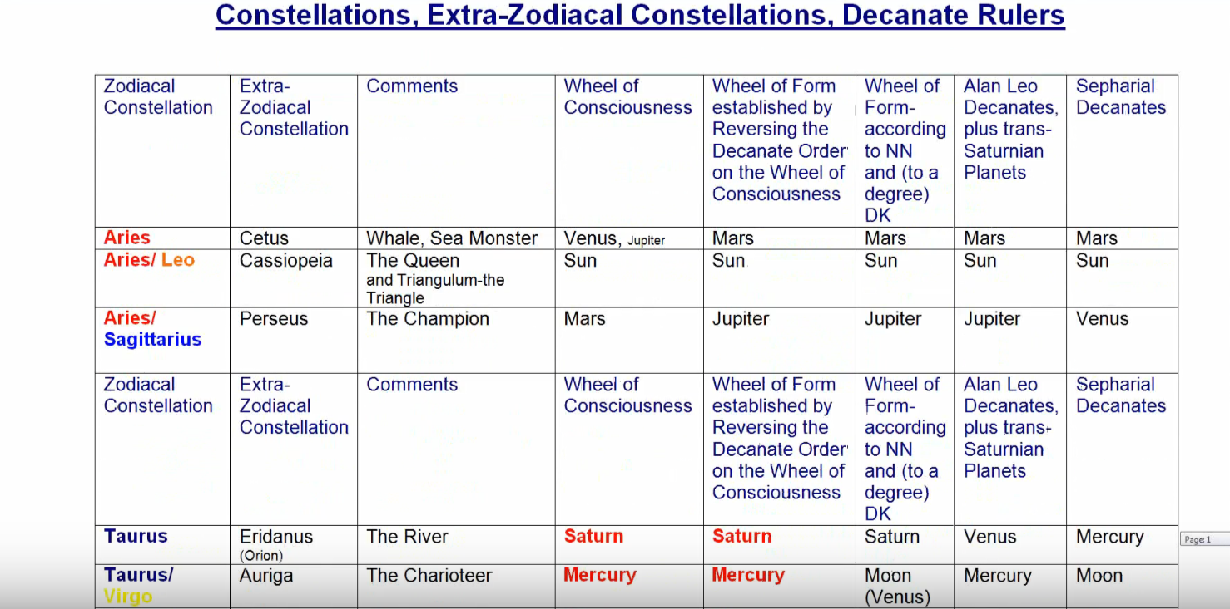

Well, Cetus, the Sea Monster, is well under control, since the ancient authority of the personality is ended, and all the unconscious forces are rendered conscious.

1:45:32 Cassiopeia? She is the queen and she's the material queen, and she no longer sits upon the throne; the soul sits upon the throne.

Perseus? We are the hero and we have overcome Medusa. Aries is very connected here, and every sign of the zodiac is connected here with every petal so every sign of this zodiac is connected with a particular petal, then the extra zodiacal constellations connected to the sign post also be connected. So, Perseus defeats illusion. He uses the burnished shield of the mind to get his bearings upon the location of the Medusa, and its nature, and without staring at her directly, he cuts off her head. So, illusions by Perseus are dethroned and we realize that this is the petal in which the first major illusion of time and space is defeated. There are other illusions along the way. They are defeated and DK has reminded us that until the ninth initiation is completed we have not really dispelled illusion. Of course, I guess it could go on because I imagine that compared to the Beingness of the One and Only, the entire universe is a veil.

If we go further, the River of Souls, well we are certainly mastering the incarnational process by this time. Maybe not all, but those who are the occult nature, and who are treading this path of who are conscious occultists, they are more consciously taking their incarnations and they are part of the reversed flow. Eridanus, can be connected with the antahkarana or with the sutratma, the flow into life and the flow out of life in form, out of form, and into Liberation.

With Auriga, the speedy charioteer perhaps the speed of Sagittarius is involved in the beginning of this petal as we are on the level tableland, and approaching via our galloping horse, the mountain, which we must climb in this petal.

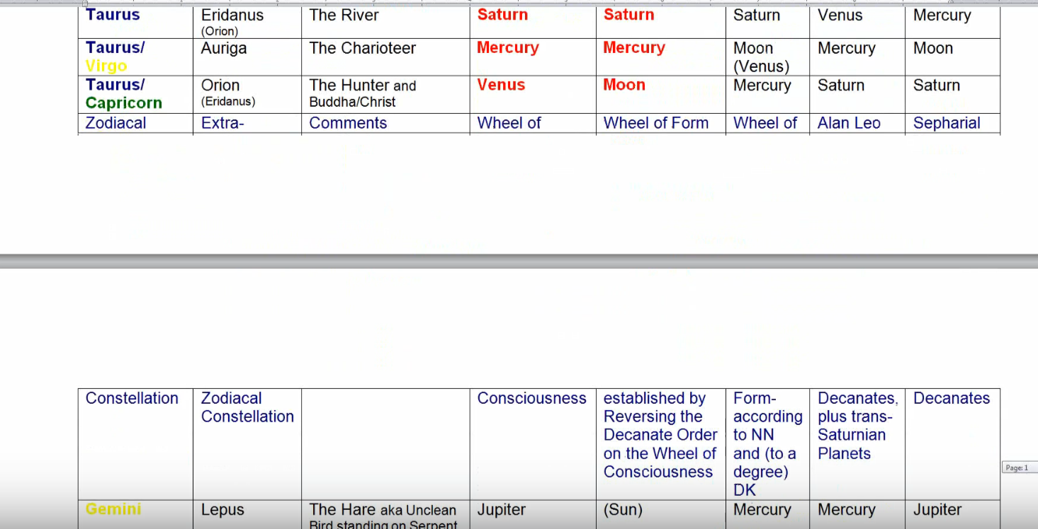

Orion is the symbol of great illumination and also the Christ consciousness of the soul. Orion definitely can be connected here. There are seven great stars in Orion. Seven great stars in the bear. Seven head centers. We are able to connect Orion with the transfigured state.

With Lepus, the personality can no longer escape. Cannot get away, because we really have a dominating position here. That domination already began in relation to the seventh petal, we are told, we learn to control even in the seventh petal of the personality of the dominance is very stronger here.

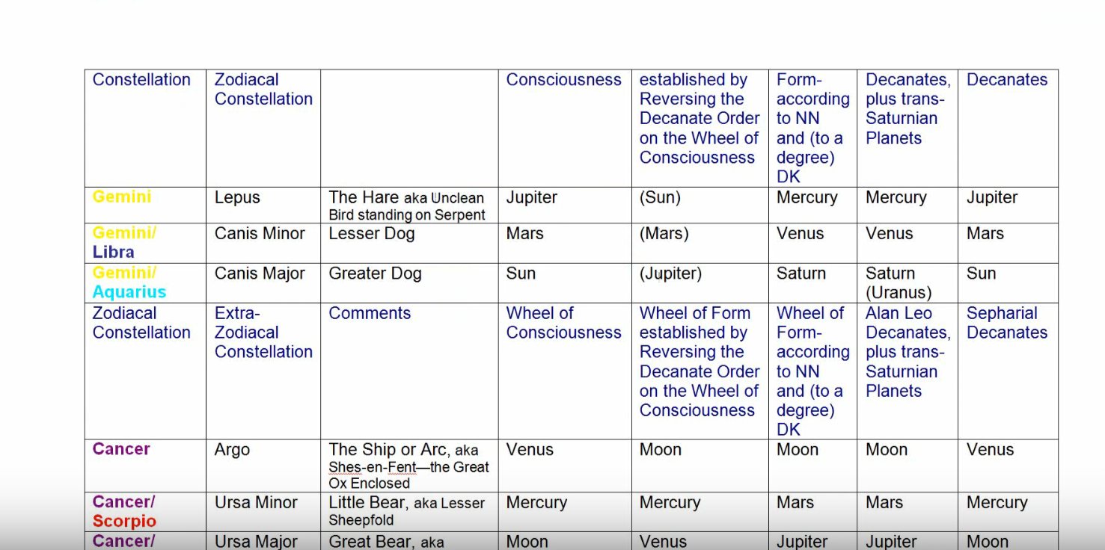

Canis Minor we know what smaller ashram were part of, and in Canis Major we are becoming definitely a part of the larger ashram of hierarchy. We're in an ashram and we travel with that ashram on the ship Argo. All of us who are actually ashramic members are venturing on a great quest. Again, well let’s see have I really done that correctly? If I go back, I would say that Canis Minor is all about our aspiring state of mind, and we have that, but it has given way to the star of initiation, in Canis Major, the greater dog, and we're definitely confirmed in the Sirian method of initiation. When it comes to the ashrams, I should have spoken here in relation to Cancer.

Ursa Minor is the lesser ashram of which we know ourselves to be a member by this time, and a fuller member once the third degree is taken. And Ursa Major, the ashram which is the hierarchy itself, and now we are confirmed, having taken the third degree, confirmed member of that ashram. Not at its very inmost heart, of course, but we are a confirmed member.

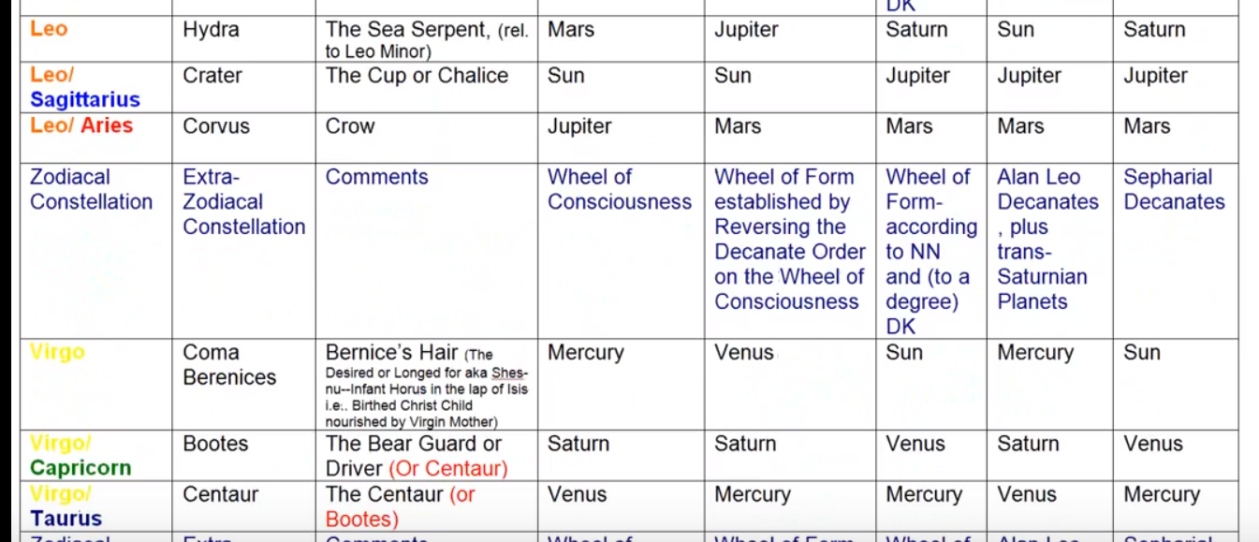

Again, as with Cetus the Hydra is controlled in Leo. It can lead us into maya, deception, glamor, illusion,

Crater, our egoic lotus has become a definite cup of receptivity, and the Christ force is pouring into it and the energies of the spiritual pride are animating it. It can contain the higher energies.

Under Corvus, the crow, we can read the karmic signs, we know what are the omens, we know something of the law because we are living more according to that law, atma and the higher mind are related. Atma and the mental permanent atom, atma and the law, and the crow brings testimony to the law. The lower ego is never allowed to transgress that law.

With Coma Berenices I would say, yes, although it might have been a little hard to find the way Virgo is related here if we're dealing with the utter sacrifice of all forever. Bernice sacrificed her hair for her husband to return safely from war. So, we're learning how to sacrifice the lesser for the greater.

Booties sometimes the symbol of the Christ. The bear driver, and the one who cultivates the Christ consciousness, who also knows how to reap cosmically in the right way.

Centaur? Well, my wife thinks we should be reverse Boötes in the first place, as the Christ figure, and the centaur in the second place. In any case the Centaurs a great hunter here, and he spears Lupus Wolf, which is our own personality nature and lays it upon the altar. The altar of the soul. That's also part of the sacrificial theme, if it's the utter sacrifice of all forever, the Centaur is the animal being engaged in a sacrificial act here. So that the Centaur can become truly the man and the arrow of intuition and so forth, but first the sacrifice must be made.

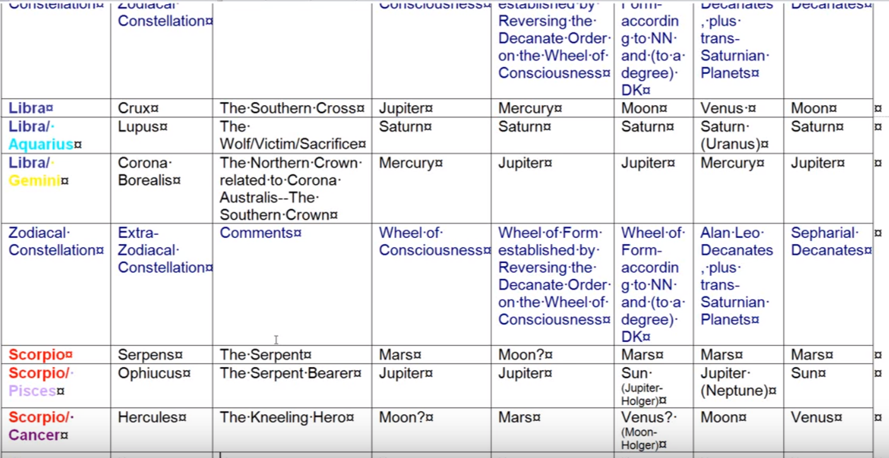

The Southern Cross in Libra, it's all about the development of Christ consciousness. There are some interesting discussions about when that cross has been visible and from what particular latitude, from what particular country.

Lupus is our hide, it's our externality, it's the personality which has to be sacrificed on the altar to the second aspect.

We will be crowned, the Corona Borealis of the third degree is a kind of crowning, there's a kind of royalty involved with it, but the later crowning comes in relation to Shamballa with Libra representing the royal road and the Corona Borealis representing the entire of the unfolded head center.

1:53:30 Serpens, the serpent who goes along with Hydra, and Cetus, is mastered by the great healer, Ophiuchus. He learned many things in his quests, just the way he does when developing the mind, becoming rich in knowledge of the world and its spiritual implications. So, the results of their many quests have come home in a type of synthesis.

Certainly, we are triumphant, we can be triumphant three times as Hercules. Under Scorpio, triumphant physically, emotionally, and mentally, now we are trying to mentally here, because we have overcome to a significant extent illusion. Yet we have humility because we kneel and we lift the Hydra up into the light of day, which is interestingly, the type of light associated with Scorpio and with the buddhic plane and it collapses, it becomes weak and is no longer the threat it has been.

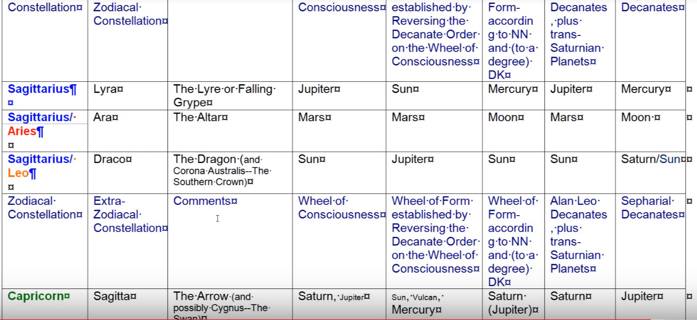

With Lyra, the falling gripe? I think it is the falling solar angel coming into incarnation, and certainly our appreciation of what the solar angel has done for us when it fell into incarnation under Sagittarius long ago, is balanced by our sight of the solar angel now, again under Sagittarius.

The Altar of sacrifice? We're all ready to sacrifice the lesser for the greater, it’s our altar.

Draco, at this time as the source of cosmic buddhi, or let's call it a major source of cosmic buddhic, which will make of us eventually a lesser dragon of wisdom has to be considered. In terms of how it conveys the second aspect. These great consolations, they don't have only one ray (neither do we) but they have their monad, their soul, their personality, that goes all through the beings found in this cosmos the first second third aspect of it. So, it sounds like a significant aspect of Draco is on the second ray and conveys cosmic buddhi, in which we're becoming very interested as we are blending buddhi and manas as we take the third degree.

1:56:00 I mentioned Sagitta, we're preparing to tread the via Dolorosa.

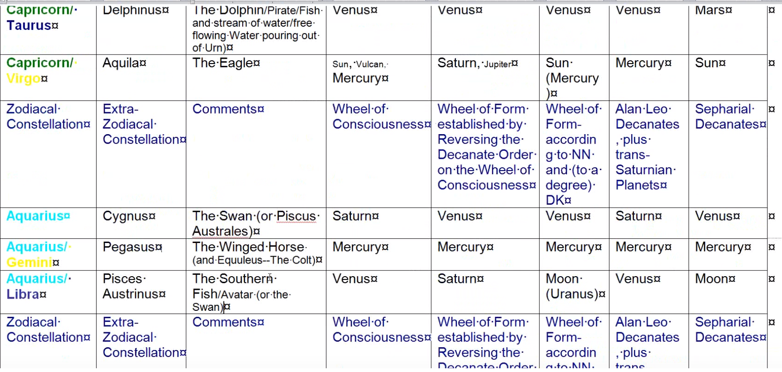

Delphinus, is giving us the freedom of the soul, because we can exercise soul powers and leave the water of matter behind.

Aquilla, it is prominent in taking the third initiation. It is the last decanate ruled by Mercury, Vulcan and the sun, and bringing great illumination luminosity and power. Aquila, of course, is the great first ray bird, and it also symbol symbolizes the spirit aspect, the will aspect, which comes in touch with us at this point.

Cygnus the swan, I always think of it as the swan out of time and space, and it relates to the appreciation not just of the three aspects, but of life itself. It is a huge appreciation that is spreading its wings here and something about the life aspects, that an Arhat appreciates, is coming into our understanding once we've taken the third degree.

Pegasus, the winged horse? We have left here and we probably have wings by means of which we can fly above the mountain. In one way, in Capricorn we stand on the mountain in another way as Cygnus the swan or Pegasus the horse, we rise over the mountain and do not need to have our feet on the ground to be sustained in the air of God.

Pisces Austrinus? We are influenced by the savior impulse. Not all will tread the path of the world saviors, but at this point we have such a benevolence towards humanity, once we have taken the third degree.

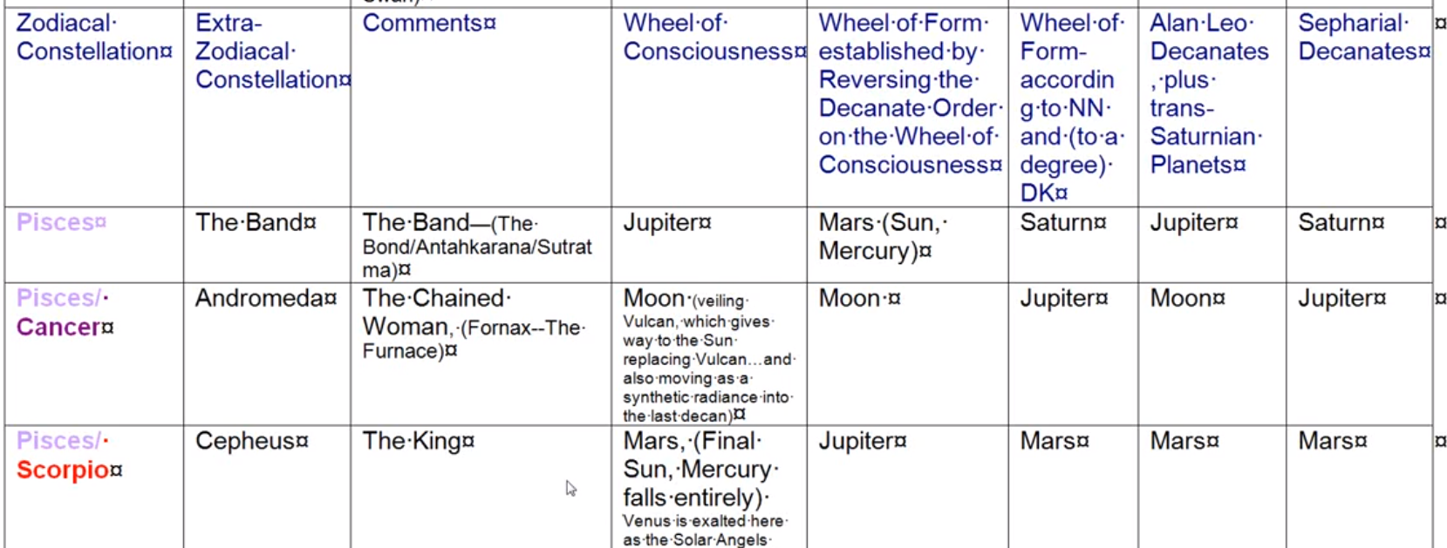

With the Band in Pisces, the soul has captivated entirely the personality. The personality’s authority is bound, utterly bound.

Andromeda, the chained woman, is the woman unchained, because the soul is now in the majority.

Cepheus, Sanat Kumara, the King is in sight, and His energy is now released. In a moderate way but still in a significant way, into our consciousness and into our energy system. When we achieve the fifth degree, Cepheus will really emerge and we too become the master and the king.

So interesting those extra zodiacal are they not? I find them. The more you go with them, you realize that yes of course the average person can also receive something of their nature, it will not be in the full archetypal sense, but it will bear the signature of what that extra zodiacal diagram constellation really brings.

I think, under the circumstances, it may be useful to bring this little program to an end, and go on with number 37 at the next occasion, which I hope and trust will be soon. So, this is the end of egoic lotus webinar commentary program 58 … part two, of synthesis for petal number nine and we will be beginning of egoic lotus webinar commentary program 59 which will be part … three of the synthesis for petal number nine.

It’s so interesting to me. The great thing would be of course to have the kind of facility with these energies that one could summon them and direct them towards the target, which represented for the individual the next step ahead of him the particular petal which he had isolated as being the petal in which he's working. So, you can get a synthetic picture, but can you use it, can we use it? That's the question. Can we use it? If you will have some practice sessions in using these things, maybe some kind of example about how to use a particular energy to accomplish a task in a particular petal, that would be of the practical side, wouldn't it?

Okay, everybody, we’ll get on to program 59.

