EGOIC LOTUS WEBINARS, VIDEO COMMENTARY – 45, Michael Robbins
Abstract

Egoic Lotus Webinar Commentaries 45: Part 4 of Synthesis for petal 6.

This webinar is about 2 hours, 2 minutes long. Program 45 continues with an analysis of the Synthesis Document for petal 6. This sixth petal is particularly related to the process of treading the Path of Probation, assuming that the Path of Probation ends at the first initiation. Some perspectives see that Path continuing until the stage of “Accepted Discipleship” is reached. This sixth petal is largely correlated with the sign Virgo (but also with Pisces) and is a ‘petal of self-correction’. One strives to correct one’s selfish tendencies for the sake of the welfare of the group. One can see that work towards the Christ-consciousness is in process.

This is an important petal for those transferring off the Mutable Cross onto the Fixed Cross at the first initiation. In this program the relationship of the various planets and signs are discussed in relation to petal 6 Processes.

Egoic Lotus Webinar Commentaries 45 279 MB .wmv file
Video of Egoic Lotus Webinar Commentaries 45 by Michael D. Robbins.

Egoic Lotus Webinar Commentaries 45 116 MB .mp3 file
Audio of Egoic Lotus Webinar Commentaries 45 by Michael D. Robbins.

Transcript.

Good morning, friends.

We are continuing with our work on the egoic lotus. We're in petal six and we're looking at the synthesis or the collection of information for petal six with its colors: rose, orange, yellow, and indigo. We've been taking this rather long section in parts. So we are at number 45 and we're beginning with part four, the synthesis of petal six, part four.

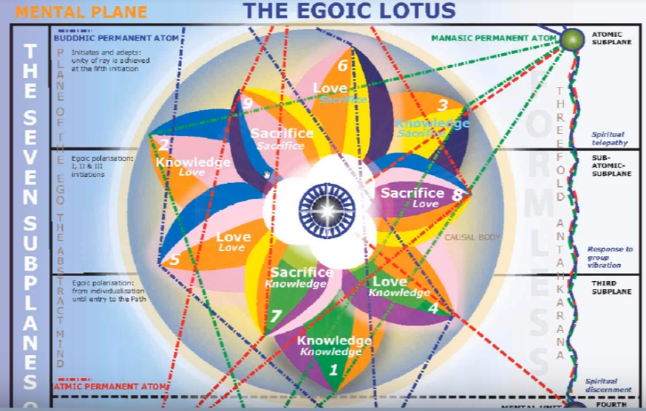

We're looking now at some signs that may be implicated in the processes of this petal and the way that they function in relation to this petal. If you have them in your horoscope or you're working with the signs.

The signs that are chosen here: Taurus, Gemini, Capricorn, Aquarius and Pisces. We've already talked quite a bit about Virgo, and we've talked about Pisces and Libra as well, so already Virgo, Pisces and also Libra have been discussed in relation to the cycles which begin at petal one with Aries or Pisces moving counter-clockwise or clockwise.

What about Taurus in relation to petal six? We have this interesting factor that in petal six one serves, one gives, but one expects to receive something back. So the factor of acquisition can be there, also the attachment to the personality and the stubbornness of the personality and giving up its prerogatives.

What about Gemini? Well there is the give-and-take here of Gemini, and what is the motive for it. There is an essential duality; I am becoming more conscious of this duality I'm becoming more consciousness of the matter conscious of the demands of the soul and of the group, and thus I am torn between these pairs of opposites. This fits as well with the way that the fourth ray can work in relation to this petal.

0:03:15 I think it would be useful to go into this to sort of repeat what is said here about this petal.

3. The Petal of Sacrifice for the astral plane; unfoldment is brought about by the attitude of man as he consciously endeavours to give up his own desires for the sake of his group. His motive is still somewhat a blind one, and still coloured by the desire for a return of that which he gives and for love from those he seeks to serve, but it is of a much higher order than the blind sacrifice to which a man is driven by circumstances as is the case in the earlier unfoldment. As this threefold enlightenment or unfoldment proceeds, again a dual result is seen: TCF 541-542

It is the petal of sacrifice for the astral plane. Unfoldment is brought about by the attitude of man as he consciously endeavours to give up his own desires for the sake of his group. His motive is still somewhat a blind one, and still coloured by the desire for a return of that which he gives and for love for those he seeks to serve, but it is of a much higher order than the blind sacrifice to which a man is driven by circumstances as it is the case in the earlier unfoldment. As this threefold enlightenment or unfoldment proceeds, again a dual result is seen: Then this about the development of the astral permanent atom accompanying the development of the physical permanent atom.

What about Capricorn? Well he is preparing for the first initiation here, so one must discipline oneself. There's a lot of the third ray and the seventh ray here in Capricorn and it helps with the summing of the mutable cross.

What about Aquarius? Well he's attempting to give up his desires for the sake of the group and this is an Aquarian thing to do. He's seeking to be decentralised with regard to his personality. Let's just say seeking greater centralisation with regard to his personality.

Pisces, I've discussed this a bit before, let's see … a number of things being discussed here, Sagittarius as well. Let's look at Pisces, well it is a sign of sacrifice and it does end the mutable cross and there's the synthesizing, a lot of karma before the first initiation, and we know how much Pluto is active before the first initiation. So Pisces is very important before stepping upon the fixed cross and we are renouncing. Pisces is the sign of renunciation, we're renouncing strictly personal emphasis or at least we are attempting to in preparation for the first initiation and all the series of initiations have increasing group emphasis. So this is just giving up, the relinquishment of desire.

What about Sagittarius? I think it should be included up here Which I didn't do earlier, but I will put it right in here. Sagittarius is there. And what can we say about how this sign in relation to this petal? Well there is the aspiration, the vision of a better and higher life, the vision of the soul and the dedication to discipline and maybe it will be physical disciplines, maybe some emotional disciplines, and the mind perhaps is taught to think in a certain way. Sagittarius can relate to the religious orders which people find themselves involved in when they seek to discipline themselves. There is the idealism a good religionist or any kind of idealistic political – people don't always have to approach along religious lines or other groups to which they can and here and for which they seek to give up their strictly personal emphasis.

Someone is asking here, can this be the petal of religion or priest in a holy order, training himself becoming an inspiration for the community? I suppose that can happen. There are the ones who are guided and the ones who guide. This can occur here as we're moving in this disciplined way towards the first initiation.

I think a number of our people in our group obviously have the two-six emphasis and so they tend to express the possibilities of this petal in terms of those two rays.

Anyway Jupiter is involved here, the desire for something higher, something more expansive.

Does the one heading towards the first degree really know his path? Perhaps only partially. It’s still a limited point of view. With regard to Leo we might favor that personality centralisation is challenged. So this is but you say the need for the centralization.

What about Libra? Libra is in a way the path, and the treading of this narrow razor edge path and we are preparing to do that, we are beginning to tread the path in earnest. The true path really begins at initiation one but we are in the leading up to that.

It was said: to want to take the first degree is not necessary to have taken it. But Sagittarius is interesting because it's involved with both the first and the second degrees initiates probationary initiates the true initiates coming in in the sense in Capricorn at the third degree. Sagittarius brings in a lot of the sixth ray, so that will come in here at the sixth petal, because the idealism to improve is strong.

Someone mentioned the idea of Advent in the church calendar, and this is the preparation for the birth.

We talked about Aquarius a little bit of the growing group consciousness, the community and sacrifice for the community.

0:10:00 So we've had Taurus, Gemini, I'm not sure we've had Cancer or Aries, a little bit about Leo, Virgo, definitely Libra somewhat in preparing for the treading of the path. Scorpio always involved with the sacrificial petals and wherever there is a struggle. Sagittarius for the higher ideals; Capricorn for the disciplines involved; Aquarius for the community; and Pisces definite transference from the mutable cross to the fixed cross.

I suppose we could say that Aries is a new orientation towards the soul.

Not quite sure what we can say here about the sign Cancer, but I'm sure we can find something along this line. It is a water sign after all and there is a kind of a growing consideration of others that comes into the Neptune rulership of Cancer, and certainly as we prepare for the first initiation here there must be that kind of growing sensitivity to others.

I think the idea has been that the little self has been building from the very first tier of petals and it's been so important as we go through the integrative process. Well we're not entirely integrated yet, because that is a factor which enters with the third initiation and even the fourth – the bringing together of these two energy systems in a very well functioning unity. But we are taking the pains to see how the integration process can be facilitated, how we can better receive and measure ourselves against the soul. This is the task here and we're definitely the beginning of the path of altruism. We can say that in a way it began in the fifth petal, the later part of the fifth petal and it's unfoldment. But here we are saying, ‘well look the self is not the most important thing. There are other and higher issues. The group is more important and the personality is being placed here in the sixth petal in a subsidiary position. There may be a bit of a struggle in doing that but at least we know that the personality is not formalized.’

We go on to the next item. What signs are implicated on the basis of color? Well, let's say Pisces, Leo, Gemini, Virgo, Libra.

The rose is not associated with any particular sign, at least rose has pink; I'm not talking about the red color. But a little bit of Pisces and the pastels come in here and that represents a kind of lightening up, we might say, we're adding the color white to red to produce the rose, and there's less heavy emphasis upon desire and more willingness to refine desire, raise desires, and give up desires.

The orange comes and brings Leo in and always the issue is what do we do with the self and what level of self are we talking about?

Yellow is the ruler or these given by the Tibetan in terms of Gemini, definitely. And also interestingly in terms of Virgo although we can look at other colors in relation to Virgo depending upon what ray we may be talking about.

Indigo is interestingly assigned to Libra, suggesting it’s ray two content certainly because it is the sign which brings in not only ray three but increasingly ray two, divine love and understanding as it is said and also the higher color, the esoteric color for the fifth ray that is related to Libra through Venus is indigo.

Many colors qualities, energies, come together all of the petal processes and it's just a question of how to use them. I think everyone should sit down with himself and say, ‘well look, where am I really working and what do I have at my disposal to help me work in that particular area?’ Your sun and your rising sign and maybe moon sign too and other stelliums are very important in how you approach life, but they will be differently mobilized depending upon the petal in which you are working, primarily, where your major concentration may be.

This kind of work can be spread across two, maybe three petals, so let's just say you are working at some sort of synthesis in the sacrificed tier. It doesn't mean that you're not still struggling with the issue of sacrifice in petal eight, or that you're not accumulating knowledge to use on behalf of humanity in petal number seven. All three areas can be nurtured by the kind of activity that you are engaged in.

What is the major constellation most implicated? We can say Sirius or Canis Major because Sirius begins our whole regime of initiation. And the Pleiades? We're still dealing with the personality, it’s not the Pleiades perhaps in the sense of cosmic buddhi. The buddhic vibration does reach the solar angels also via the Pleiades and they bring it in to our life increasingly. It's not only the initiator, it is also the solar angel whose nature is very much buddhi and bringing to us this love-wisdom vibration.

0:17:20 For Sirius the soul is the objective, but we still have to deal with all that Sirius represents because we are dealing with Virgo. There's a very interesting relationship D.K. tells us with Virgo we are leaving the form and the cross of form, the mutable cross behind. In a way this is our last contact with the mutable cross as an area of particular focus for us. We may still have to deal with many little crosses, but we're not so to speak working upon the cross of many changes hoping to increase our abilities. We are working increasingly upon the fixed cross at least in this petal we're working towards the fixed cross.

We are dealing with the constituents of the personality and these can be called the Army of the Voice, and they come in I think strongly under the Pleiades and under Virgo. We have to improve all the little lives which are in a sense ruled by the third aspect of the Pleiades. This whole idea of improvement, self improvement in the sixth petal is a strong one. There's a lot of people who are not initiates yet of the first degree but they certainly have caught the idea that their personality nature can be improved in terms of its health, it’s emotional attitudes, its mentality. The self-help books and mode of understanding is pretty popular today, I think all of this has a lot to do with the sixth petal. So we're getting our Pleiadian form into shape, so to speak.

Now we have also been taking a look at some of the extra-zodiacal constellations, the ones that are associated with the constellations of the zodiac but are not themselves zodiacal constellations … I mention here Coma Berenices is associated with the first decanate of Virgo of the Centaur. Well which decanate will it be associated with? Some people say the third, others say the second. Really in fact if one is a Virgo, all of the Virgo decanates, or extra-zodiacal constellations will be associated with one's being, but perhaps there will be an emphasis along a certain line, depending upon the degree of evolution of the individual and maybe upon decanate.

Lupus the wolf and Ara the Altar. Well, Coma Berenices is definitely associated with sacrifice. The story is that Bernice’s husband was going off to war and as was the custom at that time, the cutting of the hair was considered to be sacrificial and she did this so that he would come back safely from the war. Kind of a magical type of thinking, but the idea is that we cut off much of our expression, we discipline ourselves and the fullness of our expression which the hair can represent in order for something of a higher nature to occur. You see many priests, even nuns, they shave their head if a kind of sacrifice of their personal nature in the expectation that through the reduction of this relationship with normal life they will receive benefits of a higher kind.

Centaur, Lupus, Ara. Centaur with his spear, spears Lupus the wolf and lays the skin, or the wolf, upon the altar in Sagittarius. Centaur is found in Virgo. Lupus in the second decanate of Libra. That's what we usually associate it with. And Ara the altar the second decanate of Sagittarius. So there's the conscious sacrifice for the sake of others, and that's what these three together are all about. The sacrifice is still a little blind, if you want for yourself and for the separated personality then sacrifice is still somewhat blind.

If we look at the decanates here, I wonder if we can find others that might be associated with the processes of this sixth petal.

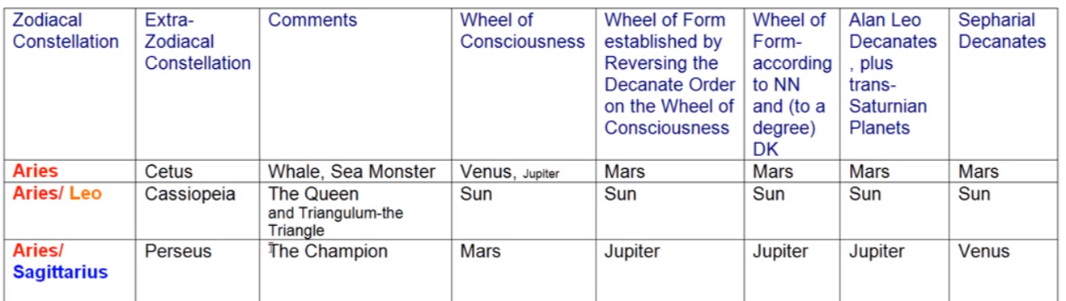

Well, Cetus, the Sea Monster, swallowing the personality. I think we are beyond that.

Cassiopeia is the queen of matter and certainly that's being put behind us.

Are we yet Perseus, the champion? Well, we're undertaking some adjustments, but we're not really cutting off the head of the gorgon.

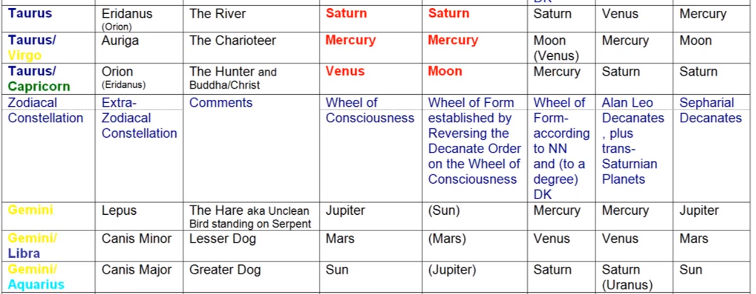

0:22:50 Eridanus, the river of incarnation in Taurus. Maybe, maybe not. …

Auriga, the charioteer? Are we making rapid progress? Maybe to a certain degree.

Orion? Not necessarily, no. Increasing illumination is coming.

Lepus the Hare? Well, in Gemini Lepus will try to run away from the Hound of Heaven, run away from the dog, which represents either the rightly oriented personality or the soul-infused personality. Canis Major? Yes we are definitely with Canis Minor, we are becoming the aspirant and that is one of the meanings according to Alice Bailey of this particular constellation with its star Perseid. And so where we're seeking to move forward rapidly along the path of probation towards the greater dog, towards Sirius. We've already talked about the connection of Sirius here representing the soul. There is soul orientation.

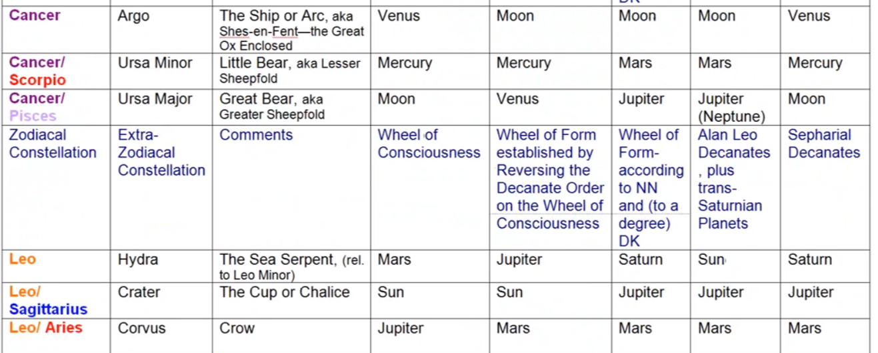

Argo, the ship in which we integrate many faculties, you and go off on a great quest. Is it so here? A little bit perhaps.

The Little Bear is again a constellation the orientation. And we are beginning to enter a group of those who are aspirants and who are lesser disciples and have to stay within certain boundaries.

The greater will of the Great Bear? Maybe not so much yet. Hydra associated with Leo and the sea serpent. Well I think we've taken care of a lot of the greater problems in our personality here, but to the extent that they have to be eliminated we can deal with Hydras.

Crater, the cup of karma? I think there is a personal karma to take care of here in relation to the sixth petal before we can be free of it and move into that new phase of life represented by the first initiation.

The intimations of karma given by the Crow? Yes we do receive messages as to what must be corrected.

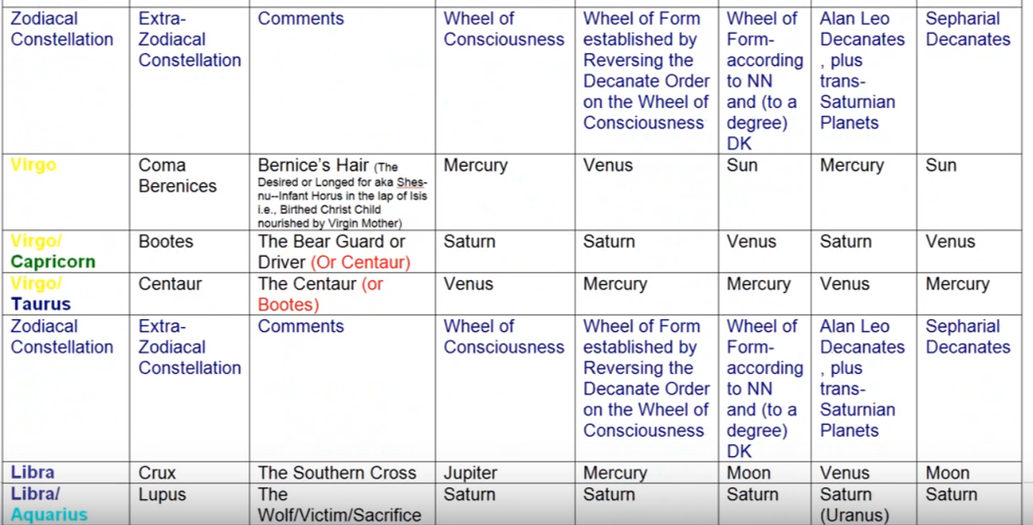

As stated, Coma Berenices. But also known, Niklas Nihlen has gathered a lot of this information. … and the infant Horus on the lap of Isis, the birth of the Christ child nourished by the Virgin Mother. There is all of this nourishing of the growing soul consciousness and that fits very well with Virgo and with Coma Berenices. It's always a sacrifice to nurture the Christ consciousness within. I think any parent who is taking care of children at an early age, before their on their own, realizes how attentive one must be.

Bootes? Well, as I say there's a reversal here oftentimes the Centaur is involved because he definitely spears the personality and places him on the altar.

The bear guard or driver? Well this said this is related to the Christ consciousness and to harvesting with the sickle that the bear driver is carrying, one's karma in preparation for higher things.

Crux, the Southern Cross? Let's say that the soul is coming into view.

The Wolf, Lupus, is the victim. He is the sacrifice, and we are definitely going to sacrifice petal here and we are learning how to sacrifice the personality.

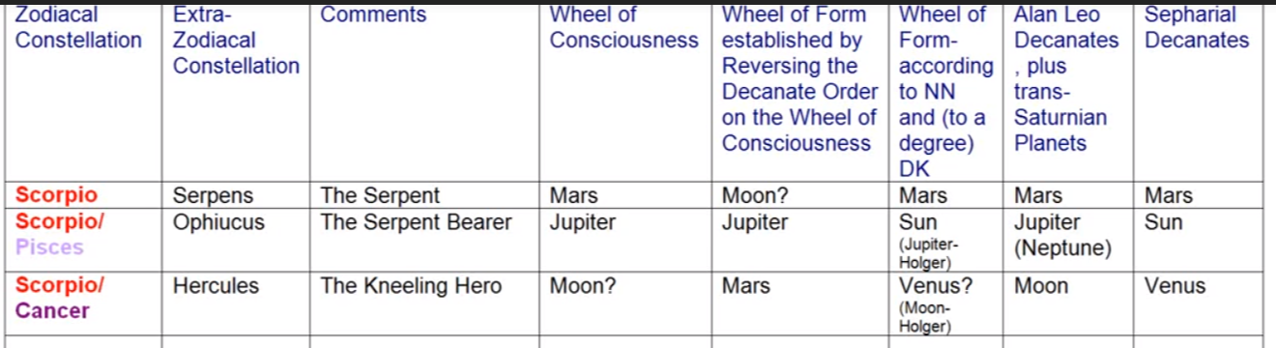

Are we necessarily crowned yet with the Corona Borealis? We're moving toward that, but it's not so focal.

Serpens, we are overcoming the serpent, but not as intensely as we will in petal eight. Do we have some remedies?

The Serpent Bearer, Ophiucus, is related to medicine and to various types of healing. We are healing aspects of the personality in preparation for its ascent onto a new level with the first initiation.

We are maybe a little bit Hercules but not as much as we will be in petal number eight.

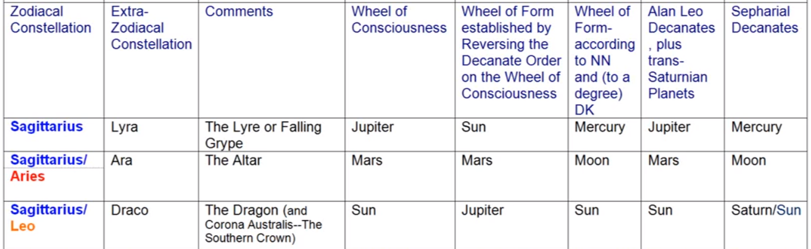

Lyra or the falling gripe? That is the descent of the solar angels one way and perhaps more and more we are feeling that solar angelic power.

Ara the altar is definitely there for the sacrificial petal number six, we are laying the personality upon the altar. We even did that unconsciously in petal number three.

The Dragon? Well it's such a huge constellation you kind of wonder how it can be associated with a simple sign like Sagittarius. But it is representing all dragons of wisdom and we are setting our foot upon this path of wisdom on the probationary path.

The arrow is Sagitta and it is the arrow of suffering, and Dolor, or Via Dolorosa, there is some of this necessary relinquishment and the sadness that goes along with that occurring in this petal. Are we free to play as the soul can play, the dolphin? Not yet.

And we are not yet the conquering eagle in Capricorn, but that begins, that really comes into his fulfillment at the third initiation.

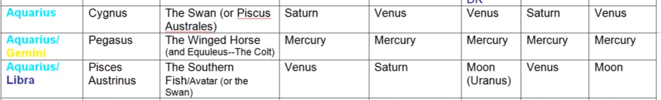

Cygnus, the Swan, well there's again different ways of looking at this. The Swan is definitely liberated and could possibly be related to the third decanate.

Pegasus, the winged horse? We are trying to make progress, but it's a little mundane and we're not quite liberated into the realm of mind and higher impression where we can really fly because the personality is the horse, we understand, and when it has wings it already is endowed with soul capacities. The southern star.

The fish avatar, the Southern Fish, Pisces Austrinus? Well we are not yet the savior but we are learning somewhat how to save ourselves by correcting the personality.

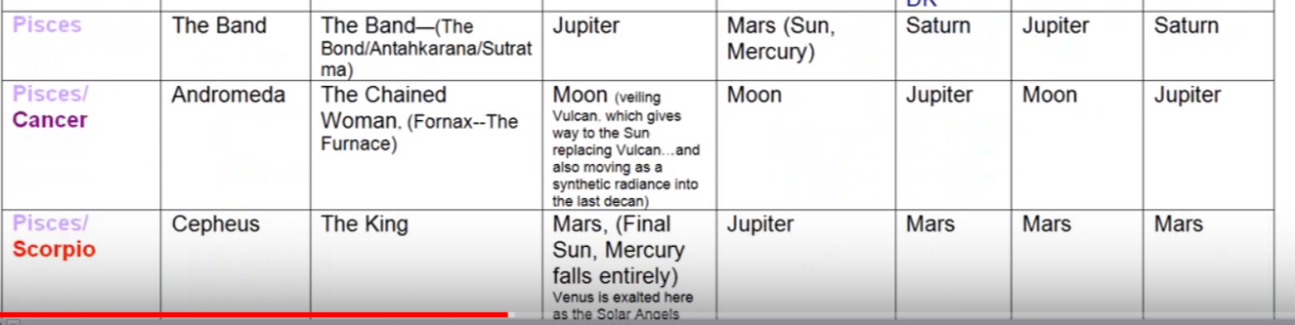

The Band is there and we are increasingly tied to the soul in Pisces.

We are liberating the personality and maybe were liberating the soul from the personality in Andromeda.

We have not yet come under the influence of Cepheus, the King, who is in a way the king of Shamballa.

0:31:00 So these are sort of a quick examination of how some of these extra zodiacal constellations might come in touch with, and influence the processes undertaken in this sixth petal. Remember we are differentiating between processes which you under taken deliberately as you are organizing and vitalizing or organizing, coordinating, vitalizing the petals, and then what happens later when additional energy is added to the work you've already done?

Maybe it's not so necessary to work in such a focal manner because you are supported. The work you've already done you've supported and made to blossom, made to unfold as it were, a fitting word in this case, made to unfold either by the second logos from the earlier days of solar angels in middle days, or by the solar angel and the rod of initiation in the later days.

I think you should look at the particular extra-zodiacal constellations associated with your ascendant and your sun sign especially or any particular stellium that you have where that may be a place where a ruling planet is found and see if any of those extra-zodiacal consolations offer you energy of a kind which can be used in the petal process on which you are focused. I mean we're all working somewhere aren't we, and that somewhere is reflected in the egoic lotus where the treasures of our labors are stored. Our capacity is what we really generated in terms of quality and ability are stored within the egoic lotus can be drawn upon, but at the same time we are working at placing new abilities that treasure house and that is more laborious. That's our work of organization, organizing, coordinating and vitalizing with our own energy, more vitalization comes later through additional supplemental helping energy.

What about the synthesizing planet most associated with this tier or petal? Well it's Neptune, with the entire tier, Neptune correlating with the astral plane and these are water petals, love petals for the astral plane and we are I think learning how to get along in the world and make a contribution in a worldly sense, a constructive sense, not necessarily one that is self consciously spiritual, but now we're in a transition phase. Always in the sacrifice of petals we're in a transition phase looking towards some higher objective.

The division of the synthesizing planetary triplicity most associated with petal? Neptune sub Uranus. In a way this is the possibility of moving from the mystical to the occult, from intense feeling nature to the mind engaged in spirituality and therefore in a sense from Neptune to Uranus. Uranus has a very strong mental content it is in a way the higher octave of Mercury, and Neptune as Neptune is the higher octave of Venus. Certainly the sentience content of Neptune is very, very high, but we are seeking to move from mysticism to the conscious, intelligent treading of the spiritual path here.

So a new order is about to occur. The order that is brought in through the process of initiation and this new order is Uranian and it's related to the seventh ray. Uranus is the planet of initiation and we are about to meet the Heirophant in petal number seven. Well the Heirophant can be the lord Maitreya, or the Christ, or it can be Sanat Kumara, or we might say that Neptune is more associated with the lord Maitreya as hierophant, and Uranus is more associated with Sanat Kumara. But always the one who raises you into a new order of life can be considered generically to be Uranian.

For many the use of the mind spiritually is now a possibility and not just the longing in the belief in the worshipping and all of that kind of thing, but any faculty of the human being can be used spiritually and that's what we are trying to understand as we make the transition in this petal.

Now the neighboring planets, what have I called them? They neighbor the earth. We can say that they are Venus, Mercury and Mars. They are different from the synthesizing planets but they have a reflection of their synthesizing planets in their nature, and I would say that they bring planet most associated with this petal is Venus. It’s with the tier. We have Mars for the outer tier, Venus for the central tier, and Mercury whose color is yellow, just the way Venus is color can be considered rose for the second or love tier, the color of Mars is orange or red and there is no red apparently built into the causal body at least in terms of the usual expression of the colors in relation to each petal though later of the red may enter as the primary color of those upon the first ray and somehow color the egoic lotus. We’ll have to wait until we really see. So far the red is not given, it's very much the color of Mars, but then so is the orange in a certain respect.

Well what division of the neighboring planetary triplicity is most associated with this petal? We can call it the Venus-Mercury division, so we're moving from the lower mind to the higher mind. Well we’re already in that type of higher mind but there is a still higher type of mind which is going to come in at the development of the sacrifice petals because they are petals for the mental plane.

Orange we can say is synthesizing the lower mind, it is associated with Venus and its fifth ray and Mercury or yellow will represent the higher mind, also buddhi of course and we are coming into application of buddhi with the first initiation.

So we are continuing to elevate our concrete thinking so that the soul affects our mind. I don't think we yet have the mind held steady in the light. Not quite, I mean we are not yet initiates when we are working at organizing this petal. But Mercury is a bridging planet and DK frequently refers to the Mercury Venus mind of the soul the mind of the divine hermaphrodite and the Mercury Venus mind is soul mind and it is coming into infusing the concrete mind. All of these sacrifice petals are somehow mental petals in a way. The sacrifice petals force you to think. Maybe man, manas, resists thinking except when necessity demands it and the harshness necessity encountered in sacrifice petals forces thinking. DK has sometimes been describing people's mental nature that can be used when there is a need for it but is not normally used.

We have to really begin thinking about the soul in this petal, thinking about what is the nature of this higher power which we have begun to feel, when working in petal four and five. As well in petal five I think we know there is a higher power, but the personality force can be so strong that we reject it and we choose to make the personality the king, instead of the soul of a king, and we suffer a downfall because of that. Then sensitized through suffering, then we are prepared to make the higher of the pairs of opposites into the monarch of our little system.

0:41:30 What about the Sun-Moon polarity most associated with the petal? Well both the sun and the moon we could say. We could say all through the second tier there was a mixture of sun and moon. Remember I called the first four petals lunar petals, and the last five petals solar petals. But in the middle tier the personality is not really subdued and increasingly the moon representing the personality is subdued during the process of initiation.

If Capricorn rules initiation and the moon rules the personality well the moon is in detriment in Capricorn so that tells us something about the position of the waning and even falling position of the moon during the process of initiation.

At the fifth petal, the sun really starts to be important so this particular sixth petal is the petal aiming at solar life, but the petal has to be connected with the moon because the moon is the esoteric ruler of Virgo and represents the forms which have to be consciously improved. In this petal the love for the form is re-directed to the love of the higher of the pairs of opposites, love of the soul.

So it's how the moon is getting ready for the sun, and the whole idea of the whole of the nuns considering themselves the Brides of Christ; they are preparing the vessel of their consciousness for the entry of the bridegroom who is the Christ. Virgo is really esoterically ruled by the moon and we're getting the moon ready for the birth of the Christ. We do not want to kill the moon. I suppose there is a possibility in this petal that people could go in for those kinds of disciplines that would make the personality a poor dead thing, as the Tibetan has warned.

But if it's a good petal for getting into shape and for shaping up, it's got a strong Vulcan quality to it and Vulcan is all about getting into shape and Mercury is about improving the ways of intelligence in matter and Venus is about refining. The solar angels fell in Venus, and we can say well that's a bad position for Venus in Virgo, but it’s not, it’s the sacrificial position which brings a lot of refinement to matter.

So we could say the first tier is really all moon, in a way. We don't really have the ahamkara, the real personality. In the second tier the moon and the sun, in the third tier the sun takes over from the time of the first initiation, and the sun then is the over balancing factor, because initiation is solar and not lunar. It will have its effect in the lunar vehicles but it is coming from Venus, the Sun and Sirius, a very solar line. So the moon is in detriment and is falling when the sun is empowered.

0:45:00 We learned that the planet Mercury is very important in this petal, and Mercury and the sun are one. We can say that in this petal the soul as the sun is training the moon. It’s really a training petal and when you see people really subjecting themselves to the disciplines here, we can know or understand that petal six may be strong. There are so many people who just say, ‘I am as I am in petal number five’, we might say that very much, ‘I am as I am and I'm going to be actually what I am.’ But in petal six we say, ‘well, how should I be? I may be as I am, and I may have built up this personality in this habit nature and all that, but how should I change the configuration in order to become more solar?

In that will-to-change we also see Uranus, don't we? Because you're in this always improving structures and – we even see the fourth ray, as we have discussed before, it is called the corrector of the form and we are involved in that, I mean Virgo is certainly a corrector of the form. And the first two planets to rule Virgo are Mercury and the moon both of them bringing in we are told the fourth ray. Also Mercury is the exalted planet in Virgo emphasizing even more the fourth ray of the necessity to correct the form, which is an act of sacrifice and the fourth ray is associated with the law of sacrifice

So what are the planets of then which are implicated here? Vulcan, Mercury, Venus, Mars, Jupiter, Saturn, Uranus, Neptune, Pluto. Looks like we've got them all. And I wonder about the earth. What about the earth? As I say we can find all of the planets implicated in the processes of every petal, but some step to the fore more easily and are more easily recognized.

Vulcan? What about it? It is it is a hidden planet but it's very effective in the lives of becoming disciples, it rules Virgo. It has to do with the purification of matter so that the light content of matter can be released. It is closely connected with the shaping up of matter and the physical disciplines which are sometimes hard to apply pressure to yourself, but that's what they say, ‘no pain no gain’. Well the forcing yourself to do something is a very Vulcanian for the town. To do something is very Vulcanian and Saturnian.

Those two go together with the hammer and sickle, Vulcan with the hammer, Saturn as the sickle. We see that that was the symbol of the Soviet Union where the proletariat, ruled by Virgo, were brought into a position of prominence. They were given some kind of dictatorship, it's a turning things a little bit upside down, but we have talked about the dictatorship of the proletariat.

Well what about the improvement of the proletariat? That inevitably was going on, and there was a huge industrialization that made it possible for Russia to prevail in the Second World War. All of this was forced upon the people so much under Vulcan and Saturn, was forced upon them by Stalin, who was says the Tibetan a disciple of Shamballa; He's not saying whether he was a good man or a bad man, maybe he was a little bit in the middle. But he was, along with Lenin and others, disciples of Shamballa and Shamballa is using these planets Vulcan and Saturn very much.

We know how much Shamballa is connected with Taurus, and Vulcan is the ruler there, and we know that Shamballa is connected with Leo and there is a progression there from the Great Bear, Leo, Saturn and Shamballa. So imposition is found with these two planets, and we have quite a bit of imposition of the nascent will here. The will is growing in petal six and desire is taking a back seat. Maybe not in the life of the mystic per se, but even the mystic will have to apply will to succeed with certain disciplines. Here it is, we are applying the spiritual wills of the matter of our vehicles so that we are worthy of the birth of the Christ.

We're also making matter lighter, refining it under Venus, but Vulcan does apply the will to help refine matter and to make it shine. We're told, it always did impress me, that Vulcan burnishes the shield of Mars; the shields are the vehicles I believe, and Mars is the entire personality, and this burnishing is a polishing act to bring out the radiatory content of the matter. We can look at a stone and well that's not very interesting it's just a stone, but then we start tumbling with a stone in the way that rock hounds do and before long we have a very beautiful shining object which has been polished and because of its polishing, its value comes out, its color value, its light value. Vulcan is doing that. We're getting rid of heaviness, we're raising the virgin matter up into heaven and making it lighter, more ethereal.

Vulcan can be connected with inferiority, it has a lot of connection not only with a dense physical plane but on the etheric level.

So Vulcan is active before initiation one and so is this petal.

Mercury? Well, we might create especially in relation to Virgo will give us knowledge of matter so that indeed it can be prepared. The mind is becoming quite keen here. Mercury in its third ray aspect is critical. It can be when it's associated with Virgo it finds the flaw, and we're learning all about the requirements of discipleship on the path and we're using our mind. The mind is revealing the internal Christ consciousness and also the need to have that Christ consciousness emerge through matter. So Mercury in Virgo is sometimes called the son of mind or the soul, and the mind can be used in matter to prepare the way for the emergence of the son of mind.

In this petal we are creative people, we have been that since petal five, we are working intelligently. Maybe not only on ourselves but to a great extent upon ourselves, but also working on the improvement of things socially. So we may have look around us in this petal and not like what we see, how human beings are behaving. Of course, it's just a reflection of how we are behaving. Service is growing stronger now and the mind can be active in the use of service. We're really learning how to analyze and discriminate in order to relate to the higher and lower self. This is different from the analysis and discrimination in relation to petal three which is still in the hall of ignorance.

So we are subjecting ourselves to a self-critique here. It is probationary discipleship. A lot of tendencies have to be corrected during probationary discipleship, and maybe when we're in the strictly Leo phase, we don't want to look at those tendencies, we just say, ‘well that is how I am’. If people meet you with that particular phrase (‘well that's just how I am’) that they don't necessarily want to improve their condition, that they're quite content to stay within their particular glamors and delusions.

Venus. Well it's that love of others and trying to be kind and generous and loving. Venus is altruistic, in general. Of course, you can selfishly use any one of the planets, and Mars is generically selfish. So we're giving up one's desires – that's in a Venusian manner – for the sake of the group and that relates to social harmony and not to the divisiveness which Mars can bring. We're looking towards the soul which is connected archetypally with Venus, just the way Mars is connected with the personality. So we have in a way Venus and Mars in contest. When we look at the horoscope and we see Venus and Mars in relation is not just about men and women really, it's not just about the love relationship, sex and love, it's also about the so-called battle of the sexes. It's the battle of the soul with the personality and the attempt to harmonize those. So we really have to interpret Venus strongly in terms of the soul and Mars in terms of the personality.

Venus has a lot to do with sacrifice, it falls into the sign Virgo which is matter, and can be considered in the way the dense physical body of our planetary logos. The solar angel anchor's itself within the dense physical body of our solar logos which we can consider to be ruled by all kinds of physical substance which can be correlated with Virgo, let matter reign.

Venus is the sacrificial planet, just as the solar angels represent sacrificial love, and Sanat Kumara is holding himself to his post which is extremely sacrificial and he is the lord of the Venusian love.

Someone gave an example of someone who gave their last bottle of water to tourists in Sri Lanka, and there clean water is not so easy to come by. So the heart is advanced under such circumstances, and under Virgo we are learning to cultivate the heart because it's bringing in more of the second ray at this time than any other of the signs. I think that's really so interesting as we oftentimes have a very different view of Virgo, a view of Virgo which is more correlated with the previous solar system when it was expressing more along the third or a seventh ray line.

There are I guess examples are coming forth, we've seen more and more of this in the animal lore that one species is looking after the babies of another species, and that's really amazing. You find some extraordinary connections in that way, between species that are oftentimes hostile to each other, but under Venus, we will have the peaceful kingdom. I think there is a famous, what almost looks like a primitive painting but it's very interesting, peaceable kingdom or peaceful kingdom showing a lot of the lion lying down with the lamb, and so forth. I seem to be thinking of Blake in connection with this.

Someone offered the idea of it that rats will do this, I'm not sure. Is really the cross-species caring? Maybe so. I've seen tiger and animals that they usually would devour but being raised by those animals and we've also seen the example of humans and tigers and how they are raised in a certain way and have become more benign beings. So, there's the old questions, ‘can the tiger change his stripes? Can the leopard change his spots?’ The usual answer to that is, ‘well, no they can't.’ But it seems that under the influence of Venus and the soul and a more benign type of humanity that these changes can occur, and perhaps the ferocity of some of these beings will change as the earth changes its character. It's going to become more Venus-like all the time and less subject to Mars, and especially this will be the case at the Judgment Day which lies in the fifth round one. One of the fifth rounds anyway.

1:00:20 Can we include Mars? It should be subsiding in this petal because we are letting go of selfishness. But the higher aspirational qualities of Mars may be here, and we may use Mars to aspire to bring our personality into shape discipline exercise all of that. It is not just Saturn and Vulcan that are applied to shaping up. It's the energy of Mars. So we have Mars here maybe for aspiration and for making the effort (that is such a Martian word, to do what is required) and putting your effort into the task and doing so we might say with zeal, right? Because I would expect a fair amount of aspirational zeal found here among the probationary disciples who are subjecting themselves to the disciplines which will make the first initiation a possibility.

I think we've all been through so much, sometimes I joke and say, ‘well we've lost infinitudinous universes.’ We have objectified our nature into all of these universes, and they have all dissolved and where are they now? Trying to put things in proportion, but here we are immersed in a particular universe it seems and in a particular tiny zone of that universe with small things to do, and yet life is forever and you can ask, ‘well, where is the hurry in this condition of timeless?’ Yet within any system of course we have to shake things up within a certain time limit relative to the context in which we are working. Being and time do not agree. But time and form do agree. [from Stanzas of Dzyan]

What about Jupiter? Here well, we have faith as we're looking towards higher possibilities in relation to Sagittarius and also Pisces. Jupiter as the planet of faith which is seeing a vision that looks probable and being assured of the reality of that vision and moving towards it. So we look forward with vision to the higher life of the soul then we take practical steps so that that higher life may become a reality. Jupiter maybe not be so good at taking the practical steps, but it certainly has the vision, the second ray method of inducing soul control, the quality of the hidden vision, Jupiter in relation to Virgo. Well it's a hierarchical ruler, and it opens the door, says the Tibetan, opens the door of the womb to the birth of the Christ and we are certainly attempting to do that with all our disciplines.

There's so much to sacrifice in this particular petal, so much of the personality tradition which is being sacrificed. Those are words the Tibetan has used and he wants us to cut athwart those currents of personality tradition. But we are learning in a more group sense to offer love and caring and giving and we're developing a social consciousness under Jupiter, realizing we are all together in this, so love is becoming more present. We have a certain degree of success here, which Jupiter represents, before the trials of the first initiation are applied in earnest; Jupiter represents success. I mean if the real ante chamber to the first initiation or the path leading directly to that, we are going to be under a lot of Vulcan-Pluto pressure and a lot of Saturn, but Jupiter is bringing some summation here to the petals of love. Jupiter is with the synthetic planets, and I think can be also associated with the indigo color, just like Venus can, certainly with blue.

So the soul can be considered to be Jupiterean in its nature, it's inclusive, it has a higher consciousness and we are looking forward here to the expansions of consciousness. But we realize too that there must be more than personality fulfillment. So we look towards Jupiter for higher and wider life and fulfillments and we're being subjected to the teacher or the soul who is the guru in a way.

Someone suggested here that Jupiter is the one who knows it is right to be the helper, and the service is coming in strongly here as well in this sixth petal.

Pisces and Jupiter? Well, we're summarizing the mutable cross, we're getting ready to move on to the fixed cross, Jupiter is a planet of synthesis that is bringing together in of synthetic matter the force which brings all things together. The many abilities we've developed the mutable cross, so in a way we're wrapping up all the experience on the mutable cross as we're working in petal number six, as we begin to enter the fixed cross.

What about Saturn? We are detaching from, cutting from, the mutable across. Saturn is called the tester and on the probationary path we are always being tested, definitely, and our test is often one of appetite and Satan is Saturn, well from one perspective yes, from another perspective Satan is Venus. Satan can be considered negatively to be the 666, or the summation of the powers of form which do not want to go along the way of the soul. It's sin in that respect, and sin is related to the senses and that which is not higher in the man's nature.

But Saturn has a very positive meaning here because it helps us really detach from the things that would hold us in the lower three worlds. Saturn is the planet of training and of disciplines and of restraint, and we have to learn to restrain our selfishness to hold it back and to square our motives with soul motives. Saturn seems to indicate straight lines and the squaring of things and oftentimes when we have an astrological square in our chart it operates something like Saturn, we understand the collision between two forces and how they oppose or contradict each other in some way. So we learn to relinquish our own desires.

I am recalling here the Tibetan has said how important work is, such that it seems that his very last word to his group was “work, my brothers”. Saturn being the planet of work and Virgo being the sign of work and how much we have to work upon ourselves in this area. Of course all the way through the sacrifice petals we are working upon ourselves. But here this work really begins in earnest. “Work, my brothers.”

Petals three and six, they are work petals, and we have to labor in order to qualify for that which Jupiter reveals through its vision as our next order of elevation. All the rules for initiation, the rules to be followed on the path, these are Saturnian in nature and they fit very well in this preparatory petal. So will we make the first degree without hard work? No, we will not. So, Saturn is the tester, the prober on the path of probation.

What about Uranus? We mentioned the new order is being prepared. Uranus involved with preparation for the first initiation where the etheric body is meant to control the dense physical body. So maybe it would be more important as one approaches the end of the petal, rather than just in the beginning of the petal. In other words, as we're making transition into the domain of the first initiation, Uranus becomes very important. It does rule the sacral center and energy has to be transferred at that initiation from the sacral to the throat. And starting in the initiation process the throat center to hear is interesting be ruled for a time by the seventh ray and thus Uranus is important. So we are attempting to go in a new direction and off the common and familiar cross onto a new cross and we have to do that before an initiation occurs, we really have to be quite oriented or really oriented towards the soul and Uranus is the planet of reorientation.

1:10:10 What ray really rules the first initiation? Well, I think we know it is the seventh ray, and that ray is conferred by Uranus. We're preparing here for the application of the seventh ray at the first initiation by disciplining the physical body and making sure that the etheric body is stronger than the physical body. Long ago in Lemuria, the dominance of the etheric, the physical, was established in one of the kinds of initiations that was common to them. But now we definitely have to be bringing higher or soul energies through the etheric body and the instincts of the dense physical body must not be allowed to run away with the show. So we will have the necessity to bring through the etheric body high quality energies which will dominate the physical body.

The first initiation is called the Lemurian initiation. Yes, control of the dense by the etheric, which is a principle. So with initiation we are no longer subject to that which is not a principle. In other words, we're moving into the principles of our own nature of our planet, or a lot of us and of our solar logos and away from the density which is conditioned by the previous solar system and those tendencies from the previous solar system, those patterns of action are not considered to be principles of either of ourselves or of the two logoi I mentioned.

So the etheric body is really being concentrated upon, and at that time we begin to regard the etheric body as our true vehicle. We are in a very body conscious society at this time, and it's the physical body of which we tend to be conscious. There's so much attention given to the physical body, but for the advancing disciple here who is about to take the first initiation, the etheric body is somewhat understood and seen as more important than the dense physical. In short, we are becoming principled. That is kind of a play on words, we are actually entering the point where that which is not of principled nature is becoming less important, a person who is principled has generally high principles according to which he lives. We are coming into subjection to higher principles than the instincts of the dense physical body.

Someone is saying here that we're looking at the religious life and sexuality and the struggle between sexuality and spiritual aspiration I suppose. DK really talks about the need not to mix and to confuse sexuality with religious impulse and that it has been confused during the sixth ray age and in the lives of many who have kind of a sexualized spiritual aspiration. He warns us away from that.

The new kingdom, the kingdom of God, which we will be entering in, which we are preparing for, it is Uranian in nature and it operates according to different principles, it is restructured.

Uranus is the planet of authenticity and it is connected with the finding of our true self. …

Yes, I've talked about the initiators coming in under Uranus and bringing to us a whole new order of living. As well we are raising the sacral center and getting it into order of the seventh ray, so that it is disciplined by our will and not simply by a spontaneous impulse and desire.

That is Uranus and we remember that even this sixth petal was so to speak a Neptune sub Uranus petal, and I think we can see the reasons why that should be so. We have Neptune here are again a planet of faith. Faith is the substance of things hoped for and the evidence of things unseen. So Neptune is always a planet of longing which is a kind of connection between the state in which you exist and the state in which you desire to exist. You are stretching yourself across the chasm which separates these two states and we call this longing. You are extending yourself into a long form, as it were, to reach that which is destined and towards which you aspire.

We're getting ready here under Neptune for the Christ who is the soul and who is the initiator under Neptune. Again, the idea of people who are religious about things even if they are not conventionally religious, they believe in something very strongly here in this sixth petal, and they're struggling towards the realization of their vision which in the case of those who know is the birth of the Christ in the heart, the soul vision. Christ is called Neptune, he is Vishnu; Neptune, the Christ, all related. Here we're dealing with the elevation of our desires and we are redirecting them from away from lower desires.

The color rose in relation to Neptune suggest the refinement in elevation of desire. So we are letting go of matter, letting go of the red matter so to speak. We have Pisces and Neptune together at this petal and also Virgo and Neptune. Neptune is one of the veiled rulers of Virgo, so they are both found here loosening the chains of matter. Where correcting matter and at the same time refining it and at the same time its chains are being loosened so what we are as a soul can come into some degree of freedom or prominence.

Thinking about Andromeda, who is the chained woman, but she is also the chained soul, and that soul has to be released. Andromeda is found in relation to the sign Pisces which is so powerful in relation to this petal.

We're witnessing what has been called the pralaya of the persona, per se, and now we're going to begin to have increasingly the soul infused personality. We're learning to let go of the persona, per se, and the contact with the higher energy, which we clear the way for through our disciplines will make the
elevation possible, make the letting go more possible, refinement and freedom go together.

We have a kind of personal pralaya as we are getting ready for the first initiation in areas which is one of the major reasons why Aries has to be associated with the seventh petal, but then so is Sagittarius.

Looking then at Pluto. Well, it is the esoteric ruler of Pisces and as I've said you can begin to apply the esoteric rulers at this point. You are an advanced man and the esoteric rulers can begin to be applied at that point. You are having spiritual promptings which you're trying to enact. It is not just a theory, this is a petal of application, a fixed petal upon a petal of applied spirituality or applied principles leading to true spirituality. Much has to be destroyed or eliminated, it's a Plutonic thing before the first initiation. We have all the stored up stuff in the bottom part of the aura. From the last 20 million years and Pluto is going to drag it to the surface for destruction so you can pass that door. You have to get it out of your system. So in the sixth petal there is a lot of getting stuff out of your system so that it is no longer an impediment.

The house which Pluto rules may be the area in which you experience the muck – the sediment of the ages that cannot be allowed to weigh you down. So the general eliminations of Pluto make you lighter and make it possible for you to rise into a higher kingdom. We use Pluto to find the hidden dirt, of course you can be a muckraker in society, you can be someone who's always exposing the abuses and maybe you don't have any spirituality in doing that, but it leads eventually to the elimination of negativity from the aspirant, the one who seeks to become more.

1:20:20 What about the moon? Yes, use Pluto and get those lunar vehicles into shape. Critique the integrated personality, yes, and purify the moon, prepare the moon for the sun.

These are ideas we talked about, faith and mysticism is here and faith and reason, because we have a lot of logic coming into via Virgo and Mercury. Religion begins to make sense and pursuing the higher ideals begins to make sense. We have to distinguish faith from belief, belief tends to be more blind, perhaps faith already have the substance of things hoped for.

I don't think we have early primitive childlike faith here, I think it's much more rational. But faith can even be an improvement on what we call normal reason, and it can lead to pure reason where we see everything in relation suddenly, intuitively. In the fifth petal we have achieved much in the concrete mind and now we have the need for faith beyond reasoning, I should say, I think it's clearer, beyond mere reasoning. We have faith beyond Mercury. That's a kind of a Neptunian thing. Issues of faith and reason can here occur.

Well … we have looked at the Vulcan, shaping up. Mercury, analyzing our condition and seeing where it has to be improved and bridging towards the higher mind. Venus for refinement and the helping of others and the tendency towards group consciousness. Mars for the zeal in the effort to do all of this. Jupiter for the vision and the uplift towards a higher state. Saturn obviously for all the disciplines. Uranus for seeking to tread a new way. Neptune for our longing to be in that higher state. Pluto for all the necessary eliminations.

What should we say about the Earth? Well, Virgo is an earth sign, maybe the sign most prominently affecting this particular petal. We are finding the need to purify our earth. This is a petal of purification definitely, and to purify of course continues, purification continues all the way through the initiatory process, but to purify our earth, … this is our earth – our instrument, our vehicles, our earth – and eventually the personality structure of groups and all the rest of it. It is a helping to prepare our earth for sacredness.

Earth of course is connected too, etherically, just like the moon is the very dense physical. There is some etheric connection of the moon as well, because of those etheric violet devas who wear the crescent on their forehead. But in general we're talking about the etheric nature and also the density of Earth, both, and they have to be seen for what they are, and the necessary discriminative, elimination and rearrangements and adjustments all have to be made.

My colleague, Niklas Nihlen, an excellent astrologer of the planets which are implicated here, according to Niklas, Saturn, pretty much.

1:24:42 The colors involved in this stage? Well, we've talked about beginning with savage red and then going out to the playground of life under green, and seizing the orange ball of ambition, and then entering the cave, the long, lonely, frigid cold cave where things are heating up, paradoxically, as we move towards the rosy cross athwart the oval of blue on out into the greater light.

Well, we're not playing games here anymore, and we're not ambitious in the usual sense, maybe some spiritual ambition comes into play, but I think we are definitely in the cave and we have become in a way the hermit. In other words, we do go into the closet and we do take a close look at ourselves and we are becoming aware that the Kingdom of Heaven is within.

So I think we find ourselves now walking in the tunnel, either that or just about to, as we prepare for that first initiation and we really can't get out of that tunnel no matter what kind of relationships we have with people, and they can be very loving relationships, we can't get out of that tunnel of preparation until we overturn the cross at the fourth degree.

1:26:30 We can go on a little further now, this is kind of interesting. Musical notes related to this stage? Well it's kind of interesting. We have during the do, re, me, fa, so, la, ti, do. It's a leading tone; the note ti is a leading tone.

Can we say it leads into the fifth kingdom of nature? Maybe, but … well let's see, if we start on this note here, [tones] do, re, me, fa, so, la, ti … dum, and we resolve onto the tonic. But I do wonder whether that might even more, at a certain point represent resolution into pure being and the monad. Sometimes I think that the note sol is directly related to the kingdom of souls. I know, kind of a play on words there but, S O L and S O U L are related. Let's put it this way, SOL and SOUL are related. And the tone leading to that note, let's call it G or sol, is F sharp, and F sharp is – you see, the note F, fa represents the personality as a whole and it represents the third aspect, but we're making a transition here into the kingdom of the soul and so the F sharp I think will be important and let's look at how this might work. [Toning throughout] dum, dee, that's the fifth, that fifth represents the kingdom of the soul, da dee da dee da dee dum, that’s the leading tone, on to the fifth, fifth is the F sharp, F sharp, G.

So maybe we can associate this petal kind of with F sharp and I wonder … going back a little bit whether we can associate the minor third as if it were to lead into the major third when we're talking about the transition at petal number three into petal number four where the personality begins to be integrated and the higher of the pairs of opposites comes into sight. This would sound like this [toning] da dee dum da dee dum. The major third of the personality would become important in the second tier petals and the minor third, kind of a sad third, but it can be considered as leading into the major third, which would be developed under the influence of the solar angel in the second tier petals.

Well these are theories and have yet to be really worked out in any kind of completeness.

Are there any intervals or musical chords at this stage? Well, like I'm saying, the interval might be considered the tri tone where we are making the transition from personality to soul so I think [toning] .
Da dee dum da dee da dee dum, sometimes called the devil in music because it's so divisive, but it does lead to the soul, and actually Leonard Bernstein used this in his song [singing, maria, maria] leading from a state of real dissonance into a state of harmony. The fifth is considered very harmonious [toning, is considered inharmonious and is going from a state of inharmony into one of harmony.

Interestingly, there are different signs that we can apply here in some ways we can associate Libra which divides the entire zodiac with that tri-tone. But I think that when looking at petal six in its transitional aspect we can see that.

If we're going to look at chords we might consider that we have created a kind of major third which is soul responsive and we will get a kind of accord three notes [toning] … which really represents quite a degree of soul infusion. But we're in a degree of transition from the personality which is the major of
The A major third, and I'm just beginning of a note si since it is conventionally a good starting place … well I flattered a bit there, [toning notes …] So that would be the chord C, E and F. sharp or G. flat.

All right there's much to be worked out there, the whole construction of the universe is musical and the construction of the human being is musical, and in the dissonances and harmonies and in the progression of the chords we find our development.

1:33:00 Is there any crisis which may be characteristic of this sign? The crisis of the birth place, I suppose just Station and the crisis of the burning ground to some degree. The crisis of the birth place relates to the first initiation and to Virgo. There's a crisis of gestation because it's a long and laborious process of – let’s turn to page 472 in Esoteric Astrology;
…
6. Crisis of the Birthplace … Initiation … Scorpio … Fixed
7. Crisis of the Burning ground … Liberation … Leo … Fixed

Crisis of the Birthplace, Virgo, and the crisis of gestation is all part of that the long laborious preparatory process to the birth of the Christ.

The Crisis of the Burning ground. Well, it's an early phase of this type of crisis, the one that is listed here I think can be associated even with the fifth initiation, but there is the burning ground that precedes each of the earlier initiations and even the first initiation we have to burn away many of the liabilities of personality. Does Leo rule this? Well in a way it does, because Leo is particularly associated with the first initiation, which we are preparing for with work in this petal.

The crisis of the birthplace? Yes the crisis of gestation, the long Vulcanian period requiring so much endurance and so much discomfort, if you think about it, there is psychological discomfort for those who are preparing for the birth of the Christ, definitely and there is also.

Great physical discomfort for the for the mother at least in the human species and at a certain point in the process more towards the birth Virgo prepares for the birth and it is Capricorn which is the birth yes in the crisis of the breeding ground of course as I have said and under Leo.

In the ninth month we have the ninth sign, Sagittarius. The sixth petal is the ninth month, in a way, and … well, at the end of the ninth month which is to say the beginning of Capricorn, we do have the birth so Advent is preparing for the birth and Sagittarius is much associated with this petal and with the longing towards a higher state and the sixth ray nature of it.

I think we have discussed Sagittarius, an important position all the mutable cross is here given and interestingly Sagittarius is called the guardian of the gate. It's a little gate in a way, it's also the guardian of the gate of a higher initiation, but it can be the guardian of the gate of a lesser initiation, the first initiation. Or is it called the controller of the gate? That's another word that is used.

If we go to page 333 of Esoteric Astrology we'll see that here it is:

9. Sagittarius … The Director of man. The controller of the Gate.

Sagittarius … The Director of man. The controller of the Gate which leads to the expansion of consciousness which initiation represents.

1:36:50 Cosmic law most associated with petal? Well, we have all of them. The law of synthesis, economy, and attraction. The law of synthesis because we are synthesizing the mutable cross and we are summing up our millions of years of experience before we get to the point where there is the possibility of those last few lives – fueled by comparison maybe it's 30 lives, maybe it's 20, maybe 15 it's a while – those last lives which bring us the initiatory process from one to five so the law of synthesis is there. And Virgo is considered a sign of synthesis. As well, it has a triple construction just the way Scorpio does, and it's a material synthesis and we're on a material cross.

We are synthesizing the mutable cross and Virgo-Pisces is very important in that synthesis.

We're dealing with the Law of Economy, because the new relation to matter is required, it's relation to matter which is dictated by the soul. We are functioning as well under the law of attraction because we are attracted by the soul which looms ahead in greater significance at the first degree. This is the prospect of initiation.

Somehow we are interpolating of thought here that music can be used as a refining method. Well that seems to belong more to another category.

However, it is interesting how many people with a strong Virgo are involved in the musical arts. I've checked out the horoscopes of some of the finest composers and Virgo does feature rather prominently, as does the sign Cancer. It seems that Neptune and the moon are involved very much in the musical arts.

So those [above] are looking at the cosmic laws.

Are there any systemic laws most associated with this petal? Well, the systemic laws … law of cohesion is number two … vibration one, I'll just copy of these and we will see which of any of them may apply.

3. These three are cosmic laws. There are seven system laws, which govern the manifestation of our solar Logos:

a. The Law of Vibration
b. The Law of Cohesion
c. The Law of Disintegration
d. The Law of Magnetic Control
e. The Law of Fixation
f. The Law of Love
g. The Law of Sacrifice and Death
TCF 1:39:30

So far it looks like the law of love, love, sacrifice and death, and law of disintegration. Well the law of disintegration. It's the breaking up under Pluto and Pisces of our relationship to form life per se. And the pressure of Vulcan also establishes that the law of disintegration is the third law and it tells us that every temple must be destroyed, every ring-pass-not, which is a temporary state of relative comfort our approach to the greater life, must be destroyed if the greater life truly has to be approached in its reality instead of in its mediated reality.

The reality of the spiritual triad is much different from the reality of the causal body. There is a certain comfortable spirituality that is achieved in relation to the causal body and all that can there be accumulated and then he apparent tragedy of the destruction of the causal body in order to contact a wider sphere of life. So there's a lot of disintegration operative in the breaking up of the causal body and maybe other vehicles of a higher nature as well.

The law of love applies to the astral plane and we're trying to express a higher form of love which expects nothing in return.

The law of sacrifice and death? Well, it's death of the limitations of consciousness and it's sacrificing those limitations. So letting go of the form and the structure as we move into a different kingdom of nature. We're making the transition here from the fourth kingdom of nature into the beginning phases of the fifth kingdom.

Are there any soul laws that can be both associated with this petal? We might say the law of sacrifice and the law of service. Beginning with the law of sacrifice we are consciously attempting to sacrifice our personal desires for the welfare of the group, and we are also practicing (under Virgo you do practice) the law of sacrifice and the law of service as well. We are seeking to serve even though we may be expecting something in return.

Are we finding our way into the law of magnetic impulse? Well, we are. That law of magnetic impulse will be very active at the seventh petal which is ruled by Libra which is a sign connected to the law magnetic impulse and it is a harmonious soul relation. We're trying to fit ourselves for that type of soul relation. So we're not quite there yet but we're certainly trying to do the good.

Remember that DK says, the man consciously endeavors to give up his own desires for the sake of the group. So this is the discrimination as to what are my desires and what are the group requirements and needs? That's the Virgoan discrimination here, this law of service here, even though some return is expected. The man is endeavoring to serve and help others but still is personal enough to expect some degree of tit-for-tat or reciprocity in this service.

Enter the cave and find your own. We are told that, and the hermit often times dwells in the cave and therefore the law of magnetic impulse is helping us find our own, our co-workers who are also at this stage and who are seeking to serve.

Is the law of repulse, the fourth law of the soul, operating? Well maybe just in its first stage, it is not really yet, because it is a law wielded from the spiritual triad. It is the first of the soul laws which requires triadal contact and therefore the building of the antahkarana which we cannot yet expect at this stage when we are simply on the path of probation. But we are repulsing those habits and tendencies which do not serve to fit us for taking the first initiation and for entering this new kingdom of nature where we're definitely in an uncomfortable birth process where we are sacrificing so much which is customary.

So the law of sacrifice, the law of service, none of them applied in complete measure, no, not yet. The law of sacrifice of course fits because this is a sacrifice petal. The law of service correlates with Virgo very well. The law of magnetic impulse, at least we are magnetically drawn to by group love even though we have not succeeded in really entering it. And the law of repulse simply partially a faint anticipation of the later law of repose which will be fully operative when we're really working in the eighth petal.

1:45:30 I'm going to do a few more of these and then probably pause at a certain point and start a new program.

Any astrological triangles most associated with this petal? Well, I've picked out Vulcan-Pluto and Venus and Saturn-Venus and Uranus. Well Vulcan and Pluto we've talked about, preparation before the first initiation which is contact with the Venusian soul, contact with the solar angel, contact with a part of ourselves that is infused with the solar angel. … we could probably think of quite a number of triangles that are here, but certainly Vulcan and Pluto all are preparing the way, however drastically, that may be the case. They are really coming in when the first initiation is taken but you can already feel the pressures and the eliminations and the sight of Venus in the distance.

We're led here through disciplined Saturn Venus Uranus through discipline we're led to the soul which brings us into a type of freedom which is to be experienced at the first degree. Even though the first degree is quite a limited state, still we are entering a state of greater freedom relative to the one we've been in.

Are there any the senses and their extensions? We have hearing, touch, sight, taste, and smell and the extensions that are described in A Treatise on Cosmic Fire.

So maybe idealism and the common sense comes in here, the common sense is the sixth sense we are told. It occurs before the effort here extends the seventh senses possible. So idealism is a quality of this sixth petal, it's correlated with the sense of smell and it's called emotional idealism on the astral plane. In mysticism in a way, we're trying to smell our way home. We get that sense of the scent and we follow it towards our goal, however mystically we may operate at first and we're still a long way from home. But we try to reach this higher state through our idealism, to reach the soul first and then the monad. In each case emotional idealism is involved in helping to reach the soul and pure idealism on the buddhic plane to help us reach the monad. Interestingly, the two-four-six line is there the astral plane connected to the buddhic plane connected to the monadic plane. So we're smelling our way home in a way, following our nose, to reach the soul at first.

Now, the sixth sense is very Virgoan in a certain respect. Virgo is a practical sign, so we have ability within matter, and Mercury in Virgo gives us that ability. So if the sixth sense is called by the Tibetan, the common sense, the combining of them all in relation to the mind; it synthesizes all five. There is a common sense approach in order to become the practical mystic a little later on in this petal process, which we should be by the time we really get into petal number seven. So in the early part of this process, petal six, we may still be longing in a very mystical stage, but we do learn how to apply our minds to reach the higher goals of the mind is the sixth sense, and the mind is found here, helping us understand the kinds of sacrifices we must choose to make. And the common sense of course is needed and the preparation to become the practical mystic. I oftentimes think that the combination of Virgo Vulcan and Neptune will make an individual the practical mystic and this can happen when there is response to the esoteric rulers. …

What is the guna most associated with this petal? Well, we call it rajas-sattva. It is sattva, a stage of balance before destruction, a kind of summation on the mutable cross before being forced to move on to something that's altogether different. There's the attempt to balance altruism with the hope for reward, it’s not the true sattva, but it is a balancing act. Rajas in a way rules the entire second tier, just as tamas rules the first, and sattva rules the third or sacrificial tier.

When there is soul infusion then sattva is growing and in this petal there is increasing soul infusion. We have rajas operating in relation to aspiration, and there is much of that in this petal. There's not much tamas, because we're working too hard to improve our condition. I suppose even our highest states would look to still higher beings as if they were tamasic, but for us they are not. So it's largely rajas verging upon sattva.

Are there any advance themes for meditation most associated with his petal? Well, we're not there yet, we cannot really meditate upon isolated unity, inclusive reason, or presented attributes. But we are increasingly trying to be practical in our spirituality.

Is there any other greater constellation or planet to be associated with this? I'm wondering why Jupiter is put here, I wonder if this is Niklas’ idea. Perhaps.

We did talk about the ability to synthesize much that has gone on the mutable cross and Jupiter as the hierarchical ruler of Virgo and the normal ruler of Pisces will be a synthesizing force.

Is there any type of chelaship, the six stages of discipleship, which can be correlated with this sixth petal? In general, we are reaching the stage of little chelaship. Now that becomes official or real when we've entered the first initiation, per se. The first degree initiate is the little chela. We are certainly preparing for little chelaship at this point.

What book are we beginning to read? How does it go … book of form or manifestation, the book of life, the book of wisdom. Let's get these three together, they're from Esoteric Astrology page 23, and we will kind of see what we've been talking about here. I think it’s the Book of Wisdom. We have been working in the book of form up to this time. …

The hall of wisdom is technically entered at the first degree and we are making preparation for this first degree. Therefore we are getting some sense of the looming wisdom, the wisdom looming on ahead and we're trying to put the finishing touches on our relationship, the book of form or the book of manifestation.

1:54:54 Here's our ACCLRI process rather expanded. Evolution ambition integration alignment crisis light revelation unknown integration fusion initiation duality and finally integration of a still higher sense. So what are we into here? Well alignment, let's just put it like this, we are into the attempt to align with the soul. Is this going to cause a crisis? There are a number of crises which can occur before the first initiation. So I think alignment and crisis make the most sense here for this particular stage.

Is light coming in? A little bit. Alignment, crisis, light? Yes. Is there the revelation of the divine plan? And no, but there is light upon the aspects of the nature which must be corrected. So alignment, crisis and light. …

The zodiacal lights? Well is it really correct to say of the light of the world, the light of day, the light of the world? I think that maybe a little bit far ahead. Let's look at … it's 329, I think we have to be in Esoteric Astrology … and under Virgo we have the blended dual light. Well, perhaps that is more likely. We are we are moving towards this blending of the lights and we're not quite there yet so I think that's what we should offer … I don't know why the light of the world is there, but let us see, the blended dual light because the light of the soul is beginning to stream forth on the probationary path and there is the attempt to blend them.

The keynotes from the angle of form? I think there may be some mistakes here in the transference, and so I'm not sure, go forth into matter. Well that is Virgo, let's just say that is much related to Virgo, sometimes there's so much data here that I don't know if some mistakes have been made, because I know it from the angle of the soul is I am the mother and the child; I matter, I God, I matter am. So not so much, I leave the father's house and turning back I save. Something is wrong there I think we can say rather that this is Christ in you the hope of glory. As we get that hope of glory by anticipating what it will mean for the higher of the pairs of opposites to be born in us, that is the true birth of the Christ within the heart.

I think this will be a good place for us to stop. Not all of these things have been filled in of course, but we can do that later. So this will be the end of Egoic Lotus Webinar Commentaries number … 45, synthesis of petal six, and duration let's say two hours. …

All right friends, we're making our way through this very important petal where quite a number of people can be found working at this time when they are interested in the esoteric work, or interested in the spiritual work. They have much to do on the path of probation and in a sense the path of probation even leads beyond the first initiation, from a certain way of considering it.

We will continue our work shortly. There's a lot of things coming up in fairly ambiguous categories that it may not be so easy to fill in, but I think we can say something about that, I think so. We move on, we move forward, and let us continue to address these issues in a thoughtful manner.

Bye for now.

