EGOIC LOTUS WEBINARS, VIDEO COMMENTARY – 39, Michael Robbins
Abstract
Egoic Lotus Webinar Commentaries 39: Part 2 of Synthesis for petal 4. This webinar is about 1 hour long. Program 39 summarizes the contributions of many energy-force influences which are active in producing the petal 4 experience which signifies entry into a lower-middle stage of the Aryan/Fifth Root-Race of consciousness in which the factor of personality integration can begin to occur. Although there are no names for lotuses which have the fourth petal opening or open, the term 'Lotuses of Integration' is suggested. In this concluding section for the Synthesis of petal 4 a collection of summary remarks related to the petal will be discussed.
Egoic Lotus Webinar Commentaries 39 166 MB .wmv file
Video of Egoic Lotus Webinar Commentaries 39 by Michael D. Robbins.
Egoic Lotus Webinar Commentaries 39 59 MB .mp3 file
Audio of Egoic Lotus Webinar Commentaries 39 by Michael D. Robbins.

Transcript

Good morning friends, I made a long program yesterday program 38 about five hours, but I stopped before the summary that comes at the end where various miscellaneous statements are made in relation in to petal number four.

This will be program 39, and I'm going to be continuing, it's really part two of petal four, synthesis of petal four part two, carrying on from synthesis of petal four part one.

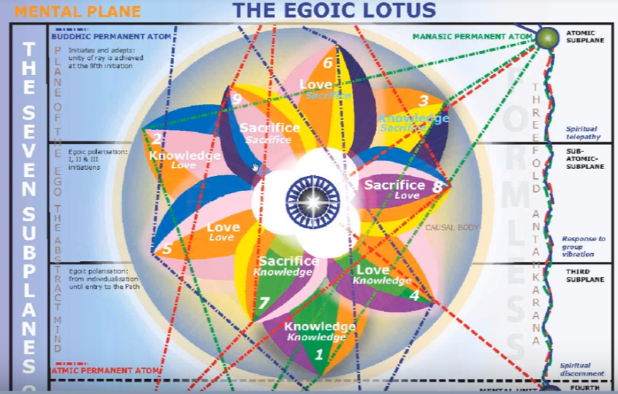
Many things can be filled in more completely. So much of what we discover it's all about a certain system of occultism which really apply when the person is on the path or at least oriented toward spirituality. So when we get into the seven or ten sephiroth that is the case, and also with the various celestial orders and so forth.

The fifteen counsels? Once we're on the path in attempting to correct ourselves I would say the fifteen counsels have a lot to do with work in petal six where we're really taking ourselves in hand attempting to improve our situation and fifteen rules for white magic. These have to do with conscious workers in the field so obviously until we are really approaching the third initiation they don't tell us much, but even at the first initiation we can begin to think in that direction. So at the end of petal five or as it's unfolding, yes we can do that.

0:02:20 The beatitudes as well coming in more as we work towards the higher states.

Special comments here, someone felt that in the country Denmark maybe sixty percent were in petal four, and I kind of wondered whether this was so. Maybe not, because there has to be a real orientation towards integration and the higher of the pairs of opposites within the individual and not just God and so forth. It probably is an over-estimation. The people are more likely found among the nice, well-to-do good people among the lotuses of passion and desire and those who are moving towards the lotuses of lower mind.

From outer pressure of society and economy you build inward, inwardly, and you ask, What is my value? How do I thrive? What is my well-being? How is my wellbeing? We are paying more attention to that in a serious way, it’s kind of interesting here the Gross National Happiness (I think it arose in Bhutan or someplace like that) where they did not measuring the welfare of the country in terms of materialism but in terms of the sense of well-being.

There is the movement away from materialism in this petal at least, if all goes well. That is, whenever one is oriented towards the higher of the pairs of opposites. Then there is an orientation away from materialism. But it's always a dangerous path and one can slip back. We're told here that (this must have been my Denmark class) we're told that the EU is trying to evaluate well-being and what real cost is, not just cost in terms of material. So the persons are considered now and not just material and external factors. Socially-conscious investing is here, the well-being of people., we might say, and Cancer is involved with this idea of economy. How much does all this really cost society, not just in financial terms.

Coziness? I'm not sure perhaps that belongs more to the nice and good people in human group number five for instance and the lotuses of passion and desire. These are people looking at how this petal might affect their own country. Intuition is beginning to come in, in relations and to Neptune, and the higher of the pairs of opposites. Perhaps some aspects of the alternative movement can come in here, longing to find one's true identity. I think though the kind of alternative movement which awoke in the twentieth century, the kind of consciousness movement, this is really further on ahead. I think we're still here trying to find our personality rather than to spiritualize it.

We've talked about the Fair Pay aspect here. One of our members was looking at the fourth petal of the heart, that is a concentration on people other than your family loving your neighbor, caring for the poor of society I think this is this is correct I think charitable feelings arise here and the family starts to be a bigger unit. So we know that there is a sympathy and compassion that goes along with the sign Cancer and once the higher pairs of opposites begins to be something of reality then the altruism is coming in a kind of protective influence. A kind of sympathy which is wider this will continue to grow, a sympathy which is wider, realizing the value of the person and not just thinking about the mass of people.

0:08:00 The mass is Cancer, the relation to humanity, now it is usually the disciple or initiate for whom it is the whole is seen as one, but the growing sense that we are all together in this. While one can have the selfishness too along the way as one integrates one's personality, one is becoming wider and the opportunity for sympathy comes in a sense if the feeling nature in this largely Cancerian petal, but also self-protective activity is part of the sign Cancer, as well. My well being, and your well being.

We have not yet overcome our selfishness, we are interested in the well-being of many, as long as our own well-being can be preserved. This question of fourth petal values. Let's take a look here DINA II, … the fourth petal in terms of page 660 if this is going by petals has to do with what patience perhaps we have group love, humility, service, patience – maybe, maybe. he's thinking here of these qualities of the heart. … I think he thinks Denmark is adapting them (heart qualities) actually it is one of the happier countries in terms of normal measurements maybe one of the happier countries in terms of the normal measurements and this is that despite the fact that there's this reputation for what's called the melancholy Dane.

There is increasing group sensitivity. Someone also suggested that with the structuring of the personality in Cancer there may be a motivation towards property and owning your own house. It’s kind of a step towards personality integration. I think. Personality integration. Basically we are our own house, but on the way to being our own house we try to own our own house; it's just symbolic of the integrating personality. It's part of your individuality, being individual by what you own, and we have discussed that. And achieving some status because of one's family and associates. Yes, ambition is on its way here and we'll comment.

Even stronger, patriotism, I think we can find. The realisation of that which really protects. The country is a great protecting method and love of country is coming in here, love of country and love of family often comes together. In petal three sacrifices were forced, here love of country may motivate sacrifice, even though it's not a sacrifice petal.

Home is the castle, artistry is coming even in the second petal, real expression is possible, artistic expression some sort of expression of the soul. The artistry requires a rich astral body. That DK has told us. Here one is more likely to have the good home, having payed much karma of the outer circle, here one may be born into better circumstances that will either help with the repayment of karma or will give advantage according to the level that one has achieved.

0:13:25 Some psychological intelligence is emerging here, maybe not the complete spiritual understanding but there is an interior and we have to deal with it in ourselves …

Various comments were coming out: Vulcan the builder, building the personality. I'm only emphasizing the ones that seem to me at the moment to carry something for us, there's a new beginning here of interiority, there's a greater sensitivity coming in, the harmony and emerging distinction is distinction in the making, in other words at least looking to rise above the mass consciousness.

Cancer visions life in Leo, and that is happening here, the glorious display of splendid individuals and all the geniuses and so forth are those that really stand out above their fellow human beings. This is found more when the unfolding of the fifth petal has taken place.

Integration of the personality and the soul or the higher the pairs of opposites is helping to bring this integration about. There's the sense or feeling that is so important of the higher of the pairs of opposites, call it soul, higher power, my true self, whatever, we're not finding occultism here, but the feeling and some thought given to what occultism will treat in a technical way.

We have upstanding citizens, the average, really good person we are told who is actually attempting to express some degree of love. This also is happening even mores o in the sixth petal and still not entirely unselfish.

This is the previous stage and this is the blossoming of the personality, or maybe that really happens in petal five, let's just say it occurs certainly before formation, but the full use or full expression of it in
a very distinctive way seems to come later. You're within a category of noteworthy people here. We're not yet so centralized that we have to worry about becoming decentralized. In other words, petal four is all about achieving some degree of centralization, gathering oneself together and centralizing. There's a movement towards the center, the real application though is coming in petal five, real or soul application in as much as we are as if applying to be accepted. But at least the soul is noted the higher of the pairs of opposites is noted …

Self-awareness is growing, something of the witnesses is coming in and really has its position in the hire of the pairs of opposites. So the position of the fair witness who maybe not quite the soul, not even the disciple really but at least it's on its way to be able to observe objectively and with understanding.

There is a standing back, the higher knowledge is based on a degree of abstraction. So we're on the threshold of becoming the self, and it was suggested lots of people in a who are in AA (Alcoholics Anonymous) looking for the spiritual life are recovering from addiction, which is often caused by pretty severe disappointment, how the world is and how they are in the world, but they are integrating themselves and the anonymous programs are adhering, an integrative program, the steps as it were.

This is all about really building the self and becoming a person at the center who is in control of the elemental tendencies. So many types of people can be found here in the anonymous programs but that's what it's building towards, creating an individual who can control the mind, the emotions, and the body and that control is a big part of the integration process. People can fall into addictions later as well,
they feed their ego with addictions even in the petal five. There is the feeding of ego with addictions and until some kind of crash in petal five is inevitable. There's such a strong Scorpio complement, the kind of shipwreck that goes on there, and then the rebuilding from a different point of view. It's maybe something of the law of repulse that is operating, though generally I think that's coming in a bit later between initiation one and two.

In petal five the work done there is preparation for the first initiation. Does this happen for the people in AA and other anonymous programs? It well could. It's kind of interesting it's been said that religion is the only cure for alcoholism, but really it would be redefined as saying that spirituality is the only cure for that Neptunian tendency which has caused alcoholism and usually addiction bring a sense of disintegration and these programs really develop the integration of the individual, they attempt put them back together. There's work being done now. AA programs even extend into the sixth petal. A sincere work is being done and it can bring people onto the path of aspiration definitely, and maybe probationary discipleship. It would depend, there would have to be a shift away from the strictly mystical attitude towards the more reasoned calm approach to self-improvement.

The path of pain is path number four, the fourth purpose of Sanat Kumara. This is happening quite a bit in the love petals, and we see how much struggle there is in petal number five, there's a lot of pain there and succeeding. The road winds uphill all the way and pain is part of this process, especially if the bulk of humanity is treading the path to Sirius one day, and the path of pain in a way turns into the path of bliss is related to that path to Sirius.

As consciousness grows the sense of pain and grows, existential pain as well. The sense of cause and effect and what effects have been as a result of causes we've set in motion, that contributes to psychologically-registered pain.

The sense of pain contributes to the need to achieve harmonious integration. We know something hurts, we have to fix it, the harmony between those painful interactions within ourselves is needed. We compare that to the fourth purpose of deity which required the causing of pain which is related to consciousness in the sense of cause and effect. Just read that and will see that it's the human being's ability to understand causes which is very much responsible for the registration of psychological pain at least.

There are cleavages and integration is the struggle to end cleavages, show us the cleavages, and also shows how to end them. Is there in the esoteric community a lack of personality integration? Sometimes people have high aspirations without really pulling themselves together but DK once said to his students, two lives lie behind you, the life of a full expression is a personality which implies petal five not petal four so much, and the life of being in a western or eastern convent or monastery and that implies a lot of work in petal six.

The kind of personality integration that the esotericist is lacking is more the integration of the personality with the soul so the integration personality with the soul is sometimes lacking but the personality integration per se is often found in the those who are dedicated to the esoteric path. But people can of course reach too high before getting their foundation together and there's a lot of that in petal four here, and the building of the foundation in petal four much of the square, building of the square as the foundation for higher expression of the integrated personality.

This esoteric teaching is mostly written for those who have taken the first degree, it assumes that personality integration is in process or has been done. The second degree, later, that really wants to exalt this personality—before the second degree there's oftentimes a love of power fear hatred and the love of power or ambition. So this is one of the temptations of the Christ. Maybe Joshua had this too.

Dealing in petal four, is only the start of real personality integration.

0:28:30 So we still really do have a personality up to the fourth degree. Later, if we generate a mayavirupa, it's not a personality in the same sense but it is an instrument, it is a vehicle and it has all the qualities that a personality had before, there is nothing deprived, it can do everything that a highly developed personality could do before.

As we move into this petal more and more there's a deeper feeling of values. We can assess or look at our experiences and think about our experiences. That's an important one: think about our experiences and integrate them into our growing sense of self. It’s not an unreflective life. The nice, good people and so forth a lotus of passion and desire they can think on occasion when it is required, but here we have so much of ray three through Cancer and the ray five for observing our life and looking at cause and effect. Five for looking at cause and effect ….

Here we are learning to become a thinker, it is not an on unreflective life. We are really moving from instinct to intellect even though there is love in the second tier of petals compared to the first tier of petals, it is a tier where intellect is utilized in some degree of loving mind is cultivated the first petals of the three in the tier of ignorance. They are instinctual. This theme of looking at, learning to be the observer is here, and hence the integration of the personality which always needs a point of consciousness from which to be controlled so that one can withdraw into that controlling point which ever elevates. At first, it is simply the mind or the sense of being in the mind as a thinker and later it is identification with the soul or as the soul.

We are constantly here building towards a better life, lots of building going on in this petal, building the self, building with associations, building society, we say lots of building and a person is becoming responsible to uphold the values of society and you can do that before you are a blazing individual.

0:32:30 Control is entering. Cancer is a sign often of great control and we're not just tossed upon the waters, we are navigating towards a different and higher goal, as stated gathering things towards the center. That is happening, that's part of the integration process. To gather towards the center is part of the integration process, and increasing awareness of humanity and more identification with humanity not necessarily in the esoteric sense yet, but sympathy, compassion, more cohesion, more solidarity, recognizing humanity as Cancer has so much to do with humanity.

Are we in the mass consciousness? Well mass is here in our consciousness but we are able to think and move towards distinction, we're able to think about the condition of the mass. …

This is page 822:

Petal 1 … Higher Knowledge applied through love on the physical and astral plane. TCF 822

Higher Knowledge applied through love on the physical and astral plane. So the attempt to be truly loving and to use this higher, and we might say almost inner knowledgeable as it's not really abstract yet but it’s called here upholding societies. So we're called at this higher knowledge and maybe we could call it inner knowledge … applied through love on the physical and astral Plane.

What we have here with petal one, it's called higher knowledge, it's kind of a nascent inner knowledge which comes from adopting a new point of view and being somewhat aware of one's psychological life, higher knowledge applied through love on the physical and astral plane.

We find that the majority of human beings have not reached the place where this petal is unfolded and when work may be going on in the fifth petal and even in the sixth petal, that the majority of human beings do not yet have the integrated or even integrating personality. We're doing well if we can stimulate the mind here.

We've collected some thoughts here, the idea of the centralization is going together towards the center, it's part of the integration process. and increasing identification with humanity. The mass maybe in our consciousness in this petal but we are able to think, and think about the condition of the mass. These people in human group five are kind of nice, beginning to use the mind, but they are not necessarily those who are beginning to participate intelligently in world affairs and to uphold some kind of significant responsibility. I think we do find this in petal four a little more here.

The colloquial idea of ‘getting your act together’, that's an integrative term. We're having increasing Venus, it's a polarity between Mars and Venus. Mars is representing the lower of the pairs of opposites, shall we say around which the personality is integrating, and Venus is representing the awareness of the higher of the pairs of opposites, and these two are blending together.

Preparatory stage to Leo. There is discomfort, someone said here that [this is] the married, prosperous couple, symbolizing the push and pull within and living a nice, middle-class, professional life. But there is more and there's a need for increasing freedom of expression and there is the thinking forward to it. Man is in search of his soul here, there is loyalty to the family, but living in that middle class life which is responsible to the world, participating intelligently in human affairs but knows there must be more and the more is in that Leo petal.

There is accumulation here under Cancer, collecting people, personality collects things. Well is it that sense of being something through having something. There is also the need to throw away and here comes Pluto to help decide what is not necessary for integration.

There has been a long journey into matter and one must break through into a perspective which is not material. So fire is then ready to break into the mental field at this point.

The mass consciousness is about comfort, but this is the peak of the high end of the mass consciousness. The Leo petal is not about that, the Leo petal is not about the mass at all.

Little things came out, all in the family, well to an extent. The moon (the personality), Mercury is the messenger of the gods. There's a duality here, the gods are speaking in the higher of the pairs of opposites, also from Venus and the moon and Mars are receiving. Mercury will help bring this through. Mercury is offering discrimination between the higher part of the duality in the lower. Discrimination and imagination; imagining what the Higher Self may be. The ideal model, we're talking about envisioning oneself imagining the completed personality, we talked about this technique of the ideal model or ideal image. Neptune, as the imagination, is used in this respect. Neptune has its growing connection with Cancer and can just as we are becoming more advanced man, Neptune can be used here to envision our possibilities. …

Somehow there was discussion in those days of the Bush family and how well-heeled it is. Getting the degree to put forth a president, I think it was Yale University even, I believe. There is this whole question of family prestige as it comes in to this petal, maybe even somewhat more accentuated in the fifth petal. Well [laughing] a rather unkind statement here ‘a family of well-to-do imbeciles’. People say these kind of things.

In the fourth stage of adaptation there is the possibility of selfishness and these fourth and fifth petals have more mental power but we cannot be sure of the selfishness is broken. Really only in the eighth petal which leads to the full unfolding of the sixth, can we be sure that the major blow against selfishness has been struck. The aspirant is striving to be rid of selfishness and the stage of aspiration is really beginning with work after the crash in the fifth petal.

Creating relationships based on a lot of personal likes and dislikes, on taste which helps with your integration, but not necessarily on a greater purpose. What suits you personally. You are the sensitively integrating unit, and Leo as I said is actually, strangely, sensitivity.

So personal taste sets up the tension that leads from Cancer to Leo. Beautiful son marries a woman who the family does not approve of. Well this is encouraging him to individuate to become the individual. Often times you're not going to get killed for it but one has to step out of the expectations of a family and class.

I wonder how it is for the masses as they look at those who achieve power in the human race and yet they look at their egoic body and wonder whether this power is justified. Can this relate to the corporation or the corporate body of the corporation as the family? There's more and more rising in life and getting together with others in order to rise. We can have here the family business as a training ground [through] dealing with integrating the pairs of opposites and actually fusing them not letting them tier you apart. The fusion increases as the technique of integration is applied. So it's time through a balancing process and intelligent balancing process to reconcile the pairs of opposites within the personality.

There is a very strong kind of broad social development from the third petal to the fifth petal. But see the agricultural, that can be back in the second petal and maybe even of the first the technical petal three social and family petal four, so this is more petal two, petal three (but of course so much more than that depending on the ray) and petal four.

Let's say that the pinnacle of this process of ascent. What did we say, hunting in petal one, farming for petal two, work in petal three, family and social in petal four, the pinnacle is found in the fifth petal.

It is said Napoleon rises on the back of the mass. There's a real example of the dominating personality, may have been to an extent driven by the first ray soul, but there was a great domination factor over the masses and the conqueror’s mentality. This is what we might call petal five before the crash.

0:47:10 The pyramid leads to Leo and a new type of group consciousness calls. Leo is the fifth point on top of the square.

Consciousness will continue to increase. There's lots of human endeavor here, more power for the individual but not as much as we will have in the final petal, the fifth of this series, rising towards the peak of personality expression. One of those lives that many of us have behind us perhaps, which does not mean that we have to have a weak instrument by any means, but it certainly means that it's no longer the dominating factor that can be used.

We're fulfilling here in petal four the goals of the fourth kingdom, but we're not really entering into the fifth and it's only when the work is being done in petal seven strenuous and abnormal efforts that we begin to abstract into the fifth kingdom interestingly enough. This fits well when petal five is completely open then we enter the fifth kingdom …

In this petal we know we are pulled in two directions and this is the beginning to be aware. I wonder how many people are aware of their essential duality. Maybe they have a vague sense that there is what they're doing, and then there's something better to do, something that's more right. But it takes a while before he does sense that there really is a higher self in other words sometimes the religious or God consciousness there's little unified me, and then there's God who is good. Here I am and there is God, but to internalize God and to make God him and then that is a process taking place in the love tier.

We can ask ourselves, what do we think a petal four? What relationship do we have to it? We're just there on the border, where we're beginning to question things. If we cannot take life for granted anymore as we enter petal four, as we work in petal four, we do not take life as it seems for granted, and we are aware of something additional behind, beneath, above.

Even though it's a Cancerian petal, basically what we're doing is finding a high -- we're fulfilling a goal which much of those in the mass consciousness held for themselves, but looking forward to something which was not conceived by those in the mass consciousness. We can almost as it were taste the sun, looking towards the light. We're still in the house but we want to open the windows look outside maybe open the door and step outside into the sunlight.

But this is a this is a petal of containment in a way, a personality is a container. So is a causal body to a certain extent but we're not really there yet. The personality is the container, to go forward we have first to contain and integrate and we're moving from an instinctive extroversion into the cultivation of a subtle and spiritually tending introversion, which does not mean that we are retreating from contact with others or cannot be outgoing in other ways, it simply means we are aware of an interior. This is something which those in the hall of ignorance are not aware of.

0:52:25 Love and knowledge. Are there a lot of psychologists here? There are a lot of those who would benefit from psychologists.

Does it make the psychologist, or the one who uses their services? I would say more the one who uses their services searching for the self to become. The psychologists have an integrated self, for the most part, and can help others forward towards that condition. A good psychologist should really already be integrated and have the stable center.

Interesting, Dr Phil's house? I've seen some of those, where he puts people who have very different attitudes, even hateful attitudes, towards each other and then under that roof they all have to get along and work. Dr Phil, I don't know his astrology might be interesting to find out whether he has any Leo, he seems to be the kind of guy who is calling the shots and helping other people get it together you might say. … I'm kind of glad that I looked it up, talk about therapeutic. He's a Virgo and he has the sun of the sixth house of therapy, and Saturn is there too, right at the descendant. So he really confronts people, has his firm ideas with the moon in Taurus, but he has strong Leo, too and it's in the fifth house or in the sixth house possibly.

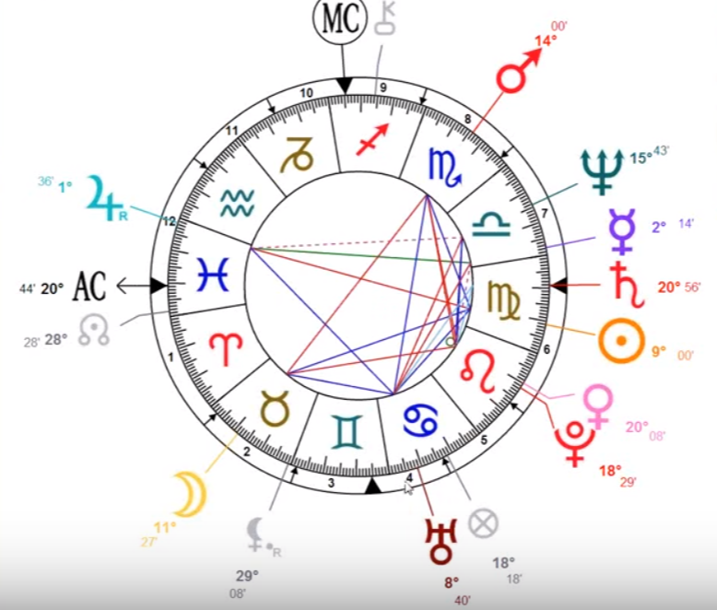

He's clearing the way towards the greater light, we might say be part of Pisces that he's in, well it looks from this is if he's in the Scorpio part of Pisces. Looks like his descendant is this and someone said he had Libra rising, but Jupiter in Pisces, also will have a fair appeal. Really outstanding, and the Mercury is in Libra, so that gives him that sense of fairness. Mars and Scorpio, and he cuts into the nitty gritty for sure he has to deal with a lot of tough circumstances, but plenty of water signs. Amazing horoscope.

Anyway when you go to Dr Phil's house I saw quite an extraordinary thing. He brought people who really I hated each other. They hated the types, and then he made them into roommates: there was a racist white man and a black woman who hated whites, and they became more or less roommates; there was a lesbian woman who thought of all straight people as breeders; and there was a religious woman who hated gays; and there was a person who hated fat people and a fat person who hated thin people. Somehow he put them all under the same roof. What an amazing, integrative task, no wonder he's so popular. Venus in Leo is very important, very strong, and really when you have Pluto there as well it does clear the way towards the greater light and talk about innovative ways of bringing integration. Look at that Uranus in Cancer.

A little bit of a side track. There's a lot one can understand about people, but if it is really Pisces rising, well he's doing his therapeutic mission that's for sure. It kind of fits with this, I wouldn't say that all the people that he's working with are necessarily fourth petal types, but he is doing the integrative factor.

So much about integration has to do with withdrawing your own projections and realizing they are part of yourself and rather than splitting them off and having antagonism towards other people who have inside themselves what you have so. Yeah there's a number of things here. It is a real training in learning how to listen to people and not inverting what they say so many people actually hear the opposite of what you say we call it the astral inversion it's due to distortion on the astral plane and it meant in a cold way, life is death and death is life.

Do we have a compilation on the integrated personality of this? Is what is happening here and especially the integrating personality? I think you probably developed a sense of what this petal is all about, and how it's really a foundation for the brilliant life that can begin in the fifth petal when we fulfil the potential that we had when we were individualized and become radiant in mind and later outstanding in some way, standing, outstanding.

Petal four is on the way to becoming outstanding, distinctive, noticeable, emergent, and remarkable. All these nice Leo words. So many people fade into the mass. Well, we're rising out of the mass here but we're still very much related to the last of the lunar petals, then we go into the solar panel this is a bridging point and very important in some forms of astrology, things begin with the sign Cancer and Leo, as if they are the center and move out from there. Especially when we're measuring the assigning of the deck and it's.

Well friends I did to take a break this is taking about an hour the other program for petal four was much longer, and I know this is like total immersion in a petal to get the feel of how it works out in the lives of people, and your own life.

This will be the end of egoic lotus webinar commentary program 39. It will be a synthesis petal four part two and it's basically one hour … then we'll move into that glorious petal five which is the moment when the Solar Angels really begin to do their work, taking it over from the second logos and giving a boost to all that the human being is able to do.

So many human beings on the planet in very early development do not have that boost and they've worked their way to where they are now without that sort of hothouse cultivation that H.P.B. talks about. We've had a certain current that has gone with us if we've had solar angelic supervision.

Okay, everybody we will be moving into program beginning egoic lotus webinar commentary program 40; synthesis of petal five. It’s likely to be quite an interesting one I daresay, at least it's really important. Whether I can make it interesting or not, we will see.
See you soon, bye bye.

