EGOIC LOTUS WEBINARS, VIDEO COMMENTARY – 37, Michael Robbins
Abstract
Egoic Lotus Webinar Commentaries 37: Part 2 of Synthesis for petal 3. This webinar is about 4 hours, 18 minutes long. Program 37 discusses the contributions of many energy-force influences which are active in producing the petal 3 experience which signifies entry into the lower part of the Aryan/Fifth Root-Race stage of consciousness. Primary Lotuses are related to this degree of unfoldment, but perhaps another title for still more unfolded lotuses might be suggested: 'Lotuses of Manas', or 'Lotuses of Lower Mind'. The bulk of modern humanity are just about to enter into this third petal process more extensively. The work done on the Synthesis for petal 3 comprises two programs of 2hrs, and 4hrs 18mins, respectively.
Egoic Lotus Webinar Commentaries 37 745 MB .wmv file
Video of Egoic Lotus Webinar Commentaries 37 by Michael D. Robbins.
Egoic Lotus Webinar Commentaries 37 247 MB .mp3 file
Audio of Egoic Lotus Webinar Commentaries 37 by Michael D. Robbins.

Transcript.

Hello Friends.

We are continuing our program … program number 37.

We are in the third petal. It's still part of the hall of ignorance and it is knowledge-sacrifice petal. It's a strongly mental petal and at the same time it leads to those enforced relinquishments, and to servitude which prepare the human being later for the true path of conscious sacrifice and service.

Colors: orange, yellow and indigo.

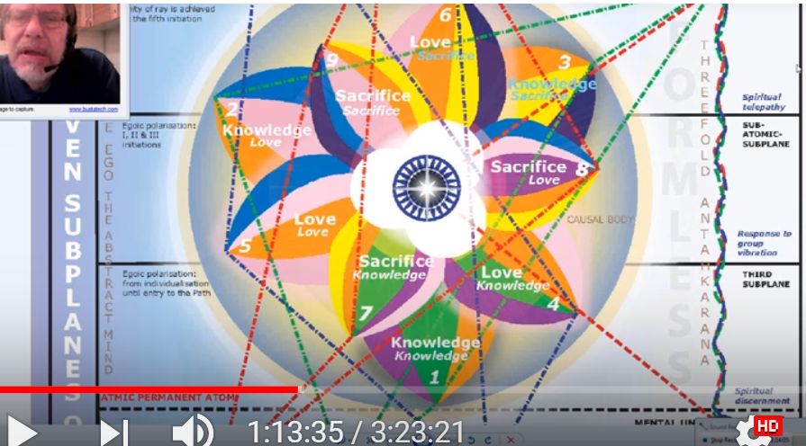

We are in the synthesis of the petals, we're looking at each petal and how it brings together many different energy factors. … We got this far and we had just finished working on the monadic stage of unfoldment most associated with this petal and some other associated thoughts.

Now we are working with that group of souls in the human groups which is most associated with this petal. I would say the late human group five and early human group six, if there is such a thing. Just take a look at this. Human group five is pretty much connected with the Lotuses of passion or desire. And it says here:

Those souls who can now be classed as intelligent human beings, capable of mental application, if trained and showing that they can think when need arises. They are still, nevertheless, predominantly emotional. They are the average citizens of our modern world,—good, well-intentioned, capable of intense emotional activity, with the feeling nature almost over-developed, and oscillating between the life of the senses and that of the mind. They swing between the poles of experience. Their lives are spent in an astral turmoil, but they have steadily increasing interludes where in the mind can momentarily make itself felt, and thus it need effect important decisions they are the nice good people who are nevertheless largely controlled by the mass consciousness, because they are relatively unthinking. They can be regimented and standardized with facility by orthodox religion and government and are the “sheep” of the human family. EP II 205

Those souls who can now be classed as intelligent human beings, capable of mental application, if trained and showing that they can think when need arises. They are still, nevertheless, predominantly emotional. and this shows of course that we're not really talking about the full unfoldment of petal number three. They constitute the bulk of modern humanity at this time, They are the average citizens of our modern world,—good, well-intentioned, capable of intense emotional activity, with the feeling nature almost over-developed, and oscillating between the life of the senses and that of the mind. … Their lives are spent in an astral turmoil, but they have steadily increasing interludes where in the mind can momentarily make itself felt, and thus it need effect important decisions they are the nice good people who are nevertheless largely controlled by the mass consciousness—it is after all the petals having to do with the hall of ignorance, right, because they are relatively unthinking. They can think what they are relatively unthinking—They can be regimented and standardized with facility by orthodox religion and government and are the “sheep” of the human family.

This is sort of two petals open, with work the object of attention, what is being accomplished or focused upon the third petal, or the object of attention being the third petal.

Then we make quite a leap actually here:

6. The souls who think, and are minds. These are steadily increasing in number and gaining in power as our educational processes and our scientific discoveries bring results, and expand human awareness. They constitute the cream of the human family, and are the people who are achieving success in some departments of human life they are writers, artists, thinkers in various fields of human knowledge and aspiration, politicians, religious leaders, scientists, skilled workers and artisans, and those who, go in the front rank, yet take ideas and propositions and work with them for the ultimate benefit of the human family. They are the world aspirants, and those who are beginning to get the ideal of service into their consciousness. EP II 206

6. The souls who think, and are minds. These are steadily increasing in number and gaining in power as our educational processes and our scientific discoveries bring results, and expand human awareness. They constitute the cream of the human family, and are the people who are achieving success in some departments of human life they are writers, artists, thinkers in various fields of human knowledge and aspiration, politicians, religious leaders, scientists, skilled workers and artisans, and those who, go in the front rank, yet take ideas and propositions and work with them for the ultimate benefit of the human family. They are the world aspirants, and those who are beginning to get the ideal of service into their consciousness.

0:05:25 I think there should be another category here, but let's just say the later, more intelligent part of group five and their earlier, less creative part of group number six maybe what we're looking at here. They are still thinking in a relatively outward way. But later when we actually get into human group six we seem to have really creative thinkers in whom the third petal would be completely unfolded and a lot of work being done even in petal number five.

So early group number six are those who can think, but not necessarily being creative individuals creative personalities. They are moving out of the astral turmoil in which group five spends its time and they are separating kama from manas. That separation of kama or manas from kama is not the same as really being a creative thinker and a successful creative thinker – that is coming a little bit later. But of course, the Tibetan is laying these out in simple terms, He’s not struggling for meticulous completeness He said there are so many over lapping conditions He couldn't possibly list them all.

In petal three we have objectivity. The power to stand back and see things as if they were objects and we say, more as they are and not as one’s bias inclines one. … When we have kama manas, we have bias. With reduced kama manas, we have more truth, or objectivity about the outer world, but not real objectivity about their own their own inner life.

The fifth ray is found here strongly. It gives objectivity, and one is able more and more to keep the emotions out of it. This particular petal is interesting in that it is mental and we have that hint because the primary lotuses whose major work has to be on petal two are already unfolding. They're a bit out of balance, but at the same time circumstances will demand sacrifice in this petal, so it's like two different streams as far as I can see. I call this petal of lower manas, or lotuses of lower manas, or lotuses of lower mind, or lotuses of manas. I didn't call them the lotuses of passion and desire, nor primary lotuses.

Of course, these people who do have emotions. Because one has not mentally polarized until midway between the second and third initiation and even then, there are feelings and sentience states, but not emotions that arise upon the stormy seas of life and engulf the swimmer, shut out the sun, and renders all plans futile. That is a more a condition in the second petal, by the time we have real mental polarization we will have a much different emotional condition which is the result of the planets Venus, Jupiter, and Neptune in the astral body producing the second initiation.

As this petal opens or as the process continues in this petal, they are less and less the sheep and more and more able to think clearly for themselves.

Petal three work—it’s always difficult to say when the unfoldment actually occurs. They can think when they are required to. Group five of the human groups we can see is quite common, I suspect is quite kama manasic and some are more advanced than others. Some in group five I suppose are learning how to think more carefully than others. The more educated is a lotus of passion and desire, a lotus more into the third petal process, they are and more resembling the early, really Aryan, and approach me to talk about a kama manasic. If I can say here when speaking of kama manasic, we are speaking in terms Atlantean-Aryan, because the kamic emphasis is Atlantean, and the Aryan emphasis is mental.

The widespread education which is so strongly emphasizing the fifth ray is creating Aryans in consciousness. (That is always a tainted word because of the terribly distorted way in which it was used by the Nazis, it simply has to do with modern consciousness, mental consciousness, and eventually the kind of mental consciousness which can receive right and recognize the light of the soul and utilize it.)

The average person, because he is in service, comes into this category white collar and also industrial, not leading, but serving, and that fits in with Virgo. They can think but are primarily directed by those who are integrated personalities they do mental work and are not just and not just physical work but are not necessarily leaders. We have government people, public servants, secretarial functions, firemen, police and interestingly they often make sacrifices demanded by circumstance. I'm thinking about the World Trade towers, about 9-11, but about all of those who are in service, gave their lives because of circumstances they could not control.

Duty is important here in this Virgo petal. Virgo is very much involved with mental cultivation, but it's the practical application in matter of mental cultivation. Their uniqueness is not yet present. Maybe a uniform goes with public servants and they function with uniformity and uniformly. Seeking to blend in with the whole, some people suggest that maybe the air traffic controllers, people have their personalities and we cannot say because somebody is in a particular profession that he is necessarily limited in his personality development by that profession but they're not exactly carving their own way as leaders. We don't expect that when petal three unfolds they will be the same kind of personality leaders as we find with the work done in petal number five.

Interesting about seeking to blend in with the whole. I'm thinking about stage of adaptation number three where He talks about is still basically a selfish adaptation but the person does seek to blend in with the whole for his own benefit. Anyway, service, duty, uniformity, intelligence applied in the services, but not leaders of men, I would say. Some lotuses of passion and desire and yes are more advanced also and are kama manasic. That's basically what they are all from the moon chain. They are entering this phase; some from the moon chain are not really yet advanced humanity they are still the lotuses of passion or desire but will achieve the status of the spiritual path before the end of the six rootrace or before the seventh begins. These people coming in from the moon chain, two fifths of them, they have to become manasic instead of simply kama manasic. Apparently the two fifths are more intelligent and would achieve in this fourth round where three fifths, interestingly, will be set aside. The two fifths I would judge have more petal three development.

The mind will take you into the public service sector. Again, some of this is repetition, they're known by the job they do and I think that's a good thing to say these people. With work being done and petal three are known for the job they do, and not so much for themselves in a personality sense. The field of knowledge in which they are engaged is governed by law. There are standards procedures they have things have to be replicated, but group six is different. Especially once we really get into the work of group six, which I think correlates with the work of petal five.

We have creative thinkers, that reminds one of Leo and eventually the world aspirants. Group six seems too high for only petal three development for petal three. We need those who think but who are not aspirants and also creative thinkers. They are not aspirants because they are not dealing directly with the higher of the pairs of opposites. May be the beginning of group six those who are mind’s eye to front from the creative thinkers that seem to be discussed a little bit later in the paragraph.

They have individually honed skills and can't be trained in a conventional way to develop such skills. There's something unique about them as they make their place in the world. That's more petal five and an end beginning and the work of petal four. When you organize a petal or when you do those kinds of things in the world which have the effect of organizing a petal apparently these skills are inbuilt in the petal response they may not be strengthened yet by the additional conferral of energy from the second logos or now into petal five by the solar angel, but there is something you can draw upon and they will show up in your life.

0:19:30 I was saying when you look at the one petallers, the Brahmic lotuses, they have a certain kind of life and it makes one think that if they're working ahead organizing in petal four and five, it's not much showing. What is showing is the unfoldment of petal six and maybe a petal one and maybe some more intensive organizational work and petal two.

In petal six or human group six, standard training is not making you what you are, it is your individuality in petal five and with the creative thinkers. In human group six we are playing on our uniqueness we have emerged from the mass. Maybe the last bit of conditioning mass consciousness has found in relation to petal for after that a person is more on his own and has entered the solar phase. He is not the victim of consensus reality where he did so because we all agree. It is so, there's kind of a gap here between human group five and human group six, but I tried to bridge it by talking about the latter part of human group five of the early part of human group six.

So we do need, in relation to petal number three and its fuller development, skilled thinkers who are not necessarily creative as persons we can call that initial group six. They sacrifice themselves often, it's interesting how the family business is often a scene of sacrifice, where people are so worried about how things are going and nobody understands they have to work on Saturdays and Sundays, and it's always on their mind and they are preserving certain values by doing that. It requires a lot of mentality, but the mentality that they have in a concrete sense is directed towards a task which demands a lot from them. People have heart attacks and they get a whole system that you see it all the time at a certain stage. They're the slave of their business or the slave of the restaurant whatever it is, who's going to run it if they don't?

They are they're not really thinking for themselves, as one of our members that they're bound up with consensus reality. And the symbolic ways of stating it is, they're devoted to the square. Mind is primary but there's a lot of aspiration here. In other words, a dedication to that which one thinks one must do, so one fulfills one's duty with mind and that duty can lead to sacrifice even of the body. Someone was thinking here of American soldiers.

Someone mentioned migrants to the US. And Australians. I'm not sure how that fits. I don't know if we're really talking about migrant workers, per se, but the second generation of immigrant families really has to somehow make a good considering the new requirements and also the origin from which they sprang and these children are encouraged to work very hard in school. They're still fulfilling the system, they are not fulfilling their individuality, that begins to happen later. The whole idea of parental sacrifice in a modern society is here, this is not just parental love. So that my children could have it better than I have had it, I will sacrifice myself.

I'm seeing all the old faces appear here is very fine fifth ray fellow with a deep knowledge of astrology and alchemy and Chinese astrology, anyway he's saying we have an important distinction here, these are basically good people who can train their minds but are not of profound mental development. They take knowledge use knowledge, but they're not doing so much with it in terms of personality expression.

The invention in matter is found here, but not the breakthroughs in the higher mind. In other words. petal three is not an Einstein petal. But in terms of working with technical equipment, then coming up with innovations along that line it could very well be, it depends on the rays involved. There's a lot of fifth ray expected of people in this petal and their third ray, too. But it really depends on your particular ray configuration and what you do with it. That's where the variation will certainly come in here, to something interesting, variation, is it rather than penetration, but maybe with some technical inventions there is a kind of penetration regarding technique.

I suppose it depends on how far it goes and what the ray type may be because we're told that the primary lotuses once they get their work done on the second petal. There’s an example of people working retroactively, they're working on a lower petal than one that is already unfolding, but that they will bring through their inventions a wonderful period for humanity and perhaps make true leisure in which one can cultivate oneself really possible.

There's a third petal ingenuity, but let’s just say not abstract thought. A higher type of mind begins to appear in the work of petal four, as it tells us when we study on page 822, higher mind is showing up but not yet.
0:28:00 Various comments were made and they have some importance.

What is the stage of application most associated with petals three? We might say it's making the best of circumstances the selfish adapting, but we should not say that all adaptations. In this petal is strictly selfish from a certain point of view everything in the hall of ignorance and in the knowledge petals is tainted by selfishness and we're not really going to overcome or strike the first blow against selfishness until the complete unfoldment of the sixth petal and with work in the Scorpionic, eighth petal.

If we look here, we see what stage this is, but it's not entirely true, because the selfishness – if the second petal is well unfolded there we already have the nice good people – so we would have to modify what is said here in stage three, number three.

3. A conscious and purely selfish adapting of oneself to the environment. In these cases, the man is definitely aware of his motives; they are consciously thought out and recognized, and the man makes
“the best of his circumstances”. He forces himself to live as far as possible harmoniously in his surroundings. In this there is really good motive, but principally the man is governed by a desire for comfort – physical, emotional and mental – to such a degree that he will discipline himself into such a condition that he fits wherever he may be and can get on with anyone. EP I 323

A conscious and purely selfish adapting of oneself to the environment. In these cases, the man is definitely aware of his motives; they are consciously thought out and recognized, and the man makes
“the best of his circumstances”. He forces himself to live as far as possible harmoniously in his surroundings. In this there is really good motive, but principally the man is governed by a desire for comfort – physical, emotional and mental – which I think fits with the earth signs in general and with the tier which relates to the physical plane. Governed by the desire comfort to such a degree that he will discipline himself into such a condition that he fits wherever he may be and can get on with anyone.

Part of that is true for the third petal work, there's another way of approaching the discussion of petals. Avoiding the problem of when do they actually unfold, we can talk about development we can talk about work and then all of these other phases come in. From this stage on the differentiations become so numerous that they are difficult to follow being misused of pure selfishness developed often to the nth degree of a growing recognition of the group of an awakening realization of the right of other people.

When the three petals completely unfold we do have a growing recognition of the group, such as the sort of selfish union worker. As the example they're saying there is group consciousness but it does repay one to be group conscious of an awakening realization of the right of other people to a similar degree of comfort and harmony. I think we can probably find that in the fourth petal the awakening to the right of other people to a similar harmony. It’s a Cancerian petal and it is somewhat protective in that respect and of a steady effort to adapt to conditions of character and personality life so that the purity selfish interests do no real damage to others until we arrive at:

5. The average really good man who is struggling to adapt himself to his surroundings, to his group relations and responsibilities in such a way that some measure of love can be seen. I refer not here to the instinctual love for family and children and herd which men share in common with the animals and which often breaks down when the lived individuals assert themselves. The tie is not strong enough to hold, and the motive is too selfish to resist the pull. I refer to the motivated love which recognizes the rights of others and consciously strives to adapt itself to those recognized rights whilst tenaciously holding onto the rights of the personality. EP I 323-324

We can probably find this in petals for five and six and I refer not here to the instinctual love, the first tier let's say, for family and children and herd which men share in common with the animals and which often breaks down when the lived individuals assert themselves. Talk about the instinctual love, have you seen the elephant society when there is a death, it's really touching. Anyway in the early petals the ties of family and children and so forth, it is not strong enough to hold and the motive is too selfish to resist the pull. I refer to the motivated love which recognizes the rights of others and consciously strives to adapt itself to those recognized rights whilst tenaciously holding onto the rights of the personality and this is still occurring with work being done in petal six, so let us all judge of our own development in terms of the balance between working on behalf of others and seeking that they shall have their rights and tenaciously holding onto our own, to live a somewhat selfish life. Or at least preserving certain areas of our life which are self-serving.

I think we can see that in this stage three making the best of circumstances and it's selfish adapting, but we should not say that adaptation of this petal is strictly selfish because we have already been the Lotus of passion and desire and we have been nice, really good people, who are even well-to-do, because there has to be intelligence if you're going to be well-to-do, so we cannot – probably the primary Lotus is a lot more selfish at first. You might say that the primary lotuses are far more selfish than these, or let’s say, lotuses of manas, lotuses of lower mind, with much work being done in petal three, and subsequent unfoldment, because the primary lotuses do not have petal two working, and you need this to turn from love of self to love of others, even though it's still quite a material form of love. If you really want to be rid of selfishness then some awareness of something higher, let’s call it the higher the pairs of opposites, is necessary.

Back to adaptation number three, fits in wherever he is and then there, some of … stage of adaptation four is also entering when speaking of a civil servant, doing conformists job, maybe intelligently, but not saying Look at me here I am, they're identified with their job and not with themselves. Those who keep things running -- I'm thinking about that. There's the white collar work, there's a lot of conformity require there too. Let's put it like this so many people's jobs do not allow them to ‘be themselves’. They are functionaries, it is another step when your vocation or career allows you to express yourself and not just to be facelessly consumed by the function. The fear of being cast out and losing one's security.

There are many security issues in the first tier. Conformity is self-preservation in that respect. Living harmoniously in surroundings, DK says, disciplining himself, so he fits wherever he may be, can get on with anyone. It's not his personality that counts, it's more the comforts and lack of danger which will be his if he just fits in. His function, his job, his role, so suppressing the uniqueness it has not become a focus and let's just say, don't stick your neck out, it's a lot safer to conform.

Now in the Leo petal, people are definitely going to be sticking their neck out there emerging from the mass and the demand to be their own person.

0:39:00 There are two types of training here, one in petal three, in petal six. In petal three there's more an outward training, in petal six much more subjective in both sacrificial training in a way. Petal six taking into consideration more psychological factors than will be possible. Basically, in the first tier there is not much introspection. This really begins, looking within with applied work in the second tier. … That is where the higher of the pairs of opposites, something internal that is you, comes into focus. We're training our individuality in petal six, and petal three, where we train our skill and function, it's different. We fulfill our criteria and petal three and petal six we have that inner critique that is ever refining how our individuality expresses and that to which it dedicates itself. The individual is on the line in petal six and the individual has really been created in the work in developing the petal five.

These are different thoughts, how much ego is there in the civil servant? The function is not based on ego. I was thinking about this man who did the river dance, Lord of the Dance, later, a real strong Leo in his character. It's not the same thing, he's artistic, but he reveres expressing his nature completely; he's not just the function, there's so much room for creativity.

Selfishness is still a part of group four, maybe some pride of mind. Is there a little bit? Really what has to happen is we have to study such a wide range of individuals mostly where we can do that, yet and even the Masters concentrating His attention on those who He can train to cooperate with Him he cannot give that that kind of attention except with broad understanding to the other categories. They will have to be handled by other people who have less development than He.

Some of the consciousness is emerging here because the mind is more used. There's more focused mental consciousness, people think and are aware that they are thinking, and they use the mind to derive their answers, but cannot really be called introspective. With the second tier we turn within to a degree.

You’re making the best of being in the box, so to speak, in the consensual reality of reality that's not really reality, but what people think it is there are taboos and one is careful about stepping outside the conventions. I'm sure that's very much the case in the emotionally focused second petal and also the whole idea of taboo is anti-individual, we see this in societies and religions. People do not dare to step out of line, when they do they are really punished.

People sometimes from these religions coming into contact with western society and its relative freedoms and they want that and then they're severely punished by those to whom they belong at least the people still remaining in those boxes think that the people trying to break loose still belong to them and they would be very threatened if they could break loose. We have the honor killings, one of the most despicable methods of relating to your fellow human beings, and especially beings and especially your family, but don't get me started. Actually, you don't have to because I'm a self-starter when it comes to those things.

There is conditioning here, Saturn is the conditioning planet. We remember the movie called The Matrix, and people can either be deluded by the matrix or they can establish their consciousness from outside it and see the prison of the conditioning which those within the matrix cannot see.

Uranus is not here in relation to freedom, maybe in relation to scientific mind. Uranus has a strong ray five as part of it, and it grows in petal four. It's not really the kind of planet that has a big place in the conventionality and the standardization of the first tier. Uranus does not agree with the mass consciousness, just think of its relation to Leo. Leo represents the emergence from the mass consciousness and it is the veiled hierarchical ruler of Leo, Uranus is. So it's all about really emerging and being the unique individuality which one senses oneself to be, the divine pattern which you are. It’s not about just going along, it's not about subservience to the prevailing conditioning which everybody thinks has to be preserved.
I'm not so up on these things, I know that Ken Wilber talks about the various memes. There are spirals I think, spiral dynamics, that arc about the different strata in which people operate. I don't know the colors, how they assign those, I have a vague idea. But there are groups of human beings definitely, and those who work with the psychology of a human being have to understand the general categories and the general next steps ahead for these categories otherwise they cannot offer good advice or help to set up circumstances which will be really helpful for the progress in a certain stratum.
Those were the stages of adaptation, largely the third stage and part of the fourth stage, I would say, maybe I don't know if we're dealing with the nth degree of selfishness because that requires a lot of personality which I think comes in more in the beginning of the Leo petal, at least it seems to me. There has to be a big crash and burn in that Leo petal, a death of a kind engineered by Scorpio, death, so that one can realize the futility of attempting to be just the dominant personality and the need to acquiesce to the presence of a higher type of self.
0:48:50 Now what about the chakra most implicated? Throat, sacral, solar plexus. The throat center, well man controlled from the mental plane … Here's a A Treatise on Cosmic Fire page 179, man controlled from the mental plane will be the heart, throat, and base of the spine. The throat of course is very important, heart is the sustainer here.

Creativity comes in after the second petal, so we cannot say the creativity is missing from petal three as long as we're not dealing with the primary lotuses, they are not necessarily what we consider to be creativity in terms of the combination of things. Maybe in terms of inventiveness they can be creative, even though the second petal, inventiveness of matter, even though the second petal is not really all that developed, in fact shut. But for real creativity instead of pro-creativity, the throat center need not be active. Put it like this, for pro-creativity the throat center need not be active for real creativity. The sacral center must be active, and let's not forget the sacral center, which is the home of the mental elemental. It's not that the people here will be sacrally active like the Lemurians of the Atlanteans, but the sacral in as much as the mental elemental is focused there will be engage with respect to the concrete mind. Petal three is related to concrete mind.

Is this man controlled from the mental plane? Well, maybe in a way the lower mental body and lower mental plane, but it's not creative man.

So we have to throat center, the heart center, and the base of the spine, base of the spine center of course keeps things going and I think is going to be found in all of the outer circle. The pranic triangle maybe doesn't feature, the base of the spine is there, it's nature does sustain life and will be there and certainly in the Lemurian petal, the work of the Lemurian petal. I suggested some alternative chakra arrangements and the base of the spine center was always included.

But what is the planet that rules the throat center of these people? Saturn and Earth are ruling the throat center at first, and Earth at the throat center is certainly found earlier and I would say also here. Earth is about proliferation. We don't we do not really have the disciple, we have more the average man, and Earth is related to concrete thinking it, from one perspective the earth is like a mental unit to the solar logos. Different planets play different functions at different times in relation to the solar logos.

Saturn is there for the disciple, the disciple has to choose words and sounds and not just say anything. But I suppose as work with the third petal continues, some aspect of Saturn could be consider at work here in the throat chakra. As work in the third petal continues, Saturn would have its place for technical workers and so forth, people who have to speak appropriately in relation to their function, and so forth.

What role does the sacral center play here? Well, we should start to divorce the mind from strictly instinctual life. That is what's happening.

Is the sacral, throat center connection here very strong? Well not yet. The whole idea that the sacral center will rise to the throat center is in preparation for the first initiation. The rise of the sacral center to the throat center is in preparation for the first initiation.

Esoteric Psychology I, page 420, solar plexus center is conscious as response to knowledge. I would have to look here, in terms of Esoteric Psychology volume one, some important things, there are charts and tabulations … kama manasic … the principal of sentiency is seated in the solar plexus … this principle of desire is seated in the sacral centre, with a higher reflection in the throat, and that has to do with the sixth rays, so I'm not really finding what I'm looking for, but these are important final statements about the idea of the pure reason, seated in the ajna center, between the eyes. Functioning when the personality reaches a high stage of co-ordination.

So there is the definite connection of the ajna center to the spiritual triad, and I suppose pure reason is the very center of the spiritual triad. … This is it, the sacral center takes what we believe should occur at the solar plexus center and the solar plexus center takes what we often believe should occur at the throat center.

0:57:30 In terms of chakras, the solar plexus center still has to be very active here. Even though it can be somewhat subdued by the growing mind, we do remember that we lay the life upon the altar of desire in this petal, and later aspiration, but desire still. So that requires the solar plexus. This is a kind of clearing that occurs due to the sacrifices people make in this petal.

Of course, Ara, The Alter will be involved with Sagittarius, second decanate, and its rulership by Mars. At the same time the mind is strongly coming into existence so maybe one can begin to separate from the kama manas, but maybe there is not so much inclination to do so in an introspective way. I think when we talk about therapy and the kinds of self-improvement strategies that are present today, it really is taking place more in the second tier.

Some people, yes, go into the mind to avoid pain, of course.

Is there much kama manas here? I would say decreasingly, compared certainly to the lotuses of passion or desire with the second petal unfolded and working in the third petal, but not having it much developed. When we really have a strong we develop third petal manas comes into a stronger position and we don't just go along with the emotions all the time.

Are these third petallers still kama manasic? I would say it is on the wane, it's a preparation for developing the persona which occurs in the love tier or the second tier. Stepping back for analysis of ourselves is maybe not so commonly done, but with Virgo increasingly we can do it. Virgo is one of the major rulers of this petal. We step back from our emotions, especially in petal six, which is the major Virgo petal. We do have a Virgo in petal three, but if it doesn't it doesn't tend to apply to the self. In other words, we really still have extroversion of the consciousness and spiritual introversion is not with us, but we're getting ready we're getting ready for it with this Virgo application we have to be able to use the mind if in petal six we are going to be able to do this.

People are coming up with various examples here, the stress of being a nurse, really putting their back out in the work and needing regeneration, Virgo the nurse. Sacrificially having to tend to other people's needs and this is maybe the mantra of the of the third petal from the sacrificial point of view: I must do my job even if it kills me. Well, so often that's just what happens and people really die in their work.

Anyway, they've got their physical in place, their emotional is in place, and their mind is now coming in place, and as they coordinate these things they progress to the next possibility which is considering themselves as an individual.

All right, I think that's enough, we have talked about the sacral center, the solar plexus sacral center, the the heart is the sustainer of course. Solar plexus has to be added, even though this is increasingly man being governed from the mental plan, which is the throat center, heart, and base of the spine center, but the throat center is not displaying its higher creative functions, but I think in order to do some of the kinds of work that has to be done here the throat center has needed. The chakras themselves take a long time to develop and to show all of their capabilities. Some of the lower functions of the throat center will here be found, and I think some responsible use of the throat center, it seems to me that some Saturn will have to be involved.

Some responsible use of the throat center for responsible tasks. So, it's base of the spine, the heart, and throat. Also maybe throat, heart and solar plexus. You know, laying your life upon the altar of desire certainly requires that solar plexus center doesn't it? You can understand how various triangles become active at a particular stage, not only one. DK has singled out certain of them but there are other combinations and we want to look at that. You cannot really, at least at this stage, sacrifice without the solar plexus center, and this is a sacrificial petal. Think of the monad, it's on the sixth plane from below, it's a lord of ceaseless and perseverance devotion. Of course, the heart is the great organ of sacrifice in a way, but the solar plexus is part of that, and the number six is part of the number two.

We have to realize that this is petal is interesting in that there is development of the mind and objectivity at the same time there is a strengthening of the desire to achieve certain objectives. The body may be sacrificed in doing so, laying one's life upon the altar of desire, so Ara in a way, the altar in Sagittarius or at least related to Sagittarius.

Throat center, solar plexus center, base of the spine. Well the base of the spine it will keep you going because it's got to be there, driving yourself forward through personal will. The meeting place of desire and will, in every sacrifice petal there is a will even if it's incipient. In this case the meeting of intensely focused desire and incipient will.

First the astral body keeps you going, and then the will, and they shade into each other. The base of the spine still relates to all of the physical petals which are—the base the spine is in the etheric generator and its direct stimulator it's related to the number four, and the four ethers, but you wouldn't have the dense physical plane staying in coherence without etheric coherence. Here we have possibly the base of the spine center, sacral center, and throat. … This is a mental combination by the time it reaches a petal three, so this is the steady application of the mind.

1:07:00 Now looking at different combinations of chakras, which can feature in this type of experience and this type of building of capacity.

What about the higher parts of the solar plexus? Devotion, aspiration, sacrificial devotion is in the highest solar plexus center. I would say, yes, to a degree. To a degree. Because the intensity of desire to achieve something that one feels one must achieve, the intensity of desire to achieve what one feels one must achieve. One is inwardly, or maybe outwardly first, outwardly or inwardly forced to achieve. One's astral body align or aspiration align with this, must do, and the body suffers.

This is kind of interesting, at the sixth petal it is the astral body which suffers, at the ninth petal, which ends a certain type of illusion, it is the mental body and its illusions which suffer. There's a different layer of sacrifice and each one of these sacrifice petals, each third petal in the tier. But for the major for the majority of people the astral body is the major focus of attention and so devotion is the key and we've been under a very strong sixth ray impulse for years, and there's still some 21 thousand, approximately, years of it left.
Well I think that gives an idea of different triangles of chakras or is there can be involved. We've seen the throat, the heart is pretty well a sustaining factor, the solar plexus definitely laying the life on the altar of desire, the sacral center – not for its procreativeness, but for its relationship to the mental elemental. And the base of the spine, continuing to vitalize everything.

There's a lot of human vitality found in the outer tier, and the base of the spine is sustaining that. Of course when the emotional nature gets corrupted that can rob the vitality. Basically these are physical petals and the man is spared so far the conflict between his inner higher self and his outer form, and that can be quite draining as well until he learns how to handle that.

Are there other chakras implicated? None so very important. We have talked about the base, the solar plexus, and heart is still active, but a new emphasis upon the throat center, but not in its higher—it's sort of a combination of Earth, for practical mind, and Saturn. But not the higher aspects of this sort of center, which can be very high indeed and can take us into abstract areas.

There is a new emphasis upon the throat center with the Aryan mind. We have to realize the throat center has been involved all the time in everything, because from the time that man could speak the throat center must be involved, but still a low level of functioning, a repetitive low level of functioning, not creative function. All of that is in our distant past.

We have some people in Esoteric Healing in our work. Thinking that the throat, for the astral chakras, the throat and the fifth ray will be important. Yes, I think that is the case, we do have the astral chakras here, and the throat center. There's some some creativity perhaps, but it's in the realm of matter and it's more in the realm of invention, I guess, there is not so much emphasis on the artistic creativity. Knowledge though is certainly emerging, I don't think there's what we call fifth ray inspiration here, I think that comes later.
What are the rays most implicated in relation to this petal? ray three and ray five for the most part. There will be some ray four and we can discuss that, because after all it is a petal ruled by a Gemini and also by a Virgo, so Mercury with its ray four quality is there, but maybe Mercury is not demonstrating its soul ray as its personality ray which I presume is ray three.

It's not an emotional petal, it's really a petal which corrects emotionalism in fact.

Ray three and it is the third petal and intelligence in general is developing even though the lotuses of passion and desire are intelligent, in a sense, even though those in human group five are basically intelligent people. Who can think when need arises more intelligence is developing here there'd be strong involvement in business is found here Virgo in the third ray it involves matter intelligence in matter ray three as matter working with matter business works with matters. Mercury in relation to Virgo is intelligence in matter. We're not talking about its exalted meaning as the son of mind, we're talking about much more mundane meaning.

What about ray five? Because of the concrete mind, to think in a manner less kamic. The technician here and Virgo in general, technique, and we need that for the fifth ray and technique are allied to each other. The third and fifth ray primarily here the second petal, more the soft lines. The first petal, a lot of ray one and seven, and the constant five of the developing mind. Man is mind in a way, he is that creature which has been created midway between divinity and materiality and he is centered in the mind, and in a conscious way which is not possible for the animal.

Are there other rays implicated and the meaning of this implication? Let's take a look at one, six, and seven. ray one. If the petal of sacrifice, forced sacrifice, your circumstances apply ray one to you and there is no escape, you have to do it, it's your job after all, and we can see in this forcing process (I'll probably talk about it a little bit) in this forcing process we see Vulcan at work.

See what has to be done, there are all these different energies coming together to make a petal experience what it is. People have to say, ‘sit down, let's look at my life, where am I really working, what can I rely upon that's working for me, what's my cutting edge, what energies can I bring to bear on the task that I feel I must do, and how will I look at my horoscope to discover the degree to which those necessary energies are present for me, and in what strength they are present and when according to cycles they are present?’

1:18:30 … All of this is just preparation for sitting down with yourself and applying the knowledge of the energies and forces to bettering your life and improving your service. That is really needed because right now we're just collecting descriptions of what the petal process involves, but once we locate ourselves in a petal process, where our organizing and vitalizing work is occurring, that's all really we can do, then we just have to improve the way we're doing it. That's the idea behind all of this.

Ray one is involved in terms of sacrifice, it is a ray of sacrifice, right? Ray four also rules the law of sacrifice but it's not coming in here as a conscious law of the soul, it's an enforced, unconscious enforced demands, to which the one demanded is unconscious.

Ray six, though sacrifice occurs because the body is laid upon the altar, it's a burning altar, right? At petal three we realize there's something more important than our body, and we're willing to give our life for that, and our intelligence, whatever we have. Virgo does have a lot of ray six in it, it's a transmitter of ray six, and Virgo is always looking to that something greater, which it needs to obey, so the ray six is looking for something greater to which to be devoted. That something greater will often appear here. The necessity for the sacrifice may be understood, or maybe not, with increasing work in the mind it will be understood.

Every third petal of any tier is tending towards or yearning for the next tier, so there is always the elevating effect of the sixth ray. Sixth ray is a ray of sacrifice. It's possible to sacrifice along any ray line but some of the rays have a particular reputation for sacrifice for sacrifice, ray one, ray two, ray six and maybe ray four. Maybe not so much three, five, and seven, but as I said you can sacrifice along any line, there always has to be something higher and when you reach the end of the development of a tier what you can do with it. The sixth ray raises its sights. Sagittarius and the sixth ray raises … the sights towards something higher in the next tier.

What about ray seven here? We find a place for it? Well there is order in terms of function and conformity, doing what is expected of you, the social pressure to conform, to behave, and to do your duty. You must sacrificially meet the requirements of your job. We might say that Atlanteans, let's call them those who are too vulnerable to the emotional vehicle, they cannot be trusted, they are not reliable, the astral currents can take them off and they do not have the hard line disciplining abilities to keep those in check.

Is ray seven related to Virgo? It was in the previous solar system and correlates highly with it now even though the emphasis is ray two and six. Maybe in the last system the emphasis was ray seven and ray three, but many routines are handled in this petal where you go through the routine demanded by your duty through the routine.
This all is just to get this idea and then bring all of these thoughts together and apply them to yourself and those you know. It’s one thing to analyze an astrological chart, but let’s suppose you were doing some sort of petal analysis and tier analysis of an individual, and were trying to locate with the help of the individual of course, what's really happening in the egoic lotus, even before really seeing it. I think it's possible to tell where the focus is and how it can be improved.

The colors of the petals? Basically orange, yellow, and indigo. Orange is foundational throughout, it is in this tier, the concrete mind, and it's becoming more powerful. The orange, let's say the orange in the first petal, is weaker than in the second petal, is weaker than in the third. This is the highest of the knowledge petal and it should exemplify knowledge, ray five and orange must be prominent. With yellow, yellow is the color of Mercury with its fourth ray, and the fourth ray is the ray of the law of sacrifice. Always when the fourth ray is present, the man is torn and has to make a decision in favor of the higher of the pairs of opposites.

Yellow is here for mentality. Interesting, considering it is both a color of sacrifice and harmony. It’s been said that Gemini produces the greatest cowards, and Lepus, the hare, the first decanate of Gemini, is always running away. But of course, the pillars of Gemini can stand their ground as well, it's hard for pillars to run away, there's a great form of stability in Gemini, underlying the whole thing. There may be a lot of mutability at the present time and the coward is quite mutable, cannot stand the ground, and will run from the conflict, but also with Gemini there is this anchoring in the wisdom.

Yellow is important here for the growing mentality interesting here that yellow closes the door on lower psychism and helps keep us off the astral plane this is developed and discussed in Esoteric Psychology volume II, a lot of psychics don't like to use the color yellow because they know it does close the door to that area of experience upon which they have come to depend for a number reasons. DK tells us that the Aryan race of which this petal number three is beginning is not meant to be psychic. With the scientific types in this petal a strong skepticism here, a kind of commonsense and no nonsense. Virgo, the sixth sign can be related to the sixth sense. Someone talked about the British mind. Maybe it's ray five and they say well yes, that's sensible.

1:28:00 London is ruled by the fifth ray and its soul and the seventh ray units personality we certainly do see the rituals everywhere surrounding the royalty and the scientific societies centered in London have had a great reputation for a long time.

Yellow is synthetic and harmonious and leads to standardization. Standardization is needed in this petal where people function. People's function is more uniform and less individualistic. … Yellow is associated mostly with mentality, but not for intuition. The yellow in the ninth panel would be keenly developed in terms of intuition. She really what could happen is that one could make an assessment of how an individual could use all the signs of the zodiac and planets to accomplish the petal work which was next to be accomplished, and then look particularly for what the horoscope reinforced and what the ray chart reinforced. It's a question of maybe maximizing the use of one's forces and abilities.

I have asked the question here, when does your uniqueness become your business? Usually your business is stamping out your uniqueness, often it is. Later, I would say. We're looking at an earlier expression of yellow and not the buddhic expression.

When it comes to indigo, it represents the synthesis of knowledge on the physical plane. I talk about the intensities of the color, we don't expect the indigo of the knowledge tier to be as intense as the indigo of the sacrifice tier where a real synthesis of the many incarnations is beginning to occur. We do have the lovely lemon yellow, we're told, of the innermost tier.

Sometimes I wonder for synthesis why the indigo should not be present as well. We're looking at Indigo here, the synthesis of knowledge on the physical plane, and the next group of love petals is a definite being organized by this point of course. And that would be of the synthesis of love eventually at the sixth petal. Indigo, ray two, Virgo petal, the sixth, lots of ray two, a majority of ray two coming through to humanity via Virgo at this time.

So, ray five is important to this first tier, and indigo is the highest color for ray five, of course it's esoteric color, and probably the kind of ray five that we're talking about for the first tier, is not the esoteric ray five. Since Indigo is the synthetic color, we are synthesizing the knowledge tier petals. Three, six, and nine, are each synthesizing the earlier two of their tier or circle. Virgo and ray two, sacrifice and indigo.
In a profound sense, ray two is the great sacrificial ray. There is the will to sacrifice of course through the first ray, but ray two is the great embodiment of loving sacrifice, and is the highest type of sacrifice in our system anyway and it is embodied by the Christ. So there is always inclusiveness in the finishing of a tier. Initiation of a kind, if you open all three of these, you get a minor initiation. So indigo, synthesis and sacrifice, and their relation. When we consider indigo we have to think that way.

What is the relation between indigo, synthesis and sacrifice? The common sense is the sixth sense and it synthesizes the senses—interesting, indigo is the sixth color. If we start red, one, orange two, yellow three, green four, blue five, indigo six, and then comes the seventh or violet.

Mind is the reason or the common sense, so then the esoteric sense is the seventh sense or the intuition, but we are certainly in this case using the mind as a synthesizing common sense. All that has been learned in the knowledge petal is brought together in the mind.

Wholeness is always given by indigo. And three petals are made whole through the indigo quality. There is subjugation to the whole in this petal, I think this is important, which is sacrifice. A greater is at work, the will of the whole, and in this petal we are submitted, and to and subjugated this will. Unconscious love in fact is behind the whole thing, especially on our planet with a second ray soul and in the second solar system, unconscious love is causing the sacrifice even if it feels more like ray six coming from the person laying his self upon the altar of desire.

Indigo adds to 58, someone came up with that, it’s a four I guess.

Mercury and Saturn are here at this petal, Virgo being birth of the Christ through concrete reason. We are we are preparing to meet the Christ in an early form in the love tier. Later the real Christ comes into view, but … the higher of the pairs of opposites is the beginning of Christ consciousness.
Are there additional colors involved in this petals process? Green of course for the third ray of the third petal in the playground of the mind, and the play is green. With mind there is activity and activity is the color related to third ray green. From a certain perspective the three tiers can be viewed in color language as green, blue, and red, for outer, middle and sacrifice tiers.

What are the rays implicated on the basis of color? Well we have orange, yellow, and indigo, so five, four and two. We've talked about the growing mind of petal three, but they'll also be the conflict as circumstances demand sacrifice and the overall union with the greater whole of ray two. All this leads to an overall union though perhaps unconscious with the greater whole under ray two. Sacrifice has this unifying effect so, clearer sight struggle and union.

1:39:20 Let us continue with [commentary] number 30. The major signs in the series? Beginning with Aries, in the counter-clockwise order and it would be Gemini. You know what I'm saying, Aries, Taurus, Gemini, and also for later, Capricorn, Taurus and Virgo.

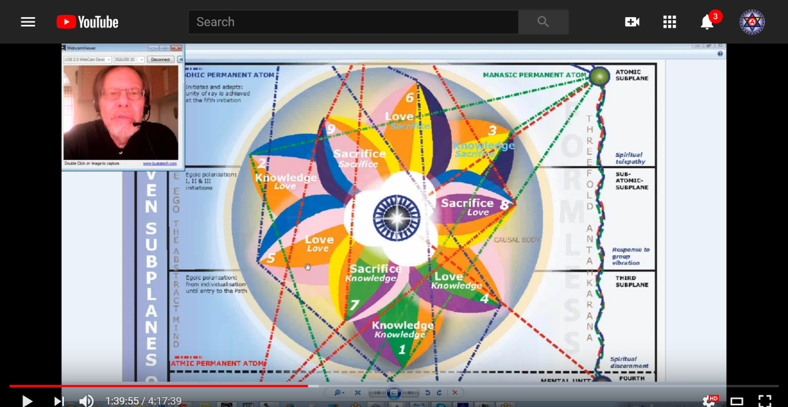

So, it's intelligence, it's Mercury. There is a mental focus, maybe I shouldn't call it an intellectual focus, because intellectual focus implies more the abstract mind, and we're not talking about abstract mind here. We're not talking about higher mind, that we will begin to discover in petal four, because after all the higher of the pairs of opposites is not just love, it's mind, it's love, its will. We certainly will understand the mind part of it, we begin to enter into the field of petal four, we begin to be aware of soul mind. Higher mind is not necessarily abstract mind, but soul mind, and we begin to be aware of it when entering the petal four, working in, developing petal four. We might say the love higher of the pairs of opposites in petal five, the will of the higher of the pairs of opposites in petal six. That's one way we can look at this. This is not really intellectual, it is mental.

Lower mind is strongly emphasizing with Gemini, manual dexterity, a person can do many technical things with their hands. This would be a characteristic of the primary lotuses, engineering skills and so forth. Gemini can make the good technician at this point in the manner in which it is expressing. It's good for invention in matter, providing mechanism for the carrying out of technical requirements. Now that doesn't mean that everybody concentrating in this petal will be necessary to the technician. … When the second petal is really unfolded it makes a big difference along with a third petal. The primary lotuses don't have that second petal unfolded, so it takes time to round ourselves out.

Invention in matter? Yes, providing mechanism for the carrying out of technical requirements and later those that help humanity and for those with the second petal unfolded, they can already work in that direction if petal three is highly developed.

We're preparing for the sense of duality beginning with the next petal to pass into the hall of learning. As I've said often this learning is not about learning of what's in the outer world, you can do that quite well with petal three, but the love petals are about learning something about the inner worlds and then having to bring that higher type of love, morality, and light, goodwill, into your intelligent participation in world affairs with other people. This is preparation for duality and there may be here kind of the sixth ray longing for something else, a little bit of the intimation of the higher the pairs of opposites, because as this petal is developing for those who are really the third petal types, there has to be some advance work going on. I wouldn't say so, and I've said why.

In relation to the Brahmic lotuses, they are, when you encounter them, pretty well as described, and it's not really high, is it? If you if you think about it, when you encounter one of the Brahmic lotuses with one petal unfolded, what do you get?

1:45:15 This:

Brahmic lotuses in which the first or knowledge petal is fully unfolded. They are so called as they represent on the physical plane the fully active intelligent unity, the man of small mental development, the lowest type of workers, agriculturalists, and peasants on every continent. They are also called “third class creators,” as they express themselves only through the act of physical creation on the physical plane, and their function is largely to provide vehicles for those of their own group. TCF 841

Brahmic lotuses in which the first or knowledge petal is fully unfolded. They are so called as they represent on the physical plane the fully active intelligent unity, the man of small mental development, the lowest type of workers, agriculturalists, and peasants on every continent. They are also called “third class creators,” as they express themselves only through the act of physical creation on the physical plane— Not much mentality there, not much throat center. We talked about people having a strong Vulcan at the throat center, or near the throat center, there are two little centers, and be quite inarticulate. –and their function is largely to provide vehicles for those of their other group.

When you organize you create something you can use, and if you're organizing, you necessarily have been organizing in the second tier before any petal unfolds in the first, then you have those abilities that you've been organizing, maybe not as strong as you would have them when the second logos really comes to an energizes them, but you have them, and these people don't seem to have them.

This is something that goes round and round in my mind as I try to work out the reason why it is said that there must be a lot of organization in the second tier before the first tier even opens. And here it is open, and as it is open, this is how these people are demonstrating, and not with any higher type of organization within the love tier.

The lotuses of Brahma, in which the second petal is showing signs of opening and the second petal in its lowest manifestation is showing signs of demonstration. They stand as representing certain groups of Egos from certain planetary schemes, notably Jupiter and Venus, who are a grade higher than the class above, but which have as yet a long way to go. They are called “second class creators” for though they demonstrate on the physical plane in the act of physical creation yet they are more swayed by love than by animal instinct as in the first case. They are to be found in incarnating at this time in the Orient, particularly India and in the Latin countries, and just lately in America. TCF 841

The lotuses of Brahma, in which the second petal is showing signs of opening, whatever the signs are, DK would know, and the second petal is showing signs of demonstration the lowest part of love, they stand as representing certain groups of egos from certain planetary schemes, notably Jupiter and Venus, who are a grade higher than the class above, but which have as yet a long way to go. They're called second class creators, for though they demonstrate on the physical plane in the act of physical creation (sacral center), Yet they are more swayed by love than by animal instinct as in the first case they are to be found in conning it at this time in the Orient particularly India and in Latin America and just lately in America. It's always good to read and reread these things until they really sink in and become a part of our understanding. The higher of the pairs of opposites is coming into view, not in explicit detail necessarily, but in terms of being a kind of magnetic and higher part of ourselves, and we begin to realize that that is the case.

The major signs in the series beginning with Aries in the clockwise order? Aquarius is at the third petal. As I have explained, it takes a long time to develop and work in a petal, maybe not as long as times in the first petal, but of takes a long time, so every sign of the zodiac is going to somehow be impressive in that process of working a development organization and vitalization. But Aquarius is one of the ones that fits with the series, so for some types emphasizing the fifth ray of this petal we have the scientific applications through Uranus, which is a scientific planet and can represent concrete science just as Mars can. The lower scientific mind helps with the synthesis of knowledge, a knowledgeable attitude to the outer world. The man is oriented in this extroverted manner (it doesn't mean flamboyant character, but about his consciousness). Consciousness turned towards the world of the senses. It's a task-oriented mind, it's a lower form of Aquarius that has to do with working in relation to the baskets of nourishment which are basically the atomic lives or the life within the atomic lives. Aquarius is a synthetic sign, I would just say, Aquarius is good at synthesizing, and knowledge, just like Gemini is, but Aquarius is perhaps even more synthetic more related to a first ray.

What is the major sign in the series beginning with Pisces in the clockwise order? Capricorn. Pisces, Aquarius, Capricorn. This is where we are going to discover some of the hardness in enforced sacrifice, the state says you must do this your job, your duty, your military role, regardless of what that means for your personal welfare. Capricorn does enforce that, so conform to the requirements of your job economic pressure.

We see that even now when Pluto is in Capricorn how a number of our economic systems are breaking down under that influence. Economic pressure can force as much sacrifice at this petal as the pressure of war. So a lot of nice, good people are being forced to work very hard and sacrifice much as they try to fulfill their desires or as their country or community demands it. People say well, ‘I should be free of servitude, I am a free individual.’ But at this point we're not really free, we have to earn our individuality, it is there within us in seed, we can say.

We might say that this third petal is the petal of having to do this, and not yet deliberately willing to. There can be some aspect of – let’s say you can be willing to do what you have to do, that is possible, you can also be unwilling to do what you have to do, but then the lessons are not learned and one is forced to return into those circumstances until the lessons are learned.

If the second petal were closed, there could be quite a cold materialism, but intelligent, and that we have that possibly in these primary lotuses who have contributed much mechanism to society and to humanity, but destructive mechanism, the weapons of war, for instance.

Here we have the function which must be upheld as you serve others in your role in society. Capricorn is the role of civil servants, all of the civil services is much Capricorn and Virgo, civil servants have a role and they perform their duty, duty, duty.

Look at the primary lotuses where is the affect? It's not there, hence Capricorn? Capricorn can be quite a cold sign. And if your second petal is shut then even more so. What we're talking about the Lotus is of lower mind I'm aimed at we have kind of invented ‘lotuses of manas’, that kind of thing.

It's not how we feel about it it's just what must be done. If you are fulfilling a role there is not much room for you to be a distinctive personality. The demands of the role overshadow or … outshine are greater than the demands of personality such as it is.

What other signs might be implicated in this third petal and the meaning of the implication? I put down some, but I usually try to include them all: Gemini, Sagittarius, Capricorn, Pisces. I guess all of the mutable signs of course. Every sign has a place; it’s a Gemini petal, so Sagittarius opposite. If it's a Virgo petal, Pisces is opposite it. We did talk about the idea that the sign opposite is a distinctively relevant petal, also relevant.

We’ve talked about the Gemini petal, but one is bound to the altar of Bucyres, thinking that knowledge comes from only one direction. Of course it depends on the rays, right? Not very well rounded in that sense. The petal alone, without the other. Earlier and later petals, earlier or later, is not known this early for well-roundedness. The intellect alone can be tyrannical. So skepticism can appear here, in one sense, in a phase of this petal one can build up quite a resistance to what will appear as more real in the love tier.

Gemini was Hercules, and found himself bound to the altar of Bucyres, the false teacher. It's not that we're really looking here for teachings relating to the spirit. You can believe in someone's thinking but you are not yet a spiritual aspirant at this point, if Gemini is part of it.

Trying to get along with all? Aquarius also found here, all things to all people, all things to all men, as DK says, needing to adapt to circumstances, to fit in and harmonize the third group. Third stage of adaptation? But Gemini is searching the external world out there on the mission to find out everything about everything. Since we're still in the hall of ignorance there must be an intense focus on learning in the material world and finding your answers there.

Listening to the voice of Nereus? Maybe later. He missed that opportunity, the intuition came to him and he ignored it. It's Gemini, let's just say it is the failures to attend to the inner voice and to really know oneself that are evident here, in the skepticism. We're skeptical of Nereus, that's the voice of the intuition, we don't believe it? We attend too much to Enteus[?] and we get carried away by glamor, especially if the second petal is also quite strong. If it's not, maybe he wouldn't so much, and then we listen to the one who knows. How we can call this, Bucyrus, the one who knows or seems to know. But the real Bucyrus lesson is coming in later, I think the Gemini here is more about knowledge of the outer world.

1:59:30 Putting the bodies with the petals? Yes, it's certainly possible to do that as well. The mind with Gemini and also the etheric body. With Sagittarius we have low desire, but we also have aspiration and Sagittarius is the body of that must be sacrificed upon the altar of desire, and later of aspiration. Capricorn is the driving force of circumstance. Virgo is, I give up my will for the higher will, the armed services under Virgo. I really didn't realize that, but how much of your own will is taken away as you have to simply follow orders. Also, in a way, we have the army of the voice in Virgo. Mars in Virgo, the Army of the voice. Pisces? I have no choice. I'm being forced to sacrifice; It's out of my control.

Virgo and Mercury? The business indicators. I put this in before business is working with the mind in matter.

Eking out a living under – I'm looking at the plight of many unskilled workers in our society and how they're being forced closer and closer into slavery. I'm a slave to my business, or serving expectations of my employer. That's the Virgo that we've been talking about, Scorpio? We find that here: death, loss of life, giving up your life, struggle, right? For when circumstances force you into it and then you die, I think Scorpio has its application here. And thus Pluto, right? Where you lose your life on the altar of desire, then Scorpio can definitely be involved. It's not the latest Scorpio, the fifth petal, it is not the Scorpio of the eight petal, but it is very stressful circumstances which are life and death.

I'm remembering that Tennessee Ernie Ford song, old song Sixteen Tons, right? One of the closing line is ‘I sold my soul to the company store’. So expensive, and one has to have the necessities that one keeps selling one's future to it and eventually even one’s soul.

I think we’re still dealing with –the advanced chain people, not here, they are more the personalities coming – the capitalist problem of capital and labor. When we talk of capital and labor, this is more labor. We're not talking about people who have risen into dominant, powerful positions, the Moon chain in the Earth chain. But remember that there are some moon chain types who are still lotuses of passion or desire, right, so some Moon chain types are lotuses of passion or desire, and this the bulk of humanity. But two fifths of them are them, and if you've moved on to become a lotus of lower mind (… we'll make sure that we say that that term is not the Tibetan’s name; He didn't suggest a group of that kind, but just to fill in the big gaps I am suggesting a lotus of lower mind. …) They could certainly be Moon chain lotuses, too, couldn't they? But also Earth chain. We have to realize that there are some Earth chain lotuses who are already masters and that's astonishing and has something to do with the expression of the power of love.

1:06:15 The signs implicated on the basis of the color? … have I included enough? I do think we should make sure that we've included all of them because mostly I have.

What about the others? Aries, sacrifice, plunging in, and committing one's body fully. Taurus? Yes. Taurus, knowledge, but also economic necessity so that others can have. Gemini is mentioned. Cancer? Yes. Providing for one's country, ken, family, and it has the third ray of activity.

Leo? Leo has much of the fifth ray in it and let's just say the light of knowledge is growing stronger. We are not yet an integrated personality, no, not yet, but Leo is closely related to the fifth ray and to the mind. Virgo is mentioned, it's a bit exclusionary in a way. I think we see that not all the signs of the zodiac have equal power here. Virgo, of course. We mentioned, it's a largely Virgo sacrificial petal.

The next one is Libra and decision or sacrifice. Scorpio is mentioned. I think I've included Sagittarius, so this has to do with the altar of sacrifice and the animal body. Sacrificed for desire and aspiration. Capricorn is there for school of hard knocks. Aquarius is there, we talked about science. Pisces is there, of course, and we didn't talk much about that, but I have no choice.

So those are little epitomes that tell us something about how the signs could operate in the third petal work process, experience, and so forth, but what we really need is the ability to identify who is where. Who's working where? What is unfolding naturally in support, where is your cutting edge? Where do you spend the majority of your time? Working away, organizing, preparing? Where is your cutting edge? Are you working equally over the cutting edge area and the more normal area? What are you leaving behind, relying upon the solar angel or the second logos or the initiator to take care of?

All of these are not easy discriminations, especially because we're not seeing with accuracy, everything we need to see we – as St. Paul says, We're seeing through a glass darkly on these matters. But you have to begin somewhere, and this is what man has done man can do, and if there are those who can look and see exactly and understand the implications, then we will too. That is something that has to be understood.

The signs implicated in this petal on the basis of color? Leo, Gemini, Virgo, Libra. Orange is Leo, and He tells us, not to just accumulate knowledge, but we justify knowledge in Leo. Kind of a prove it and determine its value. So, we prove the value of knowledge that it is worth having and of practical use.

Yellow is associated not only with Gemini but also by the Tibetan with Virgo, and basically we commit our mentality to the sacrifices which are demanded of us.

Indigo? It’s is a Libra color, balancing of forces before the opening of the next tier. A choice, decisions, but remember the sacrifice is largely unconscious still decision can be made on the basis of emotion. DK has told us that really important decisions are being made by the mass of humanity in Libra, on the basis of their ideals and how they feel about things. Disciples are making similar decisions using the intellect in Scorpio. Big decisions, being made by much of humanity on the basis of ideals and emotions. It’s how one feels that is determining the nature of the decision.

(We need dragon of wisdom naturally speaking, I've always thought what if the Tibetan uses some sort of voice recognition software in his next work, I think it would maybe take something out of it, but we would call it not just dragon of wisdom naturally speaking, the dragon of wisdom naturally speaking, a dragon of wisdom would be naturally speaking.)

Saturn is here, there's some finalization here and a general balancing of the forces in the first tier. We have oftentimes the tamas and sattva, for the third petals are sattvic and related to will. Third petals generically are subject and related to the will. So, some degree of harmony must be created before going to the next petal, just the way the causal body has to be harmonized before destroyed.

Balance has been completed in the first tier, even as the causal body must be balanced before it is ripe to destroy. There's something about the equilibrium of monadic types which relates to this, if I can find this … page 1082 of A Treatise on Cosmic Fire, and noticed some of the very last words … 13. The equilibrized atoms …
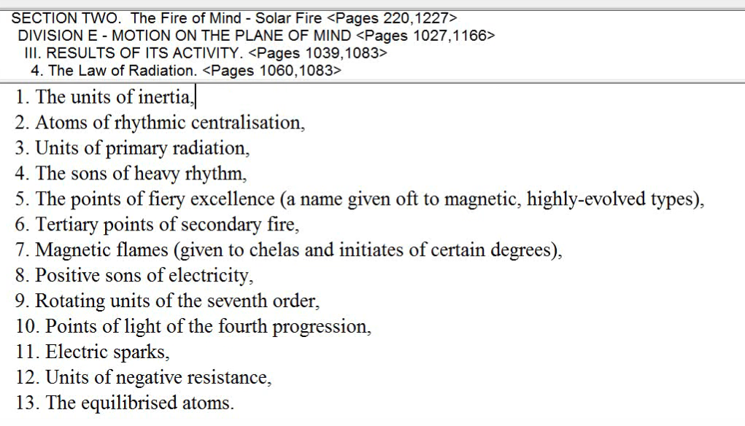

The equilibrized atoms are on the point of destruction. They are monads who have brought their hearts into a state of equilibrium. In general, we can say that equilibrium, harmony, Libra, preceeds destruction. I think that's an important principle and hence justifies Libra in relation to the sacrifice petals and sacrifice of individuals in a collective to maintain social harmony. The individuality is sacrificed. Individuals or individuality to maintain social harmony, to fit in to get along, fitting in getting along. Third stage of adaptation and then in a sense, Libran.

I think it's important to get these ten stages of the human groups in the eight stages of adaptation. Maybe that's important to do. The 33 stages of appropriation? That's a bit much. But one could have that in front of one just to have the basic categories of human beings in one's mind. Opportunism exists in Libra and making the best of your circumstances.

2:17:30 We've looked at the orange of Leo, the yellow Gemini and Virgo. Although sometimes I think Virgo should really be blue-green, but there is a scale of colors that the Tibetan used, and because of the strong Mercury effect in Virgo I suppose yellow is good enough. Then applying indigo to Libra, interesting, because He talks about the second ray nature of Libra, when usually for the third ray is discussed [it is green], and the higher type of Venus relating to the fifth ray [orange], and being in a sense indigo and the very depth of Venus being Indigo, it is ultimately second ray monad, right?

Other major constellations most implicated? Pleiades. There is a kind of mind in matter, a triangle it goes Pleiades, Capricorn and Mercury, I think we can see how all of these would relate. Pleiades is the ultimate source of course (and is the hub of the wheel for our local One About Whom Not May Be Said, but Capricorn is doing the enforcement here, helping humanity rise through its intellect and there's a lot here about the concrete mind, Capricorn it is usually said gives you rays one, three, and seven, but there's a place in the books where the ray five a suggested as well but even with the third ray Mercury will be there and using all one's knowledge to advantage and making the best of one circumstances.

Are other, secondary constellation implicated? Centaur, Lupas and Ara. I went through them all last time and I might do a quick run.

Centaur in Virgo, spearing the wolf, Lupus, to lay the skin of the wolf upon the altar of sacrifice. Lupus is the wolf, sacrifice body, a personality, Ara is the altar, the altar of aspiration. Is Bootes connected with Virgo, the bear driver, performing a labor? Coma Berenices? Definitely, sacrifice.

Looking here at the decanates, let’s take a quick look:

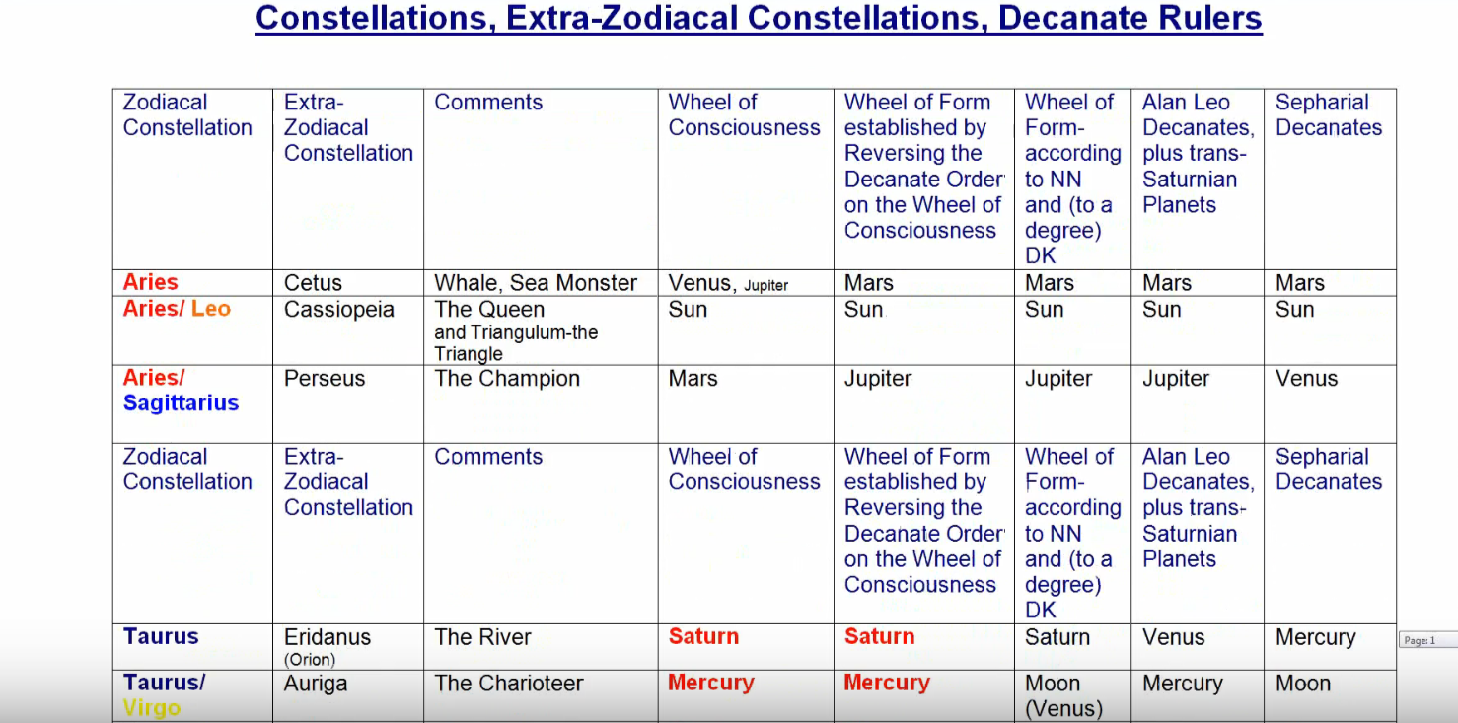

The Whale, the Sea Monster? The Queen? Only in the sense of Virgo, Virgoan materialism. The Champion, Perseus. [unintelligible] not so much. The river of incarnation, Eridanus? Not so much.

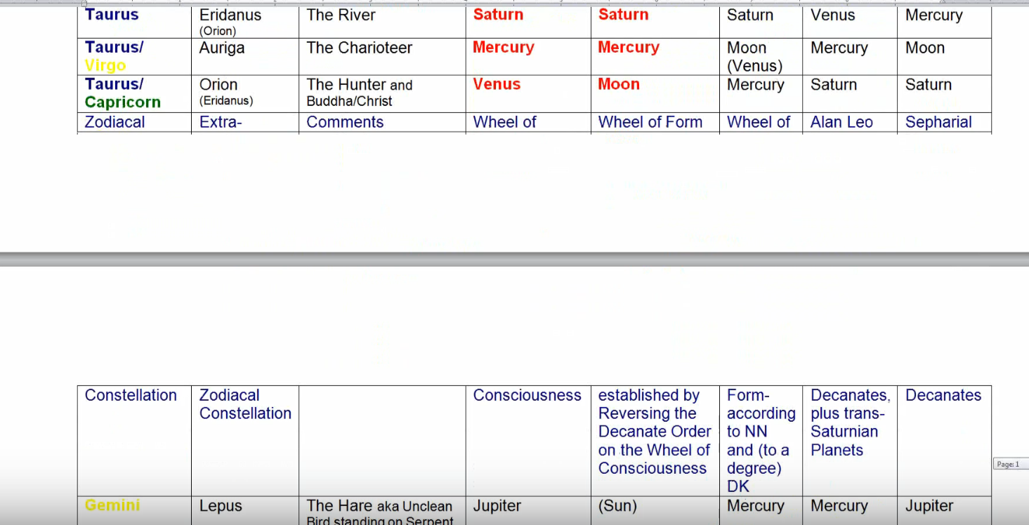
The Speedy Charioteer? No. Orion, bringing illumination, the hunter who is the Buddha and the Christ? No.

It's a Gemini petal in a way, running away … Lepus, the hare. If one runs away from the sacrifice expected, Lepus applies. …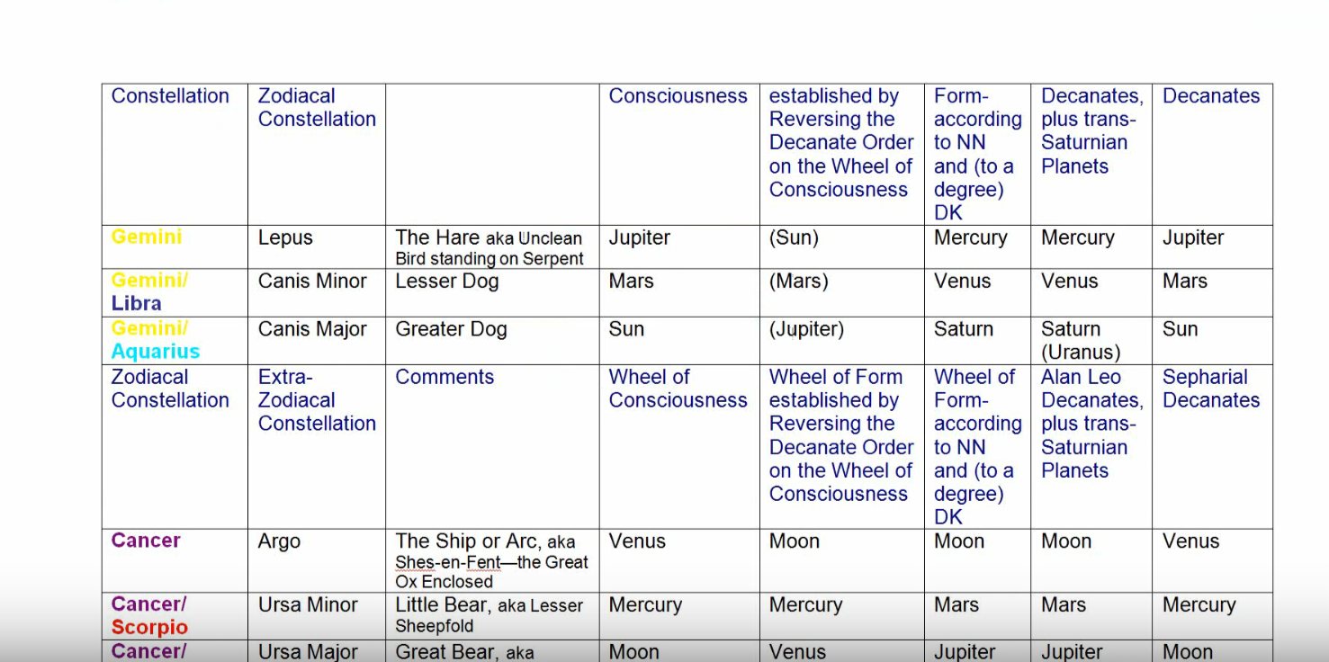

The Lesser Dog? Maybe not. The Greater Dog? No. That's Sirius. Argo, the vessel? I don't think. Ursa Minor, the Little Bear, in terms of guidance. No. The Great Bear? No. The sea serpent, Hydra? No, the cup or chalice, maybe Crater. Expecting the cup of karma, Crater, you take what you must, your cup of karma is filled. Crater as the cup of karma, you must accept what is poured into it so that is there. Maybe Corvus, with messages from the Gods demanding sacrifice, that's possible, too.

Let's go on, into Scorpio, [which is] the serpent here? No. But nor the healer necessarily, but in Virgo petal orthodox medicine could be part of it. As well possible the kneeling hero, well you're on your way, some Hercules vibration is here, you have to you have to rise to the occasion, that sacrifice commands.
What else? Well we talked about the Altar and the arrow. Of Capricorn? Well, it's the suffering, so I suppose Sagitta, the arrow of suffering through sacrifice, not the same as, for the initiate, but it's a warm up; it is practice.

Anything else here? The Eagle? I don't think so. The Swan? No, it's too abstracted. The winged horse? Travelling fast and going high? No. The Southern Fish? The Savior? No. The band which is holding the two fishes together? Yes, the band, which is holding the two fishes together, yes, I think so, maybe. The band in Pisces holding the personality in obligation to the higher powers, and the chained woman, one is still the chained woman, Andromeda, one is still in servitude. This I enforced service, servitude.

2:25:50 That brings in some of the consolation influences. Remember that these fixed stars although in a sense they are for those people who have taken the third initiation, research shows that they do affect normal people and normal circumstances. So, think of the sacrificial task that has to come in here and then think of the relationship of these constellations to that task—certain stars to the task.

The synthesizing planet most associated with this tier or petal? It's going to be Saturn. Neptune brings relinquishment, it is one of the rulers of Virgo, but you've got a higher turn of the spiral and Uranus, the concrete science, so synthesizing knowledge.

The division or planetary triplicity most associated with this petal? Maybe we can call it Saturn sub-Uranus. We have the three synthesizing planets associated with the three tiers, Saturn with the outer tier. So maybe Saturn, sub Uranus. Saturn is a very sacrificial planet and Uranus is the scientific mind. Uranus is also related to Mercury which is ruling Virgo here in the mind. Mercury has to do with all kinds all aspects of the mind, including the concrete mind. Sacrifices is being forced to line up with the pattern of Heaven. … and that being forced to conform to the pattern, Saturn is the conformity and Uranus is the pattern in the heavens. After all Uranus is the Heavenly One and reflects the divine pattern in the heavens.

All of this is preparing for individuality. I remember, a long time ago the so-called Silent Majority (one would think of the lotuses of passion and desire; they can keep the world running you might say and doing all the routines). We have increasingly skilled labor here we have very crude labor in petal one; increasingly skilled labor but not yet accomplished artists or craftsmen where individuality is involved.
This is the synthesizing planetary triplicity, Saturn sub-Uranus, but they all seem to be involved, Saturn, Neptune and Uranus. You wonder whether by the time we reach the synthesizing petals, whether we don't synthesize all the three synthesizing planets. I can think of that in relation to Capricorn, in relation to that to the final, ninth petal. Saturn is the fulfillment and the ending of all karma, the kind of karma to keep you from mounting to the mountain top, Neptune is the response to the Buddhic plane which is beginning to occur, and Uranus is the indicator of being and of the monad which becomes possible at that point.

I call the Neighboring Planets, Mars and Venus, as they neighbor us, they are our neighbors … Earth’s close neighbors, that's why I call them that. Most associated? Still Mars. Why Mars? Mars is the concrete mind. Mars, concrete mind and the senses, and the desire and aspiration which lay the body upon the altar of desire. Mars I think is the most important, maybe it's a sub Mercury, Mars sub-Mercury because of all the learning that goes on here. Mercury being a planet of conflict also and of sacrifice.

The division of the planetary triplicity most associate with the petal? I said Mars sub-Mercury, the thinking gets sharper but for a different reason I'm offering this.

What about the Sun/Moon polarity associated with petals? Still the moon, the first four petals are still the moon, the mental elemental is still lunar and it relates to the sacral center and the moon as the mother of the form also relates to the sacral center. The moon the sensorium. Saturn the brain. The moon in some respects the brain too.

Other planets implicated in the reasons for this implication? Well I'm including Vulcan, Mercury, Mars, Saturn, Uranus, Pluto, Moon. Am I leaving out Venus, Jupiter, Neptune? Let’s see, looks like Venus, Jupiter, Neptune, Earth, not included yet.

Vulcan, the driving force of circumstances. Spiritual will, unconsciously delivered the hammer stroke of spiritual will is more powerful than the free will of the individual. Circumstances drive you to sacrifice. Whenever you're being pushed, pressured, forced. Vulcan is one of those planets so all of this is a process understood as the lower reflection of spiritual will. Vulcan is pushing, pressuring, forcing, hammering you into place. Metal is quite resistant, when heated up it is less resistant, but the real force of a hammer blow is there. Vulcan rules Virgo, so shaping up, the mind shapes the body.

Someone put in here the stubbornness of the Silent Majority. Well, I'm not sure that the Silent Majority are really the lotuses of lower mind, they can be more perhaps involved in what we call the lotuses of passion and desire not the Lotus is of lower mind I know and also that is a somewhat dated idea. There is not so much of an emphasis upon that anymore, it was kind of used some years ago to silence innovative or dissenting opinion.

Anyway, Vulcan, the hammer driving of the nail. I can say here in the coffin of sacrifice, the assembly line, ray seven, keeps people doing the same thing. There is ray seven involved in Vulcan because of its connection to the mineral kingdom and connection to rhythm. It's repetitive, this petal, the actions that have to be done, even the machines that are made to go through repetitive actions, repetitiveness is somehow important here, the same task over and over again. Filling out the tax forms and so forth, the civil servants work, it's not really, ‘What should I create this morning?’

Anyway, shaping the task-oriented mind that's what Vulcan does. Vulcan was the servant of the mother, he served women, he was rescued by women, that was brought in. Vulcan related to the primary lotuses, their separation problems with both parents, Vulcan was considered to be rather ugly and misshapen though having a great love of beauty. He was the mis-shappen one, shaping beauty he worked within the mineral kingdom, hence number seven. He was the number one, he was the trustee one, he was reliable. Wayland was another name for the Celtic's Man. So Vulcan has an important role to play at this petal.
2:37:35 We take a look now at Mercury in relation to this petal. Ruler of Virgo, of course, and if we call these things lotuses of manas, or lotuses of concrete mind, concrete intellect, it fits. Also its involvement with sacrifice and the color yellow.

Venus may be secondary, it’s only that the fifth ray is getting stronger at this point. Venus, fifth ray, orange, continues to increase in its power until the causal body is actually destroyed in concrete mind, fifth ray. But there's also the possibility here of the appreciation of the arts, perhaps through the connection of Vulcan and Venus.

All of the earth signs are involved in every earth sign petal. Vulcan and Venus together, the two rulers of Taurus, one of the majorly artistic signs in terms of fashioning form. The Earth? Well I don't know, it's the body, and this is the field of sacrifice and we might say we're still applying mind to concretion so mind is still being applied to that which is concrete and sensory. So the Earth related to the senses?

Mars certainly is there. The driving force of circumstances, the altar of desire, low desire or aspiration, and also devotion. Mars related to the five senses and the concrete mind, Mars is active in all of the first four petals of the personality because Mars represents the integrated though rebellious personality.

We're told that Vulcan traps Mars and Venus in a net. Venus is supposed to be married to Vulcan, but she has an affair with Mars and then Vulcan traps them – concrete mind is trapped and shaped by the cultural factor. Mars is the concrete mind, that's one way of looking at it, but there's more to it, its will and desire. Mars is desire and Vulcan is will, so from another perspective, Mars the concrete mind, Venus is culture, Vulcan is the forcing will, perhaps an integration between all of these is needed. Vneus is pretty much the ajna center and Vulcan, the will center at the top of the head. So these two have to be united. Mars has a generally lower place.

Jupiter? Rather secondary, only involved perhaps in that it is a synthesizing, so gathering everything together into the tier.

Saturn? Yes, no free will. Do what you must, you must sacrifice, you are compelled. The fact of duty is very big. Saturn is strongly on the third ray and it also rules the concrete mind and it's involved with keeping the structure going, keeping the structure of society and going. Saturn always forces a conformity to the next requirements. This is your duty, this is the next thing before you, this is the next thing to which you must conform. It forces you to give up your will to the collective and eventually to give up your will to the plan, and to Sanat Kumara Himself, who is in a way a representative of Saturn

This is the nature of sacrifice; your will is given up for the collective. At this time, you hardly know why, later, under Saturn, you do know why because what the plan is. Uranus is here from the point of view of scientific mind, and Neptune is the sacrificial planet. But this is perhaps secondary, it is more a Saturnian sense of sacrifice than a Neptunian. In other words, doing your duty and the duty it leads to the sacrifice. Saturn fits so well with the type of mind that is involved here and Neptune does not.

Neptune is related to Virgo, yes in terms of the Christ consciousness, but we're not dealing with that right now. As for Pluto? Yes, we are forced to sacrifice and lose our life. It is the ruler of Pisces in a sense, certainly the ruler of Scorpio. The consequences of the intense desire and aspiration it is found here is the loss of the vehicle.

Servitude? Yes. People don't like servitude, who does? What they don't realize that the servitude to which they are compelled is the beginning of the ability to serve freely and creatively, and according to one's nature, but the elementals are not in the habit of servitude. The blind elementals, perhaps, they are members of the Army of the Voice, but they have a resistance to the kind of demands that are required in the upper part of a man's nature.

Those are the planets, we've talked about Vulcan, the forcing, Mercury the mind, Venus is just generally here all through all throughout and it is the beginning of – it has an important mental component but usually it's related to higher mind and we're not really into higher mind yet, but there is the possibility of continuing the artistic impulse when two petals are open, so Venus is necessary there.

The Earth is the field of experience in the field of service. Mars for the forcing process. Saturn for the inescapable demands of a higher authority. Uranus for the scientific mind to a degree or at least the practical, concrete though innovative mind … Neptune? It is a sacrificial planet, Pluto, though, you definitely lose the life, the you're attachment to the body is in a way cut, and as I said before the at the second degree your attachment to the astral body is cut, in the third degree your attachment to the conventionally organized physical body is cut.

The colors? I haven't really gotten into that, but it's not yet the orange ball of ambition although we're getting we're developing the mind to such an extent that before long ambition will be seen. We need this development, we need mind for the success of ambition. Capricorn is more top down in this particular petal, it's not the desire to reach the top which comes in more with individuality in the second petal.

The musical notes? Fa and mi, the fa is the great green fundamental, and mi is the note of Mercury, the yellow note. At least it is the Mercury part, it has a Buddhic connotation but we cannot speak a Buddhic connotation here so. All in the mind he is concrete and deals with specific things.

Intervals of music? We’re not even at an, well, interval of the third. The third gives you a personality, really I suppose there has been to a degree – well the personality is always present in a way. But there is not an integrated personality yet.

Crises characteristic of this? None of the Tibetan’s crisis, crises of duty to be performed regardless of consequence, it's a real Saturnian stay at your post kind of petal.

Is there a cosmic law most associated with the petal? Again, the law of economy, not the Law of Attraction, is involved the second petal, but it's all with the law the economy for this first tier because we're dealing with form. Law of Economy and it's also true that economics is forcing you to do many things. Which require sacrifice also, the security of your of your country or of your particular group is forcing you to do certain things.

The sub law here is synthesis? It is after all a kind of a third or synthesis petal at the end of every tier.

The systemic law most associated with its petal? The law of fixation, disintegration, sacrifice and death. Law of fixation is not necessarily a flexible mind, it has a crystallizing effect dealing with concrete things and with concretions.

Law of disintegration is the third law, maybe we cannot use this, the work is not yet done yet, maybe not. I think the law of sacrifice and death is pretty obvious because that is what is required here for reasons not understood.

Are there any soul laws involved here? We haven't really moved into the second tier, there will always be however in the third petals a reflection of the law of sacrifice, but we don't recognize the pairs of opposites or the higher of the pairs of opposites. Maybe there's a little bit in the later part of the third petal working ahead into the second tier, we're going to recognize something of this higher of the pairs of opposites, but what we have here is in a sense the law of enforced sacrifice. That's the only one I can think of it's not magnetic impulse, it's not service. If there was such a thing as the law of servitude perhaps, we don't have you have the law of repulse, and we don't yet have the law of progress and as for the higher laws they are way beyond the pale

2:50:30 The astrological triangle almost associated with this petal? Mars, Saturn, Pluto. Mars, Saturn, Mercury. If we look at Mars Saturn Pluto, the driving force of circumstances and the death that occurs because of this driving force of circumstances and the resultant. Mars Saturn Mercury, concrete mind, and the use of that concrete mind in all manner of mental application in the normal world of the senses.

The senses and their extensions. We have to look at that, the sense of sight, seeing through the mind. It’s not “to feel the petal”. It doesn't have the two and six, it doesn't have the rose and the blue.

Venus and Mercury are here for sight, one is beginning to see through the mind and common sense mind is formed and that's a lot like seeing, this sight puts many things together. This is the petal of common sense mentality, there's objectivity along with the sight. It's not a biased sight, objectivity, and is a very good word for petal three. Not for all of it but certainly for some.

Clairvoyance? Maybe not. The kind of clairvoyance that we're more likely to see is associated with petal two in the Atlantic stage. Here with the color yellow clairvoyance might be more likely to decrease, but then Virgo makes with a mental psychic, and there are mental psychic powers. I wonder how much this would be related to those? Not so much I think.

What about discrimination on the fourth subplane of the mental plane or is it too early for the meaning of discrimination? I think so, too early to discriminate between the personality and the soul. We don't even really yet have an integrated personality. We are starting to the speak of discrimination of this from that, of course, and clear distinctions ever being made and the mind can be quite separative and skeptical.

Is it a synthesizing mind? If it's synthesizes, it’s not in any philosophical sense, synthesizing practical knowledge. There is a lot more to mind than practical knowledge, but at this point I don't think we can expect much more. Some of the discrimination must arise at least from the fifth subplane of the mental plane. It's a lower manasic petal and not a petal so much associated with a subplane four, although there is a lot of Mercury there.

Venus with its fifth ray and its magnetism is of the divine connector. Interesting, but is it that kind of fifth ray? I don't think that lower mind and higher mind are yet being connected here, such a person would not be inclined to meditate. Lower mind and higher mind are not yet being connected.

What about the guna, tamas, rajas, and sattva? Tamas for the tier as a whole, rajas is still there with the driving force of circumstances, and some material form of sattva, adapting yourself to circumstances intelligently making the best of them, getting on with others achieving harmony with your environment under fourth ray Mercury, poise, opportunism, achieving harmony for selfish purposes – the lower form of sattva – making the best of your circumstances by balancing them and harmonizing the.

Are there any advanced themes here? Not really, you do need a good concrete mind to present an attribute, but the motive to do so comes later.

From the greater constellational point of view? It says Pluto, but I'll bet that's supposed to be Pleiades. … It’s not yet the Great Bear, It's not yet Sirius. It's still the source that induces the life of matter.

No chelaship here yet. We are still in the book of form and we're on the path of evolution and not yet really of ambition that we are understanding, the mind as the source of ambition. Because the mind helps you isolate yourself has a separate ego, lower ego, and then you begin to identify with it in want the best for it.

The blended dual light of Gemini. Perhaps we can talk of that, it's not blending the higher and lower pairs of opposites, but it's seeing the relationship between two things. I think it's a bit early for so dark a light.

The keynote from the angle of form? Under Virgo let matter reign. Interestingly under Gemini it would be let stability do its work.

From the angle of the soul? I am the mother and the child. I god, I matter am, but we're not really bringing together not only a pairs of opposites but a kind of triplicity, it's too early.

Hands are important as organs of action, and maybe the feet, to go learn. The head with the voice, organs of excretion and of … let’s see how this goes, from the Light of the Soul it's page, 157: The five elements are there: including the ether, the five sense organs, the ear, the skin, the eye, the tongue, the nostrils, those physical organs or channels through which identification with the tangible world becomes possible. But the five organs of action, voice, hands, feet, excretory organs and the organs of generation. Hands and feet mostly. Maybe also excretory organs, let's just say, that which you can sacrifice.

Yes possibly, every sacrifice petal, Pluto, excretory organs, that which can be sacrificed. Not so much the voice, although kind of wonder about the Army of The Voice working here. Maybe working within the Army of the voice on the tangible level. But basically the hands and feet I think, maybe the sacrificial organ. The organs of generation not so much here, much more in the second petal and the first petal. The organs of receptivity here, skin, the eye, the tongue and nostrils, I think especially the eye.

3:01:30 The alchemical journey? I'll just leave that to goes who really know.

With the tarot? I'm not sure. The Mercury card is the Fool, and it doesn't seem to fit well here. Aries towards Gemini, the Lovers? Maybe not. The Chariot? Not quite. The Strength of the lion? Not quite. The Hermit? Not really. Judgement? No. Death? Well, the Death card, perhaps, the Scorpio or death card. Temperance? No. The Devil? Well, the mind is the slayer of the real, Capricorn or Devil card, I don't know. The Star of it's called Aquarius, and I'm not sure what the Pisces card will be. Is it the World? Let's see, Pisces card in the tarot. So here we have some of the tarot deck:

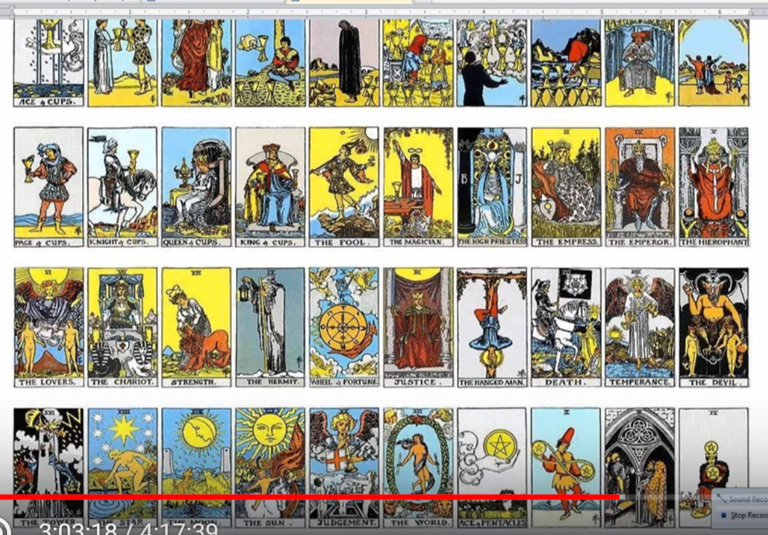

I think the … High Priestess is in some ways related to Venus, maybe the Empress is Venus, the Emperor is Aries, the Hierophant, giving light. Taurus. The Lovers? Yes. Gemini. The Chariot, Cancer. Strength? The Lion. The hermit, Virgo. Then we have Justice for Libra, and Death for Scorpio, Sagittarius is Temperance, the Devil card, interestingly Capricorn. Uranus, the blasted Tower, the Star, Aquarius, and the Moon maybe connected with Pisces. Possibly.

The Sun card is number 19, and Judgment, the Judgment Day. The World seems to be the last of the trump cards and others are related to lesser cards. Probably we could find different connections here, but I don't see anything that – Virgo is there, the Lovers? Not necessarily. Maybe the Virgo card. The blasted Tower? Well, the sacrifices are involved for sure. I don't think there's a one-to-one correlation here, I'll think about that a little bit more later.

I don't think the Moon and Pisces should go together. I wonder if Judgment or the World should be considered more of the Pisces card of the tarot …

The mental chakras, I would say yes, we are dealing with some of them, the lower mental chakras, the lower mind.

The eightfold path? We're not there yet.

The eight means of yoga, we have especially Yama, the Commandments, or Nijama, the rules.

Harmlessness to all beings, abstention from theft, that would go very much with the stage of adaptation number two. Incontinence, petal one petal two. Abstention from avarice? Petal two again in the Atlantean days, some of petal three possibly, but especially found before the human being takes himself herself in hand.

When it comes to the universal duty. Commandments or yama? Niyama or the five commandments can constitute the universal duty – let’s see it looks like these are the five commandments, universal duty.

Then we have the rules, internal and external purification, that's not really happening yet. Contentment? Not happening. Fiery aspiration? Not in the spiritual sense necessarily. Spiritual reading and devotion is far ahead, no they are not really happening, not yet.

Thoughts contrary to yoga are harmfulness, falsehood, theft, incontinence, and avarice. And so our duty is to abstain from these things. [Light of the Soul, page 117]
The Beatitudes? Until we've really repented, no.

Advanced themes of meditation? No.

The fifteen counsels? Well, we are having some thoughtform building going on here, definitely, but man is not yet taking himself in hand in terms of spiritual purification, so they do not apply, neither do the fifteen rules of white magic.

Sephirotic associations? I won't get into that right now.

Celestial orders and tribes? No, none of those things. One can extend it further if one wishes.

3:09:00 Next thing I will do is spend a little time dealing with special comments that may have occurred in relation to this third petal. This then is the last section and I’ll we go over some of this collection of comments that ends every one of these more systematic approaches, in relation to the third petal. …

Here's a comment about people in certain countries where in ‘the good old days’ it was wonderful, but now it's work work work work work all the time. Well, family, children, should have a better chance and so forth. Maybe there was always some sort of parental sacrifice, that always goes with having children from the very earliest days, to protect and so forth, but now in many places it's triply hard. We see in some ways the natural way of life seems left behind with this petal of sacrifice. Must work 14 hours a day at the company? That kind of thing, working all the time, Virgo is labor and Mars is hard labor.

We have the whole question of slavery if you think about being forced into servitude is the ultimate. Forced into servitude. Captured. Shipped abroad, sold. Slavery is not gone in our world today, not by any means.

Someone was observing the Muscovites, Moscow, walk very, fast no smile.
The Sagittarius part is here, one becomes very one-pointed, very serious. Even though exhausted, one must work. This seems to be the general principle. What happened to the joy of life? The industrial revolution has forced a great deal of this. Remember this was the pressure of Shamballa. It's like it many people were brought from a more natural life in the second petal in just a 100 years they were brought into this kind of slavery to productivity. I think about how when Stalin realized the danger that he and Russia were in, this incredible forced industrialization. China had also forced industrialization. These were disciples of Shamballa forcing the issue, Stalin and Mao. We're not just talking about war, but economy and industrialization as well.

So many hardships occurred in the United States as well during this period of the robber barons and increasing industrialization. There were protest, novels written. I'm remembering The Jungle, about the meat packing industry. We have even a possible repeat of this, the days of the robber barons are gone, but if society allowed it they would return, because what's called the predator-elite would try to seize all the resources and make economic slaves of people. There has not been sufficient development of morality to avoid that.

The localization factor is operating, work being sent abroad, outsourced. In certain countries we don't have the same type of hard labor, but it is returning, as India and China are finding their place and they're both first ray countries, and so it will have a big impact on the world labor force. We are really talking about the labor force and the conditions of labor and the sacrifices involved.

We're talking also about a future period of added leisure where through technical improvements man can cultivate himself. But we're not quite there yet, and there will always be the need for a sacrifice, petal, the sacrifice will simply have to come in another way.

How long will it take the bulk of humanity to really develop this third petal? We're talking about millions of years then another round, into the fifth round. Why should it take millions of years? Well, that's just for some, and then there are those behind the lotuses of passion and desire who are developing this, who will have to develop this, the Lotuses of Brahman, then the Brahmic lotuses, so many millions will have to go through this. And how will the sacrifice then be made, because there are certain ingredients in the development of any human being which simply have to be there.

When have you ever become less through sacrifice? Master Morya says, well we cannot say now there is no sacrifice, no there is no way forward except through sacrifice which is such an occult statement and one which people really reject.

So, if we're going to have true individuality it depends upon this willingness to acquiesce to the fate of sacrifice without necessarily consciously knowing why. But perhaps the whole standard of human knowledge will increase because always discipleship rises to higher turn of the spiral and people will begin more to know why.

How can the spiritual kingdom merge with the human kingdom in 2,000 years if there is only second petal humanity? I don't really think the human and spiritual kingdoms will completely merge for all people. It’s a question of consciousness, isn't it?

One of our members said that a three-petal humanity is needed for better effort, better effect, to be created when the hierarchy merges and starts influencing humanity, more mental understanding. So it is important that the lotuses of passion and desire, the bulk, really raise their mental standard.

DK has made a prediction of when this will take place and when – let’s take a look at this because I want to make sure I'm quoting correctly—I think it's about when they will have opened that petal.

They have two petals open and unfolded and the third is for them at this time the object of their attention. Many may succeed in unfolding it before the second rootrace of the next round, and will stand ready before the close of the round to pass on to the probationary path, having unfolded one tier of petals, and organised the second. TCF 842

They have two petals open and unfolded and the third is for them at this time the object of their attention. Many may succeed in unfolding it—this is not about being on the path, this is about simply unfolding the third petal, before the seventh root race of this round, that means by the end of the sixth. The sixth rootrace is a million, ten million year process, but the bulk will not unfold it until the second race of the next round, which is I suspect well before the Judgment Day, and will stand ready before the close of the round to pass on to the probationary path having unfolded one tier and organized the second.

That is kind of an interesting idea about when one really passes upon the probationary path. This is for DK the time of the probationary path. The complete unfoldment at first then the organization of the second—I wonder whether some unfoldment of the fourth and fifth petals will not be needed for the passing of a probationary path. I suspect it is so. This is when DK says the path of probation begins and we stand ready before the close of the round to pass on the probationary path having unfolded one tier of petals and organizing the second. It’s not really initiation per se, a lesser initiation of a type. …

If people in the old days were devoted, how can the bulk of humanity come to the third petal quickly, so if the hierarchy really has something to work with, so cooperation of a more mental kind can eventuate? The idea is here that idea is that it will not be quick. Hierarchy will only be able to work consciously if those who know something about the work of the second tier. …

3:22:22 Now there are all kinds of difficulties scurrying in the third world but no time for be sure, it's all part of a larger process, all part of a larger, preparatory process. Shamballa gets involved through its cycles and forces issues. We have Vulcan being so important there. First ray Vulcan, connected with Shamballa.

Slavery is a horrible thing, very horrible thing, whether it is through the captivation of the body or through economic captivation. Can it have behind it all a larger purpose? Of course, it cannot be allowed, but in those instances where it did happen, can it have some kind of purpose in the long run which under pressure will advance those who have been enslaved, whether economically as is now the case in the East very much, and maybe increasingly the case in the West, or whether in the grosser form of slavery where your body is held captive and your will is enforced. These are not pleasant things. But it's kind of like with some of this servitude we have where we might call ‘paying our dues’.

Then another class came in [and here are their comments], sacrifice on the physical plane, mind is coming in more formally, it’s a pre-personal will, a sense of personality happens a bit later, you respond to a will which reflects the spiritual will. You don't know, that's the thing. See here in the West, I think we've been privileged with a teaching like this, and many of us are ready to take another step and we are certainly very individual and we've gone through a lot of fifth petal process to make our individuality what it is, and we've begun to start correcting it on the path of probation and offering it up in service with our work in the sacrifice petal. Think of the transition between the love-sacrifice petal, and then all the three sacrifice petals, all the three. It really strikes me here we have four petals of petals of sacrifice. … four in a row. So after the first initiation which sees five petals completely unfolded, the next four to unfold will be petals of sacrifice, sacrifice-knowledge, sacrifice-love, sacrifice-sacrifice.

There's a lot about the path on ahead where one has the choice to make to have no choice. One has the choice to have no choice in the later petals if all is to be properly fulfilled. All of this is because our planetary logos is behind in his time and space schedule. One is forced to give something away. ‘Must do’, is a stern command, my teacher always used to say that, I've elaborated on that idea earlier.

We have here the synthesis of the three lower petals, the indigo is involved, grouping all accomplishments in the world of experience, of the senses. They are now a good instrument of intelligence is available to the lotuses of lower mind.

Desire is definitely transmuted into aspiration to help with the leap forward into the second tier. Think of those great leaps forward and all the casualties of personalities in the process. But maybe for the entire country something was accomplished.

Uranus, the planet of the transmutation, I should have mentioned that when desire is transmutted into aspiration as it will eventually be. Aspiration need not be for a spiritual, subtle factor ... but simply for something better. Uranus is also the alchemist. If we thought that maybe Uranus or Venus did not have so much to do with petal number three, Venus and Uranus have something to do with the higher process in petal three.

Lots of yellow here for the light in the mind.

Harmony achieved through sacrifice. That is an interesting idea, the law of sacrifice is there, Mercury, yellow, and the harmony of the fourth ray and yellow the harmonizing color. This is one of those ideas to ponder on, harmony achieved through sacrifice. It's something larger than oneself always at the third petal of any tier one is presented with something larger than oneself, and sometimes one might understand it, or not, but one is obliged to acquiesce to it. It's always in preparation for real concentration within the next tier.

So service is being taught here through servitude, that's a familiar idea right now –there are certain places where if you assert yourself too strongly you will lose your job. Just try doing that in the armed services and you can be subject to a court’s martial or be dishonorably discharged and so forth.

The whistle blowers are interesting. These have more the Uranian vibration, and they are against the routine which grinds all down; they don't want to be hemmed in by the bad old ways and by Saturn. So, this is all the work. The nice good people have not yet learned to work in this way, so the two point five we might say and here the lotuses of the lower mind are three point zero. This is not accurate, but it's just to give us sort of a mental peg to hang our thought upon.

The NGP, abbreviation, I like that, something economical about that. Like growth or product and we'll call it the nice good people. Sometimes it's better to be a nice good person, than kind of what passes for an esotericist these days—one can do one's job a lot better as a nice, good person, I mean doing well in that level, and failing as an esotericist, as we all know the possibility. So the NGP, nice, good people, do not have the same mental acumen. The lotuses of lower mind are less emotional, let's say, and they don't let the feelings get in the way of doing their job, they are not deflected from the sacrifice by their emotions.

3:33:30 We said the same thing in various ways, ‘I have to I'll do it if it kills me.’ Right, ‘regardless of how I feel about it, I have to do it.’ That's already a step isn't it? This represents a step-by-step and moving beyond kama manasic, where with kama manas we can say that emotion will oftentimes interfere with a mental directive. So we have more dutiful and if we are more dutiful we are more Saturnian. Saturn is not really such a big planetary influence in the second petal. There is conformity there, to the community standards, in the second petal there is conformity, community standards. Whatever that community might be. …

When personality gets into the act, kama manas may return, because there is a connection there with the personality in the astral body. Personality related to solar plexus. We have all kinds of examples that we've looked at before you see them.

[Another comment] ‘Can't get off work because you don't feel like coming.’ So when you say Saturn is here, Capricorn to a new level of responsibility from which fortunately you cannot escape and your physical vehicle may be broken in the process.

I'm thinking about the … emergence of economic slavery. I'm thinking about how the people are forced into the mines, terrible accidents happen … You think about all the people who were brought over from Africa, they were forced to work on these cotton plantations, but even now the migrant workers are forced. It seems a terrible thing, but as DK said, we are unconscious of the idea that servitude precedes service. It is such an unpopular idea, nobody wants to be in servitude, but somehow servitude will find its way to exist even in a more leisurely age, maybe with better understanding, but there we just cannot avoid the sacrifice of the lower for the higher, and it's not always a willing and pleasant process.

Enforcement is a big deal here.

The first tier then becomes the foundation for progress. Have you seen smart and disintegrated people? Yes, one sees them all the time, where there's just such an uneven development, there's no solid foundation, and terrible things can happen there too.

There's the synthesizing here of physical plane experience and by the time one is a lotus of lower mind one can really handle the physical plane.

Is it possible to somehow to have missed some of these developmental stages? I guess it is, or to be so concentrated in that which is higher, that one ignores the little bit of attention at least that has to be paid to the lower levels. It depends on the country and the time and also on the rays.

Following synthesis, a new development is indicated and necessitated and this is always the case. Look at the synthesis of the causal body and then its destruction with the new possibilities offered.

The three-five connections are occurring here but lots of ray one. There's hardly a lengthy petal process, there isn’t, where all the rays don't have to be involved in some way – they will reach in some way, you can't have a physical object with only two dimensions. All the rays will reach and we just have to understand how they do so, whether astrologically mediated or through a ray chart, or whatever. Here you're not going to have the first and second ray through the ray chart, because you don't really yet have a really integrated personality. So still extroverted in terms of consciousness.

These first three petals are from the consciousness point of view petals of extroversion. From the consciousness point of view, which does not mean that you will not in Atlantis … exploring the astral plane, you may well indeed, but that's still extroversion. Extroversion consciousness is anything which does not consider the higher of the pairs of opposites. It's not subjectivity which considers the higher of the pairs of opposites, as the soul the subject of the astral plane is not.

The question, why is this happening to me? Well under Saturn a Capricorn you can be reasoning your way into the law of karma and you can begin to maybe realize what that is and that can turn you inward. I'm remembering a book recently, maybe written by Rabbi, possibly, When Bad Things Happen To Good People. It didn't necessarily have a karmic point of view from what I understand, I mean the point of view of classical occultism, but it gets people thinking, questioning yourself, you begin to lean inward.

The last of the fifth human group comes in here with the beginning of the sixth. If you are going to be a successful writer and thinker, you have to turn inwards and eventually discover something in yourself which is a higher part of yourself, even if you don't give it the occult name.

All of this turns out to be the basis for personality development, physical, emotional, mental. Mind is important, manas is important, very important, for development of personality taking place on the fourth subplane of the mental plane. Mind is pivotal here, mind is primary for man.

The first tier is the School of Hard Knocks. Especially petal one. It’s the seven hundred of the seventy, and the seven. The first three petals are the seven hundred incarnations. The seventy have more to do with intelligent participation in the world of affair, and the seven have to do with the developments in the fifth petal, I suppose, which put a man on the path of aspiration or the probationary path.

The seven doesn't really reach into the sacrifice petals, so we are rising, we have a basis for our ascent, we enter that phase where we realize that we exist in a higher sense. I think, because I am, because I think. You need self-observation and not only the observation of the not-self.

All of these transitions don't take place overnight and maybe if you were to look at two lives, compare them, you might not see much, but maybe if you look at five lives you would really see the change, and may that perspective be ours because it will certainly help us be better psychologists and we’ll be able to tell where people actually are and assist them with the next step ahead.

3:45:30 Basically, DK’s wonderful letters to his students were wonderful in no small part because he really knew and could see their next step ahead, and was helping them find it, helping them even discover it for themselves you. You cannot give all, says Master Morya, because to give all is to put on chains, he says.

In this petal we are of the mind yes but not the observer of the mind. In other words, we have not yet achieved the higher point of observation, not yet.
[Another class:] The driving force of circumstance, of course, Saturn-Capricorn-Virgo.

The outer thing forces conformity to a standard where your own comfort is no longer the main objective. I think we all have to pass through that. DK defined service in a way that the man must sacrifice of time and interest now. So many of us are very happy about our connection with the ageless wisdom because it offers endless promise, but in Gemini … I'm really happy I thought about this now because Gemini has labors which demand sacrifice, helping Prometheus and helping Atlas. Hercules has to slow down his pursuit.

[scrolling up] Allow me here to go up a bit and if I don't run into real trouble I might find Gemini … so many things being done here … ah ha another really important, very important, very important, Gemini fact. Sacrifice of time and interest in the helping of Prometheus and Atlas, yes and so it fits. Gemini really does fit with this sacrifice petal.

[Humorously] I’m sacrificing your time, this may give you a moment to breathe … this particular petal of sacrifice. I'm going to go up even further because certain things just stand out to me as really, really important, and I'm not able to highlight them in a manner that is sufficiently noticeable. I'm happy to have recognized that a few times I have a flashing recognition and I know it's really important.

The Atlanteans, then were pretty self-indulgent by comparison, and that is the case with those who are Atlantean petallers, lotuses of emotion. … it's nice to have a good old time in Atlantis and not have too much Saturn to drive your time, but Saturn is maybe not so strong as to be the time driver that it is in petal three.

This is a collection of thoughts as we work together and try to reach some kind of synthesis, there were commonalities in every class and some differences.

There's not a lot of wiggle room in petals three. The people not knowing why they feel they are between a rock and a hard place. Obviously it's Vulcan and Saturn; they are constructive members of society by and large. Negative people have to be found in any of these petals. We're talking pretty much about the good people. There are negative people in all petals doing bad things, but actually DK is not going to emphasize that. These things are done because of cleavage between the individual and his society and surroundings.

There are some extremely separative attitudes being displayed, I mean what does it take to feel very happy about oneself when you could not kidnap three hundred young girls from their school in the middle of the night and threaten to sell them into sex slavery. What does it take? what petal is that man and those people working in, there's a lot of very primitive ideas. Maybe they're certain idee fixes can occur in petal three, but we have in religions we have fixations in religion and we have a fixated mind. If you capture three hundred girls and sell them, it's a perversion. But there is a fixed idea supported by fanaticism, so it's a combination of petal two and three and maybe some of the people involved are already quite selfish, integrated personalities.

3:55:00 Ray six will come through in this petal because it will be at the altar of desire and aspiration but desire nonetheless, swept by circumstances, do as you're told, and you cannot change your circumstances that is interesting. Some people maybe rise over their circumstances under this. Influence. That too will require sacrifice. In other words, a petal of great exertion.

The Mars is definitely strong so one is more driven than driving. One is conditioned. The conditioning is combining with a lack of personality integration and one is usually not strong enough in an individual sense to rise over the circumstances. They themselves cannot decide, as I said before, theirs is not to reason why there is but to do and die. This is the Tennyson poem.

They internally are not the standard, something external is the standard. Maybe you have a reflection of the spiritual will, but it seems external to the degree of psychological development which has so far happen.

This petal is tied into the belief system of the collective, mass consciousness, what the collective believes. I can see a lot of dogmatism. I'm so used to thinking of the positive things, one time we should get a group together and think about well what are the negativities that can really occur in this petal, where people can justify it for themselves such horrible things. Or in petal two for that matter. I mean they were terrible abuses in Atlantis, but again you see they were often controlled by people who had come in with a number of petals open and had reached the stage of dominance.

I don't think that for petal two or petal three the stage of dominance is really being reached, but of course these people can be regimented and maybe some can be regimented by dogmatism and invest their sense of self in the dogmatism, and then fight fanatically to preserve this because of idee fixe.

It is still the beginning of the Aryan consciousness, all of these abuses that are happening today are happening in Aryan times. How many people have an enough mentality in their consciousness to make it effective. Mercury skill service they're all there.

Someone was talking about the Asperger Syndrome and the autistic spectrum people who are quite bright but no capacity to understand emotionally.

We would ask our primary lotuses included here? Possibly, because the second petal is shut. That’s quite a word, shut. Yes, I asked that.

What people in the world have to do their job, the industrial factory worker, intelligence required, repetition, a lot of repetition of this problem so the regimentation of repetition, and not much thinking for yourself. It’s not a petal of originality.

Again, still going on in third world countries. I read recently all those women forced back into the building with cracks in the walls and then it collapsed and that is a real sacrifice. They are afraid of losing their jobs or their family, and the bosses forcing them back in. Obviously capital and labor here again, but just a terrible thing. That's a real third petal kind of event … for the women that was circumstance demanding sacrifice.

Law of economies here, Virgos the work, and things are changing, this is the industrial revolution. The East now are becoming industrialists we are providing the services, there's a lightning, etherealization going on in the West and some of the heavy things now are moving to the East, looking after machines. The labor movement could happen in this petal and that's where we talk about three petals open and the union worker, the example DK uses of this lower kind of initiation, but still a kind of initiation.

So Asia is getting more power because we are more selfish and wanting too much, and that can be a real point of corruption, our vehicles want a lot and we're no longer willing to sacrifice. Maybe some people in our society who should be going through the petal three experience want to skip over it. Not a very pleasant thought, I suppose all of us in the past have been worked in some extraordinary manner. Just think about the abuses of the nineteenth centuries, we had to run the machines, the paper mills, the meat packing industry. One abuse after another, and no choice because no other economic opportunity existed.

We're certainly in the need for a change of values, our earth cannot sustain our present approach, greed is causing a huge imbalance. Globalization is all part of this and we have to find a new and better way as humanity moves into this petal; there have to be better ways to learn this type of sacrifice.

… The whole economic and military spheres are here involved, the whole solving of the problem between the third ray personality of the Earth and its second ray soul. We can't solve it in the old third ray way. … because the resources of the earth are finite. We have developed the technological power to see our finiteness. We have the technological power to see from the Moon our finiteness.

One European Master works with the labor movement, and the revolution of the proletariat is … connected with the Virgo aspect of this petal and communism as well, and this is humanity's thoughts along the ray three line because DK said communism came from humanity, democracy from Hierarchy, monarchy from Shamballa.

So to solve the problem of the worker, to solve the problem of capital and labor, obviously different petals relate perhaps to different problems in our humanity. The problem of capital and labor has a close connection with petal three. Maybe problem of the churches with petal two. I'm not sure we have any problems particularly. We don't have the bulk of people found still in petal one, the psychological rehabilitation of the nations, this is further on.

4:08:00 Let's see, we might have Problems of Humanity and does it give us anything about what these problems are? We don't have a good table of contents here, so … psychological rehabilitation takes more sophistication that has to come from people who are higher up. [POH 32] The problem of the children is the educational problem, and that's a third petal issue.

Problems of capital and labor, churches, problem of the children, this is petal three. Of course good education will take us further into the higher part of the petals. … I'm just interested here, capital and labor we have discussed, it's really a third ray issue.

Problem of racial minorities, well, again I think a lot of petal two is going into that, if we can get over our parochialism, that's a big question, and our – because the religions are connected and from the problem of religions I think is very much a petal two issue, the problem of the church is petal two, I think, and I think, is the Jewish problem here as He discusses – it is the problem of the regenerative church. … International unity, it's a higher type of problem, international unity. Later petals and the realization that we have right human relations are really necessary also the problem of the Jews, their integration into the world, which is already happening of course. It's hard to locate that particularly, it may have something to do with petal three, but it's more the problem of the third ray and the second, a problem of the personality of humanity and its soul and the personality of the planet and its soul.

Anyway, the problems of humanity, I would like to be able to discuss those perhaps in relation to the petals that we are talking about because these problems really have to be solved. When I was in India and Nepal and Tibet also, I had not been to that part of the world and one just cannot believe how the people are forced to live by their circumstances. Such an environmental challenge. On the highways the blue smoke pouring forth out of the motorcycles and the mopeds and the cars that have not been fixed forever, breathing this poisonous air and choking on the dust and obviously the basic standards that we consider basic not able to be met by the people. All of these things really have to be solved with the problem of the moon chain types who by now are many of them focused in the second tier, but maybe stopping at the selfish level, and the problems of the earth chain humanity.

Aquarius has its connection with the third petal, so learning how to how to circulate the goods of the earth, thoughts, ideas, techniques. In other words, all of value circulating but proportionally. In other words, you can't give everything to everyone, otherwise the hierarchy would dump on us the five initiations. We're not in any position to use it, so one has to learn to give, using the mind, how to give proportionately and that is again not so easy. A great deal of wisdom is needed.

Obviously, we began to speculate here because the newer forms of energy are needed and that will bring in all the possibilities of what can be achieved scientifically at the third petal. Newer forms of energy engineered by the scientific types in petal three and things will change accordingly and a new civilization will give us more advantage, but as I say sacrifice will come one way or another. We need energies now which are not of the substance of the earth, so the solar techniques and the energies of the atom given in a new way.

The next group of petals are about those who cultivate themselves, the individual phase, the love petals of the Astral Plane.

Okay friends, I think that is, what I can say. I know there's a lot said and probably if we were to sort it all out it could be systematized. I've done my best with what I have under the time circumstances. Circumstances forced me to do this! Well, not really, but time is circumstance and time is a great prod. The pressure of time I do think, I think I should put this in here. At petal three the pressure of time really enters.

We're going to move on to petal four, maybe a couple of days remain to be here before some other things have to be done and I have to take a little break and hopefully remember the continuity because I'm learning a lot as I do this and I hope you are too, certain things really stand out as being important.

This will be the end of … egoic lotus webinar commentary, synthesis of petal three, part two, four hours and seventeen minutes … that's where we are friends. I know these are long programs, but I'm only hoping that they will be of some value to some people in the general cause of spreading the knowledge of the ages wherever one can find a response.
I’ll be with you for the beginning of program 38, the synthesis of petal four and whether it's part two, I don't know, but there it will be, four hours … now it's eighteen minutes, a nice convenient time for your average You Tube slot. Bye bye.

