EGOIC LOTUS WEBINARS, VIDEO COMMENTARY – 33, Michael Robbins
Abstract
This is Egoic Lotus Webinar Commentaries 33: Synthesis for Petal 1. This webinar is about 3 hours long.
Program 33 discusses the contributions of many energy-force influences which are active in producing the very long Petal 1 experience—spanning, by some reckonings, perhaps 17 million years—the duration of the Lemurian Period dating from individualization on our Earth globe. The early Lemurian was quite different from the product of the later Lemurian civilizations, yet they all shared in a basic orientation towards physicality or etheric-physicality at best.
Egoic Lotus Webinar Commentaries 33 506 MB .wmv file
Video of Egoic Lotus Webinar Commentaries 33 by Michael D. Robbins.
Egoic Lotus Webinar Commentaries 33 173 MB .mp3 file
Audio of Egoic Lotus Webinar Commentaries 33 by Michael D. Robbins.

Transcript

Hello friends.

We are beginning with the program number 33 in the egoic lotus webinar commentaries book, and we have reached the point where we've done a lot of preparatory work. Maybe at some point I'll have to insert a bit more if I see that it is necessary, but we are at the point where we can begin to look at the synthetic picture of each particular petal and draw many things in a more systematic manner. Of course there has been a lot of preparation already, and many, many points have been covered, but now I will try to draw many points together.

The material I'm going to be using has been prepared for various classes that I've taught on this subject, and it contains maybe in a somewhat unedited version, many comments that were offered in the class. I'll probably end up deciding which ones are really valuable as I go along, at the time I simply put them down. It's a bit as if you are participating in one of the many classes on the egoic lotus that over the period I have taught—maybe ever since 1990—when one had huge swathes of butcher paper on the wall all around the class and we were filling in these various correlations to try to bring some degree of Pure Reason to the understanding of the egoic lotus as a symbol of the entire spiritual path that man treads with all the energy is available to him in the treading of that path.

The purpose of it all was a synthetic grasp of the human life process and then of course the attempt to locate oneself as one presently is within that overall process. … B.L. Allison has helped me greatly in assembling this material getting it into more readable form and later the charts that will be produced, which will be our final stage of synthesis. I owe B.L. very much for her organizing ability.

00:03:20 We begin with petal one:

I. The outer "knowledge" triad:
a. Petal 1...Knowledge on the physical plane.
Colours: Orange, green and violet. TCF 822

As we read before, this tier of petals is organized and vitalized in the hall of ignorance, where man does the majority of his work but remains unopened and only begins to unfold as the second circle is organized. How far ahead man works ahead in his organizing work?

It would seem, as I have been saying, that there's a lot of concentration on the organization, petal by petal. I don't see how it's possible to organize all petals simultaneously, but perhaps sequentially one can do that. Now you wonder whether the people who are still very close to the earliest unfoldment of the bud, and who don't have one petal completely open and have no other petals open, how far ahead really can they be working on the organizational task? I don't see them going very far into the love tier. I see them maybe doing some work in the mental tier and certainly in the Atlantean tier. If they do work in the area of the fourth petal, which I consider to be kind of a middle Aryan petal, I think that would be a big stretch. Sometimes the Tibetan is going to give general statements and then when one looks more closely into the matter one will see that they need to be adjusted, or our understanding of them needs to be adjusted with a greater finesse.

In any case, some people today who have almost one petal open, the second petal on the verge—showing signs of opening, two petals open –turning their attention to the mental petal. If the attention … of the Lotuses of Passion or Desire is on the mental petal, and attention can only work out really as organization, or learning the skills associated with the petal upon which they are concentrating, then how can Lemurian man be doing the same thing? To me it doesn't make sense.

For many of the nice, good people, who are basically intelligent, the third petal is the object of their attention and all they can do really is organize. So how can it be so for the straight Atlantean, for the Lotuses of Brahman who are Atlantean in nature, emerging out of the in the Lemurian stage, and for the Brahmic Lotuses who have one petal completely open, how can it be so for them? And for those who are not even entirely Brahmic Lotuses? By now, what I'm talking about, because we have studied these different phases in the 32 programs that have gone before, and if we study carefully, then we can bring together knowledge at this point. So already there is unfoldment of the Lemurian petal, the first petal, before that It makes sense to me that such people would be working in the second tier petals. So I have to go with what makes sense and to be corrected as more light appears.

I have proposed a three petal process, and we're basically told that in the hall of ignorance these first three petals are organizing and vitalized in the hall of ignorance, so some kind of skill is going on but it seems to me that if we look at the those who are simply Brahmic Lotuses today, and there are those not even that far. Can it really be said that when those who are more advanced than they are working in the mental petal, organizing the mental petal presumably, because that's what a man can do, that these more primitive types can also be working ahead somehow into the love petals? Because it says these petals remain open, presumably even the Lemurian petal remains open, and only begin to unfold as the second circle is organized. Organization means work in the type of experience related to the petal.

There are many things still to answer and I'm sure that some things that look like serious problems and contradictions at the moment will be resolved in the twinkling of an eye when one just sees a representative sample and with all accuracy. I think I'm making a case to become a serious student of the egoic lotus. I can think of a lot worse things to do in the future, because it really holds the key to so much of human psychology. Meanwhile we have to clear away so many of the mistaken beliefs based on instinct and the wish life, and having nothing to do with reality.

I hope what I'm saying here is clear. I'm not trying to contradict the Tibetan, one does so at one’s peril, but I'm trying to look at the different references and see how they interface with each other and which ones are said with all exactitude and which ones are said in a more general way because he sometimes does talk about it, saying ‘I'm choosing my words with care’, He says. Sometimes He simply gives a more general statement and the interface of the general statements and those in which words are chosen with extreme care. It is important to understand exactly how things work, albeit providing for the great differences due to individuality and different ray combinations, and as time goes on different kinds of experiences which form the background in our conditioning of the present process.

00:11:50 The quotation from 539 to 544:

a. First Group of Petals—Knowledge Petals:

1. The Petal of Knowledge for the physical plane. Through the breaking of the Law and the ensuing suffering the price of ignorance is paid and knowledge is achieved. This unfoldment is brought about through physical plane experience. TCF 539

The Petal of Knowledge for the physical plane. Through the breaking of the Law – Mars Saturn — and the ensuing suffering – Saturn again and Pisces – the price of ignorance is paid and knowledge is achieved. This unfoldment is brought about through physical plane experience. The price of ignorance is paid, Saturn, and knowledge, third ray. This unfoldment is brought about through physical plane experience. I guess we cannot help but break the law when we come into incarnation. We come into incarnation in many ways, in the sign Cancer, Saturn is in detriment. The law is in detriment in our first groping experiences. …

The main foundational quotations are found in the section from 539 to 544 on which I spent a lot of time, and then what I've just completed from 822 to 824:

I. The outer "knowledge" triad:
a. Petal 1...Knowledge on the physical plane.
Colours: Orange, green and violet. TCF 822

Petal 1, knowledge on the physical plane, the colors, orange, green and violet. I discussed the meaning of mind activity and instinctual, rhythmic instinctual response.

I have an outline to help us systematize our thought:

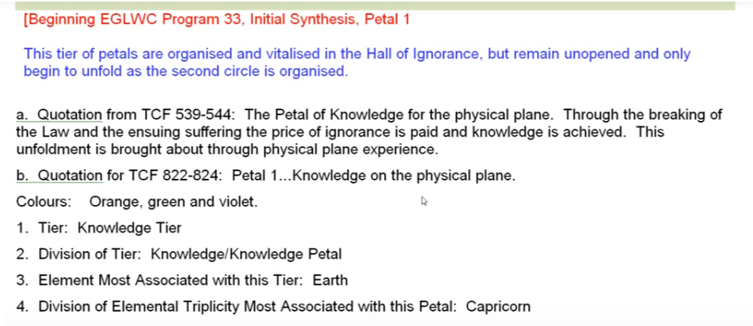

Obviously to get deeper into the subject you're going to want to memorize certain things, just as to get deeper into the subject of astrology, there are just certain things you have to memorize. You must know the names and meanings of all the planets, all the signs, and all the rays. For rayology and for esoteric astrology, you just have to memorize it and then when it comes to these things you have to basically memorize the key idea of every one of the nine petals.

The division of this first tier of petals, knowledge-knowledge petals.

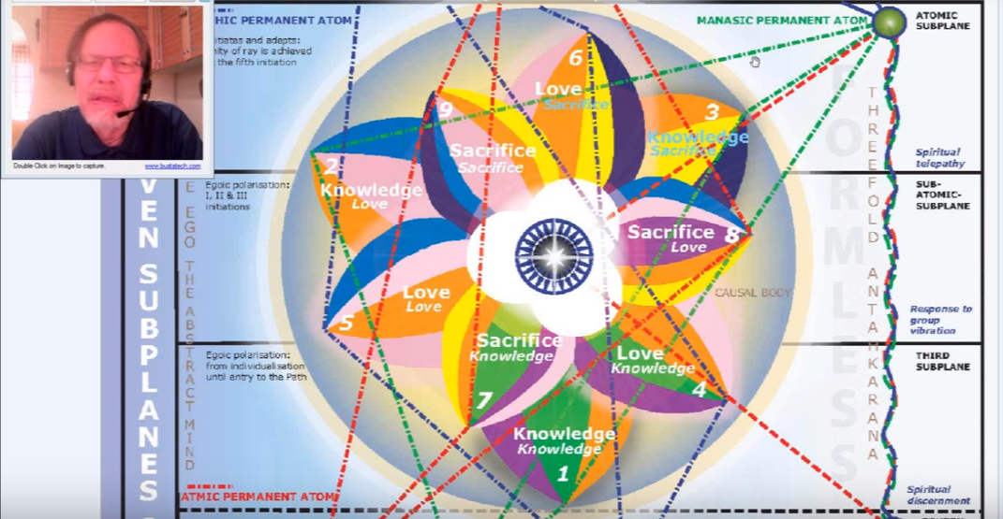

The element most associated with this tier? Earth. Sensory life. Especially the lower five senses as they relate to the physical plane. The division of the elemental triplicity most associated with this petal? Well the earth triplicity is Capricorn, Taurus and Virgo.

The sign most associated with it? Capricorn. Capricorn represents the deepest physical immersion in physicality, and the many hard knocks or early experiences upon physical plane, events occurring under natural law which the man cannot successfully transgress.

The other signs play a significant part also: Taurus suggesting the inertia of the dense physical body and of a life lived subject to the dense physical subplanes. It is a sacred planet, but when used in connection with non-sacred forms, Vulcan sets up a lot of resistance. We all know the innate stubbornness or resistance of the undeveloped Taurean type, and even some developed Taurean types who are having kind of a flashback [laughter] of how they used to be.

With regard to Virgo, matter reigns. “Let matter reign”. Which is the normal evolutionary movement of Virgo. So matter is reigning in this first petal, which really goes with it only open, they are definitely Earth humanity. Others from the moon chain and so forth came in with one petal open already and more. The Buddha had to have come in with virtually nine petals open because he was ready for the third initiation. On the moon chain though, it could not be given at that time.

00:16:50 Which of the three fires is most associated with this petal? Fire by friction. Obviously that is the case with all the all the outer petals. It's definitely the lowest fire. Fire by friction is also the most closely associated with the first petal of all the three petals in the knowledge tier and really we don't get out of fire by friction until … the balance does not tip in relation to Solar Fire until the latter work in the fifth petal process.

The planar focus most associated with this petal? Definitely physical plane. The solar or systemic physical plane and especially the lower subplanes of the physical plane. Later some etheric focus and early etherically centered initiations. For some of the people for whom the petal has unfolded, we have also astral experience but very physical eyes. Anyway the astral plane is a kind of replica of the physical plane and DK says, ‘well when you're dealing with phenomena that show replication of the physical plane it's going to be astral phenomena, the permanent atom or unit.

The permanent atom phase most associated with this petal? Obviously the physical permanent atom. Saturn, in one way, is the planet most conventionally associated with materiality, if not the moon, but Saturn and the moon have so much to do with each other. Really the moon is part of Earth for Earth is related to materiality.

So it is the ruler of the physical permanent atom of the cosmic physical plane. Saturn can readily be associated with the rulership of the human physical permanent atom as well. It does rule physical planes, and especially the lower part of physical planes; like if Uranus rules the four systemic ethers, then Saturn rules the lower three dense subplanes. And the moon, too. In this respect, Saturn and the moon cover the same territory. If Uranus rules the four cosmic ethers then Saturn rules the dense physical body of the solar logos, the lowest twenty one subplanes, and especially the lowest eighteen which relate more to the planetary logos. But in a larger way, Saturn has a deep correspondence with the physical permanent atom of the entire cosmic physical plane

It should be noted that the Tibetan associates the sign Aquarius, ruler of the lowest manifested creative hierarchy, and as you keep going up the scale of hierarchy the signs repeat themselves on higher and higher planes. (I had a Finnish friend here, who being on the third ray wrote a couple of almost not-understandable books. And I used to talk with him about these and try to draw them out into clarity of expression. He extended the Zodiac on to higher and higher some planes going on to the cosmic planes and derived what he thought were some real significance is from that.)

So it should be noted that the Tibetan associates the sign Aquarius with the physical permanent atom. I think we have all seen that, I'll just go there [Esoteric Astrology, page 35] to refresh our memories, here: Aquarius with the baskets of nourishment, the elemental lives, the lowest of the groups:

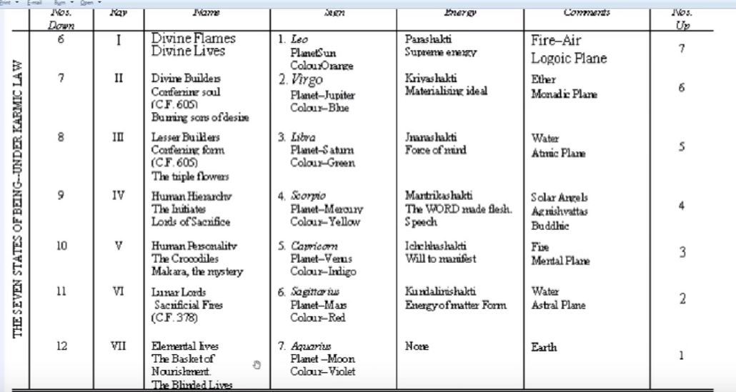

Uranus. Saturn is also one of the rulers of Aquarius … not only Uranus. From a practical consideration there are very sectarian Aquarians. Of course it is also the ruler of the first decanate of Aquarius, so that may have something to do with bringing the Saturnian quality into Aquarius.

Uranus is the ruler of the atomic subplane of the solar physical plane. It can also be associated with the moon as a ruler of the Aquarian hierarchy; Moon veiling Uranus, or possibly Vulcan in certain respects. It has a definite connection with the dense physical body of man. There is no antahkaranic phase, yet. Here is the moon as the Hierarchical ruler of this dense physical group, but it would be mostly Vulcan I think, more than Uranus. Vulcan being the densest planet.
[Transcriber note, unsure if ‘densest’ was the word?]

00:22:45 The hall we're in? (I hope this is helpful, because I realize I did a lot of cross connecting and pulling things in from all over the place. But this is systematic, at least to begin that way, later the comments in the class, those of the students and my own and some pretty strange ones are listed in sort of a miscellaneous section.) The hall we’re in? The hall of ignorance. Knowledge is gained slowly through the experience of the dense physical substance. The worlds we're in? These are the world of the senses, emotions, mind, meaning, significance, being, causes and purpose. Well, we’re in the world of the senses. I've gone over this before, but the world of the emotions, senses, emotions and mind are obvious worlds of meaning as the world of the soul, the world of significance of the triad, world of being, of the monad, world of causes and purposes, that's the logoic world, the logoic plane.

We’re in the world of the senses. Since animals demonstrate astrality, animal man will definitely have astrality as well, but it will be far secondary to his dense physical plane activities, and when he has astrality it will be very physical in nature. It may even relate to the densest, two something, six and seven, where DK tells us we really should not be focused, at least not now. That matter of that type should play no part in our astral bodies, presumably the astral body of those who are in the Aryan consciousness.

The Deva group most associated with this petal? The Agnichaitans, the Agnisuryans, Agnishvattas, the Agnichaitans who are related to the systemic etheric physical plane and also to the atmic plane, and also in a cosmic sense to the entire cosmic physical plane. So the Agnichaitans are devas of the solar physical plane. It’s systemic and solar, or they mean the same thing. The solar physical plane. They may also have a higher correspondence to the atmic plane because it's a plane of will. And the man who can operate from that at atmic plane and through wielding the power of Vulcan can enlist the aid of the Agnichaitans in great volcanic displays and Continental changes and so forth, let’s just say Vulcan has a lot to do with earthiness in one of its aspects.

The astrological cross most associated with this petal? Definitely the mutable cross. This is the cross of common experience. It's really the beginning of the mutable cross. There may be some connection to the cardinal cross because Capricorn is a cardinal sign, but that would be secondary. In the first incarnation, for humanity as a group, is ruled by Cancer and it's another cardinal sign, and cardinality represents beginnings. Of course we're really on the mutable cross, the cross of ignorance, the cross of many changes that have to produce greater consciousness and areas is yet another cardinal sign which is involved in all incipient processes, and the first petal is an incipient process and thus in the early lives upon the dense physical plane, Aries is entering in to this new field of experience. New, because the consciousness through individualisation is different; it's the same old trees, same old rock, so to speak, but the consciousness participating in this environment sees other things.

00:27:00 All the gunas – cardinal, fixed and mutable—are involved. In terms of the cross of consciousness, it's mutable. In terms of a lot of the signs, it's cardinal. and there is also the inert resistance of the fixed sign Taurus. Perhaps we should consider the cross involved as mutable sub-cardinal. The fixed seems less, we have to do a lot of moving around and learning and coming in touch with different aspects of our environment and learning the hard way. So I would say mutable sub-cardinal, but you really cannot exclude any of the gunas, any of the three modes of motion from any petal.

The stage of the path most associated with the petal? … Man’s work is mainly to organize and to an extent vitalize. The opening is handled more by the second logos the solar angel eventually, and then by the rod of power. So the work in which we prepare, like leaving the elements of the shoe out overnight, and then the elves come along and sew it all together? Well our elves in this case are the second logos mostly, and which is underlying the Agnishvattas or Solar Angels (emanations of one solar angel) and then of course the two initiators, The Bodhissatva and the Lord of the World, respectively, the first, and second for the Bodhissatva at the third initiation and beyond, to a point for the Lord of the World.

We're definitely on the path of evolution here, at least we're on the path of evolution. We don't really know what it is to be on the path of ambition yet, it’s too early. So evolution? Yes, man has been individualized and is slowly evolving, even though he doesn't know it. A path is a collection of certain type of experiences, which must be completed before engagement with a collection of higher experiences. A path is a pattern of actions, distinctive of a particular dimension of reality. For instance, the physical-etheric dimension, the emotional dimension, the mental dimension. That's for me one of my definitions of a path. We tread the path, meaning we engage in certain types of activities at certain levels, with a certain effect, if all things are properly handled.

What stage of the path are you on? It has to do with what types of experiences you are engaged in, what types of activities, and to what end? In what dimensions?

We may indeed choose from these following paths, and we have chosen the path of evolution. But just to repeat them: evolution, ambition, the path of the advanced man now with altruistic purposes, the path of aspiration, path of probation. I don't know if I should distinguish probation from probationary discipleship, maybe that's one thing. Discipleship, path of probationary initiation, path of initiation, and then finally after the fifth earlier, and sixth now, initiation, the way of higher evolution.

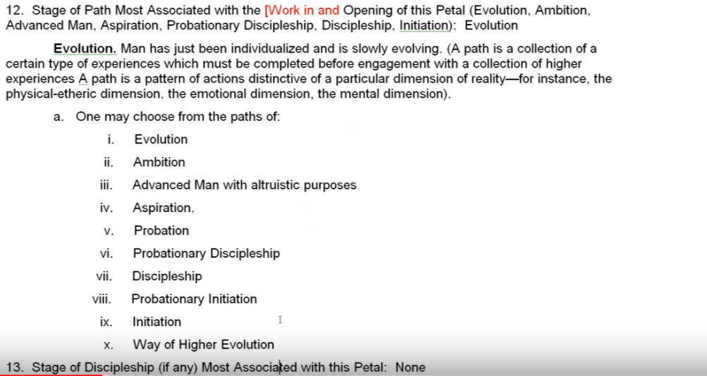

00:31:00 The stage of discipleship (if any) most associated with this first petal? None.

The initiatory stage, if any? None. We could say in a way that individualization is a kind of initiation, it is indeed: you're being brought into a new environment which appears new anyway because of new equipment in consciousness. So this is a kind of initiation into physical plane experience as an individualized human entity, and later … in the experiences associated with this petal, we have the early Lemurian initiation, relating the etheric body to the dense physical body. That is indeed a type of initiation. Present day hatha yoga has its origin there in the deliberate manipulation …

The color of the five human stages most associated with the petal? It is red. I really do have to go over that particular section where he symbolically discusses the colors red, orange, green, rose and blue in relation to the development of the human being. I haven't really done that in terms of the preparatory work but you may remember it, the savage red playing upon the playing field of green. Seizing the orange ball of ambition, related to Leo of course and sort of a lower form of the first ray, orange being a non-esoteric color in relation to the first ray. Then going down the long tunnel and seeing the rosy cross against a background of blue and overturning that cross and going out wide into the light of day.

So, we have the savage states; we have the activity state of running around simply being a human being following one's desires, then things get more one-pointed and have the stage of ambition, seizing the orange ball of ambition, and then when that fails, going into the long tunnel which represents the path to spirituality and seeing the vision at the end of it—of love and the rosy cross that one has to mount, and as it were, overturn. Then go wide into the light of day and lead the games, be a true high initiate, past the fourth degree, initiate of the fifth degree and be the leader of the game is working within the light of a great revelation and helping those who are still subject to the early problems helping them see more clearly.

That's what I mean by the color of the five human stages most associated with this petal, it's red. The red of Mars symbolizing desire in order to fulfill physical appetites. Mars does rule physical appetites, it also rules every elemental vehicle in the personal and as a whole, but is very much connected with the dense physical body as is the moon and is from a certain point of view, Saturn. Earth has an etheric connection and also increasingly so our planet but it can be considered as well a planet of density though from a certain point of view, Mars must be more dense. Mars is the for all vetted rules it doesn't seem to rule so much for the etheric aspects of physicality, as the dense part and then of course the astral plane the lower mental and the assertive personality. It rules all those things. But Earth has risen somewhat and seems to be more associated with the etheric living than Mars does.

00:36:15 The name of the egoic lotus at this stage? Brahmic lotuses.

All egoic lotuses presently have at least one petal open. He says all the egoic lotuses have at least one petal open. I say, but how far open? That is that is the question, I think there are some pre Brahmic lotuses who have not yet quite reached even into this relatively advanced Lemurian stage.

So what is the time of individual individualisation? At the time of individualisation the lotuses produced were bud egos or lotuses in bed, as well as, probably called the colorless lotuses as well. Earlier I hypothesized that there are some who do have the first petal open, but not fully open. Now DK seems to have been saying that they are working on organizing the love petals, but for the reasons that I explained to you (or to myself) that even the Lotuses of Passion or Desire, who have two petals open, are working in the third petal and that is the object of their attention, so that's their work and they are not apparently working in the love tier, so that seems like a contradiction and I think we have basically a general statement to compare with specific statements and we should always choose the specific statement for accuracy, or choose the specificities that turn out to be necessary based upon many statements and hints.

So at the time of individualisation, the lotuses produced where the bud egos or lotuses in bud, and probably a little later the colorless lotuses. …

00:39:45 The most primitive types of human beings are expressions of these lotuses. They may not have even been individualized through solar angelic intervention. According to the Tibetan:

They can dig and carry under direction; they eat, sleep, and procreate following the natural instincts of the animal body. EP 204

They can dig and carry under direction; they eat, sleep, and procreate following the natural instincts of the animal body. That is going to be Group Two of the human groups. We have to keep the human groups in mind, because they are very important – coming in there around page 232 or 234 of Esoteric Psychology, Volume II.

The monadic stage of unfoldment most associated with this petal? Well, units of inertia, sons of heavy rhythm, possibly. Really this suggests a lot of the lunar Vulcan, vulcanian energy. The moon veils Vulcan for the undeveloped.

The group of souls most associated with this petal? Well it's the human group one, group three? Maybe. Well let’s see, possibly group one, Let us call them HG1, HG2, HG3, etc.

1. The souls who live but whose consciousness sleeps. These are the dormant human beings whose intelligence is of such a low order, and their awareness of themselves and of life is so dim and nebulous, that only the lowest forms of human existence come into this category. Racially, nationally, and tribally they do not exist as pure types, but occasionally such a person emerges in the slums of our great cities. They are like a ‘throw back’ and never appear among what are called the natural savages, or the peasantry. EP II 203

We have 1. The souls who live but whose consciousness sleeps. These are the dormant human beings whose intelligence is of such a low order, and their awareness of themselves and of life is so dim and nebulous, that only the lowest forms of human existence come into this category. Racially, nationally, and tribally they do not exist as pure types, but occasionally such a person emerges in the slums of our great cities. They are like a ‘throw back’ and never appear among what are called the natural savages, or the peasantry.

Below are some thoughts about human group one, which may be a group in which the first petal is only a little open. I said there's a difference between the word open and opening, open and fully open.

So that's human group one and a couple of points made. This type of individual may learn through repetition of physical plane tasks as they carry out these tasks under instruction and thus they gain intelligence of a relatively low order. They seldom can be mentally trained, but can be trained for the carrying out of repetitive tasks and that's even true of human group two. I have to ask, why is human group two not listed here? I think it should be. There may be some mistake in the transmission in the transferring to this text. They seldom can be mentally trained, it basically says that. Later how human group number two. …

00:43:50 It has been suggested that the lowest types of these human beings are those who function through the medulla oblongata or involuntary brain. Some of the merely vegetative, maybe some of the very first groups, first human group one, maybe vegetative and maybe institutionalized, but it's an unhealthy state and should not be considered as the norm. There was further discussion on this: Downs Syndrome individuals are not found in human group one or two because their emotional relations are often far more developed; love is present, so Downs begin to look like a deliberate karmic privation of a faculty, engineered by the soul.

If we remember the primary lotuses (TCF 841) are really quite advanced lotuses and have the first and third petals only opening, though not fully opened, and contrasts them with the members of human group one, it may be that human group one could contain those who do not have the first petal very much unfolded, as much as needs to be. It probably has the least amount of unfoldment of petal one of any of our Earth humanity, because it is the most primitive group.

I do feel that human group two, should be here as well and I don’t know why it’s not. I would like to insert human group two in relation to this petal, because we can't really have human group three without human group two. So if I go here to Esoteric Psychology, Volume Two, and I go to page 203, I'm going to find this. This is going to be those who have the first petal unfolded.

Souls who are simply aware of physical plane life and of a sensation and these people are slow, inert, inarticulate, bewildered by their environment, but they are not bewildered, as are the more advanced and emotional types, by events. They have no sense of time or purpose; they can seldom be trained along any mental line, and they very rarely exhibit skill in any direction. They can dig and carry, under direction; they eat, sleep and procreate, following the natural instincts of the animal body. Emotionally, however, they are asleep, and mentally they are totally unawakened. These too are relatively rare, though several thousands of them can be found upon our planet. They can be recognized through their complete incapacity to respond to emotional and mental training and culture. EP II 203-204

Souls who are simply aware of physical plane life and of a sensation and these people are slow, inert, inarticulate, bewildered by their environment, but they are not bewildered, as are the more advanced and emotional types, by events. They have no sense of time or purpose; they can seldom be trained along any mental line, and they very rarely exhibit skill in any direction. They can dig and carry, under direction; they eat, sleep and procreate, following the natural instincts of the animal body. Emotionally, however, they are asleep, and mentally they are totally unawakened. These too are relatively rare, though several thousands of them can be found upon our planet. They can be recognized through their complete incapacity to respond to emotional and mental training and culture.

00:48:30 … Then point c would be to some extent the group of child souls who are the representatives of the later Lemurian cultures can be found in the first petal group, or at least when that is unfolding, and they probably have some work being done in petal number two. …

3. The souls who are beginning to integrate, and who are emotionally and psychically alive. In them, of course, the animal nature is awake and the desire nature is becoming rampant. These people are to be found in all races to a small extent and a number of them can be found among the negroes, which race contains a large number of those who are today relatively children. These are child souls, and though the mental equipment is there and some of them can be trained to use it, the preponderance of the life emphasis is entirely upon physical activity as it is motivated by the desire for satisfaction of some kind, and by a shallow “wish-life” or desire nature, almost entirely oriented towards the physical life. These souls are the modern correspondences to the older Lemurian cultures. EP II 205-206

The souls who are beginning to – be emotionally and psychically alive, maybe only to some extent because there are parts of this group which don't really belong because they are just beginning to be souls. who are beginning to) integrate, and who are emotionally and psychically alive. In them, of course, the animal nature is awake and the desire nature is becoming rampant. These people are to be found in all races to a small extent and a number of them can be found among the negroes, which race contains a large number of those who are today relatively children. I already explained this language, which we know is not politically correct, but that's how it was perceived 80 years ago when this was written. These are child souls, and though the mental equipment is there and some of them can be trained to use it, the preponderance of the life emphasis is entirely upon physical activity as it is motivated by the desire for satisfaction of some kind, and by a shallow “wish-life” or desire nature, almost entirely oriented towards the physical life. These souls are the modern correspondences to the older Lemurian cultures.

So in the Lemurian culture there is some working ahead into the second petal. The astral life is beginning to be shown, especially as the first petal is open for some, and completely open even for the Brahmic lotuses, I think. … let’s look up Brahmic lotuses, just to refresh; if I can't remember it after all these years then maybe you will not be hurt by a repeat repetition:

The Brahmic lotuses in which the first or knowledge petal is fully unfolded. They are so called as they represent on the physical plane the fully active intelligent unity; the man of small mental development, the lowest type of workers, agriculturalists, presence on every continent. They are called “third class creators” as they express themselves only through the act of physical creation on the physical plane, and their function is largely to provide vehicles for those of their own group. TCF 841

The Brahmic lotuses in which the first or knowledge petal is fully unfolded. Now that's the case; definitely working. So could these be Brahmic lotuses, yes, they could be and They are so called as they represent on the physical plane the fully active intelligent unity; the man of small mental development, the lowest type of workers, agriculturalists, presence on every continent. They are called “third class creators” as they express themselves only through the act of physical creation on the physical plane, and their function is largely to provide vehicles for those of their own group.

… Bringing together some of these things, there is a wide range, it takes a long time to work in this petal and a long time presumably for it to unfold. It worked in this petal is going on during the Lemurian period and I suppose at some point in that Lemurian period it does begin to unfold under the power of the second logos, and that period extends all the way from 21 million years ago, to 4 million years ago, to the some 17 million years possibly involved in relation to this first petal, either organizing or unfolding, though meanwhile there's work being done in the Atlantean petal, and there is unfolding presumably of some unfolding of that petal. There are people in whom the Lotuses of Brahman, the second petal is on the point of opening because they've been working on it for quite a while.

00:53:30 Now we go to the stage of adaptation most associated with this petal, and this is from Esoteric Psychology, Volume One:

a. 1. That unconscious adaptation to his environment of the man who is primarily an unintelligent animal, low-grade savages are in this case, and many purely agricultural peasants who have not been subjected to modern education. The man at this stage is little better than an animal and is governed entirely by instinct. EP I 322

That unconscious adaptation to his environment of the man who is primarily an unintelligent animal, low-grade savages are in this case, and many purely agricultural peasants who have not been subjected to modern education. The man at this stage is little better than an animal and is governed entirely by instinct. So that fits the first petal process and this certainly suggests a Lemurian stage of development. There's not a higher type of culture here. In later Lemurian, which is the stage of skill and consciousness, in which the consciousness can be related to.

In later Lemuria, in which the stage of skill and consciousness can be related to later unfoldments in petal 1, there is more development than is listed in adaptation stage one. Petal two is already in process of organizing and bringing in qualities of sentiency and developing emotion. The memory and cultures did show some signs of success toward the end of the Lemurian period and the solar angels were sufficiently pleased with them. I'm not sure we can look at the second stage of adaptation in which we have the selfish and petty criminal, maybe there's something of this, but it seems more intelligent in a way.

We get the idea of the lotus groups, the lotuses of the first circle which are connected to this first petal, either in the state of organization or unfolding. And there will be a big span and so all the way from the most inert to those who have this very crystallized wish life and very physicalized desires. You can put what is said here together with what was said in detail earlier.

The chakra most implicated in relation to this petal? Both the base of the spine and the sacral. The base of the spine is implicated because these human beings are vital and are driven by the survival instinct and with what we might call the will to survive. The sacral center of course is implicated because they are focused on procreation, as we are told here they eat they sleep they procreate and they follow the natural rhythms of their type of life.

“Brahamic lotuses in which the first or knowledge petal is fully unfolded. They are so-called as they represent on the physical plane the fully active intelligent unity, the man of small mental development, the lowest types of workers, agriculturalists, and peasants on every continent. They are also called “third class creators” as they express themselves only through the act of physical creation on the physical plane and their function is largely to provide vehicles for those in their own group. TCF 841
As Brahmic lotuses, they are third class creators, strongly involving the sacral center. “Brahamic lotuses in which the first or knowledge petal is fully unfolded. They are so-called as they represent on the physical plane the fully active intelligent unity, the man of small mental development, the lowest types of workers, agriculturalists, and peasants on every continent. They are also called “third class creators” as they express themselves only through the act of physical creation on the physical plane and their function is largely to provide vehicles for those in their own group.

The splenic center is also necessarily implicated because these are human beings for whom physical vitality is a predominating energy, and these can easily make access to planetary and solar vitality. DK said modern man could recover that healthy primitive vitality which was so much his in earlier days.

What is the chakric triangle most closely related to this petal? I would say if the pranic triangle, certainly at first. The splenic center, the center in the lower part of the shoulder blades and the center immediately above the diaphragm, where the solar plexus is actually below the diaphragm. …

It has also been suggested that a lower pranic triangle, consisting of the base of the spine center, the sacral center, and the “splenic minor” center may be involved base of the spine. Some of the people who are into esoteric healing talk about these minor centers and there is something to be said.

01:00:00 Some emotion will enter towards the later unfolding of this petal, and this can be called the Lemurian petal, and later Lemurian cultures or Atlantean cultures were filled with child souls and characterized by the shallow wish life. … When emotion comes in another triangle will emerge, the base of spine center, the solar plexus center, and the heart center; that is man controlled from the emotional plane. At least some of this triangle is being activated.

It's important to remember in this context that in the sacral center lie the ancient racial fears and deep seated personal desires. So the solar plexus is not the only place where there is a desire. … that’s, Discipleship in the New Age, Volume II, page 747, in respect to instructions to a person who had a very strong Scorpio in their chart but a definite modern person. We can expect in this vastly durating Lemurian petal that the sacral center element with that part of emotion which relates to the ancient racial fears will be found.

Are there other chakras implicated in reasons for this implication? … I put down none, but it is the spleen as previously stated because the experiences related to petal one occur in a vitalistic stage of life, prana is the main thing, all minor centers must be active as the body must function, and the minor chakras were evolved in the previous solar system, we’re told, and petal one indicates the stage of development more akin to developments in the previous solar system than this one. That makes sense. It should be remembered that minor centers have emotional and mental complements and in the three lower worlds there are three aspects to every chakra’s functioning, physical, emotional and mental, so it gets quite complex.

Basically, there is some emotion growing here and of course the man comes out as a unit of mentality and the brahmic lotuses are considered to be the full unit man, how does it say? They represent on the physical plane the fully active intelligent unity. TCF 841. There we certainly see ray one for unity and we also see the work, and I call it the third ray for the active intelligent part.
Are there any astral chakras most associated with this petal? This is on page 51 of Esoteric Healing:

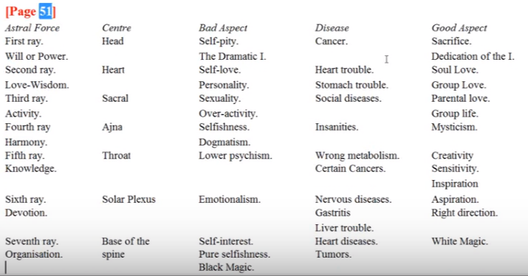

… The man has to be alive here as well, but he's not really the astral entity yet, but there is some of that and I suppose the base of the spine correspondingly, the sacral center and the solar plexus are ruled by different rays, so we have to consult this interesting chart, but especially once he begins to live the astral life and that's kind of secondary at this point. …

01:06:00 I want a systematic look at the rays, by petal, but first I want to show you this little collection of astral chakras, and when we can see these engaged I don't know, but the first ray astral Force, head center, will power, the bad aspect of self pity on the ‘dramatic I’, the disease is cancer and the good aspects the sacrifice and the dedication of the ‘I’. Then comes. …

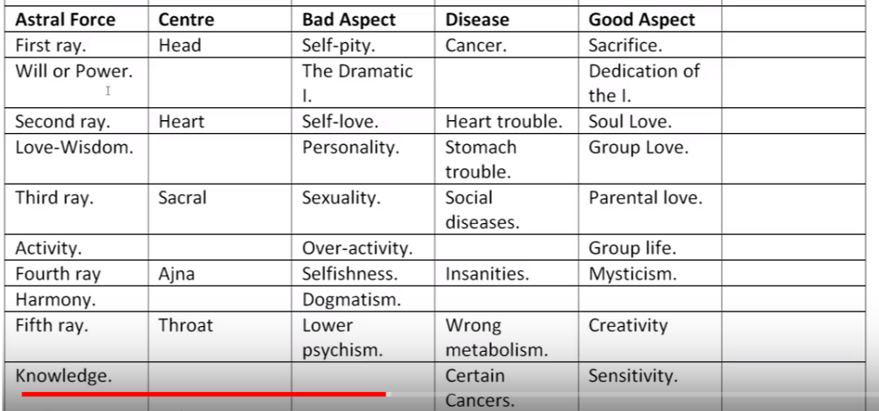

Then comes the second ray, love-wisdom. The center is the heart, astral heart, bad aspects, self love and personality. Emphasis, heart trouble is the disease and apparently stomach trouble as well, let’s see if I am correct in that, yes, it looks like stomach trouble as well. Good aspect, love, and group love I guess, is a reflex action of the solar plexus.

The third ray is the ray of activity and it's the activity in the sacral center that shows the third ray connected with the sacral center, bad aspect, sexuality and over activity. Diseases are social diseases. Parental love is found here and also group life. Some different emphases I think we see.

The fourth ray is working through the ajna as it sometimes does and the etheric level when Mercury is operating. Harmony is the ray, and we can give selfishness and dogmatism. That I find really interesting because usually I would associate that with the sixth ray, or the idee’ fixe of the fifth ray. The problems are various kinds of insanities and the good aspect is mysticism.

Then with the fifth ray is associated with the throat. This is different from the etheric association and lower psychism is involved, which is unusual. Wrong metabolism and certain cancers. Creativity and sensitivity … and inspiration, I suppose through its connection with the first ray. But remember these are operating on the astral plane and not in the usual etheric area.

The sixth ray of devotion the solar plexus Emotionalism is the problem, nervous diseases and gastritis, and the good aspect aspiration and that right direction. … Liver trouble also.

Then the seventh ray base of the spine is involved. Pure self interest, pure selfishness, black magic aspects that we don't usually see associated with the seventh ray. So heart diseases and tumors and white magic. …

All the chakras are inter-related, they are vortices of force coming from the soul and operating in the different vehicles and they may even come before that from the monad, and there would be these vortices on higher turns of the spiral. There's a lot still to be researched here; we're just learning about something about the etheric chakras and the way the Tibetan has put in the astral chakras is a plus, of course, we really understand something additional because of that. But it would be interesting to see if they are connected with some of the liabilities shown in the petals. We can probably find those same liabilities arranged in connection with different chakras in the etheric system

01:10:30 Back to more familiar territory, the rays most implicated in this petal, and the rays would be rays one, seven, three, five, and four, with two and six to a lesser extent. Let's take a look at the reason, we have this all in one place.

Why ray one? It's the first petal, so numerical resonance of course, and ray one initiates, starts things going … it is the first, impelling force. This is the first kind of human experience, we might say entry into the new. The question of survival, fight or be destroyed, is there. Breaking the law, the law comes in on the first ray, and breaking it is definitely a first ray liability at first, ‘doing precisely what you will and want’. Ray one says, I exist, I want, I will do, despite prohibition. So the first petal, first ray, and the numerical resonance through the breaking of the law, the paying of the price of suffering, knowledge is acquired. This doesn't mean that a person can have a first ray personality; they cannot yet, but they can have astrological equipment during this time that carries the first ray and Mars will characterize them in terms of the their general type of attitude. The red of Mars.

We have learned that no one who was not on the path, at least of aspiration, can have a ray one or a ray two personality. So that's an interesting piece of information which I've been emphasizing over the years. If they seem to have a one or two ray, it's coming in from another source; they can't have the ray one or ray two soul, either until they are on that path of aspiration there has to have been a change from the previous ray. That will occur as we are approaching the opportunity for initiation.

Ray seven is here. This is the most material petal, the basic rhythms of life which are instinctual will be pronounced, instinctual rhythms. Instinctual life is rhythmic, it is only modern man that has corrupted those rhythms, laws coming on the seventh ray, and this is about the breaking of the law. Capricorn is the major sign for this petal, then ray seven moves through Capricorn in this world period more powerfully than in any other sign. You can expand upon this if you wish but this is simply to bring the idea of what life is like in that first petal; it's a pretty hard line petal. Notice too, for a seven, it has the violet. Maybe we'll be talking about the colors a little bit here.

Ray three, its color is green, and it's connected with Capricorn, too. Ray One is connected with the Aries petal … let's just say that ray one will be connected. It is an inaugural petal and assigned to Aries (I’ve assigned it there) and connects to ray one. Ray three rules materiality, material life, and is closely associated with knowledge. This is the knowledge-knowledge petal. In this case rudimentary knowledge of the external world. … It's in one way the primary ray of the physical plane, if you begin numbering from below instead of from above. Whereas three and seven are the primary rays of the physical plane, if you number from above, ray seven primary ray, physical plane if numbering from the logoic plane, but here if we would number from below, ray one would be the primary place. But there's another way to look at it, looking at ray three, this is called of the primordial ray and is definitely connected with the physical plane if we begin numbering from the mental plane which is legitimate, mental astral physical.

So it is the ray of the previous solar system; the dense physical plane is composed of substance of the previous solar system, so this is the primary ray of the physical plane. … This is the most physical petal, ‘learning the ropes’ of the physical plane and even the ropes connect with ray three. Someone in our group offered it is a ray of aspect, of the synthetic rays, and they take effect in the process in the early times in the early times and in the later times. This is an active time, the idea is ‘move or get killed’; this one hunting phase in here over all the many years you have to kill or be killed; it takes intelligence, but we can go back here, surviving to ray one, kill or be killed. Especially by the animal group which is strong which is the third kingdom the third kingdom preying upon the fourth interesting. You have to move and get your food and you have to use your intelligence and without sufficient intelligence you will not survive.

01:17:30 What about ray five? Man has just been individualized under a five stimulation of the mental unit the coming in of the sons of mind. The fifth creative hierarchy of Solar Angels extending themselves into animal man or fanning the mental unit which controls the vehicle which brings in the fifth principle. He's learning about his environment, through cause and effect. There's a nascent budding going on here, is as the bud lotus expands, anyway cause and effect learning.

All individualized people have a mind, however dull that mind may be. The mind is the fifth principle. They're finding out from experience the fifth ray of hierarchy of Solar Angels gave the spark of mind. So ray five of the concrete mind is definitely involved; that's where the spark of mind is working. Of course it's more than a spark of mind. As DK says, it contains also the quality of love latent in the quality of Will, latent, but it first we simply call it the spark of mind.

What planet has helped us become individualized particularly? It is Venus. And what is its ray? Ray five and it took place in a Leo period which is the fifth sign and conveys ray five and so forth. There are reasons.

What about ray four? Because humanity is the fourth kingdom and it is born there. It is conflict without harmony at first and that's the lower part of the fourth ray, there is pain and suffering primitive action-reaction. Ray four signifies the growth of human consciousness within that field, through pain. Through pain and suffering consciousness grows and this is the planet of purifying pain and releasing sorrow. Why is the conflict present? Well you just don't know what's happening, you don't know yet how to deal with the surroundings. Think about Mercury and its relation to knowing. When you know more there is less conflict; you're not involved in confused combat. You know how to avert conflict, but this is a very primal level.

The base of the spine is fourfold. The adrenal glands involved with fight or flight that suggest the fourth Ray in one of the groups. The fourth ray rules the base of the spine and the adrenals are animated from the base of the spine center. It's a forward or backward fight, or fight or flight, so the base of the spine with its fourfoldness inaugurates human life on the lowest plane. … This is a definitely a conflicted period. One is opposed to natural law one fights against natural law one is in the maximally frictional period except perhaps those beings in the early days who really sense the inner God and listen to his law, but man quickly descended from that happier possibility.

Now what about ray two and ray six? Well it's more minor. Ray two has to do with the general objectivity of the solar angels so to the extent that there began some social gathering, ray two is part of that, but not very much. Ray two in a sense rules the entire egoic lotus and just the way Venus as well as a strongly ray two planets in its monadic aspect and maybe a personal aspect. Some instinctual congregating in gathering a community for protection, but mostly it's just a period of every man for himself and a social instinct is not yet strong, but even in animals there is some strength of that instinct. It is generally a cohesive factor. It's impossible to go through all those lives, maybe over 17 million years in the Lemurian period, and not have all the rays and signs involved. As the petal continues to unfold, I suppose the social instincts grow.

01:22:30 The astral plane is the second petal focus, but there is astrality also in this petal because work is also being done on ahead and the facility for leaving the body is pretty strong in some of the less-developed groups. Ray six … we can find a way in for all – the sacral center is ruled by Mars and part of ray six is there, so there is insatiable desire. But it seems that ray two and ray six, which are on the soft line, the astral-heart line, are not as prominent; there is no idealism of course. I suppose there has to be some primitive ray two even though it is a ray of aspect.

Are there other rays implicated and the meaning of this implication? I say none here, and two and six are not focal certainly, but love and the astral body comes in later, and with the Aboriginals of Australia certainly there's a strong astral dimension and they have a strong social dimension to their likelihood of continuing their evolution on this particular And this particular round is not high. DK pretty much talks about the next round for their full development. In the part of petal one, petal two begins to be organized and eventually unfolded.

The colors of the petals? It's orange, green, violet, and we've discussed this a bit. Orange will relate to the awakening of the solar factor in man the nascent mind. Orange, it’s the sun's color and has to do with vitality. Orange is the color of the fifth ray, too, and there would be no man without the intervention of the fifth ray. There would be no implantation of the spark of mind, nor would there be even the fanning of the mental unit and its fifth ray implications. The ability to separate what he perceives as the self and what is perceived as the not-self (eventually perceived). So there would be no intervention—there would be no man without the fifth ray, given by the fifth creative hierarchy.

Orange is the color of self and would relate to Leo, primitive vitality, we breathe in orange. The Tibetan advises us to augment our vitality which is connected with prana. The sun can be considered orange, though we're told the true orange has more yellow in it. It's all orange. Orange is a reflection of the solar angel and a promised sun orange. Orange is also the color of the sacral center so prominent in this place; the second group has to provide vehicles for others within itself, for those of their own kind. Sacral is based on the separation of the sexes again the emphasis is on the separation. It's interesting that in the Buddha's communities they dress in a kind of orange robes and prefer to be males, so the male is more separative of the sexes. Even Mars is more orange than really red. So orange is, as we realize from seeing it … here it is orange is the leading color here and throughout the entire egoic lotus.

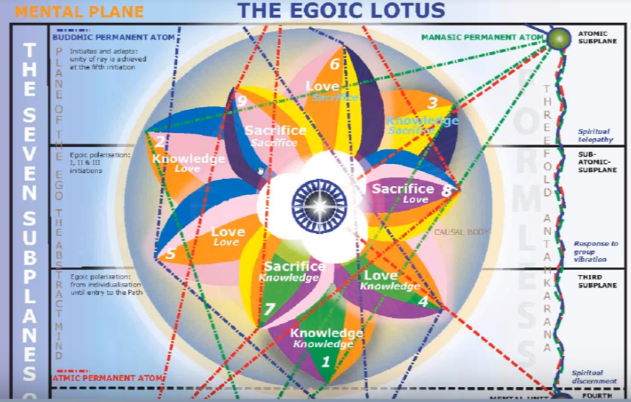

About green? It's the ray of the previous solar system, an activity system, it’s the previous solar system related very much to the personality of the solar logos. Green it’s the primordial ray of a material life; it's the color of nature and of elemental life. Green is most associated with the dense physical body and adaptation to the environment. Interesting the sort of folklore about the moon – the moon is green, the moon is made of green cheese, and so forth, all those funny things, but green goes with the natural life a primitive man. It is close to nature the green a vegetative life it's one of the major healing colors. Spring green has to do with vitality, this is a very vital era.

Is green the abstract mind? Well we can't worry about that now, there is no mind yet along abstract lines. Green is involved here in relation to the fecundity of nature which surrounds man and of which he is a part at this early stage. A little aside about the two green devas who will be working with doctors to provide healing. The animal kingdom is the third and hence green is related to animal man which is pretty much what this type of man is in the early days of this petal.

Could it be a chronology of the color such that the first ones relate to earlier phases of the petal unfoldment? I talked about that. Is it possible when you look at this [chart] that orange has to be considered first, then green, then violet, whatever the leading color. Maybe consider it first, and then the other, like in this case petal seven, petal four, even rose comes first, then orange, then green and violet. There might be a chronology there, but we'd have to really study the history of man each petal. Just imagine with that would be like, because the petal is not a monolithic experience; there's all different kinds of phases of development in the petals.

What about violet? That's part of the first petal and it suggests the etheric body and there is necessitated a fusion between violet and green between the etheric and physical bodies. Those were the initiations of those days the God Kings of early Lemuria taught the fusion of the etheric-physical. For us it's second nature, we don't think about it we shouldn't even think about it because it's running on its own, but it was a form of initiation.

Interesting, the two colors of the black lodge are associated. They call it lurid green and loathsome purple, but that's not the same as green and purple. The attack of the black lodge I suppose did not really happen until the early Atlantean days. However, those may have been times when the first petal was unfolding. Remember the organizational work is the greatest amount of work to be done by the man himself, and then maybe he moves his attention forward principally and works in further petals, and then based on all the work he has done, unfoldment takes place with the access of the other energy.

Should the base of the spine center be associated with violet and with the seventh ray? Yes, because the base of the spine rules the etheric body, we are told. Violet is the color of the four ethers; the four purples are at work in the ether. So ray seven keeps the man in incarnation in that sense, anchors him. The ethers of ray seven provide the vitality and hence violet is important. So I think someone in healing says use violet if you don't want to die and use the color orange if you do. Well Orange is related to the first ray? Interestingly enough of orange isn't so sandalwood incense and the color orange. To be a little wary if one of your relatives suggests to you, [laughing] ‘oh I have a new light for you, in your bedroom, and oh I've lived some sandalwood incense – just spend the night here in this orange light with the sandalwood incense going on I'll play a certain note, and I’ll see you in the morning’. Anyway it will be used rightly in healing work revive it is kind of an anchor interestingly enough, the seventh ray brings heaven to earth, violet brings heaven to earth so …

… Some additional thoughts in relation to violet. It's the earliest incarnation, so Cancer is going to be important. A color of Cancer given by the Tibetan is violet. There's an anchor in going on here, Cancer anchors on the physical plane, and … the color given by the Tibetan for Cancer is violet (at least it was whether he got this from another list, or there's a question about it whether it's related to one of those earlier orders, a Golden Dawn color, and so forth it may be). Anyway He found these colors of sufficient value to use them in meditations with some of his students.

The moon is there the crescent shaped moon is on the forehead of the violet devas we are told for the moon and violet. Cancer has a connection with the moon it's ruled by the moon. Violet we have seen here … Notice under planet, the moon, color violet. (Esoteric Astrology page 35):

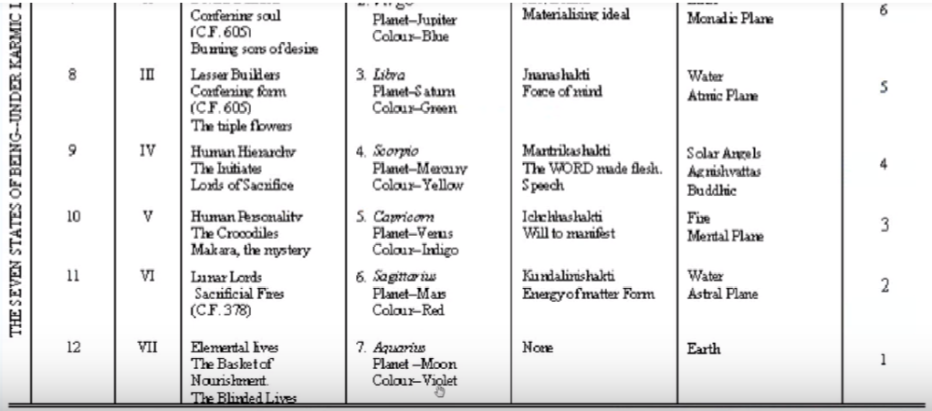

It's the hierarchical ruler of course, but since Cancer is so important at that level, violet will be important. It's an anchoring color, somehow. Some people have said it relates to unreality, you know when you take these color tests, a sort of magical thought process, but that is not beyond the pale either. Since the base of the spine center is so important anchoring the life on the physical plane, violet is implicated as part of the seventh ray anchoring process. It’s the seventh center from a certain point of view it's related to the etheric body which is related has the violet devas serve. The violet devas have the crescent moon, its color is closely related to violet and to the seventh plane in the outer rind of man.

So violet and green must come together to link our solar system with the earliest earlier solar system. The etheric vehicle may be the means of that linking the base of the spine center is the means by which we anchor ourselves in dense physicality through the instrumentality of the etheric body.

What about this learning from pain and suffering? That the seventh ray is the law the law of instinctual rhythm, the rhythms of nature and one if one goes against them in the physical sense, one suffers. Violet is connected then also with the law, because the law is connected with the seventh ray. Violet is red and blue, so it's the blended first and second, and allows us to suffer. Violet is Cancer and the seventh ray is incarnation. Violet is holding you in incarnation and anchoring. Those are some additional thoughts that came in relation to the color violet are there.

… Are there additional colors in this petals process? Red in a sense. It's not in the petal but it's certainly in the man—red for savagery and crude (notice how the word root a ruddy, ruddy crude), vital experience bloody experience, hunting and full of blood. The red is there in the experience if not in the petal. For some reason we don't have red in the petal, but if you are a first ray type eventually your color will be demonstrated we are told in the lighted expression of the egoic lotus at a high stage of evolution.

The rays implicated on the basis of color? Obviously five, three, and seven. Five for orange or a three for green or ray seven for violet. I'll be repeating these kinds of things and you will see. Due to the repetition the comparison from petal to petal. A lot of this is now been put into a chart form in which these factors are easy to see, but unless we discuss them they don't hold much information; you need the associations and some of the rationale and then when you look at the chart it's going to make a fair amount of sense.

The major signs in series beginning with Aries in the counter-clockwise order, which is the natural order of the zodiac. Yes, Aries, physical experience. So we begin with Aries or with Pisces at this first petal. So let's look at the rationale of each. The raw physical experience the collision with circumstances and learning lessons from the hard way much karma is generated Aries is great at generating karma. Saturn falls there and Saturn gets even it seems eventually so no one can generate karma like Aries. Saturn falling in Aries is the planet of the law, through the breaking of the law. How this is an Aries trait? What is the planet of the law? It’s Saturn, and what happens to Saturn in Aries? It falls. So that's the way the law falls in Aries, it takes a long time Saturn to learn the law because we are so red, so full of instinctual desire which does not respect natural law around us, where we don't even know what it is so we test our boundaries and the law holds firm and we suffer.

So the major sign, in series, beginning with Aries clockwise, tells us about our blind undirected experience, and this comes from pages 332 and 333 of Esoteric Astrology on which we spent a long time: blind undirected experience … instinctual reaction. Indeed this is what we would expect.

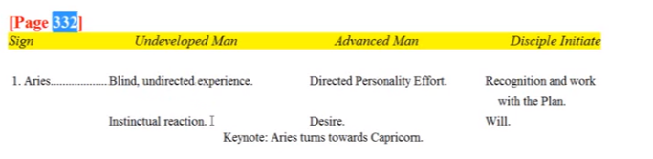

01:40:00 Why the Tibetan uses Aries clockwise, Aries counter-clockwise; Pisces clockwise … why he does this, He knows the reason but he does start the zodiac with Aries then he moves clockwise around, that of the natural order of the signs, and he does move seemingly backwards, clockwise starting with Aries. And He also starts with Pisces which in a way is a first sign.

Pisces is a major sign in the series beginning with Pisces in the clockwise order. So what do we say about it? Well go forth into matter. It's the stage right before dense matter. The fish plunges into the ocean of matter, it into caves vulnerability through the environment. The animal kingdom we're told took a tremendous toll on humanity and we are in those early days, until we know better, at the mercy of the elements and of the animal kingdom.

Of course, it's interesting, man in those days was probably pretty big. I know it seems ludicrous, Blavatsky seems to suggest there were times when man was walking with the dinosaurs. Maybe not enough was known about paleontology at that time, but she has some different time scales in mind. Certainly man was huge, but DK does say that in early days the animal kingdom took a tremendous toll on humanity.

Pisces, the ill-defined, inchoate sense of self, Pisces, water is matter and Pisces is a water, matter sign. Pisces, the early man does not discriminate between himself and his environment very well, and must learn to do so. The discriminating planet Mercury falling in Pisces, so everything is rather a blur – it’s hard to separate one thing from another. Pisces gives mediumistic identification with matter; it's very hard, you cannot think of yourself as something separate, you have to learn how to do that. So, Pisces can be considered the beginning of the ordinary wheel.

From another point of view, Pisces is involved in that monadic coming forth, leaving the father's home, and finding yourself immersed in matter. You haven't yet been able to turn back and save. In a way you have left the monadic Father, although he is still at home is a strange way, dual location, and are having your first incarnation in Pisces. Interesting enough, the group incarnation of Cancer, the first individual incarnation in Pisces, the monad descends into the causal body or the monad descends into the field; that is to say field where the causal body will be created. The monad descends into this field and contributes to the creation of the causal body. With Pisces you are in the foreign land far from the monadic home.
Those are signs of what we call related to the first petal; they are the beginning of the series which goes clockwise or counter-clockwise – we don't have anything with Pisces going counter-clockwise we only have clockwise.

Are there other signs implicated? I have here Capricorn, Taurus, Cancer, Aries and Pisces, some of them are repeats and we'll have to see the ones we may have left off. We have … Leo, Virgo, Gemini, every one of them is there. So it's a very long period. We're going to be born, all of the human unit of the time won't know anything about it, but he's going to be born with different qualities under different stars so to speak.

So just looking at these different signs of the zodiac and more, in fact, all. Capricorn, for the law and for dense material immersion for resistance to sensitivity and just learning the hard way; hardness and impenetrability. If we believe Blavatsky on this, the early animal man did have some sense of the inner God, so he was also able to look up with some devotion … the devotion to the dimly sensed inner God supplied by the solar angel. So, ray six is present in this way.

… We're looking at the signs that are associated. Pisces of course for karmic suffering, because of the breaking of the law.

Taurus for instinctual, heavy, inert material life. It's related to tamas, of course, this is a tamasic period at least in terms of consciousness. There is inertia to the higher energies, but there also has to be activity otherwise one will not survive; the one who cannot move in this petal will not survive. That’s where Saturn is related to survival: think, move, survive. But there is a tamasic consciousness, low consciousness, very instinctual and basically by comparison a non-intelligent approach.

Cancer? Yes, the first entry into incarnation as a group and the sign of form and of the instinctual lunar life; early tribal consciousness. So man is under the sway of the moon and for Esoteric Astrology 332, the blind unit is lost.

What about Leo? Primitive self knowledge. It's involved in all three petals of the knowledge tier. It is primitive and the self that is known is only the outer self. Leo is all about coming into knowledge of oneself as a separate being, its dim at first this ‘I’ sense is dim. We remember the Tibetan says it really takes three million years, but then those are still Lemurian times, not even early Atlantean times, and one wonders whether one is really working even yet in the second petal when that is occurring.

Virgo? Yes, for materiality, let matter reign, matter reigns most in the first petal. It is a knowledge petal connected with Mercury. There is some intelligence stirring but it's very slow and inert. We’re related to the mother aspect; mothers are related to Cancer, Virgo and Capricorn, all signs important in this first petal. Capricorn as a major sign and the opposite is Cancer.

What about Libra? As embodying the thought that for every action there is an opposite and equal reaction, for the man is upsetting the balance, through Aries, and the consequence of doing so are brought home through the balancing aspect of Libra unconsciously. There's a rebound for breaking the law, that's the Libra rebound. There is sexual affinity. It's what's called unbalanced fiery passion on page 333 of Esoteric Astrology. And there is procreative activity basically through the sacral center which is much associated with Libra through unbalanced fiery passion.

Gemini? Well, knowledge is achieved. The opposites here are the self and the environment. It's not the higher self and the lower self, it's what I'm dimly sensing myself to be and what the factual environment is. So there's the discovery of knowledge through contrast: what happens when I break the law? What happens when I do not? So the alternation between extremes: there's pleasure and there's pain, those are two pretty big ones in this first petal process.

Ray four is involved through Mercury, learning through contrasts. I think it's still a good way to learn: if you want to know what something is, find its opposite. So the environment and ‘I’ are the early duality, the fight or flight for bitter conflict on the physical plane. Mercury is called the star of conflict and Gemini is always involved in the engagement of these opposites, not necessarily in such a civilized manner as later.

What about Aquarius? It is involved in the lowest hierarchy of the baskets of nourishment, and lunar life, and the color Violet. (…I put eighth level here I know there is an eighth sphere, but we're not exactly talking about that at the moment.) There is tribalism an Aquarius is primitive community, but it's more based on Cancer in a way, you might say first Cancer for the primitive family groups and later, Aquarius. Now in the animal kingdom the mother has to oftentimes protect the babies from being eaten by the father. This is so with alligators and other kinds of animals, so there's not necessarily that warm-cuddly feeling in the original groups, that takes a while to produce but it will come together under Cancer.

01:51:25 With Sagittarius, well it's a bit of a centaur isn't it? Man is animal man. Who is the Centaur? Half animal half man. The hunter is Sagittarius, so it fits with certain of the kinds of activities that one would have to engage in.

Scorpio? We would say for life and death; it's a dangerous world and death is always around the corner, coming in unsuspected ways, it's also a bloody world and at any moment you could be deprived of form life. Hence Pluto is important. … We have Aries, we've mentioned Taurus, Gemini, Cancer, Leo – the primitive unity and vitality, Virgo matter reigning, Libra unbalanced fiery passion, Scorpio life and death, Sagittarius the hunt, Capricorn dense immersion in materiality, Aquarius the early community, perhaps – desire in form does become ruler but it certainly applies more in the next petal, but still millions of years you're going to have some influence of that sign, and Pisces go forth into matter and the identification with matter-form.

I think all of the signs of the zodiac have been mentioned, but what we most associate it with the is the very first petal is the very first sign it's Aries, and since the knowledge petals are related to the earth signs, it's Capricorn, beginning with the cardinal signs.

What about signs on the basis of color? This is another category here, well then they would emphasize Leo, Capricorn, and Cancer because Leo for orange, Capricorn for green (the need for green), and Cancer for Violet, anchoring the factor of violet. Actually bringing and holding the sub-dimensions into the grosser dimensions.

Major great constellation most implicated? Pleiades, bringing in at first the third aspect, and thus relating to Taurus and to Virgo, according to DK. All the lunar petals are connected with the Pleiades and also the sign Cancer is connected to the Pleiades. So we see these two mother signs, (Virgo and Cancer) and we see the materiality of Taurus.

Any secondary constellations implicated? Serpents and sea monsters perhaps. There are those. So Argo, perhaps the first decanate of Cancer carrying the principles of man into incarnation. Eridnus, in Taurus, the river carrying souls into incarnation. Cetus the Sea Monster, always with the danger that matter will swallow the soul. And, is it Hydrus or Hydra, it’s a sign in the Constellation Leo, and it spans many, many signs, and it has to do with the primitive unity of the physical nature and it's inimical relationship with higher principles Cassiopeia, the enthroned Queen; matter is on the throne. Draco, connected to the base chakra. Centaur for animal man. Some people were bringing in some other thoughts that the Chinese moon mansions starts in Virgo. So these do start with an accentuation of matter and that the Praeseppe cluster, related to ghosts. The moon of course, and Spica as the Eye of the Green Dragon, related to materiality.

01:55:25 Well, these are associations. We cannot let's just say the energy of the surrounding constellations is reaching us all the time, but we appropriate it in different ways depending upon the condition of our form.

We're talking about an early kind of appropriation based upon a very primitive form. We haven't any idea even right now what early man looked like. We know that he doesn't look like a monkey or like the present day gorilla; these were huge, forms, huge tabernacles of clay, as they have been called. So you get to get a sense that the true history is much stranger than the very. Limited and capsulated compressed history and we are imagining all these beings who are being quite small and that the stature of man has risen, where in fact according to Blavatsky and the ageless wisdom the stature of man has been greatly, greatly diminished.

What is the synthesizing planet most associated with this tier? It's going to be Saturn for intelligence, for density, for law, simply for materiality and the limitations of living in a very material world.

Division of synthesizing planetary triplicity most associate with the petal? It be Saturn, sub Saturn. Saturn will be the planet ruling the entire knowledge sphere; that one of the synthesizing planets ruling the entire knowledge sphere and this is a sub-Saturn petal.

Neighboring planet most associated with this petal? It would be Mars and we talked about the Mars-Saturn connection with this rather brutal situation.

Division of neighboring planetary triplicity most associate with petal? Mars, sub-Mars. Aries ruler of Mars, Mars will have Aries and Mars exalted in Capricorn. So we usually have a sequence, we might call it Mars, Venus, Mercury. So we begin at the first petal of any of this series with Mars. The second petal has more Venus quality, and the third more Mercury quality, but then the whole outer tier is ruled by a Mars. If we're going to choose non-synthesizing planets to rule the outer tier it's going to be Mars. So Mars through the outer tier, and it also focuses on that particular inaugural petal.

What about the Sun-Moon polarity most associated with the petal? It's going to be the moon. There are four lunar phases, the Foursquare moon. This is about anchoring in the number four and the Moon continues its kind of group rulership in the sun-moon connection, up through the fourth petal.

Planets implicated and reasons for the implication? Looks like we've got them all: Mars, Saturn, Earth, Mercury, Venus, Vulcan, Jupiter, Neptune, Pluto, Moon, Sun, Uranus. All of them. Have I left something out? Even Vulcan is in the picture. Well, there are new planets being discovered and they have their pushes and pulls. But I think what's being said here will make some sense.

01:58:20 Then we're looking at the planets that are implicated in the processes of this petal? Some of them are obvious, right? Mars, rude. Notice the red in there: red, rude, crude. Notice the red, rude, again rude crude material breaking the law, rebellious against natural law, primitivity, first and undeveloped stages. Primitive self-assertion through the body, sexuality, the physical vehicle. Particularly Mars does rule of the physical vehicle. Those are a few things you get the idea.

Saturn and it's denser aspects, Saturn is the law which is broken, and also the karmic consequences of breaking that law. Interesting that it is the hierarchical ruler and exalted ruler in Libra. The planet of karma. Saturn is also the patterns of instinctuality. Saturn is the general ruler of the physical plane, especially the dense part, Uranus rules the etheric part, and of the last solar system. So, Saturn applies in the case where we have a hard and cold world of hard knocks. It is dense and lead-like, but lead is malleable and you can be molded by experience. Saturn is also the grim reaper, is the Lord of Death and losing one's physical body over and over again through breaking the law, and not knowing enough about the surroundings. Saturn relates the law of sacrifice and death, which is the seventh law. It is also complete confinement in a material body of limited scope, except for maybe some of the astral ability to leave which gradually over the years became less and less, but it was active in Atlantis. Still the spirit must feel very confined. That’s Saturn and it is the ruler of Capricorn which is the first of the signs connected with the earth triplicity and assigned to the first of the petals.

Earth. We're having our first experience as man on Earth, a member of the fourth kingdom. Earth is the field of redemption. So this is a new field of experience and eventually leading to etheric-physical union. Earth is so connected with the etheric body we are told in Esoteric Astrology. Also with the base of the spine, which has its connection to the etheric body whereas the sacral actually more to do with the dense physical. Something is out of order there.

Mercury? Some knowledge is gained through the breaking of the law; learning from the breaking of the law. There is illusion of the grossest kind. The skills are rudimentary, learning how things work, moving around, motion in general. Moving through the environment and running from the beasts, and running after the beasts. Mercury has to do (along with the third ray, the third ray being probably the personality ray of Mercury and certainly I would say it's physical ray), is mobility.

Venus? Is it a primary or secondary? The fifth ray emerges in its earlier pursuit of knowledge of the physical plane, Venus is money, it is value, it is price, and it is paying the price of ignorance. So, through pain, new values do arise. Venus can be connected somewhat with sex and with the sacral center. There is no real creation of beauty. It is no exact creativity involved with this petal – that comes in the next petal where Venus will have a stronger place. Venus is hierarchical ruler of Capricorn, but that possibility is very distant. Except for the fact that the man has been in a way created as a human being, by the solar angel – either through implantation or through fanning of the mental unit – Venus is not so prominent, things are too crude for him to really appreciate. Maybe later on in the Lemurian civilization this is changing somewhat.

Vulcan? Sure, Vulcan is connected with every Earth sign. It is a strong ruler of Taurus, it's a veiled ruler of Virgo, and it's connected with the last decanate of Capricorn. So we have Vulcan in these experiences for density, for rhythm, for survival and holding out for endurance on the physical plane – persisting on the physical plane for the millions of years it takes to cultivate, organize, and open this petal. Vulcan is related to the mineral kingdom, and that's the kingdom of greatest density. Man is definitely in the hard world. The lower part of Vulcan? The first petal, one of the purposes is to sort of soften you up through hard knocks, rendering some degree of sensitivity. Vulcan in its lower aspect has not much sensitivity at all; the ability to understand and reflect upon whatever impression might come from you. These are the dense days. One is reminded how the Native Americans used to call the Westerners tenderfoots, because they could not walk with their feet on the ground, which for the Native Americans had been hardened through continual practice at this. [laughter remembering the group context of initial presentation … ] people are saying different things we were trying to in our imagination conceive of how this would be.

The density of Capricorn and Vulcan; the dense planet and the dense sign. Also the inertia, the tendency to remain just as one is, and not to learn. There's also the resistance of matter that is built into early man. Certainly much more resistant than what we find today, and maybe part of that was the reason that the good laws given by the God Kings were resisted. Could be. That gives the idea of the heaviness—hunting with a rock for heaven's sake is very vulcanian. It wasn't immediately that bows and arrows were designed, and there were these great civilizations in later Lemuria, but then we also had people coming in from the previous solar system who were already on the earth I suppose with some petals open before individualisation even took place for Earth humanity. So there's a much inertia to be overcome here and much resistance of the third solar system type of energy to the new types of energies which are being applied in the second solar system.

What about Jupiter? Perhaps secondary. Man is engulfed by matter, he's envelop by matter, the whale swallows Jonah, you're engulfed in a sea of matter, it's just overwhelming in terms of the overwhelming of the environment, Jupiter is there … let's just say overwhelming environment not knowing much and overcome.

Neptune? Maybe will be secondary. We're in the sea of matter, we're blind, the blind unit is lost and bewildered, we're all at sea. Bewilderment; where is my center? who am I? It is very inchoate and as DK says bewildered by circumstances but not by events, which he cannot possibly understand.

Pluto? There's a lot of death going on. Is it secondary? At least it's related to the base of the spine center which has to sustain the man in terms of survival. Death and survival are the issues and by transgressing the law one pays the price, the price of death. You break the law and you lose your body, and that's Pluto, it was cutting the thread the loss of the body, when you might not have had to lose it. You learn a lot in these days by privation. The body is taken away. There's all kinds of deadly dangers in the environment, the poisonous animals and animals that can tear you apart all kinds of things that we could relate to Pluto.

What about the Moon? It really is part of the earth chain, but it did bring over certain people onto the earth chain. At least not at this time particularly, except for those who came from the first solar system that's even somehow more interesting later in the Atlantean days – I think Philip Lindsay said that in the fourth race and the third subrace of the group from the moon, that had been individualized on the moon, came in for further development. If the mother of the form, it's instinct-form, it's the rhythm of the lunar Lords which we think we are. Moon is conditioning the twelfth and lowest creative hierarchy and you are indeed a prisoner in the body. We're dealing with some of the extremes of the planets here.

The sun? A little of the identity is growing. Some of the sense of center, but maybe we shouldn't call it secondary because we need the sun for primitive vitality, just health and we can assume that the health of such a being was rude, crude, strong with abundant prana. DK sometimes talks about wishing that modern man could have the promise of let's say the South Sea Islander that civilization had not corrupted, maybe at the time he was writing.

Uranus? If I do not follow the natural order I am broken, so discontinuities and accident are here, accidents through ignorance breaks with natural law. It’s a new thing to be an isolated human being different from everything around oneself from awakening to something.

I was working with my colleague Niklas Nihlen, who says Mars is important here … I'm just the same thing attempting to gather many correlations in relation to the long series of experiences within this first petal.

02:12:00 I have some musical correlations. Well how do they, do they apply? I mean who knows who is sounding the notes of nature? All kinds of subtle manipulations of sound and color are going on. Sanat Kumara has a daily ritual and so forth and so much of what seems to be occurring on the level of the senses is really the result of internal occult processes.

The notes involved?

It's interesting, do or C is the red note is primary, it’s do re me. The red note of matter. Re or D is the orange note, and also a note of the will, it’s the lower note of the first ray and it relates to the new identity as a human being. Also relates to the Sun, and its life and vitality.

Now fa is really important, it's the green note of matter, Fa is F, and it's called the subdominant, it’s in these primary experiences. So the green note relates to the previous solar system and also to that which the moon gives. It relates to matter, per se.

La – do re me fa, there’s not so much sol, except the souls behind the scenes. Do re me fa, that’s an A and is the note of the fifth Ray. So some of this will be found because of the individualization. It's also related to the synthetic Indigo. Do re me fa sol la and ti, and then do again, Ti or B then do it again.

Ti or B. It's the note of the seventh ray which is violet. I'm what we might call in ‘correlation fever’ here, I'm not so sure how many of these things are especially important but I did do a lot of work in the meaning of certain musical chords in their sequences and I've not given here any chords, but I could do that but it's probably secondary.

What about crises, if any, at this stage? Well it’s the crisis of incarnation, the crisis of individualization. We reviewed that earlier, the crisis of individualization comes in under Leo. It's what is seen then is that the self is considered to be the body, and the crisis of incarnation comes in under Cancer where the human family came into incarnation in those far off times. The crisis of the battlefield is under Scorpio. Maybe there's a lower reflection here of the crisis of the battlefield under Scorpio.

What Cosmic Law is most associated with this petal? Of course the Law of Economy, ruled by the third ray principally. There is a law of synthesis in a special case a primitive material synthesis.

Law of karma? This is a karmic petal, very karmic petal with Mars causing infringement and Saturn the rebounding blow that teaches one the result of one's infringement under Mars. So paying the price of Karma. Price is so often related to Venus and the light grows as we appreciate the consequences of our acts. With first petal people, being of the strong and resistant nature and not very sensitive it requires a real impact to get their attention. Was the Lemurian consciousness focused upon the physical plane and did impacts have to be intense to produce results? Well, when you're dealing with a huge vehicle, how big? Philip [Lindsay] has this I think, but maybe one hundred feet tall? It's all out of proportion with our ordinary thinking. I understand that the Bahamian Buddhas that were destroyed, was it in Afghanistan? Were considered to be replicas of these early types of human beings, and thus as ignorance has destroyed the record.

What is the systemic law most associated with the petal? The law of sacrifice and death. Consciousness is dead and only coming to life slightly.

What about the law of fixation? Well you are fixing the causal body in a formal place. The mind is related to the law fixation and has become a good tool, no matter how slightly It may be used at this point. Wouldn't it be nice to spend a few days in these primitive first petal? A bit like the movie Jurassic Park, the idea where you actually go on a holiday and you spend some time with the dinosaurs, but we'd be spending time with some earlier incarnations of ourselves or of other Earth humanity beings, and we would learn something about the very, very slow nature of human development. Painfully, painfully slow. And even worse once man became corrupted and deviated from the good law given by the God Kings, basically, Venusian laws and maybe it's the resistance of the matter aspect of our planetary logos, but there was deviation and then various slow process in the attempt to correct that deviation. Also time was lost on the moon change as well but a few days with the man of stature 60 feet 780 eighty feet 90 or 100 feet, and they were even before individualisation some of these forms were huge, I understand or gathered from Blavatsky. But they were animal forms of an unusual kind really descending from the etheric. It's very interesting to read her account of these early root races, the first, second and part of the third. Most of that before the division of the sexes.

02:19:00 Is there any soul law here that's involved? Well the law of sacrifice. There's unconscious, subconscious, and one is coming into incarnation. But the law of magnetic impulse? No. That’s a second ray law. Law of service? No, except for serving oneself and unconsciously. It's a more six ray law. The law of repulse? No, a first ray law. The Law of Group progress? No, a seventh ray law. Then the law of expansive response? A first ray law, certainly not. The law of the lower four? Much later, no. It's only some kind of reflex about the law of sacrifice. We have monad sacrificially came forth from the father's home on a sacrificial redemptive mission. Now the primitive creature who is the extension of what we are as a monad doesn't know that in the beginning, and is stumbling around, maybe even without an eye in some of the early days. All of this is for sacrificial impulse. So the greatest sacrifice for the soul-spirit is to be bound or contained in a restricted place with the loss of so many faculties. So it's definitely a lot of sacrifice in kind of an inverted manner that is operating in relation to this panel.

What about astrological triangles most associated with this petal? Well some possibilities, it says here ‘not until I can think of one’, [laughing] well I'm not sure, sometimes I don't know who wrote this, but Mars, Saturn, and Pluto. Aggression. Karmic, hard karmic circumstances and death. Mars and Saturn you see are always there. Aggression and learning of karma but some growing intelligence for Mercury, Mars, Saturn, Neptune suffering, Pluto death, and why is Mercury there? Mars is always there. We can combine these in various ways: Pluto, Mars, and the Earth – death, aggression, the material experience; Pluto, moon and Mars – death, dense physical vehicle and primitive aggression. Those kinds of planets and Saturn is usually related to the throat center but sometimes it's connected with the base of the spine actually in some tabulations, Pluto with the base of the spine, Mars of the base of the spine, Mercury even with the base of the spine in terms of the caduceus. Neptune has a higher correlation usually, but there are these reflexes of the higher planets and of course that's just the beginning. One could include also Vulcan, Saturn, Mars, for instance Mars, Saturn, Vulcan and talk about the resistance to change. Vulcan is very stiff, we know the first ray frequently is destroyed through shattering. Vulcan is part of that and so is Capricorn.

So there are various planets involving the lower chakras, even with planets that usually rule the higher chakras they are reflected into a lower rulerships. … Think of it, our planet as a chakra and all the other planets are involved, so on a lower turn of the spiral every chakra was like a planet. Maybe all the planets are involved to some extent and in various levels of sensitivity or responsiveness or fullness of expression. There are primitive levels of expression of the planets in lower forms and higher levels of course. Now we are at a pretty primitive place.

Sensors in their extensions most associated with the petal? Hearing is the first sense, taste and smell as primitively considered are secondary, but they will be there. Touch is the base of all the senses and with individualisation sight emerges slowly so that there is that curious groping creature when that creature comes in. I'm not sure, I think maybe by the time individualisation occurs sight has emerged, but we did come out of some kind of inheritance where sight was not a part of it. I think I've looked at this before with you. Yeah there is that groping creature, groping creatures … [Discipleship in the New Age, Volume II, page 292]:

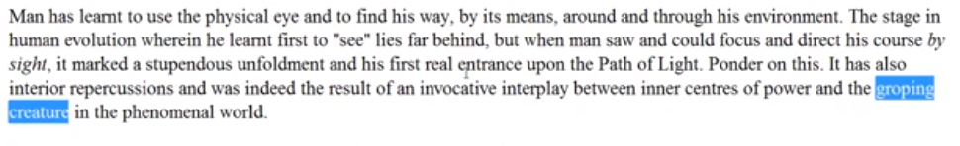
Man has learnt to use the physical eye and to find his way, by its means, around and through his environment. The stage in human evolution wherein he learnt first to “see” lies far behind, but when man saw and could focus and direct his course by sight, it marked a stupendous unfoldment and his first real entrance upon the Path of Light. Ponder on this. It has also interior repercussions and was indeed the result of an invocative interplay between inner centers of power and the groping creature in the phenomenal world. DINA II 292

It is, Ponder on this. It has also interior repercussions and was indeed the result of an invocative interplay between inner centers of power and the groping creature in the phenomenal world. So man did not always have an eye, and the question is that there were times maybe when he had simply a single physical eye. Maybe we have to go to Leadbeater for some of his psychic assessment on those early forms, but he had to learn to use the sense of sight. Animals had it, but then he had a different kind of genealogy; he came from above, he descended through root races which were etheric – the Adamic root race and the Hyperborean root race and only then the Lemurian root race and there was no sight in those early root races. The eye had to develop. So, man has learned to use the physical eye to find his way, by its means around and through his environment. The stage in human evolution where he first learned to see lies far behind, as he was the man who was the animal man, but when man saw, he could focus and direct his course by sight, and it marked a stupendous unfoldment and his first real entrance upon the path of the light. That has to do I think with really becoming a human being.

Venus is a great planet of sight and so is Mercury and they're both involved in individualization. It also has interior repercussions, all of this is about the eye and was indeed the result of an involvement of interplay between inner centers of power and the groping creature in the phenomenal world for man was once a groping creature. Was it pre individualisation or was it post individualisation? … You have a grouping creature without an eye amazing probably we have to pinpoint this the best we can, and again I think Philip [Lindsay] and his work may be useful in that regard.

02:26:40 What is the guna or mode of motion most associate with his petal? Well, definitely tamas. There is inertia, and inertia is coming from the moon veiling Vulcan. There is Raja, in the sense of following the animal desires but the consciousness is quite tamasic.

Which advanced theme for meditation associate here? None at all, no, these are categories. Greater constellation or Planet? Earth. Nothing about Chelaship. It is the book of form. There's no ACLRI process, because we're just on the path of evolution. We have not reached anything called alignment.

I'm not sure about these zodiacal lights, and why the light of initiation should be here. I don't think it applies too much. Maybe the light of Aries, but they're all given in higher cosmic interpretations.

Keynotes from the angle of form? Well there's no ambition here, there may be Capricorn but no personality to have ambition. There is a huge animal creature with great power learning something about the environment and breaking the law and learning as he goes.

Keynotes from the angle of the soul? Not really. Lost am I in light supernal? No. It may be the way of life but no. (I think these have been added by my editor, some of these.)

There's no particular emphasis on the organs of action. Maybe the organs of action, of course, some of them continue. The sacral center is an organ of action and it's involved, and let's see, excretion of course, which is a natural work of sustaining any body of form, excretion will operate in. The hands, feet, the voice is an organ of action, maybe these are not so important to consider the organs of receptivity are there, of course, and maybe the ear is certainly emphasized. And also touch, perhaps the skin eventually.

Alchemical journey? (I'm wondering, did I put these in? It has been so long ago.) Lead, the base metal, that's what the man is ruled by, Saturn. So we're beginning with lead, ruled by Saturn. It's the prima material, it's finding the base material, primordial matter, and we have to work that into gold. Man does not become gold until quite a bit later and eventually he becomes radiation itself, the radioactive man. Some interesting additional thoughts emerged here, glass has no crystal structure, interesting, dense and amorphous. Well alchemy could be applied, right?

We could probably look at the tarot, here I'm not going to get into this, this is something that you can do if you wish. All of these correlations are possible and I think this was inserted by my editor, obviously the beatitudes are not relevant, there is no intelligence to understand that.

There is no attempt at yoga here, so that the eightfold path is not being trodden, obviously. The mental chakras well, the very, very slight maybe, with the idea that the base of the spine and the sacral center are mental factor. Center related to the home of the mental elemental, and so forth, there are many other correlations that we could make but I'm not really going to get into this. We can get into them at some point if people think it's interesting Later I mean, I think one can understand when the means of yoga might come in for the aspiring initiate of the first degree, when the beatitudes would be relevant only for one on the spiritual path and they are enunciated from a high atmic level so maybe they can only be fulfilled by fairly advanced. So anyway these were added.

02:32:00 … The next section is not that important. I have a couple of pages where the different classes offered thoughts which are in association with this petal, and I think the thing that I should do is just kind of scroll through them so you can see the kinds of things that were stated.

Interesting that Atlantis became more dense. If I see something standing out I may speak of it, but you can take a look at these as they go, different classes. Different colors. There were huge tabernacles of clay inhabited by the solar angels themselves, or some of these early men were actually with great intelligence because the solar angels actually took on the incarnation. Gives us a sense of the incredible journey we've been on. Moon change humanity had not yet come in, it would follow a very different kind of process with a first class in the hall of ignorance, it's dark, it's dangerous, it's red, it's full of hard knocks, it's the school of powerful impacts …

Uranus is interesting, because one is forced to move. Uranus usually rules migrations, so early man becomes a nomad, a hunter, a wanderer, so he's coming forth from deepest ignorance. Check out the blessed ones for the fifth ray tells a lot about how the monad descends and what his reaction may be. Physical brain awakening is going on here, primal man is coming forth, Sanat Kumara has touched ground. And the ground rules are laid here, this is the fourfold field, the field of form. All the kingdoms of nature, the lower ones, are experienced, but not yet higher ones. The plant, the mineral, the animal kingdom, our experience and relationship is learned the hard way. Is there a connection with the jewel in the lotus? Maybe, just in terms of the grounding. It's the beginning of life, it's the cube in space, it's Mars. The projected soul is experiencing time and space. Saturn limits their sacrifice because of limitation we have to get our material foundation straight.

All the petals unfold more quickly than this one if the slowest petal to unfold and takes the longest time. We're very close to the mud, we are physical man learning the hard way. Relationship begins, but not really until second petal does something that we call love begin to transcend instinct. Our relationship is primarily to the physical environment.

We wonder why more of the skeletal remains are not to be found. It has been said that cremation was a very early practice, but we're also told that when the time is right the gigantic skeletons will be brought forth or people will be directed to them. It's a different environment that the animal experiences because the spark has been implanted or the unit has been fanned.

You can look at some of these things. Some joker [in a class] said ‘throw the club away and join the club’. Well it's kind of interesting because the club is the symbol of your own independence and you will bash your way through life or you will begin to aggregate with others of your kind and sort of refrain from using the club to hurt others, you will have to moderate your behavior. [laughing] Someone said they're not living in nice houses. So it's the hammering down of the spark of life, quite a bit of reactivity, not really knowing how to think ahead.

There's no proactivity just the dig and carry phase is not pro-active, but then those later civilizations did emerge. But remember they were directed by higher beings. The fierceness of the lion mother or the mother bear was evoked. The whole idea that the throne sits on the feet of the dragon, that the ancient throne has had dragons legs, so we have to master these primitive energies. It's a confusing time and earthy time, the two malefic planet, Mars and Saturn, are very strong, but man must survive and the two lower chakras are a lot about survival, just keeping the vitality going and keeping one procreating so the race can survive.

Someone said there could shamanic journeys, going out onto the astral plane in a very material sense is possible. I think the Aboriginals do that quite a bit. There's always the fear factor, fear is very strong in his eyes in the sacral center we remember the fear of being eaten or destroyed is always there. Survival is the name of the game, and we have to find out what that is, more consciously. As an animal you die, but you don't know what's happened, you just have a change of scene. All the brutalities of this hard life keep us moving forward and around until we learn, so it's a primal condition. Now all of these primal tendencies are part of our shadow they are in the bottom part of our aura, we don't even know we have them anymore. So it's more man as the beast and some people today can go back to those kinds of days and turn into the beast. The Beastie Boys are back [laughs] well you can see it was a bit of fun as we brainstormed on these things. Dig and carry, you are inert.

A fresh start in the human race, millions of years to go. How far we have come? They were scared. Seventeen million years on a petal, not exactly like Brahma floating on a lotus petal. We are scared, fears in the sacral center, animal fear is a big factor today in the relation between the lord of the animal kingdom and a lord of the human kingdom, the kingdom lords. There is still plenty of fear and it is related from Moon chain days in the animal kingdom, and man has a physical body too, the fear is there. Minimal experience, no real point of reference, they were essentially animals.

I think is an interesting idea, they were hunted down by the spark of mind. We are told these fascinating stories of the death of the forms when the solar angel would project its essence into the form of the animal anchoring it in the brain and the head would explode. The forms couldn't take it, it would often time mean the death of the form. Eventually it had to be anchored in some way, certainly it could be anchored in the mind.

So the time of instinctual reactivity. Later Lemuria, overlapping with early Atlantis, did have a culture and the people were already becoming disciples and they were already anticipating what initiation was. But they were not those who had been individualized on the Earth, unless such fast movers as the Christ. The whole factor of safety the seventh ray was very big so the huddling together for survival is the beginning of community. One had to be then the strong man who could be relied upon and that's a very first ray period as in a way here might makes right.

Who is respected? The strong. Not so much perhaps a plant-eating age, until maybe later. It's closer to the animal kingdom and one looks to the animal for food. What is the difference in your consciousness now that you are man-animal compared to when you were animal-animal. Yes these are not all in such great order but these are thoughts as they occurred. The old Lemurians worshipped the inner god, they had says Blavatsky a childlike reverence for the inner life. We must have a joker in the group, the group just didn't know who to marry, so the old idea of hitting someone on the head with a club and dragging them off by the hair. It’s a joke, but maybe there's more to it than we know even in modern times we see people kidnapped for the purposes of marriage or being sold into slavery, so there are people who are have not quelled the use instincts.

02:42:40 … you see these things and that's probably enough. Well what have we done here? Basically, even though the text doesn't look so pretty, it would take ages just to work that all out. We have proposed a series of categories and in the beginning of the document the categories are fairly well organized, and all kinds of correlations are coming in here so that we can begin to have a sense of the synthesis of forces and … energies which come together to make the first petal experience what it is, spanning the whole time of Lemuria from the time of organizing in this petal, vitalizing, and then moving on to other areas of work to the time of the unfolding when all of these things that have been prepared, organization and vitalization are actually part of the man's makeup and he can really work with him.

We look back so far upon those early days. First of all when you think about what the history of man is conceived to be at the present time, the thought that there may have been civilizations five, six, seven million years ago, is considered to be preposterous, we're looking for even fifty thousand years ago we're looking for quite crude behavior and crude forms.

The forms that we suspect existed are nothing like some of the huge forms which did exist and we simply have to accept the Secret Doctrine’s word for this and the reports of those who are high in their soul and have these faculties developed. So far the necessary discoveries have not been made but one day the necessary discoveries will be made and people will be – actually sometimes people just don't see what they don't expect to see – we are told that there were the native dwellers, the indigenous people of Florida, who when they saw the ships coming from Europe they just couldn't see them because it was not within their paradigm to register the reality of such objects. We've been told that skeletons of giants have been discovered, but it's as if man doesn't know what to do with them. He cannot conceive in his present paradigm of understanding human history that these would be skeletons of early creatures that were man or related to man, and so mostly they have been assigned to the animal kingdom to some unknown species.

Some people believe, oh yes we found a giant here; a giant like Goliath may be nine or ten feet or maybe bigger a little, but nothing compared to the Atlantean types of forms which are said to be buried under the sea. Master Koot Humi has said that geology will have to be entirely revised on the basis of these new discoveries, but I think the hierarchy also works to prevent a premature discovery of the plan and not all information that would be relevant and upsetting to consciousness can be released at once. There are many discoveries to be made which will somehow confirm I believe the secret history of the Secret Doctrine which is stranger than fiction in a certain respect, and when we bring forward these ideas from the Secret Doctrine we are considered to be a fanciful, deluded, hyper imaginative, gullible, and all the rest of it, but if you look at how the fabric of the ages with them all hangs together, studying the many different parts we see that these are not random and fanciful perceptions. Size has been gargantuan and it has diminished. We even see this in the animal kingdom, you look at the animal today and except for the whale the land animals have diminished tremendously in their scope, their size.

We know so little about really early man, we think about a Neanderthal, fifty thousand years ago a hundred thousand years ago, and we study the genome and we wonder who they mated with and how the Cro-Magnons man emerged and how the modern man emerged and we don't think as Blavatsky told us to think of the rise and fall of great civilizations, and that the great civilizations had very advanced types but then there were long periods after destruction of the civilizations when progress went into abeyance and man did fall down into the cave life. When we look at the cave life we think that all men live this way, because we cannot conceive of great Atlantean or even Lemurian civilizations. So the study of the Secret Doctrine – I always used to tell my children, as it does capture their attention –well, there used to be men they were 27 feet tall, ‘oh really’. And they're interested and then only later did I reveal where this all comes from the Secret Doctrine and from a whole different view of what early humanity is like.

I'm sure that if we were able to see on the historic screen the progression of the Adamic and Hyperborean races into the early the Lemurian and finally individualisation and to actually see that occurring because the record is there it would be just an astonishing historical study. And one which will be very possible for mankind before long. We have a lot of things to clear up and the ageless wisdom has to establish itself, and then the records can really be studied. Of course that they will require the third ray, the so-called keeper of the record, and then maybe we will not be so doomed to repeating stupidities of the past, those who are ignorant of history are destined to repeat it, are bound to repeat it, and we will understand something about our true origins and will not get caught in a tiny little fictitious fragment of thought that we take for all of reality.

Do we really need to study early man this way? I think for the completeness of the picture we do. We even have of course some people on the planet who while not being anywhere near in physical stature what the earliest man was, have elements of consciousness which are not so far removed, they are far removed but not so far removed from the consciousness of early man. So we have all kinds of types on our planet and we don't have the paradigm to recognize them for what they are, and we have this crazy idea that all human beings are equal. Well all human beings as spirits, as monads, as essences are absolutely equal, there's only One Being, but in terms of the expression through form it's a great fallacy and if we try to legislate all things in terms of the equality of all human beings, it just doesn't make sense because they have different objectives depending upon the stage of evolution for which they are passing and if we try to enforce this idea of the equality of the form and the equality of the psyche, we are going to do violence to people who need something else. There's a whole range of needs in humanity, they need their next step, they need the next step of development. If you have somebody who is working on unfolding the ninth petal and you have someone who has not yet unfolded, lotuses of Brahman have not unfolded the second, they obviously need entirely different kinds of approaches. We cannot force upon all human beings the fallacy of the equality of the development of the form and psyche only the development. The spirit never develops, so only the spirit itself is utterly equal, and every human being is as necessary as any other human being we are all spirit we are all God. We are all the essence we're all the one being living through different stages of differential unfoldment.

The ability to learn who a human being is and find out what a human being needs and provide in a balanced manner those opportunities for those needs to be fulfilled is a whole science of the vocational understanding. There is a voice inside, a voca, a voice it's calling and every human being has to respond to its type of calling. Right now it's just a big mess. Maybe when the seventh ray comes in there will be more an understanding of the division of labor within the human family. This is not any kind of elitist thought because we've all been everywhere. Whatever stage we are at we've all been through all the previous stages and whatever stage any less developed individual is at they will all pass through the later stages. It's a question of recognized equality in relation to unfoldment in time.

Once we get the time equation, and the fact of reincarnation, then we are no longer going to have the tremendous mismanagement of our world and the mismanagement of humanity. I mean once reincarnation is an established fact and people feel the proof of it they will, we will not no longer be eat, meet and be merry for tomorrow you die. The rapacious attitude of the so-called predator elite will be subdued because they realize that they're going to ruin their environment for the next incarnation, they're probably going to be placed on top of the garbage heap as a corrective.

So we need the ageless wisdom is the long and short of it. You think of it well why are we studying all these remote things. We're nothing like the man of that period, but we want to know something about the history of humanity and how all the different beings and the energies that they represent came together in a certain way to create that history and the opportunities for humanity. This is what we want to know. It’s all a part of the growing omniscience that we require as we move farther and farther along on the initiatory path and become more and more members of the planetary kingdom. We can become members of the kingdom of souls, and we're on our way to doing that from the time of the first initiation or thereabouts, but eventually we're going to be helping to run this planet, at least certain people will be if they choose the path of Earth service, and even for a long time before that choice is made (between the fifth and sixth initiation) they'll be enlisted by Sanat Kumara to help with the management of the planet, they need to know what's really going on in our planet and with the different kingdoms of nature as they appear on our planet and to know these things factually and not in some fanciful way written down in some scripture by some individual who was maybe advanced for the period but not at all as advanced as men will become. The whole idea of the exclusive holiness of various bibles is a fallacy. They are works at a certain amount of time and they're meant to help certain people. We are told mostly those in the stage of aspirant, serving not in the stage of occultists although you can have occult interpretations of those books.

That whole idea that there is constant progression and no final revelation of divinity is absolutely essential and we will learn accordingly the ageless wisdom and it will open up a great, great light for struggling ignorant humanity, however intelligent it thinks it is at the moment. Intelligence is not wisdom and we are dealing with the ageless wisdom, so hence we have studied petal number one
Let’s do the Great Invocation before we end this. …

Okay friends this is it … this will be the way I'll have to treat all these comments, they just have to be gone over like we have done, we see something interesting and deal with it. This is the end of egoic lotus webinar commentary program 33. Three hours and petal one, that's what we have done. so we will see you as we get in to petal two, and hopefully they're all going to begin to make increasing amount of sense. All the best. See you soon, bye bye.

