EGOIC LOTUS WEBINARS, VIDEO COMMENTARY – 29, Michael Robbins
Abstract.
This webinar is about 2 hours, 35 minutes long and covers A Treatise on Cosmic Fire pages 542-549. Program 29 is the closing program from this section of A Treatise on Cosmic Fire—536-549. It consists of a summary of many points offered in the foregoing programs on the individual petals. It also offers many statements of inspired prophecy regarding how the information on the egoic lotus can be used to improve the lot of the average human being through such human sciences as vocational guidance. A very broad, optimistic and inspiring view of the value of this information is offered.
Egoic Lotus Webinar Commentaries 29 498 MB .wmv file
Video of Egoic Lotus Webinar Commentaries 29 by Michael D. Robbins.
Egoic Lotus Webinar Commentaries 29 149 MB .mp3 file
Audio of Egoic Lotus Webinar Commentaries 29 by Michael D. Robbins.

Transcript

Hello everybody, again. This is program number 29. We have a couple of more pages in this section we've just read, that the Egoic Lotus shines forth in perfect … how is it said here?

b. The three higher petals unfold, and the nine-petalled lotus is seen perfected. Treatise on Cosmic Fire, page 542

The three higher petals unfold, and the nine-petalled lotus is seen perfected. Okay, now we move on a little bit and this is sort of rounding up. In context,

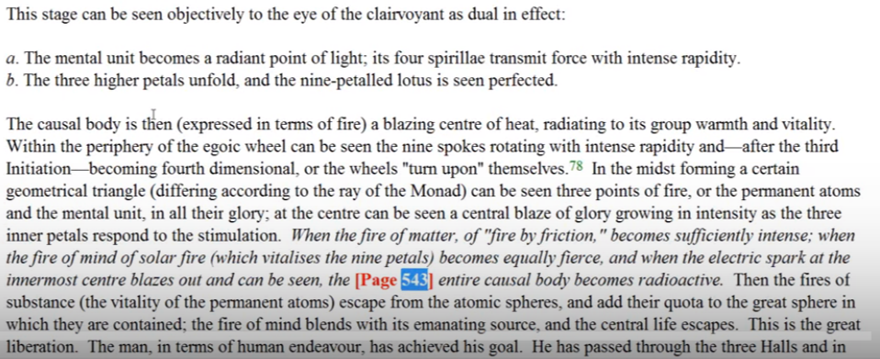

We've dealt with the nine petals … but there is no real discussion of the function of the synthesis petals. If we want to know what they do we have to think about what goes on between the third and the fourth initiations, particularly when they are the focus.

The causal body is then (expressed in terms of fire) a blazing center of heat, radiating to its group warmth and vitality. TCF 542

00:01:00 The causal body is then (expressed in terms of fire) a blazing center of heat, radiating to its group warmth and vitality. We are speaking here of the interchange of energies, interchange between causal bodies. We remember that causal bodies occur in groups of seven, and seven groups of seven informed by the life of certain solar beings who express through these groups. So there is an interchange going on between all of those who have succeeded in opening the nine petals and I suppose there is a general enrichment occurring of causal groups.

When the nine petals have been fully and opened a causal body becomes a blazing center of heat. So this is being expressed in terms of fire. The warmth and vitality represent the Solar Fire which is now fully infusing the causal body and increasingly the buddhi will represent itself through the three in-most petals.

Within the periphery of the egoic wheel can be seen the nine spokes rotating with intense rapidity. TCF 542

Within the periphery of the egoic wheel can be seen the nine spokes rotating with intense rapidity. Maybe the way we would see a fan rotating, how it rotates so fast that the blades almost seem to stand still. … [as] blades of a rapidly rotating fan seem to stand still and thus here, three tiers, nine spokes, and probably all going in the same direction. The wheel turning on itself happens a little later when we enter the fourth stage, and there is a fourth dimensionality that occurs.

The causal body is seen then as a wheel in rapid rotation, and we can see that the powers of the petals are being blended and fused through this rotation. This is a growing synthesis.

After the third initiation – becomes fourth dimensional and the wheels turn upon themselves. TCF 542

After the third initiation it becomes fourth dimensional and the wheels turn upon themselves. Well how far after? It seems that maybe, as we move towards the fourth initiation, perhaps, but we are dealing with synthesis and all things related to each other, in every manner conceivable.

00:04:00 We have previously discussed the fourth dimensionality of the chakras of different vehicles preceding certain initiations, now we speak of the fourth dimensionality of the wheels found within the egoic lotus. Now it probably cannot be described just the wheel turning upon itself not just in two directions but eventually in all directions.

Such fourth dimensional rotation is always a prelude to a state of elevation or ascension. I don't mean the sixth initiation by that, but an upward moving of the particular factor that is turning in that way, or of the consciousness related to that turning.

In the midst forming a certain geometrical triangle (differing according to the rate of the monad) can be seen three points of fire, or the permanent atoms and the mental unit, in all their glory. At the center can be seen a central blaze of glory growing in intensity as the three inner petals respond to the stimulation … TCF 542

In the midst forming a certain geometrical triangle (differing according to the rate of the monad) can be seen three points of fire. Now this is very interesting. Here we have an example of the extraordinary symbolizing power of nature, and the idea that God geometrizes.

Now, it has been suggested, because at least I've suggested it [laugher], that in terms of the ray of the monad which is probably one of the three major rays. That the first Ray monad will be an equalateral triangle, the second Ray monad will have an isosceles triangle, and this is the question, will it have forty-five degree angles, and one ninety-degree angle? Because that's a special kind of isosceles triangle, and perhaps it seems that it might be the case, but the third Ray monad out of the 3-4-5 triangle of Pythagoras containing within it so many of the important musical relationships. And the scalene, where all sides are equal, but again this is a right triangle triangle. If it has one right angle, one thirty degree angle, and one sixty degree angle. Well it's been a long time since I've studied Euclid, the few things pass on and they do have their spiritual meanings. These are the members of the atomic triangle which form the three types of triangles.

So three points of fire, or the permanent atoms and the mental unit, in all their glory, consummated after the fourth initiation. This is a great consummating display of causal form and it seems that everything is participating in this consummating glory. The rotation of the petals or spokes, and even the arrangement of the members of the atomic triangle. We are speaking of a time which follows the third degree. Judging from the glorious display we are approaching the fourth degree, it would seem to me.

At the center can be seen a central blaze of glory growing in intensity as the three inner petals respond to the stimulation. And let us say burst open revealing the fullness of the central fire, the Jewel and the Lotus.

The inner three inner petals are likened here to “a central blaze of glory”. The response of the three synthesizing petals to such a stimulation occurs only after the third initiation. We're really talking about a great climax here; the impression is, in some people's minds, that they are at this stage, but if one studies carefully what really means that there is always what we call the neophyte’s tendency towards exaggeration.

00:09:30 The term “glory” suggests a great display of light heat and magnetism.

When the fire of matter, of “fire by friction”, become sufficiently intense; when the fire of mind of solar fire (which vitalizes the nine petals) becomes equally fierce and when the electric spark at the innermost centre blazes out and can be seen, the entire causal body becomes radioactive. TCF 542-543

When the fire of matter, of “fire by friction”, become sufficiently intense and when the fire of mind or solar fire which vitalizes the nine petals). That's really important point. The Solar Fire at least in its lower expression vitalizes the nine – we can always find it on still higher planes and when the fire of mind of solar fire (which vitalize of the nine petals) become equally fierce and when the electric spark at the in most Center blazes out and can be seen, the entire causal body becomes radioactive.

This is a prelude to its destruction. We are attempting to become radioactive man. Radioactivity is the kind of thing which only increases rather than decreases the so-called half life idea, maybe contrary to the way esoteric nature works. Maybe there's a tendency towards growing radioactivity rather than a tendency towards the decay of radioactive bodies, however small.

We have a brilliant description here of the radio-activation of the causal body preceding its destruction. It broadcasts, or should we say, it casts what it is, broadly afield.

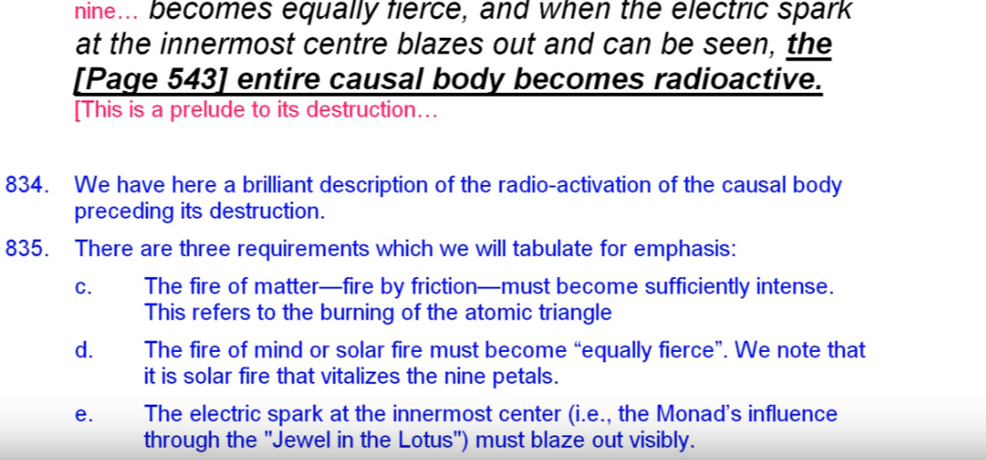

There are three requirements which we will tabulate for emphasis.

c. the fire of matter, or fire by friction, must become sufficiently intense and this refers to the burning, the heat of the atomic triangle.
d. The fire of mind or solar fire must become “equally fierce”. We note that it is solar fire the vitalizes the nine petals. In another and higher way, solar fire also, from the agni point of view, would be vitalizing the inmost three.
e. The electric spark at the innermost center (ie, the monad’s influence through the jewel in the lotus) must blaze out visibly.

00:12:00 We can assume that radioactivity of the body precedes its destruction. We are all heading towards that radioactive state, let us say that radioactivity for man signals consummation of the human stage. The Masters still continue to be considered human in a certain sense, but at this point … there is no more need for reincarnation as a human being in a human body produced through human reproduction. If there is going to be a human body, it can be produced through the power of will, mind and imagination and kriyashakti.

Then the fires of substance (the vitality of the permanent atoms) escape from the atomic sphere, and add their quota to the great sphere in which they are contained. TCF 543

Then the fires of substance (the vitality of the permanent atoms) escape from the atomic sphere, and add their quota to the great sphere in which they are contained.

This is interesting, very. We are speaking here of an occult process by which the energy of the lesser permanent atoms and the mental unit is absorbed by the triadal permanent atoms and this will happen eventually. What is this great sphere? Is the great sphere in which they are contained the egoic body, or the three triadal bodies, or first one and then the other? Possibly.

Given the nature of the liberation in the fact that fire at the center of the Jewel in the Lotus must be transferred into the triad, one would be led to suspect that “the great sphere” is eventually at least the triadal sphere, the personality of the monad. … We might say, perhaps until the causal body is completely destroyed there is not liberation into the triadal sphere. So there may be what we call a mediated transfer of fire vitality of the permanent atoms, first in general to the sphere of the causal body, and then as the causal body is destroyed to the permanent atoms of the spiritual triad

00:15:00 …It's difficult to know how that transfer exactly will work. We do know that the astral permanent atom will be transferred to the buddhic, but with the other two there's ambiguity. From some point of view it might seem that the mental unit should be transferred to the manastic permanent atom, and the physical permanent atom to the atmic permanent atom. It could be the other way around, it could be the physical permanent atom to the mental permanent atom, and the mental unit to the atmic, as pointed out, and somehow that just doesn't seem as right as it could be; I don't think it's been stated.

The fire of mind blends with it's emanating source and the central life escapes. TCF 543

The fire of mind blends with it's emanating source and the central life escapes. The emanating source is the spiritual triad. And the center life is the monad in extension, which escapes first into the triad and only then later (later? when?) to the monad, and maybe the sixth initiation will somehow have to be undergone. Where does the central life reside? It seems necessary to keep the monad in extension until the monad has completely withdraws its extension back into itself right. Seems to me.

If the fire of mind is considered Solar Fire, then the solar angel is the emanating source of that fire, in one way. The solar angel too must return to its emanating source. This is one way to consider it, the central life which escapes is the fire at the center of the jewel in the lotus, it is the fire of the monad, which may not immediately return to the monad but which may be first absorbed by the spiritual triad. There are references that seem to say that, in what way we do not know.

It would seem that the initiate now living focussed within the spiritual triad (and not yet focused within the monad) has need of the experience gathered in the incarnational process, and so the central life which has been confined within the causal body would (in a mediated manner) be temporarily confined within the sphere of the spiritual triad. Let's see. The initiate now living folks within the spiritual triad has need of the experience gathered in the incarnational process – that would come from the permanent atoms of course and but the vitalization would come from the central fire. The escape of the central life is an alchemical transmutative process, it's the volatile essence we call it. And the triad must still continue to be animated by the central life

00:19:00 This is a little vague as to exactly what happens to the central fire, but we do get the idea that it is first transferred into the triad, and maybe into the atmic area especially, but not yet a complete return to the monad which we would expect at the sixth initiation.

This is the great liberation. The man in terms of human endeavor has achieved his goal. He has passed through the three halls and in each has transferred that which he gained therein to the content of his consciousness. TCF 543

This is the great liberation. It's the liberation achieved at the fourth degree. There's another kind of liberation when the monadic vehicle is destroyed, when does that happen exactly it is not stated. The man in terms of human endeavor at least in terms of human endeavor has achieved his goal. He's still a human being we're told they are no longer men as are the masters. DK is talking of the chohan and even at the fifth agree there is still the connection with the human kingdom and always the connection with the fourth grade of hierarchy. The temporary goal at least of the fourth kingdom human is the fourth initiation, there are other and higher goals. He has passed through the three halls and in each has transferred that which he gained therein to the content of his consciousness.

The three halls are correlated with the three tiers of petals: the hall of ignorance with the knowledge tier, the hall of learning with the love, and the hall of wisdom of the sacrifice tier. We might say the hall of wisdom continues even to the fifth initiation, for a master is a master of the wisdom.

So all of this is built through the work of the Solar Angels. The quality gained is built into the egoic lotus and becomes a permanent part of the consciousness of the individual. That is fairly straight forward occultism. Basically what we see we are doing is. Making a summary of all that we have reviewed.

00:21:30

He has in order to sequence developed and open the petals of the Lotus – first opening the lower three which involves a process covering of as per your time. TCF 543

He has in order to sequence developed and open the petals of the Lotus – it looks like ordered sequence does prevail. I have made a case for sequence rather than each tier opening all petals simultaneously. There may be a point in which there is complete opening of every petal, but let's say the first petal must left open, then the second, then the third, then they will all open. So he has in ordered sequence developed and opened the petals of the Lotus – first opening the lower three which involves a process covering of as per your time. We are familiar with these quotations because we have used them before.

The sequence is ordered but there are necessarily overlaps and sometimes anomalies and irregularities. DK has talked about people who have not completely opened a previous tier, but seem to have a petal open into succeeding tier. This I suppose has much to do with their karma and also their ray structure, certain peculiarities have happened and it's an abnormal and an even development where one would expect certain types of behavior and abilities and they are not there – one would expect them from the highest petal open, but they have no foundation because there's been a leap to jump.

The opening of the first three petals can take perhaps ninety percent of the time allotted to human evolution. There are ways to look at this: thirty, thirty, thirty, ten, maybe three hundred, three hundred, three hundred, one hundred.

But if you think that so many people have taken twenty one million years already, and have not even fully open the third petal, and these are the nice good people in group five, human group number five and they can probably be found in stage of adaptation number four. That's 21 million years, and maybe if it takes 25 million years, 4 million years remain, for over 20, one-fifth, 20 percent? Eighty percent of the time a lot of human evolution, 80 or 90 percent. it is a process covering many millions of years, a vast amount of time, we can understand the lack of development of so many human beings at this time and why the world is in such turmoil because of the competing types of desires.

Then the second series of petals are opened during a period of time covering his participation intelligently in world affairs. Until he enters the spiritual kingdom at the first initiation. TCF 543

Then the second series of petals are opened during a period of time covering his participation intelligently in world affairs. Until he enters the spiritual kingdom at the first initiation. I don't think this is a technical – this is a general statement as we discussed before – the spiritual kingdom of the first initiation covers the complete opening of the fifth and partial opening of the sixth, but the second series of petals are opened. When the fifth and sixth petals are opened we assume he is still participating intelligent in world affairs.

It is statements like this which seem to throw up a contradiction. When we look to the more technical statement we saw that when the star of initiation shone forth, five petals had to be open, and now it seems to imply that the second series are open, but are they completely open? That's the point. Are the completely unfolded, or open? In any case it to me it looks like the first initiation sees to a degree almost the full opening of the second tier but it could be quite a while. The unfolding sixth petal may take quite a while because I think it signals the sixth initiation. I’m trying to deal with the principle of overlap, to look at what I call the three petal process: the simultaneous three petal process.

The processes connected with the opening of the second series of petals are intelligent. That's important, it starts out with the Cancerian petal in which the third and seventh ray come in, and Venus is an assigned ruler. Venus is the planet of intelligent love. So he is a participant in world affairs, intelligently. Venus, the planet of intelligent love, in the second tier. I have shown how many different energies can be simultaneously used, but Venus is a prevailing energy, and from one perspective its color is rose. It’s color could also be the fifth ray color, which would be the orange and even a fifth ray color of a higher nature which would be the Indigo.

00:27:40 The entry of the spiritual kingdom, the kingdom of souls, occurs at the first initiation, or a bit earlier. So we have seen some references, it's hard to pin down exactly. The causal body can move to the second subplane of the higher mental plane for what we call advance man who is not quite initiate of the first degree. From other perspectives advanced man can be even more than the Initiate of the first degree. We have fluid terms here.

When the first initiation does come, this is the mounting of the fixed cross and the beginning of true discipleship. I do think however we saw that four petals remain to be unfolded, so we could not look at the second tier as completely unfolded by that time, because then there would not be four petals that needed to be unfolded. See, at the first degree, in the more technical writing, four petals remained to be unfolded and so upon entry into the spiritual kingdom at the first degree, the sixth petal cannot be fully unfolded, otherwise there would be only three to unfold. One has to count carefully here, and differentiate the broad statements from the ones that are more precise and technical?

The opening of the first six petals takes this to the point in which the first initiation can be taken, but what do we mean by the opening? It's not the full opening, not according to the theory we are using, the full opening, and I've shown why that should be the case by that very important reference relating to the star of initiation and of the first degree and the four remaining petals to be open.

I want to say that the complete opening of the fifth petal takes us to the point at which the first initiation can be taken or the almost complete, but the initiation before the initiation is taken, it is necessary that the seventh petal be at least vitalizing, organized, and I've looked further into this (I’m trying to correct as I go) and some what unfolded due to the strenuous set of noble effort of the man. So to what degree of must be unfolded? We do not know and that is something specific to be understood by the initiator, not possible for us to understand. So we have to be so careful about open and fully opened, and I'm going to use my own term here, specially adjusted a relationship between tiers of petals which begins their rotation relative to each other. The rotating three spokes, the rotating six spokes, the rotating nine spokes.

We're bit like the blind man trying to describe the elephant. All we need is sight, and it will be so easy, but we're using the sense of touch, so it's just a piece at a time because touch is much more limited than the synthetic nature of sight. But this is preparation as I've tried to explain, doing the groundwork to make sure that we will not fall victim to the astral phantasms which just don't make sense.

00:32:40 Once there is entry into the spiritual kingdom a period of abstraction has slowly begun. I did go over this quite a bit, this earlier one, are open but are they completely unfolded? That is that, that is the word, and I think not open. Yes, primarily this opening years occurring with intelligent participation in world affairs. But full opening has a different – see we might say the second series of petals are gradually opened during the period of time covering his participation in world affairs until he enters the spiritual kingdom at the first initiation.

It is problematic, but I hope I've gone over it sufficiently enough with other references to indicate that the full opening of the second tier is not really to be expected until there is unfoldment of the seventh, unfoldment at least through the abnormal and strenuous effort, of somewhat of the eighth. If the fifth petal, fully unfolded, indicates the first initiation it just seems pretty obvious that the sixth petal fully unfolded, at a rather later time, long period of time between the first and second initiation and will indicate the full indication of taking of the second initiation along with the development through strenuous and abnormal effort of the eighth petal and the continuing unfolding of the seventh.

… and a final and briefer period wherein the three higher or inner ring of petals are developed and opened. TCF 543

And a final and briefer period wherein the three higher or inner ring of petals are developed and opened. Here DK is being very sequential, in all this DK is being very sequence, and he's acting as if one thing happens after another, but there is the simultaneous we have also to look at (I want to call it and I think it's a good phrase) differential simultaneous unfoldment. So a lot here, less ahead and still less further ahead, but all unfolding at different degrees.

00:36:00 In this case the inner ring of petals is the sacrifice tier and not the innermost tier, the synthesizing tier. The “final and briefer period” is really much briefer, even than the period during which the central three petals of the love tier are opened. That's a long time participating as an integrating personality, as a a complete human being. Well, in terms of the third aspect, as a complete human being from the perspective of the third aspect of divinity.

We tried to suggest that it's opening could occur a few thousand times faster than the opening of the knowledge tier. The number 700 and 70 and 7 may give the idea of the factor of 10. I'm not sure that the factor of 10 is even sufficient. I have suggested that the inner petals in a way can open even 3,000 times faster. Suggestion or hypothesis. … 21, 22, 23 million years compared to a few thousand years for the petals to really open.

We have seen that the application of the rod does not signify the entire opening of the petal, at least that is the presumption here because we know the rod has to be applied for the seventh petal for the first initiation, and we know that the fifth petal is completely unfolded and four other petals have to be unfolded until the third degree. If the seventh petal were completely unfolded at the first initiation then that statement would not be accurate – there would not be four more petals to be unfolded fully before the third degree, because one of those petals would already be completely unfolded due to the rod. I tried to deal with his earlier, sometimes one must simply use logic and then sight will follow.

In closing what may be said on the subject of the egoic Ray and fire of mind, I would request the student bear the following point in mind: First. That the order of the development of the petals and the stimulation of the fires depends upon the Ray of the Monad, and the subray upon which the causal body finds itself. TCF 543

In closing what may be said on the subject of the egoic Ray and fire of mind, I would request the student bear the following point in mind: So we remind ourselves (amidst all the detail) that we have been talking about in the “ego Ray and the fire of mind” – the vehicle through which the egoic ray principally operates. First. That the order of the development of the petals and the stimulation of the fires depends upon the Ray of the Monad, and the subray upon which the causal body finds itself.

See, this immediately violates the infallibility of strict sequence. Maybe there will be a tendency towards strict sequence but there can be all kinds of anomalies due to the monadic rays. So the ray of the monad, and it's going to be one of the three that we're considering here even though there really are seven, the ray of the monad is the chief factor and secondarily the egoic ray, too, and the sub ray on which the cause of body finds itself. Both rays we are told contribute to the order of the development of the petals.

00:40:15 So this is so important, it's not only the ray of the monad, it is the subray as well. In other words, if you have a third ray monad and second ray soul, it's a three-two combination that is going to determine according to some occult formula the order of the development of the petals and the degree to which they are developed relative to each other in time. We can remind ourselves that this subray is the same as the ray or really subray upon which the spiritual triad finds itself, because all the permanent atoms of the spiritual triad are on the same ray and is the ray of the soul really the ray which qualifies the permanent atoms to the spiritual triad, is the same as the soul ray.

From the manasic permanent atom, if there's a strong stimulation which helps to create the egoic lotus, buddhic-manasically mediated, buddhi flows to the manasic permanent atom, and I suppose is helping to create the innermost set of petals.

This thought would bear expansion and would prove a fruitful source of study to the occult investigator. TCF 543

This thought would bear expansion and would prove a fruitful source of study to the occult investigator. I think it will, in later times, when we can actually measure the years and cycles involved in the unfoldment. Everyone is a special case of course, you cannot reproduce in any two people the exact ray structure and the modifications of astrology as well. But it gives an idea of how regulated the whole process is, and what we've been given is the generic cycle of unfoldment. I mean if somebody comes to us and we can help them realize what petal process they are focally involved in, what petal process might operate by reflex, what is their further extension that they really have to accomplish in their life and what energies from their astrological ray chart they have to accomplish these? We will already have given some strongly orienting material see through a glass darkly at this time. It's pretty clear it would be nice to know all of this as an exact science, but we are really not at the point in terms of the interactions of our society and how it's structured, and the structure of our own minds where we can actually benefit from the absolutely meticulous fifth ray knowledge of how this works.

00:43:10 During the course of these commentaries we have speculated upon the order of activation of the different points in chakric triangles according to the ray of the monad. It seems obvious that the ray of the Ego will modify its order of activation, and this is not to forget even in relation to the chakric triangles. It is also well regulated under the Department of Karma; we have no idea how really dense we are when we compare to the intelligence that is administrating the relationship of our consciousness to our form.

For instance, if a first ray monad would tend to stimulate only as a last resort the triangle point in a triangle representing love, than a first ray monad with a second ray Ego (as a subray) would hasten the stimulation of that love related point of the triangle, more than a first ray monad with a third (subray) ego. You see how it would work. But he has told us that basically it's always the third aspect chakra that activates first. They do go in order and that the most difficult to activate is that which is on the first ray. But for the second ray type, the second chakra point in the triangle is opened almost as rapidly as the first one. Certainly for the first ray type although the area of sacrifice is the most difficult the first ray area he would open much sooner than for the other types even though it might be the last to really fully open.

So we have the generic pattern of opening, and we have the special pattern of opening to be superimposed upon the generic pattern based upon the ray of the monad and the ray of the soul. Actually what we've been looking at here is some kind of summary.

First. That the order of the development of the petals and the stimulation of the fires depends on the Ray of the Monad and the subray upon which the causal body finds itself.

Second, that this unfoldment proceeds slowly in the early stages, and only proceeds with rapidity as the man himself works at it with conscious effort. TCF 543

00:45:30 First, bear the following points in mind, the ray of the monad and the subray upon which the casual finds itself … the ray of the causal body which is a subray of the monad – a subray of the monad, again we have to be careful about the article a and the: the represents the only one, and a means is one of perhaps more.

Second, the fifth unfoldment proceeds slowly in the early stages and only proceeds with rapidity as the man himself works at it with conscious effort. So this means being aware of the higher of the pairs of opposites and then you can be conscious about what you are striving for. Conscious application adds to the speed of unfoldment. I’m remembering even Master Morya’s advised even to take vitamins with consciousness; don't just swallow vitamins but take them with consciousness because it will make them far more effective. He also advises us against the mindless repetition of mantram. Probably your body already knows many mantras, but if your mind is off there while your voice is repeating, it is not anywhere near as effective. So, conscious application adds to the speed of unfoldment and one can rely solely upon the natural process but intelligent attentiveness to process hastens the process and renders it more effective.

We have looked at …

The Ego takes no active interest in the development until the second petal of the second series is beginning to open, TCF 543

The Ego (the Solar Angel AS the “Angel of the Presence” within the causal body (as a way of defining it a little more precisely) takes no active interest in the development until the second petal of the second series is beginning to open,

We would say well before the first initiation, but at the time when an individual can become an aspirant. If not too caught up in lower ego, personality identity.

00:48:00 While the Ego is responsible for the overall progress of the process, its individual interest is not piqued until its personality has made sufficient progress. When you use words like ego you have to be careful what specifically does it mean. Is that higher intelligence within the causal body the egoic lotus? Is it the solar angel on its own plane? Something other than the man is operating here surely. The identity of the man in the higher mental plane, which is an extension of the monad, can also be called ego. We have to be careful when using the word ego whether we mean that which the man really is and his identity as a monad extension on the higher mental plane in the causal body egoic lotus, or the solar angel as an intervening entity which is supervising the growth of the man.

Then there was supervising from within because the Angel of the Presence seems to be that part of the solar angel which he inserted and which is present all with him the higher identity of man substanding that identity, and substanding that consciousness. Anyway. The fact tells us much about the soul, the fifth petal, and its relationship to the great second aspect. Somewhere it tells us also that the great second aspect of divinity will supervise the earlier affairs of the egoic lotus and its early development. Then from the same aspect, the solar angel becomes a downward-gazing soul and becomes more aware of what its supervisee is actually doing to promote growth.

So there are different terms and we have to be careful what this term ego can be mean. It can mean monad, it can mean triad, can mean solar angel, can mean the human identity within the egoic lotus substanded by the interjected presence of the solar angel which is known as the angel of the presence. It depends very much upon the context

We note that the ego's interest occurs at the beginning of the opening of the fifth or second petal in the second series. In other words, long before the actual first initiation one has to be an aspirant before one can take the first initiation and there's plenty going on before that fifth petal can completely unfold, just four more petals to unfold before the quote final initiation. What I think is meant here by “final initiation”, is the final initiation with respect to the opening of the nine petals.

We can assume that for most individuals this interest occurred well within the last million years (and perhaps much closer to our present time), the so-called Aryan race. … if it has occurred of course, as there are people who as I say you know the fifth petal is just not unfolding; they are not integrated personalities. Given the long expanse of human development over many millions of years, the Ego, we may presume, has been ‘standing by’ awaiting its proper moment of engagement, but otherwise engaged in its own interior affairs, involving spiritual telepathy. We are told at one point. That's a creative hierarchy far ahead of our own so how in the world can we really know exactly what it is doing? We do know that DK did say, almost humorously: leave your soul alone for a while let it attend to its own affairs don't be always importuning it.

We note that the term ego is used here, it appears to be equivalent to the solar angel. Or maybe the projected aspect of the solar angel, the angel of presence. One must closely examine the meaning of the term ego. I've been saying this. It can mean different things in different contexts and sometimes it refers directly to the solar angel, and of other times it carries a meaning more related to the inner spiritual life of the human being, even to the monad itself. As I pointed out, the monad is egg-shaped in a way, or at least its vehicles are egg-shaped, it can be called the egg-o also.

00:53:30

Before that time, the work proceeds under the law of its being, and through the inherent life of the second logos, which is the life of the petals of the Logos. TCF 543-544

The life of the petals and not the Solar Angel per se, even though through an emanation of the solar angel. There are lesser solar angels which are underlying the petals, but I suppose the matter of the petals is here involved as animated by the second logos.

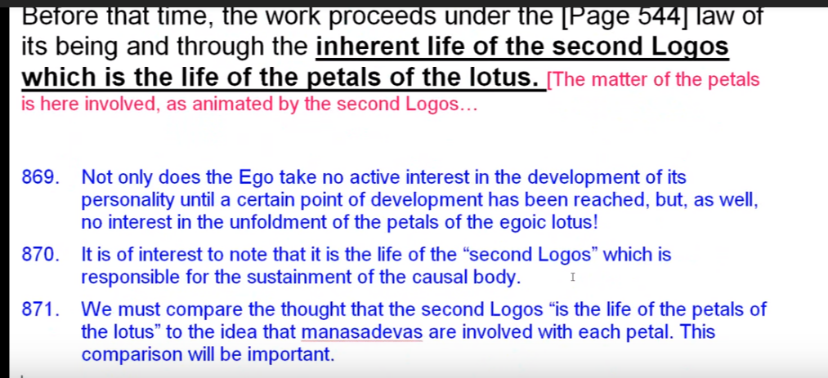

This whole range is not all that interested in everything its personality is doing, because it did a big job back in the point of individualization, either fanning the spark or inserting itself as the spark of mind, but I guess it had to look in at a certain point in later Lemurian civilization to assess whether its work had been accomplished. That's certainly not a time when the fifth petal is opening, late of the Atlantean civilization, except maybe for the few disciples who exist, but probably were on the planet even before individualisation came from the previous solar system.

So, not only does the Ego take no active interest in the development of its personality until a certain point of development has been reached, but as well, no interest in the unfoldment of the petals of the egoic lotus. This is really really interesting, but of course when we become really interior self conscious beings, integrated personalities, and begin to understand the higher, the higher the pairs of opposites exists. That's a point at which we might say some unfoldment begins to occur.

We are working ahead. I suppose in the sixth petal for some unfoldment to begin to occur in this fifth petal. We don't know the exact cyclic timing of when the organizational vitalization work begins in any particular petal, and when a man leaves behind, no longer attending to a certain petal. Maybe we can assume that, and that when a petal is fully unfolded the man no longer attends and trusts it to be automatic. Maybe when a petal is fully unfolded, the man no longer attends to it and considers its activities to be fully automatic.

Well, it's like Maslov’s Hierarchy of Needs. Certain needs are just taken care of and we have within ourselves the automatic habit patterns to see to those needs. When we drive a car, for example, it becomes automatic; we don't think about every shift of the gearshift, every turn of the wheel, we can't have a tension that is on all things. Even previously accomplished things simultaneously. It's often sometimes difficult, people have a stroke and then have to learn how to walk again and it becomes again a conscious act instead of a well-cultivated automatic system.

00:57:30 I'm giving generally the span of three petals of attention simultaneously. Am I wrong? I don't know, but let's see. I hypothesize a span of three petals to which attention is given simultaneously: one ahead, one behind, and then the focal petal. … Attention can shift back and forth between them.

It was interesting to note that it is the life of the second logos which is responsible for the sustainment of the causal body – basically a vehicle connected with the second aspect of divinity. We must compare the thought that the second logos is the life of the petals of the Lotus to the idea that the manasadevas are involved in each petal emanated. This comparison will be important.

I don't know if there's any way we can solve it. Maybe the second logos is in a way somehow sustaining the solar angels themselves and the emanations. Maybe the second logos is responsible for sustaining the solar angels and their emanations as lesser solar angels. There does seem to be one great solar angel, say with every man, but a number of lesser ones and their method of reproduction must be a reproduction of themselves. So the method of reproduction of a solar angel must be an emanation of itself. It's not the coupling aspect that man goes through. So much that awaits us that is very different from how we seem to be proceeding under the division of the sexes.

Here's an insert:

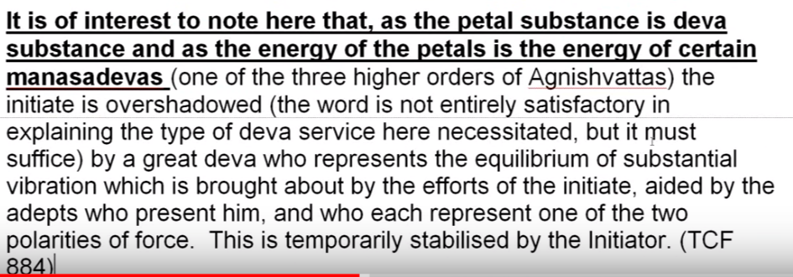

It is of interest to note here that, as the petal substance is deva substance and as the energy of the petals and as the energy of the petals is certain manasadevas (one of the three higher orders of Agnishvattas) the initiate is overshadowed (the word is not entirely satisfactory in explaining the type of Deva service here necessitated, but it must suffice) by a great Deva who represents the equilibrium of substantial vibration which is brought about by the efforts of the initiate, aided by the adepts who present him, and who represent one of the two polarities of force. This is temporarily stabilized by the Initiator. TCF 884

It is interesting to note here that as the petal substances they have a substance that is the energy of the petals, is the energy of certain manasadevas (one of the three higher orders of Agnishvattas) the initiate is overshadowed (the word is not entirely satisfactory in explaining the type of Deva service here necessitated, but it must suffice) by a great Deva who represents the equilibrium of substantial vibration which is brought about by the efforts of the initiate, aided by the adepts who present him, and who represent one of the two polarities of force. This is temporarily stabilized by the Initiator.

01:00:20 This is all about how the solar angels or agnishvattas get involved in the initiatory process. But if we're talking about petal substances, devic substance, and the energy we might call that life of the petals the energy of manasadevas. But are … these underlaid by the life of the second logos? That would be a question, probably too difficult to answer at the moment, but there are different points of view and we understand that there's a whole vitalizing information power by certain manasadevas which take the petal substance which is deva substance of the higher mental plane, beginning with the third mental plane, and at least for certain parts of the egoic lotus, is probably for the nine petals at first and build them into the form of egoic lotus. Are there energetic sustaining power the reason they are held in that particular form?

So is that the second logos, is that the Solar Angels are manasadevas, or is it that the manasadevas underlaid by the second logos itself? These are all to be worked out. It's quite technical, but one day it will be all clarified. One can see the universities of the future where this highest type of thought is really worked on with great clarity and can come forth into society very usefully. I would say.

Then we have the next sentence from the Tibetan:
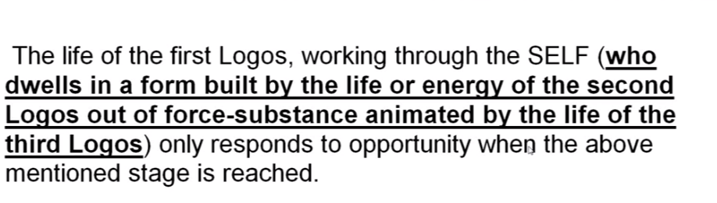
The life of the first logos working through the SELF (who dwells in a form built by the life or energy of the second Logos out of force-substance animated by the life of the third Logos) only responds to opportunity when the above mentioned stage is reached. TCF 544

The life of the first logos working through the SELF … Notice how it's capitalized (who dwells in a form built by the life or energy of the second logos out of force-substance animated by the life of the third Logos) … I suppose that means Brahman. Brahma in this case only responds to opportunity when the above mentioned stage is reached. Well when does the first logos really get into the act? When does the mode that really gets into the act? The work of the second and third? Love must precede the work of the first.

Since the causal body was built at a time relatively recently a time relatively recent in planetary history, we could say that the work of a second logos was not completed at the second outpouring, but continued and continues until the present time. The second logos used to form builder while the third logos is the substance animator and we say, first logos directs this process.

01:04:00 Now this is the question. There is the fifth petal work being done, but this is the response of a second aspect of divinity in a certain sense. It is the solar angel standing in for the second aspect of the man, because it has not been sufficiently developed in previous times. So what has to be reached before that time the work proceeds under the law of its being through the inherent life of the second logos? TCF 543-544

What is the time we're talking about? The opening of the fifth petal? It seems a bit early for the entrance of the first logos, but, aha, well I am remembering this, that when the first initiation takes place the monad becomes influential within the soul, but only upon the plane of soul and is not detected at first in the brain.

This first initiation seems a bit later then the opening process of opening the fifth petal. We don't really have the years involved here, the lives involved here, but the first aspect that the monad serves becomes active at that time in that way, even though really is a conscious part of the man's soul infused personality more of a fair degree.

Notice that the the third logos is connected with the first stop oring the second lowest with the second outpouring and the first logos with what we might call the third outpouring.

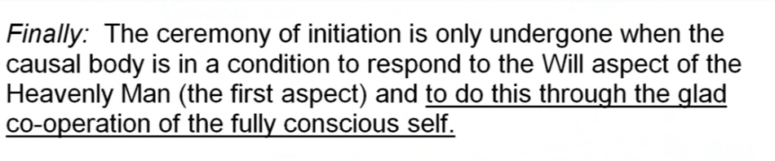

Finally: The ceremony of initiation is only undergone when the causal body is in a condition to respond to the Will aspect of the Heavenly Man (the first aspect) and to do this through the glad co-operation of the fully conscious self. TCF 544

Finally: The ceremony of initiation is only undergone when the causal body is in a condition to respond to the Will aspect of the Heavenly Man (the first aspect) and to do this through the glad co-operation of the fully conscious self.

This is kind of interesting. Any ceremony of initiation? Or do we mean do we mean the third initiation or any initiation? There is a kind of acquiescence here of the soul infusing personality with the intention of the first aspect to be active in the life. As I said, that first aspect takes its place within the soul, but undetected at the time of the first degree. So we may presume that the fully-conscious self here referenced is the soul-infused human being. To what degree soul-infused? That's what we must ask. To what degree soul-infused? Initially or rather fully? Our work in building the antahkarana is allowing us access the will aspect of the Heavenly Man more rapidly.

We are not told which initiation is here under discussion, but it may well be initiation one through four. Any of those. Even at the first initiation, the monad influences the causal body. I could go try to find that for you, I am tempted to take a quick look. Well that took a while but fortunately you didn't have to go with me as I search through hundreds of monad references.

01:08:30 … It's from Rays and Initiations page 312-313.

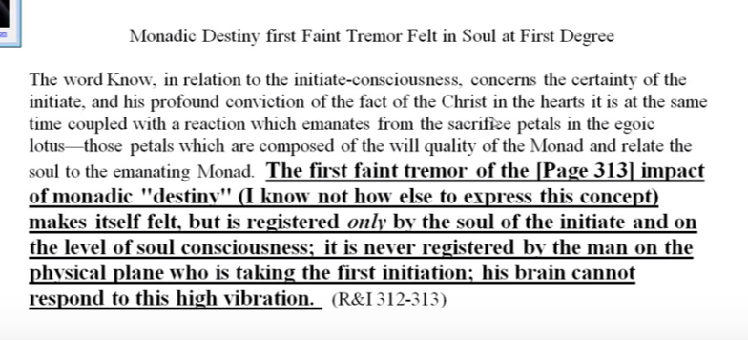

The word Know, in relation to initiate-consciousness concerns the certainty of the initiate, and his profound conviction of the fact of the Christ in the hearts it is at the same time coupled with a reaction which emanates from the sacrifice petals in the egoic lotus—those petals which are composed of the will quality of the Monad and relate the soul to the emanating Monad. The first faint tremor of the impact of monadic “destiny” (I know not how else to express this concept) makes itself felt, but is registered only by the soul of the initiate and on the level of soul consciousness; it is never registered by the man on the physical plane who is taking the first initiation; the brain cannot respond to this high vibration. R&I 312-313

The word Know, in relation to initiate-consciousness concerns the certainty of the initiate, and his profound conviction of the fact of the Christ in the hearts it is at the same time coupled with a reaction which emanates from the sacrifice petals in the egoic lotus—those petals which are composed of the will quality of the Monad and relate the soul to the emanating Monad. Important. Here we go. The first faint tremor of the impact of monadic “destiny” (I know not how else to express this concept) makes itself felt, but is registered only by the soul of the initiate and on the level of soul consciousness; it is never registered by the man on the physical plane who is taking the first initiation; the brain cannot respond to this high vibration.

… So we are not told which initiation is here under discussion. Even at the first initiation the monad influences the causal body. That’s what I wanted, right there. So the first faint tremor of monadic influence producing a sense of monadic destiny and hence a certain direction is registered by the soul of the initiate at the first degree, but not really before and with the unfoldment of the fifth petal in the egoic lotus we do not yet have the first degree. Not yet.

When the man mounts the fixed cross we can say that the causal body has arrived at a condition sufficient to respond to the will aspect of the Heavenly Man. This actually happens at the first degree, though unconsciously.

More on this is not now possible, but enough has been indicated to open up various lines of study. These, if followed, will lead the student to much of practical value and application. TCF 544

More on this is not now possible, but enough has been indicated to open up various lines of study. And that's really what he wants to do. These, if followed, will lead the student to much of practical value and application.

The Tibetan has given us much—indeed so much more than we can know by ourselves, and how will we avail ourselves of this treasure bestowed. I was wondering if people want to stand on their own level and try to see through a jungle or jump on the shoulders of a giant who offers his assistance, and see far beyond anything that can be seen even by very keen sight within the jungle.

01:12:00 The next subject is the elementals of the mental plane. They are lower beings from the Solar Angels of course and the thoughtforms they animate, and the force centers and all that, but he wants to go farther. So we are not speaking of the Agnishvattas who express solar fire, we are speaking of the fires of lower mind. We're not really going to get into that subject … their constructiveness, their destructiveness … a large question remains: are these mental elementals related to the creative hierarchy Makara, or are Agnishvattas related to Makara? That is a big question but it's another subject, not an egoic lotus subject.

Before taking up this matter, however, I want to gather together some threads of thought in connection with the matter just dealt with. TCF 544

Before taking up this matter, however, I want to gather together some threads of thought in connection with the matter just dealt with.

So it's a summary. In this gathering together we deal with Mercury and the third ray. The attempt at cohesion pertains to the second ray making the whole out of that which is gathered, an integrated network of relationships, and then seeing the whole as one we might even begin to relate that to the first ray, Isolated Unity. He's attempting to leave as few loose ends as possible.

He goes on and says,

If we carefully followed the data given about the egoic manifestation on its own plane, and the fires of the causal body, we shall have noted the close resemblance between that egoic body, viewed as a force center, and certain aspects of look toward manifestation. TCF 544

If we carefully followed the data given about the egoic manifestation on its own plane, and the fires of the causal body, we shall have noted the close resemblance between that egoic body, viewed as a force center, and certain aspects of look toward manifestation.

So the idea here is that if we study the egoic vehicle we shall learn much about the life of the planetary logos and the solar logos. Both the Heavenly Man and the solar logos are in possession of a causal body on the higher cosmic mental plane, third level, and first level respectively, and this causal body can be presumed to function in a relatively similar manner to the egoic lotus of the human being. Sometimes it's said to be 12-fold, very definitely, and other times at least with regard to the egoic vehicle or egoic Lotus of the solar logos, maybe 21-fold. That is enigmatic.

01:14:30

The causal body has been seen as a wheel of fire, containing within its periphery three focal points of energy, the permanent atoms. They are analogous as earlier pointed out, to the seventh principle of each of the three aspects, will or power, love-wisdom, and active intelligence. TCF 544

The causal body has been seen as a wheel of fire, containing within its periphery three focal points of energy, the permanent atoms. Not really, he's just being general here, the members of the atomic triangle including the mental unit. Okay literally the atomic triangle with the two lower permanent atoms plus the metal unit.

They are analogous as earlier pointed out, to the seventh principle of each of the three aspects, will or power, love-isdom, and active intelligence – and maybe there is some way that the mental unit and the manasic permanent atom come together making a seven-fold unit as is the case with the physical permanent atom and the astral permanent atom making several units as is the case.

So as these aspects express within the personal sphere, it is the directing force center the permanent atom is that the permanent items are not consequential they actually have a high rank among the forces of substance. They are conduits for the highest of the seven principles in relation to the substantial sheath. They are related to the transmitting devas who are transmitting the intentions of the ego, I recall.

01:16:30 Holding their place upon the atomic subplane of each of the five planes on which they manifest this high in directive position would be expected so we have to you know it's not entirely the mental unit really the manasic permanent atom is still within the dense physical body of the soul of course. Maybe you somehow considered to be contained within this causal body, although most diagrams don't make it seem that this is the case.

Each of these focal points has its own internal economy as seen in the spirillae, which are essentially streams of force, responding to stimulation and vibration, aroused within and without their limiting ring-pass-not. The internal life of the permanent atom and that which animates and produces its activity, is the life of the third aspect; the force playing upon it and through it is the life of the second aspect. TCF 545

Each of these focal points has its own internal economy as seen in the spirillae, which are essentially streams of force, responding to stimulation and vibration, aroused within and without their limiting ring-pass-not. So spirillae are not so much structures as they are streams of force. Of course on some of these internal levels energy force – is responsive streams. The internal life of the permanent atom and that which animates and produces this activity, is the life of the third aspect; the force playing upon it and through it is the life of the second aspect.

… I don't want to deal too much with the permanent atoms because it's another matter, but:

As evolution proceeds the intensity of the life forces from within and those which affect it from without, grows gradually stronger and stronger and the light of the permanent atoms increases. TCF 545

As evolution proceeds the intensity of the life forces from within and those which affect it from without, grows gradually stronger and stronger and the light of the permanent atoms increases. Okay, the petals of the lotus unfold and the spokes of radiatory fire come into action. So these are parallel processes under discussion and one process concerns a permanent atoms in their increasing light. The unfolding of the petals of the ego close parallels the increasing light of the permanent atoms and as the petals are stimulated their dynamic aspect as spokes of radiatory fire makes its appearance.

01:18:30 I just want to stick with the egoic lotus here,

Bear in mind here, that the permanent atoms are concerned with the substance aspect of Existence or Becoming, while the petals of the lotus, or the fiery spokes of the wheel, deal specifically with the psychical aspect, or the development of consciousness; the central nucleus, or the three inner petals, embodies the aspect of pure spirit. TCF 545

Bear in mind here, that the permanent atoms are concerned with the substance aspect of Existence or Becoming, while the petals of the lotus, or the fiery spokes of the wheel, deal specifically with the psychical aspect, or the development of consciousness. They are vehicles of consciousness, instead of vehicles of activity. The central nucleus, or the three inner petals, and including the central fire embodies the aspect of pure spirit.

So, here is one of these important, synthetic statements. DK wants us to keep this in mind:

a. permanent atoms are not connected with the psyche or spirit.
b. the petals of the lotus or the fiery spokes of the wheel are not concerned with substance or spirit, and
c. the central nucleus (the three inner petals, plus, presumably, the jewel, the central fire) is not concerned with substance of psyche.

All three lines of evolution are proceeding simultaneously and have a reflex action upon each other. TCF 545

All three lines of evolution are proceeding simultaneously and have a reflex action upon each other.

This is a very important idea. The reflex action of the various aspects of the egoic lotus upon each other including the atomic triangle.

01:20:00 The focus of each is clear but they do affect one another by reflex action indeed and when a triangle representing the three aspects goes into rapid rotation the unit play of the three aspects is indicated, by the rapidly rotating spokes the rapidly rotating members of the atomic triangle. The petals in rotation let us say if we want to look at it in that language, and maybe the pulsation of the central fire, does that possibly increase in its frequency?

It is this which produces the consequent perfection of unfoldment. TCF 545

So all this is this which produces the consequent perfection of unfoldment. If there is to be perfection or unfoldment of the three aspects, the three aspects must enter into dynamic interplay.

It is neither possible nor desirable to follow each line of this threefold evolution separately nor to consider them as dissociated from each other. TCF 545

So it is neither possible nor desirable to follow each line of this threefold evolution separately nor to consider them as dissociated from each other. The mind using the fifth ray wants to isolate and study everything … in a vacuum, in isolation.

The interplay is too accurate, and the mutual stimulation too important to be neglected by the student of egoic evolution. TCF 545

So the constant interplay obvious and otherwise is maybe too great, the interplay between these factors is too accurate and the mutual stimulation too important to be neglected by the student of egoic evolution.

DK is advising us against separative study. The interplay is not casual; it’s accurate. It's not happenstantial; not by the way. We have to learn to think relationally, and not just as regards one level of divine expression, but in terms especially of the three principal level, spirit, soul and matter.

It is, as stated elsewhere, through the permanent atom that the Ego comes on rapport with the objective world. TCF 545

01:22:00 It is, says the Tibetan, It is, as stated elsewhere, through the permanent atom that the Ego comes on rapport with the objective world. They do, through the atoms the vehicles are built; the Ego needs the vehicle – the permanent atoms are the instruments of the Ego. They are its methods of influencing the objective world and of transmitting the experience gathered in the three worlds into something useful, and they are responsible for building the vehicles of the Ego, the personality vehicles.

He works upon and through his environment successfully or blindly just in so far as he can energize his permanent atoms, and bring the spirillae out of latency into potency. TCF 545

He works upon and through his environment successfully or blindly just in so far as he can energize his permanent
toms, and bring the spirillae out of latency into potency. The more spirillae are activated, the more the ego has contact with the outer world.

We must be aware of the importance of what is being said here, the permanent atoms of the bridge between the ego and the objective world, and of course the ego's relationship with a permanent atoms is in a way its own business. We don't know what that great divine alchemist, the solar angel, here pretty much referred to as the Ego can actually do with those permanent atoms. With this process here we can’t interfere nor should we, it's beyond us.

We should pause: does the term “Ego” as here used, still mean what is meant a little earlier in the text? Ie, the solar angel? It seems to relate to the superior entity, or as much of it that is within our own egoic lotus and can effectively work.

This becomes possible when he unfolds the petals of a Lotus. TCF 545

01:23:50 So, all this becomes possible when he unfolds the petals of a Lotus is the closer connection of that inner identity we call the Ego substanded by the consciousness of the solar angel. In a way, it's really our own consciousness. Ego is our own, in a way, but enriched by the presence of the solar angelic consciousness.

The Ego’s increasingly effective relationship with its permanent atoms is indicated and assisted by the unfoldment of the petals of the egoic lotus. Power centers are built in that higher structure and the higher structure can influence the lower structure, and the higher structure itself becomes an instrument for the indwelling life, which is the life of the monad in extension. Apparently such unfoldiment makes it possible for the Ego to energize the permanent atoms and bring the spirillae from latency to potency.

It must be remembered that the three lower petals when fully unfolded affect, through their vitality, the three major spirillae in the physical permanent atom. As the second ring of petals gradually opens, the astral permanent atom undergoes a similar process, leading up the full arousing of the spirillae within the mental unit. TCF 545-546

It must be remembered that the three lower petals when fully unfolded affect, through their vitality, the three major spirillae in the physical permanent atom. As the second ring of petals gradually opens, the astral permanent atom undergoes a similar process, leading up the full arousing of the spirillae within the mental unit – of which there are four. We have to try to see how many spirillae are aroused with the opening of the different tiers of petals. So the correspondence is what we might expect. Have we noticed, however, that the three knowledge petals influence the three major spirillae in the permanent atom (and not, principally, all the others.)

That's important: three above, four below, and even a lesser three still farther below. This seems to be the case for the love petals – that they would affect the three major spirillae in the astral permanent atom. There are no three major spirillae in the mental unit. If we follow the analogy however we would expect the three sacrifice petals to be connected in some way with the manasic permanent atom. I've been trying to bring that idea out and perhaps with its three major spirillae (the only ones it has). Here is another quotation brought in:

7. The closer the approach to reality the simpler will be found the arrangement of this spirilla. These streams of force shows septenary arrangement in the lower three permanent atoms of man, while the higher three contain but three spirillae—the major three. TCF 531-532

The closer the approach to reality the simpler will be found the arrangement of this spirilla. These streams of force shows Septenarius arrangement in the lower three permanent atoms … whilst the higher three contain but three spirillae—the major three. Well, this is a little problematic, unless in some way we can blend the threefold manasic permanent atom with a mental unit and get a sevenfold expression. But then there are no longer a higher three.
The manasic permanent atom, however, may be on a plane higher than that on which the three sacrifice petals are found, so the subplane ‘placement’ of the various factors in the causal body has to be further studied. We don't really have three major spirillae in the mental unit, so there's a little bit of a problem here. The mental unit is not septenary, the physical permanent atom, and the astral permanent atom are septenary.

Here I would point out that there was a slight difference is the case of the mental unit, for the four spirillae of the mental unit are aroused to full activity when the knowledge petal of the final three opens. TCF 546

Here I would point out that there was a slight difference is the case of the mental unit, for the four spirillae of the mental unit are aroused to full activity when the knowledge petal of the final three opens.

Well, that's a piece of interesting and technical information, that when petal number seven opens then we're going to have the four spirillae of the mental unit fully aroused. But we know the higher three must include the manasic permanent atom, so it doesn't seem entirely the clearest language, but at least we have the picture: the physical permanent atom, seven; the astral permanent atom, seven; the mental unit, four; the manasic permanent atom, three; buddhic permanent atom, three; atmic permanent atom, three.

01:30:00 Here is the explanation, the power of the knowledge petal of the sacrificed tier is sufficient to arouse the four spirillae of the mental unit into full activity. It is a very mental petal isn't it? The seventh petal has so much to do with the cultivation of higher knowledge. This is like going to medical school to study this kind of material and we will discover that every bit as much attention must be given to it as would a serious student give in a good medical school.

To what degree does this opening correspond to the achievement of mental polarization? That comes more in the eighth or ninth petal, or would true mental polarization appear later – only as the ninth petal was opening? Through strenuous and abnormal effort. … Some mental polarization is appearing in the end of the Scorpio petal process … the Temptations in the Desert.

We can see a definite connection here between the first initiation (related to the opening of the knowledge petal of the sacrifice tier). Somewhat of an opening. And the arousal to full activity of the four spirillae of the mental unit. Obviously doctors would be in a tough shape if they could only feel their way and not see the anatomy. Reasoning is not yet sight, pure reason is sight.

The opening of the remaining two reveal the glowing threefold flower which lies at the center of the egoic manifestation. TCF 546

The opening of the remaining two reveal the glowing threefold flower which lies at the center of the egoic manifestation. Reasonably revealed at the third initiation but not fully.

01:31:30 There is some information here which is of value, I was afraid it was going to get too technical in terms of the permanent atoms and the atomic triangle, but it does still cast light upon the petals of the egoic lotus. There has to be some light at initiation one, there has to be some light coming through because the first of the synthesis petals is actually said to be opening, maybe not very much. Initiation two, the second of the synthesis petals opening, and by the time initiation three has arrived, three of the synthesis petals are opening and there must be quite a light coming from the central fire.

Here we have an amazing piece of occult information. It has been suggested at the third initiation the bud surrounding the jewel in the lotus is revealed. But a more gradual form of revelation of the three innermost petals is also suggested in the section of text immediately above.

So, reveal a glowing threefold flower which lies at the center of a court manifestation. I don't know how the set up is but there's some kind of opening that is occurring whether … the gradual opening of the innermost petals at each initiation is visible as petals before the complete opening of the third tier—we do not know but opening there is. They are open and then the glowing threefold flower is revealed as maybe not a bud, but as a threefold flower, to a degree open, but still revealing only translucence and not completely revealing the jewel. This threefold flower reveals the light of the jewel in the lotus translucently, but not directly until there is the bursting open of the innermost petals.

01:34:30 It has been suggested that at the third initiation the bud (better, flower) surrounding the jewel in the lotus is revealed, but a more radical form of revelation of the three innermost petals is also suggested in the section of text above. There is unfoldment of the synthesis petals at each initiation, but the question is, is the unfoldment seen? That's the question. That's that big quotation that we use, so how indeed to do we reckon this in comparison with what we just read:

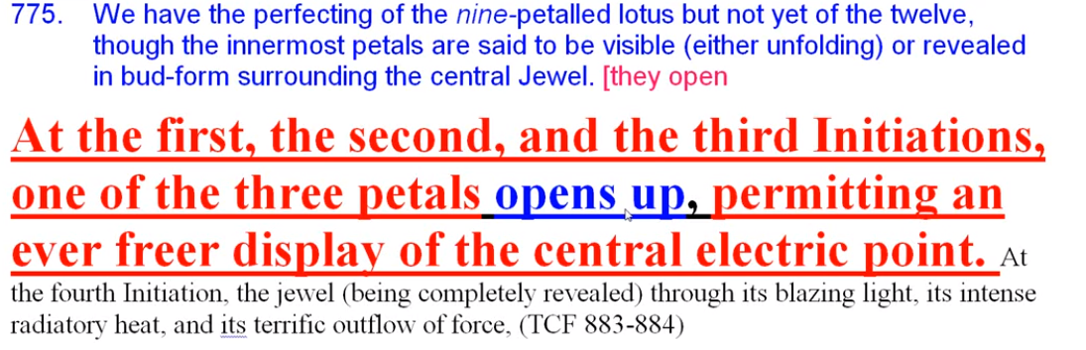

At the first, the second, and the third Initiations, one of the three petals opens up permitting an ever freer display of the central electric point. At the fourth initiation, the jewel (being completely revealed) through its blazing light, its intense radiatory heat, and its terrific outflow force. TCF 883-884

At the first, the second, and the third Initiations, one of the three innermost petals opens up permitting an ever freer display of the central electric point. Whether that may be a translucent display, let's just say. At the fourth initiation, the jewel (being completely revealed) through its blazing light, its intense radiatory heat, and its terrific outflow force. The display at the first, second, and third initiation may be a tranclucent display and not necessarily the revelation of the jewel itself.

You can see how these references require very careful reading. They may seem to be a little contradictory, so that's where we are. … It has been suggested that at the first three initiations one of the petals of the inner three is opened as follows:

At the first, the second, and the third initiations, one of the three petals opens up, permitting an ever freer display of the central electric point. At the fourth initiation, the jewel (being completely revealed) through its blazing light, its intense radiatory head, and its terrific outflow of force, produces the distintegration of the surrounding form, the shattering of the causal body, the destruction of the Temple of Solomon, and the dissolution of the lotus flower. TCF 883

At the first, the second, and the third initiations, one of the three petals opens up, permitting an ever freer display of the central electric point. and not just of the … glowing threefold flower, but perhaps this display is a translucent display. At the fourth initiation, the jewel (being completely revealed) the bursting open of the flower involves all these things and contributes to the shattering of the causal body … and the dissolution of the lotus flower.

These two thoughts seems contradictory, I'm glad I noticed that a few years ago. In one the first synthesis petal opens with the first initiation that is somewhat displayed in the other the opening of the eighth and ninth petal reveal the glowing threefold flower. Then there is the thought that only at the third initiation is the central tier of petals revealed. So we have to contend with some apparently different indications.

01:38:20 There can be no doubt that ever freer displays suggest that the time of the first initiation the innermost petals are progressive revealed, otherwise there would be no display, there would be no visibility. But I'm presuming that there is a kind of translucent radiation of the jewel in the lotus and then a revelation of the jewel in the lotus with no synthesis petals in the way. … It's frustrating one wants to see this just as one would study any object of a nature and sometimes we may get tired of studying the so-called garment of God, but this is part of the garment of God, too, and I don't know many students who would be tired of studying this kind of form and learning all about it. One could become as captivated by it as scientists are by the more superficial forms.

Perhaps the seventh petal was somewhat opened at the first initiation, yes, but not sufficiently to reveal very much of the glowing threefold flower. Though some opening of that first synthesis petal had to occur, and some display had to occur, so indeed the indications are a little bit ambiguous and we have to wait to see for ourselves.

It would be wise to sound a note of warning here in connection with this question of egoic unfoldment. What has been said here has been but the formulation of a general plan of egoic unfoldment as interpreted in terms of consciousness or of fire. TCF 546
It would be wise to sound a note of warning here in connection with this question of egoic unfoldment. What has been said here has been but the formulation of a general plan of egoic unfoldment as interpreted in terms of consciousness or of fire. I'm glad that he's sounding this warning, because there's not enough for us to understand all the details. That which is a general plan may admit of many modifications in specific instances and He did really talk about the ray of the monad, not the ego, modifying.
In studying the subject with due personal application, the student should bear in mind the following facts:
First, that according to the ray of the monad, so will the petals unfold. TCF 546

In studying the subject with due personal application, the student should bear in mind the following facts:
First, that according to the ray of the monad, so will the petals unfold.

We do recall in previous text that the subray of the monad, that is the egoic ray, ray of the causal body, also had some influence on when the petals would open, and presumably any chakric triangle, the activation in time of the chakras in that triangle.

For instance and this is so important somehow if the rate of the monitor is the second rate the knowledge petal will be the first to open, but the second petal of love will almost parallel its development being, for that particular type of Ego the line of easiest unfoldment; the knowledge petal will be for it the most difficult to open. TCF 546

For instance and this is so important somehow if the Ray of the Monad is the second Ray, the knowledge petal will as per expectation, be the first to open, but the second petal of love will almost parallel its development being for that particular type of Ego. Alright look at that: here the monad is called the Ego, so it seems the easiest line of development because it's the second ray monad and he didn't tell us anything about the ray of the Ego. It's that type of Ego which is on the second ray so the monadic ray is most important, the monad is implied to be an Ego. But also that doesn't mean we're talking about an Ego with the second ray monad. It's another way look at it. It will be the line of easiest unfoldment; the knowledge petal will be for it the most difficult to open fully. There will be some opening of the knowledge petal, but full opening will be more difficult for … a second ray monad, then for the first ray monad, or the third ray Monad.

We have discussed this process in previous commentaries.

01:43:00 One wonders why the Tibetan switches from plural to singular—first discussing the opening of the petals and then only of the petal only. The knowledge petal. The knowledge petal will be the first to open and the second petal of love will be almost parallell.

Well what did I mean there? He seems to be talking of a couple of petals, but finally he focuses on one petal. First discussing the opening of the petals, previously I suppose, and then of one petal only. Maybe one petal in each tier always the knowledge petal will be the first to be opened in a tier, but for the second ray monad the second (Love) petal will almost parallel it, and the Knowledge petal will not fully open, and for the first ray monad and the very difficult Will petal will perhaps unfold more rapidly than for the other two types of monads.

Notice how he kind of interchanges the word monad and the word ego, and at times he seems to blend with the monad at times it seems to stand by itself. At times it seems to suggest the monad behind any type of ego. We talk about those egos that came in from the moon chain. Basically on the first, second, and third ray, … well they they can't really be egos because the individualization process requires that there only be fourth, fifth, sixth, and seventh ray souls and personalities. Unless for some reason the ones coming in from the moon chain could have a difference, but since so many of them coming in from moon chain were very, very undeveloped; they have not reached the point where the ego could be the first second and third ray unless moon chain specifics were different. So there's all kinds of technicalities here and I think we just have to view for best value the general process …

But still we talk about egos coming in and individualizing on the earth chain, and that second ray egos were in great preponderance: 75 percent; third ray, 25 percent. Well, if they individualized on the earth chain, you can't have a second ray soul, yet, because in the process of individualization it's got to be four, five, six, or seven. So one has to look for the contradictions and then one will see the layout of the process. So the ray of the monad it looks like.

01:46:10 In this commentary we have speculated on the relationship between the moment of the application of the rod to a petal—seven, eight, or nine—and the degree of unfoldment of the seventh, eighth or ninth petal when the rod is applied. Presuming that there is some unfoldment … due to the strenous and abnormal effort of the man before the rod of initiation is applied.

Now we see there is a complication, the ray of the monad will also influence the rapidity or lack thereof of a petals unfoldment, and this will thus influence the moment when the rod is to be applied. But that's good to know, because obviously all of this equation is taken into consideration by the initiator knowing the ray of the monad that is behind whatever type of ego it may be, ego in the normal sense, so sometimes it's earlier or later in the cycle depending upon the influence of the monad upon a particular petal to which the rod is to be applied, and the ray of the soul of the normal way we use Ego, is also concerned, the subray of the monad.

As to the first ray type, it's my presumption that the love petal is hardest open because they are lacking in love, and the will type the easiest, even if due to normal procedure, the petal of knowledge will be the first open because there is a resonance between one and three, so DK has told us how very difficult it is for the first Ray monad to be loving, so obviously the love petal for them is going to be very difficult to open. Even though it is next to the knowledge petals in the normal sequence.

Again we have to watch this happen. We know where the deficiencies of people can be found depending upon their type. Some people are just impractical, some people are too practical, some people cannot love, some people are too loving. Is it possible to be too loving? Well without wisdom there's always these areas these spaces of non-achievement and they oftentimes have to do with the individual's type and then they have to balance themselves.

Here's the statement that I was going to refer to; I'm glad I have it at this time.

The Monads of power have a much greater struggle, and hence the facts so often apparent that people on what we term the power ray, have so often a hard time, and are so frequently unlovable. They have to build in on all six planes the love aspect, which is not prominent in their development. TCF 578-579

The Monads of power have a much greater struggle, and hence the facts so often apparent that people on what we term the power ray, have so often a hard time and are so frequently unlovable. Does that mean they're unloving? They have to build in on all six planes the love aspect which is not prominent in their development.

All of us are responsible for rounding out our natures and our normal tendencies will indicate the unfoldment of certain petals at a faster rate than other types. But then we have to build in, we have to compensate, for our deficiencies. There is so much about being a rounded out, soul-infused personality, which has to do with what are our deficiencies? Now I don't want to predict the future here, but if I were to be born in another life I think I'd better have some pretty strong fifth ray and seventh ray to compensate for certain deficiencies which are so easy for my two, four, six, three-type. The ego sounds its note before incarnation, says, what's missing? So sometimes the personality ray is chosen. I want to shudder, I don't want a fifth ray personality, but maybe if it was to research the egoic lotus I wouldn't mind.

01:50:30

Second, that the effects of one circle of petals opening will be felt within the next circle at an early stage and will cause a vibratory response, hence the greater rapidity of the later stages of unfoldment as compared with the first. TCF 546

Second, that the effects of one circle of petals opening will be felt within the next circle at an early stage and will cause a vibratory response, hence the greater rapidity of the later stages of unfoldment as compared with the first. Well a lot greater rapidity, a lot greater rapidity. But say we have the 700, the 777 and the 7, and that's too small. A factor of ten is too small. We have a lot greater rapidity of the second tier over the first, and of the first over the second. The facts of the figures would be fascinating to know and when we learn all about the law of cycles, learning all knowledge on the third subplane of the atmic plane, this will be ours, when we can use it, I suppose, and have earned it and can use it constructively. …

It was a wild figure, but what if these sacrifice petals open 3,000 times faster than the outer tier? How I got that, taking the number of lives, arbitrarily the number of years, maybe not so arbitrarily, but the first tier is not even open in 21 million years for so many people. So how long would it take to really open that first tier and get to working in the love area and have all three petals open up together? Another million years or more? There must be some kind of incremental speed whereby each succeeding petal opens up a little faster than the one preceding it except of course for the monadic ray and how that influences it and the succeeding tier opens up faster than the one preceeding it and by a large factor.

An opening tier will stimulate the next tier and hasten the opening of that stimulated tier. We see that the opening of a tiers has an exponential quality, and each tier of petals opens faster than the previous tier and the rate of the opening of the succeeding tier is actually very much faster. Probably each succeeding petal opens faster than the previous—by what factor or multiplier? Does each succeeding petal open twice as fast, as the succeeding petal? I have no idea of the mathematics, I'll have to talk to my friend who is an excellent mathematician. But there are so many variables because we're going to get the ray of the monad in here, not only the ray of the monad but the ray of the causal body, and not only those two rays, but the ray of the subsidiary monadic focus, any one of seven.

When the Tibetan says something is too intricate for the human mind to fathom, and besides what can we do with it? We have to pay attention to what our next level unfoldment might be and it usually is in the area of controlling the astral body or having better human relations or learning somehow to be harmless, these are fundamental things and all of the rather divine mathematics involved with these measurements are beyond us, but just to know they exist is important.

01:54:45

Third, there may exist many cases of uneven or unequal unfoldment. Quite frequently people are found with perhaps two petals unfolded in the first circle one still in latency, while a petal within the central or second ring may be in full development. TCF 546

Third, there may exist many cases of uneven or unequal unfoldment. We mentioned before hence the danger of generalization when it comes to specific cases. He's just giving us the general degree of unfoldment. Quite frequently people are found with perhaps two petals unfolded in the first circle one still in latency, while a petal within the central or second ring may be in full development. Well how did that happen? Due to the special karma, maybe dharma and ray structure of the individual?

What comes to mind is the unfoldment of the first and second petal with the fifth petal unfolded. This type might be found upon the soft line rays and might tend to avoid mental development, because there's a lot of mental development in the third petal and even in the fourth petal, which has considerable third ray connected to it and is a knowledge petal.

This is the explanation frequently of the power in service along certain lines displayed by some, coupled with a comparatively low stage of development or of consciousness (egoically speaking). TCF 546-547

This is the explanation frequently of the power in service along certain lines displayed by some, coupled with a comparatively low stage of development or of consciousness (egoically speaking). How did such an ability arise in someone who otherwise is so undeveloped? We might ask ourselves the question, did such an ability arise in someone who is otherwise so undeveloped?

I think all the business of the adolescence of Mozart is exaggerated, but there's certainly some sort of extraordinary reception of the streams of music and connection to the deva kingdom, which maybe were not completely supported by a mature personality. The movie, Amadeus, makes that somewhat evident, and Roberto Assagioli talks about it in one of his books, I don't remember whether it's Psychosynthesis or The Act of Will, but he does say there's some contact with the divine mind here but the personality just is not fully formed.

So, high powers can be accessed by people who are not very well rounded out, we just can't assume it's one, two, three, four, and so forth. They are highly developed along one specific line of expression and have arrested development along more normal lines. One remembers that famous psychic, Peter Hurkos, was a house painter, and he fell off a ladder and his psychic faculties were opened. What happened? His normal personality was such as it was, and then these higher faculties suddenly appeared. They were certainly psychic faculties. Some time for rounding out would probably have to be provided later on. To perpetuate a lopsided development is ultimately dangerous to the integrity of the individual.

01:58:00 Just imagine a machine that is knocking as it's running and you put more and more juice into a new just falls apart so it's that way when people do not have a certain smoothness in the interelationship of their factors. A degree of harmony and sustaining of the structure, and when there is an imbalance that structure may crack up.

This is due to varying causes, such as the karma of the monad itself on its high plane and the strength of them and that a grip upon the ego; many lives given to a particular line of action resulting in the setting up of a strong vibration—one so strong that it renders the development of response to subsidiary vibrations difficult of attainment;
TCF 547

This is due to varying causes, such as the karma of the monad itself on its high plane and the strength of them and that a grip upon the ego; this is really interesting. I'm not sure how much we can make of it, but he proposes some rather occult causes for such developments.

It is important to note that monads do indeed have karma; they've been someplace before, right? Some people think that when they reach the high consciousness of the monad they will be beyond karma—not at all. The monad has had other venues of expression in some form or another before being this particular human monad, maybe was as an aggregate monad, but the reaches of what lies beyond the monad or when monads begin to aggregate and form a group being on a higher turn of the spiral – all that is beyond our study. But it is somewhat like a higher correspondence to group souls. Interesting, but we have to differentiate between what is interesting, and what is both interesting and useful. So again, This [uneven development] is due to varying causes, such as the karma of the Monad itself on its high plane and the strength of the monadic grip upon the ego. Well, right and there's also the strength of the egoic grip upon the personality, but we're talking now about what appears to be ego, and how the quality of the monad might come in there and influence development in a non-sequential manner.

Perhaps, many lives given to a particular line of action resulting in the setting up of a strong vibration—one so strong that it renders the development of response to subsidiary vibrations difficult of attainment;

Well, what about Mozart? What about the artist who takes many lives along the same personality ray, how there are those and he tells us this can happen, or the rising sign, for even nine lives is a possibility. Repetition of a certain quality we'll build that quality over much and slight for ignore the building of other qualities equally necessary. So we have to ask ourselves as we sound our own notes, where do we need the rounding out?

02:01:30 Excessive focus in a particular direction makes a more rounded out development difficult. Maybe sixth ray is involved somehow, a sort of tunneling focus upon only one thing. We all prefer to use a well-established function rather than go through the pain of cultivating an under-used function. This was noted by Carl Jung when he dealt with his intuitive-feeling-sensory-thinking types; there's always an inferior function and it's kind of difficult to develop that function that it's not easy to do. For example, there's a great fifth ray type and you put him out in a dance floor and he can't move; it’s clumsy and he doesn't really want to go through that. He could, but doesn't want to, because it's much easier to use that which is already well established.

It strikes one that the dark brothers have exactly this difficulty. They do not want to go through the pain of developing their vastly underused vibration of love. Because they're so good at intelligence, that's the problem. It's just it's kind of a laziness in a way, not wanting to humble yourself and go through the early walking stages. The early stages are painful in developing any function and they don't exactly give you an exalted position. So if lower ego is exalted by the use of a particular function, and then you have to compromise yourself and develop another function and you look quite helpless and not at all that imposing or impressive, some types don't want to do it. Response to subsidiary vibrations difficult of attainment.

Certain peculiar conditions hidden in the evolution of any particular Lord of a Ray, and the effect of that condition upon a particular group of cells; TCF 547

Certain peculiar conditions – these are really interesting things. Just think, is it so that Tibetan Buddhism in its inner recesses has this kind of information and access to these ancient libraries which are more current than Atlantean or even Lemurian? Information that the Tibetan is translating all of this for the Western language? It's amazing what he's bringing forth to us; he's been a Tibetan Buddhist monk of high rank of course. Is this the kind of thing that that kind of training will lead to?

Anyway many lives given to a particular line of action. That's a strong vibration, the karma of the monad … the strength of the monad ... What else?

Certain peculiar conditions hidden in the evolution of any particular Lord of a Ray, which is not necessarily a totally balanced being and the effect of that condition upon a particular group of cells; and Monads are cells.

The cause may lie within the Lord of a Ray Himself, and one might not expect the problem to exist in relation to the more abstract rays which are more inclusive. I don't know you know the the lower rays of attribute are more concrete especially the five, six, seven, and maybe more as on those rays are more cultivating along a particular line of exclusivity. But you know that's just a speculation

the group karma of a collection or congery of causal bodies, and their mutual interplay. Every ego a key unit or monadic center has a definite effect upon the group a community of Egos in which it may have a place and as the interaction proceeds results are sometimes produced of a temporary unexpected nature. TCF 547

02:05:30 the group karma of a collection or Condrey of causal bodies and their mutual interplay … it's amazing all these esoteric causes every ego a key unit or monadic center that's what an ego unity is has a definite effect upon the group a community of egos in which it may have a place and as the interaction proceeds results are sometimes produced of a temporary unexpected nature.

Okay, I did list them. It's my nature to go through a paragraph and then try to list in tabular form.

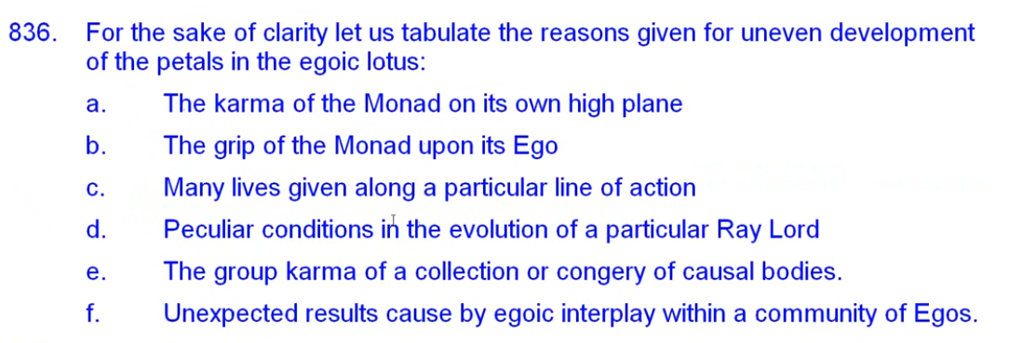

a. The karma of the monad itself on its high plane. This is all He's given for the uneven development, right? The karma of the monad on its own higher plane.

b. The Monadic grip upon the Ego. If you ever ask yourself, what kind of grip does my monad have upon my egoic nature? My egoic lotus?

c. Many lives given along particular line of action –

d. –because you are conditioned to the peculiar conditions in the evolution of a particular Ray Lord.

e. The group karma of a collection or congery of causal bodies. How would we find that out?

f. Unexpected results caused by the ego going to play within a community of Egos. At all of this you know leading to those strange cases those anomalies of uneven development

It is probably best to reserve judgment on many matters concerning the apparently uneven development of those we encounter. We know too little and it's always important to know how little we know. A little knowledge is a dangerous thing. All knowledge is a little knowledge, knowledge is a dangerous thing.

These points should be carefully borne in mind by the student of egoic evolution. TCF 547

These points should be carefully borne in mind by the student of egoic evolution. Are we that? That's funny, I was just going to ask myself that, and then I saw that I did ask myself that: Are we students of egoic evolution? Really an interesting area isn't it? That history of that psychological entity that we call the soul.

One can see what an incredibly fascinating subject. I haven't changed my view one iota since writing this some time ago, but I have corrected a number of things in what I have written. The whole subject is of interest and that is the next step ahead for the student of occult psychology. … There is quite a bit of Monadic Psychology here which has to be developed. One cannot simply talk of the Ego, our own Ego, without also talking of the Monad.

02:08:20 We are reminded that A Treatise on Cosmic Fire is essentially a psychology text. We can see how much clear knowledge of the developmental phases of egoic lotus would add to our understanding of many human beings who might be seeking our assistance.

Of course for that we would have to have it have egoic vision, egoic sensitivity and relate to people as Souls. Somehow look beyond, behind, and through the personality with spiritual discernment and detect what is this Egoic nature which is sponsoring this appearance called the personality? … It will be interesting and DK is always telling us to look at people as if they are souls, and not just relate to them as limited human beings. That would be so important and so rarely to be found, not easy.

Much will eventually be ascertained which will throw new light about the possibility of work upon the physical plane for man. TCF 547

Much will eventually be ascertained which will throw new light about the possibility of work upon the physical plane for man. This is a prophecy, and I guess when we really know who someone is and what it is they as a soul are trying to do, then what they do on the physical plane will take on an additional importance. We seem to be dealing here with an occult form of vocational guidance, finding the right mode of expression for the human being who is considered as a soul.

The whole secret of success in any endeavor or enterprise is primarily based on two things:
First, the ability of the Ego to work through the personality using it simply as a medium of expression. TCF 547

The whole secret of success in any endeavor or enterprise is primarily based on two things:
First, the ability of the Ego to work through the personality using it simply as a medium of expression. By this we mean the Solar Angel, Angel of the Presence, and man as the projection of the monad within the egoic lotus.

I sometimes think of Ego as a composite term – … the Solar Angel, the Angel of the Presence, and the consciousness of the soul as a monad in extension within the causal body/egoic lotus. I try to be inclusive here, they're all interpenetrating on those levels and the method of the solar angel to help the monad is by pervasion, a kind of infusion, a kind of offering its presence, and how those things are done? Well, we have to learn to experience.

So we recall the recently mentioned importance of the permanent atoms is the instrument through which the Ego can reach and influence the objective planes. Our is our ego really working through the personality and is our personality a medium of expression for the ego? Or is it a rather rebellious and veiling, obstructing unit? Rebellious unit of obstruction? How is that? Is our personality a rebellious unit of obstruction.

02:12:00

Second, the karma of the egoic group as it becomes more apparent on the physical plane. Hitherto, much has been said and taught about individual karma. Group karma in the future will slowly assume its rightful place in the thought of students and this will lead to a more intelligent cooperation to a more sympathetic understanding of group responsibilities and to more adequate solution of group problems. TCF 547

Second, the karma of the egoic group as it becomes more apparent on the physical plane. So the whole secret of success, what is the karma maybe the dharma too of ego, the group as it becomes more apparent on the physical plane.
Hitherto, much has been said and taught about individual karma. Group karma in the future will slowly assume its rightful place in the thought of students and this will lead to a more intelligent co-operation to a more sympathetic understanding of group responsibilities and to more adequate solution of group problems. Success. Knowing one's group, and what it has accomplished.

Perhaps we do not think as often as we should about the karma of the egoic group to which we belong. Not only the limitations of karma, but the advantages of karma, but the dharma as well, the dharma of the group purpose.

Our own individual success is of far less important than the success of our egoic group. Boy, let's think about that one. You know, a large second ray egoic group is present at this time. It's supposed to be in a way John the Baptist, a spiritual propagandist for the ageless wisdom. Is it working? Years of working?

So our own individual success is of far less importance than the success of our ego or group? Groups too can succeed or fail. The dynamics leading to group success or group failure often evade understanding. There's been some really good work done by as esotericist at the Dallas school of Ageless Wisdom, Gloria Crooke working with the whole group process, and the stages through which it passes [Fires of Group Work booklet]. This will change as we move into the group age the Aquarian Age, understanding will be ours.

Let us tabulate the results of a deeper understanding of group karma.
a. There will be a more intelligent cooperation
b. a more sympathetic understanding of group responsibilities
c. a more adequate solution of group problems. This is success.

Can the Ego work through the personality? And what is the nature of the group to which the ego belongs and what is its karma/dharma?

The study of occult psychology involves a true conception of the nature of the Ego, or the arousing of the Ego to full activity in manifestation; TCF 548

The study of occult psychology involves a true conception of the nature of the Ego, or the arousing of the Ego to full activity in manifestation; bringing through what is on the higher mental plane into full manifestation in the lower three worlds. How shall the Ego be studied? How shall the Ego be aroused to full activity in manifestation?

02:15:00 We are speaking of the rightful expression of the Ego upon the physical plane, so the Tibetan is offering us much concerning Esoteric Psychology in the two books titled by that name, and the energetic underpinnings of the study however are given here in A Treatise on Cosmic Fire.

Following are a number of avenues necessary to the study and understanding of true occult psychology. And that's not just the psychology of the fourth force, which says yes there is a higher self, and yes it directs your life, and yes you have to get in touch with it—this is the study of the energies involved in occult psychology.

so some of the laws of Egoic unfoldment have been presented to us in the seven laws of the soul, also in the rules for inducing soul control found in Esoteric Psychology, Volume Two. They will be of value, you know, what is it? The factor of synthesis, the quality of the hidden vision, the urge to formulate a plan, the creative life, all that. It that doesn't make any difference what your ray may be, it applies to all the different souls, methods of inducing soul control.

We note that there is specificity of the proposed methods, petal by petal, each will have its own curriculum and close attention will be paid to the necessary process through which people are passing, and the highly trained clairvoyants will be sure of that and report, and maybe even draw or somehow render what they see, so that the person progressing in the understanding of occult psychology will really see precisely what has to be done. So we're only in the earliest stages of setting up such a program of achievement.

Further, this understanding of occult psychology:

It will bring about an eventual apprehension of the true meaning of force, and of energy in its dual aspect—internal vibration and external radiation; it will produce the centering of the attention of all advanced students upon the centers—in this case not the physical centers on etheric levels but the psychical centres, such as the Ego in the causal body and egoic groups. TCF 548

It will bring about an eventual apprehension of the true meaning of force, and of energy in its dual aspect—internal vibration and external radiation; force and dual energy and so we are we moving into a study of psychology as a science of subtle energy. Already in the study of the more subtle forms of psychology this distinction is meaningful: is that which I am experiencing coming from within me? Or from without? Or is that within me radiating into the environment as it should, with integrity? Or is it blocked in some manner by congeries of forces variously configured? The question seems easy, but the discernment is often lacking. Are we in fact the radiant soul or are we not getting through what we mistakenly think is ourselves?

It will produce the centering of the attention of all advanced students upon the centers—in this case not the physical centers on etheric levels but the psychical centres, such as the Ego in the causal body and egoic groups.

This is very interesting; it's not so much that we have to focus on the centers as they are operating within the dense physical body, the lower eighteen subplanes of the planetary logos, but the petals are also centers. Let us remember the petals are also sources of energy and can be considered as centers.

02:19:00 The instructions are clear, we are to center our attention not so much within the few extent as is within the centers which are a fear of God They may be in a sense for planetary logos or solar logos. You wonder with the higher mental plane for our planetary logos is a kind of etheric focus. I've often wondered that, but for our solar logos you definitely have to be on the buddhic plane, and there are egoic groups there on the buddhic plane and within ashrams and so forth and we have to center our attention there and bring through what is there transpiring. Transparently, eventually. If we achieve ashramic focus, the correct activation of our etheric, astral and mental centers will occur correctly, so we need not focus within the dense mechanism. That is still the dense mechanism compared to the subjective mechanism which is occurring first on the higher mental plane and then on the buddhic plane.

This will produce later a better comprehension of the effect of one consciousness upon another consciousness on the physical plane and this knowledge will be scientifically utilized to produce specific results in group evolution and thus some of the world problems will find solutions. TCF 548

This will produce later a better comprehension of the effect of one consciousness upon another consciousness on the physical plane and this knowledge will be scientifically utilized to produce specific results in group evolution and thus some of the world problems will find solutions. We're really into the future realm of prophecy here.

How does one consciousness affect another? What type of consciousness could best be brought into relation with another type to produce the best results? Kind of an inner psychological alchemy. We are dealing with a form of psychic chemistry, which presently is little understood in any factual way, though people may have feelings about how to handle such influences. I think it would be good to bring X together with Y, they would have a good effect upon each other. … DK often would have X write a letter to Y, saying, stay in touch, be a friend, you have something to give, you have something to receive – this is all part of the psychic chemistry.

Finally, the laws of fire will be studied and the nature of heat, of radiation, and of flame will be occultly investigated, and the action of one fire upon another fire, the result of radiation from one conscious sphere to another will be realised; the method of arousing consciousness or the different planes by action upon the fires of the causal body and their stimulation will be gradually revealed. TCF 548

Finally, the laws of fire will be studied and the nature of heat, of radiation, and of flame will be occultly investigated, and the action of one fire upon another fire, the result of radiation from one conscious sphere to another will be realised; the method of arousing consciousness on the different planes by action upon the fires of the causal body and their stimulation will be gradually revealed.

02:21:30 Prophecy showing the practicality of our study. The amazing kind of developments towards which we can look. I tend to tabulate so it cannot hurt going over the tabulation. This is a most occult promise, so let us tabulate:
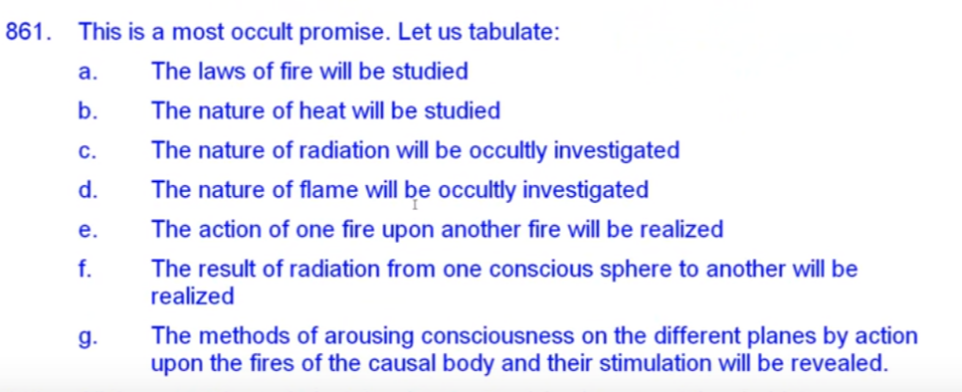

a. the laws of fire will be studied.
b. the nature of heat will be studied
c. the nature of radiation will be occult investigated
d. the nature of flame will be occult investigated
e. the action of one fire upon another fire will be realized
f. the result of radiation from one conscious sphere to another will be realized
g. the methods that were arousing consciousness on different planes by actions upon the fires of the causal body and the stimulation will be revealed.

Within this we could almost do now, haltingly, through the imagination, knowing how the egoic lotus is composed. One can imagine one's egoic lotus and working out of the vortices, different vortices which have different powers and different rays in planets coming through them. they are like centers and at some place we are told that the petals of the causal body do indeed control the chakras below; they do indeed control the man.

All of these are technical developments of the future and they hold for humanity presently incredible possibilities. Presently incredible but certainly catalyzing, certainly marvelous to contemplate.

The whole question is slowly, very slowly, coming to the fore in human thought (even though this is little realized) through the study of vocational education, business efficiency, and the place of the human unit in any trade or enterprises. Men are being spoken of and considered in terms of potential force factors and this is a step in the right direction. TCF 548

The whole question is slowly, very slowly, coming to the fore in human thought (even though this is little realized) through the study of vocational education, business efficiency, —the round peg in the square hole, or the square peg in the round hole? Is that the right person for the job? – and the place of the human unit in any trade or enterprises. All these interests tests, some of the ray-analysis tests we have created. Who are you? Where do you fit? What can you do? Men are being spoken of and considered in terms of potential force factors and this is a step in the right direction.

What kind of energy do we need to fulfill this job and then we get a divine kind of configuration which is harmonious to the right division of labor based upon inner occult structure.

02:24:10 Even today, occult psychology is making its appearance in rather mundane settings and people are being understood in terms of energy and force, and this is the correct approach. We can feel the hand of the Manu in this, seeking that individual human units (and group units) will find themselves. This is the way I've heard it, that doing the right thing (for which they are ideally suited), ideally suited in the right place and at the right time, that … it’s the job of the Manu to make sure the people are in the right place, doing the right thing for them, for which they are, in the right place and at the right time.

Approaching the same question from the personality standpoint and not egoic, the time is fast approaching when the emphasis will be laid in education upon how best the young can be taught to contact their own ego or higher energy; how best they can be led to appropriate the knowledge and ability of their higher self for use on the physical plane; how best they can ascertain their group formation, and thus work along with their group, and in unison with the total energy of the group what's my group what's my placement in my group; how best their threefold lower self—physical, astral, mental—can be brought into direct alignment with their higher centre force and thus draw down a continuous supply of energy for the strengthening of the three vehicles and their wise manipulation; how best the various spirillae – can be awakened and the energy within their own cells released for action. TCF 548

Approaching the same question from the personality standpoint and not egoic, the time is fast approaching when the emphasis will be laid in education upon how best the young can be taught to contact their own ego or higher energy; We see this in AA [Alcoholics Anonymous] and so many people resist this moment of silence, because they think it's a religious thing, they fear dogma and all the rest, but something might come through of the higher energy in silence the research on silence should be promoted and it should be dereligionated or put into psychological terms—

how best they can be led to appropriate the knowledge and ability of their higher self for use on the physical plane; this is education the antahkarana is involved, isn't it? Especially those people who are using the head, the ajna, and their throat centers.

how best they can ascertain their group formation, and thus work along with their group, and in unison with the total energy of the group what's my group what's my placement in my group; how best their threefold lower self—physical, astral, mental—can be brought into direct alignment with their higher centre force and thus draw down a continuous supply of energy for the strengthening of the three vehicles and their wise manipulation; how very practical, how best the various spirillae – a little more technical can be awakened and the energy within their own cells released for action. It's really the maximization of the human being. It's amazing. …

02:26:45 Here are promising possibilities, and some of them have already been developed are developing some of these unfolding possibilities are quite technical, but others have been the very substance of the modern human potential movement. Let us tabulate. Education of the future will emphasize:

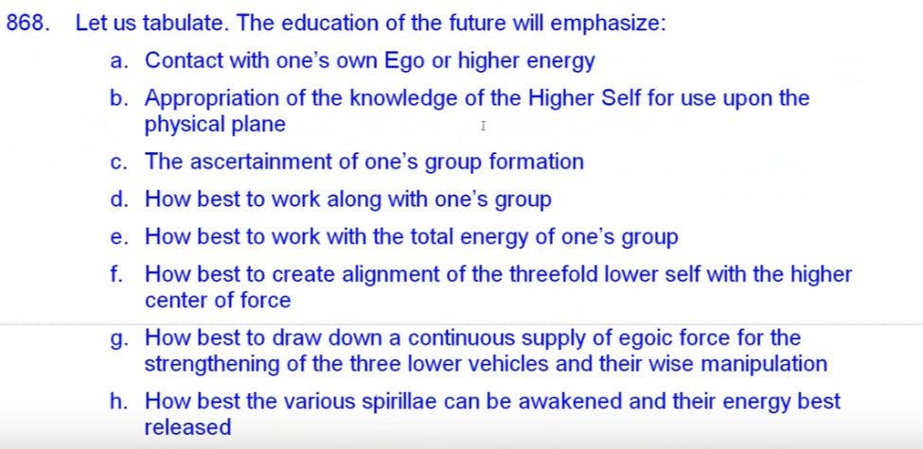

a. contact with one's own Ego or higher energy
b. appropriation of the knowledge of the Higher Self for use upon the physical plane. Meditate. I'll go into the quiet, I'll think about it, and see what's best to do. Right?
c. the ascertainment of one's group formation; to what groups do I already belong, and what am I doing in that group?
d. how best to work along with one's group
e. how best to work with the total energy of one's group
f. how best to create alignment of the threefold self with a higher center of force, because that higher center force can have a different effect upon each aspect of the threefold self
g. how best to draw down a continuous –the continuity of contact—with the egoic force, a continuous supply of egoic force, where the strengthening of the three lower vehicles in the wide manipulation and not just, the rhythmic streams of force when the ego's first trying to get the attention of the lower man, and the man ignores them? Or maybe recognizes one or two, no, we need that continuity of consciousness of the presence of the ego, and
h. how best the very spirillae can be awakened and their energy best released? That’s very tactical but it will come

There is an all-powerful force of energy within every one of us; it is the true source of our nourishment, strength and confidence. Those higher streams coming from the ego that are discussed in A Treatise on White Magic. It is imperative that we learn how it may be contacted and utilized in occult psychology lies one of the great hopes of humanity.

All this will be a thing of gradual evolution, but I have here outlined the trend of the future study, as in the formulation of possibility lies its eventual realization. Such a process must necessarily be slow. The powers of the ego are stupendous are stupendous and if released now through the agency of an unready personality would lead to dire disaster. TCF 548

All this will be a thing of gradual evolution, but I have here outlined the trend of the future study, as in the formulation of possibility lies its eventual realization. A great principle there. So we look into the future and we think of what may be and if that what maybe is in line with the plan, it will be so. Such a process must necessarily be slow. The powers of the ego are stupendous (the Solar Angel really or Angel of the Presence within the Egoic Lotus) are stupendous and if released now through the agency of an unready personality would lead to dire disaster. Well everybody says, Contact your soul be more in touch with your soul, but at the same time avoid overstimulation.

02:29:30 By this we may mean the powers of man himself upon the higher mental plane are stimulated by the powers of the solar angel; the Angel of the Presence stimulated by the Solar Angel, being in a sense the higher man himself, and those powers are tremendous. The powers of the Solar Angel already trained on Sirius is more than any human being could stand I'm sure, so it all has to be well modulated.

We could mean the powers the Solar Angel considered as the Ego. Well, I'm going through all the things we could mean.

We can see the need for personality preparation humanity must enter a great period of purification leading to the building a body is which can withstand the “powers of the ego.” This will be done under the incoming seventh ray energy. Better bodies, which will be better etheric bodies, and thus better physical bodies.

But the time will come, and in the meantime a due apprehension of inherent capacity will profit all who have the intuition to recognize the goal. TCF 548

But the time will come, and in the meantime a due apprehension of inherent capacity will profit all who have the intuition to recognize the goal. Of what is the man made? What is his stage of evolution? What are his powers? What are his deficiencies? Really study the human being for rounding out, systematically study, so we can come closer to a balanced presentation of what our egoic nature intends, and what's missing in the ego, too, in terms of the ego and what has to be built in.

There is tremendous optimism in the thought that within our very nature as we have that which will strengthen sustain and leave to undreamt achievements. In dark times we need constantly to remind ourselves of our inherent possibilities.

My friends I know I have blitzed through this. I wasn't sure to what extent it was really going to relate to our study of the egoic lotus, but it certainly does. I've spoken quickly, but everything is in front of your eye and I think you can follow what is being said, it's not all that difficult. The really heavy abstract thoughts are not here in this section it's a section about our human potential …

02:32:30 This is the end of the egoic lotus webinar commentary program 29, and it goes from TCF … all the way from 542 to 549 … and of an unknown duration. [Laughter] … Due to the fact that this was not properly recorded in the audio, but … we will be beginning with the egoic lotus program 30, and it will be TCF 820 to 825, something like that beginning with 820 and dealing with color. Okay, beginning with 820 and we'll see how far we go.

We've done a lot today … it's good to review these things together, it's like giving a class but very concentrated because often in the class you have to go slower and stop for questions here and there, you can be led off the track very much – I just rely upon myself to lead myself off the track – in this case I don't have class members leading me off the track. Well nothing leads off the track if it's a relevant question, so that will be it for the moment and we’ll start tomorrow with program 30.

… we'll see you soon, let's keep absorbing this and applying it the best we can. Bye.

