EGOIC LOTUS WEBINARS, VIDEO COMMENTARY – 27, Michael Robbins
Abstract.
Analysis of Petal 7. This webinar is about 3 hours, 17 minutes long and covers A Treatise on Cosmic Fire page 541.
According to the Tibetan’s Statement: "The Petal of Knowledge for the mental plane; its unfoldment marks the period wherein the man consciously utilizes all that he has gained or is gaining under the law for the definite benefit of humanity. Each of the groups of petals is distinguished by a predominant colouring; Knowledge, on the physical plane, with the colouring of the other two subsidiary; Love, on the astral plane, with the light of sacrifice weaker in tone than the other two, which practically show forth in equal brilliancy. On the mental plane, the light of sacrifice comes to its full display, and all that is seen is coloured by that light."
Content for EGLWC Program 27: close attention is paid to the astrological, rayological and chakric implications related to the organization and unfoldment of Petal 7. This is in preparation for wider correlations to be attempted in relation to all petals after what DK has said about them specifically is analyzed. An important question is herein discussed: “When is the Rod of Initiation applied to the seventh petal (and the eighth and ninth) for that matter. Is it on the point of petal organization? Is it after the petal has been somewhat unfolded through the strenuous and abnormal effort of the candidate? Or is it upon the completion of the unfoldment of the petal? Much reasoning in relation to important references is undertaken in this program.
Egoic Lotus Webinar Commentaries 27 689 MB .wmv file
Video of Egoic Lotus Webinar Commentaries 27 by Michael D. Robbins.
Egoic Lotus Webinar Commentaries 27 189 MB .mp3 file
Audio of Egoic Lotus Webinar Commentaries 27 by Michael D. Robbins.

Transcript
Well good morning everybody.
This is the 27th program and we seem to be making our way finally into the sacrifice petals of the egoic lotus petals, number seven, eight, and nine. Whether eventually they revolve in a clockwise direction or a counter-clockwise direction remains to be seen. There are some references that seem to suggest that they will revolve in exactly the same way as the earlier two tiers of petals, the first and second.
But the way this diagram is drawn with the knowledge petal touching the third subplane of the higher mental plane, the love petal the second, and the sacrifice petal the third, it it seems that the rotation could be considered in the counter-clockwise direction which is the natural order of the zodiac, but this of course might simply be due to the constraints of how the petals can be drawn. So we have read that at some point all the three tiers of nine petals are rotating in one direction and the synthesis petals in the opposite direction.
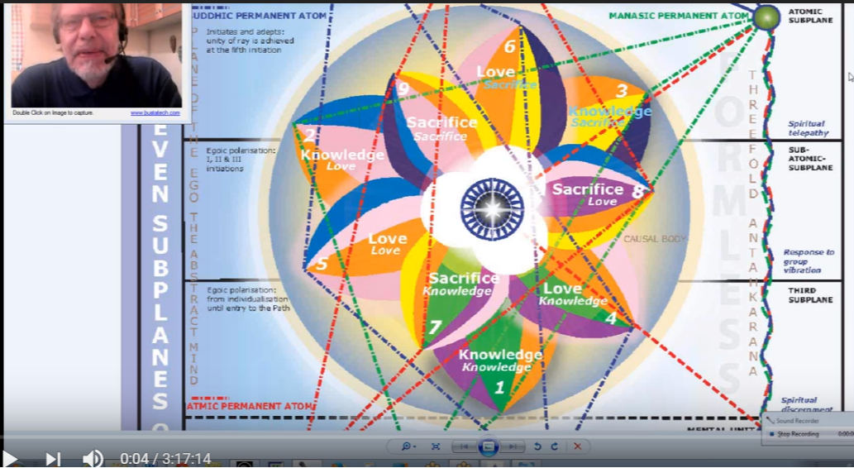
Let us proceed then with the third tier of petals, the sacrifice tier.
I'd like to simply read what is here on A Treatise on Cosmic Fire, page 541,
1. The petal of knowledge for the mental plane.
Its unfoldment marks the period wherein the man consciously utilizes all that he has gained or is gaining under the law for the definite benefit humanity. Each of the groups of petals is distinguished by a predominant coloring: knowledge on the physical plane with the coloring of the other two subsidiary, love on the astral plane with the light of sacrifice weaker in tone, than the other two, which practically show forth in equal brilliancy on the mental plane. The light of sacrifice comes to full display and all that is seen is colored by that light. Treatise on Cosmic Fire, page 541
The petal of knowledge for the mental plane. Its unfoldment marks the period where in the man consciously utilizes all that he has gained or is gaining under the law for the definite benefit humanity. It sounds somewhat like emptying the bowl, this case of its knowledge content. There is other content in the bowl or the chalice. Each of the groups of petals is distinguished by a predominant coloring: knowledge on the physical plane with the coloring of the other two subsidiary, love on the astral plane with the light of sacrifice weaker in tone, than the other two, which practically show forth in equal brilliancy on the mental plane. The light of sacrifice comes to full display and all that is seen is colored by that light.
Well the light of sacrifice in this case seems to be the yellow light, it is the buddhic impulse connected with the fourth ray. We realize from studying the laws of the soul that the law of sacrifice is actually ruled by the fourth ray. So love is the coloring of the astral plane with the light of sacrifice weaker in tone. There is of course a yellow that does appear in the love petals, in the sixth of the love petals, but it is not as strong nor would it be as strong in the third petal, as will be the yellow of sacrifice within the sacrifice petals themselves.
4:10 So let us begin. We will take it part by part, as we have been doing, I think that's the best way for us to carefully analyze. Of course much will be left out, but then you can supply what you find to be missing, or if you find that certain correlations are erroneous then you can correct them. We’re all working in groups form here and each person is bringing what he can to the pool of knowledge, and others bring what they can, and then finally the clear and corrected presentation stands forth as the result of a group effort.
It must be increasingly obvious that the evolutionary unfoldment of the human being is greatly illuminated by a close study of the egoic lotus. How would we know the phases and their inner qualitative results. They look like phenomenal results, and they are in a sense as all is taking place within the dense physical body of the solar logos, but they are also qualitative results and they have to do with empowerments within the egoic lotus which provides the energy drive which chakras normally would.
Later, with the disappearance of the egoic lotus, one can presume that there will be whorls of energy or chakras formed on the subplanes where the egoic lotus used to express. These may only be useful for expression through a mayavirupa, but perhaps not. At the fourth degree if the egoic lotus disappears and the man is still alive and moving towards the fifth initiation in the same vehicle, then those chakras will necessarily appear where the egoic lotus once held sway.
So the evolutionary unfoldment is illuminated by this study, by its energy, and force associations and by its unfoldment. … The unfolding – remember that term unfoldment is a general term – and it involves organization, vitalization, unfoldment/opening, which are pretty much the same, and then complete or full unfoldment. Sometimes when DK says something is open and he doesn't use completely open we understand that there is still some way to travel, some way to go.
The unfolding subjective flower reveals to the astute eye of the high initiate the exact condition of the evolving human individual. If we can understand with a degree of detachment from our own solar plexus and psychological reactions exactly where we stand on the ladder of evolution, we can do something constructive about improving our position. That’s exactly what the Master seeks to do for us, if he takes us in charge, as he did some of those students who were working at the times of Alice Bailey when the Tiebtan was forming these outer groups affiliated with his ashram.
We are now entering a study of those petals which have specifically to do with the process of initiation. Not just by reflex, the way the fifth of the sixth petals, I believe, open by reflex, but through the application of the rod of initiation. We're dealing with the first through third initiation and sometimes it seemed that the third initiation was called the final initiation. I would say at least of the series which concerned the nine petals.
If the knowledge tier can be considered the Lemurian petals, and the love tier the Atlantean, then the sacrifice petals can be correlated to the Aryan stage of development. I would say this is really the Aryan stage. It’s not a hard and fast division, but it's reasonably indicative. I can correct it somewhat and say that the first petal is really Lemurian, the second petal is Atlantean, the third petal is early Aryan, the second tier is increasingly Aryan, and the high ideal for the Aryan root race. Aryan root race is held forth in the developments of the third tier.
It is also true that we can loosely connect each tier with one of the three root races, but there’s a lot of development that goes on in the second tier which can be correlated with the stage of development of our Aryan race thus far. But let's say, the stage of development of the Aryan race, in the future, can be correlated with the development or unfoldment of the sacrifice tier. Of course this will continue into the sixth root race which will be an intuitive root race for the cream of the race, the vanguard of the race, but at the same time will offer initiation possibilities for the advancing people that are still within the Aryan consciousness.
13:10 The knowledge tier is associated with the physical-etheric plane; loosely, the tier with the astral plane and the sacrifice tier with a mental plane. But of course even before third or knowledge petal of the knowledge tier can be associated with the mental plane and mental achievements within the hall of ignorance and in terms of real altruistic love, it is only by the time we reach the sixth petal that a real effort is being made to care in a loving manner about others. It is an effort. The sacrificed tier requires soul infusion of the mind … increasingly held steady in the light.
So it has to be said that people such as ourselves who are studying the blue books and working with sincerity, as aspirants, probationary disciples, have already one foot in the sacrifice tier. This is especially so if we're hovering around the period of the first initiation and then of course onwards. There is not going to be a first initiation unless work is being done organizing and vitalizing the seventh petal. Then then at the appropriate moment measured by astrology and by the Masters and the Initiator’s assessment of the condition of the man, the first initiation will occur.
Astrology is very important in that, and Leo is an important sign, but so is Capricorn. I'll get into all of those signs of initiation. I think I've done it many times in many places so much so that it’s lost on this computer.
Anyway, the great initiations which we commonly study are called the monadic initiations and they are the initiations of manas, or of man, so the great initiations involve the mental plane. In fact, the higher mental plane, and occur within the causal body. They also require mental focus, we can't call it mental polarization yet because that only occurs between the second and third initiation, which means work is being done in the third petal. You understand the convention when I say work is being done in a petal, I mean within the three worlds, the type of experiences and processes to be correlated with the unfolding of that petal.
So we will first offer general impressions before becoming specific in terms of astrological and rayological chakric factors. I can see I probably have some corrections to make [in the commentaries written] … let’s just say qualities. It looks to me as if my approach now is just a little different than when I formulated some of this material. I am using the three-petalled approach of the past, present, and future—the idea is working simultaneously is that the individual is working in different ways simultaneously in three petals. Now that's not hard and fast. But it seems to me that once the evolutionary process really gets going and perhaps after we get out of the first petal there's always work being done ahead.
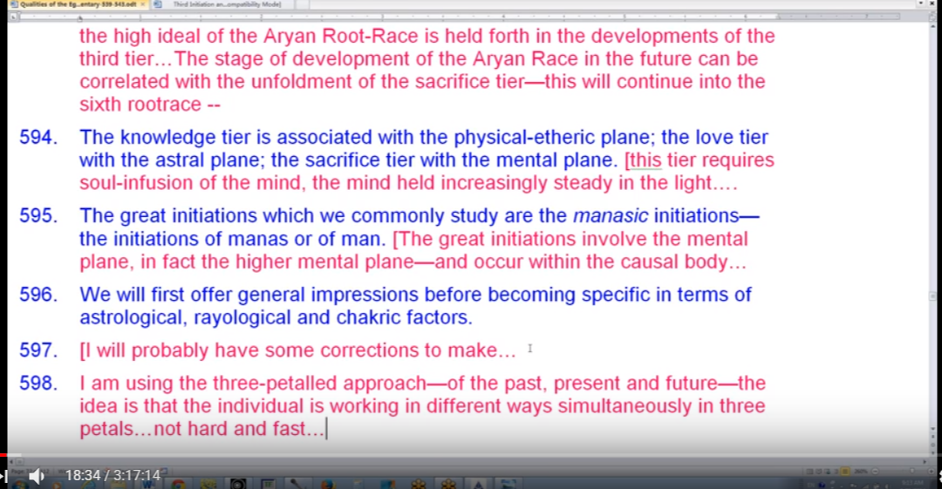
It's particularly important when initiation comes into the picture, because the reflex results of the initiatory application of the rod is working out in the second tier of petals. That's the reflex; when work is being done in the seventh petal and the rod of initiation is applied at the right and just moment, then there is a reflex action in the fifth petal. When the work is being done in the eighth petal and the rod is applied, there's going to be a reflex action in the sixth petal, and of course some further reflex action in the seventh when the eighth is the avante garde and some further reflex action in the sixth, when the seventh is the foremost petal.
It's an interrelated process and I'm going to try to correct anything that I've said that would make it seem that we're simply perceiving one petal at a time.
The idea of sequence is of course correct, but there is an overlappingness which cannot be ignored. As we all know when we look at our life, we are involved in different kinds of activities which have a different spiritual strata, distinctive spiritual stratum. We sometimes are involved in very high activities, sometimes middling, and sometimes a little more customary for us, and they will relate to different types of petal experiences.
I think really the only way is one day to be able to look at not only your own series of lives, but the series of lives of others in an objective manner, and I'm sure the Master does this. The solar angel of course has this view. We are told that the solar angel is able to include within its purview a fair number of lives before the present one, or see lives in the future. The Master does this to a certain degree. There's no sense for either one of these great Beings to go back into Lemurian times and Atlantean times and see what it all looked like at that point, because so much has been worked out and so much has come to a kind of resolution. Maybe in a specific research project looking for the origin of a particular difficulty that might be possible.
21:45 But in examining let's say five lives before and several lives ahead, one can really see what the trend should be and what will be important in the development of this particular life. So thus through the right advice the Master can save the chela a great deal of time by helping to orient the chela towards what is truly important and these age old will have its own methods which we cannot presume to know, to help direct and guide.
Since this is the petal of knowledge for the mental plane. Since it is knowledge and the mental plane, it's pretty obvious that the third and fifth rays will be important here, whatever may be the ray of the soul. Of course according to the ray of the soul a different petal processes will be emphasized and their speed will be differential, because one can proceed faster along one's own mind, or let's say within the experiences of a petal attuned to one's own mind. Yet everybody does have the third and fifth rays regardless of the soul ray.
From another perspective there is a numerical ray progression which should be observed as we move from petal to petal. Since this is the seventh petal, we will have to explore the meaning of the seventh ray. In relation to it.
There is no eighth ray except in the minds of a few fairly deluded people. And no ninth ray even though there is an eighth and ninth path out of the solar system. But I guess people who are convinced of the twelve rays or the eighth and ninth ray and all the rest are not so close to taking the path out of the solar system.
This applies to all the foregoing petals as well, beginning with the first ray, second ray, and so forth. In relation to which the first ray, for the first petal, however primitive its expression must be important and this is the factor of survival.
Just the way the beginning of some kind of love is found in the second petal, and mentality according to the third ray is found in the third petal, and the fourth petal has something to do with the initial struggle between the pairs of opposites, and the fifth, with a keen discrimination, the fifth kingdom comes in and the solar angel from a fifth creative hierarchy comes in as a keen discrimination of what belongs to either of those pairs of opposites and the light grows according to the fifth ray, the most luminous of all the Ray Lords, then the sixth petal with a mystical sixth ray operating and the striving towards the Christ center and the longing for the fifth kingdom. Then the seventh petal, where some sort of return flow towards the World of Heaven coming to Earth that the Heaven of accumulated knowledge coming to ground itself in the lower three worlds. Because the man is already becoming or is an initiate of the first degree and then has to begin to return what has been accumulated since service is the keynote of all the initiatory processes.
25:45 So it's unfolding, and marks the period where in the man consciously utilizes all that he has gained or is gaining under law. There's the seventh ray again, and the first, since it is the first petal of the sacrifice tier for the definite benefit of humanity. So the keynote is service. The seventh ray planet is Uranus, Aquarius the sign of service, there are many connections that we can make but if you feel that the storehouse is relatively full. Maybe 99 percent of the incarnations have been lived through, maybe 99.9 percent.
The storehouse is relatively full, and from its content gifts are made to the world, part of emptying the bowl. I remember that phrase because it made a big impression on me. In 1985, when I was working with the astrologer Charles Jayne; he was a really fine technical astrologer and one of the pioneers in the astrological field, and I would go to his house every Sunday morning and we would talk about all kinds of things and then one day he looked at me and he got said, “Oh I feel the shivers; I feel as if there's an emptying of the bowl.” Well, I only knew him one year, because he died on December 31st, 1985. I think I came to his house for the first time around January 1st or right thereafter, the New Year, or the early part of January in 1985. So he had a premonition that he was passing on what he knew and indeed he did to me, and through me to others who more fully developed some of his material more fully than I could have done. But he was in a sense emptying the bowl.
So whatever we have accumulated is not just ours it is always for the benefit of the others. There is this quotation in the Bible that says that the seed must fall into the ground and bear fruit, implying that if it doesn't it has no worth. So all of our knowledge and faculty is meant for the upliftment of the general whole, then whatever work we've done on it, and whatever new light we've been able to generate, it's all for others, who really are the self anyway; it's all for others and cannot be horded by the little emanation of the one.
So it’s unfoldment marks the period when the man consciously utilizes all that he has gained or is gaining under the law. And there's that word utilization – a word which is so much connected with the third ray or fifth ray. The factor of utilization with the implication of practicality. It suggests the third and seventh rays, and also the utilitarian processes of the fifth ray. The third ray expresses what has been called the process of the utilization of the many for the use of the one. That is an amazing thought and the one being of course service of the one, Gemini third sign and therefore connected by numerical resonance with the third ray. And the fifth ray, too, has a utilitarian approach. We must say the fifth ray has a utilitarian approach and the seventh ray is practical if anything.
I think I brought in from Letters on Occult Meditation, LOM 16,
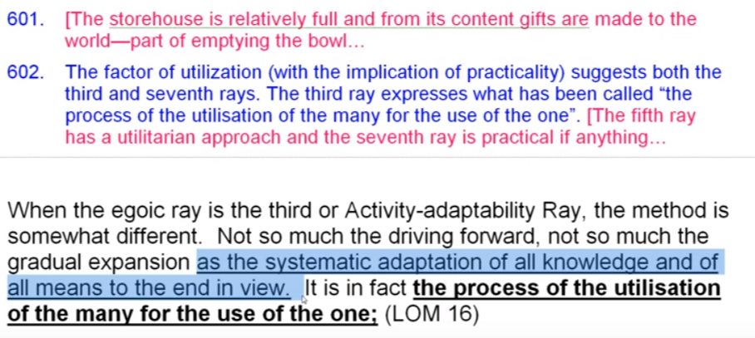
When the egoic ray is the third or activity-adaptability Ray, the method is somewhat different. Not so much the driving forward, not so much the gradual expansion as the systematic adaptation of all knowledge and of all means to the end in view. It is in fact the process of the utilization of the many for the use of the one.
When the egoic ray is the third of activity, adaptability ray, the method of destroying the egoic body, this is what this is all about, is somewhat different. Not so much the driving forward of the first, not so much the gradual expansion as the systematic adaptation – the gradual expansion of the second ray as the systematic adaptation – of all knowledge and of all means to the end in view. You can see that it has something to do with this third petal. So that utilization, we might substitute systematic adaptation of all knowledge and all means and methods to the end in view. It is in fact the process of the utilization of the many for the use of the one.
31:36 When we pass through third ray experiences on a high turn of the spiral, that will be our method. The thought of gain or acquisition is again related to the third ray. We find so many people there gathering things together. It’s is not the same as inclusion, which involves a kind of act of identification and seeing oneself the same as, but a gathering together of all that may be thought to be necessary and even more, and when it's too much more we call it greed.
Those egoic lotuses upon the third ray destroy the causal body through systematic acquisition of accumulation leading to an excessive fullness, I would say, which simply has to be used at last for the benefit of all. A real treasure house of knowledge. But any form can only stand so much accumulation and eventually it will break. There are different ways of breaking the causal body, all the way from the hammer stroke of the first ray to the incantations of the seventh.
So the orientation here is definitely towards service, and much intelligence is involved in expressing that service. We do remember by correlation that the law of service is the third law of the seven, so we find here at the very first that we are dealing with utilizing all that he has gained for the definite benefit of humanity. It's a definite service statement, and I guess it's real service. It's beginning to move towards the non-expectation of return, which is achieved in the eighth petal. At what point of the eighth petal, we don't know, but probably it's connected with the second initiation which I think will not indicate the complete, full unfoldment of that petal but a good deal of it. And that complete unfoldment I suppose will come when the entire tier is completely unfolded at the third degree.
34:20
Each of the groups of petals is distinguished by predominant coloring. Knowledge on the physical plane with the coloring with the coloring of the other two subsidiary. Love, on the astral plane, with the light of sacrifice weaker in tone than the other two, which practically show forth an equal brilliancy. TCF 541
Each of the groups of petals are distinguished by predominant coloring. Knowledge on the physical plane with the coloring – He says knowledge is a coloring I guess) with the coloring of the other two subsidiary. There's knowledge, love and sacrifice, I guess those are the colorings, in one sense. So knowledge, love and sacrifice are the coloring books in this sense. Knowledge on the physical plane with the other two subsidiary. Love is the coloring of the astral plane with the light of sacrifice weaker in tone than the other two which practically show forth an equal brilliancy.
In other words, knowledge has been preserved and is not diminished simply because we are working in the love tier. I think I understand it better now than I did when I first looked at it.
During the unfolding of the love tier, DK is telling us that knowledge and love show forth with equal brilliancy and only sacrifice is weaker. Well the yellow of sacrifice is in every one of the sacrifice petals. It's only in one of the love petals and it also exists even in the knowledge petals, in one of the petals. During the unfolding of the knowledge petals, knowledge is strongest, love and sacrifice are present. To a subsidiary extent they do show forth of course, because you can never have any process with any of the three not present in some small measure. It’s like saying try to live life without all three dimensions being present.
May we infer that when the sacrifice tier unfolds knowledge-love, love and sacrifice will demonstrate more or less equally? I think it is a reasonable inference based upon the fact this statement here that the other, to show forth in equal brilliancy, practically show forth in equal brilliancy for all practical purposes. I think this is what He means here for all practical purposes. Knowledge and love are called interestingly colorings; they are divine qualities which qualify the first and second tier and knowledge, love, and sacrifice are qualities of being which veil being, so the different qualities are colors and they are always considered to be veils.
On the mental plane, the light of sacrifice comes to its full display and this is conscious sacrifice and all is seen colored by that light. TCF 541
The related color of the light is yellow. Whether he talks about yellow in relation to the fruition of autumn, the harmonizing of all in autumn, it's a kind of a synthetic color. There's been some theories put forward concerning its relation to the previous solar system and the transmission of life from the previous solar system to the present. Sometimes yellow is connected with the third ray, as well as green, and why is this? When dealing with monads on the third ray DK uses the color yellow and not green. This is so interesting. Yet the previous solar system was the green solar system. I kind of wonder whether the third ray monads did not come in large part from the previous solar system, when yellow could have been a color of the third ray, but that's another matter for research and for direct observation.
In any case, DK talks about relations of human beings whose primary color is red, blue, or yellow and we will have to observe the interactions of such beings who, since its their primary color it is the color I suppose displayed upon the monadic plane. Not the essence of the monad which is pure being, but by the coloring of the monad. The additional quality which it carries in some manner. But the essence has no color. However, when there is expression through matter of different levels of density that color will appear. Exactly how remains to be seen.
It is interesting to consider the light of sacrifice. Just as we consider the light of knowledge and the light of love. What would we mean by that? We would mean that each of these—knowledge, love and sacrifice—gives a revelation. When we see, new things come to light when we love. Love reveals that which could not be seen when love did not exist. When we sacrifice maybe even more is revealed by the light of sacrifice, the light of knowledge, the light of love.
When thinking of the light of sacrifice the mind turns to Mercury expressing the fourth ray in its soul nature. The ray ruling the first law of the soul, the law of sacrifice. It's the star of conflict. I'm wondering if the Mercurian tendency to anchor itself on a high level and still distribute itself on a low level is not part of the revelation of sacrifice; to know that one is high and you have to work in a sphere that is much lower, must have an important revelation. … Light brings forth the emergence into consciousness of that which has been concealed so it's obvious that the light of knowledge brings forth still more knowledge. In that light we shall see light. We are told.
Love is also a great revealer. I guess one has to have the experience, but if one sees people in a certain light and then one begins to love the person, many more important things are revealed that were typically closed when there was not a sufficiency of love. Love sees very deeply, more deeply.
So as I was suggesting, carrying the idea further, sacrifice is the same and sacrifice has its own revealing light, and there are many important revelations which will only come to those who sacrifice. We're told later we will understand the necessity for the fourth initiation and the tremendous sacrifice of renunciation is required. Maybe not until that moment is upon us and we are engaged in it that we see the great necessity of it. Those who do the will of God shall know. So once were engaged in the process then we see. We can't say, “Oh show me and then I'll do it”. First I want to know then I’ll do. No. We actually have to do this, this is the amazing reversal we have to do what we know is right and then the light related to that doing breaks forth. So we might say then, “sacrifice and you will understand.” Just as we have said, “love and you will understand.” We have been told that those who do the will of God, those who sacrifice, shall know. The will of God is basically sacrifice, and giving the gift of the Spirit, Dane Rudhyar wrote the book the Gifts of the Spirit, talked about the great repositories of energy that exist in each one of the astrological signs and how they have to be given to the lesser lives.
43:40 So the light of sacrifice is, from one perspective, yellow and associated with both Mercury, yellow, and the fourth ray, yellow. The fourth ray rules the law of sacrifice. That we've been saying that as we go. The knowledge petal in the sacrifice tier then is the seventh petal following the usual method of assigning a petal to a sign of the zodiac and proceeding in the counter-clockwise manner, we have Libra, the seventh sign associated with the seventh petal. The beginning at Aries, working in the normal zodiacal order, counter-clockwise, we have Libra.
Libra is the hub of the wheel, it's called that in astrology and it signifies a synthetic process in which the gains of the first six signs are gathered together and to be used for the next signs that are forthcoming. Libra is divided and I'm remembering DK said there was once a time when there were eleven signs of the zodiac. But we have six before Libra, and Scopio, Sagittarius, Capricorn, Aquarius, Pisces, and it’s not exactly dividing the zodiac exactly in half, but if we gave half of Libra to one side of the zodiac, the earlier part and half of Libra to the other, it would be an exact division and maybe we could say something the same of Aries. Anyway if for practical purposes Libra is the hub of the wheel.
We note a very strong third ray emphasis in relation to this seventh petal because Libra is transmitter of the third ray. It's said to transmit only the third ray of active intelligence at this time, in this world period, so the correspondence does apply. We might consider Libra a sign promoting skillful manipulation; harmonious manipulation we might say. … It also has altruisic tendencies so the manipulation especially here is accomplished on behalf of those who are served skillfully, with skill in action. In the case of the seventh petal, a growing number of beings are served lots of skill in action because of the harmonizing abilities.
So from the counter-clockwise perspective beginning with Aries, we have … wow that's interesting we have again the Libra influence it looks like let me. Let me count and be sure … sure enough a double Libran influence, it is coming or going, it is a seventh petal is a Libran petal. Of course we could begin with Pisces as well. Working clockwise that's the only way to really work with Pisces. Go forth into matter and if Virgo shows up signifying that initiatory processes related to the first initiation and that purification must simply continue while one nears an aspirant to true initiation, which is that occurring at the third degree. From a certain point of view, all aspirants before the third degree.
Master DK works with aspirants to initiation. Initiation of the first, second, and even third degree, and the various self-denying disciplines of discipleship still being worked out there. Also I suppose discrimination in knowledge would be useful as related to knowledge, which has to be dispensed because we know how strong Mercury is in Virgo and here we are dealing with the sacrificial giving of all accumulated knowledge and capacity, skill for those who are in need of it. So once Virgo and Libra were considered to be one sign. Here they are in a sense working together in the same petal.
With regard to the three petals of the sacrifice tier we can apportion the seventh petal to the first initiation, the eighth to the second … and the ninth to the third initiation. It seems pretty clear from what has been said throughout the books that this is appropriate. Certainly there are definite statements that we just looked at about the opening of all nine petals at the third initiation. So there's much hidden complexity in this assignment, but in general it will serve to indicate a necessary truth. The later opening of the three sacrifice petals is definitely occurring on the path of initiation. A complete opening also of the fifth and sixth is occurring and there will not be a complete opening of all these three until the three sacrifice petals. At least this is my present assumption.
Until the third initiation there will not be a complete opening of the sacrifice petals until the third initiation and there is really complete and we saw that. Just a little while ago when we were working on petal six, I laboriously gathered some references and demonstrated that to be the case.
51:00 Is it worth going back and demonstrating that again? It just wasn't so far was it?
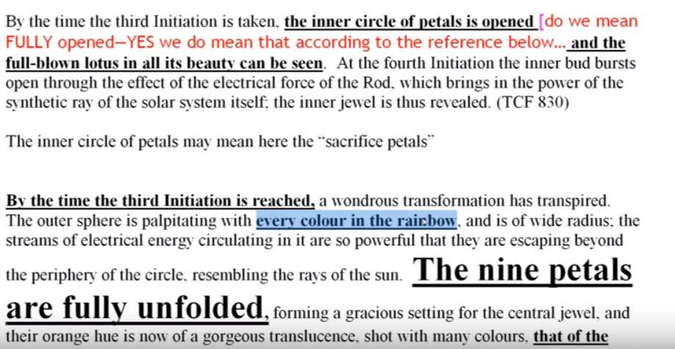
By the time of the third initiation is reached a wondrous transformation has transpired the outers tier is palpitating with every color in the rainbow, and it is of wide radius. The streams of electrical energy circulating in it are so powerful that they are escaping beyond the periphery of the circle resembling the rays of the sun. The nine petals are fully unfolded forming a gracious setting for the central jewel and the orange hue of the nine petals is now of a gorgeous translucence shot with many colors that of the egoic ray predominating. TCF 763
By the time of the third initiation is reached a wondrous transformation has transpired the outers tier is palpitating with every color in the rainbow, Red too? Doesn't seem to show in the petals but everywhere it says “with every color in the rainbow” and red is in the rainbow, and it is of wide radius. The streams of electrical energy circulating in it are so powerful that they are escaping beyond the periphery of the circle resembling the rays of the sun. The nine petals are fully unfolded forming a gracious setting for the central jewel and the orange hue of the nine petals is now of a gorgeous translucence because they can pass the light of the jewel through them, shot with many colors that of the egoic ray predominating.
Even if the egoic ray is the first ray, if its every color of the rainbow, then red will also be expected but the normal color of the petals is not that, but perhaps in this final stage of display red is somehow included and the triangle is simply adding and so forth and so forth. That's a really important reference and where does it come from … I think it will be on page 763 of A Treatise on Cosmic Fire. So I want to put that down as it's important to know where we are. … We come back to this point so, the mind is turned to Mercury. Light reveals, sacrifice … of those who know the will of God. Those who do the will of God shall know the yellow, the law, sacrifice and I think we were just at this point.
I think it's very important to think of the three sacrifice petals in terms of the three initiations which means that the Rod of Power first by the boddhisatva and then by a Lord of the World is applied to them, not applied to the petals of the love tier but applied to the petals of the sacrifice tier, causing reflex actions earlier. And never complete unfoldment I think until the Rod of Power, the flaming diamond wielded by the Lord of the World, is applied to the ninth petal then everything opens up and we have the kind of description we have just read on page 763.
54:50 So just as we assigned the Earth signs to the three petals of the knowledge tier, and water signs to the petals of the love tier, in classical astrology we could understand why that is so, so it is reasonable to assign the fire signs to the mental or sacrificial tier. Especially since the air signs really relate to God in the very first of the formulas in DINA II (Discipleship in the New Age) to Discipleship Two.
In astrological terms, Air is associated with mentality often in classical astrology and there is justification for this assignment but it is the fiery sacrifice we're talking about. The realm of air in occultism is more specifically associated with the faculty of the intuition, though Sagittarius is a fiery, intuitive sign and bordering by one method of counting, toward the nine, bordering on the Earth signs in that respect. The association of fire with mind is also explicit in occultism; we’re dealing with fiery sacrifice.
Shall we continue however with the listing the cardinal signs first, and mutable signs last, as we have in relation to the early of two tiers? This I've talked about as we've gone into discussion. There are qualities of areas which seem to fit the seventh petal process, indeed, because we're dealing with the mind, and Aries, I come forth from the plane of mind I rule. Mercury is an esoteric ruler of Aries and has to do with knowledge and the sacrifice of knowledge but the fit is not exact or complete. Aries is mental and synthetic but also extremely willful, and so how willful? Being the major sign of the first ray we see a reason to assign it also for the ninth petal, as I have described, and that has come to me much more vividly with this reexamination of the whole egoic lotus. I have just begun to see how much Aries is related to the third initiation and to the apprehension of Being.
This is a question. And I kind of want it both ways, I want to start with Aries and end with Aries. Start with Sagittarius and end with Sagittarius. Sagittarius might be of better fit as Sagittarius has a definite association with the higher mind and with a broad expanse of of the application of knowledge. But of course Aries is much associated with the head and with knowledge, the mind, the head, the brain, and all of that, so it's not exclusive. While Aries can be associated with the first initiation indeed it can because one as it were breaking into the kingdom of God. So definitely it's a whole new way of being. Sagittarius is also associated with the aspiration necessary for the first and second degree processes … here, intuition governing aspiration Sagittarius (EA 178). It’s so interesting because the intuitive revelation looming on ahead is what almost unconsciously governs aspiration towards what? Towards that very revelation, even though the aspiring one does not know. But yet there's some power coming from the intuition which orients the aspiration in increasingly better directions.
So, Soul consciousness in the early stages. Initiation one and two. (EA 178) associated with Sagittarius. Of course we can also associate it with even initiation number six, and outward bound on one of the paths of the way of a higher evolution as of course Sagittarius is the major distributor of the sixth ray. There are many other ways of using Sagittarius but here initiation number one and two. And with Aries, definite connection with initiation number three. Although of course with, as I say it is sort of a breaking into the kingdom of God and starting the new regime and reversing the wheel which leads that way it can be associated with the first initiation.
There's so many ways to achieve initiation of the various signs of the zodiac. Some of them are popularly frequently assigned to particular an initiation like Leo to initiation one, Scorpio initiation two and Capricorn to initiation three, but that's not the whole of it by any means that's not the full story. Scorpio connect with all the first three initiations. Capricorn with all the first five, and maybe beyond. Leo not only with the first but you can find a place for it in relation to the Heart of the Sun of the second, and to the soul luminosity of the third, and its defeat in the fourth, and so forth. One has to realize that there are many roads to initiation and that if one is due to take that initiation, different astrological factors can be used to see to that intended accomplishment.
1:01:35 It might be better to use the progression: mutable, fixed, cardinal. I'm going both ways: mutable, fixed, cardinal; Sagittarius, Leo, Aries. Then the sequence we have been using when looking at the two tiers which is cardinal. It's mutable from the perspective of the four elements. Utilization of Aries in relation to the ninth petal, and the third initiation seems to be correspondentially accurate. It's kind of an end it is a beginning at the third initiation involves a realization of pure being to which realization areas is definitely related.
So we will take a look at some very interesting statements from Esoteric Astrology and one which will demonstrate the correspondential accuracy of Aries with the third initiation.
1. The secret of Aries is the secret of beginnings. of cycles and of emerging opportunity. At the third initiation the initiate begins to understand the life of the spirit or the highest aspect; until that time, he has expressed first the life of form and then the life of the soul within that form. This experience is of so high a nature that only those who have passed through it could in any way comprehend anything I might say. (EA 387-388)
The secret of Aries is the secret of beginnings of course the beginning of the phase when one enters the first initiation, as well of cycles and of emerging opportunity. At the third initiation the initiate begins to understand the life of the spirit or the highest aspect until that time he has expressed first the life of form and then the life of the soul within that form. This experience is the experience of spirit, I presume, is of so high a nature that only those who have passed through it could in any way comprehend anything I might say.
Definitely the connection of Aries with the third initiation, where the monad comes into sight. So the assignment of Leo, of the fire sign through the central petal seems secure. But what should we do with Aries and Sagittarius? I say use them at each petal because they both have different meanings. They have meanings which are appropriate for each of those petals. …
Sagittarius is somehow very appropriate at the ninth petal. It leads towards the third initiation, but Aries really is the consummation of it. Of course Capricorn has its place there as well. It cannot be denied that the energies of Gemini and Aquarius can also be reasonably associated with the seven petals. They are about knowledge and the distribution of knowledge. For one thing Gemini is directly related to the secret of the first initiation to which the seventh petal processes, plus the rod of initiation admit.
1:05:00 Here it is said,
The secret of Gemini has to be grasped at the first initiation because it is the mystery of the relation of the father, mother and child. The birth of the Christ child upon the physical plane is the consummating glory of the Gemini force. EA 388
Who would have thought that? Always with Capricorn and Virgo we seem to understand something of the first initiation and Leo has its place as well being in the horoscope of a first degree initiate. But this is DK’s statement regarding Gemini. Of course it's about knowledge, it's a knowledge petal and Gemini itself is about knowledge. So we can find Gemini and Aquarius with the distribution and giving of knowledge most definitely. And if Sagittarius is found at that first petal, then Gemini is its opposite. They're just many ways to think about it, here Leo at the first initiation, and Aquarius is its opposite.
I've already introduced the idea that choosing the opposite sign is almost certainly finding another sign in relation to the process which one is considering. So since in general we are dealing with the process of initiation the sign of initiation Capricorn must be included, not only in relation to the first petal in the sacrifice tier but in relation to all three and indeed beyond, because five is the number of initiations connected with Capricorn and who knows? I mean does it go through the sixth and seventh? At least we have five which are in a certain sense Brahmic initiations. When we're dealing with seven initiations. The lower five have to be considered Brahmic and Capricorn related to Saturn. Well, both of them are Brahmic indicators.
From the planetary perspective the entire sacrifice tier is ruled by Mercury, or by Uranus, depending on whether we are considering rulership of the tiers in relation to the triangle: Mars, Venus, Mercury, which are lesser planetary entities. Or using the synthesizing triad: Saturn, Neptune, Uranus. We can certainly see the connection. Saturn, Mars closely related Neptune, Venus. Neptune the higher octave. Uranus Mercury, Uranus the higher octave of Mercury. So they do both fit there. Such an interpenetration and mixing of planetary rays is the truth of the matter and we with our rather clumsy and concrete mentality try to take a very rapidly mobile, scintillating situation of intermixture and freeze it in some concrete manner as if we were somehow in doing that grasping the truth.
Because the process of initiation is ruled in general by Venus, representing the Solar Angels and the Solar Angels are preparing us for initiation and have their role in each of the initiation ceremonies, Venus will naturally be important in relation to the seventh petal which indicates the first initiation. We can say that initiation is the overcoming of Mars by Venus. In a certain way. …
Then Jupiter rules the expansion of consciousness equated with entry into causal consciousness which initiation signifies. Because remember that initiation occurs within the causal body for the first three initiations. Jupiter, a second ray planet, will contribute to that considerable expansion of consciousness which the first initiation represents. And well, in general we are dealing with the soul nature here and it's progressive domination of the personality which, really is effective beginning with the first initiation. Jupiter also represents sight and vision, as the ruler of Sagittarius. With Jupiter one always sees more, it is so with Venus as well. So the sight within the chamber of initiation of the solar angel, Jupiter has a close connection with the sun; Jupiter is sometimes considered if one follows the hint as the orthodox ruler of Leo. Maybe in fact the sun and the moon, those luminaries, cannot be considered ever as real rulers of anything. With Leo it would be the sequence: Jupiter, Neptune, Uranus, with the sun as the central luminary and essentially a veil for planets, just the moon is a veil for Neptune, in relation to the sign Cancer.
So there's a wider perspective here and we can understand that if Sagittarius is the ruler of the seventh petal then Jupiter of course would be important. So higher mind is entering. It may even be the case where higher mind is associated with the fourth petal. We’ll see that when we start to study the colors and will try to resolve that strange thought. Except we're talking about the higher of the pairs of opposites, the soul, now when I talk about higher mind, here I'm a talking about triadal mind and Libra rules triadal mind. Libra in relation to the third ray. It rules the spiritual triad as a whole and Saturn with its third ray monad. So there's a real connection between Libra third ray, Saturn third ray and higher mind and third ray. Beyond the egoic lotus itself a part of the spiritual triad.
1:12:25 So many connections. If we associate the three synthesizing planets with the three sacrifice petals, then Saturn, the major ruler of Libra will be connected with the seventh petal. Remember we saw that there was a double Libra right, a double Libra starting with Aries clockwise or counterclockwise we get Libra for the seventh petal.
Saturn is also the third ray planet representing the use of gathered resources on behalf of the Divine Plan. A very practical planet. So Saturn here is at once a planet of gain or accumulation and definitely a planet of utilization. It’s a practical planet and the practical side of the third ray is also involved with Saturn, the intelligence in matter. Mercury as well. Mercury and Saturn have a close connection also. In the whole initiation process and for the study of discipleship earlier on in the fourth degree.
Since the first petal is the knowledge petal. In this first petal the knowledge petal in the sacrifice tier is a mental problem. The third ray will naturally be important. We can see how, if we really want to assign three synthesizing planets to each of the tiers, it will go Saturn, Neptune, Uranus, of course … it could also go the other way of course. But, Saturn, Neptune, Uranus is reasonable and Uranus is where you meet the One Initiator, I forgot to say that. The Aries part of it, for the ninth petal. You’re in Aries, the hierarchical ruler which applies at the third degree, is Uranus who is the initiator, the Hierophant.
It really fits in that respect. To begin with Sagittarius and end with Aries when dealing with the sacrifice tier. Especially since Aries is a great sign of sacrifice and is related to that saying the seed falls within the ground and brings forth fruit and the Lamb is slain from the foundations of the world. The sacrificial lamb. So sacrifice. Aries … fits with the apparent reversing process by which the sacrificed tier appears to be moving sequentially in a counter-clockwise direction compared to the knowledge and love tiers.
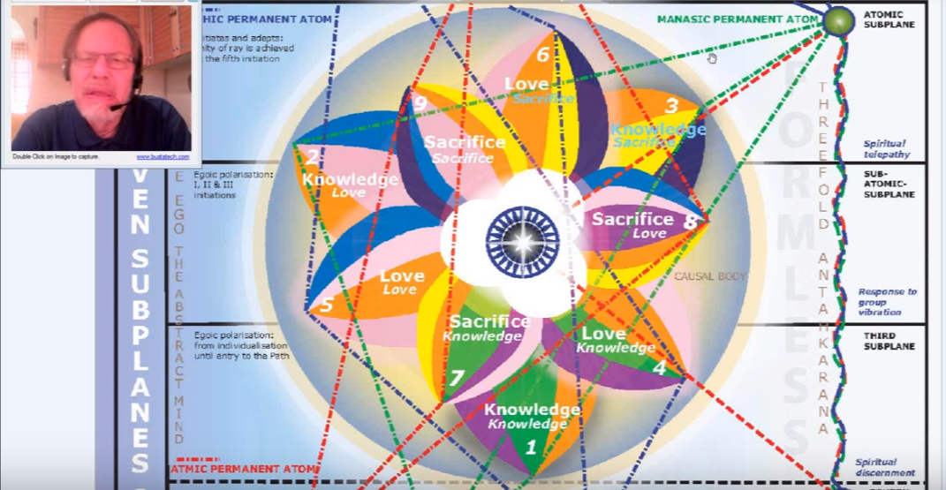
Well these are speculations and they seek confirmation. But there is some reasoning connected with it.
1:15:40 Okay so, Saturn is also a planet through which the first ray expresses, as in the triangle Leo, Saturn, Shamballa. This is that wonderful triangle: Leo, Pisces, Capricorn. Saturn, interestingly enough in this case, is associated with Leo, and Mercury with Capricorn, connecting to the third ray and humanity.
I’ve expanded upon this quite a bit when working in the Esoteric Astrology book, so we are dealing with the first initiation and the first ray of commencement is naturally important. There's Leo, as well, the sign particularly found in the horoscope of first degree initiates. But not exclusively, because it can apply to any degree, but when a person is detected as being around the area of the first degree, we could expect Leo … DK tells us it's taken in that sign or under that sign. I'm just amazed at the network of interior relations. I think I see more now than I saw when I was putting this together and thus the realisation of significant connections will only increase until all the things to be connected become as one.
1:17:17
A significant transformation begins with initiation. For all the initiations Uranus is important, but especially for the first and third initiations more than for the second. Uranus is expressive of the seventh ray, (prominent at the first degree, because the etheric body must at that time demonstrate considerable control over the physical elemental). EA 517
A significant transformation begins with initiation. Transformation that's Uranus’ part, of course. For all the initiations Uranus is important, but especially for the first and third initiations more than for the second; those on the hard line. Although Uranus does have that second ray association with the Pisces line which is very remarkable, considering its usual expression. So Uranus is the esoteric ruler of Libra, and we're talking about the first initiation, we're talking about the sacral center which Uranus rules? Right. Uranus expressive of the seventh ray, (prominent at the first degree, because the etheric body must at that time demonstrate considerable control over the physical elemental).
This is sort of a Uranus over Saturn thing, and Uranus is the rooler of the sacral center which must be transformed at the first initiation and lifted to the throat where the seventh ray of Uranus again prevails. So you can take a look there and confirm some of this. One of the pages to do so is Esoteric Astrology, page 517.
So we're looking at the planets and why they would be important at certain petals. Uranus is also a planet of increasing knowledge and of abstract knowledge. It has a lot to do with the cosmic ethers into which one is beginning to penetrate. Well the lowest part of the spiritual triad is not yet in the cosmic ethers; it’s on the highest sub level of the mental plane, but Uranus rules all the cosmic ethers and once you begin to work with the spiritual triad you're essentially working in the realm of something that is strongly influenced by the cosmic ethers.
Mercury in relation to the first sacrifice petal suggests knowledge accumulated to be shared, and it has a strong third ray complement to it. Third ray is important for this petal. We cannot stop at the rays that DK outwardly, blatantly gave us for these planets. We have to look for other and subtle references and there's no question that Mercury is connected with the third ray. There's a reference connecting it to the moon and the third ray, and well just reasoning reveals it: all the lore about Mercury and the difference between the Buddha and the Christ, and Mercury and Venus. That’s a strong parallel there. And the third ray and second ray are featured in this parallel.
1:20:12 Vulcan represents the increasing control of the personality by the soul and this begins in earnest at the first degree and hence during the seventh petal process. We have to say the physical disciplines are applied and there is mastery of the physical body to a requisite degree, and Vulcan applied before the first initiation is one of the planets to bring this about, along with Saturn and Pluto. Pluto gets rid of a lot of things which we don't need. There is so much ejection which is necessary for changing kingdoms. And Saturn the disciplinary and connected with the physical body. There's a lot of elimination and regularization and containment and restriction which has to go on before one can truly enter the fifth kingdom in the hall of wisdom. So Saturn is a great teacher here and will be operative
Why is all this important? Well you can more or less assess by the kind of experiences you are passing through, what petal is your cutting edge, where you're really working and not depending upon reflex unfoldment. Then you can look at your horoscope, then you can look at the kinds of ways that signs and planets and rays promote the process through which you must be passing, that particular petal process. Then looking at your horoscope you can have the hint as to how to use that horoscope, in a more direct manner to achieve correctly and efficiently in the petal process, upon which you are focused. That can be a whole branch of astrology that's so interesting: you're working on this. Here's what you've got, how is what you've got usually related to what you have to do? And how can you use what you have to actually work on what you have to do?
You may want to emphasize certain planets as you do that. If a person were working on the third petal process, emphasizing Uranus would be really important, because Uranus kind of resolves time and space and helps to end division and brings us into the realm of being if they had areas in their horoscope they could possibly use that to detect The One. If they were working in the second petal, and seeking the true nature of sacrifice, Scorpio and Pluto would be very important. Saturn again. We'll get to that.
But it's just a question of looking at your horoscope and detecting what is your equipment. What is your task? Then, how do I use my equipment precisely to fulfill this task? And remember of course you're probably working in three petals at the same time. It is kind of like a bell shaped curve. So I wonder how many people actually take the time or the thought to look at each planet and say, “Okay, my task is? How do I use this planet?” This is proactive astrology, not the astrology of what's going to happen to me? It's the strategy of, “These are the energies I have. What's the best way to use them?”
Anyway, from the ray perspective we've already spoken of the third ray and the seventh ray where we seek to … it's interesting that that thought energizes the etheric body. I've had the experience, I'm sure you have too, that certain types of high thoughts really have a kick to them and bring in a lot of energy to the etheric body. I can see how the highest and the lowest could meet here and that the seventh ray could be significant. The third ray of course. A strong ray of mind and involved with knowledge, and involved with the abstract mind which certainly is the abstract mind, is feeding the seventh petal. Just the way buddhi is feeding the eighth petal, and atma is feeding the ninth petal, even though Atma in a sense feeds all the sacrifice petals, buddhi all the love petals and higher mind all of the knowledge petals.
1:26:10 When you look at the diagram of the Masters, here … Chart XIII
[Transcript note: the image shown below is from the http://sevenray.net, store, Reference Posters. Created by Vicktorya Stone 1999; the version Michael refers to in his commentary notes and the video are from Keith Bailey. They should be in essence the same; this image is clearer than what you would be able to see in a video screenshot and so has therefore been substituted. VS 2018.]
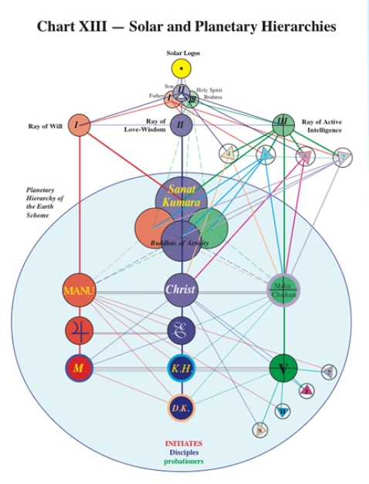
Yes I notice the different Masters are not just connected only to one another; there are all kinds of distinct lines of force coming to different Masters differentially. Look at all the lines that the Manu has, quite interesting and also Master M has many connections and there are some blue lines connected to the Christ, a European Master, and Master DK, Master KH of course, and strangely a red line connected to Master DK.
Why are some of these blue and why is this red? Of course when Keith Bailey was doing these he may have done this on purpose, because the original diagram has no colors and most of the colors are of course very straightforward. You can see red, green, and blue what the connection must be much more is connected to this entire line of the first ray adepts. But there's something interesting connected with DK and perhaps it's something about the first ray that DK has in his petal monadic nature.
* (see note above re the chart, but basically it is red, blue, green, for Rays One, Two, Three. VS)

Anyway many of interconnections are not always obvious and thus it is with all the petals, they're fed from different sources and not always obvious. So we have to understand this mesh, this network, and the more we understand it the complexity of real life will appear before us and we will not take the concrete mind and make these hard and fast immovable rigid categories, non-inclusive categories. So the process of initiation signifies that the second ray (generically the ray of the soul) is beginning to dominate the three of the personality, which is generically the third ray. So the second ray through Jupiter and Venus, which we've already related to this seventh petal, will be prominent at the petal and increasingly so as the causal body gains in scope and brilliance.
Oftentimes, I think that sacrifice is not just of the first ray, but is a combination of the first ray and the second ray, I find that to be the case, love and will together tends to be that which offers the sacrifice. Of course Libra has so much of the second ray in it, as well prominent Libra petal where buddhi has entered the causal body strongly, buddhi is beginning to enter the personality as soul love. So when the initiation process begins buddhi or the second ray, the sixth principle of the second ray is going to be present. Fourth plane of buddhi; it is the expression of the sixth principle which is love-wisdom, second ray. It is a real two-four-six meeting place. Mercury representing the mind, as well in pure reason that intuition has its place on the buddhic plane.
1:30:25 But right now we're dealing with abstract knowledge, we're dealing with the ability to think in terms of the vision of the higher of the pairs of opposites and even beyond. It's not simply soul knowledge something of the antahkarana process is beginning here. That will allow us to contact the impersonal mind of the spiritual triad, which is not about what we've done in the lower three worlds, or the accumulation of what we've done as expressed through the causal body. It’s more; it’s higher.
Because the first initiation is the first, the first ray will be important in relation to it. At least in terms of preparation. So Vulcan and Pluto both first ray planets, on one of their levels, they will be prominent in the preparation period preceeding the first degree. So some work has to be done in the seventh petal preceding the first degree. There has to be organizational work done there and vitalization work done there. Who knows exactly when the rod of initiation can be applied by the Bodhisattva, but some previous work has to be done there, and Pluto and Vulcan will be part of that work just as they are in part of the work of petal six. Vulcan being very related to Virgo of course, the veiled esoteric ruler, veiled by the moon in Virgo.
As stated, Saturn has its first ray complement. Uranus is a deeply first ray planet so because of the necessity of the first ray all of these planets carrying the first ray will be required. Maybe not Mars so much here because we're entering the realm of the abstract mind and Mars is more the realm of the concrete mind. But Mars does get things going and it can be presumed that fiery aspiration must be strong all the way through the initiatory process. So higher Mars still has its place.
We’re speaking of the language of energy, it's all here all the time with different emphases at different times and different types of sensitivity to the ever-present energy for us depending upon the time of our evolutionary process which is the present moment. It’s difficult to know where one stands and what one must do, but that's the whole thing, know who you are, and know what you must do, and not only what you must do in the far distant future but the very next moment. Know what you must do.
Sixth ray aspiration will naturally continue building towards the second degree or between the first and second degree. So between these a lot of sixth rays friends told me then that the astral body is tamed to a degree at the second degree and still fiery aspiration continues. Master Morya telling everybody to strive, fire fierly, and since Aries is his sign, Mars has a lot to do with who he is. Then of course also Mercury is interesting me. For all his books he's given to and through Helena Roehrich and Uranus, of course.
The sixth ray aspiration continues even after the second degree and there are those who … we cannot say that the astral body necessarily changes to the second ray at the second initiation. I think it is not safe to say that there are higher examples of the sixth ray and we can have a sixth ray astral body, which still can strive fierly. Maybe between the third and the fourth degree astral body though long since subdued could be utilized on the sixth ray.
Alice Bailey had a second astral body, but we can see as she was recapitulating some of her initiations in the early days as a fiery preacher, she must have had the sixth ray astral body. Did it change after her third initiation? Which we can presume to place in her last incarnation? It is a presumption. Of course the record can be set straight by those who definitely know this.
Initiation is taken through the power of the fifth ray and Venus. Were told how much the fifth rays related to initiation and Venus. Well, the Christ is Neptune and the Christ is Venus and He is the First Initiator and when the One Initiator comes into the picture. That initiation is ruled by the fifth ray and Venus is rising so strongly in Capricorn where it's the hierarchical ruler so that is a real initiation process. Venus is tremendously important and the one initiator is the Lord of Venusian love and Venus is extremely connected with His nature.
So Venus and initiation are inseparable, just the way Sirius and initiation are inseparable, Sirius sponsors the entire initiatory regime under which we function. Venus is like a little Sirius. Maybe when what Venus is now becomes a star, it will be like Sirius. Initiation is taken by the power of the fifth ray and Venus. The light of the fifth ray coming through Venus ruler of Libra has much to do with the growth of the fifth petal and really higher mind is ruled by Venus. The higher three planes of the mental plane are Venusian, the lower four are in a certain sense Martian and Mercury can be applied on either side.
Venus is found in every initiatory process, introducing the light of the soul through knowledge, spiritual knowledge of the first degree and taming the astral body of the second, and bringing true illumination of the mind at the third, and releasing the Solar Angels at the fourth degree, and substituting something else for their departure. Going to be related with its fifth ray to the fifth degree. What are we becoming in terms of Venus at the fifth degree? Well that's another subject. Venus is like a little sun in which the greater luminary stores its rays. Some quotation to that effect has been offered.
The seventh petal is not so much one in which the fourth ray will be prominent except for the general processes of conflict and the attempt to harmonize that conflict, which is the lot of all disciples. … The Mercurian connection brings in the fourth ray, the connection between higher and lower knowledge, and the attempt to apply higher knowledge in the more concrete contexts.
The fourth ray is interesting because it's involved with the probationary path. Well, maybe some work in the seventh petal area is done on the probationary path. If even the first initiation still makes of a disciple a probationary disciple. That's one way of looking at it. So the fourth and the sixth ray are both involved on the path of probation. The third the fifth ray more in the path of discipleship, but as one of my colleagues says maybe that's more the path of accepted discipleship. Of course, Mercury and Saturn, are planets of discipleship most definitely but they are planets more of accepted discipleship, I suppose. Then later of the fourth initiation.
So how much is the fourth ray involved here? Well one is beginning to develop a mental perspective, but there are still many struggles involved in the period between the first and the second initiation, so I suppose between the first initiation and second initiation there are many struggles and this can indicate the importance of ray four in this petal.
… I should have mentioned Scorpio in connection with this. Because Scorpio is present at all the first three initiations. I don't think that I had that so much in my mind when I was doing this. So Scorpio with its fourth ray will be found here as well indicating the first initiation. The testing power of Scorpio is involved in the first second and third initiations even though Scorpio is mostly known for its connection with the second initiation
So in that way maybe I have to take back what I said. The seventh petal is not so much one in which the fourth ray will be prominent, with the exceptions listed below. More pondering reveals more. From the chakric perspective, both for sacral and throat centers are strongly involved. The goal of the first initiation is the transfer of the sacral energy to the throat. Well this is a very strongly throat centered petal. Both of these centers have a correlation to both the seventh and the third rays. And both are prominent in the seventh petal processes. I cannot say the sacral center will be so prominent except as a source of energy. The sacral center becomes prominent as a source of energy to the throat center which is definitely implicated at the seventh petal.
We wondered how much the throat center would be found active at the third petal? Well, it is, Mercury is strong there. But maybe is more the mental elemental of the sacral center. But now we're dealing with a higher type of mind almost getting into triadal mind. So the throat center, with its emphasis upon the third ray and also the seventh ray at the first initiation, will be definitely involved here. The heart center also from the chakra point of view is especially stimulated during the unfoldment of the seventh petal, because we have the birth of the Christ within the heart.
So naturally both at this first initiation, really at all of them, but especially of the fourth and the first, and maybe the heart of the Sun initiation which is the second. Well we have the heart all the way through, don't we? We’ll find a way for the heart chakra to be in all of these. Although it might give way to the heart within the head in some of the still higher initiations maybe a monadic initiation.
1:44:00 A major question arises here. Must the seventh petal be completely unfolded before the first initiation occurs or does the unfolding of that petal suggest the period between the first and second? … I would say no. Not completely unfolded.
So if we work backwards we realize that the completely unfolded ninth petal represents the completion of the third initiation. Thus the completely unfolded eighth petal would represent the completion of the second, and if we work analogically then the completely unfolded seventh petal would indicate the completion of the first initiation. This is possible but not ascertained.
The more I think about this, the more I see that the seventh and eighth continue to unfold to completion after the application of the rod and only when the rod of initiation is applied to the ninth petal signifying the completion of the nine, are petal seven and petal eight completely unfolded. Because we are I think working in three petals, always, simultaneously. At least this is my present hypothesis. I've dealt with this before, with every tier there is a degree of unfoldment of each petal but that final unfoldment to fullness is occurring when the very last petal in the tier is completely unfolded and then the other two … will gain whatever unfoldment they have remaining and fulfill that. And maybe not before. This seems to be the case in relation to the first tier. In relation to the second tier? Well we have the full unfoldment it seems of the fifth petal of the first initiation, and some degree of unfoldment of the sixth petal. But at the second initiation it seems the sixth petal is completely unfolded, and then perhaps the other two have already been completely unfolded so maybe this does not hold up completely.
My impression is however that we don't necessarily have to have the completion of the seventh and eighth petal at each one of those initiations. It seems that the application of the rod assists the unfolding and that following the initiation there will be plenty of work to do between the first and second initiation and that more work needs to be done in the seventh petal while work is being done in the eighth. So that the period between the first and second initiation is not only work in the eighth petal, because even the sixth petal will be involved. So it's not conceivable that the unfoldment of the sixth petal, which will not be complete until the second initiation is complete, and thus still requiring some degree of work would be a factor in the process, and no more work being done in the seventh petal. Because it's completely unfolded; it doesn't make sense.
I'm looking at the three petal process and thinking that after the first initiation the seventh petal will not be completely unfolded, but will be unfolded to a high degree and that the continuing work of the abnormal strenuous work of the disciple will continue to contribute to its unfoldment. When the rod of initiation is applied to the eighth it will become further unfolded, the seventh will become further unfolded and then when is applied to the ninth, completely unfolded. This is my present hypothesis having read and attempted to correlate many things and finding what appear to be at times inconsistent references which make me realize of course that I am missing something. From all this I gather what has been said.
1:50:00 Now, going back to these interpolation here,
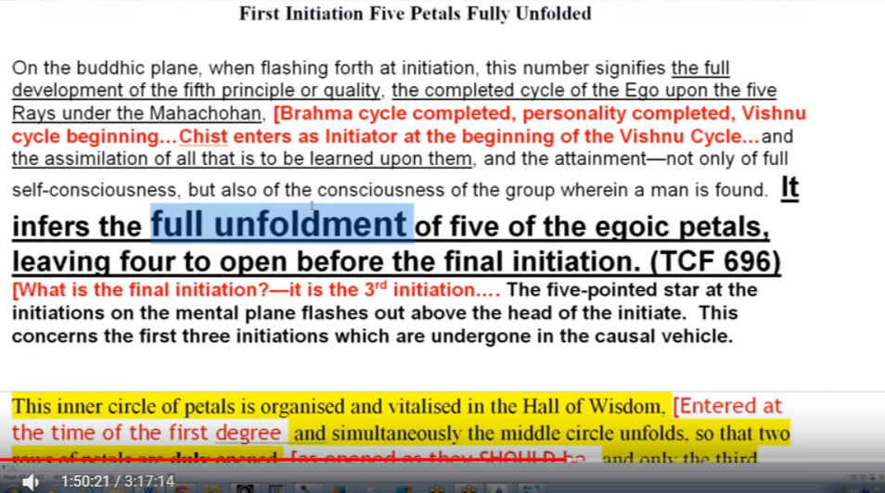
It infers the full unfoldment of five of the egoic petals leaving four to open before the final initiation. TCF 696
That's so interesting because at the first degree five, full unfoldment. So that's pretty clear and seems to be a somewhat different method.
But see here, and that's a very important reference.
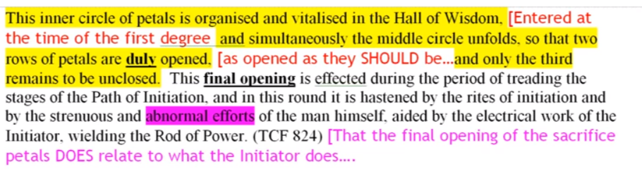
This final opening is affected during a period of treading the stages of the path of initiation and in this round it is hastened by the rights of initiation and by the strenuous and abnormal efforts of the man himself. By the time the third initiation is taken the inner circle of petals is opened and the nine petals are completely unfolded. TCF 824
That is such an important statement.
Anyway, for the moment I will say that I am not expecting when I look at how things are done with the application of the rod, I am not expecting the complete unfoldment of petals seven, at the first initiation, and petal eight at the second, I'm expecting that—and here’s why … my reasoning, since petal five is completely unfolded at the first, and petal six cannot be completely unfolded until the second initiation, then it makes no sense to think that petal seven is completely unfolded at the first initiation because the petal behind it, petal six, is not yet completely unfolded.
In other words, you would have petal seven completely unfolded along with petal five. It doesn't make sense if you leave petal six in a state of incomplete unfoldment. Then we can also apply that same idea to the second initiation. We have the idea that petal seven is not completely unfolded. So then at the second initiation petal eight would be completely unfolded and petal six together? While petal seven was not yet completely unfolded? It’s a little different. But again it doesn't make sense to look for the complete unfoldment of two petals which are separated by another petal occurring at the same time.
It's a technical matter I suppose and one that it would be nice to know and … it's a little bit vague. But I'm suspecting that what four more petals remain to be unfolded from the time of the first initiation. … and there’s the hint … important here on page 653
… The first initiation has been taken, the flashing fourth of the five point to start initiation. TCF 653
then here
The first initiation is taken but four petals remain to be unfolded. TCF 696
They are not yet. So, petal seven is among them, and so it is not yet at the first initiation completely unfolded. There's a confirmation. I think we can go on and say the same of petal eight. The analogy is there I think that at the second initiation there is still more work to do. I suspect that for the second initiation, or let’s say for petal eight, there is work to be done in the wilderness between the second and the third initiation, and this work in the wilderness will contribute to the further unfoldment of petal eight along with the necessary work in petal nine and the application of the rod of initiation to petal nine will be that which is needed to guarantee the full opening of petal eight.
Now, the application of the rod of initiation does indicate the full third initiation. In St Paul's life would seem to go on for a while. The question can be when was the rod applied? Maybe the beginning of the process was somewhere along the road to Damascus, and then DK talks about, he describes it as writing the letters to the Hebrews when he was reaching out towards the light, but maybe the rod is not fully applied. Yet at that point it seems to me we have a confirmation and that the initiate is initiated before he is an initiate.
In this particular case it might be that since the full opening of the nine indicates the third initiation that has to be pretty well achieved and then the rod of power confirms. It’s a little complicated isn't it? So the rod of initiation is the confirmation of the full opening of the nine because the nine, because the initiate is initiated before he is an initiate. At least that's one way to look at it. There's a bit of a difference there in the ninth petal because there is a climax and the Lord of the World comes into the picture and sort of presides over the completion of the nine.
1:59:30 Okay we have that climaxing moment that is occurring at the end of the whole process so it is a little different from what occurs earlier which are initiations of the threshold. But anyway I'm glad to have confirmed this. It [the first initiation] infers the full unfolding of five of egoic petals leaving four to open before the final initiation. TCF 696
Therefore, they are not yet open even though the rod of power is applied to the seventh petal. At least we can confirm that in relation to the seventh petal and since it seems reasonable to say that it is so in relation to the eighth, and the final consummation is literally of a different order and the rod of power is applied.
Here is the real question, Does the application … of the Rod of Power occur after all nine petals are fully opened, or does it cause the final opening? Now I will say that, based on the thought that the ninth petal cannot be fully opened before the seventh petal and the eighth petal are … I would say that the application of the rod of initiation completes the final opening process and is not based upon it.
Of course what is needed is direct accurate sight of the process. But right now one uses the reasoning, the references, to say how it must be. People will often say, “Well you’re only reasoning and using references.” I see it but allow my mistrust. So much of what is seen is related to reflection on the astral plane, and is related to wishful thinking, and is not confirmed, and contradicts often what the Master says. So maybe in my third ray manner, I will stick with the reasoning as the builder of the foundation of pure and accurate sight. I hope that this little digression has not been terribly frustrating. …
The rod of initiation is the confirmation of the full opening of nine because the initiate is initiated before he is an initiate. But this is probably not the case. The way it probably is … given below, with the rod of initiation causing the final opening of the entire tier.
Now we go back again to see 763, … By the time the third initiation is reached … The nine petals are fully unfolded. Well, it doesn't really tell us does it? … Let’s just say that since we know … that the application of the rod of initiation at petal seven and petal eight causes further opening or unfoldment, why should we not hypothesize that the same is true of the rod of initiation applied to petal nine?
So it's pretty much like the finishing touches are given by the rod of initiation. Some unfoldment has occurred before, due to the abnormal and strenuous effort of the man and the application … of the rod of initiation adds to the unfolding. Is it not conceivable to me at least that the application of the rod would not facilitate unfoldment?
There are some final adjustments to be made between these tiers of petals as we've learned in order for them to begin to rotate and so forth, and it seems that the finality of the rod of initiation at the ninth petal gives us finality. Hypothesizing that the rod of initiation applied at the ninth petal gives us finality with respect to the nine petals. … That is my hypothesis of the moment. Of course, until one can see these things working out in all clarity then it has to be a hypothesis, but assembling the references, this is what I come up with at this time. Of course arguments will occur or heated discussions will occur in the future on what exactly happens here, but we do have the Tibetan’s final word on it, that by the time of the third initiation occurs all nine are completely open, and at the first initiation five are fully opened and four remain to be opened. So at least at the first initiation the seventh cannot be fully open. No, it cannot be. I continue that idea by saying that at the second initiation the eighth cannot be fully opened. Maybe the seventh is almost open but still has a little way to go. The rod of initiation applied by the Great Lord, SK, puts the finishing touches on the sacrifice petal process, and for that matter on the process seeing to the opening of the entire nine.
2:09:00 Well, if nothing else, friends, I've gotten something more out of this more diligent research into these matters. I thought I was being fairly diligent seven years ago when I was making commentaries on A Treatise On Cosmic Fire, but I now see that some things may have escaped me and that is the value of continued study and never thinking in the speculative matters that you necessarily know it all because we don't.
So using inference then, after all this! We would understand some of the unfolding seventh petal to indicate a process of preparation for the first initiation. And this is a general term on organizing, vitalizing, etc., but definitely let's just say when the rod of power is applied there must be to some extent unfoldment.
We are told of the seventh petal that its unfoldment marks the period when the man consciously utilizes all that he has gained or is gaining under the law at Saturn. That's Saturn, that’s Libra, for the definite benefit of humanity and … stimulation represents this conscious utilization. Nor does its organization. I guess you have to inquire acquire something first. I'm going to say organization here, because that is the word that really perceives and then vitalization, but only if unfoldment … Perhaps it seems to be the case that the first initiation takes place some time during some degree of unfoldment of the seventh petal due in part through the strenuous and abnormal effort. And not during the earlier phases of stimulation, vivification, organization etc.
All right these are technical matters and one day we will see. It’s just that there is a certain point – this is the important take away – there is a certain point in the seven-petaled process at which the rod of power can be applied by Bodhisattva, and not before, and that is what has happened. Has only organization and vitalization occurred? Or has some degree of unfoldment occurred due to the man's efforts? When the rod of initiation can can be applied.
2:13:13 If we look again at A Treatise on Cosmic Fire page 543 there is that quite disturbing little reference. But let's just see what that seems to be saying.
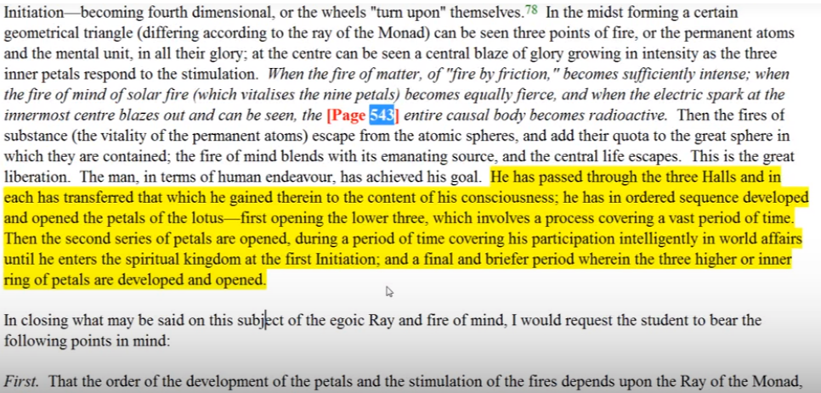
The man in terms of human endeavor has achieved his goal. He has passed through the three Halls and in each has transferred that which he has gained therein to the content of his consciousness; he has an ordered sequence developed and opened the petals of the Lotus—first opening the lower three ...
Well, this is interesting “ordered sequence”, of course, so much depends here. Are we talking one by one by one? To a certain extent I think that's true and then the entire tier, with differential opening of the different petals. So he has in ordered sequence open the petals of lotus first opening.
…the lower three which involves a process covering a vast period of time. Then the second series of petals are opened, during a period of time covering his participation intelligently in world affairs until the spiritual kingdom at the first Initiation; and a final and briefer period wherein the three higher or inner ring of petals are developed and opened. TCF 543
And we don't really have the words fully opened here, in any case. So for looking for the ultimate stage of full opening we may have to be more technical. Let's see page 543. This is an important page for us to go over and I think we're coming up to it soon.
Yes, his intelligent participation in world affairs, opening will occur, but the final opening. This is not to say of course that the first and second degree initiates do not participate intelligently in world affairs. But a final and I would say much briefer period wherein the three higher or inner ring of petals are developed and opened. Well it might not be a period as short as the period between the first in the fourth initiation because some development in terms of organization and vitalisation may be occurring before the first initiation. Some development in that higher ring of petals the sacrifice tier. A little necessary diversion.
2:16:20 Now, if the second petal of the sacrifice tier achieves complete unfoldment, only once the second initiation is taken, then vitalization, organization, and unfoldment of the second petal must take a much longer time than the same process in relation to the third petal. Because we're dealing with the period of time between the first and second initiation.
The third petal can complete its unfoldment in one life, as the second and third initiations are commonly taken in the same life. But the first and second initiations are not taken in the same life, and usually quite a number of live separate them.
… The unfoldment of petal mine will be much more rapid than the unfoldment through the strenuous and abnormal effort of petal eight. And even the completion of petal seven, so a lot of time is being spent there in the unfoldment of petal seven, after the rod has been applied there's still some work to do I think, and in terms of gaining knowledge and sharing it. And the sacrificial work a petal eight. … In the petal eight so much lengthy work has to be done as a sacrifice is hard to do.
Thus, learning the true meaning of sacrifice takes a long time and it is this which is the major theme between the first initiation and the second initiation, at which time one enters the stream. Even greater sacrifice than at the second initiation is done in the desert confronting the world, the flesh, and the devil. This is still eighth-petal work requiring strenuous and abnormal effort. But the rod of initiation adds something to unfoldment which the man cannot contribute and thus, in a way, finishes things off. I hope that's becoming clear: that this little of sacrifice the really big and final sacrifice of all that man might want in the astral body is accomplished when one gives up the world, gives up the flesh, and gives up the devil, pride. In the desert between the second and third initiation. This will require of course concomitant work in the ninth petal because after all these two can be taken together, or in the next life, but often times together. so naturally work in the ninth petal is required preparing let's just say that the rod of initiation does not come along and do all the work for the man of the ninth petal. No he has to work very very hard and he's doing this work in the ninth petal … while he is fighting with the world, the flesh and the devil. Some are not succeeding and if they don't succeed they, in a way, become their own dweller and they can head off into the left hand path.
So that’s amazing, even while working in petal nine it is possible to veer off onto the left-hand path. That's amazing. So even while doing that kind of work, which should lead to the utter sacrifice of all forever, even while trying to understand the will associated with the ninth petal, one can fail at this intermediate place where love of the world, love of the flesh, and love of one's own unsubdued ahamkara, I can prevail, and victory not be achieved.
2:23:25 It is clear, considering the principle of overlapping development, that when the first petal achieves complete unfoldment that is completely open. Well, I might have to change some thoughts here and of course this is humbling, but it's better the truth than to stick by something that may not be entirely true. So it seemed clear at the moment anyway, that there is this principle of overlapping that when the first petal achieves … a reasonable degree, a fairly full unfoldment, and is heading towards opening, the second petal is already organized, vitalized, and perhaps in the process of some degree of unfoldment. When the second petal achieves … a fairly full unfoldment, and is heading towards opening, then the third petal of the sacrifice tier is already stimulated or is already organized, vitalized and probably in the process of unfoldment, and you guessed it: strenuous and abnormal labor. … I'm making my assessment of this a little bit more subtle based on the sort of three-petal theory and based on the thought that when important work is going on in petals ahead, it doesn't necessarily mean that the petals behind will be completely unfolded especially when dealing with the sacrifice tier.
I used to love to take the book, Cosmic Fire, and meet a friend and just lock up for about two days and do nothing but pour over Cosmic Fire, and try to solve the difficult problems presented. That used to be my idea of heaven: disappearing with A Treatise on Cosmic Fire. But I see it's a humbling experience, realizing that there is always more to learn, and that some of your best assessments at a certain time may not be fully correct.
Anyway I'm expecting for instance that when petal five is fully unfolded, some … degree of unfolding exists in petal six and even in petal seven. Due to abnormal and strenuous effort. That when petal six is fully unfolded, there will be continued unfoldment in petal seven and some degree of unfoldment in petal eight, through strenuous and abnormal effort before just as the rod of initiation is applied. I am saying that some degree of unfoldment receives the application of the rod of initiation, which grants further, though not necessarily complete unfoldment, as in petal eight.
What I said, “Look you're out there in the desert … scorpions run around in the desert don't they?” When you live in Arizona you have to be careful about walking barefoot because they're running around your house, so even in petal eight you're out there in the desert. Being out there in the desert follows the second initiation, meaning there's more work to be done in petal eight through your own continued strenuous and abnormal effort aided by the power of the rod, which has been behind you; which has seen complete unfoldment of the sixth petal and the almost complete involvement of seventh, but not the complete unfoldment of the eighth because there's more work to be done in that eight petal after the rod is applied. You on your own have to make a choice, and only when you've made the proper choice can the third initiation be taken.
There is a very short time between the desert and your Transfiguration. Probably in the life of Christ not a long time at all. You're in the desert and then later the Transfiguration occurs, but not much later. So you make that choice properly and you put down the world, the flesh and the devil, then more unfoldment is occurring in petal eight and only the rod in petal nine gives the finishing touches to petal eight and to petal seven, and gives the final opening for petal nine. It is a very great gift in a way is it not from the Lord of the World?
2:30:00 So it's hard to match exactly the degree of unfoldment to the moment of initiation. Working backwards, it seems, that the third degree marks the point of full unfoldment of the sacrifice tier. Thus we would not expect that the first initiation would be taken when the seventh petal is only beginning to be opened, and yet, see this has been my conflict. Now I would say now that a certain degree of unfoldment has occurred in petal seven due to … strenuous and abnormal effort. (I like that phrase and tells what the man must do.)
… Some degree of unfoldment has a good part of seven due to strenuous and abnormal effort and only then the rod of initiation can be applied. So obviously I was wrestling with this at the time, and I think I'm coming closer and I hope that you are coming closer to understanding this and if some aspects of understanding are still escaping us then maybe they will occur to you and you can let me know what you think. If I'm still alive by the time anybody is reading this or listening to it. (Laughter) Yet I see the picture is not clear and the main problem is this, when does initiation occur following the organization of the petal and before the process of unfoldment is fully matured? Now I say yes.
Or does initiation occur only once the petal which corresponds to that initiation is completely unfolded? This would be the corollary to the initiate is initiate before he is initiated. Okay, now that would be the corollary.
From the following statement, one one could think that initiation occurs when the petal is organized and about to unfold.… let's see if this is confirmation here:
In this fashion the work of the disciples carried forward, and his testing in training carried out until two circles of petals are unfolded and the third is organized. Thus he is brought through right direction of energy and wise manipulation of force currents, to the Portal of Initiation, and graduates out of the Hall of Learning into the great Hall of Wisdom—that hall wherein he gradually becomes “aware” of forces, and powers, latent in his own Ego and egoic group. TCF 867
So his testing in training is carried out until two circles of petals are unfolded, and here I have to ask again does this mean completely folded. Because there's lots of organisational work going on in the third tier of petals and yet the rod of initiation has not been applied, yet. Following the organization, the rod of initiation is applied and I would say due to strenuous and abnormal effort, the rod of initiation is applied without that strenuous and abnormal effort, I do not see how the rod of initiation could be rightly applied?
Let's see what I say about this. In this case the rod of initiation would stimulate the unfoldment and would not be the seal of certification that the petal has been unfolded, and now I say “yes” to this. When the third tier is organized in general we might ask to what extent is the seventh petal in process of opening. … A very important question due to the strenuous and abnormal effort of the man working in the sacrifice tier. … the unfoldment of the third petal of the sacrifice tier is probably a very rapid affair, possibly occurring in part of one life cycle.
Is the rod of initiation applied by the Lord of the World as the ninth petal is about to unfold? While it is unfolding? (I'm glad I'm asking myself these questions) and now I say “yes” to option two. I laid out the options here, or only as it is completely unfolding, whichever is the correct answer we have such references as the following to guide us. …
By the time the third initiation is reached, the wondrous transformation has transpired the outer sphere is palpitating with every color in the rainbow, and is of wide radius; the streams of electrical energy circulating in it are so powerful that they are escaping beyond the periphery of the circle, resembling the rays of the sun. The nine petals are fully unfolded … TCF 736
I always love to see that word “fully” because it erases the ambiguity of “unfolded”, “open”, how much? How fully? We saw that there are no bud lotuses, strictly speaking, and everybody has one petal open. But how far open? Fully open? Okay, so that's one and we have talked about that.
2:37:28 This is in another place, TCF 830
By the time the third initiation is taken the inner circle of petals is opened and the full blown lotus in all its beauty can be seen. At the fourth initiation the inner bud bursts open. through the effect of the electrical force of the rod, which brings the power of the synthetic ray of the solar system itself; the inner Jewel is thus revealed. TCF 830
By the time the third initiation is taken the inner circle of petals is opened and the full blown lotus in all its beauty can be seen. “Full blown”. That sounds like the full thing, doesn’t it? In all this beauty can be seen. At the fourth initiation the inner bud bursts fully open. I put the word fully in there even though there is some unfoldment of the synthesis petals with each initiation, through the effect of the electrical force of the rod, which brings the power of the synthetic ray of the solar system itself. And that is the great second ray. the inner Jewel is thus revealed, reminding us that we're not only dealing with a first ray phenomenon but also with the second ray … Let's see, we have a little more to go.
It is suggested that the inner circle of petals is opened. Are we speaking of the sacrifice tier? It seems so. And are these petals fully open?
From the reference, on TCF 763 again, it seems so.
By the time the third initiation is reached, the wondrous transformation has transpired the outer sphere is palpitating with every color in the rainbow, and is of wide radius; the streams of electrical energy circulating in it are so powerful that they are escaping beyond the periphery of the circle, resembling the rays of the sun. The nine petals are fully unfolded … TCF 736
The words “full blown lotus” suggests so. One can wonder whether the rod of the Bodhisattva starts the unfoldment going, for both the first and second initiation or whether the rod of the One Initiator confirms the result of the opening of the ninth petal and the third, to rather than inaugurating the opening. We have answered this. And we have concluded that the rod of initiation adds something to the opening, and that the rod of the Bodhisattva also adds to the opening. And maybe the opening dies not start, because the opening of petal seven and petal eight, because the strenuous and abnormal effort has contributed something to the opening already.
Now, all of this has to be checked against direct observation of the facts on the higher mental plane. With this case the Bodhissatva would stimulate the opening of the first petal of the sacrifice tier, which would take a very long time and would stimulate the opening of the second petal of the sacrifice tier, which would comparatively might not take long at all.
21:41:10 Well I am changing my views here. The third petal of the sacrifice tier would already be vitalized organized and partially unfolded then perhaps the rod of the One Initiator would be applied towards the end of the ninth petal’s unfoldment. It is only with reference to the third initiation that we have a text confirming the complete unfoldment of the petal associated with it and that's very important.
Obviously I have been wrestling with this problem and because of dealing with this issue, forcing you to wrestle with it as well does it have a practical application? Well there is just very strenuous work to be done in petal number eight, and intense and shorter strenuous work to be done in petal number nine. The rod of the Bodhissatva would stimulate the opening of the first petal of the sacrifice tier, which would take a very long time and in addition the opening would have begun under the strenuous and ab normal effort of the man, and would stimulate the opening of the petal of the sacrifice tier … provided that some unfoldment had taken place through the strenuous kind of normal effort.
Now I'm going to just check this question all together which might not take long at all. This we have to see. There is no final opening. … I want to speculate that much work will be done here in petal eight before the rod of initiation is applied. Then let's see simulate the opening … this is the question, where is this work accomplished? Where does the majority of the work take place? Well it's a very long time between the first initiation and the second initiation when the rod of initiation is applied at the first of the first initiation. There could be say thirty lives of continued of work within the eighth petal and some continued work within the seventh petal, there is the constant gathering of more knowledge to be shared and the constant for the seventh petal and the constant work in the area of learning what sacrifice is and to give without receiving in the eighth petal.
I think this opening of the second petal of sacrifice … it could take a long time because of the interval between the first initiation and the second initiation. How long does it take working in the seventh petal? Well it can still take a long time before the first initiation becomes possible. I must add that it could still take a long time working in petal seven before the first initiation takes place. In trying to come to some understanding of this, pouring over and over it, I have modified my points of view. And I hesitate to leave this commentary on makara the way it is, I’d like to make these rectifications, or perhaps have one of my colleagues who understands my way of thinking, take these notes and make the rectifications.
2:47:00 The third petal of the sacrifice tier would already be organized, vitalized, and partially unfolded, and then perhaps the rod of the One Initiator would be applied towards the end of the ninth petals’ unfoldment. Maybe towards the end, and it is only with reference to the third initiation that we have the text confirming, the complete unfoldment at a particular initiation. Let's say the rod of initiation always adds a plus to what man has been able to do himself. So how much of the unfoldment of the members of the sacrifice tier has occurred due to strenuous and abnormal effort, and how much due to the rod? Let’s wait and see. I would say quite a bit depends upon the candidate and his strenuous and abnormal effort.
… Importantly we might also consider that the rod of initiation is applied when … a given petal is open to a sufficient degree. To provide some degree of mastery over the requirements associate with this petal. And then the application of the rod promotes further and rapid unfoldment until the petal is almost completely open. Assuming that the final opening occurs at the third degree, I think this pretty well expresses my present views, so let us keep this in mind as we examined some contrasting possibilities, and we have been examining them so I'll try to make relatively short work of this.
We have a somewhat contradictory reference to some consideration and perhaps they can be reconciled by considering that there are two orders of initiation here. Certainly that is true. One of them supervised by the bodhisattva and the other by the One Initiator. The intervals between the second and third, and third and fourth, and the fourth and fifth, are much shorter than that between the first and second. Perhaps the third, fourth, and fifth initiations administered by Sanat Kumara function according to other rules. We're not so interested here in the fifth initiation, but we know the fourth and fifth can be taken the same life. The third and fourth in the same life, the second, third and fourth in the same life. It's almost like the second and fifth, can be taken in the same life.
2:50:30 I have to ask a strange question. Did Milarepa take the second initiation, the third initiation, fourth initiation and fifth initiation in the same life? After I read about his life, such was his amazing accomplishment. Was it by Evans-Wentz this book about the great Tibetan Saint Milarepa. I'm trying to think about the name of the book, but anyway I just put the book down as what can be done? Because the heroic effort of such a soul as Milarepa must have had such a first ray. Cannot be duplicated. How can we come close to being able to do that? and yet we cannot forget that essentially the initiate is initiate before he is initiated. Therefore … initiation is confirmation. But maybe a confirmation not of all that the rod of initiation can do but of a sufficient part of what the rod of initiation waiting for the the rod of initiation to put the final touches and the completed expansion upon the pre-done work and unfoldment.
Yet at the balancing thought, initiation is also commencement or as we have suggested, maybe there is a middle road in this consideration with the rod of power being applied well after unfoldment has commenced but somewhat before it is completed. Well I really like myself here, for having tried to find a way out of the thicket of these options, and having expressed it reasonably, at least. In this case initiation would not only be confirmation but a gift, a bestowal and addition, rapidly stimulating unfoldment until unfoldment is complete. Or in the case of petal seven and petal eight nearly complete. For petal nine complete entirely.
We are probably dealing with the fact that the exact moment the rod of initiation can be applied is a highly technical and secret matter: the inner assessment of the readiness of the candidate is essential and we don't know those things. The degree of petal unfoldment may not be exactly the same for each candidate as other factors of timing astrological for instance, may have to be considered. Okay, I was hoping that I did not leave myself in the terrible quandary which seem to arise in the earlier part of this speculation, but then I had to re-reason the whole thing, only discover that I had thought about it before, but maybe not with as sufficient detail as has appeared in this reasoning through.
However to summarize the pertinent questions in the line of speculation we've been following. Could make sense that the Bodhisattva gives (through the first and second initiations) the impulse towards unfoldment, whereas the Lord of the World (in relation to the third fourth and fifth initiations) sets the seal of confirmation? That's another another question. Certainly in the ninth petal there's a lot of work done but even in the ninth petal there is some unfoldment after the rod of initiation is applied. It is not from this present hypothesis the seal of completed work. So what's obvious here is the matter is not easy to solve. That must be very clear.
If the first initiation comes all be when the unfoldment of the seventh petal is complete, and we've already showed that this cannot be (we found the reference to show that this cannot be), if the second initiation comes only when the unfoldment of the a petal is complete, and we have shown that there is still further Scorpio work to be done in the desert, after the second initiation, then the unfoldment of the eighth petal will take a very long time, for there is a long interval between the first and second initiations. It will take a long time but maybe not longer than the seventh petal, because there's some seventh petal work being done before the first initiation takes place. So the eighth petal unfoldment will take a long time, but some of that unfoldment may be the responsibility of the man through strenuous and abnormal effort. (My favorite abbreviation at this time!)
If the first and second initiations are given before the first and second petals are completely unfolded and perhaps when they are organized and about to unfold are somewhat unfolded. That's what I seem to be covering all the options there. Then it will be the unfoldment of the seventh petal, which takes a very long time when compared to the unfoldment of the eighth or ninth petal, but not in relation to the unfoldment of petals earlier than the seventh.
I can see now the seventh petal taking a long time, because there is plenty of work to be done before the first initiation is taken. See there is plenty of work to be done before the first initiation is taken, and some degree of unfoldment may be possible, as the candidate for the first initiation has already begun his strenuous and abnormal effort.
So this latter solution seems most appealing to the intuition even though some references might seem to contradict the reality or the possibility of this. I am thinking though that the eighth petal unfoldment does take a very long time and that the seventh petal unfoldment can take a long time because we don't know how many lives are required, as one moves towards the first initiation. How many lives are required as a man moves towards the first initiation? If many, then there is much pre and initiatory work being done in the seventh petal before the rod is applied.
Well … looking at sample cases over many lives we will solve this problem and this is what the Solar Angels themselves can do, because they have to be experts in these matters. Probably each initiation has a number of steps in it and the steps correspond with the various stages of the unfoldment of a given petal and that makes sense. Each initiation has a number of these preparatory steps in it and these steps correspond to the various stages of the unfoldment of a given petal. We are presented only with the most symbolic picture. First hand reliable clairvoyant observation will be required to correlate the degree of petal unfoldment with the steps in the initiation process. We can call these preparatory and even in the initiatory process per se, as some such processes seem to span a long time.
3:01:40 Look at the later initiations for instance, look at the Christ’s seventh initiation which was begun in Palestine two thousand years ago, and will probably not be completed until towards the end of the Aquarian Age. … it’s different stages of it. Maybe there was a stage in it that related to the high points of the Gemini high points, of the full moon in 1943. We could ask of course if in some respect when … but I think I've settled that I've asked that question of myself before whether it's the eighth initiation that will be taken when the Christ and the Buddha stand before the Lord of the World at a point later in the Aquarian Age. But I think I decided upon references that it was really the completion of the seventh initiation.
So, in over our heads here certainly, over mind, but indicating at least what some of the issues are and what has to be worked out we can summarize very generally by saying that the seventh, eighth, and ninth petals, i.e., the three petals of the sacrifice tier are associated with the first, second, and third initiations respectively. Well I began with that simple statement long ago, at the beginning of this inquiry. At some time in the unfoldment of these petals, either earlier or later or upon almost complete or complete unfoldment, the rod of initiation is applied.
I guess I have given every option here, every option has been given here. With the suggestion that … complete unfoldment is not required. Because the rod of initiation must add something to the unfoldment. Otherwise, why apply it except for confirmation? Not the very earliest stages of work in the petal and not the very latest, but at the appropriate moment when some unfoldment has occurred due to the strenuous and abnormal efforts of the candidate.
Unfoldment we are told takes place due to both of these unfoldments: takes place due to both strenuous and abnormal effort and the application of the rod of initiation, and not just due to one or the other. Both. So since we know that strenuous and abnormal effort is going to take place before the rod of initiation is applied and since strenuous and abnormal effort produces unfoldment, then there must be unfoldment before the rod of initiation is applied and not just organization and vitalization. Whoa, okay, I hope that brings us to some kind of clarity. At least I'm getting clearer about it so I would suggest that we continue to ponder the matter and see if the intuition can confirm the moment in the process of petal unfoldment that a rod of power applies.
Here I feel I have come closer but nothing scientifically. Whosh. Maybe that's the most strenuous and abnormal effort I've had to apply in turning this series of commentaries on the egoic lotus. But you feel you get closer over time. The bottom line is you have to do something before the rod of initiation is applied, so the candidate must do something to prepare for initiation before the boosting effect of the rod of initiation can play its part. Boosting open.
Well we have a little bit more to go here. A long program I realize but I've explained to you why I do these longer programs just to preserve the momentum and to save time. …
Continuing with chakra unfoldment we would imagine the ajna center to continue developing from the first to the third degree. As we are told from page 170, A Treatise on Cosmic Fire, at the third degree it will be fully functioning. For that degree is ruled by the fifth ray which expresses through the ajna center via Venus. Venus as the fifth ray ajna center is the chakra directly associated with the third degree, fifth ray, third degree, ajna center of Venus. Those are the ideas to keep together at that point. If there are five of the seven head centers functioning at the time of the first initiation, then these four will be correlated with seventh petal process leading to the first initiation. Then five will show us we have reached the first initiation.
The unfoldment of all seven head centers will be relatively complete because the fourth initiation ruled by Vulcan, just as the seven heads centers are, looms ahead, by the time the third degree is taken. So basically, seven centers will be complete by the time the third degree is taken. Vulcan is active before the first degree, no question about it. So some of the head centers are involved. … Vulcan rules the head centers which are involved in increasing measure between the first degree and the third degree.
In all occult processes, the highest head center is active to a degree, we've seen that when we look at the methods of service the ten seed groups, all head centers involved in the chakras being used in all ten seed groups. We can expect the growth of the crown center stimulation as the initiatory process moves from the first through the third initiations and beyond. Even at the fifth at the sixth because even if you have a mayavirupa, the crown center can demonstrate increasing growth. We will not expect crown center stimulation to any significant extent before the first degree, it’s ruled by Pluto then when Vulcan comes in with those seven will centers we expect the stimulation and we expect it to a considerable extent at the third degree when monadic purpose will begin to come into view, and it continues to expand after that point. You say we don't have a body? But you can generate the replica via a mayavirupa process, and there's no reason to think that that body must demonstrate only what a previous initiation had been able to express through it. Now with new initiations, maybe new developments in the body can be expressed.
In other words, if I was looking at have center of a master, the fifth degree, who had created a mayavirupa. If I was looking at the head center of a third degree initiatie who had his own body which had not been created by mayavirupa, or let's say a fourth degree initiate just before his death, I would not expect to find the same type of stimulation. I would expect to see more head center stimulation in the mayavirupa of the Master. And if I was looking at Chohan, or a seventh degree Chohan with a mayavirupa, I would not expect that their head center would be limited in its expansion to what it was when they were simply a Master. But supposing that they were a Master and had a normally-generated physical body, not a mayavirupa.
In other words, what I'm saying is the mayavirupa will allow expanded expression according to the degree of the initiates generating it. More expression for the seventh than the sixth, more expression for the sixth than the fifth, more expression for the fifth than a fourth. I see my original sense here, we would not expect the crown simulation much before the first degree. Well that is there so this is fitting. I say, as the crown is the seventh chakra and the first initiation is associated with the seventh petal. So by the numerical resonance there will be stimulation. We now continue with the unfoldment of the second petal of love, the eighth petal overall.
Oh heavens, well friends, this has been tough, maybe. I don't know who it’s been tougher on, tougher on me or tougher on you? But at least I've seen what I consider to be the adjustments that have to be made in my own assessment. I have accounted for these adjustments in the text while not coming down decisively and deciding which should be which, and this time I think I've done that, if I can just freeze this in my mind and realize why I have frozen it.
So this is the close of webinar commentary program 27. It is 3 hours and let's say 17 minutes and it's been A Treatise on Cosmic Fire, page 541 …
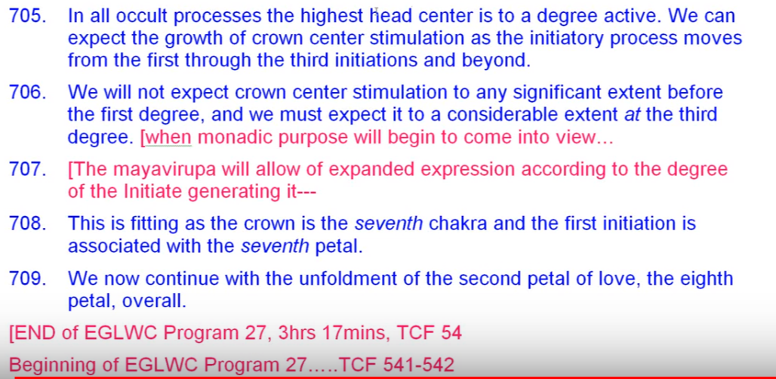
One day maybe all of this will be nicely condensed and you won't have to go through the sort of comparative reasoning process that I've had to go through here, which sort of shows work going on in the seventh petal, where the higher mind is involved. In trying to make a synthesis of it all maybe getting some influence from the knowledge synthesis petal.
All right so that's going to be the end of our work for right now and we'll see you in program 28 shortly. Lots to think about. See you soon. Bye bye.

