EGOIC LOTUS WEBINARS, VIDEO COMMENTARY – 24, Michael Robbins
Abstract.
Analysis of Petal 4. This webinar is about 2 hours, 15 minutes long and covers A Treatise on Cosmic Fire page 540. Analysis of Petal 4:
According to the Tibetan’s statement: “The Petal of Knowledge, for the astral plane; unfoldment is brought about by the conscious balancing of the pairs of opposites, and the gradual utilization of the Law of Attraction and Repulsion. The man passes out of the Hall of Ignorance where, from the egoic point of view, he works blindly and begins to appreciate the effects of his physical plane life; by a realization of his essential duality he begins to comprehend causes."
Content for EGLWC Program 24: close attention is paid to the astrological, rayological and chakric implications related to the organization and unfoldment of Petal 4. This is in preparation for wider correlations to be attempted in relation to all petals after what DK has said about them specifically is analyzed.
Egoic Lotus Webinar Commentaries 24 471 MB .wmv file
Video of Egoic Lotus Webinar Commentaries 24 by Michael D. Robbins.
Egoic Lotus Webinar Commentaries 24 130 MB .mp3 file
Audio of Egoic Lotus Webinar Commentaries 24 by Michael D. Robbins.

Well hi everybody.
We are beginning to work on the 24th program of our webinar book, or video book, in which I'm commenting on things that the Tibetan has written, and also using some of my written commentaries, I hope judiciously, trying to make them come as alive as possible, as I know they are arduous to read. In any case, we are now entering the love tier. Now, the way things are going I'm doing simply an analysis of what DK has said about each petal. And he has only given a sentence, and I'm bringing thoughts together about that. When this is completed and we have turned to the discussion of the colors of the petals on which he has also commented – at least he has listed the colors – then we will go to a listing, a kind of a synthesis with regard to each petal. Then we’ll do some charts which I hope will be useful.
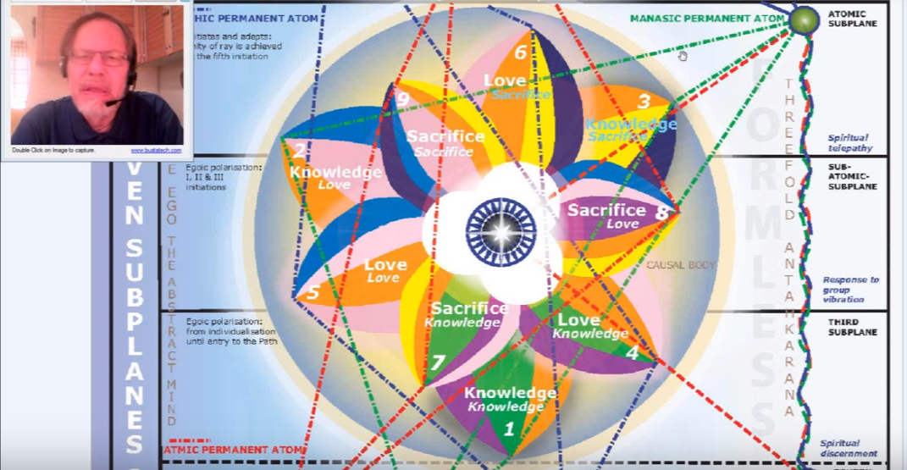

There is so much to say about the egoic lotus and yet all of it pales to what could be directly seen and known if the accurate faculties were ours to view the causal body directly. And as I say, with accuracy, because we are not interested in the astral reflection of the Masters or of this vehicle. It is so easy to fall into that particular trap, where the wish becomes the father to the thought. So we try to avoid that and at first simply use the reasoning power and, to an extent, the intuition, and wait for the day when confirmation will be ours with direct sight.
02:40 We are here with the second group of petals. We remarked earlier that although these petals are called love petals they have more to do perhaps with, well I want to say with desire than love, or let's just say with a high form of desire than love. Not always high, but after all we're dealing with the astral plane. The astral plane is home to the impulse of desire and later, increasingly, the impulse of truer love. So it says the petals of love for the astral plane.
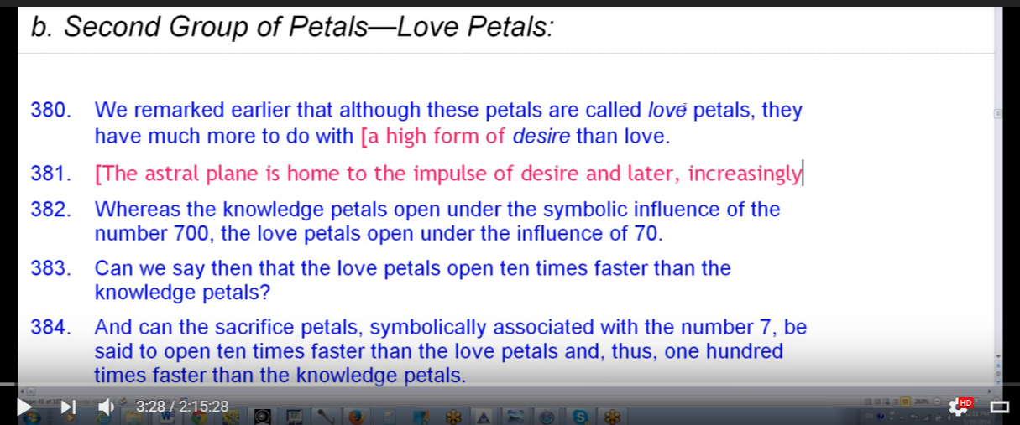
We know that there has to be the opportunity for the buddhic energy to pour via into these love petals and into the astral body. And when we begin to have a connection whereby buddhi begins to replace ordinary desire in the astral body then these love petals will really flourish. In fact we expect that to happen at the first and second initiations and at least as I see it, the complete unfolding of this tier of petals occurs when the second initiation is complete.
04:25 So whereas the knowledge petals opened under the symbolic influence of the number 700, the love petals open under the influence of 70. Does each opening take 10 times as long because there are petals which are organized by lives under the influence of the number 7, each is less by a factor of 10. The 70 does not really open the 5th and 6th petals, nor do the 7 completely open them. The 70 will take us as far as the central petal and work within those kinds of experiences which are related to the central petal. The 7 takes us onto the path of probation where there is certainly work being done in the latter part of the 5th petal and in the 6th petal, and when I say that of course I mean we're not like the divine alchemist working in the petal, we're actually working in the three worlds with the kinds of experiences which correlate with the path of aspiration and probation.
So we don't know yet whether we can say the love petals open 10 times faster than the knowledge petals, but it does give us the hint that indeed they do open faster. Can the sacrifice petals symbolically be associated with a number 7 and be said to open 10 times faster than the love petals and thus 100 times faster than the novice petals? Not exactly because the 7 only takes us through the end of the path of probation and not to the actual opening of the sacrifice petals in the Hall of Wisdom.
So there is no number that we have been given in terms of the 777, or related to it, that actually deals with the work to be done in those kinds of experiences which relate to the sacrifice petals. It would be convenient of course if one could make this case, but the proportion will be I think too small. At least this will be the case for the sacrifice petals which could open perhaps 3,000 times faster than the knowledge petals. Well let's just say this is of course highly speculative and it would depend on the ray of the soul and how well the striving disciple or probationary initiate was actually doing, so it's very approximative, if there is such a word, probably should be approximate but I like that word, so and based on the idea that perhaps 30 lives would be symbolically found between the 1st and the 3rd initiations, less are possible of course and perhaps 6,000 years. A high figure is required to make this process. So we remember that symbolically at least 30 years separated the birth of the initiate Jesus from the time the Christ demonstrated through him the meaning of the 2nd initiation or took over his body so that he could work in that way. The 2nd, 3rd, and 4th initiations were taken within 3 years. Each year can be considered a considered symbolically perhaps as a lifetime so there is much that can be learned from these particular figures but the learning must be indicative and symbolic rather than taken literally.
09:00 Let's just say for some people who have individualized in Lemuria, are part of Earth humanity, are members of the Lotuses of passion and desire and have not even opened all three petals, after 21 million years. So what is a few thousand years between the 1st and 4th initiations. Matter of fact it might be just 300 years between the 2nd, 3rd, and 4th initiation or they can all be taken in the same life. I'm not going to get into all the figures which have to be symbolic anyway.
The thing for us to take away from this is that there's a much more rapid process occurring when we begin to work within the sacrifice petals. You understand what I mean by that: work on those kinds of experiences and developing capacities related to them and what we do after a while, there is going to be a complete opening of the 5th petal and then after maybe a longer time, what 30 lives? If it's 30 lives, that's to say 100 years a life, to be round about it, that's about 3,000 years between the 1st and 2nd initiation. It might not be that at all. There's even a reference that seems to indicate that one can take that 2nd initiation almost immediately after the 1st, that’s a very rare reference, but it makes you pause and think.
So everything accelerates as we move towards the climax, and especially because we are under this forcing process we call initiation so the rod of initiation is being applied and even though we have an abnormal and strenuous effort being made on our part, we are being facilitated by the rod of power and saving how much time, who knows? So if this, let’s say 6,000 year figures taken between the 1st and the 5th (maybe 5,000 is even better) then the individual living some 30 lives between the 1st and 2nd initiation and some three lives between the 2nd and 4th would incarnate on the average every 200 years. But of course we know that that is, actually toward the end, a rather large figure and incarnation for the disciples is rather rapid. So it's really a smaller figure.
12:05 Now I think what we should look at here are 18 million years, but what about 21 million years? Given when individualization occurred for some of the earlier ones. If we divided that by 6,000 we'd have about 3,500. Okay, that 3500 does it make any sense to say that the sacrifice tier opened some 3,500 times faster than the knowledge tier? Well 21 million years and the knowledge tier is not even open for many people and the duration of years between the 1st and 4th initiations is rather long I think given what DK is telling us here, we're kind of using a long figure.
So how long does it take to make the first tier open? Well, 18 million years have passed since the individualization of man of the earth chain, and not just 18 million years but, really 21 million. And still there are many who have not opened this knowledge tier first tier. So others have moved faster of course. So in dividing how we did it before 18 million by 6,000 a very speculative period required for the opening of the sacrifice and a clear comparison is being set up which can reveal however crudely the degree to which the time required for the knowledge tier to open is much greater than the time required for the sacrifice tier. It’s a speculative figure. What if we use 21 million years, so it's even the degree opening is that much faster, and between the 1st and 2nd between the 1st and 4th initiations we might not have 6,000 years at all, we might just have 3,000 half that much.
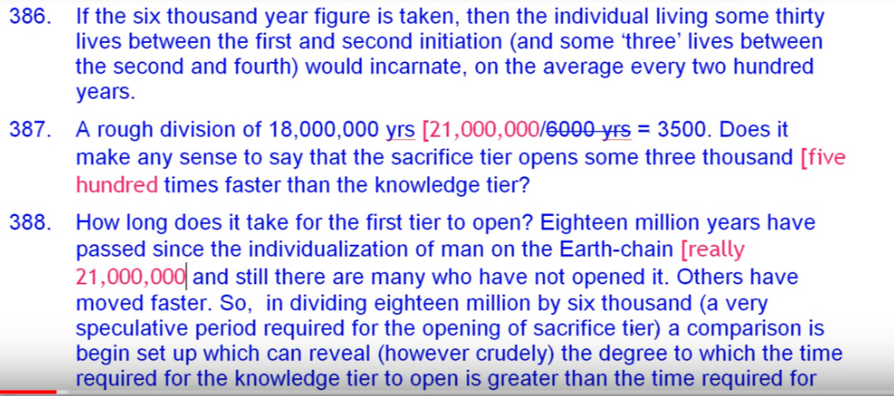
Depends on how people are moving and yet millions of years are required to really fully open the knowledge tier. And to then organize at least most of the love tier. So even if these figures prove to be erroneous (and of course they have to be erroneous they were intended only to be indicative of a very general proportion).
15:35 I think it will be found that the sacrifice petal opened very much faster than the knowledge petal, and considerably faster than the love petals. There's always a 3-2-1 acceleration. I'm surprised that I used 18 million years as the time of individualisation, I really should have used (but maybe I did it for convenience as 6,000 was so easily divisible by 18. I really should have used 21 million years, for those who individualized first on our globe through the intercession of the solar angels. There are other forms of individualization, but as stated, they might have even come later and they had to do with the fanning of the spark.
DK seems to say some things which to our understanding might look a little bit contradictory or at least give counter indications and we'll just have to be very careful about them. I often say to people, well if you're at the 1st degree and you have 30 lives left, and suppose there's 100 years per life approximately, then you have 3,000 in relation to the number 21 million and basically you have a procedure going 7,000 times faster. If the figure 3,000 years is used between the 1st and 4th initiations, and I don't think we can look back on how Master Jesus did it – there was just such an expansion of time then.
We have to look now at the compression of time which is offered to us on page 84-85 initiation that the 2nd, 3rd, and 4th initiations to be taken in the same life, so then how long would 30 lives last?
Let's just say the same life and then 30 lives, but 35 says it is between the 1st and 2nd. It's a rather long time maybe just 15 and maybe devachan is not indulged in so much. Maybe there's only 1600 years or 1500 years half 3,000, but even with 3,000 years between the 1st and the 4th initiations, we could say that the petals of sacrifice will open … 7,000 times faster and if there were 1500 years between the 1st and 4th initiations then the figure here is about 14,000 times faster.
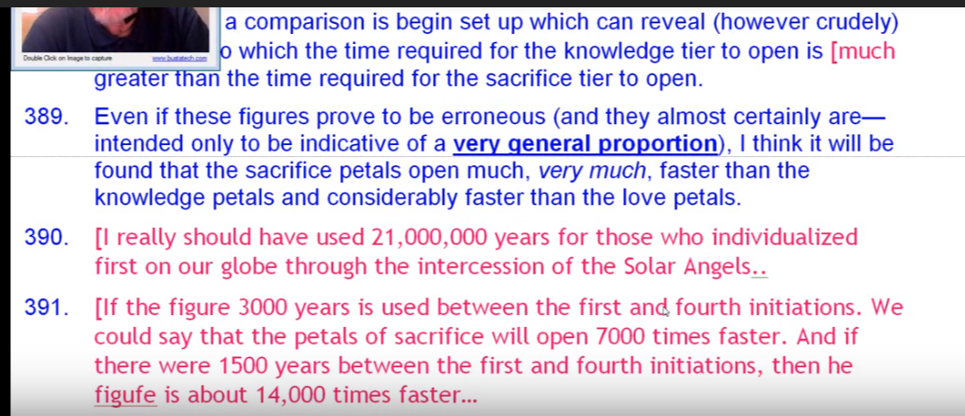
20:20 Of course it's got to be erroneous, because it is just meant to induce a sense of proportion because there are all these soul cycles when we cannot be incarnation because of a kind of ray which is our soul ray or our monadic ray, the kind of monad we are and so forth. The idea is simply to show that since 21 million years have passed for many many people and they're a long way yet from opening all three petals, springing open, all three. Because if for the lotuses of passion and desire, they are 3/5th of them are individualized on our globe, and well they won't even be on the path for a long time. But forget that it will be the fifth round for some of these people before they are on the path so we won't take those intervening years between rounds and try to have them in and be rather hopeless.
Really what we need is a very clear idea of the science of cycles, and we have to earn that we really have to work on that and much can be conferred to us in the process of initiation and will be, but there's so much that we have to reason about and use our intuition. We don't know when Master Jesus took the first initiation but we do know as Joshua maybe 5,000 years ago he took the 2nd, and then it was 2,000 years, 3,000 years later maybe, before he took the 4th. So there's 3,000 years and, as I said there was not such compression at that time as there is now. For St. Paul, the first ray I suspect moving very fast and basically an initiate of the 2nd degree. I think taking the 4th from the 2nd to the 4th in that same life it seems to me so that then as … Hilarion he could take the 5th degree. So there's no exact rule here and DK often warns us against trying to find exactly the number of lives that we have between incarnations or what is a real average and so forth.
I guess my main point is to impress upon us the staggering difference between the end of the initiatory process leading to the 4th and the path of evolution. We have an amazing opportunity at this time for accelerated progress. There's such a compression, it has to do with the end times – of the times towards which the hierarchy has been looking ever since its founding on our planet – and it has to do with a great need and the abnormal forcing process of initiation.
24:00 So we are in, as one of my colleagues calls it, in a very powerful updraft. It's as if a wind would take you up, and lift you into the air, maybe like the in The Wizard of Oz, take you high very very fast. There are dangers in this of course, one can lose one's stability, one’s steadiness. And and the various unredeemed factors within our nature can be stimulated, but we will assume that need not be the case.
So the ways in which some of the masters took these initiations might be very extended. For the Buddha, we don't know when He took the 4th , but we suspect that Christ took the 4th as Krishna, and died 5,000 years ago but took the third degree in Atlantis with the Buddha. And so, millions of years may have transpired between the time that the Christ and the Buddha took that 3rd initiation of Atlantean times, maybe three sub four, three sub five. And that Arian time much later when the Christ took the 4th initiation. But then again He's such a Boddhisatva in the sense he's such a compassionate being, and so determined to, in reflection of what his Father intends that the last weary Pilgrim should find his way home before he leaves his post, that we cannot look at The Christ as setting the example.
I mean, the fascinating thing is he would have taken the 3rd degree in Atlantis, now who knows exactly when, but let's just say it's more or less in the middle of the Atlantean period and let’s say maybe another four million years remain, so let's say four million B.C. of course an erroneous figure, but we will go back and we will look at his time of individualization as 21 million years ago. Then that means it only took Him 17 million years to reach the 3rd degree. Now the 3rd degree and the 4th can be taken in the same life, but in the case of the Christ it was not so, for whatever reasons. So before He took the 4th degree, it was going to be some figure less than 21 million, but fairly close, taking the 4th degree I suspect as Krishna. But of course reaching the 3rd degree in just that number of millions of years consider the people who have not even opened the 1st tier of petals and they've spent 21 million years already, so the Christ even though maybe delaying in some way through compassion was moving very fast.
27:40 And when we become true initiates, then some of these secrets, the deeper part of understanding, will be given to us.

1. The Petal of Knowledge, for the astral plane
Now we have here that the petal of knowledge for the astral plane and the sentence mentioning the Astral Plane confirms that love petals are petals in which the principle of desire plays a very significant role, but there is also a growing love, and I should emphasize that. Let's just read it, because I think that will be best to keep in mind and then we'll divid it into different sections.
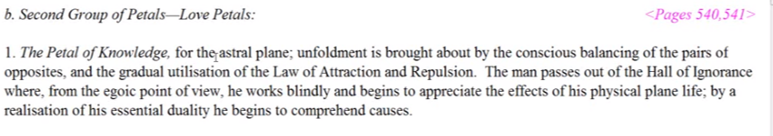
The petal of knowledge for the Astral Plane; unfoldment is brought about by the conscious balancing of the pairs of opposites and the gradual utilization of the law of attraction and repulsion. The man passes out of the hall of ignorance where from the egoic point of view he works blindly and begins to appreciate the effects of his physical plane life by realization of his essential duality he begins to comprehend causes. TCF 540
The petal of knowledge for the Astral Plane; unfoldment is brought about by the conscious balancing of the pairs of opposites and the gradual utilization of the law of attraction and repulsion. The man passes out of the hall of ignorance where from the egoic point of view he works blindly—at least he doesn't know the ego exists and begins to appreciate the effects of his physical plane life standing back somewhat one would say and by realization of his essential duality he begins to comprehend causes – causes arising from within the personality elemental and its sub elementals and causes arising from the higher aspect of his nature.
… So we have that to refer to here. We are definitely moving from desire toward selflessness. I wonder if it's ever completely achieved when the man is working in those experience to areas but when the sixth petal, I believe is completely unfolded then the first major blow against real selfishness is achieved. We're dealing here with the fourth petal overall, and in this movement out of the hall of ignorance there is definitely a beginning awareness of a higher self, a higher power which doesn't just belong to God we might say, but belongs to the human being himself. We will first deal with the energies which the words of description bring to mind and later attempt to be more systematic.
Unfoldment is brought about by the conscious balancing of the pairs of opposites. TCF 540
In other words there really is a sense that something exists within oneself that is of a higher nature and needs to be cultivated and somehow balanced with the demands of everyday life.
31:30 There's a dualism suggested here and the work of the constellation Libra, in relation to the astral plane. Some pairs of opposites are found on the astral plane but the ones we are really speaking of are the vertical pairs of opposites.
The power of the conscious mind is also suggested because the balancing is not just a feeling process, which of course is one way to achieve balance, but it seems to suggest the application of mentality and let us remember, mentality is present. It is a knowledge petal. And the third ray is related to Cancer and it's kind of a double Cancer petal. A double Cancer petal, I'll get into that, and also to Libra, suggested by the balancing process.
So if we look at the actual picture.
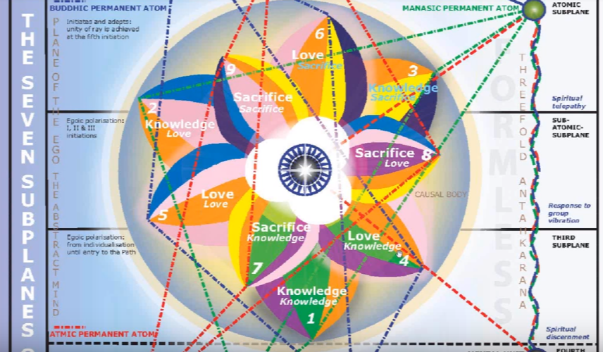
33:20 We see that by going one Aries, two Taurus, three Gemini, four Cancer, that's one way to do it. Or starting with the water signs and the cardinal we do Cancer four, Scorpio five, Pisces six, so in a way a double Cancer petal. Interesting enough the colors green and violet would be related to Cancer because Cancer at this time is expressing the third and seventh rays which the colors green and violet represent.
So we have to remember that a significant degree of mentality has been built with the opening of the third petal, or even its unfoldment, even if it's not completely unfolded. Because look at the mentality of the primary lotuses and the third petal is not completely unfolded.
So this unfoldment of the fourth petal begins before the third petal is completely open. We've learned that and maybe I shouldn't say unfoldment, I should say organizing – the organizing of the fourth petal begins before the third petal is completely open. I think one of the things I've done is to use the general word unfoldment too liberally and overlooking the organizing phase. Because as He says:
These petals are organizing and vitalized in the hall of learning but remain unopen. The outer tier of petals simultaneously unfolds till it is open entirely revealing the second circle. TCF 823
Kind of interesting that you don't see something until the next tier, until the tier before it is completely unfolded. As I begin to look at this there is a need to be careful about this word unfoldment as I have used it, as I sometimes mean it in simply a general sense as the whole process is being one of unfoldment, but let's just say there is definitely work being done in that area of life which correlates with the fourth petal before the third petal is completely open and unfolding.
36:20 And the gradual utilization of the law of attraction and repulsion. How did we look at this? Unfoldment is brought about by the conscious balancing of the pairs of opposites. I think DK really uses that word unfoldment in a similar manner to speak of the general process of organization, vitalization and opening, and then followed by the gradual utilization of the law of attraction and repulsion.
Here we have the second aspect of divinity in demonstration as it relates to the second cosmic law, the law of attraction and repulsion. Since this petal is the fourth we would expect to find much conflict between the dualities and is also so regarding the fifth petal, under Scorpio, I think strongly under Scorpio, and even under Leo from another point of view. Those two signs are very related to each other and are challenging to each other and ultimately helpful to each other, so numerologically the numbers two and four are resonant.
Now we have to wonder how much of the law of repulsion, which we sometimes know as the law of repulse, is involved here. Some attitudes and behaviors have to be cleared away, so that the individual can be increasingly under the sway of the higher of the pairs of opposites. In the work done in life in relation to this petal, in order to achieve the kind of personality integration which can be achieved in this petal. Repulsion of that which does not fit the integration process must be applied.
At first we are interested in the integration of the personality per se and not of its integration with the soul. Maybe later when the fourth petal, is completely unfolded, presumably before the 1st initiation, integration with the soul is considered and becomes somewhat effective. But it takes a long time, I think. DK tells us in the integration process we first really reach that stage of selfish personality integration, which can be indicated by either Cancer, or and especially by Leo, so there is some of this central Leo petal which can make for, at a certain stage of organizational work going on there it can make for an individual who is very selfish and thinks that the world revolves around them.
I think He tells us that the genius can be found when there are two petals unfolded in the second tier … Genius and the petals.
A creative work can be carried forward when two of the knowledge petals of the egoic lotus are unfolded. The man can produce through knowledge and creative energy something upon the physical plane which will be expressive of the soul's creative power. When two of the loved petals are also unfolding then that will take us to the 1st initiation then a genius makes his appearance. This is a technical piece of information for those students who are studying the science of the Ageless Wisdom but it is no value to those who do not recognize symbology or the fact of the higher ego or soul. Education in the New Age, page 18
So it does show us that they do unfold differentially; not all at once, but maybe the completion is all that once. I think this is really an amazing education in the New Age. So when two petals are unfolded the people who are the lotuses of passion and desire, they can demonstrate some creativity. I think that's very interesting. …
43:00 It’s very important to understand this transition into the second tier, to come up with a fairly exacting understanding. Let's just say that if two knowledge petals are unfolded, work is being done in the third petal and work is also being done, organizational work in the area of experience covered by the fourth and even fifth petal.
You understand that DK is not giving us with any kind of precision that I can locate an exact kind of method of unfoldment, but he does say that organizational work is done ahead before there can be real unfoldment in the knowledge tier. Work is done ahead of the love tier. How far ahead? That's the question. Is it two petals ahead? For instance when there is the unfolding process of the second petal, is organizational work going on in the fourth? Or is it a little different? Is it also in the fifth? When there's work being done in the third petal then is there organizational work being done in the fifth petal? I think so and maybe to an extent in the sixth.
We don't really see the petal as unfolded when that organizational work and vitalizing work is being done. When there is vitalizing it is on the verge of unfoldment. So this tells us that when two of the knowledge petals have unfolded, presumably four and five, work is definitely going on in that area of life correlated with the seventh petal, which has so much to do with what one does with knowledge and how one offers it in service.
45:25 The man passes out of the Hall of Ignorance where from the egoic point of view he works blindly.
The implication is that throughout this experience within the three knowledge petals, the evolving man has been passing through the Hall of Ignorance. So when there is some degree of opening and some organization but no real work in the second tier, the individual is blind to the higher self. At at a certain point as he begins to work in the area of the second tier, that which is the higher of the pairs of opposites comes into view and the process of balancing the personality life, with that higher self becomes an objective and certainly before the first initiation is really taken.
So before the first initiation is taken the fourth petal is necessary unfolded because if the unfolding of the fifth petal, which signifies the taking of the first initiation.
I’m kind of liking this idea of working two petals ahead. It doesn't always work out exactly but in order to consciously balance the pairs of opposites and lead to the unfoldment of the integrated personality in the fourth petal, because the personality elemental is lunar and correlated with the fourth petal, one has to be doing some organizational work in the sixth petal where what one needs and doesn't need is more clearly understood. Discrimination.
In order to balance the pairs of opposites in the fourth petal. … So while this is going on this balancing work in the fourth petal, discrimination in the sixth petal has to be underway. There is a close connection between Cancer and Virgo. They both are related to the mind … Inherently, Virgo has the third ray because of its position in a previous solar system. It was with Cancer, ruling the second part of the previous solar system, and Cancer rules the first parts of these two. They both relate to the mother aspect and increasingly using intelligence within the mother aspect.
50:00 As I go through this I begin to realize how it perhaps must work, without actually seeing it the way DK sees it surely and begin to appreciate the effects of his physical plane lives so what is he doing he is. A man passes out of the Hall of Ignorance where from ego point of view he works blindly and begins to appreciate the effects of his physical plane life. And by realization of his essential duality he begins to comprehend causes.
What has caused what, from what source, are these causes are arising? … Study your life and see. So this essentual duality at this time is not spirit and personality but it is soul and personality. It would seem that at this point in his development he begins to realize, probably more towards the end of the fourth petal development that he has an inner and higher or soul nature. At first he might simply be interested in integrating what's under the same roof. At first there is simply integration of that which pertains to the personality elemental. But later he seeks to bring into rapport with his integrating personality, the higher self which he senses, so realization of the essential duality.
52:35 Cancer is a very interesting sign because in some ways it's so material, but in other ways it has a deep connection with the Buddhic plane via Neptune and with this fifth almost-liberated creative hierarchy via Neptune, the Christ, and that with the Solar Angels. If it is in the way that the fifth hierarchy and the hierarchy of solar angels, is also a fifth, the lower fifth, and also a tenth. So the whole is seen as one and with Cancer, what is the whole for the Cancerian individual? The question arises for the Cancerian individual, what is the whole which is to be seen as one? So there is a conscious balancing of the pairs of opposites which means that something within oneself which is of a higher nature has to be balanced with the familiar self.
From another perspective, I say mentality seems accentuated in this petal. The causes which the man begins to appreciate are not simply those which are at work between things in the world of effects, but which originate from a world beyond the world of effects. In other words, how do energies from the higher of the pairs of opposites impact the world and the life of the personality?
So immediately the fourth ray, Mercury, the fifth ray, Venus and Libra come to mind, and we can undertake these a little bit farther down below. I see the method I've used is just to certain thoughts that come to mind and then the attempt to be more systematic.
54:40 Using the counter-clockwise method of assigning of vital signs of the petals a fourth sign of Cancer appears in relation to the fourth petal and this I have been stating. Cancer, like all water signs may be considered one of the rulers of the astral plane. The ocean. The plane on which dual forces are to be found in conflict under the influence of the Law of Attraction.
So what I'm referring to here is, Rule Seven in A Treatise on White Magic
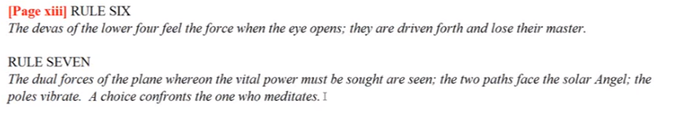
… the dual forces of the plane were on the vital power must be sought are seen the two paths face the solar angel. Or at least that part of him which is invested in the man. The poles vibrate. A choice confronts the one who meditates.
It’s very Libran type of process and seems to correlate with the fourth petal. You begin to wonder whether some kind of tendency towards one path or another is not operative or does not begin here. Does a tendency towards the left or the right begin here when having to deal with the two directions of the dual forces found on the astral plane?
56:40 Cancer is also much associated with incarnation upon the physical plane for it is the fourth sign, and the dense physical plane is the fourth or lowest vibratory level among the four vibratory strata of a personality. Cancer with the moon has much to do with dense physicality. We remember that as far as the human family as a whole is concerned there was a mass movement into incarnation through the sign Cancer, even if Pisces was the sign in which the individual unit went forth into matter.
Cancer is ruled by the moon which is directly correlated with the dense physical body which is not a principle. In any case it is suggested that man begins to appreciate the nature of incarnated life with all its limitations and its distinction from something higher and more subtle, a perspective which is no longer that of the hall of ignorance, and realizing the causes which affect the personality and outer world are indeed dual.
The number four here is also a number particularly associated with man, the fourth kingdom of nature, the human kingdom. Man as personality (something more than man is merely mind). That's what is so important because there are people who have the mind quite well developed but as an integrated personality, as something which is quite distinct, they have not yet achieved that. So man as the personality begins to emerge here through the fourth petal processes. The process of blending in fusing his many aspects is set in motion before petal does not represent the full integration in power of the fifth petal.
I think that's really important that really expressive and even dominant and noteworthy personality, but it is the beginning of making a man an integrated being and let's remember it is the soul which really works at the process of integration. The integration formulas are applied by the soul and be individual can cooperate with it.
We remember that it takes intelligence to engage in the integration process and the fourth petal processes are based on intelligence and utilize intelligence. The conscious balancing of the pairs of opposites and appreciating the effects of his physical plane life. TCF 540.
So comprehension of causes is almost as if the fifth ray can be applied in a new way, not just on things and environmental factors. But to see the relationship between an inner world of causes and an outer world of effects.
1:01:10 So one of the rays coming through Cancer is of course the third ray of active intelligence, it's the green that we see. If we begin with Pisces on the clockwise wheel, which we are allowed to do we shall have Sagittarius representing the fourth petal and Sagittarius is also very important sign of integration making of many the one, especially through the process of alignment. The straight arrow of Sagittarius symbolizes the straight alignment which must be achieved. Through Sagittarius the many are fused into the one.
I've sometimes talked about the relationship between Sagittarius and Cancer, and how both of them deal with the One. The One in this case the personality, and later when we get into the ninth petal the One is something much greater because the Cancerian mantram the whole is seen as one is being applied in the vision of the Sagittarian sees that oneness.In this sign, Sagittarius, we find the reorientation of desire, in this case towards something more subtle than material effects. Sagittarius takes aim towards a higher of the pairs of opposites. Whatever that appears to be at that point.
The two signs, Cancer and Sagittarius, are intimately associated with the creative hierarchy of lunar lords. After all the Moon is there; they're called lunar lords, and Sagittarius with Mars rules that hierarchy. So the personality itself is a four fold elemental Lord and hence this particular petal has much to do with the emergence of these four elementals as forces to be reckoned with, or shall we say, as a unified force to be reckoned with.
The number four can be very material very material. Number four represents the square of the foundational, material aspect of life. So, the personality is the body in a way. We sometimes say spirit, soul, and body, and by that we mean personality.
1:04:00 If we begin the clockwise wheel, which is the, the wheel of form, we begin it with Aries we shall arrive at Capricorn, the opposite polar opposite the Cancer, and also a sign of structural integration. So under the sway of a logical, realistic Capricorn, the effects of life upon the physical plane can increasingly be appreciated. The effects of life or the effects of the higher of the pairs of opposites upon the physical plane can increasingly be appreciated.
… I think it's quite legitimate to take always the opposite of the sign which essentially rules a petal and consider how that opposite sign may be acting in the developmental process associated with the petal. Water is definitely associated with emotionality and fire can also be thus associated to a degree; the enthusiastic Sagittarian and the sensitive Cancerian. But it's harder to associate an earth sign like Capricorn with the love petals, but water imagery can definitely be associated with Capricorn the “Sea Goat” – the goat with the tail of a fish.
We're told of Capricorn in relation to the advanced man – that is the one who crosses the water – and is thus moving into greater mentality. A process required as the personality becomes integrated. So we cannot say that there is no emotion in the Capricorn individual. It's just that the movement toward the control of the emotional nature by the mind is in process. It’s sometimes pretty hard to cross that water, and you have to cross it for manifestation in one way and you have to cross it to find your higher aspects and not be drowned in the crossing.
Kind of wonder what sign Noah's Ark could be associated with? The Blessed Ones build him an ark, it is certainly associated with the second ray and he floated upon the bosom of the waters, so look at the Blessed Ones stanzas for information on the Ark. The idea is to save what has come from the land, and at the same time not be overcome by the turbulent waters.
1:07:00 From the Capricornian perspective, the man passing through the fourth petal processes, is no longer the earthbound soul, the earthbound soul, Capricorn, the first petal, and decreasing so during the development of the knowledge petals. But by this time, no, there's a higher of the pairs of opposites and Capricorn has this duality in it with the peak of the mountain and the depth, making the diamond shape. But here he has begun then to pull himself out of the depths of density and to climb towards the pinnacle or summit of personality integration. A partially Capricornian task. The Capricornia going through fourth. processes is climbing towards a higher perspective which personality integration can reveal.
I should also say that the Capricornian tendency towards structuralization than integration will be powerfully found in relation to the Leo petal. The lion and the unicorn are found in the relationship between Leo and Capricorn. It’s also a Scorpio petal the fifth and we're told the Capricorn consummates the work of Scorpio. Capricorn consummates the work of Scorpio. So there are connections between these different signs which work out in the petals.
1:09:10 Anyway, integration is a kind of summit, it's a kind of number four, the highest point in the tetrahedron. It is the fourth point above the three, or from another perspective if the fifth point above the square, the pyramid, and either one of those shows the Capricornian perspective, but at least when there is integration, there is power. An increasing amount of power will be found in this petal though not to the same extent as when working from the fifth petal.
If we continue astrological associations with the fourth petal, we have already mentioned Libra, the sign through which the pairs of opposites are balanced, and we might say the forces of the mental plane are balanced against those of the astral plane. We've already passed through one field of mentality in the third petal and so it's not that mentality will be reduced, it will just be used from a different perspective and increasingly as one wants to be an integrated being, the elemental nature must be held in check. Now one of the first things to do is to deal with the tendencies of the astral plane, and one can do that from one's mental life, from a mental perspective. So the mental life will tend now towards the apprehension of a factor deeper within the human being, whilst the astral life is still full of desire but also of aspiration for elevation. There has been a reorientation of desire and this we can see through Sagittarius.
Yet it may be assumed that the power of Neptune, associated with Cancer, will begin to refine the astral life so that it becomes more integrated; less out of alignment within the personality and more serviceable to the personality objective. Let's just say that the purposefulness of Capricorn gives the sense of the objective and the integrated personality can better achieve that objective.
So in order to be balanced, the pairs of opposites have to be recognized. This was not the case in the hall of ignorance when attention was given to that type of mind – the kind of mind which just deals with effects rather than causes. In the hall of ignorance the mind deals only with effects and not with causes, not about that coming from a higher dimension.
This is a function of the sign Gemini in a way: I recognize my other self in the waning of that self I grow and glow. For that reason, when dealing with the pairs of opposites, Gemini and Libra have a relationship with each other. Gemini helps us when it's operating in a vertical way. Gemini helps us recognize the pairs of opposites, different from its application in petal three.
What is interesting is, always before there is an elevation there's going to be a sacrifice. So the sacrifice petals stand on the border of an elevation to the next dimension, and a sacrifice is required in order to engage with the energies of the next higher tier and it even operates in relation to the ninth petal where one wants now to engage with the energies of the synthesis tier, between the third and fourth initiation.
1:14:00 So according to our present theory, until proven incorrect, the three water signs are to be associated with three love petals. Just as the three earth signs are associated with the three knowledge petals. So again Cancer seems to be that one of the water signs which has the best fit with the fourth petal processes.
The great battles of the fifth petal is more Scorpio, and the relinquishments of the six petal suits more Pisces so we recal in earlier times, earlier than fourth petal developmental processes, it was said of the undeveloped Cancerian being, the blind to unit is lost, and that fits so well with the very first petal and its millions of years of development. At this point of development however some of the blindness is lifted. The man has entered the hall of learning and he wakens to that which is around and it’s called the house, right? … The individual awakens to that which is around, and subtly too. The house. And not just groping in blindness, Leo really rules the sight. One wonders about the animal man before sight was bestowed upon him, whether that was a Cancerian stage … I think before individualization. …
Man has learned to use the physical eye to find his way, by its means around and through his environment. The stage in human evolution wherein he learnt first to “see” lies far behind, but when man saw and could focus and direct his course by sight, it marked a stupendous unfoldment and his first real entrance upon the path of light. Ponder on this, it has also interior repercussions and was indeed the result of an involvement of interplay between the inner centers of power and the groping creature in the phenomenal world. Discipleship in the New Age, Volume II, Page 292
Man has learned to use the physical eye to find his way, by its means around and through his environment. The stage in human evolution wherein he learnt first to “see” lies far behind, but when man saw and could focus and direct his course by sight, it marked a stupendous unfoldment and his first real entrance upon the path of light. Ponder on this, it has also interior repercussions probably in relation to the third eye and was indeed the result of an involvement of interplay between the inner centers of power which can involve Solar Angels or his own monadic nature and the groping creature in the phenomenal world.
Doesn’t sound like we have individualized man yet, it sounds like individualization goes along with sight. There are so many ways in which the fifth ray and sight are connected and individualization and the fifth ray. “The groping creature in the phenomenal world making his way …” only by feeling, which Cancer can be connected. Cancer is not very much connected with sight, at least not in the ordinary sense, because Cancer as a constellation is one of the least visible. You have to really strain your eyes or use some sort of binoculars to see it. On either side, Gemini and Leo are vivid and relate very much to the promised vividness of the individualization process, but Cancer relates to previous energies which are fading away.
1:18:45 So all we have to see is the statement the blind unit is lost and we understand Cancer’s connection with blindness. Anyway some inner sight is restored here at the fourth petal processes. It is not that mentality has dropped when entering the fourth petal, not at all, if anything it is enhanced. We may remember that mental Mercury is not only to be associated with the third ray, but also very much with the fourth ray, hence the fourth petal. The fourth petal and fourth ray of Mercury are allied and contribute to the recognition of and balancing of the pairs of opposites … under Mercury. We ask what is going on within and how does it affect what is going on without? Mercury gives a very good entrance into the question of the relationship between higher and lower dimensions it's always the intermediary, not only on the horizontal plane, Mercury is the intermediary on the vertical planes. So Mercury, a fourth ray planet from its soul perspective, is a planet of discrimination, the fourth subplane of the mental plane has, for its quality, discrimination. If we go back a little further we can see how the powers of the soul and find their way here it is discrimination on the fourth subplane. This is the transposition of these siddhis, from page 188, A Treatise on Cosmic Fire, and following is very useful in that respect.
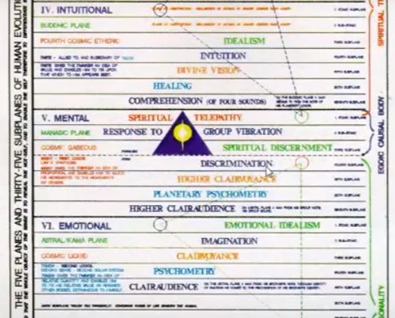

So it's a fourth ray planet from the soul perspective giving discrimination. Its associated with a fourth level, the mental plane where on discrimination is found, so four is definitely a mental number and we would say also. It is kind of the connection between kama and manas in a certain way and four is also a number of the intuition we call that Sirius gives us the fourth path out of the solar system and Sirius is equivalent to kama manas, at least it has that kind of cosmic meaning, one of its meanings. Therefore, we would expect a degree of harmonization to occur in relation to this petal, as a number of factors are to be brought under one roof, so to speak, the home, the Cancerian home, and reconciled through the harmony through conflict action of Mercury. Fourth ray forces work through the moon, ruler of Cancer, to reconcile the various forces gathered by Cancer. The elemental nature is fourfold, and Mercury also under the four ray helps to reconcile them to each other.
Vulcan has a strong fourth ray but it's quite high in its nature. Usually we can we consider its forces on the first ray. But let's say, out of four, one. This has to be accomplished in petal four.
1:23:00 So from the planetary perspective, Mercury is very important. It is a significant planet of integration and it brings the factors to be integrated, gathered together by the magnetism of Cancer, remember the attraction or magnetism gather the factors to be integrated. Bringing these factors gathered together in Cancer into relationship and contributing to their harmonization through the fourth ray.
This is not easy because in a way we are asking to harmonize energies from the hall of ignorance with the hall of learning. We are seeking to reconcile a growing light with we have visual darkness in which we have lived while gaining many faculties in the hall of ignorance. Faculties which of course can be used, but we were blinded to the fact that there are other worlds. Or at least that our own higher nature is found in higher worlds.
See, in the hall of ignorance one can believe in God but not believe in oneself, as God. And those who understand the esoteric perspective on this will realize that I'm not just saying something foolish there. Hopefully. There is always the nice good people reach up towards a God but it's dualistic. The self is in one place, the self for the nice good people is unitary and God is other. This is not true, although you will be well and truly roasted if you try to bring this forward in a declarative manner. Maybe things are not as bad as in the Inquisition, but I don't know, maybe they are getting that way. The appreciation of the effects of physical plane life is facilitated as well by Mercury and the word appreciation is interesting because Venus is the paramount planet of appreciation and contributes to the ability to evaluate and assess.
What is the value of what is going on? Where do these effects come from? That's what we have to begin to understand from this petal. What is the value of what is transpiring in the lower worlds, and what are the causes of that which is transpiring. From what dimension do they emanate? The fourth ray moon, though a dead planet, is the ruler of Cancer and it's the symbol of the fourfold personality. It’s to be contracted with the fourth ray of Mercury. Mercury represents the intelligent fourfold personality and the moon represents the instinctual tendencies within the personality. The elemental personality, which are recognized at this point as pulling in a direction different from that of mentality and the greater light.
You just have to look at Scorpio and the buddhic plane to understand what this is. Examine Scorpio and the Buddhic plane, and see Mercury as the hierarchical ruler and the moon falling. That’s what's supposed to happen: a great illumined, intuitive understanding is supposed to be focused on the elemental life, and gradually it's supposed to be lifted up into heaven.
The gradually integrating personality subject in its higher aspects to the sense of a growing in a light is working against the strictly lunar tendencies. This tells us of the struggle in the fourth petal as wherever the number four is found, there must be an initial struggle. So it's Mercury versus the moon, and intelligence versus elementality. The fourth petal is the last of the petals to be associated more with the moon than with the sun. It’s a kind of a transitional petal in that respect. Some people I think behave in the fifth petal as if the moon were still very powerful, in some ways they are kind of like Sun-Moon petals, the fourth and the fifth, but the sun is really taking over in the fifth petal processes.
Interestingly, in the ninefold structure of petals, we have a division between four below (petal one to four) and five above. I’ve talked about the note mi – do re mi – which is the buddhic note, five over four is its proportion. The Solar Angels and buddhi are meant to gain ascendancy in that fifth petal. If we have been among those who have a solar angel associated with our inner process; not all yet do. And it doesn't necessarily mean that if you have not had a solar angel associated with your individualization process that at no time can it be associated.
1:30:00 You can indeed I think a lot of people from the moon chain who came in and they had been individualized in a way without the solar angel, will then have a solar angel affixed to their inner process, in what manner I could not say. But DK treats these advanced people as if they have to deal with the solar angel and so many of them probably never had the solar Angel involved in the individualization process.
So four is in this respect a lunar number, and five is a solar number, associated with the fifth kingdom. A significantly solar Kingdom and associated with the sun-bearing Solar Angels, but there's a four that takes us into the cosmic ethers as well and to the great sun of love-wisdom and identification shining there. So only from a certain respect is four a lunar number. Whenever the process of balancing is found, a planet Saturn, foremost ruler of Libra, hierarchical ruler, and also exalted is also implicated. We recall that there is a way to associate Capricorn with the fourth petal, so Capricorn, Saturn here will be doubly emphasized. There is a an integrative task and Saturn assists, it gives structure and one has a truer human identity. From a certain perspective, third ray Saturn facilitates the integration of the four personality elementals, just as Cancer does.
The third ray is also integrative, think of how the third ray integrates the rays of attributes and sort of gathers them into a circle just as we have seen in chart six of A Treatise on Cosmic Fire, how greater Saturn is integrating many of the planetary schemes. Actually, maybe four of them. It says six but Venus and Mercury are drawn respectively to Neptune for final integration. So just as Cancer draws a kind of ring-pass-not around the forces of the personality, so does ringed Saturn contains and integrates within one space. It is after all the Planet Of The ring-pass-not.
1:33:20 I think it's been discovered that Uranus has some rings, I don't know what to make of that; it is a seventh grade planet. The idea of limitation is also found from the glyph of Saturn, we see the glyph of the moon. That the glyph of the moon is part of its construction, so if I were to draw this backwards see there's the cross above the moon.
Saturn can represent the limited, materialistic personality, which at first that's what we're going to have, but also the increasingly intelligent, purposeful and constructive personality aligned with conscience, which is a reflection of the soul's purpose which is attuned with the Divine Plan, which is formulated on the atmic plane which Saturn rules.
The third petal process processes that does cover the idea of whether it's organization, vitalization, opening, unfolding, or completely unfolded and open open processes. Developmental processes, it seems to be a way to simply deal with the whole of all those many factors that would be going on, with a neutral word.
If in the third petal processes a relatively high degree of intelligence could be reached, indeed because the very intelligent primary lotuses do not even yet have a fullness of the third petal opened. You kind of wonder whether they have to concentrate so much on the second petal that they cannot work very much in relation to the pairs of opposites in the love petals, which just would then in a way increase their skepticism because if they could work in the love tier, a sense of the higher of the pairs of opposites would be there, but so often they just shut that off – the unbelieving, scientific types, the skeptical scientific types, with the fifth ray being the law of cleavage, the cleavage between the higher self in the lower self.
If you're in third petal processes, a relatively high degree of intelligence could be reached, how much more so than under the influence of a fourth petal? A deeper kind of intelligence but the intelligence associated with the fourth petal is not yet solar, as is the intelligence of the fifth. I want to use the word completely. I am remembering the idea of the solar plexus, which connects through the astral plane.
In a way, though petals four and six have a strong lunar and Neptunium meaning, they are also associated with the sun, through the fifth petal mostly. So the sun of love is shining within the astral plane. Nevertheless the lunar petals, it’s pretty clear the first four are associated with the fourfold lunar elemental, are more specifically the lunar petals and later just by virtue of the fact that it is a petal of love for the astral plane, and love is the love wisdom of the solar logos, and so forth, there will be some association in the petals of love with the sun with the quality of the sun.
There is increasing intelligence and a more subtle kind of intelligence is growing and Neptune does it work and we also have to remember that Neptune is associated with the solar flames. Neptune is like a bridge between the sun or the moon, and the sun between Cancer and Leo; between four and five.
The third ray is called the human names of the ray lords, the “Builder of the Foundation”, and then there's no question that in the fourth petal phase the personality of a square, based on the number for use really being built. And by the time of the fourth petal unfolds you have a truly integrated personality but not a totally empowered personality which requires Leo.
Because the fourth petal individual can appreciate the effects of his physical plane life, that building can occur intelligently and somewhat in alignment with the indications of the height of a pairs of opposites, and somewhat alignment with the higher of the pairs of opposites. The building process connected with the fourth petal and Cancer is further strengthened by the seventh ray of organization of magic which also expresses through Cancer and we also see the violet, which is the color of Cancer and of the moon, from one perspective.
1:40:20 Just as Mars is one of the general rulers of the first tier of petals, and Saturn as well if we look for the synthesizing planets, so Venus is one of the general rulers of the love petals and Neptune, the second synthesizer, is part of that process. There is no petal where Neptune is not involved. Neptune is . the ruler esoteric and hierarchical, of Cancer, it is the veiled esoteric ruler of Leo (sun veiling Neptune in the esoteric expression), and it is a veiled esoteric ruler of Virgo, the moon veils Neptune and Vulcan of course.
Neptune is everywhere in this love petal process. So we might expect mystical development within the love petal processes, and maybe quite a bit even when the Virgo petal is undergoing development. There are lots of Virgo people who sort of suspend their critical analytical mind and then get into what Neptune can bring them in terms of contact with the Christ, with the higher of the pairs of opposites. Perhaps Neptune is closely related to the fourth petal, as one of the rulers of Cancer and perhaps during this fourth petal phase new levels of ancestral sensitivity are reached more so than during the development of the Second, that of sacrifice.
We did have some growing astral sensitivity and even the movement from the love of self to the love of others but its still pretty much in form, and Neptune begins to disengage from form. For better or for worse of course. Neptune helps one disengage from form so it's quintessentially the planet of fusion, the mystical fusion where all things become one, not in a very articulated way. If we have Uranus with it, all things are seen as one occultly and in an articulated manner. So the fusion of the various constituents of personality as part of the integration process occurs during this fourth petal. Not blazing expression necessarily, you might have to wait for concentration on the next peal for that. The light continues to grow as man opens one petal after another.
As we enter the second tier we are dealing with those petals through the processes of which man becomes definitely oriented towards the soul, this is in all the higher of the pairs of opposites definitely. How many people are there definitely open towards the soul. I'm thinking about the people in AA (Alcoholics Anonymous) how they embrace this higher power, that shows that they're doing definite work in the second tier, because the higher power is theirs – not just God. God the Almighty making you do this making you do that but you as a part of the highest power. Your higher power being part of the highest power and they specially specified that they are not a religious group but a spiritual group, so it makes sense.
With the second tier we are dealing with those petals through the processes of which man becomes definitely oriented towards the soul. That spiritual something in his nature which promises escape from rising over material lunar material sense-bound living so in this respect the influence of Venus makes itself felt if the fifth re-analyzing cause and effect is significant for it but the processes that Venus use as well. Venus will always take us towards the solar angel when used in a higher way, and not just for pleasure-giving satisfactions.
1:46:30 From the ray perspective … the fourth ray has been mentioned focusing upon the conflict. What DK calls, I want to use his words, internecine warfare within the province of personality between the constituents of the personality and contributing to the necessity of their harmonization. We recall that the fourth ray is expressed through both Mercury and the moon and, Mercury is called the “star of conflict”, and I would say leading to harmonization.
So there's a lot about this sign, Gemini, with its rulership by Mercury which causes a lot of division and suffering and agony upon the astral plane. The fourth ray will surely contribute to the fourth petal process called realization of one's essential duality. The fourth ray is a very dualistic ray, you can operate horizontally with it but you can also operate vertically with it. It is the vertical pairs of opposites which are somehow the most important, at least for the aspirant on the disciple.
One way of looking at this essential duality is the contrast between the solar and lunar life, as mediated by the fourth ray. Look at Taurus, moon exalted and yet giver of the highest light. Full illumination and the sun, esoterically, moves in the direction of Taurus, and the Pleiades. It is on the sixth path, of the solar logoi, and leads to the cosmic buddhic plane. It moves towards the cosmic buddhic plane, Pleaides demonstates its great Second Ray, which is the destiny of the path which our sun is on. So it is a lunar sign and a solar sign at the same time.
The struggle of Taurus is perhaps between these lunar and solar factors, where one be the elemental man – so many people with the moon and Taurus I've seen a lot of them what a struggle it is. I have friends, I also have observed in the some of the Tibetans highest disciples that moon a Taurus giving definitely a struggle with the exalted elemental, personal nature. In the last analysis the sun will prevail in the greatest light, the unfettered and the unfettered light of Shamballa will prevail at last.
Interestingly, in the Labor of Hercules related to the sign Cancer, the sun (expressing partially through Diana, though more fully through Apollo) and the moon (expressing through Artemis) are at war. So we are going to expect somewhat, not as strenuous a war as in the fifth petal, but still a war between the sun and the moon in the Cancerian petal.
We might presume that the fifth ray continues to develop through the appreciation of the effects of physical plane life. Venus, appreciation, and cause and effect fifth ray coming from Venus. Venus related to appreciation and to the assessment of the cause and effect of the fifth ray mode of thinking; it is cause and effect thinking: what really caused this? What really was the result? Because Cancer is a strong influence in relation to this petal the sixth ray of Neptune, will be prominent alongside the fourth ray. Aspiration towards the higher of the pairs of opposites eventually. So realizing that the higher must be reached, Neptune and the sixth ray reaching.
1:52:30 Another aspect of Cancer related to the law of attraction and repulsion is what we might call the … law of affiliation, the fourth petal so closely related to family and human family as a whole has to preside over the processes of human groupings. Group consciousness is coming into effect, as we see from the type of minor initiation undergone by one who has opened all the petals of knowledge. Group formation is going on here, it's accomplished very much through attraction and repulsion: what group you are gong to? What are you attracted to? What are you repelled by?
Functioning at this point on a quite personal level. So advances in social living can be presumed at this point. There is so much in this tier, regarding love and right relations within the world of men. Within the social sphere. We are still however somewhat in the realm of mass consciousness. Now I would say the real mass consciousness is going to be found at that second petal, but still until we are completely integrated personalities and have really emerged from the Cancerians sea, one will still be guided quite a bit by public opinion about what others think and not thinking for oneself.
So those with unfoldment proceeding are not yet true or complete individuals, the self-determining individual who really thinks for himself, instead of being standardized. We realize Cancer expressing the regimented, standardizing seventh ray emerges into the real individual through the fifth petal processes, but we say
“in these groups we all do this”, so we keep up the standards of our society and we do not break out into untrammeled individuality.
But when the higher pairs of opposites is coming into view and one is longing for it and seeking to incorporate it, less and less of the mass consciousness is in evidence, because one is becoming more integrated. More a unit on one's own. Really in the hall of ignorance we have more of the mass consciousness. But Cancer, through it's a solar plexus telepathy is definitely a sign of mass consciousness, no question about that. So I don't think there's been the full emergence into the really free-thinking, creative individual. The free thinking creative individual needs Leo, Uranus, and the fifth petal.
Because the fourth petal is the knowledge petal of the love tier the rays associated with knowledge must be significant so we have already pointed to the fifth ray appreciating the effects of causes in life and in the normal world, and to the third which must be important since it is so closely associated with the sign Cancer as well. Third ray will contribute to the gathering and blending of forces and to the intelligent fusion of the person, we know that the throat center, as a third ray center, is a gathering, a clearing house, before one prove he enters the esoteric life in relation to the second and first ray, and in relation to the two highest of the seven subplanes.
1:58:20 So there's a kind of a Brahmic integration which occurs before really launching into the truly esoteric factors. A Brahmic integration occurs under the third ray before launching into the more truly esoteric levels of one's being …
DK has basically said, “look of the ethers, the systemic ethers”. The fourth and the third ethers are not esoteric, but the second and the first ether are, and they correlate with ray two and ray one, but those that correlate with ray four and ray three, no, they're not yet considered to be truly esoteric.
So we've been told that the third ray cannot really express (as a factor independent from its astrological expression) until the human being has reached the stage of real intelligence. In relation to this fourth petal, this is happening. We might say, in the fourth petal developmental process perhaps some third ray personalities can be found; it would require a change either from the sixth ray to the third, or the fourth ray to the third, before man is truly an intelligent being, he cannot have a third ray personality. And only later when he is becoming more spiritual being around the time of the first initiation can he have either a second ray or a first ray personality. If he seems to have these rays they are coming in from astrological expression.
The number four is related to grounding upon the fourth plane of the personality, the dense physical plane and the personality ray has a strong effect upon the physical body, just the way the soul ray has its effect upon the astral body, and the monadic ray upon the lower mental body.
2:01:00 So this number four is related to all things that stand foursquare, it is that the city of the stands foursquare that is man I believe. The number seven as well is related to establishment upon the physical plane as it ends the fourth sign Cancer, through which the seventh ray is expressed.
… City foursquare. … Yes humanity, the city standing foursquare is the human kingdom of man. So we see in a way how much this petal is related to the fourth grade of hierarchy to humanhood, and to that standing of this particular kingdom, foursquare and anchored.
The dense physical plane, the number seven as well is related to the establishment upon the physical plane as is the fourth on Cancer. Seven is a number of integration and the fourth petal is a petal of integration, even if that which is integrated is only the lunar aspect of the personality and I want to say, at first, because higher possibilities do exist in relation to this fourth petal. There is a solar aspect of the personalities ruled by the sun and confers a strong sense of I-ness, or Ahamkara, and this aspect will emerge into real fullness with the activation of the fifth petal. Some of it has to be present with the fourth petal, I've already explained how we can have some solar quality in relation to any of the love petals.
From the chakric perspective the solar plexus center will continue to be important to all of petals especially if as proposed these petals are related to water signs, we have Neptune the sixth ray ruler of Cancer, you have the sixth ray Mars double ruler of Scorpio and you have the sixth ray coming in through Pisces and also its special ruler Neptune for the sixth ray always going to relate the astral plane to something it also has something to do with a monadic plane, but that's a higher meaning of it when one counts from below so.
The astral plane is the plane of water and access to this plane is controlled by the solar plexus center whose ray is the sixth, sometimes ruled by Mars and sometimes by Neptune depending on the quality of the individual. …
Within fourth petal processes there is some transcendence of the sacral and base of the spine centers in relation to the lower functions. The predominately third ray throat center which promotes integration of the personality is becoming influential, and has upon the sacral center, an upward draw. Now the kundalini is active in the beginning and more towards the end. We’re not talking about activating the kundalini except in such measure as it itself is active in various phases, but the deliberate activation is not what we tend to.
The strength of Mercury would signal this as with the strength of third ray earth and third ray Saturn. So we're drawing things upward here and becoming more creative two petals ahead of petal two, which when open gives some kind of creativity, as given in Education in the New Age, above. (Discipleship in the New Age, Volume II, Page 292)
2:06:25 The throat center or the of the three major centers is particularly associated with personality, the third aspect, and through fourth petal processes the elementals of the personality have been brought into an increasingly harmonized integrated infuse state. So intelligent processes are at work. Let's not forget that Libra so important in the balancing conscious balancing of the pairs of opposites distributes almost exclusively the third ray, we can look for other rays like the second, but it's known immediately for its third ray distribution, a ray which is also associated with Gemini by numerical affinity, bringing together the pairs of opposites third sign, third ray.
So we cannot really say that the heart center has become active in the fourth petal processes, but when you when you check out active in a higher way, because even man controlled from the astral plane has the heart as one of the three major centers active. Is it hard solar plexus and base of the spine? I think it's on page 170 of A Treatise on Cosmic Fire. … yes, base of spine, solar plexus and heart, but not in its higher meaning, some degree of love-wisdom and familial love and a social love will be found here. In this tier we can say in this a growing amount of social love. Love of others for their personal selves and not necessarily love of others for their soul nature. That’s a higher state, maybe it comes in more in the eighth petal.
02:09:00 The attention is on the growth of personality even if that personality has not yet become dominant and masterful as it well may do in the earlier phases of the fifth petal processes when for three, seven and sometimes eleven lives we have the dominant personality. That’s not the aspirant yet is it? So we have to wait a bit later for the later lives occurring in fifth petal experiences to get the true stage of aspiration. And usually there's a big crisis that occurs when that happens.
The heart is solar in relation to the fourth petal, but we are still very much in a world dominated by lunar considerations, by the integrating personality. But at least the sense of duality is increasing and we can do something with it matters beginning to sense something that lies beyond lunar living, even if he is not especially oriented in that direction at first. Later in these fourth petal processes, he will be. Well, I’ve always felt this fourth petal is very pivotal and needs to be understood.
It has four colors and the rose color is there as it is for all of the love petals, of the rose of aspiration the rose of the purifying astral body. We can say that one of the objectives of these love petals is to purify the astral body. That is not the case in the hall of ignorance one wants what one wants and one goes for it. But there is an increasing purification operative here, and the presence of the rose and even a double rose in the petal coming up, may be the most dramatic petal for people of our stage of development, shows … it’s not the red of the astral body the savage red, the red of wanting what the instincts want at all cost no matter what it means to others rose is entering. Rose can be used in the social contract to be considerate of others and kind of others to others even as one pursues one's own objectives. Even in sixth petal processes we have not completely eliminated selfishness maybe not until it's open and even then it's just the first major blow against selfishness.
2:12:28 I never know whether I'm going to do to or one of these, I think it's best simply to do one at this point and so what I will say is that this is the end of egoic logoic commentary program 24 and we’ll say 2 hours and 15 minutes and it's from A Treatise on Cosmic Fire, page 540. I don't think it's anything other than that I don't think we've gone that far … definitely page 540, and even the sixth petal, the petal of sacrifice will be 540, the petal of knowledge for the astral plane will be 540, so will be the petal of love for the astral plane …
I'm going a little slower I know sometimes I race along, that galloping Mercury in Aries, I have to rein it in sometimes, but I'm just trying to think this through with you and see if I can gain additional insights from when I wrote this commentary in blue, seven years ago and indeed I'm certainly finding typos and I'm finding some language now which I would like to use a little differently. It’s always a shame one has to put out what one does, and then it's in the condition it's in, and later you may have second thoughts and may want to revise, but there isn't time. Let’s just say we will now move on to the beginning of egoic lotus commentary program 25 and how long it will be we don't know, but it will be TCF 540.
Friends, I think that's it and we will persist in trying to bring light to this amazing interior process which has been operating in us for millions of years and which now is in that period when it is coming to a climax maybe all but one percent or even one tenth of one percent has been unfolded. Will talk to you soon.

