EGOIC LOTUS WEBINAR COMMENTARIES – 19, Michael Robbins

Abstract

Egoic Lotus Webinar Commentaries 19: The Origin and Type of Some Monads and the Possible Relation of these Types to Egoic Lotus Unfoldment. This webinar is about 2 hours, 17 minutes long and covers A Treatise on Cosmic Fire pages 1082-1083. In this program we study a list of sixteen types and origins of Monads. The names are fascinating and thought-provoking though not easy of interpretation. The different types and origins suggest different kinds of focus within the egoic lotus and different degrees of unfoldment. These are brought forward for discussion. In the next program the degree of unfoldment of various types of Monads is analyzed in accordance with their names.

Egoic Lotus Webinar Commentaries 19 429 MB .wmv file
Video of Egoic Lotus Webinar Commentaries 19 by Michael D. Robbins.

Egoic Lotus Webinar Commentaries 19 131 MB .mp3 file
Audio of Egoic Lotus Webinar Commentaries 19 by Michael D. Robbins.

Transcription of Egoic Lotus, Program 19, A Treatise on Cosmic Fire, pages 1080-1083

Okay, hi everybody. This is Egoic Lotus Webinar Commentaries for a kind of video book on the Egoic Lotus, and we’re into Program 19. We're going to take our study, a preparatory study from A Treatise on Cosmic Fire, pages 1080-1082.

There are a couple of paragraphs I would like to discuss before we get into the different types of Monads. Sometimes, DK calls them Egos, but it seems pretty clear to me that they are Monads. Maybe they have produced various egoic types. But it seems to me the Monad is definitely behind the egoic type, and we are not given any certain number of petals and these beings are called points. And the fact that they are called points leads me to believe that they are units of being. So let us look here.

A great factor and one that it is hard to explain so that the average thinker can understand it is the cyclic coming in of egos who are at a point in evolution where they are ready for their first radioactive life. TCF 1080

A radioactive life I think begins as one becomes a radiant lotus. The word rad, rade is there and that begins with the initiation process. So we can say that this way, initiation is the induction of radioactivity.

In one great department of hierarchical endeavour all egos are divided into two groups, according to their cycle and according to their type of energy. TCF 1080

In one great department of hierarchical endeavour all egos are divided into two groups … you see of course, the division may take place on the place of the Ego but behind it I believe is the Monad. And we can talk about Egos that are produced by particular types of Monads … all egos are divided into two groups, according to their cycle and according to their type of energy. And by cycle I suppose it means when they came in and the type of energy has to do with their particular quality. So one relates to time, the cycle, and the other relates to a particular division of the one life that is quality.

These grades are in turn subdivided according to the quality and the vibratory effect to be induced upon any one kingdom of nature by their united, or single, incarnation. TCF 1080

Because these groups do have an effect and one wants to know what their service will be so they are divided according in a sense here to the service they will render. The quality and the vibratory effect to be induced upon any one kingdom of nature by their united or single incarnation. So the original division cycle and type of energy and then a further division according to their effects.

This might be illustrated by pointing out that by the gradual coming in of human beings who are vegetarians by natural inclination and by the appearance of egos who are interested specifically in the welfare and nurture of the animals. TCF 1080

This might be illustrated by pointing out that by the gradual coming in of human beings who are vegetarians ... by natural instinct instead of what he calls quite dramatically cruel meat-eating groups of the last 500 years … who are vegetarians by natural inclination and by the appearance of egos who are interested specifically in the welfare and nurture of the animals … two different kinds of groups here, we have of course there will be naturally overlaps of course. We have the cyclic appearance of a whole group of human units who have a definite karmic relation to the third kingdom.

So the appearance of certain types of what can we call them? You know, can we call them here Monad Egos? Can we call them that? As if blending the two? Really, the two are blended. Without the Monad, there would be no Ego. The Solar Angel is a support, but the Solar Angel has not itself alone and unaided created the Ego. The Ego is really an extension of the Monad. Any type of consciousness is the extension of our own Monad supplemented, augmented, by a type of infusing of consciousness that the Solar Angel makes possible.

This relation is of a kind differing in specific detail from the meat-eating, and oft inhuman, groups of the past five hundred years. TCF 1080

05:45 See, The word “cruel” was not there but I think the word “inhuman” – not treating the animals in a humane way. All of this somehow related to early karma. He tells us where the human kingdom was devastated at times by the animal kingdom, but maybe enough is enough.

So the different types of Monad Egos coming in will have a particular effect on other kingdoms. Obviously, the vegetarians and those who are into the nurture of animals affects the Animal Kingdom in a certain manner and the meat-eating and often human groups in another manner.

It might be of profit and of interest if we here enumerated some of the occult terms applied to some of these differentiated groups, remembering that we are only touching upon a few out of a vast number, and only name those the terminology of which conveys information and educational benefit to the student: TCF 1080-1081

It might be of profit and of interest if we here enumerated some of the occult terms applied to some of these differentiated groups … of Monad Egos … remembering that we are only touching upon a few out of a vast number … and again you begin to realize what a Master like Master DK must know and you begin to wonder how he learned it. Some of it of course would not be available to even the earnest human student. One would have to be pretty well a fourth or maybe fifth degree initiate to read the inter- inner libraries, the text from the inner libraries and see the presentations of the inter-facts in order to understand this kind of material, to have this presented … and only name those the terminology of which conveys information and educational benefit to the student …

What I’ve done is I’ve thought about this in the past and never enough, because it's always so deep, nor can I give full explanation of any, but I have some notes here that might be of interest.

8:24
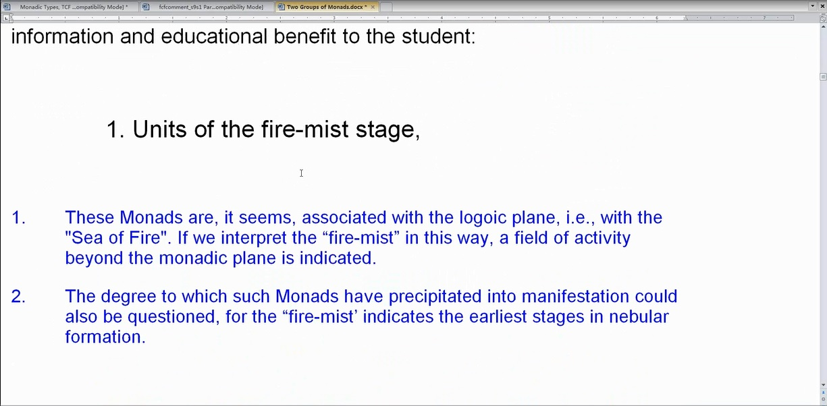

1. Units of the fire-mist stage, TCF 1082
We know that the fire-mist is associated with the logoic plane and the fire-mist is a stage in the nebular formation of that which precipitates into denser form. So the nebulae comes first, the fire-mist and the sea of fire is that in which the fire-mist occurs. When we say mist it seems like a blend of fire and water. Water being that out of which matter is precipitated. We begin to see the nebular construction of the fire-mist.

These Monads are, it seems, associated with the logoic plane, i.e., with the Sea of Fire. If we interpret the fire-mist in this way, a field of activity beyond the monadic plane is indicated. I think we understand that the monadic plane is here.

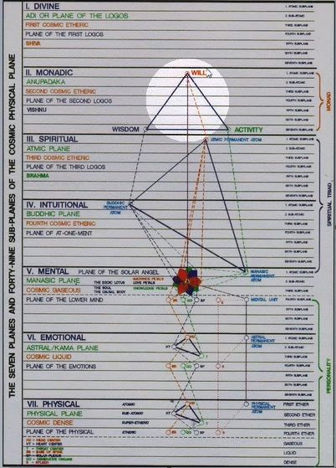

0:09:28 It is the first plane of sevenfold form. The sea of fire is found here, the first plane of the Logos. And so in a way, these beings relate to this divine plane.

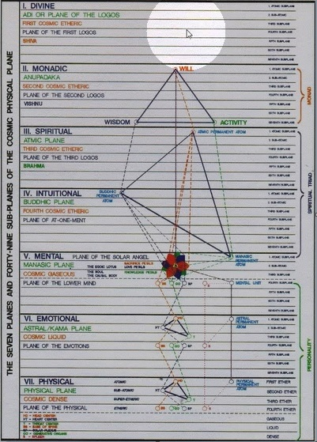

Of course, I have often said that the monadic plane is the present place of expression of that aspect of ourselves which we call the Monad. But there is within us a volatile essence, a flying essence which can liberate itself from the present monadic vehicle made of monadic essence and elemental essence of the monadic plane. And when that is liberated from the monadic vehicle, it flies a volatile, ‘volare’, flies to the divine plane. And there it takes up a different kind of habitation.

So it seems like the Monad actually … begins (well there is no beginning) but in terms of the logoic plane and then takes up habitation on the monadic plane. If at a certain initiation something, the essence of the Monad is liberated, onto a higher plane. It has to have been an essence which has come from higher planes than the one in which it is now encased. The degree to which such Monads have precipitated into manifestation could also be questioned, for the fire-mist indicates the earliest stages in nebular formation.

Our question here is to what degree have these Monads even taken the monadic vehicle? They seem to be early in their cycle. Now the Monad is said to be that which has or finds its home within the Sun.

It’s Initiation, Human and Solar, … that is such a good statement about the Monad … one wants to find it,
yes, page 196:

13:04

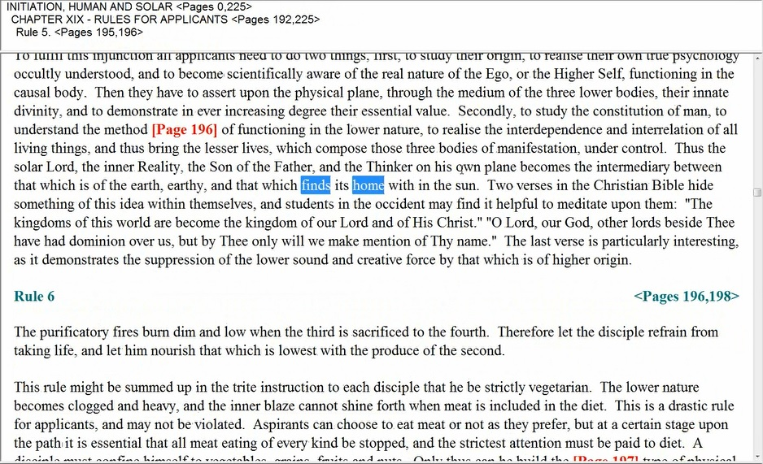

… the Thinker on his own plane becomes the intermediary between that which is of the earth, earthy, and that which finds its home with in the sun.
Initiation, Human and Solar, page 196

… the Thinker on his own plane becomes the intermediary between that which is of the earth, earthy... which is the personality … and that which finds its home within the sun.

It's a somewhat vague description, but one thinks about the essential Monad and realizes that it has to come from ever higher Beings which generate septenates and into which it flows by emanation then on into other septenates. So septenates above, septenates below.

By the Sun, I don't think it’s meant here, the physical Sun. So remember, he's talking Monads of a certain cycle I believe.

Now this next group of Monads or Monad Egos, because this group did actually come in with some degree of petal unfoldment and some of them quite a bit of petal unfoldment. We have discussed this already in terms of the Moon chain Monads, meant for the individualization, was different, yes. But they have the Lotus and that would mean it would have to be generated by the interaction between the Monad and the upward reaching aspect of the personality, the animal man of that cycle because the Solar Angels did not intervene at that time.

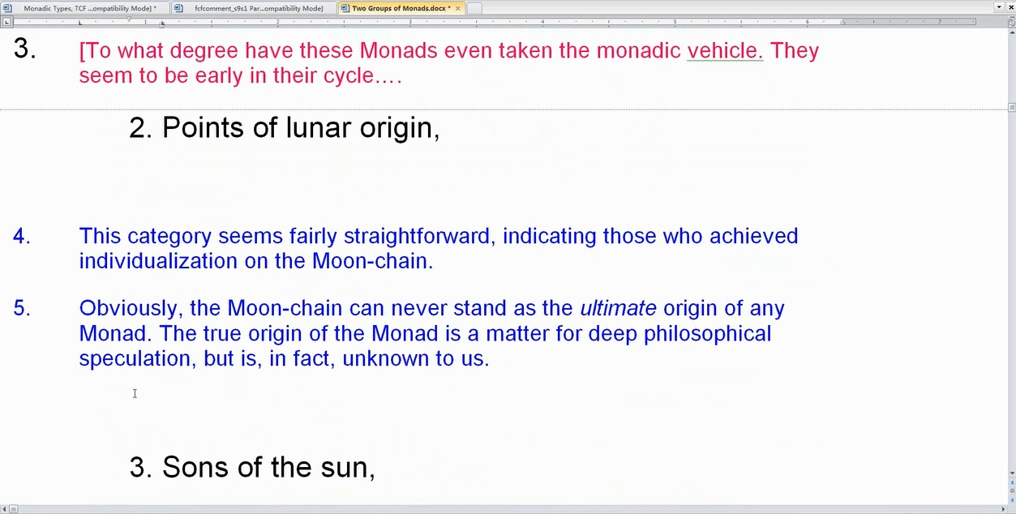

2. Points of lunar origin, TCF 1082

14:47 You know we could say that this category seems fairly straightforward, indicating those who achieved individualization on the Moon-chain. This is interesting you know. I've often thought about the Buddha, what he represents, Moon-chain Humanity. Do we know that the Buddha was individualized on the Moon? Or could he have been first solar system Humanity who appropriated an Egoic Lotus when coming to the Moon-chain. … Let’s see what DK says here.

1. The evolutionary cycle from individualization… Initiation, Human and Solar 474 … the cycle of initiation… This is not exactly what I’m looking for. 4. The Act of Individualization. The work of the particular Buddha responsible at the time… RI 268. No, this is a Buddha of Activity. No. So let’s search, Buddha and individualize, they spell it with an ‘s’… individ-u-al-ise. Well, no there’s nothing there. So this can be a little mysterious.

But the Buddha did come from the Moon-chain and he was the latest of the Moon-chain humanity to achieve. He was ready to take the third initiation on the Moon-chain. I think that the fourth initiation was offered on the Moon-chain but at the time he was ready to take the third, the third was not offered and he had to take that when he came in much much later in Atlantis. Did he really individualize on the Moon-chain?

You know, I want to kind of ask that. Alright so let's see if I can make this correct, okay.

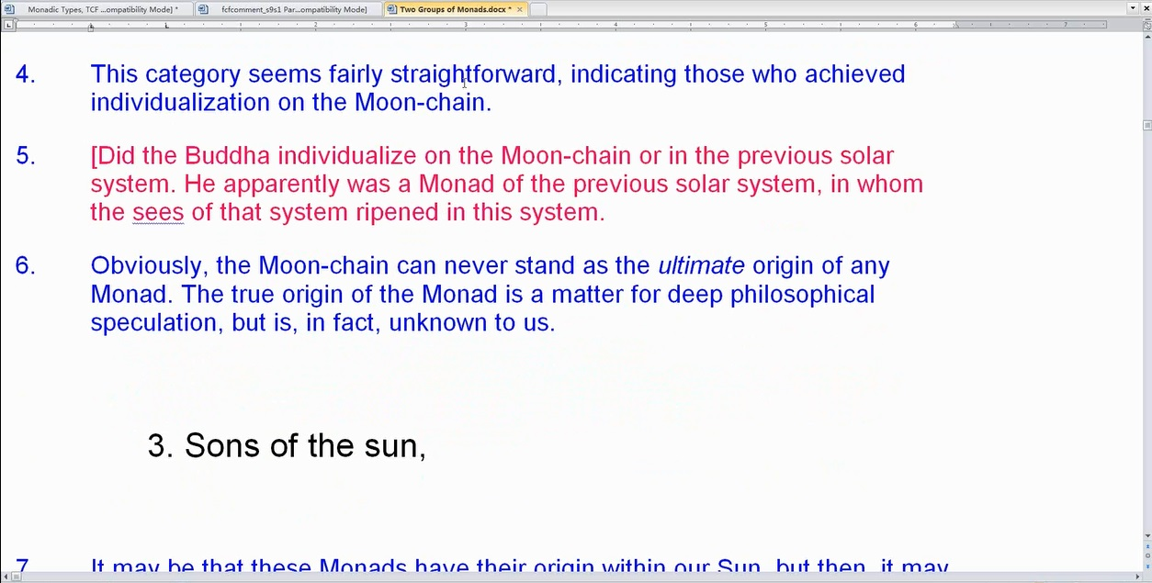

Did the Buddha individualize on the Moon-chain or in the previous solar system. He apparently was a Monad of the previous solar system, in whom the seeds of that system ripened in this system.

Anyway, there’s so many of Humanity now, at least advanced Humanity, who are Moon-chain Monads and we are told that those coming into… well let’s see. We are told that of those who came from the Moon, 75% were third ray Monads, Monad Egos and 12 ½ percent each for second and first ray Egos. So their origin here seems fairly straightforward, the Moon-chain coming into our Earth-chain later by different method probably brought in around the fourth of the third subgroup or sub-race of the fourth root race, I think that would be perhaps correct.

19:00 Alright I’m talking a little more slowly for various reasons. Some of them relating to health, one just cannot overdo it and speak too rapidly, I hope you can be patient with me. Also, the subject demands careful thought.

Obviously, the Moon-chain can never stand as the ultimate origin of any Monad. The true origin of the Monad is a matter for deep philosophical speculation, but is, in fact, unknown to us. But I suspect it is an aspect of the Ray of the Absolute. And by Absolute, maybe I should put this all in (caps) Ray of the Absolute. And in any case comes, is an emanation of the universal Logos.

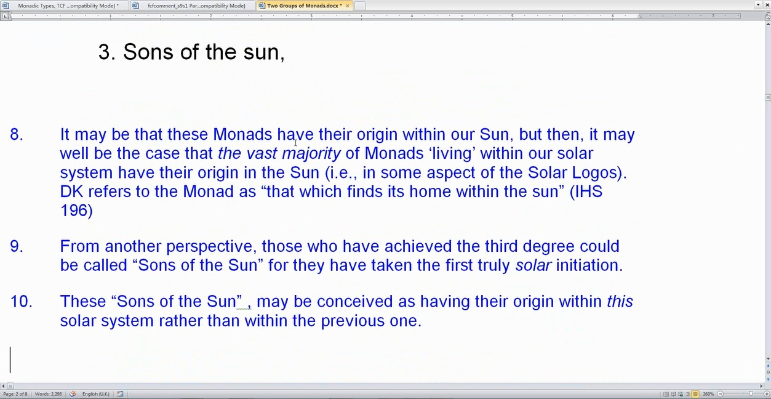

3. Sons of the sun, TCF 1082

This is interesting, in Alice Bailey I’ve been told fairly authoritatively that she intended to start a new group within the Arcane School that was to be called the Sons of the Sun. These were to be applicants to the portal of the real initiation, the third initiation. At least they were to work in that direction.

So there, the solar aspect of these Monads is emphasized. It may be that these Monads have their origin within our Sun, but then, it may well be the case that the vast majority of Monads ‘living’ within our solar system have their origin in the Sun (i.e., in some aspect of the Solar Logos). DK refers to the Monad as that which finds its home within the sun. IHS 196 Probably essence requires identicality with essence. So it would be ultimately from the monadic aspect of our solar Logos. DK refers to the Monad as that which finds its home within the sun. Yes.

From another perspective, those who have achieved the third degree could be called Sons of the Sun for they have taken the first truly solar initiation. You know the first two initiations are planetary and initiations of the threshold and the next two initiations are well, the next five initiations are solar. So mastership in relation to our Sun is actually the sevenh initiation which is the third initiation in relation to Sirius.

These Sons of the Sun, may be conceived as having their origin within this solar system rather than within the previous one. That’s one way to think of it of course you know, the sons are different, the entity is the same. The solar Logos has had apparently five solar logoic incarnations, three of them a minor corresponding to the etheric, physical, astral and lower mental. The last one responding to the personal, which is personal mental. Every personality is of the third aspect of divinity and so when we talk about a previous third ray solar system, we’re probably quite correct even though it may have had the personality focus. The present solar system seems to be given over to the development of the soul of our solar Logos. So maybe, it is, these Sons of the Sun, may be conceived as having their origin within this solar system rather than within the previous one – the previous personal solar system.

It's very hard to think about even the proximate origin of the Monad. Philosophically we can trace it all the way back to the one emanating source of all cosmos but when we look at the Monad’s recent history, from whence has it really come. Every planet is in a sense a chakric aspect of the Sun, every sun is a chakric aspect of a cosmic Logos. Every cosmic Logos is a chakric aspect of a super cosmic Logos. Eventually, they will all be chakric aspects of a galaxy, and the galaxy itself. But a chakric aspect, an emanation of an aspect of a larger super galaxy, family of galaxies and on and on it goes until we finally reach the One.

24:35 So all of us are emanations of this. The Sons of the Sun though, from the point of view of time, if they're passing through the third initiation, then of course the opening of the ninth petal is characteristic of them:

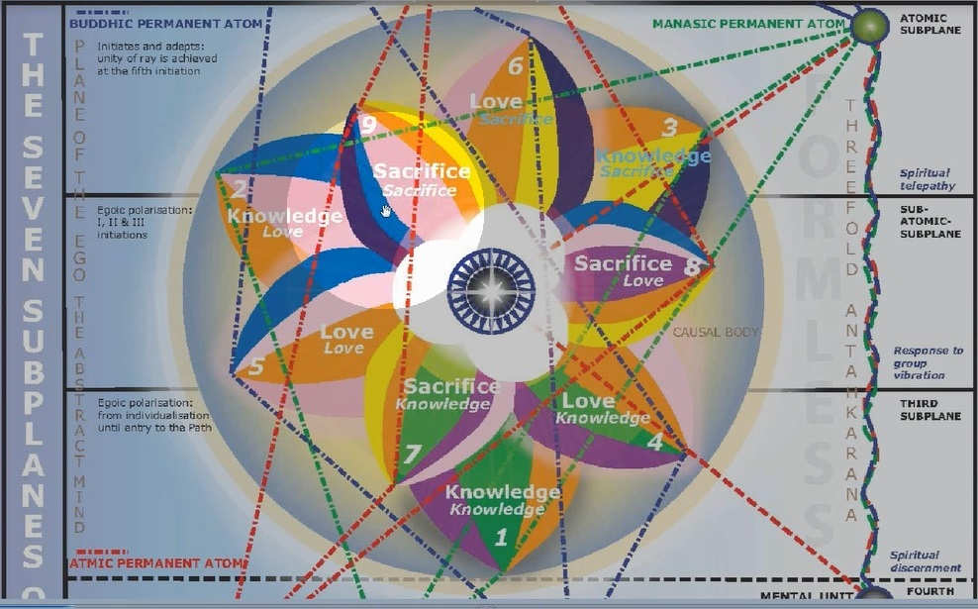

If we're talking about the kind of energy that they express, then within the particular Egoic Lotus there's no way to locate them particularly because the Egoic Lotus is a cyclic structure or the degree to which it is unfolded corresponds with time and cycles. The type of Monad behind the Egoic Lotus, while it may be released in a certain time into manifestation, does not tell us so much about the unfoldment of the Egoic Lotus.

I mean if we know that points of lunar origin originated before, let us say, Sons of the Sun, we're likely to think that the point of Lunar origin has a greater degree of unfoldment. Or we cannot tell how much. The Sons of the Sun, if they are Monads of this particular solar system. Let me clarify that: a point of lunar origin would still be a Monad within this solar system and would be unfolding before one of the Sons of the Sun, probably.

The Sons of the Sun probably are certain types of Egos and the question is at what time were they released? If they were released later, then their unfoldment will normally, except for rare example such as the Christ, be of less development, less unfoldment. Alright … I really can only speculate upon the nature of many of these names.

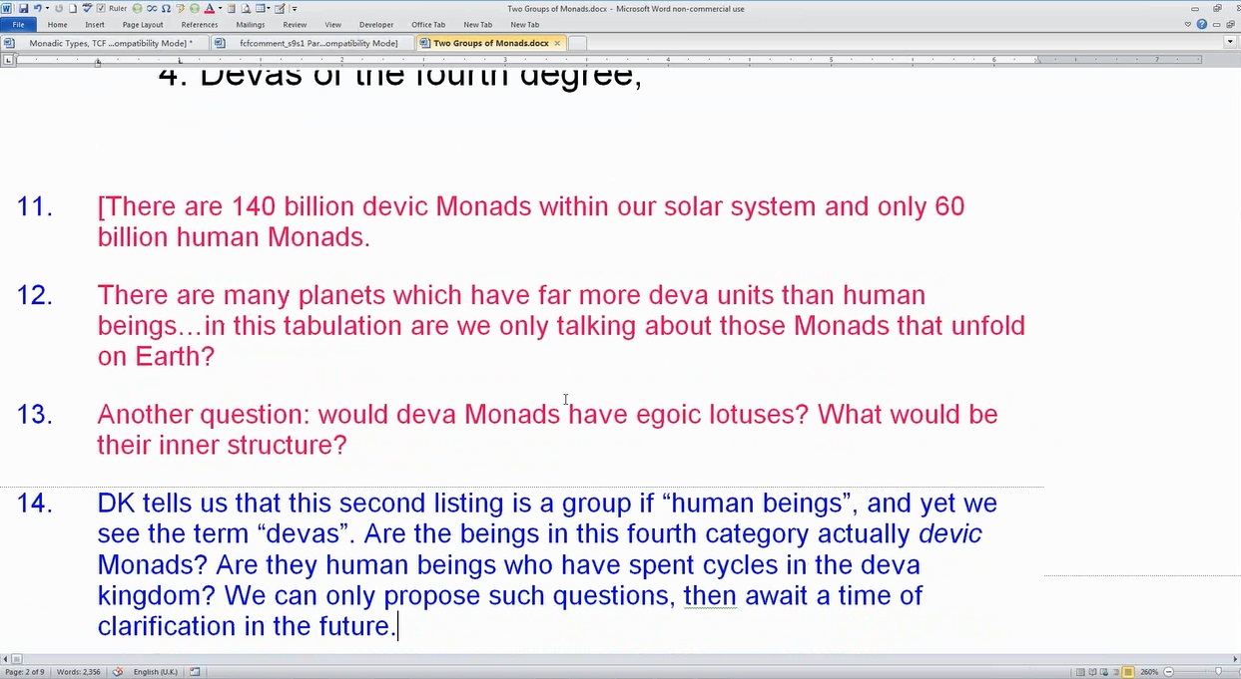

4. Devas of the fourth degree, TCF 1082

You know what's interesting? There are 140 billion devic Monads within our solar system and only 60 billion human Monads. … So, when he talks about devas, these can certainly be Monads. DK tells us that this second listing is a group if human beings, and yet we see the term devas. Are the beings in this fourth category actually devic Monads? Are they human beings who have spent cycles in the deva kingdom?

So there’s different questions I’m asking here. Are they actually devic Monads? Because every Monad has a, every deva has a Monad, every demonstration of the one infinite being has, in a sense, a Monad or as part of the monadic demonstration. So, we can await the time of clarification. But you know, in our solar system, there are
many planets which have far more deva units than human beings. In this tabulation are we only talking about those Monads that unfold on Earth? Maybe not. And then another question is do Monads have egoic lotuses? What would be their inner structure?

29:09 And we have no teaching on that point. Their structure might be quite different and yet they do unfold through intense feeling and through identification through building themselves into form. They unfold in different ways than the human being unfolds. So would they apply in terms of Egoic Lotuses?

DK talks about egos here in this section, maybe it is so. And right below I can see of course that we are not just talking about egos from the Earth chain. I said here on my point number 19, that again, since the term fourth degree is used, the fourth initiation could in some manner be indicated. Or the fourth or buddhic plane and a focus in relation to it? Possibly.

4. Devas of the fourth degree, TCF 1082

You know increasingly as man rises, I wonder you know interesting… the fourth degree. We should note that the Solar Angels seem to have a place on the buddhic plane. And I think you can see that in one of our diagrams, we go here just a little further. This one:

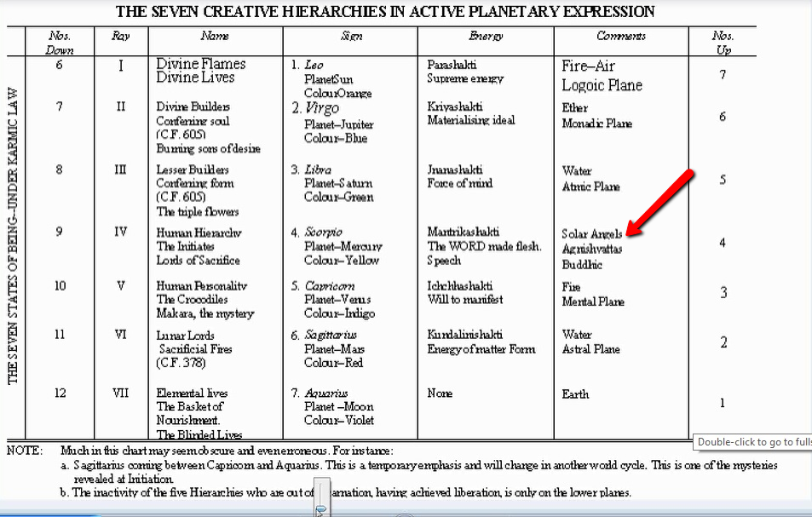

Take a look at the buddhic plane here, and we see Solar Angels, Agnishvattas, Buddhic. It seems the place at least to which they have descended in a kind of first fall and they are working from that place in their first fall. The second fall would be their extension into the dense physical body of the solar Logos and hence the mental plane.

5. Flames from interplanetary spheres, TCF 1082

Obviously we are not simply speaking of Earth Monads. These Monads may have their immediate origin (immediate, before being transferred to the Earth-scheme) on other planetary schemes, or, there seems to be a suggestion that there may be points of origin between the various planetary spheres. It depends on what the word ‘inter’ means. Interplanetary, it can mean between usually. ‘Intra’ means within.

Notice that Monads are called Flames – can we think of the egoic lotuses as Flames or perhaps Solar Angels as Flames. Lords of the Flame, you know. Lords of the Flame of course can be considered to be the Kumaras … and Kumaras can be considered as planetary Logoi. But Solar Angels eventually make planetary Logoi so maybe in groups, so maybe the higher types of beings can be referred to occultly, subjectively, as Flames. Anyway, they come from elsewhere and whether they remain there or come to Earth, we have heard of their Monads that come to Earth now and again.

DK discusses this in terms of Monadic origin or sometimes you’re just simply used to the word ‘ego’. It’s up to us when we see that word ego to know whether he means an already formed Egoic Lotus or whether he's concentrating on an earlier type of origin, the Monad itself, arriving in the Earth scheme either ready to individualize or carrying with it in a way its own Egoic Lotus.

One can also wonder about obscure origins what has been called the ‘inner round’. Which may well be etheric locality, etheric cloves. Every time you see a 7, you should suspect a 10 and the 3 that would make the 10 with the 7 may not be tangible. What else might we think of? Certainly, such Monads do not belong originally to our Earth-scheme.

34:31 But then you kind of wonder how many Monads actually do belong originally to our Earth scheme at all. The reason we would ask is because our planetary Logos does not create an expression that lasts throughout the mahamanvantara. The reference on that you know, you might want to see it … Okay and let’s see what we have here, and here it is:

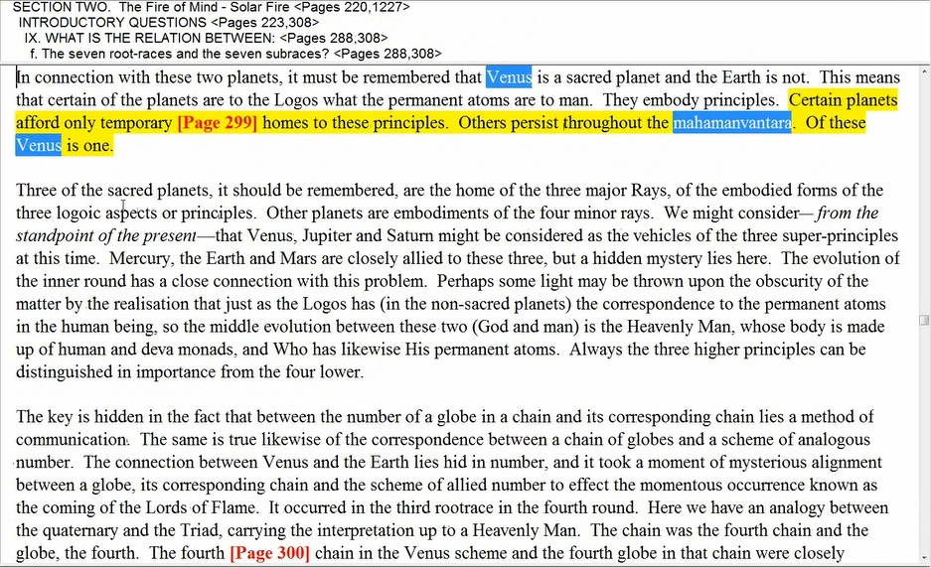

Certain planets afford only temporary homes to these principles. Others persist throughout the mahamanvantara. Of these Venus is one. TCF 299-300

Certain planets afford only temporary homes to these principles. The planets and by its principles is what it’s trying to say. Others persist throughout the mahamanvantara. Of these Venus is one. They embody principles. Let’s see if there’s anything else here … Vulcan and Venus schemes – Their work is nearly completed. TCF 742, which is the same reference about the mahamanvantara, simply gathered at the end of Esoteric Astrology. Okay.
Now we’re talking about…

The coming of the Lords of Flame to the Earth was all under law and not just an accidental and fortunate happening; it was a planetary matter which finds its correspondence in the connection between the mental unit and the manasic permanent atom. TCF 298

There is such a hint about the relation of Venus to the Earth. Venus being the manasic permanent atom and Earth upholding a kind of mental unit position.

Again, as the antaskarana is built by individual man between these two points, so – again in a planetary sense – is a channel being built by collective man on this planet to its primary, Venus. TCF 298

Venus is the primary alter-ego, the word primary is often related to Monad but okay, in this case it is a… well it may be actually that which absorbs the principle of Earth eventually. But let’s just say Venus is the sacred planet, Earth is not. It seems to imply that Earth is not a planet which lasts throughout the mahamanvantara.

The mental unit really is providing a kind of temporary home to the manasic principle. It is consumed, isn’t it? It’s a kind of a division of the manasic permanent atom and it even suggest in the relationship between the fourfold mental unit and the threefold manasic permanent atom. At least three spirillae in that manasic permanent atom that we have the Earth, the mental unit being actually a part of the manasic permanent atom completing the seven, and the Earth in a sense being a part of Venus. But of this, we will learn more trillions of years later when there is an absorption of the subtle principles of the planet into greater planets of greater development of which Venus certainly is one. The whole question of how planets are absorbed into each other is of the greatest interest.

5. Flames from interplanetary spheres, TCF 1082

So Monads are called flames and maybe in a certain sense, when you look at what the Egoic Lotus is in its truer demonstration, it can look flame-like but this a word which is frequently used in terms of the Monad, the Monad is sometimes considered to be part sparks hanging from the one flame by a thread of finest fohat. Now here we go again.

6. Atoms from the crimson sphere— a reference to certain Egos who have come to the earth from the planetary scheme whose note is red, TCF 1082

Atoms from the crimson sphere … you know one thing is atoms, one thing is Egos … a reference to certain Egos who have come to the earth from the planetary scheme whose note is red.

Well the language is occult, mixing and blending the terminology of colour and sound. Note is red and we could say that the obvious choice for the origin of these Monads is the planetary scheme of Mars, with which the color red is always associated.

39:50 I think if we look here, let’s just go to this and then will backtrack just a little bit. And here are the planetary schools and other planetary schools for at least for dense physical planets which includes Vulcan interestingly enough.
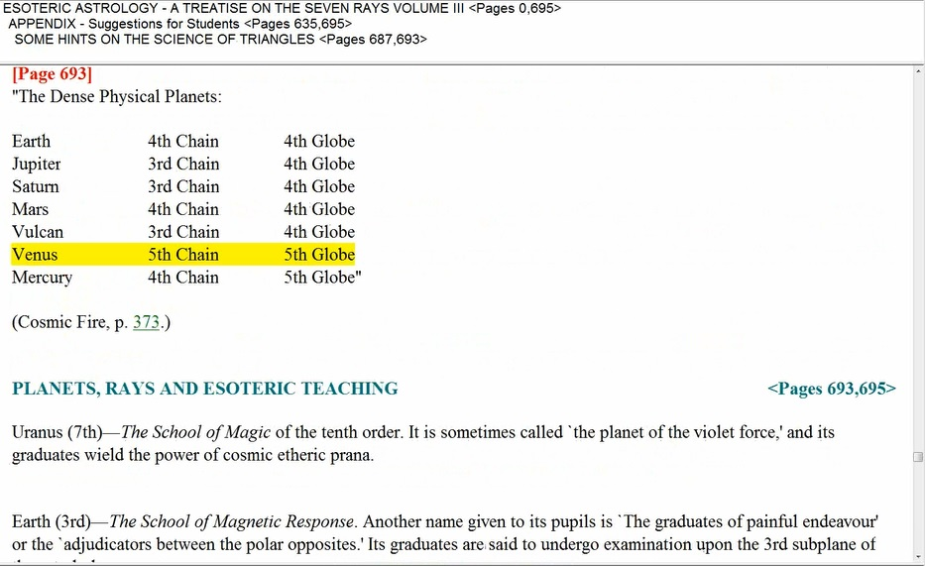

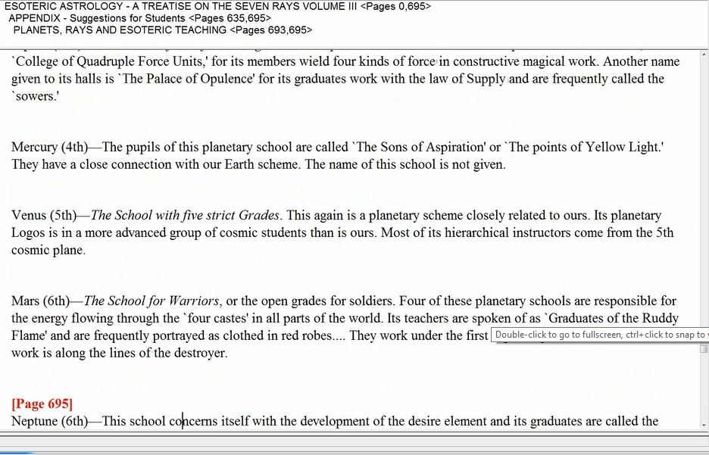

Mars (6th)—The School for Warriors, or the open grades for soldiers. Four of these planetary schools are responsible for the energy flowing through the `four castes' in all parts of the world. Its teachers are spoken of as `Graduates of the Ruddy Flame' and are frequently portrayed as clothed in red robes.
Esoteric Astrology 694

So the Kshatriya … the warrior caste in India, they are the next to the highest class of brahmas. Its teachers are spoken of as `Graduates of the Ruddy Flame' and are frequently portrayed as clothed in red robes.... The color rose or red is very associated with Mars. Ruddy, red. Elsewhere it tells how they carry ebony wands for some. Here, it has dots and at other places it talks about them carrying wands of black. I suppose black and red, it seems to suggest Scorpio and when you're dealing with crimson you are I think dealing with Scorpio. Scarlet red is more associated with Aries.

41:35 So it seems to be Mars, and monads are most definitely atoms … Monads are most definitely ‘atoms’. Any ‘unit of being’ is, occultly, an ‘atom’. I think we have to understand that, let’s see. I mean if a solar Logos can be an atom, a Planetary logos and atoms, so can a Monad be an atom? I think H.P.B. writes about the identicality of Monads and atoms. It’s probably put forward in a different way than this, but any unit of being is atom, any ‘unit of being’ is, occultly, an ‘atom’.

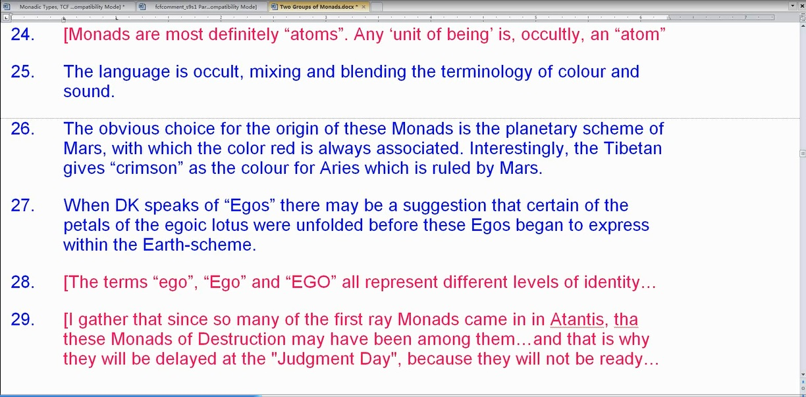

When DK speaks of Egos there may be a suggestion that certain of the petals of the egoic lotus were unfolded before these Egos began to express within the Earth-scheme. It is possible although you know, Mars is a less developed a planet and Earth just as Pluto is said to be though it is esoteric, less developed than Mars which is its alter ego just as Venus is the alter ego of the Earth. So this word ‘ego’ spelled in small letters, spelled with a capital ‘E’, spelled in all caps. It means different levels of identity.

The terms ‘ego’, ‘Ego’ and ‘EGO’ all represent different levels of identity. … this is found there on Page 177 of Treatise on Cosmic Fire and certainly represents the triad rather than simply the ego on the higher mental plane … all represent different levels of identity. So are these Monads that have come from Mars and then the individualized. Yes yes yes that's pretty interesting. I just had a thought here, lions of the destroyer. I think. It’s just first time this thought has come to me but I gather that since so many of the first ray Monads came in in Atlantis that these Monads of Destruction may have been among them… and that is why they will be delayed at the Judgment Day, because they will not be ready.

45:10 Alright, you know as you read through, I’m not saying that that supposition is actually correct, but it makes sense to me. It seems to follow the Law of Correspondences and as you read along, these kinds of connections occur to you. And as they do … occur, note should be made of them. There are many missing pieces in our understanding of the teaching and yet DK has given us so much more on various levels, undetected levels. His writing in a multi-layered manner for those with eyes to see and then for the rest of us who may not have at a certain time eyes to see and later gain eyes to see. So much is there that we don’t suspect is there, and then something jumps out at you and there it is.

In terms of the Egoic Lotus, the Atlantean petals, let’s look at the Egoic Lotus, and see how much Mars there is in this first petal, and also the second petal. Some of the least advanced of those who are with us now as human beings will have individualized in Atlantis rather than in Lemuria and they are still in the Martian state which we can call more the savage state.

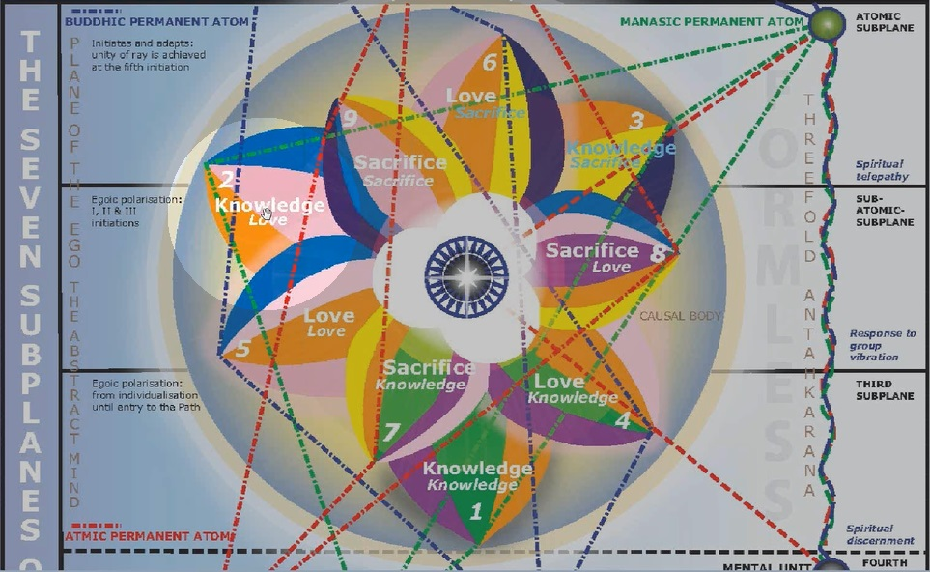

Also, they are connected of course with Atlantis and the Atlantean petal which is the second petal. So given that things will proceed in a normal way, we might say that according to the time of individualization, the cycle in which the individualization occurred, so will be the stage of development in which we find these different groups.

But there's a lot of first ray in connection with Mars and since it is a non-sacred planet, the ray that we are given concerning it just as we are so much given the third ray in connection with the Earth would be the ray of its personality: third ray personality of Earth, let us presume sixth ray personality of Mars with the first ray soul, and maybe a fifth ray Monad which is a supplementary Monad, and finally a first ray Monad in the higher sense, it could be. But this is speculation. One must speculate in order to understand, to put a proposition, test them and see whether they really work.

Vyasa was a very ancient Teacher, we are told, and helped men prove that death is an illusion. That's what DK says about him. So perhaps these were Monads or egos grouped around him and instructed by him and have successfully proved to themselves and others that death is an illusion. Were there ‘unsuccessful’ Vyasians? That remains to be seen. Did such Monads/Egos achieve in ancient days when their Teacher was instructing humanity, or are these still those among us who could be called ‘successful Vyasians’?

In any case, it seems apparent that these Monads or Egos were linked to the Teacher Vyasa or to the stream of teaching which emanated from Him.

49:38 Now usually the chronology that has been handed down to us except for the brahmanic chronology is pretty condensed. It’s pretty fore-shortened if we look at Vyasa here. (Google: Vyasa – Wikipedia)

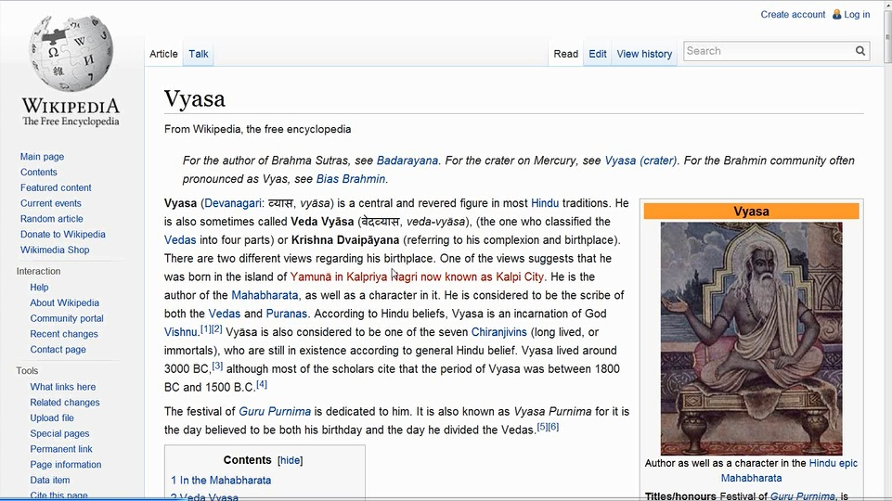

Vyasa … is a central and revered figure in most Hindu tradition. He is sometimes called Veda Vyasa… in the Mahabharata. So let’s just see. It looks like a very venerable stage. Author as well as character in the Hindu epic, the Mahabharata. Called Veda Vyasa, the one who classified the Vedas into four parts. And also… Krishna Dvaipayana (referring to his complexion and birthplace). Here it has… Vyasa lived around 3000 B.C… Vyasa is also considered to be one of the seven Chiranjivins (long-lived or immortals), who are still in existence according to general Hindu belief. Well certainly, a Master you know, certainly a high being. Vyasa lived around 3000 B.C. or the most scholars cite that the period of Vyasa was between 1800 B.C. and 1500 B.C.

Let’s see what DK says about him. Oh my goodness, there’s quite a bit.

… and once or twice from cosmic sources, have at times lent Their aid… profound wisdom and experience, They stimulated earth’s evolutions and brought the purposes of the Planetary Logos so much the nearer to completion. Then They passed on, and Their places were taken by those among the members of the Hierarchy Who were willing to undergo a specific training and expansion of consciousness. In turn these adepts and Masters had Their places filled by initiates, and thus constantly has there been opportunity for disciples and highly evolved men and women to pass into the ranks of the Hierarchy, and thus constantly has there been a circulation of new life and blood, and the coming in of those who belong to a particular period or age.Some of the great names during the later periods are known to history…

Some of the great names during the later periods are known to history… and once or twice from cosmic sources, have at times lent Their aid… profound wisdom and experience, They stimulated earth’s evolutions and brought the purposes of the Planetary Logos so much the nearer to completion. Then They passed on, and Their places were taken by those among the members of the Hierarchy Who were willing to undergo a specific training and expansion of consciousness. In turn these adepts and Masters had Their places filled by initiates, and thus constantly has there been opportunity for disciples and highly evolved men and women to pass into the ranks of the Hierarchy, and thus constantly has there been a circulation of new life and blood, and the coming in of those who belong to a particular period or age.
Initiation, Human and Solar 37

Probably divine circulatory flow. Some of the great names during the later periods are known to history, such as Shri Sankaracarya… apparently living in B.C. although many people have said A.D. I think DK settles on B.C. … Vyasa, Mahommet, Jesus of Nazareth and Krishna, down to those lesser initiates, Paul of Tarsus, Luther, and certain of the outstanding lights in European history. Let’s see the era. Some of the great names… Vyasa…

Page 29, this is in The Light of the Soul and it has taken Alice Bailey’s writing in the commentary here. These are Vyasa’s commentaries.

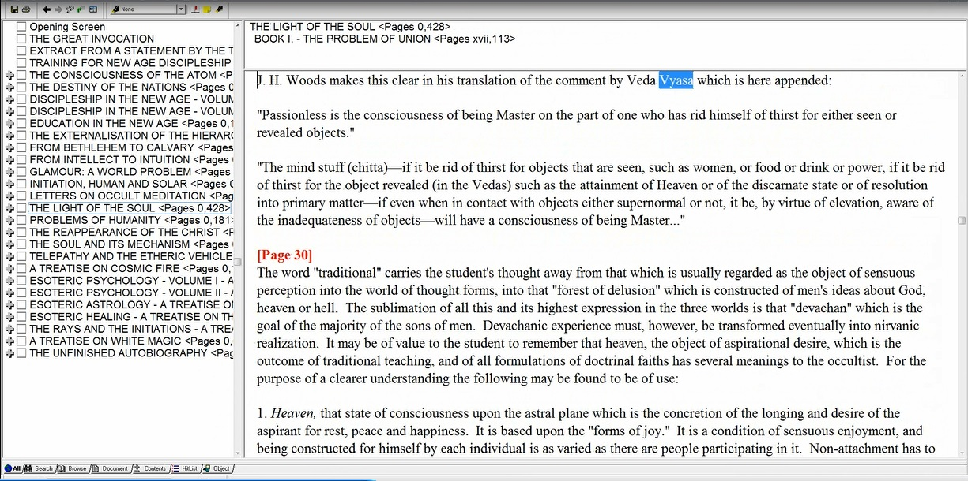

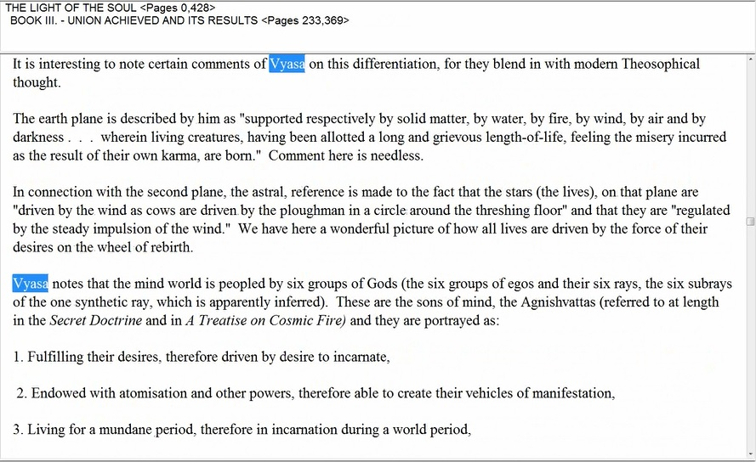

Vyasa notes that the mind world is peopled by six groups… The Light of the Soul 299

He’s a very great sage. Vyasa notes:

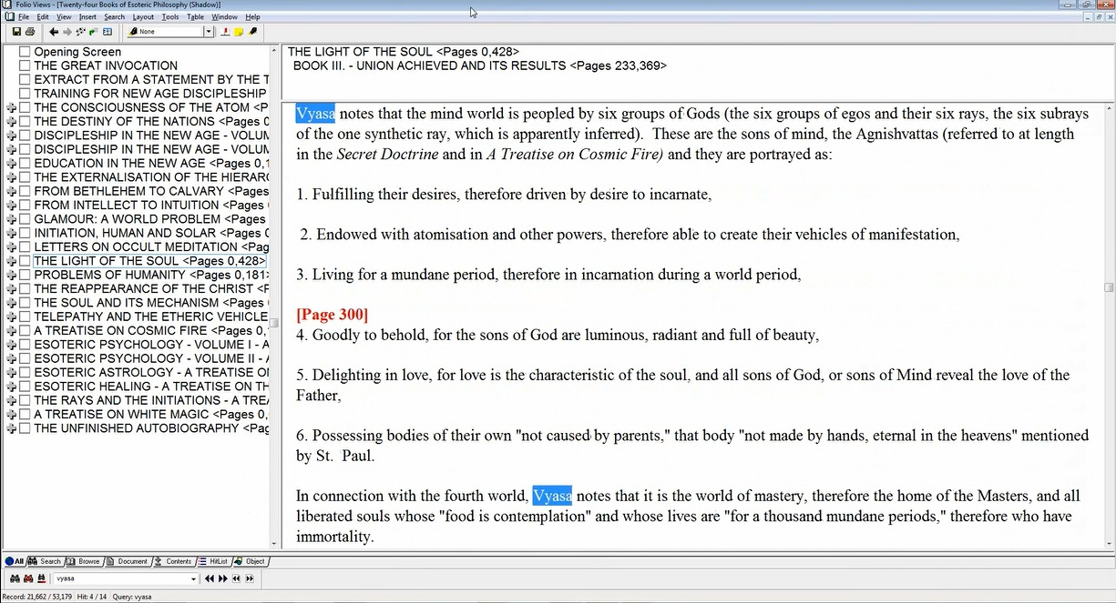

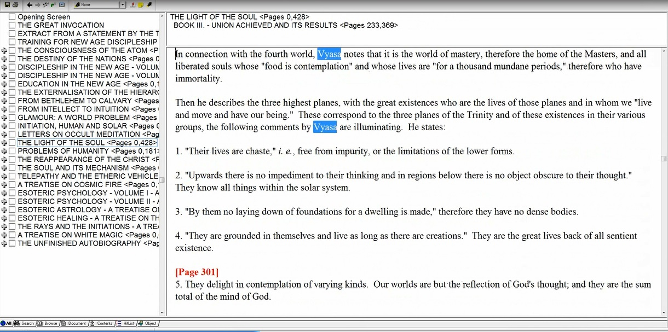

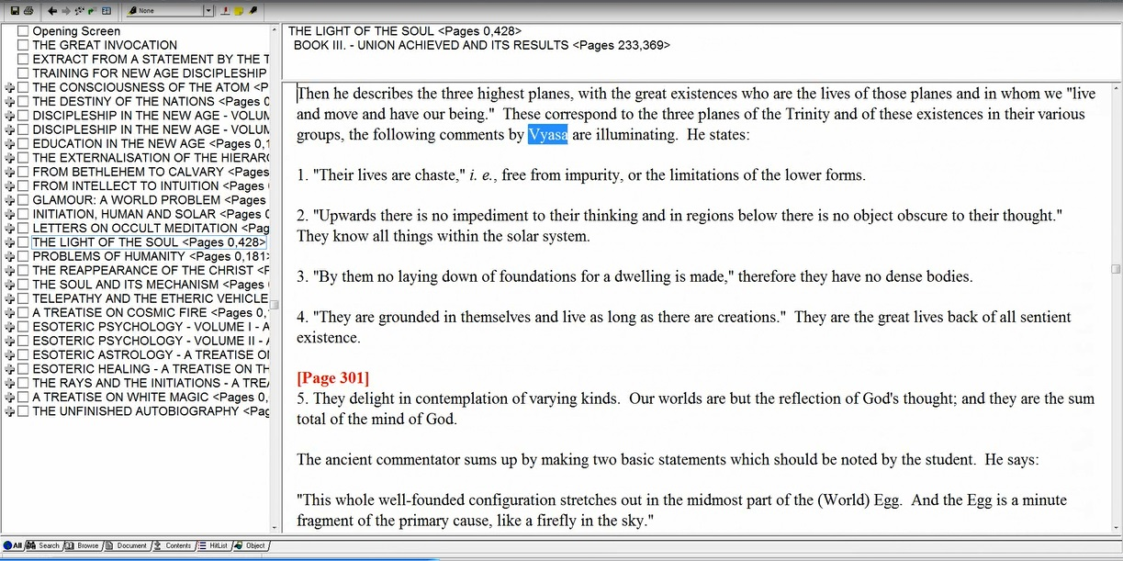

Okay. Most of this is by Alice Bailey. I’m interested [to see if] DK might be in the position to place the cyclic timing of Vyasa. In The Light of the Soul:

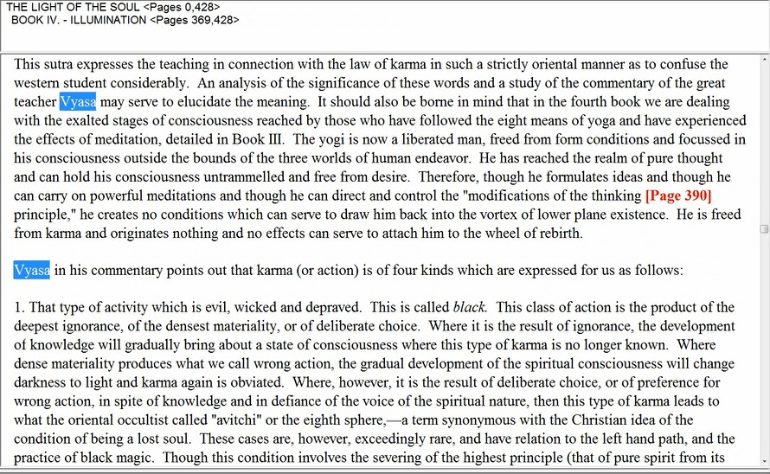

An analysis of the significance of these words and a study of the commentary of the great teacher Vyasa may serve to elucidate… it’s mostly about what Vyasa said. Vyasa in his commentary points out that karma (or action) is of four kinds… etcetera. A great sage indeed…

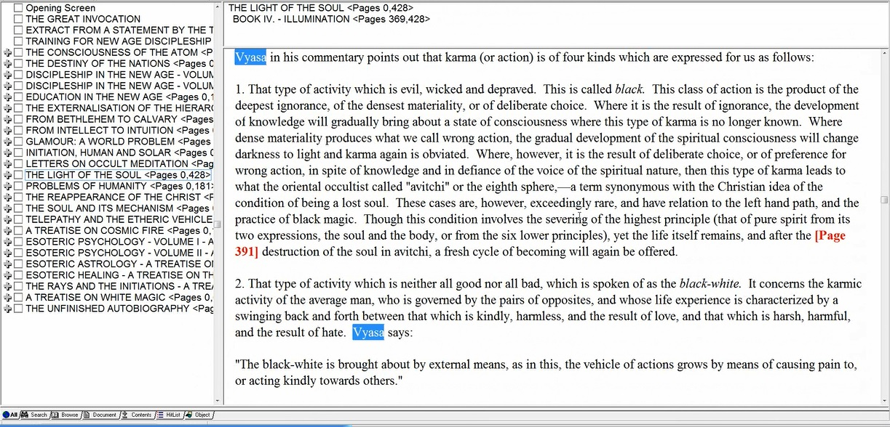

And, Vyasa says, again, Vyasa says, and Vyasa explains it thus.

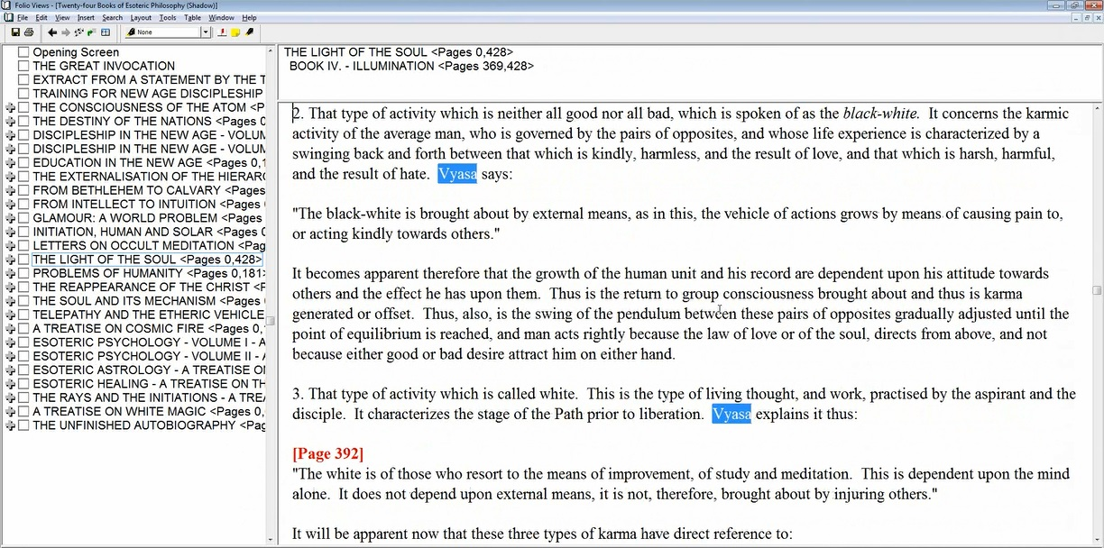

Okay now, here we have some discussion of The Reappearance of Christ about the timing of appearance of Vyasa which might tell us something about who are successful Vyasians. I mean are they those who are being taught or who have followed his teaching? Taught by him at that time or those who have followed his teaching?

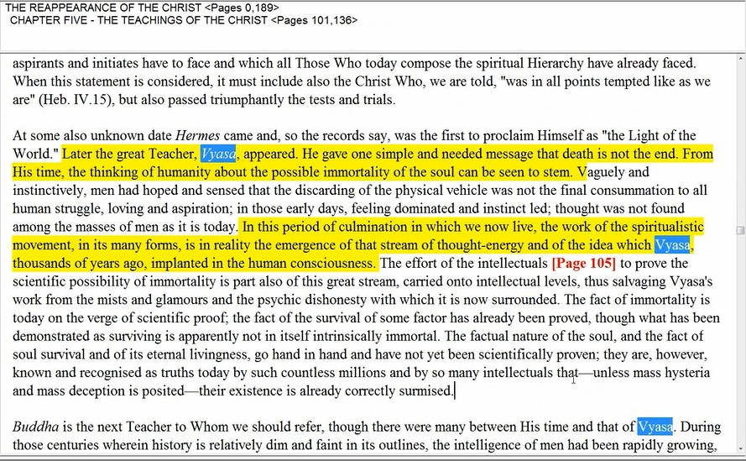

At some also unknown date Hermes came and, so the records say, was the first to proclaim Himself as ‘the Light of the World.’ Later the great Teacher, Vyasa appeared. He gave one simple and needed message that death is not the end. From His time, the thinking of humanity about the possible immortality of the soul can be seen to stem. The Reappearance of the Christ 104

55:22 Of course in a way, Humanity knew something of this with its closer contact with the spirit world. But then according to Blavatsky, lost that sometime in Atlantis with a period of de-spiritualization and densification.

In this period of culmination in which we now live, the work of the spiritualistic movement, in its many forms, is in reality the emergence of that stream of thought-energy and of the idea which Vyasa, thousands of years ago, implanted in the human consciousness. The Reappearance of the Christ 104

In this period of culmination in which we now live, the work of the spiritualistic movement, in its many forms, is in reality the emergence… this is so interesting … of that stream of thought-energy and of the idea which Vyasa, thousands of years ago, implanted in the human consciousness. Thousands of years ago. So we get the idea, well he didn't say millions of years with Hercules, you know he was Atlantean. Vyasa may have been Aryan. Since Hercules was Atlantean, we’re dealing with millions of years ago.

Buddha is the next Teacher to Whom we should refer, though there were many between His time and that of Vyasa. The Reappearance of the Christ 105

Aha, many between his time. Well, it can go in either directions. So Vyasa I think pretty much was pre-Buddha. Okay, here’s another one.

Buddha answered the questions posited in His time by giving out the Four Noble Truths… – the realm of physical living, which is the true death of the spirit. He made a unique contribution to the teaching given by Hercules and Vyasa, and added to the structure of truth which They had erected… Between the times of these two great Teachers, the Buddha and the Christ, lesser teachers appeared to amplify and add to the already given basic truths; of these Sankaracharya was one of the most important. The Reappearance of the Christ 107

He made a unique contribution to the teaching given by Hercules and Vyasa... who was that, Buddha did that. So Vyasa clearly was before. Hercules seems to have been a bit before Vyasa. Early Aryan, it begins to appear but that would take us back you know, many tens of thousands of years. Let’s see. Buddha answered the questions posited in His time by giving out the Four Noble Truths…– the realm of physical living, which is the true death of the spirit. Indeed. He made a unique contribution to the teaching given by Hercules and Vyasa, and added to the structure of truth which They had erected. Okay, well thousands of years ago. If there were 3000 years ago that Vyasa lived, then we’re talking 3000 years B.C. let us say.

Then, it is about 2500 years before the Buddha. But then again, remember that the Buddha had to have been the Bodhisattva, the head of the Hierarchy for 2500 years before he relinquished that position to Lord Maitreya the Christ. Between the times of these two great Teachers, the Buddha and the Christ, lesser teachers appeared to amplify and add to the already given basic truths; of these Sankaracharya was one of the most important…

So Sankaracharya is definitely B.C. because the Christ, we begin to date A.D. from the time of the Christ. We are putting these things together. You know, we want to get the sense of chronology. We can see that according to the Tibetan, it's more likely that the dates of Vyasa was some 3,000 years and I would think even long before that. You know, one was the Mahabharata actually created and the Mahabharata has so much to say about the great battle that took place in India apparently 4 million years ago. So we have so much to learn about the chronology here. Is there anything else here? I know I've run through this a bit exhaustively but it is a matter of interest of Vyasa.

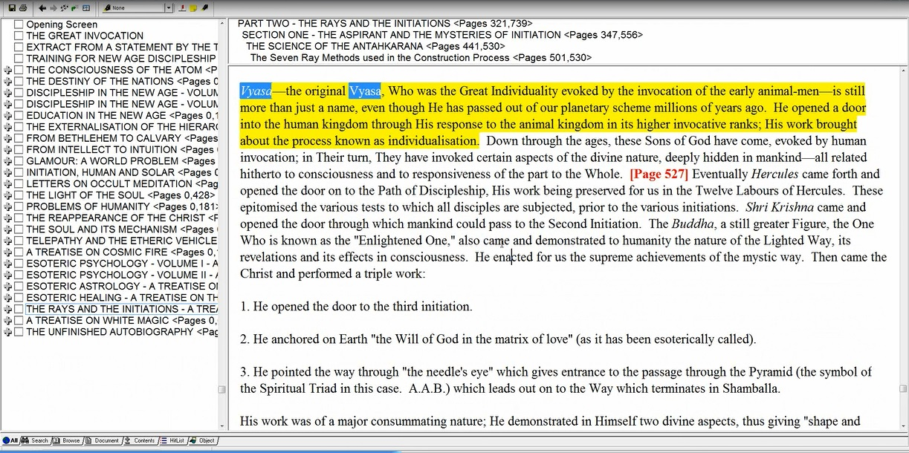

… the original Vyasa, Who was the Great Individuality evoked by the invocation of the early animal-men – is still more than just a name, even though He has passed out of our planetary scheme millions of years ago. He opened a door into the human kingdom through His response to the animal kingdom in its higher invocative ranks; His work brought about the process known as individualization. RI 526

1:00:02 Well the original Vyasa. There we have, interesting thing, and that would make him even earlier than Hercules. There must have been some important Vasas who followed in his line after that point. Here, we have kind of a discussion of Hercules and then Shri Krishna and then the Buddha. Is Shri Krishna an incarnation of the Christ? But he died in 3001 or 3002 B.C. If things kind of add up, the Buddha would have had take on the development of the Bodhisattvahood, you know 2500 years is the term of being head of the Hierarchy. And he was head of the Hierarchy and it seems his term was fulfilled when the Christ took it over around Lord Maitreya around 500 B.C. He wouldn’t be called the Christ, he would be called Lord Maitreya in the Hindu terms.

7. The successful Vyasians… TCF 1082

They know something about life and death apparently and we don't know really when they came in. Now it's interesting because DK tells us about individualizing man.

… the Great Individuality evoked by the invocation of the early animal-men – is still more than just a name, even though He has passed out of our planetary scheme millions of years ago. He opened a door into the human kingdom through His response to the animal kingdom in its higher invocative ranks; His work brought about the process known as individualization. RI 526

Now would this then be, this is an interesting question if Vyasa opened ‘a door from animal kingdom into the human kingdom, and that was only opened in this scheme 21 million years ago, then are the ‘Successful Vyasians’ those who individualized at THAT time… some like the Christ then have been successful. SOME are members of the Hierarchy even now.

So we're going back and forth between different periods of the past and wondering when the Vyasa that is here discussed originated. I’m so glad I saw it all through and waited until that last reference appeared.

Down through the ages, these Sons of God have come, evoked by human invocation; in Their turn, They have invoked certain aspects of the divine nature, deeply hidden in mankind – all related hitherto to consciousness and to responsiveness of the part of the Whole. RI 526

1:04:27 Eventually, so it sounds like time passed after Vyasa after the original Vyasa. But then maybe another Vyasa came and was proving the immortality of the soul. In any case, in terms of the lotuses that these have produced, have many of them already passed out of the human kingdom. Vyasa has passed out of the planetary scheme altogether so he must have gone on one of those Great Paths. Alright, I know we took quite a bit of time with that but it is interesting to note who this Vyasa may have been or how many of them there may have been. There had been you know, there is the tendency to take to oneself the names of great teachers even as the Pope seems to take to himself the names of disciples and apostles and of the Pope's.

8. The points in the third planetary petal, and groups of others related to the twelve petalled planetary lotus, TCF 1082

This is fairly obscure. There is a sense in which every planet is twelvefold, but the number of petals is differential when looked at from other perspective. Are we speaking of the twelve-petalled heart center of our own Planetery Logos? In which case, this is a planetary petal and groups of others related to the twelve petalled planetary lotus. Is the third petal within the twelve petals, or is there a particular configuration of petals for our planetary Logos of a certain number and we’re speaking of the third? Or are we speaking of an entire planetary scheme as being the third petal in the twelve-petalled lotus of the Solar Logos. The points in the third planetary petal. Well it doesn't sound like solar logoic petal. Which, then, from the solar systemic perspective is third planetary petal?

Is it Venus, considering the planets in their order from the Sun – including Vulcan in order? Or you know, is Vulcan not to be considered? In which case, the Earth is the third. Is it the twelve petalled planetary lotus our very own planetary scheme? Or, could Jupiter as the hypothesized twelve-petalled heart center of the Solar Logos be considered the twelve-petalled planetary lotus? Yeah not necessarily our planetary lotus. The third planetary petal, you see. It can be, considering our whole scheme as a petal, or it can be considered, considering the different planets as chakras each having a different number of petals.

We may remember that in studying various groups of Egos, the Lotuses of Brahman originated on both Venus and Jupiter. (TCF 841) The points in the third planetary petal and groups of others related to the twelve-petalled planetary Logos. You know if we count Vulcan, then Venus is the third. Then the twelve-petalled planetary lotus would be a heart center. And it's pretty clear that Jupiter can and should be considered the chakric heart center of our solar Logos. The planets in a way, are part of the solar Logos. They are not exactly independent beings. There is no such thing as an independent being. So I think we see how this might work and we can ask ourselves this question. It’s quite obscure.

Are there Monads indicated here from Venus (as the third planetary petal if we consider Vulcan)… considering the Vulcan, Mercury and Venus … and from Jupiter, as the twelve petalled heart center of the Solar Logos. Of course in a way, you know we could say that Jupiter has its own heart center and the solar Logos has its own heart center. But it appears that Jupiter is associated with the heart center of the solar Logos and Venus more with its solar plexus center. So DK tells us about these Lotuses of Brahman, so let’s just say it’s a theory.

Is this another way of viewing the Lotuses of Brahman, who are developing the second petal of the egoic lotus as found on this planet – not yet very highly developed.

1:10:28 We have different kinds of egos demonstrating different kinds of development according to their origin. Now the points of lunar origin, well many of them are already quite released. Some of them may be still part of the lotuses of passion and desire and will only achieve in let us say, the end of the 6th root race of this, our fourth round. Others will achieve in the 5th round but they are lunar origin and they are farther ahead in general than the Lotuses of Brahman. So the Lotuses of Brahman came in from Venus and Jupiter. And maybe another way of describing Venus and Jupiter are the third planetary petal and groups of others related to the twelve-petalled planetary lotus being Jupiter. Now there are other possible interpretations here.

What if we are talking about our own planet… what type of petal are we talking about? Well, the Monad has 12 aspects…. The Monad seems to be twelvefold. At least for man, is the Monad twelvefold for the planetary Logos also? And if so, is the third petal related to intelligence? In some way.

If we are talking about a twelve-petalled monadic structure of our Planetary Logos, is the third petal related to intelligence… And are these Monads can begin from his own monadic nature or sort of stored in his own monadic nature? And coming in representing intelligence. I kind of like the earlier theory, however. It would be most interesting to look at the method of blinding.

8. The points in the third planetary petal

Hidden, hidden implication of the solar Logos and groups of others, related groups. Multiple, related to the twelve-petalled planetary Lotus. Ours, maybe not… maybe Jupiter. So a little bit obscure. Well…

9. The lovers of low vibration, TCF 1082

I guess we should not look at them as being excessively advanced in our present period. This name indicates, so it seems, a stage of development rather than a point of origin. Perhaps among units of all origins, there are those who love low vibration.

1:14:09 Why do they love low vibration? You know, we could say. Have you ever you know passed one of those or had one of those low riders with a booming boom box passed you? That is even a physically low vibration. It just affects the lowest chakras and with that incredible booming pulsation I think you all know what I mean. Alright so let’s see here. Well we might say you know.

They love low vibration because it is the ONLY type of vibration which their crude stage of development can respond to… We know that as we become more etherealized and we, and our vehicles rise in the frequency of their constituents or through the frequency of their constituents. We can refine, respond to every more rapid and refined vibration but here we have a low state which seems to relate certainly to the unfoldment of the petals of ignorance.

One wonders whether a primitive expression of Vulcanian energy… You know the hammer blow, boom, boom. You know, maybe some of you saw the Lord of the Rings and I’m not sure which adventure it was but a kind of passing under the mountain. And it’s supposed to do is so very silently because the oryx and other demons are living below. And one of their group makes the mistake of dropping a bucket into a well and then it’s heard and then a drum begins. Very menacing drum. It’s just a sort of thud, boom boom. You know, It just seems to evoke from the bouts of the Earth. All of these extremely unpleasant beings and also evokes a still more fierce demon called the balrog. Well there are those of you who have studied the Lord of the Rings more than I have.

I was very impressed by the low vibration of that beating drum, and I think of the hammer blow of Vulcan and how it strikes its blow upon the drum head. It could be vulcanian but then perhaps points from various non-sacred planets could be classified in this way. Suffice it to say… the level of evolution is not high, and therefore, the degree of unfoldment of the Egoic Lotus is not high.

Among us, if there are levels of low vibration, they are going to be found very much in the Hall of Ignorance. I think you know, we have to deal with those types of Monad egos who have made their way to Earth and who were unfolding among us. They may have origins which tells something about their nature but we’re interested in what they’re going to do in terms of man and this planet.

So we would expect wherever these groups originated from whether from Vulcan in some primitive sense, you know. Some non-highly developed Vulcanians or whether from other non-sacred planets that have come to our planet. And there are so many non-sacred entities in our solar system, majority are non-sacred. We don’t know how many are fed to our planet and for what purposes. We do know pretty well that there are Martians, Venusians, Mercurians, Vulcanians. You know maybe among the primary lotuses, Jupiterians. Beyond that, I don’t know whether we have references from the teaching. At least our teaching at this time that there are other representatives of other groups. Plutonians, who knows? Neptunians? Well, there certainly are people that are responsive to the Neptune vibration and have a strong vibration of Neptune and their Monad.

10. The rejectors of the eighth scheme, TCF 1082

This is interesting because you know, we also want to remember that… Saturn built a bridge for the human beings of the first solar system to come into our solar system… However this was done, we don't know. That’s one way of looking at it.

From one perspective, Saturn is the eighth scheme, but from another, Mercury is the planet always associated with the number eight. If we begin let’s see, we’ll start to kind of count together – Vulcan, Mercury, Venus, Earth, Mars… do I have that right? Vulcan, Mercury, Venus, Earth, Mars, Jupiter, Saturn. Saturn is the… from another point or view, it’s the 7th scheme in order, from another point of view the 6th.

From another point of view Saturn is the seventh scheme and from another if we leave out Vulcan, the sixth—now let me just make sure I'm doing this correctly, I always have the count on my fingers to see whether I’m keeping them all in order. So we have the Vulcanian scheme, Mercurian, Venusian, Earth scheme that’s 4, 5 is Mars, 6 is Jupiter, 7 is Saturn. And if we leave out Vulcan, it’s the 6th. In this case, is Uranus the eighth scheme? Of course Saturn is so connected with the number 8. Also, catalistically connected with the #8 and Mercury is the guardian at the 8th gate. Something has been rejected. Is it a value? Has that which has been rejected, is it of value?

Is that which has been rejected of value, and is the result a compromised position? Or because of the rejection is there an elevated position? It does seem… okay let’s see a bit more here. The following reference may hold a clue about those who reject the third manifested creative Hierarchy. Okay right, right, right.

Each Hierarchy manifests a triple energy… It is the rejection of the Triadal lives by units in the fourth Hierarchy, that of the human Monads, which precipitates a man eventually into the eighth sphere. He refuses to become a Christ, a Saviour and remains self-centred. Esoteric Astrology 41

Each Hierarchy manifests a triple energy… you have to look for the word reject because I think it tells a story. The Law of Repulse is a rejecting energy, it seems to be connected with the first ray and with Pluto. You know there are many forms of rejection but sometimes we want to reject. The question is, is this rejection an advantage or a disadvantage to the Monads involved. Each Hierarchy manifest a triple energy or an aspect of each of the above and that necessitates a ninefold differentiation for the first two or triple as is the third. We’re talking about Hierarchy of divine flames, of divine builders, divine flames on the first or Logoic flame, divine builders on the second Monadic plane and the Triadal lives on the third plane.

And this is interesting. It is the rejection of the Triadal lives by units in the fourth Hierarchy… kingdom… now it is you know in a way the 8th Hierarchy and it is ruled by Saturn. Okay. It is the rejection of the Triadal Lives by units in the fourth Hierarchy, that of the human Monads, which precipitates a man eventually into the eighth sphere. You know, it’s association of the devil and Saturn and hell and DK and the dust hole that H.P.B. talks about which he talks about the 8th sphere, a kind of phantom planet that follows our planet around … the rejection of the Triadal Lives by units in the fourth Hierarchy, that of the human Monads, which precipitates a man eventually into the eighth sphere. He refuses to become a Christ, a Saviour and remains self-centred.

Let’s just say, are these units upon the left hand path? Okay. Are these units upon the left hand path? There are many on Earth and probably throughout the solar system.

1:24:53 I’ve had another idea, from another perspective, if Saturn is the eighth scheme could this rejection suggest a rejection of the Brahmic aspect? Could this rejection then signify a kind of elevation into higher spheres?

Well I don't know, I just come up with some ideas. This is a particular group of Monads. It’s a planetary scheme and we have to find out which one it is. I mean you know really, it can be either, it can be Neptune also, Uranus as well, from a certain point of view, Uranus is the 8th and I want to put that here. We have to remember that from a certain point of view, Uranus is the 8th Scheme… But what would the rejection of Uranus mean? The #8 is connected with Mercury, it’s connected with manas, it’s connected with the evil use of manas.

Eight is connected with the evil use of manas – when an 8th Hierarchy appears in the midst of the lower seven, then concrete mind is a problem and we have the BL which exalts concrete mind. But it sounds as if that type of well you know, there are just so many ways to look at this. This is the problem, the eighth scheme if it’s Uranus who will rule the cosmic ethers and have they in some way plunged into the dense physical vehicle of the solar Logos and planetary Logos because they reject the possibility of expressing on the cosmic ethers.

Really, all I can do is offer some possibilities. Is there a rejection of mind though? That is my question. Is there a rejection of mind and therefore, of the Brahmic aspect? Well that is a big enigma to me and maybe we'll be able to figure that out as we go along.

Right, how many more do we have? Oh we have a few more. This is going to take a little while … here we have:

2. The monad in the vegetable kingdom…
4. The human Monads in their myriads of groups…
6. The planetary Monad… TCF 1078

The human Monads in their myriads of groups… 6. The planetary Monad… 2. The monad in the vegetable kingdom. How interesting this whole section is about the Monads. Yes, let's go to Page 1082 and 1081 of A Treatise on Cosmic Fire, 1081.

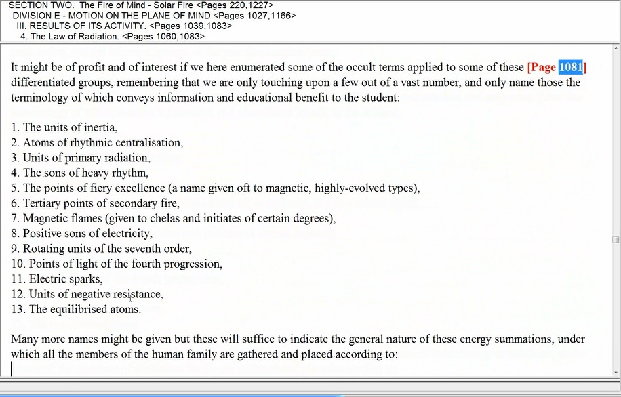

9. Rotating...
13. The equilibrised atoms. TCF 1081

The equilibrised atoms… 9. Rotating... Aha, I think we may be, yes. Somehow we seem to be looking at the stages here.

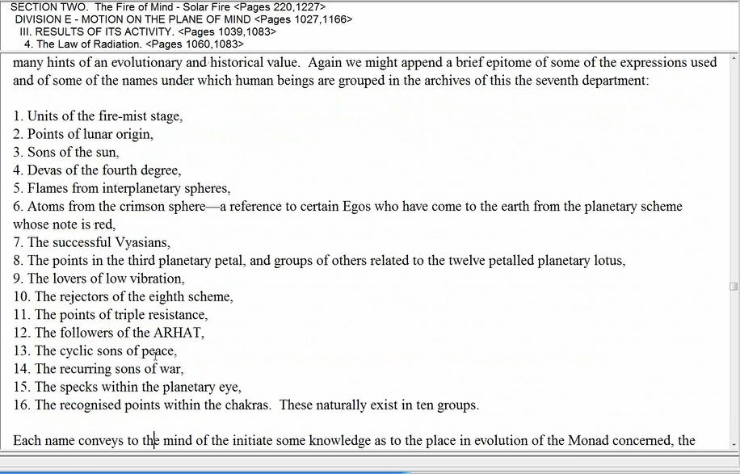

But there are also these equilibrised. There are others that we have also to consider very definitely. Okay, well in checking on this, I see that I have actually began with a list that is about origin and nature and not so much about the list of development. I think I got things slightly out of order here and the first list that should have been discussed is the list on page 1081. But I have begun the list on 1082 first.

You can find this on A Treatise on Cosmic Fire on www.makara.us. I will continue the second first and then come back to the first. When it comes here to…

11. The points of triple resistance, TCF, 1082

1:30:20 … Again, interpretation depends upon what is being resisted. It is something higher or low? Is the good being resisted in a triple way or is threefold evil similarly resisted? This sounds like a capacity rather than a signal of deficiency. Okay. But whenever we deal with the three, we think of either the three aspects of the personality of the soul, of the triad, of the Monad. They all have triple aspects and are they able let us say in this case, to resist the allure of the threefold lower personality which demonstrates itself most? In the Hall of Ignorance, is that what is resisted? Is that which is found within the Hall of Ignorance resisted – namely the elemental power of the etheric-physical vehicle, the astral vehicle and the lower manasic vehicle? Or is it something else? Is there a triple capacity of a higher nature to put up a triple resistance?

Let’s just say if there is a resistance to the threefold personality, then these units probably find themselves having transcended the Hall of Ignorance. But that is simply a speculation and so much is put into this book A Treatise on Cosmic Fire which has later to be revealed, I suppose by the Tibetan himself when the time is right. When there is resistance, there’s either the resistance against good or the resistance against evil. So our question is what is being resisted? It sounds however as if there is an ability.

It does sound as if there is an ability to resist three types of force due to three types of higher energy which have cultivated… But let time tell us.

12. The followers of the ARHAT, TCF 1082

Are these the followers of the Buddha? There are certainly many of the ‘Sons of Men’ today and during the course of the last 2500 years who have been followers of the Buddha. Of course. Well, who is the Buddha? This is very interesting. We see and how the word ‘Arhat’ is being used. Arhat is interesting word. Arhat – it means a Noble One and may or may not be limited to the technical definition of the fourth degree.

Perhaps an Arhat is of the 5th degree. But there’s also another interesting thing here, it comes in with this. Who was Gautama and Who was the Buddha? If Gautama was the prince as I’ve often said here, he may have played the same role to the Buddha who was the head of the spiritual Hierarchy for almost 2500 years at that time as Jesus played to the Lord Maitreya or the Christ. We can expect that Gautama became an Arhat… just as the Initiate Jesus did… We can expect that Gautama became an Arhat… a fourth degree initiate. But then who is followed? … just as the Initiate Jesus did it seems that Gautama is being followed, but really it is the Buddha…
There are so many mysteries in this question of taking over the body of another or emanating into another. I think you know, buddhism in its inner lore answers many of these questions.

We see that some of these monadic groupings are associated with particular Teachers and also particular locations in our solar system. As such, these groupings do not necessarily indicate evolutionary status, as seemed apparent in the first list of thirteen. We see that some of these monadic groupings are associated with particular Teachers… Vyasa, Buddha … and also particular locations in our solar system. As such, these groupings do not necessarily indicate evolutionary status, as seemed apparent in the first list of thirteen. Which we have not yet considered because we're out of order, okay Is the Arhat the noble one, is the Arhat the Buddha?

If you use the Buddha, then so many who are followers of him are going on the bodhisattva Path and in terms of the Egoic Lotus, are far advanced. They are certainly working in the Sacrifice petals. Of course they interestingly do not speak of the soul per se as existing. Maybe in esoteric Buddhism they do in terms of the more commonly taught doctrine. There is not considered to be a soul. And so the main attention is paid to Egoic Lotus. But we are studying the Egoic Lotus and we want to know where such people might be found and certainly, they themselves are becoming. Well, not everybody that follows buddhism but…

If one practices Buddhism as presented by the best teachers one will eventually become the Arhat – just like the one followed. One will go through the Great Renunciation, and be working in the later stages of the petals. It is a mental path, because the Buddha was a third ray Monad… And as such, he presented a path for the deeply thinking meditating individual. So we will find these people most likely definitely beyond the stage of personality expression. These people will be found beyond the stage of personality expression and cultivating the sixth petal and beyond.

1:40:00 Organizing and stimulating that and beyond. Do they go through the usual initiations that others pass through? Maybe what one passes through has a great deal to do with what one expects. The buddhist don’t expect anything like the kinds of initiations that Master DK are great buddhist Master, Tibetan buddhist Master has presented. I think he’s presenting a kind of internal esoteric Buddhism. Mostly, the focus is on stages which truly would lie beyond the Egoic Lotus development altogether. But of course, so many that are taking up Buddhism have just passed through the stage of personality expression and are beginning to become aspirants towards the truth which means that they have to pass through the lower stages before they can completely renounce all forms and enter into voidness, emptiness, suchness, whatever they want to call it. So there still will be Egoic Lotus development but a higher type.

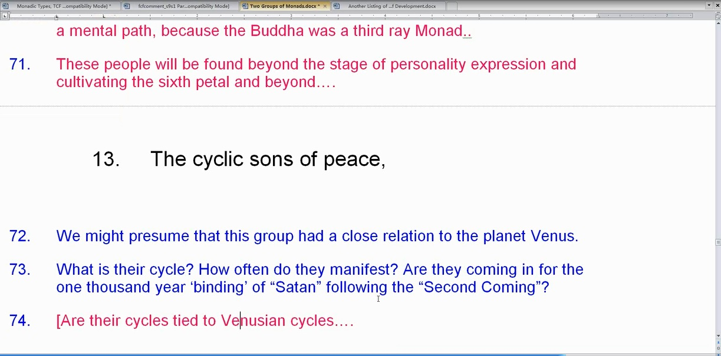

13. The cyclic sons of peace, TCF 1082

We might presume that this group had a close relation to the planet Venus. What is their cycle? How often do they manifest? Are they coming in for the one thousand year ‘binding’ of Satan following the ‘Second Coming’. Are their cycles tied to Venusian cycles? If we think about it, when we put an end in there, what's happening here is a connection with the spirit of peace ruled by Libra and ruled by the second ray aspect of Libra. I have a theory that Libra is a profoundly second ray sign that a deeper part of it is second ray than third ray. We’ve been given the third ray. It might have something to do with the degree of evolution of the Lord of the constellation Libra.

You know how we're given certain rays according to the stage of development of the planet like Earth is usually considered third ray because it’s mostly involved in personality expression. But Libra may also be involved with law, sex and money you know the third aspect of divinity because it's mostly involved that way at its present stage of development. But I think hidden behind and within it is a great second ray which is not discussed just the way a great first ray of Scorpio is not discussed.

These Lords have Monad, soul, personality, and therefore three major rays. So the rays given are not always the rays which are presently being widely expressed. I mean the second ray is not fully expressed for the Earth. It’s said to be the true ray of Earth. But the second ray of Earth, of the Lotus of Earth is hardly ever expressed or discussed. What about the second ray of Libra? It’s hardly ever discussed but the hints are there when we look at some of the cosmic Paths. And also on Page 333, it talks about divine love and understanding in relation to Libra. And that’s not just Venus because we’re talking about the hierarchical position where the ruler is Saturn. So it's got to be connected with the constellation itself. Okay.

13. The cyclic sons of peace

How advanced are they we don’t know but you know I would say: Fairly advanced – because their task demands it… And here, you know as a balance to what they are, come in…

14. The recurring sons of war. TCF 1082

1:44:35 Does this group of Monads or Egos have a regular cycle or do they recur whenever conditions make it possible for them to recur? Because they recur? Whenever conditions are correct for the recurrence, cyclically correct. Are we in such a time right now? It seems that we are.

It would seem that their point of origin is Mars, and if not Mars, then, at least, they would seem to be strongly influenced by that planet. Mars is the god of war very simply and you know we had an earlier group that we attribute the atoms of the bloody spheres.

We might inquire whether there exist in active manifestation on our planet and at this time a large grouping of those in this category. We might also inquire if they are related to the sixth ray either in their soul nature or monadic nature.

There is the, you know we’re told about the Aggressive fire of the Sixth Logos... I'm not sure what Page that is found. But it might be Cosmic Fire again and it might be 433. Yes it is. Aggressive fire of the Sixth Logos...

Well there are certainly some martian groups at the moment and they are battling the Venusian groups. It might sense that the day on our planet of these Martian groups is not now, is no longer. And that the Venus groups must prevail and that the peace over which the Christ will officiate must win the thousand years of divining of Satan. Let’s remember. Satan, in the lower sense, is 666 or the triple, personal form ruled by Mars… but 666 is bound and Venus the Angel, prevails…

So what are these cycles? They have to come in I suppose in some fascinating way they both enhance each other that the contending of opposites brings out the essential quality of those opposites and it might be a faster way to sharpen and hone the particular skill so that Mars will end up fighting for that which is worthwhile and Venus will somehow learn through love to control these more violent impulses coming from Mars. Definitely, Venus is the higher planet. So we would not expect the cyclic sons of war to be so highly advanced in the Egoic Lotus.

Not expect the Recurring Sons of War to be so highly advanced- maybe into the Sacrifice petals in some circumstances—Noble Warrior for a good cause, but the title of the group implies that the induction of war is their method. So you know so often, what we have is the reluctant warrior who has to fight and does not want to fight but will fight as needed. And these seem to enjoy fighting.

Seems the lunar lords are at work—the first four petals that are lunar. See if you look at this, interesting fact:

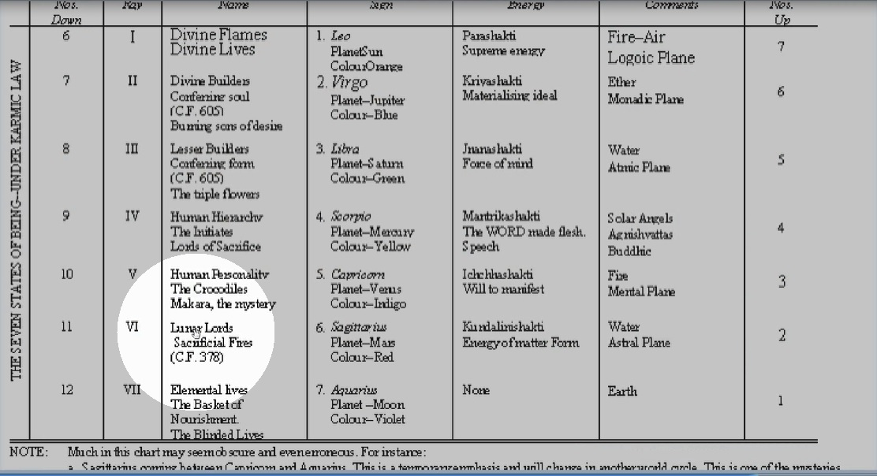

The Lunar Lords are ruled by Mars, Mars and the moon together. So the first four petals are in a way lunar climaxing with Cancer the fourth petal. Mars and the moon though are connected. So when we’re just fighting for ourselves and for the personality and for the right of our ancestral Lords, they have their way because Jupiter is… aha find the place right. Jupiter is the god of the ancestral lords and is exalted in Cancer. Jupiter exalted in Cancer which rules the fourth elemental, the personality elemental.

1:50:46 So I would not expect to see such a high stage of development with these groups. Now you see basically, we’re talking about types of Monads here, types of Monad Egos. It’s sometimes a little hard to discern their stage of development but according to their type, sometimes we can know. However, when it comes to the other list, it pretty much is a cyclic list, the developmental list. This is not so much a cyclic developmental list but it has its implications in terms of time.

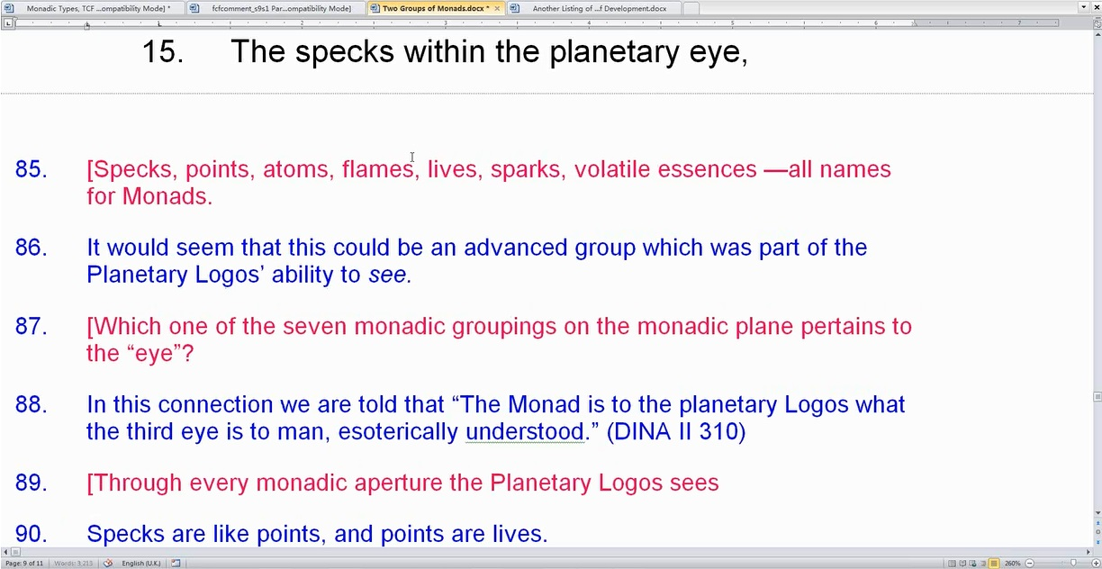

15. The specks within the planetary eye, TCF 1082

Is it our, specks is another name you know. These are Monad, these are names for Monads. Specks, points, atoms, flames—all names for Monads. It would seem that this could be an advanced group which was part of the Planetary Logos’ ability to see. Which one of the seven monadic groupings on the monadic plane pertains to the eye? Because you know they are going to be… just check out around Page 37 of Letters on Occult Meditation and it’s going to be seven monadic groups. One of them is going to be up here connected with the ajna center, in the body of the planetary Logos.

In this connection we are told that The Monad is to the planetary Logos what the third eye is to man, esoterically understood. So truly expects the Monad sees through every aperture, through every Monadic aperture. Through every monadic aperture the Logos sees. And it’s really our planetary Logos we’re talking about I think. It’s hard to know when he’s talking about our planet when he’s talking about what comes from other planets to our planet.

Specks are like points, and points are lives. That’s another term we could use for lives, sparks, volatile essences—all names for Monads. This might also be a particular group of Monads associated with the ajna center of the Planetary Logos. That’s what I’ve been find true. Say, what is the ajna center? Well you know, it’s our planetary Logos, maybe some other planet rules the ajna center and maybe Mercury has a lot lot do with it.

We have read that all human Monads find their place in a particular center within the Planetary Logos and the ajna center (associated with the function of seeing) is one of the higher ones. And then we can ask. Is there a Mercurian function here?

Anyway, the idea of sight is associated with the mind and the fifth ray – so maybe these tend to be higher in their expression and are working with Mercury, yellow and the sacrifice and synthesis petals.

We have also to ask whether, in some way, these specks actually assist the sight of the Planetary Logos or impede it? Well he talked about… how does it said, the mote and the beam, mote to mote and there’s a lot of quite correct and it’s mote which means a little bit. To mote is mote and beams within the eye. … We remember the reference in the Bible to motes: and beams within the eye. A beam is much bigger—a mote is like a speck…

1:55:36 So are they impediments? Or, are they methods of assistance in the seeing? If the Monad is as a third eye to the planetary Logos. Anyway, a higher grouping it seems and closely connected with the third eye which is the better eye even than the pituitary eye. So let’s say it’s closely connected with the third eye… connected it seems with planetary logoic vision…

Well let’s just say we really start to see when we find ourselves in the sacrifice petals, loving sacrifice reveals and synthesis is all, you know, buddhi is about sight and the buddhic petals are the synthesis petals. So from sacrifice to synthesis we would expect this to occur… loving sacrifice reveals…

16. The recognised points within the chakras. These naturally exist in ten groups. TCF 1082

Whose chakras? Are these the planetary logoic chakras or the solar logoic chakras? The chakras exist in ten groups. A picture that might be useful:

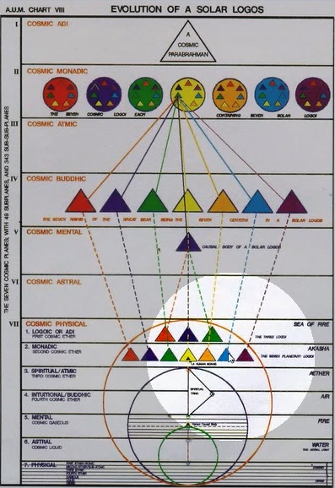

The seven below. The three of the three above the seven. We also have the tree of life with the ten, second row 7 below, 3 above. It does naturally exist in 10 groups.

Well, you kind of wonder when you turn to page here in Letters on Occult Meditation Page 39, and you have seven monadic groups.

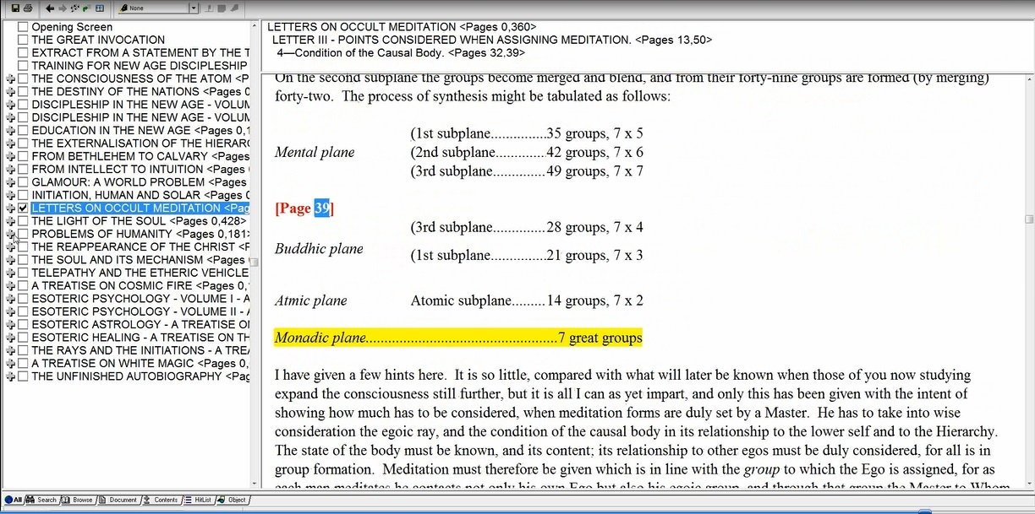

You kind of wonder in some way although these are all multiples of seven. Do you have three great greater groups on the logoic plane? Certainly, Chart V on Page 344 on A Treatise On Cosmic Fire seems to indicate that one does. So all of these will be associated with different chakra groups in the what? Whatever in the solar Logos or planetary Logos. So we have to think in terms of ten.

The spleen, alta major center, the seven head centers considered as one grouping, the heart-in-the-head center—all of these are possible chakras to be added to the normal enumeration of seven in order to make the requisite ten.

1:59:12 Within a Greater Being such as the Planetary Logos or Solar Logos, there are ten chakras and Monads find their placement within the chakras of these Beings… now, are we talking about the ten chakras within a Plantary Logos, and thus, perhaps, of His ten chains, as points of origin for various types of Monads currently expressing themselves through our planetary scheme? (DK tells us that, at various times, our Planetary Logos has ten, seven or three chains.) Might be chains.

Or, are we talking about the chakras of the Solar Logos. The various Planetary Logoi and Their schemes fulfilling the role of chakras within the system of our Solar Logos? DK might be telling us that various types of Monads or Egos come from all the planetary schemes. If we count Vulcan, we have ten such schemes. Eventually 12… and ALL eventually will be sacred… but eventually 12… schemes and really many many more of a non-sacred variety. But eventually 12… and ALL eventually will be sacred.

So when looking at the Egoic Lotus, it's really hard to say you now if they're coming from different chains of different stages of development or different planetary schemes, what their stage of development might be. So it is a very full, very complete kind of enumeration. But their origins are there and although every type of quality associated with the origin has a particular sort of rhythm of unfoldment or speed of unfoldment we’re not in a position to assess that.

We’re just in a position to see what the different types have been and I think what we should do is just read them you know, back to ourselves. We've kind of tried to explain some of them a little bit.

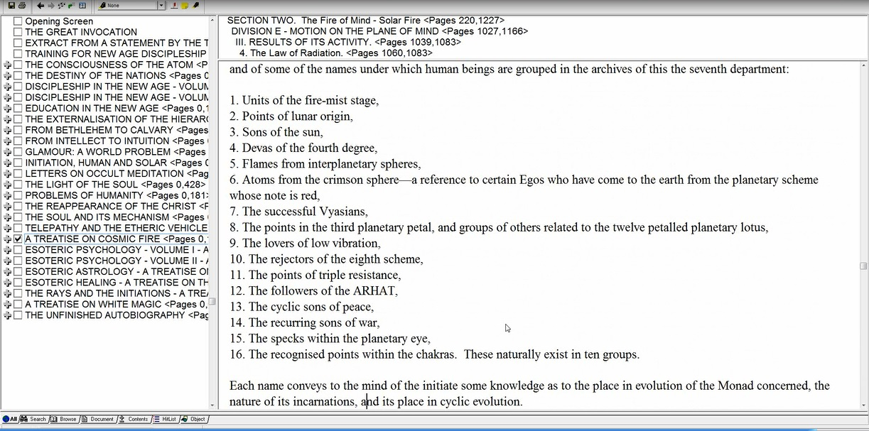

1. Units of the fire-mist stage

Now that's a kind of a stage, not… but it is a particular grouping.

2. Points of lunar origin,
3. Sons of the sun,
4. Devas of the fourth degree,
5. Flames from interplanetary spheres TCF 1082

That devas of the fourth degree, it could be Monads that have achieved the fourth degree. These titles, these names are among the most obscure that we can find in the book, so we cannot expect of ourselves any definitive interpretation just some thoughts in the direction of what an interpretation might be but those tendrils of thought will bring down the lightning of intuition when the time is right.

5. Flames from interplanetary spheres,
6. Atoms from the crimson sphere— a reference to certain Egos who have come to the earth from the planetary scheme whose note is red.

And the idea of coming into the earth is really what has to be emphasized here. These may have all kinds of origins but they do apparently come to the Earth.

7. The successful Vyasians…

Maybe one who integrates early on in the Lemurian days, is in a sense a Vyasian when you consider who the first Vyasia was.

8. The points in the third planetary petal, and groups of others related to the twelve petalled planetary lotus,
9. The lovers of low vibration,
10. The rejectors of the eighth scheme,
11. The points of triple resistance,
12. The followers of the ARHAT

All in capitals, ARHAT of a high nature.

13. The cyclic sons of peace,
14. The recurring sons of war,
15. The specks within the planetary eye,
16. The recognised points within the chakras. These naturally exist in ten groups. TCF 1082

2:04:31 Well, what a load of occultism one must have digested before it is possible to be definitive about these origins of the points. You see, an Egoic Lotus is not really a point. An Egoic Lotus is a fulfillment, an outgrowth of a point. The point is really the central fire that is found at the heart of the Egoic Lotus and it reflects the Monad which can be more property called a point.

The point really is the essence; it’s the essential appearing as something specific. So in a way can be the origin of the Egoic Lotus but I think we should not consider a point as the Egoic Lotus per se.

Each name conveys to the mind of the initiate some knowledge as to the place in evolution of the Monad concerned, the nature of its incarnations’, and its place in cyclic evolution. TCF 1083

Well the nature of its incarnations, yes, perhaps if we know enough. If we knew what the Master knew. If we had all knowledge of the third subplane of the atmic plane. We get the sense of beginning and end here, of early work and later fulfillment. We're not necessarily told what the cycles are. We get the sense of origin and origin can help us determine the kinds of cycles that the originating unit is involved in now, its place in cyclic evolution. Later, we're going to look at those names that have definitely more to do with the stage of unfoldment of the Monad. I think so. But there's no question about it. This is the Monad we’re talking about. And we’ll just say: Even though the Monad is called Ego or EGO, it IS the Monad…

So he began talking about Egos didn’t he? But now he has told us what he is really talking about though every Monad is going to be represented as an Ego. So it’s okay to speak of the ego as long as we keep it connected to the Monad. Okay there is a little more to say here. Obviously, one cannot go through the entire book Cosmic Fire. I've written so much about it but I see that if I have the chance to elaborate on it, it would be a little better but in the time one has. So let us tabulate.

Each name conveys to the mind of the initiate some knowledge as to the place in evolution of the Monad concerned, the nature of its incarnations’, and its place in cyclic evolution. TCF 1083

And I kind of realized that he may be referring back to the list on Page 1081 as well. Because you know I began
with the second first.

Let us tabulate what the names of these groups conveys to the initiate:
- The place in evolution of the Monad concerned
- The nature of the Monad’s incarnations.
- The place of the Monad in cyclic evolution
- We should also add that a number of monadic points of origin are to be found on this tabulation, but not, it seems, in the prior listing.
We do note that DK has used the word Monad, so it is, indeed, of Monads we are speaking, yet, also at time, of the Monad’s expression as an Ego (i.e. as a spiritual triad or as an Ego in a causal body on the higher mental plane). Sometimes when Masteer DK speaks of Egos He is really referencing Monads. Monads do express through an auric egg just as Egos do.

We do note that DK has used the word Monad, so it is, indeed, of Monads we are speaking, yet, also at time, of the Monad’s expression as an Ego (i.e. as a spiritual triad or as an Ego in a causal body on the higher mental plane). So either one. (i.e. as a spiritual triad or as an Ego in a causal body on the higher mental plane)

Sometimes when Master DK speaks of Egos He is really referencing Monads. Monads do express through an auric egg just as Egos do. So we have that in mind. You know because as we’re studying the Egoic Lotus, who is it that's evolving? This is the question. We look at the Lotus and we say this one is thus unfolded and that unfolded. But who is the Monad behind the Egoic Lotus and how does that Monad, its point of cyclic entry, its origin determine how the unfoldment is proceeding? Maybe even you know certain ray tendency showing up in the Egoic Lotus will be as a result of what the Monad is.

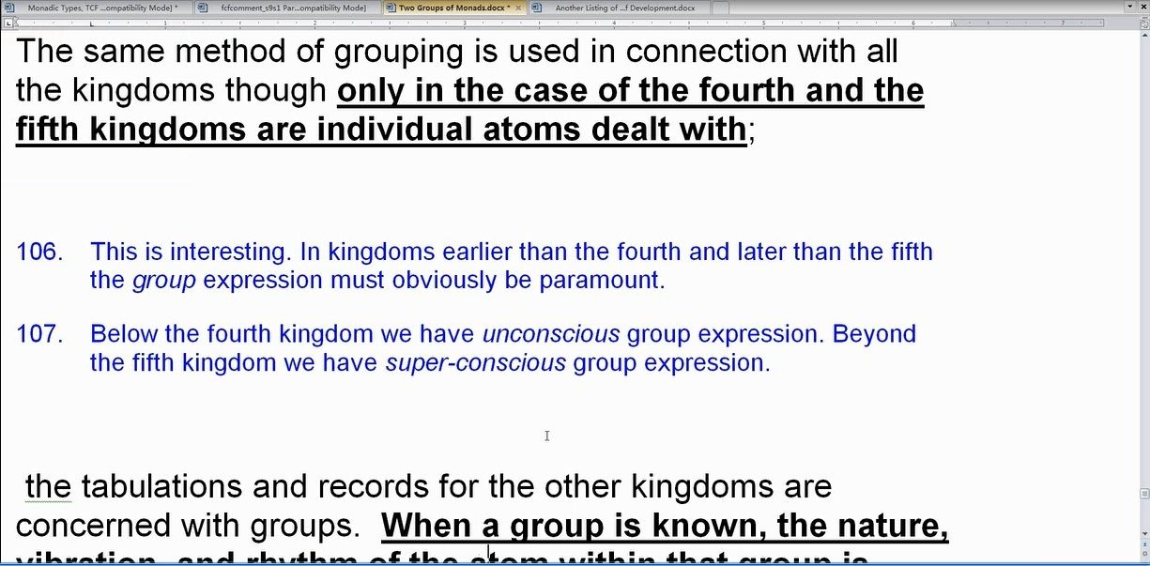

The same method of grouping is used in connection with all the kingdoms though only in the case of the fourth and the fifth kingdoms are individual atoms dealt with… TCF 1083

2:10:12 Maybe groups of Monads are found in relation to the other kingdoms and maybe when they take their… in metallization, in digitalization, in zoo-nation they do that as groups. That has yet to be revealed to us, it seems that we have a lot more to learn about man particularly before we can know so much about the lower kingdoms whose consciousness is outside our range of apprehension.

This is interesting. In kingdoms earlier than the fourth and later than the fifth the group expression must obviously be paramount. Below the fourth kingdom we have unconscious group expression. Beyond the fifth kingdom we have super-conscious group expression.

Who is member of the 5th kingdom? Well everybody up to the Master. From the first initiation, we, the newly entered member of 5th kingdom at the 5th initiation, the highest member 5th kingdom when one becomes a Monad. They are no longer manas of the Masters. Well they are perhaps members of the 4th grade of Hierarchy, the hierarchy of human Monads but not men per se, not human beings per se. A Master is the last human being then comes the Chohan. And they actually enter into well, this is interesting you know. Do they stay as members of the fourth grade of Hierarchy or are they planetary lives? That is a question that I really have to consider. In a way, they are members of the 4th creative Hierarchy. They haven’t moved on and become Solar Angels. They haven’t entered. They enter different kingdoms. The planetary lives is a kingdom. The 5th kingdom is a kingdom. The Kingdom of Souls is a kingdom. You can be a member of the 4th creative Hierarchy and still stay as a member of those kingdoms.

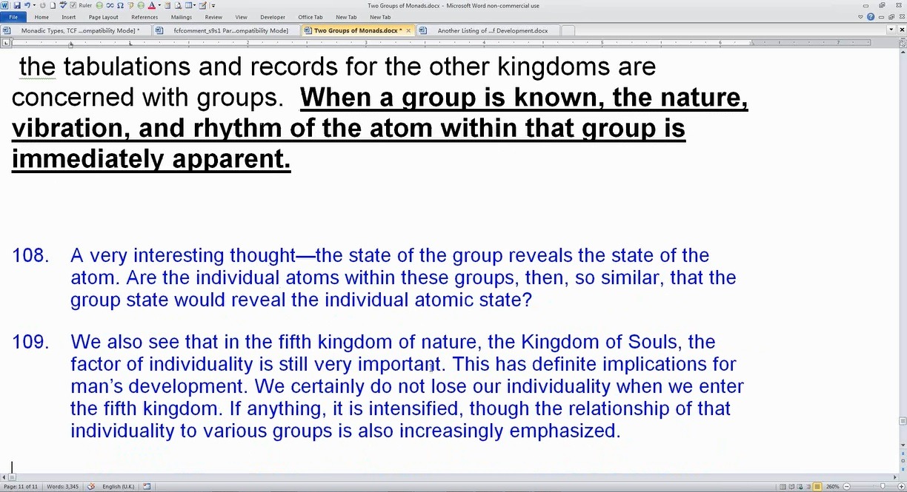

… the tabulations and records for the other kingdoms are concerned with groups. When a group is known, the nature, vibration, and rhythm of the atom within that group is immediately apparent. TCF 1083

Well there’s so much to learn! It’s just wonderful, wonderful study even on our tiny little planet, this tiny little speck of dust. But the whole universe is just a speck of dust. The whole universe is a ciphered point. A point, a vacuous point with no own being, self-being all generated from the one infinite being, the absolute.

A very interesting thought – the state of the group reveals the state of the atom. Are the individual atoms within these groups, then, so similar, that the group state would reveal the individual atomic state? Yes. There has been no great pursuit of distinction here. That happens when individualization occurs and then they factor, differentiation really enters.

We also see that in the fifth kingdom of nature, the Kingdom of Souls, the factor of individuality is still very important. I mean you know, indeed from the time of the first degree initiate, none of that of the Master, the individuality is still very important. This has definite implications for man’s development. We certainly do not lose our individuality when we enter the fifth kingdom. If anything, it is intensified, though the relationship of that individuality to various groups is also increasingly emphasized.

Even as a Monad, even as one who returns as a 6th degree initiate, there is the indivisibleness of individuality but there is also such an intense relatedness, of beingness that it overshadows the distinction and it is a whole that is seen and all the parts of the whole are seen within that whole and do not stand forth in the greatest importance. It is the whole that is more important.

See how I’ve begun this, Two Groups of Monads Arranged by Type and Cycle:

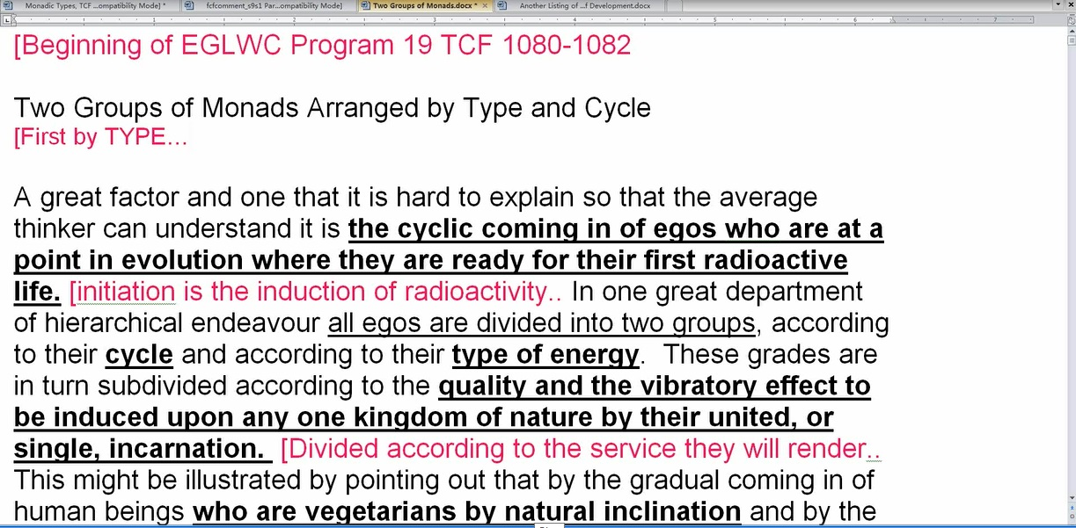

2:14:38 First by type, and then we’ll take the next one by cycle and will be going from Page 1082 and 1083 to back to 1081. So that's just the way it turned out. I could the numbering but I think in light of what I’ve said it’s better to keep them in order. So this is the end of Egoic Lotus Webinar Commentaries Program 19, two hours fifteen minutes and we’re in TCF 1082 and 1083.

That should be enough for the moment, plenty to think about. We have to think with what we've got. We have to learn with what we have. If we don't know, we have to try to know and then we will know because we are the one or only being who is essentially on mission so we will know all.

So it’s just a question of patience and on we go. Alright friends, we’ll go on to #20 next and it'll be beginning Egoic Lotus Webinar Commentaries Program 20. We don’t know how long it will be, TCF 1081 approximately. Maybe it’s 1080 also and this has lasted now 2 hours and let's call it 17 minutes.

Okay, will see you soon, will continue with the support of material we need to go into the Egoic Lotus petal by petal so we can get in a synthesis of thought.

