EGOIC LOTUS WEBINAR COMMENTARY #12 – Michael Robbins

Abstract

Egoic Lotus Webinar Commentaries 12: Planets, Initiations and Petals. This webinar is about 2 hours, 2 minutes long and covers Esoteric Astrology pages 70-71 and Esoteric Psychology Vol II pages 245-246. This program focuses on a discussion of the various planets which are involved in each of the first five major initiates—from the Birth of the Christ in the Heart, to Mastership. The reason why these planets are rightly involved in each initiation is elucidated, from the ray as well as astrological perspective. Two sets of references are used and each provides a different angle of vision. The areas of the egoic lotus involved in each initiatory phase are indicated.

Contents

Abstract 1
Contents 1
Transcription of Egoic Lotus Commentary #12 1
First Initiation (EA) 4
Second Initiation (EA) 6
Third Initiation (EA) 7
Fourth Initiation (EA) 10
Fifth Initiation (EA) 11
First and Second Initiations (EPI) 13
Third Initiation (EPI) 14
Fourth Initiation (EPI) 14
Review 17

Transcription of Egoic Lotus Commentary #12

Well hi everybody. We are beginning our 12th program in the Egoic Lotus series. Here is the Egoic Lotus.

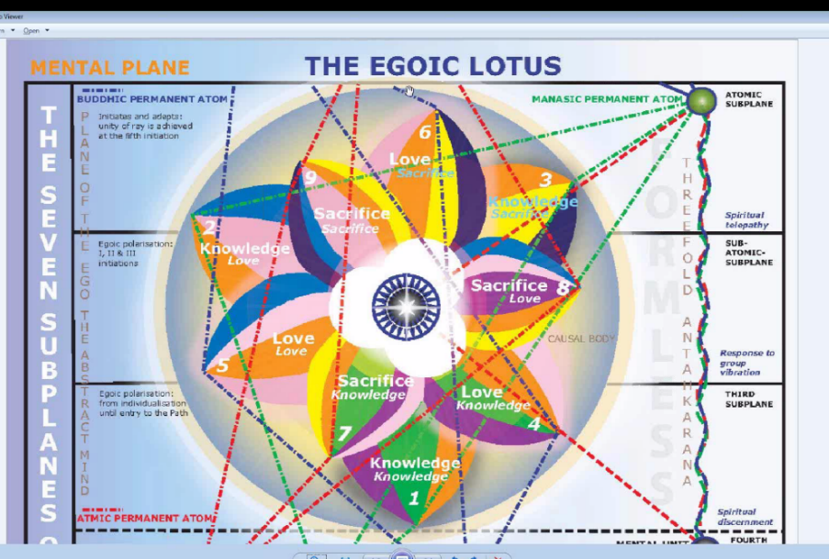
We have here our reference point. I rather like to begin with the picture of the lotus so we can get it in our minds. We are discussing preparatory material before discussing each one of the petals. And if we have the picture of the tiers and the petals, as nonrealistic as it is, we can be in a better position to relate the subjects we are discussing to the Lotus. Every one of us has this structure on the higher mental plane. And for people who are interested in these matter, it's probably on the 2nd subplane of the higher mental plane, centered in that way, although there is the statement that the Jewel in the Lotus itself is found on the borderland between the higher mental plane and the lowest part of the buddhic plane. So that presents a bit of a problem but for all practical purposes the Egoic Lotus of the one who is to follow the path of initiation from the 1st through the 4th is found on the 2nd subplane of the mental plane.

02:00 Now we are going to work in astrology here. The different preparatory subjects are listed on this tabulation.

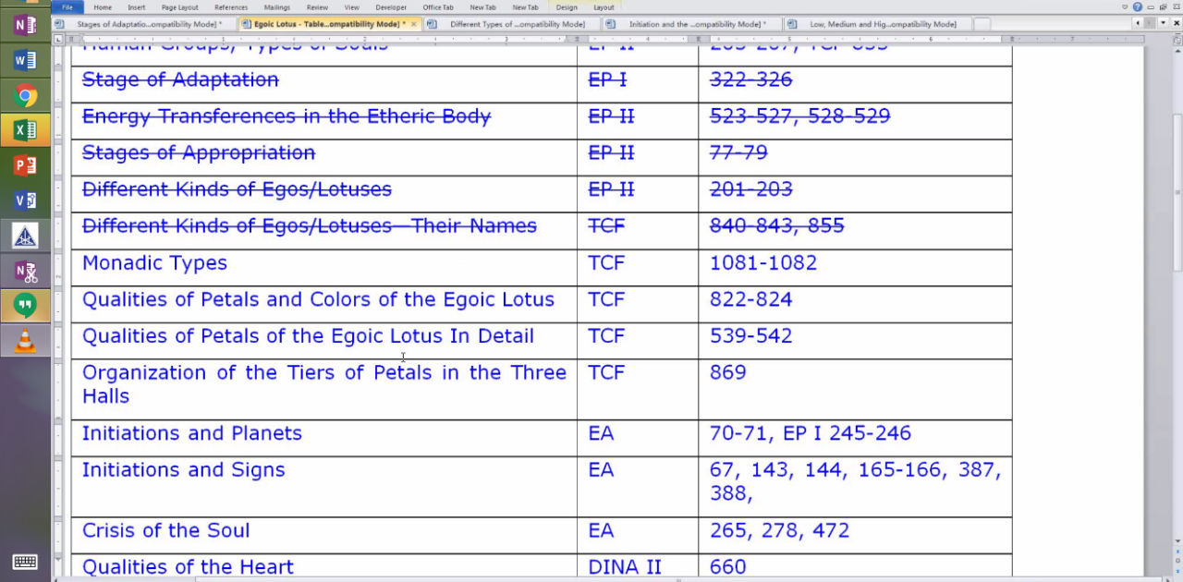

I decided to defer just a little while from discussing the monadic types. It's a difficult abstract subject and there is no way that we can confirm these different types. They are only suggestions given to us and we don't know their cycles, and we don't know which among these types we actually are. But we certainly are among the types. And we will after all get to it.

But the planetary and the ray factors are so important that I thought I would begin discussing this section on initiations and the planets. I have done this when working through the book Esoteric Astrology which is now completely recorded and most of it is up on Makara.us website. It is of great interest to know when we look at the Egoic Lotus which initiations the individual may be passing through and what might be the indications in terms of the organization or stimulation, opening or unfoldment of the petals. So if we know something about the planets involved as the various planets do work in the types of experiences we have to open these petals, then we will be able to correlate this material and understand what we should be doing from the planetary perspective when we are working on the opening of the petal or trying to perform those kinds of activities which relate to the opening of the petal.

04:19 So our first work then will begin here in Esoteric Astrology and then there is also some supplementary material in Esoteric Psychology, there is a little information which is I think also of use.

"Astrologers will eventually be able to cast the horoscope of the soul, which is sensitive to different combinations of forces to those controlling the personality life. The disciple and the initiate respond distinctively to the incoming influences and their response differs from that of the undeveloped man or the self-centred person. This will have to be recognised. Those who "live below the diaphragm" and who react to the incoming energies through the medium of the lower centres will have a very different type of chart to that of the disciple and initiate. It will require a different mode of interpretation. I have referred to this before and would remind you of some of the points which I made." EA 70

Astrologers will eventually be able to cast the horoscope of the soul,. . . ﻿﻿that will be a magnificent thing, as far as I can see it has not been successfully attempted . . .which is sensitive to different combinations of forces to those controlling the personality life. ﻿﻿We do have our 3 periodical vehicles - the 3 divisions of our nature, and each one of them receives astrological influences but uses them in different ways. Here it seems D.K. is speaking of the particular forces to which the soul is sensitive and one wonders if that is in the process of initiation. The personality has to do certain things to bring about initiation but the soul is active on its own level. And the emancipation of the man really is the triumph of the soul. So the particular energies which it receives and which it directs to its personality are important to understand.

The disciple and the initiate respond distinctively to the incoming influences and their response differs from that of the undeveloped man or the self-centred person. ﻿﻿Obviously what we have here we understand that increasingly the disciple is decentralized. The same planetary influence may be present in whatever way it is present and yet the response will be entirely different depending upon the nature of the individual and the quality of the form. This will have to be recognised. Those who "live below the diaphragm" and who react to the incoming energies through the medium of the lower centres will have a very different type of chart to that of the disciple and initiate. ﻿﻿That is strictly a personality chart and some of the lowest types of expressions expected of the various planets and signs will be the ones that are in evidence. It will be interesting to see what kinds of charts emerge. We will have such expert guidance in our ways of doing the right thing, taking the next step, our ways of evolving. We who are interested in astrology and use astrology probably think about how much is missed by people who cannot use astrology, who have never had it applied to their lives and in the future those who can draw up these new kinds of charts will be thinking about how much we have missed by not having been able to do so.

08:05 It will require a different mode of interpretation. I have referred to this before and would remind you of some of the points which I made. ﻿﻿And he is going to remind us.

"1. Disciples upon the Path of Discipleship are strongly influenced by Mercury and Saturn—one bringing illumination and the other offering opportunity." EA 70 ﻿﻿

1. Disciples upon the Path of Discipleship are strongly influenced by Mercury and Saturn—one bringing illumination. . . ﻿﻿that's Mercury . . .and the other offering opportunity. ﻿﻿To detach and disengage from our elemental tendencies and patterns. Now one of my friends who is a good astrologer said well it's not just the ordinary path of discipleship here, Saturn and Mercury may apply more to accepted discipleship, because it is at that point that a true disciplining of the mind and of the nature begins in earnest. Up to that time from some perspectives even though we have taken the 1st initiation we can still be considered to be treading the path of probation, of probationary discipleship. Well Mercury and Saturn certainly bring us release from our astral tendencies and from the type of expression which does not observe the proper boundaries in society and between the individuals.

So the impulsive nature of Mars and the lower wish fulfilling tendencies of Neptune are overcome by this clear and careful mind that Mercury and Saturn represent. We will find that these planets appear again as influential at a higher turn of the spiral of human development.

"2. At the various initiations, the influence of the planets affects the candidate in a totally different manner than earlier. Cyclically the energies from the constellations pour through the planetary centres." EA 70

10:28 2. At the various initiations, the influence of the planets affects the candidate. . .﻿﻿the candidate, you know we mean here by that: the candidate for initiation . . .in a totally different manner than earlier. ﻿﻿Because earlier planetary influences were processed mainly through the lower centers and the orientation of the life was strictly personal and self-centered and now it is not so. The higher centers are able to respond to the higher vibrations of the planet and to appropriate them in a way that is quite different than the earlier appropriation of the lower vibrations.

Cyclically the energies from the constellations pour through the planetary centres. ﻿﻿Now when we say the planetary centers, we can mean that on our Earth there are a number of chakras through which the constellations can pour their energy. Continents represent chakras. Certain important cities represent chakras. So the different constellational energies will pour through and they will affect the human beings in those areas and really all human beings. But also the different planets are connected with different constellations and one planet can be related to let's say 4 constellations. Take a look at Uranus, the hierarchical rules of Aries, the veiled hierarchical ruler of Leo, the esoteric ruler of Libra and the orthodox ruler of Aquarius plus it's exalted in Scorpio. So different constellations will pour their energies through these planetary deities at different times and the planet itself will carry a transmission from several of the constellations and not only from one. We have to discover when we are coming in contact with a particular planet what constellation may be reaching us at any particular time - the energies of what constellation.

First Initiation (EA)

"a. At the first initiation, the disciple has to contend with the crystallising and destroying forces of Vulcan and Pluto. The influence of Vulcan reaches to the very depths of his nature, whilst Pluto drags to the surface and destroys all that hinders in these lower regions." EA 70

13:17 At the first initiation, the disciple has to contend with the crystallising and destroying forces Vulcan and Pluto. Now the crystallizing forces are particularly related to Vulcan and the destroying forces, although Vulcan can destroy, related to Pluto. Now when we are talking about the 1st initiation, the disciple may be focused in petals #5, 6 and 7. Work is being done in 7 and the rod of initiation is directing energy towards #7, but there is a reflect action that is causing greater unfoldment of 6 and complete unfoldment of 5. Probably our attention is not so precisely focused that we work in one level of experience only. We might say we always keep our concentration focused on quite a high level of spiritual work, but probably our attention wanders and there is a span of petal experiences to which we relate during the course of a day or a week or whatever. We may have a period of very, very high work, let us say in petal #7, but we haven't completely finished our work in petal #6 or 5. And our attention may be drawn to those types of activities as well. So the 1st degree initiate is pretty well focused in the latter part of petal 5 or the latter type of activities associated with the unfoldment of petal 5. The work of petal 6, which is largely disciplining altruistic work though the disciple is not at the end of the unfoldment of petal #6 because that would indicate the 2nd initiation and quite a long period of time can pass between the 1st and 2nd initiation. It is symbolized in the life of Master Jesus between the birth and the baptism there were 30 years, and then the other initiations each took place in the following years until the year 33. By the time he had reached 33 we had the crucifixion. Between them was 32 and 31 and somewhere in there with 32 and 31 the transfiguration occurred. I cannot say in which year. But suffice it to say the great span of time is spent, from the petal point of view, working in that 7th - well let's see working in a way in the 8th petal, the latter 7th and the 8th petal developing over time the various attainments of the long series of lives. Until the 2nd degree when the work in the 8th petal plus the abnormal and strenuous work of the candidate, until that type of work and the application of the rod of initiation by the Bodhisattva sees to the complete unfoldment of petal #6.

17:36 So work in petal #7, the latter part of it and the early and middle part of petal #8, let us say take a long time, quite a number of lives. And so it might seem when looking at the Egoic Lotus that the unfoldment of the 8th petal is proceeding very slowly and also the complete unfoldment of the 6th petal, very slowly. Because that complete unfoldment will signal the 2nd initiation. Between the complete unfoldment of the 5th petal - 1st initiation and the complete unfoldment of the 6th petal a long series of lives can occur.

Anyway we are dealing with that point wherein initiation has to be considered and these two 1st ray planets are involved and it's so interesting - it's really the 7th ray that rules the 1st initiation. We can say that Vulcan might have some connection with the 7th ray because of its association with rhythm and the 7th ray is the rhythmic ray and with the mineral kingdom and that is in a way the 7th kingdom from one perspective and the 1st from another.

Pluto doesn't look like it has a lot of relation to the 7th ray. But the 7th ray is the ray that is associated there. The transference from the sacral to the throat is also involved and at a certain point interestingly, the throat begins to be ruled by the 7th ray and not the 3rd ray. But you know I don't know how much evidence there would be in the Egoic Lotus. Obviously the Masters with their type of vision can see comparatively considerable differences within the petals on their way to complete unfoldment. We are not given information about that. We can only imagine that someone who had just taken the 1st degree and was working strenuously in the 6th, 7th and 8th petal, you know continuing to work in the 7th and working in the 6th and the early part of the 8th, that such a person might have an Egoic Lotus appearance quite different from someone who had been doing that same thing for 15 lives, had not yet achieved the 2nd initiation, but was working for many lives on the process and the true inner eye of the Master could see the difference in the 6th petal, even the 7th and certainly in the 8th between those disciples or candidates who stood at different levels of attainment.

21:10 The influence of Vulcan reaches to the very depths of his nature, . . . Now it’s the downward pointing arrow of impact is one of the useful symbols of Vulcan, . . . reaches to the very depths of his nature, whilst Pluto drags to the surface and destroys all that hinders in these lower regions. Pluto is the upward pointing arrow - D.K. tells us and he says that is the true symbol of Pluto the upward pointing arrow of death. Vulcan - downward pointing arrow. Pluto - upward pointing arrow.

Now what would be going on here? Well it's kind of interesting this purgation which is required. Well there is a purgation - it is particularly connected with the 6th petal and the Virgo idea of cleansing. Virgo is a healer and Pluto is also a healer with the power of the serpent, we are told, in the Secret Doctrine. So before the 5th petal is completely unfolded and the work in the latter part of the 5th petal being directed towards the soul, there is a lot of cleansing work going on in the 6th petal. The 6th petal is going to take a long time to work in and I would say that Pluto fits very well with the cleansing aspect of the 6th petal and Pisces, interesting, the Christ is said to have said that no matter how black your sins may be, I will wash them until they are completely white or pure. I'm paraphrasing slightly, but I think you get the idea. So, the Christ is Pisces in a way. That's the sign most associated with him. That's the cosmic decanate most associated with the Christ. The waters of redemption and of cleansing can wash the person of his sins, dissolve his sins and they can be washed away, sped away so Virgo and Pisces both have the cleansing aspect to them. Interestingly enough the 6th petal from the way I organize the analysis is a Pisces petal. It can also be other petals and every sign of the zodiac can play its role in that which is to be achieved in any petal but I do 4th petal Cancer, 5th petal Scorpio, 6th petal Pisces so you have got in the 6th petal Virgo/Pisces polarity with Pluto really fitting there to cleanse the individual and drag to the surface all that hinders in the lower region.

24:45 Vulcan is very close to the Sun and has quite a bit to do with the 5th petal. It is making matter responsive to the light, drawing forth the light content of matter, but we cannot exclude the influence of Vulcan in relation to Virgo which in the order of things, whereby it is the 6th petal, the 6th sign reaches and Vulcan is the veiled ruler of that's 6th sign. So a lot of the personality is being cleansed, prior, in the 6th petal prior to the full unfoldment of the 5th which signal the 1st initiation. And then we have work going on in the 7th petal. It's more in the range of wider and higher knowledge which the becoming initiate will need and the use of all knowledge in service.

So Vulcan has its place also leading to the fitness of the personality on the way to initiation. Vulcan has its place in the 6th petal as well, though it is closely related to the Sun and the Sun obviously is connected with the 5th petal. So I think we can see that during this kind of activity, petals #5, later 5, petal #6 not in its final stages by any means, and the early stages of petal 7 are the focus of the individual’s attention. It is an abnormal effort and the rod of initiation also confers initiatory power in relation to the 7th petal.

So very interesting how much 1st ray initiatory power - the 1st ray is the will to initiate, that's the type of will it has and how much a whole new regime of life is being initiated by Vulcan with its great power to push downward, push forward and Pluto to cut the relation of the individual with previous patterns. Pluto is the end here and Vulcan is the beginning. Of course we could say that the pressure, the crystallizing pressure of Vulcan also contributes not only to the beginning but to the end of old ways which break under that pressure.

28:00 We have different ways of describing the planets and how they are active in Esoteric Psychology Vol I and sometimes you know a different statement is made. Of course Psych 1 was written earlier than Esoteric Astrology. Nevertheless both have to be put together - the testimony at both.

Second Initiation (EA)

"b. At the second initiation, the candidate comes under the influence of three planets—Neptune, Venus and Jupiter. The three centres—solar plexus, heart and throat—are actively involved." EA 70

28:40 b. At the second initiation, the candidate comes under the influence of three planets—Neptune, Venus and Jupiter. The three centres—solar plexus, heart and throat—are actively involved. Now how shall we appropriate this? Neptune apparently is the ruler of the solar plexus center, thus it says, if we go to page 517 of Esoteric Astrology, you would see that Neptune is the ruler of the solar plexus for the disciple and initiate. Solar plexus center, 6th ray, Neptune and we are talking about the 2nd initiation, we are not talking about the average man where the solar plexus center is ruled by Mars. The heart center is classically ruled by Jupiter for the disciple or initiate or the one who is the candidate for initiation, so that's how we would assign that. Now Venus interestingly is connected with the ajna center in both cases. Venus ajna center for the average man. Venus ajna center for the disciple/initiate, though there are other planets that are later to be involved, Mercury for one, and even Neptune from another perspective, and to a certain extent the Sun as the place of the integrated personality - that's earlier of course. So this leaves Venus for the throat center.

How do we justify that? I think you can probably think of it. Venus is actually connected with the manasic permanent atom, the way Earth is connected with the mental unit. When we are considering things from a larger scale in the body of the Solar Logos. Taurus, however, is the ruler of the throat center because the different astrological signs, as you probably know, are assigned to the different parts and areas of the body and Venus being the ruler of Taurus and being a planet of intelligence, would be applied at the throat center, but this would suggest that loving mind would be generated, because Venus is not only intelligence, it's loving intelligence. The throat center so often acts independently of the love and the heart. But for the 2nd degree initiate that's not supposed to be the way because there is a rising, interestingly enough, from the solar plexus to the heart center and so the quality of love is stronger. It's the 2nd initiation. The numbers 2 and 6 are involved. We could say that because Virgo expresses the 2nd and 6th ray and Pisces as well, that both of those signs could be involved at the 2nd initiation and Sagittarius expresses a strong 6th ray.

32:33 So these are all in a sense 2nd ray planets and this is the 2nd initiation and a desirous astral body is being tamed, the Martian aspect of it is being tamed and it is becoming a reflector of the energy of love as that can be expressed from the soul. So there is a transference here at the 2nd initiation, in a sense, from the 6th ray to the 2nd ray. It doesn't necessarily mean that all those who have taken the 2nd initiation will have a 2nd ray astral body, but there is a tendency for more of the love energy to enter.

Now when you look at Neptune, it has a 2nd ray Monad. Just look around page 420 or 421, I think at the end of 420 in Esoteric Psychology 1 where those summaries are and you will see that the 3 synthesizing planets are assigned rays 1, 2 and 3 and Neptune is assigned ray 2, which is different from the ray 6 which is usually discussed in relation to it. Venus has a 5th ray soul. It is a sacred planet, but when you look at its higher energy qualities, we find that it is the home of the Planetary Logos of the 6th ray, and so that's kind of interesting with the solar plexus being that place of transference to the centers above the diaphragm. And if we speculate that although there are 7 types of Monads, the final type of Monad has to be ray 1, 2 or 3, we can well image that the 2nd ray is the final Monadic ray of Venus and that it's sub-monadic quality is the 6th. We can also imagine that in its personality nature, not soul nature, it has much of the attractive 2nd ray.

As for Jupiter, we know it is the planet of the 2nd ray soul. So it's very interesting. That all of these planets with much 2nd ray to them are involved in the 2nd initiation. They also have considerable 6th ray. Neptune of course is always connected with the 6th ray. It is a distributor in its soul nature of the 6th ray. Venus has that 6th ray Monad, home of the Planetary Logos of the 6th ray and Jupiter, well the 6th ray is not assigned to Jupiter, but I have sometimes wondered whether in its enthusiasm which it promotes, that it is not closely related to the 6th ray.

So they are all actively involved here. You can imagine that they would be prominent planets in the unfoldment of the Love tier of petals. There is a lot of 2nd ray that is connected with the 5th petal, and 5th ray too because it is the 5th petal and when you look at Venus having the 2nd and 5th rays working through it, you can see how important Venus energies would be in relation to the 5th ray processes. When a person is being drawn away from Mars and is beginning to tread the path of aspiration or the path towards light. When we look at Neptune and Jupiter, they do have a place connected with the Virgo petal - where so much work has to be done in order for an unfoldment of that petal to completely occur and thereby make the 2nd degree initiate. Neptune is a veiled esoteric ruler of Virgo. The Moon in the esoteric position veils Neptune as well as Vulcan as we discussed a little earlier. And Jupiter is the hierarchical ruler of Virgo, so we can wonder whether hierarchical rulers would come in at a point like the 2nd initiation, some think they are and there is a gradual increase in their influence, but anyway it is associated with the petal in which so very much work is being done at the 2nd degree. Of course a lot of the work from which 6th degree unfoldment is the reflex is being done in the 8th petal. And there Neptune can be related in terms of the necessary relinquishments and sacrifices. Venus, the continued growth of soul love, which is to be manifested through the astral body and of course the number 8 along with Scorpio has a close connection with the astral body.

38:22 Jupiter I think with the general expansion of understanding which operates as the mind is used in that 8th petal. So what is going on in the Egoic Lotus here is a concentration no more on petal #5, which is completely unfolded, but on petal #6, continuing work on petal #7 and preliminary work, well maybe even a little more than preliminary, the petal has to be prepared (it's already organized of course, a long time before) so that the rod of initiation can direct its energy towards that 8th petal and bring about the 2nd initiation.

So those are the 3 that we are working in and we have seen how closely these planets are connected with the 6th petal. Interestingly Venus is a ruler of Libra, which is connected with the 7th petal so that is the increased soul knowledge. Jupiter is one of the decanate rulers of Libra. When it comes to the 8th petal, I think we could look at various decanate rulers. You know Jupiter can be connected with Pisces, of course and Neptune with Cancer. So whenever we are dealing with a petal that has a water sign associated with it, the other water signs will also have a part to play and this in the general sacrificial work of the 8th petal.

There is a place here Treatise on Cosmic Fire and it says:

The petal of love on the mental plane is unfolded through the conscious steady application of all powers, of all the powers of the soul to the service of humanity. . .TCF 542-543

So there is Venus, the powers of the soul, . . . with no thought of return or any desire for reward for the immense sacrifices involved. In other words here we find the great generosity, the great givingness of Jupiter bestowing upon others and we find the powers of the soul under Venus and we find the tendency towards sacrifice under Neptune. So I think we can see that even in the petal of Love for the mental plane, and although Venus is in detriment in Scorpio we can find that these 3 planets are powerful in the work done in that 8th petal. Immense sacrifice. Under the powers of the soul the great impulse of giving under Jupiter and of the ability to relinquish and to let go under Neptune.

Third Initiation (EA)

"c. At the third initiation, the Moon (veiling a hidden planet) and Mars bring about a fearful conflict, but at the end the man is released from personality control." EA 70-71

42:25 c. At the third initiation, the Moon (veiling a hidden planet) and Mars. . .Now we begin to speak of the 3rd initiation and it speaks of the Moon veiling a hidden and Mars which is the ruler of the entire integrated personality. . . .Mars bring about a fearful conflict,. . . ﻿﻿D.K. does not use his words inadvisedly, it's not just an adjective thrown in there. The astral body and the Moon are involved here, even though man is overcoming illusion, but he is also leaving behind in a way the entire life of the personality - the ancient domination of the personality is overcome at the 3nd degree and so there is fear involved in this relinquishment . . .but at the end the man is released from personality control.

﻿﻿What is that hidden planet? It's interesting that in the 3rd decanate of Capricorn, the eagle decanate so to speak, the Aquila decanate where initiation can be said to take place, there is a combination of Mercury veiling Vulcan and the Sun. Vulcan is the spiritual will. The Monad is coming into expression and there is reason to think that this hidden planet is Vulcan because Vulcan is after all hidden. We could relate it to Uranus as well and say the hierophant at the 3rd initiation is Sanat Kumara, and he is said to fulfill the role of Uranus - Uranus and the hierophant are sometimes equivalent when we are speaking of the higher of the hierophants. But Uranus is not a hidden planet. In the old days, before telescopes and so forth, it may have been a mystery planet as HPB seems to suggest. But this is very likely to be the Moon veiling Vulcan and what is interesting here then is that Mars represents the entire personality which is dominated by the planet which represents the will of the soul and in the higher sense the spiritual will. So the Monad is coming into expression. This is going to be a conflict between the will working through the soul and you know Vulcan is not only the will, it is also the heart of the Sun, and Mars which represents the waywardness of the self-determining personality largely driven by the astral body and by the concrete mind. Mars is every aspect of the human personality, but it is also as well the personality as a whole.

So phobos and deimos - a fear and terror - these are the two satellites of Mars. I think KH, someone in the early theosophical books said Mars has no right to those satellites, but I believe we could check that out if we want to. Phobos and deimos. What do they mean? Maybe there is a description here in Wikipedia, possibly: “which are thought to be captured asteroids,” interesting. Phobos is panic and fear - on my god. haha. “Deimos is terror or dread who in Greek mythology accompanied their father Aries, god of war into battle. Aries was known as Mars to the Romans. It is possible that Mars may have moons smaller than 50 to 100 meters, etc.”

47:15 But anyway, let's get that down. Phobos - panic and fear and they don't really sound much different from each other. There are fine distinctions I suppose. It sounds as if terror is the most manifest of all these 4 qualities. It seems the height of fear. Panic is fearful but terror is the height or the apotheosis of fear - as far as it goes. That may be the reason that D.K. speaks of the fearful conflict. We have to overcome our attachment to the personality.

What I want to look at here is the words ‘ancient authority’ and there is only one reference. Initiation 3 on page 686 of Rays and the Initiations. Freedom from the ancient authority of the threefold personality marking a climaxing moment in the history of all initiates. This is an important statement. So that is what is going on with those planets. Mars no longer has his authority and the panic and the fear, the terror and the dread of abandoning of that particular dimension which is in the lower or dense physical body of our Planetary Logos is overcome. We overcome the panic, fear and the terror, dread of abandoning our identification with the dense physical body of the Planetary Logos - the lower 18 subplanes.

And interestingly enough the Moon is involved here because the Moon is the 18th card and represents those 18 subplanes but instead spiritual will from the soul and from Shamballa, in the form of Vulcan confronts Mars and Cain kills Abel. Abel is the shepherd and the shepherd takes care of sheep and sheep are related to Aries and to Mars. Cain is very much Vulcan and represents the spiritual will. Maybe it's a little different twist on the biblical story, but in this particular case the personality is overcome, the lower Moon is overcome and Vulcan is substituted for it.

51:16 Now you begin to wonder if we might not look at a progression called Vulcan, Neptune and Uranus and see them at the 3rd, 4th and 5th initiations respectively. The most material of these advanced initiations is Vulcan - it is close to the Sun and it is an illuminous initiation, called Transfiguration. Neptune is of the heart, with its 2nd ray Monad and it’s very sacrificial and the heart is the chakra which is focused upon at the 4th initiation. Uranus, it is the hierarchical ruler of Leo, it means freedom and Leo, the 5th sign is active at the 5th initiation.

So in the Egoic Lotus we will be looking for the work now in the 7th, 8th and 9th petals.

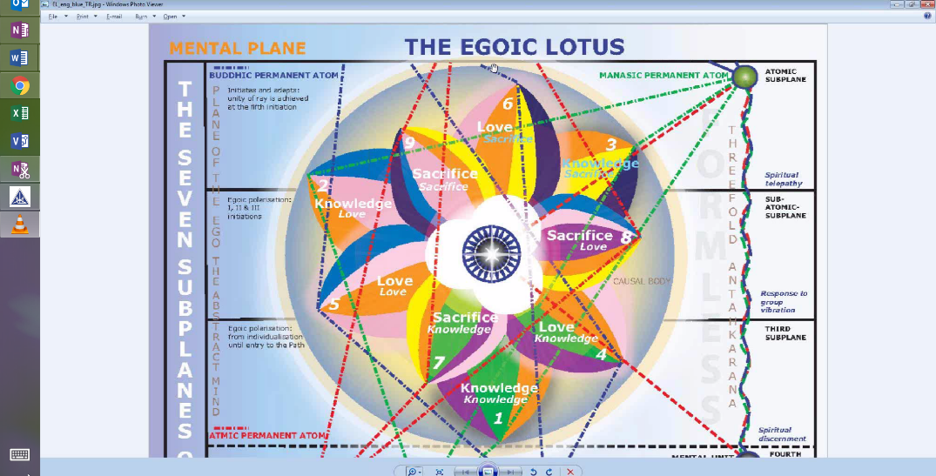

The 6th is completely unfolded at the 2nd initiation, but work is finishing up in the 7th petal in terms of the accumulation of the higher knowledge. The rod of initiation has directed its energy to the 8th petal, but there is continued unfoldment to be done and the work is primarily in the 9th petal. Can we consider that ruled by Sagittarius? Possibly. Or possibly by Aries. It is I think justifiable to assign the fire signs to the Sacrifice and the air signs to the petals of Synthesis. Water signs to the Love petals related to the astral plane. And of course when it comes to knowledge of the world, the Earth petals. The earth signs would be assigned to these outer Knowledge petals.

Is this Aries at the final petal? Things are going in kind of a reverse direction here. Everything looks like it is moving in a clockwise manner for the 1st two tiers, but suddenly if we begin with that petal which most touches the 3rd subplane of the higher mental plane and then go to petal that touches the 2nd subplane and finally the one that touches the first, the order is different and so we might instead of beginning with the cardinal sign and ending with the mutable, we might begin with the mutable sign, the fixed sign will always be in the middle, and end with the cardinal. Aries is both the beginning and the end and it does represent the sacrificial lamb. It also has a definite connection with Pluto. Aries/Pluto/Shamballa and a certain type of destruction which is necessary for the liberation of the spirit. And Aries, of course, is a sign of great willpower. The foremost sign of the 1st ray and of will at this time. We can look later at how we will justify this. I think that Aries gives entre into the world of being, which one more fully begins to experience after the 3rd initiation. So Aries definitely does rule the 3rd initiation, and Sagittarius only rules the path towards the 3rd initiation, having more to do with the 1st and 2nd initiations.

55:26 Anyway, in the Egoic Lotus we will be working on the 7th, 8th and 9th petal. A lot of work is being done at this time in the 9th petal. And Mars will be overcome. The lower ruler of Aries will be overcome, but by what? In this case we can understand that the hierophant who is associated with Uranus would easily be connected with the 9th petal if Aries was the ruler, and this is where the rod of initiation of Sanat Kumara is applied - it's no longer the Christ. It's the Uranian rod and not the Neptunian rod. So the more I think about it the more I think we can assign Sagittarius, Leo and Aries to the 7th, 8th and 9th petal, now apparently moving in a counter-clockwise direction. There is still much to sort out there because at a certain point all the 9 petals move in the same direction, a different direction from the Synthesis petals but definitely if we look at beginning with Sacrifice/knowledge, it touches level 3, Sacrifice/love touches level 2 and Sacrifice/sacrifice touches level 1, therefore we can follow the rotation in this tier of petals from the 3 to the 2 to the 1 - it is counter-clockwise and ending with Aries seems to me very correct when we assign fire signs to the Sacrifice petals. There are different ways to assign the signs to the petals and we will discuss them as move meticulously through a discussion of the various petals.

Can we connect Aries with Vulcan? I think we can. Certainly there is the 1st ray connection, definitely. There is also a connection with one of the pointers. Pluto, Vulcan and the pointing stars are all involved here. There is a figure in Esoteric Astrology which deals with that. And there are many qualities which Aries and Vulcan share. I would say applied forceful pressure, and the power to initiate; I think both share. So when the Martian personality is overcome by Vulcan at the 3rd degree in the Aries petal, it seems both are justifiable. Aries relation to Mars, yes, but a higher relation to Vulcan involving spiritual will of Vulcan and a dynamic will of Aries. Now we move a little farther and we go to the fourth initiation and discover something very interesting.

Fourth Initiation (EA)

"d. At the fourth initiation, Mercury and Saturn again bring about great changes and unique revelation, but their effect is very different to the earlier experience." EA 71

59:07 Of course when we come to the 4th initiation we have to realize that it's only just before that initiation that we can study the causal body because at that initiation the causal body is destroyed. d. At the fourth initiation, Mercury and Saturn again. . . remember how they appeared in relation to discipleship. Mercury and Saturn again bring about great changes and unique revelation,. . . it's the revelation of the buddhic plane or atmic plane or both, but especially the buddhic plane. Mercury is associated with the buddhic plane and with the true illumination and Saturn with the atmic plane, but also with density, and thus the worlds the initiate is leaving behind. . . .but their effect is very different to the earlier experience. The earlier experience was simply illumination and discipline. The later experience is discrimination and intuition. Well that intuition is going to come from the Synthesis petals and beyond because they are fed from the buddhic plane. There is a cutting free. There is a viveka, a discrimination in the Sanskrit. One has to discriminate between the real and the unreal at this point, and understand that life upon the cosmic ethers is real and pertains to the higher initiations: the 4th and the 5th and beyond, and life within the lower 21 subplanes is not real in that sense, because it belongs to the dense physical body of the Solar Logos. So with the Saturnian scythe, one cuts oneself free from attachment to those lower worlds. Saturn is a detaching planet - we have to realize that and Mercury leads into the still higher levels of mind.

It said in the 12th rule about Aquarius (R&I, 227): Let the group serve as Aquarius indicates; let Mercury speed the group upon the upward Way and let Taurus bring illumination. . . and the attainment of the vision;. . . with Mercury very connected with Taurus and with buddhi and then there is another part to that rule as well but it's not relevant to this . . . let the mark of the Saviour, as the group toils in Pisces, be seen above the aura of the group. but it’s not about entering the 4th initiation.

01:02:26 Well, so we learn truly what is reality. We might expect at the 4th initiation that also Pluto would be effective, that Vulcan certainly is effective at the 4th initiation, Pluto, Uranus - two 1st ray planets. We might expect that the great power of sacrifice, Neptune, is active there as well and simply because Mercury and Saturn are operating at this initiation in terms of changing the perception from a fragmented, illusory perception to that of pure reason, just because they are active does not mean these other planets that I have mentioned are not active.

So before 4th initiation, that's the one we are talking about here, the Synthesis petals which were created through a buddhic down flow we are told, are opening very fully and there is all kinds of synthesis operating in the field of knowledge, the field of love, and the field of will. So the one will is discovered, the one love, the great love is discovered and the synthesis of all knowledge is discovered as well. We are really not concentrating any longer in the lower 9 petals which are completely unfolded. There may be other effects in them, but really the work has to be done within the Synthesis petals and maybe the focus in the Jewel in the Lotus as the Monad is coming in with greater force at the 3rd degree and persistently beyond the 3rd degree. So it is legitimate to focus within the realm of being as that realm is revealed by the intuition and with that kind of focus and understanding, the synthesis petals will continue to expand, although it is said they burst open suddenly towards the end.

As far as work within the Jewel I can only say concentration on the meaning of being. There is also work within the Synthesis petals. It is really concentration about how the many can really be the One. That all the many aspects of knowledge are contained within one acute perception of what knowledge is. All the many loves are One love and all the many acts of volition are really One. So that type of focus and thinking within the triad will open the Synthesis petals increasingly.

01:05:34 So what can we expect? We can expect in terms of the Lotus, the full blown Lotus, on the verge of demonstrating its fullest possible display. That is what we can expect. Now we move onto the last point before we take up what is said in Esoteric Psychology Volume 1. I guess we should be brief concerning the stage of Mastership because the object of our study will no longer exist. The Egoic Lotus will have been destroyed in any one of 7 ways of destruction, given in the beginning of Letters on Occult Meditation, on around page 15 or 16, right in there. So here is the object of our study and it is no longer there.

Fifth Initiation (EA)

"e. At the fifth and final initiation, Uranus and Jupiter appear and produce a "beneficent organisation" of the totality of energies found in the initiate's equipment. When this reorganisation is complete, the initiate can then "escape from off the wheel and then can truly live."

All this time the energy of the sun (veiling a sacred planet, hitherto unknown) is steadily and persistently reaching the man via the solar angel." EA 70

e. At the fifth and final initiation,. . . ﻿﻿of course we know it's not final, but it's final in the realm of humanity. The Master is still a man. It is said of the Chohans, they are no longer men as are the Masters. Well the Masters are men, still. The Chohans are something else. At the fifth and final initiation, Uranus and Jupiter appear. . . ﻿﻿or at least they are received in a new way, their impact is received . . . and produce a "beneficent organisation" of the totality of energies found in the initiate's equipment. ﻿﻿There has to be the dispelling of the debris of the supernova which we can use as a symbol of the destruction of the causal body and a reorganization - why a reorganization? Well this is interesting, it has something to do with the mayavirupa, which can be created after the 4th degree, but is more likely created at the 5th degree, which is a replica of the former energy system of the individual, not the causal body but of the spiritual triad in relation to the reconstituted, reorganized personality.

When this reorganisation is complete, the initiate can then "escape from off the wheel. . .﻿﻿well in a way at the 4th degree he is already escaped from off the wheel of rebirth, but is it necessary to be a 5th degree initiate to thus escape? Well there are still considered to be the man. So when they can escape, does it mean that they prepare to enter the Monadic life? They are already upon the atmic plane; they already can focus in the spiritual will. But it's almost like the wheel of Brahma. We might call it the wheel of the 3rd aspect of divinity, the wheel of Brahma. After the 5th initiation begins the escape off this wheel which has to do with rotary motion and the 3rd aspect. Rotary motion is exemplified by the wheel and the 3rd ray motion is rotary motion. Brahmic, 3rd ray motion is rotary motion.

01:09:57. .. and then can truly live." ﻿﻿Where does true livingness come? Does true livingness come within the vehicles of the spiritual triad or within the Monad itself? And I kind of default to the last conjecture here, that one can truly live when one becomes a Chohan and of course the 5th degree initiate is on his way to becoming the Chohan who can focus as a Monad outside of his vehicles. You know how it is. It's the same with human being. As we are progressing, we first are at first very focused in our etheric/physical nature, later a long Atlantean period occurs, and we are focused in the astral nature. Then comes the Aryan period, when we are focused within the mind. But we are focused within one of the lower three and only when we can abstract ourselves from such a focus and focus within the soul, do we gain a certain type of freedom from the lower three. Well I'm thinking here of a kind of freedom from the spiritual triad which is considered to be the personality of the Monad and there is a kind of containment that occurs there, even though for people like ourselves, it would be a great expansion, but after the 5th initiation, one can begin to abstract into the Monad - one can truly live because the Monad is the center of life. It's not the vehicle of the Monad that is the center of life, but the essence of the Monad at the heart of the Monadic vehicle.

01:11:40 So, you know Uranus is the 7th ray planet of organization and Jupiter of beneficence. The kind of organization that connects one with purpose and interesting too that Jupiter is involved in the creation of the mayavirupa because it is Kriyashakti from the Virgo plane on which Jupiter rules hierarchically that is the energy that is going to create the mayavirupa. So with the causal body out of the way, the spiritual triad and the personality have to be brought into new relationship and the Monad completes the trinity and these two planets coming in at the 5th degree, help there to be a very close connection to the Monad, a very strong expression of the atmic spiritual triad and as the spiritual triad as a whole, and Jupiter has a fusing power and Uranus brings heaven to earth.

So we can see how the new focus of the man, which is in the spiritual triad, can be integrated with the personality. There are these advanced methods of integration - in a way the personality of the Monad and the Monad itself begins to come to Earth, this is discussed in Treatise in Cosmic Fire around page 166-169, right in there, we are talking about the creation of the body of fire. The way a man must now represent divinity after the causal body has been destroyed requires a reorganization, but as I said the object of our study has disappeared, so just for the sake of completeness we talk about a reorganization going on within the energy system. Naturally when there is a gap, a vacancy between two parts of man's energy system, a new kind of approach has to be arranged and a new type of interplay has to be arranged. Personality, triad, Monad, 3, 2, 1.

01:14:42 All this time the energy of the sun (veiling a sacred planet, hitherto unknown) is steadily and persistently reaching the man via the solar angel. And making not only a Master of him, for the Sun is connected with Mastership, but influencing the 6th and 7th initiations. In other words, higher Chohanship. The Sun shines ever brighter. You know when you look at this diagram, Chart VI,

we see that the Sun towers above all these different planetary schemes, so the Sun is almost that which will take us into true Chohanship. Uranus won't quite do it. Uranus takes us to the 5th degree. The Sun brings us to true Chohanship because the Monad is that which finds its home within the Sun.

The Chohanship is very solar. The 7th degree initiate is coming into connection with the Solar Logos. It is a love and wisdom type of initiation. In any case we see that the symbol of the Sun stands for progressive initiations. Now a sacred planet hitherto unknown, that is very mysterious in some way. We could perhaps think of the planet Isis which is a planet which distributes, I believe, energy, I believe, from the star Sirius to our solar system. There is a map or a kind of a chart in Esoteric Astrology where it shows that the Sirian influence comes through Saturn, Neptune and also Uranus, but there is closer to it another planet. It says an unknown planet which is a distributor. How many sacred planets can there be in our solar system? The Tibetan has hinted that there may be there will be 12 and so then each one of them is associated with one of the signs of the zodiac. In any case, we have no known what this sacred planet is. The term - hitherto unknown - is a little bit vague. I don't think it's going to be Vulcan. But Isis is very much connected in its lore with the Solar Angel. The Solar Angels are from Sirius in a way, and Isis is a strong representative of it. And there is a certain planet X through which Sirius distributes its energy and then onto the 3 synthesizing planets. This will have to remain for the moment the unknown, but there is a possibility there that Isis may be involved. Otherwise, it's going to be one of our own sacred planets and are there any of them that are hitherto unknown?

01:19:39 Now from Esoteric Psychology 1 we talk about the same kinds of forces and I just want to add a little bit here because it is information which is closely related to that which we have already discussed. So let's go on.

"There are other planetary influences to be felt, and hidden forces likewise play upon our planetary life, but these are the Page 246 major influences bringing about the desired results in the kingdoms of nature under the Plan. It must be remembered that these are the cyclic influences dominant at this time, and that they change from cycle to cycle." EP 1, 245-246

There are other planetary influences to be felt, and hidden forces likewise play upon our planetary life,. . . ﻿﻿at least hidden to humanity's knowledge . . . but these are the major influences bringing about the desired results in the kingdoms of nature under the Plan. It must be remembered that these are the cyclic influences dominant at this time, and that they change from cycle to cycle. ﻿﻿Really some deep knowledge of the science of cycles is needed if we are to be wise in our reception and distribution of energies. First of all so many of us don't know many of the hidden energies. We know certain of the energies which reach us from known sources such as our planets and our zodiacal signs and we know those cycles, but we don't know the hidden sources and more than that we don't know their cycles. So there is so much that remains to be understood if we are going to be able to wisely receive and distribute energies.

First and Second Initiations (EPI)

01:21:22 "For instance, a disciple who is upon the path is strongly influenced by Mercury and by Saturn, but when he begins his training for the first initiation he has to contend with the influences of Pluto and Vulcan; the training for the second initiation brings him under Neptunian influences with Venus and Jupiter contending for control." EP1, 246

For instance, a disciple who is upon the path is strongly influenced by Mercury and by Saturn,. . . ﻿﻿and this we learned in Esoteric Astrology, page 70 . . . but when he begins his training for the first initiation he has to contend with the influences of Pluto and Vulcan;. . . ﻿﻿well D.K. elaborated on this two books later. You see this is written in the 1st book of the series of the Treatise on the Seven Rays. It will be a 5 volume treatise and when he got to Volume #3 in that treatise, he elaborated on this statement here. . . .the training for the second initiation brings him under Neptunian influences with Venus and Jupiter contending for control. ﻿﻿Now he said nothing like this at all in the Esoteric Psychology book. (??This is the Esoteric Psychology book). The Neptunian influences are there. It has to do with the right kind of desire, an upward streaming desire. It has to do with the heightening and refinement of the aspiration and sensitivity to subtle influences. It has to do with the love energies, compassion entering the astral body and so forth. But why do Venus and Jupiter contend for control? Well in the Secret Doctrine there is the story of the battle between Brihaspati, which is Jupiter, and Venus, it goes by another name, but it is associated with Narada and Jupiter ruled the ancestral gods and Narada/Venus was trying to create of people a higher type of human being - more the ascetic, more the celibate, one that is not so given simply to the reproduction of form via the ancestral gods. But remember back a little while we discussed Venus as related to the throat center possibly and Jupiter to the heart center. And I wonder if they are contending for control is not as it was in the Secret Doctrine where the two were really in battle for a lower or a higher way of living, but that Jupiter rules the heart center and Venus the throat center and has more to do with the mind. So we wonder then whether the fuller heart expression, influencing the causal body, will be represented by Jupiter, with Venus more of the rational faculties at the throat center. With the heart having to win but still remembering that spiritual intelligence and mental illumination have to be developed at the 2nd degree.

01:24:20 Anyway, it remains a somewhat enigmatic phrase, but all three of them are involved in preparing the man for the 2nd initiation. The solar plexus, the throat and the heart have to be strongly and harmoniously involved with each other and it's very important that at the throat center via Venus which brings in the Solar Angel from a certain perspective, we have spiritual intelligence and mental illumination and we can certainly expect that from Venus. Given that both of them are so positive, one wonders why Venus and Jupiter have to contend for control. We do know at the 2nd initiation those faculties of spiritual intelligence have to be developed, but so does a heart response as expressed through the astral body. Not a desirous response, but more a love and heart response which Jupiter would convey. At least that's my take on it but I certainly haven't stopped thinking about it. There is a lot more to discuss here.

"The link with the vegetable kingdom is then strong, and hence the frequent recognition of "astral perfumes" which the disciple can note. Before the first initiation, the static mineral world within him has been broken up." EP 1, 246

The link with the vegetable kingdom is then strong,. . .. ﻿﻿i.e. at the 2nd initiation, because it is the 2nd kingdom and the 2nd initiation, just as the link with the mineral kingdom will be strong at the 1st, and I wonder then about the animal kingdom at the 3rd. . ..and hence the frequent recognition of "astral perfumes" which the disciple can note. ﻿﻿I had a friend who told me her impression of the perfumes associated with various of the Masters with the scent of fragrance of freesia for Master Morya, the carnation for Master D.K. and the white rose for Master K.H. and one certainly does wonder about the red, red rose when it comes to the Christ.

01:26:25 Before the first initiation, the static mineral world within him has been broken up. ﻿﻿Lots of insights come from the different references and this means that Vulcan with its pressure and its hammer blows has broken up the hold of the static mineral world on the would-be initiate. So that is another statement about what Vulcan can do as it descends to the depths of matter with its crystallizing power but it also has the power of the hammer blow.

Third Initiation (EPI)

"At the third initiation, the Moon and Mars struggle to assume ascendancy, and there is his battle-ground. Hence at the great Transfiguration, the body is "transfigured" as the indication of triumph." EP 1, 246

01:27:17 At the third initiation, the Moon and Mars struggle to assume ascendancy, and there is his battle-ground. ﻿﻿But if we were to simply read this without the enlightenment of Esoteric Astrology reference, we would think of the Moon as the lower thing and Mars as some sort of victorious planet. But it is the Moon veiling Vulcan and bringing in the spiritual will to control all the lunar elementals including Mars that is meant. There is going to be a struggle between what the personality as a powerful integrated being wants to do and what the spiritual will from the Moon/Vulcan gives. What does the integrated personality want to do in a Martian way and what does the spiritual will - Vulcan hidden behind the Moon direct.

Hence at the great Transfiguration, the body is "transfigured" as the indication of triumph. ﻿﻿This is interesting because it's Vulcan that gets this tremendous light value out of matter. Vulcan draws forth from matter a great light which is seen at the transfiguration. So that is yet another piece of information which we may not have had before. And the Moon, which is the reflector, now shines with this Vulcanian light. Its own matter is no longer dark. It is transmuted, transformed and transfigured. It shines with the new light. And one probably can begin to see the halo following he transfiguration - for those who are etherically sensitive.

Fourth Initiation (EPI)

"At the fourth initiation, Mercury and Saturn act as the great translators, and bring the disciple to the door of realisation. When the final initiation is taken, it is the activity of Uranus and the in-pouring force of Jupiter that bring about the reorganisation which results in the final emancipation. The vastness and complexity of the subject thus become apparent." EP 1, 246

01:29:33 At the fourth initiation, Mercury and Saturn act as the great translators,. . . ﻿﻿now that is not an idle word. Not at all. You know I've read this many times but right now I'm getting a lot more out of it than I did before, . . . and bring the disciple to the door of realisation. ﻿﻿Here is how it goes. Let's get the series: Transmutation, Transformation, and Transfiguration and Translation to the buddhic plane, which is a cosmic ether and pertaining to the 4th degree. And what's really interesting here is that it prepares the man for realization - realization relates to the 5th degree. Mercury and Saturn are lifting the consciousness into the cosmic ethers. I suppose Saturn is also cutting the connection with the normal area of life with which the man has been identified. Mercury certainly is speeding the group upon its upward way. It's translating the transfigured man into the world of buddhi; then preparing for the world of realization which is the atmic world at the 5th initiation. So the door of realization - realization is achieved upon the 5th level of the atmic plane. So the 5th initiation, the 5th level, ﻿﻿realization. So maybe our sequence would be even though the 'Ts' do not hold: transmutation, transformation, transfiguration, translation, realization - maybe sometimes I've said transubstantiation trying to keep the keys. Is that technically correct? I'm not sure.

When the final initiation is taken,. . . ﻿﻿why is Saturn a translator and not just one that severs identification with lower life? Because Saturn rules the area in which realization is had, namely the atmic plane. Saturn is the ruler of the atmic plane. So Mercury is the translator and Saturn kind of lifts the life toward the atmic plane where realization can be achieved. Of course at this time the causal body is destroyed and the Egoic Lotus is not the issue. ﻿When the final initiation is taken,. . . ﻿﻿and again, not final . . . it is the activity of Uranus and the in-pouring force of Jupiter. . . ﻿﻿why does he talk about one as an activity and the other inpouring . . . that bring about the reorganisation. . . ﻿﻿he earlier called it beneficent organization but I have always liked the idea of reorganization when it comes to Uranus. So I would like to call it beneficent reorganization . . . which results in the final emancipation. ﻿﻿At least, emancipation from the need for reincarnation and emancipation from life in the three lower worlds in which the man becomes the Master.

The vastness and complexity of the subject thus become apparent. ﻿﻿So all of us, you know we have teeny minds the size of a pea and we think that man is the very paragon of knowledge and intellect and we finally wake up to the truth we will realize that these incredible vistas are presented to the true occultist just as Alice Bailey saw them when the Tibetan was dictating to her - always knew things that he was not dictating appeared to her - vistas that were so vast she could only fall back in wonder at them. And in this simple sentence, whether we see it or not, the vastness and complexity of the subject thus becomes apparent.

01:34:03 I am so glad the opportunity presented to consider the earlier references. We would think it might be sufficient to consider only the later references in Esoteric Astrology but these have enriched the consideration.

So there is, in terms of the Egoic Lotus, in order to open that 9th petal, there is going to be quite a battle going on there. Of course we usually think about the hydra is always active and the hydra is active at the 2nd degree for which Scorpio is the most characteristic sign, but Scorpio also is involved as well at the 3rd degree. Its peculiar testing potency we are told ends after the 3rd degree and then maybe it comes in in a different manner, but in the 9th petal, as one does what is required in the overcoming of illusion, there is going to be a great battleground between the power of the integrated personality, represented by maybe Mars or Sagittarius there and the power of the spiritual will, and we have to decide whether the man has the willingness to go on and not to do as the rich young man did, turn sadly away when the Christ asked him basically to follow him onto the buddhic plane and towards the 4th initiation. And when we kind of look at the colors, the colors here have to do - deep indigo of the 2nd ray, blue is it a substitute for the 1st ray? I'm not exactly sure, usually associated with the 2nd and 6th. Rose definitely for the 6th ray. The 5th ray of orange and the 4th ray of sacrifice.

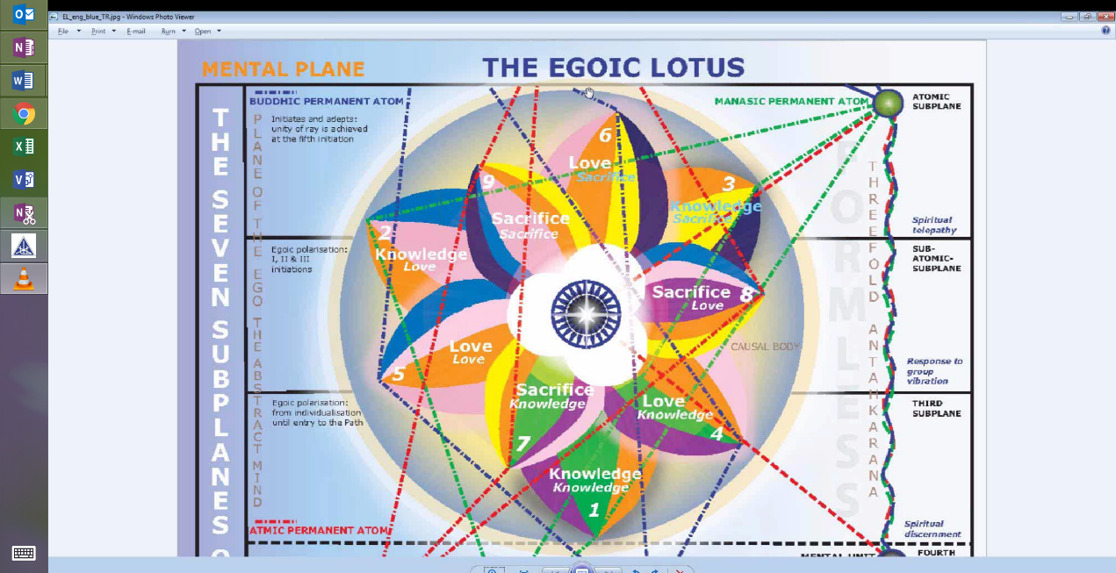

These are the prevailing influences but you never have a place, let's see here, with these yellow, orange and rose will always be found. Violet is interestingly found in 2 of the Sacrifice petals. Green only in one. And then for the final Sacrifice petal, well when we get into the study of the colors, we will deal somewhat with this. I'm trying to see what they have carried forward from petal #8 - they carried the yellow, the orange, the blue and the rose but indigo seems to take the place of the violet and why should violet appear twice? It doesn't in any of the other circles. It just appears in the place it is supposed to appear. But it appears twice and let's see what is usually going into the 2nd petal - violet is going into the 2nd petal, but usually rose and orange are carried forward, they are in the 4th petal, rose and orange are in the 5th petal, but a double, double rose and a blue there appears and the blue is replaced by indigo, by a deepening of synthesis in the 6th petal.

01:37:56 So the arrangement of the colors in the Sacrifice tier begin to show some differences. You always have the orange, you always have the rose. That is consistent. And you always have the yellow. But violet is a color that appears twice so it seems, if this is drawn correctly and that is not an expectation. Here in a Treatise in Cosmic Fire we have confirmed this.

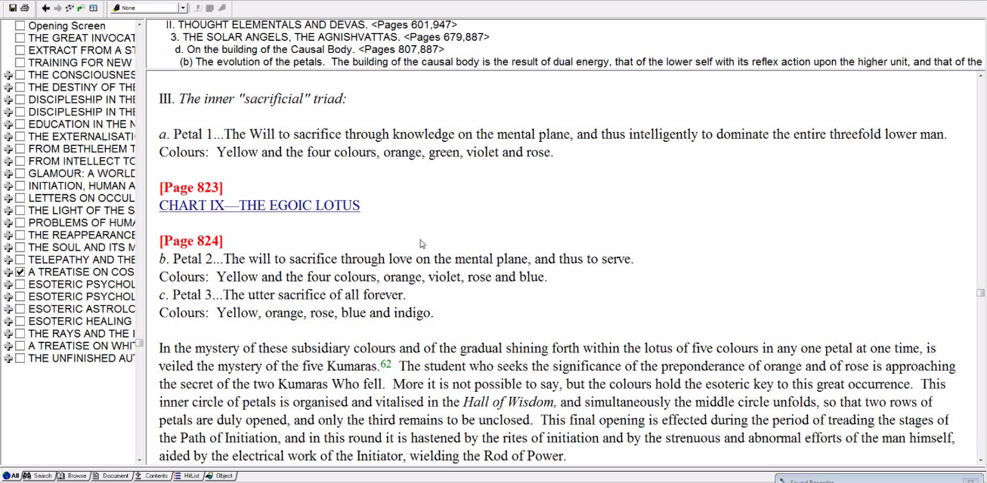

The violet is uncharacteristically brought forward into the 2nd Sacrifice petal and normally violet is not brought forward, it is just left where it would be. And then blue is to be found as it was found in the Love petals and blue is carried forward again. So let's just examine this one more time. Is there ever a place where blue is carried forward twice? No. Because although blue does appear, the blue and the rose they appear and relate to the astral plane in the Love petal, the blue is not carried forward, indigo takes its place. But here not only is violet doubled when we consider the movement from petal 7 to petal 8 but blue also goes forward and accompanies indigo, and yellow, orange and rose remain as the 3 constants. So it's kind of interesting to look at what the petals other than the 3 constants are. We have the yellow for Sacrifice. The rose for astrality and desire and the orange for the physical knowledge, for the 5th ray - knowledge on the physical plane. The other colors for petal 7 are green and violet and then you have violet and blue. The rose is not doubled again. Notice when you carry forward from petal 4 to petal 5, you have a double rose. That is really the Solar Angelic petal. So in petal 8 it is violet and blue and in petal 9 violet is dropped and it's blue and indigo.

Now what shall blue represent? It usually represents the 6th ray, definitely and sometimes the 2nd ray and there is one reference in Letters on Occult Meditation where blue represents the 1st ray and red represents the 6th ray though they seem to be reversed. Anyways, there is a lot of the 2, 4, 6 line with the Synthesizing - yeah here, this is interesting, you know you might think that you would have a double yellow someplace because usually in the Sacrifice petal we have a combination of indigo and yellow okay and then we go to petal 6, also a Sacrifice petal in the Love tier, indigo and yellow. Well we do have - yellow is found in all the Sacrifice petals but not twice. We might expect when the indigo/yellow petal came up, the Sacrifice petal for the Sacrifice tier we would double on the yellow but instead we introduce blue a second time. All of these have deeper meanings and you know, when we are undergoing the transfiguration it is necessary to have these soft lines very strong.

01:42:29 But also the 1st ray comes in there. We keep on with the 5th ray, all the way through. There is not one petal that does not have orange all the time and that's the only consistent color throughout. The orange of the Solar Angel related as they are to being great scientific workers and using the 5th ray and establishing the soul body on the 5th plane. Well when we get to the colors we will try to decipher this. It is not going to be so easy, I think, but it is interesting that the violet does disappear. It's used twice in the Sacrifice area which has something to do with manifesting things on the Earth. The violet is the 7th ray color - the color of manifestation. But there is no double yellow and there is no - would there ever be a double orange? No I think not.

Review

So friends, this has been a discussion of certain planets which are operative at different stages of man's evolution. Mercury and Saturn for discipleship and maybe especially, well discipleship in earnest, not simply probationary discipleship. Vulcan and Pluto for the 1st initiation. Neptune, Jupiter and Venus for the 2nd. The Moon veiling Vulcan as I believe it to be, maybe someone else has a different idea about what that hidden planet is, but Uranus is not hidden and Vulcan is. He even uses the word hidden when he talks about Vulcan in relation to Mercury so there is the application of the word that he is using. Moon veiling Vulcan and Mars at the 3rd. Again Mercury and Saturn as great translators into the triad at the 4th degree, though obviously every planet can play its part at every initiation and contribute something of importance. And then Jupiter and Uranus giving beneficent organization or beneficent reorganization if we look at what is said Esoteric Psychology 1.

And you know of course the different planets have their colors. And I suppose it would be an interesting study to say okay well what petal is particularly involved at the 1st initiation? Well we'd have to say it is petal #5. We have a double rose. We have an orange and a blue and yet interestingly the two planets involved do not suggest those colors. Maybe Vulcan has some red-orange in it, but its Vulcan and Pluto - those colors are not suggested.

At petal #7 where much work is being done, there are no colors again that correlate with Vulcan and with Pluto, but are there any colors here which represent the 1st ray? You see look we have 2nd ray indigo, 3rd ray green, 4th ray yellow, 5th ray orange, 6th ray rose and even blue and 7th ray violet. The 1st ray color of red is not represented here. Under some circumstances orange can be considered a color of the 1st ray, but it is not represented in the Egoic Lotus - even though when you are a Lotus on the 1st ray there might be a reddish tint coming through in some manner because he says that the color of the ray does show through the Lotus. So that one place where blue and red have a reversed position - blue is in the place of the 1st ray and red is in the place of the 6th ray. I believe this is in Letters on Occult Meditation. Can the blue represent the 1st ray? Well you know it looks like it's not placed in the right place to represent the 1st ray, because we are told that Master K.H. on the 2nd ray works with the devas which are rose and blue. Well it's usually put in the middle petal which is the Love petal of any particular tier. Here is the Knowledge Love petal so here is the blue and rose. Here is the Love/Love petal, here is the blue and the rose. Here is the Love petal of Sacrifice it's the blue and the rose. And only in one petal is the blue carried along and there is no double yellow, basically the blue is substituting for yellow and on the basis of that can we say it represents the 1st ray? I don't think so.

01:48:25 So whatever can represent the 1st ray, orange is the closest thing and blue is kind of a strange possibility. There is no real representation of the 1st ray color in the Egoic Lotus. The color rose which is not one of the primary colors or even of the secondary colors, is used, and not red. There is one earlier depiction of the Egoic Lotus where I think - well let's see - I think red is used but I think that's simply a mistake.

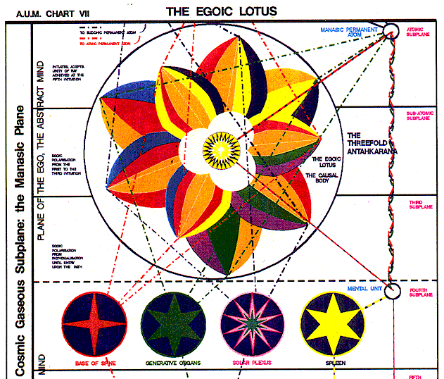

Red is used and it is as far as I can see mistaken. They are differently organized in this earlier rendition from the AUM group and then my wife, Tuija took another look at this and supplied the proper rose color instead of the red and also changed the petal - this was in the earlier version, petal #8, she called it petal #7 because it's the Sacrifice Knowledge petal and it's touching the realm of knowledge, so I think she was justified in doing that. There are still, I think, some secrets here. So that's the 1st initiation.

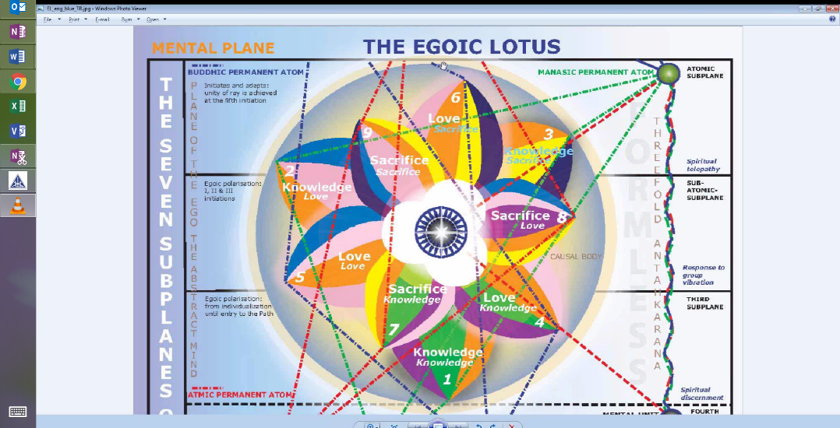

With the 2nd initiation, we have Jupiter, Venus and Neptune. Well certainly those colors are very much in evidence in the 2nd tier. The rose color of Venus or Neptune is there in petal #4, 5 and 6. The blue in this very important petal for the Solar Angels - the blue that can be associated with Jupiter - Jupiter has kind of a royal blue quality to it - is found in this petal #5. It's also indigo which is also a Jupiterian color and also a color profoundly connected with the 2nd ray. We can see how the Jupiter influence could make its way into the Love tier. There would be a correlation of the planets and the petal colors. Venus, well it can be associated with rose and there is rose everyplace but also with orange of the 5th ray and the 5th ray is everywhere found. So it's as if Venus is found everywhere throughout the Egoic Lotus.

01:51:34 We get to the 3rd initiation. We have Mars, well what is its color? Its color is primarily red. It's not found here. Maybe when the idealism becomes higher and purer, its color can be related to rose. But in the third tier where Mars is playing an active part we do have rose in every petal, a rose strand as it were, but you know relating Mars to rose, well it's certainly a big refinement of what Mars is. Usually it's kind of a reddish-orange, it can involve a deep red - it's the color of blood, but gradually as the idealism raises we can find the connection with Mars and rose.

When we think about the Moon - it's a 4th ray planet and the 4th ray color is the yellow; that is found everywhere. But the Moon veiling Vulcan, what shall Vulcan be? Well Vulcan sometimes substitutes for the Sun and the Sun is orange, so Vulcan can relate to orange as well. Therefore Venus and Vulcan would seem in a way to invade the color system of the entire Egoic Lotus. But I don't find any deep red or orange or anything of that nature.

When it comes again to Mercury and Saturn, well Saturn is green. But we're talking about the 4th initiation and so we're talking about working within the Synthesis petals, which are said to be of a lovely lemon yellow. That would correlate well with Mercury and with buddhi, not so much with Saturn, but then we don't know much about the other color striations in the Synthesis petals and when we come, of course, to Jupiter and Uranus, well Uranus is the violet, in a way the Moon is also violet, the Moon veiling Uranus.

And it would be interesting if we put the planets in their places. But let's just say that the Jupiter/Uranus contribution is not really relevant to the Egoic Lotus as it has been destroyed, but at an earlier stage of evolution, perhaps we do have relevance. From a certain point of view:
Petal #1 = we can have Venus/Vulcan, Saturn and Uranus.
Petal #2 = Venus/Vulcan, Neptune, higher Mars or even Venus itself related to the rose and the blue can be related to Jupiter.
Petal #3 = Venus/Vulcan, you see the connection with Vulcan and orange. Orange is a color of the 1st ray but it's said to be an exoteric color of the 1st ray.

When Blavatsky presents the notes, do, ra, me - it's the Sun note and it's considered to be orange, and one can understand that Vulcan is connected with it. Yellow is Mercury and the Moon, and the indigo is has got to be Jupiter and to what extent is it the Sun - the indigo Sun pervading all of this? We could continue to add. The color rose is added as a constant and that is certainly Neptune, part of Venus and maybe a very high type of Mars. And then the color yellow is added as a consistent one to the Sacrifice petals.

01:55:54 This color language scintillating, interpenetrating, combining along with the notes associated with the colors are all going to be part of the Egoic Lotus demonstration. So the Lotus must not only be magnificent in sight on the inner planes, but as well it must sound.

Obviously I am tempted to just go on and on and try and make these correlations, but you can see you can put different planets in different petals. For instance, if I look at petal #9, I could put the Sun, Jupiter in indigo. I could put Jupiter as related to blue. I could put Neptune, Venus and higher Mars as related to rose. I could put Venus/Vulcan related to orange. I could put the Moon and Mercury related to yellow. And here I would obviously put in 4th ray, 5th ray, 6th ray, 2nd ray and x-ray. It is again the 6th ray when we are talking about this color of blue.

The God of our planet certainly has made an amazing creation and certainly worked things out with the kind beautiful, meticulous entirety which we are just on the fringes of taking the first steps to discover or understand in the slightest way. All of this is woven together. It all has great meaning and significance. It all reflects the divine archetypal purpose. And we are just taking a thread here, a thread there, trying to unravel this in our understanding to see how it was put together, why it was put together, and what final divine consummate pattern it represents. Because the evidence of God is everywhere and in this great temple of Solomon, this great Sun-flower of the soul, these colors combine and they tell a story of the unfoldment of ray quality, astrological quality, especially planetary quality. Even the signs are involved. When I look at yellow, I could put Gemini in. When I look at rose, well it's pretty close to lavender, okay, possible Pisces which has its own 6th ray. When I look at the indigo, put in Libra. That's what the Tibetan gave. When I look at rich blue, it's possible to introduce Sagittarius.

01:59:01 So from the color correlation angle, so many of the different signs of the zodiac can be inserted, only not Aries because it is red. Well I recall that the God of our solar system has repelled much of the entrance of the 1st ray to concentrate on his present 2nd ray purposes. So maybe the sunflower which is kind of reflective of the great Sun also repels the 1st ray and does not have it in its constituents. If there is such a thing as a causal body in the 3rd solar system, I bet it will have red.

Alright. That's it for this program, program #12.

