EGOIC LOTUS WEBINAR COMMENTARY #9 – Michael Robbins

Abstract

Egoic Lotus Webinar Commentaries 9: The Thirty-Three Stages of Appropriation. This webinar is about 1 hour long and covers Esoteric Psychology Vol II, pages 77-80. Continued preliminary material necessary for a more complete study of the egoic lotus. Program 9 discusses the sixteen Stages of Appropriation of matter/form and the seventeen Stages of Appropriation of soul/spirit. Each of these is interesting and we have passed through so many of them. These stages can, of course, be correlated with the Eight Stages of Adaptation and the Ten Groups of Souls. The insightful student can also discover the chakras which are operative during these thirty-three stages. The number thirty-three is, itself, interesting, relating to the Christ—the Soul—and its descent into matte/form and its renascent into the life of the soul/spirit. Each group of petals and the petals individually enter into this process as may be expected. Some idea of how this is done is given—ranging from work within the Hall of Ignorance during the stage of appropriate of matter/form and moving towards the sacrifice petals as relinquishment of matter/form gains momentum.

Contents

Abstract 1
Transcription of Egoic Lotus Commentary #7 1
Stage of Adaptation #6 2
Stage of Adaptation #7 5
Stage of Adaptation #8 7

Transcription of Egoic Lotus Commentary #9

Okay friends, hello. We are back again to our study of the Egoic Lotus. I think it's always good when I can to hold the picture up before us because there are many correlations here and there are certain things we have to memorize. We have to memorize the name of each petal such as Knowledge/knowledge, Knowledge/love and so forth; the tiers of the petals: the Knowledge tier, the Love tier, the Sacrifice tier. Soon we will have to memorize the colors that are connected with each one of these petals and maybe the particular color associated with each one of the tiers: orange particularly for the Knowledge tier, rose color for the Love tier and yellow for the Sacrifice tier.

Review from Webinar #8

We have been discussing the different types of energy transfers which occur from the time that a man is living well and truly below the diaphragm to the period when he is in fact passing beyond the 3rd degree and towards the 4th degree. In the mystical life, which is the life of the true spiritual aspirant, we have a stage in which all the lower energies go to the solar plexus thence to be carried to the heart and throat. This is an early stage of the mystical life. The period is the Path of Probation. Aspiration and probation - much work being done in petal 5, the later part of it, and petal 6. The keynote is discipline and idealism and the 6th ray are involved.

1:58 Then, the 2nd period on the mystical path, is the transference of the personality life into the ajna center and the personality becomes integrated and powerful. We might consider this, in a way, a post-mystical personal integration. Well since it's mystical, it can never be entirely the selfish integration that we experienced more at the beginning of petal #5. The later stages of the path of discipleship, so up until the 3rd initiation and there are different chakras and triangles, chakric triangles to be associated here we may go to page 170 or so in A Treatise on Cosmic Fire and that would tell us something about the chakric triangles involved at these different stages. The keynote is the expression of the soul through the medium of the personality and here the understanding of the plan is found and we are really dealing with the true disciple, almost with the initiate and then a 3rd and final stage which he does not much describe: all the forces are blended, they are focused in the ajna center with the soul forces in the head center, and a kind of divine marriage occurs. What's so interesting is the way the kundalini power surges upward on the impulse of devotion, aspiration and enlightened will. Now who would have imagined that devotion and aspiration were so involved in the upward surging of the kundalini. You know sometimes it just seems like an act of will that takes it from the base to the crown, and thus fuses itself with the spiritual will.

4:00 So there are a number of these lists we might say, these lists that take us from an early stage to a later stage. Even the rising of the kundalini takes place in 3 levels and this is not simply stimulation of the solar plexus but of the solar plexus by the kundalini. And of the heart by the kundalini and the throat. And all the 5 lower forms of energy focused in the ajna, in the head, from which these energies are directed to the highest head center. And earlier in this section on the transference of energy he gave us 7 periods under the title a, b, c, d, e, f, g and he talked about the degree of activation of the centers, all the way from the sluggish and semi-dormant state to a powerful scintillating radiant period at stage g. A period wherein the highest head center is brought into radiant activity. We began with a period in which even the lowest centers were sluggish and gradually there became the activation of the centers until the central area of each chakra dominated and overpowered and as it were overcame the other parts of the chakras. So that is another one of those lists of progressions and we see how the different chakras function in terms of their activation.

And then, 3 points related to the transcendence of energy of all the lower centers to the higher ones, of the energy of the base of the spine along the spinal column via the ajna center, the sacral center must be risen to the throat and we are familiar with the solar plexus to the heart. And all these centers are developed and brought into activity in 3 stages. So every one of these centers in the a to g list goes through a period of sluggishness and eventually, sooner or later, enters a period of great activity and radiance. The lower centers become more radiant sooner.

Let's see there is probably one more list that we have to look at. The undeveloped man through the 3 centers below the diaphragm, the average man primarily through the solar plexus beginning the process of transference, the aspirants with energy rising to the throat center and they become creative in the higher sense and the soul also nourishes the throat center. I guess there are 5 of these stages. The world disciples with the throat and heart center. And these energies are being raised to the ajna. So this creates the integrated personality. How far does it go? Up to the 3rd degree. That is where the real integrated personality is found. And the more advanced disciples and world initiates connecting with the highest center at the top of the head. So that is just a brief review of this section that we had on energy transference.

8:05 In every petal there is a tendency for different chakras to be activated. For instance, the 5th petal is one of the strong heart center chakras. The 2nd petal is strong solar plexus chakra. Some degree of the mentalized sacral center is coming in at the 3rd petal. The base of the spine and the sacral are obviously strong at the 1st petal. There is the blending of heart and throat at the 5th petal - the personality and the soul. I think the ajna is also powerful at the 5th petal but I think at the 7th petal, where we are really beginning on the Path of Sacrifice and beginning to direct all energies in the proper way according to the Plan, the ajna center is found there. The head center obviously at the 9th petal. The ajna and heart found at the 8th petal and so forth. We will get into this discussion.

When we talk about the Synthesizing petals, we are pretty much working within the field of the head and we have the 7 head centers. We have the ajna series of centers. We have the centers at the top of the head of which there are more than one. And then we have the highest head center with the synthesing power of will. So the head is pretty much involved in the synthesizing petals and the heart in the head as well since the synthesizing petals are the product of buddhic emanation.

Alright I just wanted to review that because it's not always satisfactory to me to go through it the first time. So much seems to be left out and an overview may be lacking so at the beginning of the next program I sometimes attempt to create a little bit of a review which will help clarify. The point is when we look at our own life we should be able to have an idea of what tier we are working in, or tiers. What petals is our particular concentration at the time. What particular chakras and energy transferences are operative in terms of the petal in which we are working.

It is said that even Alice Bailey was transferring the solar plexus to the heart and she certainly began as an initiate of the 2nd degree and I'm sure went onto the 3rd degree as a world disciple. There was no question of that in my mind. Even Dane Rudhyar was considered a world disciple. I think that pretty much means an initiate of the 3rd degree, but then D.K. also said that no initiate astrologers were working at the time that he wrote the book Esoteric Astrology, so who knows, maybe Dane Rudhyar later became that. That's his business of course, but we can attempt to kind of access his impact. His impact and that of Alice Bailey in the field of astrology, Rudhyar very, very strong. In the field of occultism, because the Master was behind it, Alice Bailey's impact amazingly strong.

11:45 So now, we are going to work in what will be called here the Stages of Appropriation. This begins with the soul appropriating its vehicles and then ends with the relinquishment of those vehicles. It's a descent and a re-ascent and as we do this we will think of the 10 soul groups, the 8 stages of adaptation and the various stages of energy transference and along with that our petals and how these energy vortices are activated at certain times of the unfoldment. They are as if the evidence that a type of unfoldment is occurring.

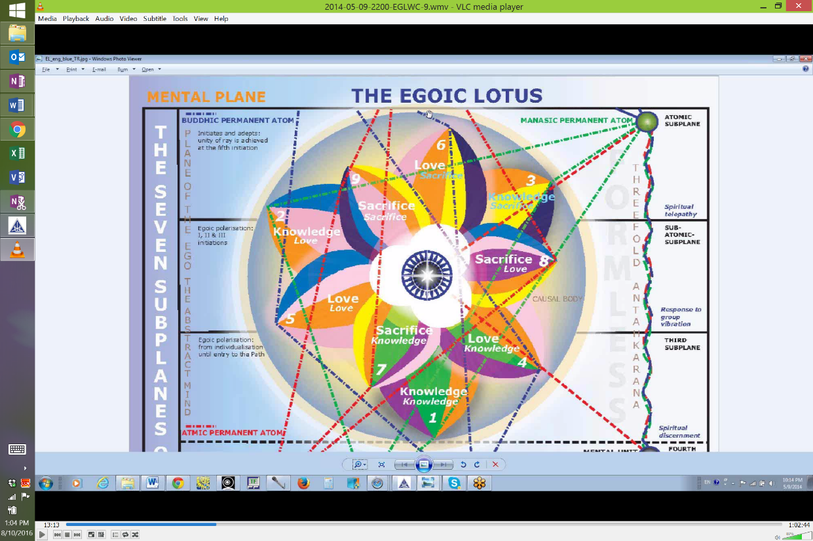

They also are causative in terms of unfoldment because it's not only what we put into these petals or these vortices, but what comes into them from the spiritual triad as well. So they are fed from heaven, they are sustained by the Solar Angel and they are also supplemented by the qualities which we add working in the quarries of the lower life.

So let's look at these stages of appropriation from Esoteric Psychology II, page 77 and 80. You know what I have tried to do - I think you have seen this, this is my table of references:

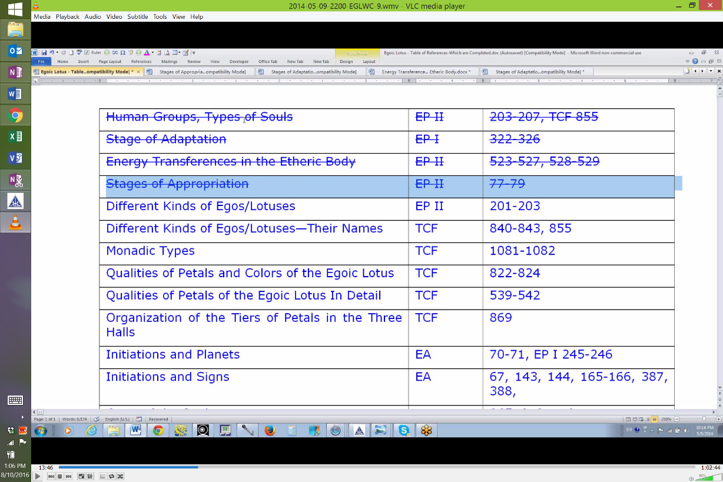

And I have been more or less going in order and crossing them out as we complete them. Well we can never say we complete them. All we can say is that we have given some attention to them because this information will all be drawn together when we start studying the Egoic Lotus petal by petal and bring in the many factors which are operative in the stimulation or organization unfoldment, opening of the petals. Perhaps it is a lot to consider. But one wants to think, if possible, in terms of synthesis, I think it is very useful for the occult mind to think in terms of synthesis.

Stages of Appropriation

14:44
"In considering the processes of appropriation, the following phrases should be studied, as they throw a light upon the various stages from different angles:—
1. The stage of concretisation and materialisation. The soul takes to itself what it needs and desires for form building." EPII, 77

In considering the processes of appropriation, the following phrases should be studied, as they throw a light upon the various stages from different angles:. . . ﻿﻿Well you know it can take quite a long time for the soul to appropriate its vehicles - a long time before birth there is a great preparation that goes on before the building of the physical body in the mother on the model of the etheric body. Only those souls which have appropriated their mental sheath and astral sheath are ready at the time of conception to link themselves to an etheric body, upon which the building of the dense physical body can occur.

So there is in this downward process this The stage of concretisation and materialisation. The soul takes to itself what it needs and desires for form building. ﻿﻿And we have the engagement of the transmitting devas, the building devas, the manipulating devas, and of course the elemental essence itself out of which the vehicles are built. So it's a group process and the soul is directing it but some of these devas of course can also direct the process. To what degree are they conscious? That remains to be seen, but in a sense they know what they are doing.

16:30 The soul is building before incarnation occurs, on the model of the physical, astral permanent atoms and mental unit which is called the atomic triangle, the Solar Angel is manipulating the content of those tiny force centers so they become magnetically attractive and carry out in the matter of the dense physical plane of the Planetary Logos. I mean, because we are dealing with the mental, astral and etheric planes which is the dense physical body of the Planetary Logos and also the Solar Logos including even the causal body in that dense physical body.

But mostly we are talking about the Planetary Logos and there is an attracting of the elemental lives which have served over many, many, even millions of years and they are reattracted to the soul after having been temporarily dispersed and then the lesser elemental essence is built in according to the patterns which are stimulated by the Solar Angel; those patterns found within the members of the atomic triangle. So it is all done by design and the selection of rays is all done by design when, as it were, the Ego sounds its note, the Solar Angel attends to that note and sees what is needed. D.K. gave the example of how the mystic type sometimes will need a 5th ray personality in order to build in a steadier and more accurate mind. That is one of the examples he gives and that was detected from the sounding of the note by the Ego before incarnation and then the Solar Angel can get to work on that process and bring together the energies that are required and also the timing of astrological energies. So that the new incarnation is fully equipped to take the next step in the building process.

"2. The stage of incarnation, taken at this time blindly." EPII, 77

2. The stage of incarnation, taken at this time blindly. ﻿﻿I think as the Ego on the higher mental plane becomes more and more developed, its participation in the incarnation process increases. But at first when you have the newly made human being, incarnation is at first blind and maybe it is guided somewhat by the Solar Angel or somewhat by other external factors, but let's just say that the self-conscious man is not really taking part in the selection of the kind of incarnation that it is to be. So, you know, appropriation, it means making something one's own, gathering something to oneself, the different types of energies, the different types of beings, the different types of matter - all of these magnetically gather to the soul.

20:04 "3. The period wherein satisfaction of the desires is the major goal. These range all the way from physical desire and its satisfaction to a general and undefined desire for release." EPIII, 77

3. The period. . .﻿﻿ now of course the incarnation has come, . . .wherein satisfaction of the desires is the major goal. These range all the way from physical desire and its satisfaction to a general and undefined desire for release. ﻿﻿There are desires even in the 1st petal and these will be particularly physical satisfactions, physical desire. They will relate to the planet Mars, very much as we will see. And he does expand the concept all the way far ahead to the desire for release, but perhaps life can appear painful enough so that even before the incarnating man realizes anything about the Higher Self he begins to develop a desire for release into heaven or haven, even in the 2nd petal I imagine that that can happen not realizing that this heaven is really an aspect of himself and that he has a higher nature which is heavenly. So the satisfaction of desires, it's a red period. It's very much going on in the Hall of Ignorance particularly, because there is ignorance of the higher nature. Later there is also a more defined desire for release carried on within the petals of love where the duality of man begins to be cognized or recognized within the consciousness. So there are various processes involved here that are cyclic in terms of incarnation and the inner man begins to take a degree of control over these different vehicles.

22:15 "4. The processes, in detail, of appropriating
a. A body or bodies.
b. A sheath or sheaths.
c. A vehicle or vehicles.
d. A form or forms." EPII, 77

These are all pretty much equivalent terms. So it is a habitual process - always to have new bodies, new sheaths, new vehicles, new forms, constantly improving if all is going well. So these are early incarnations in the Hall of Ignorance, and there is some increasing degree of control over these vehicles that is being exerted, but it's not control to execute the Plan or something of that nature. It's control is order to fulfill one's desires, to achieve satisfaction. So the incarnating soul is quite blind, very identified with the body or bodies. This is all going on in the outer petals, in the Hall of Ignorance. So we have immersion in darkness. The number 6, 6 represents the number of the form and Mars is the planet of immersion in this particular sense and lower Saturn. This is not about the spiritual consciousness pull of Venus or the higher planets, but there are, always of course, lower expressions of the various planets, depending on the form through which the energies of the planets are expressing.

﻿﻿"5. Immersion in darkness. This was the result of desire. The darkness of ignorance was chosen and man started, through desire, to work his way from darkness to light, from ignorance to knowledge, from the unreal to the Real. Such is the great symbolic work of Masonry. It is an elucidation of the Way of Relinquishment." EPII, 77

23:53 Immersion in darkness. This was the result of desire. ﻿﻿Lower desire, heading for the 'd'. The d is the 4th level, the 4th letter, the 4th number. It's the dense physical plane. The darkness of ignorance was chosen. . . ﻿﻿and the soul incarnation started on its cyclic pilgrimage into the dense physical vehicle of the Planetary Logos consisting of the 18 subplanes. . . .and man started, through desire, to work his way from darkness to light, from ignorance to knowledge, from the unreal to the Real. ﻿﻿We all recognize those ancient mantrams: lead us from darkness to light, lead us from the unreal to the real, lead us from death to immortality. Let's just say it hasn't really begun yet because the man is very much immersed in ignorance in the forms which he has appropriated and taken to himself because of the way that the Solar Angel has constructed those forms and the man is naturally identified with the construction and he has not come to himself in terms of realizing what he really is. Such is the great symbolic work of Masonry. It is an elucidation of the Way of Relinquishment.﻿﻿ That is a beautiful idea for the Masons. It is a gradual giving up of that with which one was identified and you can understand that this path leads to participation in the processes of the Sacrifice petals.

26:00 So by the time we reach the petals of sacrifice, we are in the initiatory stream which is achieved through sacrifice, through the making sacred of all things - that means to make all things correspond to the higher patterns which are in heaven and which are meant somehow to structure all of the lower conditions. So lead us from darkness to light. In Masonry there is the great search for Masonic light. We are still on this path of outer appropriation we might say.

"6. The Path of outgoing in order to possess." EPII, 77

This is the centripetal force and Mars takes you to the periphery of life. It has been said of Mars - he who goes forth, and always, this is a period of spiritual extroversion. The man does not yet know what he is and he is fascinated by all that is presented to his consciousness by the forms which the Solar Angel has created and by other forms which other spiritual creators have created. We might simply call that his lower environment. So he wants to have and this acquisitive urge is still very much in the Hall of Ignorance. It is still operative in the lower 3 petals, in the petals of Knowledge concerning the physical plane and in a way, man is learning all about the physical plane without realizing that he has a Higher Self which is part of his nature.

"7. Selfishness, the major characteristic of the self in relation to, and identified with, the not-self." EPII, 77

So then another Martian quality is selfishness. The major characteristic of the self in relation to and identified with the Not self. If I think I am the not self, then I will be selfish, I will grasp at the not self. I will want it for my own. I will not share that which is found in the not self.

26:15 We can link this with stage of adaptation #4 which spans a number of stages of bewildering complexity. But it is a stage of selfish adaptation even though at the extremes of that adaptation the man is more cognizant of the needs of others, which he is able to acknowledge not for the sake of altruism, but because it will make it easier for him to acquire that which he selfishly wants.

So even the soul group #5 can express this selfishness quite strongly. So whenever we are dealing with the 5th petal, we have the sign Leo involved and Leo is potentially a very selfish sign. It is often found where the Black Lodge has made its incursions, because the black lodge depends upon the fostering of the ahamkara quality, this sense of limiting I-ness, not a unitive I-ness, but a limited I-ness. Of course there are Leo people who have gone far beyond that obviously. But when we are stuck in our own lower ego, we are really identified with an aspect of the not self. It's the not self which we stubbornly think is the self and it is so very close to us that we persist in identifying with it. It is hard to shake off that ahamkara. So the path of outgoing, I demand this, I want this, I want these satisfactions. I hold to things and I aggrandize the Not Self which I have thought to be myself. The 5th petal has a lot of this - the apotheosis of personality grandeur in the 5th petal. The man becomes, D.K. says, colossal. The man becomes colossal in his mind and in his personality nature. Of course it's a pretty small victory and it doesn't last because always something reveals that there is more, and that integration is interrupted by the intrusion of the Higher Self. All of this is occurring in the 5th petal.

31:45 The man is creative at first. He is a thinker. He is in soul group #6, but he has not become truly the aspirant because he has not become discontent with his own personal grandeur and it inevitably does happen. Sometimes, as Carl Jung said, it is accompanied by such dreams as the king is sick. Well the king is the lower ego, however grand it thinks it may be and there is something wrong with the king and only some medicine from the higher planes can solve the problem.

"8. Love of possession, the prostitution of spiritual love." EPII, 77

So there is this love of possession. We can see how the Taurus can get in here, prostituted Venus as well, too much love of the not self really. So one is SO attached, attached to one's ego, and attached to all that one's ego possesses and you can see this in the world today. You see people who are through greed amassing tremendous fortunes at the expense of other people, and they somehow are attempting to inflate and aggrandize the not self which they have decided that they are. The gap between the super-rich and the poor or the average person is just widening all the time, and it is going to bring great instability and possibly revolution as it almost always has and this is because the people who are acquiring for themselves feel no responsibility that they must share. There is nothing in them except their own picture of themselves and its grandeur and of course that is what the Black Lodge in Atlantean suffered from - heights of luxury, personal grandeur, maybe some sort of magnetic love and caring for those who were the very closest to them, and who were considered to be reflections of themselves. You know the offspring, the children, not as independent beings but as a reflection of what you are. My children, as if one owned them.

34:33 So we can see that even people can be possessed in this stage and that a great detachment must be in the offing, must come inevitably, because after all man is much more than this and when the higher part of himself begins to intrude in this great fanciful picture of life that he has made, extreme discomfort is caused and conflict.

"9. Acquisitiveness, the illusion of material need." EPII, 77

There is the acquisitiveness; this is a very Taurean, earth sign type of thing, 3rd ray as well because so much of the unfoldment of the Egoic Lotus at first is on the 3rd ray with the prostitution of 2nd ray magnetism and 1st ray will to 3rd ray ends. Third ray, 3rd petal, using one's intelligence to get and this continues as you augment your sense of power. Let's just say that 1st and 2nd aspects are misused for the sake of the acquisitive 3rd aspect of Divinity.

"10. The period called in the Bible, that of "riotous living" on the part of the Prodigal Son." EPII, 77

35: 46 Then, comes this period of riotous living on the fringes of life, out there, far away from the father's home. The prodigal son is the Monad, in extension the jiva, the one who has gone forth, impulses come from your lower nature and you follow them without any higher plan. You are living it up. This is a period of license. No rules contain you except the wish to aggrandize what you think you are. So we all know where this is going, this is going to lead to surfeit the sense of nausea, over-fullness with the husks of life.

"11. The application and use of energy for personal, selfish intent." EPII, 77

Eventually man spends himself and is left destitute of energy, and incentive, because the higher Self within him is going to be pulling on him and it starts to pull away from all of his outward, centrifugal Martian tendencies. So the application and use of energy for personal selfish intent. This is very much going to be found in the 5th petal, the early part of it and building up to that through the 4th petal and you have to have of course have the mind of the 3rd petal to do it.

"12. Personality life, with all that is therein implied,—ambition, selfish purpose, etc." EPII, 78

And then we have the fullness of personality life that is all that is there and implied, ambition, selfish purpose, etc. We have nth degree of selfishness in stage of adaptation #4. He didn't really get into the degrees of selfishness in the soul groups. He did talk about stage of adaptation, I think it was #2 where you have the petty criminal and the animal cunning, but this is much, much more. This is very deliberate. It is egotistical, deliberate egotism and at this point, and maybe this is what Master D.K. means by those lives where 3, 7 or even 11 lives are, and where does he get those figures, that is just amazing to me, because he seems very definite about them, so there must be some kind of cyclic process which yields those numbers. Anyways, 3, 7 or even 11 of the dominant personality without thinking of the Higher Self. The personality itself becomes as if a Higher Self and everything is centralized within this dominant personality and on whatever ray it might be because you don't have to be ray 1 to dominate. There are all sorts of ways of making your personality intrude upon the rights of others on any of the rays and you can feel very self-satisfied about it. Just think we have all been through this business and still a number of us we can still detect vestiges in our life, can we not?

39:45 He is summing it up.

"13. Attachment to the seen, the known, and the familiar, external, objective forms." EPII, 78

There is attachment to the seen, the known, and the familiar,. . . oftentimes called the personality, external objective form. So this is not the period of the Sun. It's the period of the Moon and if the Sun, then the lowest aspect of the Sun connected with Ray 3, which we know operates with rotary motion and is separative. So Leo is one of the most separative signs. Ray 3 we know how separative it can be. Oftentimes, with the factor of criticism. This is a situation which has to be reoriented, is it not?

"14. The stage wherein thought forms are built, at first ignorantly, and then with deliberate selfishness." EPII, 78

The mind is in use, but if it is going to serve the personality we have to at least get into petal 4 and 5. The mind is in use in petal 3 but there is not enough lower ego to really fit with this stage that we are talking about.

"15. The period of engrossment in the things of the kingdom of earth." EPII, 78

So selfish, building for the sake of aggrandizement. The period of engrossment. There is a good word. A person cannot extricate himself, cannot disentangle himself in the things of the kingdom of earth.

"16. The world, the flesh, and the devil." EPII, 78

This is the world of the trio - the world, the flesh and the devil. And there is no at this point spiritual refinement even though there is capacity which when there is a reorientation can be used in a better way. So he ends it by saying, The world, the flesh, the devil. These are the physical heads of the hydra. The flesh is desire - those are the astral heads. The devil is mental. All of this matter is reigning. It is kind of Virgo ruled by the Moon. It is the material aspect which has ascendency. It is Cassiopeia, the queen of materiality. She sits on the throne and there has been no been no battle for detachment. Let's just say that all of this is the product of attachment.

42:30 I think we can see how the man does descend, yes and how it leads to a great snare and he is on the point through great dissatisfaction of the 1st reversal of the wheel. When in the 5th petal he really becomes sick of his not self which has been posing as the Self. He begins to realize he has been living in a very little kingdom after all. So this is taken him to the 5th petal. He is a thinking powerful individual, but his thoughts are guided towards his own aggrandizement and he is working still in the field of the personality which he mistakes for reality. So he is the victim of maya, glamour, and illusion, and one of the greatest illusions is the illusion of ahamkara that the personal self is the real Self and this he has to be disabused on this point of view.

Stages of Soul Expression

"On the side of soul expression, which is governed by detachment, the following phrases and sentences will give an idea of the progress and intent:—" ﻿﻿EPII, 78

On the side of soul expression, . . . ﻿﻿we are now going to reverse our direction and we are going to be rise . . .which is governed by detachment, the following phrases and sentences will give an idea of the progress and intent: ﻿﻿Now you know obviously these things take lives and lives to work through and people like ourselves certainly should be on this rising arc.

"1. The stage of spiritualisation and of de-materialisation. The soul functions with the purpose of liberation before it, and not of further physical plane experience." ﻿﻿EPII, 78

The stage of spiritualisation and of de-materialisation. Kind of a new view of Ray 7. The soul functions with the purpose of liberation before it, ﻿. . . ﻿that is the soul in incarnation, . . .﻿and not of further physical plane experience. ﻿﻿So we become tired of all we have accumulated, realizing it to be a limitation and that we are engrossed in that which is not real. Not everybody necessarily has to go through such extreme phases of ahamkara. I think it might be possible to reach the 5th petal and disengage oneself from this without becoming a totally dominant personality who is completely in illusion. I think maybe 1st ray types may create that very dominant personality, the 1st ray soul types, but then they are also quicker to destroy its hold I suppose.

"2. The relinquishment of form life." ﻿﻿EPII, 78

Well, the prodigal son realizes that he is eating the husks of life and even a servant in his father's house is better cared for than he is. The old nostalgia awakens in him and he begins to realize what he has left behind.

"3. The period wherein satiety is experienced; the desires have been so dominant and so often satisfied that they no longer attract." EPII, 78

46:26 And you know, what is said to oneself, Is this all there is? I read about a man who had achieved fame, a young man, and there he committed suicide shortly after. He had a great following. He was some kind of entertainer. Then he said well I have everything I want, is this all there is? Well he had not been reached by his own higher of the pairs of opposites to begin to attract him. I was thinking about Madonna is a perfect example of an incredible - she is a Leo by the way - and she has this incredible 5th petal operation going on. She is just the most dominant and to some attractive personality, and yet she is interested in the Qabalah. Why is this? Something of the Higher Self is awakening in her and then there is going to be this pull between that which belongs to another world and that which belongs to the world that she has conquered. But at a certain point she is going to say, Is this all there is? When there is the whole planet, the whole solar system, finally the whole universe? This would be then beginning to move into Leo stage 2.

"4. The process, in detail, of liberation from
a. A body or bodies.
b. A sheath or sheaths.
c. A vehicle or vehicles.
d. A form or forms." EPII, 78

So instead of appropriation of the body or bodies, or sheath or sheaths, vehicle or vehicles or form and forms, there is the way of, let's call it, divine extrication and there is no such word but I'll use it anyway - disengrossment. Because we have so engrossed. We have been so trammeled by matter and we begin to realize we have been slaves to matter. Now this is going to begin to occur in the 5th petal. This is going to occur in the 7th soul group where the aspirants or probationers are coming in. This is going to begin to occur I think in the I think the 6th or the 7th stage of adaptation? The 6th stage begins the process of aspiration, helping group needs, so the true motive is to train the 3-fold lower nature. There is no such thing as killing the personality. So this is carried on by aspirants. So by the 6th stage of adaptation people are beginning to wake up to their imprisonment and they are becoming the true aspirant, and including discipleship I think because the next stage is stage #7 which is a completely unselfish adaptation, and well no aspirant is completely unselfish, that's for sure.

"5. Emergence into light, a symbolic way of expressing the reverse of immersion in darkness." EPII, 78

So out of the darkness of matter, because that was the parallel, wasn't it - immersion in darkness, emergence into light - the symbolic way of expressing the reverse of immersion in darkness and the light of the soul begins to show itself especially in all the vehicles, but I suppose especially in the mind and a greater light lures us on and what matter can offer, coming as it does from the previous solar system and from a creative regime that is already spent and is simply residual, it no longer attracts. So the path of return is beginning now.

50:43 "6. The Path of Return, motivated by the wish to appropriate nothing for the separated self. The beginning of group consciousness and of group work." EPII, 78

The Path of Return, motivated by the wish to appropriate nothing for the separated self. ﻿﻿By the time we end the Leo petal, there is a whole different idea of what the self is and the Higher or unitive Self comes into it and the disciplining of the 6th petal also enters. So this path of return is a path of aspiration, of probation and of discipleship, of initiation and finally of Mastership. The beginning of group consciousness and of group work. ﻿﻿Well we are sacrificing our ahamkara and this means that we are beginning to work in the Sacrifice petals.

"7. Selflessness, the major characteristic of the Soul or Self." EPII, 78

This means initiation 1 and 2, the buddhic energy enters the soul life and stimulates the heart center and one can have the birth of the Christ in the heart and one can have a purified astral nature which begins to aspire towards the realities of life.

So Uranian freedom comes in, freedom from desire to possess. I mean Taurus can give that too. The Buddha was a Taurus and he had great freedom from the desire to possess anything material. The highest form of spiritual aspiration - aspirational idealism is found in Taurus. That's a quote from Esoteric Astrology.

52:12 "8. Freedom from the desire to possess, freedom from acquisitiveness, and therefore the state of desirelessness." EPII, 78

And this is coming in at the 2nd degree; it is still a probationary initiation, but at the 2nd degree, selfishness has been dealt a major blow. Well you can't get rid of desire, but you can get rid of desire for that which is not worthy, useful, for that which is confining, restricting. You can get rid of that kind of desire and you can begin to desire something that is much higher - the higher of your pairs of opposites, the Higher Self. You can begin to desire that and we do. And let's see if we went back and we looked at #8, it wouldn't be freedom, would it? It would be the love of possessions. So acquisitiveness is #9. The establishing of the sense of reality as the ruling principle of the life. ﻿﻿So we are approaching the 3rd degree. Lead us from darkness to light, from the unreal to the real and from death to immortality. Certainly from the unreal to the real - the real is found as the Monad makes its impression at the 3rd degree. From the unreality of material life we are definitely working in the Sacrifice petals here and we are sacrificing all kinds of things. The 8th petal is very good at letting go of all kinds of things. It is a Scorpionic petal and we remember that the group of human Monads is ruled by Scorpio of all things. Interesting, in which the Moon falls, thank goodness. So, The establishing of the sense of reality as the ruling principle of the life.

54:05 "10. The return of the Prodigal Son to the Fathers home." EPII, 79

The Monad is now within range and we are coming in touch with the Monadic life so the Father aspect is making its nature felt and it certainly does that in the 9th petal. It does that in the Synthesis petals and the more the Jewel in the Lotus is revealed, the more the Father's home is revealed, because the Jewel in the Lotus is in a way an extension of the Monad onto the higher mental plane or at least onto the borderland between the higher mental plane and the buddhic plane. So then comes service, I suppose.

"11. The application and use of energy for group purpose and in cooperation with the Plan for the whole." EPII, 79

He is definitely the initiate here and what did it say earlier because it is probably good to contrast what the earlier ones were. 11. The application and use of energy for personal, selfish intent. Well, okay and that's not at all what we have now. It's the application of energy for the whole and the beginning of isolated unity or the awareness of the whole is coming in, the 5th rule. Let the group know there are no other selves - that's the 9th rule. The macrocosmic whole is all there is - macrocosmic wholeness - that's the 5th rule. So the man is an initiate. And instead of the life of the personality we have:

"12. The life of the soul with all that is implied in that phrase." EPII, 79

This is going on between the 3rd and 4th initiations. And the 9 petals are completely open and the Synthesis petals are rapidly opening so he is focused now on the higher mental plane. He is an initiate of the 3rd degree.

"13. Love of God in contradistinction to love of self." EPII, 79
And there is love of God, so the buddhic energy is coming in. So remember that the Synthesis petals are buddhic in origin and are related to the love energy. That is something we should be understanding.

56:23 So the causal body is beginning to disappear. It does disappear on its outer tier first. The Knowledge petals begin to dissolve and I suppose knowledge becomes intuition.

"14. Attachment to the unseen, the true, the subjective and the Real, which is only possible when there has been detachment from the seen, the false, the objective and the unreal." EPII, 79

So now in this detaching process, there is an attachment to that which is not tangible to the unseen, the true, the subjective and the real. And this is possible via the antahkarana which is in process of building. Do we still have a causal body here? Well perhaps we do, but we can be impressed by the spiritual triad because the antahkarana has been built. This is only possible when there has been detachment from the seen, the false, the objective and the unreal. So there is a real detachment which has occurred and no more is the outer world considered anything but a sphere of service. It is certainly not a sphere of great interest or a sphere of acquisition.

"15. Complete liberation from the control of the lower mind." EPII, 79

57:29 We are dealing with the higher mind and with the abstract mind and with the intuition. There is the conquering of illusion which we pretty well do by the time the 3rd degree is taken, at least one type of illusion. Master D.K. said we don't really conquer illusion until the 9th initiation.

"16. The period wherein the centre of interest is the kingdom of God and of the soul." EPII, 79

And we can focus at will on the higher mental plane and now it looks like here we have gone beyond the Egoic Lotus altogether.

"17. Reality. Formlessness. God." EPII, 79

This is the life of the Monad, liberated from the causal body because the Egoic Lotus is also form. So this is atmic and monadic and we have transcended the causal body.

58:13 "It should be remembered, when considering the seven ray methods of appropriation and the reverse stages, that we are dealing with energies. Occult students must increasingly think and work in terms of energy. These energies are spoken of esoterically as "having impulsive effects, magnetic appeals, and focussed activities." The streams or emanations of energy exist, as is well known, in seven major aspects or qualities. They carry the sons of men into incarnation and withdraw them from incarnation. They have their own specific qualities and characteristics, and these determine the nature of the forms constructed, the quality of the life which is expressed at any particular time or in any particular incarnation, the length of the life cycle, and the appearance and disappearance of any of the three form aspects. Certain brief paragraphs will suffice to define each of the stages of appropriation. The paragraphs which detail the methods of detachment have been given earlier in A Treatise on White Magic." EPII, 79

It should be remembered, when considering the seven ray methods of appropriation and the reverse stages, that we are dealing with energies. Occult students must increasingly think and work in terms of energy. These energies are spoken of esoterically as "having impulsive effects,. . . ﻿﻿driving effects, . . .﻿magnetic appeals, and focussed activities." ﻿﻿So those are the 3 aspects of divinity, through those 3 descriptions. The streams or emanations of energy exist, as is well known, in seven major aspects or qualities. ﻿﻿Maybe they are more spheres of radiation. They carry the sons of men into incarnation and withdraw them from incarnation. ﻿﻿We enter upon our ray. We exit upon our ray. And it all depends on ray cycles. They have their own specific qualities and characteristics, and these determine the nature of the forms constructed,. . .﻿﻿different for each ray . . .the quality of the life which is expressed at any particular time or in any particular incarnation,. . . ﻿﻿because a ray is quality, . . . the length of the life cycle,. . . ﻿﻿because people on different rays live in a differential manner according to the ray tendency . . .and the appearance and disappearance of any of the three form aspects. ﻿﻿Which are appearing and disappearing according to the rays that qualify the forms. Certain brief paragraphs will suffice to define each of the stages of appropriation. The paragraphs which detail the methods of detachment have been given earlier in A Treatise on White Magic.

﻿﻿We are not going on further with the stage of appropriation. We are simply thinking about what it all means to descend into matter and to rise out of matter. And we are thinking about the progress from the petals of Ignorance, the first 3, through the petals of Love, with all of the normal life of the human being, through the petals of detachment which are the Sacrifice petals and then we have the synthesizing work going on in the petals of Synthesis and in this appropriation descent and re-ascent we have even gone beyond the causal body. Where in this stage of appropriation do we find ourselves? Hopefully we are divesting ourselves of unreality. And are achieving something of a knowledge of reality, formlessness and God, some degree of monadic impression.

I have done that rather quickly but it is one hour and I think maybe enough has been said here for you to get the idea of the appropriative descent and then the appropriation of higher energies and the disappropriation or the divesting of the lower unreal energies.

Quite interesting to think about that. Put together now the stages of appropriation, put together the transferences of energy, put together the 8 stages of adaptation, put together the 10 soul groups - let all of the Mercurial connections come before your eye because they are all interrelated and intuition will reveal the true relationships. The mind can only set up those relationships.

