EGOIC LOTUS WEBINAR – 1, Michael Robbins

Abstract

Egoic Lotus Webinar Commentaries 1. This webinar is about 2 hours, 2 minutes long. In the study of our first foundational reference (Program 1) we move from Esoteric Psychology II, p. 200 - 203. This full reference will be completed at EP II p. 214. This webinar deals with the fundamentals of the study of the Egoic Lotus (studying various diagrams of the lotus—some, in interesting esoteric ways, more correct than others) and begins the task of looking at background references which are required to study the lotus in a foundational manner. The first such study of necessary references refers to the Five Groups of Souls (or Monads) who are taking incarnation on our Earth. It will be found that these groups, in general, have different numbers of petals unfolded.

Contents:

Transcript of Egoic Lotus Webinar 1 1
Basic Structure of the Egoic Lotus 3
Table of References 21
Table: The Petals and Means, Paths, Truths 26
Five Groups of Souls – Esoteric Psychology, Volume 2, page 201 29
Picture of the Earth Scheme – 7 Chakras 31
Four Ways the ‘Soul’ is Regarded in Modern Psychology 34
Seven Groups of Lotuses 38

Transcript of Egoic Lotus Webinar 1

Hello friends, today is the fourth of May, 2014 and I would like to begin a series discussing the Egoic Lotus which is that structure upon the higher mental plane – the higher three subplanes of the mental plane, which we see here depicted. (See diagram on page 2)

It is something which the higher clairvoyants do see, clairvoyants such as Master D.K. and other initiates of his caliber, and see with accuracy. And he has reported to us what is there to be seen in terms of the structure and dynamics and amazing display, which eventually is established as the higher levels of human evolution are reached. Maybe more importantly, he has established the meaning of that which is to be seen.

01.31 And we can get some idea, a good idea, about the developmental process of the human being by examining the Egoic Lotus and the different phases through which it passes, perhaps over a 25 million year period. So, many human beings individualized on the Earth Chain more than 21 million years ago have not even fully developed their Egoic Lotus nor have those individualized on the Moon Chain, long before that, arriving as they did into the Earth Chain with some unfoldment of the petals or potencies of the Egoic Lotus.

So, it is not something that we just hope to see with wonder. One day we will, of course. But it is something we hope to understand. And, we hope to understand the processes through which we may be moving: the developmental processes occurring right now in our life. Each of us is in process of unfolding this lotus which contains the harvested qualities of our life within the lower three worlds. There is nothing bad within the lotus – no negative qualities, only positive qualities. There are, however, deficiencies within the lotus, and let us say, blank areas or areas where quality and capacity has not yet been filled in by the struggle in the lower worlds to achieve those qualities and capacities.

So everyone of us, every one of us below the 4th initiation – and, let us just say that the great probability is that all who would be listening to this or producing it, are below the 4th initiation, that everyone below that initiation is in the process of unfolding these qualities and capacities, which are developing on the higher mental plane; and are instilled within the lotus within the higher mental plane; and then serve as centers of activation once the qualities are created for life in the lower three worlds.

04:35.2 So the more we build our Egoic Lotus, the more we fill in these generic capacities and qualities, the more spiritually we will be able to live our lives in the lower worlds. Because this is our true treasury, our true repository of spiritual value, which stimulates all that we do in the lower worlds. And helps us live a less elemental life and a life of realization: First, as a soul in incarnation, and then, as a soul or unit of consciousness upon the higher mental plane.

05:23 Master D.K. has given this diagram:

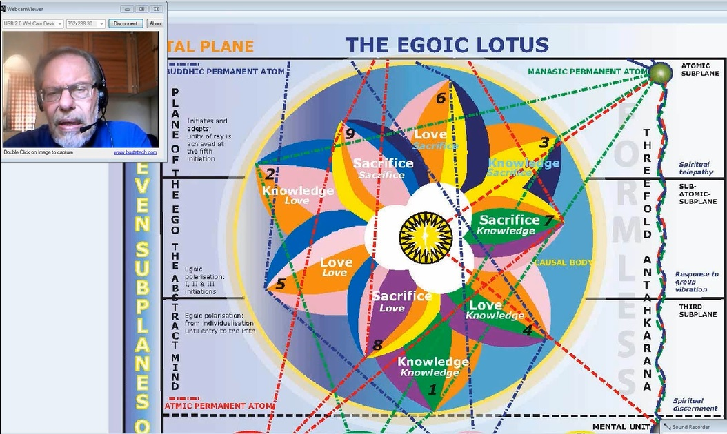

And, he has also indicated which colors pertain to it. My wife Tuija, who is artistic in this sense, has filled in these colors. Of course, you know this is simply a symbol.

As Master D.K. says, the true vision of the Egoic Lotus is tremendously vibrant, scintillating, full of movement, full of radiation, pulsation, sound and color in a beautiful combination, which displays the stage of development of any human being.

So, we just simply have a symbol here, and before this, Keith Bailey of the AUM (Ancient Universal Mysteries) Lodge has done some work on this same type of diagram. The colors, I think in some cases, are a little different. And we have tried to be as faithful as we could be to what Master D.K. has described. So the color rose is here used instead of the color red as appears in earlier diagrams, or earlier illustrations.

There are so many secrets hidden in the Egoic Lotus even if we don't see it with our inner eye. We can imagine it and we can understand something of the stages of development which occur over the many, many years. Certainly, there is no one alive today as a human being, well I will say that in a general sense, who has not been undergoing lotus development for probably 20 million years or 21 million years, very slowly at the beginning. And even if we were individualized billions of years ago, on the 3rd Chain of our Earth Scheme, the Moon Chain, that type of timing is very likely, (as a matter of fact, processes move slower there as they always do with the number 3 compared to the number 2). We are on a chain now - the 4th chain – which is much more resonant to the number 2 than the previous chain, and the speed of development increases from the 3 to the 2 to the 1.

So, if individualization occurred on the Moon Chain and we were working at the development of this lotus without the aid of a Solar Angel and that is apparently the case because the intervention of the Solar Angels pertain to this chain and not to the previous chain, well then, the process was even slower.

08:36 What I am trying to say is that we have been at work on this Egoic development for a very long time. And now that period of development is reaching near its end, the whole process is accelerating. So many of us who are serious students of the great teaching that Master D.K. has brought forth through Alice Bailey and through the work of H.P.B. (Helena Petrovna Blavatsky), those of us who are sincere students of that work, probably have probably completed ninety-nine percent (99%) of our lives within the human kingdom and maybe more.

In the beginning, things move very slowly. There is so much we don't know about soul cycles and personality cycles and how long the incarnating human jiva may spend out of incarnation, but we do know that many, many lives or incarnations are relatively inconsequential in terms of the development of quality compared to the later lives, when development is consciously undertaken. And from the time we are approaching the first 1st initiation, well, you know there have probably been thousands of incarnations, and maybe from the 1st initiation onward then there may be only 30 remaining, that is a symbolic number, of course, or 33 remaining. And, I suppose people can undertake their development towards mastership in a shorter time than that if they are willing, or perhaps a little bit longer. But you can see the proportion there. Let us say you have had 3,000 lives which is a humble estimate – probably many more. And you compare 30 (remaining) to 3,000, you are coming up with only 1/100th of your lives remain. And that is a very short time. Thirty lives can be lived in a couple or three processional ages – the Age of Aquarius and of Capricorn, and maybe into Sagittarius.

By that time, serious students of this teaching certainly should have entered the stage of mastership – the 5th initiation. The 4th and 5th initiations, we are told – can be taken in the same life. They were not in the case of the Master Jesus. He was crucified and took the 4th initiation. But then shortly afterwards, took over the body of his disciple who was even alive at the time that he was alive as Jesus. And then took in that body the 5th initiation.

So, let us just say that – once we reach the period of the 1st initiation, although many arduous lives lie ahead of us, in terms of time as human beings count time, the great majority of time has been passed in previous development, and the petals of the Egoic Lotus are rapidly unfolding.

Basic Structure of the Egoic Lotus

Well just a few generalities here about the Egoic Lotus:

- These petals are vortices of energy – scintillating displays in color and in sound of spiritual qualities.
- We notice that there are 9 petals in 3 circles or tiers.
  - The Outer Tier of Petals – the 1st, 2nd, and 3rd.
  - The Middle Tier of Petals – the 4th, 5th, and 6th.
  - The Inner Tier of Petals (but not the inner-most tier) – 7th, 8th and 9th, apparently going in a reversed direction. That is another possible secret here of the structure of the Egoic Lotus.
Interesting – how the numbering here shows:
- a clockwise rotation from the 1st, to the 2nd, and to the 3rd, and
- a clockwise rotation from the 4th, to the 5th, and to the 6th.

And these are the densely physical, etheric and astral aspects of man are implicated here.

13:23 The first two tiers are the irrational aspect of man. They are not yet involving the mind.

But according to the way these petals are laid out, and my wife Tuija discovered this, at least in our circle, noticed that there is a kind of a touching of the different planes:

The Knowledge petal (of the Love Tier) seems to touch the 3rd level:

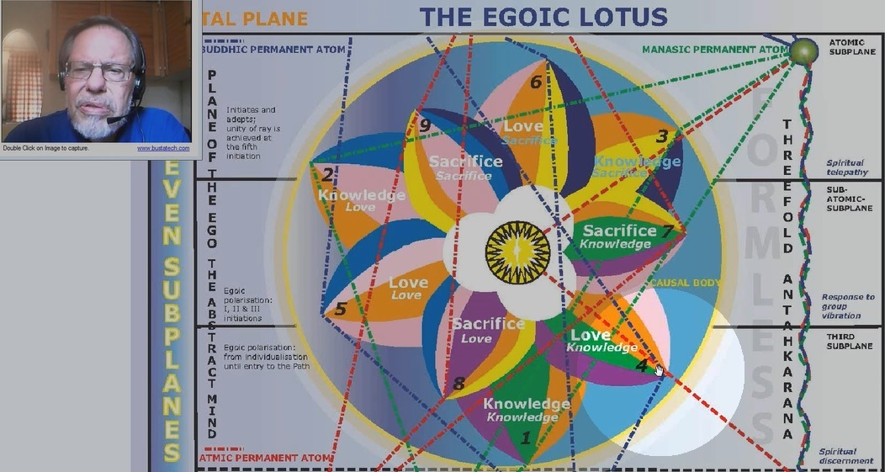

The Love petal (of the Love Tier) – touches the 2nd level–

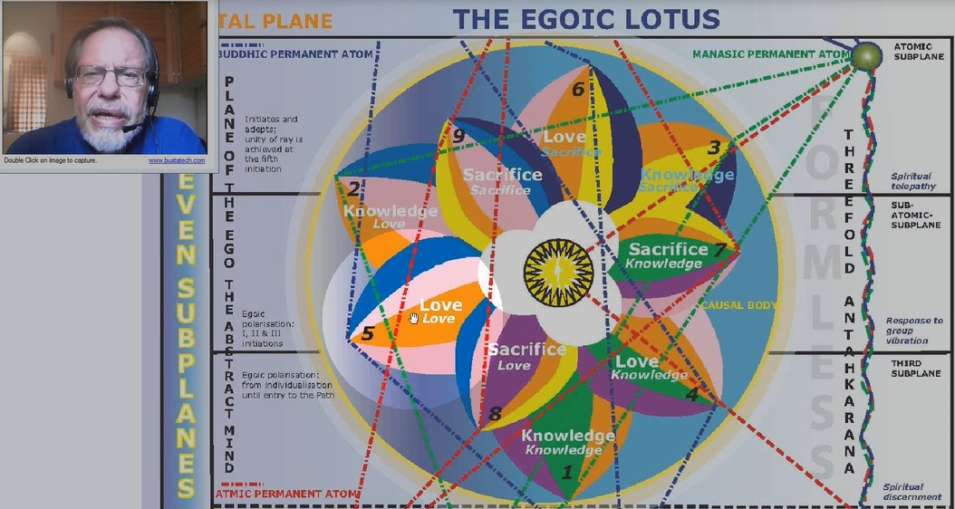

And the Sacrifice petal (of the Love Tier) touches the highest or 1st level –
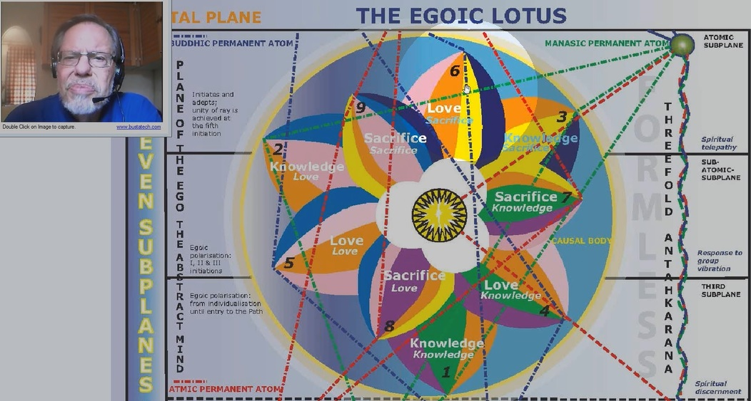

Here again, the Knowledge petals touch the lowest plane.

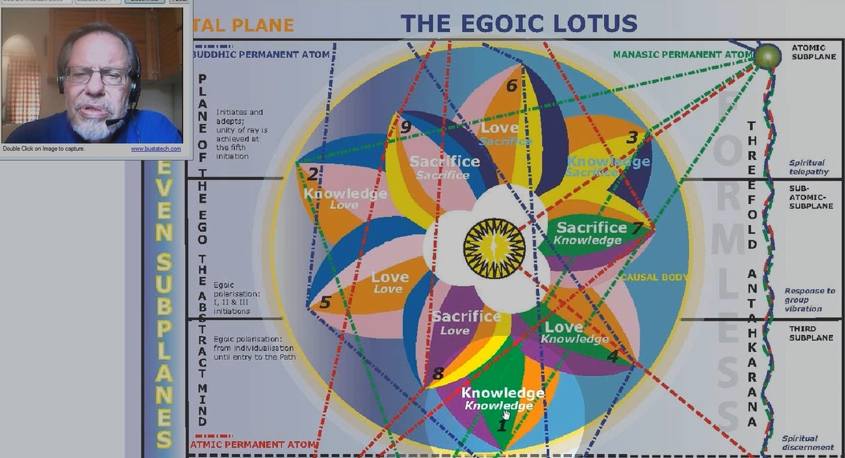

This is close. We could draw it somewhat differently. The Love petal of the Love Tier or circle touches what looks like the highest plane but it could be drawn on the 2nd plane. And if it were just somewhat rotated,
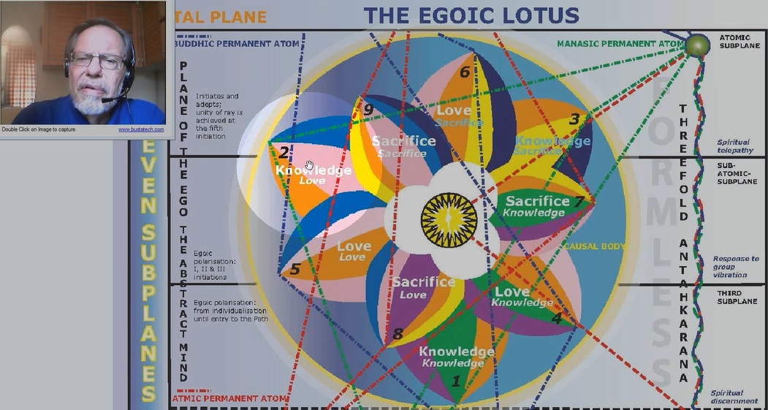

and the Knowledge petal of the Sacrifice Tier is definitely touching the highest level,

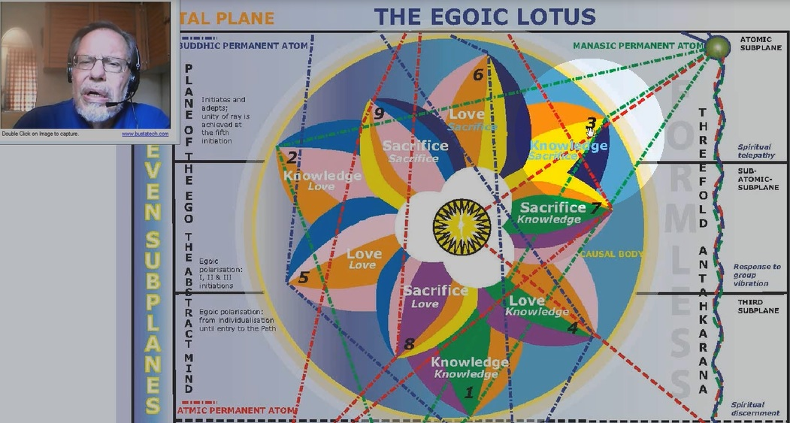

and so it is with petals 7, 8 and 9.

However, it is drawn here in such a way that there is apparently a reverse rotation. We do know that reversal of rotation does occur, whether it occurs in the Sacrifice petals, or whether we have to wait until we get into what is called the Synthesis petals, that just still remains to be seen.

The Knowledge Tier relates to what is called the Hall of Ignorance, which is the acquiring of basic knowledge in the 3 lower worlds, and especially in the lowest world of the physical plane, the etheric physical plane and especially the physical plane.

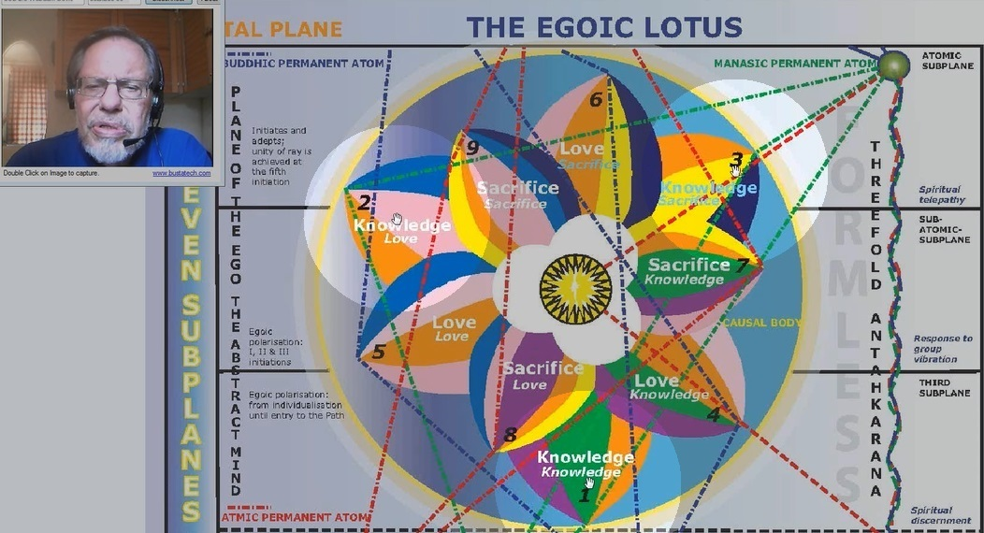

Then we have the Love Tier that relates to astral development.

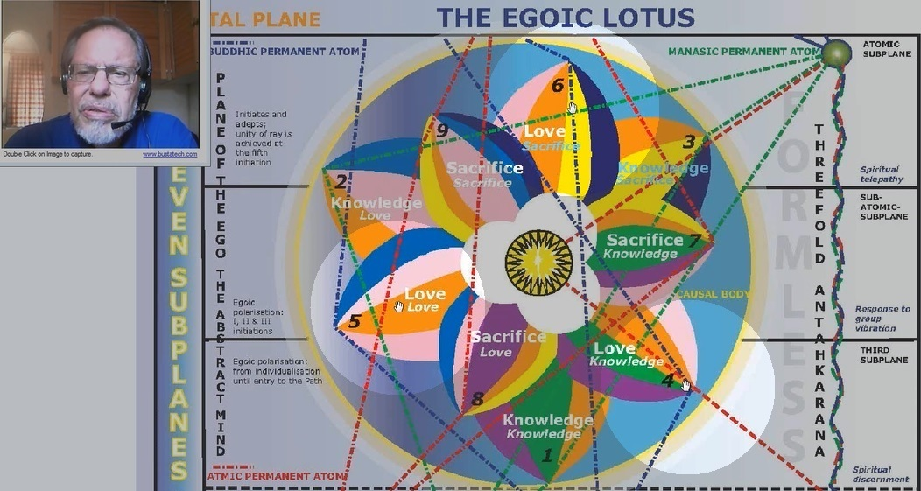

While it does relate to the astral body, there is also a higher type of development that occurs with it through which the pairs of opposites are introduced to the consciousness of man. And by the ‘pairs of opposites’ I mean largely the personality and the soul. In the Hall of Ignorance, while the first three petals are unfolding, the man can be very intelligent in a worldly sense but has no real notion of the higher or inner self.

When we reach development in the petals correlated with the astral plane, but they are also influenced by the planes higher than that, for instance, the buddhic plane, then the man begins to be aware of this higher center and a certain sensing of duality concerning his nature sets in.

By the time we reach the development of the Sacrifice petals, we are into the process of initiation, technically understood.

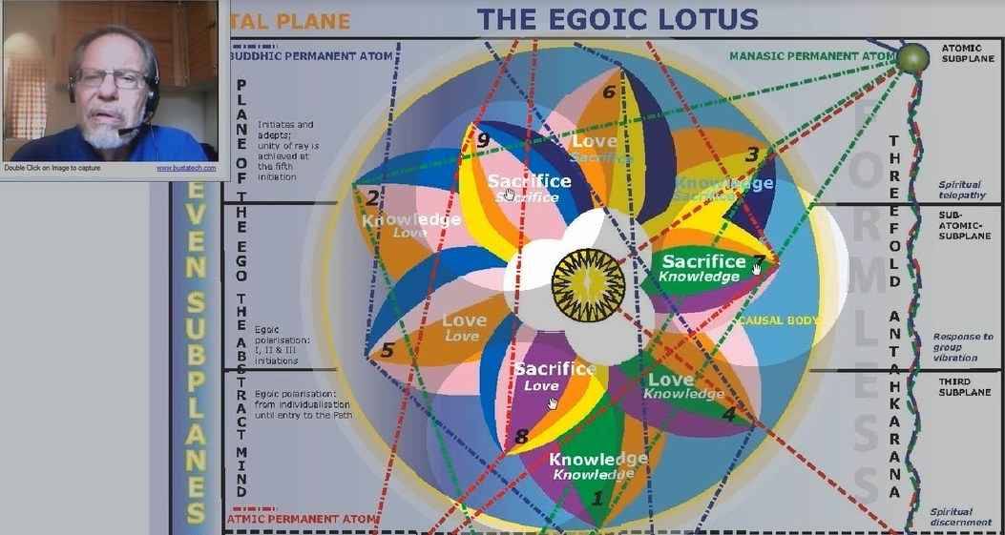

And then the soul, or the Higher Self, or the higher power – whatever people may want to call it – the inner God – is certainly an established reality in the consciousness of the individual. And his attention is now turned to the development of that higher of the pairs of opposites and seeing to the possibility that its energy can and will permeate the lower life.

17:43 So we are just looking at the basics here, of structure:

- The Petals of Knowledge 1, 2 and 3 unfolding in the Hall of Ignorance.
- The petals 4, 5 and 6 unfolding in what is called the Hall of Learning and correlated closely with the development of the astral body.

I mean, the astral body is existent from the very beginning, but its higher form of development occurs obviously later in the evolutionary process.

And then these Petals of Sacrifice 7, 8 and 9 are concerning entry into the Hall of Wisdom which is really occurring at the time of 1st initiation and this is the tier or circle or wheel of petals that allows the human being, when this wheel is unfolded, to enter the 5th Kingdom of Nature or the Kingdom of Souls.

Meanwhile, as all this is happening, these petals that are called the Synthesis petals, are unfolding, and a great unification of knowledge and quality is occurring as they unfold. And one of them begins its unfoldment at each of the first 3 initiations. And by the time the 4th initiation is taken, they are completely unfolded.

At the very center of lotus is the central fire or the ‘Jewel in the Lotus’.

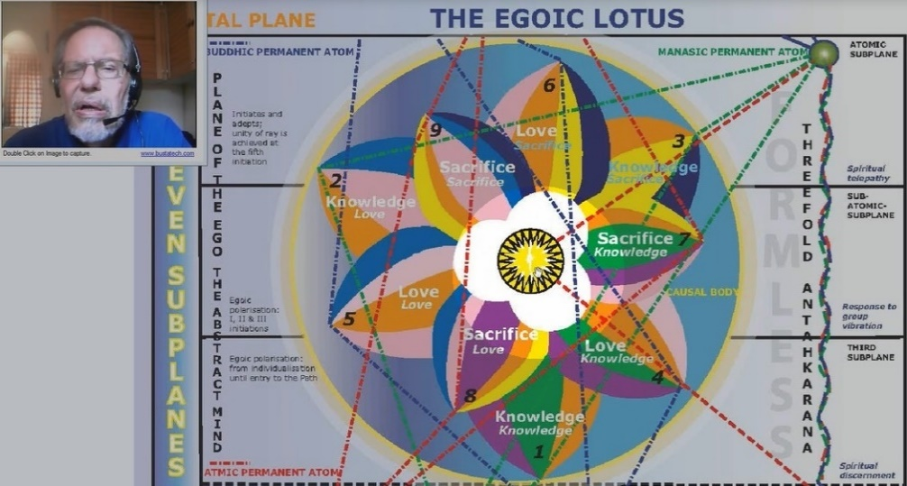

It is considered to be a 7-faceted jewel but has 8 radiations which can be discussed later as we come to it. There are 24 of these spikes or mountains or indications of potency. And that fits very well with the central fire because the number of Shamballa is 24 and at the Jewel in the Lotus, Shamballa is represented. Shamballa is the home of the Monad or our true spirit in being. And its number is 24 or 6. And its location, at least, on the Cosmic Physical Plane, is on the 6th plane counting from below. So the number 24 is fitting.

21:00 We will have to see whether Master D.K. actually drew this out or whether it has been put in, in some other way. We would go to A Treatise on Cosmic Fire, ‘Chart IX’:

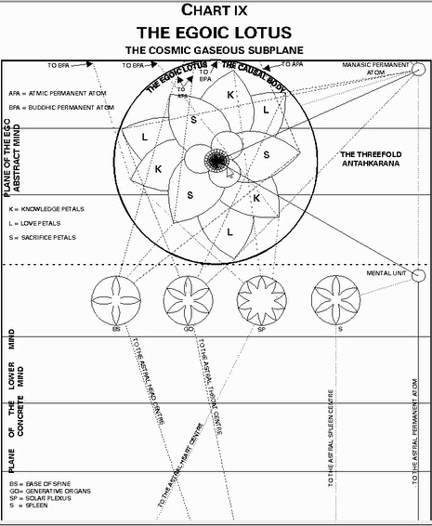

There are number of different points represented therein and I suppose that these little squares are those potencies that are represented in the other diagrams.

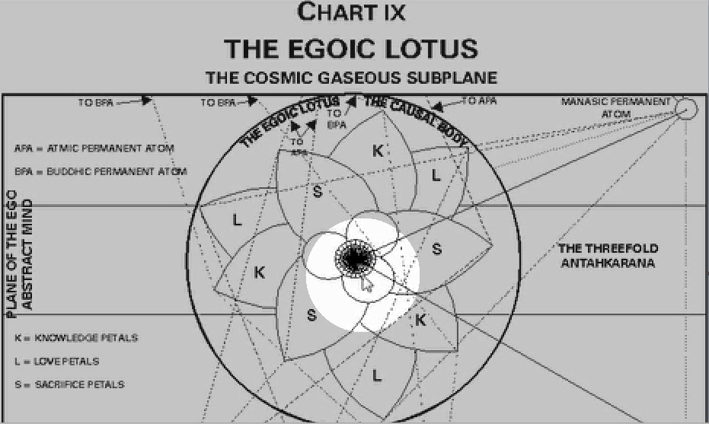

It is very hard to see otherwise. There appears to have been a mistake in the transfer of this lotus to the CD-ROM inasmuch as:
- the petals that are indicated as Knowledge petals should be on the outer tier and
- the Love petals should be on the inner tier.
- and I believe that mistake is not made in the book.

22:32

Let us say, the Knowledge petals operate in a clockwise manner. The Love petals – even though they are at the wrong place – operate also in a clockwise manner, but the Sacrifice petals rotate in a counter-clockwise manner.

In other words, it goes like this:

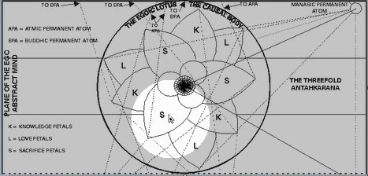

Sacrifice – Love
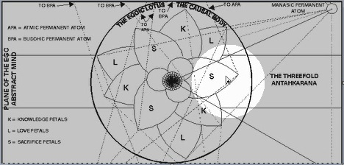

Sacrifice – Sacrifice
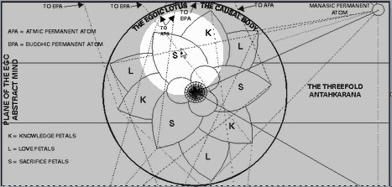

And we are going in the direction of the zodiac. So that is what this diagram seems to show us.

Well, I think I may have made my point. I discovered that there was a corrected version of this lotus and I guess the point has been made. Here is the corrected version:

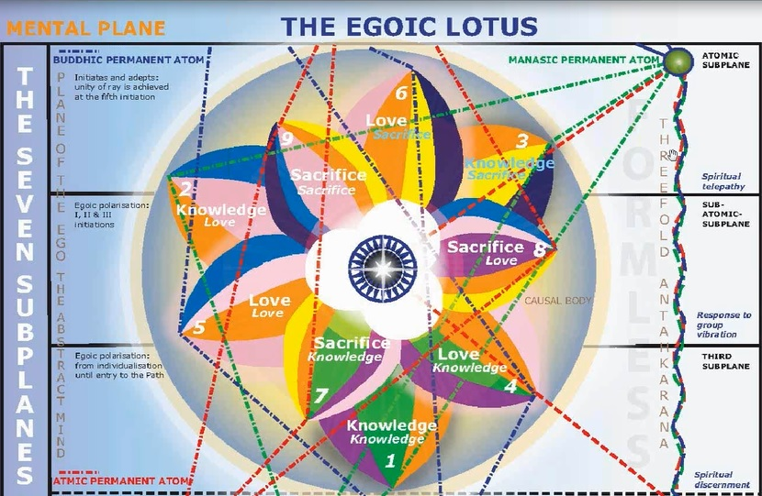

It does begin with –
Seven (7)
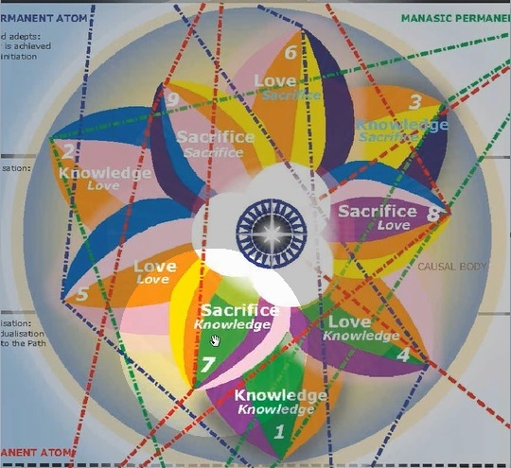

Goes to –
Eight (8)
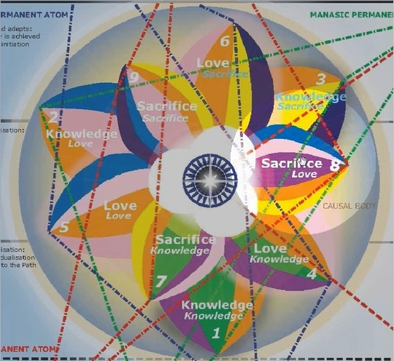

Goes to –
Nine (9)
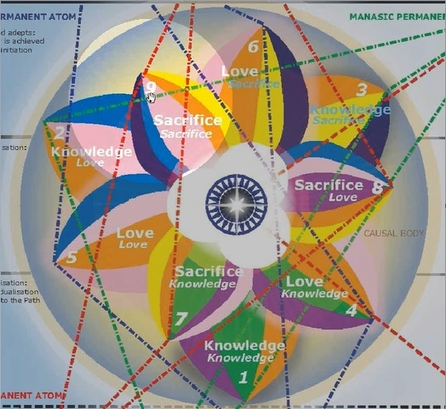
The 8th should not be there –

As in the previous diagram.

And this is the corrected one –

So that calls to our attention that there is a counterclockwise rotation here.

And when we looked at the Tibetan's diagram:

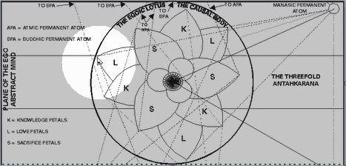
Here, we saw that the Love petal did touch here.

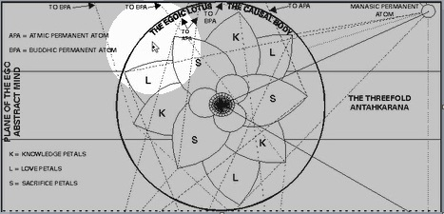
Not on the higher plane.

24:48.0

So –
Love on the 3rd Level
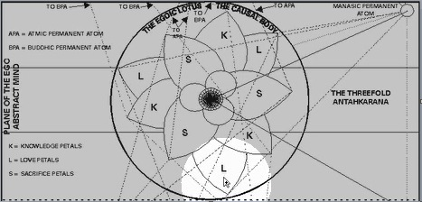

Love on the 2nd Level
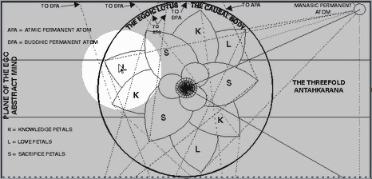

Love on the 1st Level
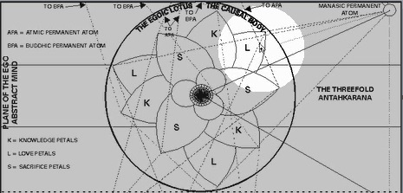

Yes. And here we have the same:

Love on the 3rd Level
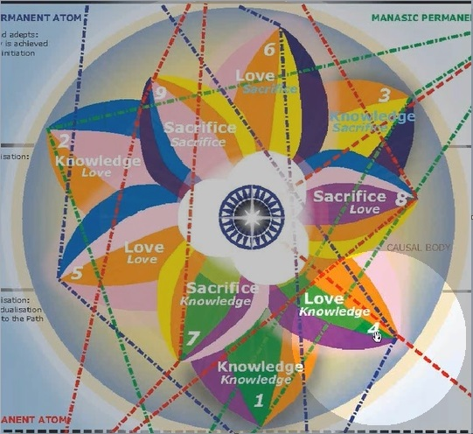

Love on the 2nd Level
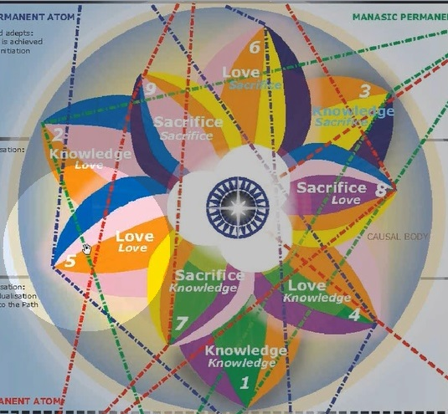

Love on the 1st Level
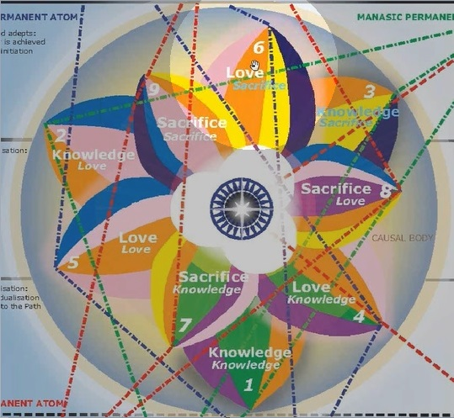

Knowledge on the 1st Level
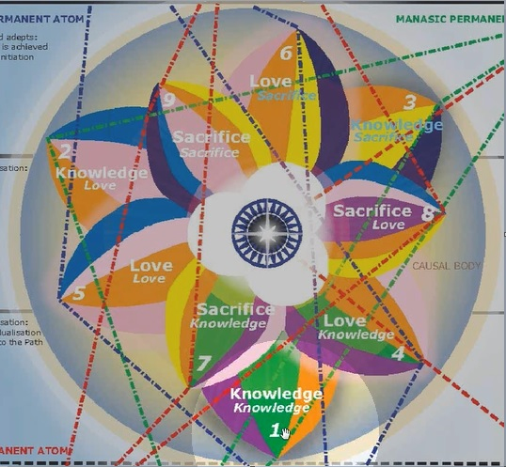
25:09.1 And here, this –

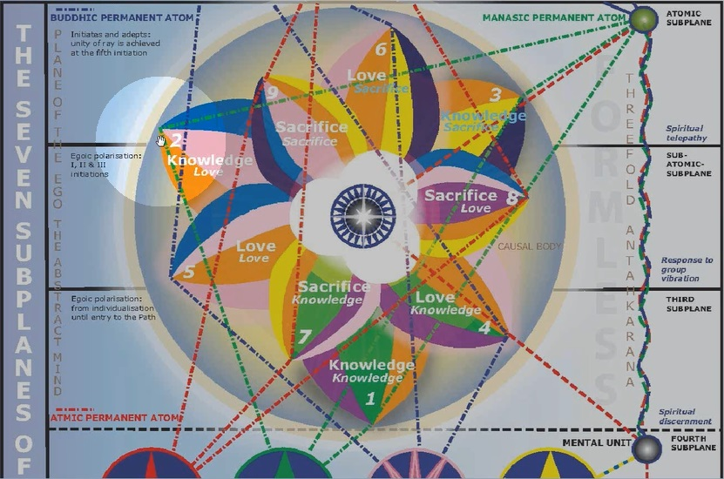

Should be touching right there –

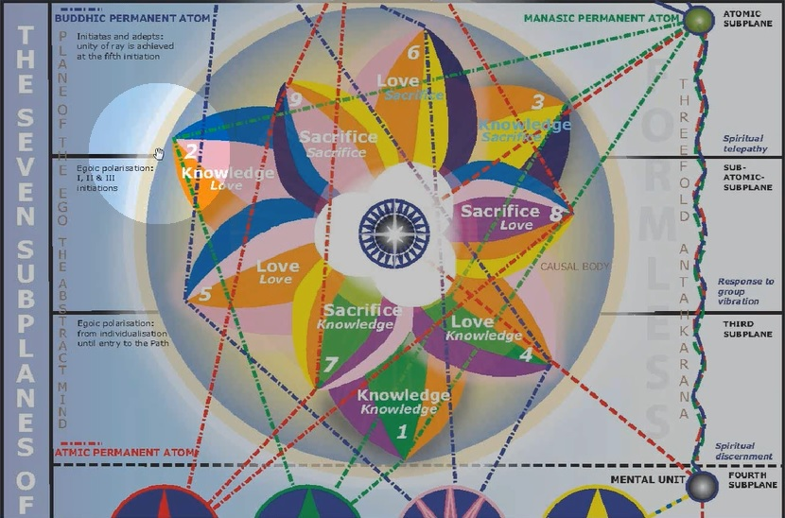

On the love area which it could be drawn in that way… and should be drawn in that way.
Okay. Well, from now on, obviously, we will use this corrected version, my lesson there.

25:28 In general, let us just say that these 3 tiers of petals relate to the unfoldment of the man throughout his long history in the 4th Human Kingdom, he is still a member of the 4th or Human Kingdom, while these petals are unfolding and even while the Synthesis petals are unfolding, he is a member of the 4th Kingdom. He is in transition, however, into the 5th Kingdom from the time the Sacrifice petals are unfolding. And when the 5th and 6th petals have completely unfolded, he has entered the 5th Kingdom, the Kingdom of Souls, but we can say that he is not a true member of that 5th Kingdom until he stands as a Master at the 5th degree.

However, he is what should we say, a strong participant, even if not a full member. He still has his human aspects when he is taking the 4th initiation. At the time the Egoic Lotus is destroyed, those human aspects have been destroyed as well, and he is rapidly entering the 5th Kingdom of Nature in which he is going to stand as a Master at the 5th degree.

So, it is going to be our task here to examine many, many things, and see if we can weave together this picture of the unfoldment of the human being by consulting the various stages, colors, qualities, astrological and ray qualities, which pertain to the Egoic Lotus at those different stages of unfoldment. This is kind of interesting the way it has been drawn, and I think very beautifully.

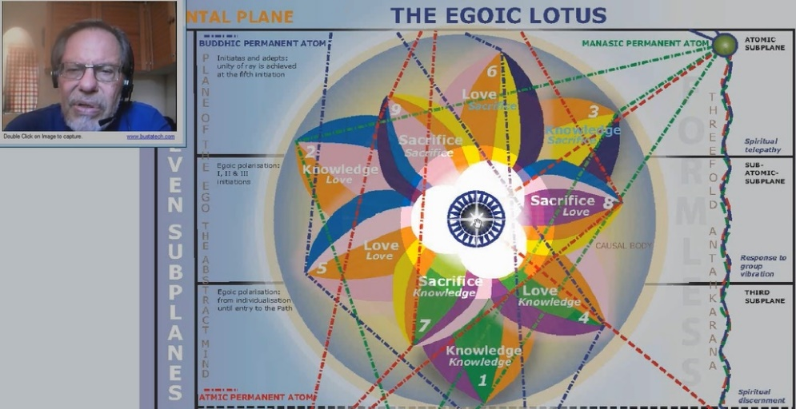

We have an eight-pointed star here in the center of the lotus.

And there are these 24 spikes around it which is the number of Shamballa.

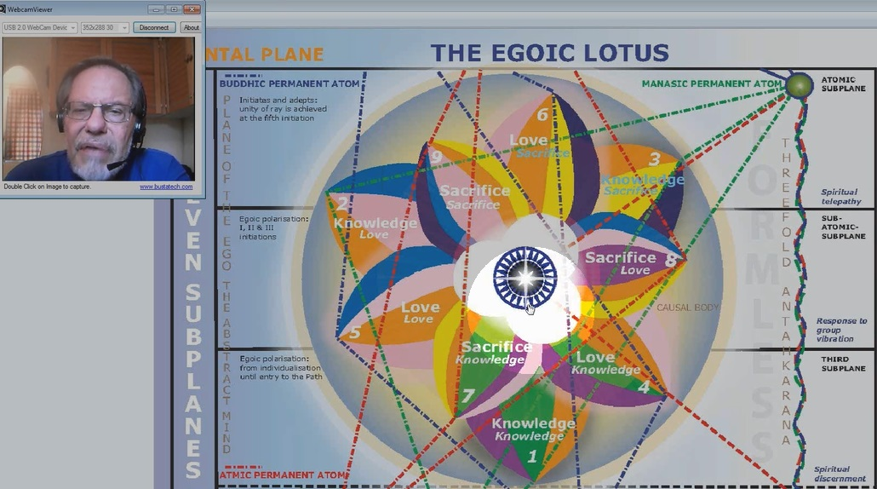

So the inner work has been amplified. And this star we might consider to be the influence of Sirius. Sirius is said to be the star of Mercury. And that is kind of interesting. Mercury and Sirius are closely allied.

Let me just check out that reference for sure, in Esoteric Astrology, page 659:

<Page 659>

NOTES & HIGHLIGHTS
Egoic Lotus 1 — Webinar Commentaries by Michael D. Robbins
ESOTERIC ASTROLOGY – A TREATISE ON THE SEVEN RAYS VOLUME III
APPENDIX – Suggestions for Students - SIRIUS

There is, somehow, at the very heart of this lotus, this representation of Sirius.

Also, there is the representation in the way it has been drawn here at least of the Cardinal Cross and of the Fixed Cross. And, therefore, of the 8 particular power points which we are going to find in this central fire.

We do know that once all 9 petals are unfolded, the man has definitely entered upon the ‘Sirian Path of Initiation’ in such a way that he cannot and will not turn back. Before that occasion, or at least before the midway point between the 2nd and 3rd initiations, it is possible to turn back and veer off onto the path of form. But once all 9 petals are unfolded completely, the man is solidly in the ‘Sirian Regime of Initiation’, and then is a great benefit to the Planetary Logos. This does not necessarily mean that he will take the path to Sirius, for training as a Solar Angel once he becomes a 6th degree initiate, but it does mean that all of the benefits of the Sirian system of initiation which go on to the 6th and 7th and beyond those initiations, are the path that he will follow in taking initiations.

Let us say up to the 6th initiation, the Sirian system of initiation prevails. After the 6th degree, then the human Monad can be, so to speak, outward bound to the usual 7 types of destinations along 7 cosmic paths. Or even these days, we are told that 2 additional cosmic paths on the way of higher evolution are added. And so, the liberated Monad can now have a 9-fold choice.

31.07 Well, how am I going to approach this? I have already managed to make one serious mistake. But okay. You can see that I corrected that and you can see why the correction was necessary.

If, in the earlier diagram, this was the 8th petal –

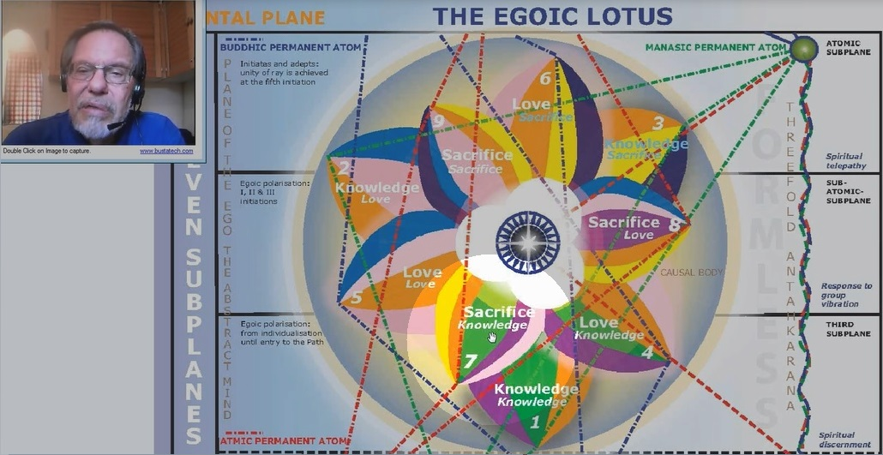

And this was the 7th –

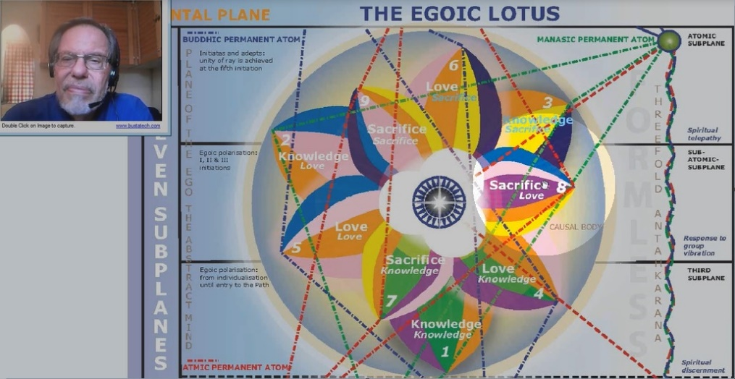

Seven, eight, nine - they would all continue to revolve in the clockwise direction. But no. In fact, the 7th petal touches the 3rd level. There is a petal touching the Love Level, which means that it should be the 8th, and the one touching the 1st level – the highest subplane on the mental plane – should be the 9th.

So there is a reversal of rotation. And it is now rotating with the clockwise wheel which is the wheel of the truly developing soul. That is an example of what we would call the reversal of the wheel. The direction put here of the Sacrifice petals and the way they progress one to another indicates a significant reversal of the wheel which means that the man is really progressing along the right-hand path, unless there is one of those unexpected deviations, which are possible because after all, man does have free will, but once the 8th petal is mostly unfolded and the 9th petal partially unfolded, it is not likely, or maybe even impossible that the man will deviate. Although we are told strangely that there are some black magicians who actually focus on the causal level and they are immensely powerful. But it is certainly not the usual.

Once the midway point has been reached, the man is free from the lower tendencies. The wheel is truly reversed. And in all likelihood, he will continue along the Path of Sirian unfoldment, the path of Sirian initiation.

Table of References

33:24 I want to show you something here which I think would be of great interesting: this is my Table of References. Now I have been teaching this subject for a long time, which does not mean I know all that much about it, but I know something. I have taught this in many Ph.D. classes and in esoteric psychology classes at the end, and what I discovered is that in order to really understand the unfoldment of the Egoic Lotus, a number of different references are required. And then they can all be brought together to supplement our knowledge of the Egoic Lotus. So these are the references that I am going to want to be discussing with you.

And in order to be as clear as possible, once we begin discussing the lotus, I will go over these references first. So you have, or at least, quite a few of them, in your mind when we put all the information together, what has gone before. There are various books which have these. And I am probably going to go through, if not all, then quite a number. So that we have the foundation for bringing together a synthesis of understanding regarding the development of each petal. In a way, what we are attempting is nothing less than to trace human evolution from the very beginning, talking about the energies which are involved, the types of experiences which promote those energies. It is a vast subject.

References (Full List)

Human Groups, Types of Souls | EPII 203-207
Stage of Adaptation | EPI 322-326
Energy Transferences in the Etheric Body | EPII 523-527
 | EPII 528-529
Stages of Appropriation | EPII 77-79
Different Kinds of Egos/Lotuses | EPII 201-203
 | TCF 840-843
 | TCF 855
Monadic Types | TCF 1081-1082
Quality of Petals and Colors of EL | TCF 822-824
Qualities of Petals of EL in Detail | TCF 869
Initiations and Planets | EA 70-71
 | EPI 245-246
Initiations and Signs | EA 67
 | EA 143
 | EA 144
 | EA 165-166
 | EA 387
 | EA 388
Crisis of the Soul | EA 265
 | EA 278
 | EA 472
Qualities of the Heart | DINA II 660
Triangles | EA 88
 | TCF 169-170
Summary of Soul Laws | EPII 198
 | TCF 169-170
Initiations and Rays | RI 340
Accomplishments of Initiation | RI 685-687
Logoi and Initiations | TCF 433
Centers and Discipleship | EA 517
Systemic Laws | TCF 569
Types of Souls | EPII 203
 | TCF 855

36:04.8 So –
- all the ray energies,
- all the astrological energies,
- the energies of the planets, and
- all that -

They are involved in every petal, the unfoldment of every petal. And remember that 1st petal unfolding can take millions of years, and over millions of years, the human being is bound to be born in every sign with every sign rising. So somehow, all of those astrological factors and the various ray factors will be contributing to the enfoldment of every petal. But I will emphasize certain rays, certain signs of zodiac, certain planets in relation to particular petals. And you will get a very intricate idea of how these all work. But in terms of the synthesis and coming to simplicity, this will require some time.

We are going to look at what is called the ‘Stages of Adaptation’ from Esoteric Psychology 1 (EP1). And we are going to look at the human groups or types of souls. (For sake of clarity, they will be referred to as soul groups throughout the text version of the webinars). As a matter of fact, I would almost rather look at that first and the Stages of Adaptation next.

We are going to look at ‘Energy Transferences (in the Etheric Body)’ within the human body:

We are going to look at the ‘Stages of Appropriation’ by which the soul appropriates the different vehicles:

Inevitably, we will discuss ‘Different Types of Egos/Lotuses’ because D.K. has some names for them and it helps us understand how they are classified in the inner karmic departments when they are being considered:

So the names of those as they are given in the different places.

We will also discuss the ‘Monadic Types’:

Now, I certainly don't have the last word on these types but they have different names. And these names can tell us something about the Egoic Lotuses representing these types.

We will look at ‘Qualities of the Petals of the Egoic Lotus in Detail’:

I have a very large document which has been gathered over many years waiting for some sort of synthesis. It usually takes days to go through in an esoteric psychology class or a Cosmic Fire class and we will go through it meticulously.

We will talk about the ‘Organization of the Tiers of Petals in the Three Halls’:

39:31 Inevitably, since we are discussing the stages of evolution of the human being according to the degree of unfoldment of the petals, we will talk about ‘Initiations (and Planets)’ and which planets are involved. And ‘Initiations (and Signs)’ and which signs are involved:

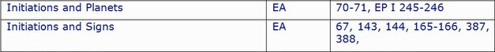

I think we can find that while certain signs like, let us say, Capricorn represent the 3rd initiation generically, and Scorpio the 2nd. We will find that any signs of the zodiac can contribute to the completion of an Initiatory Phase and I will try to discuss how that is done.

The ‘Crisis of the Soul’ will be discussed:

And we will see that as certain petals unfold, crises will come with them. And perhaps, if you are undergoing a particular crisis at this time, it is an indication that you are in that phase of life when the petal and the crisis coincide and you will understand what petals may be unfolding by the nature of the crisis.

The ‘Qualities of the Heart’ are valuable:

There are eleven (11) qualities, and one synthetic quality. They will talk about the ‘Higher Development of Love’ in relation to the Egoic Lotus.

Different sorts of ‘Triangles’ will be studied from Esoteric Astrology and also from the Cosmic Fire:

The ‘Soul Laws’ begin to apply when the person begins to enter the 5th Kingdom of Nature, that is when –
- the Sacrifice tier is being stimulated and
- the Love tier is reaching its full unfoldment.

So we will look at ‘Soul Laws’ and how they relate to the Egoic Lotus:

The ‘Initiation and the Rays’ tell us which rays are dominant at particular initiations:

And so according to the unfoldment of different petals, which indicate different initiations, we will see that different rays are implicated. I know it all sounds like a lot, you know – meticulous entirety or maybe as we joke who are on that ray – the ‘Ray of Ridiculous Entirety’. But you know, although it sounds like lot of detail in the beginning, it all starts to come together, and to fuse and blend and merge and to be intuitively accessible. So it will just require some patience on your part.

42:11.7 The different ‘Accomplishments of (the) Initiation(s)’ and how they relate to the petals:

‘The Logoi and the Initiations’ – which particular planetary Logoi are involved in them:

The ‘Centers (and Discipleship)’ unfolding in relation to Discipleship, and what centers we can expect to see unfolding when different petals are unfolding:

The seven ‘Systemic Laws’ of the solar system and the ‘Types of Souls’:

And it looks like – maybe we have that on twice. Looks like we do. But at least TCF 855 is an amplification on that. So, we will examine all this closely.

43:00 I would like to be able to say that all of these will be organized in perfectly systematic manner: in a linear fashion so that the concrete mind can assimilate it with ease. But I can't really promise that. I can only promise to the attentive viewer and listener that the interrelations between all these factors will stand out in a way perhaps clearer to the mind and consciousness than they were before the study. My purpose is always to somehow illustrate the ‘Science of Relations’, which I think is such a fundamental science and underlies all multiplicity in our cosmos.

“All is related to all, each to all, all to each, everything to everything else.”

So, in this amazing web of interrelationships, we actually have an underlying oneness. And to the extent that these relationships can be discussed clearly, they may promote in us – as students – a growing sense of the unity of everything. And we may be able to find our way from any point in the network of relationships to any other point by clear and logical means. So we will perhaps come closer to understanding how every specific thing is related to every other specific thing and to the whole in general. Now you know there is more, of course. But this is really quite enough to get started.

So, yes, my first work here will be to look at certain references and give us the foundation we need to go into the Egoic Lotus. What I am finally going to do here – there is a lot of data here and BL Allison has helped me collect this – I am going to go a large table which will help us understand the synthesis of the many factors:

Table: The Petals and Means, Paths, Truths

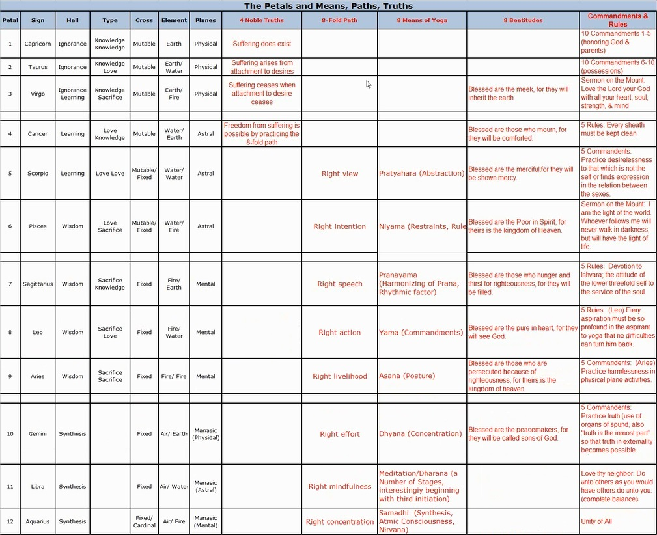

(Link to table on website: http://www.makara.us/04mdr/webinars/eglwc.html)

We will move along in such a way here that many, many factors are brought together. And hopefully, I will be sufficiently organized here to be able to help us get that synthetic picture, which is somewhat related to what work within the Synthesis petals would help us do. We are told by Master D.K. that a huge amount of learning occurs between the 3rd and 4th initiation. Maybe by looking at this, we can prepare ourselves somewhat for that time when we will have to absorb a great deal of knowledge in a synthetic manner. At first, it looks like so many parts and pieces. But eventually, it is going to look like many, many logically, meaningfully interrelated items, which will reveal a synthetic wholeness.

47:26 So here we are with the Egoic Lotus with the different permanent atoms that are related to it. What you see here basically, you see the Egoic Lotus, and then you see a bypass of the Egoic Lotus along the antakarana. Really, the antakarana is a triangle,

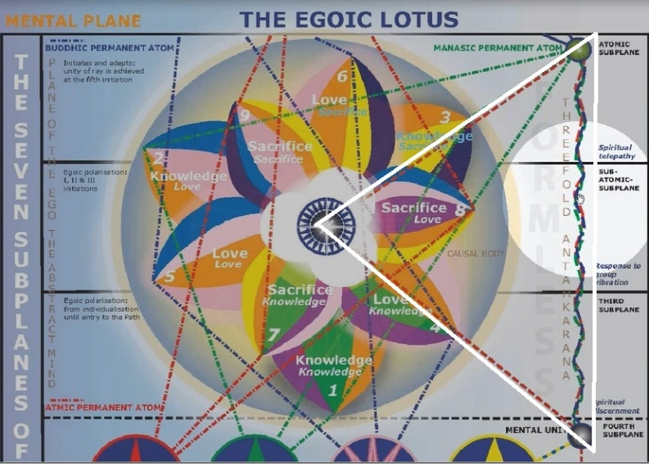

and its first approach is from the Mental Unit on the 4th subplane of the Mental Plane to the Egoic Lotus itself
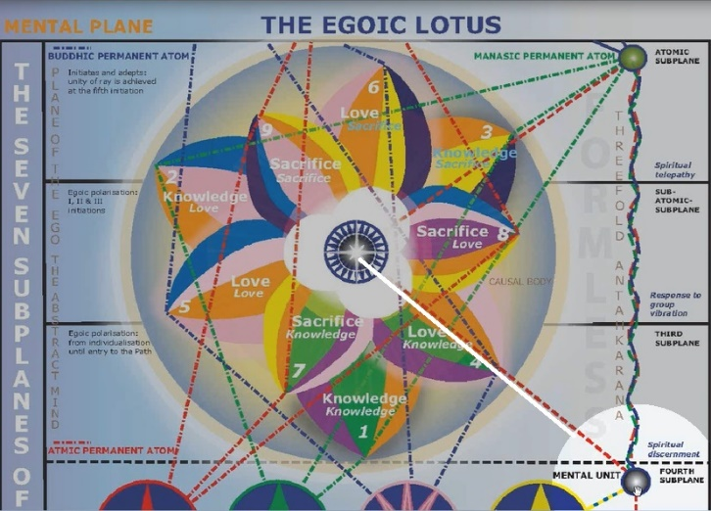

And its second approach is towards the manasic permanent atom” from the lotus itself.

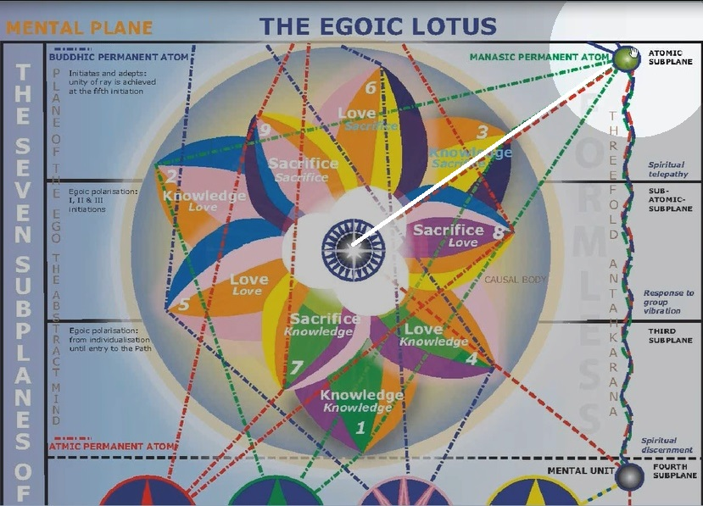

The antakarana that we study is a bypass of the Egoic Lotus. The other two involved are the two points of the triangle involved in the Egoic Lotus. But our method of building the antakarana is via a projection from the mental unit on the 4th subplane of the mental plane to the manasic permanent atom at the height of the abstract mind. And that is the projection occurring after we have absorbed into the mental unit quite a bit of the influence of the Egoic Lotus.

So, we will be referring frequently to this particular diagram. One day, I have artist friends who are already working on trying to animate this thing. And make it stand out in a form truer to its probable inner appearance.

And one day, it will be a holographic image as well – and all the vortices will be discovered. But for right now, we have it pretty much in two dimensions and with flat colors and in the state of non-rotation.
But we can imagine what it would be like in the inner levels; its actual appearance.

The purpose of all this is to gain a real understanding of:
- where we stand on the path,
- what we are doing,
- what energies we are using,
- what unfoldment we may be passing through,
- what we have to do to reach our next unfoldment
- And make ourselves more worthy of cooperation with the spiritual hierarchy.

49:48 The purpose of all this is ultimately practical:
- We got a sense of history.
- We take a look at the human family and where the different members of the human family may be standing with respect to this process.
- How we can perhaps help some with respect to this process.
- How we can help each other with respect to the unfoldment process.
- And perhaps through visualization and knowledge of the inner meaning, the actual vision of the Egoic Lotus will begin to come to us.

It is inevitable, of course. But right now, just the way we prepare for our knowledge of our ability as white magicians, we prepare by doing the academic work.

We will here also prepare by doing some meticulous academic work, and as it all comes together, I think that what the Egoic Lotus is will really begin to live in our consciousness, and perhaps fleeting glimpses of its actuality and certainly the sense of what it is will live within us. I mean, here we are – when we look at each other, we may see the form and we may see the personality at work. But behind this, and being a far truer and more real self is this unfolding, vibrating, scintillating, pulsating lotus. That is a much more real self, not the ultimate, but a much more real self than the person we seem to see.

And so if we can somehow begin to look at each other in a different way and see through the personality and beyond to the unfolding lotus and get such a sense of its reality that we are dealing more with this inner vibrant structure on the higher mental plane. Then we will would have advance in our ability
- to deal with each other,
- to relate to each other,
- to understand each other.

Well, okay friends. You know, I am one of those Aries people. I try never try to go back. And of course, I want to go back. I want to make that correction (of the Lotus diagram), but we are learning together, so I assume you will pardon me for using the wrong illustration. And then wondering about it, maybe we all learned something in the process.

And now I will go on and begin to lay the foundation by consulting different things which Master D.K. has said. And which we are going to attempt to correlate as we bring together all of the knowledge in some sort of final synthesis. I don't know how long from now – I maybe have a month to do this and I will see what is possible to accomplish.

Five Groups of Souls – Esoteric Psychology, Volume 2, page 201

We are going to begin with the ‘Five Groups of Souls.’ We are going to begin in Esoteric Psychology Volume 2 with the 5 groups of souls, and this is what I consider to be background material. Some of it is straightforward.

There are really many groups of souls, but D.K. is dividing them into 5 groups for useful purposes. I will fill in a few things here and then move into other texts where I have already made comments.

“III. The Five Groups of Souls
We now begin our study of the five groups of souls. For purposes of classification and comparison, we shall divide our earth humanity into the following groups:
1. Lemurian Egos ------------------our true Earth Humanity.
2. Egos which came in ------------on Atlantis.
3. Moon chain Egos ---------------from the moon.
4. Egos ------------------------------from other planets.
5. Rare and advanced Egos -------awaiting incarnation." EPII, 201

We now begin our study of the five groups of souls. For purposes of classification and comparison, we shall divide our earth humanity into the following groups:
And notice – he talks about earth humanity here, but he does not mean necessarily humanity that originated in the Earth Chain. In fact, sometimes the word Earth humanity relates precisely to those who individualized on our globe and in the Earth Chain. But here, he is talking about those who are currently on our planet whatever their origin might have been.

1. Lemurian Egos ------------------our true Earth Humanity.
55:33 So, the Lemurian Egos are here. And he calls this our true Earth humanity. And they individualized about 21 million years ago. It does not mean they knew they were human beings at that time; but that was when the spark of mind was implanted in animal man of our particular chain.

2. Egos which came in ------------on Atlantis.
In the earlier Atlantean times, which were about 12 million years ago, according to D.K. So, there can have been quite a space of time between the entry of the true Earth humanity – the Lemurian Egos and Egos which came in at Atlantis. And there are different ray likelihoods, possibilities, with these different types of Egos.

Now, I must say that when we uses the word ‘Egos’, we cannot think only of souls. We actually have to think of Monads who individualized. And in a certain sense, the word Ego can stand for the Monad. The shape of the Egoic body on the higher Mental Plane is egg-shaped, oval-shaped, or at least in many instances, or spherical. And I have the sense that there is something called the ‘Monadic egg’.

Let’s see if D.K. uses that term in any place. Well, there are. There are several.

So yes – ‘The sphere of manifestation, the monadic egg.’

QUERY 1
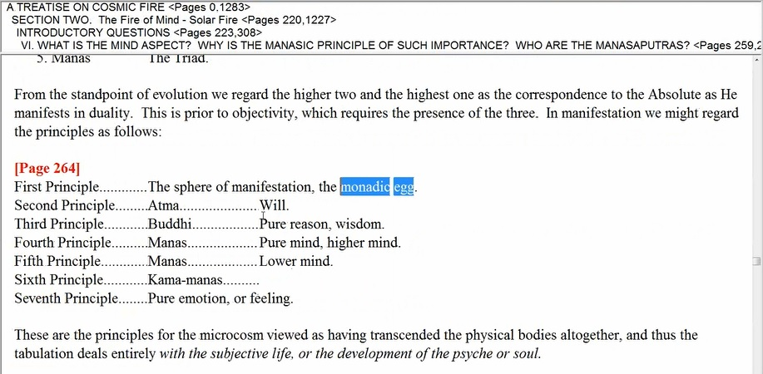
A TREATISE ON COSMIC FIRE
SECTION TWO. The Fire of Mind – Solar Fire [Page 264]

Okay, and the egg of course we know, is oval. The monadic egg or auric egg.

QUERY 2
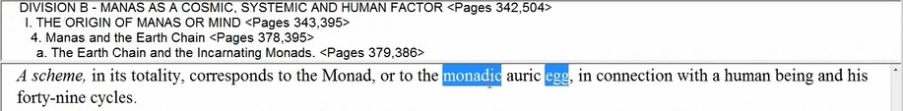
A TREATISE ON COSMIC FIRE
SECTION TWO. The Fire of Mind – Solar Fire
DIVISION B – MANAS AS A COSMIC, SYSTEMATIC AND HUMAN FACTOR
I. THE ORIGIN OF MANAS OR MIND [Page 382]

The causal body … monadic heart center – not there so much. And let us see if we have it over here –monadic auric egg – indeed, we do.

And maybe, one more. Let us try it.

And monadic auric egg. Okay.

QUERY 4
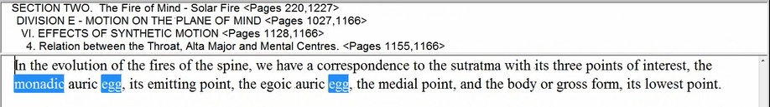
A TREATISE ON COSMIC FIRE
SECTION TWO. The Fire of Mind – Solar Fire
DIVISION E – MOTION ON THE PLANE OF MIND
VI. EFFECTS OF SYNTHETIC MOTION [Page 1159]

58:10 So, we get the idea that the Ego, so to speak, exists on a Monadic level as well as what we call the soul level. So we are actually talking about the entrance of certain types of Monads who are not yet possessed of causal bodies but who are creating causal bodies even by natural processes or with the help of Solar Angels when individualization occurred in our particular chain.

Picture of the Earth Scheme – 7 Chakras

I would like to show you something that is of value, something you have seen many times, of course: the picture of the Earth Scheme.

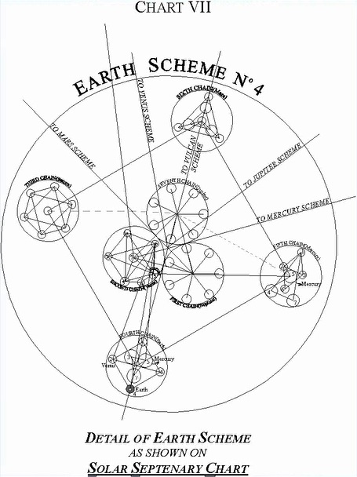

I think I can come to a better one that Tuija has done here. So here is the Earth Scheme.

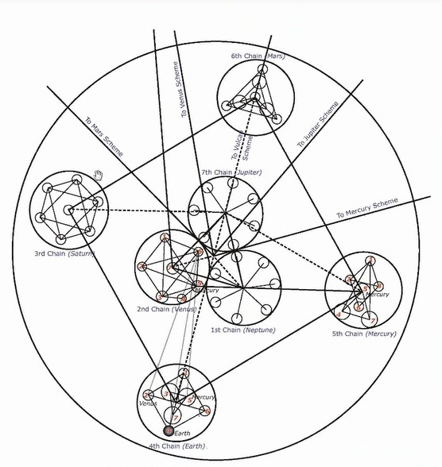

And here are the 7 major chakras of the Earth Scheme which are known as chains. And our chain is the fourth.

So originally, the 3rd Chain, now called the Saturn Chain, was the Moon Chain. There is a mystery there in the connection of Saturn and the Moon. One wonders whether that Moon Chain has not been regenerated in some manner. But it was not in those earlier days and the life was transferred from the 3rd Chain, the Moon Chain, to our 4th Chain when the progress on the Moon Chain was interrupted.

1:00:20 Anyway, here are the depictions of these various chains and some significant geometry. And in my commentaries which are written commentaries, and not the spoken commentaries – I do get into that and discuss their shapes. So you can find them on Makara.

3. Moon chain Egos ---------------from the moon.
So going back then, we also have the Moon Chain Egos and they came from the Moon Chain which was in this place in those days – the 3rd Chain. However, the Saturn Chain has taken the place of the Moon Chain. We are not told the particular method, but it seems that the Moon Chain Logos was transferred to the 4th Chain and is participating in the development of those lives which it was originally supervising on its own chain. It is participating with the 4th Chain Lord in the supervision of development on the 4th Chain which now contains Moon Chain Egos as well.

Advanced human beings being very likely among those Moon Chain Egos. The Moon Chain Egos did come in with some petal development. The Egos which came in at Atlantis were fresh, newly made Egos. And the Egos coming in from Lemurian were also fresh, newly made.

But with the Egos from the Moon Chain, petals 1, 2, 3 – who knows, maybe more – were unfolded. If the Buddha was a Moon Chain Ego, which I am told he was, and he was on the verge of taking the 3rd initiation in the Moon Chain, but it could not be done at that time, we are told then he had virtually 9 petals unfolded when he came in. Well, maybe. Well, yes, if he was on the verge of taking the 3rd initiation then. Or certainly, significant number of petals unfolded. It takes 9 petals to make the 3rd degree initiate.

So these are Egos unfolded in various degrees. Egoic Lotuses with anywhere from one to how many petals open.

4. Egos ------------------------------from other planets.
Egos from other planets, particularly Venus, and Jupiter, Mercury and Vulcan. And maybe others. But those are the ones that are mentioned. And they may come in with petal unfoldment to a certain degree. And some of them perhaps do not come in with petal unfoldment but they are Monads that are transferred into our Planetary Scheme. And then they undergo Egoic Lotus development, here in our scheme and chain.

1:04:05.2 So we will have to look carefully there whether petals are unfolded or not, or whether both can be the case, that they can come in as Monads and individualize on our particular chain, or whether they come in with some petals unfolded.

5. Rare and advanced Egos -------awaiting incarnation. Until the time is propitious.

So he has divided our earth humanity – those who are undergoing development on our earth into five categories:
(a) Those who came in from the Moon Chain (3) of which there are really quite a few among the advanced humanity. And they have some petal development whether a lesser amount or a greater amount;
(b) Those who came in on Lemurian (1) and who individualized in that rootrace some twenty-one million years ago or so;
(c) Those who came in later, maybe 8 million or 9 million years later in early Atlantean times and obviously had the birthing of their Egoic Lotus right here on our planet in our chain;
(d & e) And then other rarer types (4 & 5), especially the rare ones are the advanced egos. But there may have been quite a number from Venus, Jupiter – coming in either as Monads or with some petal development, and from Vulcan definitely with petal development, and may be from Mercury with petal development.

Venus, Jupiter, Vulcan and Mercury – those are the ones of which I am aware. Now I would not be surprised if there are Martian Egos as well, because there do seem to be a certain number of human beings who are very connected with that planet, and they may be the ones who have to go back to that planet for further instruction when the judgement day occurs in the next round, probably of our chain millions of years ahead.

1:06:18 Alright. So those are the divisions. And when we are talking about the unfoldment of the Egoic Lotus, we want to have these divisions in mind. Naturally, some people would be further ahead than others in their petal unfoldment. You know stimulation, organization, opening, unfoldment. these are the different words that are used for different stages of the process. It will be expected that the Moon Chain Egos or Monads will have a greater degree of petal unfoldment in general than will the Earth Chain Egos. Either the Lemurian, especially the Atlantean, probably the Atlantean, are the furthest behind. They contain quite a few 1st ray Monads and will undergo their further development in the next solar system; at least that is what D.K. seems to be saying.

So when you look at Earth Chain humanity in general, those who actually individualized on our planet and in our Earth Chain, the Egoic development will be generally less, the petals unfolded generally less though some fast-moving, Earth Chain humanity is already a part of the hierarchy, which means they have already destroyed their causal body, which is amazing. And foremost among Earth Chain humanity is the Christ whose rapidity of unfoldment is unparalleled, we are told.

So just because we see a certain amount of unfoldment does not mean that we can necessarily determine which chain has been the scene of individualization for that type of Ego. Probably there are other indicators which would tell the Master when he looks at it. But the number of petals unfolded actually cannot tell that. Except that the majority of petals, a greater number of petals unfolded, would be found in the Moon Chain types generically, or generally than in the Earth Chain types.

Four Ways the ‘Soul’ is Regarded in Modern Psychology

“We enter, therefore, upon a brief consideration of a subject that, to the ordinary psychologist and student who is not familiar with the occult teaching and terms, will sound fanciful and unintelligent. The reason for this is that we are considering the origin of the souls which are expressing themselves through human beings, of the selves who are functioning through form and are therefore intangible and—scientifically speaking—non-provable. They are only to be inferred by those who can accept inference, deduction and conclusions which cannot be demonstrated, with the type of human equipment now in use. Modern psychology, speaking generally, regards the soul in one or another of the following ways:” — EPII, 201

We enter, therefore, upon a brief consideration of a subject that, to the ordinary psychologist. . . who is dealing mostly with the personality, wouldn’t we say? . . .and student who is not familiar with the occult teaching and terms, will sound fanciful and unintelligent. As if we are making huge fanciful assumptions. The reason for this is that we are considering the origin of the souls. . . the origin of the souls or Egoic units – higher Ego . . .which are expressing themselves through human beings,. . . members of the 4th Kingdom .. .of the selves. . .now, you know, when we look at selves, a Monad is a real self – Now when we use the term self, it is not just the soul; not just the personality; it is the deeper being the deeper unit.

1:10:16 So, the reason for this is that we are considering the origin of the souls which are expressing themselves through human beings. Notice he really differentiates the human beings seems, in this case, to be more of the personality although the members of the 4th or Human Creative Hierarchy are Monads and have the word ‘human’ attached to them.

So, we are considering their origin - expressing themselves as personalities or selves . . .who are functioning through form and are therefore intangible and—scientifically speaking—non-provable. So the real self is presently non-provable – real selves, real units of being, consciousness – are not provable. They are only to be inferred by those who can accept inference,. . . because I suppose of their training and their thinking. . . .deduction and conclusions which cannot be demonstrated,. . . and I think I would like to say – yet – be demonstrated. . . .with the type of human equipment now in use. And I think we can say – this will improve.

“Modern psychology, speaking generally, regards the soul in one or another of the following ways:” — EPII, 201

“1. Either non-existent, the only obvious and provable thing being the intelligent mechanism.” — EPII, 201

The personality is provable because seen and experienced, and the soul or Ego is NOT provable because not seen and not experienced by many. At least the majority of human beings are not yet in a position that they experience the soul, at least not in a conscious and easily recognizable way. So modern psychology considers the soul may be non-existent; or

“2. As being the sum total of the conscious reactions of the cells of the body—the sentiency of the organism, in other words.” — EPII, 201

So, again a lower definition, as if matter produced sentiency, which we know is the reverse of the occult truth. So you know where does the ability to feel and so forth come from? It is thought by modern psychology, that the soul is a by-product of our material construction and in this case, the tail is wagging the dog. Since this book (Esoteric Psychology II) was written, a number of developments in the field of psychology have come closer to considering the soul or trans-personal Self.

“3. As a gradually evolving self, conveying life and, as time elapses, awareness; it is regarded as being conditioned by the body and as a product of the evolution of that body during the ages. It does not, however, exist in the lower types of human beings, and it possibly possesses immortality, but that is not provable and may not be posited as a fact.” — EPII, 201

So this is a sort of an indeterminate position that modern psychology takes. Awareness, conditioned by the body, well there are others which are not recognized, and as a product of evolution and the lower types of human beings do not possess this, Of course, this is incorrect. All human beings necessarily possess soul but of course it is not so easily demonstrable in those who have not have sufficient number of incarnations.

“4. As a definite Self, an entity, informing a body, functioning at various levels of human consciousness, and having continuity, immortality and potentiality.” — EPII, 201

As a definite Self, an entity, informing a body, functioning at various levels of human consciousness,. . . human consciousness here being the filter, human consciousness is like a filter upon the qualities of the soul, . . . and having continuity, immortality and potentiality. And let us say that this is the highest type of definition from the most advanced type of modern psychology which esoteric psychology might be considered to be the highest example.

How many esoteric psychologies are there really? Well, D.K. would have the number, I suppose. But not so many compared to those who practice psychology in relation to the personal psyche and not to the transpersonal psyche.

1:16:20
“The occult teaching accepts all these hypotheses as correct, but as relative in time and space, and as having reference to different forms of divine life and to differing aspects of those forms.” — EPII, 202

The reason given is not necessarily as the psychologists think. But within an understanding of true esoteric psychology: soul psychology, place is given to all of these other recognitions. And the conclusions that they come to are accounted for within esoteric psychology for different reasons than the ones given.

I mean the body is not the source of sentiency, and all human beings have souls even if relatively undeveloped. And the soul certainly is non-provable but existent. And the intelligent mechanism is obvious and thus exists, but it is an aspect of soul projection. So, many of the conclusions of the psychologists are clearly correct, but for different reasons.

“It is with the occult teaching, right or wrong, that we are at present engaged, and our premises and conclusions can be stated in the following propositions:” — EPII, 202

It is with the occult teaching, right or wrong, Is cautious not to impose, is it not? . . . that we are at present engaged, and our premises and conclusions can be stated in the following propositions:

“1. Every human being, in or out of incarnation, is a "fragment of divinity," and an outpost of the divine consciousness, functioning in time and space for purposes of expression.” — EPII, 202

Every human being, in or out of incarnation, is a "fragment of divinity,". . . we might call them an emanation, the divine spark of the one flam, an inseparable fragment, if I may call this by its truer description. I mean, in consciousness there seems to be separation, in factuality, there is no separation.. . . and an outpost of the divine consciousness,. . . in some form, attenuated or fuller. . . . functioning in time and space for purposes of expression. That is in the world of parts and pieces – in the world where sequence is necessary.

So our premises and conclusions according to occult teaching regarding psychology are as follows – we have read number 1.

“2. All these souls, selves, or human beings are found, as we have seen, on one or other of the seven emanations of spiritual energy, issuing forth from God at the beginning of an era of creative activity. They return to their emanating Source when that particular cycle is brought to a close.” — EPII, 202

All these souls, selves,. . .Here, the word ‘self’ is being associated with the word ‘soul’. But let us remember that Monad has soul, which means, Monad has consciousness. Monad has awareness. So the ‘True Self’ is not necessarily the Egoic Lotus. The True Self is indestructible. It is at the heart of the Monad and the Egoic Lotus, we know, is destructible. But not the true Self which has resided within the central fire of the Egoic Lotus. . . . All these souls, selves, or human beings. . .And notice how he, this time, puts together the idea of the self and the human being. Earlier, he differentiated the apparent human being as obviously not the true self, but at the very core of the human being is the true self. And that is not the Egoic Lotus, but it is the center of being within the Egoic Lotus, and even within the Monadic vehicle, which is destructible, that pure core of being, which is the essential Monad does exist.

So there is some overlapping of meaning in these words. We just have to be alert to it. One cannot speak with utter precision and technically all the time, or it will become utterly tedious.

1:20:34
All these souls, selves, or human beings are found, as we have seen, on one or other of the seven emanations of spiritual energy,. . . each one of them is related ‘monadically’ to one of the ‘Great Seven Ray Lords’.. . . .issuing forth from God. . . Well, will this be God of the Solar Logos or the God of Planetary Logos? I think, in a way, we should consider it God of the Solar Logos in which each Monad finds its home. Its home within the Sun. … issuing forth from God at the beginning of an era of creative activity. They return to their emanating Source when that particular cycle is brought to a close. And I think here, we are talking about the Solar Logos as the Source of emanation of the Monads in our solar system. Because it is very interesting, the Monad is that which has its home within the Sun; D.K. tells us this in Initiation, Human and Solar. It is always good to see that. Home – Sun. There is only one.

“Thus the solar Lord, the inner Reality, the Son of the Father, and the Thinker on his own plane becomes the intermediary between that which is of the earth, earthy, and that which finds its home with in the sun.” — INITIATION, HUMAN AND SOLAR, 196

. . .the Son of the Father, and the Thinker on his own plane becomes the intermediary between that which is of the earth, earthy,. . . which is the personality. . . .and that which finds its home with in the sun. And not the outer physical Sun, but D.K. is not specifying here, but still, an inner part of the Sun. And you know, ultimately, I think the monadic nature of the Sun, ‘True Being’ comes from there. At least those emanations of being which are found in our solar system.

So we come forth on 7 emanations. We come forth monadically on three emanations and then seven more as souls. Not to forget the triplicity of triads. So there are number of different ways in which the rays that characterize us come forth and are combined and overlapped. So the occult teaching has the following premises:

“1. Every human being, in or out of incarnation, is a ‘fragment of divinity,’…

2. All these souls, selves, or human beings are found, as we have seen, on one or other of the seven emanations of spiritual energy, issuing forth from God at the beginning of an era of creative activity. They return to their emanating Source when that particular cycle is brought to a close.” — EPII, 202

All these souls. . . come forth . . .on one or other of the seven emanations of spiritual energy,. . . from our Solar Logos and also from other planets where they have a truer home than on our own planet. Because our planet is not one of the sacred planets. And our planet does not last throughout the Mahamanvantara, but the Monads have existed even before the creation of the Earth. And this is problematic and interesting thought: have they been within the higher aspect of our Planetary Logos, having come, via the Sun? or via the inner nature of the Sun? Well, these things will be solved in time.

1:24:15
“3. In the interim between emanation and reabsorption, these souls pass through various experiences until such time as they can "shine forth in all their exactitude of truth." — EPII, 202

In the interim between emanation and reabsorption,. . .And remember it is Monads that are reabsorbed, not souls because here, it is as if the word soul is being used to indicate Monad. So between emanation and reabsorption, the selves emanate from the heart of being. Well, a soul is a unit of consciousness and a Monad also, is a unit of consciousness. It is the first unit of being because you have to exist, you have to be, before you can be conscious. At least, that is my assumption. And in that, I think I differ from maybe some Buddhists, but it seems that Being is primary; and Consciousness is derivative from the state of being.

In the interim between emanation and reabsorption these souls pass through various experiences until such time as they can ‘shine forth in all their exactitude of truth.’ That is beautifully stated and either shining forth within the Egoic Lotus or within the Temple of Ezekiel.

Because as beautiful as the display of the Egoic Lotus has been described by Master D.K. what would we be able to say about the display of the Monadic vehicle once it is fully developed and ready for its destruction? At what point, you know maybe preceding the 7th initiation, or maybe at the 7th initiation, or
maybe somewhat beyond it.

You cannot take your Monadic vehicle onto the Cosmic Astral Plane and it just depends on when transit to the Cosmic Astral Plane is possible. It does look as if the Christ is able to make his way onto the Cosmic Astral Plane but I would say that this must be done as an unsheathed Monad, or a Monad carrying some different kind of sheath.

These souls pass through all manner of experience until they can shine forth in all their exactitude of truth, which means their Divine name is in expression, fully, with respect to our cosmic physical plane. So we are not just talking about the 4th degree initiate here; we are talking about something else.

Seven Groups of Lotuses

Now, we come to the Different Groups of Lotuses:

“4. They are called, as has been stated, in A Treatise on Cosmic Fire (See page 855.)
1. Lotuses of revelation.
2. Lotuses with perfume.
3. Radiant lotuses.
4. Lotuses wherein the flower is on the point of opening.
5. Lotuses of closed and sealed condition.
6. The colourless lotuses.
7. Lotuses in bud.” — EPII, 202

D.K. has said more here in different places. So, I will use this particular reference to deal with the seven groups of lotuses. We will go to this other document (TCF 855) where this part of the document we have come to is discussed. And, we are in this section where we are dealing with certain premises and conclusions that can be formed and stated with respect to the occult teaching.

1:29:04 We are not exactly in order here. We are in descending order, as you see. We are beginning with the high and descending to the lotuses of lesser development.

1. Lotuses of revelation.
What I presume here is that the lotuses of revelation are those in which the Jewel of the lotus is about to be revealed. We have taken or are taking the 3rd initiation and the nine petals are unfolded, or coming to that point. The Jewel in the Lotus will shortly be fully seen. Already, the light from the Jewel is intense and thus the possibility of revelation.

So these lotuses, there may be other technical names here. But these are very highly developed lotuses. And for a while, as the Jewel shines, the Synthesis petals are open and all the other petals are open, all the other nine. And the inner qualities of unity, of synthesis, and of being are being revealed. But I think this starts at the 3rd initiation and it goes to the 4th, this is my impression, at which point, there is no more lotus to reveal anything. The revelation has to come in other ways. Revelation will come through the spiritual triad.

Of all the names we had been given, the most advanced lotuses. And when we look at this figure, in which obviously, the Causal Body has not been destroyed. The Egoic Lotus is very much there. We have a Lotus of Revelation.

Now, the rest of us, I think they are going to look to the inner eye, something less than this. So this is a very full development. This is the fully developed Egoic Lotus. And I think we can call it successfully a lotus of revelation. It has to be remembered that there are different types of names associated with the initiations. Now, the 5th degree is called the Revelation; the 4th the Crucifixion; and the – well, let us see. No express reveal. That is how it goes. No express reveal, destroy, resurrect. So even though the 5th initiation is called the ‘Initiation of Revelation’, it seems to be associated with the kind of resurrection. Not the resurrection at the 7th degree, although you could start that sequence. No express reveal, destroy, resurrect. You could start that at the 3rd initiation too. And it would be most interesting, but let us just say that, the ability to reveal the One or reveal the Monad is accorded or attempted at the 3rd degree.

So from the 3rd degree to the 4th degree, the revelation of the central fire of the Jewel in the Lotus is being attempted. And for those individuals for whom it is possible, they will be called ‘Lotuses of Revelation’. So minimally the 9th petal, has opened. And so, all the nine are open. Although at the beginning of this Process of Revelation, the inner Synthesis petals are not fully opened – they will burst open just before the 4th degree and reveal the Jewel in the Lotus. And that revelation itself will begin the destruction of the causal body.

1:34:23 So the period of revelation spans approximately this period, a period of the 3rd degree to the 4th degree.

2. Lotuses with perfume.
This correlates with the period between the second degree and the third degree. Perfume is a very magnetic attractive substance and it has to do with the Love petal of the Sacrifice Tier. So when that petal is almost quite in process of unfoldment; the rod of initiation is supplied, however it is applied. And the 2nd degree takes place. The opening of that petal will not be complete until the 3rd. But it is mostly open until the 6th petal unfolds fully at the 2nd degree. So there is a very strong magnetism created through loving sacrifice. The perfume of the individual is demonstrated through loving-sacrifice.

We will get into the different ways in which the sacrifice occurs. The sacrifice of all forever is occurring when the 9th petal is completely unfolded. But the 8th petal unfolding will give us that magnetism which occurs when the person is so selfless that they are harmoniously related to the wholeness.

We will get into this later, but I can’t say anything in order. It is the Scorpio petal. The Scorpio brings in the 4th ray. The 4th ray of harmony at the present time. It is the greatest conveyor of the ray of harmony.

So a perfume shows a relationship of substance which produces something very attractive. This particular odor or smell is very attractive. And it could not be if disharmony existed. When disharmony exists, you have putrefaction. You have smells which are not attractive; they can be off-putting. But when a perfect harmony is created, then the attraction occurs.

So these lotuses, by their demonstration of sacrifice, are demonstrating a very strong love principle. And the love within them is the perfume within them that attracts all beings towards the state of unity. So I would call this Initiates of the 2nd degree on their way to the 3rd degree or reaching the 3rd degree. At which point, they begin to become Lotuses of Revelation.

3. Radiant lotuses.
When it comes to the next petals, Radiant lotuses, I would say that these are mainly in different degrees of unfoldment in the long process between the 1st initiation and the 2nd initiation. These are initiates of the 1st degree until the 2nd degree.

1:38:07 So the principle of light, it is often associated with the 3rd ray. And this initiation should be associated with the 3rd ray in one respect, just the way with the 2nd ray, and the 3rd initiation with the 1st ray, but also with the… well, they are all involved. There is a 1st ray thing that happened at the 3rd degree. But also a 3rd ray and a 5th ray factor is involved. At the 2nd degree, the 6th ray factor is involved, but it is the 2nd initiation and generically connected with the 2nd ray. And the 1st initiation has to do with the 1st initiation of the personality. And it involves intelligence. Light is considered particularly to the 3rd and 2nd ray, occasionally to the first as in the light of life. But this idea of radiant intelligence is starting to come out here at the 1st degree.

So the radiant lotuses are those with whom the 7th petal is unfolding. It will not unfold completely until the 3rd degree is completed, but the Christ directs his energy to this 7th petal and increases the radiance of intelligence, and although that petal is not fully unfolded with the touch of the rod, it is very unfolded.

So it is 7th petal work, and it involves also by resonance, the complete unfoldment of the 5th petal. And of course, the 5th petal, connected with Leo and at the Sun and so forth, gives us the idea of radiance. So our light is shining and it is always shining through sacrifice. This is the key. Hard to take maybe. But the more we sacrifice, the more our light shines.

So, we have here the description of the 1st, 2nd and 3rd degree: Radiant lotuses, Lotuses with perfume, and Lotuses of revelation. And so many of the students of occultism in the world today find themselves between the 1st and the 2nd initiation. Between the 1st and 2nd initiations the students should become increasingly radiant lotuses.

So, we realize by the time the 2nd degree is reached that spiritual intelligence and a mind, how does he describe that? Yes, there is a special way of describing it. I think spiritual intelligence is one of the ways of doing it. Let us just check that out. Mental… – it is mental focus, for sure. It is not yet mental polarization.

Let us see if we can find that. My first shot in Discipleship in the New Age. –

SEARCH RESULT
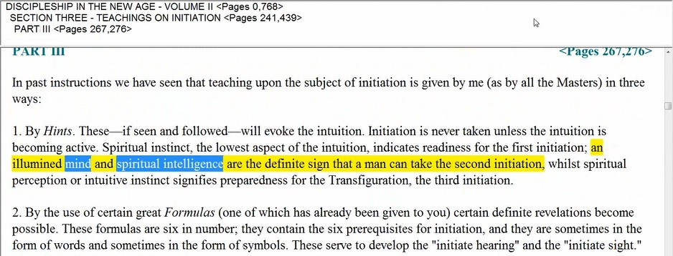

“… an illumined mind and spiritual intelligence are the definite sign that a man can take the second initiation, whilst spiritual perception or intuitive instinct signifies preparedness for the Transfiguration, the third initiation.” — DINA II, 267

This is such an important quotation. So, we can see how radiation or radiance would correlate at the 2nd degree with a high degree of the illumined mind and spiritual intelligence. All the way from the 1st to the 2nd, radiant lotuses. So I would say that most of us as occult students or students of occultism, are increasingly radiant lotuses. Whether we have made sufficient sacrifices to become lotuses with perfume. Okay, that remains to be seen. And to become lotuses of revelation, we must reveal the One. We must reveal the Monad because it is the spirit aspect at the heart of the lotus which is in process of revelation.

And maybe there are other names I say here that could be given for lotuses. We have reached the 6th petal as partially unfolded and the 5th partially unfolded, and so forth. They are not given. They are, let us just say it is possibly intermediate names for lotuses in various states of unfoldment.

4. Lotuses wherein the flower is on the point of opening.
Then this probably covers quite a bit – ‘Lotuses wherein the flower is on the point of opening.’ But which flower? We have already dealt with the interior opening of the Sacrifice petals and that makes a full-fledged 3rd degree initiate. When the 2nd flower (tier) is completely opened, you have already the 2nd or 1st degree initiate. So I don’t think that this opening is that. I think it refers to the first opening more. Reference to the 1st Tier of petals opening.

Now this is not yet a stage of real initiation. But it is a stage of one of the earlier initiations where something of group consciousness is beginning to unfold. And there is a stimulation in organization within the 2nd tier of petals, as D.K. points out.

So these people are emerging from the Hall of Ignorance into the Hall of Learning. I believe the flower referred to here is the very 1st tier of petals because there are lotuses in various degrees of unfoldment of the 2nd tier, but they are not yet initiates of the 1st degree unless the 2nd petal is fully opened. And when the 3rd petal of the 2nd Tier is fully opened, you have the initiate at the 2nd degree and there is activity going on with the rod of initiation in the petals of Sacrifice.

So, I do believe, here, we are talking about emergence out of the Hall of Ignorance. Now it is kind of interesting. These other names all seem to refer to more or less same condition. And maybe for a long time in the early days, they are that way.

5. Lotuses of closed and sealed condition.
Lotuses of closed and sealed condition – maybe we have stimulation and organization, but not unfoldment of the 1st Tier.

Lotuses of closed and sealed condition. And this can go on for a long time, if we are talking about the entire tier. Now we are told that all human beings have at least one petal unfolded: the 1st petal, whether it is completely unfolded, or mostly unfolded, but anyway, unfolded. So no one alive today as a human being is in category number five. Because this refers more to a state of stimulation before unfoldment.

6. The colourless lotuses.
1:47:03 This has to do with the creation of the Egoic Lotus. But now, it has to unfold somewhat even though there is not much color of quality and capacity built into it. So it is a very early stage.

7. Lotuses in bud.
And the lotuses in bud are there from the very beginning. When the Monad and Solar Angels have cooperated in at least, in our chain, in the creation of the Egoic Lotus, it starts out in bud and there is no unfoldment. So, a true lotus in bud is a lotus at the point of individualization.

So from the very beginning 21 million years ago, or however it occurred on the Moon Chain by a different process, the lotus in bud is the very beginning of the process. The colorless lotus is not much quality has been built-in and so we would think that although there has been engagement in certain experiences, not much a benefit from those experiences has occurred.

But with the lotus of closed and sealed condition, benefit has occurred through stimulation and organization of that lotus. All of this is pretty much under the supervision of the second person of the Trinity – the 2nd Logos. The Solar Angel is not yet supervising the unfoldment of the lotus which it does more at the unfoldment of the 5th petal. That is when the Solar Angel gets involved.

So it is interesting what D.K. has essentially given us here is the first three stages where not much is going on and no real unfoldment has yet occurred. But some experience occurred. And this can take a long time. This can take millions of years. Look even the least developed human beings on our planet right now who can be considered to be those who individualized in Atlantis, there has been 9 to 10 million years since that individualization occurred. Maybe more, you know.

So there is plenty of time for stimulation and organization of those petals to go on and for those experiences to be engaged in, but the real benefit in terms of those qualities being able to really show themselves are not yet occurring. There are petals on the point of opening before the flower of the 1st tier is on the point of opening.

1:51:00 So, this stage where the 1st tier is opening up is already quite an achievement and it signifies mentally, a man who can think though not necessarily be aware of the inner subjective self. So there are many stages where the 2nd petal has to be on the point of opening, or the 3rd petal has to be on the point of opening. Those stages are not yet discussed here. Now the thing about the unfoldment is there is always being work done ahead while the unfolding of earlier petals is occurring. It is an overlapping process and not a rigid sequential process which must not be obvious. I mean, we are all working on ahead, thinking of things that we have not yet been able to engage in or master at any point. Although some things in our life, of a simpler type, we had been able to master and we can demonstrate. So, always work fully capable in one point and partially capable in another and interested but hardly capable at all instill another lying farther ahead.

D.K. has not given us everything here. But basically, he has pointed out, in terms of the Egoic Lotus, the last three stages: Revelation, Perfume and Radiance, and the first three stages: the Bud, the Colorless Lotus, which has of course, somewhat unfolded, or who say, it is at least visible. The petals are visible, and small, but not colored or filled with quality.

And here at point number 5, there can be color and quality, but not demonstration which comes with unfoldment.

In other words, we can work on something before we are really ready to show it and to do it in any coherent manner. We always have our aspirations but it is not right to drag out the objective of our aspirations until there has been some degree of proficiency acquired and eventually, mastery. So I hope that is a little bit clear. Obviously, D.K. could have said more.

“These egoic lotuses are all organized, and have a number of petals unfolded whilst some are in the final stages of development.” — TCF, 855

This looks like another place that he seems to be working, and it is very interesting material. It does seem to be page TCF 857 and ending 858 and beginning before that, of course.

So let us see. He is saying a bit more. So right here, this is coming from Cosmic Fire and the previous text from Esoteric Psychology II. So the ones below here are all organized and they have a number of petals unfolded. We are obviously not talking about lotuses in bud, colourless lotuses, or lotuses of closed and sealed condition. We are not talking about that.

“They have also been grouped under the following three heads:

Lotuses of revelation. Those in which the "jewel" is just about to be revealed.
Lotuses with perfume. Those whose occult "smell" or aroma is permeating their environment. They are those Egos who have not yet completely unfolded the final tier of petals, but whose lives are of magnetic force in the three worlds, and whose careers are distinguished by altruistic service.
Radiant lotuses, or those whose light is beginning to shine forth as lights in a dark place.” — TCF, 855

We are talking about, Lotuses of revelation. Those in which the “jewel” is just about to be revealed. And as I have said - almost 4th initiation.

Lotuses with perfume. Those whose occult “smell” or aroma. . .That is a better word, isn’t it?. . .is permeating their environment. Magnetically and attractively permeating their environment. And drawing others towards integration, unity, cohesion. They are those Egos who have not yet completely unfolded the final tier of petals, This hints that the lotuses of revelation have completely unfolded the 3rd or Sacrifice Tier.. . .but whose lives are of magnetic force in the three worlds, and whose careers are distinguished by altruistic service.

1:57:03 So, we have a type of sacrifice going on at the Love-Sacrifice petal which would make altruistic service possible. And as I said, the complete unfoldment of the 6th petal is the objective here, and the stimulation by the rod of initiation of the 8th petal. So, lotuses with perfume, I would say, as here – many members of the New Group of World Servers.

And this is interesting because we are told that the New Group of World Servers should be on the outlook for those who are taking the 1st or 2nd degree. So members of the Servers are quite high. They actually should have taken the 2nd degree and would be magnetic – they would be lotuses with perfume on their way towards revelation.

Radiant lotuses, or those whose light is beginning to shine forth as lights in a dark place.
I asked – Does he mean chakras as ‘lights’? And in a way – Yes, the seven points of light within him transmit the outward streaming radiance. And low the face of those upon the darkened way, receive that light, and low their way as not so dark. Well, that is not exactly correct. But it is pretty close.

So, this fits with initiates of the 1st degree, shining their light from the Hall of Wisdom into darker places. And that is what initiates of the 1st degree do. They are told to let their light shine. And they do. And so many of us, as students of occultism are exactly in that place. Okay now, I think I am at the point where I can stop here and let us just say that this is the end of Program 1.

Maybe at places, a bit of a rocky start. But I am the type who wants to get the washing machine out the door, even if it is not a 100%. Maybe it is 70%. Maybe it is 80%. And the feedback will come. And improvements will come. And at least, people will benefit from having clean clothes. I guess I began this series with Virgo rising. So, my allusions to cleanliness are suitable. So that is number 1 and beginning of EGLC, Program 2.

