A Treatise on White Magic — Mental Rules 20
Transcript of Video Commentaries by Michael D. Robbins

Abstract

Content for A Treatise on White Magic, Video Commentary, Program 20, Rule 2.4, Continuing Rule Two, THE OVERCOMING OF THE HINDRANCES. 1 hr, 3 min: pages 87-89.

Continuing the discussion of the positive and negative vibrations. The relation between the centres below the diaphragm and those above. The twelve Creative Hierarchies. The relation between the two head centres. The relation between the pineal gland and the pituitary body. The relation between the higher and the lower mind. The soul and the monad. The solar Angel approaches a time of crisis and of re-orientation. A great crisis which we call individualisation. A second fecundation. The first effort of the solar Angel turned animal-men into human beings; the second will turn human beings into spiritual entities. The soul is organising itself and re-orienting itself.

A Treatise on White Magic Video Commentary 20 101 MB .wmv file
Video of A Treatise on White Magic Video Commentary 20 by Michael D. Robbins.

A Treatise on White Magic Video Commentary 20 61 MB .mp3 file
Audio of A Treatise on White Magic Video Commentary 20 by Michael D. Robbins.

Transcript

Okay, hi everybody.

We are at the 20th video commentary, we're calling it rule 2.4, because it's the fourth program on the second rule. We'll begin on page 87.

We have been dealing with the various hindrances to the impress of the higher energy, and lately with the overcoming of those hindrances through obedience to the next duty, emotional dispassion, and mental synthesis.

Our work has been connected with positive and negative, the positive energy is the soul, the negative energy is the personality, but it's not negative in the sense of being passive and unmoving, it is rather attentive to the impress of the soul in these positive and negative vibrations.

Thus, again, we have a relation established between a positive and a negative vibration, and the study of these relations carries much information to the student, and is part of the teaching given in preparation for the first initiation. A list of these related situations might here be given showing them in their progressive relation on the path of evolution. TWM 86

Thus, again, we have a relation established between a positive and a negative vibration, and the study of these relations carries much information to the student, and is part of the teaching given in preparation for the first initiation. A list of these related situations might here be given showing them in their progressive relation on the path of evolution.

We have,

1. The relation between male and female physical bodies, called by man, the sex relation, and deemed of such paramount importance at this time. In the vale of illusion, the symbol oft engrosses attention and that which it represents is forgotten. In the solving of this relationship will come racial initiation, and it is with this that the race is now engrossed.

2. The relation between the astral body and the physical, which, for the majority, is the control, by the positive astral nature, of the negative automatic physical. The physical body, the instrument of desire, is swayed and controlled by desire,—desire for physical life, and desire for the acquisition of the tangible.

3. The relation between the mind and the brain, which constitutes the problem of the more advanced men and races and of which the vast system of schools, colleges, and universities indicate the importance. Much progress in this relation has been made during the past fifty years, and the work of the psychologists marks its highest point. When this is understood, the mind will be regarded as the positive factor and the other two aspects of the form nature will respond receptively. They will be the automatons of the mind.

4. The relation between the soul and the personality, which is the problem engrossing the attention of aspirants now, for they are the pioneers of the human family, the pathfinders into the world of the soul. With this relation, the mystics and the occultists concern themselves. TWM 86-87

[1.] The relation between the male and physical male and female physical bodies we call that sex. We have

[2.] the relation between the astral body and the physical,

[3] The relation between the mind and the brain, and finally

[4.] The relation between the soul and the personality.

All of these are related to the overcoming of the hindrances presented by the newness of occultism by the factor of the concrete mind. Those two especially, and there are other conditions which I have discussed here but, basically two of the hindrances here, the comparative newness of occultism in the Occident and the development of the concrete mind with its dispositions and its hyperactivity. Then of course materialism is another one of the hindrances, the disbelief in the world of abstract and subjective consciousness the suppression and inhibition of the natural reaching out of the masses towards some more subtle condition than that which with which they are presented, their lack of understanding of the future because we have such childish presentations of the destiny of humanity.

0:03:00 So He tells us that the whole secret of success in treading the occult path depends upon an attitude of mind, and when the attitude is one of concrete materialism of concentration upon form and a desire for the things of the present moment little progress can be made in apprehending the higher esoteric truth.

There's another hindrance a given here, and that is the limitation of the physical body built up in the wrong way through eating of fermented foods, and meats is considered to be a fermenting food, and a statement here which excuse me cannot be considered absolute in all cases because, Bailey with her blood condition was actually put on a meat diet by the Tibetan so that she could get through and finish her work. However, DK says for the rest of us and in general that when a fresh fruit and vegetables clear water and nuts and grains cooked and uncooked form the sole diet of the evolving sons of man, then we'll be built bodies fitted to be vehicles for highly evolved Egos, which are waiting their time and ready to come in the overcoming of the hindrances yes through obedience dispassion and the synthesis of the mind.

I think I already went over this one, the relation between the positive and the negative, appears in various places, and the positive must always dominate especially in the matter of the vehicles of the man where we have the astral body in relation to the physical so at least desire overcomes crude physical instinct. The relation of the mind to the brain, which is two-thirds of the alignment process, that we must cultivate of soul mind brain and the relationship of the soul to the personality.

So this takes us now to where we are in our ongoing discussion, and now we're talking about,

5. The relation between the centres below the diaphragm and those above, or between:

a. The centre at the base of the spine and the thousand petalled lotus, the head centre. In this the four petals of the basic centre become the many, or the quaternary is lost in the universal.

b. The sacral centre and the throat. In this there comes a union between the twelve Creative Hierarchies and the quaternary, and the secret of the sixteen petals of the throat lotus is seen.

c. The solar plexus centre and the heart, in which the ten of the perfect man in this solar system is lost in the consummated twelve. As the twelve Creative Hierarchies (in their outer and creative aspect) are contacted by the man, who is the perfected quaternary from the standpoint of the form, so in the relation between the solar plexus and heart is the second aspect perfected; the love of the soul can express itself perfectly through the emotional nature. TWM 87

[5.] The relation between the centers below the diaphragm and those above. In general, the centers below, or between, below the diaphragm signify the personality, and those above, the soul.

So, now we're looking at these relations between:

a. The center at the base of the spine and the thousand petalled lotus the head center. Yet, astrologically this can be considered a relation between Uranus and Pluto, and you can guess which is which, right? Uranus represents the purpose, the head center, so Uranus represents purpose of the head center, and Pluto the will of the base of spine center.

In this the four petals of the basic center become the many or the quaternary is lost in the universal. And this on a higher turn of the spiral … represents the way in which the fourfold man is absorbed into the greater group and into the one now at the first initiation or thereabouts.

0:08:00 We have the relation of

b. The sacral center to the throat. In this there comes a union between the twelve Creative Hierarchies and the quaternary, and the secret of the sixteen petals of the throat lotus is seen. What is that secret? Well, we know the secret has to do with creativity and the mind. We can say that much. The union between the 12 creative hierarchies, and interestingly enough some of these creative hierarchies these are chohans, right?

Some of these creative hierarchies are even found focused on the cosmic astral plane. And yet can it be at the throat center that is somehow responsible for the union of all these hierarchies, or engineering the vehicle so that they can unite? It's easily said a union between 12 creative hierarchies, but we have some very high hierarchies and one wonders how the union can be found.

Here are some:
[tabulation pages 34 and 35 in Esoteric Astrology]

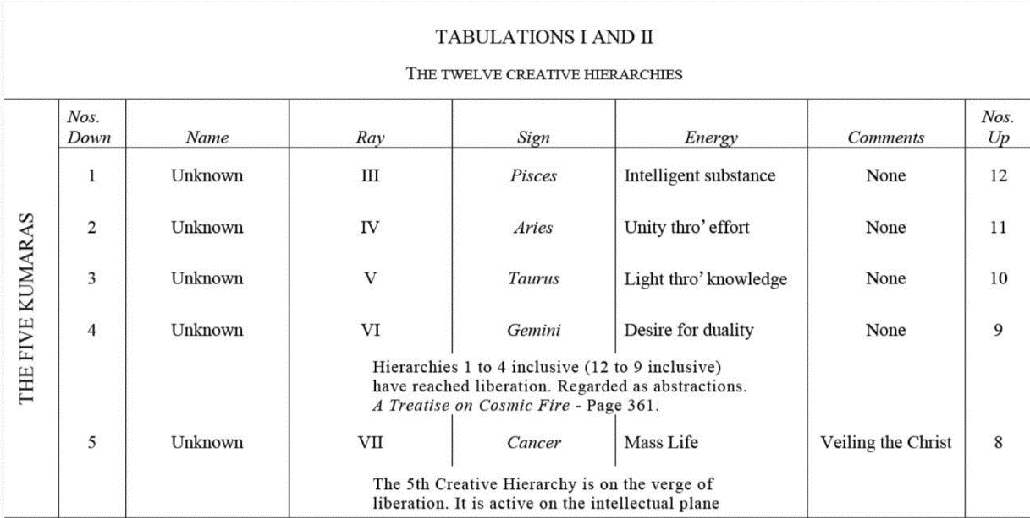

Okay, and we go as you see they go up to a very high level on to the logoic plane, and if we were to go even farther, we have the following, and they go all the way to the third sublevel of the cosmic astral plane.

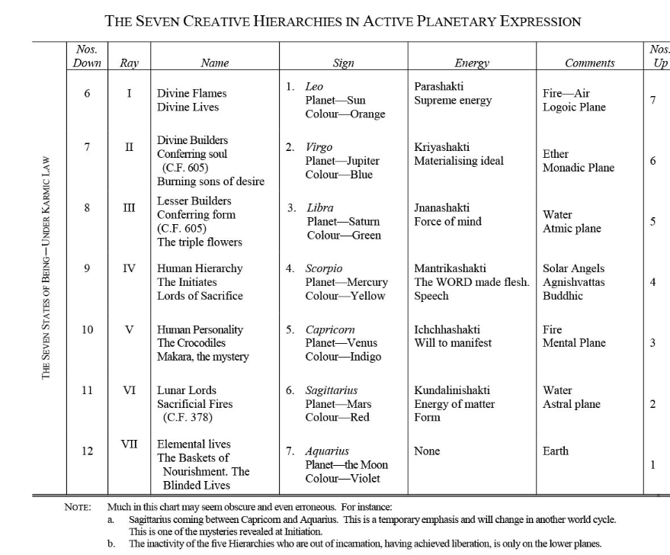

Really, can we seek the union of all the 12? How is that to be done? Well, we'll have to leave that for the moment because it would involve a stupendous alignment.

Anyway, from

b. The sacral centre and the throat – especially the period of the first initiation and following until the second initiation.

Then the solar plexus to the heart,

c. The solar plexus centre and the heart, in which the ten of the perfect man in this solar system is lost in the consummated twelve. As the twelve Creative Hierarchies (in their outer and creative aspect) are contacted by the man, who is the perfected quaternary from the standpoint of the form, so in the relation between the solar plexus and heart is the second aspect perfected; the love of the soul can express itself perfectly through the emotional nature. TWM 87

The solar plexus centre and the heart – well, the perfect man, the solar plexus center has ten petals and the heart center has 12. So that's what it means here, and 22 is indeed a sacred number and represents the union of the ten and the twelve. This is a type of dynamic seen in the approach to the second initiation and following. How much longer? We don't know because the base of the spine center will be the next point of focus of activation and it will take three initiations before that process is completed at the fifth. Although when dealing with a mayavirupa, maybe the head center of the chohan’s mayavirupa is still more unfolded than that of the master, and the head center of the seventh degree chohan, though it is a mayavirupa, still more unfolded. So – in which the ten of the perfect man in this solar system is lost in the consummated twelve. So, in which the tenth of the perfect man, because 10 is the number of perfection.

Interestingly enough, in this solar system is lost in the consummated 12. What we might say is that 10 is the number of perfection, more so than 7, and that 12 is the number of consummation. Twelve is a devic number, 10 is a more human number, the 22 represents a union of man and devas.

As the twelve Creative Hierarchies (in their outer and creative aspect) implying that there is an inner aspect are contacted by the man, and well, and when are they? Some of them of higher nature that they are cosmic astral in nature, and don't you have to be pretty much an initiate of the seventh degree before cosmic astral contact is possible? At least we know the Christ has this end. Well. The Christ at the sixth initiation did contact the cosmic astral plane had a cosmic astral impress of what nature who knows what probably of the nature of true love and the Buddha at the same time had cosmic mental contact He being a third ray monad, the Christ almost certainly it's inescapably the second ray moment.

As the twelve Creative Hierarchies (in their outer and creative aspect) as the 12th grade of hierarchy is in their outer and creative aspect are contacted by the man who is the perfected quaternary from the standpoint of the form, The personality is fourfold, but another and higher quarter Mary appears as personality, soul, spiritual triad and monad, another quaternary. Next, in the relation between the solar plexus and heart is the second aspect perfected; the love of the soul can express itself perfectly through the emotional nature. Under the influence of Venus, Jupiter and Neptune, the three planets that are active at the second initiation, overcoming Pluto and Mars, and maybe lower Neptune.

In the relation between the solar plexus and the heart the second aspect perfected; the third aspect is related to the first initiation, the second aspect of the second, and the first aspect under the guise of the fifth ray, which eventually terminates in the first ray, is beginning his process of perfection at the third initiation the love of the soul can express itself perfectly through the emotional nature. And thus we see that so many an over estimate themselves as the love of the soul surfing is not expressing.

0:17:10 Right, solar plexus and the heart, these are relations that are consummated along the way and promoting the infusion of the personality by the soul and the general interplay of soul and personality.

So, … the base of the spine, thousand petal lotus, that's they related to the third, fourth and fifth initiations. Sacral to the throat, the first initiation. Solar plexus to the heart, the second initiation.

Okay, now there's another relation the relation between the two head centres are between the center between the eyebrows and the center above the head.

And also go to, I think it's page 170 in A Treatise on Cosmic Fire. This relation is set up and stabilized when soul and body are a functioning unit and a high degree of integration is achieved. So, … we see that:

There is a relationship being set up here between the two many-petalled lotuses presumably the ajna center and the center above the head and also the seven centers within the head as they're called the seven head centers are involved in this. TCF 170

There is a relationship being set up here between the two many-petalled lotuses presumably the ajna center and the center above the head and also the seven centers within the head as they're called the seven head centers are involved in this. So, it's a rather high stage of development when there is a strong connection between the center above the head, the thousand-petalled lotus, and the ajna center which has the 96 petals; 96 is a very important number, and if we multiply 96 by 10, it will be an important number in relation to the head center. Add 12 to it, and the 12 of the inner center the heart and the head center and we have the actual number of the petals in the highest head center, 972.

Let's see where we are here
[back in A Treatise on White Magic]

6. The relation between the two head centres, or between the centre between the eyebrows and the centre above the head. This relation is set up and stabilised when soul and body are a functioning unit.

7. The relation between the pineal gland and the pituitary body as a result of the above.

8. The relation between the higher and the lower mind, involving steady and increasing soul contact. The meditative attitude of the soul is duplicated in the three bodies (or by the spiritual man) and the steady meditation of the soul goes on also on its own plane. It is with this and with its effects that we are primarily concerned in this rule. TWM 87

The relation between the two head centers, and this occurs really at a high stage of spiritual development. Then, in reflection of this chakra interplay, we have the relation between the pineal gland and the pituitary. It’s precipitated as a result of the above etheric concentrations, the highest head center and the ajna center. Of course, remember the alta major center, has to get into the act in order to create the triangle with the dispelling radiance which every true healer has and which completed his indicative of the third initiation.

So, [7.] The relation between] the pineal gland and the pituitary body (I guess He would also call it a gland, elsewhere it is called a gland), then we go above the level of chakras and we find a relationship –

[8.] The relation between the higher and lower mind involving steady and increasing soul contact.

And if we were to look at this, higher mind here on the second and third subplanes and the lower mind here in the fourth.

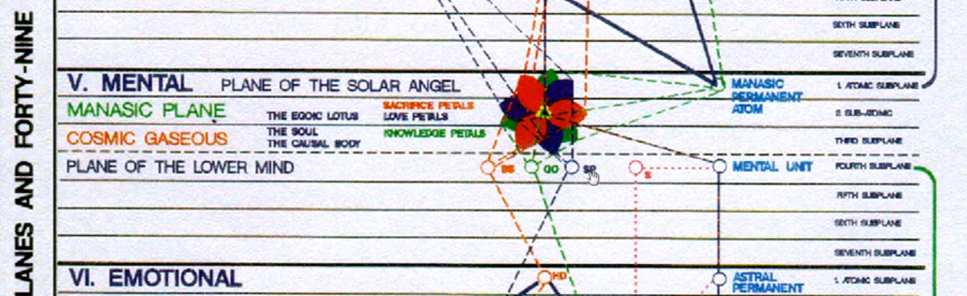

Now, He's not talking yet about the abstract mind, which is relation with which is begun and then completed via the antahkarana. So, this is involving a steady soul contact, and see first, between the mental unit and the soul, per se. Higher mind is found here, third and second, and abstract mind on the first. So, it's the relationship first between the mental unit and the soul as a whole, penetrating towards the jewel in the lotus.

I mean, all of these occult contacts cannot only be approached academically, as we are now, but have to be felt in meditation. There are, of course, some people who do feel these things and detect the movements within them.

0:23:00 The relation between the higher and lower mind, involving a steady and increased soul contact. through meditation right. The meditative attitude of the soul is duplicated in the three bodies (or by the spiritual man) and in this case, the soul in incarnation or the projection of the soul energy and consciousness into the personality, and the steady meditation of the soul goes on also on its own plane. So, both are meditating, both factors are meditating, each invokes the other, and in a way evokes the other, the result of the invocation is evocation, the response.

It is with this and with this effects that we are primarily concerned in this rule. The mutual invocation and then evocation, of by each of the other … well hmm, which happens first? Well, maybe the soul on its own plane sees the readiness of the soul in incarnation, or that aspect of consciousness which is invested in the personality, and then sends forth the call. Then the response to that is called from the higher perspective evocation, but the way it works out is that the lower man or the soul and incarnation within the personality invokes the soul on its own plane, and then another evocation results. So it's really all about calling and answering.

A later relationship, which in no way concerns us, is set up after the third initiation between the soul and the monad, and throughout the course of cosmic evolution these relationships will emerge. The race as a whole is, however, only concerned with the setting up of a relation between soul and body and beyond this there is no need to go. TWM 87-88

A later relationship, which in no way concerns us, is set up after the third initiation He knows he's writing this for write this book, unlike A Treatise on Cosmic Fire, it is not written for initiates of the third degree or beyond, it is written for the more average disciple who is preparing for the first or second degree, and maybe somewhat beyond the second degree.

A later relationship, which in no way concerns us, is set up after the third initiation between the soul and the monad, and throughout the course of cosmic evolution these relationships will emerge. The personality and soul of the planetary logos, and the soul and monad of the planetary logos, the personality and soul of the solar logos, and the soul and monad of the solar logos, and on and on. So throughout the course of cosmic evolution these kinds of relationships these relationships will emerge …

The race as a whole is however only concerned with the setting up of a relation between soul and body and beyond this there is no need to go. When instructing those who are perhaps readying themselves, even if they do not realize it for the first initiation, I mean we cannot go back too far, we can go towards the aspirant working at the end of the fifth petal, and because from that point in the egoic lotus – working within that fifth petal, the latter part – there is a slow preparation for the first initiation which is indicated when the fifth petal is completely unfolded, we are told.

As the man seeks to reach control of the mind, the soul in its turn becomes more actively aggressive. The work of the solar Angel has hitherto been largely in its own world and concerned with its relation to spirit, and with this the man, working through his cycles on the physical plane, has had no concern. The main expenditure of energy by the soul has been general, and outward-going into the fifth kingdom. Now the solar Angel approaches a time of crisis and of re-orientation. In the early history of humanity there was a great crisis which we call individualisation. At that time the solar Angels, in response to a demand or a pull from the race of animal-men (as a whole, note that), sent a portion of their energy, embodying the quality of mentalisation, to these animal-men. They fecundated, if I might so express it, the brain. Thus was humanity brought into being. This germ, however, carried within it two other potentialities, that of spiritual love and spiritual life. These must in due time make their appearance. TWM 87-88

As the man seeks to reach control of the mind the soul in his turn becomes more actively aggressive. After all, what we call the soul that type of consciousness extended from the monad encapsulated in the higher mental plane, underlaid by the angel of the presence, an aspect of the solar angel, that type of what can I call it., it’s on the mental plane in any case. That type of presence is on the mental plane, both of them are on the mental plane, the controlling point within the personality for the mentally focused person is on the mental plane, but in general the personality is on the fourth subplane of the mental plane, the center which generates the personality and the soul center what we call soul anyway, as relates to human being, is on the higher mental plane.

The work of the solar Angel has hitherto been largely in its own world note that and concerned with its relation to spirit which is not yet perhaps perfected because there is a monadic aspect, the solar angels have their own monadic aspect, and they have to do I suppose certain things to come en rapport with it – and with this the man working through his cycles on the physical plane has no concern. Solar angel has hitherto been largely working in its own world and in relation to its own projects, concerned with its relation to spirit.

0:29:40 There are within the planetary logos and within the seven great centers on the monadic plane, both human and deva monads. Now, of course the solar angel will have passed the initiations which have to do with the cosmic physical plane, unless for some reason in the previous solar system for which five was the major number, one did not really ascend to the monadic plane. Yet, we have no other indication that the men in that previous service system who went on the path of solar angels, no other indication then that they went to Sirius to be trained. If they went to Sirius, they would have to find their way onto the cosmic astral plane, and if they were limited to the atmic plane (which is the fifth from below) and somehow had to exclude the monadic and logic plane, they couldn't travel as monads to that distance center.

Well, not so much is given about how they were trained to become solar angels but we receive a great deal of information. Well, not a great deal, but quite a bit of information about the training of the bulk of humanity, which will become solar angels in this solar system, or following the solar system, or through a departure from this solar system and a duration on Sirius, or in the Syrian system. Who knows for how long a time?

So, we come generalize from the condition of training for modern man, becoming solar angel generalized backwards towards the previous solar system. Yet this number is 5, and that number of being 5 and the number of our presence of a system being 7 might tell us something about the planes of attainment which were possible. The previous solar system being one in which intelligence was cultivated and the atmic plane, the fifth from below is a plane of intelligence, third from above, fifth from below, the numbers are correct for intelligence. So, I'm just going to say there's some things that we cannot know here can speculate a little but cannot know at least I cannot, others will know.

So when it says that the solar angel has been largely concerned with its relation to spirit. Spirit is very extensive and can even be considered as reaching through the cosmic astral plane and beyond. It's one of those protean words, it has certain flexibility, malleability, it's not a word that can easily be pinpointed that the spirit. Can even mean being, and being if something is it is possessed of being as its very first identifier.

Anyway, we're not concerned with the solar angel’s work, because this is a graduate human being, a member of the council within the Sun, the solar pitris, solar angles, said to be members of the council within the Sun, and this makes it possible for them to focus down on an even higher level than the master of the wisdom who under ordinarily certain ordinary circumstances is not even a member of the Council on our planet within Shamballa.

So we have to keep things in proportion.

So, we don't have any concern about this although DK has given hints

[repeating:]

The main expenditure of energy by the soul has been general, and outward-going into the fifth kingdom. Now the solar Angel approaches a time of crisis and of re-orientation. In the early history of humanity there was a great crisis which we call individualisation. At that time the solar Angels, in response to a demand or a pull from the race of animal-men (as a whole, note that), sent a portion of their energy, embodying the quality of mentalisation, to these animal-men. They fecundated, if I might so express it, the brain. Thus was humanity brought into being. This germ, however, carried within it two other potentialities, that of spiritual love and spiritual life. These must in due time make their appearance. TWM 87-88

The main expenditure of energy by the soul has been general and outward going into the fifth kingdom. Well that is what do we call it, the kingdom of souls. But, it has not been specific perhaps for his shadow. Man we are told that the general second aspect of divinity looks after the progress of the man before He comes into the possibility of cultivation, individual cultivation in relation to the solar angel. Obviously He advances, but it's a general type of advancement without that individual culture that is caused by the downward-turned solar angel.

0:35:00 Now the solar Angel approaches a time of crisis and of reorientation. This is the solar angel is not yet an avatar, because avatars have nothing to gain from the lower level to which they descend – it's an act of pure altruism, but solar angels will still have something to gain and as part of their life curriculum, so we can speak of a crisis that occurs in the life of the solar angel crisis of reorientation.

In the early history of humanity there was a great crisis which we call individualization. And this correlated with one of the early initiations of our planetary logos. Was it his first initiation? Maybe. First cosmic logos, and perhaps we filled up perhaps the first cosmic initiation of the planetary logos. And, we have not yet interestingly taken our second cosmic initiation. That's how I understand, that at least although in a subsidiary series we are taking the fourth in our solar system through our particular planetary chain.

At that time, the solar Angels in response to a demand are pulled from the race of animal men and I suppose from the planetary logos (as a whole, note that), As a whole note that. It was the center, a center in the planets represented by the aggregation of animal men …

0:37:50 So, the solar angels responded, as a whole, the planet represented by an aggregation of animal men … sent a portion of their energy embodying the quality of mentalization to these animal men. A portion, note … the solar angel sends portions of energy and not the wholeness of itself, fortunately for whatever form is receiving that which is sent. …

At that time the solar angels in responsible demand or a pull from the race of animal men … as a whole note

At that time the solar Angels, in response to a demand or a pull from the race of animal-men (as a whole, note that), sent a portion of their energy, embodying the quality of mentalisation, to these animal-men. They fecundated, if I might so express it, the brain. Thus was humanity brought into being. This germ, however, carried within it two other potentialities, that of spiritual love and spiritual life. These must in due time make their appearance. TWM 87-88

… note that … sent a portion of their energy embodying the quality of mentalization to these animal men as a whole note. … sent a portion of their energy, embodying the quality of mentalisation, to these animal-men. And maybe also the quality of self-reflection, due not to awaken immediately, due to awaken maybe 3000 years from the time it was sent. We're told of a [?] Sagittarius and the awakening later, under a Leo influence. They feel inundated, if I might so express it….

0:41:30 They fecundated if I might so express it, the brain. And let's just say … this indicates that the solar Angels did indeed implant a portion of their energy in the brain, but also in the area of the mental unit on the fourth subplane of the middle plane.

Thus was humanity brought into being. so you know Humanity is not just about the outer body being human is about a state of consciousness in advance of that of animal man.

This germ however carried within it two other potentialities okay that of spiritual love and spiritual life. This is a very important statement. So another fecundation was not necessary, just the coming of the time when these other germs could grow. This is very important, and later these two other germs could be would be cultivated during a different root race … in the Atlantean period the love germ could be cultivated, and in the Aryan race the mental germ could be cultivated.

These must in due time make their appearance.

The flowering forth of the mind in men, which so distinguishes the present age, indicates to the solar Angel a second crisis, of which the first was but the symbol. That for which the solar Angel exists is making its presence felt within humanity, and another strong pull is being exerted upon the solar Angel which this time will produce a second fecundation. This will give to man those qualities which will enable him to transcend human limitations, and become a part of the fifth or spiritual Kingdom in nature. The first effort of the solar Angel turned animal-men into human beings; the second will turn human beings into spiritual entities, plus the gains of experience in the human family. TWM 88-89

The flowering forth of the mind in men which so distinguishes the present age indicates to the solar angel a second crisis of which the first was but the symbol. Maybe this is the perhaps the crisis of the great mental, manasic initiations.

That for which the solar angel exists is making its present self within humanity and another strong pull is being exerted upon which the solar angel which this time is here upon this over a range of which this time will produce a second fecundation. Okay, another pull and this will require the second crisis opportunity, as crises of opportunity, will require direct supervision of the lower man by the solar angel, angel of the presence.

This will give to man those qualities which will enable him to transcend human limitations and become part of the fifth or spiritual kingdom in nature and this is done through the process so of initiation. So, it's not just the Masters of the wisdom that train their up-and-coming disciples for initiation, but that great host of solar angels, which in their essential nature must be even higher than a master, because the master has not been too serious. Or, to any of those constellations in the one about whom not maybe said, which are the destination of those who leave the cosmic physical plane even if temporarily, and the solar angels those who are now solar angels have indeed done this.

The first effort of the solar angel turned animal men into human beings; the second will turn human beings into spiritual entities plus the gains of the experience of the in the human family. What we have here is the realization that the solar angels are involved in helping man pass through the human kingdom and to a certain extent through the kingdom of souls.

You know, you stay in the fifth kingdom until a master, and when you become a chohan you are a planetary life. But the solar angels are allowed to return to the heart of the Sun, and maybe some to the central spiritual Sun, at the time of the fourth initiation and man is still man. So, they don't go all the way through supervising the human being, but that the monad can working through the spiritual triad can take over.

This is such an important sentence. The first effort of the solar angel turned animal-men into human beings the second will, and it's already happened, increasingly, with the taking of the first initiation by a certain proportion of humanity. will turn the human beings into spiritual entities plus the gains of experience in the human family. Helping … animal man pass into the human kingdom, and as man passed through the human Kingdom, and to a certain extent through the kingdom of souls

For this the solar Angel, the soul, is organising itself and re-orienting itself so that its power can be redirected into the world of men. Contact must be made by the soul between the lower aspect of its triple nature and the aspect which has already found lodgment in the brain of man. Intelligent activity and love wisdom must be united, and the union must take place on the physical plane. In order to do this the soul is entering into "meditation deep", in union with all other souls who may have brought their instrument into a responsive state. This is the basic group meditation, and when a man achieves what the oriental books call "samadhi", He has succeeded in participating, as a soul, in this group meditation, and enters upon that cycle of service which expresses itself through the planetary Hierarchy. The rational mind and the abstract mind function as a unit, and the motivating principle is love. The soul, expressing love and abstract intelligence, is at one with its expression on the physical plane through the brain, and, when this is the case, the lower man has synchronised his meditation with that of the soul.

This is the objective of our work. Let this not be forgotten, and let every effort be made to bring mind and brain into such a functioning condition that a man can slip out of his own meditation and (losing sight of his own thoughts) become the soul, the thinker in the kingdom of the soul. TWM 89

For this the solar angel the soul is organizing itself. The soul, now there is a statement in aposition which cannot be denied (let me make it really big. A friend of mine, Zak Rymill, makes wonderful compilations and he makes bigger certain statements which he deems of greater importance. It's probably a pretty good idea).

So, in this case, the word soul definitely means solar angel, or that part of it which is invested in the, what is it the ego is lotus angel of the presence.

For this the solar angel the soul is organizing itself in reorienting itself so that its power can be directed into the world of men. – we're talking about … turning points crises and turning points in the life of the solar angel. Well, we can think of the solar angel investing is portion of its nature in the egoic lotus, and when that portion prepares to introduce the man to the monad it becomes the angel of the presence and who knows how much the solar angel on its own plane helps in that process.

0:51:00 … The solar angel does not return to the solar logos /son until the soul and incarnation, who is the disciple is introduced to the monad. I guess that is true, we are the monad even as a personality, we are the monad as a type of consciousness on the higher mental plane, we have the monad as the triad we are the monad, and as the monad we are the monad, but the lower aspect of our nature is somewhat behind in its program and the higher agency of these solar beings, the solar angels, represented within our causal body egoic lotus, plays a role and a role I don't understand, but a role in introducing that extension of the monad which is way down on the personality, they call it the soul-in-incarnation, introducing the soul and incarnation to the monad at the third initiation.

When I say introducing, who knows what kind of process we're talking about here. But, making it more possible for that contact between monad and soul infusing personality to occur contact must be made by the soul between the lower aspect of its crippled nature and the aspect which has already found lodgment in the brain of man amazing stuff here and I'm just realizing so far, when it comes to descriptions of the white magical process within magician as the creator. A Treatise on Cosmic Fire has a lot to say – (and on that I have rather than offered video commentary. So you can find that on the Makara website, or if this is listened to in years in the future who knows whether that website will exist, but hopefully somewhere these commentaries will be preserved. http://www.makara.us/portal/?page_id=331 [2019]

Contact must be made by the soul between the lower aspect of its triple nature and the aspect which has already been found that has already found lodgment in the brain of man. Well, what is the lower aspect of its triple nature is it the knowledge petals. … Are we speaking of the knowledge petals? …

0:54:45 Intelligent activity and love wisdom must be united, and the union of course, love-wisdom comes from the soul really comes from the source, from what is the source must be united, and even the knowledge aspect of the soul is suffused with love-wisdom, simply because the causal body egoic lotus soul consciousness is suffused with love wisdom. Intelligent activity and love wisdom must be united and the union must take place on the physical plane. So, into the brain of man, this of course, we have to say necessarily the etheric brain will be involved if the energy reaches the physical brain. So, intelligent activity in love with them must be united and the union must take place on the physical plane.

[repeating:]

In order to do this the soul is entering into "meditation deep", in union with all other souls who may have brought their instrument into a responsive state. This is the basic group meditation, and when a man achieves what the oriental books call "samadhi", He has succeeded in participating, as a soul, in this group meditation, and enters upon that cycle of service which expresses itself through the planetary Hierarchy. The rational mind and the abstract mind function as a unit, and the motivating principle is love. The soul, expressing love and abstract intelligence, is at one with its expression on the physical plane through the brain, and, when this is the case, the lower man has synchronised his meditation with that of the soul.

This is the objective of our work. Let this not be forgotten, and let every effort be made to bring mind and brain into such a functioning condition that a man can slip out of his own meditation and (losing sight of his own thoughts) become the soul, the thinker in the kingdom of the soul. TWM 89

In order to do this the soul was entering into “meditation deep”, in union with all other souls who may have brought their instrument into a responsive state. So, what do we have here? It's a group of downward-gazing souls or solar angels. When I say solar angels, we keep in mind that the entirety of the solar angel cannot really enter the vehicle on the higher mental plane. I think it would destroy that vehicle, but a portion, always a portion. The man, having pervaded the entire universe whatever that universe may be having pervaded the entire universe with a portion of my fragment myself I remain, I remain on the higher plane, and I've sent in a stream of energy into this tiny or greater universe which is a complete whole, in order to animate that whole in a new way. The word animate is interesting because, it really means soul, anima, soul.

This is the basic group meditation and when a man achieves what the oriental books called “samadhi”, He has succeeded in participating, as a soul, in this group meditation. So, let us say that apparently samadhi can be achieved after the third initiation, but would change in character once the solar angel departs. So, this tells us something about those who are achieving samadhi. But of course there are, in the East’s grades of samadhi, and there's also the samadhi of a fourth degree initiate pose and of a fifth and sixth and seventh and so on; its progressive so and samadhi, which is the goal of contemplation and enters upon that cycle of service which expresses itself through the planetary hierarchy the members of the planetary Hierarchy. are at will capable of samadhi.

0:58:50 The rational mind and the abstract mind function as a unit. The antahkarana has made that possible and the motivating principle is love coming from the soul fusion, but also from the spiritual triad which is the higher correspondence, in one sense anyway, to the soul on its own plane. So the spiritual triad is an intermediate center, characterized by the second ray, because it is the true ego and also by the first ray because it is a projection of the monad.

The soul, expressing love and abstract intelligence, is at one with its expression on the physical plane and it must have absorbed some triadal energy, if it's expressing abstract intelligence, it certainly could express higher intelligence, is at one with this expression on the physical plane through the brain, and when this is case, the lower man has synchronised his meditation with the soul. This requires the third initiation, minimally, for this group synchronization to occur. He's really giving us some very important information here definitely.

Let's call this here the end of A Treatise on White Magic video commentary number 20 and rule 2.4. We seem to still be, oh yes we are, and maybe my next commentary will be quite small because I'm trying to keep the commentaries related to the rules themselves. This day is the 30th of the January 2018.

Okay, and we’ll be beginning here with number 21. So, beginning next on A Treatise on White Magic video commentary number 21, 2.5, and whenever we might – oh, now I'm faced with the page issue. Well where did it begin? Goodness, goodness! … sorry about that, I'm always losing my place. Page 89 and hmm, page 89, and I think we only began – is that possible?—on page 87? I think. We didn't cover too much there, and we'll begin here on page 89. It's almost as if there's a mistake, but there is page 89 all right, and here we began on page 87 to 89.

All right everybody, thank you for attending this thinking-through with me. Obviously there's much that I'm missing of course, given my own present state of ignorance, which is all I can work from all any of us can work from really. We will go on with number 21 and finish off rule two and there will be 2.5.

All right, see you before long, and thank you for your presence. See you soon.

