A Treatise on White Magic — Mental Rules 13
Transcript of Video Commentaries by Michael D. Robbins
Abstract
Content for A Treatise on White Magic, Video Commentary, Program 13, Rule 1.1, Beginning Rule One, SOME BASIC ASSUMPTIONS. 1 hr, 6 min: pages 51-56.
Rule One. Some Basic Assumptions.
Student must be sincere. Differentiation between the two aspects. The need for steady persistence and application to the things at hand. Development of character. Learn how to link the lower self with the soul. Learn to understand one’s own nature, control one’s own forces, and unfold latent powers.
A Treatise on White Magic Video Commentary 13 91 MB .wmv file
Video of A Treatise on White Magic Video Commentary 13 by Michael D. Robbins.
A Treatise on White Magic Video Commentary 13 63 MB .mp3 file
Audio of A Treatise on White Magic Video Commentary 13 by Michael D. Robbins.

Transcript
Well, good morning everyone.
We are continuing now with A Treatise on White Magic video commentary. We've worked through about 50 pages of the introduction, that is the entire introduction, and found it to be a very deep and sustaining fundamental document.
Now we actually start to enter the rules for white magic and at page 51. This is commentary 13.
At the beginning of every one of these rules, the rule is stated.
The solar angel collects himself scatter is not his force but in meditation deep communicates with his reflection the solar angel collects himself scatters not his force but in meditation deep communicates with his reflection. TWM 51
The solar angel collects himself scatter is not his force but in meditation deep communicates with his reflection the solar angel collects himself scatters not his force but in meditation deep communicates with his reflection. There is much ambiguity about the solar angel. It was a human being in a previous mahamanvantara, a previous solar system. It had to be educated as a solar angel. It seems that a human being, being educated in that way, it goes to the star Sirius, at least that's the way it is at this time.
These solar angels have returned, they can be active in other planets as well as the earth from what I understand, but when the planetary heart is opening, and we can say that the initiation process of our planetary logos is in a way the opening of the planetary heart. They are found more active within the economy of the planet and they did intervene on behalf of humanity, which was sorely delayed through mistakes occurring on the moon chain.
On what plane is the solar angel found? When we actually look here at one of these compiled charts, we find the solar angel. (Number 9 – IV – Human Hierarchy … Comments: Solar Angels, Agnishvattas, Buddhic)
[The Seven States of Being – under karmic law, page 35 Esoteric Astrology.]

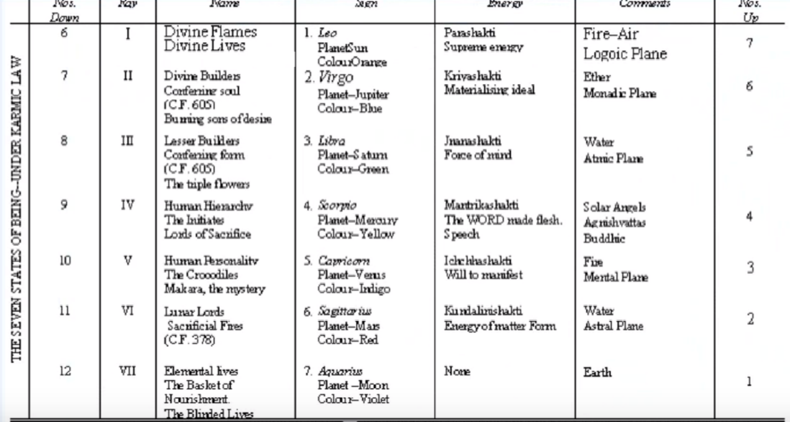

The solar angels are … found on the buddhic plane. In order to reach Sirius, they have to have traveled on the cosmic astral plane and their consummation is found on the cosmic astral plane. Then they fell again out of the motive of service, into the cosmic physical plane, and another fall (had they gone all the way to the Buddhic plane in their descent) another fall would be to fall into the dense physical body of the planetary logos, which would involve either eighteen subplanes or twenty-one subplanes and they would be associated with the fifth creative hierarchy [numbers 10, V, 5., 3], which here is referred to as the human personality and the Crocodiles. But they are from a higher perspective – the word Makara can also mean the solar angels, and they are members it seems of this fifth creative hierarchy, at least they are manifesting in this way.
There are other little subtleties, perhaps, that show the solar angel to be located on still higher levels, but at least in this tabulation we have a major focus on the buddhic plane. They are love-wisdom and action in a way, they are hearts of fiery love, they have the second ray, they have the fifth ray strong, the second ray connects them with buddhi. The fifth ray connects them with the mental plane whereupon they anchor themselves, in or about the mental unit of man and also apparently in the physical brain.
0:05:00 The solar angel, it's a huge subject. I think Torkam Saradaryan has written an entire book on this, and from my own work, I have found that there are many references which need elucidation scattered throughout the Tibetan’s many books.
So, we'll try to understand the distinction between the solar angel and the angel of the presence. The angel of the presence is found or focuses on the mental plane within the egoic lotus. The way I understand it, is an extension of the solar angel, or as much of the solar angel as can be incorporated in the Temple of Solomon, the vehicle of man upon the higher mental plane. So, it's the action of the solar angel within the egoic vehicle. Eventually it does reveal the presence itself, which is the monad.
DK has told us that we're not at this stage of our development going to be able to understand the solar angel with any degree of clarity. I do understand that, and that it is a huge subject and it is veiled, and veiled again, and veiled again. But perhaps we can understand something of the fact that the solar angel has for the majority of human beings at this time (even from those from the moon chain from the previous solar system) invested itself in the psychic vehicle on the higher mental plane of the human being.
There are some human beings who do not have within their structure of the presence of the solar angel. They are among the most primitive of our humanity, but their mental unit has been stimulated by the solar angel and this mental unit has been growing even before individualization took place, and as a result of that stimulation by the solar angel. Even though the solar angel, angel the presence is not invested in the vehicles of such human beings they can take individualization and become true members of the human kingdom.
Very many mysteries, and one day we human beings present human beings after our training on Sirius. Maybe 85% of us will become solar angels operating in a still different way in the next solar system. There individualization will have more to do with the monadic plane. DK tells us, what we're worried about, that if and when we get there (and not all of us will take those that particular path but the great bulk of humanity will return as solar angels. And given the fact that solar angels combined in groups to create or manifest as planetary logoi), then it would seem that a lot of human beings will go in that direction to become planetary logoi, eventually. …
0:9:30 … There they are:
The solar angels, the Agnishvattas, they have so many beautiful names with their conveyors of love wisdom as hearts of fiery love. … we should look at those so many names … oh, my goodness, there were so many named here, solar angels and just get an idea: the sons of wisdom, connected therefore with the second aspect, the aggregate of the Ah-hi, and that is their of their higher meanings the Ah-hi are high beings. Agnishvattas a combination of agni and the air element vata. The asuras, really they are suras. Asura sometimes has a negative connotation, but asura represent the Sun, Surya, Sun the builders of the body of the Ego, and we have remember that higher mental matter is involved in that building even though the solar angels or angel of the presence underlie this Temple of Solomon, this apparatus this vehicle on the high mental plane.
Dhyan chohanic forces, fire dyhanis, those who can meditate profoundly on the higher planes lords of the flame or these representatives of the lords of the flame. Because the kumaras are lords of the flame but these are solar angels are lesser Lords of the flame. Manasadevas, because they are so profoundly manasic, having been educated to that degree on Sirius. So, under rays two and five they have both love and manas planetary spirits, I suppose, of which there are a number.
Producers of realized consciousness; they make possible self consciousness in man that reflected or reflexive Venusian consciousness, and the petals that they help to build out of higher mental matter contained in them the quality of I-ness, which takes the sight back to a directing center. They are the producers of individualization. There are other methods not involving the solar angels, but these solar angels make it possible for a human being to realize itself as distinct.
This word Satan does not mean the devil; it's a luminous host that bestowed mind upon animal man is not in the lower three vehicles which are lunar and seen as obstructive to the development of consciousness; it represents a very, very high fiery spirits and the fall of these angels is actually an act of service, and is not because of some kind of celestial demotion. Of course, solar angels are sons of mind, but sons of love as well the great Devas of mind they are well, Sirius, probably as a ray five soul and an ultimate ray two monad.
So, the training there will involve a tremendous fifth ray and we're told that if we are not especially developed along the line of manas that the path to Sirius is the one we will take. Such as that path destined for Master Jesus and Master Serapis at this time. These devas have tremendous scope of knowledge, the vehicles of the divine mind and they follow out the divine plan and purpose as it is understood by those on a still higher level of the cosmic planes. In a way, these solar angels are part of a still greatest over angel which have found them the higher mental cosmic plane.
0:15:15 … there are different places where I have other names, but I think you get the idea that these are luminous, loving, brilliant beings, who were once human beings in a previous solar system and an aspect of their service is to help the human being tread a higher path. And, in our case, after a long and agonizing delay caused by a planetary failure on the moon chain. But, how they associated with the already individualized moon chain Egos, we don't know but we know they did. How they associated with the egos who were individualized even the previous solar system again we don't know, because the methods of individualization there in the previous solar system and also on the moon chain were different. They did not require solar angelic intervention but that intervention, but eventually it did come when those beings came to the earth chain in his fourth round and they would then be in need of a solar angel to undertake progress with a sufficient rapidity in this our present chain, and on this our present globe.
There are probably other beautiful names for these great being. I think the important thing is to be able to meditate in such a way that we can sense the presence the angel of the presence underlying an entire causal structure. Remember that the causal structure is not made exclusively of these angels because it's possible to have an egoic body without the presence of a solar angel. But, I would say that there is an infusion of the presence – the intelligence the power, the love of the solar angel into the causal body – which they were instrumental in helping to design the egoic lotus.
So, we have two factors there. We have the vehicle itself made out of higher mental substance and we have the solar angel underlying that vehicle and fusing his consciousness with the slowly growing, higher consciousness of man, right? That's just a little bit of along the line of background.
The solar angel, maybe on the buddhic plane, collects himself scatters not his force but in meditation deep as his extension the angel of the presence communicates with his reflection, and man, the personality, is considered his reflection. Maybe the reflection of the solar angel and the correspondence to the spiritual triad. There is a difference between a reflection in which there is inversion, and a correspondence in which, let's say, that one triangle rests above another without requiring the inversion of the lower triangle
All right so some basic assumptions and the way of the disciple this is the first rule, and it's on page 53: …
0:20:00 SOME BASIC ASSUMPTIONS
We are entering upon a course of study wherein the entire tendency will be to throw the student back upon himself, and thus upon that larger self which has only, in most cases, made its presence felt at rare and highly emotional intervals. When the self is known and not simply felt and, when the realisation is mental as well as sensory, then truly can the aspirant be prepared for initiation. TWM 53
Some Basic Assumptions. We are entering upon a course of study wherein the entire tendency will be to throw the student back on himself, ... Why is that? Because we have to prove these things for ourselves. We have the authority of the Tibetan teacher who at the time He was writing was simply known as the Tibetan, the Tibetan disciple. It was not understood that He was Master DK, except perhaps by a few. Certainly Alice Bailey understood that and some others intuited it, but DK asked them if they had intuited it to keep it to themselves. Later, of course, his identity was revealed, not purposeful, it just happened and they all made the best of it.
[continuing] … throwing the student back himself, and thus upon that larger self, the real self, which has only in most cases made his presence felt and rare and highly emotional intervals.
… The souls connected with all the vehicles, but the soul is especially connected with the astral body. So, it's possible to go through very emotional states where the astral body expands, or maybe heightens its vibration in some way, or comes into resonance with the soul, or with this supervising being we call the angel of the presence. The Buddha counseled self-reliance. But, what is this self upon which one is to rely, actually? The final self knows everything. We're not just talking about personality reliance, not relying upon the powers of your own personality, but relying upon higher aspects of yourself when the self is known and not simply felt.
Remember the very first of the fivefold sequence of initiation is – Know, Express, Reveal, Destroy, Resurrect. But first to know. Not just to feel. That involves sight, and it involves the mental plane, the plane of knowing, of knowledge.
When the self is known and not simply felt and when the realization is mental as well as sensory then truly can the aspirant be prepared for initiation. So, some kind of mental focus is necessary the if initiation is to take place it's not enough for us to just feel our way into the presence of the initiator, the illumine mind, the somewhat illumined mind is required. Okay.
I would like to point out that I am basing my words upon certain assumptions which for the sake of clarity I want to stage so these assumptions, –TWM 53
I would like to point out that I am basing my words upon certain assumptions which for the sake of clarity I want to stage so these assumptions – of course, obviously, you could read this yourself and gain a great deal from it, but this is more for study purposes and to take into consideration the thoughts of another person in this case myself and see if they can be of any value to you. I think back about how I worked with all of this, I read a lot on my own. I remember a trip which included a visit to the FDR library in Wheaton Illinois and almost out of reach of the Alice Bailey books could be found. There hasn't always been a wholesome relationship between the early Theosophy and Alice Bailey. I had to reach very high to find them and I took them home with me to North Dakota and I just began to read, and realize that this is amazing, amazing material. That was almost fifty years ago, maybe 47 years ago.
So, oftentimes we have to work on our own proving our true interest and dedication to these matters on our own at first without the support of others although the minute you join the Arcane School you do receive support and I did, joining in 1972, 46 years ago.
0:25:30 Anyway, He's basing his words on certain basic assumptions, right:
Firstly, that the student is sincere in his aspiration, and is determined to go forward no matter what may be the reaction of and upon the lower self. Only those who can clearly differentiate between the two aspects of their nature, the real self and the illusory self, can work intelligently. This has been well expressed in the Yoga Sutras of Patanjali. TWM 53
Firstly, that the student is sincere in his aspiration. We all aspire, the rising fire the redirection of desire to higher objectives. not just now and then, but something we really want and desire and even willfully intend to have, and we sustain the quest. … the student is sincere in his aspiration and is determined to go forward no matter what may be the reaction upon the lower self.
I try to tell this to people who enter the Morya Federation, that the whole personality is going to rebel against this kind of exposure, to this kind of discipline. But it's difficult to get that across until it really happens. We've all gone through it, those who have persisted in this work and we discovered whatever's hiding, Pluto will drag it to the surface and throw it up in your face, as it were, you'll see it in your consciousness and you may be appalled. I was appalled. All of this, it can’t be part of me. But it was, and one just has to work one's way through it, persisting until one dissipates the obstructions and substitutes for them something much better.
Anyway, going forward no matter what may be the reaction upon the lower self – and if only our students of esotericism could get this into their minds when they begin, and resolve never to quit, because they'll only have to rejoin some similar enterprise at a later date, they would save themselves much time and agony.
Only those who can clearly differentiate between the two aspects of their nature, the real self from the illusory self, say the soul self, can work intelligently. So, this fundamental discrimination may be found upon the fourth subplane of the mental plane where we find what we find …
0:28:30 Discrimination on the fourth subplane. If we go back to this compendium which put together we have discrimination on the fourth subplane. This is a composite chart which helps us see the various siddhis that we find on the various levels so we must be able to discriminate between the customary energy of the personality and the energy of the soul when it enters.
[NOTE: it is here shown Vicktorya Stone’s chart, or see Bruce Lyon for ownership, http://sevenray.com, this graphic replaces the video that shows Keith Bailey’s chart, due to clarity of resolution and free use.]
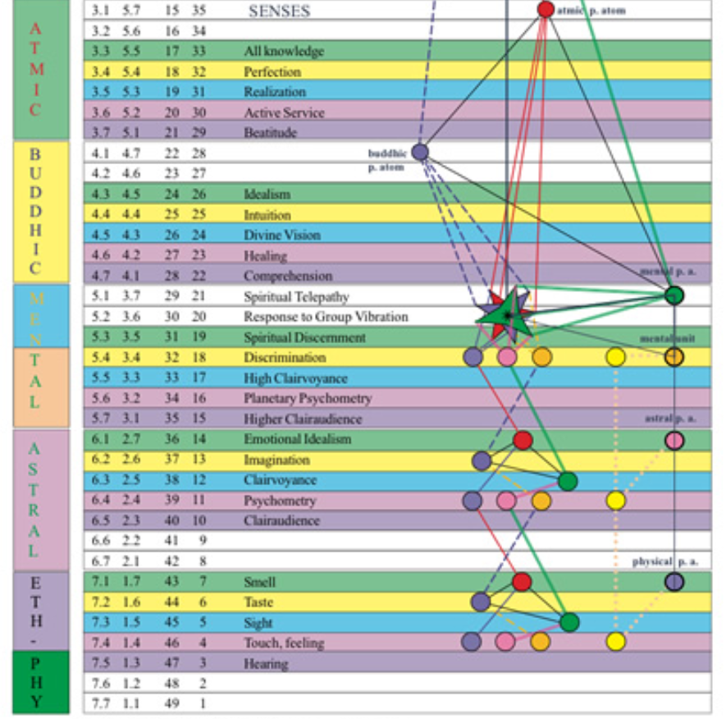

Now, that's up to you to decide whether you really know the difference, whether I really know the difference. It has to be an inner certainty that discriminates and differentiates between the two.
Now: This has been expressed in the Yoga Sutras of Patanjali.
"Experience (of the pairs of opposites) comes from the inability of the soul to distinguish between the personal self, and the purusa (or spirit). The objective forms exist for the use and experience of the spiritual man. By meditation upon this arises the intuitive perception of the spiritual man." Book III.35.
The forty-eighth Sutra in the same book gives a statement covering a later stage of this discriminative realisation. This discerning quality is fostered by a re-collected attitude of mind, and by careful attention to the method of a constant review of the life. TWM 53
“Experience (of the pairs of opposites) comes from the inability of the soul to distinguish between the personal self, and the purusha (or spirit). Well, spirit, soul, we can consider them one thing. So if we're going to experience pairs of opposites we haven't really found the purusha, the spirit. The objective forms exists for the use and experience of the spiritual man (meaning both soul, triad and monad. That's the spiritual man).
By meditation upon this arises the intuitive perception of the spiritual man. The accessing of that which the spiritual man knows and as we ascend in initiatory potential identification as the spiritual man. We have to learn who we really are normally and it's not what we so often think.
The forty-eighth Sutra in the same book gives a statement covering a later stage of this discriminative a realization. This discerning quality (now remember that on the fourth subplane we have discrimination and on the third subplane, or the fifth from below, we have spiritual discernment, being able to detect in the mass of presented perceptions that which is truly spiritual and underlies all the other perceptions which pertain more to the lower worlds.) This discerning quality is fostered by a re-collected attitude of mind, and recollected, it means a meditative attitude of mind, and by careful attention to the method of a constant review of the life. Recall the evening review and seeing where we are seeing what is of the personality and what is of the higher consciousness and being willing to be disappointed at first and working towards an ever greater proportion a life lived under the influence of the soul and expressing the soul
0:32:30 So, this is the first assumption: we are sincere in our aspiration and determined to go forward no matter what. Well, we can say that, but when the going gets tough, as they say, the tough get going. We never know, having said that, whether we really will persist or whether we will find those thousand-and-one excuses for not going forward, or as a favorite word of Alice Bailey, find those alibis for not going forward.
Secondly, I am acting upon the assumption that all have lived long enough and battled sufficiently with deterrent forces of life to have enabled them to develop a fairly true sense of values. I assume they are endeavouring to live as those who know something of the true eternal values of the soul. They are not to be kept back by any happenings to the personality or by the pressure of time and circumstance, by age or physical disability. They have wisely learnt that enthusiastic rushing forward and a violent energetic progress has its drawbacks, and that a steady, regular, persistent endeavour will carry them further in the long run. Spasmodic spurts of effort and temporary pressure peter out into disappointment and a weighty sense of failure. It is the tortoise and not the hare that arrives first at the goal, though both achieve eventually. TWM 54
Secondly, I am acting on the assumption that all have lived long enough and battled sufficiently with deterrent forces of life to have enabled them to develop a fairly true sense of values. Taurus, Venus, and the sense of values which are the kinds of desires and orientations which we cherish and according to which we live our life. If we don't value the cultivation of the physical body in terms of sports, which is a definite and necessary stage, then and we develop more the aesthetic life than that type of desire for aesthetic development remains with us and we got our life thereby and are not so involved in the kind of athletic activity which is the main value for many. If we tend to value the mind and its cultivation more than we do the present, and doesn't which is presented to us via the emotional body then our values concerned not so much finding emotional comfort as finding mental illumination and on it goes. We have certain cherished desires and aspirations by which we guide our life and certain cherished desires and aspirations by which we are we are expressed in which we sustain in consciousness and by which we hide our life.
I assume of these people (that's us, hopefully) are endeavouring to live as those who know something of the true eternal values of the soul. So, its soul cultivation and not personality success. We are looking for soul cultivation and not personality success or fame or even notoriety. Eternal values of the soul values which relate to the wisdom which relates to the wisdom which the sight emanating from the soul present.
They are not to be kept back by any happenings to the personality or by the pressure of time and circumstance, by age or physical disability.
These people we hope we, they, are not to be kept back by any happenings to the personality. Think about that you’re sick, you're unhappy, you're depressed, you're broke, you lose your job, you lose your relationship, whatever. Anything. Go around the houses of the horoscope: you lose your money, you may not be able to go here and there, and the environment is not as you like: your home breaks up, something happens to your children, you have nothing or you get sick, you break up with your partner, you have to pay too much in taxes, you want to go to college but you can't, you're fired from your career, whatever, you lose your friends, you're plagued by unconscious fears. I've just gone around the houses and talked about the negativity that can arise there, but they are not to be kept back by any happenings to the personality or by the pressure of time and circumstances, such as saying, ‘I'm too busy, and too tired, and there's no time in my life’, the classic alibi. ‘You see, I have so many important things to do that I cannot study meditate or serve. We all know the alibis. Oh, not now, please later, I'll do that later and procrastination, I'll put it off till tomorrow, but I will do it you know’, and so forth.
They have wisely learnt that enthusiastic rushing forward and a violent energetic progress has its drawbacks, and that a steady, regular, persistent endeavour will carry them further in the long run. Spasmodic spurts of effort and temporary pressure peter out into disappointment and a weighty sense of failure. It is the tortoise and not the hare that arrives first at the goal, though both achieve eventually. TWM 54
They have wisely learned that enthusiastic rushing forward – there is no rational hurry and yet there is no time to lose. The rules of the road tell us. An enthusiastic rushing forward and a violent energetic progress has its drawbacks. Later, it exhausts the mechanism, and then He explains it to us, that if we don't take care of the body we're going to spend days in bed and lose time. So part of wisdom that the enthusiastic rushing forward and the violent energetic progress has its drawbacks, and that a steady, regular, persistent endeavor will carry them further in the long run.
Now, He tells us somewhere in the Taurus chapter, [Esoteric Astrology], I think, that the first ray type crashes through, but the second ray type works with no let-up. Let me see if I can find that, because somehow it's important … it tells us how the second ray works, and He's on the second ray very much, and his students have something considerable on the second ray.
2. The will which brings fulfilment demonstrates through the second ray by the means of that driving force which enables the second ray soul steadily to achieve its goal, relentlessly pushing forward, permitting itself no let-up or leeway until the desired goal is reached. This is a different expression to the will of the first ray which is dynamic and which crashes forward in spite of all obstacles; the latter does not require the slower methods of the steady drive. EA 624
We're talking about here, the will which brings fulfillment and it's a driving force which … relentlessly pushes forward, permitting itself no let-up or leeway until the desired goal is reached. And this is different to the first ray expression which is dynamic and which crashes forward in spite of all obstacles and the latter does not require the slower methods of the steady drive. So, crashing forward can be fast … This is really somehow important to gauge the manner in which we actually operate and we may discover in ourselves that steady drive of the second ray, rather than smashing through the door … but assess your manner. Is it consistent? Is it now and then? Is it intermittent? Maybe the third ray has a greater degree of intermittency and working very skillfully when it does work, and rapidly, but may hold off from time to time. But the steady drives a relentless ongoing steadiness of the second ray and not the huge crashing efforts from the first which can be fast, but disruptive. The Master DK is giving us the second-ray perspective.
Spasmodic spurts of effort and temporary pressure peter out into disappointment and a weighty sense of failure. It is the tortoise and not the hare that arrives first at the goal, though both achieve eventually. TWM 54
Spasmodic spurts of effort and temporary pressure peter out into disappointment and the weighty sense of failure. Because we're not going to be able to achieve everything all at once, and when we gather and marshal our energies for great exertion, there will come the time when the energy is gone and we are left feeling quite stranded in our process instead of steadily driving forward.
Not that the rabbit is on the first ray, but the rabbit is certainly intermittent. It is the tortoise and not the hare that arrives first at the goal, though both achieve eventually. Well, the intermittency the sudden bursts and then the we gathering of energy and another sudden burst. This is characteristic of the hare, the rabbit in the fable. Comparing humanity to the different animals, we also have the grasshopper and the ant. The summer comes and there's work to be done, the grasshopper is enjoying himself; winter comes the grasshopper is out in the cold and the ant who worked during the summer has a warm place to be. Which are we and what is our real means of achievement? These seem like simple things, but at the outset we have to estimate the manner in which we will go forward, because we must go forward in time and space. We are not there yet. Then it requires work and movement in the form new relationships and we are driven and we drive. So what is our mode? It is the tortoise and not the hare that arrives first at the goal, though both achieve eventually.
Okay, now the further assumptions DK makes.
Thirdly, I assume that those who set themselves seriously to benefit by the instructions in this book are prepared to carry out the simple requirements, to read what is written thoughtfully, to attempt to organise their minds and adhere to their meditation work. The organising of the mind is an all-day affair, and the application of the mind to the thing in hand throughout the daily avocations, is the best way to make study and meditation periods fruitful and bring about fitness for the vocation of disciple. TWM 54
0:44:00 Thirdly, I assume that those who set themselves seriously to benefit by the instructions in this book are prepared to carry out the simple requirements, to read what is written thoughtfully, to attempt to organize their minds and adhere to the meditation work. So, DK was supervising his students. He often found they really didn't do their meditation work, they didn't do their reading necessarily, and a lot of them didn't submit their papers. It's hard to imagine that if a Master was supervising one's work and was going to respond through a trusted amanuensis, that one would not do all one could. But then, you never know until you're under the gun, when you're under the pressure. In other words, He's saying here … basically, I assume you will do your work. He discovered the course that they didn't, not all did, and He said, ‘well, you know whether you done your work or not, I'm not going to berate you about this, you know who you are, have you done your work, have you not done your work, you know who you are.’
All right, and all of us have our conscience to help guide us in the use of our time. Will we do the work when a master himself demands that we do the work? Well, it's hard to believe we wouldn't, but such was the case. The will which brings fulfillment demonstrates with the secondary by means of that driving force. …
With these assumptions clearly understood, my words are for those who are seeking to measure up to the need for trained servers. I say not, you note, those who measure up. Intention and effort are considered by us of prime importance, and are the two main requisites for all disciples, initiates and masters, plus the power of persistence. TWM 54
With these assumptions clearly understood, my words are for those who are seeking to measure up to the need for trained servers. … we are talking about being trained servers in the service of hierarchy and for the sake of humanity and we're not there yet as really excellent servers that hierarchy can always rely upon. We're told we're something of a hazard before the midway point between the second and third initiations. DK’s students had, by and large, not reached that point between the second and third initiations; they were still and these initiates mostly of the first degree with maybe the second degree in sight. We cannot assume that we are further advanced than they, we are still hazards and unreliable to a certain extent and inconstant. We have to give that up; that steady drive forward that will help us do so. I say not … those who measure up. But, seeking to measure up. This is what He says.
So, motive is all important. What is your motive? Was my motive? Are we selfishly involved in the desire for self advancement, or are we on fire with the need to serve? He pretty well assures us that at first we're seeking selfish advancement. We have to be honest with ourselves whether this is true, and how many years are we allowed to be in the work still seeking selfish advancement. The will to serve has to be very strong. – note, those who measure up. intention and effort are considered by us of prime importance, – so your motive, your goal, your vision, and the concrete effort that you apply to make the vision real, they are of prime importance to us and are the two main prerequisites of all disciples. So intention and effort, this is what we seek to develop along the right lines, these are the two main requisites for disciples, initiates, and masters, plus the power of persistence.
0:50:00 Well, we might even say that … even masters and initiates are evaluated by their superiors, according to intention and effort. Intention and effort are considered by us of prime importance, and are the two main requisites for all disciples, initiates and masters, plus the power of persistence. I still persist. The great first ray mantram, found in various places in the books. I still persist. Now one of them at least, gives the mantram as I will persist, but it's not quite as far developed as the statement of fact: I still persist. I will persist tell us about something we will do in the future, but I still persist tell us about something that we are in process of doing.
In our consideration of these rules, I am not so much interested in their application to the magical work itself as in training the magician, and in developing him from the standpoint of his own character. Later we may get down to the application of knowledge to the outer manifestation of world forces, but now our objective is something different; I seek to interest the minds and brains (and therefore the lower self) of students in the higher self, thereby keying up their mental interest so that sufficient impetus is generated to enable them to go forward. TWM 54-55
In our consideration of these rules, I am not so much interested in their application to the magical work itself as in training the magician, and in developing him from the standpoint of his own character. This is very important, so He's not yet teaching us to be practical magicians. That might be the kind of thing that attracts the person to the book and you say, ‘oh, well, I'm going to learn how to be a magician’. There's a lot of glamour around that because it exalts the ego, it exalts the personality, and ‘I am special, I'm a magician.’ He's training in character, however, and it's a book about the control of the astral body.
This is most important, the success in spiritual occultism depends upon the foundation of a good character. Success in just occultism, it doesn't need that good characters matter of fact it almost depends upon the development of a selfish character, though there are certain requirements that the leftward veering. initiative the first and second degree must also develop. As DK says, at the second degree, the one who's veering off on the left-hand path will know that he has to maintain a certain type of purity for his own safety and that's a selfish consideration. Later, we may get down to the application of knowledge to the outer manifestation of world forces, later when asked in the third installment or still later, but not now, because we don't necessarily have the character or even the intelligence to carry out, or the bravery, the courage, to carry out magic in the other world.
But now our objective is something different; I seek to interest the minds and brains … the brain, well, you keep it in alignment with the mind, right? And therefore the lower self: soul-mind-brain of students in the higher self, – so, what are we interested in? The world, the flesh, and the devil or the higher self? What does it hold of the content of the mind, that which is directed towards the higher self, hopefully. So, the higher self, our soul, the type of consciousness we have on the higher mental plane – thereby keying up their mental interest so that sufficient impetus is generated to enable them to go forward. It takes a certain amount of energy to really go forward spiritually.
0:55:30 So, DK is strengthening our spirituality, our ability to really move forward on the right-hand path, that leaves further initiate training in relation to Sirius. This is what He's trying to do, and you might say, ‘well I'm interested in these things’, but how interested? Enough to drive and drive and drive forward into greater light, into greater love, and greater willingness to sacrifice? Do we have that kind of incentive within us, driving us forward? Well, everyone will have to figure that out according to his own abilities and internal sight of his own character.
Also, let it not be forgotten that once the magic of the soul is grasped by the personality, that soul steadily dominates and can be trusted to carry forward the training of the man to fruition, unhampered (as you necessarily are) by thoughts of time and space, and by an ignorance of the past career of the soul concerned. It should always be borne in mind that, when dealing with individuals, the work required is twofold:
Also, let it not be forgotten that once the magic of the soul is grasped by the personality, that soul steadily dominates (that is our solar angel right angel the presence) and can be trusted to carry forward the training of the man to fruition, – so, once we really begin to value the soul, once we value the inner higher self, the self will work in and through us, so it will carry. We're being trained right now, not just by the master, not only by our teachers, we're being trained internally by our own soul, in and through. Once we value the self the self will work in and through us, that's what it is. So, it will work in an unhampered way, unhampered (as you necessarily are) by thoughts of time and space, the soul has overcome those higher beings working within us have overcome the illusion of time and space. I mean, they're always higher and higher illusions and time and space are illusions, but they are persistent and the great breath is the great archetype of time and it is an infinite eternal factor. Anyway these great beings work through us unhampered by the thoughts of Thomas Bass and by an ignorance of the past career of the soul concerned. That is the human soul
The angel the presence knows the past several incarnations of the soul in incarnation or the disciple and how those past incarnations are affecting the present one, and we might say the soul on its own plane. So, on its own plane, can also see ahead a few incarnations long enough to with sufficient acuity to know what a man must do in order to progress along the right path and fulfill the destiny which already exists. It should also be borne in mind, when dealing with individuals, that the work is twofold.
Let's see, because we're getting close to the point where we're going to stop. Okay, the work is twofold …
1. To teach them how to link up the personal lower self with the overshadowing soul so that in the physical brain there is an assured consciousness as to the reality of that divine fact. This knowledge renders the hitherto assumed reality of the three worlds futile to attract and hold, and is the first step, out of the fourth, into the fifth kingdom. TWM 55
To teach them how to link up the personal lower self with the overshadowing soul, so that in the physical brain there is an assured consciousness as to the reality of that divine fact. Is the soul on its own plane a reality for you or me? How practical are we in realizing the factual nature of the soul through our meditation process? This knowledge renders the hitherto assumed reality of the three worlds futile to attract and hold, and is the first step, out of the fourth, into the fifth kingdom.
What we value, the soul or higher power more than the three lower worlds and their previous attractions. Now this is the twofoldness of the work, I would just look at this and then we'll call it a halt.
2. To give such practical instruction as will enable the aspirant to—

a. Understand his own nature. This involves some knowledge of the teaching of the past as to the constitution of man and an appreciation of the interpretations of modern Eastern and Western investigators.

b. Control the forces of his own nature and learn something of the forces with which he is surrounded.

c. Enable him so to unfold his latent powers that he can deal with his own specific problems, stand on his own feet, handle his own life, solve his own difficulties and become so strong and poised in spirit that he forces recognition of his fitness to be recognized as a worker in the plan of evolution, as a white magician, and as one of that band of consecrated disciples whom we call the "hierarchy of our planet". TWM 55-56
To give such practical instruction as will enable the aspirant to – understand his own nature and most people are very far from really understanding their own nature and This involves some knowledge of the teaching of the past as to the constitution of man and an appreciation of the interpretations of modern Eastern and Western investigators. What are we really in our personality nature and our soul nature and in the general energy system of man.
Control the forces of his own nature and learned something of the forces with which he is surrounded. And be able to direct them correctly and then: Enable him so to unfold his latent powers that he can deal with his own specific problems, we have to stand on our own feet, handle his own life, solve his own difficulties and become so strong and poised in spirit that he forces recognition of his fitness to be recognized as a worker in the plan of evolution, –
I'm reminded of Master Morya saying ‘make yourself indispensable, at least make yourself useful’. When I had my interview with Mary Bailey long ago, she said her husband Foster said, ‘at least let me be useful.’ So may that be so for all of us. So, he forces recognition of his fitness to be recognized as a worker in the plan of evolution as a white magician and is one of that band of consecrated disciples when we call the hierarchy of our planet. Note that the members of the hierarchy are also disciples.
Well, we’ll maybe quickly review that when we come back. But right now, let us say that this will be the end of A Treatise on White Magic video commentary number 13, and we began on page 51 and we're here on page 56. The next time beginning of A Treatise on White Magic video commentary number 14, page 56.
It's a wonderful book. I'm realizing again how wonderful it is and why it is foundational, and why these lessons went out right after Light on the Path as part of the Arcane School curriculum, which Master DK did not devise but which he approved. Alice Bailey was in training with her own teacher, Master KH, through her headship of this esoteric school to do future work. We always have to remember that whatever we're passing through in in terms of training, is training for future possibilities, and those possibilities for still more distant possibilities. We are always in training, we're always moving forward, we're always trying to understand, but not so much that we stop moving. It's possible to become so aware of things and accumulate such knowledge about things that one doesn't move. This is the second ray liability and hopefully we can avoid that.
… anyway we've just worked on the need to understand the work required as an individual all very practical, is wonderfully practical book, it's just a question do we do it, do we follow the instructions, do we follow out the clear instructions given by the master? Hopefully we do, because if we don't, it's like having medicine in the medicine cabinet not taking it when you need it.
Okay, friends, thank you very much for attending this, in whatever year it is, and we will go forward with number 14. … We'll be back, lots of love, take care, and study hard, meditate well, and engage in your service. That's the triangle we have to uphold: meditation, study and service.
Bye, bye.

