A Treatise on White Magic — Mental Rules 10
Transcript of Video Commentaries by Michael D. Robbins
Abstract
Content for A Treatise on White Magic, Video Commentary, Program 10, Continuing the subsection: Man’s Three Aspects. 1 hr, 2 min: pages 39-44.
Continuing the discussion of the soul. Soul as a triplicity. Because the soul represents the second aspect of divinity spiritual love is the primary aspect expressing through soul. Also called Wisdom and Activity. Wisdom demands the presence of intelligence and knowledge. Love-wisdom enhances rapport. Higher energies. The light in the head is a point of soul light.
The influence of the spiritual will. A steady union requires the mind and its irradiation with light from the soul. The Monad is more than the Will—the very center of the Monad is the presence of Pure Being. The limitation of soul life is superseded, and much greater access to Oneness is attained. The scope of monadic consciousness or awareness. The Monad is that which finds its home within the Sun. The Monad when fully attained, i.e., when the Pilgrim has returned from the Great Pilgrimage, offers insight into solar systemic consciousness, which is the Consciousness of the Solar Logos. Triadal knowledge—the spiritual triad being the true Soul or Ego. “The great need at this time is for experts in the life of the soul.”
Beginning with discussion of the body, the phenomenal experience. The body functioning in correct rhythm. All parts are through the nervous system, really in touch with each other. Even the smaller parts have their designated function. We want to think organically and holistically. Recognizing the enumeration of man is important. When an aspect of the greater organism is out of alignment or control, the rest of the organism suffers. Animated by inherent multiplicity animated by the overshadowing Unity—the soul, the spiritual triad and eventually the Monad. We must search for essential structures. The strongest esoteric significances are found in relation to these ten in the head. We must understand these analogies, and they must make sense to us.
A Treatise on White Magic Video Commentary 10 116 MB .wmv file
Video of A Treatise on White Magic Video Commentary 10 by Michael D. Robbins.
A Treatise on White Magic Video Commentary 10 59 MB .mp3 file
Audio of A Treatise on White Magic Video Commentary 10 by Michael D. Robbins.

Transcript:
Okay, hello everybody again.

This is our continuation of A Treatise on White Magic Webinar or Video Commentaries and we’re on Page 39 and we’ve just read about triplicities. There is a basic triplicity of manifestation that we have been basically discussing as we went along and there is also, and that is the energy, the quota of energy, the nervous system and the body mass. So, the quota of energy is correlated with the spirit, the nervous system with the soul and the body mass with personality or the third aspect of divinity.

… so the soul can also be known as a triplicity, the higher correspondences of the lower. TWM 39

… so the soul can also be known as a triplicity, the higher correspondences of the lower.

Now, let's see what this triplicity of soul looks like.

There is first of all what might be called the spiritual will,—that quota of the universal will which any one soul can express, and which is adequate for the purpose of enabling the spiritual man to co-operate in the plan and purpose of the great life in which he has his being. There is also the second soul quality which is spiritual love, the quality of group consciousness, of inclusiveness, of mediatorship, of attraction and of unification. This is the paramount soul characteristic, for only the soul has it as the dynamic factor. The spirit, or monad is primarily the expression of will with love and intelligence as secondary principles, and the body nature, the personality, is paramountly distinguished by intelligence, but the soul has outstandingly the quality of love which demonstrates as wisdom also when the intelligence of the body nature is fused with the love of the soul. The following tabulation may make the thought clearer. TWM 39-40

01:10 There is first of all what might be called the spiritual will,—that quota (portion) of the universal will which any one soul can express, and which is adequate for the purpose of enabling the spiritual man to co-operate in the plan and purpose of the great life in which he has his being. Now that great life for us is at first, well we certainly have a globe lord, we have a chain lord, but will consider it basically the planetary Logos.

… that quota of the universal will … and universal could be even the quota of solar systemic will. As I say this word, universe and universal, these words have limits unless we are really talking about the grand entirety and sometimes he does this and at other times the word universe means our particular solar system and then of course we could extend it and we would find that a galaxy is an island universe.

So spiritual will, the first aspect of the triplicity of soul and we need to cooperate with this great being and we have to have kind of a fortitude, a necessary fortitude, in order to do it. And this is provided by the spiritual will as it expresses through the soul, but of course its real origin is in the higher soul. We know as the Spiritual Triad and on the atmic plane, we find the spiritual will. The true Ego is the Spiritual Triad.

We can also consider this coming through the spiritual will, coming through the jewel in the lotus, we can consider it coming through one of the petals of synthesis and through the sacrifice petals in general. It makes its way down to the lower vibratory levels from its source and even the atmic plane is not its source, the monadic plane is more its source but even there, there are behind the factor of monadic will, still greater sources of will.

Then: There is also the second soul quality which is spiritual love… it pertains very much to the Spiritual Triad but as I say it’s found also in the egoic lotus or causal body … the quality of group consciousness, of inclusiveness, of mediatorship, of attraction and of unification. Alright so this, here we have spiritual love and here we have spiritual will.

Now: This is the paramount soul characteristic, for only the soul has it as the dynamic factor. The soul is most motivated by spiritual love because the soul represents the second aspect because the soul represents the second aspect of divinity, spiritual love is the primary aspect expressing through soul.

The spirit, or monad is primarily the expression of will with love and intelligence as secondary principles…

See this:

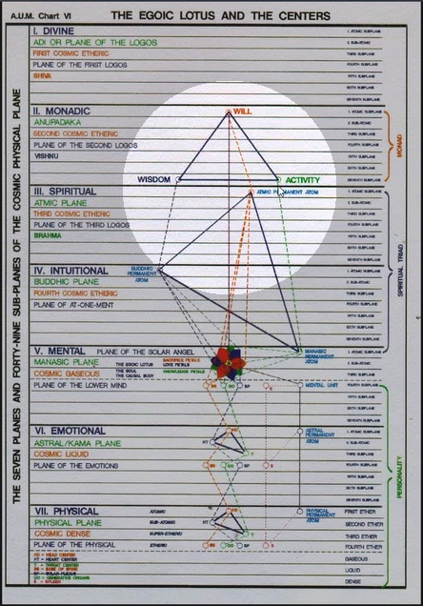

Will is at the top, and then wisdom and activity, wisdom-love, activity-intelligence. So the will is the primary expression of the monadic aspect and when we come to the soul, well the true soul is the Spiritual Triad and its reflection as the egoic lotus but the buddhic permanent atom is probably the most important here within the Spiritual Triad at least at this time because it's infusing the egoic lotus causal body which is our objective or at least we need to polarize our consciousness within the higher mental plane within this vehicle upon the higher mental plane.

[repeating:]
This is the paramount soul characteristic, for only the soul has it as the dynamic factor. The spirit, or monad is primarily the expression of will with love and intelligence as secondary principles, and the body nature, the personality, is paramountly distinguished by intelligence, but the soul has outstandingly the quality of love which demonstrates as wisdom also when the intelligence of the body nature is fused with the love of the soul. The following tabulation may make the thought clearer. TWM 39-40

This is the paramount soul characteristic… spiritual love, but anytime we use the word spiritual, Spiritual Triad is necessarily involved if we want to be truly accurate. So, The spirit, or monad is primarily the expression of will with love and intelligence as secondary principles… also called, what can we call it? Also called wisdom and activity … and the body nature, the personality, is paramountly distinguished by intelligence… so DK is spending much time here dealing with triplicities as they applied to many different levels. A great triplicity is monad, soul and personality but within each one of them is a triplicity as well.

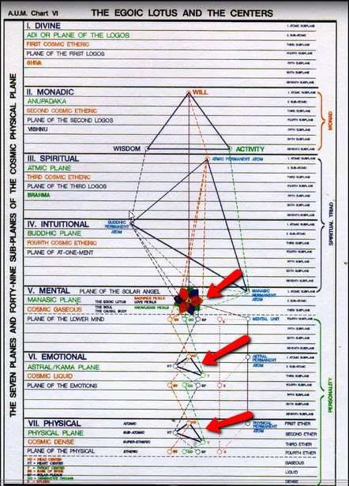

Look at this particular map and you see here’s the triplicity in the personality of mind, emotions and etheric physical. Maybe we can look at it as a quaternary thru which you divide etheric and physical.

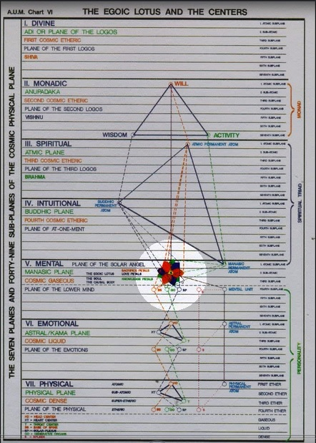

Within the nine petals of the egoic lotus we have the sacrifice petals, the love petals and the knowledge petals and if we want to make out of it a quaternary, we kind of look at the synthesis petals just the way we would look at the personality, down here:

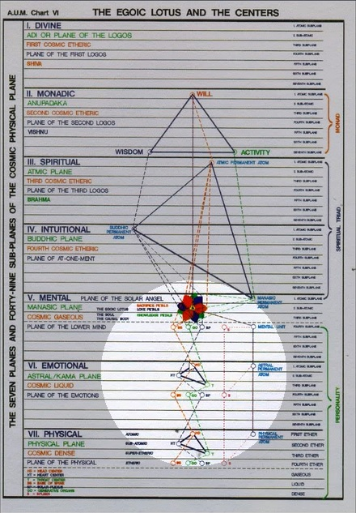

As the synthesis of mind, emotions and etheric physical, up here:

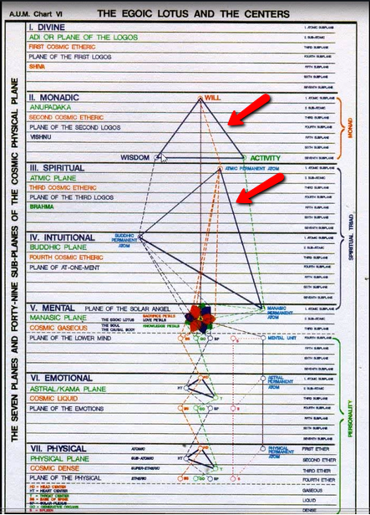

In the Spiritual Triad, we have obviously a triplicity and in the monad we have a triplicity as well.

And if we look on the divine plane:

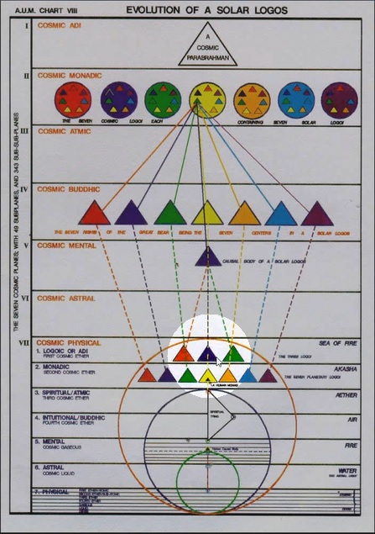

07:55 We see that three great cosmic Logoi are found there. Another triplicity of the Father, Son and Holy Ghost, the first Logos, second Logos, thirrd Logos, and so forth.

Alright so … [repeating:]
This is the paramount soul characteristic, for only the soul has it as the dynamic factor. The spirit, or monad is primarily the expression of will with love and intelligence as secondary principles, and the body nature, the personality, is paramountly distinguished by intelligence, but the soul has outstandingly the quality of love which demonstrates as wisdom also when the intelligence of the body nature is fused with the love of the soul. The following tabulation may make the thought clearer. TWM 39-40

… the personality, is (primarily) paramountly distinguished by intelligence, but the soul has outstandingly the quality of love (no matter what its ray, and) demonstrates as wisdom also when the intelligence of the body nature is fused with the love of the soul. So, let’s just say that wisdom demands the presence of intelligence and knowledge.

The following tabulation may make the thought clearer.

Monad ---------------------- Will ---------------- Purpose

1st Aspect ----------------- Will, enabling the Monad to participate in the universal purpose.

2nd Aspect ---------------- Love, the energy which is poured forth into the soul, making it what it is.

3rd Aspect----------------- Intelligence, transmitted via the soul and brought into manifestation through the medium of the body. TWM 40

08:45 Monad ----------------------- Will ---------------- Purpose

Okay, He’s dividing this into three parts, yup into three parts, so… Monad, Will, Purpose. Will and purpose sometimes equivalent, sometimes distinguished. Will and purpose seen as aspects of the monad but what really is the monad? There is but one monad and there are many monadic extensions of the one monad, all of them with a differing scope and a differing depth of immersion in matter or in what we call objectivity? So, this is the … 1st Aspect (in the Monad) enabling the Monad to participate in the universal purpose.

2nd Aspect… the energy which is poured forth into the soul, making it what it is. Maybe this is found to a degree in the Spiritual Triad, the spiritual will of the triad allowing the monads to participate in the universal purpose as that purpose is projected downward, the … 2nd Aspect of Love, the energy which is poured forth into the soul, making it what it is.

So, that’s the wisdom-love aspect, and then the:

3rd Aspect … Intelligence, transmitted via the soul and brought into manifestation through the medium of the body. The soul is inherently intelligent, it has the Angel of the Presence, Solar Angel within it and it’s found on the higher mental plane, which is a plane of higher intelligence.

Monad, will and purpose, in a way we’re dealing with the monad with the will, wisdom and activity but we’re also dealing with the Spiritual Triad, which is an extension of the Monad and a prototype of what we normally call the soul on its own plane. The consciousness within the egoic lotus.

Now with respect to the level of soul, we have:

Soul -------------------------- Love --------------- the Method

1st Aspect ----------------- Will, held in abeyance but expressing itself through the mind aspect of the personality and through Kundalini, which when aroused correctly makes possible the final initiations into the consciousness of the Monad.

2nd Aspect ---------------- Love, the dominating force of the soul life; through this possession and this type of energy, the soul can be en rapport with all souls. Through the emotional body, the soul can be in touch with all animal or subhuman souls, through its work on its own plane, with the meditating souls of all men; and through the principle of buddhi, with the second aspect of the Monad.

3rd Aspect----------------- Knowledge. This aspect is brought into touch with the intelligence of all cells in the threefold body mechanism. TWM 40

11:12 The 1st Aspect of Will, held in abeyance but expressing itself through the mind aspect of the personality (will and mind are related) and through Kundalini (at the base of the spine with Pluto, a first ray planet ruling and with Mars there as well with its first ray component, so the mind aspect of the personality and through Kundalini, which when aroused correctly makes possible the final initiations into the consciousness of the Monad. And we might say ruling especially the fifth initiation. This is about what is expressing through the soul and from the soul.

The 2nd Aspect of Love, it is the dominating force of the soul life; because soul represents the second aspect and is the second of the periodical vehicles. The Monad, soul and personality are periodical vehicles and soul is the second of those vehicles with its particular type of consciousness being the second loving wise consciousness. We have the willful consciousness of the Monad and the intelligent consciousness of the personality, not and all of them really have each member of the triplicity in various grades and in certain portions … through this possession and this type of energy, the soul can be en rapport with all souls.

Love-wisdom enhances rapport. Through the emotional body, the soul can be in touch with all animal or subhuman souls, through its work on its own plane, with the meditating souls of all men; and through the principle of buddhi, with the second aspect of the Monad. The principle of buddhi has been brought into the higher mental plane but if we consider the soul to be the Spiritual Triad, then we find there the origin for practical purposes of the principle of buddhi and it places us in touch with the second aspect of the Monad.

Here, let’s see if I can get back to that point, we see the love petals and that they are in touch with the buddhic permanent atom:

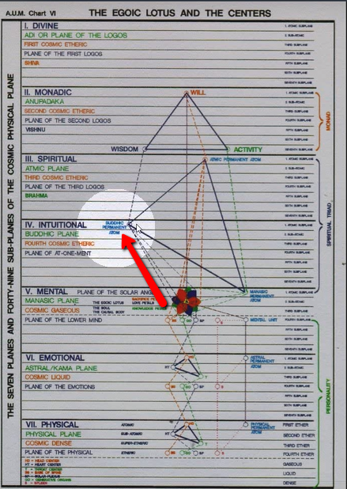

14:20 Just as the will petals or sacrifice mind, will petals, are in touch with the first aspect of the triad:

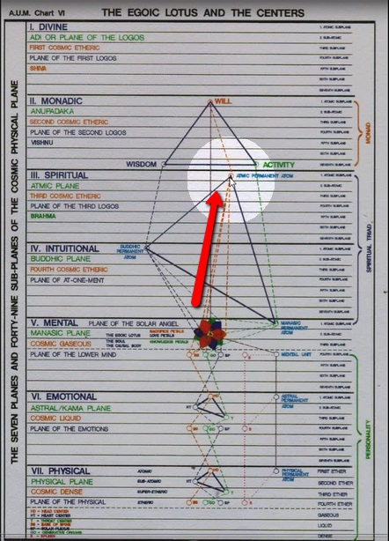

And here, from the buddhic level we find the connection to the love-wisdom aspect of the monad:

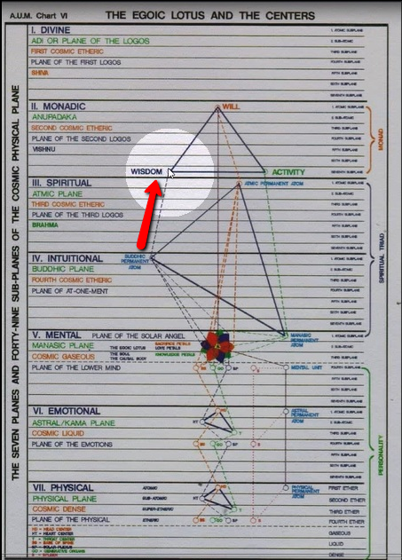

And from the atmic level, the connection with the will aspect of the Monad:

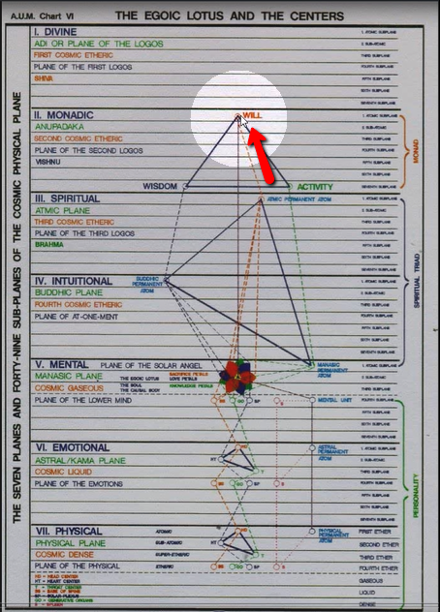

And from the manasic permanent atom, the connection with the intelligence activity aspect of the Monad:

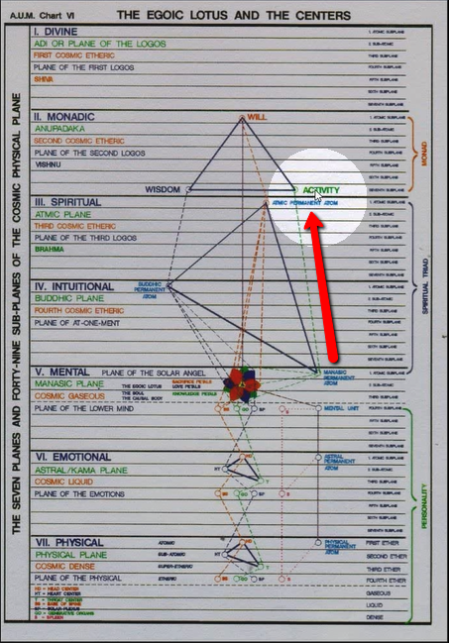

All these things are far less divided than we may suspect but in order to understand relationships in time and space, the divisions are useful.

[repeating, in part:]
2nd Aspect ---------------- Love, the dominating force of the soul life; through this possession and this type of energy, the soul can be en rapport with all souls. Through the emotional body, the soul can be in touch with all animal or subhuman souls, through its work on its own plane, with the meditating souls of all men; and through the principle of buddhi, with the second aspect of the Monad.

3rd Aspect----------------- Knowledge. This aspect is brought into touch with the intelligence of all cells in the threefold body mechanism. TWM 40

Through the emotional body, the soul can be in touch with all animal or subhuman souls, through its work on its own plane, with the meditating souls of all men through its work on its own plane, with the meditating souls of all men; and through the principle of buddhi, with the second aspect of the Monad.

So the soul can be variously in touch with the astral nature, here:

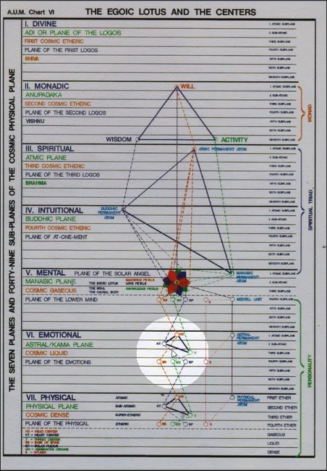

So, the emotional body, the soul, can be in touch with all animals and the lower kingdoms of nature and though its own qualities with the similar qualities and energies in other human beings and through the buddhic energy which is also found infusing the causal body but through that buddhic energy with the love and wisdom of the Monad.

Alright so:
It has the … 1st Aspect ----------------- Will
It has the … 2nd Aspect ---------------- Love… and
It has the … 3rd Aspect----------------- Knowledge

And we find these things really in the soul, in the three types of petals. This aspect is brought into touch with the intelligence of all cells in the threefold body mechanism. In a way it's controlling the dense physical vehicle, the cellular structure therein and also the correspondence to cells within the etheric body.

By a close study of the above it becomes apparent in what way the soul acts as the mediator between the monad and the personality. TWM 40

17:00 By a close study of the above it becomes apparent in what way the soul acts as the mediator between the monad and the personality. Because all aspects of the personality are in touch with the soul, the will, with the mind, the love-wisdom aspect of the monad with the buddhic principle, with the love petals, with the soul in all human beings and with the astral body. Then we have the manasic principle which is in a higher sense connected with the intelligence activity aspect of the Monad but also with the knowledge petals and with the underlying cellular and atomic structure of the vehicles within the personality and especially I suppose with the dense physical cellular and atomic structure and the etheric.

Well, it’s intricate, intricate interrelations are here given and we just have to realize that all these different aspects of our energy system are indeed in touch with each other and from the highest flows of energy which eventually reaches the lowest and there is going to be a return energy towards the highest as we get hold of ourselves and understand the direction that we should be traveling.

There is elevation of the lower energies into the sphere of the higher energies and thereby a great energizing, purifying energizing of the lower aspects of our nature enabling them to be better conduits of the higher energies. But, we have to have our aspiration operating if we are going to be able to receive and benefit from these higher energies. We just don't care if we ignore, if we continue the lifestyle which is deflective of the higher energies. They just will not come in and purify what they do. They will be very destructive in their effect.

Okay, so let’s see what else.

The personality hides within itself, as a casket hides the jewel, that point of soul light which we call the light in the head. This is found within the brain, and is only discovered and later used when the highest aspect of the personality, the mind, is developed and functioning. Then the union with the soul is made and the soul functions through the lower personal nature. TWM 41

19:30 The personality hides within itself, as a casket hides the jewel, that point of soul light which we call the light in the head.

Now, let’s just remember the light in the head is a point of soul light. It has been caused by the irradiation of the ethers around the pineal gland, and this irradiation is of a phenomenal nature and is sensed by the consciousness of the individual for whom it is happening and also the brain cells are stimulated as a result. Let me just offer this, this light in the head – This is found within the brain (etheric and physical) and is only discovered and later used when the highest aspect of the personality, the mind, is developed and functioning. Carrying, as it does, the influence of the spiritual will. Then the union with the soul is made and the soul functions through the lower personal nature. Let’s just say a steady union requires the mind and its irradiation with light from the soul. So, there are a number of things that are hidden in our correspondential.

The light on the head hidden within the brain or around the pineal gland has a kind of correspondence to the irradiation of the jewel in the lotus. Maybe the pineal gland and the jewel in the lotus are strongly connected, and as well connected with the Monad. This kind of a line from the monad, to the jewel in the lotus, to the very center of the brain, the light in the head being the irradiation around the pineal gland. Well, all of this is anatomical occultism and much of this will develop on its own as we meditate and we serve and then of course it’s possible to do targeted development under correct supervision.

The soul hides within itself, as the "jewel in the lotus," that faculty of dynamic energy which is the manifested attribute of the monad, the will. When the soul has unfolded all its powers and has learnt to include within its consciousness all that is connoted by the "myriad forms that Being takes," then in turn a higher or more inclusive state becomes possible and soul life is superseded by monadic life. This involves an ability to know, to love, and to participate in the plans of a life which has the power to include within its radius of consciousness not only the sum total of the lives and consciousness of the life of the Logos of our planet, but all the lives and consciousnesses within our solar system. The nature of this awareness is only possible of comprehension by the man who has arrived at soulknowledge. The great need at this time is for experts in the life of the soul and for a group of men and women who, undertaking the great experiment and transition, add their testimony to the truth of the statements of the mystics and occultists of the ages. TWM 41

22:50 The soul hides within itself, … yeah, we’re talking about what is hidden. I guess I jumped again on that, but I felt it was coming and now he is going to describe it. So anyway, we had the monad, will and purpose and we have the soul, love and rather than the purpose, it’s the method.

Here we have the third aspect and it is knowledge. There is intricately interconnected mechanism within the general human energy system and there are lines of connection which are specific but everything is interconnected and must eventually function in an integrated manner. We need to be integrated beings as we face our environment and as we face our internal environment. Integration comes with experience, a steady practice. The utilization of goodwill and the will-to-good which aligns us with the Divine Plan and its integrative power.

We don't want to be fragmented human beings. So many of us do have fragments and aspects of our nature which do not really cooperate rhythmically with other aspects which may be somewhat integrated. At the third initiation we achieve the majority of this integration and I would say by the fourth initiation we are totally integrated in terms of the soul and personality union.

But now we’re talking about what hides, what is hidden within the various factors, again, The soul hides within itself, as the "jewel in the lotus," that faculty of dynamic energy which is the manifested attribute of the monad, the will. Now, the Monad is more than the will, the very center of the monad is the presence of a pure being.

Anyway, the jewel in the lotus does seem than to have disconnection with the light in the head and of course one of the ways of stimulating the light in the head. I’m not saying that we should do that, because it is phenomenal and can arise on its own when we do the right thing with respect to others and to our environment. But one of the ways of stimulating that would be to bring the power of the jewel in the lotus down into the pineal gland into the ether surrounding the pineal gland and thus into the physical brain.

When the soul has unfolded all its powers and has learnt to include within its consciousness all that is connoted by the "myriad forms that Being takes," then in turn a higher or more inclusive state becomes possible and soul life is superseded by monadic life. Let’s just say the limitation of soul life is superseded and a much greater access to Oneness is attained. So, again, When the soul has unfolded all its powers and has learnt to include within its consciousness all that is connoted by the "myriad forms that Being takes"… that is a very somehow inclusive consciousness, inclusive consciousness due to sufficient sensitivity … then in turn a higher or more inclusive state becomes possible… soul consciousness can reach only so far. Now you know when we’re talking about soul consciousness, we never know entirely whether we’re talking about the consciousness on the higher mental plane or whether we're talking about the consciousness within the Spiritual Triad, which is the true ego. But mostly I think we’re addressing consciousness within the higher mental plane. This involves a superseding consciousness or awareness.

This involves an ability to know, to love, and to participate in the plans of a life which has the power to include within its radius of consciousness not only the sum total of the lives and consciousness of the life of the Logos of our planet, but all the lives and consciousnesses within our solar system. Now this is kind of a very good definition of the scope of monadic consciousness. So we might say… Thus is the scope of monadic consciousness or awareness described, so we … know, to love, and to participate in the plans of a life which has the power to include within its radius of consciousness not only the sum total of the lives and consciousness of the life of the Logos of our planet, but all the lives and consciousnesses within our solar system.

We’re reminded, the monad is that which finds its home within the Sun. This is found even in Initiation, Human and Solar and so the Monad is, when fully attained (i.e. when the pilgrim has returned from the great pilgrimage), the monad offers insight into solar systemic consciousness which is the consciousness of the solar Logos. Let us remember that on the second subplane of the cosmic physical plane there is a heart center, a great heart center, whether it’s of the planetary Logos or solar Logos, the Monad has its home within that center. It is still not the liberated monad, but it has its home within kind of a sevenfold heart center and the monad is not just a planetary being, but is already in hearing within the awakening to the fact that it adheres within the consciousness of the solar Logos. Just as our planetary Logos does, our planetary Logos is a center or chakra within the solar Logos and the constituents of our planetary Logos, many devic monads and human monads in here in their own way within the solar Logos. Well it’s a high state of initiatory expansion.

The nature of this awareness is only possible of comprehension by the man who has arrived at soul-knowledge. And I might say and even of triadal knowledge, the Spiritual Triad being the true soul or Ego. Well these are words and we need to fill them in with the consciousness, a living consciousness which is appropriate to the levels which the words describe.

The great need at this time is for experts in the life of the soul and for a group of men and women who, undertaking the great experiment and transition, add their testimony to the truth of the statements of the mystics and occultists of the ages. I’m going to underline this because I think it just is so fitting and somehow really tells us what we have to do. So, The great need at this time is for experts in the life of the soul… and not just the soul on the higher mental plane, but the truer soul, the unsheathed soul considering the causal bodies discovered you know, and we unsheathed the soul as found represented by the Spiritual Triad. Of course, to do that we have to be building the antahkarana. Therefore, to be an expert in the life of the soul, the antahkarana has to be in process.

This last section, very detailed and abstruse really, has been about the nature of the soul. ‘a.’ has been about the Spirit, Life… and … Energy… and here ‘b.’, how does he describe it? I have to go back a bit … b. The Soul, the Mediator or Middle Principle. So, we have a. Spirit, Life, Energy, and then b. The Soul, the Mediator or spiritual Middle Principle. And focusing within the soul is the great objective for students of occultism at this time.

Okay, the next and final here is:

c. The Body, the Phenomenal Appearance.

Not much need be written here anent this, for the body nature and the form aspect have been the object of investigation and the subject of thought and discussion of thinking men for many centuries. Much at which they have arrived is basically correct. The modern investigator will admit the Law of Analogy as the basis of his premises and recognise sometimes the Hermetic theory that "As above, so below" may throw much light on the present problems. The following postulates may serve to clarify:— TWM 41-42

34:30 c. The Body or the Phenomenal Appearance. Not the noumenal appearance, the noumenon is pretty much the soul for the bodies functioning and purpose and the design that it must create in any one incarnation as every incarnation is represented by a design, the Tibetan tells us. A geometrical figure, irregular at first and not too pleasant, and then they’d be with a greater beauty and regularity.

So the soul is a noumenon but a still higher noumenon which contains the name of that emanation of the One which we are is the Monad and we call it a. Spirit the Life the Energy.

Okay. c. The Body, the Phenomenal Appearance. Not much need be written here anent this, for the body nature and the form aspect have been the object of investigation and the subject of thought and discussion of thinking men for many centuries. As students of the Tibetan, we’re dealing with what the world considers to be intangibles and probably not realities as the conception according to the inception, world conception of even very powerful thinkers who are still relatively materialistic in their biases. Much at which they have arrived is basically correct. The modern investigator will admit the Law of Analogy as the basis of his premises and recognise sometimes the Hermetic theory that "As above, so below" may throw much light on the present problems.

Okay, so now we’re going to, he says he's not going to elaborate on this great deal, and we’re going to deal with certain postulates concerning the body or phenomenal appearance.

1. Man, in his body nature, is a sum total, a unity.
2. This sum total is subdivided into many parts and organisms.
3. Yet these many subdivisions function in a unified manner and the body is a correlated whole.
4. Each of its parts differs in form and in function but all are inter-dependent.
5. Each part and each organism is, in its turn, composed of molecules, cells, and atoms and these are held together in the form of the organism by the life of the sum total. TWM 42

37:00
1. Man, in his body nature, is a sum total, a unity. Now, do we mean the dense physical body? Let’s see. Or, what do we mean the whole personality considered as body is sometimes is considered that way.
2. This sum total is subdivided into many parts and organisms. And do even we investigating the body understand the distinction of function of the various parts?
3. Yet these many subdivisions function ideally in a unified manner and the body is a correlated whole. And we would say in correspondence with the seventh ray, functioning in rhythm and we would say not just rhythm but correct rhythm.
4. Each of its parts differs in form and in function but all are inter-dependent. We might say all parts are really in touch with each other through the nervous system.
5. Each part and each organism is, in its turn, composed of molecules, cells, and atoms and these are held together in the form of the organism by the life of the sum total. So, always smaller and smaller parts, but even the smaller parts have their designated function.

6. The sum total called man is roughly divided into five parts some of greater importance than others, but all completing that living organism we call a human being.
a. The head.
b. The upper torso, or that part which lies above the diaphragm.
c. The lower torso, or that part lying below the diaphragm.
d. The arms.
e. The legs.
7. These organisms serve varied purposes and upon their due functioning and proper adjustment the comfort of the whole depends.
8. Each of these has its own life which is the sumtotal of the life of its atomic structure and is also animated by the unified life of the whole, directed from the head by the intelligent will or energy of the spiritual man.
9. The important part of the body is that triple division, the head, upper and lower torso. A man can function and live without his arms and legs. TWM 42

6. The sum total called man is roughly divided into five parts… man is the star, remember the Da Vinci drawing; there is man as the cross and man as the star [Ventruvian Man]. The sum total called man is roughly divided into five parts some of greater importance than others, but all completing that living organism we call a human being. And we want to think organically and holistically, right?

So we have:
a. The head.
b. The upper torso, or that part which lies above the diaphragm. The diaphragm is a great dividing line. The other night we were discussing the cross, the horizontal arm of the cross as representing in a way the diaphragm. All of these symbols have various meanings and possible interpretations and some of them elude us.
c. The lower torso, or that part lying below the diaphragm. So with at the higher and lower chakras.
d. The arms.
e. The legs.

We have, in Sanskrit, sat, chit, and ananda, and nama rupa. Nama and rupa are the arms and the legs, sat is the head I suppose, chit is the part lying below the diaphragm, and ananda or ananda the upper torso. We are a five-part division, and let’s just say recognizing the enumeration of man is important. In other words, we have to count: we have four fingers and a thumb, ten fingers in a way, ten toes, two ears, one nose, two nostrils and so forth. It’s all numbered and the numbers are significant.

Alright, so DK is in this section where basically we are dealing with postulates and we're also working with the Hermetic axiom as above so below and we’re reminding ourselves that thinking human beings for many centuries have been focused on the body and trying to arrive at certain conclusions about it and have advanced medicine to an extraordinary degree compared with the level of advancement and earlier centuries and the law of analogy has been used. The above correspondence has been used by the more advanced investigators but not anywhere as fully as by the occult investigator. So these are postulates.

7. These organisms serve varied purposes and upon their due functioning and proper adjustment the comfort of the whole depends. When an aspect of the greater organism is out of alignment or control, the rest of the organism suffers. Goodness.

8. Each of these has its own life… each part, each organ, each chakra … which is the sum total of the life of its atomic structure and is also animated by the unified life of the whole… It is animated by the parts and animated by the whole … directed from the head by the intelligent will or energy of the spiritual man. Who is the observer and can it be considered at this point the soul, and later the monadically-infused soul, and later the monad dealing with its mayavirupa? Each of these parts is really an organism; five parts we’re talking about at the moment and certainly the chakras that relate to the five parts. So, animated by multiplicity and animated by unity… animated by inherent multiplicity and animated by the overshadowing Unity – the soul, the spiritual triad and eventually the monad.

9. The important part of the body is that triple division, the head, upper and lower torso. A man can function and live without his arms and legs. Certainly, without arms and legs there is a limitation upon the individual's relation to time and space. Or at least they used to be, maybe aided by technology it makes less difference. With the internet, we can go everywhere we don’t have to use our arms and legs to go there and with technology we can easily manipulate many things even without the arms. The important part of the body is that triple division… So, three above are more important than the two below. Now.

10. Each of these three parts is also triple from the physical side, making the analogy to the three parts of man's nature and the nine of perfected monadic life. There are other organs, but those enumerated are those which have an esoteric significance of greater value than the other parts.

a. Within the head are:
1. The five ventricles of the brain, or what we might call the brain as a unified organism.
2. The three glands, carotid, pineal and pituitary.
3. The two eyes.

b. within the upper body are:
1. The throat.
2. The lungs.
3. The heart.

c. Within the lower body are:
1. The spleen.
2. The stomach.
3. The sex organs. TWM 43

45:20 10. Each of these three parts is also triple from the physical side, making the analogy to the three parts of man's nature and the nine of perfected monadic life. There are other organs, but those enumerated are those which have an esoteric significance of greater value than the other parts. We must search for essential structures.

a. Within the head are:
1. The five ventricles of the brain, or what we might call the brain as a unified organism. Over the period of these discussions we have looked at the ventricles of the brain.
2. The three glands, carotid (associated with the alta major center) pineal (associated with the head center) and pituitary (with the ajna center).
3. The two eyes. 5 and 3 is… 8 and 2 is 10. Okay, so these are those that have the strongest esoteric significance, are found in relation to these 10… 5, 3 and 2. Now.

b. within the upper body are: We have a triple division, the division within the head of the ventricles, the glands, and the eyes. We should commit ourselves to memorizing that perhaps less obvious division. It’s very obvious when we say:
1. The throat.
2. The lungs.
3. The heart.

And these are part of the actual physical body, and...

c. Within the lower body are… we have:
1. The spleen.
2. The stomach.
3. The sex organs.

That triplicity.

We've seen that in the upper body there is a ninefoldness. In the upper body there is a ninefoldness above enumerated. Is the number of the monad nine? Is it twelve? I think is it four? That case can be made for all those numbers, but the part is ruled by the higher nature, our own higher nature, may be the head and the upper body, and then we have to include a significant lower body. This created nine, which is a number of completeness.

Okay, now, let’s see what else:

11. The sum total of the body is also triple:
a. The skin and bony structure.
b. The vascular or blood system.
c. The three-fold nervous system.

12. Each of these triplicities corresponds to the three parts of man's nature:
a. Physical nature:—The skin and bony structure are the analogy to the dense and etheric body of man.
b. Soul nature:—The blood vessels and circulatory system are the analogy to that all pervading soul which penetrates to all parts of the solar system, as the blood goes to all parts of the body.
c. Spirit nature:—The nervous system, as it energises and acts throughout the physical man is the correspondence to the energy of spirit. TWM 43

49:05 11. The sum total of the body is also triple:
a. The skin and bony structure.
b. The vascular or blood system.
c. The three-fold nervous system.

Here we have the nervous system in the place of the first order, really, the blood system in the second place, and the skin and body structure in the third place, even though they are here given in an inverted manner. Now, we recall that the nervous system was occupying the second place when we talked about the propelling energy, the nervous system and the body mass. But here, looking at the body as an entirety, the nervous system becomes very important. Of course with the blood, we have to say that the blood is life. So we might again question which represents the second, and which represents the first aspect. The skin and bony structure pretty much the third aspect.

12. Each of these triplicities corresponds to the three parts of man's nature:

a. Physical nature:— I see, he’s given a twist. The skin and bony structure are the analogy to the dense and etheric body of man. So, this is connected with the third aspect of divinity.

b. Soul nature:— is always the second aspect and The blood vessels and circulatory system are the analogy to that all pervading soul which penetrates to all parts of the solar system, as the blood goes to all parts of the body. We might say nourishing, energizing, and finally the…

c. Spirit nature:— corresponds in this case, the spirit nature which is the directorial nature. The nervous system, as it energises and acts throughout the physical man is the correspondence to the energy of spirit. It is the directing system through which the will can operate.

So we see the relationship between many triplicities and we see the ninefoldness, maybe we can find twelvefoldness, but right he's particularly dealing with triple divisions and this kind of fifth ray information has to be pretty solidly within our consciousness.

13. In the head we have the analogy to the spirit aspect, the directing will, the monad, the One:
- The brain with its five ventricles is the analogy to the physical form which the spirit animates in connection with man, that fivefold sum total which is the medium through which the spirit on the physical plane has to express itself.
- The three glands in the head are closely related to the soul or psychic nature (higher and lower).
- The two eyes are the physical plane correspondences to the monad, who is will and love-wisdom, or atma-buddhi, according to the occult terminology. TWM 43

13. In the head we have the analogy to the spirit aspect, the directing will, the monad, the One:

Now He’s going to enlarge upon this and break it down into aspectual types:

a. The brain with its five ventricles is the analogy to the physical form which the spirit animates in connection with man, that fivefold sum total which is the medium through which the spirit on the physical plane has to express itself. The five interestingly enough relating to the previous solar system whose number was five and was ruled by the third ray, so this is actually interestingly here as He puts it, a third aspect correspondence. Now, usually the brain is the directing agent, but in this particular case He has related it to the dense physical body, I think.

b. The three glands in the head are closely related to the soul or psychic nature (higher and lower). So, higher nature around the pineal, lower nature around the carotid, something intermediary with the pituitary.

c. The two eyes are the physical plane correspondences to the monad, who is will and love-wisdom, or atma-buddhi, according to the occult terminology. It looks like He has inverted this, let’s just see. Well, okay, yeah, He's trying to find the correspondences between monad, soul and personality, and when He deals with the skin and the bony structure, he has vascular blood system and the nervous system. He assigns them as 3-2-1 and then when he deals with the head itself representing the monad, He has correspondences which are again 3-2-1 or body, soul and monad. Now in the upper body, it all seems very intricate in this treatise, but it’s rather necessary because the Magician has to be well informed on all of these anatomical matters.

14. In the upper body we have an analogy to the triple soul nature.
a. The throat, corresponding to the third creative aspect or the body nature, the active intelligence of the soul.
b. The heart, the love wisdom of the soul, the buddhi or Christ principle.
c. The lungs, the analogy for the breath of life, is the correspondence of spirit.

15. In the lower torso again we have this triple system carried out:
a. The sex organs, the creative aspect, the fashioner of the body.
b. The stomach, as the physical manifestation of the solar plexus is the analogy to the soul nature.
c. The spleen, the receiver of energy and therefore the physical plane expression of the centre which receives this energy is the analogy to the energising spirit.

The vital body is the expression of the soul energy and has the following function:
1. It unifies and links into one whole the sum total of all forms.
2. It gives to every form its particular quality, and this is due to:
a. The type of matter drawn into that particular part of the web of life.
b. The position in the body of the planetary Logos, for instance, of any specific form.
c. The particular kingdom in nature which is being vitalised. TWM 43

55:12 14. In the upper body we have an analogy to the triple soul nature.

- The throat clearly corresponding to the third creative aspect or the body nature, the active intelligence… and ruled by the third ray.

- The heart, the love wisdom of the soul, the buddhi or Christ principle. Ruled by the second ray, but remember that the heart holds the life principle as well, and sometimes the brain is looked at as holding the consciousness principle. But this is in the upper torso and does not include anything in the head.

- The lungs, the analogy for the breath of life, is the correspondence of spirit. That makes sense, but the lungs have also been associated with the third ray. So, it all depends on the context and what are the factors that are included together, how we shall enumerate them and assign them to rays?

15. In the lower torso again we have this triple system carried out:

- The sex organs, the creative aspect… and you know, relate to the mind. As a matter of fact in the sacral center is the seat of the lower, the health and mental elemental. So it’s … the fashioner… or the creator … of the body.

- The stomach, as the physical manifestation of the solar plexus is the analogy to the soul nature. The 6th ray of the solar plexus related to the soul, to the 2nd ray really, and thus to the soul, and…

c. The spleen… the giver of energy … the receiver of energy and therefore the physical plane expression of the centre which receives this energy is the analogy to the energising spirit. … We must understand these analogies and they must make sense to us, so I recommend that we review this, study this and the threefoldness of each of the three parts of the body: the head, the upper torso and lower torso and the ray correspondences. Or maybe we take the body as a whole without dividing it. The lungs would represent something else.

The vital body is the expression of the soul energy and has the following function... now this is interesting and well…

- It unifies and links into one whole the sum total of all forms. All the energies pass through it.

2. It gives to every form its particular quality, and this is due to:

- The type of matter drawn into that particular part of the web of life. You know, because we have a magnetic operation operating here and around the scaffolding of the web of life, the dense physical body is built.

- The position in the body of the planetary Logos, for instance, of any specific form. And…

- The particular kingdom in nature which is being vitalised.

This is all about the vital body, and I have a feeling that it would be best for us not to venture too strongly into this vital body. It is part of the physical nature, and we’ve just looked at the physical nature and now we have to examine the vital body which is a subject on its own.

So, let’s just say that we will begin here. Let’s call this the end of A Treatise on White Magic number10 and we were on Page 39, and then now on Page 44 and this is the beginning of A Treatise on White Magic number 11, and we will start from Page 44.

I think we’re into an entirely new unit of work here and I don't think it’s wise to venture into it when there's so little time remaining to make a one-hour program.

First we looked at the physical body and its three major divisions and the threefoldness of those major divisions and now the vital body as the expression of soul, energy and its functions. And there are a number of functions here. So, this is an important standalone section. Well, there’s nothing really standalone, everything is related to everything else but will get into this a bit later.

Alright, so, thank you for your attendance and of course to really study these matters – well, we're not studying it sufficiently, we’re giving some thoughts about what are possible ways to think, but there are deeper methods of studying and this enumeration of the parts of the physical body and vital body and maybe other vehicles into triplicities, into a fivefoldness, of threefoldness or twofoldness and so forth. These are important in understanding the basic structure which reflects the Divine Plan behind it.

Alright friends, that’s it and thank you for your attendance, on to A Treatise on White Magic number 11. See you soon.

