A Treatise on White Magic — Mental Rules 04
Transcript of Video Commentaries by Michael D. Robbins
Abstract
Content for A Treatise on White Magic, Video Commentary, Program 4, Continuing the subsection: Man’s Three Aspects. 1 hr, 1 min: pages 12-16.
Psychic. In our form nature we have a high presentation of animal soul which is not yet self-consciousness. A self-consciousness center. This type of soul is higher than the animal soul, which is sentient but not self-conscious. The soul on its own plane. The heavens are really beginning on the third sub-plane of the mental plane. The true soul is the true Knower, or Thinker on a higher place than the lower mind and certainly than the astral body. Higher soul powers will be understood and utilized. Unfoldment. The unfoldment of sentiency or sensitivity. A kind of climax within the dense physical body of our Planetary Logos. Knowledge. We accept much from the Tibetan and it is the course of wisdom to do so.
Eventually we have to put all knowledge that we accept to the test once our mind is better trained. Meanwhile we reserve judgment. Virgo types should be capable of prolonged concentration which is equivalent to meditation. Knowledge can still be theoretical even through much reasoning has gone towards the verification of that knowledge. Sustained concentration which is meditation will yield understanding in various areas. Occult meditation. Bridging. Theoretical, discriminative and intuitive knowledge. Intuition apprehends that which is NOT man-made. Higher knowingness. Always present aspects of the Deity from which any system gains its manifestation.
Preparation for the recognition and utilization of the intuition. Growth of the light-receiving mind and its bridge to direct knowledge or intuition by men. Soul truthfully transcends the higher mind. Every sphere of activity has its own type of omniscience. Intuition leads to omniscience. We will enter the decanate of Aquarius ruled by Mercury. Just try to teach occultism to those who are not ready, or to members of one’s own family. From vision to fact to law.
A Treatise on White Magic Video Commentary 4 136 MB .wmv file
Video of A Treatise on White Magic Video Commentary 4 by Michael D. Robbins.
A Treatise on White Magic Video Commentary 4 58 MB .mp3 file
Audio of A Treatise on White Magic Video Commentary 4 by Michael D. Robbins.
Transcript
Hi everybody.
This is the beginning of A Treatise on White Magic webinar commentaries number 4 and we’re on page 12.
We’ve just been dealing with the definition of terms. The terms have been defined so far are occult, which are the hidden energies that are causative and which lie behind the effects, the archetypes behind the arrangements in the mosaic world, the causative energies which produce effects, the world of being in relation to the world of becoming. I think that’s one way to look at it.
Then the question of the word law which has to do with the carrying forth of the will of a superior being and it cannot be countermanded. It is absolute within the system, it cannot be violated. It’s absolute within the system that it control. It's not like a rule which you can follow or not. It has rather to do with a type of order, a type of boundaries which must be respected. They cannot be somehow circumvented within the system to which the law applies.
Then we come down to this word psychic, and this word psychic has to do with the animal soul and with the human soul. The true psyche is the soul but there are lesser degrees of this type of sentiency, as He says here:
3. Psychic. There are two types of the above force in manifestation as far as the human kingdom is concerned, and these must be clearly grasped. There is the force which animates the subhuman kingdoms in nature. – the ensouling energy which, brought into conjunction with the energy of matter and self, produces all forms. The effect of this junction is to add to the embryo intelligence of substance itself a latent sentiency and responsiveness that produces that subjective something we call the animal soul. This exists in four degrees or states of sentient awareness: TWM 12

There are two types of the above force in manifestation as far as the human kingdom is concerned, and these must be clearly grasped. There is the force which animates the subhuman kingdoms in nature. – the ensouling energy which, brought into conjunction with the energy of matter – that is, inherited from the previous solar system – which, brought into conjunction with the energy of matter and self, produces all forms. So, we have self, psyche and matter in the production of form, and psyche is the sensitive nature. The effect of this junction is to add to the embryo intelligence of substance itself – inherited from the past – a latent sentiency and responsiveness that produces that subjective something we call the animal soul. And this seems to be applied to the animating soul in its non-self-conscious state of development. This exists in four degrees or states of sentient awareness:

So, there is the various kingdoms of nature and the degree of their sentiency. Note that sentiency or consciousness is even found in the mineral kingdom:

a. The consciousness of the mineral kingdom.
b. The consciousness of the vegetable kingdom.
c. The consciousness of the animal kingdom.
d. The consciousness of the animal form through which the spiritual man functions, which after all is but a department of the former group in its highest presentation. TWM 12

We are pretty much as human beings an animal plus a god. The indwelling higher soul or really the indwelling Monad or unit of spirit or presentation or externalization of spirit, emanation of spirit. So this is the animal soul and it has to do with sentiency, but a kind of sentiency which is not yet self-conscious. Through this type of soul, we have risen, we the immersed monad, passing through the stages of involution and anchoring ourselves in the mineral kingdom, or at least anchoring the extension of ourselves in the mineral kingdom, have risen through the vegetable, the animal kingdom. Even now we have that type of sentiency in our vehicles which is the same type of sentiency found in the animal kingdom altogether. We do have, after all, an animal nature.

05:23 d. The consciousness of the animal form through which the spiritual man functions, which after all is but a department of the former group in its highest presentation. So we human beings, let’s just say in our form nature, we have a high presentation of animal soul that is not yet self-conscious. Alright, so that’s the animal soul that exists in four degrees or states of sentient awareness.

Secondly, there is that psychic force which is the result of the union of the spirit with sentient matter in the human kingdom and which produces a psychic centre which we call the soul of man. This psychic centre is a force centre and the force which it is the custodian or which it demonstrates, brings into play a responsiveness and an awareness which is that of the soul of the planetary life, a group consciousness which brings with it faculties and knowledge of a different order than that in the animal soul. These supersede eventually the powers of the animal soul which limit, distort, and imprison and give man a range of contacts and a knowledge which is infallible, free from error and which admits him to “the freedom of the heavens”. TWM 12-13

Secondly, there is that psychic force which is the result of the union of the spirit with sentient matter in the human kingdom and which produces a psychic centre which we call the soul of man. Now this is a self-consciousness center, this type of soul is higher than the animal soul, which is sentient but not self-consciousness. This psychic centre is a force centre – in a way, it’s considered to be the heart center of the monad. Heart always has about it that quality of feeling or sentiency. This psychic centre is a force centre and the force which it is the custodian or which it demonstrates, brings into play a responsiveness and an awareness which is that of the soul of the planetary life.

Eventually, we’re told, soul is group conscious and the more we send towards the state of soul and bring a state of soul into our mind, the more group conscious we become. Okay, continuing … a group consciousness which brings with it faculties and knowledge of a different order than that in the animal soul. So, let us call it the human soul or later, the soul on its own plane. These supersede eventually the powers of the animal soul which limit, distort, and imprison and give man a range of contacts and a knowledge which is infallible, free from error and which admits him to “the freedom of the heavens”. The heavens are really beginning on the third subplane of the mental plane … so, basically here we have a picture of this:

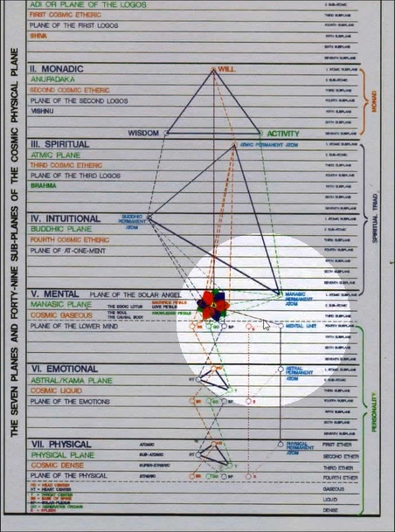

Increasing freedom begins here above the dotted line and which we are trying to polarize our consciousness within these higher areas. And when we can do that we can truly meditate, the Tibetan tells us.

Okay, so let’s see… we are here: “the freedom of the heavens”. These supersede eventually the powers of the animal soul. These psychic powers are there and they are collected and they are discussed here in this composite diagram:

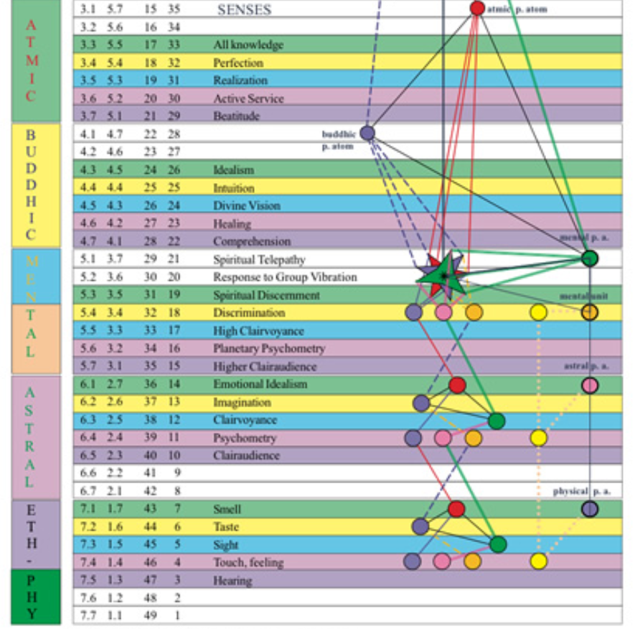

09:50 See, all of these: clairaudience, psychometry, clairvoyance, these are attributes or qualities of the animal soul. Even this higher type of clairaudience and clairvoyance and psychometry still pertain to the animal soul. But of course after the third degree, we’re told to become as possible to use these lower psychic capacities in the right way. Otherwise, we can be swept by them, swept away by them and they can delude us, unfortunately.

So, what we do have here? The idea that if our consciousness remains subject only to the animal soul that would be: limitation, distortion, imprisonment, a generally deluded state characterized by glamour and delusion and we would not have the freedom of the heavens, which I think really begins for us to be aspired to it before the third degree but it begins at the third degree.

[continuing:]

The effect of the free play of the soul of man serves to demonstrate the fallibility and relative uselessness of the powers of the animal soul. All I desire to do here is to show the two senses in which the word “psychic” is used. Later we will deal with the growth and development of the lower psychic nature or the soul of the vehicles in which man functions in the three worlds, and then will seek to elucidate the true nature of the soul of man and of the powers which can be brought into play once a man can contact his own spiritual centre, the soul, and live in that soul consciousness. TWM 12-13

The effect of the free play of the soul of man serves to demonstrate the fallibility and relative uselessness of the powers of the animal soul. Now many psychics are deluded by the powers of the animal soul and they somehow are convinced of its value. But relatively speaking, it is not of value. However, what we do discover in this process is that there’s a certain type of psychism in the animal kingdom, and because it has not been the focus of man for many, many thousands and even millions of years, when we rediscover it, we think it’s something new but it isn’t. It is something very, very old that only seems new because we are no longer accustomed to it. We don’t want to be trapped in it; our proper place of development is the mind in this Aryan Age and then at the third degree, the recovery, if necessary, of the lower psychic powers and the building in of the conscious use of the higher psychic powers.

So … the fallibility – that’s interesting – the fallibility and relative uselessness of the powers of the animal soul. So many psychic seem to think that, because their impressions are, what shall we say – impressive? – that they are definitely true. But we are swept into a delusion thereby and we can cover up the true influence of the soul, unfortunately. All I desire to do here is to show the two senses in which the word “psychic” is used. Animal soul and human soul, or animal soul and the soul that will eventually have omniscience, it’s the true knower. The true soul is the true Knower or Thinker on a higher plane than the lower mind, and certainly than the astral body.

Later we will deal with the growth and development of the lower psychic nature or the soul of the vehicles (the lower psychic nature is) … the soul of the vehicles …. This has to be emphasized. It’s the sentiency of the vehicles and it can be useful, but only when we are working from a higher vantage point. Later we will deal with the growth and development of the lower psychic nature or the soul of the vehicles in which man functions in the three worlds, and then will seek to elucidate the true nature of the soul of man and of the powers which can be brought into play once a man can contact his own spiritual centre, the soul, and live in that soul consciousness.

So, higher soul powers will then be understood and utilized and we begin with the spiritual discernment in response to group vibration and spiritual telepathy and then we go on to the buddhic powers, the lower five of them and the atmic powers, the lower five of them and so forth. Eventually, the powers of the monad will come into focus and we shall be very well equipped indeed to understand and contribute usefully with the development of all interactions on the cosmic physical plane.

4. Unfoldment. The life at the heart of the solar system is producing an evolutionary unfoldment of the energies of that universe which it is not possible for finite man as yet to vision. Similarly the centre of energy which we call the spiritual aspect in man is (through the utilisation of matter or substance) producing an evolutionary development of that which we call the soul, and which is the highest of the form manifestations—the human kingdom. Man is the highest product of existence in the three worlds. By man, I mean the spiritual man, a son of God in incarnation. The forms of all the kingdoms of nature—human, animal, vegetable and mineral—contribute to that manifestation. The energy of the third aspect of divinity tends to the revelation of the soul or the second aspect which in turn reveals the highest aspect. It must ever be remembered that The Secret Doctrine of H. P. Blavatsky expresses this with accuracy in the words "Life we look upon as the one form of existence, manifesting in what is called Matter; or what, incorrectly separating them, we name spirit, soul and matter in man. Matter is the vehicle for the manifestation of soul on this plane of existence, and soul is the vehicle on a higher plane for the manifestation of spirit, and these three are a trinity synthesized by life, which pervades them all." (The Secret Doctrine. Vol: I. p. 79. 80.) TWM 13-14

15:26 Okay, here's another term that he wants us to understand and determine, it’s unfoldment. He said it’s a very good term … like as a flower may unfold so does consciousness and you can envision the unfolding of the petals. They are rather closed-in upon themselves, but they open to the light of the sun or to the sun of buddhi, we might say to the higher wisdom, and all of the egoic lotus becomes eventually irradiated by buddhi, which turns out to be a kind of a destructive force and demands of liberation from the temple of the causal body.

The life at the heart of the solar system is producing an evolutionary unfoldment of the energies of that universe which it is not possible for finite man as yet to vision. Well, maybe the entire universe is unfolding, it’s difficult to understand sometimes what DK means by the word ‘universe’. Sometimes He means even a limited solar system, but maybe were talking about an island universe that is a galaxy, which is also unfolding or some lesser structure which is much greater than our solar system but is still less than the galaxy. Anyway, let's try to be aware. The entire universe is in a way unfolding according to a great universal purpose, but we’ll try to understand that the term has a certain fluidity and we have to see the context in which it is used.

I guess it’s not possible for us to understand the grand entirety of the complete universe of all galaxies and starry systems, not at all possible. We can't even really understand the unfoldment of our particular galaxy which we, by the law of analogy at least, know isn't ensouled by a stupendous life that is just a tiny life compared to that which ensoules the entirety of the universe.

To get a true scale of the way things relate to each other and what is big and what is small, it takes a great sensitivity or consciousness which we’re trying to cultivate and are slowly on our way. We’re told the solar system is producing an evolutionary unfoldment of itself as a tiny universe and that's contributing to the unfoldment of a cosmic Logos, a greater universe and contributing to the unfoldment of a super-cosmic Logos which we sometimes call The One About Whom Not May Be Said, which is contributing to the unfoldment of a sub-parabrahmic Logos. If I were to try to find a diagram of that I would say, this is our… This is the sub-parabrahmic Logos:

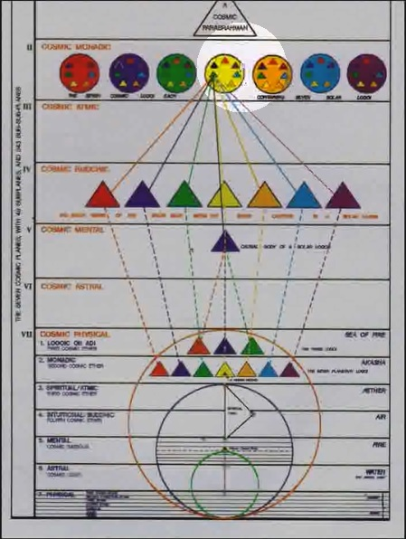

These seven wheels here.

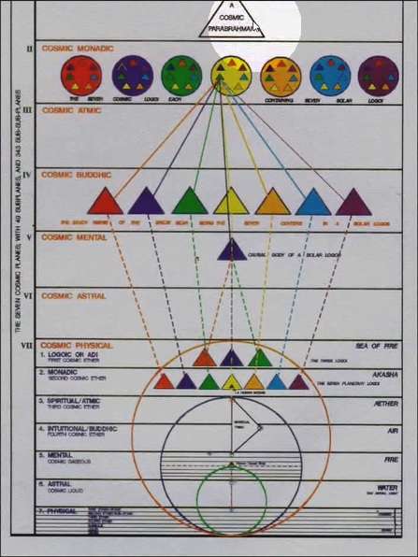

19:00 Here is a parabrahmic Logos. It’s on the 7th of the cosmic planes and there are other planes as well. Let’s just say that this is just the beginning in a way of the [stratified universe, as it really is]. We’re just tiny mites trying to understand this grand entirety, which is an impossible task. But at least we can expand our abstract mind and our intuition to the point where there’s a greater clarity than otherwise might be the case and that will help us, under ordinary circumstances live a better life within our limited circumscribed sphere of action or attention.

[repeating:]
4. Unfoldment. The life at the heart of the solar system is producing an evolutionary unfoldment of the energies of that universe which it is not possible for finite man as yet to vision. Similarly the centre of energy which we call the spiritual aspect in man is (through the utilisation of matter or substance) producing an evolutionary development of that which we call the soul, and which is the highest of the form manifestations—the human kingdom. Man is the highest product of existence in the three worlds. By man, I mean the spiritual man, a son of God in incarnation. The forms of all the kingdoms of nature—human, animal, vegetable and mineral—contribute to that manifestation. The energy of the third aspect of divinity tends to the revelation of the soul or the second aspect which in turn reveals the highest aspect. It must ever be remembered that The Secret Doctrine of H. P. Blavatsky expresses this with accuracy in the words "Life we look upon as the one form of existence, manifesting in what is called Matter; or what, incorrectly separating them, we name spirit, soul and matter in man. Matter is the vehicle for the manifestation of soul on this plane of existence, and soul is the vehicle on a higher plane for the manifestation of spirit, and these three are a trinity synthesized by life, which pervades them all." (The Secret Doctrine. Vol: I. p. 79. 80.) TWM 13-14

Similarly the centre of energy which we call the spiritual aspect in man is (through the utilisation of matter or substance) – matter is lower than substance and some things that are substance are matter compared to a still more refined substance – producing an evolutionary development of that which we call the soul, – the unfoldment of sentiency, the unfoldment of sensitivity; the unfoldment of sentiency or sensitivity – and which is the highest of the form manifestations—the human kingdom.

Well, what should we consider form? The lower twenty-one subplanes are the dense physical body of the solar Logos and maybe, depending on how you look at it, the dense physical body of the planetary Logos, although there's a case for saying that only the eighteen lower subplanes are its dense physical body. But anyway, at the height of the twenty-one subplanes, we find that structure we call the soul, and – By man, I mean the spiritual man, a son of God in incarnation. That which has gone forth as a miniature son from a greater son which we can call God, the planetary Logos. There are whole series of ascending sons, s-o-n.

The forms of all the kingdoms of nature—human, animal, vegetable and mineral—contribute to that manifestation. The energy of the third aspect of divinity tends to the revelation of the soul or the second aspect which in turn reveals the highest aspect. So, each one of the aspects is revelatory of a superior aspect at least when dealing with the higher three archetypal aspects. We build the foundation with the third aspect and through it reveal the second and we have the soul-infused personality. With the second aspect, we build that consciousness through which the divine will can reveal itself and through all of these three being, which is the life at the center and no aspect particularly, but in a way inclusive of all of them, the all-three being reveals itself.

It must ever be remembered that The Secret Doctrine of H. P. Blavatsky expresses this with accuracy in the words – and this is the ongoing quote that I was looking for: “Life we look upon as the one form of existence. Or, existence depends on, technically, within the universe, that which is, exists. There’s also a kind of beingness which is super-universal beyond any universe. Will we call it existence or will we call it being or beingness? “Life we look upon as the one form of existence, manifesting in what is called Matter; or what, incorrectly separating them, we name spirit, soul and matter in man. Matter is the vehicle for the manifestation of soul on this plane of existence, and soul is the vehicle on a higher plane for the manifestation of spirit, and these three are a trinity synthesized by life – so life and being here are equivalent – which pervades them all.” (The Secret Doctrine. Vol: I. p. 79. 80.)

This is the great quote and reminds us that we do incorrectly separate the three aspects of divinity. However, in order to study them and understand them, I think some form of focusing is needed. Eventually, just as the mind becomes a completed sphere without all of the breaks within it, you can ascend and descend from the concrete to the very abstract with no obstruction. So, it is with spirit, soul and matter. They’re all really of one substance, one life is the substanding factor that unifies them all and which is the essence of all of them. Thus, through the use of matter the soul unfolds and finds its climax in the soul of man… well, it is a kind of climax at least within the dense physical body of our planetary Logos … and this treatise will concern itself with the unfoldment of that soul and its discovery by man.

Now Cosmic Fire went further, right? A Treatise on Cosmic Fire went farther and talked of higher expressions of soul. … It’s located in A Treatise on White Magic in the very beginning and I suppose on some page, page 14 it looks like. Alright, I’ll try to remember and make it bigger so I can fool myself into thinking that it will always be there when I want it.

“Life we look upon as the one form of existence, manifesting in what is called Matter; or what, incorrectly separating them, we name spirit, soul and matter in man. Matter is the vehicle for the manifestation of soul on this plane of existence, and soul is the vehicle on a higher plane for the manifestation of spirit, and these three are a trinity synthesized by life, which pervades them all." (The Secret Doctrine. Vol: I. p. 79. 80.) TWM 14

Alright: “Life we look upon as the one form of existence, manifesting in what is called Matter; or what, incorrectly separating them, we name spirit, soul and matter in man. Matter in a way is spirit, soul and the matter when considered to be working through the dense physical vehicle of the planetary Logos. So, it’s Matter with the big capital M. But practically, Matter is the vehicle for the manifestation of soul on this plane of existence, – we hope to become in our personality, the soul-infused personality – soul is the vehicle – there it is, on the higher mental plane and it has a material structure, a subtle material structure the – soul is the vehicle on a higher plane for the manifestation of spirit, – which we consider to be monad and triad – and these three are a trinity synthesized by – now, let’s say beingness – by life, which pervades them all.” – and from which they were emanated or extruded; they came forth from life itself which is completely unified being. Now what is the matter of that coming forth? That’s very difficult to say. Sometimes I think it is self-perceptual coming forth and knowledge.

5. Knowledge might be divided into three categories:—First, there is theoretical knowledge. This includes all knowledge of which man is aware but which is accepted by him on the statements of other people, and by the specialists in the various branches of knowledge. It is founded on authoritative statements and has in it the element of trust in the writers and speakers, and in the trained intelligences of the workers in any of the many and varied fields of thought. The truths accepted as such have not been formulated or verified by the one who accepts them, lacking as he does the necessary training and equipment. The dicta of science, the theologies of religion, and the findings of the philosophers and thinkers everywhere colour the point of view and meet with a ready acquiescence from the untrained mind, and that is the average mind. TWM 14

28:03 Knowledge might be divided into three categories:—First, there is theoretical knowledge. Of that we have plenty if we’re students of the Tibetan, because He is even writing about things which He infers and has read about and understands, but He has not experienced directly, such as when He writes about, let’s say the cosmic astral plane and the cosmic mental plane. Knowledge might be divided into three categories:—First, there is theoretical knowledge. This includes all knowledge of which man is aware but which is accepted by him on the statements of other people, – well we’re doing a lot of that aren’t we? … statements of other people, and by the specialists in the various branches of knowledge. Such as the Tibetan is. So let’s just say we accept much from the Tibetan and it is the course of wisdom to do so as we trust Him, having proven His accuracy in so many ways and write so rationally and convincingly if we do not accept what He offers as the truth, whose testimony will we accept? So this is theoretical and we have not proven it ourselves but it seems reasonable, rational to us.

It is founded on authoritative statements and has in it the element of trust in the writers and speakers, and in the trained intelligences of the workers in any of the many and varied fields of thought. We have to have a certain kind of trained intelligence in order to realize that the knowledge offered authoritatively by the experts is in fact likely to be reliable. It is founded on authoritative statements and now of course we have to test this out to a degree, because there are many false authoritative statements and people bewilder themselves by accepting these; they have not sufficient experience to compare these statements with what the teacher involved has said otherwise or with what other reliable teachers have said. The material within the Ageless Wisdom should all be rationally related.

If we find the aspects of the Ageless Wisdom contradicting each other, and with a very strong contradiction, (some of the contradiction might just be our inability to interpret), then we have to suspect that something being said is not accurate, or maybe the probability is when dealing with the Teacher or that of the Tibetan, if we find how relation is our own lack of interpretative skill which reveals his statements as contradictory. That's kind of how I approach it and I think of others do too and it has in it, element of trust in the writers and speakers. I think we acquiesce to a probable accuracy and truth of a trusted teacher and when there are factors which do not seem to support each other, we reserve our judgement until we can see more and then again evaluate once our intelligence is trained further.

The truths accepted as such have not been formulated or verified by the one who accepts them, lacking as he does the necessary training and equipment. Well, we really are in this situation as students of the Master DK, we are very much in this situation. When He’s writing of the buddhic plane, the atmic plane, even the plane of the soul and of other things, who are we to say, except we have to see whether his statements do seem mutually supportive and consistent? We’re not even in a position to know that entirely. I guess [we trust as Master Morya said] of the mine, as if you go digging in a mine, the mine of trust, and many valuable things will come out of the mine of trust, because we will not obstruct the energies which could come through because we do trust. It’s a bit like the discussion of the value of faith that we find in the New Testament. Faith is healing, faith is making many things possible. My faith has made the home and perhaps home as an understanding will also come through, or at least is the opening of the door to possible understanding through faith.

The dicta of science, the theologies of religion, and the findings of the philosophers – interesting, the word findings after an extensive reasoning process – the findings of the philosophers and thinkers everywhere colour the point of view and meet with a ready acquiescence from the untrained mind, and that (of course) is the average mind. So … eventually we have to put all knowledge that we accept to the test once our mind is better trained, meanwhile we reserve judgment.

Now another type of knowledge here, he said comes in three categories, right? Okay.

Then, secondly, we have discriminative knowledge, which has in it a selective quality and which posits the intelligent appreciation and practical application of the more specifically scientific method, and the utilisation of test, the elimination of that which cannot be proved, and the isolation of those factors which will bear investigation and are in conformity with what is understood as law. The rational, argumentative, scholastic, and concretising mind is brought into play with the result that much that is childish, impossible and unverifiable is rejected and a consequent clarifying of the fields of thought results. This discriminating and scientific process has enabled man to arrive at much truth in relation to the three worlds. The scientific method is, in relation to the mind of humanity, playing the same function as the occult method of meditation (in its first two stages of concentration and prolonged concentration or meditation) plays in relation to the individual. Through it right processes of thought are engendered, non-essentials and incorrect formulations of truth are ultimately eliminated or corrected, and the steady focussing of the attention either upon a seed thought, a scientific problem, a philosophy or a world situation results in an ultimate clarifying and the steady seeping in of right ideas and sound conclusions. The foremost thinkers in any of the great schools of thought are simply exponents of occult meditation and the brilliant discoveries of science, the correct interpretations of nature's laws, and the formulations of correct conclusions whether in the fields of science, of economics, of philosophy, psychology or elsewhere is but the registering by the mind (and subsequently by the brain) of the eternal verities, and the indication that the race is beginning also to bridge the gap between the objective and the subjective, between the world of form and the world of ideas. TWM 14-15

34:33 Then, secondly, we have discriminative knowledge … reminding us that on the fourth subplane of the mental plane is the factor called discrimination, and it pretty much applies to discriminating that which is of the personality to that which of the soul. It’s a lower Mercurial function along with Saturn ... discriminative knowledge which has in it a selective quality and which posits the intelligent appreciation and practical application of the more specifically scientific method, and the utilisation of test, the elimination of that which cannot be proved, – unless we suspend our judgement in trust -- and the isolation of those factors which will bear investigation and are in conformity with what is understood as law. We don’t reject everything simply because we cannot yet understand it.

So, this is what discrimination has within it: a selective quality and which posits (or requires or demands) the intelligent appreciation and practical application of the more specifically scientific method, –the fifth ray is involved here in the fact of discrimination – and the utilisation of test, – the things to the test. even the entire yoga sutras is written on that assumption that the student will work what is said to the test, and … the elimination of that which cannot be proved, – but maybe a temporary elimination while we suspend judgment, unless it seems to be beyond the pale, or outlandish, or unlikely to conform with what we consider law, and the isolation of those factors which will bear investigation and are in conformity with what is understood as law. We have to discriminate what is worth studying and what we simply throw away as unlikely to produce Light.

The rational, argumentative, scholastic, and concretising mind is brought into play with the result that much that is childish, impossible and unverifiable is rejected and a consequent clarifying of the fields of thought results. This is the facility of the fifth ray and relates to the lower concrete mind which is much characterized by at least the lower part of the fifth ray, the entire mental plane being the fifth plane from the top, as we call it, of the cosmic physical plane, is the fifth plane. We have to use all of these and our modern educational systems train us in the reason, our imitation scholastic approach, concretization, so forth. We try to throw out that which is childish, we have to beware though, because sometimes in what appears to be childish to the sophisticated, analytical mind, is in fact very true to the mind that can see things from the perspective of the soul or higher energy centers.

This discriminating and scientific process has enabled man to arrive at much truth in relation to the three worlds. We've been applying it immensely ever since 1775 when the fifth ray came into expression in its cycle, maybe of 350 years. So successful have we been that the fifth ray ashram has had to have its investigations held in suspension simply because the discoveries would be dangerous in the hands of a humanity that has not developed itself morally; without sufficient morality to use the discoveries wisely we could destroy ourselves.

The scientific method is, in relation to the mind of humanity, playing the same function as the occult method of meditation (in its first two stages of concentration and prolonged concentration or meditation) … that’s interesting isn’t it? … plays in relation to the individual. Prolonged concentration He equates with meditation and interestingly, let’s say that Virgo types should be capable of prolonged meditation, prolonged concentration is equivalent to meditation.

So many things we could pause and labor over, but it’s the fifth-ray process, we simply do not accept as a matter of course. We can accept after analyzing and the knowledge can still be theoretical. … Knowledge can still be theoretical even though much reasoning has gone towards the verification of that knowledge. We have enough reasoning, discriminations and so forth, to know we're onto something, but still we have not entirely proved it to ourselves, so it still remains within the realm of unverified knowledge, theoretical knowledge. However the probability continues to increase that this theoretical knowledge is accurate and this comes in with the fifth ray, which is closely related to the proving of the accuracy or inaccuracy of knowledge.

[repeating:]

Through it right processes of thought are engendered, non-essentials and incorrect formulations of truth are ultimately eliminated or corrected, and the steady focussing of the attention either upon a seed thought, a scientific problem, a philosophy or a world situation results in an ultimate clarifying and the steady seeping in of right ideas and sound conclusions. The foremost thinkers in any of the great schools of thought are simply exponents of occult meditation and the brilliant discoveries of science, the correct interpretations of nature's laws, and the formulations of correct conclusions whether in the fields of science, of economics, of philosophy, psychology or elsewhere is but the registering by the mind (and subsequently by the brain) of the eternal verities, and the indication that the race is beginning also to bridge the gap between the objective and the subjective, between the world of form and the world of ideas. TWM 14-15

Through it right processes of thought are engendered, non-essentials and incorrect formulations of truth are ultimately eliminated or corrected, and the steady focussing of the attention either upon a seed thought, a scientific problem, a philosophy or a world situation results in an ultimate clarifying and the steady seeping in of right ideas and sound conclusions. So this is not an overnight process. When we apply the fifth ray correctly and (let's call it) the discriminative mind, correctly, I think it’s related not only to the fourth subplane, but in a way to the fifth (the fifth from the top), the fifth subplane of the fifth plane would have something to do with discrimination, I do believe. But on the fourth subplane we certainly discriminate between the soul and the personality, but the fifth subplane has to be very strongly manasic in a concrete sense. Through it right processes of thought are engendered, non-essentials and incorrect formulations of truth are ultimately eliminated or corrected, – so there’s a rejecting factor that occurs here based upon the improbability of such thoughts being accurate so there is … focussing of the attention either upon a seed thought, a scientific problem, a philosophy or a world situation … a sustained concentration will yield understanding, so sustained concentration (which is meditation) will yield understanding in various areas, and He mentions some of these areas:

The foremost thinkers in any of the great schools of thought are simply exponents of occult meditation and the brilliant discoveries of science, the correct interpretations of nature's laws, and the formulations of correct conclusions whether in the fields of science, of economics, of philosophy, psychology or elsewhere is but the registering by the mind (and subsequently by the brain) of the eternal verities (through occult meditation) and the indication that the race is beginning also to bridge the gap between the objective and the subjective, between the world of form and the world of ideas. So the first bridging occurs here between the four subplanes of the lower mental plane and the higher mind. Then another bridging occurs which links us with the triad found on the highest levels of the higher mental plane, and then further bridging into the buddhic and atmic planes and beyond. We’re continually extending that bridge forward towards the intangible. So, we are but objectivity and subjectivity, the dividing line is there between the fourth subplane of the mind and the third subplane from above … and the indication that the race is beginning also to bridge the gap between the objective and the subjective, between the world of form and the world of ideas. Technically, the world of ideas begins on the buddhic plane, but there are so many things that we contact on the plane of higher mind that we consider them to be ideas, even though they are, in a way, formulations in a more abstract mental form of actual intangible ideas found on the buddhic plane and beyond.

This leads inevitably to the emergence of the third branch of knowledge, the intuitive. The intuition is in reality only the appreciation by the mind of some factor in creation, some law of manifestation and some aspect of truth, known by the soul, emanating from the world of ideas, and being of the nature of those energies which produce all that is known and seen. These truths are always present, and these laws are ever active, but only as the mind is trained and developed, focussed, and open-minded can they be recognized, later understood, and finally adjusted to the needs and demands of the cycle and time. Those who have thus trained the mind in the art of clear thinking, the focussing of the attention, and consequent receptivity to truth have always been with us, but hitherto have been few and far between. They are the outstanding minds of the ages. But now they are many and increasingly found. The minds of the race are in process of training and many are hovering on the borders of a new knowledge. The intuition which guides all advanced thinkers into the newer fields of learning is but the forerunner of that omniscience which characterises the soul. The truth about all things exists, and we call it omniscience, infallibility, the "correct knowledge" of the Hindu philosophy. When man grasps a fragment of it and absorbs it into the racial consciousness we call it the formulation of a law, a discovery of one or other of nature's processes. Hitherto this has been a slow and piecemeal undertaking. Later, and before so very long, light will pour in, truth will be revealed and the race will enter upon its heritage—the heritage of the soul. TWM 15-16

45:20 This leads inevitably to the emergence of the third branch of knowledge, the intuitive. So far we have speculative, or maybe theoretical, and we have discriminative, and we have intuitive. The intuitive mind is also called the transcendental mind, it’s a function of a higher aspect of Mercury. … the emergence of the third branch of knowledge, the intuitive. The intuition is in reality only the appreciation by the mind of some factor in creation, some law of manifestation and some aspect of truth, known by the soul, emanating from the world of ideas, and being of the nature of those energies which produce all that is known and seen. It’s causative, just the way systemic etheric planes are causative of that which appears on the dense subplanes: the gaseous, liquid and truly dense.

… The intuition is in reality only the appreciation by the mind – notice how the mental factor is involved in intuition, not just the feeling factor – the appreciation by the mind of some factor in creation – some pre-existing factor – some law of manifestation – intuition apprehends that which is not man-made. Maybe some psychic powers can apprehend that which is man-made but the intuition works in relation of the spiritual triad which is the realm of the expression of the divine aspect of man and is not harvested from the lower three worlds. Some aspect of manifestations, some law, some aspect of truth known by our higher knowingness we call the soul is not just confined to the higher mental plane, known by our higher knowingness, even monad has soul. In other words, if anything has consciousness, it has soul.

These truths are always present, and these laws are ever active, but only as the mind is trained and developed, focussed, and open-minded – not prejudiced, right? – can they be recognized, later understood, and finally adjusted to the needs and demands of the cycle and time. So these are always present aspects of the Deity from which any system gains its manifestation, because everything in our planetary system is gaining the power to manifest from our planetary Logos. So these things are apprehended by the intuition, pertain more to the emanating source of the system than they do to the creature who is on the lower planes and learning as it goes along. The intuition is not focused in those lower realms.

[repeating, in part:]

Those who have thus trained the mind in the art of clear thinking, the focussing of the attention, and consequent receptivity to truth have always been with us, but hitherto have been few and far between. They are the outstanding minds of the ages. But now they are many and increasingly found. The minds of the race are in process of training and many are hovering on the borders of a new knowledge. The intuition which guides all advanced thinkers into the newer fields of learning is but the forerunner of that omniscience which characterises the soul. The truth about all things exists, and we call it omniscience, infallibility, the "correct knowledge" of the Hindu philosophy. When man grasps a fragment of it and absorbs it into the racial consciousness we call it the formulation of a law, a discovery of one or other of nature's processes. Hitherto this has been a slow and piecemeal undertaking. Later, and before so very long, light will pour in, truth will be revealed and the race will enter upon its heritage—the heritage of the soul. TWM 15-16

Those who have thus trained the mind in the art of clear thinking, the focussing of the attention, and consequent receptivity to truth have always been with us, but hitherto have been few and far between. So these are like precursors: … the focussing of the attention … receptivity to truth… it’s preparation for intuition. This is preparation for the recognition and utilization of the intuition. They are the outstanding minds of the ages. But now they are many and increasingly found. This is the growth of the luminous mind and its bridge to intuition in the modern era… growth of the light receiving mind and its bridge to direct knowledge or intuition by many in the modern world. The minds of the race are in process of training and many are hovering on the borders of a new knowledge. And we might say in this case, intuitively apprehended.

The intuition which guides all advanced thinkers into the newer fields of learning is but the forerunner of that omniscience which characterises the soul. And not just on the plane of higher mind … soul truthfully transcends the higher mental plane. That’s something we have to understand; the vehicle of the soul as we usually contemplated or think about it was on the higher mental plane but even the ones that is destroyed, soul continues to exist. The truth about all things exists, and we call it omniscience … Maybe omniscience in relation to the cosmic physical plane is found upon the Logoic levels. That’s not omniscience with respect to the cosmic astral plane or cosmic mental plane, but every sphere has its own type of omniscience. Every sphere of activity has its own type of omniscience, omni-science. The truth about all things exists, and we call it omniscience, infallibility – the church got to be ahead of itself when thinking that the leader of the church was infallible and all things, obviously. Insufficient occultism was understood by those who claim such a thing … infallibility, the "correct knowledge" of the Hindu philosophy.

So intuition leads to omniscience, but look, there’s the intuition of the cosmic astral plane, the intuition of the cosmic mental plane, and on and on. So different types of intuition are two different types of omniscience and eventually universal. Well, who has universal omniscience? The one and only Logos of the universe, as universal omniscience we are so far from that, but of course it’s ludicrous to propose the subject, but we just continue to think analogically.

When man grasps a fragment of it and absorbs it into the racial consciousness we call it the formulation of a law, a discovery of one or other of nature's processes. We just get the fragments and of course the fifth ray in many ways works piece by piece. It has that kind of a laser-like focus on the part at least to clarify the part and its relation to those factors which surround it but not to all things. We cannot be overly ambitious when it comes to the quest for omniscience, we have for all the marvelous depths and complexity of the books we’ve been given we have just the abc’s of occultism. Hitherto this has been a slow and piecemeal undertaking. That’s a fact, that’s the fifth ray word.

Later, and before so very long, light will pour in – we can think about the water carrier, that is the urn is filled with electrical energy and the energy of occult knowledge – truth will be revealed and the race will enter upon its heritage—the heritage of the soul. I think once we go through the difficulties of the first 720 years of the Aquarian Age, we will enter the decanate of Aquarius ruled by Mercury, the God of mind and eventual omniscience. Let’s just say limited omniscience. We have to think about the various spheres. I mean, you can only imagine what kind of being has a galactic omniscience, not even our little One About Whom Not May Be Said has a galactic omniscience. It’s always a little ludicrous to me to hear people speaking of what's going on in the Galactic Council here and there when we can’t even control our astral body. So let’s not let our minds get too far ahead of our attainments. At least have some humility about it.

In some of our considerations, speculation must perforce enter in. Even for the Tibetan and certainly for us. Those who see a vision that is withheld from those lacking the necessary equipment for its apprehension are regarded as fanciful, and unreliable. Just try to teach occultism to those who are not ready, or maybe sometimes to members of the one’s own family, because right there we run into the old statement that a prophet is without honor in his own home.

When many see the vision, its possibility is admitted, but when humanity itself has the awakened and open eye, the vision is no longer emphasised but a fact is stated and a law enunciated. So from vision to fact to law, this is what we’re looking for, from vision to fact to law. All of this is about the verification of knowledge, we are sadly incapable in the realm of higher knowledge, but we've been given (through the Tibetan’s work and the work of Blavatsky and other reliable theosophical and occult authors) bridges to the higher types of knowledge which we must finally recognize and make our own. Such has been the history of the past and such will be the process in the future.

Alright, now I think although I failed to press the chronometer button in time, let’s just say that this is the end of A Treatise On White Magic program number 4 and we are on page 16 and we will begin here with the same thing, beginning of A Treatise On White Magic program number 5, from page 16 to who knows what, we’ll see. A few pages at a time, that's all we can really do, try to deepen our knowledge of things by putting together in a reasonable, rationale, coherent manner that which the Tibetan has presented to us making our own connections you know, taking the connections easy given as finding new connections and giving the opportunity for light to flash forth between the various items of knowledge so that a great interrelated sphere of knowledge appears.

Okay friends, that will be it and will see you soon, we’re going on to number 5. Take care.

