Preface:
The format for these transcriptions is as follows:
- Michael’s comments on the transcript are in normal type, no bold and no italics.
- The quotes from the book as a complete reference and with page numbers are in red, bold and italics.
- The quotes from the book that are part of what Michael is reading as he is commenting, are in bold italics.
- Timecodes to the video or audio are highlighted in light blue.
Every effort has been made to makes these transcripts a true representation of the dialog in the video commentaries. At times, words like you know, or references to typing mistakes are eliminated but nothing of import has been edited out. There are probably typos and other, hopefully minor mistakes in the transcripts. If you find any that you think warrant being corrected, please contact the webmaster and we’ll get them corrected.

A Treatise on White Magic —
Transcript of Video Commentaries by Michael D. Robbins

Abstract

Content for A Treatise on White Magic, Video Commentary, Program 1, Beginning the section: RULES FOR MAGIC. 1 hr, 2 min: pages xii-5.
A foundational book. Meditation on the Great Invocation. A review of the astrological chart when we begin this work. The circle of Hierarchy. Reading of the 15 Rules. Beginning the Section: INTRODUCTORY REMARKS and the Subsection: Man’s Three Aspects. Use the discriminative mind. The fifth kingdom of nature. Keep on keeping on. The idea is, that because the Teacher said it, it must be true and we, the students, must acquiesce to the authority behind the Teaching. The magic of the soul.
A Treatise on White Magic Video Commentary 1 76 MB .wmv file
Video of A Treatise on White Magic Video Commentary 1 by Michael D. Robbins.
A Treatise on White Magic Video Commentary 1 60 MB .mp3 file
Audio of A Treatise on White Magic Video Commentary 1 by Michael D. Robbins.

Transcript
Friends, hello.
Today is the 12th of January 2018 and I'm beginning to work here in this important book A Treatise on White Magic which as you may know if you have participated in the Arcane School is the second lesson-set that they teach after the light on the path series.
This is an important book and it deals with the control of the astral body. And it is a book which is foundational to discipleship as Master DK has presented it. I really don't know how long this video commentary will take. When I began to work on the Rays and the Initiations, which is now complete and it was only part 2 it seemed to take more than three years. But we'll see as we go along.
The books that are now completed in one form or another with commentary are the Rays and the Initiations and the first part of the book is written. There is some exactitude to that and then when the second part begins I do the video commentary. The entire book Esoteric Astrology is done with video commentary and the book A Treatise on Cosmic Fire is done in a mostly written form with the last hundred or so pages done with a video commentary. So, you'll have plenty to study.
The idea behind this work is to suggest thoughts for study groups and for individual study - things that may have come to your mind or perhaps have not come to your mind and which can help to bring things together. In a more unified manner so that the teaching becomes one great wholeness rather than a lot of disparate pieces of information.
I'd actually like to begin with the great invocation and then show you the chart for the beginning of this endeavor. So let's align with this great word of power. We will align with the forces of light, of love, and of power, spiritual will with humanity as a whole.

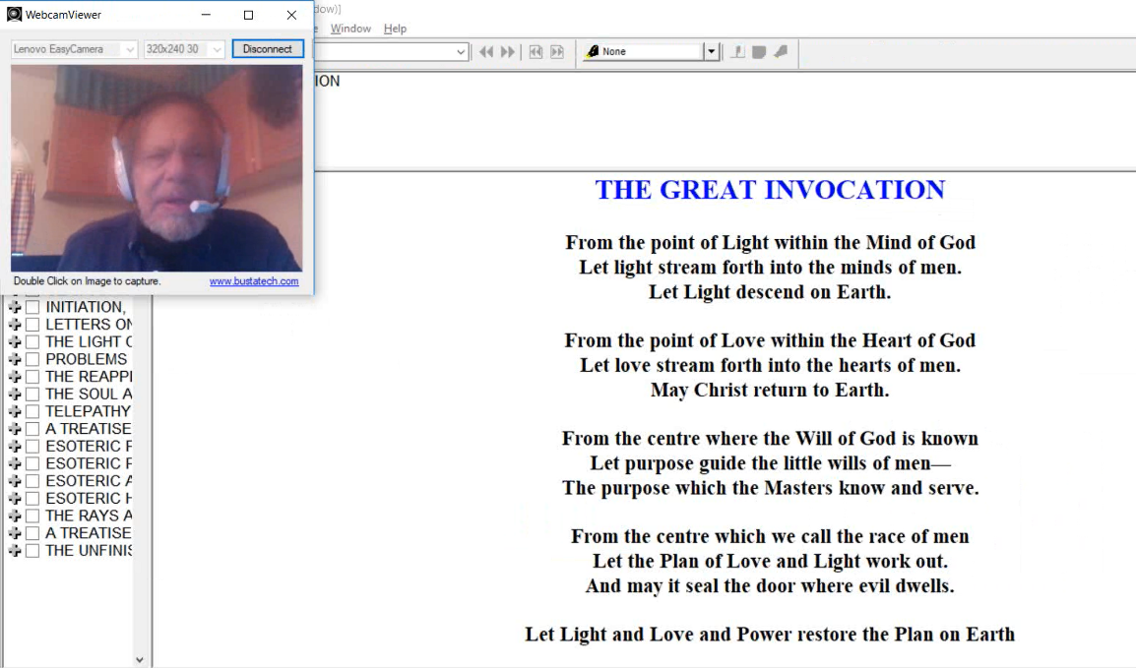
OM. OM. OM.
6:26 That's the great invocation that we should always have in mind when we're doing this work.
Excuse my voice. It's a little bit early in the morning here in Finland. Not so early but I haven't been doing much talking yet. I guess we can say that these video commentaries will be somewhat informal somewhat conversational as if I were working with you in a study group, for example. It’s not meant to be a totally formal presentation but one which stimulates your thought.
I want to look at the chart with which we begin this work.
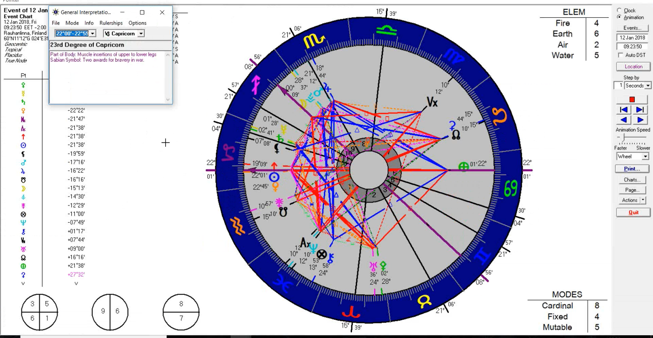

I've got Capricorn rising. It's about sunrise here. And, of course, the Sabian symbols are nice to us. The moon has moved into Sagittarius which I think is, it's better to begin with the moon in Sagittarius than with Scorpio. It gives that kind of forward looking progression and enthusiasm which is useful. All of these degrees 22 plus for the Sun and Venus have a rather nice symbol here two awards for bravery in war.
Sometimes I think that when undertaking commentaries of this kind, one has to be rather brave. One never knows what one is going to run into and whether one will know something worth communicating.
8:27 Here the Mercury and Saturn are in conjunction which concentrates the thought and this is a good thing because we want to be as accurate as possible. The Sun and Venus are together rising so hopefully this is the influence of the solar Angel because the solar Angel plays a very big role in white magic as we will see when we read the rules in just a moment. We have a Jupiter and Mars conjunction in Scorpio and Vesta. There is a certain amount of expansive attitude here and the overcoming of obstacles. Pluto is also rising. I hope this means that we go deeply into the book. I'm not pretending that the last word can be said because there's so much missing from A Treatise on White Magic: the practical words of power are missing, but He tells us that if we will study this work academically then when the time comes to release these words of power and of accomplishment we will be farther ahead.
10:14 The singleton planet interestingly enough is an asteroid it's Ceres; it's in the same degree as the North Node and it is the mother asteroid and the asteroid of taking care and looking after and nurturing. And so, I hope that what Leo represents here: our soul, our identity, our higher self can be nurtured in this process.
I hope we also develop that group attitude that comes when Juno is in Aquarius as it is. Let's see what the degree is here for this: sunshine just after a storm. Well I rather like that: sunshine just after a storm.
So, these singleton planets are always powerful. The moon is in the first degree of Sagittarius: A Grand Army of the Republic campfire. The coming together of those who have fought in the war for the freedom of the human spirit. The war is of course related to the Civil War when the issue of freedom was very strong. Hopefully if we become truly white magicians eventually, we will know something about the creative process in line with the divine Plan and we will create according to that divine Plan. That would be the hope and not create those forms which obstruct the human soul and spirit but which rather promote the development of the human soul and spirit.
12:45 I don't think we have to read too much into this. We have Capricorn of course which is a great sign of achievement and accomplishment, and it allows us to work towards that discipline of the soul over the personality which would allow us to become white magicians.
I guess every member of the spiritual hierarchy is a white magician and we aspirants and disciples, we are included within this circle of hierarchy. Maybe I can show that to you. [see below] Within this blue circle we are included here. The grades of initiates, less than Master, the various grades of disciples and the people on the probationary path. All are included within the circle of hierarchy. This is a marvelous diagram as you probably know. It's the Tibetan's diagram and it's filled in the significant colors by Keith Bailey for the AUM group long ago. [Note, the image from the video is replaced with a similar recreation of Chart XIII, Solar and Planetary Hierarchies, by Vicktorya Stone, for better reproduction.]
These colors help orient us as to the qualities being demonstrated and the qualities which the Masters demonstrate.
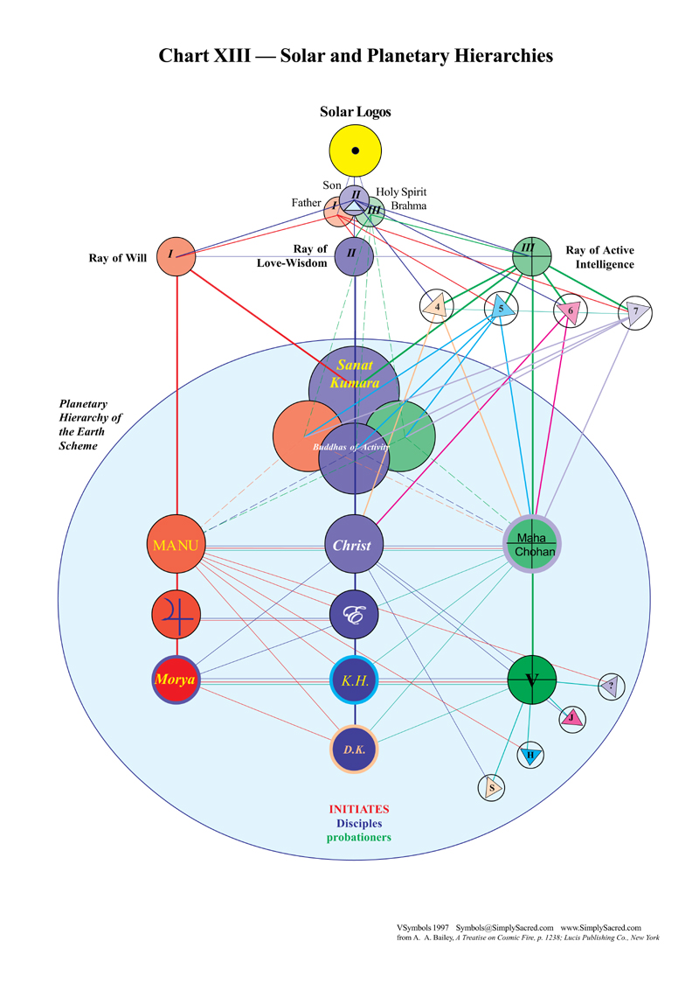

So, we have our astrology chart, and hopefully it keeps us going over the months and even over the years that it will require to complete this book which has more than 700 pages. It is said that young people are refraining from reading so much as they want more the immediate image; that we're living in kind of a post-literate society and that we'll get our information differently than through the spoken word. But I think that when we're dealing with the intricacies of occultism the reading is necessary. So I encourage you all to do your best to continue to apply yourselves to what some people consider to be difficult reading. Maybe it's not so difficult once you get into it. It's certainly unique and it's certainly a unique presentation of the ageless wisdom.

15:50 I look at the degree of Pluto here and I like it: a hidden choir is singing and hopefully the choirs of the angels, some of the devas, are behind us because this book is a lot about that. I should probably consult with my wife Tuija who knows a lot more about the devic kingdom than I do and will along the way teach a course on these matters, on the deva kingdom and three courses on A Treatise on White Magic in the Morya Federation.
I don't know when you'll be listening to this, what year it will be whether it will be soon or later but hopefully the Morya Federation will be in existence and you can utilize this esoteric school to bridge towards the future schools of meditation about which the Tibetan writes and which presents I think so exciting a prospect for true students of the wisdom.
17:19 Now let's get into the rules for magic and then into this interesting introduction. It's quite a lengthy introduction to the book and in a way it had such a degree of depth and complexity that the story goes that in one of the editions of the book it was included more than once because people didn't realize they had already read through the first part and they started to include it again as if it were entirely new.
Maybe that's just a story; I don't know, but we'll be reviewing these rules with great care. So let's concentrate our soul infused mind as we read these rules one after another and this will give us a start into this deep penetration into this treatise. The Tibetan is writing a series he says of bridging treatises and these treatises are coming out or really have been coming out in three installments and the third and final installment is almost upon us beginning in or around the year 2025.
And I think we'll bridge towards the possibility of the beginning of the Aquarian Age in 2117. That's the year given in one of the Tibetan’s letters to the psychologist Roberto Assagioli who was a member of his discipleship groups. That's the year when the vernal equinox aligns with the 30th degree of Aquarius. Everything precesses it moves backwards. So, we begin with 30 and move gradually through the lesser degrees of the sign. We will be here and being born during these years of the Aquarian Age in which so much promise for humanity exists.
20:27 Let’s thoughtfully read these fifteen rules for white magic.
RULE ONE
The Solar Angel collects himself, scatters not his force, but, in meditation deep, communicates with his reflection.
RULE TWO
When the shadow hath responded, in meditation deep the work proceedeth. The lower light is thrown upward; the greater light illuminates the three, and the work of the four proceedeth.
RULE THREE
The Energy circulates. The point of light, the product of the labours of the four, waxeth and groweth. The myriads gather round its glowing warmth until its light recedes. Its fire grows dim. Then shall the second sound go forth.
RULE FOUR
Sound, light, vibration, and the form blend and merge, and thus the work is one. It proceedeth under the law, and naught can hinder now the work from going forward. The man breathes deeply. He concentrates his forces, and drives the thought-form from him.
RULE FIVE
Three things engage the Solar Angel before the sheath created passes downward; the condition of the waters, the safety of the one who thus creates, and steady contemplation. Thus are the heart, the throat, and eye, allied for triple service.
RULE SIX
The devas of the lower four feel the force when the eye opens; they are driven forth and lose their master.
Now although it does not say so here we begin the, I think five, rules for the astral plane. The first six are for the mental plane.
RULE SEVEN
The dual forces of the plane whereon the vital power must be sought are seen; the two paths face the solar Angel; the poles vibrate. A choice confronts the one who meditates.
RULE EIGHT
The Agnisuryans respond to the sound. The waters ebb and flow. Let the magician guard himself from drowning at the point where land and water meet. The midway spot, which is neither dry nor wet, must provide the standing place whereon his feet are set. When water, land and air meet, there is the place for magic to be wrought.
RULE NINE
Condensation next ensues. The fire and waters meet, the form swells and grows. Let the magician set his form upon the proper path.
RULE TEN
As the waters bathe the form created, they are absorbed and used. The form increases in its strength; let the magician thus continue until the work suffices. Let the outer builders cease their labors then, and let the inner workers enter on their cycle.
We can see that this is a very technical presentation and requires a very observant following of the rules as we go along.
RULE ELEVEN
Three things the worker with the law must now accomplish. First, ascertain the formula which will confine the lives within the ensphering wall; next, pronounce the words which will tell them what to do and where to carry that which has been made; and finally, utter forth the mystic phrase which will save him from their work.
28:35 We understand that there is danger in this creative process, and as the Tibetan will tell us, many careless magicians have died along the way by not following carefully the rules. Now these next rules the next four are for the etheric plane as it affects the physical plane.
RULE TWELVE
The web pulsates. It contracts and expands. Let the magician seize the midway point and thus release those "prisoners of the planet" whose note is right and justly tuned to that which must be made.
RULE THIRTEEN
The magician must recognize the four; note in his work the shade of violet they evidence, and thus construct the shadow. When this is so, the shadow clothes itself, and the four become the seven.
RULE FOURTEEN
The sound swells out. The hour of danger to the soul courageous draweth near. The waters have not hurt the white creator and naught could drown nor drench him. Danger from fire and flame menaces now, and dimly yet the rising smoke is seen. Let him again, after the cycle of peace, call on the solar Angel.
RULE FIFTEEN
The fires approach the shadow, yet burn it not. The fire sheath is completed. Let the magician chant the words that blend the fire and water. The solar Angel collects himself scatters not his force. But in meditation and deep communicates with his reflection.
Now all of this is taken from A Treatise on Cosmic Fire and when we went through A Treatise on Cosmic Fire, I'm trying to think, I've written on these matters, there was some commentary offered but we will do that again, in the larger scope with this particular book. I think I also called upon some sections from A Treatise on White Magic when I was doing the written commentary on A Treatise on Cosmic Fire. That did take a long time.
32:34 Well here are the 15 rules. At one point I memorized them. Of course, one has to keep them going in order for them to stay in the memory.
Now we can get into the book itself. And I suppose this is something of the introduction. Yes, it is and we will see how careful the Tibetan is in laying out the foundation for this significant book. You know many of the things that are going to be found here you will be familiar with and other things perhaps not as much but we will in fact begin.
These are introductory remarks. He begins with man's three aspects which we probably recognize as the spirit, the soul and the body or personality. Personality is often considered body not just the physical body but it is comprised of a number of vehicles and as a whole it is considered body.
Man's Three Aspects
In the study of the ideas outlined in this book and their careful consideration certain basic concepts are borne in mind:
First, that the matter of prime importance to each student is not the fact of a particular teacher's personality but the measure of truth for which he stands, and the student's power to discriminate between truth, partial truth, and falsity. TWM 3
In the study of the ideas outlined in this book and their careful consideration certain basic concepts are borne in mind:. . . we can see that the Tibetan is working with the mind of his students. He's working on the plane of mind. He was not working particularly in the astral nature. He is trying to produce the mind held steady in the light.
35:35 First, that the matter of prime importance to each student is not the fact of a particular teacher's personality. . . his various vehicles of his appearance. . . but the measure of truth for which he stands, and the student's power to discriminate between truth, partial truth, and falsity. So, we are enjoined to use the discriminative mind in our efforts here and not to, as has been done so often in the past with the more devotional type of students, emphasized the personality of the teacher to which the devotion is directed.
Second, that with increased esoteric teaching comes increased exoteric responsibility. Let each student with clarity therefore take stock of himself, remembering that understanding comes through application of the measure of truth grasped to the immediate problem and environment, and that the consciousness expands through use of the truth imparted. TWM 3
Second, and this is an important one, that with increased esoteric teaching comes increased exoteric responsibility.. . .We can't just keep piling up knowledge and not using it because there's a heavy karma for that, and as I've sometimes recounted the old adage that even a donkey can carry a library on his back. Let each student with clarity therefore take stock of himself, remembering that understanding comes through application of the measure of truth grasped to the immediate problem and environment. So, if we apply we will understand and that we simply hoard the knowledge we will not. Understanding comes through application to the measure of truth grasped to the immediate problem environment because there will always be a problem confronting us.
Our planetary development is not such that problems do not exist, severe problems exist actually at this point of transition between the Age of Pisces and Age of Aquarius and even a larger transition between the twenty-five thousand year approximately Age of Pisces and the approximately twenty-five thousand year Age of Aquarius the larger plutonic age . . . and that the consciousness expands through use of the truth imparted. I guess we can ponder on that. It's not just the stocking of the mind, but circumstances will arise in which that which we have assimilated will be called for and do we use it? Do we apply the measure of truth which we have grasped?
39:10 So it's not the personality of the teacher, and must apply in a responsible manner that which we assimilate.
Third, that a dynamic adherence to the chosen path and a steady perseverance that overcomes and remains unmoved by aught that may eventuate, is a prime requisite and leads to the portal admitting to a kingdom, a dimension and a state of being which is inwardly or subjectively known. It is this state of realisation which produces changes in form and environment commensurate with its power. TWM 3
Third, that a dynamic adherence to the chosen path. . . wherever the word dynamic has been used that [the aspect of] will is suggested . . .and a steady perseverance that overcomes and remains unmoved by aught that may eventuate,. . . in the realm of personality and an environment. . . is a prime requisite and leads to the portal admitting to a kingdom, a dimension and a state of being which is inwardly or subjectively known. And I think we can call this the fifth kingdom of nature, the kingdom of the soul. That is the kingdom to which really we are making application in all these studies. It is this state of realisation which produces changes in form and environment commensurate with its power.
We do not get off the path. We do not deviate or if we do deviate we come back very quickly. It says that is the capacity of the disciples to return quickly to the path that deviation has been experienced and a steady perseverance. This is the kind of perseverance of the second Ray, interesting enough. Not the crashing through of the first ray but that steady application which allows of no let up or leeway, as he tells us and a steady perseverance that overcomes and remains unmoved by aught that may eventuate. . . and much will eventually people discover this. They begin with great enthusiasm and the next thing they know they're up against their environment. They're up against their own personality and they have to make a decision about whether they keep going unmoved by any of that which has been evoked because of their interest in application to the teaching. It's a prime requisite and leads to the portal of initiation. Really that's what we're talking about.
42:01 So the spiritual will must be applied and all other aspects of Will under the higher aspects. We must not deviate and we must keep on keeping on as they say somewhat humorously in the Arcane School circles, probably dating back from the time of Alice Bailey. Keep on keeping on.
Unmoved by aught which may shockingly eventuated and the enthusiastic neophyte is faced with all kinds of difficulties, and this is one of the first tests. So not the personality of the teacher. Applied truth and dynamic adherence and perseverance, and being unmoved by whatever may eventuate.
I think He was writing this book in the late 1920s maybe early 30s. It takes a while to write these books. They came out in lesson sets for the use of the Arcane School students at that time and then later were gathered into a book. It wasn't until after Alice Bailey died, she died in December of 1949 that this book was first published in 1951. So, the gathering together of the various sections of the book made the possibility of publication and we are in a position right now where we can look at the whole presentation and all that has been published from the Tibetan's work in the second installment.
Now the third is coming and we don't know the method by which it will be presented or who may be the amanuensis here and how easy or how difficult it will be to recognize the Tibetan's note. Because I suppose with each amanuensis the note of the teacher undergoes a kind of modification. I mean DK considered HPB (Helena Petrovna Blavatsky) his first amanuensis but it's a very different note which comes out of those works and then indeed it wasn't a word for word transmission with Blavatsky as much as it was with Alice Bailey. But let's just see the promise is the third installment is coming. And it will be of real significance in preparation for the externalization of the hierarchy and the eventual reappearance of the Christ when certain of the masters and their initiates and disciples have done what is required. And it's pretty significant and demanding what is required.
45:45 We have three suggestions here.
These three suggestions will merit a close consideration by all, and their significance must be somewhat grasped before further real progress is possible. It is not my function to make individual and personal application of the teaching given. That must be done by each student for himself. TWM 3
These three suggestions will merit a close consideration by all, . . . it's the truth that comes through, that counts and not the personality of the teacher. Doing something with the teaching. It's sticking to it. These are requirements and we have to review our relationship to them within our meditative consciousness. So . . .will merit a close consideration by all, and their significance must be somewhat grasped before further real progress is possible. It is not my function to make individual and personal application of the teaching given. That's up to us, right? That must be done by each student for himself.
Well some of us, by now, are fairly experienced students of this teaching and we know it isn't an easy teaching but it is deep and as thorough as may be possible for people of our nature.
You have wisely guarded the teaching from the taint of superimposed authority, and there lies back of your books no esoteric principle of hierarchical authority or support, such as has produced the narrow limits of certain ecclesiastical bodies and groups, differing as widely as the Catholic Church, Christian Science, those who believe in the verbal inspiration of the Scriptures, and numerous (so-called) esoteric organisations. The curse of many groups has been the whispered word that "Those who know wish...." "The Master says...." "The Great Ones command..." and the group of silly sheep feebly and blindly tumble over themselves to obey. They think thereby, through their misplaced devotion, to contact certain authoritative personages, and to get into heaven by some short cut. TWM 3-4
You have wisely guarded the teaching from the taint of superimposed authority. . . I guess in a way he's speaking to Alice Bailey and maybe some of his group members. I think in 1931 or so the group members began to be chosen. Maybe the book started to be written beforehand. You have wisely guarded the teaching from the taint of superimposed authority, and there lies back of your books. . .AAB right? . . . no esoteric principle of hierarchical authority or support, such as has produced the narrow limits of certain ecclesiastical bodies and groups, differing as widely as the Catholic Church, Christian Science, . . . with Mary Baker Eddy, right? . . .those who believe in the verbal inspiration of the Scriptures, . . . and DK is looking like he is not one who does because he often tells us that the scriptures are incomplete or misrepresent what actually happened . . .and numerous (so-called) esoteric organisations.
48:39 The idea here is that because the teacher said it, it must be true, and we the students must acquiesce to the authority behind the teaching.
The curse of many groups has been the whispered word. . . I've heard that, people conveying messages to you about what you must do because the Hierarchy suggests it . . .that "Those who know wish...." "The Master says...." "The Great Ones command...". . .and of course you must fall into line which gives the conveyor of the message a certain ego satisfaction because he or she is the intermediary, conveying that which you must obey. So, it's like obeying the one who conveys . . .and the group of silly sheep feebly and blindly tumble over themselves to obey.
Here the comparison to members of the animal kingdom. This what Master Morya always does. He says compare people to animals and they will soon place emphasis upon their human pedigree. So, all of these messages conveyed are a curse. And this will to obey the authority, well we're still in a sixth ray age; it's passing out, but there is the tendency with that ray particularly to obey in that manner. They think thereby, through their misplaced devotion, to contact certain authoritative personages, and to get into heaven by some short cut. Whatever heaven is, whether it's a higher plane or some post-mortem state.
You have wisely guarded your books from the reaction accorded to those who claim to be masters, adepts and initiates. My anonymity and status must be preserved, and my rank be regarded as only that of a senior student and of an aspirant to that expansion of consciousness which is for me the next step forward. What I say of truth alone is of moment; the inspiration and help I can accord to any pilgrim on the path is alone vital; that which I have learned through experience is at the disposal of the earnest aspirant; and the wideness of the vision which I can impart (owing to my having climbed higher up the mountain than some) is my main contribution. Upon these points the students are at liberty to ponder, omitting idle speculation as to the exact details of unimportant personalities, and environing conditions. TWM 4
You. . . I suppose this must be to Alice Bailey because the books are hers really . . .have wisely guarded your books from the reaction accorded to those who claim to be masters, adepts and initiates. There are so many, it's just ludicrous when you see what their real accomplishments are compared to their claim. My anonymity and status must be preserved. Okay, Alice Bailey knows what that is . . .and my rank be regarded as only that of a senior student and of an aspirant to that expansion of consciousness which is for me the next step forward.
Maybe it would have been entirely guarded, but somewhere in the stress of the teaching many, many years later, Alice Bailey apparently left at the bottom of a document, the words Djwhal Kuhl. Maybe it was the Tibetan’s intention to remain anonymous throughout the entire teaching. And for those who could intuit his identity, well then they did. But it was revealed many years later. And who's to say if the revelation has necessarily a bad effect? Did it promote this curse that the Tibetan says this or rather Djwhal Kuhl says this.
53:16 What I say of truth alone is of moment; the inspiration and help I can accord to any pilgrim on the path is alone vital; that which I have learned through experience. . . note, through experience, . . . is at the disposal of the earnest aspirant; and the wideness of the vision which I can impart (owing to my having climbed higher up the mountain than some). . . see the humility of how he writes . . .is my main contribution. Upon these points the students are at liberty to ponder, omitting idle speculation as to the exact details of unimportant personalities, . . . including his own, I suppose, . . . and environing conditions.
So, this is how we are to address his teaching. What He says of truth, if it is true and the inspiration he can give and what he's learned through experience can be perhaps conveyed and made confirmed in the consciousness of the student who receives that which is conveyed.
Our theme is to be that of the Magic of the Soul, and the key thought, underlying all that may appear in this book, is to be found in the words of the Bhagavad Gita which runs as follows:
"Though I am Unborn, the Soul that passes not away, though I am the Lord of Beings, yet as Lord over My nature I become manifest, through the magical power of the Soul." Gita IV.6. TWM 4
We're dealing with a being who is and the consciousness of that being as it may be manifested through the forms of various emanated beings. And I'm so glad in a way to be reading this. I began that long ago, the way some of you have and hope that the knowledge and the understanding of what's in this book has deepened over the years.
"Though I am Unborn,. . .pure being is unborn . . .the Soul that passes not away,. . . being and consciousness, . . .though I am the Lord of Beings,. . . of the various emanations that come forth, the self-reflections . . .yet as Lord over My nature I become manifest,. . . being and consciousness of the high worlds, becomes manifest . . .through the magical power of the Soul." through the ability of the soul to make its presence felt, a radiatory presence through the lower forms which of course become by it itself or created - I actually prefer the word “become” to “created” because all that we see here is not so much a creation as a becoming of the Greater Being into forms of lesser beings.
57:30 So many, many beings that we see in the many, many objects and movements and integrated energy patterns, they are all the results of the Becomingness of this Greater Being.
The statistical and the academic is a necessary basis and a preliminary step for most scientific study, but in this book we will centre our attention on the life aspect, and the practical application of truth to the daily life of the aspirant. Let us study how we can become practical magicians, and in what way we can best live the life of a spiritual man, and of an aspirant to accepted discipleship in our own peculiar times, state and environment. TWM 5
The statistical and the academic is a necessary basis and a preliminary step for most scientific study, but in this book we will centre our attention on the life aspect, and the practical application of truth to the daily life of the aspirant. We are not yet in the position of being able to prove what the Tibetan can prove, scientifically. Let us study how we can become practical magicians, and in what way we can best live the life of a spiritual man, and of an aspirant to accepted discipleship in our own peculiar times, state. . . somewhere between the first and second initiation and probably under the influence of Mercury and Saturn, the possibility of accepted discipleship emerges and then one is directly linked to the Master. The standards for accepted discipleship may change as we go along. and environment.
To do this we will take the Fifteen Rules for Magic to be found in my earlier book, entitled A Treatise on Cosmic Fire. I will comment on them, dealing not with their cosmic significance or with solar and other correspondences and analogies, but applying them to the work of the aspirant, and giving practical suggestions for the better development of soul contact and soul manifestation. I shall take for granted certain knowledges and assume the students can follow and comprehend certain technical terms that I may be led to use. I am not dealing with babes but with matured men and women who have chosen a certain way and who are pledged to "walk in the light." TWM 5
To do this we will take the Fifteen Rules for Magic to be found in my earlier book, entitled A Treatise on Cosmic Fire. He laid out so many seats in that great book for this book on Magic, for the Esoteric Psychology book, for the astrology book, he laid it all out and for much on initiation. I will comment on them,. . .these rules, . . . dealing not with their cosmic significance or with solar and other correspondences and analogies. . . which obviously then exist, . . .but applying them to the work of the aspirant, and giving practical suggestions for the better development of soul contact and soul manifestation.
It's going to be a practical book as we would expect under the seventh ray. I shall take for granted certain knowledges and assume the students can follow and comprehend certain technical terms that I may be led to use. I am not dealing with babes but with matured men and women who have chosen a certain way and who are pledged. . . pledge disciples, may we all be so, . . . to "walk in the light."
What I'll do now friends is call this the end of A Treatise on White Magic video commentary, number one. Today is 12 January 2018. This would be about an hour in length and at least we've gotten started. Maybe things sometimes are a little bit shaky when one gets started, but as I say this is a conversation about the book and about its place in the Tibetan's imparted knowledge and wisdom and we'll just do our best. It's a foundational book and something that all of us have to study.
So, be seeing you soon. And we will move on together. Bye for now.

